LIGO Laboratory / LIGO Scientific Collaboration

LIGO-T1200551-v2 LIGO Feb. 1, 2013

Optical-lever installation interferences at LHO

Eric D. Black, Thomas Vo

Distribution of this document:
LIGO Scientific Collaboration

This is an internal working note
of the LIGO Laboratory.

California Institute of Technology  LIGO Project | Massachusetts Institute of Technology  LIGO Project
LIGO Hanford Observatory | LIGO Livingston Observatory
http://www.ligo.caltech.edu/

Introduction
This document describes the interferences between existing infrastructure and the advanced-LIGO optical-lever pylons. There are several locations where vacuum piping, chilled-water lines, cable trays, &c. run where pylons need to be installed. The original plan was to re-route these before installation, and the extent of the interference was detailed in G1000103-v2, “Provision of Space for LHO aLIGO Oplev & Photcal Installations.” A RODA was filed in February of 2010, M1000041-v1, “Decision to provide the necessary floor and elevation space for the proposed aLIGO Test mass Optical Lever and Photon Calibrator installations at LHO.” This document explores alternatives and makes specific recommendations for each installation.

Specific optical levers
Section titles refer to the sensed optic.

HAM3
Type: HAM Transceiver
Location: Under HAM2, looking into VP7 of WAMCA1
Notes: This transceiver was installed on the wrong side of the beam tube. It faces viewport VP7 whereas the design called for it to look into VP5. There is no interference with the pylon in this incorrect spot, but there is in the correct location.
Recommendation: As long as there is no interference inside the vacuum chamber, leave it the way it is. The reflecting mirror on the HAM table will have to be rotated laterally (in yaw) by about four degrees to return the beam, but since this mirror sits on the near edge of the table this should not be a problem. It is my understanding that there is a hole in the beam-tube baffle that would allow the oplev beam to come in and out of VP7.
Note: Modeling should be performed and verified before installation, drilling, or cutting is done.
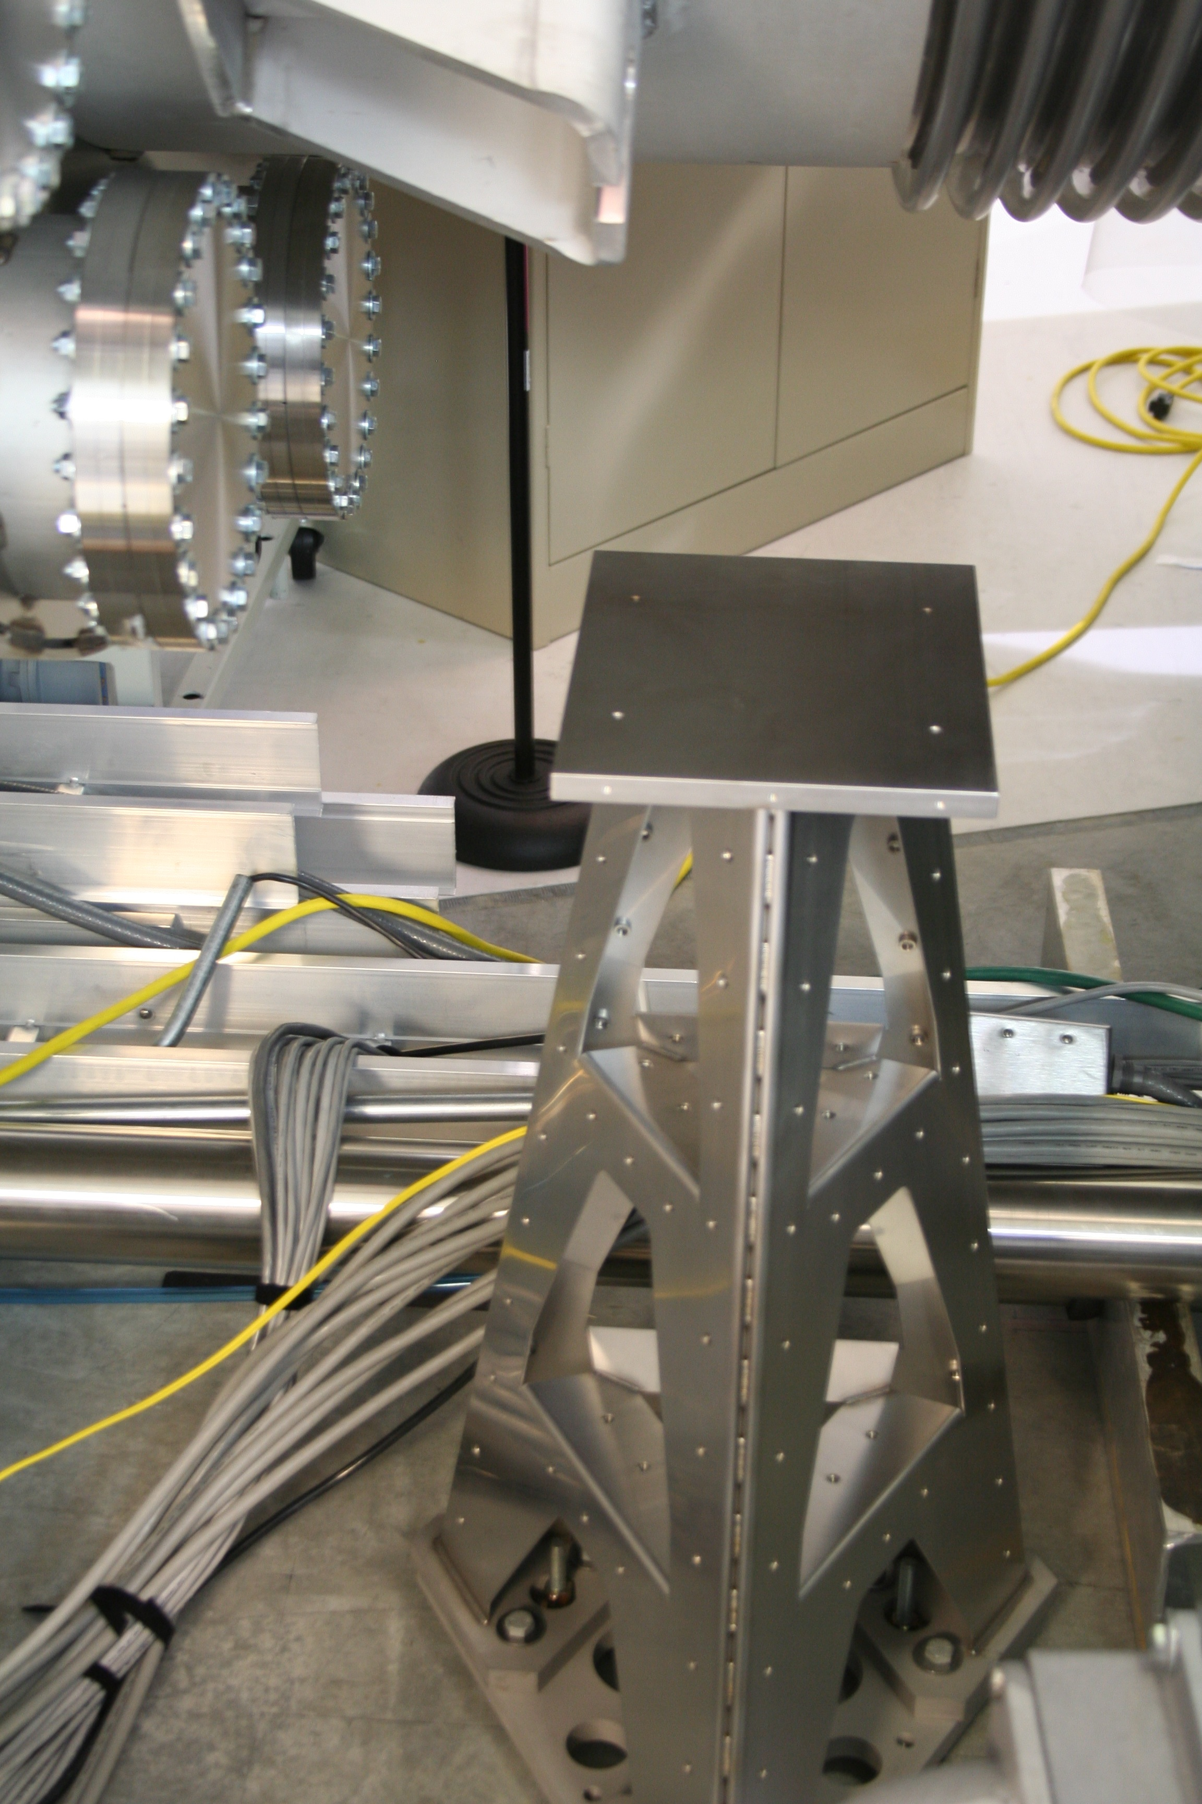
Figure 1: HAM3 Oplev transceiver as installed by WAMCA1, looking into VP7.

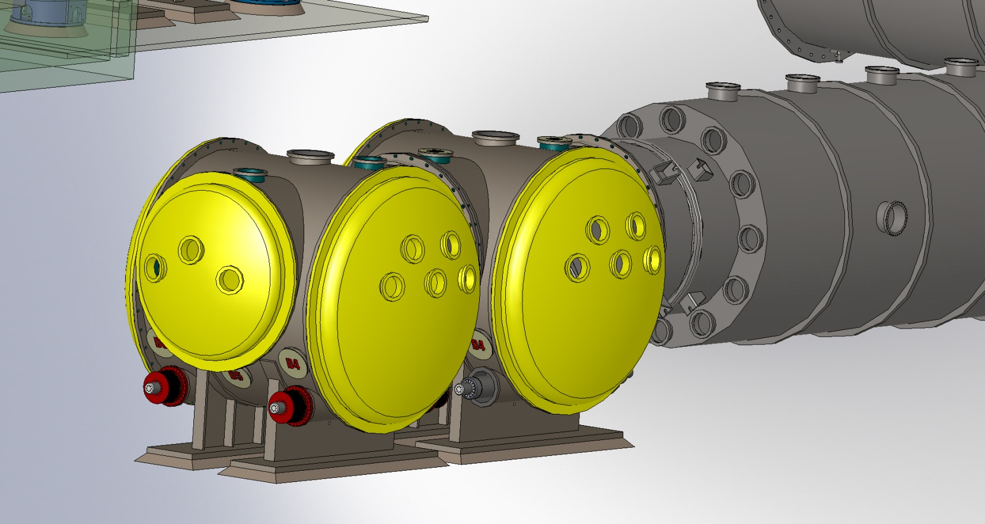
Video PR2 (VP3)
VP2
VP1
VP4
OptLev HAM3 In/Out (VP5)
VP6
VP7
VP8
Video MC2 (VP9)
VP10
VP11
VP12
TO BEAM SPLITTER
HAM2
HAM1
WAMCA1
LAMCA1
Figure 2: Viewport configuration from Figure 37 of T1000746-v7, Viewport Final Design. HAM3's optlev should look in VP5 but was installed looking into VP7.

PR3
Type: Short-dwarf transmitter
Location: Under HAM3, looking into VP7 of WAMCB1
Notes: Only one piece of pvc pipe is in the way here. The holes have been drilled in the wrong orientation, according to the floor-occupancy diagram. According to G1000740, the triangle should point into the beam-tube axis, and as shown in the photo below, it is now pointing out. This would be the correct orientation for LLO, according to G1000700, and may be just fine for LHO.
Recommendation: Re-route or remove pvc pipe. Leave orientation the way it is. UPDATE 1/30/13: John Worden and I pushed the pvc pipe out of the way and installed this pylon. As long as Richard McCarthy signs off on the close contact with the cable tray, we’re done here.
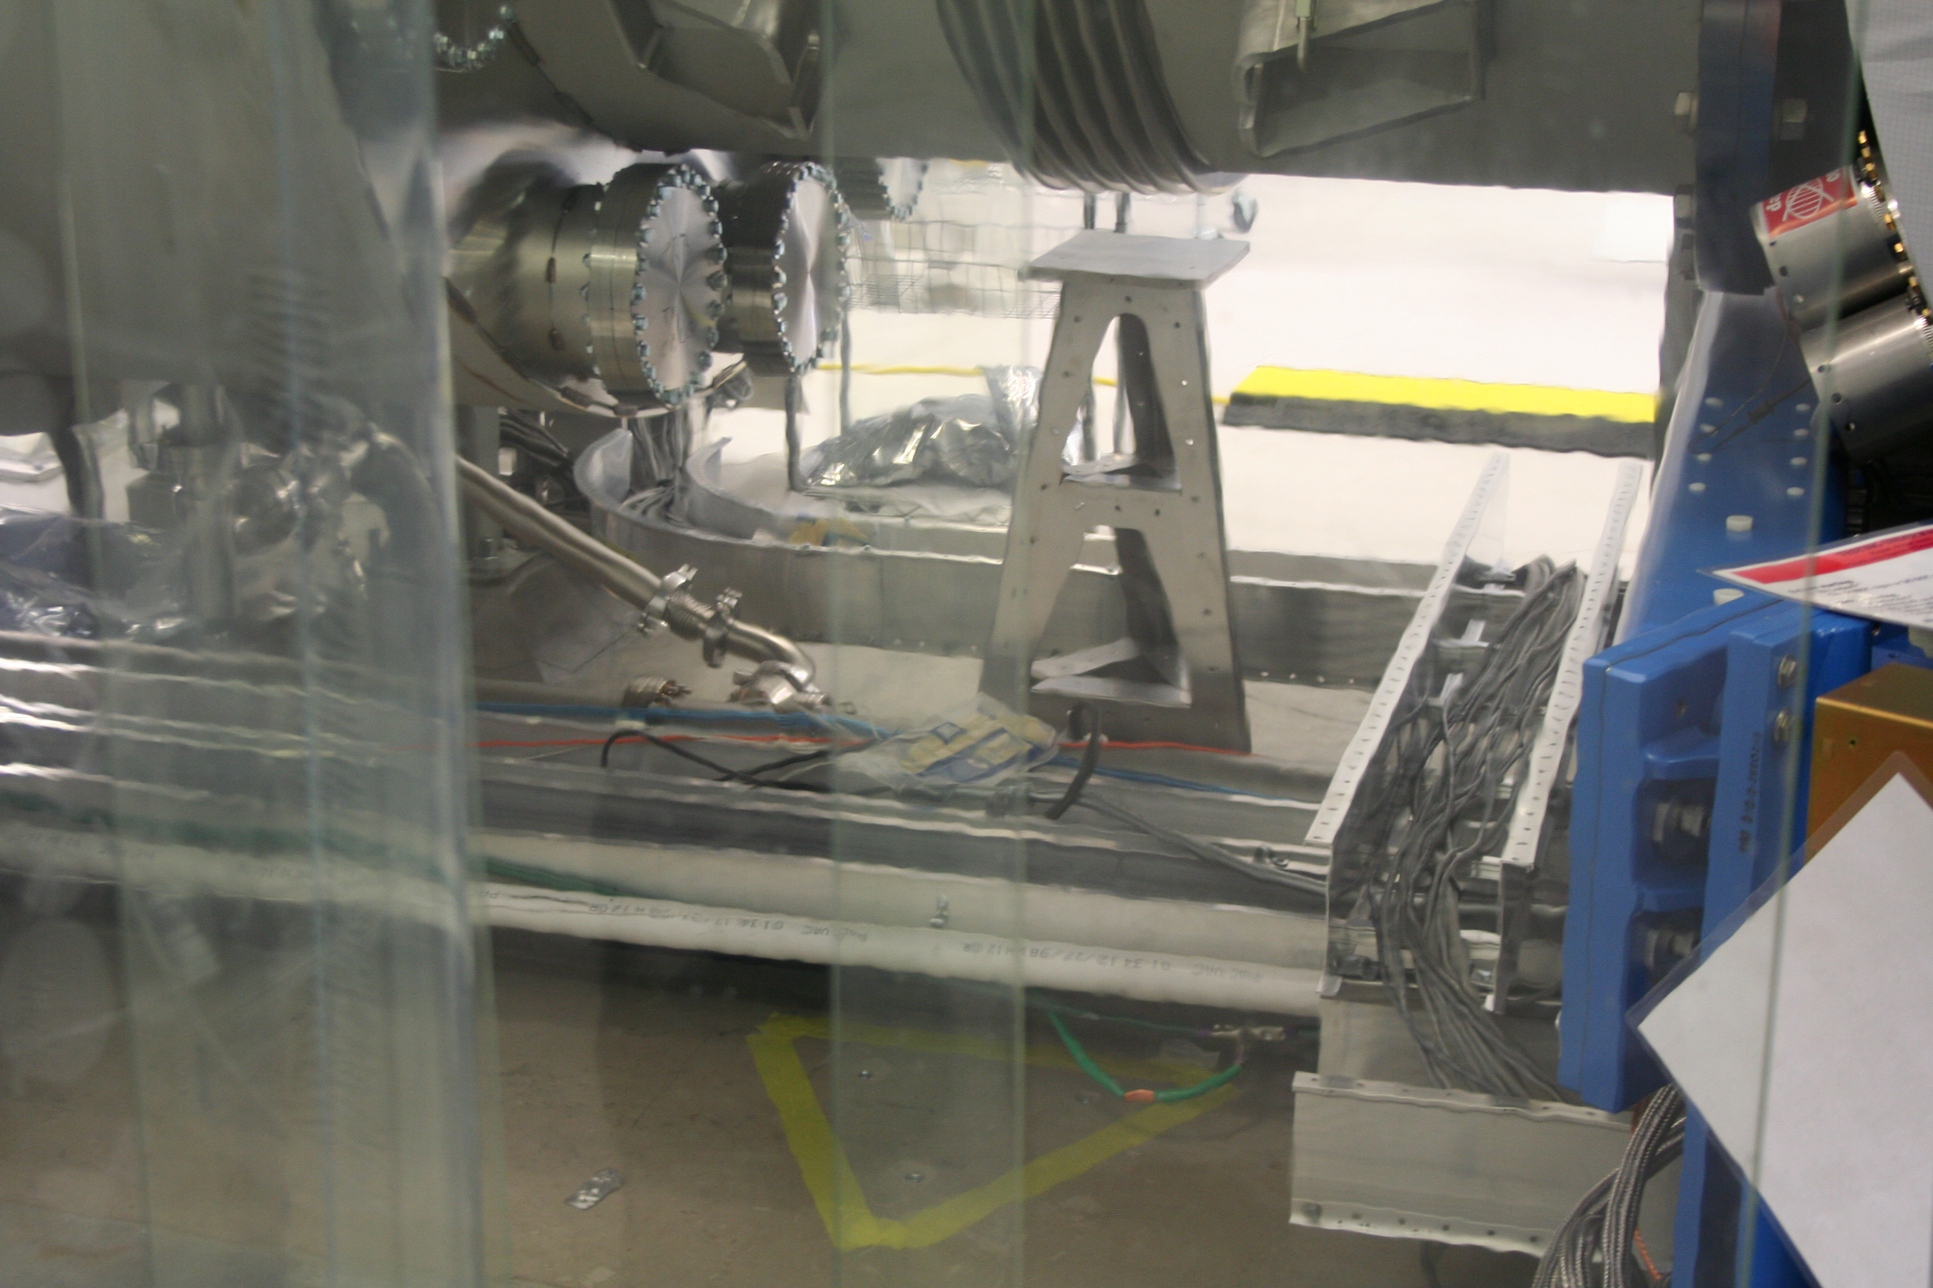
Figure 3: PR3 transmitter-pylon floorplate footprint, bounded by yellow tape in the foreground.

HAM2
Type: HAM Transceiver
Location: Under HAM3, looking into VP5 of WAMCB1
Notes: Appears to be installed. See Figure 3 background.
Recommendation: No modifications necessary.

SR3
Type: Short-dwarf transmitter
Location: Under HAM4, looking into VP5 of WAMCB2
Notes: Significant interference. See photo. As of this writing, we are measuring to see if we can get away with just moving the cable trays, or if we need to move pipes as well. Even if we don’t need to move pipes for this one, they will almost certainly need to be moved for the HAM5 transceiver.
Recommendation: Re-route purge-air pipe. Re-route cable tray.
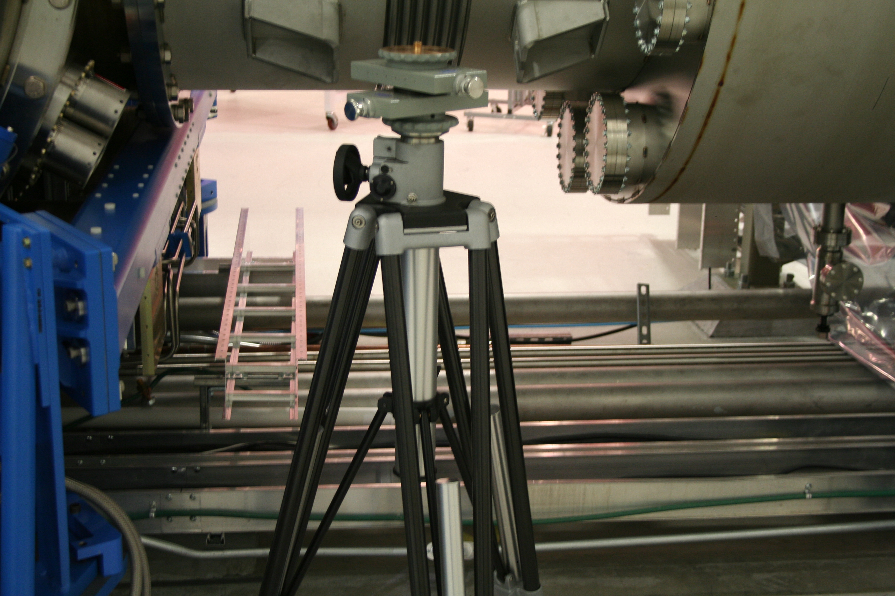
Figure 4: SR3 location.

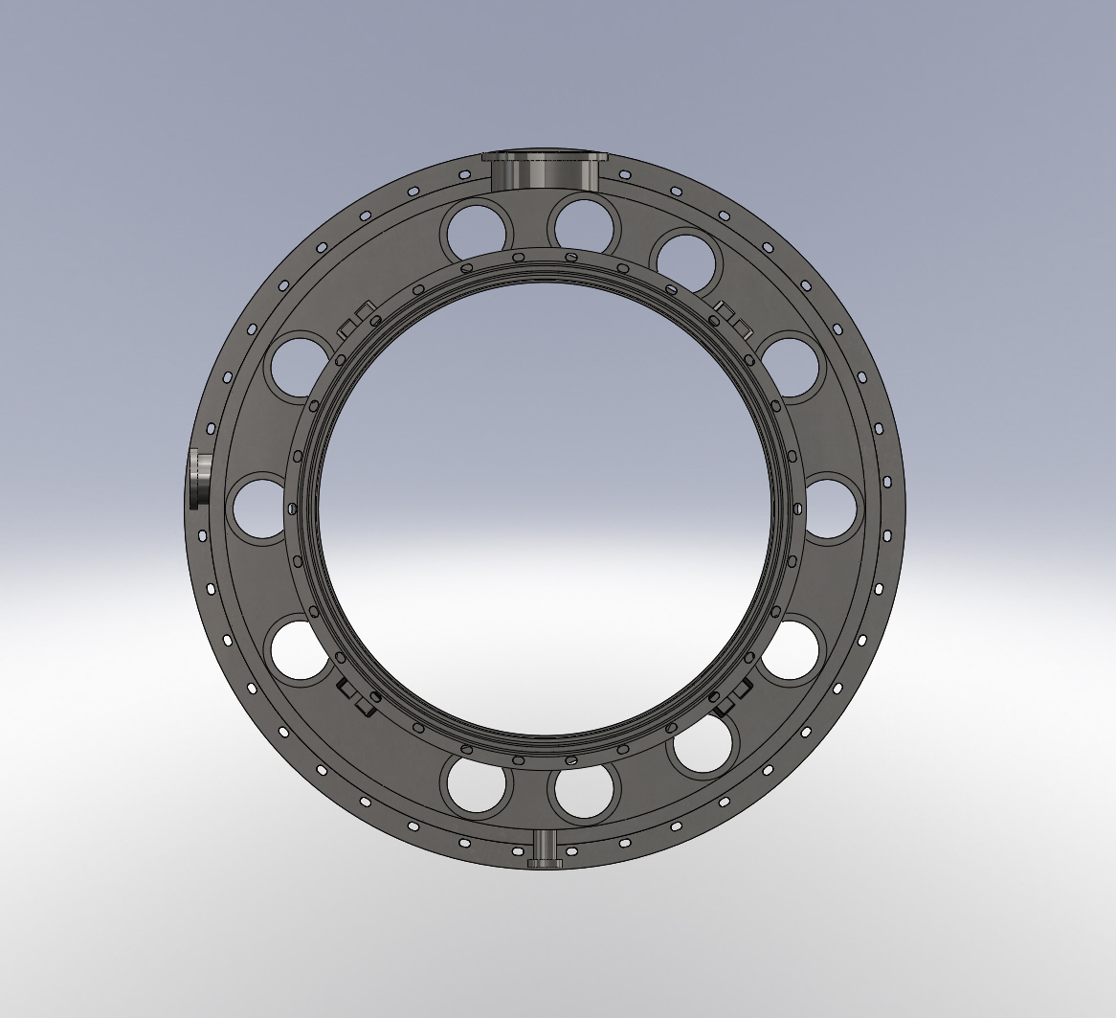
VP2
VP3
VP8
OptLev SR3 In (VP5)
VP6
OptLev HAM5 In/Out (VP7)
VP4
VP10
OptLev SR3 Out (VP1)
VP11
Away from BEAM SPLITTER
HAM4
WAMCB2
LAMCB2
Video SRM
(VP9)
Video SR3
(VP12)
Figure 5: Viewport locations for HAM5 and SR3 oplevs, taken from Figure 40 of T1000746, Viewport Final Design. The photo in Figure 4 views this flange from the right.

HAM5
Type: HAM Transceiver
Location: Under HAM4, looking into VP7 of WAMCB2
Notes: Significant interference. See Figures 4 and 5.
Recommendation: Trim pylon so that vacuum foreline can pass through. Note: Modeling should be performed and verified before installation, drilling, or cutting is done.

HAM4
Type: HAM Transceiver
Location: Under HAM5, looking into VP5 of WAMCA2
Notes: No interference. Holes drilled in the wrong orientation, but otherwise OK. NOTE: Launching-pylon footprints can be rotated 180° without loss of functionality.
Recommendation: Leave it the way it is. No modifications necessary.

Beamsplitter (BS)
Type: Beamsplitter platform
Location: Blue pylon on the “lower right” corner of BSC2, between BSC3 and HAM4.
Notes: No interference.
Recommendation: No modifications necessary.

ITMX
Type: Dwarf transmitter
Location: By X-arm cryopump, looking into VP3 of ITM-X adapter A-1, WA-1C
Notes: Significant interference. See figures below.
Recommendation: Re-route or remove interfering pipes. Mount initial-alignment monument LV7 on leaner’s baseplate. Translate leaner parallel to beam axis as needed.
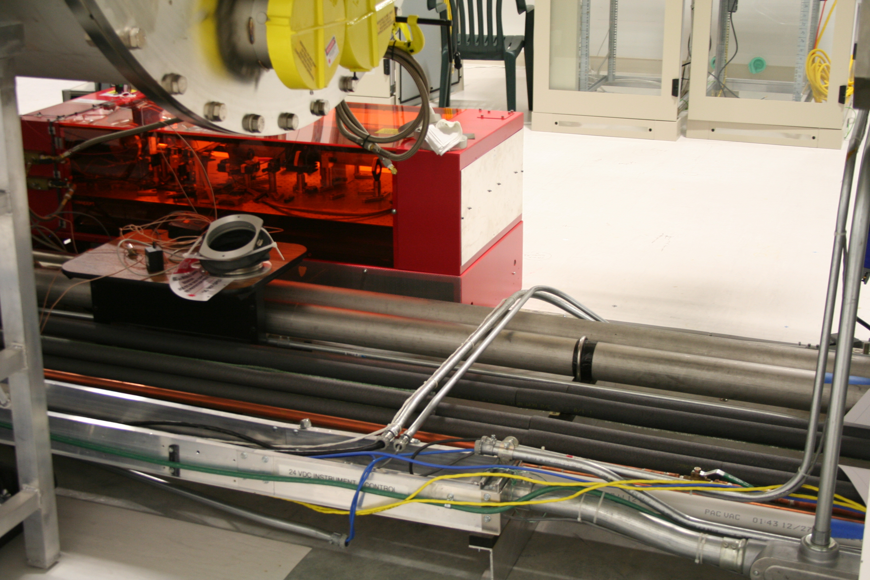
Figure 6: ITMX location, from the opposite side of the beam tube from the transmitter. The dwarf is supposed to sit next to the red TCS table. There are lots of pipes in the way.
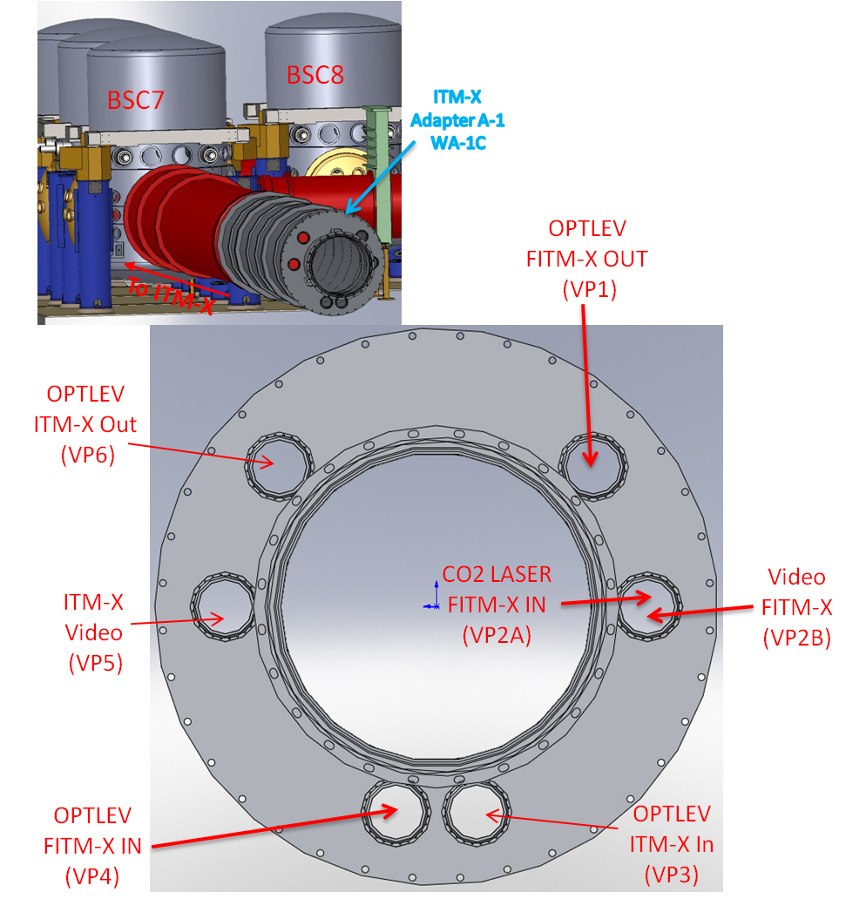
Figure 7: Viewport configuration for ITMX, from Figure 41 of T1000746, Viewport Final Design. We are concerned only with ITMX IN (VP3) and ITMX OUT (VP6). "FITM" refers to H2 and is no longer relevant.
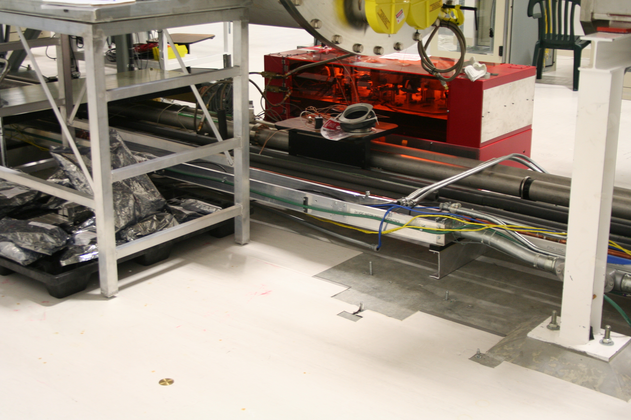
Figure 8: The receiver pylon (leaner) is supposed sit in the foreground of this picture, probably occluding the brass-disk monument set into the floor for initial alignment.

ITMY
Type: Dwarf transmitter and leaner receiver
Location: By Y-arm cryopump, looking into VP4 of ITM-Y adapter A-1, WA-1F
Notes: Installed, but occludes initial-alignment monuments LV17, LV18, and LV19.
Recommendation: Mount initial-alignment monuments on pylon baseplates. Adjust pylon positions along beam axis and rotate transmitter by 180° as necessary.

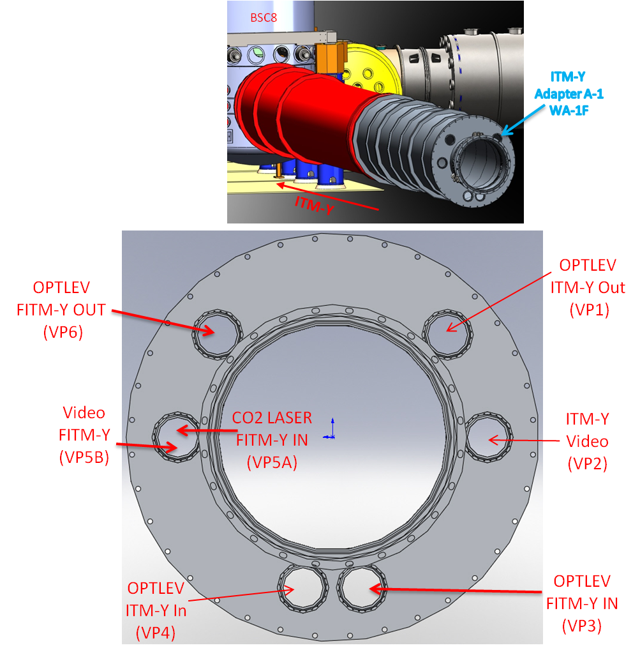
Figure 9: Viewport configuration for ITMY. We are only concerned with ITMY, not FITMY, and thus restrict our attention to VP4 and VP1.
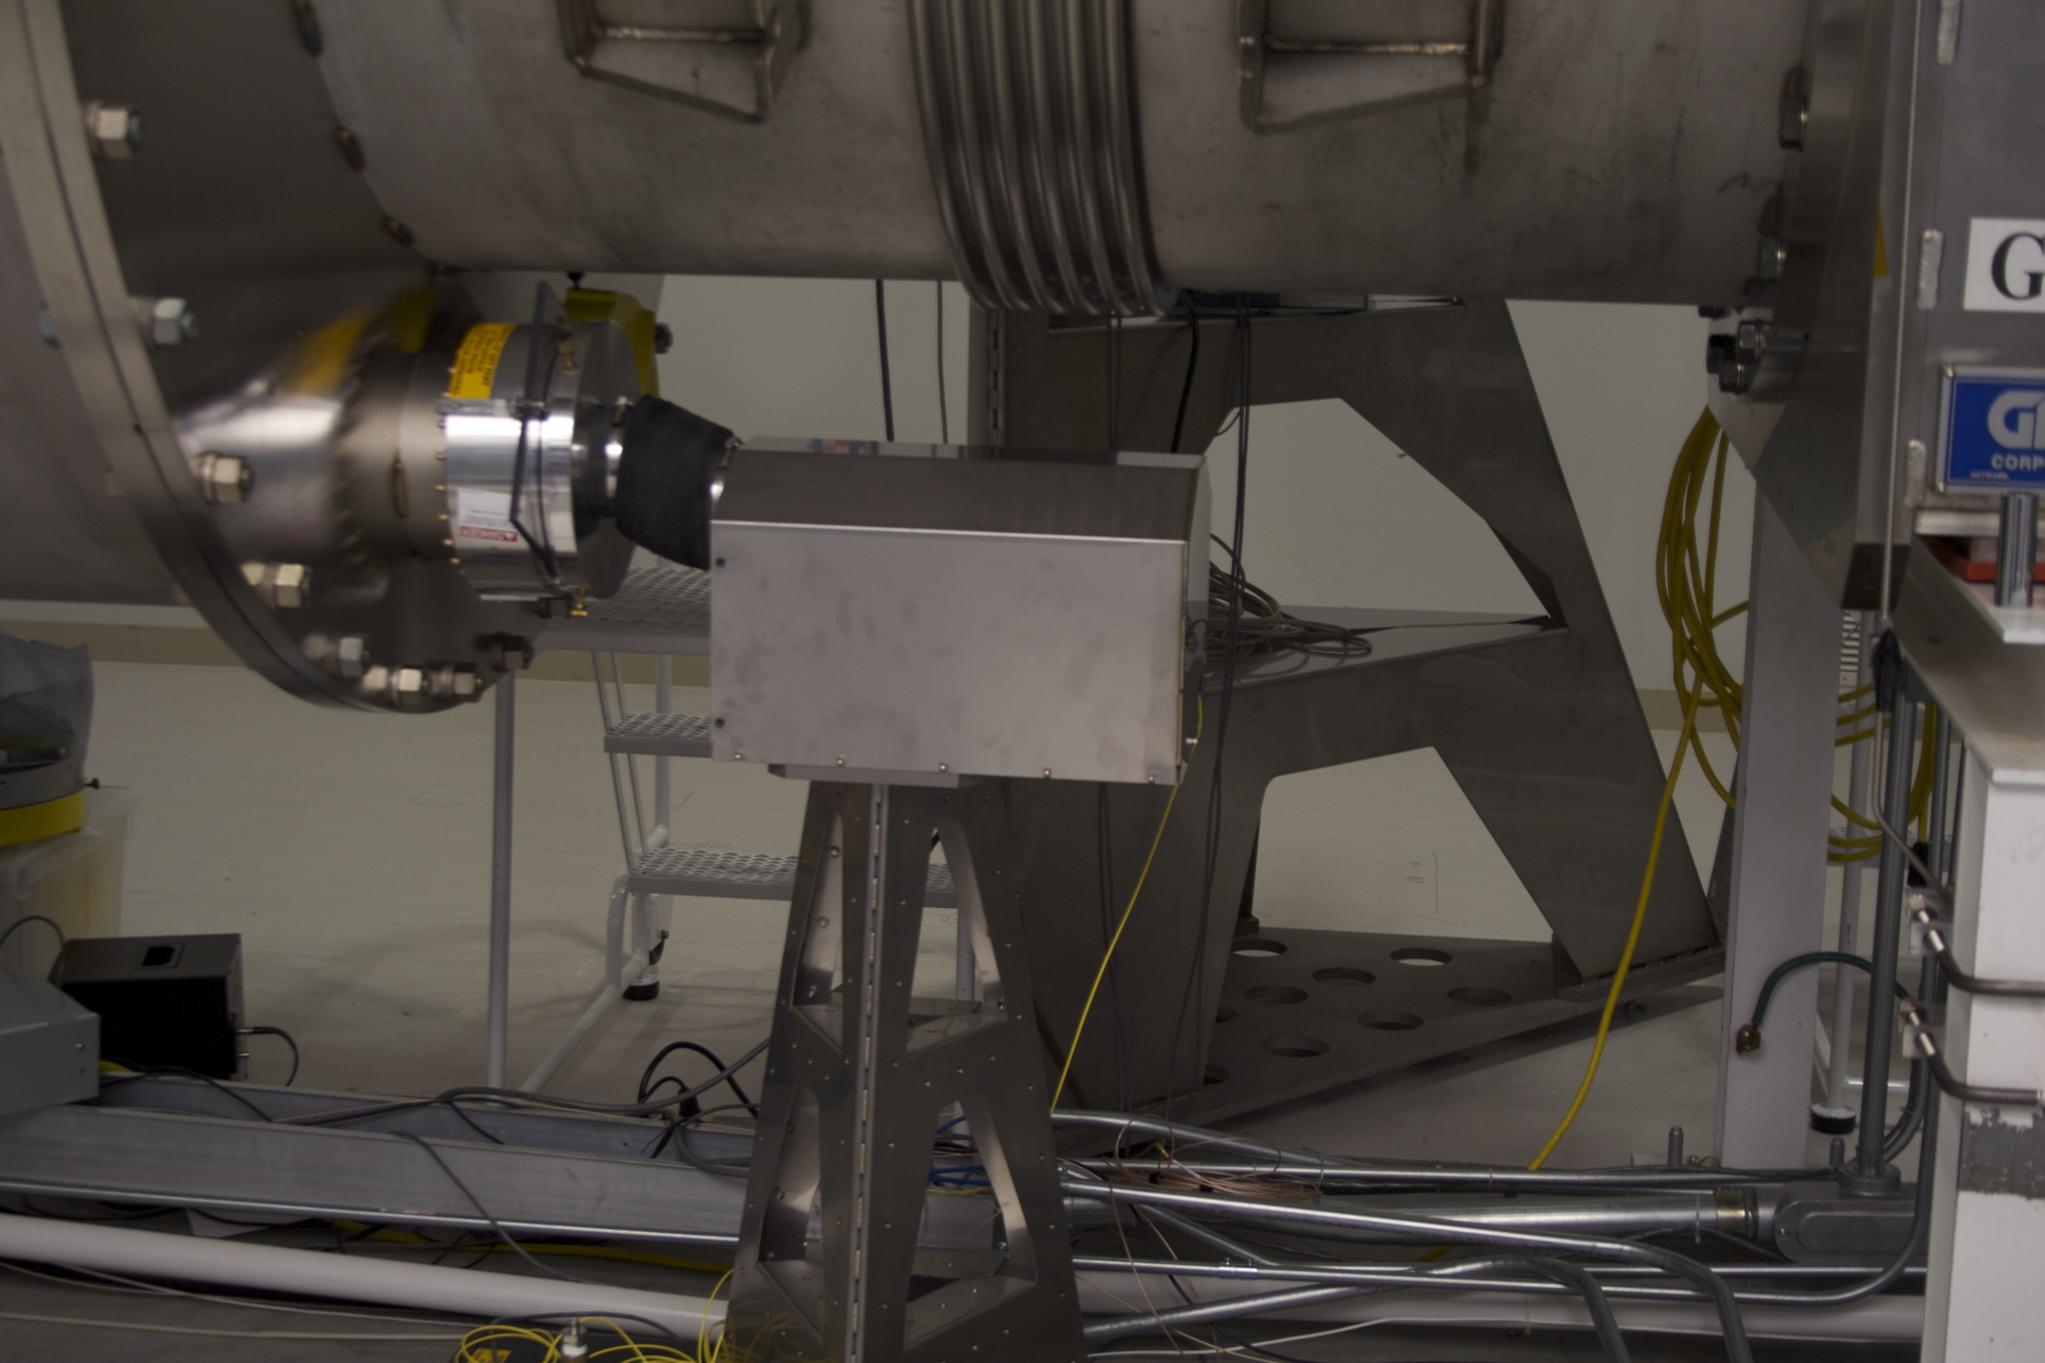
Figure 10: ITMY launching platform looking into VP4.

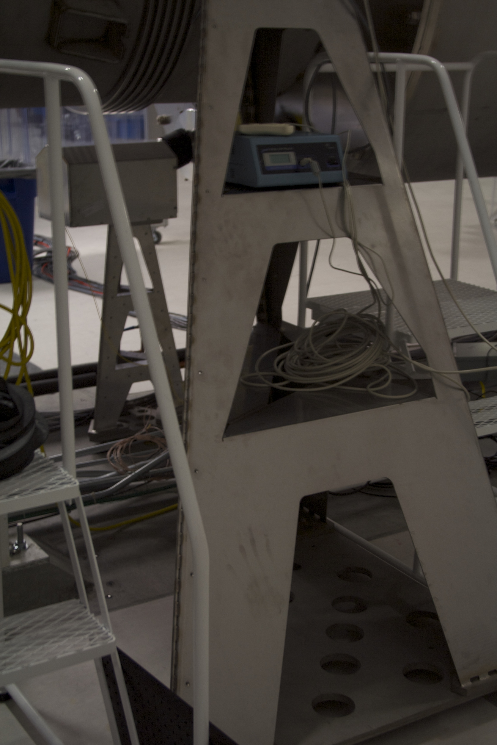
Figure 11: ITMY receiver (leaner) in the foreground, with launcher (dwarf) in the background.

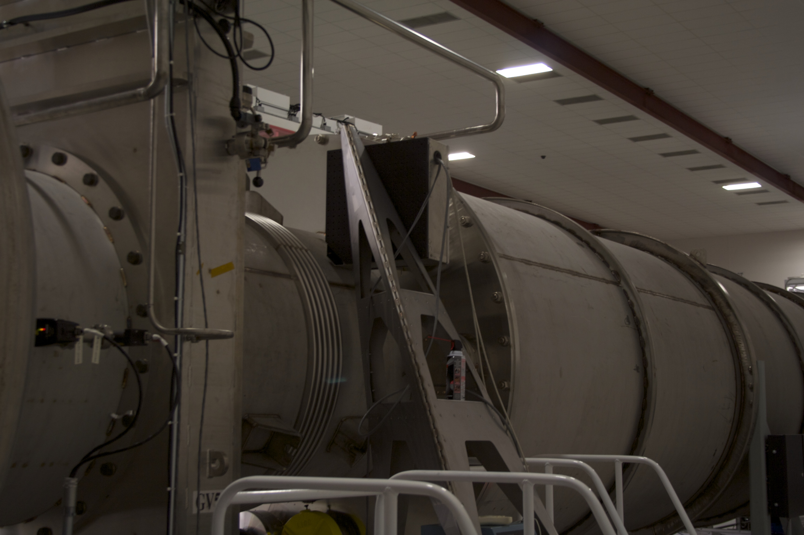
Figure 12: ITMY receiver (leaner) looking into VP1.

ETMX
Type: Dwarf transmitter and leaner receiver
Location: X-End station, looking into VP4 and VP1 of ETM-X Adapter A-1, WA-1E
Notes: Significant interference here for both the transmitter and receiver. There is a turbo pump in the way of the leaner, and the dwarf will probably occlude a survey monument used for initial alignment.
Recommendation: Re-position AUX cart to clear space for leaner. Translate launching pylon back ~3.5” and mount monument inside baseplate.
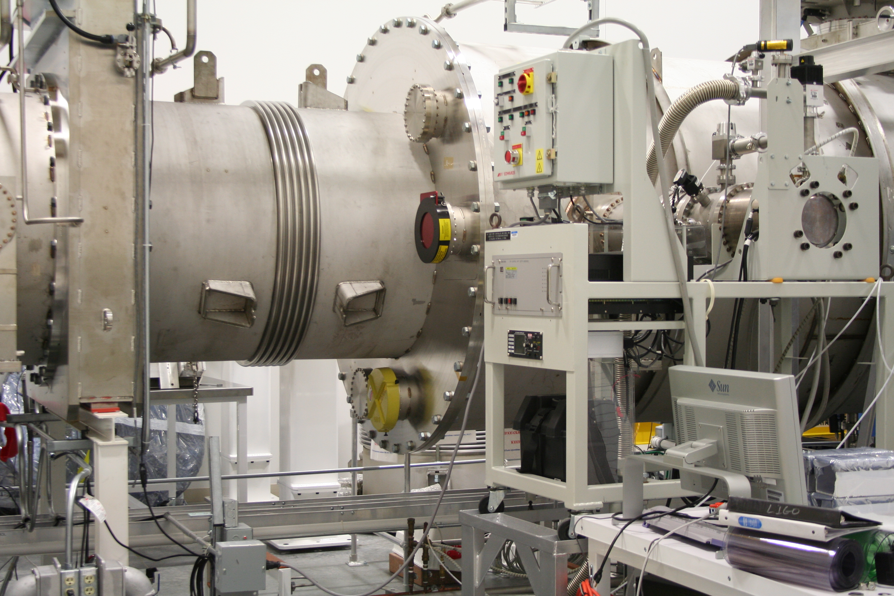
Figure 13: Turbo pumping station on AUX cart, where the ETMX leaner should go.

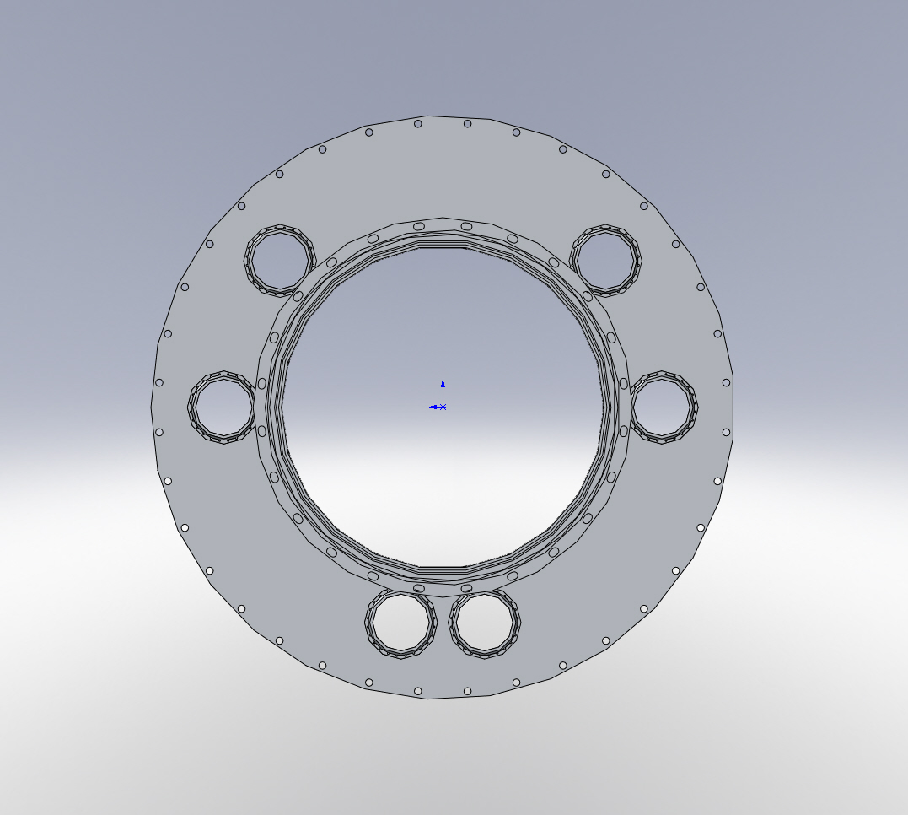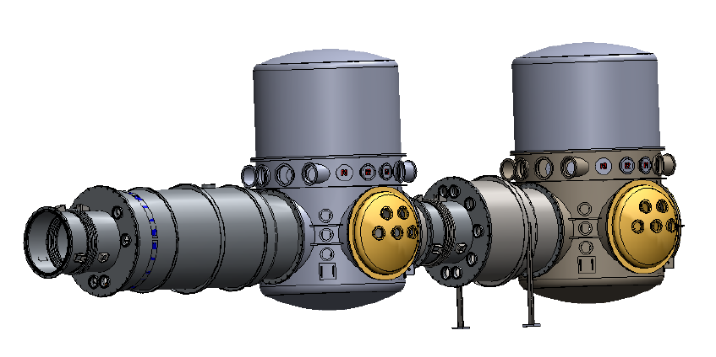
ETM-X Video1
(VP3)
ETM-X PhotCal Out
(VP2)
ETM-X OptLev In
(VP4)
ETM-X PhotCal In
(VP5)
ETM-X OptLev Out
(VP1)
WBSC5
WBSC9
ETM-X
ADAPTER A-1
WA-1E
To ETM-X
ETM-X Video2
(VP6)
Figure 14: Viewport configuration for ETMX, taken from Figure 45 of T1000746, Viewport Final Design.

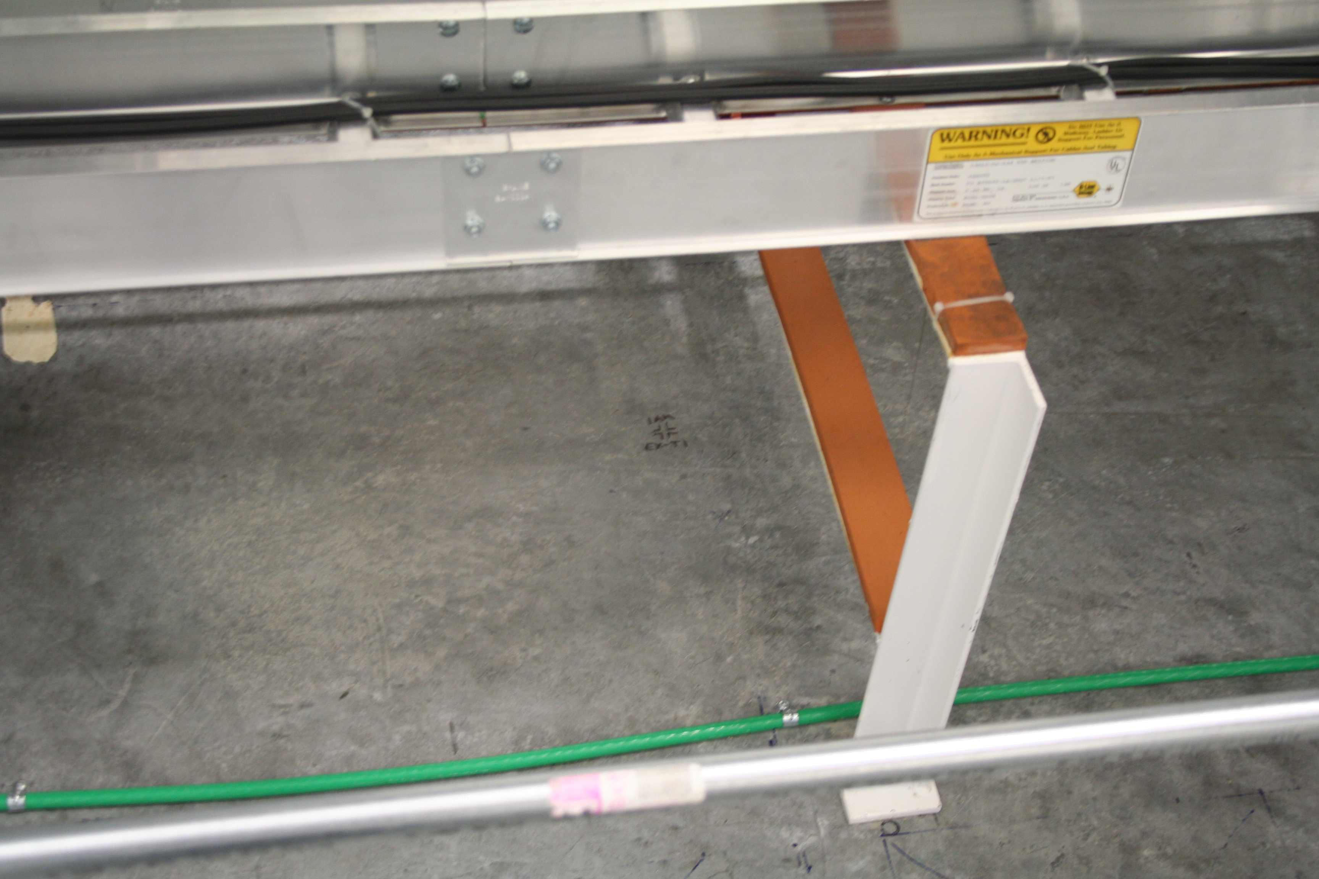
Figure 15: Monument under VP4, where the dwarf transmitter should go.

ETMY
Type: Dwarf transmitter and leaner receiver
Location: Y-end station, looking into ETMY Adapter A-1, WA-1B
Notes: Significant interference.
Recommendation: Re-route cable trays, copper pipe, and conduit around launching pylon. Move brace enough to clear pylon. Steel HEPI plumbing does not have to be moved.

