LIGO Laboratory / LIGO Scientific Collaboration

LIGO T1200525-v1 LIGO 21 March 2014

User Instructions
for D1201515 OMC Transport Fixture

Jeff Lewis

Distribution of this document:
LIGO Scientific Collaboration

This is an internal working note
of the LIGO Laboratory.

California Institute of Technology  LIGO Project – MS 18-34  1200 E. California Blvd.  Pasadena, CA 91125  Phone (626) 395-2129  Fax (626) 304-9834  E-mail: info@ligo.caltech.edu | Massachusetts Institute of Technology  LIGO Project – NW22-295  185 Albany St  Cambridge, MA 02139  Phone (617) 253-4824  Fax (617) 253-7014  E-mail: info@ligo.mit.edu
LIGO Hanford Observatory  P.O. Box 159  Richland WA 99352  Phone 509-372-8106  Fax 509-372-8137 | LIGO Livingston Observatory  P.O. Box 940  Livingston, LA 70754  Phone 225-686-3100  Fax 225-686-7189
http://www.ligo.caltech.edu/

Introduction
This document describes the proper usage of the D1201515 OMC transport fixture.
The OMC transport fixture has four primary uses:
- The fixture is used to hold the OMC optical bench during the assembly of the optical and mechanical components onto the bench.
- It serves as the first protective barrier from damage during shipping.
- It can be used chamber-side to immediately place the OMC into if the OMC is ever removed from the OMCS while the OMCS remains installed in HAM6.
- Finally, the fixture will serve as a storage container for the 3rd IFO OMC.

Terminology - please read this
- The “upper half” of the transport fixture is the thinner half. The “upper half” has written “D1201515 aLIGO OMC Breadboard Transport Fixture…”
- The “lower half” is thicker than the lower half and is meant to house the optics side of the OMC. Therefore, the OMC optics side is facing downward when placed in the transport fixture in it’s nominal position. The carrying handles are found on the lower half.
- The OMC Transport Fixture is the D1201515 assembly.
- The Output Mode Cleaner (OMC) is the D1201439 assembly. It is also referred to as the optics bench.
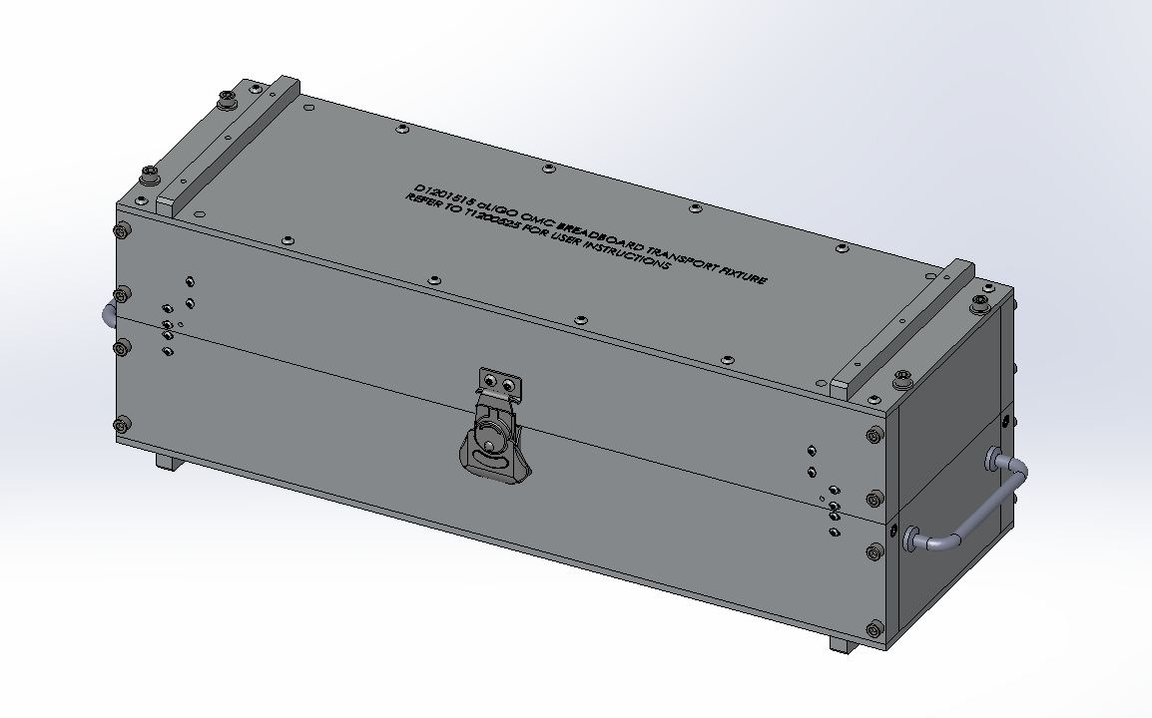
Figure 1. OMC Transport fixture.D1201515

Tools needed
- Allen wrenches

General
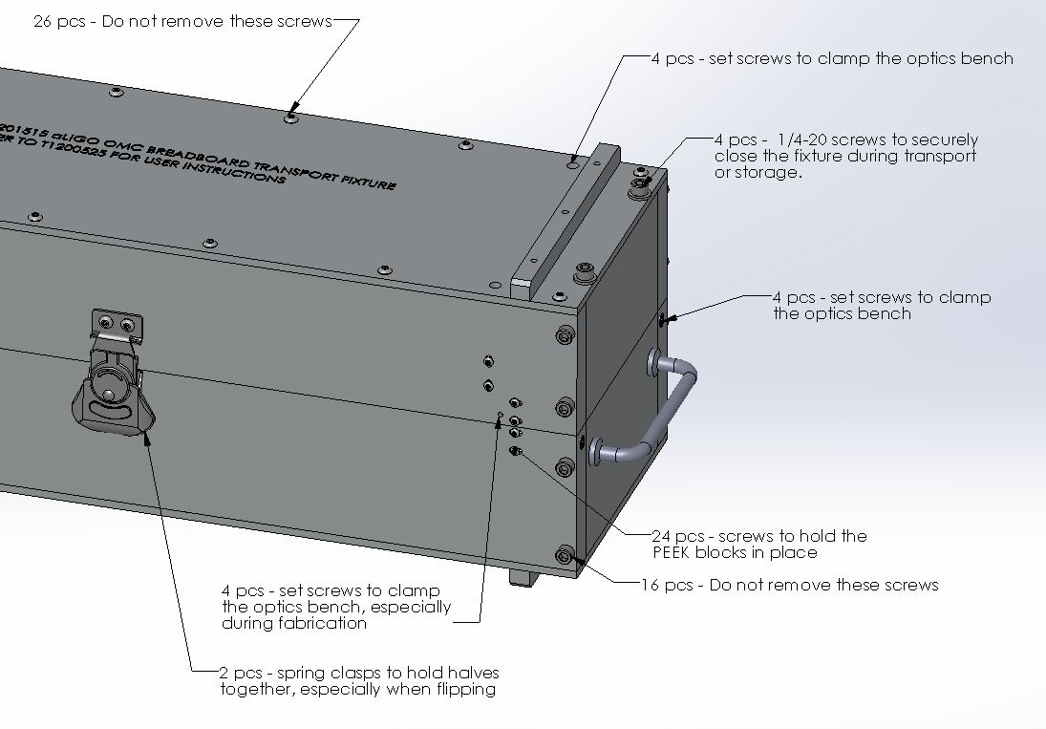
Figure 2. Exterior hardware

Use of the transport fixture during the assembly of the OMC optics bench
When being used during the fabrication of the OMC, each half of the fixture is used to hold the OMC so that either the optics side of the OMC is facing upwards or the mechanical side of the OMC is facing upwards.
With the use of #8-32 set screws, typical optical bases can be screwed to the skids on the top or bottom of the fixture to secure one half of the fixture to the optics table during OMC fabrication.

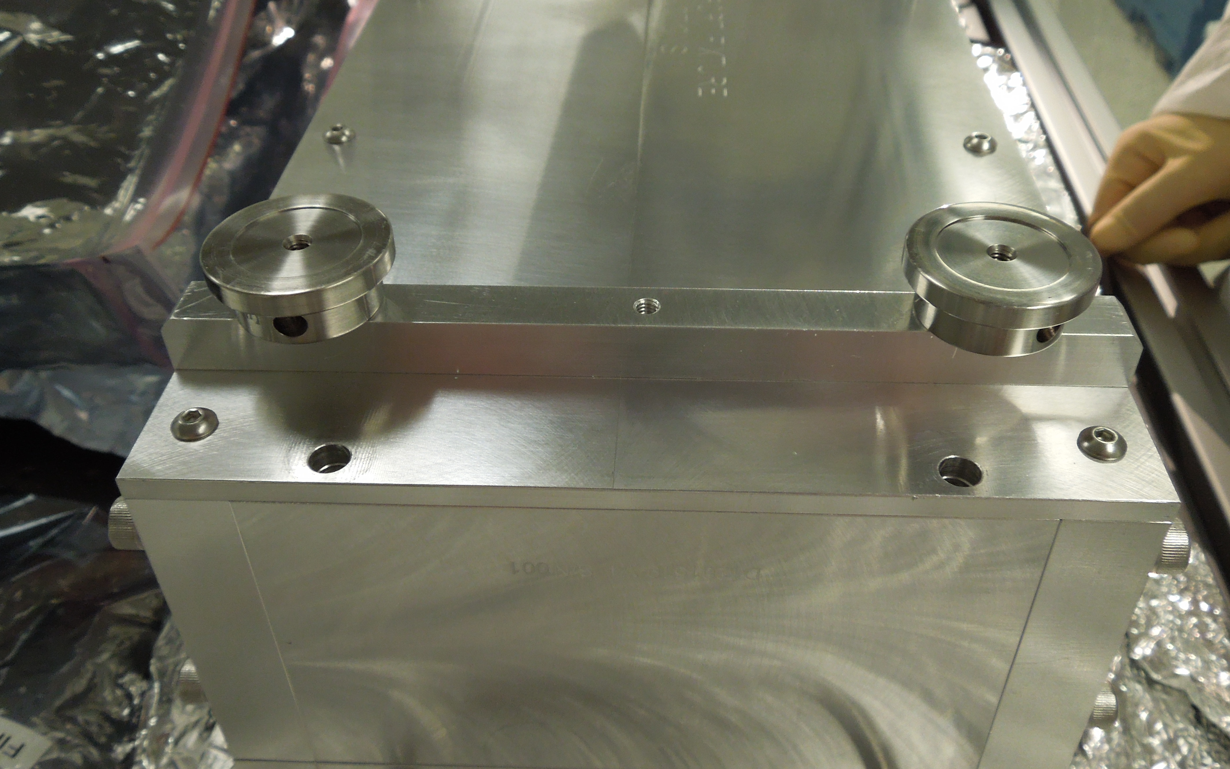
Figure 3. Optical bases attached to the skids

Back off the set screws (8 pcs of item #17 in the D1201515 assembly drawing) used to clamp the bench.
To work on the optics side of the bench, use the upper half of the fixture. To work on the mechanical or topside (relative to the in-chamber orientation), use the lower half of the fixture.
Use the set screws as necessary to clamp the optics bench inside of the fixture.
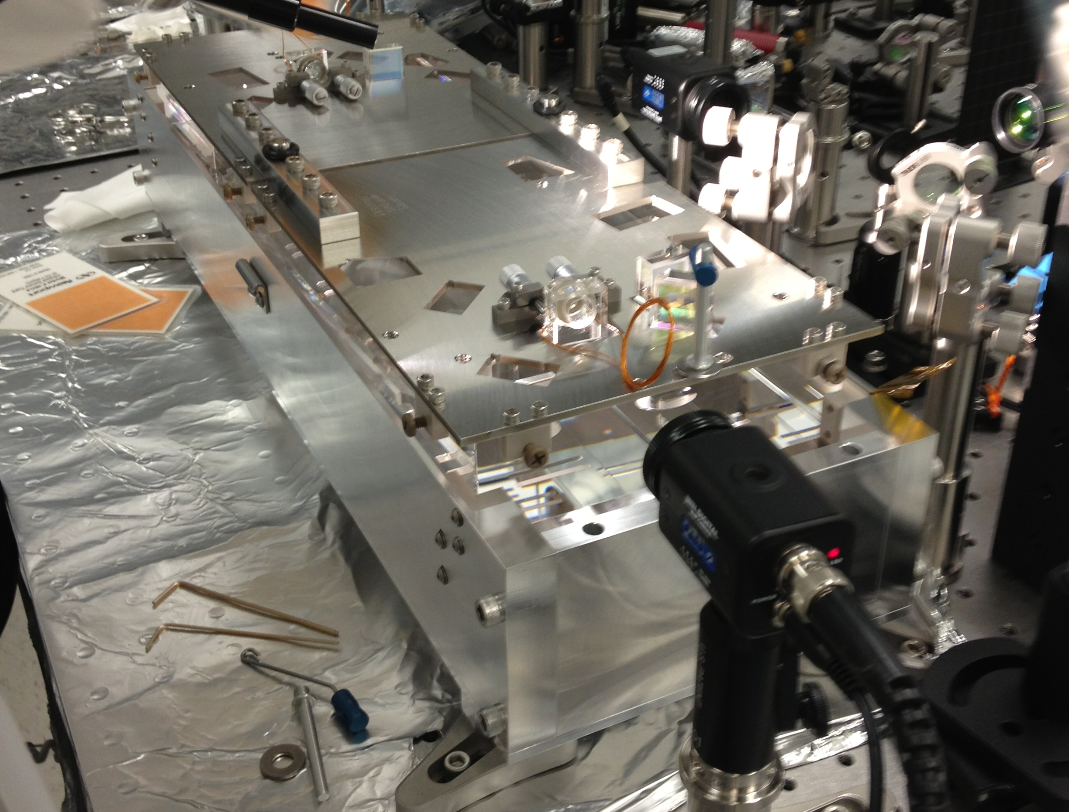
Figure 4. Working on the optics side of the OMC

Use of the fixture for protection during transport or long term storage
- Back off all set screws and move the PEEK blocks to their most open position.
- Open the fixture and wipe the interior with IPA soaked cleanroom wipes.
- Check the OMC to be sure that there are no loose components which may fall off and thrash around during transport.
- Grasp the ends of OMC optics bench with your hands. With the optical side facing downwards, carefully place the optics bench into the lower half of the fixture.
- Place the upper half on the fixture and close the two spring clasps and install the four ¼-20 x 3.75” long screws with washers to securely close the fixture.
- Snug (but do not over tighten) the setscrews which clamp the optics bench within the fixture. See Figure 5 below.
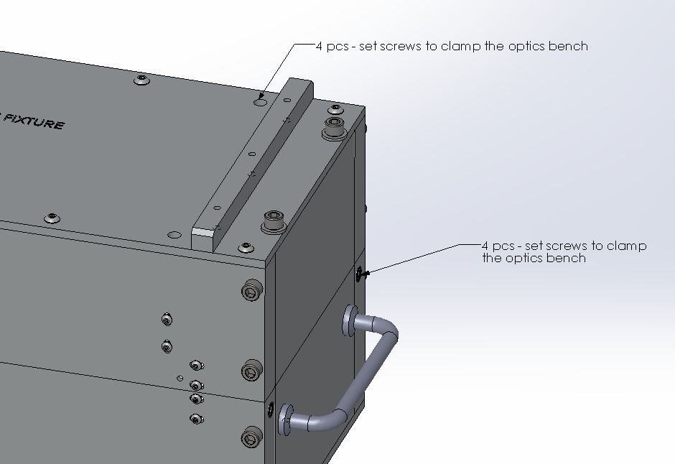
Figure 5. Set screws. These should only be hand tightened so as to not put excessive force on the fused silica bench.

- Snug Tighten the 24 little button head screws which hold the PEEK blocks in place inside the fixture. See Figure 6 below.

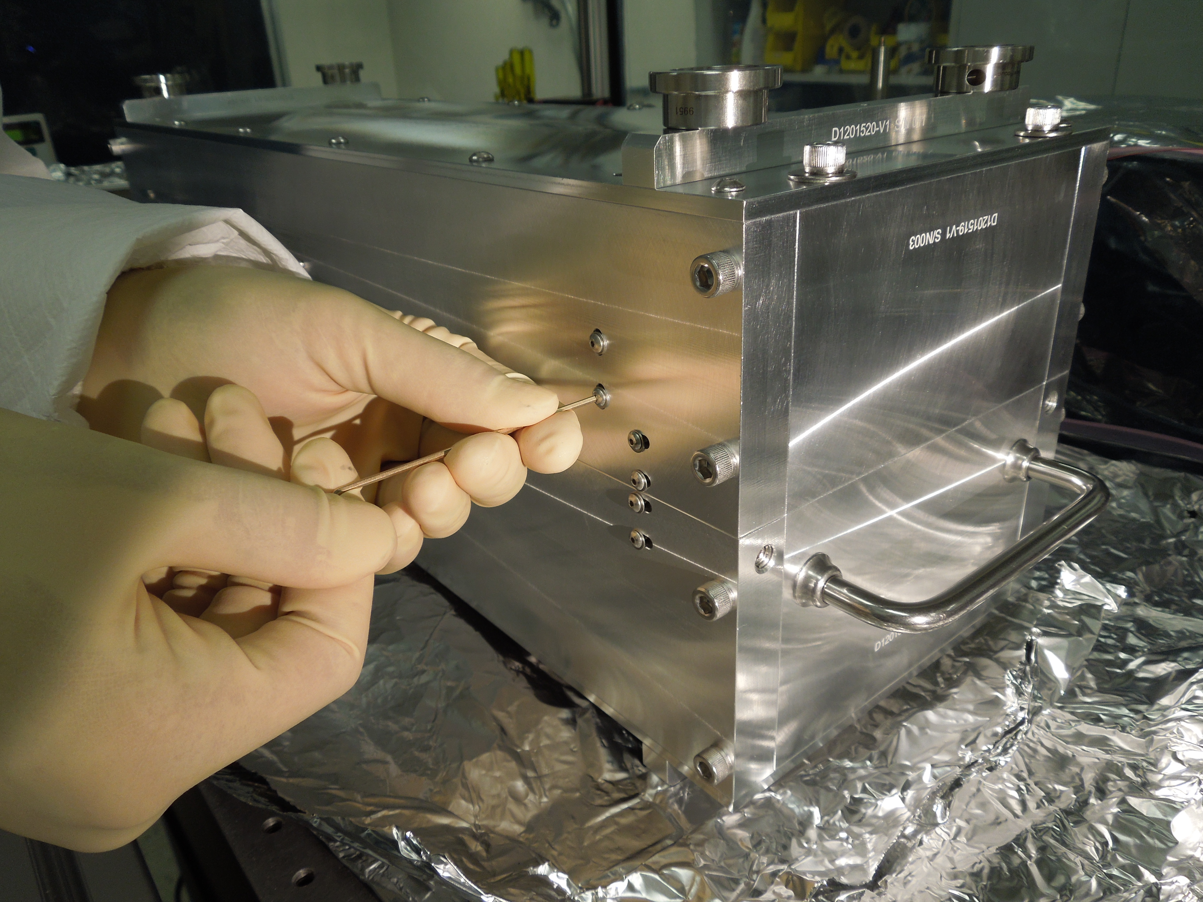
Figure 6. Button head screws

- Wrap the fixture with UHV aluminum foil and double bag with Ameristat bags.
- The wrapped OMC transport fixture is placed within a dedicated Pelican case. For extra protection when shipping to the sites, the Pelican case was placed within a foam lined cardboard box.
- Unpack the OMC in the reverse order.

