LIGO Laboratory / LIGO Scientific Collaboration

LIGO-T1200380-v2 LIGO 10 August 2012

ISC Single Channel WFS RFPD Test Procedure:

Richard Abbott

Distribution of this document:
LIGO Scientific Collaboration

This is an internal working note
of the LIGO Laboratory.

California Institute of Technology  LIGO Project – MS 18-34  1200 E. California Blvd.  Pasadena, CA 91125  Phone (626) 395-2129  Fax (626) 304-9834  E-mail: info@ligo.caltech.edu | Massachusetts Institute of Technology  LIGO Project – NW22-295  185 Albany St  Cambridge, MA 02139  Phone (617) 253-4824  Fax (617) 253-7014  E-mail: info@ligo.mit.edu
LIGO Hanford Observatory  P.O. Box 159  Richland WA 99352  Phone 509-372-8106  Fax 509-372-8137 | LIGO Livingston Observatory  P.O. Box 940  Livingston, LA 70754  Phone 225-686-3100  Fax 225-686-7189
http://www.ligo.caltech.edu/

Introduction
This document describes the testing of the single channel RFPD photodetector used in the aLIGO ISC or IO subsystems. A summary of the characteristics of this detector are available in T1100402. The schematics for this detector can be found in D1200066. A list of ISC detectors (RF & DC) can be found in T1000264.
This procedure relies upon a familiarity with the complex nature of this circuit and the techniques of network analysis, modulated laser light sources, and shot noise limited sensitivity measurements. Minimal instructions are included in this procedure to avoid lengthy and complex tutorials.
All final data results are recorded in T1200381
This procedure is broken into the following sections:
- Serial number – Unique identification of the unit is recorded in the form of the serial number if the internal circuit board and associated schematic details
- DC checks – Current draw into the detector and verification of all internally regulated voltages
- DC path transimpedance – A measurement of the DC transimpedance of the DC path of the RFPD.
- Notch tuning – Adjustment of RF notch frequencies
- Notch rejection ratios – Measurement of RF notch depths
- RF transimpedance – A white-light based measurement of the RF transimpedance
- Shot noise limited input sensitivity – Verification that the RF noise performance is within design limits

Product Perspective
As shown in Figure 1, the ASC RFPD is mounted in a metal housing with all connections on the top surface. There are 4 SMA connectors for the RF outputs. Power and the DC outputs are on the 15-pin D-sub connector.

Figure 1
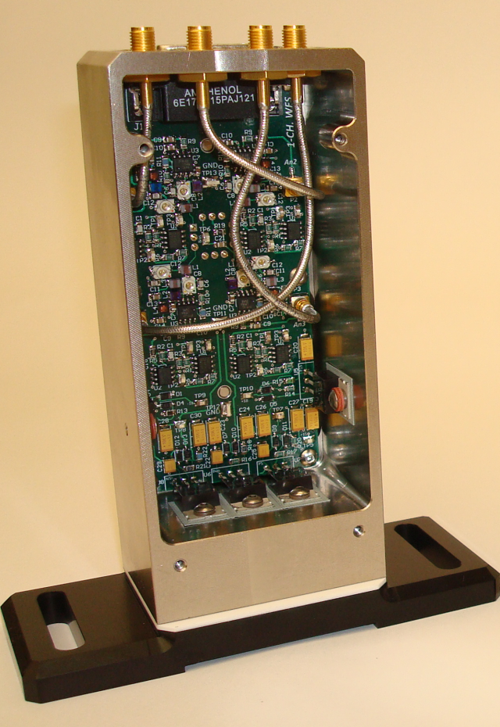

D-Connector Pinout

15 pin D Pin | Function
1 | Q1 Readout Positive
9 | Q1 Readout Negative
2 | Q2 Readout Positive
10 | Q2 Readout Negative
3 | Q3 Readout Positive
11 | Q3 Readout Negative
4 | Q4 Readout Positive
12 | Q4 Readout Negative
5 | No Connect
13 | No Connect
6 | DC Power Positive
14 | Ground
7 | DC Power Negative
15 | Ground
8 | No Connect

Serial Number Data
Record the serial number and relevant schematic D-number/revision in T1200381

DC Checks
Record the total circuit board quiescent current draw and regulated voltages in T1200381. Use caution in believing the digital readouts of laboratory triple output power supplies. Their meters are not highly accurate. When in doubt, use a multimeter on the appropriate scale in series with the supply to be measured.

DC Readout Path
Using a handheld current calibrator, inject 1mA DC into the anode circuit of the RFPD through a 100 Ω resistor. By observation of the DC voltages present at each differential DC readout terminal-pair on the 15 pin D-connector, calculate the transimpedance of the DC readout chain for each quadrant, $Z_{dc}$ by:

$$Z_{dc}=\frac{Vout}{0.001A}$$

Record each result in T1200381.

Notch Tuning
The ASC photodetector circuit has series resonant RF notches that are tuned to allow amplification of some frequencies, while providing rejection at other frequencies. The notches are tuned by means of surface mounted RF trimmer capacitors on the photodetector PCB. Table 1 shows which capacitor to tune for each notch frequency. Due to the fact that there is no electrical monitor of the anode of each quadrant, the fundamental frequency notch must be adjusted by using a FET probe right on the anode of the quadrant under test. The 2ω notch is visible at the SMA output connector for each quadrant under test.
Using a laser capable of RF AM modulation, and an RF network analyzer, perform a frequency sweep from the photodiode to the FET probe for the fundamental frequency, and each RF output connector on the top surface of the photodetector housing for the 2ω notch.

Table 1, Notch Adjustment Frequencies
Notch Frequency | Adjustment Capacitor
Fundamental Frequency | C8
2ω Notch | C12

After adjusting each notch, record into T1200381 the achieved 2ω tuning frequency as indicated. Be sure to note the DC photocurrent for each quadrant when it is illuminated by the laser light source. This data allows for normalization if so desired later on.

Notch Rejection Ratios
With the series resonant portions of the circuit tuned to the appropriate frequencies, a measurement can be performed to establish the ratio of the gain at the desired readout frequencies to the gain at the undesired frequencies corresponding to the rejection notches.
Using a laser capable of RF, AM modulation and an RF network analyzer, perform a frequency sweep from the photodiode to each SMA output connector on the top surface of the photodetector housing. Use the delta marker function to record the difference between each notch and the relevant RF operating frequency. Be sure to note the DC photocurrent for each quadrant when it is illuminated by the laser light source. This data allows for normalization if so desired later on. Record the results in T1200381.

RF Transimpedance Measurement
Illuminate the photodiode with white light (as generated by a shot noise limited source such as an incandescent bulb) to generate between 5 mA and 10 mA of photocurrent. At each SMA connector, use an RF spectrum analyzer to measure the RF power spectral density at the readout frequency associated with each output. A low noise RF pre-amplifier (gain ~20dB) is useful to boost the signal to a comfortable level. Be sure the measurement is not electronically noise limited by careful attention to signal levels.
Establish a photocurrent between 6mA and 10mA. Observe the RF power spectral density present at the operating frequency of the detector. Convert the RF PSD to an rms amplitude (voltage) spectral density, $Vrms$ assuming 50 Ω and note it as well as the associated DC photocurrent$I_{DC}$. Using the Microsoft Excel worksheet available in the DCC as an attached document to this document, enter the data as needed to calculate the transimpedance,$Z_{RF}$ with the following:
$$Z_{RF}= \sqrt{\frac{{Vrms}^{2}I_{DC}}{3.2×{10}^{-19}}}$$

Enter the transimpedances in the appropriate spots on T1200381.

Shot Noise Limited Sensitivity
The shot noise limited sensitivity will characterize the minimum useful optical signal level below which the photodetector will be limited by electronics noise. Using the Microsoft Excel worksheet available in the DCC as an attached document to this document, enter the data as needed to calculate shot noise limited sensitivity. In general, the formula used is:

$$Ilim_{rf}=I_{DC}×\frac{{V_{dark}}^{2}}{{V_{light}}^{2}}$$
Where I_{DC} is the DC photocurrent associated with the illuminated diode, and V_{light} is the RF voltage as derived from a spectrum analyzer reading at the detector fundamental operating frequency

Record the resulting shot noise limited sensitivities in T1200381.

