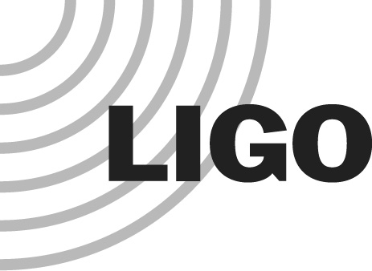
LIGO LABORATORY

MEMORANDUM

DATE: 22 July 2015

TO: | All aLIGO Project Science & Engineering Staff
FROM: | Dennis Coyne (System Engineering)
SUBJECT: | Engineering Change Request (ECR) Process
Refer to: | LIGO-M1200274-v4

Contents
1 Introduction 1
2 Scope 2
2.1 Changes which require an ECR 2
2.2 Changes which do not require an ECR 3
3 Relationship of ECRs to other LIGO Processes 5
3.1 Relationship to the Configuration Control Board (CCB) Process 5
3.2 Relationship to the Technical Review Board (TRB) Process 5
3.3 Relationship to Software Development Process 5
3.4 Relationship to the Document Change Notice (DCN) Process 5
3.5 Relationship to Design Changes before Installation 5
3.6 Relationship to “Integration Issues” 5
3.7 Relationship to “Field Changes” 6
3.8 Relationship to Observatory “Work Permits” 6
4 Engineering Change Request (ECR) Process 7

Introduction
The Engineering Change Request (ECR) process defined in this memorandum is imposed for all changes to the detector (interferometer) system, as well as the vacuum system and the facilities that directly support the detector.
The ECR process is related to the LIGO Configuration Control process which is described in section 1.4.2 of E010613-v2, “Generic Requirements and Standards”. The purpose of the ECR is to request and get approval for a proposed change(s). The purpose of the Document Change Notice (DCN) is to record the implemented change(s) in the design/build record.

The basic process for evaluation of proposed changes is depicted in the Event-driven Process Chain (EPC) diagram in Figure 1. Anyone can propose an engineering change to the LIGO system. The Systems group is responsible for pursuing a resolution, through a Technical Review Board (TRB) and/or Configuration Control Board (CCB) if/as necessary.

Scope

Changes which require an ECR
The scope of the ECR process is the design of the system, not its operational settings or parameters. All design aspects of the LIGO System will be under ECR control, including but not limited to the following:
- All aspects of the LIGO System including the detector, vacuum system, and facilities which support or effect the detector (e.g. electrical power and HVAC).
- Applies to hardware, software and associated “configuration controlled documentation” for the LIGO System
- All science frame channels (names, definitions, rates, etc.)
- The Hardware Injection System
- The Calibration System

If you are in doubt about whether a change requires an ECR or not, then contact Systems Engineering for guidance.

All changes, regardless of how trivial they may seem, must be tracked in the design/build documentation record. We use a Document Change Notice (DCN) to explain what changed and why. Once a document is placed under configuration control, all subsequent changes must be tracked by DCNs.

Changes which do not require an ECR
The following changes do not require an ECR:
- Parameter changes made for the purpose of tuning the design (e.g. gains, filter coefficients, matrix element values, calibration factors, etc.), whether these parameters are hard-wired into code or not. However parameter values which fundamentally change the control topology or strategy will require an ECR, e.g. changing matrix elements to transform controlled degrees of freedom from a Cartesian basis set to a modal basis set.
- Interferometer Sensing and Control (ISC) Guardian user code, as long as the change(s) does not significantly alter the control strategy. Note that this exclusion applies only to ISC user Guardian code, not the core Guardian code and not the Guardian user code for other subsystems.
- Fixes or modifications found necessary for the design to perform as intended. Of course all changes must be appropriately tested and recorded in detail. Examples:
  - A software bug: the regression test suite must be expanded to enable detection of this flaw in future releases, the code must be archived in the SVN, and if appropriate related documentation (e.g. user guide) must be revised.
  - An electronics parameter value change: the test procedure must be revised or expanded be consistent with the revised parameter value, and all documentation (schematics, parts list, etc.) must be updated.
- Temporary changes: Modifications to the System which are made for the purpose of experimenting, or testing the efficacy or benefit of a proposed change can be made with the approval of the site Commissioning Leader (during periods of commissioning), the site Detection Coordinator (during runs), or Systems Engineering. If the desire is to subsequently make the modification permanent, then an ECR must be submiited and approved. Otherwise, the modification must be reversed.
- Field changes: During the course of commissioning, it is often found to be necessary to make frequent/urgent changes. As often as possible the ECR process should be followed before making any changes, so that careful and deliberate review (even if an expedited review) can be performed. However, in cases where the impact of the proposed change is deemed to be small or modest and the schedule need is urgent, then the change can be implemented on the authority of the site Commissioning Leader (during periods of commissioning), the site Detection Coordinator (during runs), or Systems Engineering. However, even in these circumstances the change will be completely documented, and propagated (to other installations/instances) via the Document Change Notification (DCN) process.
- Changes to the commissioning frame channels (additions, deletions, or changes in rate).

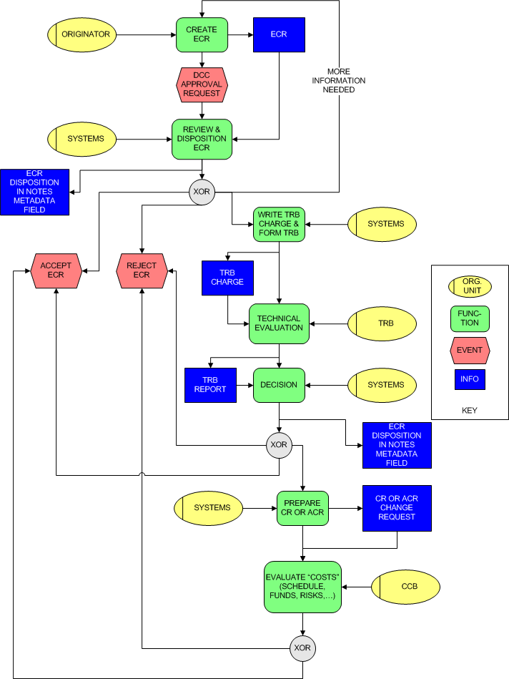
Figure 1: Event-driven Process Chain (EPC) Diagram for the ECR Process

Relationship of ECRs to other LIGO Processes

Relationship to the Configuration Control Board (CCB) Process
If there is significant impact to cost, schedule, programmatic risk or safety then it is necessary for the Configuration Control Board (CCB) to review the change request.

Relationship to the Technical Review Board (TRB) Process
If there is significant technical aspect to the proposed change, then an ad-hoc Technical Review Board is formed to review the proposal first. Once approved by the TRB the proposed change is then reviewed by the CCB.
For a CCB and/or TRB change, a change request (CR) form (F0900037) is prepared and submitted to the LIGO Business Manager, who then schedules appropriate review.

Relationship to Software Development Process
The Software Development Process is defined in T1300427. This ECR process also applies to software.

Relationship to the Document Change Notice (DCN) Process
In all cases an approved ECR will result in changes in design/build documentation. The record of review and approval of these changes is handled by the DCN process which is defined in E030350.

Relationship to Design Changes before Installation
Changes to a design in advance of a Final Design Review (FDR) are generally not under configuration control and do not require an ECR or a DCN. Once the FDR has been completed, regardless of whether fabrication, assembly or installation has begun, all changes are subject to the ECR and DCN processes.

Relationship to “Integration Issues”
The general sequence of events during the installation/integration/commissioning phase is as follows:
1) An "issue" or problem is identified and added to the Integration Issues & ECRs tracking list:
https://services.ligo-wa.caltech.edu/integrationissues/
The Systems group has a regularly scheduled meeting to review the list. An individual is assigned to work on resolution of the issue. (Of course this person may be helped by many others.)

2) As the issue is investigated, the individual(s) working on resolution briefly reports progress with added notes to the issue entry on the Integration Issues & ECRs tracking list.

3) Some issues are resolved without a design change. For example perhaps a part was not built to specification or drawing. In this case the resolution might be to rework all of the instances of this part. In this case, the resolution is so noted on the Integration Issues & ECRs tracking list but it is left as an open issue until all of the rework has been accomplished.

4) Some issues require a design change to resolve. In this case an ECR is written (and this is noted in the entry for the issue with a link to the DCC entry for the ECR).

5) If an ECR is written, then the Systems Group reviews and decides on a disposition for the ECR

Relationship to “Field Changes”
During the course of installation and System Test (aka commissioning), it is often found to be necessary to make changes. In some cases there is time to carefully consider proposed changes. In these cases, the ECR process should be followed. In fact as often as possible the ECR process should be followed before making the change so that careful and deliberate review (even if an expedited review) can be performed, properly documented, properly propagated (e.g. to the other observatory, or to units in fabrication, etc.)
In cases where the impact of the proposed change is deemed to be small or modest and the schedule need is urgent, then the change can be implemented on the authority of either the site installation leader or site system test (commissioning) leader or the subsystem leader(s). However, even in these circumstances the change must always be completely documented, and propagated (to other installations/instances) via the Document Change Notification (DCN) process.

Relationship to Observatory “Work Permits”
Observatory Work Permits (see M050194 for hardware and M1300052 for software) are authorizations to implement or install at the observatories. Work permits should only proceed on the basis of approved, configuration controlled documentation issued via the DCN process for hardware or the Software Configuration Control process. The general sequence is a change request (ECR and possibly a TRB and/or a CCB), then once approved the change is implemented and associated documentation is updated through a DCN. Then any field changes (changes to the installed plant) are covered by a Work Permit(s).

Engineering Change Request (ECR) Process
The basic steps for the initiator of an ECR are as follows:
- Create an ECR (using form F1200011), upload to the Document Control Center (DCC) and request sign-off/approval in the DCC
- Create a new entry in the “Integration Issues and ECR Tracker” and cross-reference the ECR tracker entry to the ECR in the DCC and vice versa (using the DCC meta-data field “Notes and Changes”)

The ECR process is intended to provide review, approval and guidance for proposed changes. If the Systems group thinks that a detailed technical evaluation is necessary before a decision can be made, the Systems group will convene a Technical Review Board (TRB). On the basis of the TRB’s technical evaluation the Systems group will determine the disposition of the change request. If the technical evaluation is favorable but the costs (schedule, funds, risks, personnel requirements, etc.) are significant (above thresholds) then the Systems group will refer the change request to the Configuration Control Board (CCB) for a decision. (See Figure 1 for the ECR process flow.)
Personnel on all levels are encouraged to identify the need for changes to the interferometer/detector system (hardware, software, facilities, support equipment, etc.) or its associated controlled, documentation. These changes can either be motivated by the need to correct errors, inconsistencies, or to improve performance, reliability, maintainability, etc.
Changes that were/are found to be (or appear to be) necessary in the course of System Test (aka Commissioning) must also be documented by the ECR and DCN processes. (However see the comments above regarding the authority of the install and commissioning leaders in approving “on the fly” changes when deemed necessary, with ECR follow-up.)
The requester must complete the ECR form, F1200011, defining the nature and scope of the proposed change, and identifying all documentation which must change in accordance with the proposed change. If significant time or resources are required for the initiator to explore the proposed change to a level sufficient to make estimates of the impact (cost, schedule, etc.), then (s)he must obtain approval from their supervisor(s) before expending effort/resources.
The originator of the ECR is encouraged to contact the “experts” associated with the systems impacted by the proposed change as part of the process of completing the ECR form, so that it is clear that the proposed change has merit, does not violate other design intent or functions or interfaces and so that all of the potential impacts are identified.
Once completed the requester files the ECR into the DCC (as an E-numbered document) and then notifies the Systems Engineer, Deputy Systems Engineer and System Scientist by email (or uses the DCC electronic “signoff” feature to notify these personnel).
Proposed changes must not be filed in the DCC before getting approval through the ECR process. (We do not want to “litter” the DCC with unapproved versions of changes to controlled documentation.)
Once an ECR is approved, then the person(s) assigned to perform the changes (not necessarily the ECR originator) will then implement the change, including any revisions to associated documentation (in order to keep our documentation consistent with the as-built condition of our systems). These changes to the configuration controlled documents are then reviewed and approved through the DCN process (described in E030350).
The Systems Engineer (or designee) will keep a log of all ECRs. Within one week, a first-order disposition of the ECR will be made and feedback given to the originator (and all other persons identified as “interested”). This first-order disposition will be either:
- approved (for noncontroversial items with little or no cost or schedule impact), or
- to be reviewed by a Technical Review Board (TRB), or
- to be reviewed by the Configuration Control Board (CCB)
A standing ECR review meeting will be held each week so that ECRs do not languish and so that interested personnel know when/where to show up to champion their proposed change.

“Configuration controlled documentation” refers to the documentation used to create the system (e.g. specifications, drawings, assembly procedures, etc.). See also section 4.2 of E030350-v3 for more discussion.
Good judgement is required to interpret the criteria “for the design to perform as intended”. If the implementation fails to function in accordance with the design intent, then changes to properly implement the design intent do not require an ECR. However failure to perform as intended (because the design was flawed or inadequate) indicates the need for an ECR to propose an alternative or revised design.
The “Change Control Procedure for LIGO Laboratory M&O” (M1400104) defines the threshold level for a CCB review as when the cumulative cost changes within an account exceeds $50K.
The requirements for a TRB are: 1) key performance requirements or parameters change, 2) The baseline design approach changes, 3) interface changes, or 4) the change results in moderate decrease in the reliability, quality or safety.
The general configuration control approach used for aLIGO is defined in E030350. It really should be extracted and placed into a separate document and not “buried” in a Drawing Requirements document.
We intend to implement an on-line ECR form entry, with automatic filing into the DCC and automatic notification of the relevant personnel for disposition/action.
We may also implement a database flag/parameter to denote that the document is an ECR, or assign a new letter to ECR documents to enable filtering of ECRs from the database more readily.

