LIGO Laboratory / LIGO Scientific Collaboration

LIGO-E1200784-v3 Advanced LIGO 8/3/2015

TwinCAT Library
for the Advanced LIGO Timing System

Maggie Tse, Daniel Sigg

Distribution of this document:
LIGO Scientific Collaboration

This is an internal working note
of the LIGO Laboratory.

California Institute of Technology  LIGO Project – MS 18-34  1200 E. California Blvd.  Pasadena, CA 91125  Phone (626) 395-2129  Fax (626) 304-9834  E-mail: info@ligo.caltech.edu | Massachusetts Institute of Technology  LIGO Project – NW22-295  185 Albany St  Cambridge, MA 02139  Phone (617) 253-4824  Fax (617) 253-7014  E-mail: info@ligo.mit.edu
LIGO Hanford Observatory  P.O. Box 159  Richland WA 99352  Phone 509-372-8106  Fax 509-372-8137 | LIGO Livingston Observatory  P.O. Box 940  Livingston, LA 70754  Phone 225-686-3100  Fax 225-686-7189
http://www.ligo.caltech.edu/

Library
Title | TimingMasterFanout
Version | 1
TwinCAT version | 2.11
Name space | Timing
Author | Daniel Sigg
Description | The Advanced LIGO timing system consists of timing master synchronized to GPS with sixteen fanout ports, a set of timing fanout chassis and numerous timing slaves. The master and fanouts are the same same chassis configured differently. They contain serial RS422 ports which transmit the status information of the master-fanout chassis and each of its slave once every second. By reading the serial ports of all master-fanout chassis the health of the entire timing system can be monitored.  The Advanced LIGO timing system has a wiki.  It is described in E090003, E080541, E0900036, T070173 and T0900032.
Error Codes | As part of the TimingMasterFanoutStruct (master-fanout chassis):  0x0001 – Communication error  0x0002 – Data CRC  0x0004 – Data missing  0x0008 – Loss-of-signal  0x0010 – Uplink  0x0020 – Uplink CRC  0x0040 – VCXO control voltage  0x0080 – OCXO not locked  0x0100 – OCXO control voltage  0x0200 – GPS not locked  0x0400 – GPS time error  0x0800 – External PPS time eror  0x1000 – Uplink time error  0x2000 – Firmware error (not in svn or wrong revision)  0xnnnn0000 – PORT_i (bit encoded slave or port error)  As part of the TimingFanoutStruct (port and slave module):  0x0001 – Downlink loss-of-signal  0x0002 – Downlink down  0x0004 – Downlink CRC error  0x0008 – Delay error  0x0010 – Missing delay  0x0020 – Ignored slave  0x0040 – SLAVE (implicates a slave error)  As part of the TimingSlaveStruct (slave module):  0x0001 – Invalid or no data  0x0002 – Uplink loss-of-signal  0x0004 – Uplink down  0x0008 – Uplink CRC  0x0010 – VCXO control voltage  0x0020 – GPS time  0x0040 – Unknown slave  0x0080 – Firmware error (not in svn or wrong revision)  0x0100 – FANOUT (Indicates an error in the fanout slave)  0x0200 – DUOTONE (Indicates an error in the DuoTone slave)  0x0400 – CFC (Indicates an error in the CFC slave)  0x0800 – XOLOCKING (Indicates an error in the XOLOCKING slave)  0x1000 – IRIGB (Indicates an error in the IRIGB slave)  As part of the TimingSlaveFanoutStruct (through the port):  Not used at this time  As part of the TimingSlaveDuoToneStruct slave:  Not used at this time  As part of the TimingSlaveCFCStruct slave:  Not used at this time  As part of the TimingSlaveIrigBStruct slave:  Not used at this time  As part of the TimingSlaveXOLockingStruct slave:  Not used at this time  As part of the TimingPpsStruct:  0x0001 – Cfc in error  0x0002 – No PPS 0  0x0004 – No PPS 1  0x0008 – No PPS 2  0x0010 – No PPS 3  0x0020 – No PPS 4  0x0040 – No PPS 5  0x0080 – No PPS 6  0x0100 – No PPS 7  0x0200 – PPS 0 OOR  0x0400 – PPS 1 OOR  0x0800 – PPS 2 OOR  0x1000 – PPS 3 OOR  0x2000 – PPS 4 OOR  0x4000 – PPS 5 OOR  0x8000 – PPS 6 OOR  0x10000 – PPS 7 OOR
Library dependencies | SaveRestore, Error, ComlibV2

Software Input/Output Type
TYPE TimingSerialPortBufferStruct :
STRUCT
RxBuffer: ComBuffer;
TxBuffer: ComBuffer;
COMportControlError: BOOL;
COMportControlErrorID: ComError_t;
END_STRUCT
END_TYPE
Type name | TimingSerialPortBufferStruct
Description | This structure facilitates the communication between the serial ports and the MasterTimingFanoutFB function block.  The TimingSerialPortControlFB function block is used to communicate with the hardware.
Definition | STRUCT
Element | Name: RxBuffer  Type: ComBuffer  Description: Receive buffer of the serial port
Element | Name: TxBuffer  Type: ComBuffer  Description: Transmit buffer of the serial port
Element | Name: COMportControlError  Type: BOOL  Description: Communication error flag of the serial port hardware
Element | Name: COMportControlErrorID  Type: ComError_t  Description: Communication error code

User Interface Type
TYPE TimingMasterFanoutStruct :
STRUCT
Error: ErrorStruct;
Name: STRING;
ComErr: BOOL;
ComErrCount: INT;
CRCErr: BOOL;
CRCErrCount: INT;
ComMissing: BOOL;
ComMissCount: INT;
DownTime: UDINT;
ComCount: UDINT;
ComLength: UDINT;
BoardId: STRING(10);
BoardRev: INT;
Serial: UDINT;
CodeId: STRING(10);
CodeRev: UDINT;
GPS: UDINT;
Addr: UDINT;
StrAddr: STRING(24);
DIP: WORD;
IsMaster: BOOL;
HasFanout: BOOL;
FanoutPorts: INT;
HasOCXO: BOOL;
HasExtPPS: BOOL;
HasGPS: BOOL;
UseExt: BOOL;
UseGPS: BOOL;
UseUplink: BOOL;
GPSLocked: BOOL;
OCXOLocked: BOOL;
UplinkUp: BOOL;
UplinkLOS: BOOL;
UplinkErrCount: INT;
UplinkCRCErr: BOOL;
UplinkCRCErrCount: INT;
VCXOCtrl: LREAL;
OCXOCtrl: LREAL;
OCXOErr: LREAL;
UplinkDelay: LREAL;
ExtPPSDelay: LREAL;
TimingTolerance: LREAL;
GPSErr: BOOL;
GPSErrCount: INT;
GPSLatitude: LREAL;
GPSLongitude: LREAL;
GPSHeight: LREAL;
GPS3DSpeed: LREAL;
GPS2DSpeed: LREAL;
GPSHeading: LREAL;
GPSDOP: LREAL;
GPSVisSatellites: INT;
GPSTrackSatellites: INT;
GPSStatus: WORD;
GPSFix: STRING(25);
GPSNarrowband: BOOL;
GPSAntenna: BOOL;
GPSSerial: STRING(10);
FanoutUp: WORD;
FanoutLOS: WORD;
FanoutMissing: WORD;
FanoutDelayErr: WORD;
Port: ARRAY[0..15] OF TimingFanoutStruct;
Visual: STRING;
END_STRUCT
END_TYPE
Type name | TimingMasterFanoutStruct
Description | This is the main user interface structure containing all releventa information of a master-fanout chassis and the slave modules attached to it.
Definition | STRUCT
Input Tag | Name: Error  Type:ErrorStruct  Description: Error handling
In/out Tag | Name: Name  Type: STRING  Description: Name/location of MFO unit
Input Tag | Name: ComErr  Type: BOOL  Description: Communication error flag
Input Tag | Name: ComErrCount  Type: INT  Description: Count of the communication errors
Input Tag | Name: CRCErr  Type: BOOL  Description: CRC error in data from MFO
Input Tag | Name: CRCErrCount  Type: INT  Description: CRC error counter
Input Tag | Name: ComMissing  Type: BOOL  Description: Communication missing
Input Tag | Name: ComMissCount  Type: INT  Description: Communication missing count
Input Tag | Name: DownTime  Type: UDINT  Description: Time since last valid communication
Input Tag | Name: ComCount  Type: UDINT  Description: Number of received communication buffers
Input Tag | Name: ComLength  Type: UDINT  Description: Number of received bytes(will overflow)
Input Tag | Name: BoardId  Type: STRING(10)  Description: Board type
Input Tag | Name: BoardRev  Type: INT  Description: Board revision number
Input Tag | Name: Serial  Type: UDINT  Description: Board serial number
Input Tag | Name: CodeId  Type: STRING(10)  Description: Code type
Input Tag | Name: CodeRev  Type: UDINT  Description: Code revision number
Input Tag | Name: GPS  Type: UDINT  Description: GPS time in sec
Input Tag | Name: Addr  Type: UDINT  Description: Board address
Input Tag | Name: StrAddr  Type: STRING(24)  Description: Board address as string
Input Tag | Name: DIP  Type: WORD  Description: DIP switch settings
Input Tag | Name: IsMaster  Type: BOOL  Description: This is a timing master
Input Tag | Name: HasFanout  Type: BOOL  Description: Fanout ports are available
Input Tag | Name: FanoutPorts  Type: INT  Description: Number of fanout ports
Input Tag | Name: HasOCXO  Type: BOOL  Description: Contains an OCXO
Input Tag | Name: HasExtPPS  Type: BOOL  Description: An external PPS is available
Input Tag | Name: HasGPS  Type: BOOL  Description: Has an internal GPS receiver
Input Tag | Name: UseExt  Type: BOOL  Description: Uses the external PPS for timing source
Input Tag | Name: UseGPS  Type: BOOL  Description: Uses the internal GPS for timing source
Input Tag | Name: UseUplink  Type: BOOL  Description: Uses the uplink for timing source
Input Tag | Name: GPSLocked  Type: BOOL  Description: GPS receiver is locked
Input Tag | Name: OCXOLocked  Type: BOOL  Description: OCXO is locked to timing source
Input Tag | Name: UplinkUp  Type: BOOL  Description: Uplink port is up and running
Input Tag | Name: UplinkLOS  Type: BOOL  Description: Loss of signal in uplink port
Input Tag | Name: UplinkErrCount  Type: INT  Description: Error counter for uplink port
Input Tag | Name: UplinkCRCErr  Type: BOOL  Description: CRC error in uplink data
Input Tag | Name: UplinkCRCErrCount  Type: INT  Description: CRC error counter for uplink data
Input Tag | Name: VCXOCtrl  Type: LREAL  Description: VCXO control voltage
Input Tag | Name: OCXOCtrl  Type: LREAL  Description: OCXO control voltage
Input Tag | Name: OCXOErr  Type: LREAL  Description: OCXO Error
Input Tag | Name: UplinkDelay  Type: LREAL  Description: Uplink delay in sec
Input Tag | Name: ExtPPSDelay  Type: LREAL  Description: Ext PPS delay in sec
Input Tag | Name: TimingTolerance  Type: LREAL  Description: Timing tolerance in sec
Input Tag | Name: GPSErr  Type: BOOL  Description: GPS error flag
Input Tag | Name: GPSErrCount  Type: INT  Description: Error counter for GPS errors
Input Tag | Name: GPSLatitude  Type: LREAL  Description: GPS latitude -90° to +90°
Input Tag | Name: GPSLongitude  Type: LREAL  Description: GPS longitude -180° to +180°
Input Tag | Name: GPSHeight  Type: LREAL  Description: GPS height -1000m to +18000m
Input Tag | Name: GPS3DSpeed  Type: LREAL  Description: GPS 3D speed 0m/s to 514m/s
Input Tag | Name: GPS2DSpeed  Type: LREAL  Description: GPS 2D speed 0m/s to 514m/s
Input Tag | Name: GPSHeading  Type: LREAL  Description: GPS heading 0° to 360°
Input Tag | Name: GPSDOP  Type: LREAL  Description: GPS dilution of precision 0 to 99.9
Input Tag | Name: GPSVisSatellites  Type: INT  Description: Number of visible satellites
Input Tag | Name: GPSTrackSatellites  Type: INT  Description: Number of tracked satellites
Input Tag | Name: GPSStatus  Type: WORD  Description: GPS status
Input Tag | Name: GPSFix  Type: STRING(25)  Description: GPS fix message
Input Tag | Name: GPSNarrowband  Type: BOOL  Description: GPS in narrowband mode
Input Tag | Name: GPSAntenna  Type: BOOL  Description: GPS antenna OK
Input Tag | Name: GPSSerial  Type: STRING(10)  Description: GPS receiver serial number
Input Tag | Name: FanoutUp  Type: WORD  Description: Port up and running (bit encoded)
Input Tag | Name: FanoutLOS  Type: WORD  Description: Loss-of-signal in ports (bit encoded)
Input Tag | Name: FanoutMissing  Type: WORD  Description: Missing delay in ports (bit encoded)
Input Tag | Name: FanoutDelayErr  Type: WORD  Description: Delay error in port (bit encoded)
Mixed | Name: Port  Type: ARRAY[0..15] OF TimingFanoutStruct  Description: Array of port information (16 ports)
Input Tag | Name: Visual  Type: STRING  Description: Name of the uplink MFO visual

User Interface Subtype
TYPE TimingFanoutStruct :
STRUCT
Error: ErrorStruct;
Active: BOOL;
DownTime: UDINT;
MeasuredDelay: LREAL;
MeasuredAdvance: LREAL;
UsedAdvance: LREAL;
Up: BOOL;
LOS: BOOL;
DelayErr: BOOL;
Missing: BOOL;
ErrCount: INT;
CRCErr: BOOL;
CRCErrCount: INT;
Slave: TimingSlaveStruct;
END_STRUCT
END_TYPE
Type name | TimingFanoutStruct
Description | This structure describes a single port of the master-fanout chassis. It includes the both the port information itself as well as the slave information received through the port.
Definition | STRUCT
Input Tag | Name: Error  Type: ErrorStruct  Description: Error handler
In/Out Tag | Name: Active  Type: BOOL  Description: Port is actively used
Input Tag | Name: DownTime  Type: UDINT  Description: Port down time in sec
Input Tag | Name: MeasuredDelay  Type: LREAL  Description: Measured fiber round-trip delay in sec
Input Tag | Name: MeasuredAdvance  Type: LREAL  Description: Timing advance from measured delay
Input Tag | Name: UsedAdvance  Type: LREAL  Description: Used timing advance
Input Tag | Name: Up  Type: BOOL  Description: Port is up and running
Input Tag | Name: LOS  Type: BOOL  Description: Loss of signal in port
Input Tag | Name: DelayErr  Type: BOOL  Description: Delay error in port
Input Tag | Name: Missing  Type: BOOL  Description: Missing delay measurement in port
Input Tag | Name: ErrCount  Type: INT  Description: Error counter for port
Input Tag | Name: CRCErr  Type: BOOL  Description: CRC error in downlink data
Input Tag | Name: CRCErrCount  Type: INT  Description: CRC error counter for downlink data
In/Out Tag | Name: Slave  Type: TimingSlaveStruct  Description: Describes the slave information received by the port

User Interface Subtype
TYPE TimingSlaveStruct :
STRUCT
Error: ErrorStruct;
Name: STRING;
IsFanout: BOOL;
IsDuotone: BOOL;
IsCFC: BOOL;
IsXOLocking: BOOL;
IsIRIGB: BOOL;
BoardId: STRING(10);
BoardRev: INT;
Serial: UDINT;
CodeId: STRING(10);
CodeRev: UDINT;
GPS: UDINT;
Addr: UDINT;
StrAddr: STRING(24);
DIP: WORD;
UplinkUp: BOOL;
UplinkLOS: BOOL;
UplinkErrCount: INT;
UplinkCRCErr: BOOL;
UplinkCRCErrCount: INT;
VCXOCtrl: LREAL;
Id: TimingSlaveEnum;
Generic: TimingSlaveGenericStruct;
Fanout: TimingSlaveFanoutStruct;
DuoTone: TimingSlaveDuoToneStruct;
CFC: TimingSlaveCfcStruct;
XOLock: TimingSlaveXoLockingStruct;
IRIGB: TimingSlaveIrigBStruct;
END_STRUCT
END_TYPE
Type name | TimingSlaveStruct
Description | This structure describes a slave module. It contains information about a particular slave which is identified by the Id tag. All slaves use fill out the generic structure as well as the one corresponding to their type. Inappropriate slave structures are filled with zeroes.
Definition | STRUCT
Input Tag | Name: Error  Type: ErrorStruct  Description: Error handling
In/Out Tag | Name: Name  Type: STRING  Description: Name/location of MFO unit
Input Tag | Name: IsFanout  Type: BOOL  Description: This is a fanout chassis
Input Tag | Name: IsDuotone  Type: BOOL  Description: This is a DuoTone
Input Tag | Name: IsCFC  Type: BOOL  Description: This is a comparator/frequency counter
Input Tag | Name: IsXOLocking  Type: BOOL  Description: This is an RF source
Input Tag | Name: IsIRIGB  Type: BOOL  Description: This is an IRIG-B
Input Tag | Name: BoardId  Type: STRING(10)  Description: Board type
Input Tag | Name: BoardRev  Type: INT  Description: Board revision number
Input Tag | Name: Serial  Type: UDINT  Description: Board serial number
Input Tag | Name: CodeId  Type: STRING(10)  Description: Code type
Input Tag | Name: CodeRev  Type: UDINT  Description: Code revision number
Input Tag | Name: GPS  Type: UDINT  Description: GPS time in sec
Input Tag | Name: Addr  Type: UDINT  Description: Board address
Input Tag | Name: StrAddr  Type: STRING(24)  Description: Board address as string
Input Tag | Name: DIP  Type: WORD  Description: DIP settings
Input Tag | Name: UplinkUp  Type: BOOL  Description: Uplink port is up and running
Input Tag | Name: UplinkLOS  Type: BOOL  Description: Loss of signal in uplink port
Input Tag | Name: UplinkErrCount  Type: INT  Description: Error counter for uplink port
Input Tag | Name: UplinkCRCErr  Type: BOOL  Description: CRC error in uplink data
Input Tag | Name: UplinkCRCErrCount  Type: INT  Description: CRC error in uplink data
Input Tag | Name: VCXOCtrl  Type: LREAL  Description: VCXO control voltage
Input Tag | Name: Id  Type: TimingSlaveEnum  Description: Timing slave identifier
Input Tag | Name: Generic  Type: TimingSlaveGenericStruct  Description: Describes the slave payload (generic)
Input Tag | Name: Fanout  Type: TimingSlaveFanoutStruct  Description: Describes a fanout connected to the port
Input Tag | Name: DuoTone  Type: TimingSlaveDuoToneStruct  Description: Describes a DuoTone connected to the port
Input Tag | Name: CFC  Type: TimingSlaveCfcStruct  Description: Describes a comparator/frequency counter connected to the port
Input Tag | Name: XOLock  Type: TimingSlaveXoLockingStruct  Description: Describes an RF source connected to the port
Input Tag | Name: IRIGB  Type: TimingSlaveIrigBStruct  Description: Describes an IRIG-B connected to the port

User Interface Type
TYPE TimingSlaveGenericStruct :
STRUCT
Payload: ARRAY[0..23] OF DWORD;
END_STRUCT
END_TYPE
Type name | TimingSlaveGenericStruct
Description
Definition | STRUCT
Input Tag | Name: Payload  Type: ARRAY[0..23] OF DWORD  Description: Data from timing slave

User Interface Type
TYPE TimingSlaveCfcStruct :
STRUCT
Error: ErrorStruct;
HasInput: DWORD;
TimeDiff: ARRAY[1..7] OF LREAL;
Frequency: ARRAY[1..6] OF LREAL;
END_STRUCT
END_TYPE
Type name | TimingSlaveCfcStruct
Description | This structure describes a comparator/frequency counter slave module.
Definition | STRUCT
Input Tag | Name: Error  Type: ErrorStruct  Description: Error handling
Input Tag | Name: HasInput  Type: DWORD  Description: Active inputs (bit encoded)
Input Tag | Name: TimeDiff  Type: ARRAY[1..7] OF LREAL  Description: Comparator difference in sec
Input Tag | Name: Frequency  Type: ARRAY[1..6] OF LREAL  Description: Measured frequency

User Interface Type
TYPE TimingSlaveDuoToneStruct :
STRUCT
Error: ErrorStruct;
END_STRUCT
END_TYPE
Type name | TimingSlaveDuoToneStruct
Description | This structure describes a DuoTone slave module.
Definition | STRUCT
Input Tag | Name: Error  Type: ErrorStruct  Description: Error handling

User Interface Type
TYPE TimingSlaveFanoutStruct :
STRUCT
Error: ErrorStruct;
IsMaster: BOOL;
HasFanout: BOOL;
FanoutPorts: INT;
HasOCXO: BOOL;
HasExtPPS: BOOL;
HasGPS: BOOL;
UseExt: BOOL;
UseGPS: BOOL;
UseUplink: BOOL;
GPSLocked: BOOL;
OCXOLocked: BOOL;
GPSErr: BOOL;
GPSErrCount: INT;
OCXOCtrl: LREAL;
OCXOErr: LREAL;
UplinkDelay: LREAL;
ExtPPSDelay: LREAL;
GPSDelay: LREAL;
FanoutUp: WORD;
FanoutLOS: WORD;
Missing: WORD;
DelayErr: WORD;
Visual: STRING;
END_STRUCT
END_TYPE
Type name | TimingSlaveFanoutStruct
Description | This structure describes a fanout seen as a slave module through the port.
Definition | STRUCT
Input Tag | Name: Error  Type: ErrorStruct  Description: Error handling
Input Tag | Name: IsMaster  Type: BOOL  Description: This is a timing master
Input Tag | Name: HasFanout  Type: BOOL  Description: Fanout ports are available
Input Tag | Name: FanoutPorts  Type: INT  Description: Number of fanout ports
Input Tag | Name: HasOCXO  Type: BOOL  Description: Contains an OCXO
Input Tag | Name: HasExtPPS  Type: BOOL  Description: An external PPS is available
Input Tag | Name: HasGPS  Type: BOOL  Description: Has an internal GPS receiver
Input Tag | Name: UseExt  Type: BOOL  Description: Uses the external PPS for timing source
Input Tag | Name: UseGPS  Type: BOOL  Description: Uses the internal GPS for timing source
Input Tag | Name: UseUplink  Type: BOOL  Description: Uses the uplink for timing source
Input Tag | Name: GPSLocked  Type: BOOL  Description: GPS receiver is locked
Input Tag | Name: OCXOLocked  Type: BOOL  Description: OCXO is locked to timing source
Input Tag | Name: GPSErr  Type: BOOL  Description: GPS error flag
Input Tag | Name: GPSErrCount  Type: INT  Description: Error counter for GPS errors
Input Tag | Name: OCXOCtrl  Type: LREAL  Description: OCXO control voltage
Input Tag | Name: OCXOErr  Type: LREAL  Description: OCXO Error
Input Tag | Name: UplinkDelay  Type: LREAL  Description: Uplink delay in sec
Input Tag | Name: ExtPPSDelay  Type: LREAL  Description: Ext PPS delay in sec
Input Tag | Name: GPSDelay  Type: LREAL  Description: GPS delay in sec
Input Tag | Name: FanoutUp  Type: WORD  Description: Port up and running (bit encoded)
Input Tag | Name: FanoutLOS  Type: WORD  Description: Loss-of-signal in ports (bit encoded)
Input Tag | Name: Missing  Type: WORD  Description: Missing delay in ports (bit encoded)
Input Tag | Name: DelayErr  Type: WORD  Description: Delay error in port (bit encoded)
Input Tag | Name: Visual  Type: STRING  Description: Name of the MFO visual hooked up to the port

User Interface Type
TYPE TimingSlaveIrigBStruct :
STRUCT
Error: ErrorStruct;
LeapSec: INT;
TimeZone: LREAL;
DST: BOOL;
LeapPend: BOOL;
LeapSub: BOOL;
IrigErrCountA: INT;
IrigDiffA: LREAL;
IrigErrCountB: INT;
IrigDiffB: LREAL;
IrigErrCountC: INT;
IrigDiffC: LREAL;
END_STRUCT
END_TYPE
Type name | TimingSlaveIrigBStruct
Description | This structure describes a IRIG-B slave module.
Definition | STRUCT
Input Tag | Name: Error  Type: ErrorStruct  Description: Error handling
Input Tag | Name: LeapSec  Type: INT  Description: Number of leap second
Input Tag | Name: TimeZone  Type: LREAL  Description: Local time zone
Input Tag | Name: DST  Type: BOOL  Description: Daylight saving time
Input Tag | Name: LeapPend  Type: BOOL  Description: Leap second is pending
Input Tag | Name: LeapSub  Type: BOOL  Description: Leap second will be subtracted
Input Tag | Name: IrigErrCountA  Type: INT  Description: Error counter in channel A
Input Tag | Name: IrigDiffA  Type: LREAL  Description: IRIG-B time difference in channel A
Input Tag | Name: IrigErrCountB  Type: INT  Description: Error counter in channel B
Input Tag | Name: IrigDiffB  Type: LREAL  Description: IRIG-B time difference in channel B
Input Tag | Name: IrigErrCountC  Type: INT  Description: Error counter in channel C
Input Tag | Name: IrigDiffC  Type: LREAL  Description: IRIG-B time difference in channel C

User Interface Type
TYPE TimingSlaveXoLockingStruct :
STRUCT
Error: ErrorStruct;
PresetFreq: LREAL;
MeasuredFreq: LREAL;
HasOCXO: BOOL;
OCXOLocked: BOOL;
OCXOCtrl: LREAL;
OCXOErr: LREAL;
END_STRUCT
END_TYPE
Type name | TimngSlaveXoLockingStruct
Description | This structure describes an RF source slave module.
Definition | STRUCT
Input Tag | Name: Error  Type: ErrorStruct  Description: Error handling
Input Tag | Name: PresetFreq  Type: LREAL  Description: Preset frequency
Input Tag | Name: MeasuredFreq  Type: LREAL  Description: Measured frequency
Input Tag | Name: HasOCXO  Type: BOOL  Description: Contains an OCXO
Input Tag | Name: OCXOLocked  Type: BOOL  Description: OCXO is locked to timing source
Input Tag | Name: OCXOCtrl  Type: LREAL  Description: OCXO control voltage
Input Tag | Name: OCXOErr  Type: LREAL  Description: OCXO Error

User Interface Type
TYPE TimingPpsSignalStruct :
STRUCT
Active: BOOL;
OutOfRange: BOOL;
Name: STRING(40);
Diff: DINT;
Nominal: DINT;
Tolerance: DINT;
END_STRUCT
END_TYPE
Type name | TimingPpsSignalStruct
Description | This structure describes a PPS signal structure.
Definition | STRUCT
In/out Tag | Name: Active  Type: BOOL  Description: True, if active monitoring is requested
Input Tag | Name: OutOfRange  Type: BOOL  Description: PPS is out of range
In/out Tag | Name: Name  Type: STRING(40)  Description: Name of the signal
Input Tag | Name: Diff  Type: DINT  Description: PPS arrival time difference in ns
In/out Tag | Name: Nominal  Type: DINT  Description: PPS nominal arrival time in ns
In/out Tag | Name: Tolerance  Type: DINT  Description: Tolerance in PPS arrival time in ns

User Interface Type
TYPE TimingPpsStruct :
STRUCT
Error: ErrorStruct;
Signal: ARRAY[0..7] OF TimingPpsSignalStruct;
END_STRUCT
END_TYPE
Type name | TimingPpsStruct
Description | This structure describes an PPS monitor structure.
Definition | STRUCT
Input Tag | Name: Error  Type: ErrorStruct  Description: Error handling
In/out Tag | Name: Signal  Type: ARRAY[1..7] OF TimingPpsSignalStruct  Description: Array of PPS signal structures

Function Block
FUNCTION_BLOCK TimingPpsFB
VAR_INPUT
Request: SaveRestoreEnum;
Cfc: TimingSlaveCfcStruct;
ExtraPps: LREAL := 0;
HasPps: BOOL := FALSE;
END_VAR
VAR_IN_OUT
Pps: TimingPpsStruct;
PpsInit: TimingPpsStruct;
END_VAR
Name | TimingPpsFB
Description | Checks the 1PPS signals from the Cfc slaves by specifying a nominal and a tolerance
Input argument | Name: Request  Type: SaveRestoreEnum  Description: Request for save/restore/safemode or noop.
Input argument | Name: Cfc  Type: TimingSlaveCfcStruct  Description: Cfc Slave. The TimeDiff signals of the CFC are mapped into Signal[1..7].
Input argument | Name: ExtraPps  Type: LREAL  Description: An extra 1 PPS signal (such as from the MFO GPS). This will be mapped into Signal[0]
Input argument | Name: HasPps  Type: BOOL  Description: The extra 1 PPS signal is valid
In/out argument | Name: Pps  Type: TimingPpsStruct  Description: User interface
In/out argument | Name: PpsInit  Type: TimingPpsStruct  Description: Save/restore variable in persistent memory

Global constant
TimingMagicString: STRING := 'LIGO TIMING SYSTEM VERSION 1.0$R$N';
Variable name | TimingMagicString
Type | STRING
Initialization | 'LIGO TIMING SYSTEM VERSION 1.0$R$N'
Description | Magic string which marks the beginning of a transmission from the timing master-fanout chassis through the serial port

Global constant
TimingDataLen: DINT := 2308;
Variable name | TimingDataLen
Type | DINT
Initialization | 2308
Description | Length of data sent by the master fanout in bytes

Global constant
TimingFanoutBoardId: DWORD := 16#070011;
Variable name | TimingFanoutBoardId
Type | DWORD
Initialization | 16#070011
Description | Identification of a master-fanout chassis

Global constant
TimingSlaveBoardId: DWORD := 16#070071;
Variable name | TimingSlaveBoardId
Type | DWORD
Initialization | 16#070071
Description | Identification of a slave module

Global constant
TimingSlaveDuoToneCodeId: DWORD := 16#080335;
Variable name | TimingSlaveDuoToneCodeId
Type | DWORD
Initialization | 16#080335
Description | Identification of a DuoTone slave

Global constant
TimingSlaveCfcCodeId: DWORD := 16#070568;
Variable name | TimingSlaveCfcCodeId
Type | DWORD
Initialization | 16#070568
Description | Identification of a comparator/frequency counter slave

Global constant
TimingSlaveXoLockingCodeId: DWORD := 16#080665;
Variable name | TimingSlaveXoLockingCodeId
Type | DWORD
Initialization | 16#080665
Description | Identification of an RF source slave

Global constant
TimingSlaveIrigBCodeId: DWORD := 16#090305;
Variable name | TimingSlaveIrigBCodeId
Type | DWORD
Initialization | 16#090305
Description | Identification of an IRIG-B slave

Global constant
TimingSlaveIrigBCode2Id: DWORD := 16#090030;
Variable name | TimingSlaveIrigBCode2Id
Type | DWORD
Initialization | 16#090030
Description | Wrong identification of an IRIG-B slave

Function Block
FUNCTION_BLOCK TimingMasterFanoutFB
VAR_INPUT
Request: SaveRestoreEnum;
END_VAR
VAR_IN_OUT
ComPortData: TimingSerialPortBufferStruct;
MFO: TimingMasterFanoutStruct;
MFOInit: TimingMasterFanoutStruct;
END_VAR
Name | TimingMasterFanoutFB
Description | Main function block to read the serial port information from the serial port and fill out the TimingMasterFanoutStruct.  This function block is called from the standard task running at 10ms update rate.
Input argument | Name: Request  Type: SaveRestoreEnum  Description: Request for save/restore/safemode or noop.
In/out argument | Name: ComPortData  Type: TimingSerialPortBufferStruct  Description: Serial port buffers
In/out argument | Name: MFO  Type: TimingMasterFanoutStruct  Description: User interface structure
In/out argument | Name: MFOInit  Type: TimingMasterFanoutStruct  Description: Save/restore variable in persistent memory

Function Block
FUNCTION_BLOCK TimingSerialPortControlFB
VAR_INPUT
Mode: ComSerialLineMode_t;
pComIn: POINTER TO ARRAY[0..65] OF BYTE;
pComOut: POINTER TO ARRAY[0..65] OF BYTE;
SizeComIn: UINT;
END_VAR
VAR_IN_OUT
Com: TimingSerialPortBufferStruct;
END_VAR
Name | TimingSerialPortControlFB
Description | Main function block to communicate with the serial port hadrware.  This function block must be called from the fast task running at 1ms update rate. If not buffer overflows will occur.
Input argument | Name: Mode  Type: ComSerialLineMode_t  Description: Should be set to SERIALLINEMODE_EL6_22B for EL6xxx EtherCAT terminals for serial ports
Input argument | Name: pComIn  Type: POINTER TO ARRAY[0..65] OF BYTE  Description: Input buffer of serial port. Should point to a EL6inData22B structure in the input memory region.
Input argument | Name: pComOut  Type: POINTER TO ARRAY[0..65] OF BYTE  Description: Output buffer of serial port. Should point to a EL6outData22B structure in the output memory region.
Input argument | Name: SizeComIn  Type: UINT  Description: Length of input and output buffers
In/out argument | Name: Com  Type: TimingSerialPortBufferStruct  Description: Serial port buffers

Program Example:

(* Global variables *)
VAR_GLOBAL
CdsTimingComPortDataM5: TimingSerialPortBufferStruct;
CdsTimingCOMinM5 AT %I*: EL6inData22B;
CdsTimingCOMoutM5 AT %Q*: EL6outData22B;
CdsTimingComPortM5: TimingSerialPortControlFB;
CdsTimingCMA_AFB: TimingMasterFanoutFB;
END_VAR

(* Call from fast task with 1 ms update rate *)
PROGRAM TimingFast
CdsTimingComPortM5 (
Mode := SERIALLINEMODE_EL6_22B,
pComIn := ADR (CdsTimingCOMinM5),
pComOut := ADR (CdsTimingCOMoutM5),
SizeComIn := SIZEOF (CdsTimingCOMinM5),
Com := CdsTimingComPortDataM5);
END_PROGRAM

(* Call from standard task with 10 ms update rate *)
PROGRAM Timing
VAR
SaveRestore: SaveRestoreFB;
GotoSafe: BOOL;
Request: SaveRestoreEnum;
END_VAR
SaveRestore( SaveInterval := T#1m,
GotoSafe := GotoSafe,
Request => Request );

CdsTimingCMA_AFB (ComPortData := CdsTimingComPortDataM5,
MFO := H1.Cds.Timing.C.MA_A,
Request := Request,
MFOInit := CdsTimingCMA_AInit);
END_PROGRAM

Visuals (master-fanout chassis)

Master-fanout chassis with GPS receiver (timing master):
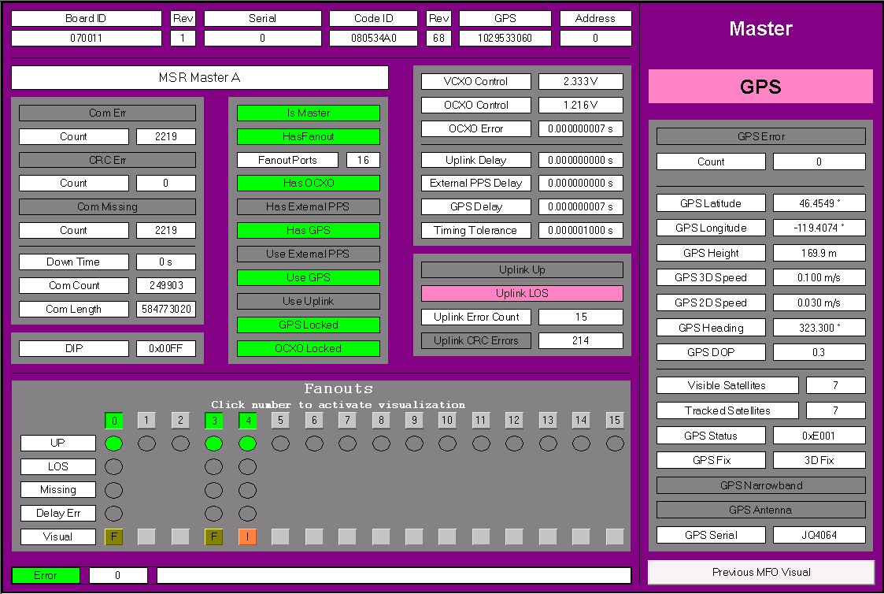

Master-fanout chassis without GPS receiver (timing fanout):
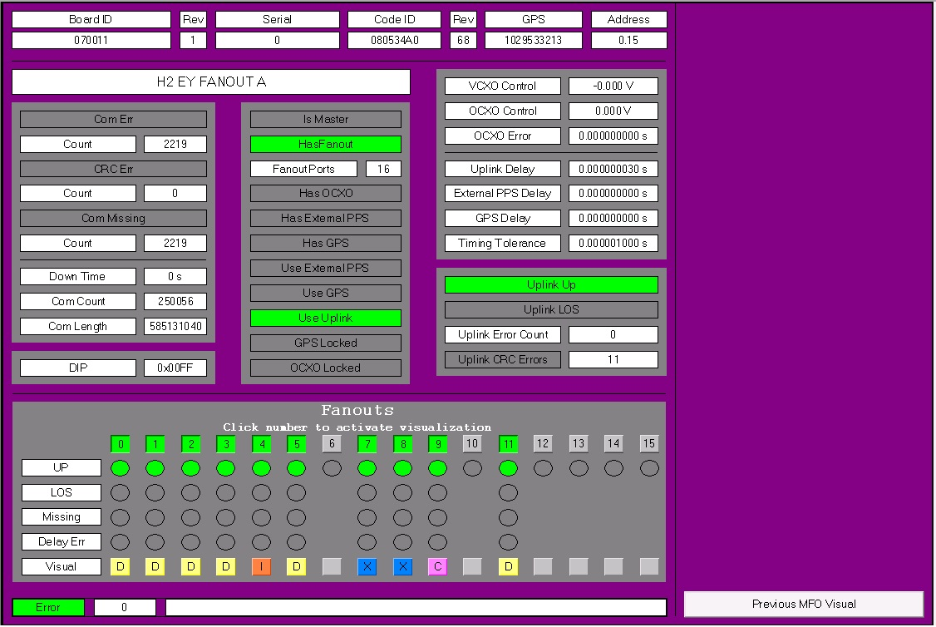

Name | TimingMasterFanoutVis
Description | This is the visual for the timing master-fanout chassis. At the bottom each fanout-put port is listed. They can be turned made active or inactive. A link to the visual of the slave module is also provided. The name of the master-fanout chassis can be chosen freely.
Placeholder | Name: MFO  Type: TimingMasterFanoutStruct  Description: Master-fanout information to be displayed.

Visuals (slave modules)

Comparator/frequency counter:
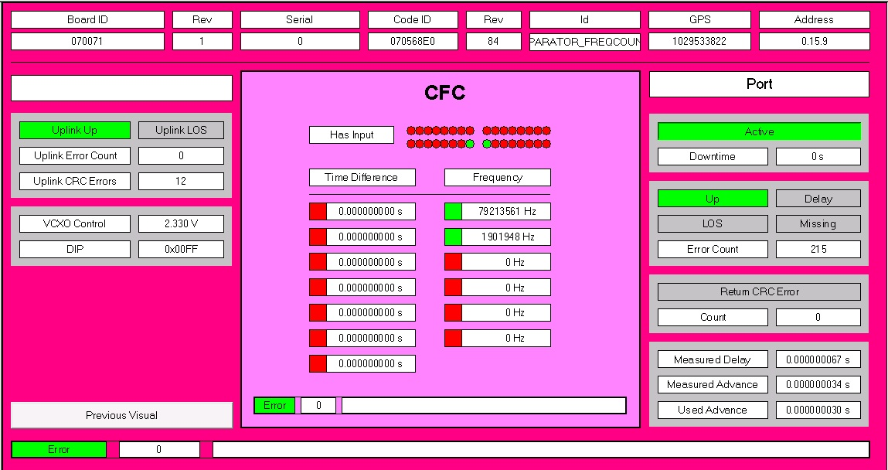

DuoTone:
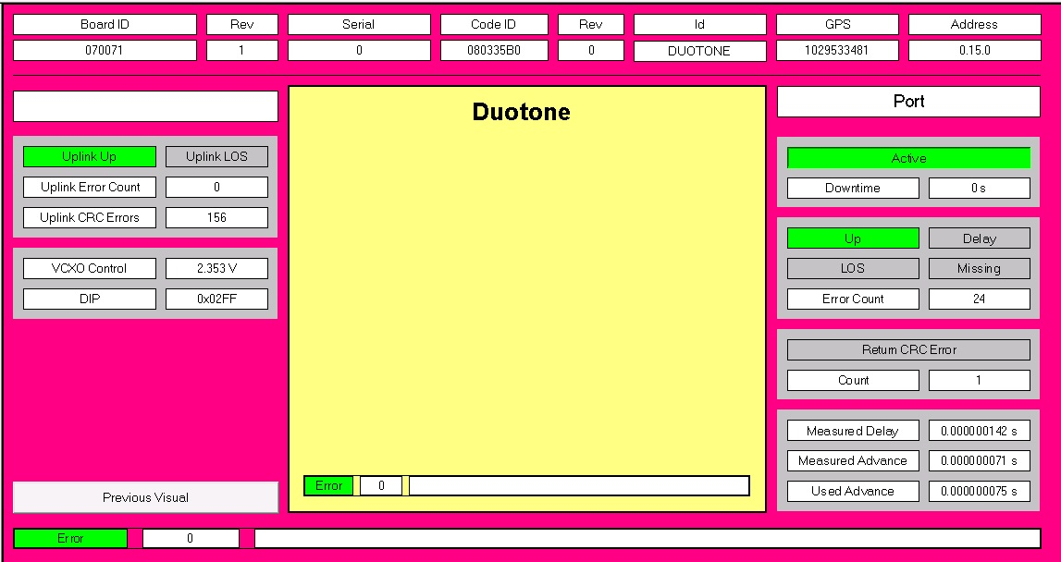

Fanout: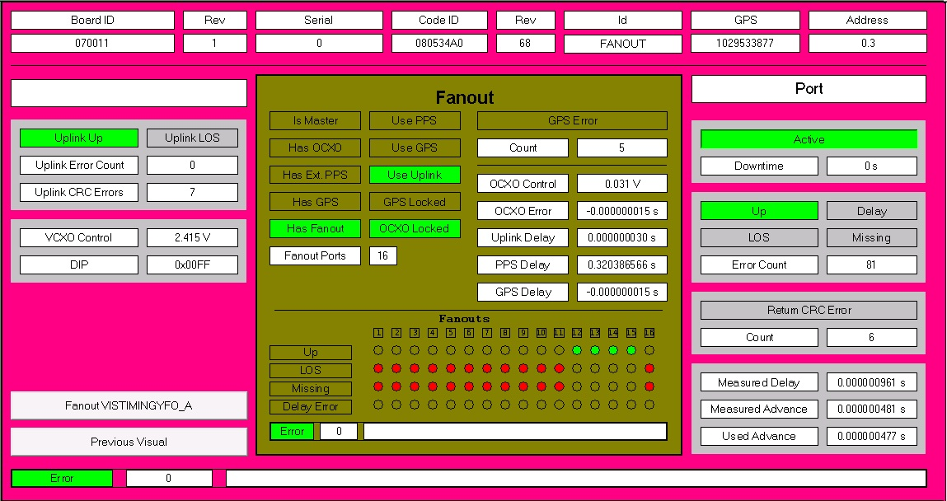

IRIG-B: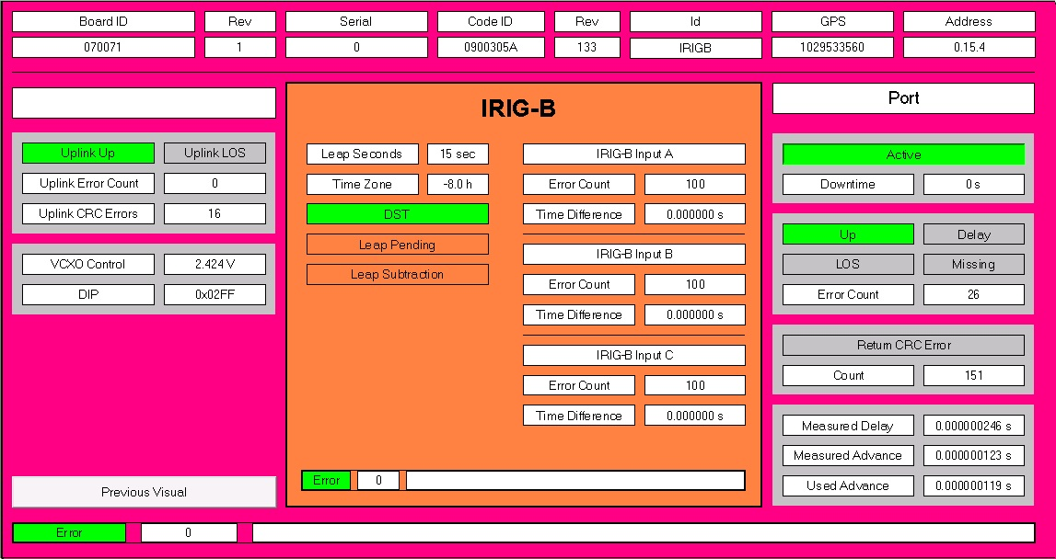

RF source:
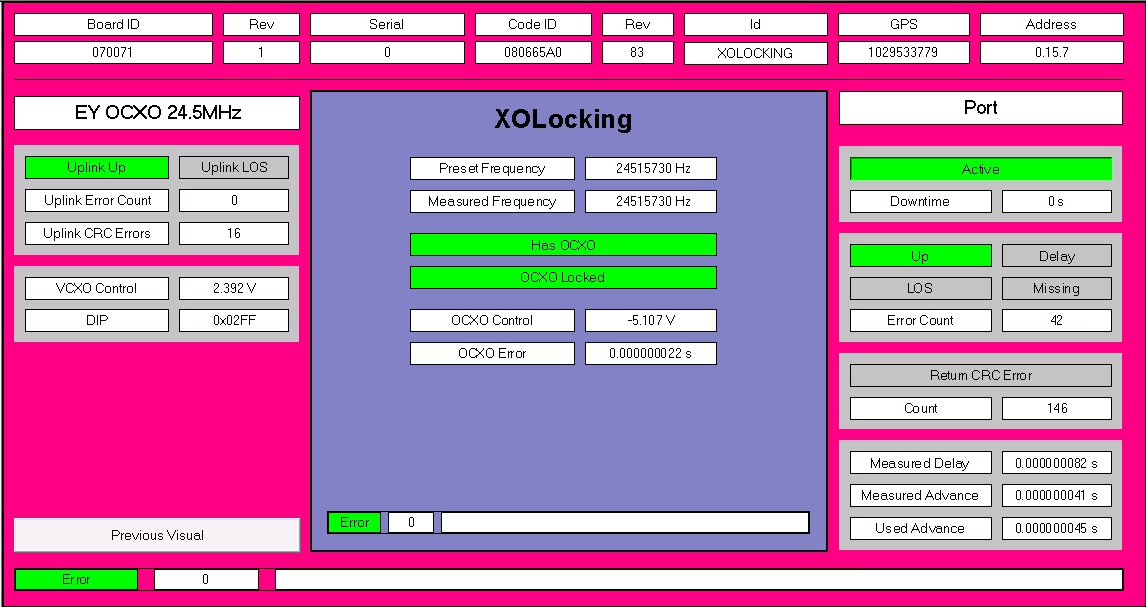

Name | TimingSlaveVis
Description | This visual contains the information about a slave module. A link to the previous visual (master-fanout chassis) is also provided. The name of the slave module can be chosen freely. The fanout slave interface also provides a link to the visual of the actual master-fanout chassis hooked up to this port.
Placeholder | Name: Port  Type: TimingFanoutStruct  Description: Port and slave information to be displayed.

