LIGO Laboratory / LIGO Scientific Collaboration

LIGO-E1200733-v1 LIGO 08/02/12

Dual PD Amp Circuit Board Test Results

Alexa Staley

Distribution of this document:
LIGO Scientific Collaboration

This is an internal working note
of the LIGO Laboratory.

California Institute of Technology  LIGO Project – MS 18-34  1200 E. California Blvd.  Pasadena, CA 91125  Phone (626) 395-2129  Fax (626) 304-9834  E-mail: info@ligo.caltech.edu | Massachusetts Institute of Technology  LIGO Project – NW22-295  185 Albany St  Cambridge, MA 02139  Phone (617) 253-4824  Fax (617) 253-7014  E-mail: info@ligo.mit.edu
LIGO Hanford Observatory  P.O. Box 159  Richland WA 99352  Phone 509-372-8106  Fax 509-372-8137 | LIGO Livingston Observatory  P.O. Box 940  Livingston, LA 70754  Phone 225-686-3100  Fax 225-686-7189
http://www.ligo.caltech.edu/

Introduction
This document contains test results for the Dual PD Amp circuit board proto-type that was put together by Alexa. Ultimately, five of these boards will be made and placed inside the ALS Fiber Distribution box (wiki). One can find the test procedure E1200731-v1 and data collected E1200732-v1 for the board.

Results
When connected to only a power supply, the dual PD amplifier reads the expected vref of -5 volts. In addition, the outputs read almost zero volts. The DC offset is measured to be less than 10mV for all gain settings on both sides of the board. We also see less than 20uV for the AC variations.

- Transfer Function:
The transfer function of the Dual PD Amp was measured with a modulated fiber-coupled laser and a SR785. The modulation of the laser had its own transfer function, which I subtracted out from the transfer function of the board. Below is a graph of the amplitude and phase of the optical transfer function for side B of the board (A is similar) at the different gain settings. Evidently, the amplitude increases accordingly to gain. Note, that the gain settings follow the Gray encoding standard. Also, one can see that the useable bandwidth is approximately 4kHz.
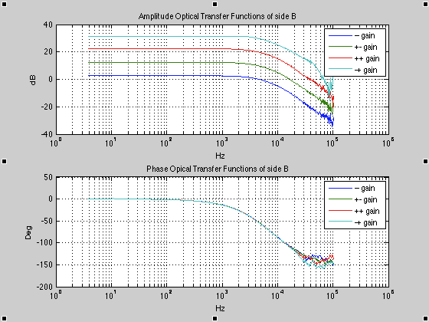

We can compare the optical transfer function with the electrical transfer function. Below is a plot of this comparison for board side B at the highest gain. They are pretty similar.

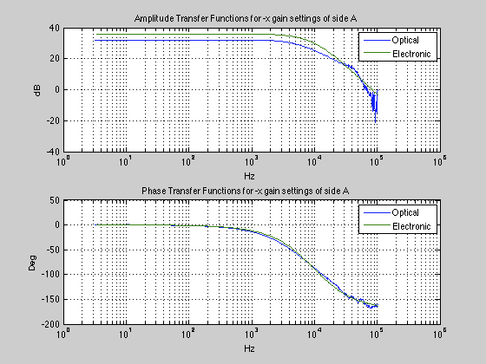

We repeated the measurements for the optical transfer function using a long cable (100ft). The results were consistent. Below is a plot comparing the two transfer functions for board side A at the highest gain.

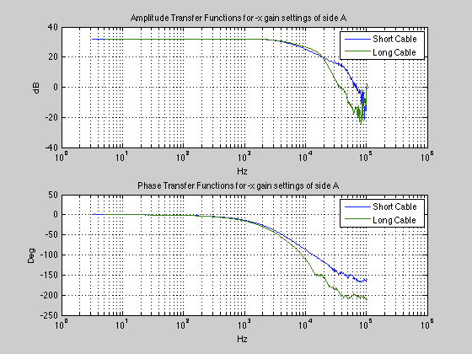

- Noise:
We also measured the total noise, electronics noise, and shot noise of the board. Using a halogen light source, the shot noise for both sides of the board for all the gain settings was measured. Below is a plot of side A at the highest and lowest gain settings. One can see that the noise increases for higher gain. Both measurements have a sharp increase below 400Hz; this is not shot noise, but comes from the noise of the light source. This measurement should ultimately be done with a more stable source connected to a battery and not a power supply.
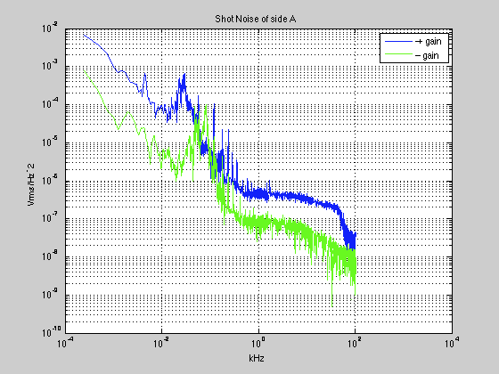

Below is a plot of the measured total noise, shot noise, and electronics noise all plotted together. The electronics noise is about 80nVrms/SqrtHz. The electrical noise was consistent for both sides of the board and for all gain settings – this is expected given that the noise is dominated by the op-amp that is not connected to the gain switches. The graph below also includes a dashed line, which represents the expected shot noise. Our measurement matches this expectation nicely between 500Hz and 4kHz.

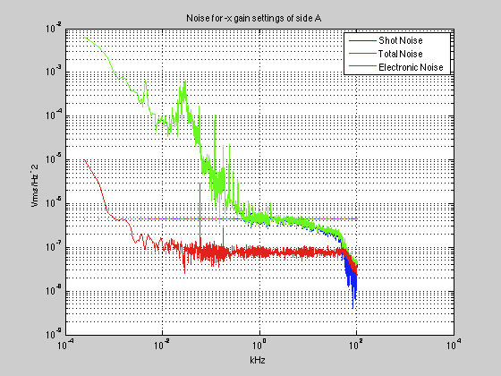

Again, these noise measurements were repeated using a long cable (100ft). Below is a graph of the electrical noise, and the shot noise of side A at the lowest gain setting for both the long and short cable. Evidently, there is not much of a difference between the two cables in terms of noise.

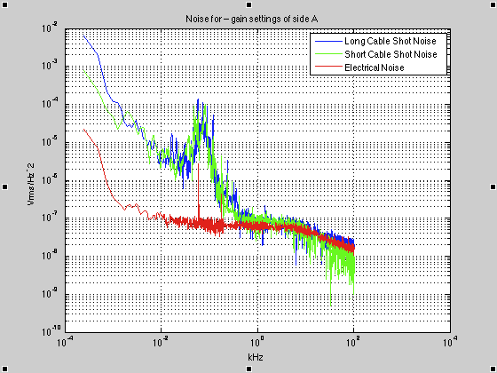

Lastly, here is a table for boards A and B averaging the noise measurements in the span of 1kHz to 2kHz. The table includes the electronics noise, shot noise, and total noise for the short cable, the shot noise for the long cable, and the expected shot noise. Note that the expected shot noise is only an approximate value given that this calculation assumed an output voltage of 10V through each channel of the board. However, it was not possible to obtain exactly 10V out of the board with the light source for each gain setting, and as the data was collected there was some saturation. Another thing to note; the 10 and 11 gain settings are less accurate because less data points were collected due to time constraints. However, I feel we can conclude that the board is behaving as we expect/designed it to.
Board Side B Average nVrms/SqrtHz from 1kHz to 2kHz
Gain | Transimpedance Gain (kΩ) | Measured Electronics Noise | Deduced Shot Noise | Measured Total Noise | Deduced Long Cable Shot Noise | Expected Shot Noise (Approx)
00 | 2 | 63 | 122 | 137 | 108 | 80
10 | 6.32 | 64 | 182 | 193 | 152 | 142
11 | 20 | 69 | 181 | 241 | 298 | 253
01 | 63.2 | 80 | 428 | 435 | 444 | 449

Board Side A Average nVrms/SqrtHz from 1kHz to 2kHz
Gain | Transimpedance Gain (kΩ) | Measured Electronics Noise | Deduced Shot Noise | Measured Total Noise | Deduced Long Cable Noise | Expected Shot Noise (Approx)
00 | 2 | 63 | 86 | 108 | 105 | 80
10 | 6.32 | 74 | 188 | 168 | 195 | 142
11 | 20 | 67 | 258 | 304 | 257 | 253
01 | 63.2 | 78 | 486 | 493 | 473 | 449

