Test Date | May 25-29, 2012
Author(s) | Liyuan Zhang, Margot Phelps, Patrick Murphy, GariLynn Billingsley
Approval(s)
Specification Doc. | LIGO-E0900041 | Specification | HR<0.5 ppm, AR<1.0 ppm
Procedure Doc. | LIGO-E1000863
S1 HR (Mean ± RMS) | 0.4 ± 0.1 ppm
S2 AR (Mean ± RMS) | 0.5 ± 0.1 ppm
Conclusion | Qualified.

Discussions and Comments:
For each surface, S1 (HR) and S2 (AR), 4 linear scans of 20 mm are carried out along X+- and Y+- outside central 120 mm in diameter. The arrow on barrel is positioned at Y+ direction. The calibration is done by a contamination cavity HR mirror (1” in dia., No. 8128), of which the HR absorption was measured to be 0.6 ppm in the optical contamination test. The results are summarized in Fig.1 and 2 for HR (S1) and AR (S2) respectively.

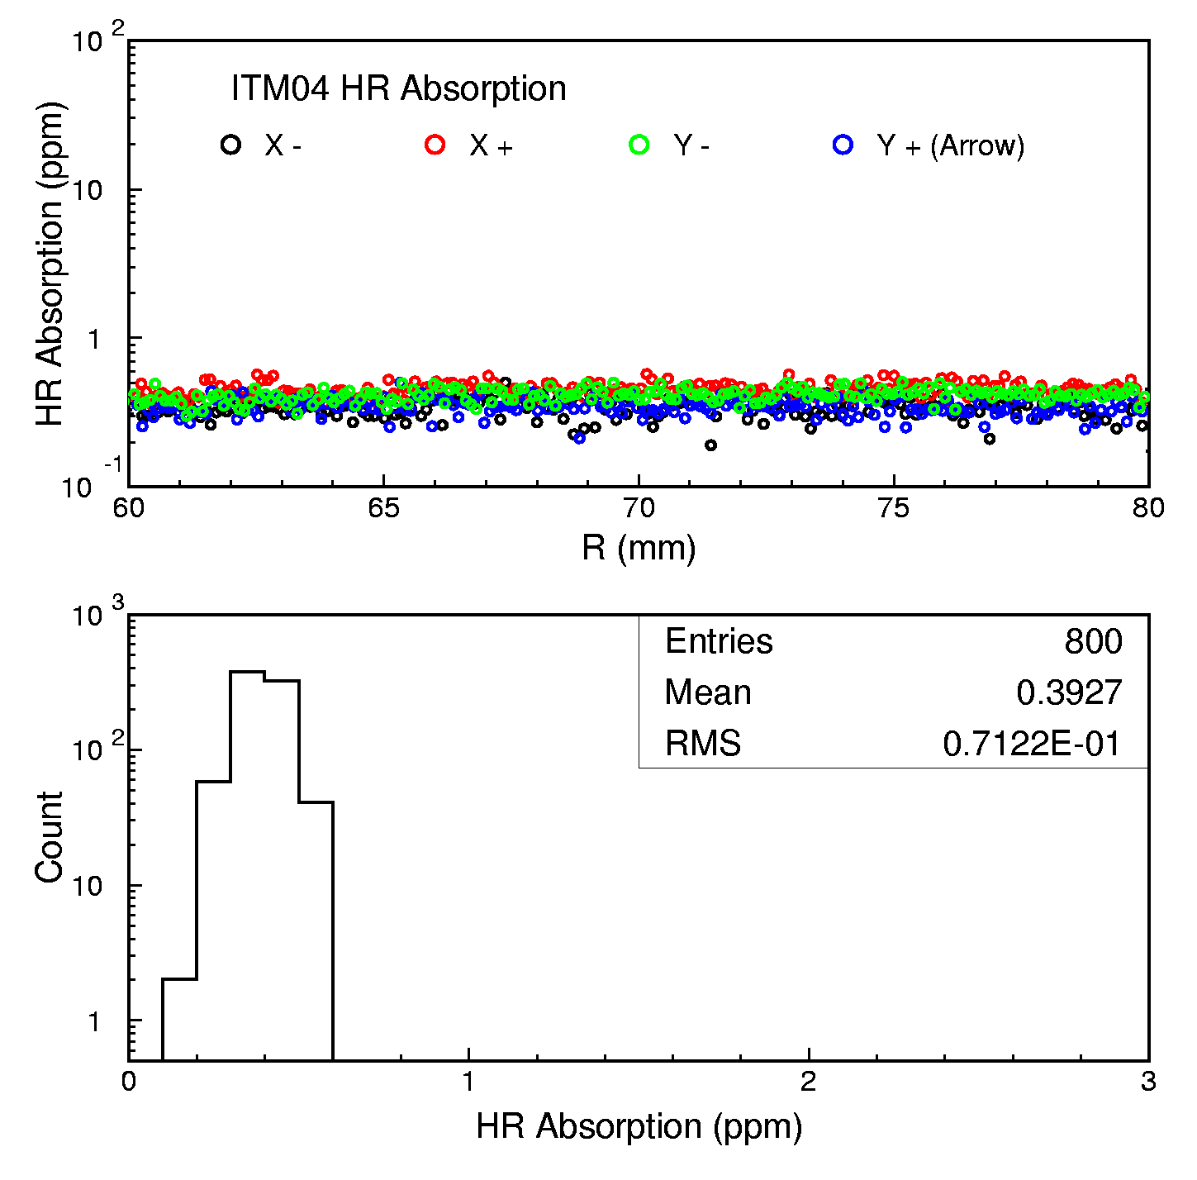
Fig. 1 ITM04 HR absorption measurements along X+- and Y+- outside central 120 mm in diameter.

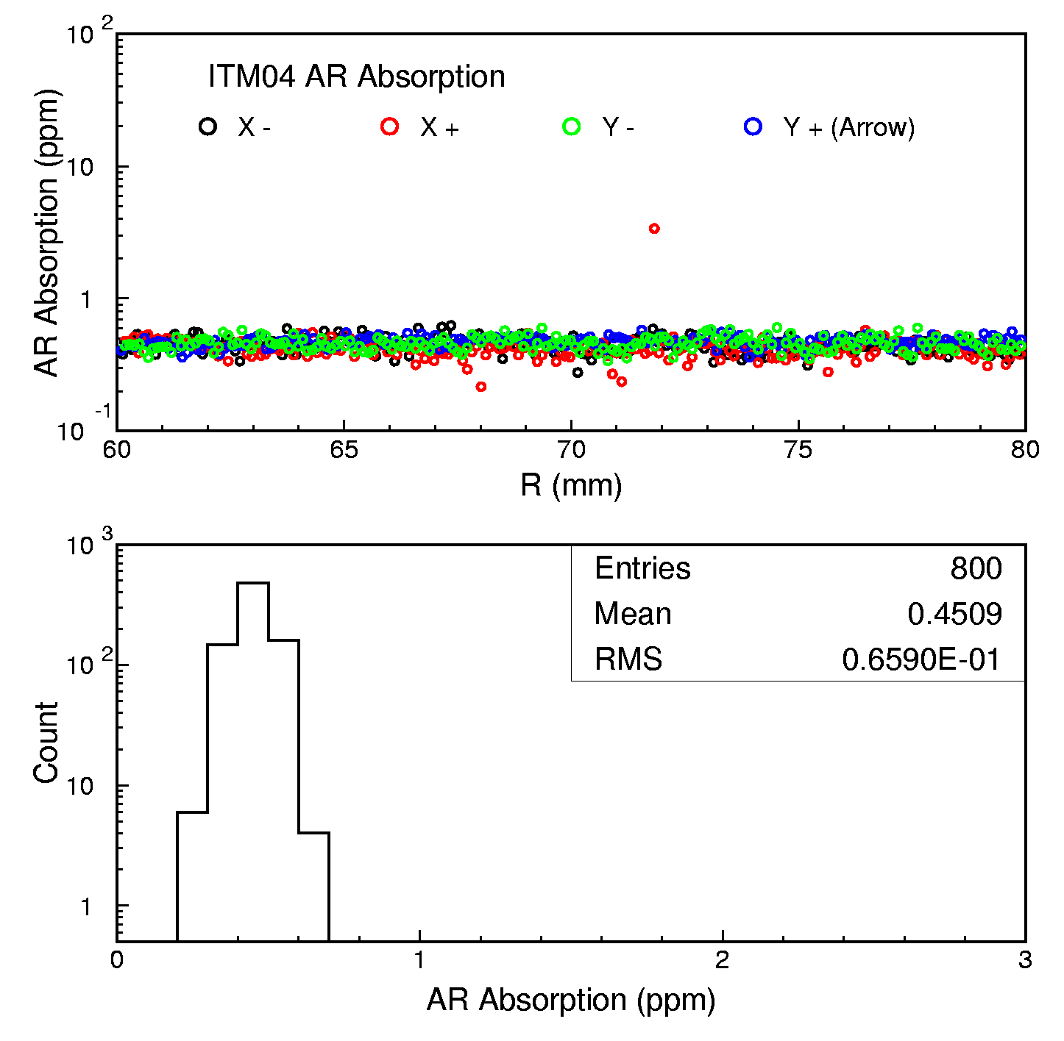
Fig. 2 ITM04 AR absorption measurements along X+- and Y+- outside central 120 mm in diameter.

