LIGO Laboratory / LIGO Scientific Collaboration

LIGO-T1200335-v2 LIGO 21 August 2012

ISC LSC RF Photodetector Test Procedure:

Richard Abbott

Distribution of this document:
LIGO Scientific Collaboration

This is an internal working note
of the LIGO Laboratory.

California Institute of Technology  LIGO Project – MS 18-34  1200 E. California Blvd.  Pasadena, CA 91125  Phone (626) 395-2129  Fax (626) 304-9834  E-mail: info@ligo.caltech.edu | Massachusetts Institute of Technology  LIGO Project – NW22-295  185 Albany St  Cambridge, MA 02139  Phone (617) 253-4824  Fax (617) 253-7014  E-mail: info@ligo.mit.edu
LIGO Hanford Observatory  P.O. Box 159  Richland WA 99352  Phone 509-372-8106  Fax 509-372-8137 | LIGO Livingston Observatory  P.O. Box 940  Livingston, LA 70754  Phone 225-686-3100  Fax 225-686-7189
http://www.ligo.caltech.edu/

Introduction
This document describes the testing of the LSC RFPD photodetectors used in the aLIGO ISC subsystem. A summary of the characteristics of this detector are available in T1100402. The schematics for the LSC detector can be found in D1101124. A list of ISC detectors (RF & DC) can be found in T1000264.
This procedure relies upon a familiarity with the complex nature of this circuit and the techniques of network analysis, modulated laser light sources, and shot noise limited sensitivity measurements. Minimal instructions are included in this procedure to avoid lengthy and complex tutorials.
All final data results are recorded in T1200334
This procedure is broken into the following sections:
- Serial number – Unique identification of the unit is recorded in the form of the serial number if the internal circuit board and associated schematic details
- DC checks – Current draw into the detector and verification of all internally regulated voltages
- DC path transimpedance – A measurement of the DC transimpedance of the DC path of the RFPD.
- DC path singularities – A measurement of the zero and pole frequencies of the whitening filter if present in the DC readout path
- DC path output noise – Used in conjunction with other circuit parameters to estimate the shot noise limited sensitivity of the DC readout path
- Notch tuning – Adjustment of RF notch frequencies
- Notch rejection ratios – Measurement of RF notch depths
- RF transimpedance – A white-light based measurement of the RF transimpedance
- Shot noise limited input sensitivity – Verification that the RF noise performance is within design limits
- Test input transconductance – A measurement of the RF transimpedance of the test input path
- Test switch isolation – A measurement of the isolation in dB for the ON/OFF states of the RF test switch

Product Perspective
As shown in Figure 1, the LSC RFPD is mounted in a metal housing with all connections on the top surface. This includes 4 SMA connectors: two for the RF outputs, one test input and one test output. Power, control lines and the DC output are on the 9-pin D-sub connector.

Figure 1
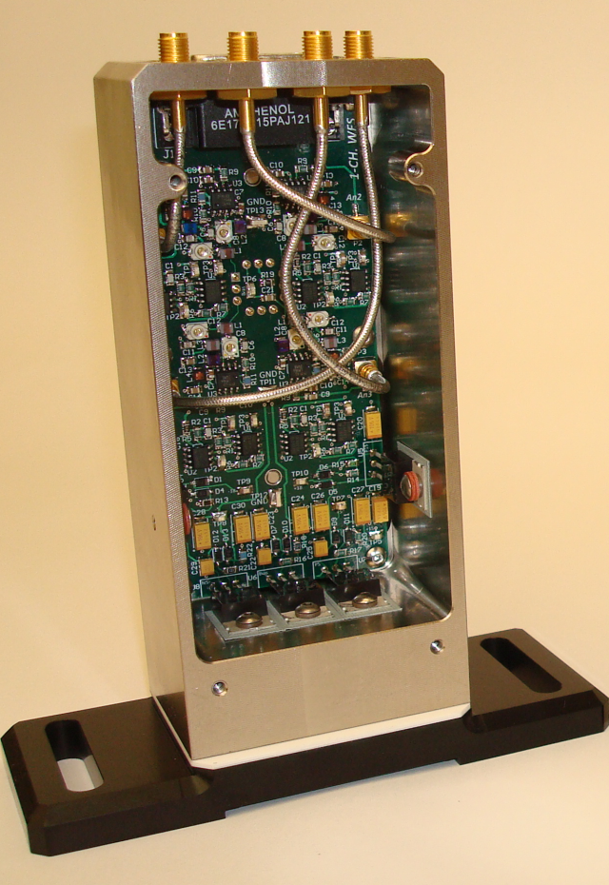

D-Connector Pinout

9 pin D Pin | Function
1 | DC Readout Positive
6 | DC Readout Negative
2 | DC Power Positive
7 | Ground
3 | DC Power Negative
8 | Ground
4 | RF Test Relay
9 | Ground
5 | No Connect

Serial Number Data
Record the serial number and relevant schematic D-number/revision in T1200334

DC Checks
Record the total circuit board quiescent current draw and regulated voltages in T1200334. Use caution in believing the digital readouts of laboratory triple output power supplies. Their meters are not highly accurate. When in doubt, use a multimeter on the appropriate scale in series with the supply to be measured.

DC Readout Path
Using a handheld current calibrator, inject 1mA DC into the anode circuit of the RFPD through a 100 Ω resistor. By observation of the DC voltages present at the BNC and differential DC readout terminals on the 9 pin D-connector, calculate the transimpedance of the DC readout chain, $Z_{dc}$ by:

$$Z_{dc}=\frac{Vout}{0.001A}$$

Record each result in T1200334.
Next, using an SR785 Dynamic Signal Analyzer, inject a 100mV signal into the anode circuit of the PD through a 100 ohm resistor. Measure the transfer function to the differential output at 1 Hz and 100 Hz. Compare them to Table 1

Table 1
Frequency | Mag/Phase
1 Hz | 18.7 dB +/- 0.5dB  56.1 degrees +/-5 degrees
100 Hz | 26.9 dB +/- 0.5dB  1.3 degrees +/-5 degrees

If the magnitude and phase is as indicated in Table 1, the circuit conforms to the design. Enter into T1200334 the zero frequency of 0.2Hz, and the pole frequency of 2.4 Hz.

At the differential output DC readout pins, measure the differential noise voltage power spectral density with the photodiode element completely shielded from light. Calculate the inferred DC path shot noise limited sensitivity $(Ilim_DC)$ and enter it into T1200334

$$Ilim_{DC}={\left[\frac{Vrms}{2400}\right] }^{2 }×\frac{1}{3.2×{10}^{-19}}$$

Notch Tuning
The LSC photodetector circuit has series resonant RF notches that are tuned to allow amplification of some frequencies, while providing rejection at other frequencies. The notches are tuned by means of surface mounted RF trimmer capacitors on the photodetector PCB. Table 2 shows which capacitor to tune for each notch frequency.
Using a laser capable of RF AM modulation, and an RF network analyzer, perform a frequency sweep from the photodiode to the RF test output connector on the top surface of the photodetector housing. The RF test relay will have to be activated to connect the test path circuitry to the photodiode readout circuit. Either use the LSC RFPD interface chassis - which has a front panel test switch (D1102079) - or connect pin 4 to pin 9 on the 9 pin D-sub present on the top of the photodetector housing. This will activate the test relay.

Table 2, Notch Adjustment Frequencies
Notch Frequency | Adjustment Capacitor
F low | C38
F hi | C15
Notch 1 (lowest freq.) | C4
Notch 2 . | C10
Notch 3 . | C17
Notch 4 (highest freq.) | C26

After adjusting each notch, record into T1200334 the tuning frequencies as indicated.

Notch Rejection Ratios
With the series resonant portions of the circuit tuned to the appropriate frequencies, a measurement can be performed to establish the ratio of the gain at the desired readout frequencies to the gain at the undesired frequencies corresponding to the rejection notches.
Using a laser capable of RF, AM modulation and an RF network analyzer, perform a frequency sweep from the photodiode to the RF HI and RF LOW output connectors on the top surface of the photodetector housing. Use the delta marker function to record the difference between each notch and the relevant RF operating frequency of RF HI and RF LOW. Record the results in T1200334.

RF Transimpedance Measurement
Illuminate the photodiode with white light (as generated by a shot noise limited source such as an incandescent bulb) to generate the photocurrent. Use an RF spectrum analyzer to measure the RF power spectral density at the readout frequency associated with the output under test. A low noise RF pre-amplifier (gain ~20dB) is useful to boost the signal to a comfortable level. Be sure the measurement is not electronically noise limited by careful attention to signal levels.
Establish a photocurrent between 6mA and 10mA. On an RF spectrum analyzer, observe the RF power spectral density present at the operating frequency of the detector, and also make note of the DC photocurrent. Using the Microsoft Excel worksheet available in the DCC as an attached document to this document, enter the data as needed to calculate the transimpedance,$Z_{RF}$ which is derived from the following formula:
$$Z_{RF}= \sqrt{\frac{{Vrms}^{2}I_{DC}}{3.2×{10}^{-19}}}$$

Enter the transimpedance in the appropriate spot on T1200334.

Shot Noise Limited Sensitivity
The shot noise limited sensitivity will characterize the minimum useful optical signal level below which the photodetector will be limited by electronics noise. Using the Microsoft Excel worksheet available in the DCC as an attached document to this document, enter the data as needed to calculate shot noise limited sensitivity. In general, the formula used is:

$$Ilim_{rf}=I_{DC}×\frac{{V_{dark}}^{2}}{{V_{light}}^{2}}$$
Where I_{DC} is the DC photocurrent associated with the illuminated diode, and V_{light} is the RF voltage spectral density as derived from a spectrum analyzer reading at the detector fundamental operating frequency

Record the resulting shot noise limited sensitivities in T1200334.

Test Input Transconductance and Isolation
An RF test input is provided for modulation, diagnostics, and RF notch tuning. The RF test input circuitry is implemented by use of a common-base RF transistor current source. This section measures the gain of the test input at each of the two operating frequencies, RF HI, and RF LOW.
Using an RF network analyzer, with the internal RFPD test switch enabled, take a transfer function measurement in through the test input and out of each of the two main RF outputs. Record the dB magnitude of each transfer function,${Mag}_{on}$ at the operating frequency of the respective output with the test input switch enabled. While observing the magnitude of the transfer function with the test switch on, disable the test switch and note the dB magnitude of the transfer function,${Mag}_{off}$ with the test switch disabled. Calculate the test input transconductance $C_{t}$ by use of the linear magnitude of the transfer function,${Mag}_{on}$ divided by the calculated average transimpedance,$Z$ for that RF path as recorded in section 9.

$$C_{t}=\frac{{10}^{(\frac{{Mag}_{on}}{20})}}{Z}$$

$${Isolation=Mag}_{on}-{Mag}_{off}$$

Record the resulting transconductance and test switch isolation in T1200334 for each of the two RF frequencies of operation.

