LIGO Laboratory / LIGO Scientific Collaboration

E1200677-v5 LIGO 19 March 2013

Advanced LIGO ITM Elliptical Baffle
Assembly Procedure

Lisa Austin, Mike Smith, Nichole Washington

Distribution of this document:
Advanced LIGO Project

This is an internal working note
of the LIGO Laboratory.

California Institute of Technology  LIGO Project – MS 100-36  1200 E. California Blvd.  Pasadena, CA 91125  Phone (626) 395-2129  Fax (626) 304-9834  E-mail: info@ligo.caltech.edu | Massachusetts Institute of Technology  LIGO Project – NW22-295  185 Albany St  Cambridge, MA 02139  Phone (617) 253-4824  Fax (617) 253-7014  E-mail: info@ligo.mit.edu
LIGO Hanford Observatory  P.O. Box 1970  Mail Stop S9-02  Richland WA 99352  Phone 509-372-8106  Fax 509-372-8137 | LIGO Livingston Observatory  P.O. Box 940  Livingston, LA 70754  Phone 225-686-3100  Fax 225-686-7189

CHANGE LOG

Date, version | Summary of Changes
2012-05-03  V3 | - Baffle Suspension Assembly updated with notes from LHO assembly on 12/11 and CIT assembly on 5/12.
2013-02-13  V4 | - Removed references to ACB, as needed.
2013-03-19  V5 | - Corrected Figure numbers and references.  - Updates and corrections to Suspension Assembly instructions.

Introduction
This document details the assembly of D1003238, the aLIGO AOS ITM ELLIPTICAL BAFFLE FINAL ASSY, H1/L1 and its subassemblies:

Clean room standards 3
Table of Figures 4
I. ITM ELLIPTICAL BAFFLE BOX ASSEMBLY 4
A. ITM ELLIPTICAL Baffle Box Assembly – D1101806 4
II. ITM ELLIPTICAL BAFFLE SUSPENSION ASSEMBLY – D1101885 8
A. D1002582 - SLC BAFFLE TUBE UP ASSEMBLY 9
B. D1101887 - ITM ELLIPTICAL BAFFLE TUBE LO ASSEMBLY 10
C. D1002564-02 - SLC EDDY CURRENT DAMPING 8 DIA TUBE ASSEMBLY 12
D. D1200140 - ITM ELLIPTICAL BAFFLE BLADE ASSEMBLY 14
E. ITM ELLIPTICAL BAFFLE SUSPENSION ASSEMBLY – D1101885 18

Clean room standards
For a clean assembly all LIGO standards should be followed, as presented in the latest version of the LIGO Contamination Control Plan (E0900047). Clean room garb including UHV gloves should be worn when working with parts.
All tools that come in contact with assembly should be cleaned to class B standards.
Assembly will be done under a portable clean room. Any time a part of the assembly is not covered by the portable clean room or not being actively worked on it should be covered with appropriate clean covers. (C3 polyester or equivalent).
All parts that will be included in the final assembly must be cleaned to LIGO standards, Class A. The list of parts to be Class A-cleaned includes screws, washers, inserts, and assorted other hardware. All tooling and other parts that are not included in the final assembly, but that contact Class A parts during assembly must be cleaned to LIGO standards, Class B.

Notes for all Subassembly:
- Assembly requires two people
- Watch for foil scratched surface

Table of Figures

Figure 1: Baffle Box Assembly 4
Figure 2: Suspension Assembly 8
Figure 3: Baffle Tube Up Assembly 9
Figure 4: Lo Tube Assembly 11
Figure 5: Lo Tube magnet placement 11
Figure 6: Eddy Current Damping Tube Assembly 12
Figure 7: Copper Plate location 13
Figure 8: Spring Blade Loading 15
Figure 9: Blade Mounting Bracket position 17
Figure 10: Suspension Rod 17
Figure 11: Suspension Rod Hardware 20
Figure 12: Suspension Rod and Tube Up Assy 21

ITM ELLIPTICAL BAFFLE BOX ASSEMBLY

ITM ELLIPTICAL Baffle Box Assembly – D1101806
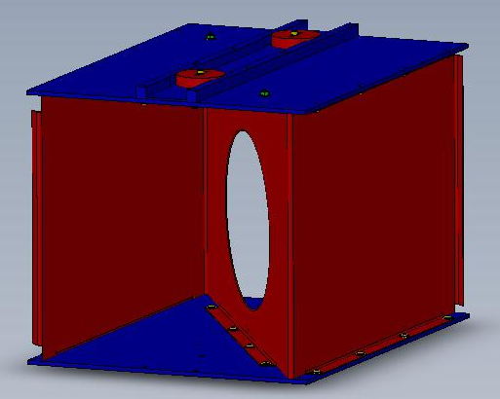
Figure 1: Baffle Box Assembly

List of parts, hardware and tools needed –

Parts:
D1101804 BAFFLE CENTER SKIN QTY = 1 SN:____________
D1101805 BAFFLE TOP-BOTTOM SKIN QTY = 2 SN:____________
D1200339 BOX TOP SUPPORT BRACKET QTY = 1 SN:____________
D1200779 1.25 POUND BALANCE WEIGHT QTY = 4 SN:____________

Hardware:
98019A355 WASHER FLAT 1/4" QTY = 38
BU-2006-N SCREW, BUTTON HD, SOCKET, 1/4-20 X 0.375 L QTY = 16
BU-2012-N SCREW, BUTTON HD, SOCKET, 1/4-20 X 0.75" L QTY = 12
BU-2020-N SCREW, BUTTON HD, SOCKET, 1/4-20 X 1.25" L QTY = 2
C-2016-N SOCKET HEAD CAP SCREW, SHC, 1/4-20 x 1" L QTY = 2
C-2032-N SOCKET HEAD CAP SCREW, SHC, 1/4-20 x 2" L QTY = 2
N-2520-A HEX NUT, SILVER PLATED, 1/4-20 QTY = 6

Tools:
5/32 Allen Key Wrench
7/16 Open-End Wrench
Torque Wrench (95 in-lbs)

Place one D1101805 BAFFLE TOP-BOTTOM SKIN on build surface.

Place D1101804 BAFFLE CENTER SKIN on top of D1101805 BAFFLE BOTTOM SKIN. Make sure skin is in the correct orientation. There is a smaller distance from the aperture opening to the bottom edge of the skin. Z-shape should face the assembler; this puts the Super 8 surface to the right. Align “Z” formation of holes in plate to Z-shape of skin. Verify orientation of Center Skin.

Loosely install hardware into corner holes (screw, washer, center skin and bottom skin) starting with bent ends, 4 places.

BU-2006-N SCREW, BUTTON HD, SOCKET, 1/4-20 X 0.375 L (4)

98019A355 WASHER FLAT 1/4" (4)

Attach the center of D1101804 BAFFLE CENTER SKIN to D1101805 BAFFLE BOTTOM SKIN. Adjust skin to align holes. Turn assembly on its side, being very careful not to scratch the surface, and attach hardware.

Install hardware (screw, washer, center skin, bottom skin, washer, and nut), 4 places

BU-2012-N SCREW, BUTTON HD, SOCKET, 1/4-20 X 0.75" L (4)

98019A355 WASHER FLAT 1/4" (8)

N-2520-A HEX NUT, SILVER PLATED, 1/4-20 (4)

Turn assembly upright and attach Center Skin to Bottom Skin on both sides in the center.

Install hardware (screw, washer, center skin and bottom skin), 4 places.

BU-2006-N SCREW, BUTTON HD, SOCKET, 1/4-20 X 0.375 L (4)

98019A355 WASHER FLAT 1/4" (4)

Place D1101805 BAFFLE TOP SKIN on top of D1101804 BAFFLE CENTER SKIN. Align “Z” formation of holes in plate to Z-shape of skin.

Loosely install hardware into corner holes (screw, washer, center skin and bottom skin) starting with bent ends, 4 places.

BU-2006-N SCREW, BUTTON HD, SOCKET, 1/4-20 X 0.375 L (4)

98019A355 WASHER FLAT 1/4" (4)

Position and attach D1200339 BOX TOP SUPPORT BRACKET to D1101805 BAFFLE TOP SKIN. Verify orientation of Support Bracket.

Loosely install hardware (screw, washer, top skin, and support bracket), 8 places.

BU-2012-N SCREW, BUTTON HD, SOCKET, 1/4-20 X 0.75" L (8)

98019A355 WASHER FLAT 1/4" (8)

Turn assembly upside down and attach Center Skin to Top Skin on both sides in the center.

- Install hardware (screw, washer, center skin and top skin), 4 places.

BU-2006-N SCREW, BUTTON HD, SOCKET, 1/4-20 X 0.375 L (4)

98019A355 WASHER FLAT 1/4" (4)

Attach “SLC ACB Balancing Weight” to corners of D1101805 BAFFLE BOTTOM SKIN and in slot of D1200339 BOX TOP SUPPORT BRACKET as defined from selection of Suspension Assembly Spring Blade serial number. See Document E1300071 for balance weights.

Install hardware (screw, washer, top skin, balance weight, washer, and nut), 2 places.

BU-2020-N SCREW, BUTTON HD, SOCKET, 1/4-20 X 1.25" L (2)

98019A355 WASHER FLAT 1/4" (4)

N-2520-A HEX NUT, SILVER PLATED, 1/4-20 (2)

Install hardware (screw, washer, balance weight, support bracket, and top skin), 2 places.

C-2016-N SOCKET HEAD CAP SCREW, SHC, 1/4-20 x 1" L (2)

98019A355 WASHER FLAT 1/4" (2)

Turn assembly as required and tighten all screws on Center Skin first, then tighten all other screws

Torque all screws to 95 in-lbs.

Weigh assembly and record: _______________ lbs. (kg/grams)

ITM ELLIPTICAL BAFFLE SUSPENSION ASSEMBLY – D1101885

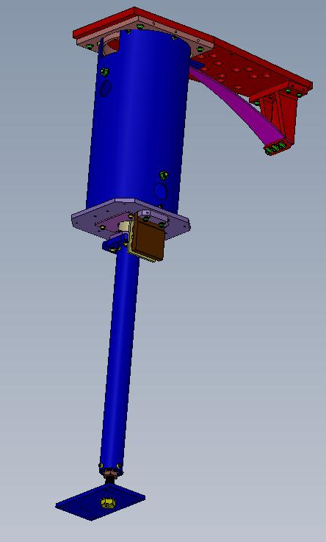
Figure 2: Suspension Assembly

D1002582 - SLC BAFFLE TUBE UP ASSEMBLY

LIGO PART SERIAL NUMBERS MUST BE RECORDED FOR ICS ASSEMBLIES

LIGO Parts:
(1) D1002612 - SLC UPPER TUBE SN:____________
(1) D1002610 - SLC TUBE UP CONNECTOR PLATE SN:____________
(1) D1002581 - SLC SUSPENSION ROD SUPPORT SN:____________

Hardware:
(4) 92200A537 (1/4-20 x 1/2 SHCS)
(4) 92200A242 (10-24 x 1/2 SHCS)

Tools:
3/16” Hex L-Key tool (¼-20 SHCS)
5/32” Hex L-Key tool (10-24 SHCS)

- Insert D1002581 – SLC SUSPENSION ROD SUPPORT into D1002612 – SLC UPPER TUBE on end closest to view holes, see Figure 3. Align with fastener holes. Parts may not slide together with ease.
  - Install hardware 4 places
    - 92200A537 (1/4-20 x 1/2 SHCS)
- Insert D1002610 – SLC TUBE UP CONNECTOR PLATE into D1002612 – SLC UPPER TUBE on end furthest from view holes, see Figure 3: Baffle Tube Up Assembly. Align with fastener holes.
  - Install hardware 4 places
    - 92200A242 (10-24 x 1/2 SHCS)

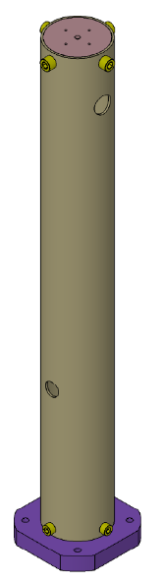
D1002581 –
SLC SUSPENSION ROD SUPPORT
D1002610 –
SLC TUBE UP CONNECTOR PLATE
D1002612 –
SLC UPPER TUBE
Figure 3: Baffle Tube Up Assembly

D1101887 - ITM ELLIPTICAL BAFFLE TUBE LO ASSEMBLY

LIGO PART SERIAL NUMBERS MUST BE RECORDED FOR ICS ASSEMBLIES

LIGO Parts:
(1) D1101889 - ITM ELLIPTICAL BAFFLE LO TUBE SN:____________
(1) D1000684 - SLC TUBE LOWER MOUNTING PLATE SN:____________
(1) D1002618 - SLC TUBE LOWER CONNECTOR PLATE SN:____________
(1) D1000930 - SLC MAGNET HOLDER STEEL PLATE SN:____________

Other Parts:
(2) N35P1000500HT - BUNTING MAGNETIC-NEODYMIUM (1.00D x .50H)

Hardware:
(4) 92200A537 (1/4-20 x ½ SHCS)
(2) 94518A510 (1/4-20 x ½ FHCS)
(4) 92200A242 (10-24 x ½ SHCS)

Tooling/Fixtures:
D1201014 – Magnet Spacer Tool
Small test magnet for Section II.B.4
Teflon Tool part number

Tools:
3/16” Hex L-Key tool (¼-20 SHCS)
5/32” Hex L-Key tool (10-24 SHCS)
Philips Screwdriver

- Insert D1000684 - SLC TUBE LOWER MOUNTING PLATE into D1101889 - ITM ELLIPTICAL BAFFLE LO TUBE, see Figure 4. Align with larger fastener holes.
  - Install hardware 4 places
    - 92200A537 (1/4-20 x ½ SHCS)

- Insert D1002618 - SLC TUBE LOWER CONNECTOR PLATE into D1101889 - ITM ELLIPTICAL BAFFLE LO TUBE, see Figure 4. Align with smaller fastener holes.
  - Install hardware 4 places
    - 92200A242 (10-24 x ½ SHCS)

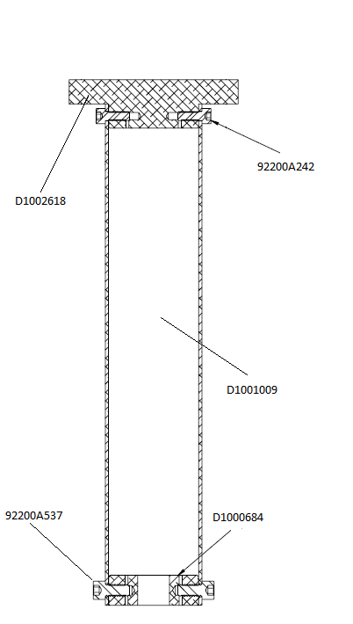

Figure 4: Lo Tube Assembly

- Attach D1000930 - SLC MAGNET HOLDER STEEL PLATE to D1002618 - SLC TUBE LOWER CONNECTOR PLATE, see Figure 5.
  - Install hardware 2 places
    - 94518A510 (1/4-20 x ½ FHCS)

- Attach N35P1000500HT - BUNTING MAGNETIC-NEODYMIUM Magnets in 2 places.
  - Need a Teflon tool part number
  - Alternate polarity of magnets (need small test magnet to test polarity)
  - If magnets are wrong, use tool to extract the wrong magnets; then, reverse the magnets as required.
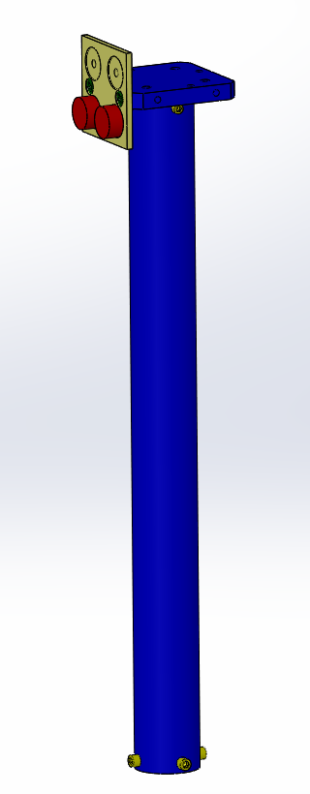
Figure 5: Lo Tube magnet placement

D1002564-02 - SLC EDDY CURRENT DAMPING 8 DIA TUBE ASSEMBLY

LIGO PART SERIAL NUMBERS MUST BE RECORDED FOR ICS ASSEMBLIES

LIGO Parts:
(1) D1002560 - SLC DAMPING TUBE TOP PLATE SN:____________
(1) D1002561 - SLC DAMPING 8 INCHES DIA TUBE SN:____________
(1) D1002617 - SLC DAMPING TUBE LOWER PLATE SN:____________
(1) D1000929 - SLC COPPER SUPPORT PLATE SN:____________
(1) D1000909 - SLC COPPER PLATE SN:____________

Hardware:
(12) 92200A242 (10-24 x ½ SHCS)
(2) 90233A815 (10-24 x ½ FHCS TITANIUM)
(2) 93286A044 (#25 FLAT WASHER ALUMINUM)
(2) 95435A755 (1/4-20 x 3/4 SHCS TITANIUM)

Tools:
3/16” Hex L-Key tool (¼-20 SHCS)
5/32” Hex L-Key tool (10-24 SHCS)
Phillips screw driver
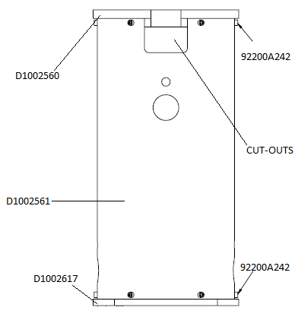
Figure 6: Eddy Current Damping Tube Assembly

- Insert D1002560 - SLC DAMPING TUBE TOP PLATE into D1002561 - SLC DAMPING 8 INCHES DIA TUBE, see Figure 6. Align with fastener holes and cut-outs.
  - Install hardware 6 places
    - 92200A242 (10-24 x ½ SHCS)

- Insert D1002617 - SLC DAMPING TUBE LOWER PLATE into D1002561 - SLC DAMPING 8 INCHES DIA TUBE, see Figure 6. Top and lower plate edges should be aligned with fastener holes.
  - Install hardware 6 places
    - 92200A242 (10-24 x 1/2 SHCS)

- Attach D1000909 – SLC COPPER PLATE to D1000929 – SLC COPPER SUPPORT PLATE.
  - Install hardware 2 places
    - 90233A815 (10-24 x 1/2 FHSC)

- Loosely attach D1000929 - SLC COPPER SUPPORT PLATE to D1002617 - SLC DAMPING TUBE LOWER PLATE in orientation shown in . Fasteners will be tightened in Section II.E.29.
- Install hardware 2 places
    - 93286A044 (#25 FLAT WASHERS ALUM)
    - 95435A755 (1/4-20 x 3/4 SHCS TITANIUM)

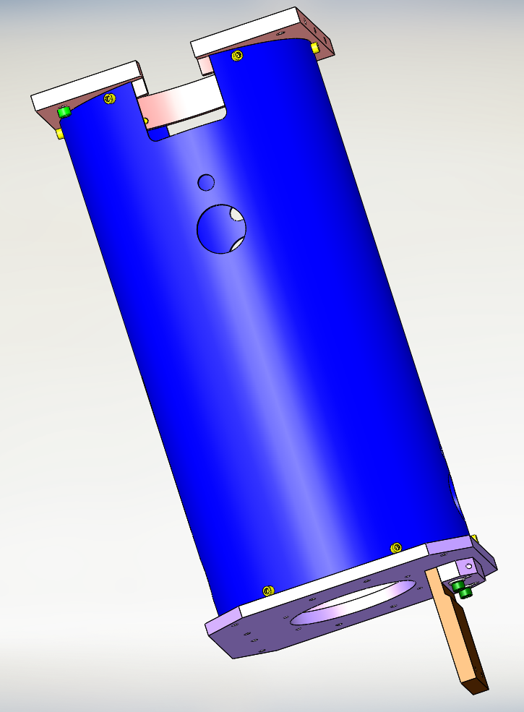
Figure 7: Copper Plate location

D1200140 - ITM ELLIPTICAL BAFFLE BLADE ASSEMBLY

LIGO PART SERIAL NUMBERS MUST BE RECORDED FOR ICS ASSEMBLIES

LIGO Parts:
(1) D1002609 - SLC BLADE MOUNTING BRACKET SN:____________
(1) D1200139 - SLC ITM BAFFLE INTERFACE MOUNTING PLATE SN:____________
(1) D1002753 – ITM ELLIPTICAL BLADE SN:____________
(1) D1002844 - SLC ACB BLADE CLAMP SN:____________
(1) D1200781 - SLC ACB SUSPENSION ROD SN:____________

Hardware:
(7) C-1820-NA (5/16-18 x 1 1/4 SHCS Ag)
(7) 98019A385 (5/16 FLAT WASHER)

Tooling/Fixtures:
(1) D1101099 - ITM ELLIPTICAL BAFFLE BEND FIXTURE
(1) D1101298 - BLADE SPRING BENDING HOOK ASSEMBLY
(1) D1101184 - SLC BEND FIXTURE PLATE
(4) D1001700 - SLC INTERFACE MOUNTING CLAMP
VARIOUS 1lb-20lb WEIGHTS

Tooling/Fixture Hardware:
(4) C-2008-NA (1/4-20 x ½ SHCS Ag)
(4) 98019A355 (1/4 FLAT WASHER)
(2) C-2016-NA (1/4-20 x 1 SHCS Ag)
(2) C-2012-NA (1/4-20 x ¾ SHCS Ag)
(2) 92200A246 (10-24 x 7/8 SHCS)

Tools:
1/4” Hex L-Key tool (5/16-18 SHCS)
3/8” Wrench (#10 Hex Nut)
3/16” Hex L-Key tool (¼-20 SHCS)
5/32” Hex L-Key tool (10-24 SHCS)

SAFETY GLASSES MUST BE WORN DURING THE FOLLOWING ASSEMBLY STEPS

- Secure D1200139 - INTERFACE MOUNTING PLATE to table “BLADE SIDE” up with (4) D1001700 - SLC INTERFACE MOUNTING CLAMP spread to distribute weight. Placement of clamps should allow for placement of mounting bracket in step #2.
  - Install hardware 4 places
    - C-2008-NA (1/4-20 x ½ SHCS Ag)
    - 98019A355 (1/4 FLAT WASHER)

- Attach D1002609 - SLC BLADE MOUNTING BRACKET in a backwards position to top of D1200139 - SLC ACB INTERFACE MOUNTING PLATE using D1101290 to guide placement of bracket to measure ½” from edge of MOUNTING PLATE.
  - Install hardware 4 places
    - C-1820-N (5/16-18 x 1 ¼ SHCS)
    - 98019A385 (5/16 FLAT WASHER)

- Attach D1002844 - SLC ACB BLADE CLAMP and D1002753 - SLC ACB SUSPENSION BLADE to BLADE MOUNTING BRACKET. Blade clamp lip should line up with suspension blade.
  - Install hardware 3 places
    - C-1820-NA (5/16-18 x SHCS)
    - 98019A385 (5/16 FLAT WASHER)
Note: Guide washers out of clearance for ¼” holes.

- Attach D1101099 - aLIGO ACB BEND FIXTURE to D1002844 – SLC ACB BLADE CLAMP. Clearance holes in BEND FIXTURE fit over 3 socket head cap screws attaching BLADE CLAMP, SUSPENSION BLADE to BLADE MOUNTING BRACKET.
  - Install hardware 4 places
    - (2) C-2016-NA (1/4-20 x 1 SHCS Ag) upper placement
    - (2) C-2012-NA (1/4-20 x ¾ SHCS Ag) lower placement

- Turnover INTERFACE MOUNTING PLATE and place on table with bracket clearing edge of table, see Figure 8.

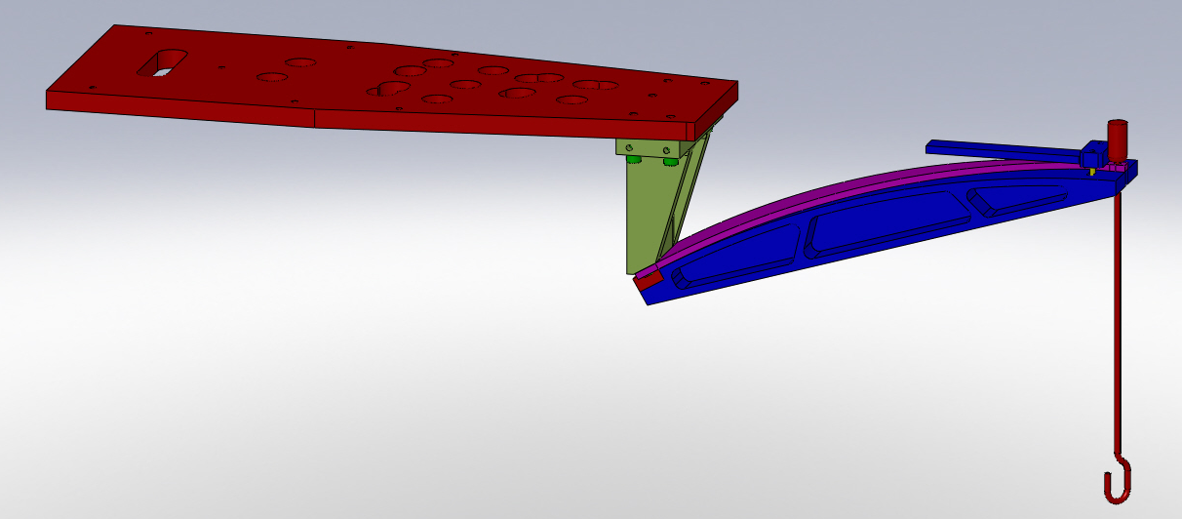
Figure 8: Spring Blade Loading

- Secure D1200139 - INTERFACE MOUNTING PLATE with (4) D1001700 - SLC INTERFACE MOUNTING CLAMP spread to distribute weight to table so that it can sustain 60 lbs. suspended from bracket.

- Attach D1101298 - BLADE SPRING BENDING HOOK ASSEMBLY to tip of D1002753 - SUSPENSION BLADE.

- Attach approx. 40lbs of weights onto hook end of D1101298 - BLADE SPRING BENDING HOOK ASSEMBLY bending SUSPENSION BLADE to align with curve on BEND FIXTURE. Weight opening placement should be staggered.

- Attach D1101184 - aLIGO ACB BEND FIXTURE PLATE to D1101099 - ITM ELLIPTICAL BAFFLE BEND FIXTURE with D1002753 - SUSPENSION BLADE sandwiched between both parts. This should be done when spring is fully bent.
  - Install hardware in 2 places
    - 92200A246 (10-24 x 7/8 SHCS)
Note: SUSPENSION BLADE should be securely attached to BEND FIXTURE before continuing to next step.

- Slowly remove weights and D1101298 - BLADE SPRING BENDING HOOK ASSEMBLY.

- Carefully release D1200139 - INTERFACE MOUNTING PLATE from table.

- Flip assembly over and place securely on table.

- Temporarily attach (1) D1001700 – SLC INTERFACE MOUNTING CLAMP to D1200139 - INTERFACE MOUNTING PLATE - closer to the BLADE MOUNTING BRACKET to ensure clearance for removal. This will secure MOUNTING PLATE to table during assembly.

- Carefully detach the assembled D1002609 - SLC BLADE MOUNTING BRACKET from the D1200139 - INTERFACE MOUNTING PLATE, rotate 180˚ and re-attach to table.
  - Removing and installing hardware in 4 places
    - C-1820-N (5/16-18 x 1 ¼ SHCS)
    - 98019A385 (5/16 FLAT WASHER)
Note: Do not install a screw to the center hole of BLADE MOUNTING BRACKET.

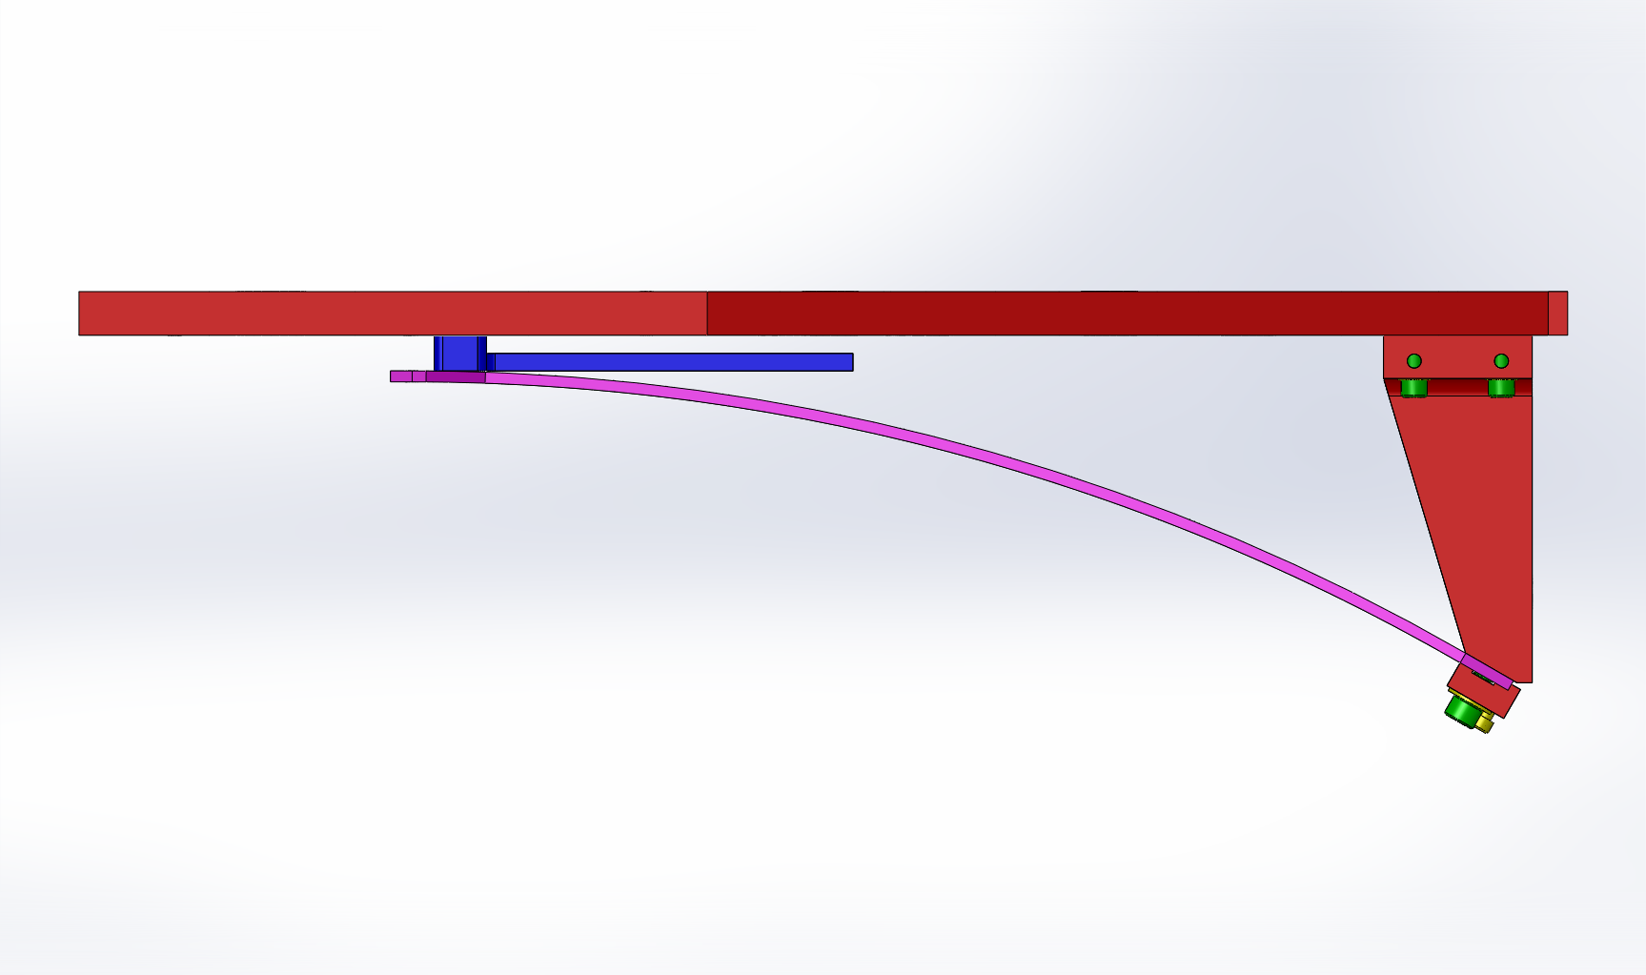

Figure 9: Blade Mounting Bracket position

- Remove D1101099 - aLIGO ACB BEND FIXTURE from D1002844 – SLC ACB BLADE CLAMP.
  - Remove hardware installed in 6 places. See Steps #4 & #9
    - (2) C-2016-NA (1/4-20 x 1 SHCS Ag) upper placement
    - (2) C-2012-NA (1/4-20 x ¾ SHCS Ag) lower placement
    - (2) 92200A246 (10-24 x 7/8 SHCS)

- Attach D1200781 - SLC ACB SUSPENSION ROD to tip of SUSPENSION BLADE. Short threaded end into blade tip. Orient the flat of rod so that a wrench can hold the flat from the blade tip direction, see Figure 10.
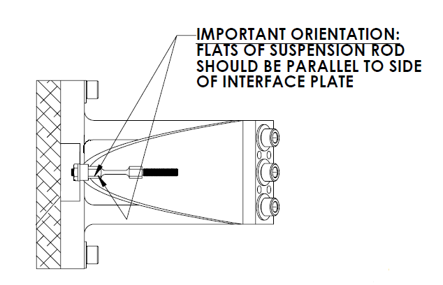

Figure 10: Suspension Rod

Note: Suspension Rod orientation is important. Make sure Suspension Rod is lined up with the center hole of the Interface Mounting Plate.

ITM ELLIPTICAL BAFFLE SUSPENSION ASSEMBLY – D1101885

LIGO PART SERIAL NUMBERS MUST BE RECORDED FOR ICS ASSEMBLIES

LIGO Parts:
(1) D1002582 - SLC BAFFLE TUBE UP ASSEMBLY SN:____________
(1) D1200140 – ITM ELLIPTICAL BAFFLE BLADE ASSEMBLY SN:____________
(1) D1002564-02 - EDDY CURRENT DAMPING 8 DIA TUBE ASSY SN:____________
(2) D1201361 - EARTHQUAKE STOP SLEEVE SN:____________
(2) D1201235 – LOCKED THREADED STUD SN:____________
(2) D1001120 - SLC EARTHQUAKE STOP RING SN:____________
(1) D1101887 - ITM ELLIPTICAL BAFFLE TUBE LO ASSEMBLY SN:____________
(1) D1200338 - ITM ELLIPTICAL BAFFLE TOP MOUNTING PLATE SN:____________
(1) D1001186 - 3/4-10 x 4 HEX HEAD SCREW, MODIFIED SN:____________
(2) D1102316 - ¾-10 x 3/8 NI-CU HEX NUT, MODIFIED SN:____________
(1) D1101285 – TRANSPORT, LOCKING BRACKET SN:____________

LIGO Assemblies:
- D1201228 – ANTI-ROTATION ASSEMBLY
(1) D1201199– ANTI-ROTATION CLAMP
(1) D1201198– ANTI-ROTATION BLOCK
(6) 1185-5EN938 (HELICOIL, 5/16-18 X 0.938 LONG)
(4) 1185-4EN250 (HELI-COIL INSERT, 1/4-20 X 1/4 LG)
(6) C-1832-N (5/16-18 x 2 SHCS)
(6) WF-31 (5/16 FLAT WASHER)

Hardware:
(1) N-1024-A (10-24 HEX NUTS Ag)
(4) 98019A330 (#10 FLAT WASHER)
(4) C-2016-NA (1/4-20 x 1 SHCS Ag)
(8) 98019A355 ( ¼ FLAT WASHER)
(4) N-3816 (3/8-16 HEX NUT)
(4) 92200A242 (10-24 x 1/2 SHCS)
(4) C-2016-N (1/4-20 x 1 SHCS)
(3) 98017A220 (3/4 FLAT WASHER)
(2) 98370A019 (#.375 X .75 OD WASHER)
(4) 98019A509 (.50 FLAT WASHER)
(1) 90945A741 (#10 FLAT WASHER)
(4) 92200A541 (1/4-20 X .875 SHCS)
(6) 1185-4EN250 (HELI-COIL INSERT, 1/4-20 X 1/4 LG)
(2) V1156 2-116 (2-116 FKM VITON O-RINGS 75D BLACK PARKER V747-75)

Tooling/Fixtures:
(1) D1101288 - ALIGNMENT FIXTURE, TUBE UP ASSEMBLY
(1) D1201252 – VARIABLE HEIGHT BRACKET
(1) D1201250 – SUSPENSION ROD GAUGE
(1) D1201014 – MAGNET SPACING TOOL

Tooling/Fixture Hardware:
(4) C-2016-NA (1/4-20 x 1 SHCS Ag)
(19) 98019A355 (¼ FLAT WASHER)
(13) 92200A540 (¼-20 x ¾ SHCS)
(1) N-2520-A (¼-20 HEX NUT Ag)

Tools:
1/4” Hex L-Key tool (5/16-18 SHCS)
1/8” Hex L-Key tool (10-24 FHCS)
3/8” Wrench (#10 Hex Nut)
3/16” Hex L-Key tool (¼-20 SHCS)
5/32” Hex L-Key tool (10-24 SHCS)
9/16” Wrench (3/8-16 Stud/Nut)
1-1/8” Wrench (¾-10 Nut)
(2) 1 1/8” Hex L-Key tool (10-32 SHCS)

Install Heli-Coil inserts into D1201198 – ANTI-ROTATION BLOCK.

Install hardware in 10 places.

(4) 1185-4EN250 (HELI-COIL INSERT, 1/4-20 X 1/4 LG)

(6) 1185-5EN938 (HELICOIL, 5/16-18 X 0.938 LONG)

Install Heli-Coil inserts into D1200338 - ITM ELLIPTICAL BAFFLE TOP MOUNTING PLATE Install hardware in 6 places.

(6) 1185-4EN250 (HELI-COIL INSERT, 1/4-20 X 1/4 LG)

Add V1156 2-116 - O-Rings to D1000909 – SLC COPPER PLATE securely, 2 places.

THE FOLLOWING ASSEMBLY PROCEDURE IS PERFORMED UPSIDE DOWN WITH THE INTERFACE MOUNTING PLATE ON A TABLE

- Attach hardware to D1200781 - SLC ACB SUSPENSION ROD. Located on D1200140 - ITM ELLIPTICAL BAFFLE BLADE ASSEMBLY.
  - Install hardware in 1 place
    - N-1024-A (10-24 HEX NUT)
    - 98019A330 (#10 FLAT WASHER)

Using the D1201250 – SUSPENSION ROD GAUGE, install hardware on long tread of rod. Once measurement is taken loosen nut 1 ½ turns before placing tube. Be very careful not to bend the suspension rod.
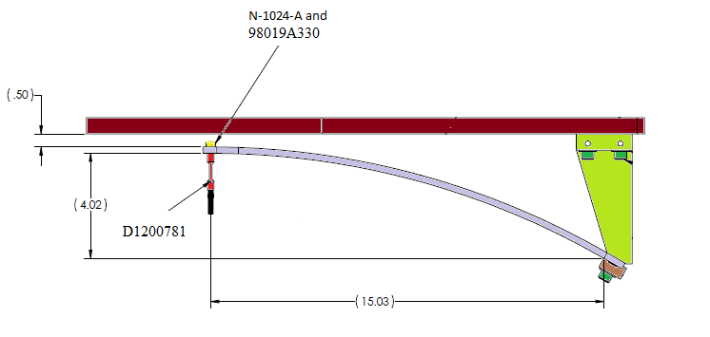

Figure 11: Suspension Rod Hardware

- Temporarily place D1002564 - SLC EDDY CURRENT DAMPING 8 DIAMETER TUBE ASSEMBLY to align earthquake holes to D1002582 - SLC BAFFLE TUBE UP ASSEMBLY. Once aligned remove D1002564 - SLC EDDY CURRENT DAMPING 8 DIAMETER TUBE ASSEMBLY.

- Attach D1002582 - SLC BAFFLE TUBE UP ASSEMBLY to D1200781 - SLC ACB SUSPENSION ROD located on D1200140 – ITM ELLIPTICAL BAFFLE BLADE ASSEMBLY. Screw the TUBE UP ASSEMBLY into the rod until it touches the D1201250 – SUSPENSION ROD GAUGE.

- Attach D1101288 - ALIGNMENT FIXTURE, TUBE UP ASSEMBLY to D1200139 - INTERFACE MOUNTING PLATE on D1200140 – ITM ELLIPTICAL BAFFLE BLADE ASSEMBLY. Bottom slotted part must be loose to slide to the interface plate.
  - Install hardware in 2 places
    - C-2016-NA (1/4-20 x 1 SHCS Ag)
    - 98019A355 (¼ FLAT WASHER)

- Align and level D1002582 - SLC BAFFLE TUBE UP ASSEMBLY. Have measuring fixture in place while twisting TUBE UP.

- Attach D1101288 - ALIGNMENT FIXTURE, TUBE UP ASSEMBLY to the bottom of D1002582 - SLC BAFFLE TUBE UP ASSEMBLY.
  - Install hardware in 2 places
- C-2016-N (1/4-20 x 1 SHCS)
- 98019A355 (¼ FLAT WASHER)

Recheck measurement by holding suspension rod in place with wrench. With an addition wrench tighten the nut at correct measurement. Be sure not to let rod twist.

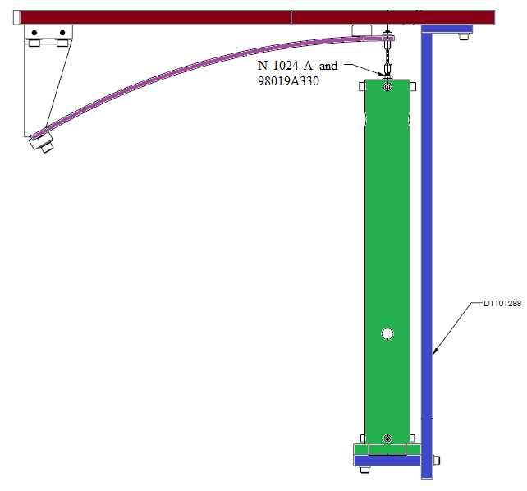

Figure 12: Suspension Rod and Tube Up Assy

Remove D1101288 - ALIGNMENT FIXTURE, TUBE UP ASSEMBLY.
  - Remove hardware in 4 places

C-2016-NA (1/4-20 x 1 SHCS Ag)
    - 98019A355 (¼ FLAT WASHER)

- Place D1002564 - SLC EDDY CURRENT DAMPING 8 DIAMETER TUBE ASSEMBLY on D1200140 – ITM ELLIPTICAL BAFFLE BLADE ASSEMBLY. With one person holding base of UP TUBE ASSY, then reaching inside of 8” TUBE and grabbing loose end of UP TUBE ASSY.

Insert (2) D1201235 – LOCKED THREADED STUD through D1002564 - SLC EDDY CURRENT DAMPING 8 DIAMETER TUBE ASSEMBLY and D1002582 - SLC BAFFLE TUBE UP ASSEMBLY. Mate STUD to (2) D1201361 - EARTHQUAKE STOP SLEEVE. TUBE UP ASSY needs to be held while threaded studs are getting placed.
  - Install hardware in 2 places (stud, .5 washer, tube, .5 washer, sleeve, 3/8 washer, nut).

98017A200 (3/8 FLAT WASHER)

98019A509 (FLAT WASHER .50 Sz)

91845A031 (3/8-16 HEX NUT)

- Attach D1002564 - SLC EDDY CURRENT DAMPING 8 DIAMETER TUBE ASSEMBLY to D1200140 – ITM ELLIPTICAL BAFFLE BLADE ASSEMBLY. Measurement from end of mounting plate to base of 8” TUBE should be ½”. TUBE UP ASSY still being held in place until EQ RING in Step 27 is in place.
  - Install hardware in 4 places
    - C-2016-NA (1/4-20 x 1 SHCS Ag)
    - 98019A355 (¼ FLAT WASHER

- Attach (2) D1001120 - SLC EARTHQUAKE STOP RING to D1002564 - SLC EDDY CURRENT DAMPING 8 DIAMETER TUBE ASSEMBLY.
  - Install hardware in 4 places
    - 92200A242 (10-24 x ½ SHCS)
    - 98019A330 (#10 FLAT WASHER)

- Attach D1101887 - ACB TUBE LO ASSEMBLY to D1002582 - SLC BAFFLE TUBE UP ASSEMBLY. Loosely, do not tighten.
  - Install hardware in 4 places
    - C-2016-N (1/4-20 x 1 SHCS)
    - 98019A355 (¼ FLAT WASHER)

- Adjust distance between the magnets and COPPER PLATE to be 0.090” using D1201014 – MAGNET SPACING TOOL. Tighten screws from Section II.C.4.

- Attach D1101285 - TRANSPORT, LOCKING, ACB to D1002564 - SLC EDDY CURRENT DAMPING 8 DIAMETER TUBE ASSEMBLY and D1101887 - TUBE LO ASSEMBLY. Place on side next to BLADE base. Align flush to 8” TUBE edge and tighten.
  - Install hardware in 4 places
    - C-2016-N (1/4-20 x 1 SHCS)
- 98019A355(¼ FLAT WASHER)
- Tighten TUBE LO ASSY to TUBE UP ASSY and loosen D1101285 - TRANSPORT, LOCKING, ACB.

- Assemble D1200338 - ITM ELLIPTICAL BAFFLE TOP MOUNTING PLATE to D1001186 (SCREW HEX HD 3/4-10 x 4, MODIFIED)
  - Install hardware listed (screw, washer, plate, washer, nut, nut, washer, tube)
    - (2) D1102316 (3/4-10 x 3/8 HEX NUT NI-CU, MODIFIED)
    - (3) 98017A220 (¾ FLAT WASHER)

Attach D1201198 – ANTI-ROTATION BLOCK to D1200338 - ITM ELLIPTICAL BAFFLE TOP MOUNTING PLATE.
  - Install hardware in 6 places
    - C-2012-N (1/4-20 x ¾ SHCS)
    - WF-25 (1/4 FLAT WASHER)

Insert D1001186 (SCREW HEX HD 3/4-10 x 4, MODIFIED) into D1101887 - TUBE LO ASSEMBLY. Screw in approximately 1.5 inches. Final rest should have the D1200338 - ITM ELLIPTICAL BAFFLE TOP MOUNTING PLATE pointing away from the D1000909 – SLC COPPER PLATE.

Attach D1201252 VARIABLE HEIGHT BRACKET to 8” TUBE. Edge of BRACKET should be flush with 8” TUBE base. Tighten to 8” TUBE base.

Install hardware in 2 places.

92200A540 (1/4-20 x 3/4 SHCS)

98019A355 (¼ FLAT WASHER)

- Adjust distance between D1200338 - ITM ELLIPTICAL BAFFLE TOP MOUNTING PLATE and D1101887 - TUBE LO ASSEMBLY by Bolt and Nuts. The scribe line on D1201198 – ANTI-ROTATION BLOCK must line up with the scribe line on D1201252 VARIABLE HEIGHT BRACKET.

- Attach D1201252 VARIABLE HEIGHT BRACKET to D1200338 - ITM ELLIPTICAL BAFFLE TOP MOUNTING PLATE and D1201198 – ANTI-ROTATION BLOCK.

Install hardware in 4 places.

92200A540 (1/4-20 x 3/4 SHCS)

98019A355 (¼ FLAT WASHER)

- Tighten D1001186 - SCREW HEX HD 3/4-10 x 4, MODIFIED against D1200338 - ITM ELLIPTICAL BAFFLE TOP MOUNTING PLATE and D1101887 - TUBE LO ASSEMBLY.

- Attach D1201199 – ANTI-ROTATION CLAMP to the D1201198 – ANTI-ROTATION BLOCK.
- Install hardware in 6 places

C-1832-N (5/16-18 x 2 SHCS)

WF-31 (5/16 FLAT WASHER)

- Set spacing between MAGNETS and COPPER PLATE to approximately 0.090 using D1201014 – MAGNET SPACING TOOL. Tighten the COPPER PLATE to the 8” TUBE.

Torque all screws, as required.

Weigh assembly and record: _______________ lbs. (kg/grams)

