LASER INTERFEROMETER GRAVITATIONAL WAVE OBSERVATORY
-LIGO-
CALIFORNIA INSTITUTE OF TECHNOLOGY
MASACHUSETTS INSTITUTE OF TECHNOLOGY
LIGO-E1200659-v2 5/28/13

AOS SLC BS Elliptical Baffle Install

Hazard Analysis
Michael Smith

LIGO Hanford Observatory LIGO Livingston Observatory
P.O. Box 1970; Mail Stop S9-02 19100 LIGO Lane
Richland, WA 99352 Livingston, LA 70754
Phone (509) 37208106 Phone (225) 686-3100
Fax (509) 372-8137 Fax (225) 686-7189
E-mail: info@ligo.caltech.edu E-mail: info@ligo.caltech.edu

California Institute of Technology Massachusetts Institute of Technology
LIGO – MS 100-36 LIGO – MS NW22-295
Pasadena, CA 91125 Cambridge, MA 02139
Phone (626) 395-2129 Phone (617) 253-4824
Fax (626) 304-9834 Fax (617) 253-7014
E-mail: info@ligo.caltech.edu E-mail: info@ligo.mit.edu

APPROVAL SIGNATURES

___________________________________________________________
Michael Smith, SLC Date

___________________________________________________________
Lisa Austin, SLC Subsystem Leader Date

___________________________________________________________
Dennis Coyne, LIGO Chief Engineer Date

___________________________________________________________
Richard Oram, LLO Operations Manager Date

___________________________________________________________
John Worden, LHO Operations Manager Date

__________________________________________________________
Brian O’Reilly, Advanced LIGO LLO Installation Lead Date

__________________________________________________________
Michael Landry, Advanced LIGO LHO Installation Lead Date

__________________________________________________________
David Shoemaker, aLIGO Leader Date

__________________________________________________________
David Nolting, LIGO Lab Safety Officer Date

__________________________________________________________
Albert Lazzarini, LIGO Directorate Date

CHANGE LOG

Date, version | Summary of Changes
5/28/13  V2 | - Corrected signature page  - Added sharp edge cutting hazard  - Corrected documentation Sec. 4  - Added damage to BS optic and suspension  - Added reference to E1200660 AOS SLC BS Ellip Baf Installation Doc

Table of Contents
1. Scope 5
2. Summary of Hazards 6
2.1. BS Elliptical Baffle 6
3. Overview 7
3.1. BS Elliptical Baffle 7
4. Related Documentation 9
5. Hazard Analysis 10
5.1. Injury to Body Parts 10
5.2. Eye Damage from Exposure to Infrared Radiation 10
5.3. Sharp Edges Present a Cutting Hazard 10
5.4. Damage to BS Suspension 10
6. BS Elliptical Baffle Hazard Analysis Severity Table 11

Table of Figures
Figure 1: Model of BS Elliptical Baffles Installed on the BS SUS 7

Scope
This document covers safety concerns related to the installation and alignment of the BS Elliptical Baffle on the cartridge or in the BSC chamber of Advanced LIGO. It must be read before beginning the installation, and used in conjunction with E1200660 AOS SLC BS Ellip Baf Installation Doc.

Summary of Hazards

BS Elliptical Baffle
The major hazards to be aware of during installation and alignment of the BS Elliptical Baffles include:

- Injury to body parts as a result of working in a cramped and confined space (4E)
- Eye damage from exposure to infrared autocollimator beam (4E)
- Eye damage from exposure to infrared autocollimator beam (4E)
- Sharp edges present a cutting hazard (4D)
- Damage to BS mirror and suspension (4D)

These hazards are described in detail later in the document.

Overview

BS Elliptical Baffle
A model of the BS Elliptical Baffle is shown in Error! Reference source not found..

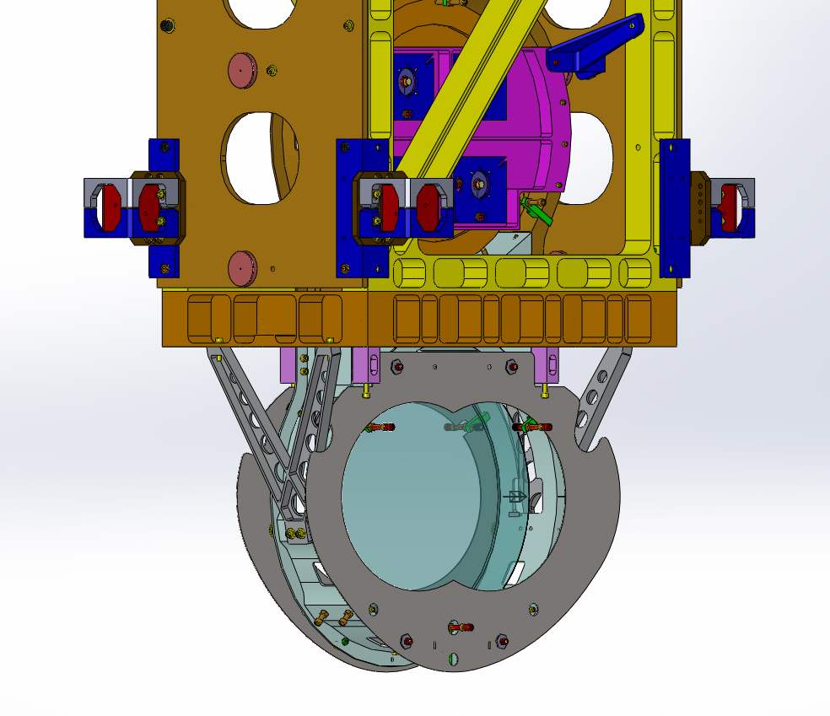
Figure 1: Model of BS Elliptical Baffles Installed on the BS SUS

The 5 lb BS Elliptical Baffle (both baffles plus hardware) is attached to the BS SUS lower frame, as shown in Figure 1. Installation and alignment may occur either on the cartridge or within the BSC.
- The Baffles will be attached, using special mounting hardware, after the BS mirror and suspension structure have been installed and aligned on the BSC ISI optical platform.
- A target will be mounted temporarily to the center of the Baffle, and the Baffle will be moved horizontally and vertically within the mounting clearance holes until the target aligns with an alignment theodolite.
- After alignment, the Baffle will be secured with its mounting bolts, and the target will be removed.
- In the event that access is needed for maintenance of the BS mirror, the Baffles will be removed together with the mounting studs. After repair of the BS mirror, the Baffle will be re-installed without the need for subsequent alignment by simply re-inserting and fastening the mounting studs.

During installation of the BS Elliptical Baffle, a task leader will be assigned to supervise all activities.

Related Documentation

E1200660 AOS SLC BS Ellip Baf Installation Doc
Advanced LIGO Safety: Processes and Guidelines (LIGO-M070360)
LIGO Project System Safety Plan (LIGO-M950046)
LIGO Contamination Control Plan (LIGO-E0900047)
aLIGO Chamber Entry/Cleaning/Exit Checklist (LIGO-E1201035)
LLO Safety Procedure documents (http://www.ligo-la.caltech.edu/contents/internalmain.htm)

Hazard Analysis

Injury to Body Parts
The BS Elliptical Baffle will be installed and aligned in situ on the cartridge or within the BSC chamber. Injury to a person’s head or other body parts may occur as a result of working in a cramped and confined space, encumbered with clumsy clean-room garb.

Eye Damage from Exposure to Infrared Radiation
A visible theodolite or a high power infrared autocollimator beam may be projected onto the surface of the BS Elliptical Baffle during the alignment of the baffle. Directly viewing the light beam could cause permanent damage to the retina.
This hazard can be eliminated by using proper laser eye protection glasses or goggles during the autocollimator alignment procedure.

Sharp Edges Present a Cutting Hazard
The baffle is fabricated from a thin piece of metal; beam passage holes are intentionally sharp-edged. A potential hazard exists for receiving cuts if parts are handled improperly. Each team member should inspect to their satisfaction the prospective part to be handled to determine if that part has a potentially hazardous sharp edge. In general, avoid grasping the sharp edge of baffle holes; use Teflon a shield if necessary when grasping the sharp baffle edges by hand. Hands may also be pinched when assembling parts to one another, but this can be mitigated with proper attention to handling the parts.

Damage to BS Suspension
The BS Elliptical Baffle will be attached directly to the BS triple suspension structure. Dropping a tool or object onto the BS suspension structure or touching the BS optical surfaces may cause serious damage to the structure or to the mirror.
Extreme care must be taken to avoid touching the mirror or the delicate suspension parts.

6. BS Elliptical Baffle Hazard Analysis Severity Table

Item # | Hazard | Cause | Effect | Unmitigated  Severity | Unmitigated  Probability  Level | Unmitigated Risk Index | Comment | Mitigation | Mitigation Severity | Mitigated Probability Level | Mitigated Risk Index
1 | Bodily injury | Bumping into rigid structures | Injury to personnel | marginal | occasional | 3C | Head injury is possible | Be observant of hazardous structures | minor | improbable | 4E
2 | Eye Damage | Direct viewing of infrared beam | Injury to personnel | Critical | occasional | 2C | Permanent retinal damage | Use Laser protective eye wear | minor | improbable | 4E
3 | Cutting hazard | Sharp edges present a cutting hazard | Injury to personnel | critical | remote | 2D | Beam passage holes in scraper baffles are intentionally sharp edged | In general, avoid grasping the sharp edge of baffle holes. Use Teflon shield if necessary when grasping the sharp baffle edges by hand. | minor | remote | 4D
4 | Damage to BS and Suspension | Bumping of BS SUS, or impact to BS optic | Misalignment or damage to BS SUS and mirror | critical | occasional | 2C | Use barrier between ITM Ellip Baf and BS SUS; Place BS optic on EQ stops; Cover BS optic with protective cover | marginal | marginal | remote | 3D

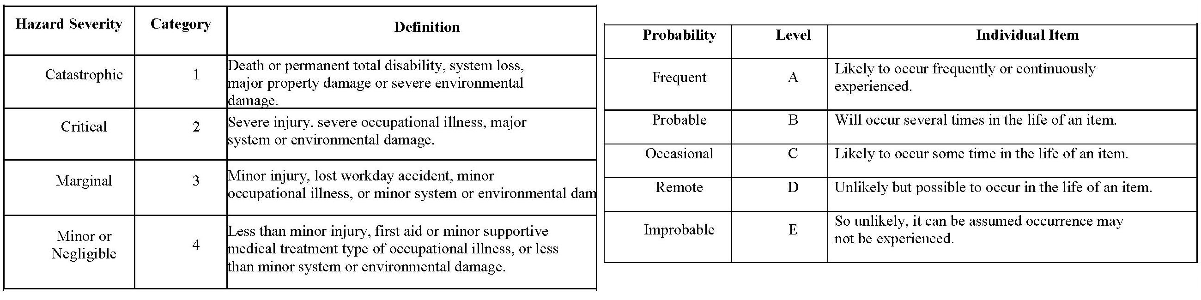

 |  |  | PROBABILITY
SEVERITY OF | E | D | C | B | A
CONSEQUENCE | Improbable | Remote | Occasional | Probable | Frequent
1
Catastrophic
2
Critical
3
Marginal
4
Negligible
Hazard Risk Index |  |  | Risk Code Criteria
1A, 1B, 1C, 2A, 2B, 3A |  | Unacceptable
1D, 2C, 2D, 3B, 3C |  | Undesirable (Directorate decision required)
1E, 2E, 3D, 3E, 4A, 4B |  | Acceptable with review by Directorate
4C, 4D, 4E |  | Acceptable without review

