LIGO Laboratory / LIGO Scientific Collaboration

LIGO- E200632-v1 Advanced LIGO 6/15/2012

TwinCAT Library for
ALS Laser

Alexa Staley, Daniel Sigg

Distribution of this document:
LIGO Scientific Collaboration

This is an internal working note
of the LIGO Laboratory.

California Institute of Technology  LIGO Project – MS 18-34  1200 E. California Blvd.  Pasadena, CA 91125  Phone (626) 395-2129  Fax (626) 304-9834  E-mail: info@ligo.caltech.edu | Massachusetts Institute of Technology  LIGO Project – NW22-295  185 Albany St  Cambridge, MA 02139  Phone (617) 253-4824  Fax (617) 253-7014  E-mail: info@ligo.mit.edu
LIGO Hanford Observatory  P.O. Box 159  Richland WA 99352  Phone 509-372-8106  Fax 509-372-8137 | LIGO Livingston Observatory  P.O. Box 940  Livingston, LA 70754  Phone 225-686-3100  Fax 225-686-7189
http://www.ligo.caltech.edu/

Library
Title | ALSLaser
Version | 1
TwinCAT version | 2.11
Name space | –
Author | Alexa Staley, Daniel Sigg
Description | Controls the ALS Laser
Error codes | None
Library dependencies | Error

Hardware Input Type
TYPE ALSLaserInStruct :
STRUCT
LaserDiode1PowerMonitor: INT;
LaserDiode2PowerMonitor: INT;
LaserCrystalTECErrorSignal: INT;
DoublingCrystalTECErrorSignal: INT;
LaserDiode1TECErrorSignal: INT;
LaserDiode2TECErrorSignal: INT;
NoiseEaterMonitor: INT;
LaserDiode1TempGuard: BOOL;
LaserDiode2TempGuard: BOOL;
InterLock: BOOL;
END_STRUCT
END_TYPE
Type name | ALSLaserInStruct
Description | Structure of the hardware input that are wired up for the ALS laser
Definition | STRUCT
Element | Name: LaserDiode1PowerMonitor  Type: INT  Description: Laser diode 1 power monitor
Element | Name: LaserDiode2PowerMonitor  Type: INT  Description: Laser diode 2 power monitor
Element | Name: LaserCrystalTECErrorSignal  Type: INT  Description: Laser crystal, TEC error signal
Element | Name: DoublingCrystalTECErrorSignal  Type: INT  Description: Doubling crystal, TEC error signal
Element | Name: LaserDiode1TECErrorSignal  Type: INT  Description: Laser diode 1, TEC error signal
Element | Name: LaserDiode2TECErrorSignal  Type: INT  Description: Laser diode 2, TEC error signal
Element | Name: NoiseEaterMonitor  Type: INT  Description: Noise eater monitor
Element | Name: LaserDiode1TempGuard  Type: BOOL  Description: Laser diode 1, temp guard
Element | Name: LaserDiode2TempGuard  Type: BOOL  Description: Laser diode 2, temp guard
Element | Name: InterLock  Type: BOOL  Description: InterLock

Hardware Output Type
TYPE ALSLaserOutStruct :
STRUCT
CrystalTemperature: INT;
DoublerTemperature: INT;
END_STRUCT
END_TYPE
Type name | ALSLaserOutStruct
Description | Structure of the hardware output that are wired up for the ALS laser
Definition | STRUCT
Element | Name: CrystalTemperature  Type: INT  Description: Crystal Temperature
Element | Name: DoublerTemperature  Type: INT  Description: Doubler Temperature

User Interface Type
TYPE ALSLaserStruct :
STRUCT
LaserDiode1PowerMonitor: LREAL;
LaserDiode2PowerMonitor: LREAL;
LaserCrystalTECErrorSignal: LREAL;
DoublingCrystalTECErrorSignal: LREAL;
LaserDiode1TECErrorSignal: LREAL;
LaserDiode2TECErrorSignal: LREAL;
NoiseEaterMonitor: LREAL;
LaserDiode1TempGuard: BOOL;
LaserDiode2TempGuard: BOOL;
InterLock: BOOL;
CrystalTemperature: LREAL;
DoublerTemperature: LREAL;
Error: ErrorStruct;
END_STRUCT
END_TYPE
Type name | ALSLaserStruct
Description | Structure of the user interface tags that are used to control the ALS Laser
Definition | STRUCT
Output Tag | Name: LaserDiode1PowerMonitor  Type: LREAL  Description: Laser diode 1 power monitor
Output Tag | Name: LaserDiode2PowerMonitor  Type: LREAL  Description: Laser diode 2 power monitor
Output Tag | Name: LaserCrystalTECErrorSignal  Type: LREAL  Description: Laser crystal, TEC error signal
Output Tag | Name: DoublingCrystalTECErrorSignal  Type: LREAL  Description: Doubling crystal, TEC error signal
Output Tag | Name: LaserDiode1TECErrorSignal  Type: LREAL  Description: Laser diode 1, TEC error signal
Output Tag | Name: LaserDiode2TECErrorSignal  Type: LREAL  Description: Laser diode 2, TEC error signal
Output Tag | Name: NoiseEaterMonitor  Type: LREAL  Description: Noise eater monitor
Output Tag | Name: LaserDiode1TempGuard  Type: BOOL  Description: Laser diode 1, temp guard
Output Tag | Name: LaserDiode2TempGuard  Type: BOOL  Description: Laser diode 2, temp guard
Output Tag | Name: InterLock  Type: BOOL  Description: InterLock
Input Tag | Name: CrystalTemperature  Type: LREAL  Description: Crystal Temperature
Input Tag | Name: DoublerTemperature  Type: LREAL  Description: Doubler Temperature
Output Tag | Name: Error  Type: ErrorStruct  Description: For error handler

Function Block
FUNCTION_BLOCK ALSLaserFB
VAR_INPUT
ALSLaserIn: ALSLaserInStruct;
END_VAR
VAR_OUTPUT
ALSLaserOut: ALSLaserOutStruct;
END_VAR
VAR_IN_OUT
ALSLaser: ALSLaserStruct;
END_VAR
Name | ALSLaserFB
Description | Controls the ALS laser
Input argument | Name: ALSLaserIn  Type: ALSLaserInStruct  Description: Input hardware structure
Output argument | Name: ALSLaserOut  Type: ALSLaserOutStruct  Description: Output hardware structure
In/out argument | Name: ALSLaser  Type: ALSLaserStruct  Description: User Interface structure

Visual
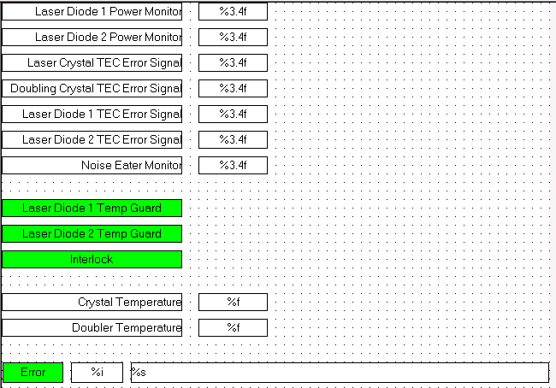
Name | ALSLaserVis
Description | Displays power monitors, error signals, and alarms for temp guard and error.
Placeholder | Name: ALSLaser  Type: ALSLaserStruct  Description: ALS laser structure

LIGO Laboratory / LIGO Scientific Collaboration

LIGO- E200632-v1 Advanced LIGO 6/15/2012

TwinCAT Library for
ALS Laser

Alexa Staley, Daniel Sigg

Distribution of this document:
LIGO Scientific Collaboration

This is an internal working note
of the LIGO Laboratory.

California Institute of Technology  LIGO Project – MS 18-34  1200 E. California Blvd.  Pasadena, CA 91125  Phone (626) 395-2129  Fax (626) 304-9834  E-mail: info@ligo.caltech.edu | Massachusetts Institute of Technology  LIGO Project – NW22-295  185 Albany St  Cambridge, MA 02139  Phone (617) 253-4824  Fax (617) 253-7014  E-mail: info@ligo.mit.edu
LIGO Hanford Observatory  P.O. Box 159  Richland WA 99352  Phone 509-372-8106  Fax 509-372-8137 | LIGO Livingston Observatory  P.O. Box 940  Livingston, LA 70754  Phone 225-686-3100  Fax 225-686-7189
http://www.ligo.caltech.edu/

Library
Title | ALSLaser
Version | 1
TwinCAT version | 2.11
Name space | –
Author | Alexa Staley, Daniel Sigg
Description | Controls the ALS Laser
Error codes | None
Library dependencies | Error

Hardware Input Type
TYPE ALSLaserInStruct :
STRUCT
LaserDiode1PowerMonitor: INT;
LaserDiode2PowerMonitor: INT;
LaserCrystalTECErrorSignal: INT;
DoublingCrystalTECErrorSignal: INT;
LaserDiode1TECErrorSignal: INT;
LaserDiode2TECErrorSignal: INT;
NoiseEaterMonitor: INT;
LaserDiode1TempGuard: BOOL;
LaserDiode2TempGuard: BOOL;
InterLock: BOOL;
END_STRUCT
END_TYPE
Type name | ALSLaserInStruct
Description | Structure of the hardware input that are wired up for the ALS laser
Definition | STRUCT
Element | Name: LaserDiode1PowerMonitor  Type: INT  Description: Laser diode 1 power monitor
Element | Name: LaserDiode2PowerMonitor  Type: INT  Description: Laser diode 2 power monitor
Element | Name: LaserCrystalTECErrorSignal  Type: INT  Description: Laser crystal, TEC error signal
Element | Name: DoublingCrystalTECErrorSignal  Type: INT  Description: Doubling crystal, TEC error signal
Element | Name: LaserDiode1TECErrorSignal  Type: INT  Description: Laser diode 1, TEC error signal
Element | Name: LaserDiode2TECErrorSignal  Type: INT  Description: Laser diode 2, TEC error signal
Element | Name: NoiseEaterMonitor  Type: INT  Description: Noise eater monitor
Element | Name: LaserDiode1TempGuard  Type: BOOL  Description: Laser diode 1, temp guard
Element | Name: LaserDiode2TempGuard  Type: BOOL  Description: Laser diode 2, temp guard
Element | Name: InterLock  Type: BOOL  Description: InterLock

Hardware Output Type
TYPE ALSLaserOutStruct :
STRUCT
CrystalTemperature: INT;
DoublerTemperature: INT;
END_STRUCT
END_TYPE
Type name | ALSLaserOutStruct
Description | Structure of the hardware output that are wired up for the ALS laser
Definition | STRUCT
Element | Name: CrystalTemperature  Type: INT  Description: Crystal Temperature
Element | Name: DoublerTemperature  Type: INT  Description: Doubler Temperature

User Interface Type
TYPE ALSLaserStruct :
STRUCT
LaserDiode1PowerMonitor: LREAL;
LaserDiode2PowerMonitor: LREAL;
LaserCrystalTECErrorSignal: LREAL;
DoublingCrystalTECErrorSignal: LREAL;
LaserDiode1TECErrorSignal: LREAL;
LaserDiode2TECErrorSignal: LREAL;
NoiseEaterMonitor: LREAL;
LaserDiode1TempGuard: BOOL;
LaserDiode2TempGuard: BOOL;
InterLock: BOOL;
CrystalTemperature: LREAL;
DoublerTemperature: LREAL;
Error: ErrorStruct;
END_STRUCT
END_TYPE
Type name | ALSLaserStruct
Description | Structure of the user interface tags that are used to control the ALS Laser
Definition | STRUCT
Output Tag | Name: LaserDiode1PowerMonitor  Type: LREAL  Description: Laser diode 1 power monitor
Output Tag | Name: LaserDiode2PowerMonitor  Type: LREAL  Description: Laser diode 2 power monitor
Output Tag | Name: LaserCrystalTECErrorSignal  Type: LREAL  Description: Laser crystal, TEC error signal
Output Tag | Name: DoublingCrystalTECErrorSignal  Type: LREAL  Description: Doubling crystal, TEC error signal
Output Tag | Name: LaserDiode1TECErrorSignal  Type: LREAL  Description: Laser diode 1, TEC error signal
Output Tag | Name: LaserDiode2TECErrorSignal  Type: LREAL  Description: Laser diode 2, TEC error signal
Output Tag | Name: NoiseEaterMonitor  Type: LREAL  Description: Noise eater monitor
Output Tag | Name: LaserDiode1TempGuard  Type: BOOL  Description: Laser diode 1, temp guard
Output Tag | Name: LaserDiode2TempGuard  Type: BOOL  Description: Laser diode 2, temp guard
Output Tag | Name: InterLock  Type: BOOL  Description: InterLock
Input Tag | Name: CrystalTemperature  Type: LREAL  Description: Crystal Temperature
Input Tag | Name: DoublerTemperature  Type: LREAL  Description: Doubler Temperature
Output Tag | Name: Error  Type: ErrorStruct  Description: For error handler

Function Block
FUNCTION_BLOCK ALSLaserFB
VAR_INPUT
ALSLaserIn: ALSLaserInStruct;
END_VAR
VAR_OUTPUT
ALSLaserOut: ALSLaserOutStruct;
END_VAR
VAR_IN_OUT
ALSLaser: ALSLaserStruct;
END_VAR
Name | ALSLaserFB
Description | Controls the ALS laser
Input argument | Name: ALSLaserIn  Type: ALSLaserInStruct  Description: Input hardware structure
Output argument | Name: ALSLaserOut  Type: ALSLaserOutStruct  Description: Output hardware structure
In/out argument | Name: ALSLaser  Type: ALSLaserStruct  Description: User Interface structure

Visual
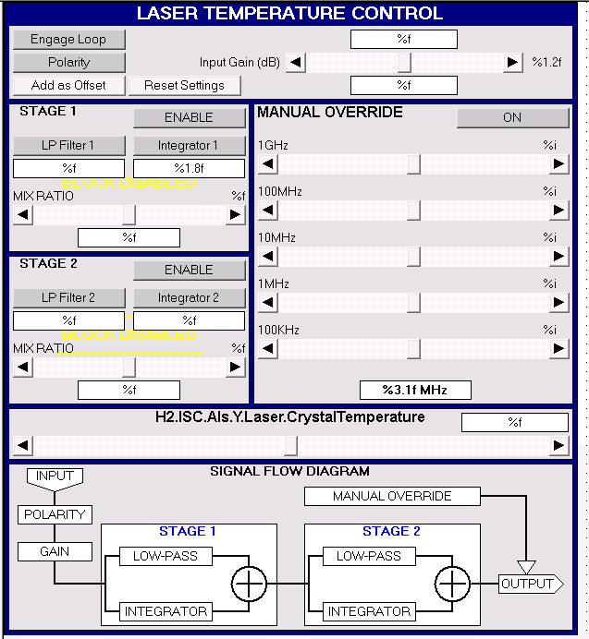
Name | LTC
Description | Displays laser temperature control
Placeholder | Name: None  Type:  Description:

