LIGO Laboratory / LIGO Scientific Collaboration

LIGO- E1200507 LIGO Dec 13th, 2012

aLIGO HAM-ISI, Installation Test Report, Phase II
Chamber-Side Testing & Initial Chamber Testing
LHO HAM6-ISI (iLIGO retrofitted)
E1200510-V1

Hugo Paris,
Hugh Radkins, Jim Warner, Mitchell Robinson, Greg Grabeel

Distribution of this document:
Advanced LIGO Project

This is an internal working note
of the LIGO Laboratory

California Institute of Technology  LIGO Project – MS 18-34  1200 E. California Blvd.  Pasadena, CA 91125  Phone (626) 395-2129  Fax (626) 304-9834  E-mail: info@ligo.caltech.edu | Massachusetts Institute of Technology  LIGO Project – NW22-295  185 Albany St  Cambridge, MA 02139  Phone (617) 253-4824  Fax (617) 253-7014  E-mail: info@ligo.mit.edu
LIGO Hanford Observatory  P.O. Box 1970  Mail Stop S9-02  Richland WA 99352  Phone 509-372-8106  Fax 509-372-8137 | LIGO Livingston Observatory  P.O. Box 940  Livingston, LA 70754  Phone 225-686-3100  Fax 225-686-7189

Table of contents:

I. CHAMBER SIDE TESTING 5
▪ Inventory 5
▪ Test 1 - CPS Check 7
▪ Test 2.1 – CPS spectra 8
▪ Test 2.2 – GS13 Spectra 8
▪ Test 2.3 – GS13 Pressure Readouts 10

PHASE II Testing

The phase II of HAM-ISI testing corresponds to the tests performed after the Assembly Validation, and before the Control and Commissioning of the Units. It is divided in two parts. The present document is divided in two sections: One for each part of the Phase II testing:

Part.1 Chamber-Side testing
Part.2 Initial Chamber Testing

Chamber-Side Testing is a basic sensor check. Units can be inserted in their chamber of destination once they pass.

Initial Chamber Testing takes place in open chamber, with the optics off, and HEPI locked. The ISI is then connected to the electronic rack with the final in-field cables. Models are installed and running. Tests are performed with Matlab® scripts.

Optics and Suspensions can be installed right after the end of this phase of testing. No test is performed during their installation.

Final Chamber Testing starts once Optics and Suspensions are installed. The lockers and the CPSs usually need to be reset at this point.

Introduction
Chamber-Side Testing

HAM6-ISI is an iLIGO unit. It was extracted from HAM6 chamber and set on a shipping container for chamber-side testing. The ISI was locked. No payload was installed, so the springs were fully locking stage 1 against the lockers. Final electronics, and models were used to run the chamber-side testing. Tests were performed between July 1st and July 3rd 2013.

This ISI did not receive aLIGO assembly validation testing. Its mechanical validation within the iLIGO scope was considered sufficient.

The goal of the Chamber-Side Testing is to ensure that the sensors and their electronics (ADE boxes of the CPSs) did not alter during storage/transportation.

In this instance, we use final in field electronics and cabling, as well as final Simulink models. This phase of testing is also a way to check that those elements are properly installed, and correctly functioning.

At the end of the Chamber-Side Testing:
- All sensors have been checked
- Data related to the tests is available on the SVN
- The HAM-ISI is on the chamber-side, ready for the in-chamber insertion

CHAMBER SIDE TESTING

Inventory

DCC Number | Part name | Configuration | Corner 1 S/N | Corner 2 S/N | Corner 3 S/N
D071001 | Stage 0 base | NA | iLigo
D071051 | Stage 1 base | NA | iLigo
D071050 | Optical table | NA | iLigo
D071002 | Spring Post | NA | iLigo | iLigo | iLigo
D071100 | Spring | NA | iLigo | iLigo | iLigo
D071102 | Flexure | NA | iLigo | iLigo | iLigo
ADE | Position sensor | Horizontal | 12043 | 12047 | 12005
 |  | Vertical | 12002 | 12052 | 12023
D047812 | GS-13 pod | Horizontal | 65 | 91 | 62
 |  | Vertical | 81 | 28 | 16
D047823 | L4C pod | Horizontal | NA | NA | NA
 |  | Vertical | NA | NA | NA
D0902749 | Actuator | Horizontal | iLigo | iLigo | iLigo
 |  | Vertical | iLigo | iLigo | iLigo
Table – Parts inventory

Cable Connects |  | Cable S/N
Part Name | Configuration | Corner 1 | Corner 2 | Corner 3
GS13 | Horizontal | S1104684  +S1104707 | S1107762  +S1106677 | S1107749  +S1106663
GS13 | Vertical
Actuator | Horizontal | S1104495 | S1104487 | S1104489
 | Vertical | S1106676 | S1104733 | S1104768
Table – Cables inventory

Hardware | LIGO reference | S/N
Coil driver | D0902744 | S1103566
 |  | S1103333
Anti Image filter | D070081 D1100202 | S1203131
Anti aliasing filter | D1000269 | S1203356
 |  | S1203357
Interface chassis | D1000067 | S1201746
 |  | S1201747
 |  | NA
Table - Inventory electronics

NA: Not applicable.

Issues/difficulties/comments regarding this test:
No aLIGO assembly validation testing for this unit. Inventory was added to the chamber-side testing.

Acceptance Criteria:
Inventory is complete

Test result: Passed: X Failed: .

Test 1 - CPS Check

During this step, we want to make sure that the CPSs, their cables and their electronics are functional.

Corner | Direction | Voltage | Sensor reacts to Target move
 |  | (No shim)
1 | H | NR | X
 | V | NR | X
2 | H | NR | X
 | V | NR | X
3 | H | NR | X
 | V | NR | X
Table – CPS Check
NR: Not Recorded

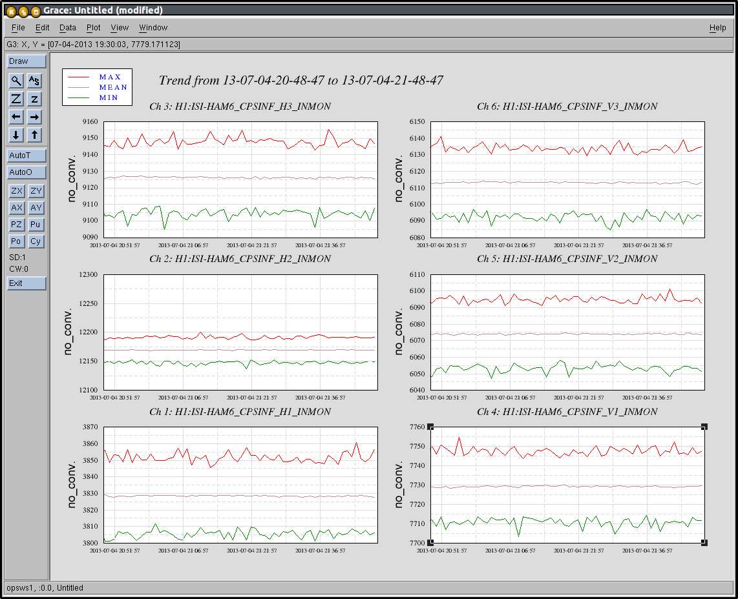
Figure – CPS readouts

Issues/difficulties/comments regarding this test:
Voltage not recorded but readouts within expected range after target setup.

Acceptance Criteria:
- All CPS were tested
- All CPS react to shim insertion/moving target
- The voltages recorded with no shim are within ⁺/-5V.

Test result: Passed: X Failed: .

Test 2.1 – CPS spectra
During this step, we want measure the noise spectra of the CPSs and make sure that it is not too high.

Final in-filed electronics are used. The ISI is locked without payload. The springs are locking stage 1 against its lockers.

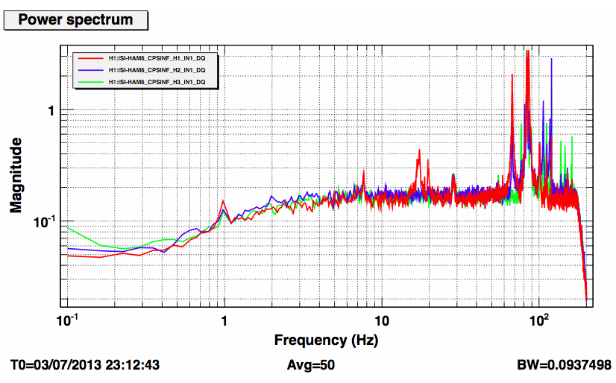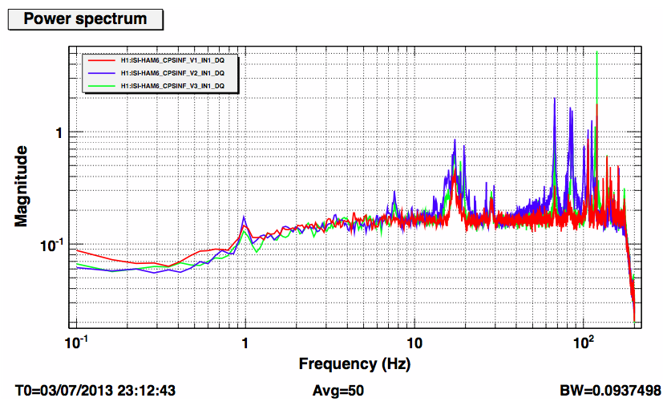
Figure – CPS Spectra

Data in the SVN at:
/SeiSVN/seismic/HAM-ISI/H1/HAM3/Data/Spectra/Chamber_Side/
2013_07_02_Sensor_Checkout .xml
2013_07_02_Sensor_Checkout .pdf

Issues/difficulties/comments regarding this test:
Measurements performed with DTT
Results presented in the LHO aLog #6983

Acceptance Criteria:
- CPS noise spectra must be below 10⁻⁴Vrms/√Hz
- Plots of Spectra are saved under the SVN

Test result: Passed: X Failed: .

Test 2.2 – GS13 Spectra
During this test we want to take spectra of the GS13s to make sure that they are still functional.

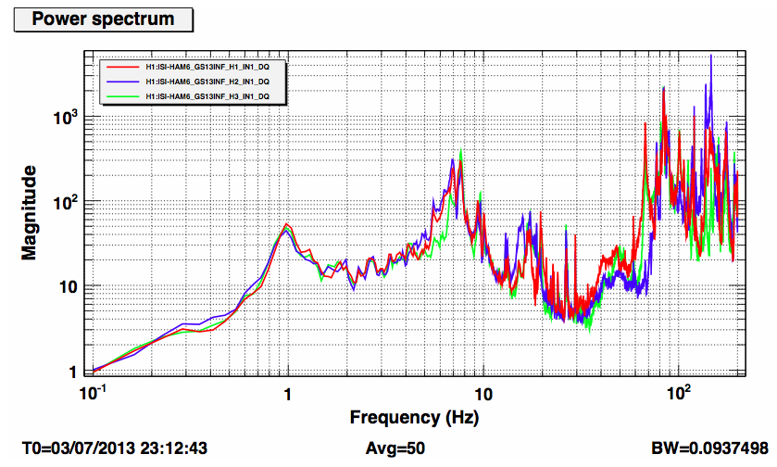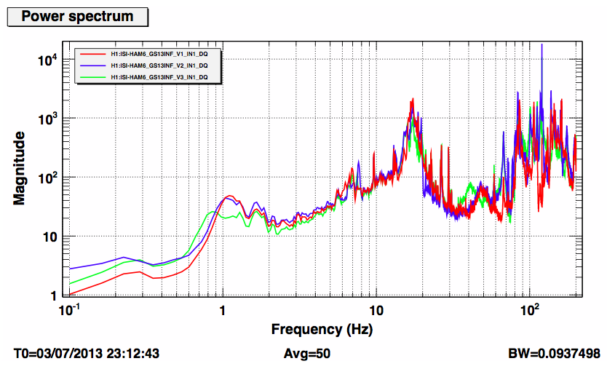
Figure – GS13 Spectra

Data in the SVN at:
/SeiSVN/seismic/HAM-ISI/H1/HAM3/Data/Spectra/Chamber_Side/
2013_07_02_Sensor_Checkout .xml
2013_07_02_Sensor_Checkout .pdf

Issues/difficulties/comments regarding this test:
- Measurements performed with DTT
- Results presented in the LHO aLog #6983
- Huddle tests prior to install can be found in LHO aLog #4058.

Acceptance Criteria:
- GS13s spectra match between corners.
- GS13s responses must not drop in low frequency
- Plots of power spectra are saved under the SVN

Test result: Passed: X Failed: .

Test 2.3 – GS13 Pressure Readouts
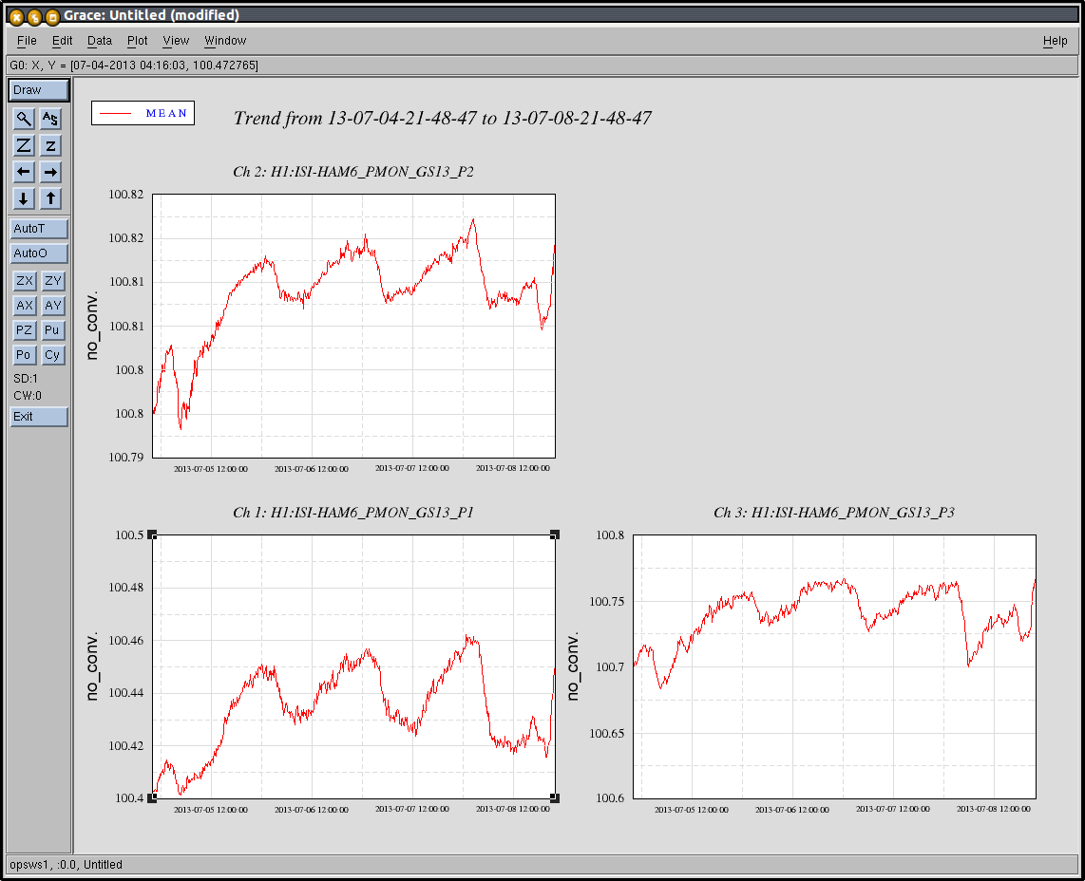
Figure – GS13 Pressure Readouts over 4 days

Acceptance criteria:
- The pressure on GS13_P channels must be 102KPa +/-8 KPa (25000 counts +/- 3000 counts)
- GS13_P must vary the same way in each corner and GS13_DIFF must be constant (channels follow comparable trend)

Test result: Passed: X Failed: .

Conclusion
Chamber-Side Testing

The tests presented here were performed between July 1st and July 3rd 2013.

All sensors appeared to be functional. Serial numbers were recorded.

HAM6-ISI was left ready for in-chamber insertion.

In-Chamber insertion was performed on July 11th 2013. Initial In-Chamber Testing will follow.

