LIGO Laboratory / LIGO Scientific Collaboration

LIGO- E1200424-v3 Advanced LIGO 6/29/2012

TwinCAT Library for ISC Whitening Chassis

Daniel Sigg

Distribution of this document:
LIGO Scientific Collaboration

This is an internal working note
of the LIGO Laboratory.

California Institute of Technology  LIGO Project – MS 18-34  1200 E. California Blvd.  Pasadena, CA 91125  Phone (626) 395-2129  Fax (626) 304-9834  E-mail: info@ligo.caltech.edu | Massachusetts Institute of Technology  LIGO Project – NW22-295  185 Albany St  Cambridge, MA 02139  Phone (617) 253-4824  Fax (617) 253-7014  E-mail: info@ligo.mit.edu
LIGO Hanford Observatory  P.O. Box 159  Richland WA 99352  Phone 509-372-8106  Fax 509-372-8137 | LIGO Livingston Observatory  P.O. Box 940  Livingston, LA 70754  Phone 225-686-3100  Fax 225-686-7189
http://www.ligo.caltech.edu/

Library
Title | IscWhitening
Version | 3
TwinCAT version | 2.11
Name space | IscWhitening
Author | Daniel Sigg
Description | Controls an ISC whitening chassis, D1002559, through the 384-channel binary IO chassis, D1100251. The binary IO chassis is controlled through a Modbus interface using four Acromag ES2113 that are connected to an EtherCAT-to-Modbus gateway, HMS AB9000. The setup instructions can be found in T1100607 and C1107420.  The ISC whitening chassis contain 8 channels of whitening, D1001530. Each whitening channel employs a gain slider and 3 separately switchable filter stages. The ISC whitening chassis are used to interface the I and Q readouts of an LSC demodulator to the DAQ system, they are used to interface the I and Q readouts of a ASC wavefront sensor, and they are used to interface the 4 segments of a QPD (quad photodiode). Four LSC demodulators can be controlled from a single ISC whitening chassis, or one wavefront sensor, or two QPDs. Up to 6 ISC whitening chassis are controlled from a 384-channel binary IO chassis.  This library is organized in two parts:  - An interface to the binary IO chassis that controls individual IO lines and organizes them by ISC whitening chassis, and  - Individual interfaces for the LSC PDs, ASC WFSs and QPDs which interface with the above binary IO chassis data structures.
Error codes | 0x0001 – Illegal chassis number  0x0002 – Illegal channel index number  0x0004 – Invalid data (first channel)  0x0008 – Invalid data (second channel)  …  0x0102 – Invalid data (eighth channel)
Library dependencies | None

Hardware Input Type
TYPE IscWhiteningInStruct :
STRUCT
LiveList: ARRAY[1..8] OF BYTE;
PCB: ARRAY[1..4,1..13] OF WORD;
InfoDataState: WORD;
END_STRUCT
END_TYPE
Type name | IscWhiteningInStruct
Description | Structure of the hardware inputs that mapped into the EtherCAT memory space by the EtherCAT-to-Modbus gateway. For mapping see next page.
Definition | STRUCT
Element | Name: LiveList  Type: ARRAY[1..8] OF BYTE  Description: Information about the active connections, see HMS AB9000 manual
Element | Name: PCB  Type: ARRAY[1..4,1..13] OF WORD  Description: Readbacks form the binary IO chassis, see HMS AB9000 and ES2113 manual
Element | Name: InfoDataState  Type: WORD  Description: State information of the gateway.

Hardware Output Type
TYPE IscWhiteningOutStruct :
STRUCT
PCB: ARRAY[1..4,1..6] OF WORD;
END_STRUCT
END_TYPE
Type name | IscWhiteningOutStruct
Description | Structure of the hardware outputs that mapped into the EtherCAT memory space by the EtherCAT-to-Modbus gateway. For mapping see next page.
Definition | STRUCT
Element | Name: PCB  Type: ARRAY[1..4,1..6] OF WORD  Description: Controls to the binary IO chassis, see HMS AB9000 and ES2113 manual

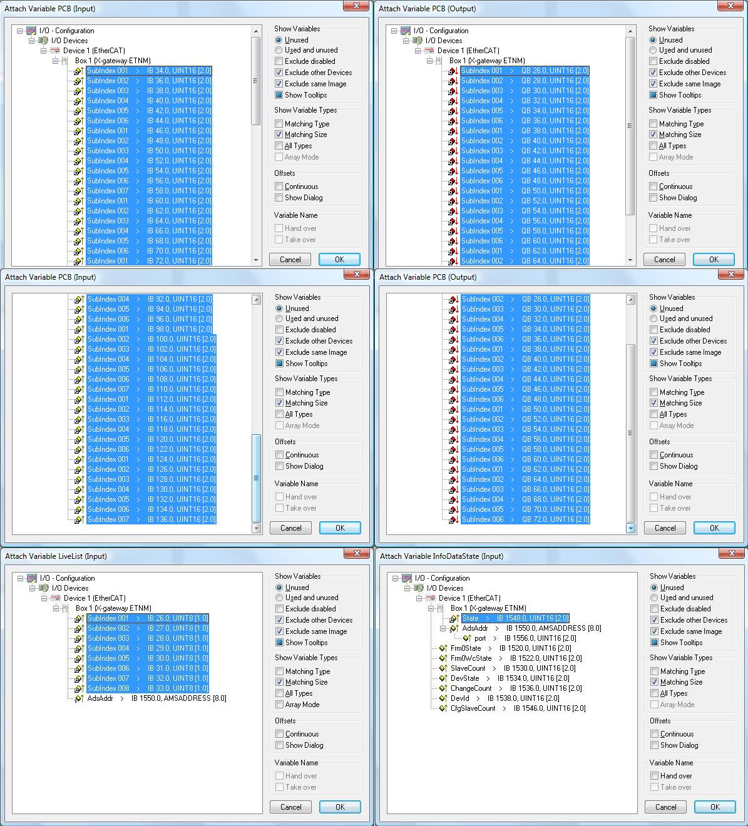

Fig 1. Mapping of IO structures into the EtherCAT memory space.

Internal Interface Type
TYPE IscWhiteningStruct :
STRUCT
Chassis: ARRAY[1..6] OF IscWhiteningRawChassisStruct;
END_STRUCT
END_TYPE
Type name | IscWhiteningStruct
Description | Internal interface structure between the binary IO chassis function blocks and the ISC whitening chassis function blocks
Definition | STRUCT
Input/Output Tag | Name: Chassis  Type: ARRAY[1..6] OF IscWhiteningRawChassisStruct  Description: Contains the binary IO data organized by chassis and channel.

Function Block
FUNCTION_BLOCK IscWhiteningInterfaceFB
VAR_INPUT
In: IscWhiteningInStruct;
END_VAR
VAR_OUTPUT
Out: IscWhiteningOutStruct;
END_VAR
VAR_IN_OUT
Val: IscWhiteningStruct;
END_VAR
Name | IscWhiteningInterfaceFB
Description | Controls a 384-channel binary IO chassis.
Input argument | Name: In  Type: IscWhiteningInStruct  Description: Input hardware structure
Output argument | Name: Out  Type: IscWhiteningOutStruct  Description: Output hardware structure
In/out argument | Name: Val  Type: IscWhiteningStruct  Description: Internal interface structure

User Interface Type
TYPE IscWhiteningChannelStruct :
STRUCT
Error: ErrorStruct;
Gain: INT;
GainStep: INT;
Filter: ARRAY [1..3] OF BOOL;
Set: ARRAY [1..3] OF BOOL;
Toggle: ARRAY [1..3] OF BOOL;
Readback: BYTE;
END_STRUCT
END_TYPE
 | IscWhiteningChannelStruct
Description | Structure of the user interface tags that are used to control a single channel of the ISC whitening chassis
Definition | STRUCT
Output Tag | Name: Error  Type: ErrorStruct  Description: Calls error handler
In/Out Tag | Name: Gain  Type: INT  Description: Whitening gain in dB from 0 dB to 45 dB in 3 dB steps.  This value is tight to GainStep. Any change in one of the two variables will updated the other.
In/Out Tag | Name: GainStep  Type: INT  Description: Whitening gain in steps from 0 to 15.  This value is tight to Gain. Any change in one of the two variables will updated the other.
Output Tag | Name: Filter  Type: ARRAY [1..3] OF BOOL  Description: True if the whitening filter is on. Each array index represents a filter section.
Input Tag | Name: Set  Type: ARRAY [1..3] OF BOOL  Description: Set value for the whitening filters. Each array index represents a filter section.
Input Tag | Name: Toggle  Type: ARRAY [1..3] OF BOOL  Description: Set to True to toggle the state of a whitening filter. Each array index represents a filter section.
Output Tag | Name: Readback  Type: BYTE  Description: Bit encoded readback value from the whitening chassis

Function Block
FUNCTION_BLOCK IscWhiteningChannelFB
VAR_INPUT
Chassis: INT; (* 1 to 6 *)
Index: INT; (* 1 to 8 *)
END_VAR
VAR_IN_OUT
IscWhitening: IscWhiteningStruct;
Channel: IscWhiteningChannelStruct;
END_VAR
VAR
END_VAR
Name | IscWhiteningChannelFB
Description | Controls a single channel in the whitening chassis (1 byte)  Call this function block before IscWhiteningInterfaceFB.
In/Out argument | Name: IscWhitening  Type: IscWhiteningStruct  Description: Internal interface structure
Input argument | Name: Chassis  Type: INT  Description: Select the chassis: Values from 1 to 6
Input argument | Name: Index  Type: INT  Description: Select the channel: Index from 1 to 8
In/out argument | Name: Channel  Type: IscWhiteningChannelStruct  Description: User Interface structure for a single channel of ISC whitening

User Interface Type
TYPE IscWhiteningDemodIQStruct :
STRUCT
Error: ErrorStruct;
I: IscWhiteningChannelStruct;
Q: IscWhiteningChannelStruct;
END_STRUCT
END_TYPE
Type name | IscWhiteningDemodIQStruct
Description | Structure of the user interface tags that are used to control two channels of the ISC whitening chassis which are used for an LSC demodulator
Definition | STRUCT
Output Tag | Name: Error  Type: ErrorStruct  Description: Calls error handler
In/Out Tag | Name: I  Type: IscWhiteningChannelStruct  Description:
In/Out Tag | Name: Q  Type: IscWhiteningChannelStruct  Description: Whitening gain in steps from 0 to 15.  This value is tight to Gain. Any change in one of the two variables will update the other.

Function Block
FUNCTION_BLOCK IscWhiteningDemodIQFB
VAR_INPUT
Chassis: INT; (* 1 to 6 *)
Index: INT; (* 1, 3, 5 or to 7 *)
END_VAR
VAR_IN_OUT
IscWhitening: IscWhiteningStruct;
Demod: IscWhiteningDemodIQStruct;
END_VAR
VAR
END_VAR
Name | IscWhiteningDemodIQFB
Description | Controls two channels in the whitening chassis (2 bytes)  Call this function block before IscWhiteningInterfaceFB.
In/Out argument | Name: IscWhitening  Type: IscWhiteningStruct  Description: Internal interface structure
Input argument | Name: Chassis  Type: INT  Description: Select the chassis: Values from 1 to 6
Input argument | Name: Index  Type: INT  Description: Select the channel: Index is 1, 3, 5, or 7  The selected index represents the quad-phase channel, whereas Index+1 represents the in-phase channel.
In/out argument | Name: Demod  Type: IscWhiteningDemodIQStruct  Description: User Interface structure for two channels of ISC whitening describing the I and Q channels of a LSC demodulator.

User Interface Type
TYPE IscWhiteningDemodWfsStruct :
STRUCT
Error: ErrorStruct;
Seg: ARRAY [1..4] OF IscWhiteningDemodIQStruct;
END_STRUCT
END_TYPE
Type name | IscWhiteningDemodWfsStruct
Description | Structure of the user interface tags that are used to control eight channels of the ISC whitening chassis which are used for an ASC wavefront sensor demodulator
Definition | STRUCT
Output Tag | Name: Error  Type: ErrorStruct  Description: Calls error handler
In/Out Tag | Name: Seg  Type: ARRAY [1..4] OF IscWhiteningDemodIQStruct  Description: The four segments of a wavefront sensor

Function Block
FUNCTION_BLOCK IscWhiteningDemodWfsFB
VAR_INPUT
Chassis: INT; (* 1 to 6 *)
END_VAR
VAR_IN_OUT
IscWhitening: IscWhiteningStruct;
DemodWfs: IscWhiteningDemodWfsStruct;
END_VAR
VAR
END_VAR
Name | IscWhiteningDemodWfsFB
Description | Controls eight channels in a whitening chassis (8 bytes)  Call this function block before IscWhiteningInterfaceFB.
In/Out argument | Name: IscWhitening  Type: IscWhiteningStruct  Description: Internal interface structure
Input argument | Name: Chassis  Type: INT  Description: Select the chassis: Values from 1 to 6
In/out argument | Name: DemodWfs  Type: IscWhiteningDemodWfsStruct  Description: User Interface structure for eight channels of ISC whitening describing the I and Q channels of a four segment ASC wavefront sensor demodulator.

User Interface Type
TYPE IscWhiteningQpdStruct :
STRUCT
Error: ErrorStruct
Seg: ARRAY [1..4] OF IscWhiteningChannelStruct;
END_STRUCT
END_TYPE
Type name | IscWhiteningQpdStruct
Description | Structure of the user interface tags that are used to control eight channels of the ISC whitening chassis which are used for an ASC wavefront sensor demodulator
Definition | STRUCT
Output Tag | Name: Error  Type: ErrorStruct  Description: Calls error handler
In/Out Tag | Name: Seg  Type: ARRAY [1..4] OF IscWhiteningChannelStruct  Description: The four segments of a QPD sensor

Function Block
FUNCTION_BLOCK IscWhiteningQpdFB
VAR_INPUT
Chassis: INT; (* 1 to 6 *)
Index: INT; (* 1 or 5 *)
END_VAR
VAR_IN_OUT
IscWhitening: IscWhiteningStruct;
Qpd: IscWhiteningQpdStruct;
END_VAR
VAR
END_VAR
Name | IscWhiteningQpdFB
Description | Controls four channels in a whitening chassis (4 byte)  Call this function block before IscWhiteningInterfaceFB.
In/Out argument | Name: IscWhitening  Type: IscWhiteningStruct  Description: Internal interface structure
Input argument | Name: Chassis  Type: INT  Description: Select the chassis: Values from 1 to 6
Input argument | Name: Index  Type: INT  Description: Select the channel: Index from 1 or 5  The selected index represents the first channel of a QPD, whereas Index+1, Index+2 and Index+3 represent the second, third and forth channel, respectively.
In/out argument | Name: Qpd  Type: IscWhiteningQpdStruct  Description: User Interface structure for four channels of ISC whitening describing the channels of a four segment ASC quad photodiode.

Program Example:

PROGRAM Whitening
VAR
IscWhiteningIn AT %IB0: IscWhiteningInStruct;
IscWhiteningOut AT %QB0: IscWhiteningOutStruct;
IscWhitening: IscWhiteningStruct;
IscWhiteningChassis: IscWhiteningInterfaceFB;

LenSensor: ARRAY [1..4] OF IscWhiteningDemodIQStruct;
Power: IscWhiteningChannelStruct;
Wfs: ARRAY [1..2] OF IscWhiteningDemodWfsStruct;
Qpd: ARRAY [1..2] OF IscWhiteningQpdStruct;

DemodLen: ARRAY [1..4] OF IscWhiteningDemodIQFB;
MonitorPower: IscWhiteningChannelFB;
DemodWfs: ARRAY [1..2] OF IscWhiteningDemodWfsFB;
MonitorQpd: ARRAY [1..2] OF IscWhiteningQpdFB;

I: INT;
END_VAR

(* Process individual sensors *)
FOR I := 1 TO 4 DO
DemodLen[I] (IscWhitening := IscWhitening, Chassis := 1, Index := I, Demod := LenSensor[I]);
END_FOR;
MonitorPower (IscWhitening := IscWhitening, Chassis := 1, Index := 5, Channel := Power);
FOR I := 1 TO 2 DO
DemodWfs[I] (IscWhitening := IscWhitening, Chassis := I+1, DemodWfs := Wfs[I]);
END_FOR;
FOR I := 1 TO 2 DO
MonitorQpd[I] (IscWhitening := IscWhitening, Chassis := 4, Index := I+4, Qpd := Qpd[I]);
END_FOR;

(* Process whitening chassis after individual sensors *)
IscWhiteningChassis (In := IscWhiteningIn, Out => IscWhiteningOut, Val := IscWhitening);

Visual
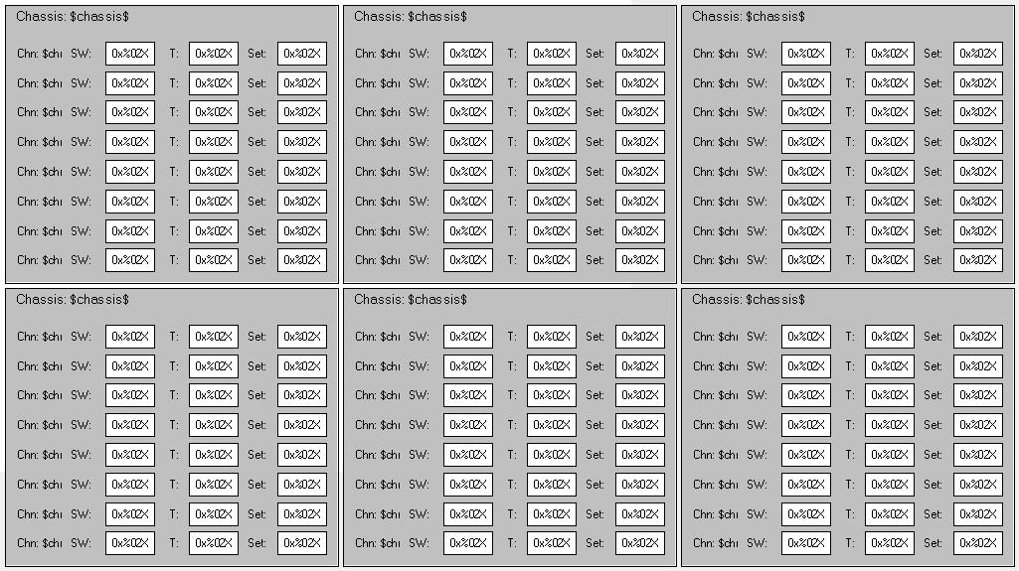
Name | IscWhiteningVis
Description | Displays the tags of an 384-channel binary IO chassis organized in six ISC whitening chassis which in turn show a list of 8 channels each. Each channel has 8 bits (1 byte) and shows the readback value. It lets you choose a new set value or apply a toggle value. The channel background turns red if the value is invalid.
Placeholder | Name: whitening  Type: IscWhiteningStruct  Description: Internal interface structure

Visual
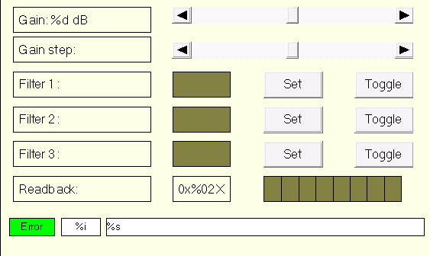
Name | IscWhiteningChannelVis
Description | Displays the tags of single channel of whitening
Placeholder | Name: channel  Type: IscWhiteningChannelStruct  Description: ISC whitening channel structure

Visual
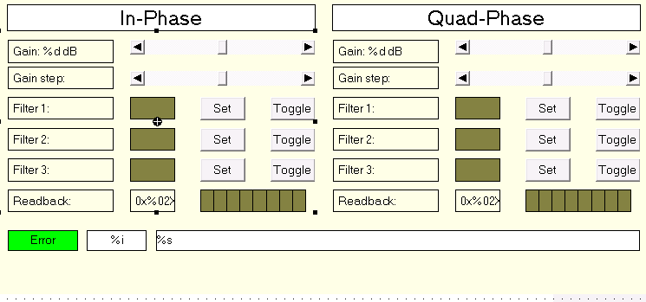
Name | IscWhiteningDemodIQVis
Description | Displays the tags of two channels of whitening
Placeholder | Name: demod  Type: IscWhiteningDemodIQStruct  Description: ISC whitening IQ demodulator structure

Visual
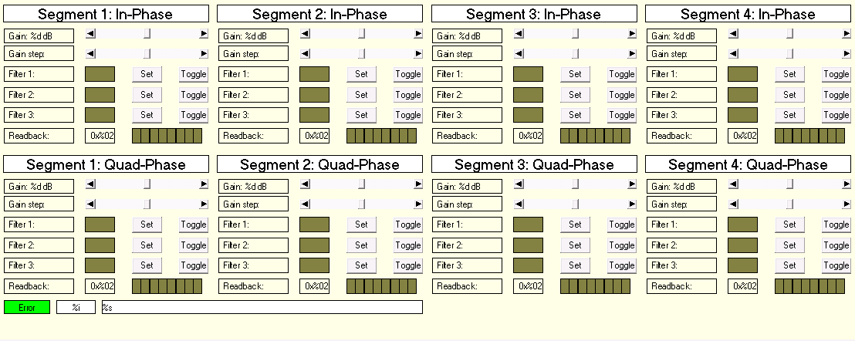
Name | IscWhiteningDemodWfsVis
Description | Displays the tags of eight channels of whitening
Placeholder | Name: wfs  Type: IscWhiteningDemodWfsStruct  Description: ISC whitening WFS demodulator structure

Visual
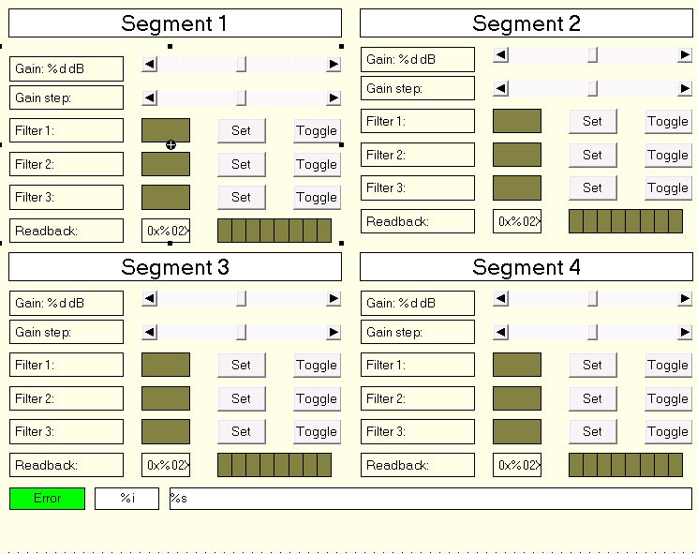
Name | IscWhiteningQpdVis
Description | Displays the tags of four channels of whitening
Placeholder | Name: qpd  Type: IscWhiteningQpdStruct  Description: ISC whitening quad photodiode structure

