Notes on Initial Alignment of the LBSC2

(supplementary notes to E1200392-v2, “Initial Alignment Procedure: LBSC2”)

Dennis Coyne  
8 June 2012

# Cartridge Assembly alignment on the test stand

Only the BS Optic and the BS AR and HR Elliptical Baffles are aligned while the cartridge assembly is on the test stand.

The LBSC2 cartridge assembly is to be assembled on LLO Mechanical Test Stand #1 (TS1), which is the test stand to the southeast (see E1100374). It has been assumed here that the test stand has been oriented in the same way as LBSC2 (i.e. the support tubes are oriented in the X-direction, or east-west direction), and that the LBSC2 cartridge has been placed in the same orientation as it will be in the LBSC2 chamber (i.e. no rotation is required to ‘fly’ the cartridge from the test stand to the chamber).

A direct view normal (i.e. perpendicular to) the HR (50/50) face of the BS optic is blocked by the test stand leg for all but a 2 in diameter region (see Figure 1)

|  |  |
| --- | --- |
| view normal to the HR face of the BS optic | close up view |

Figure 1: The view normal to the HR face is blocked by the test stand leg

The view normal to the AR face of the BS optic is not obscured, as shown in Figure 2. From this view we can angularly align the BS optic in pitch and yaw. Both the AR surface and the HR surface have relatively weak reflection (Table 3 of T1000230-v7) at the Newport LDS1000 Laser Autocollimator (LAC) wavelength (670 nm), but higher than required for the autocollimator (2%). We can expect that both the HR and AR surfaces will create a return signal. Since the wedge angle of the BS optic is small (0.073 deg on average), the separation angle of the beams will be quite small as well (~0.00371 radians). Since the LAC beam is 31 mm diameter, with a 100 microradian divergence angle, we need a separation of > 32 mm. This requires that the distance from the Total Station to the BS optic be at least 8.6 m.

Furthermore from the view normal to the AR side we can see features to position the optic:

(a) the lateral edges of the optic can be used to position the optic left and right, and

(b) the stand-off, wire prisms can be used to confirm that the vertical position of the optic is correct (or determine how far off the optic is in height).

We can then add a retroreflector to the BS structure on the AR side directed (approximately) normal to the AR face to enable a measurement of the third direction with the Total Station distance measurement capability (time of flight).

|  |  |
| --- | --- |
| view normal to the AR face of the BS optic | close up view |

Figure 2: The view normal to the AR face is not obscured

For the view normal to the AR face we can also use the Total Station to position the AR elliptical baffle. The yaw angles to the left and right edges should be equal; The lateral position of the AR elliptical baffle can be adjusted until the yaw angles are equal. Likewise, the pitch angles to the top & bottom of the AR elliptical baffle should be equal; The vertical position of the AR elliptical baffle can be adjusted until the pitch angles are equal.

In order to position the HR elliptical baffle, a target is attached to the baffle and the baffle is viewed looking in the +X-direction on the beamline, as shown in Figure 3. The removable target (to be provided by SLC) allows IAS to position the HR BS Elliptical Baffle left/right and up/down so that it is centered on the optic.

|  |  |
| --- | --- |
| view in the +X direction, showing the HR face of the BS optic and the HR BS elliptical baffle (without the target) | view in the +X direction, showing the HR face of the BS optic and the HR BS elliptical baffle with a conceptual target (to be provided by SLC) |

Figure 3: View of the BS in the +X-direction showing the use of the target on the HR BS Elliptical Baffle

At this point the BS optic and both the HR and AR BS Elliptical Baffles have been aligned on the test stand.

# Cartridge Assembly alignment in the chamber

Once in the chamber, IAS must align:

* the BS Optic in {x,y,z, yaw} by moving the entire cartridge assembly with HEPI as a rigid body
* the BS Optic in pitch, by adjusting the suspension
* the ITMy Elliptical Baffle
* the ITMx Elliptical Baffle

but not the BS AR & HR Elliptical Baffles, since these baffles were properly located relative to the BS optic on the test stand.

For the beamsplitter (BS) we set the yaw angle with a laser autocollimator (co-boresighted to the total station) viewing the BS HR surface through a LTHP, as shown in the sketches below.

We can set the lateral (y) and vertical (z) position of the BS with the target on the BS HR Elliptical Baffle when viewed looking in the +X direction along the beam line.

We need a retroreflector mounted at 45 deg to the BS optic, facing the –X direction, in order to get the third positioning degree of freedom (x).

The ITM Elliptical Baffles have targets at their aperture centers which can (hopefully) be viewed in reflection from, and in transmission through, the BS optic, by the Total Station theodolite pointed in the +X direction.

|  |  |
| --- | --- |
|  |  |

View normal to the BS HR face. The BS HR face cannot be viewed through the LBSC2 main port.

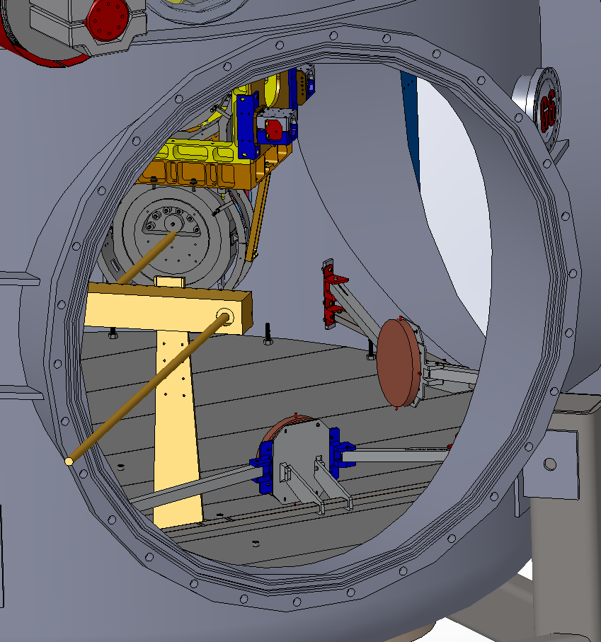

A PLX Lateral Transfer Hollow Periscope (LTHP) on the PLX mount can easily relay a view of the center of the BS HR face out the LBSC2 port. NOTE: The PLX mount shown is not complete. Need to raise the D980472, PLX Mount, Support Weldment above the floor.