IO Chassis Temperature Study
Richard Abbott, Todd Etzel
21 March, 2012

- Overview
The internal air temperature was studied in an aLIGO IO Chassis as a function of air flow. There are two main cooling fans on the front panel of the IO chassis, this study recorded the internal temperature of the IO chassis with: Both fans, one fan only, and one fan with half the inlet area blocked. Four internal temperature sensors were placed within the chassis under test, one at the rear of the chassis (rear), three remaining sensors distributed in the front of the chassis from left to right as viewed standing in front of the chassis (see Figure 2).
The chassis under test had six, 18 bit DACs, two 16 bit ADCs, and two binary IO cards of the normal aLIGO ilk. The existing ATX style switching power supply normally used to power the IO chassis was replaced with the high efficiency, fan-less supply made by Mini-Box Inc. (Part number M4-ATX). The total current draw from the 24 VDC supply used to power the chassis was:

Table 1
Total 24 V Supply Current before host CPU is booted | 3.6 A
Total 24 V Supply Current after host CPU is booted | 4.8 A
Portion of total current used to power both front panel fans | 0.3 A

From the current draw and voltage indicated in Table 1, the total internal power dissipation from all sources can be seen to be ~115 watts. As shown in Figure 1, the dotted lines show from left to right: Start time with all fans running, One fan cutoff, and lastly one half of the remaining fan was blocked. The fans are part number AFB0912VH, made by Delta Products Group. The fans are each rated at ~68CFM (unimpeded airflow) at 3800 RPM. This rotation corresponds to ~63Hz, which correlates reasonably well with the electromagnetic data shown in LIGO-T1200110.
The fourth dotted line in Figure 1 shows that the internal temperature approached 100 degrees F at the hottest point. At this point, the Mini-Box fan-less power supply shut down on over temperature, it was mounted internal to the IO chassis with the lid on the IO chassis. After this event, the test was re-done with the Mini-Box supply mounted external to the IO chassis to verify that the only thing shutting down at the reduced airflow was the Mini-Box supply. While the internal air temperature of the IO chassis remained reasonably low (100 F), the restricted airflow was causing some intense hot spots as seen with the FLIR IR viewer. One chip inside the Mini-Box supply was close to 100 C even after the Mini-Box supply was moved to be external to the IO chassis. A review of the Mini-Box power supply datasheet shows it has a thermal overload temperature of 85 C as measured by a sensor on its internal circuit board. This set point is user configurable, and the internal temperature can be monitored by a USB interface intrinsic to each Mini-Box supply. It’s quite convenient for testing purposes.
Figure 2 shows the four temperature sensors inside the IO chassis. The lid has been removed for this photo, and the Mini-Box power supply can be seen perched on top of the 6 DAC cards.

- Data

Figure 1
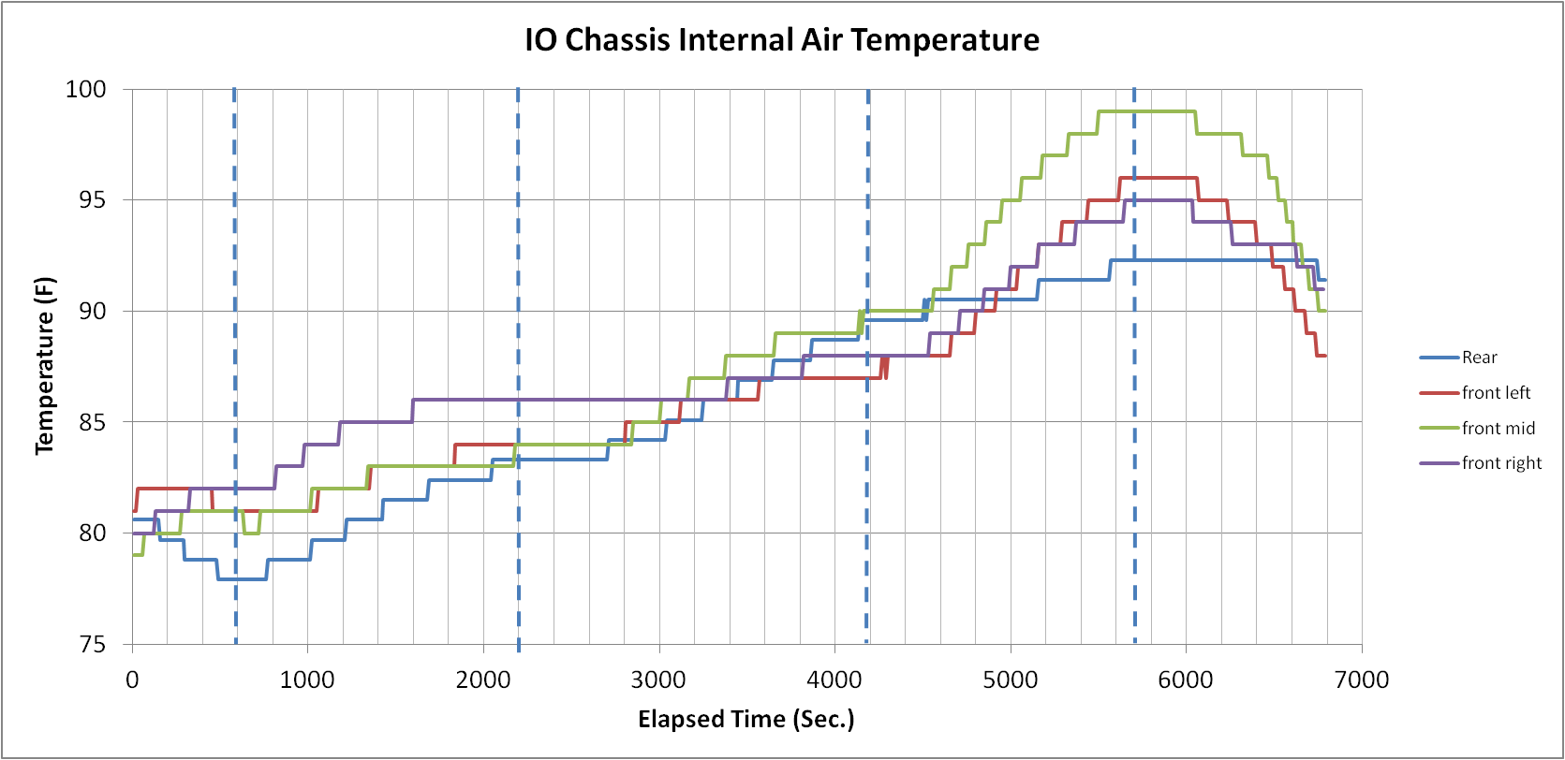

Figure 2, sensor locations
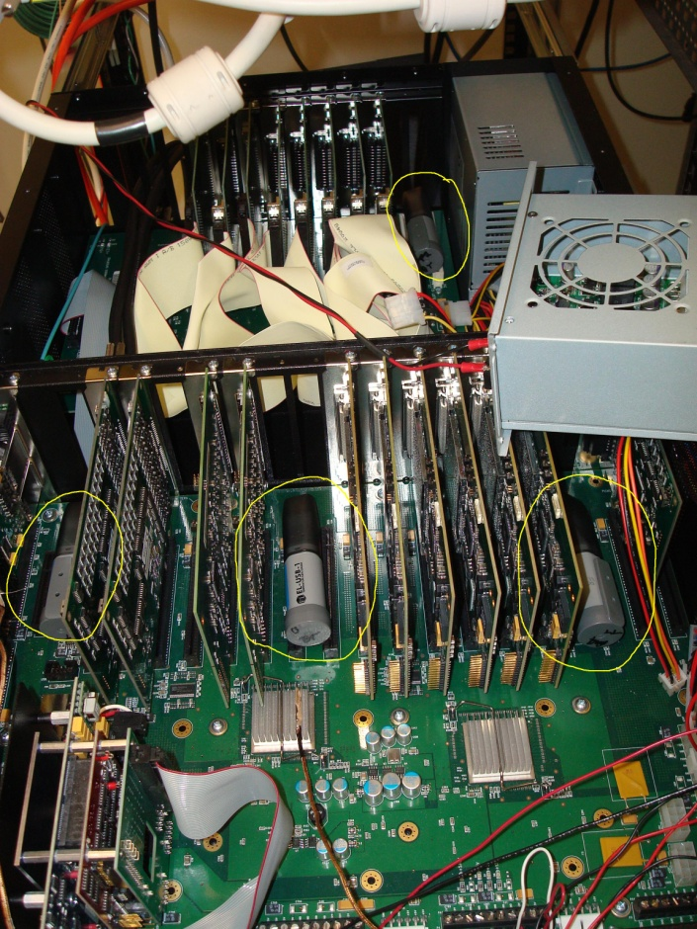

- Conclusion
It seems as though the IO chassis would require at least one fan of equivalent airflow to ensure proper cooling of the internal cards. The Mini-Box supply will not need its own fan, but should be mounted somewhere with exposure to the air flowing through the chassis. The metal box that comes with the Mini-Box supply may not be prudent, and we may find that an open frame mount of the supply to the internal wall of the IO chassis is best.

