*LIGO Laboratory / LIGO Scientific Collaboration*

LIGO-T1200103-v2 *LIGO* Date:

TCS beam shaping: optimum and achievable beam profiles for correcting thermo-refractive lensing (not thermo-elastic surface deformation)

Authors: Aidan Brooks, Alastair Heptonstall

Distribution of this document:

LIGO Scientific Collaboration

This is an internal working note

of the LIGO Laboratory.

|  |  |
| --- | --- |
| **California Institute of Technology**  **LIGO Project – MS 18-34**  **1200 E. California Blvd.**  **Pasadena, CA 91125**  Phone (626) 395-2129  Fax (626) 304-9834  E-mail: info@ligo.caltech.edu | **Massachusetts Institute of Technology**  **LIGO Project – NW22-295**  **185 Albany St**  **Cambridge, MA 02139**  Phone (617) 253-4824  Fax (617) 253-7014  E-mail: info@ligo.mit.edu |
| **LIGO Hanford Observatory**  **P.O. Box 159**  **Richland WA 99352**  Phone 509-372-8106  Fax 509-372-8137 | **LIGO Livingston Observatory**  **P.O. Box 940**  **Livingston, LA 70754**  Phone 225-686-3100  Fax 225-686-7189 |

http://www.ligo.caltech.edu/

# Introduction

The purpose of this document is to describe the optimum and actual or achievable heating beam profiles to be used in Advanced LIGO. The goal is to actuate on the aLIGO ITM and CP with the Ring Heater and CO2 laser respectively to achieve less than 0.1% round trip scatter from the TEM00 mode in the recycling cavity.

27-Feb-2012: there is, as yet, limited discussion on exactly how achievable the heating beam profiles are.

# TCS as a servo system

Like any servo system, TCS can be described in terms of a plant (CP + ITM), sensors (HWS), actuators (CO2 laser beam + RH) and a gain stage. This discussion will initially be limited to the actuators and the plant.

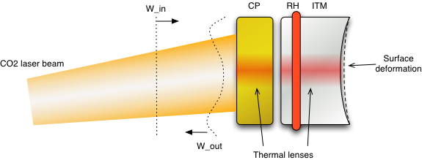

Figure : TCS as a servo system with actuators and a plant (sensor not shown)

## Plant: ITM+CP

The plant of this servo system is, loosely, the compensation plate (CP) and input test mass (ITM). Specifically, and for the purposes of this discussion, the plant is actually the wavefront distortion induced by double passing through the thermal lenses of the CP and ITM. In Figure 1, this is W_out – W_in.

The barrel of the CP is gold-coated.

## Actuators: RH and CO2 laser beam

The actuators in this system are the RH and the CO2 laser beam. However, the ring heater is the only device that can be use to actuate on the surface deformation of the ITM. Therefore, for the purposes of this discussion – the actuation on thermo-refractive lenses in the substrate - we are not free to vary the ring heater power - it will, however, be a constant non-zero value in this analysis.

The CO2 laser beam actuates on the PRC side of the CP.

# How to determine the optimum heating beam profile

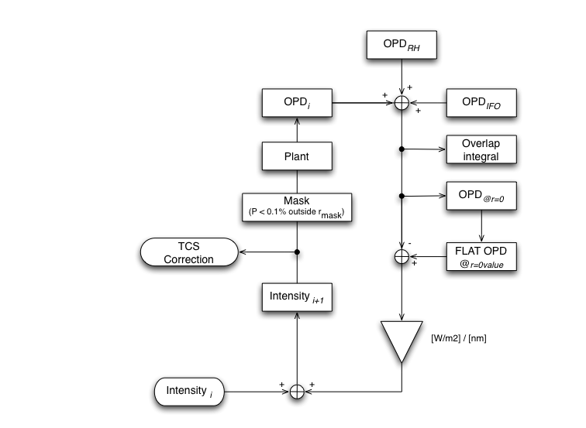

Figure : A servo loop to determine the optimum heating beam profile

The method to determine the optimum heating beam profile is illustrated in Figure 2.

* An initial uniform intensity pattern is apertured by a mask and applied to the plant. In this case the plant is a COMSOL model of the CP. The value of this intensity, *Nominal Intensity*, is equal to the peak value of intensity from IFO self heating.
* The resulting optical path distortion (OPD) from double passing the CP is calculated.
* The OPDs from double passing the RH and IFO self-heating thermal lenses are added to this to give the *Sensor OPD*.
* A flat OPD, *the Target OPD*, that is uniformly equal to the *r=0* value of the Sensor OPD, *Center OPD*, is created.
* An error signal is created by subtracting the Sensor OPD from Target OPD.
* This error signal is multiplied by a gain value, *Transducer Gain*, to convert from units of OPD [nm] to units of intensity [W/m2] and create a control signal. This value is determined on the first iteration and is equal to Nominal Intensity/Center OPD.
* The control signal is added to the intensity from the first iteration.
* The process is repeated until the scatter from the TEM00 by (OPD*i* + OPD*RH*) is less than 0.1%.
* The TCS Correction is *Intensity*.

This model as presented here is somewhat unconstrained:

* there is some flexibility in the radius of the mask applied to the CO2 laser beam profile. It must be greater than 1.86x the radius of the IFO mode (this is radius outside which there is less than 0.1% of power).
* There is no functionality, as yet, to minimize the total optical path distortion (and hence the power applied by the CO2 laser beam).

# Results

The quality of compensation required increases as the absorbed power increases. This is due to the amount of scatter from the TEM00 mode increasing as the square of the RMS of the residual OPD. Hence, this discussion is divided into the, relatively, easy low power compensation and the more difficult high power compensation.

## Low power IFO operation

The sufficient correction profile to compensate for 20mW of absorption in the ITM is shown in Figure 3. The mask diameter in this model is 100mm when projected onto the ITM. This profile yields exactly 0.1% scatter from the TEM00 mode. The total power projected onto the CP by the CO2 laser is ~300mW.

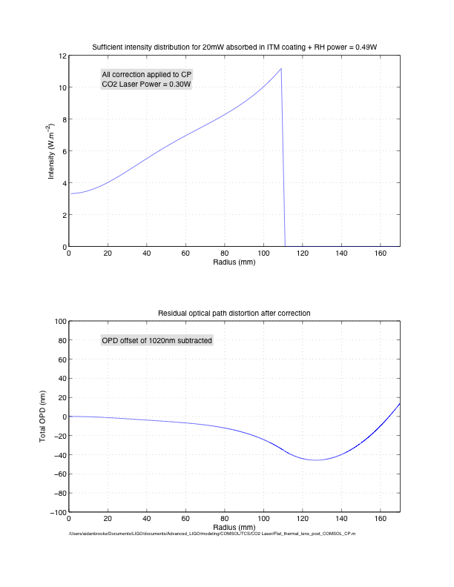

Figure : Sufficient correction profile to compensate for 20mW absorbed in the ITM.

## High power IFO operation

The plot in Figure 4 shows the heating beam profile (at the ITM) required to correct for 0.4W of absorbed power in the ITM HR surface (which is the maximum amount anticipated by the nominal aLIGO design).

The mask diameter in this model is 100mm when projected onto the ITM. This profile yields exactly 0.1% scatter from the TEM00 mode. The total power projected onto the CP by the CO2 laser is 8.15W.

It should be noted that the high power compensation pattern will also work for low power IFO operation (when scaled appropriately in power) and will give better than compensation than the low power compensation pattern.

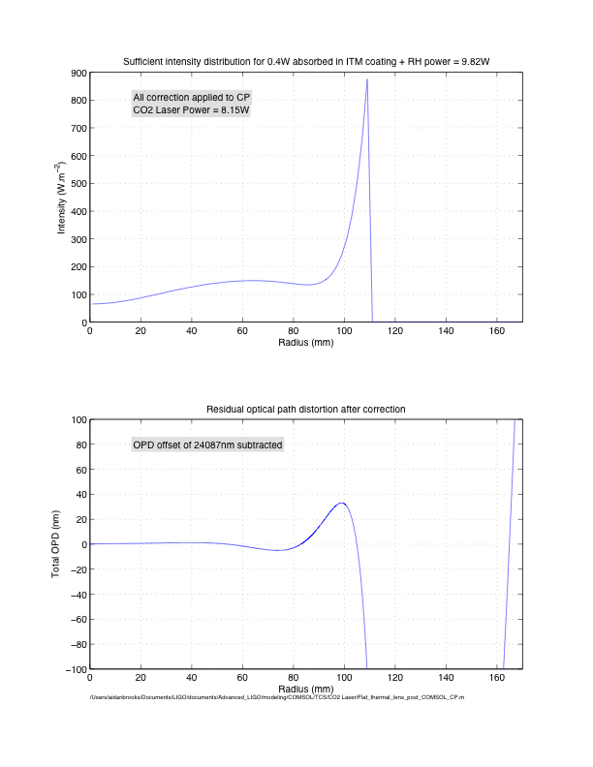

Figure : Optimum heating profile of CO2 laser to correct for 0.4W of absorbed power

# Implications for TCS optical design

The concept for the CO2 laser projector beam shaping is shown in Figure 5. Two beams shaping paths are available by using orthogonal polarization in a Mach-Zender configuration. The annuli created by this system originate predominantly by using a pair of axicons followed by masks that can be used for fine-tuning the intensity profile.

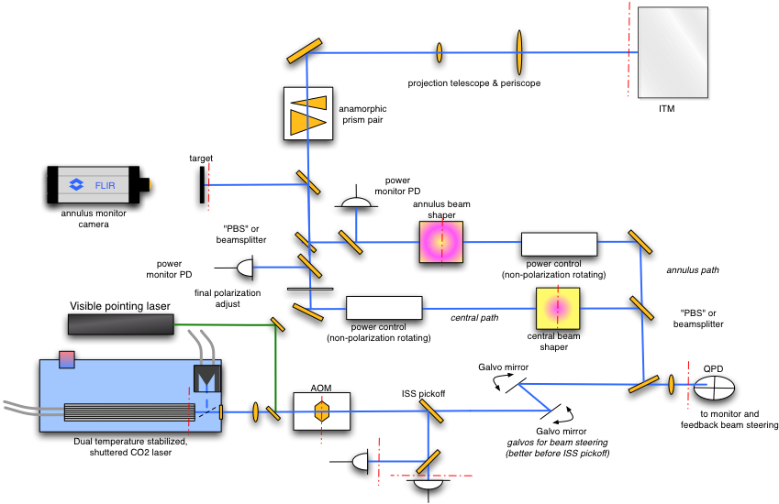

Figure : TCS CO2 laser projector conceptual optical design

## Design implications for low power operation

The compensation profile shown in Figure 3 appears to be uniform enough to achieve with a combination of a single axicon pair and mask.

Therefore, the baseline design **for low power IFO operation**, is to use a single axicon/mask systems in a single beam path to create the required intensity profile.

## Design implications for high power operation

There are two clear sections to the intensity profile in Figure 4, delineated by large differences in the average intensity: the central section below a radius of ~80mm and the annular section at radii greater than 80mm.

It would be extremely inefficient to try to compensate the overall thermal lens with a single beam path comprised of axicons and masks. Consider that the broad nature of the profile and the large maximum peak power in the intensity. This implies that a broad annulus with a high peak power would need to have a mask applied to it to eliminate a substantial fraction of the intensity and shape it into the pattern shown in Figure 4.

If, instead, two separate beam paths were used that attempted to shape the two sections described above, a vastly more efficient system could be designed.

Therefore, the baseline design **for high power IFO operation**, is to use two axicon/mask systems in two beam paths and recombine them to create the desired intensity profile.