LIGO Laboratory / LIGO Scientific Collaboration

LIGO-T1200082 Advanced LIGO 9 February 2012

Beckhoff Breakout Box
Test Procedure

Steve O’Connor

Distribution of this document:
LIGO Scientific Collaboration

This is an internal working note
of the LIGO Laboratory.

California Institute of Technology  LIGO Project – MS 18-34  1200 E. California Blvd.  Pasadena, CA 91125  Phone (626) 395-2129  Fax (626) 304-9834  E-mail: info@ligo.caltech.edu | Massachusetts Institute of Technology  LIGO Project – NW22-295  185 Albany St  Cambridge, MA 02139  Phone (617) 253-4824  Fax (617) 253-7014  E-mail: info@ligo.mit.edu
LIGO Hanford Observatory  P.O. Box 1970  Richland WA 99352  Phone 509-372-8106  Fax 509-372-8137 | LIGO Livingston Observatory  P.O. Box 940  Livingston, LA 70754  Phone 225-686-3100  Fax 225-686-7189
http://www.ligo.caltech.edu/

Overview
This test procedure applies to the Beckhoff breakout box LIGO-D1200168. This Box splits the cable from the breakout box into a connector to the shutter driver and a connector to the Hartman optical table at the end station.
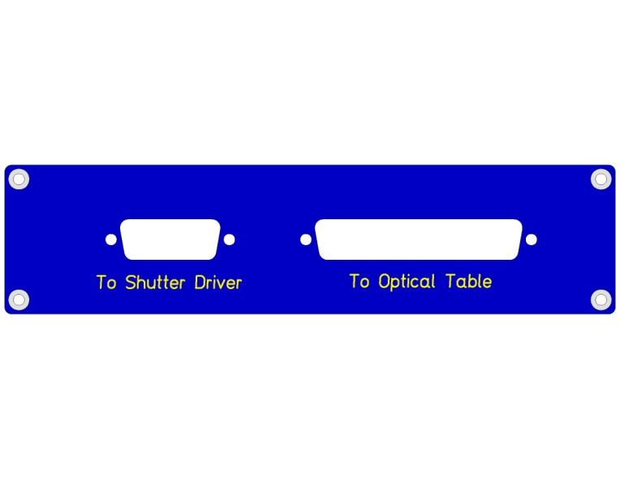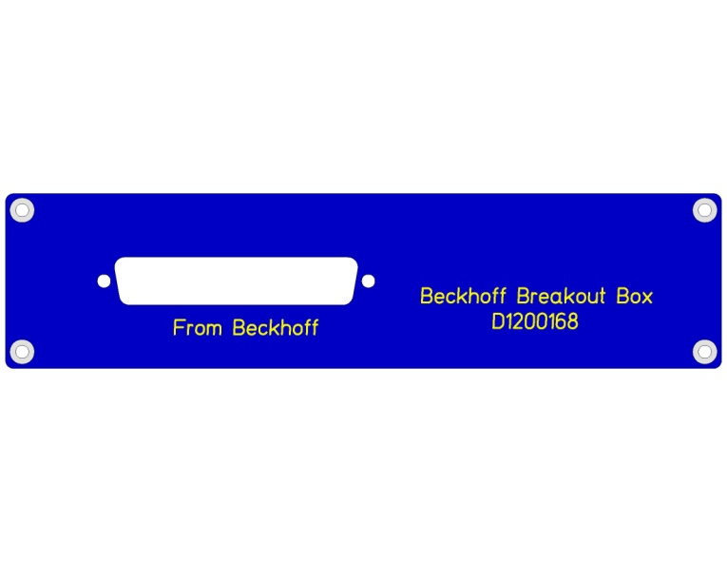

Upper Heater Segment
9 Pin D Conn

RTD

9 Pin D Conn

Lowe

I

V

T

Setup
Using connector breakouts check all connections from 37 pin connector input to the 37 pin output and the 15 pin output.

Requirements

FROM |  |  | Optical
37 pin Beckhoff |  | Beckhoff | table
to 37 pin Panel |  | pin # | pin# | Connected
 |  | 1 | 1
 |  | 2 | 2
 |  | 3 | 3
 |  | 4 | 4
 |  | 5 | 5
 |  | 6 | 6
 |  | 7 | 7
 |  | 8 | 8
 |  | 9 | 9
 |  | 10 | 10
 |  | 11 | 11
 |  | 12 | 12
 |  | 13 | 13
 |  | 14 | 14
 |  | 15 | 15
 |  | 16 | 16
 |  | 17 | 17
 |  | 18 | 18
 |  | 19 | 19
 |  | 20 | 20
 |  | 21 | 21
 |  | 22 | 22
 |  | 23 | 23
 |  | 24 | 24
 |  | 25 | 25
 |  | 26 | 26
 |  | 27 | 27
 |  | 28 | 28
 |  | 29 | 29
 |  | 30 | 30
 |  | 31 | 31
 |  | 32 | 32
 |  | 33 | 33
FROM |  |  | Optical
37 pin Beckhoff |  | Beckhoff | table
to 37 pin Panel |  | pin # | pin# | Connected
 |  | 34 | 34
 |  | 35 | 35
 |  | 36 | 36
 |  | 37 | 37
FROM
37 Pin Beckhoff |  | to driver | Beckhoff
to 15 Pin Shutter |  | pin # | pin# | Connected
Driver |  | 1 | 5
 |  | 2 | 6
 |  | 3 | 7
 |  | 4 | 8
 |  | 5 | 29
 |  | 6 | 31
 |  | 7 | 30
 |  | 8 | 19 (gnd)
 |  | 9 | 24
 |  | 10 | 25
 |  | 11 | 26
 |  | 12 | 27
 |  | 13 | 10
 |  | 14 | 12
 |  | 15 | 11

