AUTHOR(S) | DATE | Document Change Notice, Release or Approval
Dennis Coyne | 9 Jan 2012 | see LIGO DCC record Status
Instructions on the use of this document:
1) Use, and complete, this document on a cleanroom compatible computer while the work is proceeding. This procedure, and all of the applicable documents, must be available at all times during the procedure.
2) Use this procedure as a check list for preparation and during the installation; As each step is completed, enter the name of the person completing the work (or approving or checking the step), as well as the date and any comments or notes. In particular, note any discrepancies or deviations and augment with any missing definition. ALL NOTES MUST BE RECORDED IN THE COMPLETED VERSION OF THIS DOCUMENT (NOT IN OTHER NOTEBOOKS OR FILES). If the additional notes are too cumbersome to include within the body of this completed procedure, then electronically attach them to the completed procedure.
3) Once completed, file the document in the LIGO Document Control Center (DCC) as the next highest version of the procedure and add a note that this is a completed/finished procedure.
4) File any significant notes or data from the completed procedure in the electronic logbook (such as any deviations); as a minimum note in the electronic logbook that the installation was completed in accordance with this procedure (cite document number and revision).
Contents
1 SCOPE 2
1.1 Scope for the Initial Installation 6
2 Required Equipment List 7
3 PROCEDURE FOR CARTRIDGE ASSEMBLY 8
3.1 Prerequisites for Cartridge Integration 9
3.2 Applicable Documents 9
3.3 Install the BSC-ISI onto the Test Stand 10
3.4 Perform final BSC-ISI testing/characterization prior to payload integration 11
3.5 Attach the alignment templates for the TMSy and ETMy suspensions 11
3.6 Weigh the full suspension payloads 11
3.7 Install the balance masses onto the optics table 11
3.8 Install the ETMy suspension upper assembly 11
3.9 Install the TMSy suspension 12
3.10 Rebalance the ISI Table 12
3.11 Test the TMSy suspension 12
3.12 Install the ETMy lower suspension (monolithic) 12
3.13 Add Vibration Absorbers to the ETMy Suspension 12
3.14 Rebalance the ISI Table 13
3.15 Align the Optics 13
3.16 Post-Integration, CartridgeTesting 13
4 PROCEDURE FOR INSTALLATION INTO THE CHAMBER 14
4.1 Prerequisites for Chamber Installation 15
4.2 Applicable Documents 15
4.3 Prepare the Chamber for Cartridge Installation 17
4.4 Prepare the Cartridge Assembly for installation into the chamber 18
4.5 Install the Cartridge Assembly into the Chamber 18
4.6 Align the Cartridge Assembly 19
4.7 Install the Arm Cavity Baffle 20
4.8 Clean the Optics 20
5 Testing 21

SCOPE
The scope of this procedure is installation of interferometer components and assemblies in the WBSC6 chamber (see Figure 1), which are defined in the following documents:
- LIGO-D0900512: AdvLIGO Systems, BSC6-H2 Top Level Chamber Assembly
- LIGO-E1100813: BSC6-H2 Top Level Chamber Assembly BOM
- LIGO-D0900514: AdvLIGO SEI BSC6-H2, XYZ Local CS for ISI Table
- LIGO-D0900515: aLIGO SUS BSC6-H2, XYZ Local CS for ETMY
- LIGO-D0900419: AdvLIGO SUS BSC6-H2, XYZ Local CS for TMS ETM Tel Assy
- LIGO-D1001921: AdvLIGO SUS BSC6-H2, XYZ Local CS for SLC Arm Cavity Baffle
- LIGO-D1000897: AdvLIGO BSC6-H2 ISI Table, Balance Masses Assembly
- LIGO-D1101429: ALIGO, AOS, BSC FLOORING ORIENTATION DETAILS, BSC-6 & BSC-8
- LIGO-D1101478: CABLE HARNESS ROUTING CONFIGURATION BSC-6
- LIGO-D1101310: aLIGO, SUS, OPTIC TABLE .38-16 BSC8-H2 FIDUCIAL KIT
- LIGO-E1000202: AdvLIGO Detailed Mass Properties-CG Report BSC Tables LHO
- LIGO-D1101675: WBSC6 and WBSC8 additional (secondary) related documents
- LIGO-D1003085: Flange Layout – H2 Beam Splitter Chamber 6 (BSC6) ETMY
All of these documents are provided as “related document” links in the Document Control Center (DCC) entry for the top level chamber assembly drawing, D0900512.

This installation document does not cover installation of out-of-the-chamber associated elements/systems such as the Optical Levers (OptLevs), electronics racks and cable trays associated with the in-chamber installed systems.
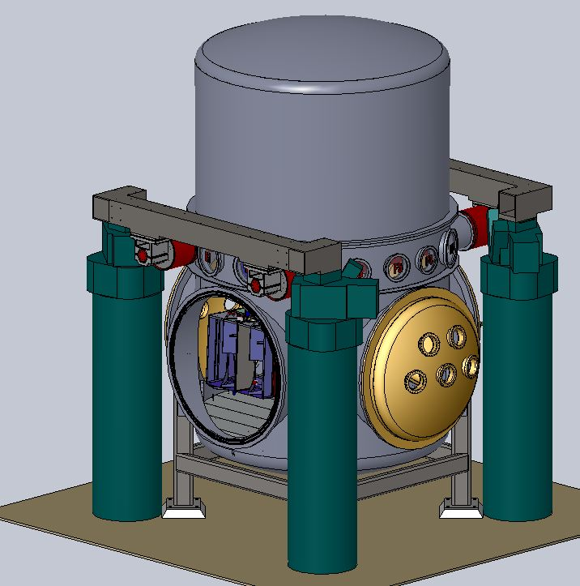  - with vacuum equipment, HEPI (shown in simplified, envelope configuration) | 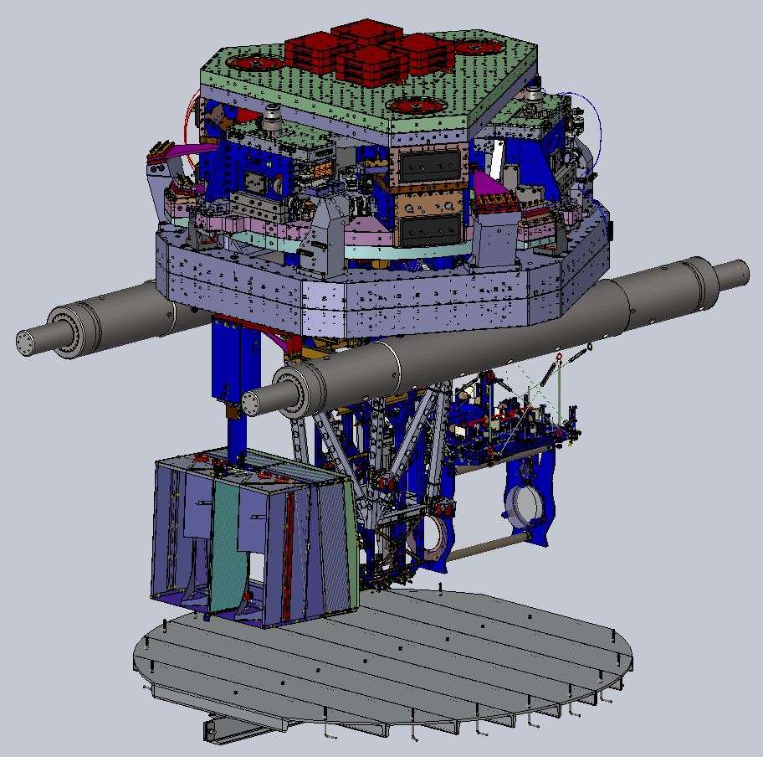  - without vacuum equipment, HEPI
Figure 1 WBSC6 Chamber Installation

This installation includes the following principal, sub-system major assemblies:
Subsys. | Assy Dwg | Sub-Assembly Name | Image
SEI | D0900514 | WBSC6 BSC-ISI assembly including:  BSC-ISI assembly (D0901182)  Balance masses  Bolts to attach to support tubes | 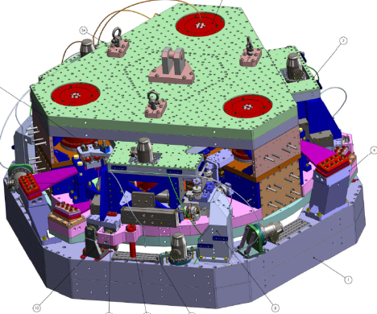
SUS | D0900515 | H2 ETMy including:  quad suspension assembly (D0901346)  TCS Ring Heater (RH) assy (D1001838+D1001895)  Vibration Absorbers (D1002424)  ITM/ETM Optics Cap (D1100052)  Dog clamps | 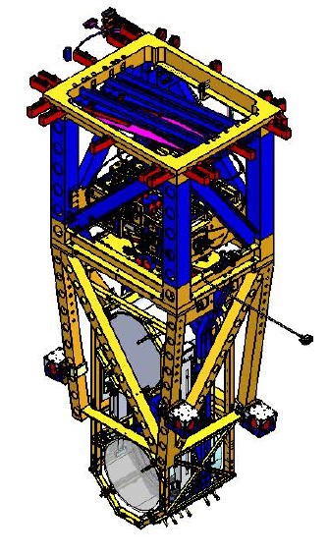
AOS | D0900419 | Transmission Monitor Suspension (TMS) Assembly, including:  Vibration Absorbers (D1002424)  Dog clamps | 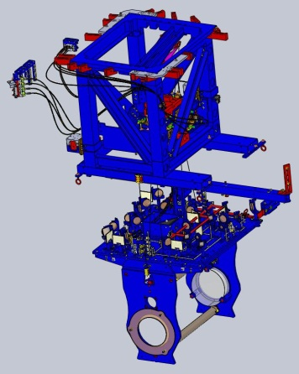
AOS/SLC | D1001921 | Arm Cavity Baffle assembly (ACB) for H2-ETMy  N.B.: The ACB will not be installed initially for the H2 One Arm Test (H2OAT) since it will not be available in time. | 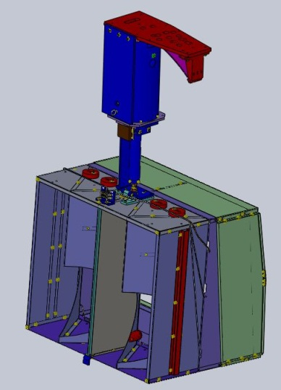
FMP | D961115  D1101429 | BSC Floor Assy  BSC Flooring orientation, WBSC6 & WBSC8 | 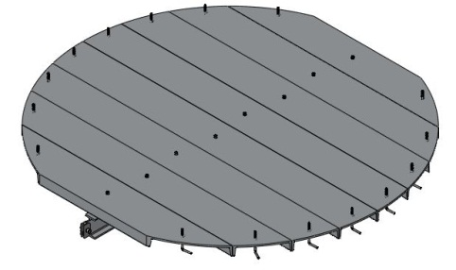
SYS | D1000897 | WBSC6 ISI Table Balance Masses | 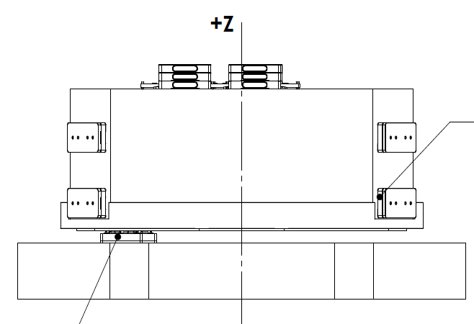
SEI/SYS | D1003085  D11014778 | Electrical Feedthroughs Layout, WBSC6  Cable Routing, WBSC6 | 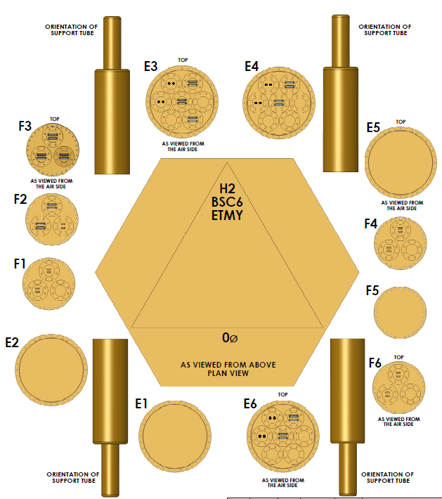
AOS/SLC | T1100292  Viewport Source List | 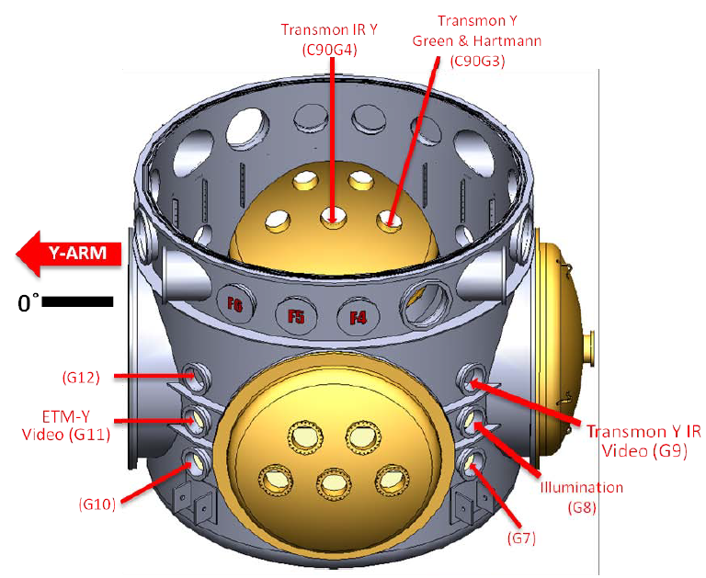 | 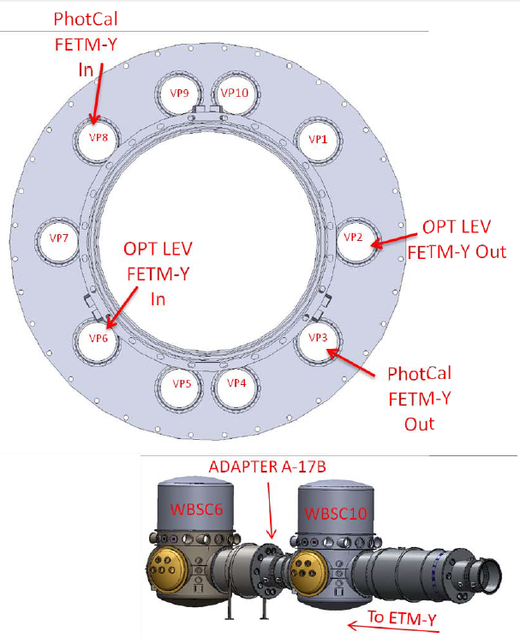
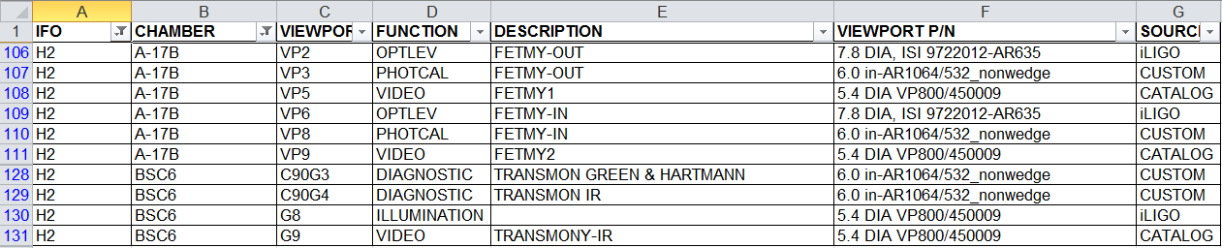
Cable tray | D1100430 | BSC Cable Tray Overall Assy  (shown without the chamber)  needs revision to as-built design | 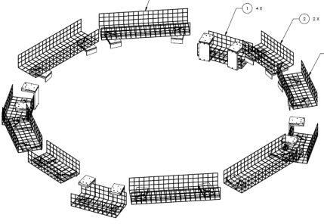
HEPI | D1000514 | Hydraulic External Pre-Isolator (HEPI) Assy  (shown without the chamber) | 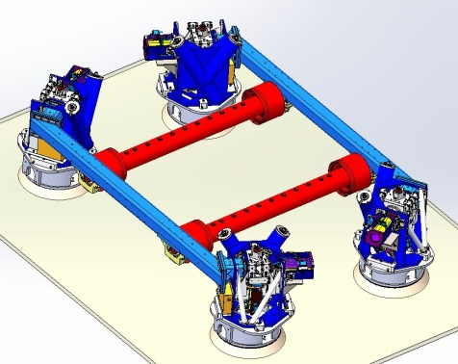

This procedure starts with the integration of the payload elements of the WBSC6 chamber in the “cartridge assembly” on the BSC Mechanical Test Stand (D1002124) and then proceeds to the integration of the cartridge assembly within the WBSC6 chamber. The “cartridge assembly” is comprised of the BSC-ISI system with as many of the payload elements integrated onto the optics table and the stage 0 structure of the BSC-ISI as possible. The cartridge assembly is integrated and aligned while on the BSC mechanical test stand. The cartridge is then lifted, flown to the chamber and lowered into position onto the BSC support tubes. The entire cartridge assembly is then aligned in situ, as a rigid body, based on the alignment of the ETMy optic. Those elements which could not be integrated on the test stand are added in situ and aligned in situ, if needed.

Scope for the Initial Installation
For the initial installation into WBSC6 in support of the H2 One Arm Test (H2OAT):
- the ETMy optic will be a temporary optic that will eventually need to be replaced
- the Arm Cavity Baffle (ACB) will not be installed into WBSC6 (because it is not available in time).
However in this document we address the alignment of all elements of a complete WBSC6 installation for completeness (and for the eventual installation of all elements).
Note: Some early documentation refers to wide angle panels or baffles. These baffles have been made obsolete by revising the design of the ACB (extending the solid angle subtended by the ACB).

Required Equipment List
Each of the procedures referenced within this overall procedure call out required equipment and parts/assemblies. Below is listed only those parts or assemblies not covered in the subsidiary procedures.
  - See the Bill Of Materials (BOM) for the WBSC6 assembly, E1100813: BSC6-H2 Top Level Chamber Assembly BOM
  - Genie lift for transport of the quad to the test stand
  - Lift cart and 5-axis table (D1101674) for transport/mating of the upper quad to the test stand
  - Genie lift for transport of the TMS to the test stand
  - For custom assembly/installation tooling, see D1101674-v3 which covers various usages of then tooling.
    - Sheet 3 is configuration used for ETMy upper structure
    - Sheet 8 is configuration used for ETMy lower structure

completed, approved or checked by:
date:
comments (optional):

PROCEDURE FOR CARTRIDGE ASSEMBLY
The WBSC6 cartridge assembly is depicted in Figure 2. The major optics assemblies integrated into the WBSC6 cartridge are the following:
- Y End Test Mass (ETMy) and End Reaction Mass (ERMy), both parts of the suspension assembly (D0900363)
- Transmission Monitor (TransMon) including the end transmission telescope, both parts of the Transmission Monitor Suspension (TMS)
- Arm Cavity Baffle (ACB) Suspension, which is not part of the cartridge assembly because of interference with the test stand (it is installed in the chamber).

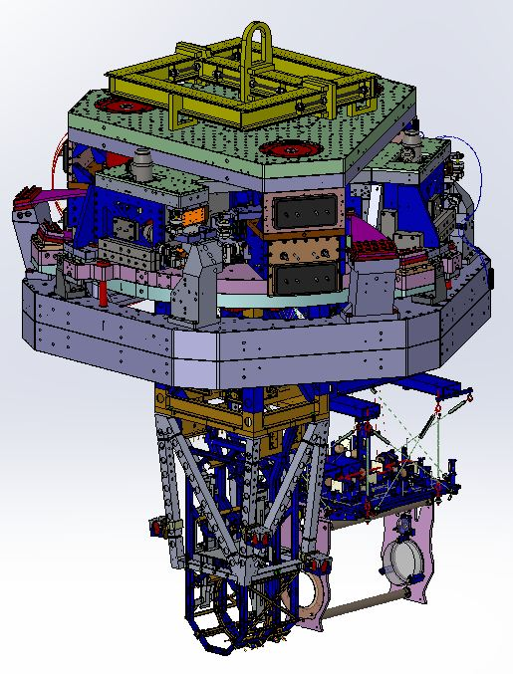
Figure 2: The WBSC6 cartridge assembly (D0900512)
The WBSC6 Cartridge Assembly (“full cartridge” configuration of the D0900512 SolidWorks model version X-101). Not shown is the BSC Mechanical Test Stand (D1002124)

Prerequisites for Cartridge Integration
- The BSC mechanical test stand must be set so that the interface plane with the BSC-ISI stage 0 is horizontal.
- The features of the BSC mechanical test stand which interface to the BSC-ISI platform shall be used to establish a centerline and two offset lines with alignment monuments/references in the floor, as depicted in the D1200076
- An appropriate clean room should be installed over the test stand.
- All payload assemblies must be acceptance tested (to the extent possible and planned) prior to integration into the cartridge assembly.

completed, approved or checked by:
date:
comments (optional):

Applicable Documents
Listed below are all of the applicable and referenced documents for this installation procedure. This list gives the latest revisions of the documents; within the installation steps, only the document number (and not the revision) is quoted.

Only documents actually required to perform the installation should be included in this list and not background or reference material. It is essential that all of the procedures and all of the drawings listed below are available with this procedure during the installation/integration work.

Document | Version | Document Title
General Documents
E0900047 |  | LIGO Contamination Control Plan
Install/Align Procedures
E1101071 |  | Initial Alignment Procedure: WBSC6
T1100406 |  | Quad Cartridge installation procedure check list (e.g. quad lock down)
E#?????? |  | TMS Installation Procedure
E1100841 |  | TMS Transportation-Installation Restraint Procedure
E1101037 |  | aLIGO BSC-ISI Cartridge Installation Procedure
E1100278 |  | WBSC6-H2, Requirements and Procedure: Cartridge Flight and Insertion into BSC Chamber
Test Procedures
E1000487 |  | “BSC-ISI Testing Procedure, Phase II : Integration process”
E1000495 |  | “SUS Quad Suspension Testing and Commissioning Documentation” (this should be a pointer to the specific phase 2 test procedure(s) and not this top level link)
E???????, |  | TMS Phase II Test Procedure
E???????, |  | ACB Phase II Test Procedure
Safety
E1100814 |  | Cartridge Assembly Hazard Analysis
E1101017 |  | Cartridge Lifting Hardware Loading Analysis
E#??????? |  | Critical Lift Plan for the aLIGO WBSC6 Cartridge Installation
E1100976 |  | BSC Cartridge Installation Hazard Analysis
E1000890 |  | SLC Arm Cavity Baffle Install Hazard Analysis
E#????? |  | TMS Install Hazard Analysis
Drawings
D0900512 |  | AdvLIGO Systems, BSC6-H2 Top Level Chamber Assembly
E1100813 |  | BSC6-H2 Top Level Chamber Assembly BOM
D0900514 |  | AdvLIGO SEI BSC6-H2, XYZ Local CS for ISI Table
D0900515 |  | aLIGO SUS BSC6-H2, XYZ Local CS for ETMY
D0900419 |  | AdvLIGO SUS BSC6-H2, XYZ Local CS for TMS ETM Tel Assy
D1001921 |  | AdvLIGO SUS BSC6-H2, XYZ Local CS for SLC Arm Cavity Baffle
D1000897 |  | AdvLIGO BSC6-H2 ISI Table, Balance Masses Assembly
D1101429 |  | ALIGO, AOS, BSC FLOORING ORIENTATION DETAILS, BSC-6 & BSC-8
D1101478 |  | CABLE HARNESS ROUTING CONFIGURATION BSC-6
D1101271 |  | ALIGO BSC ISI OPTICAL TABLE HOLE TABULATION
D1101310 |  | aLIGO, SUS, OPTIC TABLE .38-16 BSC8-H2 FIDUCIAL KIT
E1000202 |  | AdvLIGO Detailed Mass Properties-CG Report BSC Tables LHO
D1101675 |  | WBSC6 and WBSC8 additional (secondary) related documents
D1003085 |  | Flange Layout – H2 Beam Splitter Chamber 6 (BSC6) ETMY
D1101260 |  | ALIGO, BEAM SPLITTER CHAMBER, ROUGH ALIGNMENT TOOL LAYOUT, BSC-6
E1100405 |  | Interface Control Document - BSC Dog clamps and cable clamps
D1003140 |  | Lifting Bar, 3 Point, BSC Cartridge, aLIGO
G1000125 |  | Advanced LIGO BSC and HAM ISI Basis and Naming Conventions
D1101674 |  | LIGO-: aLIGO, SUS, BSC/HAM INSTALLATION TOOLING, in particular:  sh 3 for ETMy upper assembly  sh 8 for ETMy lower assembly

Install the BSC-ISI onto the Test Stand
Using D1000744, Lift Hook Receiver assembly
- The BSC-ISI must be oriented in the same direction as it will be in chamber WBSC6 (as defined in G1000125).
- Remove the LIGO-D1000744: Lift Hook Receiver assembly.

completed, approved or checked by:
date:
comments (optional):

Perform final BSC-ISI testing/characterization prior to payload integration

- completed, approved or checked by:
date:
comments (optional):

Attach the alignment templates for the TMSy and ETMy suspensions
- Attach one alignment template per suspension structure in accordance with LIGO-D1101260: ALIGO, ROUGH ALIGNMENT TOOL LAYOUT , WBSC6. The hole numbering system is defined in LIGO-D1101271: ALIGO BSC ISI OPTICAL TABLE HOLE TABULATION.

completed, approved or checked by:
date:
comments (optional):

Weigh the full suspension payloads
- Weigh the full ETMy quad suspension, record below
- Weigh the full TMSy suspension, record below
- Systems to confirm, or revise, the mass balancing plan/drawing (E1000202)

Payload | Mass (Kg) | Comments/caveats
ETMy Suspension
TMSy Suspension

completed, approved or checked by:
date:
comments (optional):

Install the balance masses onto the optics table
- Install the balance masses in accordance with LIGO-D1000897: AdvLIGO BSC6-H2 ISI Table, Payload & Suspended Mass Assembly

Install the ETMy suspension upper assembly
- Check Dog clamps are installed and tightened as per E1100405, remove TFE stops.
- Cable as per D1101478 (routing) and D1003085 (flanges)
- Set BOSEMs, accounting for buoyancy

- completed, approved or checked by:
date:
comments (optional):

Install the TMSy suspension
- Check Dog clamps are installed and tightened as per E1100405, remove TFE stops.
- Suspend TMSy as per E#??????
- Cable as per D1101478 (routing) and D1003085 (flanges)
- Set BOSEMs, accounting for buoyancy

- completed, approved or checked by:
date:
comments (optional):

Rebalance the ISI Table

Test the TMSy suspension

Install the ETMy lower suspension (monolithic)
- Utilize Optic Cap and shields
- Re-cable
- Suspend QUAD masses as per T1100406
- Install Sleeve and Wedges as per T1000369

- completed, approved or checked by:
date:
comments (optional):

Add Vibration Absorbers to the ETMy Suspension
- Per D0900515

Rebalance the ISI Table

Align the Optics
- Align the optical elements on the cartridge in accordance with E1101071: Initial Alignment Procedure: WBSC6

- completed, approved or checked by:
date:
comments (optional):

Post-Integration, CartridgeTesting
Testing of each of the major, actively controlled, assembly must be performed after integration into the Cartridge Assembly and prior to installation into the Chamber (i.e. Phase II testing per M1000211):
- E1000487, “BSC-ISI Testing Procedure, Phase II : Integration process”
- E1000495, “SUS Quad Suspension Testing and Commissioning Documentation” (this should be a pointer to the specific phase 2 test procedure(s) and not this top level link)
- E???????, TMS Phase II Test Procedure
- E#??????, ACB Phase II Test Procedure

PROCEDURE FOR INSTALLATION INTO THE CHAMBER
The completed installation of all of the interferometer assemblies and components associated with the WBSC6 chamber is depicted in Figure 3 and Figure 4.
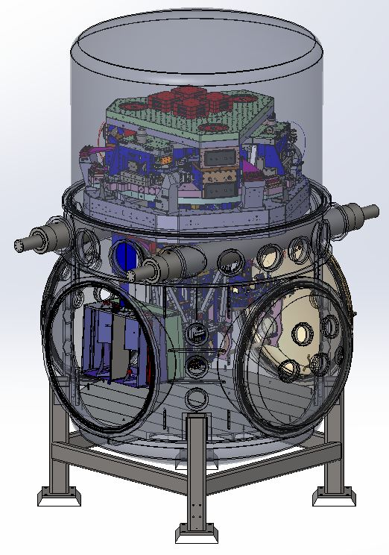
Figure 3: Image of WBSC6 installation (from SolidWorks assembly model for D0900512, with chamber transparent for clarity)
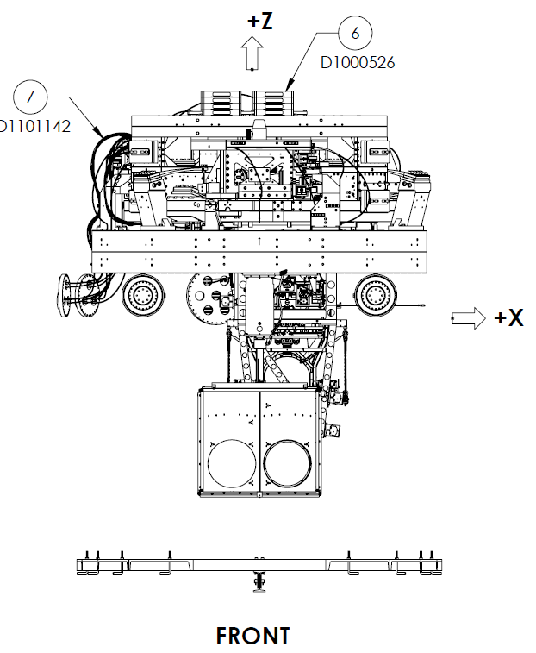 | 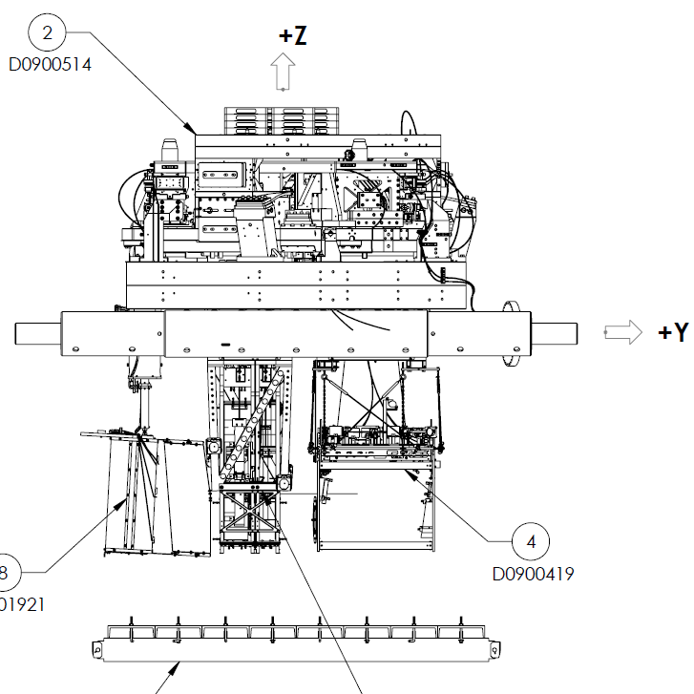
Figure 4: Image of WBSC6 installation (from D0900512, with chamber missing for clarity)

Prerequisites for Chamber Installation
- The oxide layer removed from the interior of the lower shell of the BSC vacuum chamber, and the BSC chamber certified as “clean”
- All subsystem assembly and testing completed successfully

Applicable Documents
NOTE: When completing this document indicate the version of each of the applicable documents used.
Document | Version | Title
General Documents
E0900047 |  | LIGO Contamination Control Plan
M990190 |  | Lockout-Tagout Procedure
Installation, Removal, Alignment Procedures
E1101051 |  | aLIGO BSC Work Platform Assembly Instructions
E1101071 |  | Initial Alignment Procedure: WBSC6
T1100406 |  | Quad cartridge installation procedure checklist  includes quad lock down procedure
E#?????? |  | TMS installation procedure
E1101037 |  | aLIGO BSC Cartridge Installation Procedure  includes BSC-ISI lock down procedure  includes BSC cartridge flight path?
E1100278 |  | WBSC6 Cartridge Flight Path and Lift Parameters [BSC6 H2, Requirements and Procedure, Cartridge Flight and Insertion into BSC Chamber, aLIGO]
E040011 |  | Installation Specification - HEPI Assembly and Installation Procedures (includes the HEPI static positioning adjustment procedure as well)
E1100810 |  | Arm Cavity Baffle Installation Procedure
M990173 |  | Conflat Flange Assembly Procedure
E1100484 |  | Assembly & Installation Specification for the aLIGO, High Quality,Viewports
M1100068 |  | BSC Door Removal and Installation Procedure
E1101162 |  | BSC Dome Removal Procedure
E000121 |  | Spool Removal Procedure
M1000360 |  | Vent Isolatable Volumes Procedure
E1100439 |  | General Optics Cleaning Procedure
E1000079 |  | First Contact™ Procedure
Test Procedures
E1000488 |  | aLIGO BSC-ISI Testing Procedure, Phase III: In Chamber [aLIGO BSC-ISI Testing Procedure, Phase III: Control Commissioning]
DOC#? |  | Quad Phase III Test Procedure
DOC#? |  | TMS Phase III Test Procedure
DOC#? |  | ACB Phase III Test Procedure
Safety
E#????? |  | Critical Lift Plan for the aLIGO WBSC6 Cartridge Installation
E1100976 |  | BSC Cartridge Installation Hazard Analysis
E1000890 |  | SLC Arm Cavity Baffle Install Hazard Analysis
T1000311 |  | TMS Install Hazard Analysis (not yet reviewed & approved)
Drawings
D0900512 |  | LIGO-: AdvLIGO Systems, BSC6-H2 Top Level Chamber Assembly
E1100813 |  | LIGO-: BSC6-H2 Top Level Chamber Assembly BOM
D0900514 |  | LIGO-: AdvLIGO SEI BSC6-H2, XYZ Local CS for ISI Table
D0900515 |  | LIGO-: aLIGO SUS BSC6-H2, XYZ Local CS for ETMY
D0900419 |  | LIGO-: AdvLIGO SUS BSC6-H2, XYZ Local CS for TMS ETM Tel Assy
D1001921 |  | LIGO-: AdvLIGO SUS BSC6-H2, XYZ Local CS for SLC Arm Cavity Baffle
D1000897 |  | AdvLIGO BSC6-H2 ISI Table, Balance Masses Assembly
D1101429 |  | ALIGO, AOS, BSC FLOORING ORIENTATION DETAILS, BSC-6 & BSC-8
D1101478 |  | CABLE HARNESS ROUTING CONFIGURATION BSC-6
D1101271 |  | ALIGO BSC ISI OPTICAL TABLE HOLE TABULATION
D1101310 |  | aLIGO, SUS, OPTIC TABLE .38-16 BSC8-H2 FIDUCIAL KIT
E1000202 |  | AdvLIGO Detailed Mass Properties-CG Report BSC Tables LHO
D1101675 |  | WBSC6 and WBSC8 additional (secondary) related documents
D1003085 |  | Flange Layout – H2 Beam Splitter Chamber 6 (BSC6) ETMY
D1101260 |  | ALIGO, BEAM SPLITTER CHAMBER, ROUGH ALIGNMENT TOOL LAYOUT, BSC-6
E1100405 |  | Interface Control Document - BSC Dog clamps and cable clamps
D1003140 |  | Lifting Bar, 3 Point, BSC Cartridge, aLIGO
G1000125 |  | Advanced LIGO BSC and HAM ISI Basis and Naming Conventions
D1101674 |  | aLIGO, SUS, BSC/HAM INSTALLATION TOOLING

Prepare the Chamber for Cartridge Installation
- Install HEPI per E040011
- Install the cable tray (D1100430) around the WBSC6 chamber. (Note: The wire tray support brackets will be different than shown in the drawing, but similar in overall concept/layout; Drawing to be revised.)
- Install the Platforms (D1001990) and Module E (D1002926) around the chamber, per procedure E1101051
- Install a BSC Chamber Cleanroom around the WBSC6 chamber and clean the chamber exterior and the region around the chamber. Install the leg lifting/lowering devices on all 4 legs.
- Vent the Y-Manifold vacuum volume and set the purge gas flowing per procedure M1000360. Follow the Lockout-Tagout procedure M990190
- Install the dial indicators on the BSC support tube ends
- Remove the BSC Dome per procedure E1101162
- Install the Walking Plates (D1002410, without railings).
- Remove the WBSC6 Chamber Door per procedure M1100068
- Install the electrical feed-throughs listed in D1003085, per procedure M990173
Note: The electrical feed-throughs can be installed later in the sequence.
- Install the field cabling from the electrical feed-throughs to the electronics racks, per D#s?
Note: The field cabling can be installed later, but must be done after the cable trays are in place, yet before the cartridge is installed.
- Install the viewports listed in T1100292 for WBSC6 and Adapter WA-17B, per procedures E1100484 and M990173
Note: The viewports can be installed later in the sequence.
- Install the BSC Chamber Flooring (D961115) in accordance with the orientation noted in D1101429
- Insure that the support tubes are level (to within 0.4 mrad) with a precision bubble level and HEPI static adjustment (per procedure E040011)
- Transport the Arm Cavity Baffle (ACB, D0901376) subassemblies, and associated installation equipment, into the manifold spool adjacent to WBSC6, per procedure E1100810. Note: The ACB will not be installed initially in WBSC6 for the H2OAT.

- completed, approved or checked by:
date:

Version numbers of all subsidiary documents followed:

comments (optional, e.g. deviations, exceptions, problems, “punch-list”):

Prepare the Cartridge Assembly for installation into the chamber
See also the generic preparation steps defined in the beginning of the Cartridge Installation Procedure, E1101037
- Lock down the BSC-ISI stages per E1101037
- Lock down ETMy per T1100406
- Lock down the TMSy per E1100841
- Install tooling/guards to protect the optics (e.g. the “optics caps”, tooling to prevent the CP face stops from contacting the AR face of the ETM) and place the optics on their mechanical/earthquake stops
- Disconnect all cabling/wiring and temporarily tie down to the BSC-ISI assembly with class B cable ties
- Wrap each suspension in appropriate C3 fabric bags

- completed, approved or checked by:
date:

Version numbers of all subsidiary documents followed:

comments (optional, e.g. deviations, problems):

Install the Cartridge Assembly into the Chamber
- Insure that all personnel involved have read and understood the general cartridge installation procedure (E1101037), the specifics of the WBSC6 cartridge installation (CG location, flight path, close approach regions, etc. in E1100278), the hazard analysis (E1100976) and the critical lift plan (E#??????)
- Follow E1101037 to install the Cartridge into the Chamber and attach to the SEI Support Tubes.
- Install the railings around the Walking Plates (D1002410) after landing the Cartridge onto the support tubes
- Remove all temporary cable ties and connect all cabling to the appropriate electrical feed-throughs according to D1003085
- Unlock the ISI stages
- Unlock the TMS per E1100841
- Remove the protective face shield and lens cap for the ETMy
- Unlock the ETMy suspension per T1100406

- completed, approved or checked by:
date:

Version numbers of all subsidiary documents followed:

comments (optional, e.g. deviations, problems):

Align the Cartridge Assembly
- Remove the WBSC6 Chamber End Door per procedure M1100068
- Set up the Initial Alignment System (IAS) equipment in the region of the Spool Adapter WA-1F, per procedure E1101071
- Follow alignment procedure E1101071 to align the Cartridge within the Chamber.

- completed, approved or checked by:
date:

Version numbers of all subsidiary documents followed:

comments (optional, e.g. deviations, problems):

Install the Arm Cavity Baffle
Note: The ACB will not be initially installed for the H2OAT.
- Lock down the BSC-ISI stages per E1101037
- Lock down ETMy per T1100406
- Lock down the TMSy per E1100841
- Install protective shields on the ETMy suspension
- Install the Arm Cavity Baffle (ACB) per E1100810
- Align the Arm Cavity Baffle (ACB) per E1101071

- completed, approved or checked by:
date:

Version numbers of all subsidiary documents followed:

comments (optional, e.g. deviations, problems):

Clean the Optics
- Inspect the optical surfaces. If cleaning is required, then complete the following steps.
- Lock down the BSC-ISI stages per E1101037
- Lock down ETMy per T1100406
- Lock down the TMSy per E1100841
- Clean the optics if needed. First Contact™ cleaning (per procedure E1000079) is the preferred method.

- completed, approved or checked by:
date:

Version numbers of all subsidiary documents followed:

comments (optional, e.g. deviations, problems):

Testing
Prior to pumping the Y-manifold down to vacuum all active components must pass stand-alone, in-situ testing to see that the assembly behaves properly after the installation procedure and with the field-installed cabling, etc (i.e. phase 3 testing per M1000211):
- E1000488, “BSC-ISI Testing Procedure, Phase III: Control Commissioning”
- E1000495, “SUS Quad Suspension Testing and Commissioning Documentation” (this should be a pointer to the specific phase 3 test procedure(s) and not this top level link)
- E#?????, TMS Phase III Testing Procedure
- E#?????, ACB Phase III Testing Procedure

- completed, approved or checked by:
date:

Version numbers of all subsidiary documents followed:

comments (optional, e.g. deviations, problems):

