LIGO Laboratory / LIGO Scientific Collaboration

LIGO-E1101226-v5 LIGO 13 Jan 2026

Proof Test Levels for Advanced LIGO Viewports

Dennis Coyne (eds. Melina Fuentes-Garcia and Calum Torrie)

Distribution of this document:
LIGO Scientific Collaboration

This is an internal working note
of the LIGO Laboratory.

California Institute of Technology  LIGO Project – MS 18-34  1200 E. California Blvd.  Pasadena, CA 91125  Phone (626) 395-2129  Fax (626) 304-9834  E-mail: info@ligo.caltech.edu | Massachusetts Institute of Technology  LIGO Project – NW22-295  185 Albany St  Cambridge, MA 02139  Phone (617) 253-4824  Fax (617) 253-7014  E-mail: info@ligo.mit.edu
LIGO Hanford Observatory  P.O. Box 159  Richland WA 99352  Phone 509-372-8106  Fax 509-372-8137 | LIGO Livingston Observatory  P.O. Box 940  Livingston, LA 70754  Phone 225-686-3100  Fax 225-686-7189
http://www.ligo.caltech.edu/

Contents
1 Introduction 3
2 Fracture Mechanics for Glasses 3
2.1 Formulation 3
2.2 Material Properties 4
2.2.1 Fused Silica (SiO₂) 4
2.2.2 Corning 7056 Alkali Borosilicate Glass 4
2.2.3 Zinc Selenide (ZnSe) 5
2.2.4 Calcium Flouride (CaF2) 6
3 Stress 6
3.1 Stress due to the Pressure Load 6
3.2 Thermal Stress 7
4 Proof Test 7
5 Internal Overpressure Limit 8
Appendix 10

List of Tables
Table 1: Proof Test Levels 12
Table 2: Internal Overpressure Limits 12

Introduction
The “LIGO Generic Requirements & Standards for Detector Subsystems” calls for inert environment, proof testing for all brittle, non-metallic materials on the vacuum envelope. The minimum proof test factor for pressurized brittle, non-metallic materials is 2.0. Better than proof testing at the minimum test factor is to proof test at a stress which guarantees the desired minimum lifetime,. In this memo the appropriate proof test levels, based on fracture mechanics, are calculated for each of the Advanced LIGO (aLIGO) viewports. This version (v5) incorporates additional viewports from vendors MPFPI and Torr Scientific as well as an appendix detailing the process of choosing an acceptable failure probability.

Fracture Mechanics for Glasses

Formulation
It is well established that subcritical crack growth, or slow crack growth (SCG), in glasses and ceramics, in environments containing water vapor, is caused by a tensile stress enhanced, chemical corrosion at the tip of pre-existing surface flaws. This phenomenon is known as “delayed failure” or “static fatigue”.
Weiderhorn et. al. found that some glasses exhibited subcritical crack growth in vacuum, whereas some other glasses did not (including two that had anomalous elastic behavior and an Ultra-Low Expansion (ULE) glass). I am unaware of any studies on subcritical crack growth for the optical materials that we use in our vacuum viewports. It is possible (even likely) that these materials do not exhibit subcritical crack growth (static fatigue) while under vacuum. However, it is important to consider the lifetime and strength due to static fatigue in this application, because (a) the viewports are cycled up to air multiple times and for significant durations during their lifetime and (b) there can be tensile stresses on the air side of the viewport windows (associated with the compressive loading of the seal or due to slight overpressure when venting).
Pre-existing flaws grow in size under the service load (stress) to a critical size at which a crack propagates quickly. The subcritical growth can be expressed as a power function of the stress intensity factor, K_{I}:
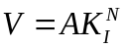
where V is the crack velocity, A and N are constants that depend on the environment and material composition. From this equation it can be derived that the time to failure, t_{f}, under a constant tensile stress, σ_{a}, is:
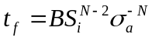
where 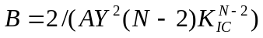, Y is a geometric constant (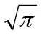for surface flaws), K_{IC} is the critical stress intensity factor and S_{i} is the fracture strength in an inert environment.
The probability distribution function for the inherent fracture strength is often well modeled by a Weibull function:
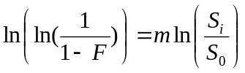
where F is the cumulative failure probability and m, S₀ are constants.

Material Properties

Fused Silica (SiO₂)
The strength and delayed failure properties of fused silica are discussed in the report on the design, and stress analysis, of the elastomer sealed viewports for aLIGO. Here only a summary of the relevant parameters are restated for convenience.
E = 10.7 10⁶ psi (73.6 GPa)
ν = 0.17
m = 4.4
S₀ = 156.5 MPa
N = 40.5
B = 5.1 x 10⁻⁴ MPa² s
A = 7.49 x 10⁶ m/s (MPa $\sqrt{m}$)^{-N}
K_{Ic} = 0.722 MPa $\sqrt{m}$

Corning 7056 Alkali Borosilicate Glass
The elastic properties of Corning 7056 (a glass designed to have a coefficient of expansion matched to Kovar for sealing to glass) are:
E = 62.8 GPa
ν = 0.21
I have been unable to find any delayed failure (static fatigue) data in the literature for Corning 7056 glass, or more generally for borosilicate glass. As a consequence, the proof test factor for this glass will default to 2.0.

Zinc Selenide (ZnSe)
The elastic properties of chemical-vapor-deposited (CVD) ZnSe windows are:
E = 74.3 GPa
ν = 0.31
and the Weibull distribution parameters for the equibiaxial fracture strength (determined by the maximum likelihood estimator) are:
m = 9.6
S₀ = 60.6 MPa
With a failure probability of F = 10⁻⁵ and a lifetime, t_{f} = 20 years:
S_{i} = 18.3 MPa
σ_{f} = 7.86 MPa
A NASA report on slow crack growth properties of CVD ZnSe windows showed a remarkably large variation in slow crack growth properties from (or derived from) data in the literature. In my opinion the most appropriate slow crack growth parameters are:
N = 39.6
B = 6.74 x 10⁻⁴ MPa²-s
A = 1.09 x 10³ m/s (MPa $\sqrt{m}$)^{-N}
K_{Ic} = 0.9 MPa $\sqrt{m}$
However it should be noted that there is a great deal of uncertainty in these values (despite reporting 3 significant digits). The interested reader should consult the source references.

Calcium Flouride (CaF2)
CaF2 is being considered for use with a laser heater system for transient attenuation on the Input Test Mass (ITM) front surface to be installed as part of the O5 upgrades. This system will utilize quantum cascade lasers (QCLs) operating at 4.65 µm. The system will be known as Central Heater for Transient Attenuation (CHETA). CHETA requires 60 mm clear view, double-glass, In-sealed, AR coated (1064nm, 4650 nm), viewports. CaF2 has high transmission from the UV to the Mid-Wave Infrared (MWIR) with low absorption and high laser damage threshold. However, CaF2 is brittle and subject to slow crack growth.
Material and fracture mechanics property data, for CaF2 is as follows:
E = 108 GPa
ν = 0.30
m = 6
S₀ = 70 MPa
N = 33
B = 1.22 MPa² s
A = 1.89 x 10¹² m/s (MPa $\sqrt{m}$)^{-N}
K_{Ic} = 0.35 MPa $\sqrt{m}$

Stress

Stress due to the Pressure Load
The response (deflection and stress) of the window/optic due to one atmosphere of load can be estimated by the response of a circular flat plate of constant thickness loaded with a uniform pressure on one side and simply supported at its perimeter:
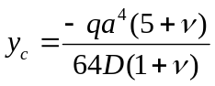, the deflection of the plate (window) at the center
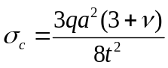, the stress at the face of the plate (window) at the center
where
a = radius to the simple support (taken as the compressed o-ring I.D.)
q = applied pressure load
t = window thickness
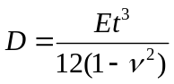 is the “plate constant”, or stiffness
E = modulus of elasticity
ν = Poisson’s ratio
This approximate calculation is reasonably close to finite element results, indicating that the response is primarily plate-like bending. The finite element analysis for the non-wedged, 6 inch, high quality viewport windows is documented in T1100346. The finite element analysis for the TCS viewport ZnSe window is documented in E1100379. In both of these cases the approximate plate bending formulation given above yields a higher (conservative) stress. The approximate plate bending formulae is used for all other viewport designs in section 4.

Thermal Stress
The only viewports which have some thermal loading are the following:
- PSL injection viewports
- TCS injection viewports
As shown in E1100379, with nominal (low) surface and bulk absorption, the small amount of absorption in the TCS viewport window causes very little temperature increase and insignificant stress. Both of these high power injection viewports (PSL and TCS) have an outer, secondary, window which does not have a differential pressure across it. This window prevents significant surface contaminants (e.g. bugs) from causing increased absorption on the pressurized window.

Proof Test
The proof test should have the same stress field as the service stress, except amplified. Since the in-service stress is principally due to differential pressure, the proof stress can be accomplished by simply applying a higher differential pressure.
The minimum lifetime after proof testing is given by:
$$t_{min}=Bσ_{p}^{N-2}σ_{a}^{-N}$$
where σ_{p} is the proof stress, σ_{a} is the applied, or service, stress and N and B are fracture mechanics material parameters defined above. The applied/service stress is the result of 1 atmosphere of differential pressure load. A proof test would impose a higher differential pressure in order to get the same stress field response except at higher amplitude. Due to the linear elastic response of the window, the proof stress can be expressed as a multiple of the applied/service stress:
$$σ_{p}=xσ_{a}$$
where x is the number of atmospheres of load to be used in the proof test and σ_{a} is the applied stress in service.
However the proof test load can be high enough to cause unintended damage if not careful. The viewport is either sealed with an o-ring or a glass-to-metal fused bellows/flexure seal. In the case of the o-ring seal, the proof pressure is generally high enough that the gap between the glass and the viewport flange will close and cause contact between the glass and metal, which can initiate surface flaws that lead to failure, i.e. without proper precaution the proof test can lead to premature failure. As a consequence either (a) a protective thin shim of soft material is placed between the glass and the metal (e.g. kapton), or (b) the window is proof tested separately from the viewport assembly and care is taken not to compromise the glass surface is subsequent handling and assembly. We have chosen the former approach.
In the case of a glass-to-metal fused seal, the proof test load is high enough to cause permanent deflection of the bellows/flexure. In this case the proof test apparatus must provide a soft landing to support the edge of the glass before the bellows/flexure exceeds the elastic limit. In the aLIGO viewport proof tester (D1101939) this is accomplished with a PEEK ring which contacts the outer radius of the face of the window, just inside the o-ring gland, which approximates the boundary condition afforded by the bellows/flexure reasonably well (though of course not exactly).
The proof test values, as well as other relevant parameters, for each of the aLIGO viewport windows is given in Table 1. The proof test levels are based on a 20 year lifetime.
Note that the TCS viewport includes two windows, one comprised of fused silica and the other comprised of zinc selenide. Both of the windows are exposed to the same proof pressure at the same time. Consequently the larger of the two proof pressures should be used (to ensure a 20 year minimum lifetime). This is possible only because the proof test levels for both windows are so similar.
For the commercial viewports which have a metal-to-glass, fused seal, the outer radius of the glass window is assumed to be .25" larger than the clear aperture, based on measurements for one design.
Note that for the large aperture (7.8” diameter) commercial viewports, the Factor of Safety (FS) is only 1.5 with a failure probability, F, of 10⁻², whereas for all other windows FS = 3.0 and F = 10⁻⁵.

Internal Overpressure Limit
If the nominal pressure differential across the viewport is reversed (i.e. the vacuum system is overpressured by the vent/purge-air system), then the outer surface of the window will be placed into tensile stress. The proof test defined in this document does not subject the outer surface of the window to a tensile stress. Nonetheless, we need to set a practical limit on the maximum allowed internal pressure level from the perspective of potential viewport failure. Some background information/references:
- Document T080145-v1, "Viewport Safety Protocols", states that "Volume backfill procedures and equipment should limit internal transient overpressure to 2 psi (10 kPa) [TBR] or less above ambient."
- Document E1200293-v4, "Venting Isolatable Vacuum Volumes at LHO", sets a 1.5 psig limit for operation (not a design limit).
- It has been recently noted at the LHO facility that the pressure regulator on the clean air skid is rated at 1-2 psig and the pressure relief valve next to it is 1.75 psig. The pressure relief valves on the flex tubes are set to 1/3 psig.
- The Advanced Light Source (ALS) project vacuum policy limits overpressure for viewports to 0.5 psi based on a recommendation from Varian.
Using the fracture mechanics formalism, and glass material properties, defined in this document, suggests that a 2 psig internal overpressure (reverse pressure) would have a minimum Safety Factor of 14.7 at a cumulative failure probability of .00001 (for all viewport types) based on the allowable stress for a 20 year lifetime, with the following assumptions and caveat (see Table 2):
- The vacuum-side surface is similar to the air-side surface, i.e. the surface flaw distribution on the vacuum side, which has been proof-tested in a tensile stress state, is statistically similar to the air-side surface, which has not been subjected to a tensile proof stress. This is only true if the same care and handling is applied to both sides. Given our careful inspections, care in handling and requirements to cover all viewports, I think that this is a reasonable assumption.
- The boundary conditions of the window are not significantly altered by the reversal of the pressure difference. This is certainly the case for the custom viewports with o-ring sealed windows (symmetric design). The covar sealed, commercial viewports used by LIGO (MDC/Larson) have an asymmetric flexure attachment to the glass window. Under vacuum there is a small stress riser in the glass at the edge of the flexure which is covar bonded to the glass. With reversed pressure, the stress in this area is likely in compression; The stress should certainly not be at a higher tensile stress value.
- For the large commercial viewports (7.8" diameter) is SF = 2.6 for F = .00001 and F = 11.4 for F = .01 (See section 4 for motivation on why this particular viewport is evaluated at a higher failure probability.)

Appendix
Choosing values for the Cumulative Failure Probability (F) and the Factor of Safety (FS)
As noted at the end of section 4, a lower F value and lower FS for is used for the large commercial viewports:
“Note that for the large aperture (7.8” diameter) commercial viewports, the Factor of Safety (FS) is only 1.5 with a failure probability, F, of 10⁻², whereas for all other windows FS = 3.0 and F = 10⁻⁵.”
The following is an explanation for why.
The cumulative failure probability, F, is specified as the tolerable failure level that we’ll accept. An F = 1E-5 means 1 failure in 100,000 (in the 20-year lifetime). This was practical to specify for most viewports, with a FS >= 3 as stipulated in section 3.4.4 of the generic requirements document for glass materials, https://dcc.ligo.org/LIGO-E010613).
However, for the large commercial viewport, F = 1E-5 results in FS < 1. Why? Either these viewports are:
  - inadequate designs, or
  - the fracture mechanics model is incorrect, or
  - the maximum stress under operational load (atmospheric pressure) is less than predicted by the formula (for a flat circular plate of constant thickness with a simply supported boundary), or
  - the fracture mechanics parameter(s) are incorrect.
Since we have employed these commercial viewports in quantity for quite a few years without failure, I chose to reject assumption (1).
Since the fracture mechanics model is the current best physical model of the static failure mechanism, premise (2) while possibly true is not a productive approach to a better estimate of failure probability or robustness (short of an extensive research project).
Consider premise (3). Instead of using the formula for the stress (for a flat circular plate of constant thickness with a simply supported boundary we could perform a Finite Element Analysis (FEA). In fact, this has been done for a number of the other viewports. The FEA calculated stresses are all slightly lower for these viewports, but not enough to explain the discrepancy – for these particular boundary designs. When comparing the two idealized cases of simply support or fixed boundary conditions (normalized to the simply supported case), it is possible that an intermediate rotational compliance at the boundary could result in a lower maximum stress:
To properly perform the FEA all of the details of the window edge joint to the flange must be known.
case | normalized  center stress | normalized  edge stress
simply supported | 1 | 0
intermediate | <1 | > -1
fixed | 0.37 | -1.7
Consider premise (4). Since fused silica material parameters (E, v, N, B, A, K_{IC}, S_{i}) appear to “work” for the other viewport designs (which employ fused silica windows), these parameters should not change (or should all change uniformly). The free parameters are then only F, FS, m, and S₀. F and FS are (to some extent) specifiable parameters, whereas m and S₀ are parameters that describe the distribution of material strengths in the population of the object. As such, m and S₀ are the result of the material processing history (casting, grinding, polishing, etc.) and the material. The Weibull function parameters m and S₀ are related to F (by the equation given in E1101226). F and FS are qualitatively understandable, whereas m and S₀ are more difficult to get an intuitive understanding. In a Weibull function, m (Weibull Modulus/Shape Parameter) defines the scatter or variability; a higher m means less scatter (more consistent material/process), while a lower m indicates greater variability. S₀ (Scale Parameter/Characteristic Strength), indicates the characteristic strength; it’s the value where about 63.2% of items fail, establishing the distribution center.
For the large commercial viewport with fused silica glass, an F = 1E-2 (meaning 1 failure in 100, which is arguably quite high), the resulting FS = 1.5, which, though low for glass, is “respectable” (greater than required for metal for example).
Note that the proof test pressure is independent of the value of F and FS, i.e. we do not need to know the projected lifetime in service to design the proof test pressure.

Table 1: Proof Test Levels
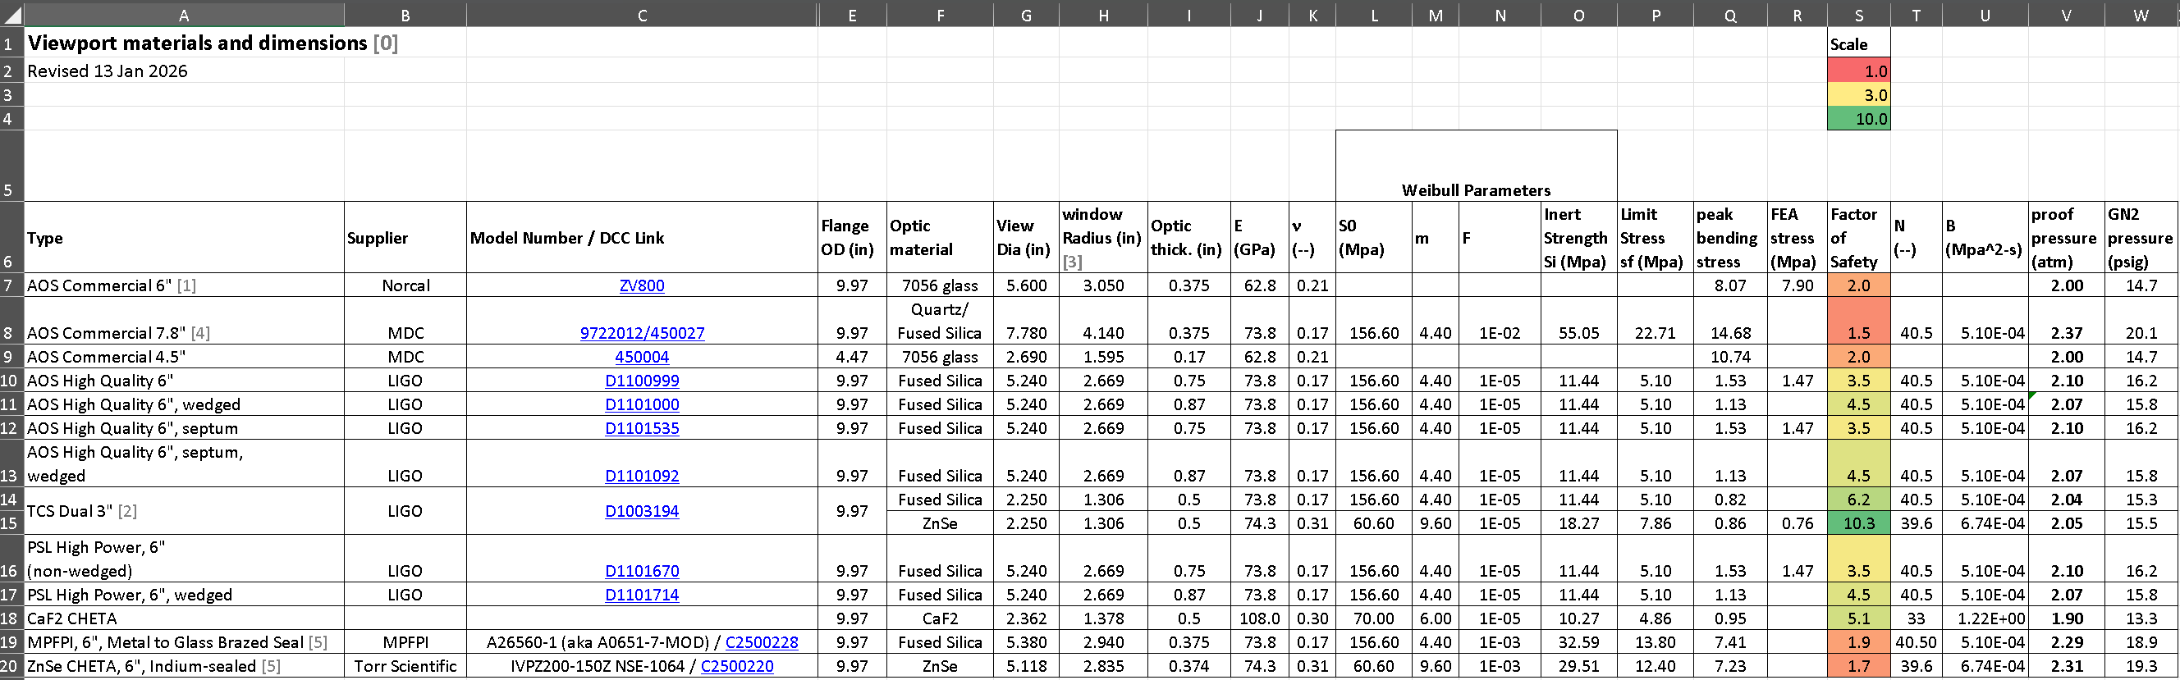
Table 2: Internal Overpressure Limits
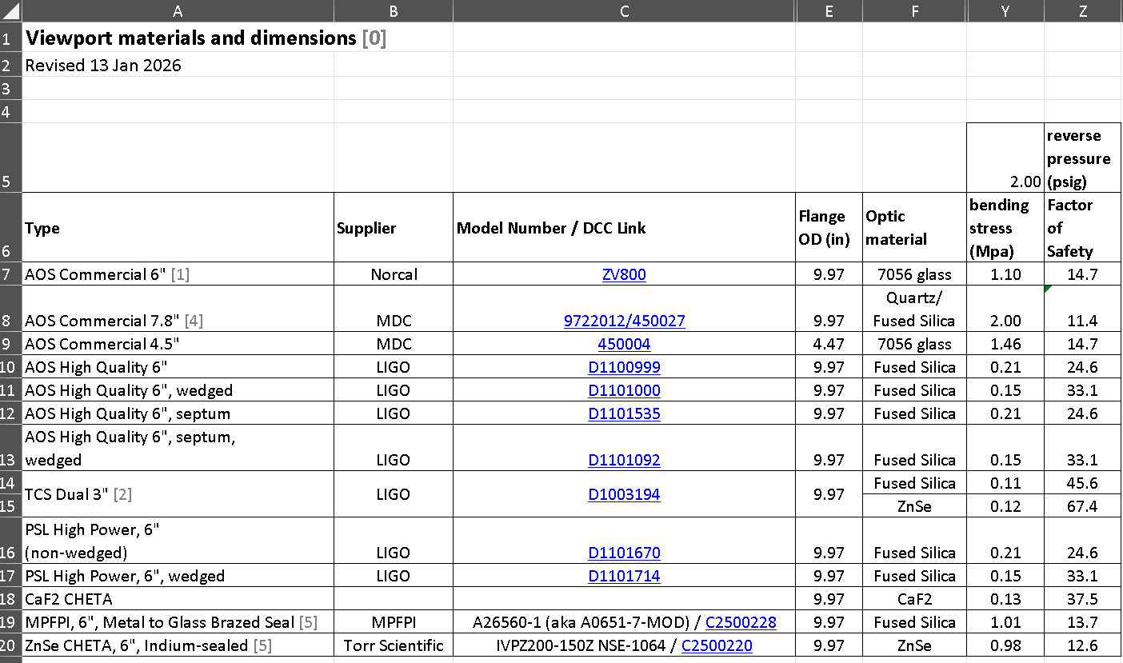

D. Coyne, “LIGO Generic Requirements & Standards for Detector Subsystems”, E010613, section 3.4.4.1.1. This section is based upon: “Structural Design and Test Factors of Safety for Spaceflight Hardware”, NASA-STD-5001, 21 June 1996. N.B.: The current version of the requirements document (E010613-v1), requires a minimum proof test load of 1.2 times the maximum in-service load with a minimum design factor of safety of 3. However, this is really only appropriate for non-pressurized applications. The document will be revised to call for a proof test factor of 2.0 for pressurized applications, such as viewports.
J. Ritter, D. Coyne, K. Jakus, “Failure Probability at the Predicted Minimum Lifetime After Proof Testing”, Journal of the American Ceramic Society, Vol. 61, No.5-6, pp. 213-216. https://doi.org/10.1111/j.1151-2916.1978.tb09282.x
K. Jakus, D. Coyne, J. Ritter, Analysis of fatigue data for lifetime predictions for ceramic materials, J. Materials Science, 13 (1978) 2071-2080. https://doi.org/10.1007/BF00541660
.
D. Coyne, “Design of the Elastomeric Sealed, High Quality, Viewports”, T1100346-v2, section 4.1. The KIc and A values are not reported in T1100346 but available from the principal source for fused silica delayed failure parameters: L. Braun et. al., “Fracture Mechanics and Mechanical Reliability Study: Comparison of Corning Code 7980 and 7940 Fused Silica”, NIST, Nov 1998.
MatWeb, Corning 7056 Alkali Borosilicate Crushed/Powdered Glass
albeit with a very limited search.
J. A. Salem, “Mechanical Characterization of ZnSe Windows for Use With the Flow Enclosure Accommodating Novel Investigations in Combustion of Solids (FEANICS) Module”, NASA/TM-2006-214100, Feb 2006
J. A. Salem, “Estimation of ZnSe Slow-Crack-Growth Properties for Design of the Flow Enclosure Accommodating Novel Investigations in Combustion of Solids (FEANICS) Windows”, NASA/TM-2005-213359, Apr 2005
The SCG properties reported in Ref. 9 are derived principally from two other references, which are referred to in Ref. 9 as Ref. 1 and Ref. 2. The Ref. 2 data has large scatter, or was fitted after truncating some of the data for a better fit. For these reasons the Ref. 2 data is suspect in my opinion. The Ref. 1 data set which has the least scatter and has an N value which is consistent with most other data cited in Ref. 9, including Ref. 2, seems the best choice for N and A values. In order to derive a B value, one must use an appropriate K_{Ic} value. In Ref. 9 the K_{Ic} value for small cracks of intergranular or transgranular nature is recommended as conservative. However this value is so conservative that the aLIGO ZnSe viewport would not be predicted to sustain even 1 atm. Consequently, the less conservative, but more realistic K_{Ic} value reported for a dry nitrogen environment is used in my recommended SCG property set.
J.A. Salem, “Crack propagation in calcium fluoride single crystals", Proceedings Volume PC13134, Optical Manufacturing and Testing, 1-Oct-2024, Optical Engineering + Applications, 2024, San Diego, CA, USA PC1313409 (2024) https://www.spiedigitallibrary.org/conference-proceedings-of-spie/PC13134/PC1313409/Crack-propagation-in-calcium-fluoride-single-crystals/10.1117/12.3031867.full
J. Salem, R. Rogers, and C. Heb, "Crack propagation in calcium fluoride single crystals", Optical Engineering, July 2023, Vol. 62(7) https://www.spiedigitallibrary.org/journals/optical-engineering/volume-62/issue-7/077102/Crack-propagation-in-calcium-fluoride-single-crystals/10.1117/1.OE.62.7.077102.full
W.C. Young, Roark’s Formulas for Stress & Strain, 6th ed., Mc-Graw-Hill, 1989, Table 24, case 10a with r₀=0
Even though the window is quite thick, its response is dominated by the plate stiffness, D (i.e. the elastic modulus, E, and Poisson’s ratio, ν), as opposed to the bulk modulus, K.
D. Coyne, “Design of the Elastomeric Sealed, High Quality, Viewports”, T1100346-v2.
M. Jacobson, “Analysis Report of ZnSe Viewports for aLIGO TCS”, E1100379-v3. N.B.: The –v3 version has an error in the finite element analysis under pressure load and will be corrected.
E1200293 is now obsolete. Refer to E2300169-v2 “Venting and Pumping isolatable volumes at LIGO” henceforth.
section 5.9 of "Advanced Light Source Vacuum Policy and Vacuum Guidelines for Beamlines and Experiment Endstations", LBL-37713, UC-410, Aug 1995: https://inis.iaea.org/search/search.aspx?orig_q=RN:27031742
A finite element stress analysis of a viewport similar to the nominal 6 inch diameter version used by LIGO was reported on pages 17-21 of the file “2008 07 18 SSV v1.6.ppt” filed in the LIGO DCC entry G080409-v1.

