5 December 2011
The TCS Periscope 1 mirror was measured using the Zygo interferometer against Flat C in the 2x configuration. The reference data file “O:\aLIGOmet\CAL\Flat_C\F2x\av_P01-P14” was subtracted. The mirror is thin and was supported on a v-block. Usually we see the effect of the v-block as a high at the two support locations. However, the wrong wavelength measurement may be misleading us.
The mirror was measured at 1064 nm. The phase response of a coating designed for CO₂ may appear different measured at 1064 than it would if measured at the proper wavelength. Contrast was good, the coating appears golden to the eye.
The occlusion at 7 o’clock is part of a clean room wipe, used to cover the v-block.
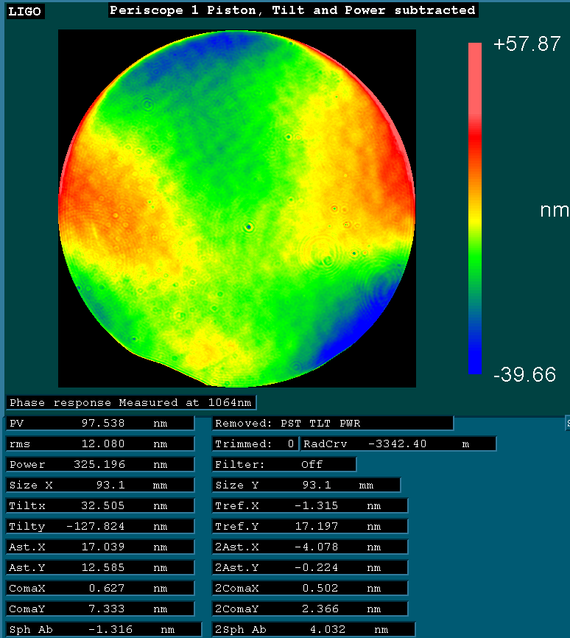
Figure 1: Full aperture view

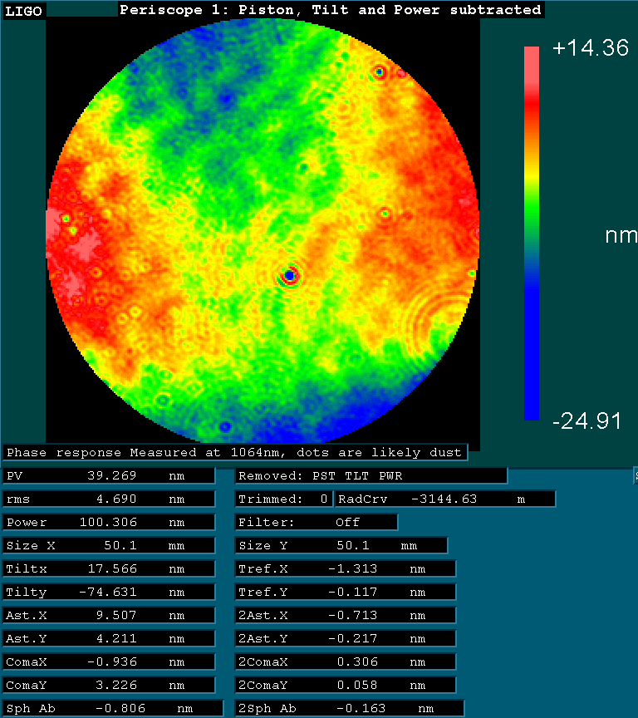
Figure 2: 50mm aperture

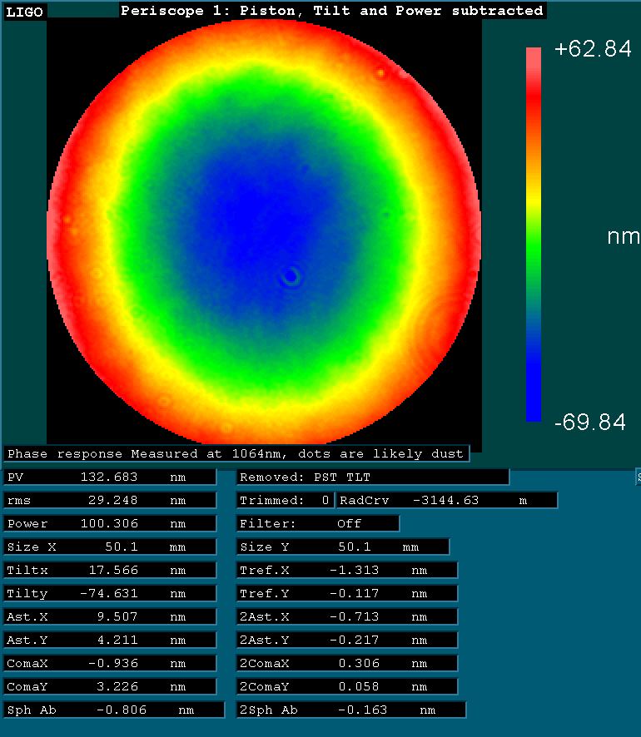
Figure 3: 50mm aperture, piston and tilt subtracted (power included)

