LIGO Laboratory / LIGO Scientific Collaboration

LIGO-T1100149-v8 LIGO Date:29-Nov-11

Vertex Hartmann Sensor: Initial and Maintenance Alignment Procedures

Authors: Aidan Brooks, Phil Willems, Mindy Jacobson,
Cheryl Vorvick, Dennis Coyne, Doug Cook

Distribution of this document:
LIGO Scientific Collaboration

This is an internal working note
of the LIGO Laboratory.

California Institute of Technology  LIGO Project – MS 18-34  1200 E. California Blvd.  Pasadena, CA 91125  Phone (626) 395-2129  Fax (626) 304-9834  E-mail: info@ligo.caltech.edu | Massachusetts Institute of Technology  LIGO Project – NW22-295  185 Albany St  Cambridge, MA 02139  Phone (617) 253-4824  Fax (617) 253-7014  E-mail: info@ligo.mit.edu
LIGO Hanford Observatory  P.O. Box 159  Richland WA 99352  Phone 509-372-8106  Fax 509-372-8137 | LIGO Livingston Observatory  P.O. Box 940  Livingston, LA 70754  Phone 225-686-3100  Fax 225-686-7189
http://www.ligo.caltech.edu/

References
- T1000230, Auxiliary Optics System (AOS) Initial Alignment System (IAS) Final Design Document
- T1100293, ITM Hartmann sensors: Alignment tolerance, resolution and range requirements
- G1000013, Livingston aLIGO Installation Schedule
- G1000061, Hanford aLIGO Installation Schedule

Introduction
The purpose of this document is to describe the initial and maintenance alignment procedures for the vertex Hartmann sensors (located on HAM4 in H1, L1 and HAM10 in H2).

Stages of Alignment procedure
- Alignment Stage 1:This occurs once the BS, ITMs, SR2 and SR3 are installed and involves surveying the site and locating the axis between BS, ITM, SR2 and SR3 to within 100 μradians. The Hartmann sensor in-vacuum optics would be installed at this stage.
  - For L1: This stage coincides with activities "IN-L1-P3150" through "IN-L1-P3160", spanning the period 18-Jan-12 through to 28-Mar-12 in the LLO aLIGO Installation Schedule.
  - For H2: This stage coincides with activity "IN-H2-FI1810", which spans the period from 21-May-12 to 24-Jul-12 in the LHO aLIGO Installation Schedule.
  - For H1: This stage coincides with activity "IN-H1-F3140", which spans the period from 25-Sep-12 to 08-Feb-12 in the LHO aLIGO Installation Schedule.
- Alignment Stage 2: this stage occurs once the vacuum system has been sealed and pumped down. The in-air table is aligned independently and then its optical axis is mated to the in-vacuum optical axis. Stage 3 will also be used to recover from a misalignment.
- Alignment Stage 3: The imaging of the Hartmann sensor is accomplished in this Stage. Once the entire HWS optical axis is aligned, the Hartmann sensor must be moved along the optical axis until it is at the conjugate plane of the ITM.

Alignment Stage 1 (procedure shown for H1):
Goals: 1-Y. Align the output beam to the surveyed ITM-BS-SR3-SR2 axis
1-X. Align the output beam to the surveyed ITM-BS_AR-SR3 axis
2. Align the Hartmann sensor optics such that the beam is centered on every optic.
3. Align the input beam (heading out from IFO) to the viewport.
4. Establish fiducial references.

Procedure [Coarse Alignment]:
An eye safe (~3mW) green laser pointer shall be used for this purpose. The beam size of the alignment laser is TBD. Modeling in ZEMAX has shown that the dispersion from SR2, BS and ITM is negligible.
Figure 1: Stage 1 alignment of the in-vacuum Hartmann sensor optics. [X-ARM HWS alignment]: the alignment beam from the theodolite (purple line) is injected through the ITM and CP, reflected off BS_AR, reflected off SR3 (not shown) and collected by ITMX PO STEER M1. The beam is then steered by Hartmann sensor optics through to the viewport location. A retro-reflector (RR-X) is inserted to reflect the beam back to the theodolite. A small fraction of the retro-reflected beam is picked-off by HWSX RR-PO and sent through the viewport. The procedure is the same for the Y-ARM HWS alignment.

Alignment with laser theodolite surveying beam
(note, MRS: here is a proposed re-write of the alignment procedure)
Before this alignment is begun, place all the Hartmann optics on HAM4 and HAM5 at their nominal positions. Have available suitable clean targets that can be affixed to the optic and then removed to mark the center of each optic in succession.
- Pull the A1-C viewport adapter and place the theodolite at a location between the x- manifold tube and the cryopump (or the H2 equivalents) as shown in Figure 1. Align the theodolite beam so that it is within 1 mm of the H1 IFO optical centerline, and perpendicular to the ITM HR surface to within 100μradians. The theodolite beam will be reflected off the BS AR surface for the X-arm, and off the BS HR surface for the Y-arm to form two beams; thereafter the two beams will be reflected by the SR3 mirror toward the vicinity of SR2 mirror.
If necessary, pull the A1-F viewport adapter on the Y-arm and place a second laser theodolite in the y-manifold.
- Y-ARM HWS beam: The Y-arm beam should transmit through the center of the SR2 mirror and hit the center of the HWSY STEER M1; if it does not, adjust the vertical and horizontal position of the HWSY STEER M1until the beam is centered on the mirror.. Adjust the pitch and yaw of HWSY STEER M1 so that the theodolite beam hits the center of the next optic in the optical train. Continue the alignment procedure by iteratively adjusting the pitch and yaw of each succeeding optic until the beam exits the center of the HAM chamber output viewport to within 1mm.
- X-ARM HWS beam: The X-arm beam should hit the center of the HWSX PO M1; if it does not, adjust the vertical and horizontal position of the HWSX PO M1until the beam is centered on the mirror. Adjust the pitch and yaw of HWSX PO M1so that the theodolite beam hits the center of the next optic in the optical train. Continue the alignment procedure by iteratively adjusting the pitch and yaw of each succeeding optic until the beam exits the center of the HAM chamber output viewport to within 1mm.

- Place the theodolite at a location near the cryopump (or the H2 equivalents) as shown in Figure 1. Set up an axis, to within 100μradians of the nominal IFO axis, that is steered through ITM, through or off the BS (for Y- and X- axes, respectively), reflected off SR3 and is incident on:
  - the center of SR2 for the Y-ARM HWS beam.
  - the position of the nominal center of SR2PO for the X-ARM HWS beam.
- Adjust the positions of the first HWS optics (the HWS collection optics) so that the surveying beam is incident on their centers:
  - Y-ARM HWS beam: Orient HWSY STEER M1 so that it is within 0.5° of its nominal orientation (HWSY STEER M2 must be placed within 1mm of its nominal position to ensure this orientation). Vary the position of HWSY STEER M1 until the incident beam is centered on it to within 1mm [Need centering procedure]
  - X-ARM HWS beam: ditto for ITMXPO STEER M1.
- Adjust the orientation of the first HWS optics such that the reflected surveying beam is incident on the centers of the subsequent optics.
  - Y-ARM HWS beam: Adjust HWSY STEER M1 pointing such that the surveying beam is incident on the center of HWSY STEER M2.
  - X-ARM HWS beam: Adjust ITMXPO STEER M1 pointing such that the surveying beam is incident on the center of HWSX STEER M2.
Q: What do we use to locate the center in the vacuum?
- Lock the alignment of the installed optics.
- For the remaining optics:
  - Position them within 1mm of their nominal position.
  - Orient them to within 0.5° of their nominal orientation (by placing the subsequent optic in its nominal position as a target).
  - Adjust the orientation of the optic such that the reflected beam is incident on the center of the next optic to within 1mm.
  - Lock the alignment of the optics.
- The final in-vacuum optics before the viewport must be positioned to within 1mm of their nominal position and within 0.5° of their nominal orientation.
- Align final in-vacuum optics such that the surveying beam exits through the center of the viewport to within 1mm.

Fiducial reference points
(note: please supply a figure and more detail to adequately explain this procedure; where is the zoom lens/retromirror placed?; how and where do you place the fiducial marks?; is this on HAM4, or outside before the exterior table is in place?; this is all very unclear )
- Establish fiducials: Set up the zoom lens/retro-reflector near the edge of the HAM4 table such that the surveying beam is incident on the center of that optic to within 1mm. Adjust the zoom lens such that there is a beam waist on the flat retro-reflector. (Probably need a zoom lens here and a flat mirror).
- Align retro-reflector orientation such that the return beam to the surveying equipment is aligned to better than 1mm. how do we check this? Isn’t the return beam going to be big? NEED the tolerance here – very important.
- Find the leakage of the retro-reflected return beam through the HWS RR PO mirrors. Q: Which are these optics? What is the leakage field (1%?)
- Insert the leakage field collection optics and align these to within 0.5° of their nominal orientation.
- Establish fiducials using the retro-reflected beam that exits the vacuum system. The precision of the fiducial references must be capable of re-acquiring the axis to within 0.2 mradians (any error more than ~1.5m radians will not return a beam through the vacuum system). The fiducial references should be irises mounted on some form of pedestal/tripod or other such mount that is capable of returning them to a specific position to within ~ 1mm.

Add the exterior table
- Leave the X and Y theodolites in position.
- Close the HAM4 chamber. Note: which HAM door is open during the procedure? If the HAM door near the table is removed during the previous procedure, how do you know where the viewports are located?
- Move the Hartmann sensor table into position outside of the chamber.
- Add the periscopes to the table and insert a pair of irises onto the table to record the position of the beam from the theodolite as shown in Figure 2.
- Mark the position of the Hartmann sensor table (ISCT4) so that it can be replaced to 0.5 mrad position precision. Note: why does the table need to be removed and replaced?

Figure 2: Insert ISCT4 by the HAM chamber before the theodolites are removed but after the HAM chamber door has been replaced.

Alignment Stage 2
[Aligning the ISCT4 table and mating the in-vacuum and in-air axes]
Notes: Return beam will not exit vacuum if the alignment of the input beam is off by 1.7mrad (so the reflected axis is out of alignment by 3.5 mrad). Therefore the goal is to achieve an alignment to better than 10% of this, or around 0.17mrad. This implies that the alignment aiming laser beam must be aligned to the super-luminescent diode (SLED) beam to better than 0.05mrad.
ZEMAX modeling indicates that dispersion due to wedged optics inside the vacuum system results in a negligible deviation between the 532nm alignment laser and a 900nm SLED probe beam.
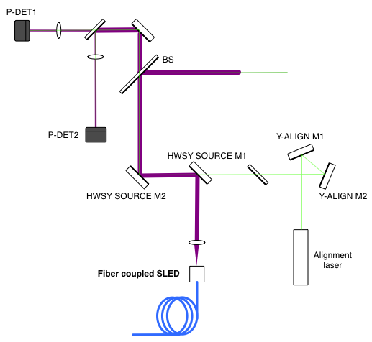
Figure 3: Aligning the alignment laser to the SLED beam

Aligning the alignment laser to the IR beam
This sub-stage is illustrated in Figure 3.
- Adjust the SLED fiber coupler such that the beam size and RoC is correct. (note: how do you do this?)
- Align the SLED beam optics (HWSY SOURCE M1, M2 and BS) such that the beam is centered on them.
- Align the SLED beams transmitted through and reflected from the detector beam splitter through the center of the two lenses and onto the position detectors (P-DET1 and P-DET2, separated by 500mm). Secure and lock all the optical mounts. Center the beam on the sensors by tilting the detector beam splitter and the detector turning mirror. Note the positions of the centers on the two sensors (note: how do you do this?). (Recommended sensors: Thorlabs PDP90A - 2D Lateral Effect Position Sensor, 320 to 1100 nm).
- Set up the alignment laser and its steering optics (Y-ALIGN M1 and Y-ALIGN M2). Adjust the orientations of these optics until the alignment laser is incident at the same position as the SLED beam on both POSITION sensors.
- Lock the steering mirrors for the alignment laser.
An analysis of the required precision is determined in Appendix: Alignment precision analysis. For two detectors with 2.2μm positional accuracy, such as the Thorlabs PDP90A, placed 173mm and 227mm after 200mm focal length lenses, the positional uncertainty in the input axis is ≈ 11μm and the angular uncertainty is ≈ 8μrad.
Result: Aiming laser is co-linear with SLED beam to within ~10 μrad and ~50μm at the BS.

Aligning the return position detector to a retro-reflected beam
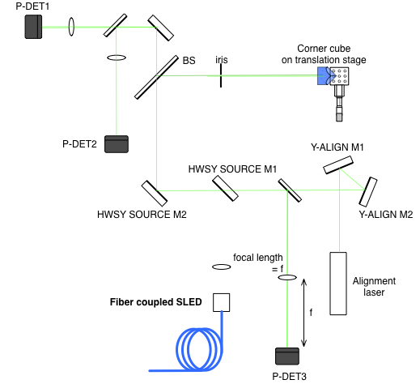
Figure 4: Determining the retro-reflection axis for the aiming laser
- Insert the corner cube and iris into the beam approximately 50mm and 100mm from the BS, respectively.
- Adjust the X-Y position of the corner cube until it’s return beam exits through the iris.
- Align the retro-reflected beam through the lens and onto the P-DET3 detector placed at the far-field.
- Open iris
- Move the corner cube transverse to the beam using the translation stage, to Modulate the corner cube by ±Δx = 1mm.
- Adjust the position of P-DET3 on its translation stage along the optical axis until the position of the spot on the detector is fixed in the presence of the modulation of the corner cube. This ensures the P-DET3 detector is placed at the far-field.
- Record the centroid of the beam on P-DET3 (note: how do you do this?).
The uncertainty in the orientation of the return beam, Δθ, is given by the uncertainty in the displacement on the P-DET3 detector, δx, divided by the focal length of the lens, f.
If the P-DET3 detector is displaced along the optical axis from the focal point of the lens, by Δz_{P-DET}, then displacement of the beam at the lens, Δx_{lens} will cause some displacement of the spot on the P-DET detector, given by Δx_{P-DET} = Δx_{lens} * Δz_{P-DET}/f.
The maximum expected displacement of the center of the beam on the test mass is ΔX_{ITM}. At the lens before the P-DET3 detector this becomes a displacement of ΔX_{ITM}/M.
Therefore, the tolerance on the position along the optical axis is given by:
Assuming, f = 300 mm, M = 17.5 ×, ΔX_{ITM} = 20 mm and Δθ = 10 μrad, then the tolerance on the position of the P-DET3 detector along the optical axis is approximately 0.8 mm.
Result: the position sensors have defined a retro-reflected return beam to 10μrad. Any beam that matches those positions will be retro-reflected from the ITM or other optic.
Figure 5: HAM 4 region showing the pick-off alignment beams (screen-shot from ZEMAX)

Align the out-going aiming laser beam so that it is centered on all the optics
Position all the optics in their nominal positions and align the alignment laser so that it is centered on all the optics (see T1000179: aLIGO Hartmann Sensor Optical Layouts [H1, L1, H2]: Input Test Masses).
- Align the alignment laser beam through the previously installed irises shown in Figure 2 (these should be between HWSY STEER M8 and HWSY PERISCOPE in Figure 6).
- Confirm that the alignment laser is centered on the periscope optics (note: what to do if it is not?).
- Adjust alignment beam using the closest mirrors to the periscope, HWSY STEER M8 and HWSY STEER M9) until the pick-off alignment beams, shown in Figure 5, are centered on the fiducial references (note: please show these in fig 5).
- Fine-tune the alignment of the final mirror steering mirror before the periscope, HWSY STEER M8, until the retro-reflected beam from the ITM is centered on the retro-reflection location on P-DET3 that was determined in 3.2.3. Note: At 633nm, there is approximately 10,000 x attenuation of the retro-reflected. If 3mW is injected into the vacuum system the return beam will barely be visible to the human eye under optimum viewing conditions. The position detector, P-DET3, will be able to easily see this provided the beam is on the detector. The alignment through the on-table irises and off-table fiducials (note: where are these located?) should ensure a return beam is on the detector. The sensitivity of the detector will be sufficient to derive an error signal to fine-tune the alignment of the final steering mirror.
Figure 6: H1/L1 ITMY optical layout (replicated from Figure 15 in T1000179-v9)
At this time the beam should be aligned to the in-vacuum optical axis to within approximately 2 mm and around 100 mrad at the input to the vacuum system. This is sufficient to ensure a return beam from the interferometer.

Alignment Stage 3 [Imaging the ITM]
- Induce a sinusoidal YAW motion on the ITM at frequency f (note: what frequency? This must be lower than the response of the HWS).
- Demodulate the HWS prism (note: explain the term “prism”)and position signals at the drive frequency f. i.e. measure the:
  - amplitude of the displacement of the beam on the HWS, and
  - the amplitude of the angular change at the HWS
- Locate the conjugate plane of the HWS relative to the ITM by dividing the amplitude of the displacement of the beam on the HWS by the amplitude of the angular change at the HWS (note: Please explain this calculation and how it is used to locate the plane).
- Adjust the HWS position and the delay line until there is no displacement in the HWS beam as the ITM is YAWed.
- Determine the magnification by comparing the tilt at the HWS with the tilt measured by the optical lever (note: This must be stated as a derived requirement for the Optlev Subsystem that the ITM optlev be operational at the time of this alignment procedure).

Required and demonstrated imaging precision
The conjugate plane of the HWS by the ITM must be located with a precision of +/-1500mm as described in [T1000715 - Requirements for the ITM Hartmann Wavefront Sensor optical layout].
Therefore, we need to determine the corresponding precision in the measurement of the amplitude of the displacement of the beam on the HWS.
Vary the ITM yaw by a sinusoidal modulation with amplitude of Δφ. The displacement of the beam at the distance L_{tol} is Δx_{CONJ} = Δφ L_{tol}. The displacement of the beam at the on the HWS is Δx_{HWS} = Δx_{CONJ}/M, where M = 17.5x.
Assume a maximum angular change at the HWS of ~ 2 mrad (this displaces the Hartmann spots on the CCD by ~2 pixels). This corresponds to a yaw at the ITM of ~110 μrad at the ITM.
Therefore, the displacement of the Gaussian beam on the HWS must be sensed to better than (note, MRS: I can’t follow where this result comes from?):

,

Therefore, we need to measure the displacement of the Gaussian beam to better ~80% of a pixel (1 pixel = 12μm).
The measured error in the displacement of the Gaussian beam in the lab is 0.014 pixels. This corresponds to a precision in locating the image plane by the ITM of ~25mm. [Brooks Lab Book 11, page 144].

Align the position of the HWS beam on the ITM using the remotely steerable mirrors [Maintenance]
The last two alignment steps fine tune the orientation and position of the in-bound optical axis such that the probe beam is coaxial with the ITM and is normally incident on its HR surface.

Figure 7: Schematic showing the remotely steerable mirrors on ISCT4 (bottom) and the resulting change in the optical axis at ITMY (top)

Sensing/steering matrices
Measure the angle to sensing and steering matrices between the remotely-steerable mirrors and the ITM (as illustrated in Figure 7).
For H1/L1: Y the nominal values of the sensing and steering matrices are calculated below:
Remotely controlled steering mirrors:
1. HWSY STEER M12:
Propagation matrix from M12 to HWS:
2. HWSY STEER M11:
Propagation matrix from M11 to HWS:
Propagation matrix from HWS to ITM:
Sensing matrix =
Steering matrix =

Positioning of HWS beam on ITM
The center of the Gaussian probe beam should be centered on the HWS. This is easily accomplished when the HWS is placed in position. The center of the Gaussian probe beam should be centered on the center of the thermal lens in the ITM (which is nominally centered on the ITM) (note: explain why this is important?).
The goal of this final step is to adjust the beam steering into the vacuum system to displace the ITM-bound optical axis such that its orientation is unchanged but it is centered on the ITM (note: this sentence is confusing).
- Induce a thermal lens in the center of the ITM (CO2 laser or self-heating)
- Determine the position of the center of the measured thermal lens (measured by the HWS) relative to the center of the Gaussian probe beam on the HWS, Δx_{HWS} (which is 2-dimensional). Translate this to the coordinate system of the ITM, Δx_{ITM} = 17.5 × Δx_{HWS}. A thermal lens offset from the center of the HWS coordinate system is shown in the left hand side of Figure 8.
- The probe beam on the ITM needs to be translated by -Δx_{ITM} on the ITM. The necessary changes in the orientations of the remotely-controlled steering mirrors should be determined using the measured steering matrices. Apply the required changes in the orientations of the steering mirrors. The thermal lens should then be centered on the center of the HWS coordinate system as shown in the right hand side of Figure 8.
- Measure the position on the P-DET3 to verify the beam is retro-reflected (note: explain this).

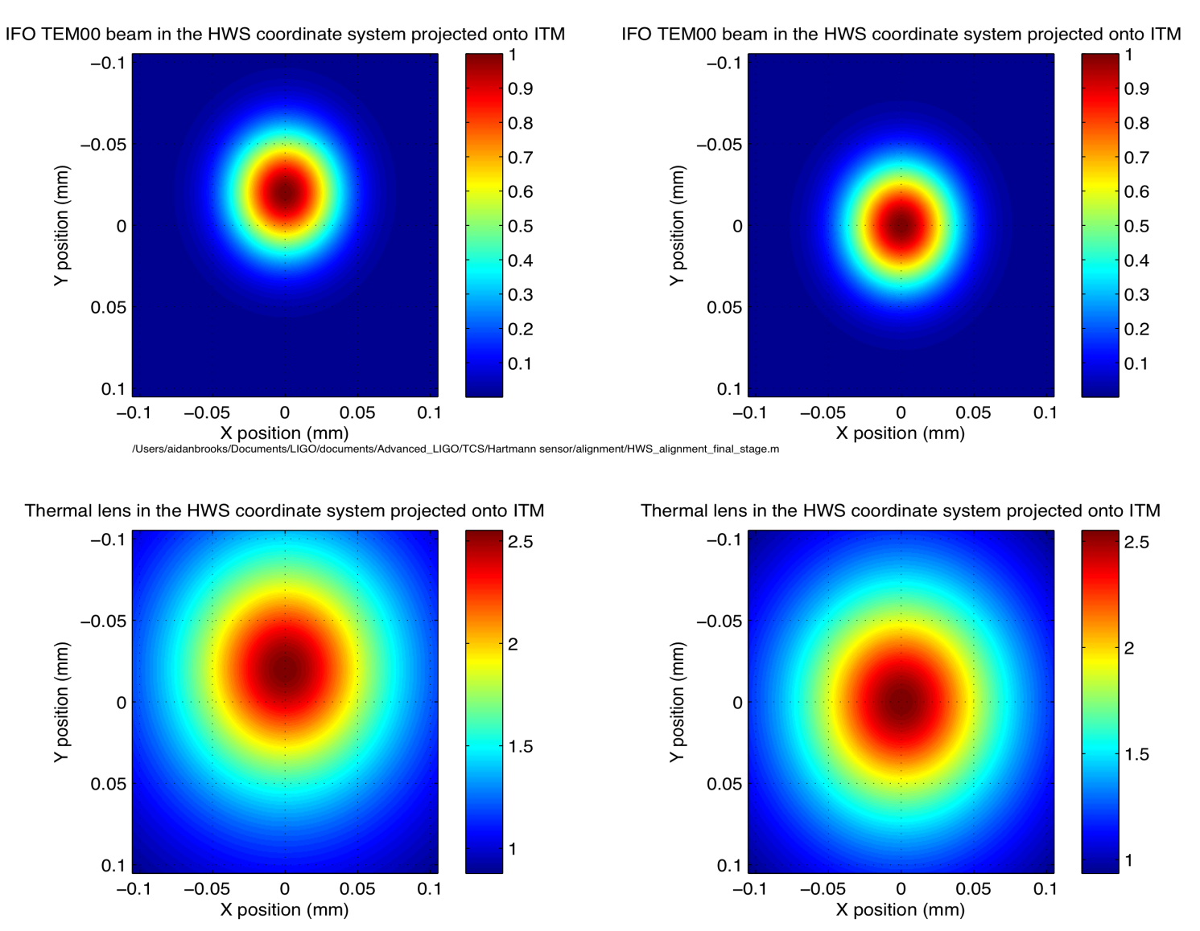
Figure 8: The HWS coordinate system projected onto the ITM. The coordinates are centered around the HWS probe beam, not the ITM center. The relative position of the IFO beam and its resulting thermal lens as viewed in the HWS coordinate system are shown. The left hand side shows a scenario where the thermal lens is offset from the center of the HWS probe beam and the right hand side shows a scenario where they overlap.

Outstanding issues
- What is the status of the First Contact on the optics during this procedure
- Can we move the Hartmann table into position while the theodolites are in positions
- What is the nature of the fiducial locators?
- We need to design a retro-reflector stage to go in the vacuum to reflect the theodolite beam.
  - A lens and a flat mirror on a rail system? Must be clean enough to go inside the vacuum chamber during an alignment procedure.

Appendix: Alignment precision analysis (paraxial)
The 1D alignment precision of P-DET1 and P-DET2 is analyzed here. We wish to determine the precision that we can resolve the input location and angle, y_{in} and α_{in}, respectively. The i-th detector is placed a distance, L_{i}, after a lens. The ABCD matrix for position on the detector is given by:
The sensing matrix, M_{sens}, is:
.
The input axis (y_{in}, α_{in}) is given by:
.
(note: what are the parameters y1 and y2?) Optimizing the sensing matrix is achieved by solving for minimum (wrt L₁ and L₂) in the uncertainty in the input position. The uncertainty in the positions, y_{i}, are the same and set by the detector. For a Thorlabs PDP90A, this is approximately 2.2 μm.
If we substitute in the common mode length, X = (L₁ + L₂)/2 and the differential mode length, x = (L₁ - L₂)/2, (note: into which equation are these substituted, and for which parameters?) we find that the uncertainty in is minimized if X = f, in other words, the two detectors are equal distances from the foci on opposite sides of the foci.
Lastly, we need only optimize the distance each detector is from the focus. The position sensitivity is improved as this is increased. However, the beam sizes become larger the further the detectors are from the focus. The Thorlabs PDP90A can sense the locations of beams of diameter 0.2mm to 7mm. If we specify that the Gaussian beam diameter of a beam can be no more than 1/3 the maximum diameter (= 2.3mm), we know the input sizes of the probe and alignment beams (= 17.4mm and 0.86mm, respectively), we assume that, to first order, the beams are collimated and we assume that f = 200mm, then we find that x ≈ 27mm (note: what is this new variable x?).
Under these conditions, the positional uncertainty in the input axis is ≈ 11μm and the angular uncertainty is ≈ 8μrad.

