*LIGO Laboratory / LIGO Scientific Collaboration*

LIGO-T1000179-v13 *Advanced LIGO* Date:

aLIGO Hartmann Sensor Optical Layouts (H1, L1, H2) Input Test Masses

Author: Aidan Brooks

Distribution of this document:

LIGO Scientific Collaboration

This is an internal working note

of the LIGO Laboratory.

|  |  |
| --- | --- |
| **California Institute of Technology**  **LIGO Project – MS 18-34**  **1200 E. California Blvd.**  **Pasadena, CA 91125**  Phone (626) 395-2129  Fax (626) 304-9834  E-mail: info@ligo.caltech.edu | **Massachusetts Institute of Technology**  **LIGO Project – NW22-295**  **185 Albany St**  **Cambridge, MA 02139**  Phone (617) 253-4824  Fax (617) 253-7014  E-mail: info@ligo.mit.edu |
| **LIGO Hanford Observatory**  **P.O. Box 159**  **Richland WA 99352**  Phone 509-372-8106  Fax 509-372-8137 | **LIGO Livingston Observatory**  **P.O. Box 940**  **Livingston, LA 70754**  Phone 225-686-3100  Fax 225-686-7189 |

http://www.ligo.caltech.edu/

Table of Contents

1 Introduction 3

1.1 The ITM+CP HWS optical system 3

2 Imaging Solutions (for ITM+CP probe beams) 5

2.1 Relative positions of HAM ISI tables and TCSHT tables 7

2.1.1 HAM4 (H1, L1) 7

2.1.2 HAM10 (H2) 8

2.2 H1/L1: HWSX (nominal) 9

2.3 H1/L1: HWSY (nominal) 9

2.4 H2: HWSX (nominal) 10

2.5 H2: HWSY (nominal) 10

3 ZEMAX optical layouts 11

3.1 H1/L1 optical layouts (HAM4 & HAM5) 11

3.2 Folded interferometer – ITM+CP 18

4 Optical layout features 21

4.1 Delay line paths. 21

4.2 Imaging optics 21

4.3 Astigmatism 23

4.4 Super-luminescent diode (SLED) source, polarizer and HWP 23

4.4.1 SLED sources 23

4.5 Secondary beam, polarization and PBS 24

4.6 Beam Height 24

4.7 Band Pass filter 25

4.8 Beam size and mirror sizes 25

4.9 Flipper mirrors 25

4.10 50/50 Beamsplitter 25

4.11 Periscope 26

4.12 Beam-steering mirror pairs 26

4.12.1 Motorized steering mirrors 26

4.13 Optic placement and direction (for usability) 26

4.14 Beam Tubes 26

4.15 Spurious defocus in the probe beam 26

4.16 Diffraction in the HWS probe beam 27

5 Analysis of thermal defocus induced by imaging telescopes 28

6 Secondary beam 29

6.1 Secondary beam telescope [H1X, H1Y, H2X, H2Y] 31

6.2 Secondary beam telescope sensitivity 32

7 Full ABCD matrices 34

7.1 H1/L1:HWSX 34

7.2 H1/L1:HWSY 35

7.3 H2:HWSX 36

7.4 H2:HWSY 37

# Introduction

The purpose of this document is to record the mode-matching solutions into the interferometer for the ITM+CP aLIGO Hartmann Wavefront Sensor (HWS) probe and secondary beams.

The optical layouts are presented in full in Section 7.

## The ITM+CP HWS optical system

A conceptual layout showing the HWS probe beams coupling into the interferometer and measuring the combined thermal lenses from each ITM and CP pair is illustrated in Figure 1. Probe beams are launched from TCSHT4, *injected* into the interferometer, *retro-reflected* from the ITMs, extracted from the injection points and measured on the Hartmann sensors on TCSHT4. The Y probe beam (green) is injected onto the interferometer axis through SR2. The X probe beam (magenta) is injected into the interferometer off the wedged AR surface of the beamsplitter (BS). A secondary beam (also magneta) is picked off from the X probe beam and spans HAM4 and HAM5. This is to monitor wavefront aberrations induced by displacement between those tables causing defocus in the HWS telescope.

The requirements for the ITM+CP HWS optical system are described in [T1000715](https://dcc.ligo.org/cgi-bin/private/DocDB/ShowDocument?docid=26293) *Requirements for the ITM Hartmann Wavefront Sensor optical layout.* The main optical requirements are summarized below:

1. The ITM must be imaged onto the front surface of the HWS. The tolerance of the imaging should place the conjugate plane of the ITM no further than 1500 mm / ***M***2 = 4.9 mm from the HWS front surface where ***M*** is the magnification.
2. The magnification, ***M***, from the ITM to the HWS should be 1/17.5 ×.
3. The imaging system must span approximately 2.5m from the in-vacuum HAM table to the in-air TCS Hartmann Table (TCSHT).
4. Reflective, not transmissive, optics should be used to avoid specular reflection of any 1064nm light back into the interferometer.
5. The thermally induced defocus, *S*, (where *S* is defined implicitly by the quadratic wavefront equation: *W* = 0.5\**S r2*) should be lower than 7.4 × 10-4 m-1.

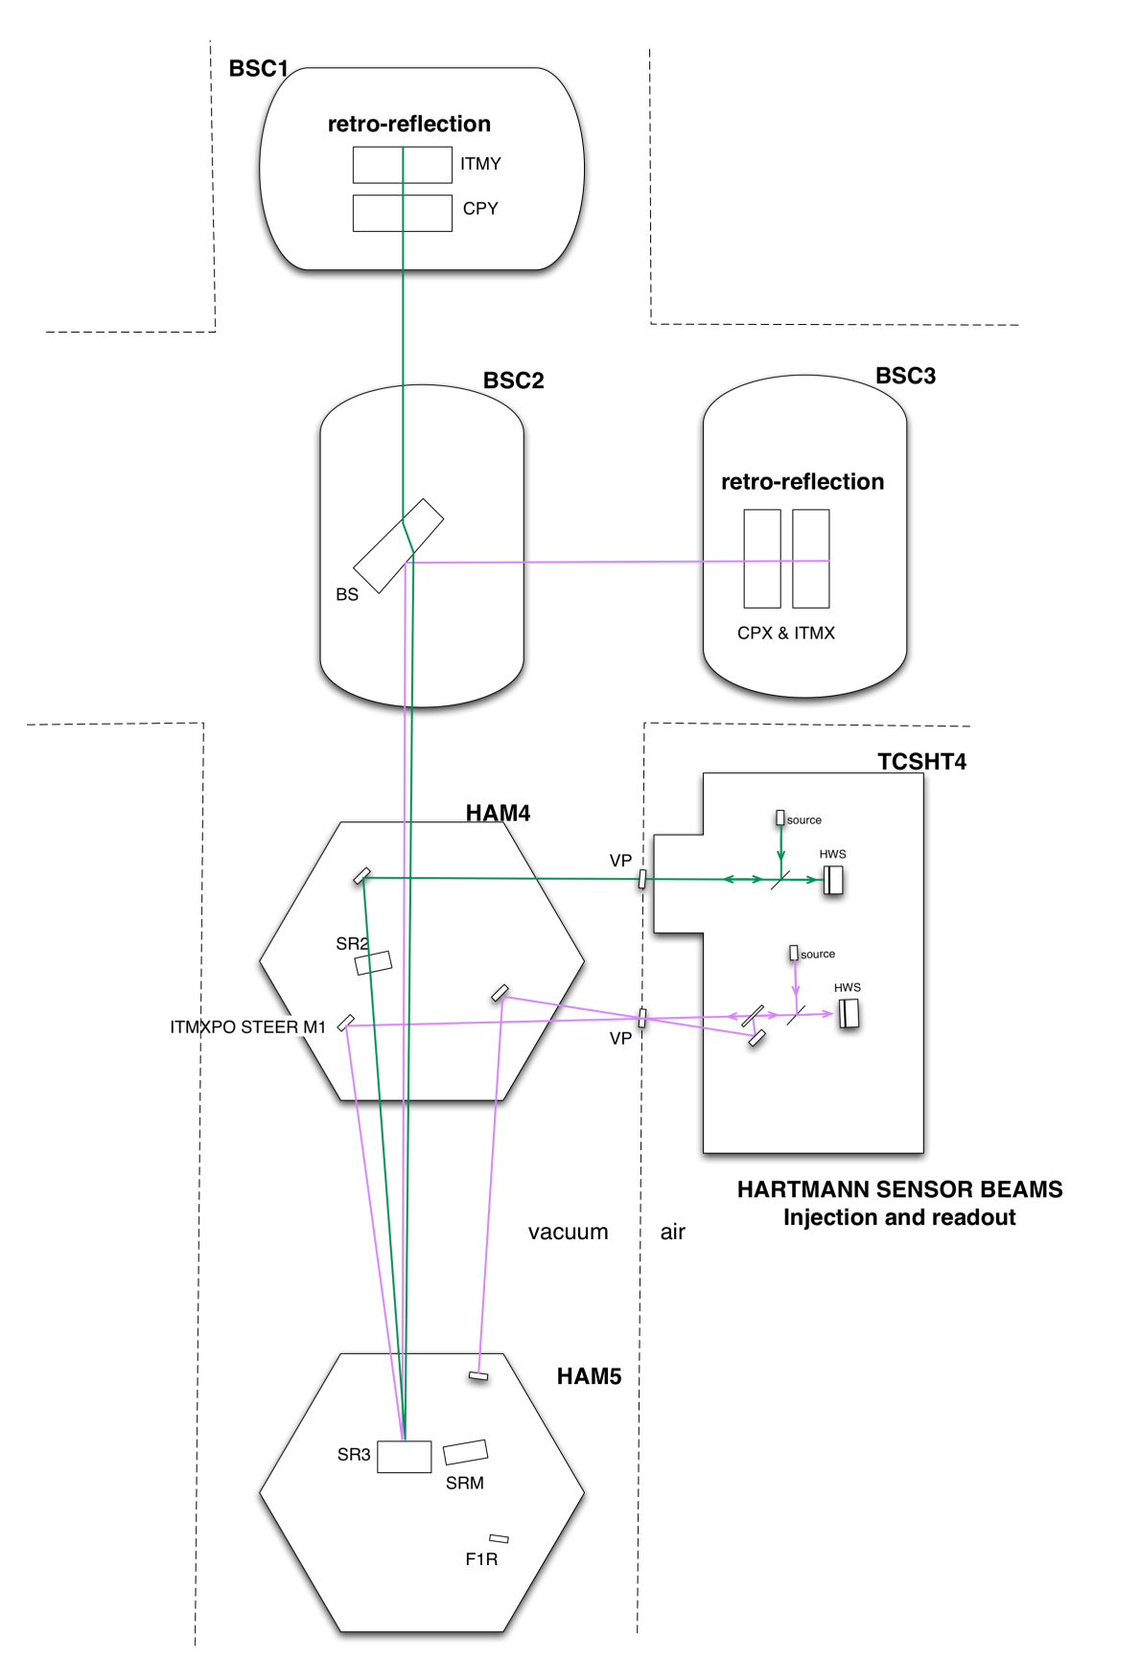

Figure : The H1/L1 Hartman probe beams are injected into the interferometer to measure the thermal lenses in the compensation plates and ITMs. The layout is conceptually the same for H2.

# Imaging Solutions (for ITM+CP probe beams)

The mode-matching/imaging will be accomplished with a telescope, conceptually illustrated in Figure 2. This telescope is located across HAM4 and TCSHT4 in H1/L1 and across HAM10 and TCSHT10 in H2. Note that the imaging optics f1 and f2 are illustrated as lenses but will, in fact, be curved mirrors. In this figure the “hand-off plane to imaging telescope” is defined for:

**H1/L1** as:

* SR2_AR for the Y-probe beam (the location of SR2 is shown in Figure 1)
* ITMXPO STEER M1 for the X-probe beam (see Figure 1 for location)

**H2** as:

* H2-HWSY STEER M1 for the Y-probe beam (this optic is located on HAM10 in H2 but is analogous to ITMXPO in Figure 1)
* SR2_AR for the X-probe beam (in H2, the optic SR2 is located on HAM10 in H2 but is analogous to SR2 in Figure 1).

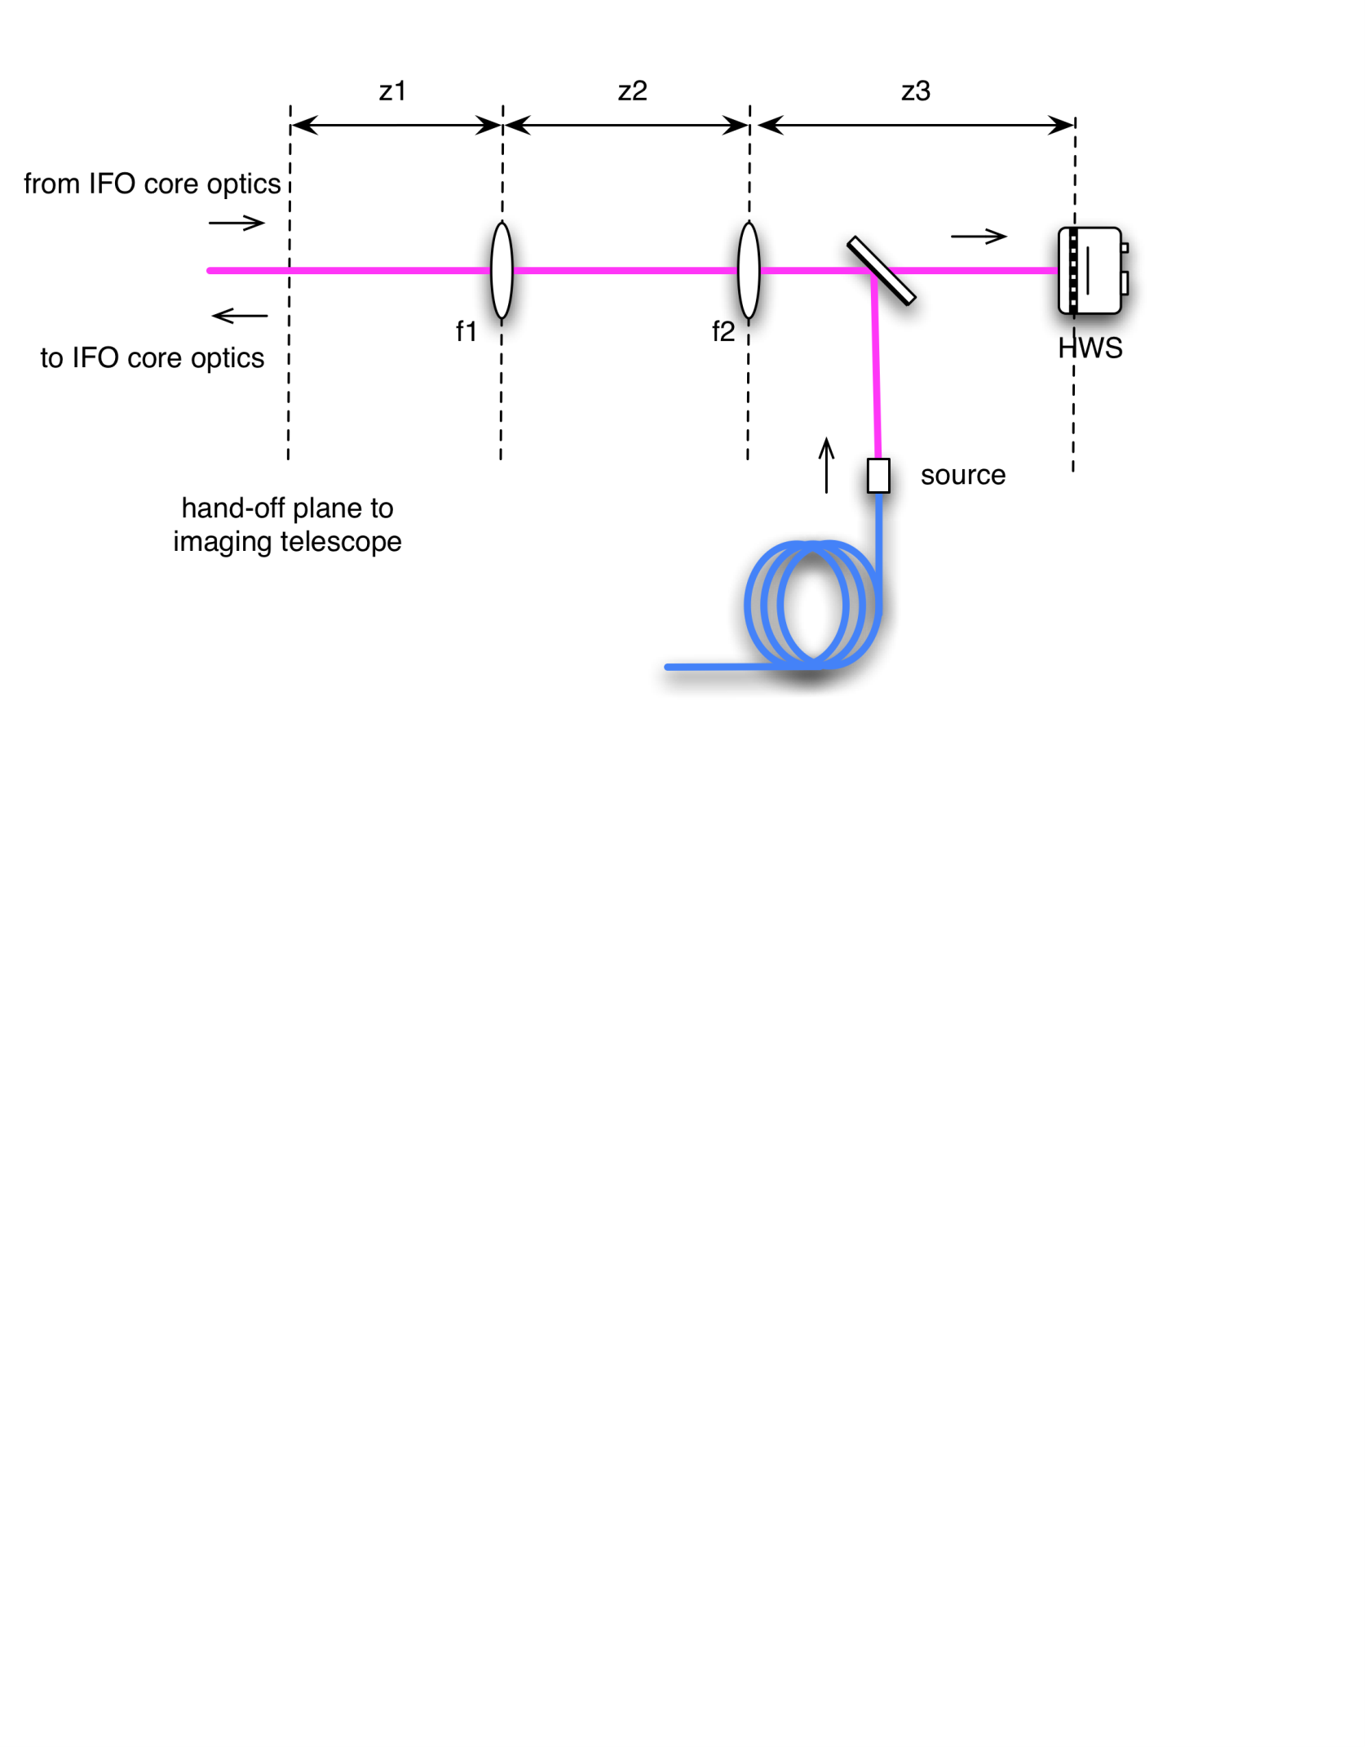

Figure : A schematic of the imaging telescope for the Hartmann sensors.

Requirements 1 (imaging) and 2 (magnification) in [T1000715](https://dcc.ligo.org/cgi-bin/private/DocDB/ShowDocument?docid=26293) constrain 3 of the 5 imaging parameters shown in Figure 2. This was used to solve for z1, z2, and z3 over a 2D parameter space of f1 and f2.

The shortest distance between the in-vacuum optical table (which houses imaging optic f1) and the exterior optical table (houses imaging optic f2) is approximately 2.5m, as shown in Figure 3. Allowing for ~1m on either side between the edge of the table and the imaging optic (in conjunction with requirement 4) this implies that the minimum distance between f1 and f2 is 4.5m.

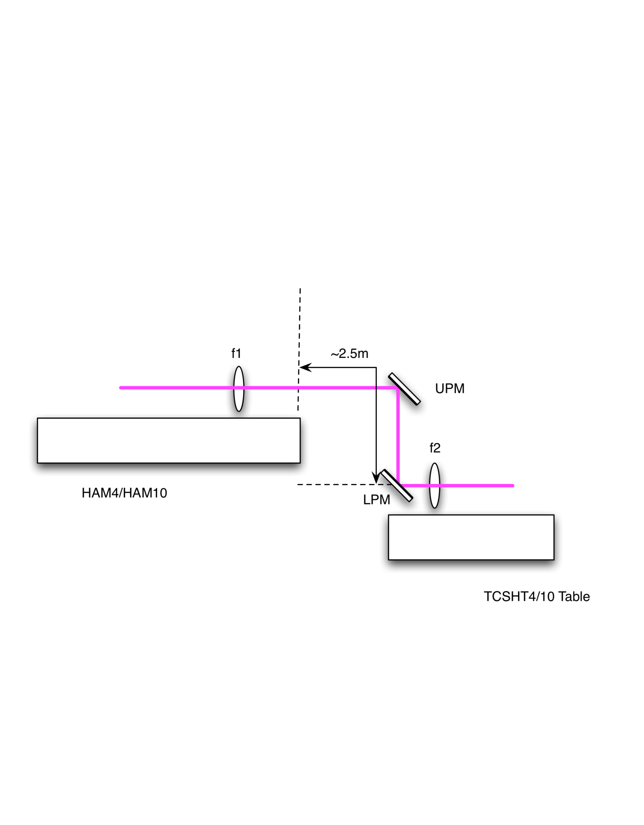

Figure : A side view of the Hartmann imaging telescope located across a HAM table and a TCSHT table. The distance from the edge of the HAM table to the lower periscope mirror (LPM) is approximately 2.5m

Taking into account all the requirements, the allowed regions in f1-f2 parameter space for H1, H2, and L1 HWSX and HWSY were calculated. Both +ve and –ve magnifications were examined in all cases but those shown are the ones that were judged to be more convenient; see sections 2.2 to 2.5.

In each case the selected point in parameter space was chosen to be in a region of minimal temperature-induced defocus of the imaging system (reviewer’s note: explain how this was done) and such that the mirror focal lengths were rounded to the nearest half meter.

## Relative positions of HAM ISI tables and TCSHT tables

To determine the imaging solutions, we need to know the distances between the tables in the HAM chambers and the in-air tables ([[D1000637 - TCS HWS Optics Table, H1_L1 HAM4]](https://dcc.ligo.org/cgi-bin/private/DocDB/ShowDocument?docid=10232) and [[D1100238 - TCS HWS Optics Table, H2 HAM10]](https://dcc.ligo.org/cgi-bin/private/DocDB/ShowDocument?docid=33261))

### HAM4 (H1, L1)

The position of the HWS table relative to the HAM4 ISI table is shown in Figure 4 and Figure 5.

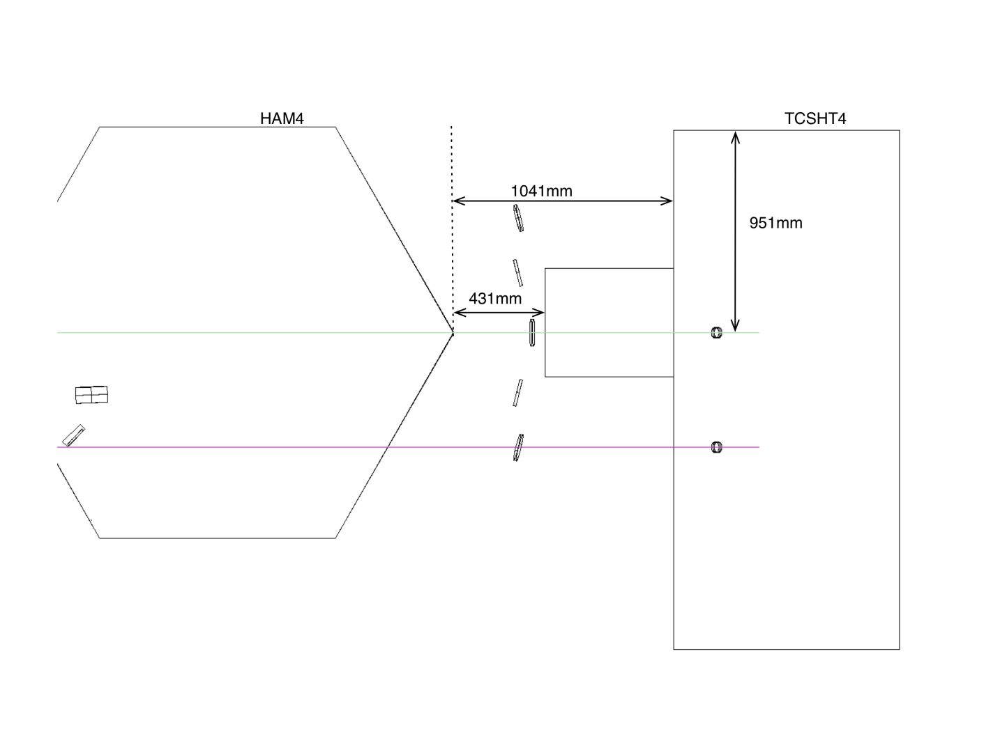

Figure : HAM4 and TCSHT4 Table relative positions - TOP view

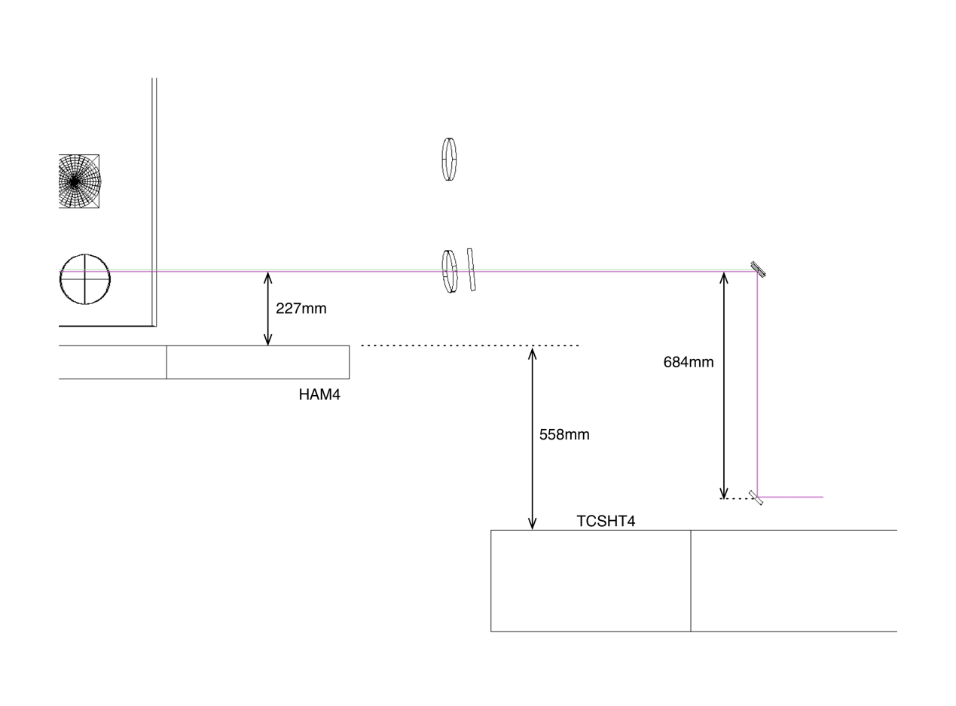

Figure : HAM4 and TCSHT4 table relative positions - SIDE VIEW

### HAM10 (H2)

The position of the HWS table relative to the HAM10 ISI table is shown in Figure 6 and Figure 7.

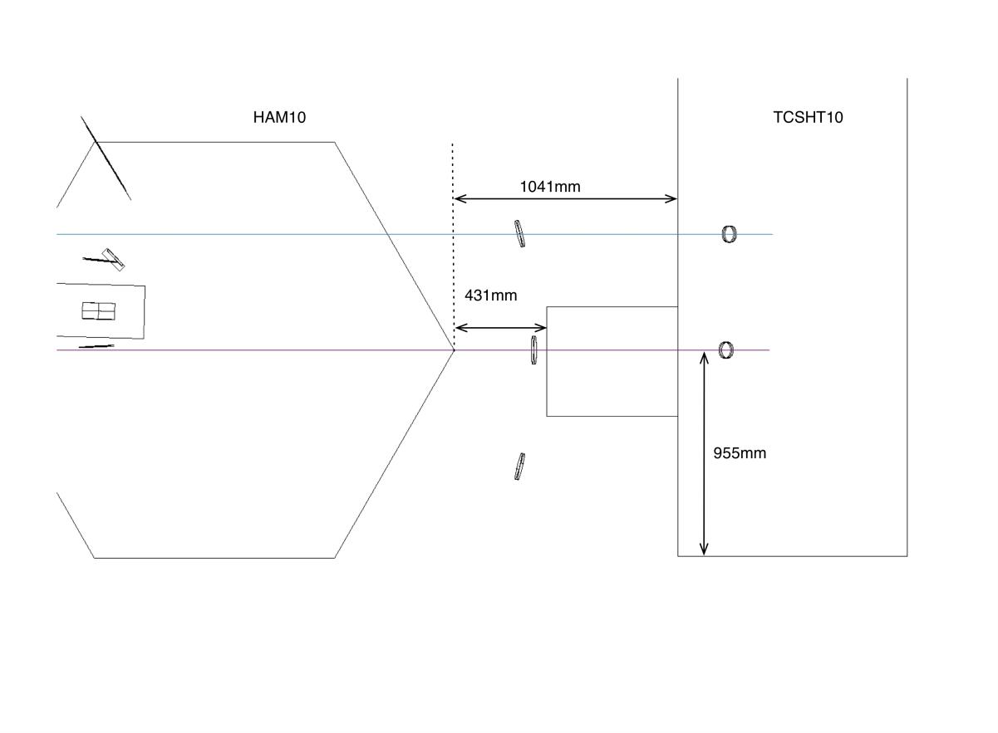

Figure : Top view of HAM10 ISI and TCSHT10 Table.

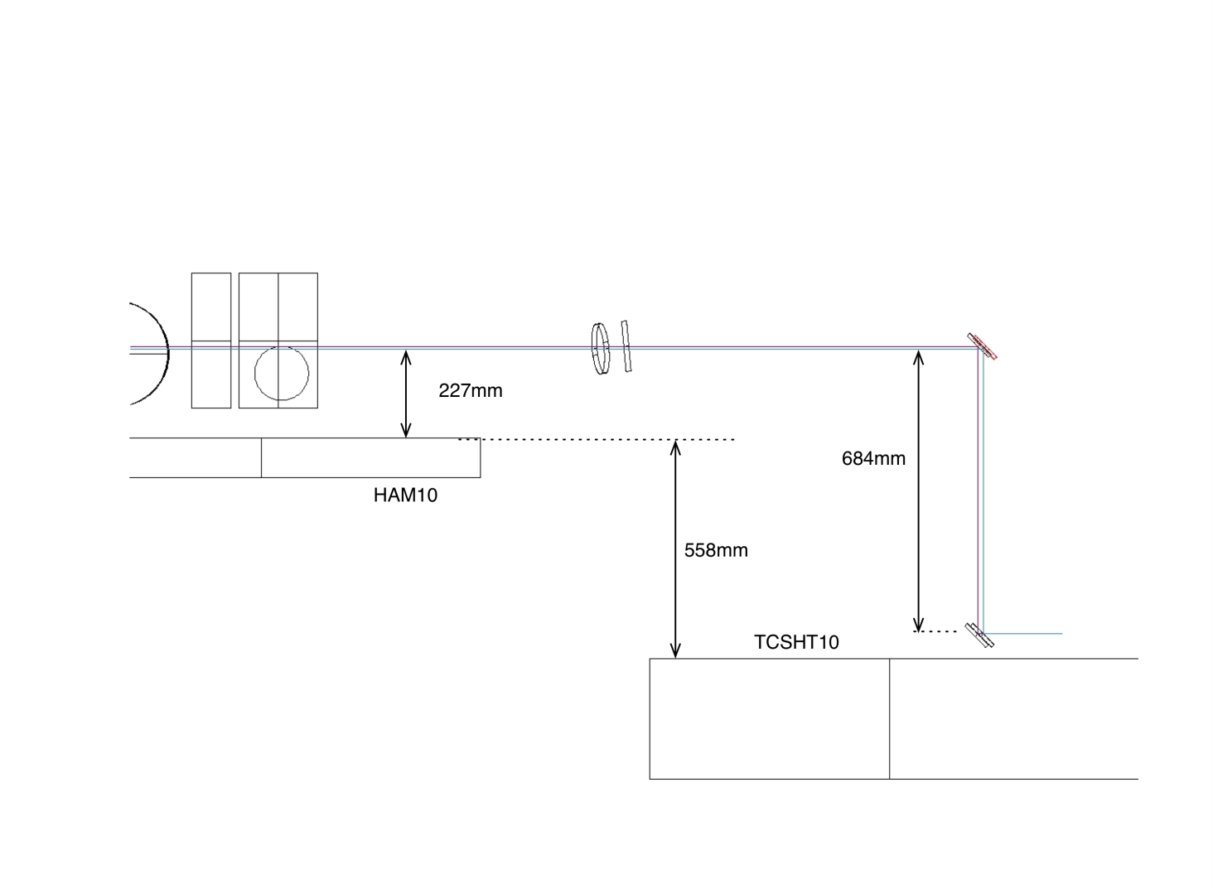

Figure : Side view of HAM10 ISI and TCSHT10 Table. The beam height on the HWS table is 4” everywhere.

## H1/L1: HWSX (nominal)

A search was conducted of the parameter space constrained by the imaging, magnification and defocus requirements. A solution that used ~~conventional~~ readily available radii of curvature mirrors and lying near the defocus minimum was chosen. The Mathematica search of parameter space is attached as supplementary documentation in the DCC entry [T1000179](https://dcc.ligo.org/cgi-bin/private/DocDB/ShowDocument?docid=10643).

Table : Imaging solution for H1/L1 HWSX

|  |  |  |
| --- | --- | --- |
| **H1/L1 - HWSX** | **Value** | **notes** |
| ITMX apparent RoC | 1331.04 m |  |
| ITMX to SR3 | 24.666 m |  |
| SR3 RoC | 36 m |  |
| SR3 to ITMXPO | 15.173 m |  |
| ITMXPO to F1: z1= | 1.65 m |  |
| F1: f = | -2.0 m | RoC = -4.0 m |
| F1 to F2: z2 = | 5.361 m |  |
| F2: f = | 2.5 m | RoC = 5.0 m |
| F2 to HWS: z3= | 3.764 m |  |

Input probe beam: [beam radius = 8.7mm, RoC = -4.348m]

Probe beam at ITM: [beam radius = 152.3mm, RoC = 1331.04m]

Probe beam at HWS: [beam size = 8.7mm, RoC = 4.348m]

Magnification from ITM to HWS = -1/17.5x

## H1/L1: HWSY (nominal)

Table : Imaging solution for H1/L1 HWSY

|  |  |  |
| --- | --- | --- |
| **H1/L1 - HWSY** | **Value** | **notes** |
| ITMY apparent RoC | 1331.04 m |  |
| ITMY to SR3 | 24.792 m |  |
| SR3 RoC | 36 m |  |
| SR3 to SR2 distance | 15.461 m |  |
| SR2 RoC | -6.43 m |  |
| SR2 refractive index at 840nm | 1.453 |  |
| SR2 thickness | 0.075 m |  |
| SR2_AR to F1: z1= | 5.794 m |  |
| F1: f = | 1.5 m | RoC = 3.0 m |
| F1 to F2: z2 = | 4.796 m |  |
| F2: f = | 1.5 m | RoC = 3.0 m |
| F2 to HWS: z3= | 2.821 m |  |

Input probe beam: [beam size = 8.7mm, RoC = -4.348m]

Probe beam at ITM: [beam size = 152.3mm, RoC = 1331.04m]

Probe beam at HWS: [beam size = 8.7mm, RoC = 4.348m]

Magnification from ITM to HWS = +1/17.5x

## H2: HWSX (nominal)

Table : Imaging solution for H2 HWSX

|  |  |  |
| --- | --- | --- |
| **H2 - HWSX** | **Value** | **Notes** |
| ITMX apparent RoC | 1331.04 m |  |
| ITMX to F-SR3 | 30.158 m |  |
| F-SR3 RoC | 36 m |  |
| F-SR3 to F-SR2 distance | 16.001 m |  |
| F-SR2 RoC | -4.89 m |  |
| F-SR2 refractive index at 840nm | 1.453 |  |
| F-SR2 thickness | 0.075 m |  |
| F-SR2_AR to F1: z1= | 5.153 m |  |
| F1: f = | 1.5 m | RoC = 3.0 m (Same as H1/L1 Y) |
| F1 to F2: z2 = | 4.784 m |  |
| F2: f = | 1.5 m | RoC = 3.0 m (Same as H1/L1 Y) |
| F2 to HWS: z3= | 2.842 m |  |

Input probe beam: [beam size = 8.7mm, RoC = -4.348m]

Probe beam at ITM: [beam size = 152.3mm, RoC = 1331.04m]

Probe beam at HWS: [beam size = 8.7mm, RoC = 4.348m]

Magnification from ITM to HWS = -1/17.5x

## H2: HWSY (nominal)

Table : Imaging solution for H2 HWSY

|  |  |  |
| --- | --- | --- |
| **H2 - HWSY** | **Value** | **Notes** |
| ITMY apparent RoC | 1331.04 m |  |
| ITMY to SR3 optical distance | 30.035 m |  |
| F-SR3 RoC | 36 m |  |
| F-SR3 to ITMYFPO distance | 15.793 m |  |
| ITMYFPO to F1: z1= | 1.03 m |  |
| F1: f = | -2.0 m | RoC = -4.0 m (Same as H1/L1 X) |
| F1 to F2: z2 = | 5.361 m |  |
| F2: f = | 2.5 m | RoC = 5.0 m (Same as H1/L1 X) |
| F2 to HWS: z3= | 3.746 m[1]Σ |  |

Input probe beam: [beam size = 8.7mm, RoC = -4.348m]

Probe beam at ITM: [beam size = 152.3mm, RoC = 1331.04m]

Probe beam at HWS: [beam size = 8.7mm, RoC = 4.348m]

Magnification from ITM to HWS = -1/17.5x

# ZEMAX optical layouts

The solutions determined in the tables in Section 2 were used to determine the optical layouts for the HWS system. The ZEMAX layouts of the HAM4/HAM10 region are in the DCC under:

* H1: [T1100463](https://dcc.ligo.org/cgi-bin/private/DocDB/ShowDocument?docid=69894)
* H2: [T1100464](https://dcc.ligo.org/cgi-bin/private/DocDB/ShowDocument?docid=69895)
* L1: [T1100471](https://dcc.ligo.org/cgi-bin/private/DocDB/ShowDocument?docid=70083) (identical to H1 except for the heights of the hand-off optics between the IFO and the HWS optics).

In the discussion below the term *forward-propagating* beam will refer to the HWS probe beam propagating *to* the ITM and the term *backward-propagating* beam will refer to the HWS probe beam once it has retro-reflected from the ITM and is propagating *back* toward the Hartmann sensor.

Also, note that the ITMX and ITMY HWS probe beams have orthogonal polarizations:

* H1/L1:HWSY and H2:HWSX probe beam are p-polarized
* H1/L1:HWSX and H2:HWSY probe beam are s-polarized.

## H1/L1 optical layouts (HAM4 & HAM5)

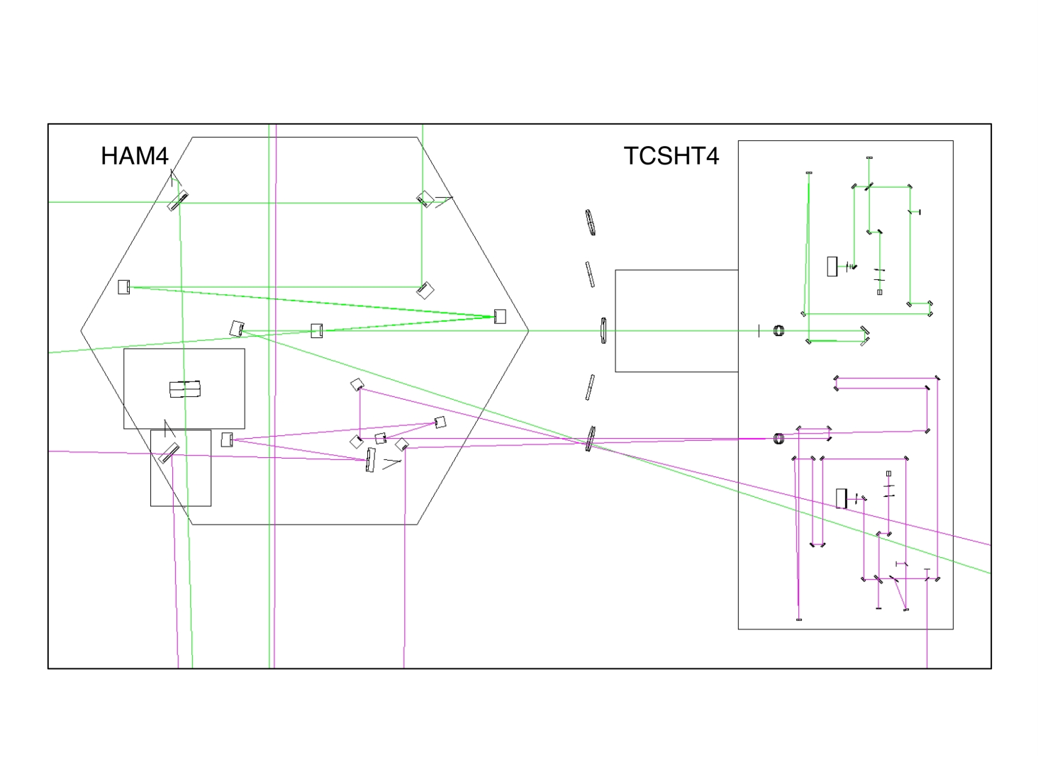

Figure : [H1X, H1Y, L1X, L1Y] ZEMAX model of HAM4 and TCSHT table of the Hartmann sensor probe and reference beams on the exterior tables. The three highlighted sections are shown in more detail in the following figures.

Figure 8 shows the region around the HAM4 chamber: the in-vacuum HAM table and the neighbouring TCSHT4 table. All the in-vacuum and in-air Hartmann sensor optics that are directly controlled by the Hartmann sensor system (for H1/L1 ITMs) are housed on these tables. Also shown in HAM4 is the core optic SR2. Additionally,

* Figure 9 shows a zoom of the in-vacuum optical table HAM4,
* Figure 10 shows a zoom of the in-vacuum optical table HAM5,
* Figure 11 shows a zoom of the in-air injection optics for the ITMX HWS,
* Figure 12 shows a zoom of the injection-optics for the ITMY HWS.

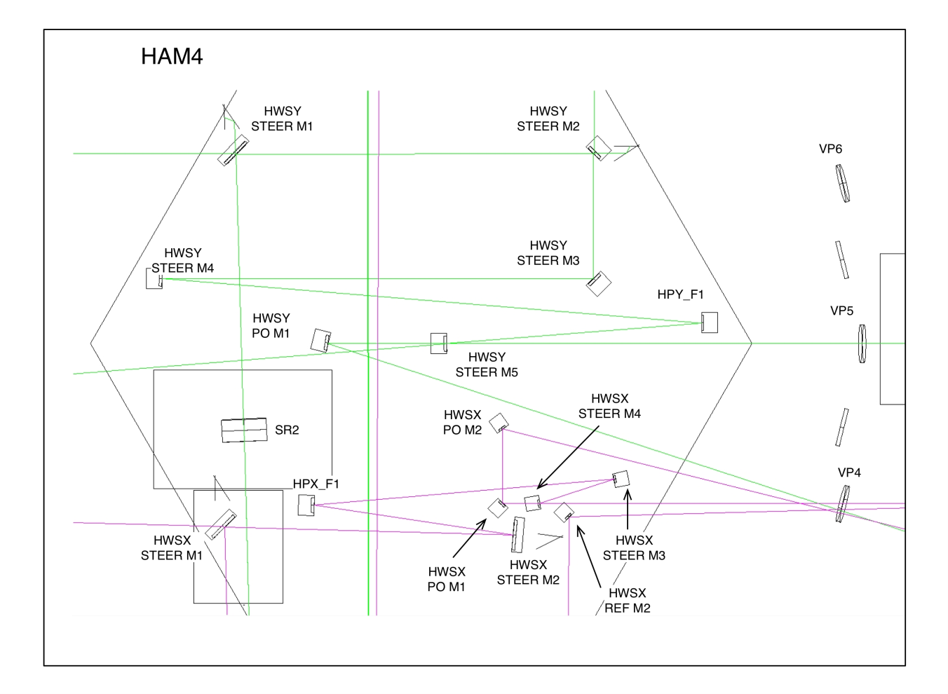

Figure : [ZOOM] HAM4 in-vacuum table. For both HWSX and HWSY the beam is incident close to normal incidence on the first imaging optic inside the vacuum (HPX_F1 for HWSX and HPY_F1 for HWSY).

HWS ITMY Probe Beam: In the illustrations, a green beam propagates through SR2 – this beam is the HWS probe beam for ITMY. The forward-propagating beam starts from a source outside the vacuum system, is injected into the vacuum system, through SR2 and onto the interferometer cavity axis. Once on the interferometer axis it propagates to ITMY (illustrated in Figure 1) and retro-reflects from the HR surface of that optic.

The now backward-propagating beam propagates back along the optical axis until, eventually, it reaches SR2 and is transmitted through that optic. From there, it follows the path shown in Figure 9: It is steered by in-vacuum beam steering mirrors HWSY STEER M1-M4. It is then reflected off a curved mirror, HPY_F4, at a slight angle (see Section 4.3 for a discussion on the astigmatism). From here it is steered out of the vacuum system by HWSY STEER M5.

HWS ITMX Probe Beam: as with the ITMY probe beam, the forward-propagating ITMX probe beam (magenta) is:

* injected from outside the vacuum system,
* steered to the wedged AR surface of the interferometer beam splitter (not shown in Figure 9, but illustrated schematically in Figure 1).
* The forward-propagating reflection from BS_AR injects the probe beam onto the interferometer optical axis.
* It is then retro-reflected from ITMX HR and propagates back to the beam splitter.
* The backward-propagating reflection of the probe beam from the AR surface of the beam splitter is, technically, the point at which the probe beam is extracted from the interferometer optical axis (again, see Figure 1).
* The beam reflects off SR3 – see Figure 1.
* The backward-propagating beam is collected by the optic ITMX STEER M1, shown in Figure 9 (magenta beam).
* The beam is steered to a curved mirror, HPX_F1, that is part of an imaging telescope.
* It is then steered out of the vacuum system by the mirrors HWSX STEER M3 and M4.

HWS PO Beams: The alignment optics HWSY PO M1, HWSX PO M1 and HWS PO M2, in Figure 9, and the beams that result from them are discussed in more detail in [[T1100149 - Initial Alignment of the ITM+CP Hartmann sensor]](https://dcc.ligo.org/cgi-bin/private/DocDB/ShowDocument?docid=39852)*.*

HWS Dichroic optics: The alignment optics HWSX STEER M1-M2 and HWSY STEER M1-M2 are all dichroic beam splitters that reflect > 99% 500-900 nm and transmit > 99% of 1064 nm light. The transmission is dumped onto black glass beam dumps (see AOS document [[T1100445 - AOS SLC: Signal Recycling Cavity Baffles Final Design]](https://dcc.ligo.org/cgi-bin/private/DocDB/ShowDocument?docid=69211) for a description of these baffles). This attenuates the 1064nm beam by > 104 × before the beam exits the vacuum system.

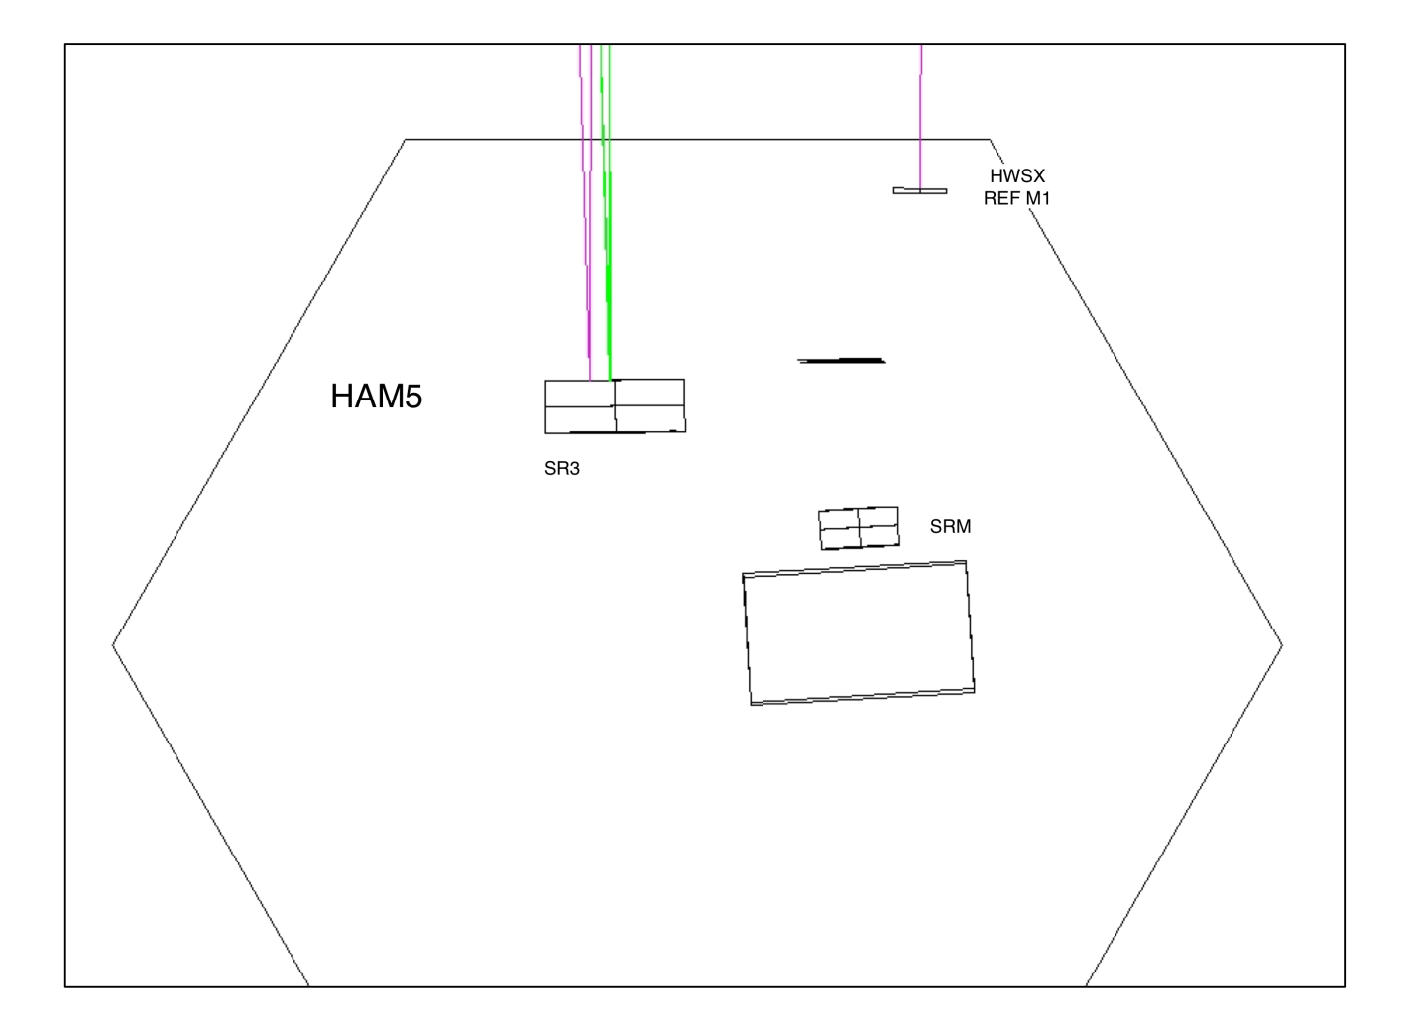

Figure : HAM5 Zoom showing HWSX REF M1

HWS REF beam: The HWS reference beam, also called HWS secondary beam, that spans HAM4 and HAM5 can be seen reflecting off HWSX REF M2 in Figure 9 down to HWSX REF M1 in Figure 10 where it is retro-reflected back to the HWS.

Reviewer’s note, MRS: move this paragraph before the Fig. 11.

Figure 11 shows the ITMX probe beam in-air optics. Since the probe beam is injected from this table, retro-reflected from ITMX and then read out again from this table, we can trace the optical axis in either direction. I will continue the convention of following the *backward-propagating* probe beam on the way OUT of the vacuum system.

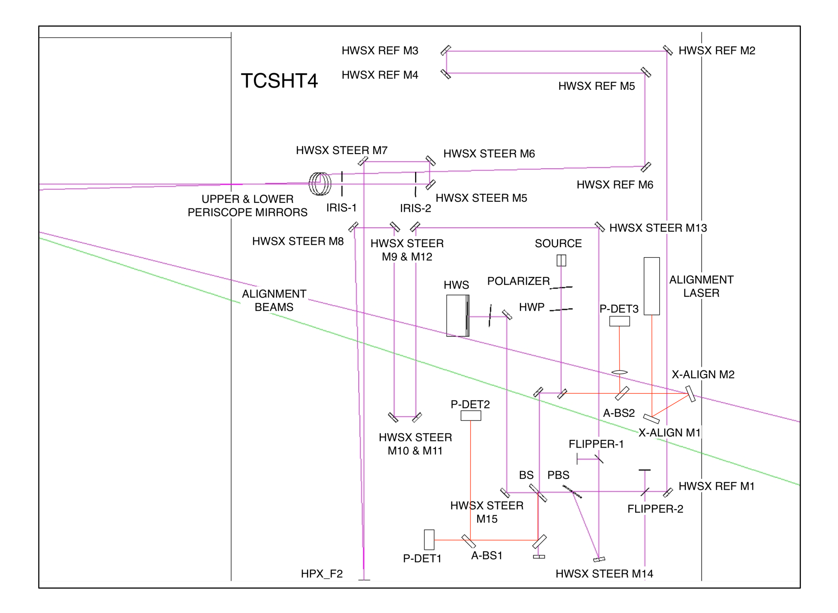

Figure : HWSX imaging optics on the exterior table. (note: remove this description from the title; it is already in the following text. ~~The beam propagates from the LIGHT SOURCE through the polarizer and HWP. The mostly s-polarized beam is reflected off a 50/50 beam splitter and then off a polarizing beam splitter (PBS). It can be blocked by a FLIPPER MIRROR after this if necessary. From here the probe beam passes through a delay that is used to adjust the F2-HWS distance and then is incident on HPX_F2 at close to normal incidence. It passes through another delay line that adjusts the F1-F2 LENGTH and then is injected into the vacuum system. The beam reflects off another imaging optic inside the vacuum and then is injected into the cavity off the wedged AR surface of the BS and then is retro-reflected off the ITM. The retro-reflection from the ITM is transmitted back to the HWS onto the HWS.~~

The backward-propagating HWS ITMX probe beam (magenta) propagates from the vacuum system (from the left) and, via the UPPER AND LOWER PERISCOPE MIRRORS (see Section 4.11), down to the height of the in-air optical table. It is steered through a delay line made from mirrors HWSX STEER M5 and HWSX STEER M6 (this is discussed in more detail in Section 4.1). From here the beam is steered to and reflected off the second curved mirror in the imaging system, HPX_F2. Two of the mirrors around HPX_F2 (note: please label these mirrors in the figure) will be motorized pico-motor beam steering mirrors – see Section 4.12.1. The beam is steered by several mirrors through another delay line (formed by HWSX STEER M10 and HWSX STEER M11).

The beam is steered by mirrors HWSX STEER M12 through M14 onto a polarizing beam splitter (PBS). [Note, the flipper mirror in this region is intended to block the *forward-propagating* beam when the flipper is raised – see Section 4.9]. The reflection of the backward-propagating beam from the PBS is then transmitted through the 50/50 beamsplitter (BS) – see Section 4.10-, a band-pass filter (note: please label this in the figure) (HWSX BAND PASS – see Section 4.7) and onto the HWS. The HWS is at a conjugate plane of the ITM (see Section 4.2).

The forward-propagating beam, in Figure 11, originates from the end of an optical fiber (LIGHT SOURCE) and is sent through a polarizer (HWS POLARIZER) and half-wave plate (HWP) – see Section 4.4. The HWP is ~~arranged~~ rotated such that the probe beam is almost entirely s-polarization. The forward-propagating beam is then reflected off the main beam splitter BS. The HWS probe beam is reflected off the PBS. The small amount of p-polarization on the forward-propagating beam will be transmitted through the PBS to create the Secondary/Reference Beam (see Section 6 for a discussion of the Secondary Beam).

The alignment laser beam (red), optics, opto-mechanics and electronics on the exterior table are discussed in more detail in [T1100149](https://dcc.ligo.org/cgi-bin/private/DocDB/ShowDocument?docid=39852) *Initial Alignment of the ITM+CP Hartmann sensor.*

Figure 12 shows the in-air optics for the HWS ITMY probe beam. (note: please label the components described in the text on the figure) There are two main differences between the X & Y setups:

* The HWSX probe beam has an orthogonal polarization to the HWSY probe beam. As such, the s-polarized *transmission* through the PBS is used for the ITMY probe beam.
* The HWSY probe beam setup does not have a reference (secondary) beam.
* Alignment lasers are not shown in these images.
* Prisms are gone

Figure 13, Figure 14 and Figure 15 show the in-vacuum and in-air optical layouts for the H2 interferometer. Despite differences in the distances between and arrangement of optics, there are no functional differences in the H2 layout versus the H1/L1 layouts. The previous discussion is sufficient to understand the H2 layout.

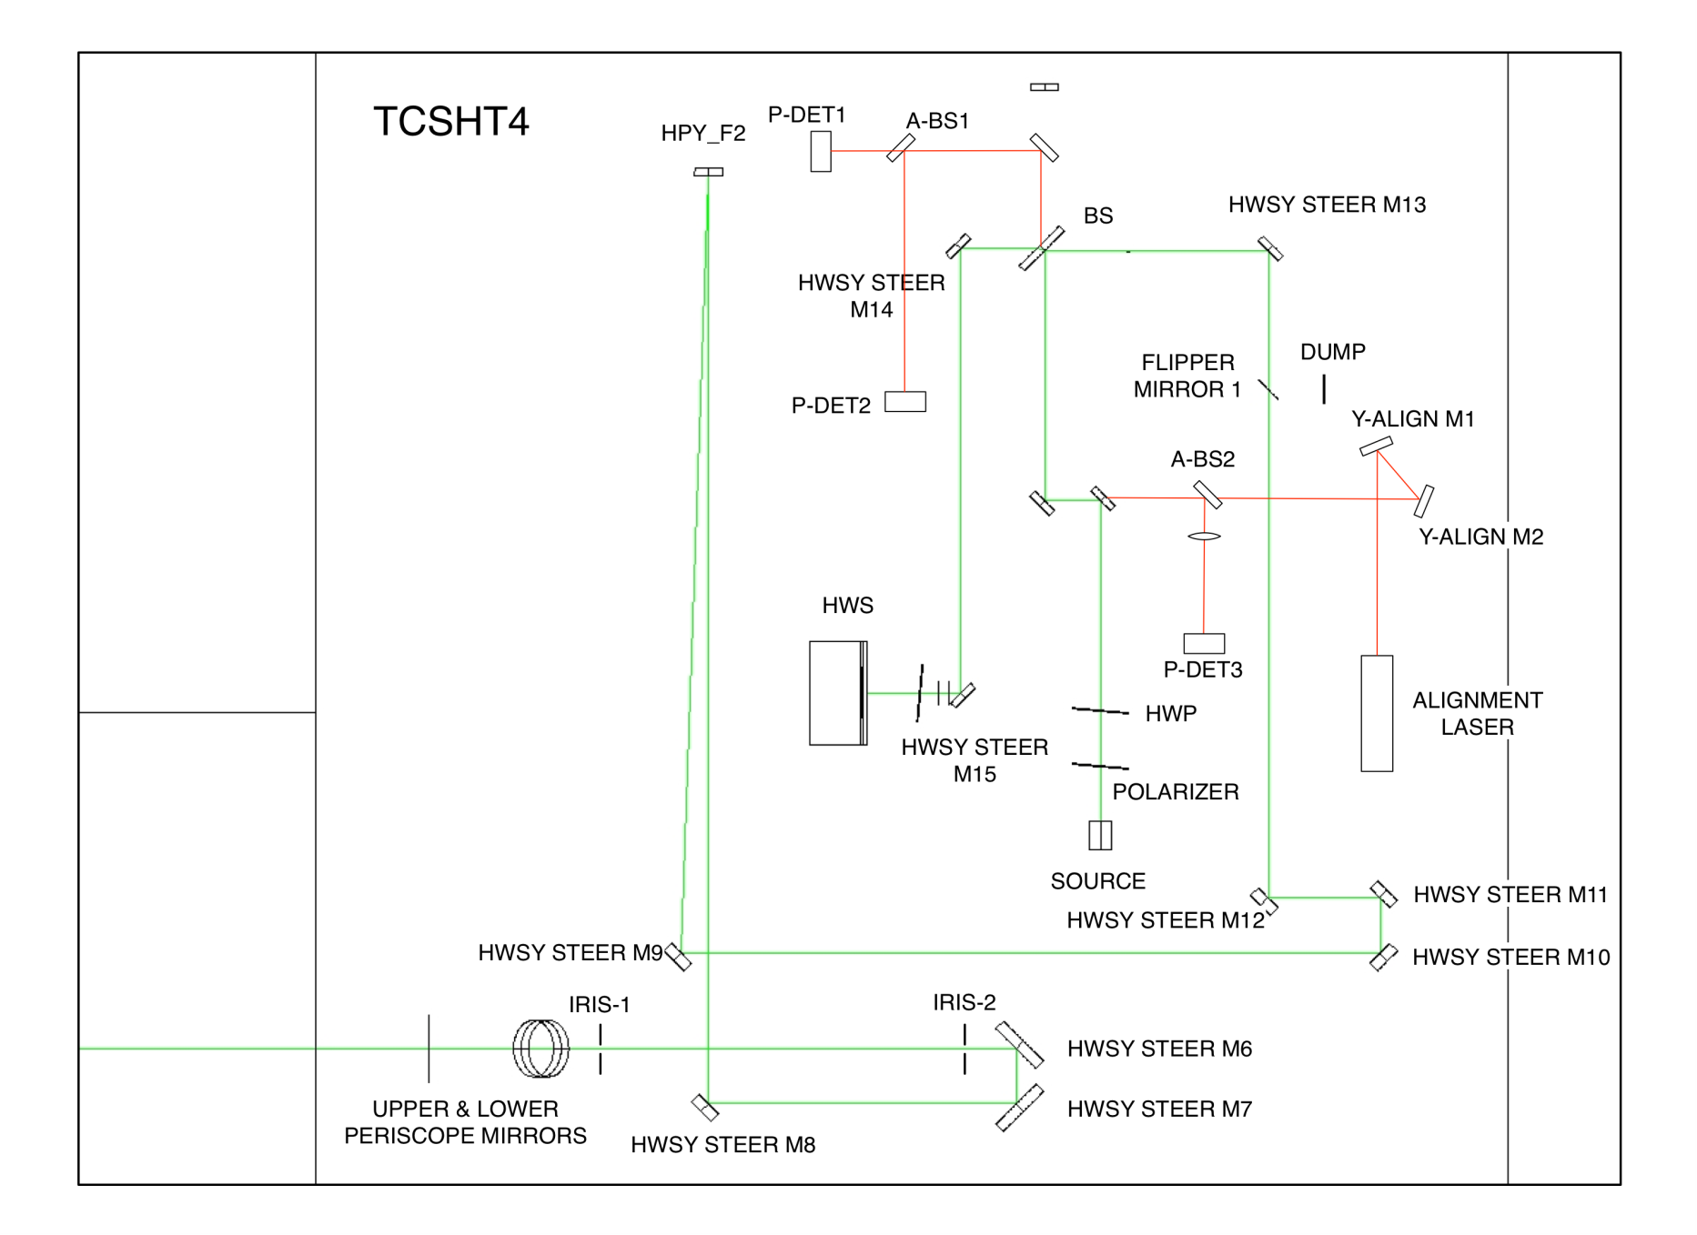

Figure : HWSY imaging optics, the probe beam (yellow) and the secondary beam (magenta) on the exterior table. The beam propagation through the optics shown here is largely the same as for HWSX, described in Figure 11, except that the probe beam is mostly p-polarized and is the transmission through PBS. Additionally, the beam is injected into the vacuum system through SR2.

## ~~Folded~~ H2 optical layouts (HAM10 & HAM11) ~~interferometer – ITM+CP~~

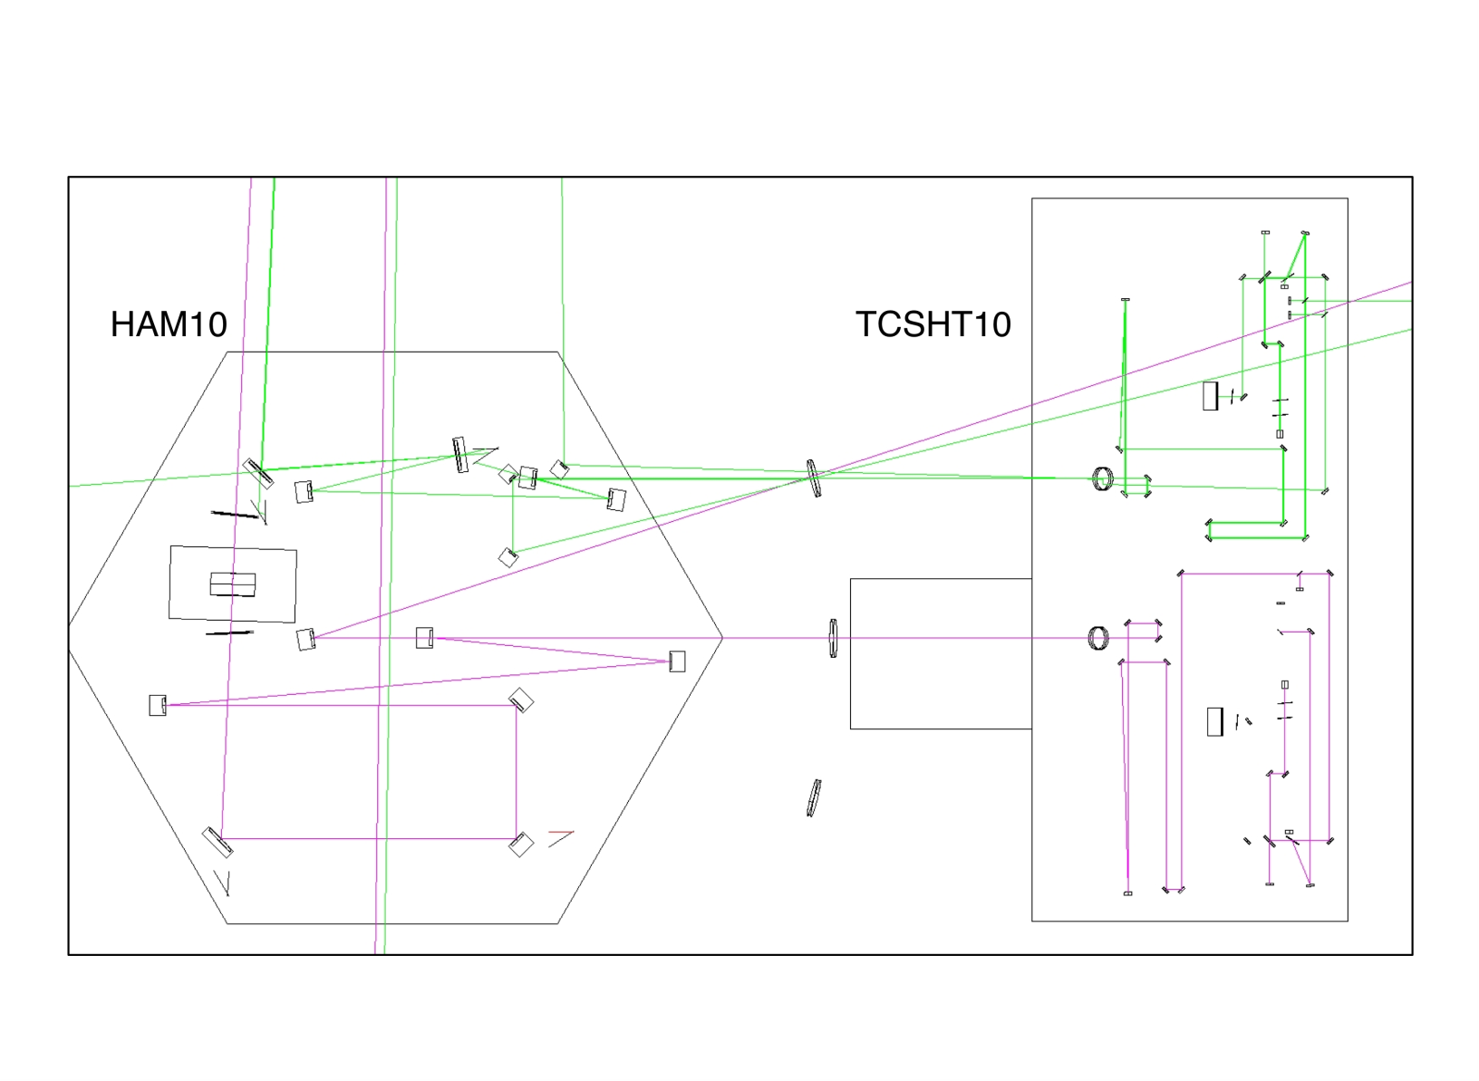

Figure : [H2X, H2Y] ZEMAX model of HAM10 and TCSHT10 table of the Hartmann sensor probe and reference beams on the exterior tables. The unlabelled mirrors are all beam steering mirrors. HWSX probe is transmitted through SR2. HWSY probe is reflected off BS_AR. The interior of HAM10 is, essentially, a version of HAM4 flipped about the X-axis.

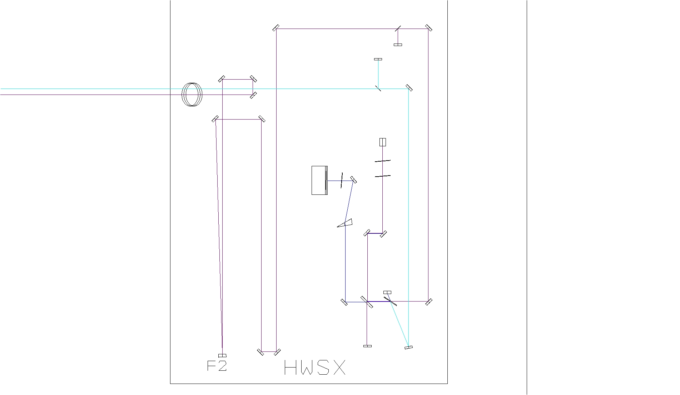

Figure : H2:HWSX imaging optics, the probe beam (purple) and secondary beam (cyan) on the exterior table. The format of the optical system is the same as in H1 and L1 HWS. For H2:HWSX shown here, the probe beam is mostly p-polarized and is transmitted through the PBS. See Figure 8 for a full description of the imaging telescope.

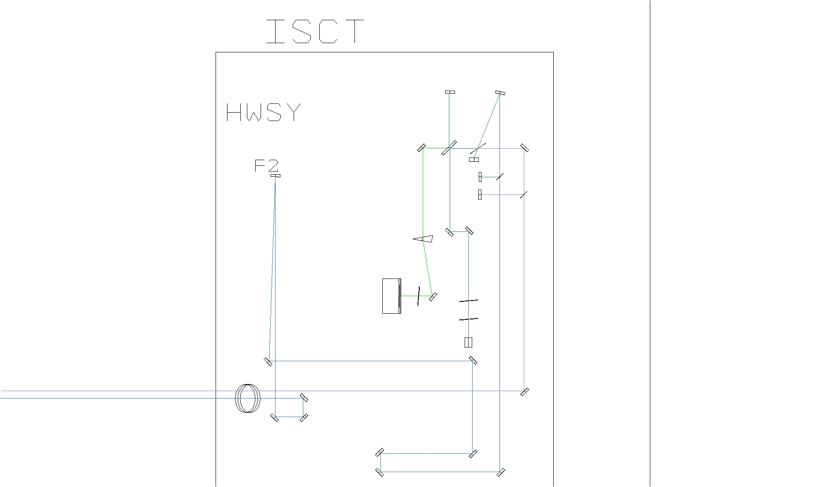

Figure : H2:HWSY imaging optics, probe beam (blue) and secondary beam (purple). See Figure 8 for a full description of the imaging telescope.

# Optical layout features

Various features of the optical layouts are described in this Section.

## Delay line paths.

(note: move paragraph before figure)

Where possible, delay lines (consisting of two beam steering mirrors that reflect the beam through 180 degrees) have been added between all focusing optics. By moving the mirrors as a set longitudinally along the beam axis these allow fine-tuning of the imaging and magnification with minimal impact on the alignment.

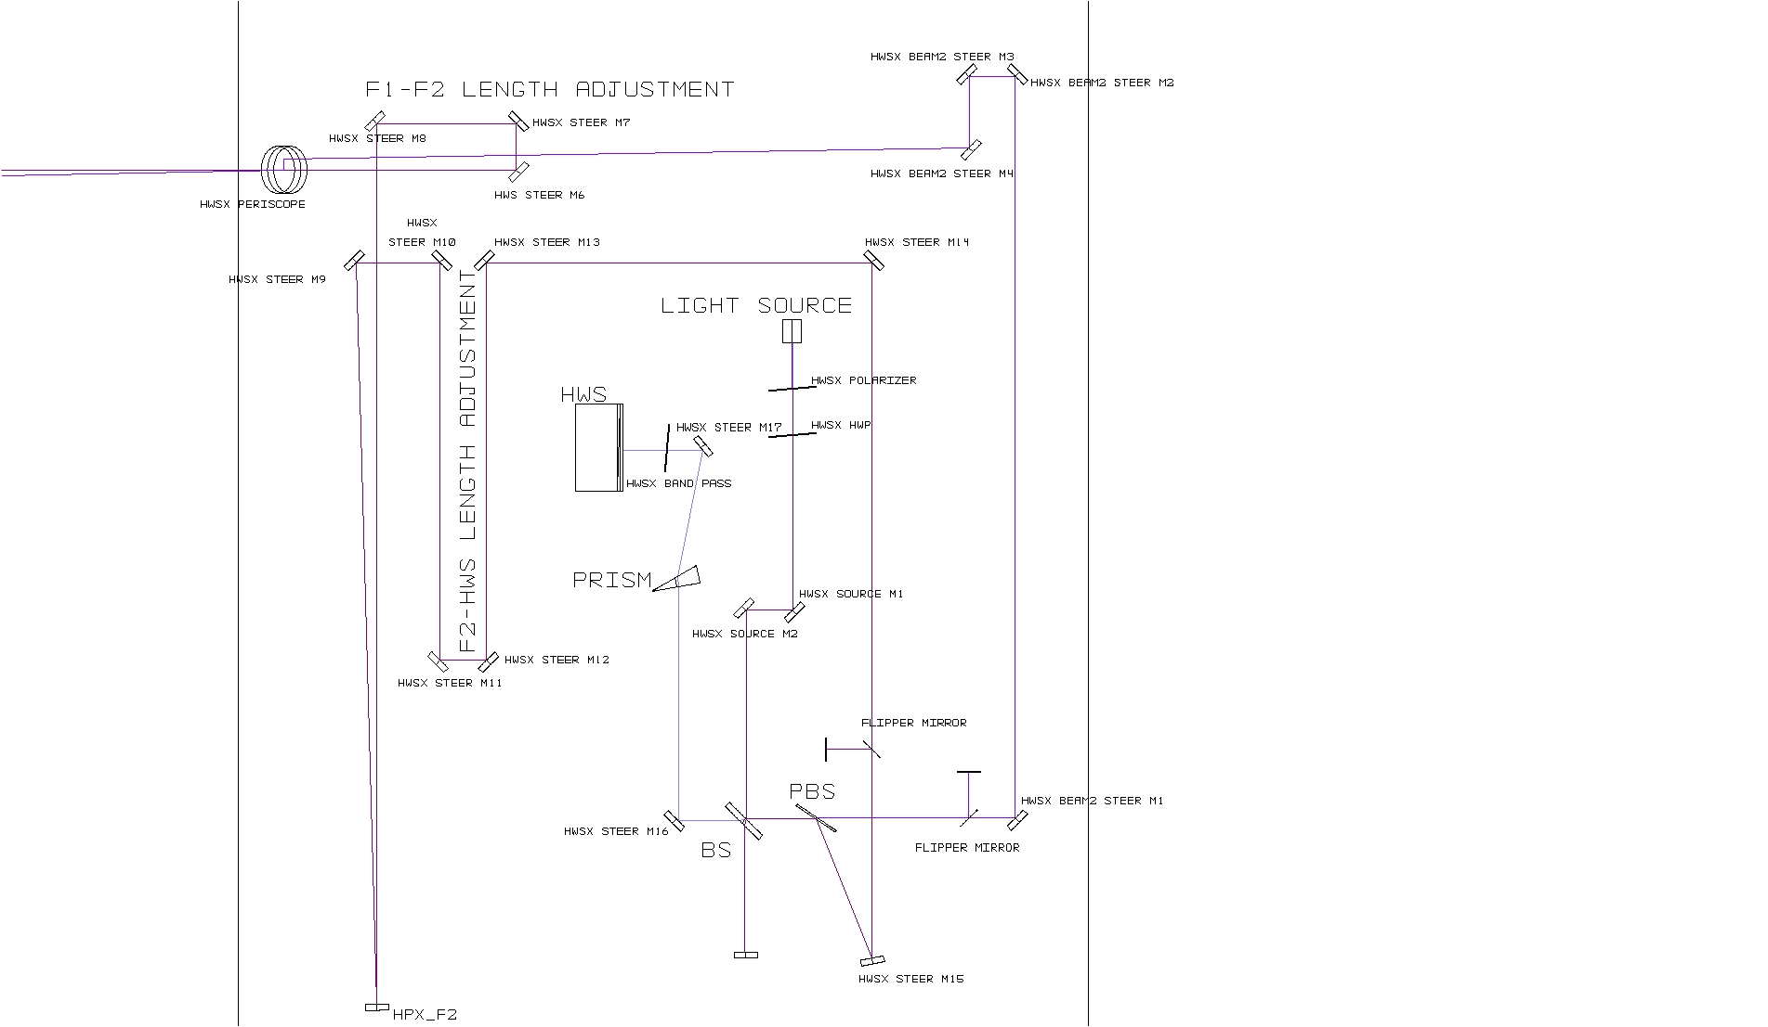

Figure : Example delay line on the probe beam (dark purple) formed by HWSX STEER M6 and HWSX STEER M7. Moving these as a pair along the axis of the incident beam allows easy adjustment of the distance between F1-F2 with little re-alignment necessary. Near periscope (large optics) and the reference beam (magenta).

Assume that these mirrors are intended to give a 180 degree reflection. They must be moved over a certain range to image the ITM, suppose this range is 50mm. Also assume that the mirrors are misaligned such that the reflection is an angle Δθ from 180 degrees. As the mirrors are moved 50mm, the optical axis will translate by Δθ*50mm. At the HWS, this translation will be demagnified by approximately 10x. The maximum allowable translation of the optical axis at the HWS should be approximately the spacing of the Hartmann plate holes (around 500 μm). Therefore, the maximum allowed Δθ is around 0.1 radians, or about 6 degrees. It is trivial to align the optics better than this. This applies to the alignment of the mirrors with respect to each other. It also applies to the alignment of the translation stage axis.

## Imaging optics

To avoid specular reflection of any 1064nm leakage from the IFO back into the SRC the imaging optics must not be lenses. The only option for these optics are curved mirrors.

A scattering analysis is presented in document [[T1100445 - AOS SLC: Signal Recycling Cavity Baffles Final Design]](https://dcc.ligo.org/cgi-bin/private/DocDB/ShowDocument?docid=69211). The results from that document summarizing the “H1 and L1 Hartmann

X and Y Scatter” are reproduced here:

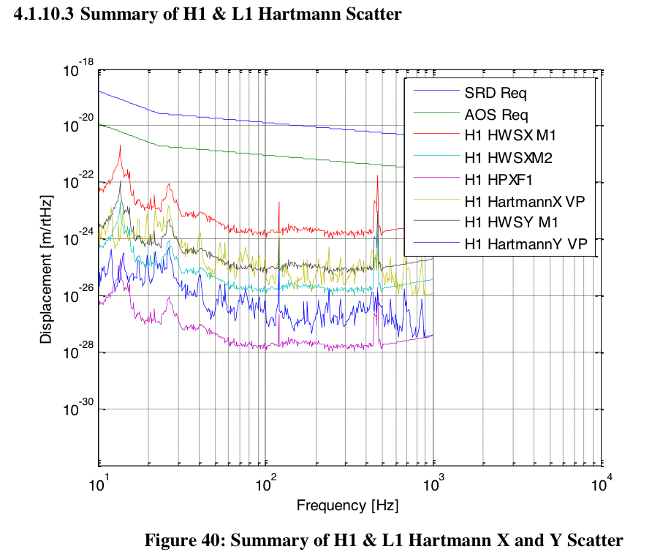

Figure : Summary of H1 and L1 Hartmann X and Y scatter, reproduction of Figure 40 in [[T1100445 - AOS SLC: Signal Recycling Cavity Baffles Final Design]](https://dcc.ligo.org/cgi-bin/private/DocDB/ShowDocument?docid=69211).

## Astigmatism

The astigmatism in the HWS is not negligible. A short technical note [[T1100539 - Compensating for astigmatism in the aLIGO ITM HWS imaging telescope]](https://dcc.ligo.org/cgi-bin/private/DocDB/ShowDocument?docid=73787) discusses this in more detail. The relevant tables from that document are listed here:

Table : Astigmatism due to the in-vacuum telescope mirrors. Angle of incidence, actual radius of curvature (vertical) and apparent radius of curvature (horizontal) for each optic.

|  |  |  |  |  |
| --- | --- | --- | --- | --- |
| **Optic** | **AOI** | **cos2(θ)** | **Actual RoC (mm) [vertical]** | **Apparent RoC (mm) [horiz.]** |
| H1/L1:HWSX F1 | 6.5° [h] | 98.72% | -4000 | -3948.8 |
| H1/L1:HWSY F1 | 4.7° [h] | 99.33% | +3000 | +2979.9 |
| H2:HWSX F1 | 7.6° [h] | 98.25% | +3000 | +2947.5 |
| H2:HWSY F1 | 5.3° [h] | 99.15% | -4000 | -3966.0 |

Table : Astigmatism due to the in-air telescope mirrors. Angle of incidence, actual radius of curvature (vertical) and apparent radius of curvature (horizontal) for each optic. The resulting magnifications in the horizontal and vertical directions are also shown.

|  |  |  |  |  |  |  |
| --- | --- | --- | --- | --- | --- | --- |
| **Optic** | **AOI** | **cos2(θ)** | **Apparent RoC (mm)** | **Δ*z3*(mm)** | **Mag.**  **[h]** | **Mag.**  **[v]** |
| H1/L1:HWSX F1 | 2.0° [h] | 99.87% | 4993.73 [h] | 0 | -17.67 | -17.50 |
| H1/L1:HWSY F2 | 2.3° [v] | 99.83% | +2995.0 [v] | -8.4 | 17.74 | 17.55 |
| H2:HWSX F2 | 3.81° [v] | 99.56% | +2986.8 [v] | -24 | 18.15 | 17.65 |
| H2:HWSY F2 | 1.77° [h] | 99.90% | 4995.2 [h] | 0 | -17.62 | -17.50 |

(note: what is the conclusion of this section? Additionally, the perturbations to the focal lengths of the imaging optics will shift the conjugate plane of the ITM. We move the HWS along the optical axis by Δ*z3* to compensate.)

## Super-luminescent diode (SLED) source, polarizer and HWP

The HWS light source on the table is a short fiber-optic cable (patch-cord) attached to a distant fibre-coupled SLED. The fiber collimator and the optical mount for the source need to be thermally and mechanically stable.

### SLED sources

As indicated in [[T1000682 - Technical Note for the aLIGO TCS Hartmann Sensor Camera and Sources]](https://dcc.ligo.org/cgi-bin/private/DocDB/ShowDocument?docid=25406), there will be one source per HWS used for measurement.

## Secondary beam, polarization and PBS



Figure : The beam from the light source is linearly polarized. The polarization axis is rotated slightly with the HWP so that it is mostly s-polarized. For H1:HWSX, a secondary beam is created on transmission through the PBS (see Section 6 for a discussion of the secondary beam).

As illustrated shown in Figure 18, there is a secondary beam (transmission through PBS) of orthogonal polarization to the probe beam (reflection off PBS). The half-wave plate and polarizer are arranged such that there is only a small amount (1%-5%) of power in the secondary beam. For a more detailed discussion of the secondary beam, see Section 6.

## Beam Height

The beam height on the exterior optical table is 4” everywhere, except for the beam in the periscope and for the non-normal reflections off F2 in H1/L1:HWSY and H2:HWSX.

## Band Pass filter

The HWS will have a band-pass filter, (790nm ± 10nm) or (840nm ± 10nm) mounted directly in front of it. This will be used filter out ambient light and any residual 1064nm radiation. This will need to be tilted vertically by ~ 10 mrad to prevent any 1064nm reflections back into the signal-recycling cavity

## Beam size and mirror sizes

See [T1000718 - *aLIGO Hartmann Sensor Optics and Opto-Mechanical components (H1, L1, H2) Input Test Masses.*](https://dcc.ligo.org/cgi-bin/private/DocDB/ShowDocument?docid=26296)

## Flipper mirrors



Figure : Flippers mirrors to block the propagation of the probe or secondary beams propagating FROM the PBS.

Flipper mirrors will be used to alternately block the probe or secondary beams, as shown in Figure 19. This will allow one or the other to be measured.

## 50/50 Beamsplitter

A 50/50 beamsplitter (BS in Figure 18) is used to split the incoming beam from the light source with the return beam from the ITM mirror.

## Periscope

The periscope optics will need to be at least 3” diameter in order to accommodate the secondary beam.

## Beam-steering mirror pairs

Several of the components have pairs of beam steering mirrors before/after them. These are in place to allow both position and angular adjustment.

### Motorized steering mirrors

The HAM-ISIs and core optics can all move, rotate and affect the alignment of the HWS probe beam – by a maximum amount of approximately 1mrad. To compensate for this there will be two motorized steering mirrors (with picomotor drives) in the HWS optical layout that can be used to periodically adjust the alignment of the HWS optical path without entering the optical table (on time scales of greater than 10-100s).

Near the viewport, alignment errors of greater than 3.5 mrad on the forward-propagating beam will cause the backward-propagating beam from the ITM to be completely clipped by internal apertures in the optical beam path.

The pico-motor mirrors (New Focus 8816) have an angular resolution of 0.7 μradians and a range of around 70 mrad. The optimum locations for the motorized mirrors on the in-air table is TBD.

## Optic placement and direction (for usability)

For ease of use, the Hartmann sensor has been placed facing away from the HAM chamber toward the access side of the table. The SLED fiber source is 90 degrees to the access direction for the table. This allows easy measurement of the mode size and divergence.

## Beam Tubes

As far as possible, the Hartmann beams should be enclosed in beam tubes to reduce the effect of air currents on the wavefront.

The HWS enclosures [[D1102033 - aLIGO TCS H1-L1 Viewport and Table Enclosure Assembly]](https://dcc.ligo.org/cgi-bin/private/DocDB/ShowDocument?docid=73822) should serve to sufficiently reduce the integrate air-currents over the HWS beam (when the HEPA filters on the enclosure are not running (note: please explain that you apparently must turn off the HEPA filters when you make a wavefront measurement?).

## Spurious defocus in the probe beam

This is discussed in greater detail in [[T1000722 - Hartmann Wavefront Sensor: Defocus defined and maximum acceptable defocus error]](https://dcc.ligo.org/cgi-bin/private/DocDB/ShowDocument?docid=26364). As defined in that document, the maximum acceptable defocus at the HWS, *Sε-HWS*, where defocus is implied implicitly by the quadratic wavefront error, *W = 0.5 S r2*, is



It is important to note, however, that the defocus, or quadratic change in the probe beam wavefront, at the Hartmann sensor will be dependent on the length change of the telescope, formed by SR2 and SR3, between HAM4 and HAM5. This length will change as the HAM ISIs and HEPIs move and also due to thermal expansion of the slab separating these two chambers. As such, as part of installation it will be necessary to calibrate and remove the effective defocus seen at the Hartmann sensor induced by motion of HEPI and ISI.



In this equation, *dS\** indicates the spurious defocus in the probe beam at the HWS induced by HEPI and ISI motion.

For reference, a . The maximum spurious defocus that can be tolerated in the HWS is ~7.4 x 10-4 m-1. Therefore, the maximum displacement that can be tolerated between the HAM chambers, without requiring any compensation of this effect in the Hartmann sensor analysis, is approximately 390 μm (see [T1000715](https://dcc.ligo.org/cgi-bin/private/DocDB/ShowDocument?docid=26293)). The maximum motion expected from HEPI is of the order of 1mm (note: how much change in length of the signal recycling cavity is allowed by ISC?). As a result, we will need to incorporate the signals from HEPI and ISI into the analysis of the Hartmann sensor signal.

## Diffraction in the HWS probe beam

Diffraction in the HWS probe beam is discussed in [[T1100549 - Diffraction in the aLIGO ITM HWS probe beams]](https://dcc.ligo.org/cgi-bin/private/DocDB/ShowDocument?docid=74167).

# Analysis of thermal defocus induced by imaging telescopes

The following table examines each telescope within the HWS optical layout and determined the temperature change necessary in that telescope to induce a change of defocus of 7.4 × 10-4m-1 at the HWS by thermal expansion of the telescope. Note that the thermal expansion of the optics is not included as the relative size of this effect is given by the ratio of thermal expansion of the optics (~5E-7 K-1) to the thermal expansion of the material separating the optics (~1E5 K-1).

Table : Maximum acceptable change in temperature based on thermal defocus in each component of the imaging telescopes.

|  |  |  |  |
| --- | --- | --- | --- |
| **Optical Path** | **Distance** | **@ HWS** | **Maximum acceptable Δ*T*** |
| **H1:ITMX** | | |  |
| SR3 to F1 | 16.823m | 4.1 × 10-4 m­-1 K-1 | 1.8 K |
| F1 to F2 | 5.361m | 1.5 × 10-5 m­-1 K-1 | 49 K |
| F2 to HWS | 3.764m | 6.9 × 10-6 m­-1 K-1 | 107 K |
| **H1:ITMY** | | |  |
| SR3 to SR2 | 15.461m | 3.6 × 10-4 m­-1 K-1 | 2.1 K |
| SR2 to F1 | 5.794m | 1.2 × 10-4 m­-1 K-1 | 5.9 K |
| F1 to F2 | 4.796m | 3.6 × 10-5 m­-1 K-1 | 21 K |
| F2 to HWS | 2.821m | 5.2 × 10-6 m­-1 K-1 | 142 K |
| **H2:ITMX** | | |  |
| F-SR3 to F-SR2 | 16.001m | 3.7 × 10-4 m­-1 K-1 | 2.0 K |
| F-SR2 to F1 | 5.153m | 1.1 × 10-4 m­-1 K-1 | 6.8 K |
| F1 to F2 | 4.784m | 3.5 × 10-5 m­-1 K-1 | 21 K |
| F2 to HWS | 2.842m | 5.2 × 10-6 m­-1 K-1 | 141 K |
| **H2:ITMY** | | |  |
| F-SR3 to F1 | 16.823m | 4.1 × 10-4 m­-1 K-1 | 1.8 K |
| 5.794m | 5.361m | 1.5 × 10-5 m­-1 K-1 | 49 K |
| 4.796m | 3.746m | 6.9 × 10-6 m­-1 K-1 | 107 K |
|  |  |  |  |

# Secondary beam

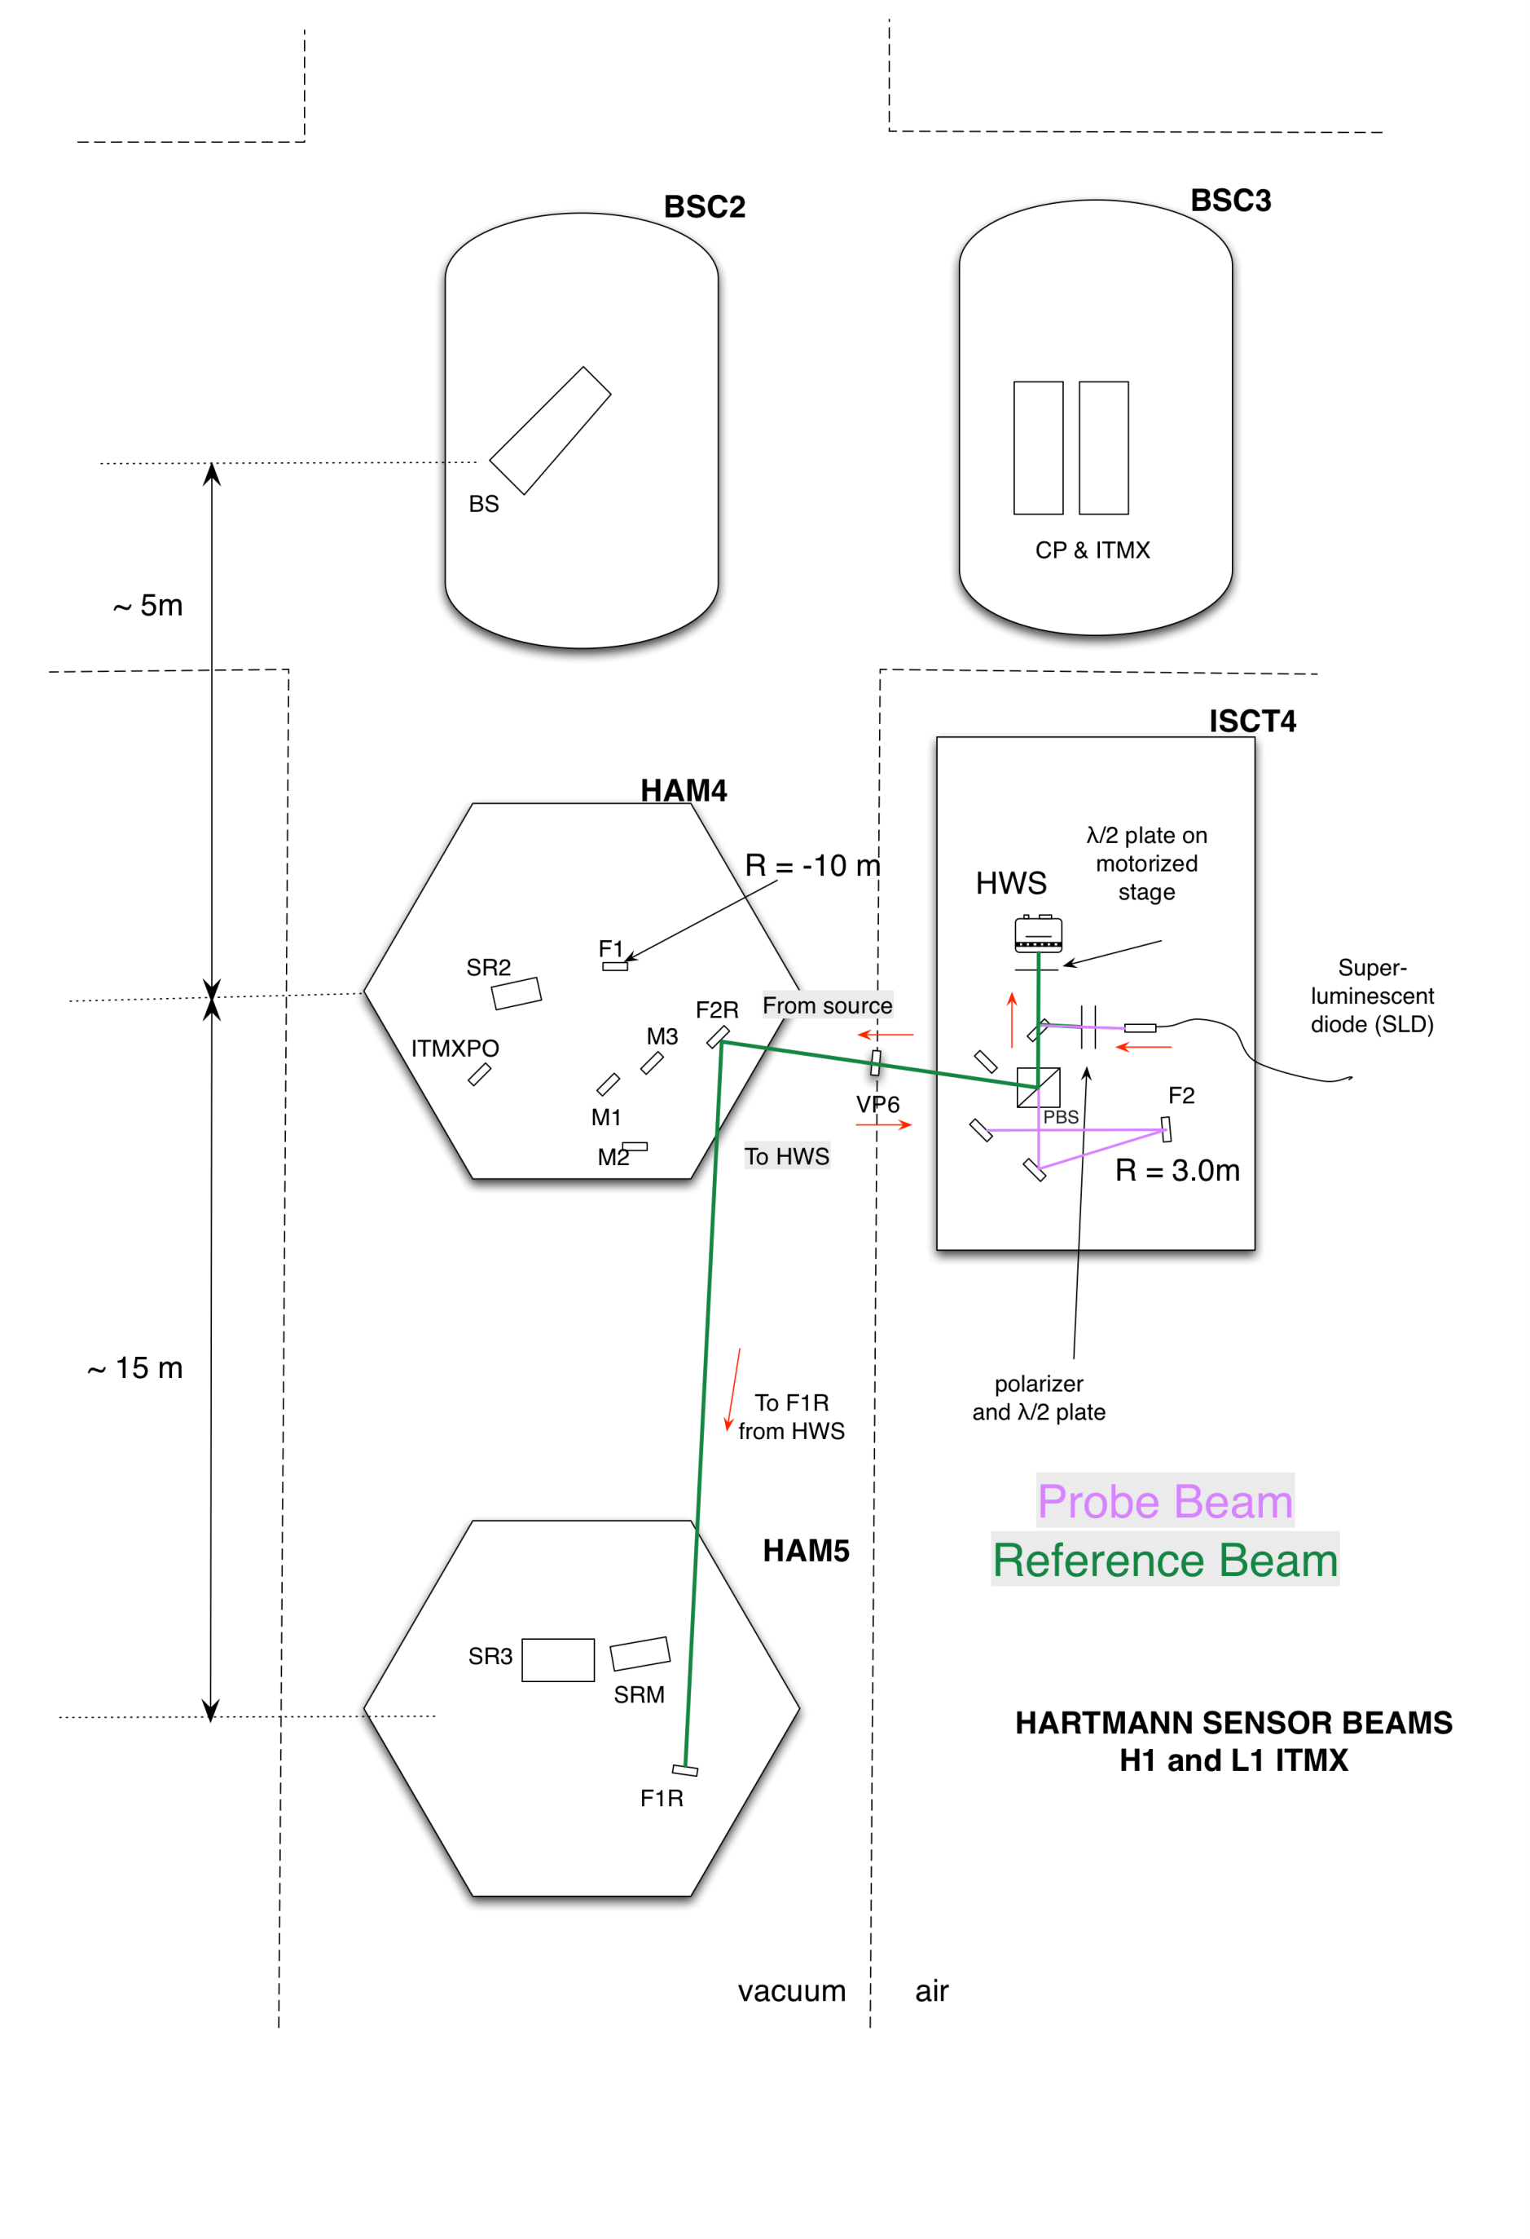

Figure : Secondary beam (green) for H1 ITMX. The secondary beam propagates through a telescope that spans the ISI tables in HAM4 and HAM5. The telescope is made from mirrors F2R and F1R.

The secondary beam propagates only between the ISI tables in HAM4 and HAM5. It is intended to show a strong change in curvature in response to changes in the distance between these two tables. This will be due to:

* Displacement of HEPI relative to the LVEA floor, 
* Displacement of the ISI table relative to HEPI, 
* Thermal expansion of the concrete slab between the two HAM chambers, 
* Thermal expansion of the ISI tables, 



We are interested in knowing the distance  as this will also induce a defocus in the probe beam that will appear as a spurious defocus coming from the ITM+CP thermal lens.

## Secondary beam telescope [H1X, H1Y, H2X, H2Y]

A telescope that spans HAM4 and HAM5 will be constructed, as illustrated in Figure 20, made from optics F1R and F2R. The Hartmann secondary beam propagates through this telescope, is reflected and returns to the Hartmann sensor. As the telescope defocuses due to changes in the distance between the two optics, the defocus (radius of curvature) on the return beam changes at the Hartmann sensor.

The defocus signal is maximized when there is a waist approximately at the Hartmann sensor. It is also approximately proportional to the ratio of the beam size at the retro-reflector and the beam size at the Hartmann sensor.

A beam radius of approximately 25mm at the retro-reflector was chosen. The optical properties of the secondary beam are listed in Table 8.

Table : Secondary beam solution

|  |  |
| --- | --- |
| **Optical component** | **Value** |
| HWS to F2R length – L = x0 | 4.5 m |
| F2R focal length (off-axis paraboloid) | 1.0 m |
| F2R to F1R length – L = x1 | ~15.39 m |
| F1R focal length | 7.5 m |
| Beam Size at HWS | ~2.35 mm |

The exact distance between F2R and F1R, x1, can be fine tuned to maximize the defocus induced for a given microscopic change in that length.

There will be a defocus induced by the change in the length of HWS to F2R, x0. This distance can be fine tuned to minimize this effect. The defocii measured at the HWS, for the values given in Table 8, are shown in Table 9 – assuming uniform expansion of the concrete floor with a CTE of 12x10-6.

Only one secondary beam is required per table since it measures the displacement between HAM4 and HAM5 which is common to both X and Y Hartmann probe beams.

Table : Secondary beam defocus effects

|  |  |  |  |
| --- | --- | --- | --- |
| **Defocus per unit displacement** | **Value** | **Defocus per unit temperature** | **Value** |
|  | -0.59 m-1/m |  | -3.2 x 10-5 m-1 K-1 |
|  | -0.99 m-1/m |  | -1.8 x 10-4 m-1 K-1 |

See document [[T1000722 - Hartmann Wavefront Sensor: Defocus defined and maximum acceptable defocus error]](https://dcc.ligo.org/cgi-bin/private/DocDB/ShowDocument?docid=26364) for a discussion of the Hartmann sensor its impact on aLIGO TCS.

## Secondary beam telescope sensitivity

The purpose of having a secondary beam telescope is to be sensitive to variations in the displacement between the two HAM chambers. This can be used to estimate the added defocus error in probe beam. By the time of the FDR, this is now unnecessary in order to keep the defocus error below the minimum level of 7.4E-4 m-1 (which corresponds to a change in the distance between the HAM chambers of 350μm), as described in [[T1100536 - Hartmann Wavefront System: Defocus error budget].](https://dcc.ligo.org/cgi-bin/private/DocDB/ShowDocument?docid=73626)

However, the residual systematic defocus error introduced by HAM-displacement-changes can be further reduced by the secondary beam. The level that this can be reduced to can be determined by determining the sensitivity of the secondary beam those displacement changes (note: confusing sentence). This is shown in Figure 21. If there is no temperature stabilization of the Hartmann sensor (upper figure), then this is dominated by the thermal expansion of the Hartmann sensor. If the Hartmann sensor is temperature stabilized to 0.05K (lower figure), then the displacement can be sensed to roughly 13μm. Therefore, the residual error in the defocus of the Hartmann sensor should be reduced to (13μm)/(350μm)*7.4E-4 m-1 = 2.7E-5 m-1, which is more than order of magnitude improvement.

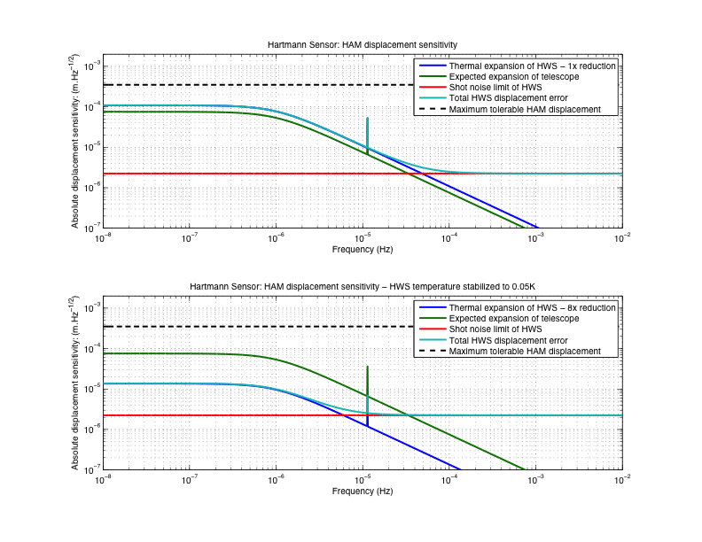

Figure : displacement sensitivity of secondary beam

# Full ABCD matrices

## H1/L1:HWSX

Table : H1/L1 HWSX nominal, horizontal and vertical optical matrices. Variations from nominal are highlighted in pink boxes. All values are unitless or in [m] or [m-1].

|  |  |  |  |
| --- | --- | --- | --- |
| **Component** | **Nominal** | **Horizontal** | **Vertical** |
| ITMX to SR3 |  |  |  |
| SR3 refl  ROC = 36m |  |  |  |
| SR3 to ITMXPO |  |  |  |
| ITMXPO to F1: (*z1*) |  |  |  |
| Mirror F1  AOI (h: 6.5°, v: 0°) |  |  |  |
| F1 to F2: (*z2*) |  |  |  |
| Mirror F2  AOI (h: 2.0°, v: 0°) |  |  |  |
| F2 to HWS: (*z3*) |  |  |  |
| **Result** |  |  |  |

## H1/L1:HWSY

Table : H1/L1 HWSY nominal, horizontal and vertical optical matrices. Variations from nominal are highlighted in pink boxes.

|  |  |  |  |
| --- | --- | --- | --- |
| **Component** | **Nominal** | **Horizontal** | **Vertical** |
| ITMY to SR3 |  |  |  |
| SR3 refl  ROC = 36m |  |  |  |
| SR3 to SR2 |  |  |  |
| SR2 surface  n = 1.453 @ 840nm  ROC = -6.43m |  |  |  |
| SR2 thickness |  |  |  |
| SR2 AR surface |  |  |  |
| SR2 to F1: (*z1*) |  |  |  |
| Mirror F1  AOI (h: 4.7°, v: 0°) |  |  |  |
| F1 to F2: (*z2*) |  |  |  |
| Mirror F2  AOI (h: 0°, v: 2.3°) |  |  |  |
| F2 to HWS: (*z3*) |  |  |  |
| **Result** |  |  |  |

## H2:HWSX

Table : H2:HWSX nominal, horizontal and vertical optical matrices. Variations from nominal are highlighted in pink boxes.

|  |  |  |  |
| --- | --- | --- | --- |
| **Component** | **Nominal** | **Horizontal** | **Vertical** |
| ITMX to F-SR3 |  |  |  |
| F-SR3 refl  ROC = 36m |  |  |  |
| F-SR3 to F-SR2 |  |  |  |
| F-SR2 surface  n = 1.453 @ 840nm  ROC = -4.89m |  |  |  |
| F-SR2 thickness |  |  |  |
| F-SR2 AR surface |  |  |  |
| F-SR2 to F1: (*z1*) |  |  |  |
| Mirror F1  AOI (h: 7.6°, v: 0°) |  |  |  |
| F1 to F2: (*z2*) |  |  |  |
| Mirror F2  AOI (h: 0°, v: 2.3°) |  |  |  |
| F2 to HWS: (*z3*) |  |  |  |
| **Result** |  |  |  |

## H2:HWSY

Table : H2 HWSY nominal, horizontal and vertical optical matrices. Variations from nominal are highlighted in pink boxes. All values are unitless or in [m] or [m-1].

|  |  |  |  |
| --- | --- | --- | --- |
| **Component** | **Nominal** | **Horizontal** | **Vertical** |
| ITMY to F-SR3 |  |  |  |
| F-SR3 refl  ROC = 36m |  |  |  |
| SR3 to ITMYFPO |  |  |  |
| ITMXPO to F1: (*z1*) |  |  |  |
| Mirror F1  AOI (h: 5.3°, v: 0°) |  |  |  |
| F1 to F2: (*z2*) |  |  |  |
| Mirror F2  AOI (h: 1.8°, v: 0°) |  |  |  |
| F2 to HWS: (*z3*) |  |  |  |
| **Result** |  |  |  |

1. Σ note that H1:HWSX (F2 to HWS) is 3.764m and H2:HWSY (F2 to HWS) is indeed 3.746m. This is not a typo.