LIGO Laboratory / LIGO Scientific Collaboration

LIGO-T1100537-v3 LIGO 8/10/2012

HEPI Pump Servo VFD controls

Eric Allwine

Distribution of this document:
LIGO Scientific Collaboration

This is an internal working note
of the LIGO Laboratory.

California Institute of Technology  LIGO Project – MS 18-34  1200 E. California Blvd.  Pasadena, CA 91125  Phone (626) 395-2129  Fax (626) 304-9834  E-mail: info@ligo.caltech.edu | Massachusetts Institute of Technology  LIGO Project – NW22-295  185 Albany St  Cambridge, MA 02139  Phone (617) 253-4824  Fax (617) 253-7014  E-mail: info@ligo.mit.edu
LIGO Hanford Observatory  P.O. Box 159  Richland WA 99352  Phone 509-372-8106  Fax 509-372-8137 | LIGO Livingston Observatory  P.O. Box 940  Livingston, LA 70754  Phone 225-686-3100  Fax 225-686-7189
http://www.ligo.caltech.edu/

In case of an emergency or if there is any reason to turn the actuator fluid pumps off, hit the red button on the front of the pump stations. There will be three running normally for all of the HAM/BSC corner station H1 actuators, so three to shut off.
The settings for the VFD on the pump stations will usually not need to be changed, even if the pump station turn off or there is a power outage, overload condition, or other condition which shut the motor for the pump station off. To restart, push in the red button on the front of the pump station and leave in for about 30 seconds. Release the red button and then press in the green button. The pump servo will need to be on, along with the MEDM screen on, to start the pump station up again.
Changing the fluid pressure is done with the pump servo by sliding the motor control on the MEDM screen or entering the value. The pressure is controlled with a PID Servo control. The on off switch for this control is below the motor speed and if on, the motor speed cannot manually be changed with the slider or entered.
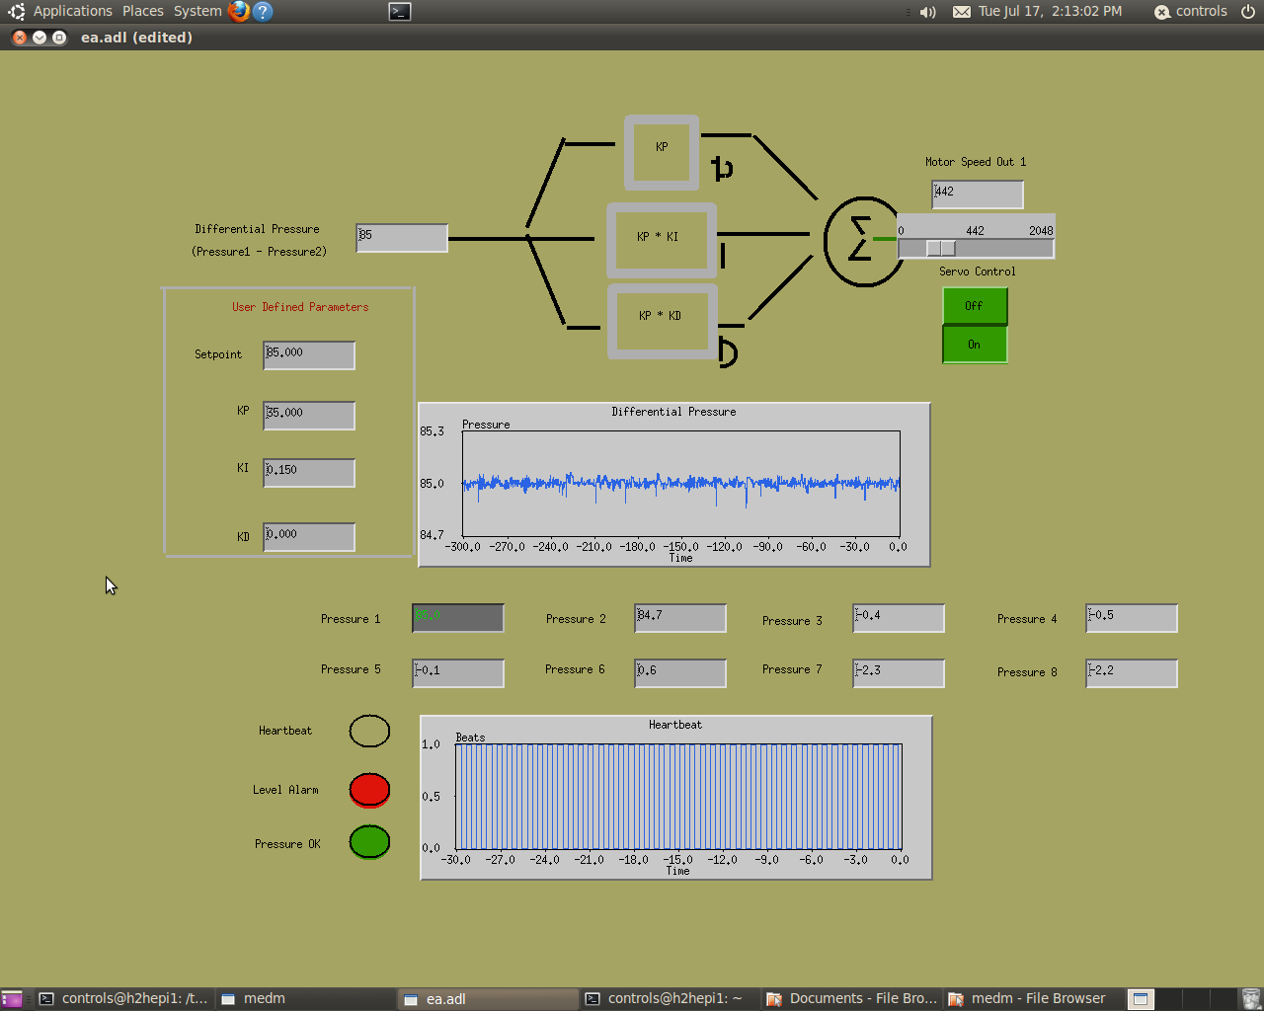

In case there is an unusual circumstance when the settings for the VFD need to be changed or reset the following will explain some of the changes made from default.
An example of how to make a VFD program change is the following: Hit PRG, Func/Data. Select F01 then hit Func/Data. Set to “1” (normal voltage input control). Hit func/Data to store. “PRG” gets out of this mode.
To reset the VFD to initial settings select H03((reset by 1)holding down stop button while pushing the up arrow button then 2)pushing function button)). The following settings are the only ones changed after resetting the VFD or post factory settings to what it is set at the present time.

H08 reverse lock is set to 1
F01 FRQ CMD set to 1
H10 energy savings set to 0
C33 set to 0.00 sec
F15 set to max speed approx. 58 Hz
F26 set to 15khz
F42 TRQVECTOR1 set to 1
F07 ACC TIME1 set to 0.2 sec
F08 DEC TIME1 set to 0.2 sec
F09 TRQ BOOST1 set to 0

Pump Servo Settings
The program for the epics program which runs the pump servo for the single BSC at end-y is set with a PID of 60 gain and a 0.15 integral shown on the MEDM screen. The pressure setting on the MEDM screen should be set at approx 85 psi from the outlet of the pump for an approximate total differential of 70 psi. The pumps should be started by slowly sliding the MEDM screen speed control with the control servo off.
Once the pump servo MEDM screen is on and the motor control slider is on the left side and the motor control reading zero. MEDM off button should be pressed in directly below the motor control slider. The FWD button on the front of the VFD will need to be pushed for the next step in initializing start up.
Now the MEDM motor control slider may be slowly increased until reaching approximately 85psi. Once this is achieved the pump servo set point should be set to 85psi and the servo control button turned on for pump servo PID control.

