*LIGO Laboratory / LIGO Scientific Collaboration*

LIGO-T1100517-v7 *Advanced LIGO* Date:

Thermal Compensation System (TCS):

Hartmann Wavefront Sensor (HWS):

Final Design Document

Authors: Aidan Brooks, Ayodele Cole, Alastair Heptonstall, Mindy Jacobson, Won Kim, Alexander Lynch, Jesper Munch, Stephen O’Connor, Zhenhua Shao, Peter Veitch, Cheryl Vorvick

Distribution of this document:

LIGO Scientific Collaboration

This is an internal working note

of the LIGO Laboratory.

|  |  |
| --- | --- |
| **California Institute of Technology**  **LIGO Project – MS 18-34**  **1200 E. California Blvd.**  **Pasadena, CA 91125**  Phone (626) 395-2129  Fax (626) 304-9834  E-mail: info@ligo.caltech.edu | **Massachusetts Institute of Technology**  **LIGO Project – NW22-295**  **185 Albany St**  **Cambridge, MA 02139**  Phone (617) 253-4824  Fax (617) 253-7014  E-mail: info@ligo.mit.edu |
| **LIGO Hanford Observatory**  **P.O. Box 159**  **Richland WA 99352**  Phone 509-372-8106  Fax 509-372-8137 | **LIGO Livingston Observatory**  **P.O. Box 940**  **Livingston, LA 70754**  Phone 225-686-3100  Fax 225-686-7189 |

http://www.ligo.caltech.edu/

Table of Contents

1 Introduction 4

1.1 Changes from Version 5 to Version 6 5

1.1.1 Major changes 5

1.1.2 Minor changes 5

2 Priority Issues indentified for consideration 7

2.1 Outstanding issues 7

2.2 Risk reduction proposals 8

2.3 Early approval 8

3 HWS Requirements 9

3.1 Original requirements 9

3.2 Further requirements since Conceptual Design 9

3.2.1 Requirements for the optical design 9

3.2.2 Requirements on systematic errors 10

3.2.3 Requirements to prevent degradation of aLIGO performance 10

4 Hartmann Wavefront Sensor Assembly 11

5 Optical Design 12

5.1 Optical Layout 12

5.1.1 Overview 12

5.1.2 Optical layout – coordinates 15

5.1.3 Diffraction in the ITM optical layout 15

5.2 Optical Layout – ETM HWS 16

5.3 Light Sources (ETM and ITM) 18

5.3.1 ITM – fiber coupled super-luminescent diodes 18

5.3.2 ITM – visible alignment lasers 18

5.3.3 ITM HWS sources – properties 18

5.3.4 ETM – source 18

5.4 Optics and opto-mechanics 19

5.4.1 ITM-HWS optics and opto-mechanics 19

5.4.2 ETM-optics and opto-mechanics 20

6 Electronics 21

6.1 HWS-Electronics requirements 21

6.2 Block diagrams 21

6.2.1 ITM-HWS Block diagram 21

6.2.2 ETM-HWS Block diagram 23

6.3 Beckhoff controls 24

6.4 Custom HWS electronics components 24

6.4.1 Power distribution box (ETM-D1002851, ITM-D1102206) 25

6.4.2 ETM-HWS table EtherCAT interface box [ETM only] 25

6.4.3 ITM-HWS table EtherCAT interface box [ITM only] 25

6.4.4 HWS Breakout Box (ETM-D1101941, ITM-D1200110) 25

6.4.5 SLED driver [ITM-only] 25

6.4.6 Temperature sensor package [ITM/ETM] 26

6.4.7 Picomotor drivers [ITM/ETM] [TCS responsibility: ITM-only] 26

7 Software 27

7.1 Software architecture 27

7.1.1 Software version control 29

7.2 Computing hardware/software requirements 29

7.3 DAQ/Storage requirements 30

8 Safety 30

8.1 Electrical Hazards 30

8.2 Laser hazards 30

8.3 Electronics 30

9 Enclosure / VEA Layout 31

9.1 End Station Floor plan 31

9.1.1 End Station Table Enclosures 31

9.2 Corner Station Floor plan 31

9.2.1 Corner Station Table Enclosures 31

9.3 Viewport enclosures 31

10 Interfaces 32

10.1 Systems 32

10.2 COC 32

10.3 ISC 32

10.4 AOS: SLC 32

11 Testing/Modeling 33

11.1 Modeling 33

11.2 Proto-typing results 33

11.3 One Arm Test 33

12 Procedures 33

12.1 Alignment 33

13 Receiving Inspections 34

14 Project Planning 34

14.1 Costs 34

14.2 Procurements 34

14.3 Schedules 34

15 Project Planning - Appendix 37

# Introduction

The purpose of this document is to provide a guided overview of the final design of the TCS Hartmann Wavefront Sensor (HWS) referencing to external documents where necessary. The goals of the final design documentation (partly collated from [M050220](https://dcc.ligo.org/cgi-bin/private/DocDB/ShowDocument?docid=68)) are to convince the final design review (FDR) committee that:

1. The HWS system will satisfy the requirements for a TCS wavefront sensor.
2. The HWS will not adversely affect the performance of Advanced LIGO
3. A mature procurement plan exists for the HWS hardware
4. Installation of the HWS hardware can be accommodated in aLIGO schedule
5. Mature plans exist to take the HWS hardware through initial alignment
6. Mature plans exist for continuous reliable operation of the HWS.
7. Costing
8. Safety
9. Interface issues

All the links presented here are also accessible from the [HWS FDR Materials Wiki page](https://awiki.ligo-wa.caltech.edu/aLIGO/Auxillary_Optics_Stuff/TCSComponents/HartmannSensor/HWS_FDR_checklist).

## Changes from Version 5 to Version 6

Version 5 of this document was the version submitted to the FDR committee for review. Version 6 incorporates all the changes to the final design based on committee feedback. The changes are outlined in this subsection.

### Major changes

* The vertex optical layouts have been overhauled (see Section 5.1)
  + Lenses are now used instead of curved mirrors as imaging optics
  + The dichroic beam splitter to strip off 1064nm is now a smaller 2” HR mirror at 1064nm.
  + All the in-vacuum steering mirrors are now metallic.
  + We have removed the alignment PO mirrors as the ALS beam can be used to define the beam axis.
  + The exterior alignment laser has been removed in favour of fiber-coupled 532nm lasers
  + The secondary beam has been eliminated from the design.
* The alignment procedure has been simplified (see Section 12.1)

**Document list**

* [[T1000179 - aLIGO Hartmann Sensor Optical Layouts (H1, L1, H2): Input Test Masses]](https://dcc.ligo.org/cgi-bin/private/DocDB/ShowDocument?docid=10643).
* [[T1100463 - aLIGO Hartmann Sensor Optical Layouts (H1): ITMs, ZEMAX]](https://dcc.ligo.org/cgi-bin/private/DocDB/ShowDocument?docid=69894)
* [[T1100471 - aLIGO Hartmann Sensor Optical Layouts (L1): ITMs, ZEMAX]](https://dcc.ligo.org/cgi-bin/private/DocDB/ShowDocument?docid=70083)
* [[T1100464 - aLIGO Hartmann Sensor Optical Layouts (H2): ITMs, ZEMAX]](https://dcc.ligo.org/cgi-bin/private/DocDB/ShowDocument?docid=69895)
* [[T1000718 - aLIGO Hartmann Sensor Optics and Opto-Mechanical components (H1, L1, H2) Input Test Masses]](https://dcc.ligo.org/cgi-bin/private/DocDB/ShowDocument?docid=26296).
* [[T1100149: Initial Alignment of the Vertex Hartmann Sensor]](https://dcc.ligo.org/cgi-bin/private/DocDB/ShowDocument?docid=39852)

### Minor changes

* The electronics design has been simplified (see Section 6)
  + All mention of CMOS cameras removed
  + Only two position detectors per beam
  + All HWS electronics are now operated via a single EtherCAT unit
  + Shutter removed from the system due to the removal of the secondary beam
* Polarization optics have been removed as these are unnecessary.
  + The different wavelengths of the X and Y sources prevent cross-coupling of one source into another detector.
  + The coating designs prevent cross-sampling of X-arm by the Y-arm sensor to ~0.5% level.
  + The removal of the polarization optics adds ~ 25% more transmission, reduces cost and simplifies the in-air layout.
* The ITM-HWS electronics block diagram now illustrates the in-vacuum RTDs in HAM4/HAM10 and HAM5/HAM11 that were absent from –v5.
* TCS must work with ISC to ensure that the ETM HWS operation is included in hazard analyses/safe operating procedures for the 532nm ALS laser.

## Changes from Version 6 to Version 7

Version 7 of this document removes all reference to the ETM secondary beam as per ECR T1201055.

# Priority Issues indentified for consideration

This section presents the identified unresolved issues up front.

## Outstanding issues

* **Design:** Not all unique solutions and optical layouts have been constructed for each ETM.
  + The exact imaging telescope for each ETM will be different but the conceptual and function design is the same.
* **~~Design~~**~~: The limiting aperture of the H1:HWSX (H2:HWSY) probe beam is marginally small and will require ~10% interpolation on the measured optical path distortion as described in Section 5.1.3. This is yet to be demonstrated.~~
* **Modeling**: A full model of the Hartmann sensor probe beam including diffraction has not been analyzed. Diffraction and HWS performance have only been analyzed separately.
* **~~Design~~**~~: The in-air HWS table optical layouts need to be revised given recent changes to the in-vacuum HWS optical layouts.~~ 
  + - ~~There is sufficient room for all the optics on the table.~~
* **~~Design~~**~~: A retro-reflector tool for the in-vacuum alignment stage has not been designed~~
* **Design**: The overlap of the alignment laser with the SLED beam on the CCD has not been tested.
* **~~Design~~**~~: The surface requirements for the HWS mirrors closet to the IFO core optics (HWSX STEER M1 & M2, HWSY STEER M1 & M2) have not been defined from a scattering perspective.~~ (this was resolved after discussed with Mike Smith, as stated in T1100445-v3 AOS SLC: Signal Recycling Cavity Baffles Final Design, standard λ/10 mirrors will be adequate here.)
* **Design**: The proximity of the H2-HWSY STEER M1 to the IFO beam may be problematic.
* **~~Design~~**~~: Given the most recent temperature measurements from the site and a revised analysis of the defocus error, the secondary beam is not necessary to keep the defocus error within the established limits.~~
* **Design**: The number of Hartmann sensors required for the ETMs will be contingent on the success of the sensor in the One Arm Test. The FDR committee is asked to make a recommendation as to increased scope for the ETM HWS. We can either proceed with:
  + one floating ETM HWS per site, or
  + two permanent ETM HWSs per site
* **~~Electrical:~~** ~~The proposed 543nm Green HeNe laser used for alignment of the vertex HWS requires 110V AC (see in~~ [~~[T1100413 - Hartmann SLED and Visible Laser Properties]~~](https://dcc.ligo.org/cgi-bin/private/DocDB/ShowDocument?docid=68109)~~). Alignment of the HWS source will never occur during science mode at which time these can be unplugged.~~ (this has been resolved: CVI Melles Griot offers a 12V DC version of the laser driver for their 543nm green laser, the 05-LPM-824-065)
* **Design:** for the ITM, will scatter from the ALS green laser from the in-air HWS optics introduce too much phase noise into the ALS green locking scheme?
* **~~Electrical:~~** ~~Break-out boxes will be added to the electronics high bay racks to distribute the TCS real-time signals to the system and to use the anti-aliasing and anti-imaging chassis inputs more efficiently.~~
* **Electrical:** Cable ID tables will be added to the block diagrams E1100891 and E1100892 that describe all the cables
* **~~Costing~~**~~: Completing estimates through all phases of installation will be added to top-level bills of materials~~

## Risk reduction proposals

* Inject a beam with a Faraday isolator instead of a beam splitter [[T1100546 - HWS risk reduction: Probe beam injection through a Faraday isolator]](https://dcc.ligo.org/cgi-bin/private/DocDB/ShowDocument?docid=74123).

## Early approval

We request that the FDR committee approve the following items ASAP:

* Frame grabbers and Camera-Link to Fiber-optic converters for the Hartmann sensors
  + These will be purchased by the University of Adelaide who must spend their grant money within a calendar year.
* In-vacuum optics and opto-mechanics for HAM4 and HAM5 (ITM-HWS for L1).

# HWS Requirements

This section summarizes the requirements for the HWS and references the documents that provide more detail.

## Original requirements

The original requirements for the HWS are described in detail in [[T060068 - Estimate of TCS Sensor Requirements]](https://dcc.ligo.org/cgi-bin/private/DocDB/ShowDocument?docid=3663). Full details are in this document, but for convenience, they are summarized here. The HWS must:

* Measure the 2D wavefront distortion from thermo-refractive and thermo-elastic distortion in the substrate and surfaces of the ITM, ETM and CP with:
  + A sensitivity of λ/467 @ 633nm (a sensitivity of 1.36 nm)
  + With a spatial resolution of at least 1cm at the ITM

## Further requirements since Conceptual Design

In addition to the requirements laid out above, several requirements have been added (or elucidated in more detail) since the Conceptual Design stage.

### Requirements for the optical design

[[T0900654 - Hartmann wavefront sensor: Optimum probe beam size calculation]](https://dcc.ligo.org/cgi-bin/private/DocDB/ShowDocument?docid=8193)

T0900654 is a simple calculation that determines the most efficient beam size for the Hartmann sensor beam on the Hartmann sensor.

* The optimum Gaussian beam radius at the HWS is the CCD diameter (12.29mm) divided by SQRT[2] = 8.69 mm.

[[T1000715 - Requirements for the ITM Hartmann Wavefront Sensor optical layout]](https://dcc.ligo.org/cgi-bin/private/DocDB/ShowDocument?docid=26293)

T1000715 describes in detail the requirements for the optical layout for optimum functioning of the HWS. In summary, they are:

* The conjugate plane of the HWS must be imaged onto the ITM HR surface to within ± 1.5m along the optical axis.
* The magnification of the HWS telescope must be 17.5×
* The length of the HWS imaging telescope, that spans in-vacuum and out of vacuum optics, must accommodate the 2.5m gap between the HAM table and the TCSHT in-air optical table.
* The imaging optics must be reflective at a non-normal incidence angle, not refractive optics at normal incidence.
* The defocus (quadratic wavefront curvature) induced by thermal expansion of the imaging telescopes must be less than 7.4 × 10-4 m-1, measured at the HWS
* It is recommended that the number of imaging optics is minimized.
* The secondary HWS beam that spans HAM4 and HAM5 (or HAM10 and HAM11 in H2) must be capable of detecting displacements between the tables in those HAM chambers with a precision of better than 120 μm.

[[T0900655 - Required probe beam power ... for the vertex Hartmann Wavefront Sensor]](https://dcc.ligo.org/cgi-bin/private/DocDB/ShowDocument?docid=8206)

T0900655 defines the required probe beam power at the HWS and the required transmission of the in-vacuum optics. In addition, this document defines the fastest rate at which the HWS needs to run. The salient points are:

* The HWS requires 262nW @ 840nm to record 1 frame per second (fps)
* 1 measurement requires an average of 2.7 frames
* If a probe beam from a nominal source were injected into the vacuum–system and all external attenuation were ignored, the required transmitted power through the in-vacuum optical system to achieve 1 measurement per second (mps) should be:



* The minimum time constant for the HWS (= 5s) is set to 1/8 of the minimum time constant for a thermal lens (= 40s)
* The HWS probe beam must probe a region of the test mass that covers at least 99.9% of power in the interferometer TEM00 beam (less than 0.1% of the power outside the probed area see [(see T0600968 - Estimate of TCS sensor requirements)](https://dcc.ligo.org/cgi-bin/private/DocDB/ShowDocument?docid=3663)).

### Requirements on systematic errors

[[T1000722 - HWS: Defocus defined and maximum acceptable defocus error]](https://dcc.ligo.org/cgi-bin/private/DocDB/ShowDocument?docid=26364)

Defocus is the principle systematic error in the HWS. This document describes exactly how we define the “defocus” (and is recommended reading as we regularly refer to defocus in the FDD). It also calculates the maximum tolerable defocus error for the HWS.

* “Defocus” is the coefficient *S* in a quadratic wavefront described by *W = 0.5*S r2*
* The maximum tolerable defocus error is 7.4 × 10-4 m-1 measured at the HWS.

### Requirements to prevent degradation of aLIGO performance

[[T1100518 - Hartmann sensor noise to displacement noise coupling in aLIGO]](https://dcc.ligo.org/cgi-bin/private/DocDB/ShowDocument?docid=71831)

T1100518 describes the coupling of intensity noise in the HWS probe beam to displacement noise in the interferometer. The salient points are:

* RIN is less than 1.5 × 10-3 Hz-1/2 from 10 Hz to 30Hz and then less than a limit rising as *f*2.

# Hartmann Wavefront Sensor Assembly

The Hartmann Wavefront Sensor assembly is illustrated in [[D1000657 - TCS Hartmann Sensor Assembly]](https://dcc.ligo.org/cgi-bin/private/DocDB/ShowDocument?docid=10275). Part of the assembly drawing is reproduced here in Figure 1.

The BOM for the HWS is presented in [[E1100148 - BOM and Drawing Tree, aLIGO TCS Hartmann Sensor]](https://dcc.ligo.org/cgi-bin/private/DocDB/ShowDocument?docid=39257).

Note that a more recent version (-v4) of the Hartmann Sensor Plate (D1000669) has been posted to the document control center, though it is not included in the master BOM. This version of the Plate is being manufactured in order to evaluate candidate surface finishes for optically black performance in this application.

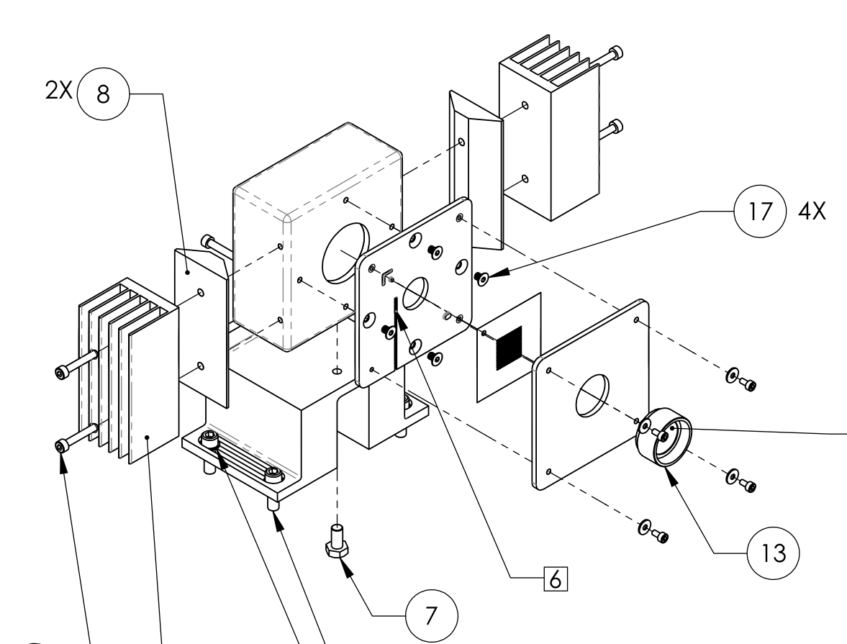

Figure : an exploded view of the Hartmann sensor assembly

# Optical Design

## Optical Layout

### Overview

The optical design is described in detail in [[T1000179 - aLIGO Hartmann Sensor Optical Layouts (H1, L1, H2): Input Test Masses]](https://dcc.ligo.org/cgi-bin/private/DocDB/ShowDocument?docid=10643). A brief summary follows:

A telescope, conceptually similar to the one in Figure 2, is used to satisfy all the requirements of the optical design.

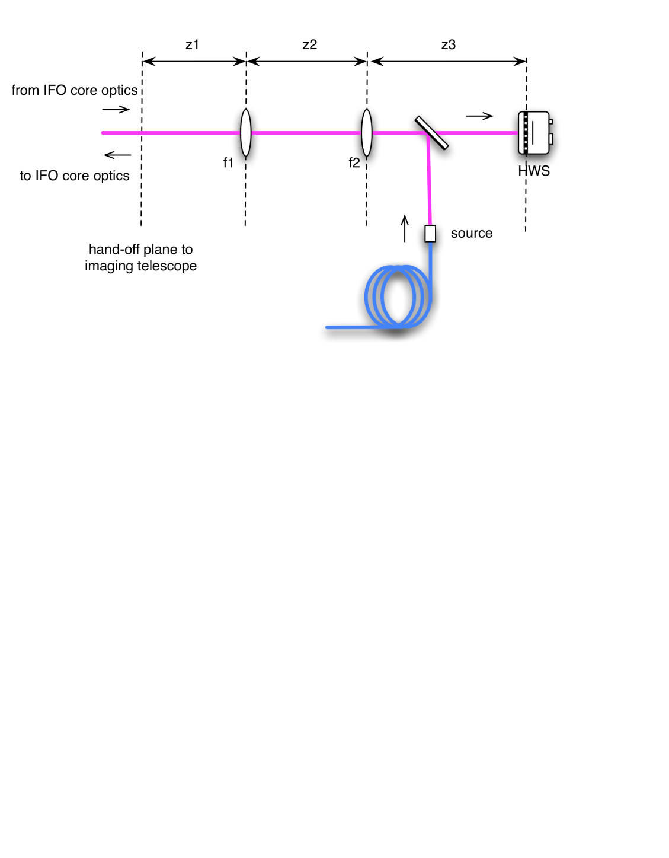

Figure : A schematic of the imaging telescope for the Hartmann sensors.

Optical layouts for all the HWS systems were created in ZEMAX. An example, (showing H1 and L1) is illustrated in Figure 3, Figure 4 and Figure 5. A 3D representation of the unfolded vertex layout is shown in **Figure 6**.

The following equivalence is made between the folded and unfolded interferometers:

HWS injection chamber: H1, L1: HAM4

H2: HAM10

The layouts in HAM10 and HAM 11 are designed to be as similar as possible to mirror images of the layouts in HAM4 and HAM5, respectively.

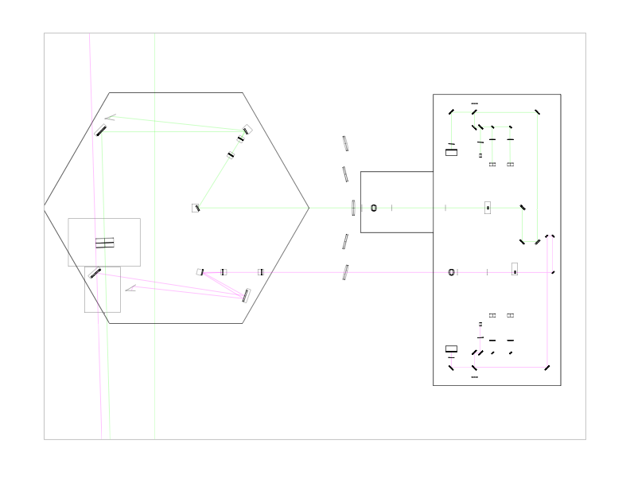

Figure : [H1X, H1Y, L1X, L1Y] ZEMAX model of HAM4 and TCSHT table of the Hartmann sensor probe and reference beams on the exterior tables.

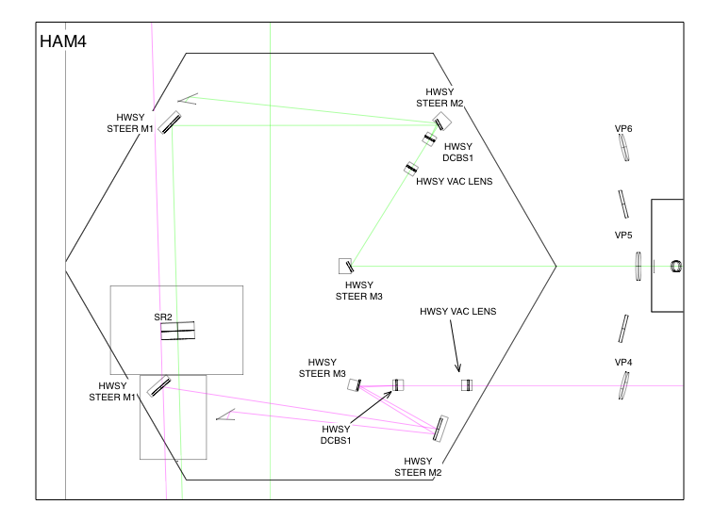

Figure : [ZOOM] HAM4 in-vacuum table. For both HWSX and HWSY the beam is incident close to normal incidence on the first imaging optic inside the vacuum (HPX_F1 for HWSX and HPY_F1 for HWSY).

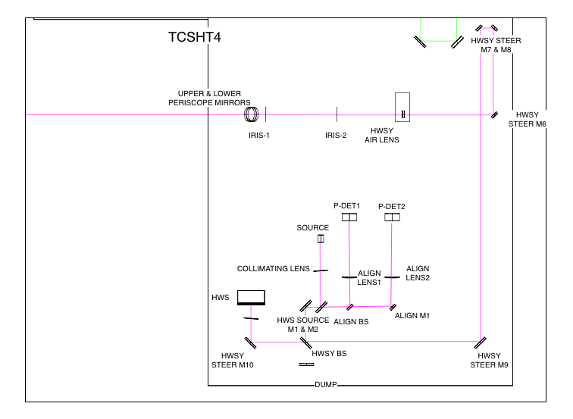

Figure : HWSX imaging optics on the exterior table.

Other pertinent details from [[T1000179]](https://dcc.ligo.org/cgi-bin/private/DocDB/ShowDocument?docid=10643) are:

* The following features of the layout are discussed:

1. Delay line paths
2. Scattering from imaging optics
3. SLED source
4. Beam height
5. Band pass filter
6. Beam size and mirror sizes
7. 50/50 beam splitter
8. Periscope
9. Beam-steering mirror pairs
10. Ergonomic optic placement
11. Beam tubes
12. Spurious defocus in the probe beam
13. An analysis of diffraction is referenced in [[T1100549 - Diffraction in the aLIGO ITM HWS probe beams]](https://dcc.ligo.org/cgi-bin/private/DocDB/ShowDocument?docid=74167)
14. Analysis of thermal defocus induced by the imaging telescope
15. Full optical layout ABCD matrices

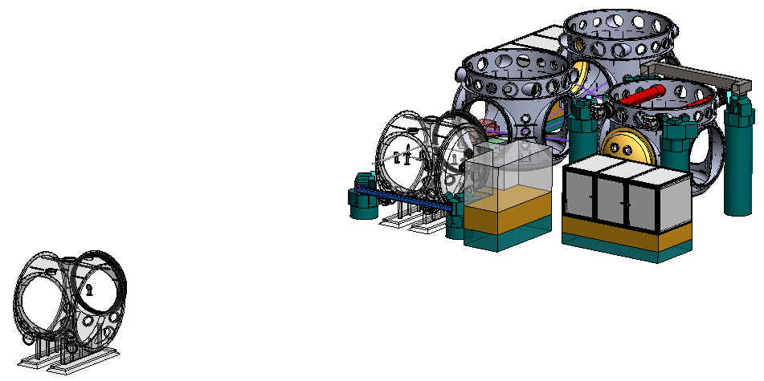

**BSC3**

**TCSHT4**

**HAM5**

**HAM4**

**BSC2**

**BSC1**

**Figure 6: 3D Representation of Corner Station TCS components in relation to each other for H1 and L1 (which is more complex for TCS than for H2)**

### Optical layout – coordinates

The coordinates for the in-vacuum and in-air optics are listed in:

* [[T1100463 - aLIGO Hartmann Sensor Optical Layouts (H1): ITMs, ZEMAX]](https://dcc.ligo.org/cgi-bin/private/DocDB/ShowDocument?docid=69894)
* [[T1100471 - aLIGO Hartmann Sensor Optical Layouts (L1): ITMs, ZEMAX]](https://dcc.ligo.org/cgi-bin/private/DocDB/ShowDocument?docid=70083)
* [[T1100464 - aLIGO Hartmann Sensor Optical Layouts (H2): ITMs, ZEMAX]](https://dcc.ligo.org/cgi-bin/private/DocDB/ShowDocument?docid=69895)

### Diffraction in the ITM optical layout

This has not been updated for –v6 of this document as none of the changes to the optical layout affect limiting or close to limiting apertures in the system.

The ITM optical layout suffers from diffraction due to the presence of the baffles and other apertures in the optical system. The effect of diffraction from those apertures on the HWS sensitivity is discussed in [[T1100549 - Diffraction in the aLIGO ITM HWS probe beams]](https://dcc.ligo.org/cgi-bin/private/DocDB/ShowDocument?docid=74167). The salient points from this document are summarized below:

* The presence of diffraction does reduce the sensitivity of the HWS when operated in a differential mode. However, the sensitivity of the HWS is reduced by a factor of ~ 2.5x over a small fraction of the measured aperture. The original requirement for the HWS [(see T0600968 - Estimate of TCS sensor requirements)](https://dcc.ligo.org/cgi-bin/private/DocDB/ShowDocument?docid=3663) stated that the sensitivity should be 10x smaller than the required correction (λ/47 ~ 13.5nm) to allow for some headroom in the sensitivity. Therefore, the decrease in the sensitivity to ~4nm over a small fraction of the sensor should not reduce the ability of the TCS to correct to better than 13.5nm.
* The limiting aperture of the H1:HWSY (H2:HWSX) probe beam is the BS baffle (ITM Elliptical Baffle, located near the BS). This is illustrated in left side of Figure 7.
  + There is approximately **0.026%** of interferometer optical power outside the total HWS probe beam aperture. This is less than the required 0.1% specified in [(see T0600968 - Estimate of TCS sensor requirements)](https://dcc.ligo.org/cgi-bin/private/DocDB/ShowDocument?docid=3663).
* The limiting aperture of the H1:HWSX (H2:HWSY) probe beam is a combination of the BS baffle and the SR3 mirror due to the offset of the optical axis of this beam on that mirror. The total aperture is illustrated in the right hand side of Figure 7.
  + There is approximately **0.2%** of interferometer optical power outside the total HWS probe beam aperture. However, this can be reduced to the required 0.1% by interpolating the measured HWS optical path distortion an additional +7.5mm on the ITM (around 10% of the limiting radius).

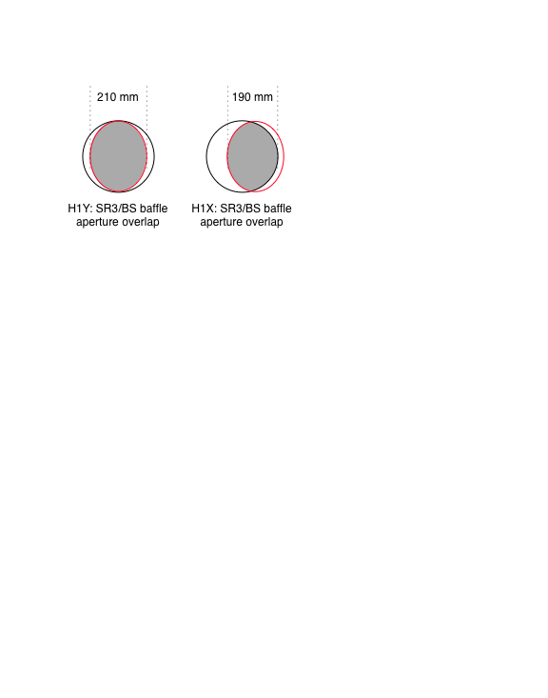

Figure : (left) the overlap of the SR3 (black) and BS baffle (red) apertures for the H1/L1 ITM-HWSY and H2 ITM-HWSX probe beams and (right) the overlap of the SR3 and BS baffle apertures for the H1/L1 ITM-HWSX and H2 ITM-HWSY probe beams reflected off BS_AR.

## Optical Layout – ETM HWS

The optical layout for the in-air H2:ETMY HWS is described in [[T1000717 - aLIGO Hartmann Sensor Optical Layouts (H1, L1, H2): End Test Masses]](https://dcc.ligo.org/cgi-bin/private/DocDB/ShowDocument?docid=26295). The salient points are:

* The HWS probe beam is a pick-off of the ALS beam
* Three lenses are used to image the ETM HR surface onto the HWS.
* For the One Arm Test, the HWS optical layout is integrated into the ALS optical layout as shown in [[D1100607 - ALS Y-End Station Optical Table Layout]](https://dcc.ligo.org/cgi-bin/private/DocDB/ShowDocument?docid=58211).
* Not all unique solutions and optical layouts have been constructed for each ETM.
  + The exact imaging telescope for each ETM will be different but the conceptual and function design is the same.

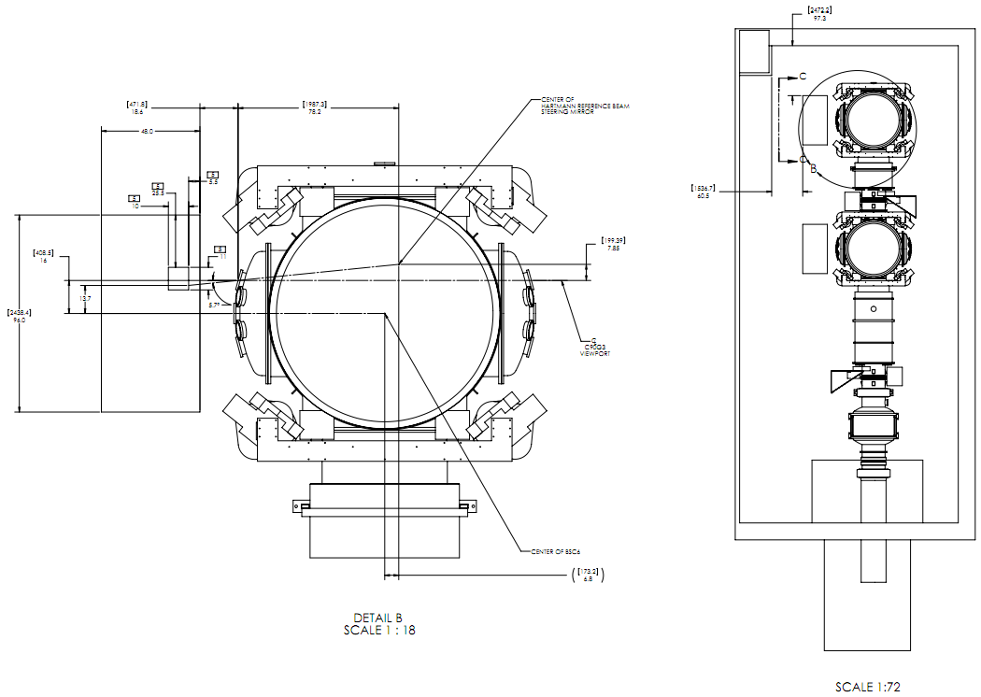

**Figure 8: 3D Representation of H2-Y End Station TCS components (on the table to the left of the BSC chamber) in relation to ISC and the vacuum system (see** [**G1100873**](https://dcc.ligo.org/DocDB/0068/G1100873/004/G1100873-v4_ETM%20TEL%20ASSY%2C%20FULL%20COMPLETE%2C%20BSC6.PDF)**)**

## Light Sources (ETM and ITM)

### ITM – fiber coupled super-luminescent diodes

The ITM light sources are fiber coupled super luminescent diodes. The choice of sources is discussed in [[T1000682 - Technical Note for the aLIGO TCS Hartmann Sensor Camera and Sources]](https://dcc.ligo.org/cgi-bin/private/DocDB/ShowDocument?docid=25406). The main results from that document are listed in the following table:

Table : Source selection for the HWS probe beams

|  |  |  |  |  |
| --- | --- | --- | --- | --- |
| **Probe beam** | **Source** | **Central wavelength** | **Transmitted power** | **Ratio to requirement** |
| H1/L1:ITM-HWSX | QSDM-790-10 (s-pol) | 800nm | 13 μW | 4.6 × |
| H1/L1:ITM-HWSY | QSDM-840-5 (p-pol) | 833nm | 14 μW | 4.7 × |
| H2:ITM-HWSX | QSDM-840-5 (p-pol) | 833nm | 9.0 μW | 3.0 × |
| H2:ITM-HWSY | QSDM-790-10 (s-pol) | 800nm | 8.3 μW | 3.0 × |

* Addtionally, these sources reduce the cross-sampling of ITMY by the ITM-HWSX probe beam and the cross-sampling of ITMX by the ITM-HWSY probe beam below than the required level of 1.3 × 10-3.

### ITM – visible alignment lasers

Also discussed in [[T1000682 - Technical Note for the aLIGO TCS Hartmann Sensor Camera and Sources]](https://dcc.ligo.org/cgi-bin/private/DocDB/ShowDocument?docid=25406) is the choice of wavelength for the visible alignment lasers for the HWS. The results are:

* A 1mW, 543nm Green HeNe is the optimum choice
  + One caveat exists: the transmission spectra for SR2 is not known. We anticipate that this will not be a problem provided that the transmission through SR2 @ 543nm is > 10%.
  + 1mW CW at 543nm allows for an eye-safe system which will assist in the alignment stage.

### ITM HWS sources – properties

The properties of all ITM HWS sources are listed in [[T1100413 - Hartmann SLED and Visible Laser Properties]](https://dcc.ligo.org/cgi-bin/private/DocDB/ShowDocument?docid=68109). This is useful for determining the required laser safety protection.

Note that the proposed source for the alignment laser runs off 110V AC power. This will either have to be modified to run on DC power or will need to be disabled once the system is aligned.

### ETM – source

The ETM source is a pick-off of the ALS 532nm laser.

## Optics and opto-mechanics

### ITM-HWS optics and opto-mechanics

The ITM HWS optics and opto-mechanics are described in [[T1000718 - aLIGO Hartmann Sensor Optics and Opto-Mechanical components (H1, L1, H2) Input Test Masses]](https://dcc.ligo.org/cgi-bin/private/DocDB/ShowDocument?docid=26296). The salient points from this document are:

* The beam sizes for the four different HWS imaging configurations (H1/L1:X, H2:X, H1/L1:Y and H2:Y) are shown in Figure 9, plotted from the SR2 AR surface for those beams injected through SR2 and the STEER M1 mirror for those beams reflected off the BS_AR surface.
* The H1 and H2 configurations are similar enough that we can make the optics identical between each configuration. We only need verify the beam sizes on the optics are small enough to avoid significant diffraction in both cases.

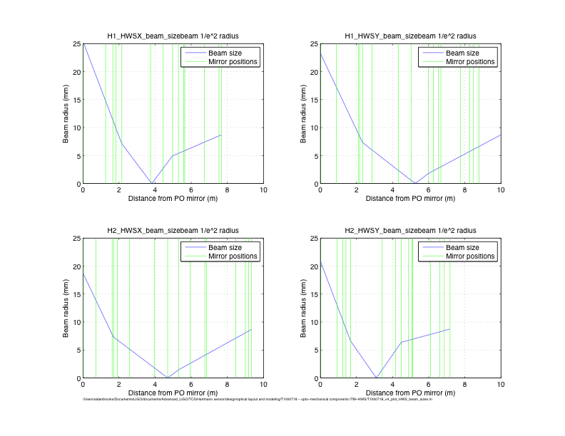

Figure : HWS beam size vs distance: (upper left) H1-HWSX, (upper right) H1-HWSY, (lower left) H2-HWSX, (lower right) H2-HWSY. The mirror locations are also shown

### ETM-optics and opto-mechanics

The ETM optics and opto-mechanics for the One Arm Test are listed in [[E1100713 - ETM HWS Equipment List for One Arm Test]](https://dcc.ligo.org/cgi-bin/private/DocDB/ShowDocument?docid=68102). This list covers only the materials required for the H2 ETMY Hartmann sensor.

# Electronics

## HWS-Electronics requirements

The HWS electronics requirements are described in Section 2.3 of [[T0900597 - aLIGO TCS Electronics and Controls Requirements]](https://dcc.ligo.org/cgi-bin/private/DocDB/ShowDocument?docid=7566).

## Block diagrams

The block diagrams show the layout of the electronics described in T0900597.

### ITM-HWS Block diagram

The block diagram for the ITM-HWS is shown in Sheet 2 of [[E1100892 - TCS Block diagram: H1 Corner Station]](https://dcc.ligo.org/cgi-bin/private/DocDB/ShowDocument?docid=70771) and is partially reproduced here in Figure 10 and **Error! Reference source not found.**.

The electronics have been simplified from –v5 of this document:

* There are no shutters at all in the vertex HWS layout.
* All vertex HWS electronics are run via Beckhoff
* The block diagram now illustrates the in-vacuum RTDs in HAM4/HAM10 and HAM5/HAM11 that were absent from –v5.

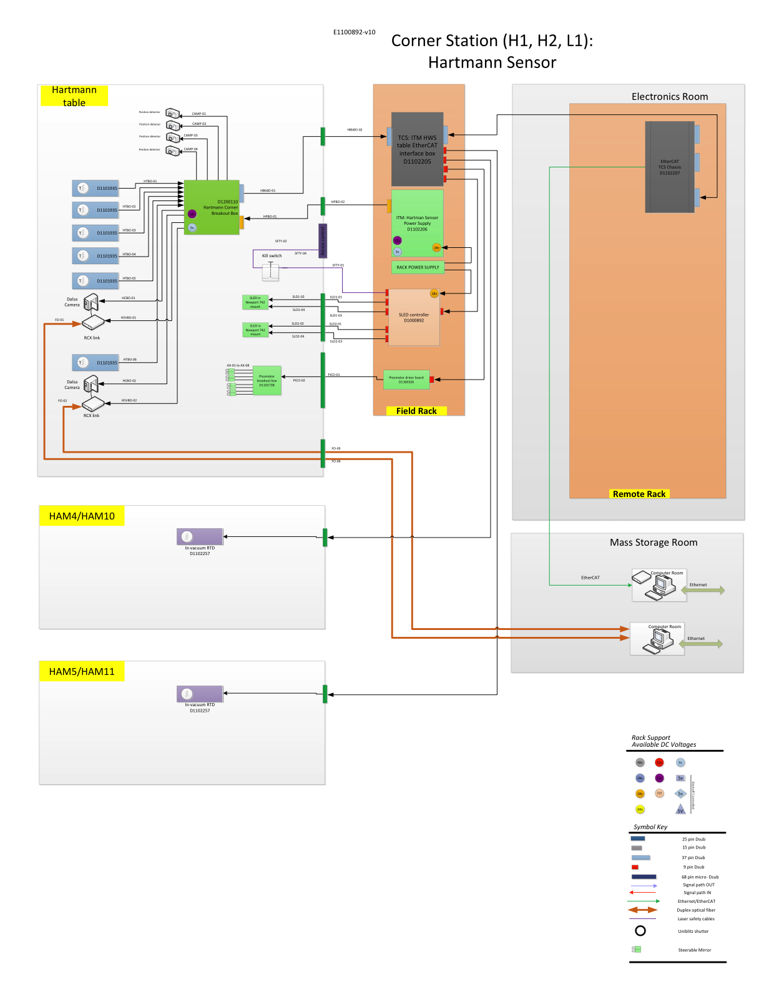

Figure : Block diagram for the table for ITM-HWS

### ETM-HWS Block diagram

The ETM HWS block diagram is shown in Sheet 1 of [[E1100891 - TCS Block diagram: End Stations]](https://dcc.ligo.org/cgi-bin/private/DocDB/ShowDocument?docid=70770) and is reproduced here in Figure 11. Key points to note are:

* All power and control signals are connected to the HWS electronics components via feedthroughs in the enclosure wall. This is to make sure that the table can be easily detached from the electronics and moved when necessary.
* We have attempted to limit the number of cables and feedthroughs in the table by distributing the power and control signals on the table with Breakout Boxes.
* The ETM-HWS components are all controlled by the EtherCAT/Beckhoff system. The chassis containing the Beckhoff modules is designed and controlled by ISC.
* All the Hartmann sensor electronics for the ETM are mounted in the CDS equipment room rack.
* The pico-motor controller driver and breakout box for the ETM HWS steerable mirrors will be built by ISC.
* The Uniblitz shutter controller will be designed and built by ISC.

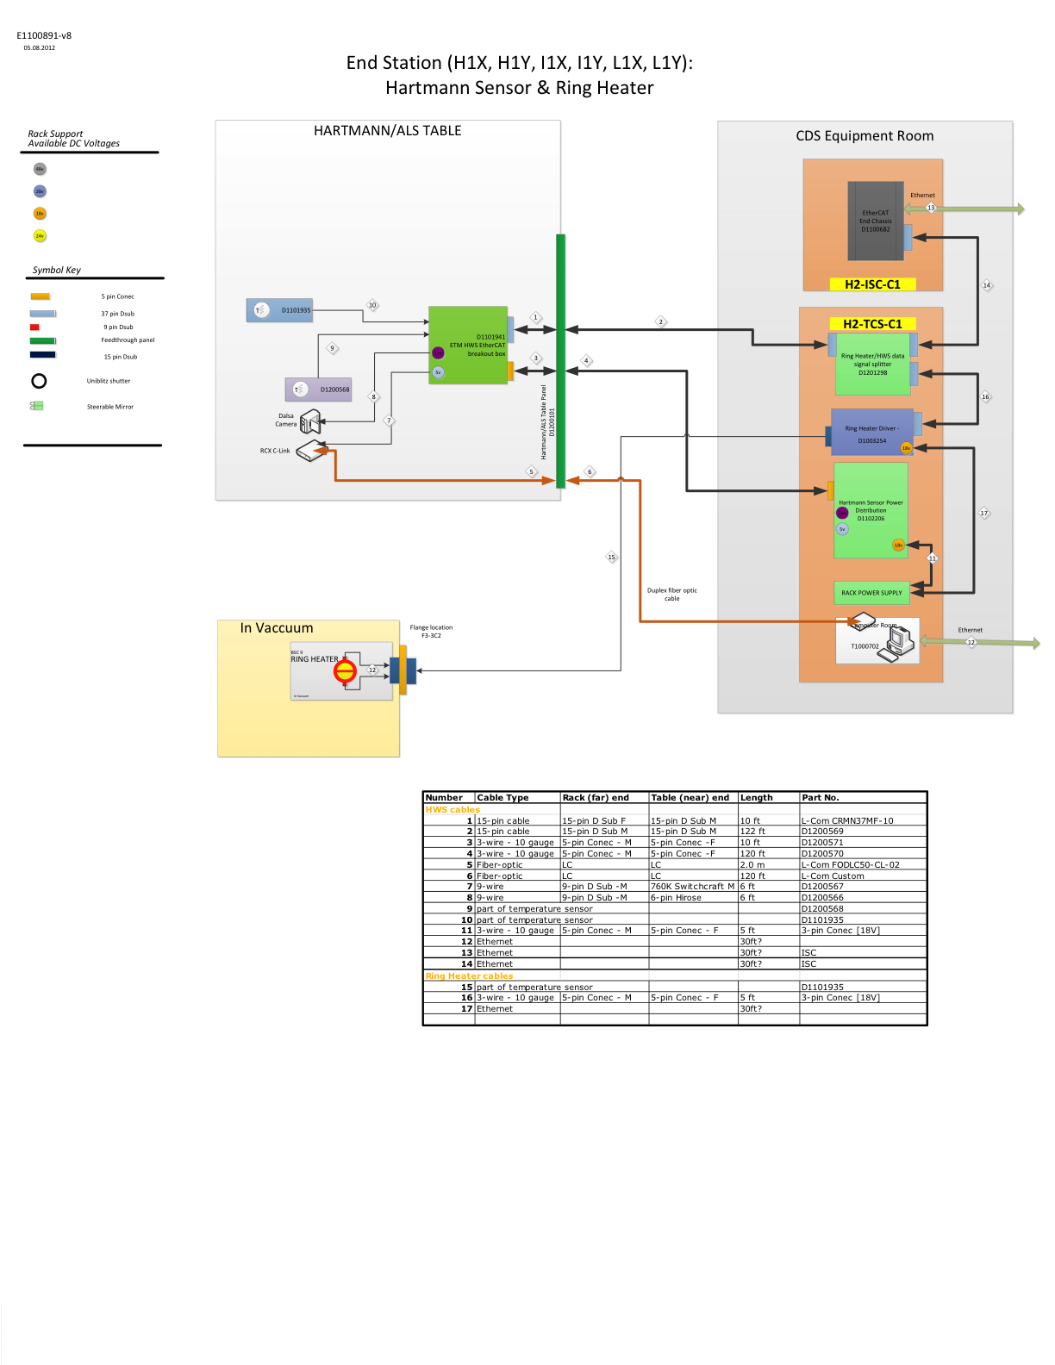

Figure : Block diagram for ETM-HWS electronics

## Beckhoff controls

The Beckhoff EtherCAT system described in [[G1100098 - EtherCAT (Beckhoff) for advanced LIGO]](https://dcc.ligo.org/cgi-bin/private/DocDB/ShowDocument?docid=32733) and used extensively by ISC for slow control, will be used for all slow controls for the HWS system. **This covers all control for the HWS**.

## Custom HWS electronics components

The custom components for the HWS are described in this section.

### Power distribution box (ETM-D1002851, ITM-D1102206)

[[D1002851 - Hartmann Sensor Power Supply]](https://dcc.ligo.org/cgi-bin/private/DocDB/ShowDocument?docid=22781)

This power distribution box for the HWS system provides power for the ETM HWS camera and RCX fiber-optic-to-CameraLink converter box.

### ETM-HWS table EtherCAT interface box [ETM only]

[[D1101930 - TCS: ETM HWS table EtherCAT interface box]](https://dcc.ligo.org/cgi-bin/private/DocDB/ShowDocument?docid=72510)

This box interfaces the [[D1100682 - EtherCAT End Chassis]](https://dcc.ligo.org/cgi-bin/private/DocDB/ShowDocument?docid=59271) that contains the Beckhoff modules. It serves the following two functions:

* provide a breakout for the control signals that turn on and off power regulators in D1002851
* provides a breakout for the remaining control signals that are sent directly to the ETM-HWS table.

### ITM-HWS table EtherCAT interface box [ITM only]

[[D1102205 - TCS: ITM HWS table EtherCAT interface box]](https://dcc.ligo.org/cgi-bin/private/DocDB/ShowDocument?docid=75821)

This box interfaces the [[D1102207 - TCS: EtherCAT Corner Station Chassis]](https://dcc.ligo.org/cgi-bin/private/DocDB/ShowDocument?docid=75825) that contains the Beckhoff modules. It serves the following two functions:

* provide a breakout for the control signals that turn on and off power regulators in D1002851
* provides a breakout for the remaining control signals that are sent directly to the ITM-HWS table.

### HWS Breakout Box (ETM-D1101941, ITM-D1200110)

[[D1101941 - TCS: ETM HWS in-enclosure breakout box]](https://dcc.ligo.org/cgi-bin/private/DocDB/ShowDocument?docid=72522)

This box provides on-table breakouts for up to:

* 2x 100-Ohm RTD temperature sensors
* 1x 12V for the HWS Dalsa 1M60 camera power
* 1x 5V for the HWS EDT RCX C-Link fiber-optic-to-CameraLink converter.

[[D1200110 - TCS: ITM HWS in-enclosure breakout box]](https://dcc.ligo.org/cgi-bin/private/DocDB/ShowDocument?docid=85608)

This box provides on-table breakouts for up to:

* up to 6x 100-Ohm RTD temperature sensors
* 2x 12V for the HWS Dalsa 1M60 camera power
* 2x 5V for the HWS EDT RCX C-Link fiber-optic-to-CameraLink converter.
* 4x PDP90A Thorlabs Lateral Effect Position Sensors

### SLED driver [ITM-only]

[[D1000892 - SLED Driver Board with the LDTC0520 Module]](https://dcc.ligo.org/cgi-bin/private/DocDB/ShowDocument?docid=10835)

This box houses the Team Wavelength LDTC0520 diode driver for the SLED. Version 1 of this box also housed the super-luminescent diode module. Version 2 has moved to a similar design style to commercial laser diode drivers with industry standard 15-pin D-sub and 9-pin D-sub connectors for laser temperature control and for laser diode current control, respectively. This is configuration allows us to mount the SLED on the HWS table directly and avoid additional safety complications associated with optic fibers outside of a laser safety enclosure.

The SLED driver connects to a Newport Model: 742 Laser Diode Mount, DIL Package, DIL ZIF socket virtually identical to the Butterfly socket shown in Figure 12. This mount is secured to the HWS optical table.

The SLED drivers will also be connected to laser safety and access control interlocks.

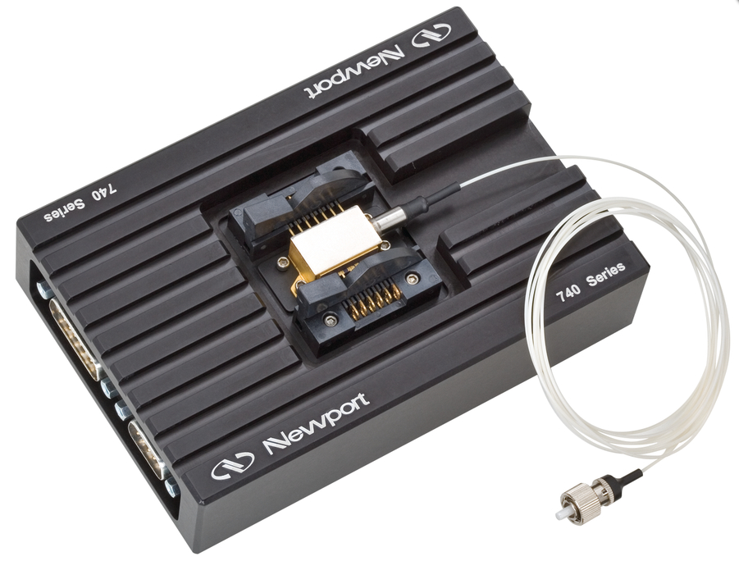

Figure : A Newport 740 Series Butterfly style laser diode socket. The 742 series is identical except for the DIL receptacle on the top.

### Temperature sensor package [ITM/ETM]

[[D1101935 - TCS RTD temperature sensor package]](https://dcc.ligo.org/cgi-bin/private/DocDB/ShowDocument?docid=72516)

All the RTD temperature sensors on the HWS table will be mounted in 12” flexible packages with TBD connectors on the ends.

### Picomotor drivers [ITM/ETM] [TCS responsibility: ITM-only]

The pico-motor mirrors will be driven the [[D1100323 - Picomotor driver]](https://dcc.ligo.org/cgi-bin/DocDB/ShowDocument?docid=39045) designed by Daniel Sigg which will connect to the on-table [[D1101738 - Picomotor breakout box]](https://dcc.ligo.org/cgi-bin/private/DocDB/ShowDocument?docid=69959).

For the ETM-HWS, the driver and the breakout box will be provided by ISC.

For the ITM-HWS, the driver and the breakout box will be provided by TCS.

# Software

There was extensive collaboration with the University of Adelaide to develop the beta-version of the HWS software.

## Software architecture

The software architecture for the Hartmann sensor is described at length in the document: [[T1000155 - TCS Hartmann Sensor Software Architecture]](https://dcc.ligo.org/cgi-bin/private/DocDB/ShowDocument?docid=10331). The function of the Hartmann software is to:

* control the Hartmann sensor camera
* initialize the Hartmann sensor measurements
* acquire and analyze Hartmann sensor measurements
* manage input requests and output of analyzed data from and to EPICS

The context of the HWS software is illustrated in Figure 13.

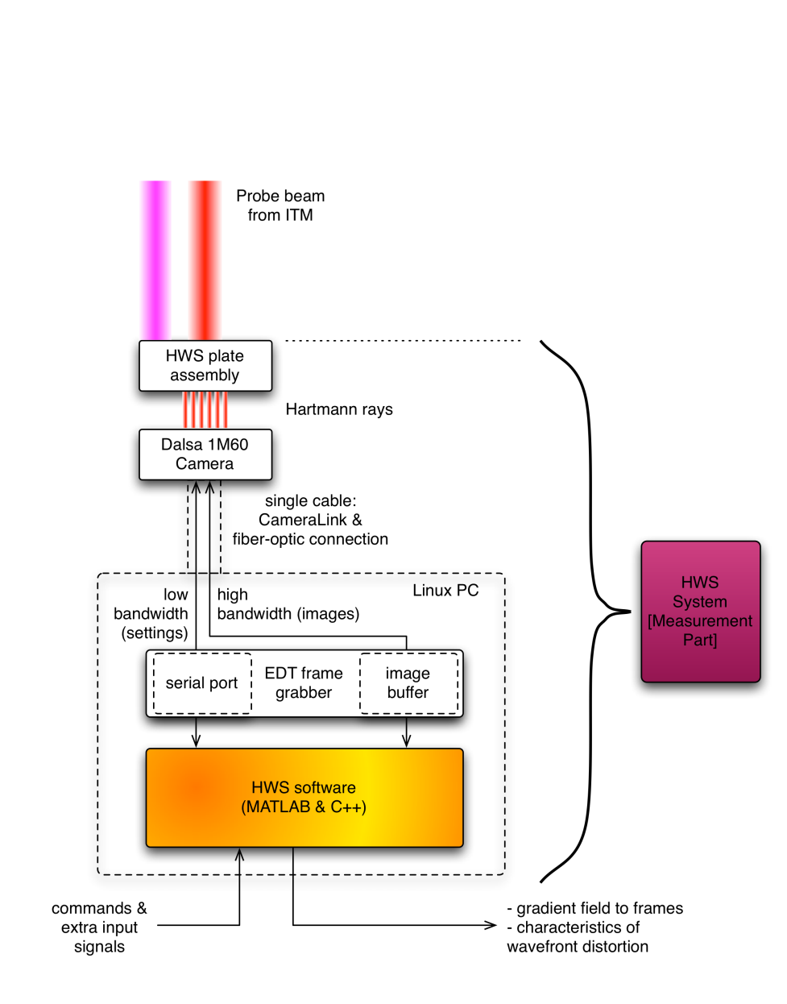

Figure : A view of the HWS System.This block contains the Hartmann plate, the Dalsa 1M60 CCD camera, the CameraLink/fiber-optic cable and a Linux PC containing an EDT frame-grabber and running the HWS software that this document describes.

The software architecture document describes in detail the different operational states of the HWS software, which are illustrated conceptually in Figure 14.

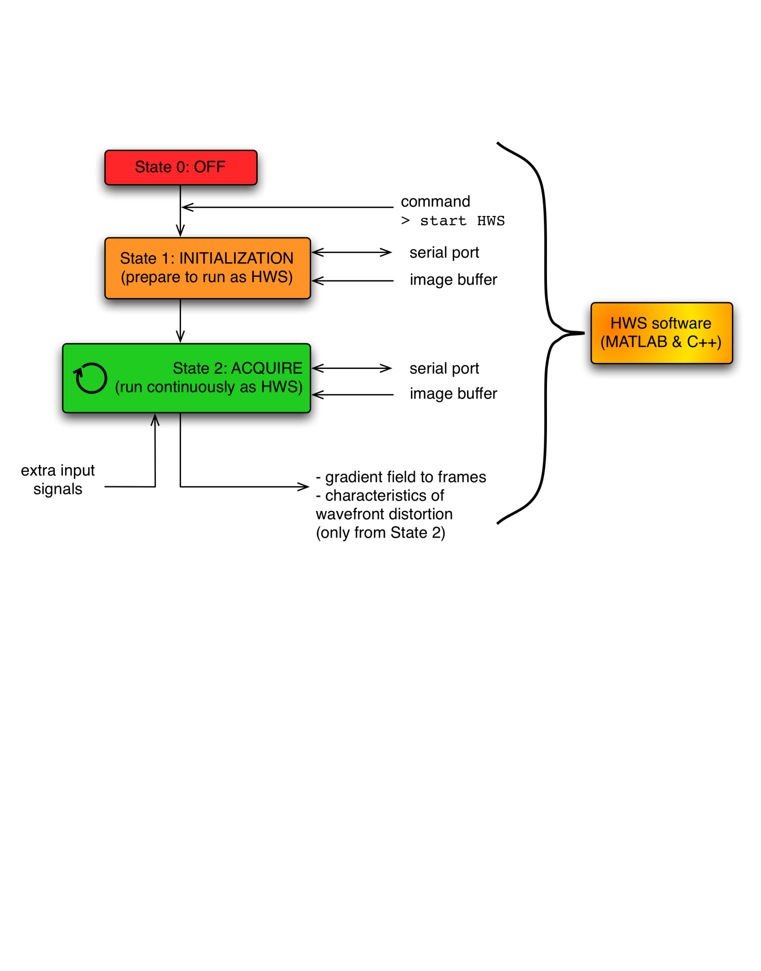

Figure : An overview of the States of the HWS software from .

Additionally, the software architecture document describes:

* Nomenclature and definitions
* Necessary hardware components
* Communication protocols
* Detailed states of sensor operation
* Mapping the operational states to fault modes

### Software version control

The Hartmann sensor software is controlled with a ligo.org access controlled SVN and a Trac Wiki located at:

* Trac Wiki: <https://trac.ligo.caltech.edu/Hartmann_Sensor/>
* SVN: <https://svn.ligo.caltech.edu/svn/Hartmann_Sensor/>

The most recent version of the software resides in the directory:

* /Hartmann_Sensor/users/won/HS_OO

## Computing hardware/software requirements

The HWS computing requirements are described in [[T1000702 - Hartmann Wavefront Sensor (HWS) Signal Processing Computer specifications]](https://dcc.ligo.org/cgi-bin/private/DocDB/ShowDocument?docid=26021). The salient points are summarized here:

* Each HWS requires a standard 19” rack-mounted computer running Ubuntu 10.04
* The frame grabber requires “a PCI or PCI-X bus, 66 MHz or faster (33 MHz will work, but at reduced data rates).”
* An EDT PCI C-Link framegrabber will be used to interface with Dalsa 1M60 camera
* In order to move the computer out of the LVEA, CameraLink to Fiberoptic converters are used. These are the RCX C-Link modules from EDT. Each module requires 5V DC.
* At least one computer per site will require an installation of MATLAB in order to compile the latest version of the HWS software.
* These computers will be added to the LIGO network. The Hartmann sensor software will broadcast some data from the sensor via EPICS channels.
* Additionally, the software will store high-resolution gradient maps in locally constructed LIGO- type frames. These should be accessible for analysis at a later date.

## DAQ/Storage requirements

The data storage requirements for the HWS are summarized in [[T1000484 - Hartmann Sensor Data Storage Requirements]](https://dcc.ligo.org/cgi-bin/private/DocDB/ShowDocument?docid=14522).

* Raw data from the Hartmann sensor
  + Storage requirements summary: ~48KB/s per interferometer
* Fast ADC channels – removed from –v6 of Final Design.
* Slow channels
  + Storage requirements summary: ~1.2KB/s per interferometer

# Safety

[[E1000205 - aLIGO TCS Hazard Analysis]](https://dcc.ligo.org/cgi-bin/private/DocDB/ShowDocument?docid=12390)

## Electrical Hazards

No electrical hazards exist.

## Laser hazards

* The 532nm alignment laser specifications:
  + OZ Optics OZ-2000-532-3.5/125-S-40-3A-3-1-5
    - Pigtail style, self-contained thermally stabilized OEM 532nm, 5mW fiber coupled source module. The output fiber is 3.5/125 micron SM, 1m long, with 3mm OD PVC cable terminated with an angle FC/APC connector. Electrical connections are located in rear panel. 5V AC/DC not included
  + Visible, 5mW, CW = Class 3R
  + Unaided eye-safe with minimal control (e.g. no constant, repeated exposure)
* The 532nm ALS laser also presents a hazard. Primary responsibility for this laser rests with ISC but TCS must make sure that the HWS needs are addressed in ISC safety documents.
* The maximum output power of the near-IR SLEDs is 10mW at 790nm and 5mW at 840nm.
  + The required optical density of safety glasses at these wavelengths is at least OD1.
* Laser safety curtains will be used around the HWS table when the enclosures are open for maintenance and the lasers are engaged.

## Electronics

* All TCS electronics will have an aLIGO EEIP sticker or a label from a Nationally Recognized Testing Laboratory

# Enclosure / VEA Layout

## End Station Floor plan

The End-station floor plan is described in [[G1100873: aLIGO TCS HWS Reference Dimensions to ETM Telescope]](https://dcc.ligo.org/cgi-bin/private/DocDB/ShowDocument?docid=68628).

### End Station Table Enclosures

At end stations, HWS components are included in established ISC/IO enclosures described in [[T1100416: aLIGO ISC/IO Enclosures: Materials and Assembly]](https://dcc.ligo.org/cgi-bin/private/DocDB/ShowDocument?docid=68179). A patch panel will be added to the ALS enclosure to accommodate the HWS cable feedthroughs. See:

* [D1200101: Hartmann / ALS Table Panel](https://dcc.ligo.org/cgi-bin/private/DocDB/ShowDocument?docid=85428)

## Corner Station Floor plan

The corner station floor plan [[D1001227: aLIGO TCS Envelopes, Corner Station, LLO, LHO]](https://dcc.ligo.org/cgi-bin/private/DocDB/ShowDocument?docid=63137) shows the size and locations of the HWS tables.

### Corner Station Table Enclosures

The HWS table assemblies are given by:

* [[D1000635: aLIGO TCS HWS Table Assy, HAM4]](https://dcc.ligo.org/cgi-bin/private/DocDB/ShowDocument?docid=10230)
* [[D1000636: aLIGO TCS HWS Table Assy, HAM10]](https://dcc.ligo.org/cgi-bin/private/DocDB/ShowDocument?docid=10231)

## Viewport enclosures

The HWS viewport enclosures are given by:

* [[D1102102: aLIGO TCS Hartmann Sensor Viewport Enclosure Assembly, X-arm]](https://dcc.ligo.org/cgi-bin/private/DocDB/ShowDocument?docid=74540)
* [[D1100053: aLIGO TCS Hartmann Sensor Viewport Enclosure Assembly, Y-arm]](https://dcc.ligo.org/cgi-bin/private/DocDB/ShowDocument?docid=31743)

These custom designs have, as their foundation [[E1000246: 6.0 inch Vacuum Viewport Specification]](https://dcc.ligo.org/cgi-bin/private/DocDB/ShowDocument?docid=13226).

# Interfaces

The documents used to guide the interfaces of the HWS to other sub-systems are listed below:

## Systems

Provided by Systems:

* [[D1002704: Rack and Cable Tray Layout, LVEA, H1 H2]](https://dcc.ligo.org/cgi-bin/private/DocDB/ShowDocument?docid=22180)
* [[D1001227: aLIGO TCS Envelopes, Corner Station, LLO, LHO]](https://dcc.ligo.org/cgi-bin/private/DocDB/ShowDocument?docid=63137)

Provided by TCS

* [[G1100873: aLIGO TCS HWS Reference Dimensions to ETM Telescope]](https://dcc.ligo.org/cgi-bin/private/DocDB/ShowDocument?docid=68628)
  + This document has been used extensively to coordinate the interactions between ALS and TCS with respect to the One Arm Test.
* [[E1000246: 6 in. vacuum viewport for Hartmann Sensor Beams]](https://dcc.ligo.org/cgi-bin/private/DocDB/ShowDocument?docid=13226)

## COC

The following documents are mostly for reference. They were used to specify the HWS requirements for the coating designs on the core optics.

* [[T1000055: Hartmann Sensor Probe Beam: Coating Specification for SR2]](https://dcc.ligo.org/cgi-bin/private/DocDB/ShowDocument?docid=8980)
* [[E0900489: Hartmann sensor probe beam requirements for CSIRO coatings]](https://dcc.ligo.org/cgi-bin/private/DocDB/ShowDocument?docid=8119)

Vendor coating reports (and links to LIGO specifications) are available at:

* <https://nebula.ligo.caltech.edu/optics/>

## ISC

This RODA describes the interface between the ETM HWS and ISC

* [[M1100121: aLIGO Components of the In-Air ISC Tables in End Stations]](https://dcc.ligo.org/cgi-bin/private/DocDB/ShowDocument?docid=62481)

## AOS: SLC

The following RODA describes the interface between TCS and SLC in the regions of HAM4,5,10 and 11 where the HWS mirrors and baffles

* [[M1100205: RODA - aLIGO SLC and TCS Interfaces within HAM chambers 4, 5, 10, and 11]](https://dcc.ligo.org/cgi-bin/private/DocDB/ShowDocument?docid=68138)
* [[T1100445: AOS SLC: Signal Recycling Cavity Baffles Final Design]](https://dcc.ligo.org/cgi-bin/private/DocDB/ShowDocument?docid=69211)

# Testing/Modeling

## Modeling

* [[T1100536: Hartmann Wavefront System: Defocus error budget]](https://dcc.ligo.org/cgi-bin/private/DocDB/ShowDocument?docid=73626)

## Proto-typing results

Summary of results on the HWS testing from the PDR.

* [[T1100052: Hartmann Wavefront Sensor PDR: Modeling, testing, and simulation summary]](https://dcc.ligo.org/cgi-bin/private/DocDB/ShowDocument?docid=32407)

## One Arm Test

The HWS testing as part of the One Arm Test is described in the following document.

* [[T1100127: Ring Heater and Hartmann Sensor Test as part of Commissioning Advanced LIGO's First Arm cavity]](https://dcc.ligo.org/cgi-bin/private/DocDB/ShowDocument?docid=39500)

The following tests will be performed on the HWS during the OAT.

1. Fit-check and alignment of all in-air ETM-HWS equipment.
2. Confirming basically functionality of the ETM-HWS equipment once it is installed.
3. Measurement, with the HWS probe beam, of the thermo-elastic and thermo-refractive lenses induced by the ring heater. Verification that these lenses agree with models and independent measurements.
4. Characterization of the RMS probe/secondary beam wander over multi-day periods.
5. Characterization of the in-situ noise floor of the HWS over multi-day periods.
6. Characterization, using the HWS probe beam, of the thermal defocus of the HWS in-air optical components over multi-day periods and verification that it agrees with modeling.
7. Characterization, using the HWS secondary beam, of the thermal defocus of the Transmon Telescope over multi-day periods and verification that it agrees with modeling.
8. Measurement, with the HWS secondary beam, of the thermo-elastic curvature change in the ETM AR surface induced by the ring heater. Verification that this measurement agrees with modeling and independent measurements.

# Procedures

## Alignment

Estimates on the tolerance on the alignment and the required alignment resolution and range for the Hartmann sensor are provided in:

* [[T1100293: ITM Hartmann sensors: Alignment Resolution and Range Requirements]](https://dcc.ligo.org/cgi-bin/private/DocDB/ShowDocument?docid=61879)

The proposed alignment procedure is described in:

* [[T1100149: Initial Alignment of the Vertex Hartmann Sensor]](https://dcc.ligo.org/cgi-bin/private/DocDB/ShowDocument?docid=39852)

# Receiving Inspections

[[T1100256: Acceptance testing / incoming inspection procedure for the Hartmann Sensor Cameras]](https://dcc.ligo.org/cgi-bin/private/DocDB/ShowDocument?docid=60909)

# Project Planning

## Costs

The most recent costing baseline is documented in [[M1000349: aLIGO AOS TCS Budget Update]](https://dcc.ligo.org/cgi-bin/private/DocDB/ShowDocument?docid=25056). Since the time of this ACR ([#110012](https://dcc.ligo.org/cgi-bin/private/DocDB/ShowDocument?docid=61146)), the HWS bills of materials (BOMs) for all components have been matured and detailed. The Appendix includes detailed BOMs

(i) for items installed in air,

(ii) for electronics, and

(iii) for items to be installed in the vacuum system.

From these, updating completion estimates can be an on-going activity.

## Procurements

The "notes" column in each of the BOMs includes vendor information. In the case of HWS, many items are readily available from commercial catalogs and (in some instances) have already been procured.

## Schedules

From the aLIGO Current Installation Schedule ([G1100061](https://dcc.ligo.org/cgi-bin/private/DocDB/ShowDocument?docid=8872)), the following activity identifiers are tracked for purposes of delivering necessary components by needed dates.

* IN-H2-SA3000
  + inre: Commissioning of H2 One Arm Test
  + critical path = FDR and resource limitations (i.e. FTE's)
* IN-L1-P3105
  + inre: HAM4 installations @ L1
  + critical path = FDR; viewport enclosure design, leak and proof testing
* IN-H2-FI1155
  + inre: HAM10 installations @ H2
  + critical path = FDR; viewport enclosure design, leak and proof testing
* IN-H1-F3115
  + inre: HAM4 installations @ H1
  + adequate float, but resource-limited (i.e. FTE's)
* IN-L1-E1419 / IN-L1-YE1439
  + inre: ETMx and ETMy installations at L1
* IN-H2-FI1980
  + inre: ETMx installations at H2
* IN-H1-EX1340 / IN-H1-EY1340
  + inre: ETMx and ETMy installations at H1
* IN-L1-IA2785
  + inre: Commissioning of L1
* IN-H2-IA2955
  + inre: Commissioning of H2
* IN-H1-IA3230
  + inre: Commissioning of H1

# Project Planning - Appendix

(i)a

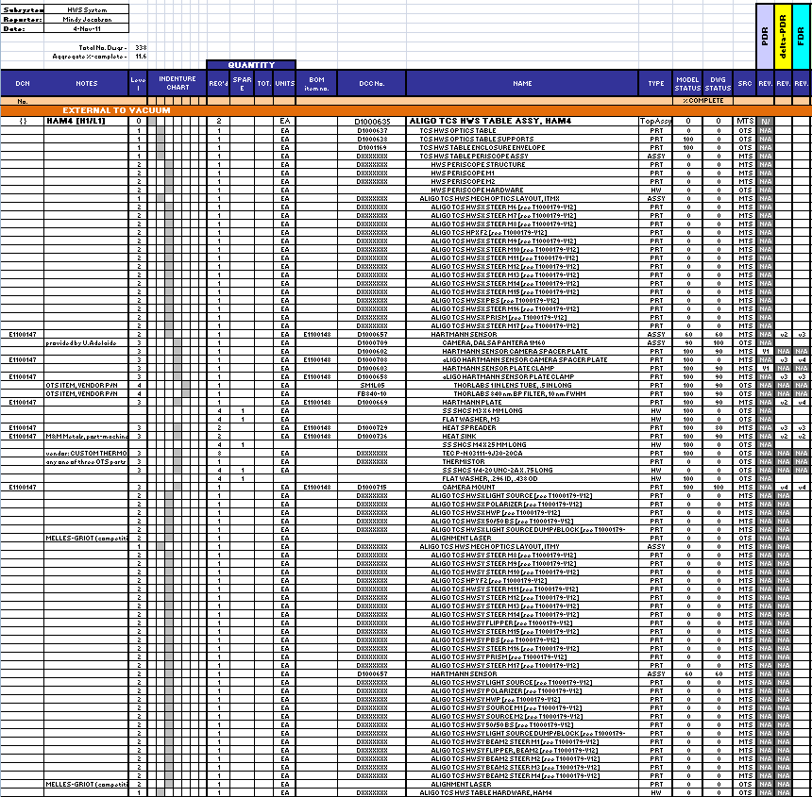

(i)b

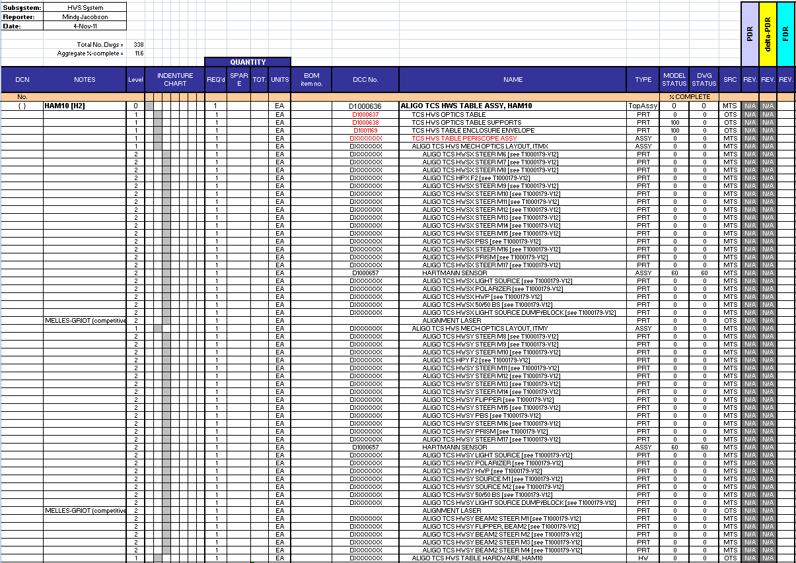

(i)c

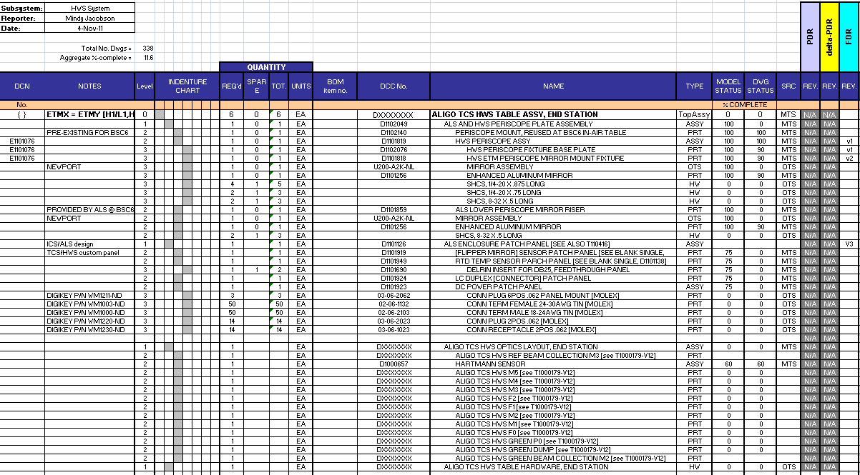

(ii)a

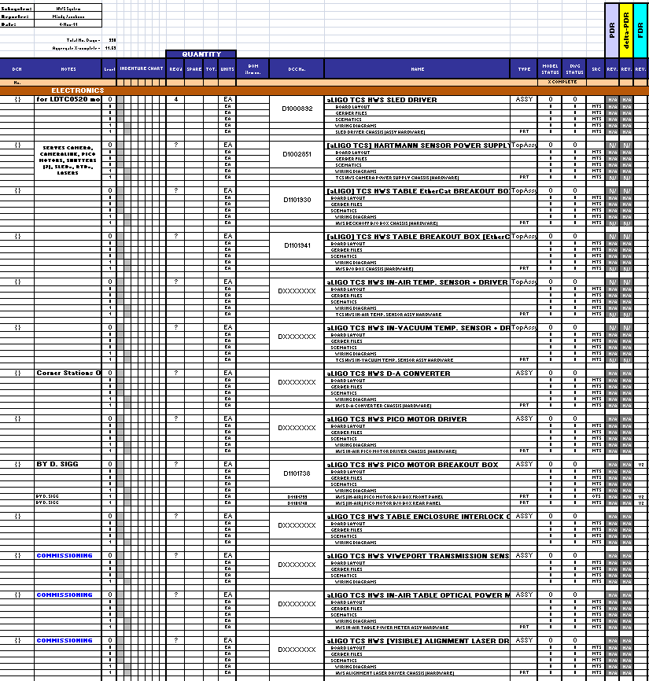

(iii)a

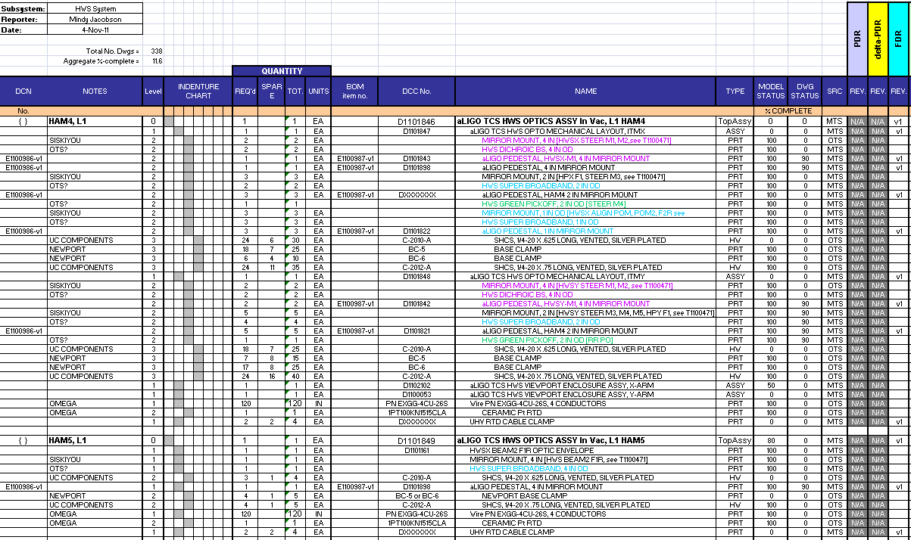

(iii)b

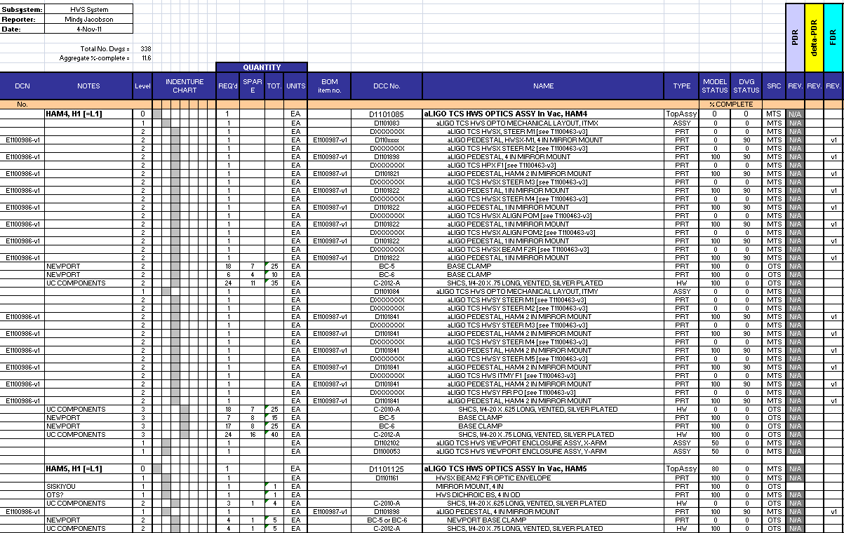

(iii)c

