*LIGO Laboratory / LIGO Scientific Collaboration*

LIGO-E1100995-v6 *LIGO* February 08, 2012

**HAM-ISI Commissioning Procedure**

S. BISCANS, F. MATICHARD, V. LHUILLIER

Distribution of this document:

Advanced LIGO Project

This is an internal working note

of the LIGO Laboratory

|  |  |
| --- | --- |
| **California Institute of Technology**  **LIGO Project – MS 18-34**  **1200 E. California Blvd.**  **Pasadena, CA 91125**  Phone (626) 395-2129  Fax (626) 304-9834  E-mail: info@ligo.caltech.edu | **Massachusetts Institute of Technology**  **LIGO Project – NW22-295**  **185 Albany St**  **Cambridge, MA 02139**  Phone (617) 253-4824  Fax (617) 253-7014  E-mail: info@ligo.mit.edu |
| **LIGO Hanford Observatory**  **P.O. Box 1970**  **Mail Stop S9-02**  **Richland WA 99352**  Phone 509-372-8106  Fax 509-372-8137 | **LIGO Livingston Observatory**  **P.O. Box 940**  **Livingston, LA 70754**  Phone 225-686-3100  Fax 225-686-7189 |

# Introduction

The HAM-ISI testing will be made in three phases:

1. HAM-ISI. Testing Procedure, Phase I: Assembly Validation (post-assembly, before storage)
2. HAM-ISI, Testing Procedure, Phase II: Integration Process (insertion in the chamber amd mating with other sub-systems)
3. HAM-ISI, Testing Procedure, Phase III: Control Commissioning

This document describes the steps to be on the **HAM-ISI Testing Procedure, Phase III: Control Commissioning**.

This document will be split in several parts, which are going from a very general architectural overview to a more theoretical explanation of this process.

This document contains four main parts:

1. **Architectural Overview**: this part is a very general overview where are described the various steps used and what they are doing.
2. **Steps contents**: this part is composed by several tables showing the various structures, variables saved and what is their utility.
3. **Procedure**: this part is a procedure to go through in order to do this commissioning process successfully.
4. **Filters description**: this part will explain the theoretical content of the filters which are applied on the platform.

Note:

Be sure to check the procedure part before starting the process. Some preparation work is required.

# Architectural Overview

## Description

The commissioning process goes through several steps, from 0 to 11. Each step is a Matlab script. They create the filters to apply in the MEDM screen.

* Step_0_Calibration_<IFO>_ISI_<CHAMBER>.m
* Step_1_TF_Loc_to_Loc_<IFO>_ISI_<CHAMBER>.m
* Step_2_Symmetrization_<IFO>_ISI_<CHAMBER>.m
* Step_3_TF_Cart_to_Cart_<IFO>_ISI_<CHAMBER>.m
* Step_4_Damping_Filters_<IFO>_ISI_<CHAMBER>.m
* Step_5_Blend_Filters_<IFO>_ISI_<CHAMBER>.m
* Step_6_Isolation_Filters_Z_RX_RY_<IFO>_ISI_<CHAMBER>.m
* Step_7_Isolation_Filters_X_Y_RZ_<IFO>_ISI_<CHAMBER>.m

**The steps are saved in the SVN at**:

/SeiSVN/seismic/HAM-ISI/<IFO>/<CHAMBER>/Scripts/Control_Scripts/

These scripts vary from one unit to another, but they are calling generic scripts named “Routines”. A routine is linked to the step by the number (example: Step_3 is calling Routine_3).

* Routine_0_Calibration_HAM_ISI.m
* Routine_1_TF_Loc_to_Loc_HAM_ISI.m
* Routine_2_Symmetrization_HAM_ISI.m
* Routine_3_TF_Cart_to_Cart_HAM_ISI.m
* Routine_4_Damping_Filters_HAM_ISI.m
* Routine_5_Blend_Filters_HAM_ISI.m
* Routine_6_Isolation_Filters_Z_RX_RY_HAM_ISI.m
* Routine_7_Isolation_Filters_X_Y_RZ_HAM_ISI.m

**The routines are saved in the SVN at**:

/SeiSVN/seismic/HAM-ISI/Common/Control_Generic_Scripts_HAM_ISI/

## Prepare File

The prepare file loads the digitized filters created by the steps and writes them in the foton file thanks to the autoquack function. It's called Prepare_<IFO>_<CHAMBER>.m.

For each time Prepare_file:

* A back-up version of <IFO>_ISI_<CHAMBER>_Filters.mat is autosaved under the name <IFO>_ISI_<CHAMBER>_Filters_<yyyymmdd-HHMMSS>.mat.
* The digitized filters contained in <IFO>_ISI_<CHAMBER>_Filters.mat are loaded in foton.

**The prepare file is saved in the SVN at:**

/SeiSVN/seismic/HAM-ISI/<IFO>/<CHAMBER>/Scripts/Control_Scripts/

**<IFO>_ISI_<CHAMBER>_Filters.mat and <IFO>_ISI_<CHAMBER>_Filters_<date>.mat are saved in the SVN at:**

/SeiSVN/seismic/HAM-ISI/M1/HAMX/Filters/

## Schematic

The following histogram sums up the functioning of the steps and what they are generated.

Legend:

|  |  |
| --- | --- |
|  | Steps (local folder) |
|  | Routines (general folder) |
|  | Prepare_file |
| XXX | Structures generated |

**Step_0_Calibration_<IFO>_ISI_<CHAMBER>.m**

Routine_0_Calibration_HAM_ISI.m

Step_1_TF_Loc_to_Loc_<IFO>_ISI_<CHAMBER>.m

aLIGO_HAM_ISI_Calibration_CT

aLIGO_HAM_ISI_Calibration_DT

<IFO>_ISI_<CHAMBER>_Filters.mat

Routine_1_TF_Loc_to_Loc_HAM_ISI.m

Coherence_L2L_Undamped_frd

date_str

<IFO>_ISI_<CHAMBER>_TF_L2L_Raw_<date_str>.mat

TF_L2L_Undamped_frd

Various Parameters

<IFO>_ISI_<CHAMBER>_Parameters_<date_str>.mat

Routine_2_Symmetrization_HAM_ISI.m

TF_L2L_Undamped_Symmetrized_frd

<IFO>_ISI_<CHAMBER>_TF_L2L_Symmetrized_from_ACT_to_GS13_<date_str>.fig

<IFO>_ISI_<CHAMBER>_TF_L2L_Sym_<date_str>.mat

Various Parameters

<IFO>_ISI_<CHAMBER>_Parameters_<date_str>.mat

Step_2_Symmetrization_<IFO>_ISI_<CHAMBER>.m

<IFO>_ISI_<CHAMBER>_TF_L2L_Symmetrized_from_ACT_to_GS13_<date_str>.pdf

<IFO>_ISI_<CHAMBER>_TF_L2L_Symmetrized_from_ACT_to_CPS_<date_str>.fig

<IFO>_ISI_<CHAMBER>_TF_L2L_Symmetrized_from_ACT_to_CPS_<date_str>.pdf

aLIGO_HAM_ISI_Sym_CT

**More infos : see Table 0**

**More infos : see Table 1**

**More infos : see Table 2**

Prepare_<IFO>_<CHAMBER>.m (case 1)

<IFO>_ISI_<CHAMBER>_Filters.mat

Back up current filters in: <IFO>_ISI_<CHAMBER>_Filters_<yyyymmdd-HHMMSS>.mat

Load Input/Output Filters in foton

aLIGO_HAM_ISI_Sym_DT

Prepare_<IFO>_<CHAMBER>.m (case 2)

Back up current filters in: <IFO>_ISI_<CHAMBER>_Filters_<yyyymmdd-HHMMSS>.mat

Load Symmetrization Filters in foton

<IFO>_ISI_<CHAMBER>_TF_Damped_SISO_ACT_<DOF>_to_GS13_<DOF>_<date_str>.fig

Routine_4_Damping_Filters_HAM_ISI.m

TF_C2C_Damped_MIMO_frd

<IFO>_ISI_<CHAMBER>_TF_C2C_Damped_<date_str>.mat

Various Parameters

<IFO>_ISI_<CHAMBER>_Parameters_<date_str>.mat

Step_4_Damping_Filters_<IFO>_ISI_<CHAMBER>.m

<IFO>_ISI_<CHAMBER>_TF_Damped_SISO_ACT_<DOF>_to_GS13_<DOF>_<date_str>.pdf

<IFO>_ISI_<CHAMBER>_Damping_TF_MIMO_ST1_ACT_<DOF>_to_ST1_GS13_<DOF>_<date_str>.fig

<IFO>_ISI_<CHAMBER>_Damping_TF_MIMO_ST1_ACT_<DOF>_to_ST1_GS13_<DOF>_<date_str>.pdf

aLIGO_HAM_ISI_Damping_CT

aLIGO_HAM_ISI_Damping_DT

**More infos : see Table 4**

<IFO>_ISI_<CHAMBER>_Filters.mat

Routine_3_TF_Cart_to_Cart_HAM_ISI.m

TF_C2C_Undamped_Symmetrized_frd

<IFO>_ISI_<CHAMBER>_TF_C2C_Symmetrized_from_ACT_to_GS13_<date_str>.fig

<IFO>_ISI_<CHAMBER>_TF_C2C_Raw_<date_str>.mat

Various Parameters

<IFO>_ISI_<CHAMBER>_Parameters_<date_str>.mat

Step_3_TF_Cart_to_Cart_<IFO>_ISI_<CHAMBER>.m

<IFO>_ISI_<CHAMBER>_TF_C2C_Symmetrized_from_ACT_to_GS13_<date_str>.pdf

<IFO>_ISI_<CHAMBER>_TF_C2C_Symmetrized_from_ACT_to_CPS_<date_str>.fig

**More infos : see Table 3**

Prepare_<IFO>_<CHAMBER>.m (case 3)

Back up current filters in: <IFO>_ISI_<CHAMBER>_Filters_<yyyymmdd-HHMMSS>.mat

Load Damping Filters in foton

aLIGO_HAM_ISI_Blend_DT

Prepare_<IFO>_<CHAMBER>.m (case 4)

Back up current filters in: <IFO>_ISI_<CHAMBER>_Filters_<yyyymmdd-HHMMSS>.mat

Load Blend Filters in foton

<IFO>_ISI_<CHAMBER>_Super_Sensor_SISO_<DOF>_Blend_Frew_<Blend_Freq>.fig

Routine_5_Blend_Filters_HAM_ISI.m

TF_C2C_SS_Damped_MIMO_frd

<IFO>_ISI_<CHAMBER>_TF_C2C_SS_Damped_Blend_<Blend_Freq>_<date_str>.mat

Various Parameters

<IFO>_ISI_<CHAMBER>_Parameters_<date_str>.mat

**Step_5_Blend_Filters_<IFO>_ISI_<CHAMBER>.m**

<IFO>_ISI_<CHAMBER>_Super_Sensor_SISO_<DOF>_Blend_Frew_<Blend_Freq>.pdf

<IFO>_ISI_<CHAMBER>_Super_Sensor_MIMO_<DOF>_Blend_Frew_<Blend_Freq>.fig

<IFO>_ISI_<CHAMBER>_Super_Sensor_MIMO_<DOF>_Blend_Frew_<Blend_Freq>.pdf

aLIGO_HAM_ISI_Blend_CT

**More infos : see Table 5**

<IFO>_ISI_<CHAMBER>_Filters.mat

<IFO>_ISI_<CHAMBER>_Isolation_Loops_TF_SISO_ACT_<DOF>_to_SS_<DOF>_<date_str>.fig

<IFO>_ISI_<CHAMBER>_Isolation_Loops_TF_SISO_ACT_<DOF>_to_SS_<DOF>_<date_str>.pdf

<IFO>_ISI_<CHAMBER>_Isolation_Loops_TF_MIMO_ACT_<DOF>_to_SS_<DOF>_<date_str>.fig

<IFO>_ISI_<CHAMBER>_Isolation_Loops_TF_MIMO_ACT_<DOF>_to_SS_<DOF>_<date_str>.pdf

Routine_6_Isolation_Filters_Z_RX_RY_HAM_ISI.m

Various Parameters

<IFO>_ISI_<CHAMBER>_TF_C2C_Isolation_V_Level_<Control_Lvl>_Blend_<Blend_Freq>_<date_str>.mat

**Step_6_Isolation_Filters_Z_RX_RY_<IFO>_ISI_<CHAMBER>.m**

Isolation_Filters_resp

Isolation_Filters_Boost_resp

Open_Loop_SS_SISO

TF_C2C_Isolation_V_Full_MIMO_frd

TF_C2C_Isolation_V_Boost_Full_MIMO_frd

TF_C2C_Isolation_V_SS_MIMO_frd

TF_C2C_Isolation_V_SS_Boost_MIMO_frd

<IFO>_ISI_<CHAMBER>_Parameters_<date_str>.mat

**More infos : see Table 6**

aLIGO_HAM_ISI_Isolation_V_CT

<IFO>_ISI_<CHAMBER>_Filters.mat

Control_Level_<Control_Level>

<IFO>_ISI_<CHAMBER>_Isolation_V_<yyyymmdd-HHMMSS>.mat

**Step_7_Isolation_Filters_X_Y_RZ_<IFO>_ISI_<CHAMBER>.m**

aLIGO_HAM_ISI_Isolation_V_H_CT

Routine_7_Isolation_Filters_X_Y_RZ_HAM_ISI.m

Various Parameters

<IFO>_ISI_<CHAMBER>_TF_C2C_Isolation_V_H_Level_<Control_Lvl>_Blend_<Blend_Freq>_<date_str>.mat

Isolation_Filters_resp

Isolation_Filter_Boost_resp

Open_Loop_SS_SISO

TF_C2C_Isolation_V_H_Full_MIMO_frd

TF_C2C_Isolation_V_H_Boost_Full_MIMO_frd

TF_C2C_Isolation_V_H_SS_MIMO_frd

TF_C2C_Isolation_V_H_SS_Boost_MIMO_frd

<IFO>_ISI_<CHAMBER>_Parameters_<date_str>.mat

<IFO>_ISI_<CHAMBER>_Isolation_Loops_TF_SISO_ACT_<DOF>_to_SS_<DOF>_<date_str>.fig

<IFO>_ISI_<CHAMBER>_Isolation_Loops_TF_SISO_ACT_<DOF>_to_SS_<DOF>_<date_str>.pdf

<IFO>_ISI_<CHAMBER>_Isolation_Loops_TF_MIMO_ACT_<DOF>_to_SS_<DOF>_<date_str>.fig

<IFO>_ISI_<CHAMBER>_Isolation_Loops_TF_MIMO_ACT_<DOF>_to_SS_<DOF>_<date_str>.pdf

**More infos : see Table 7**

<IFO>_ISI_<CHAMBER>_Filters.mat

Control_Level_<Control_Level>

<IFO>_ISI_<CHAMBER>_Isolation_V_H_<yyyymmdd-HHMMSS>.mat

aLIGO_HAM_ISI_Isolation_DT

Prepare_<IFO>_<CHAMBER>.m (case 5)

Back up current filters in: <IFO>_ISI_<CHAMBER>_Filters_<yyyymmdd-HHMMSS>.mat

Load Isolation Filters in foton

# Steps Description

The following tables describe more precisely what is generates by the scripts and where the data are saved in the SVN.

## Step 0

**Step_0_Calibration_<IFO>_ISI_<CHAMBER>.m**

**Routine_0_Calibration_HAM_ISI.m** which generates the following structure:

aLIGO_HAM_ISI_Calibration_CT

aLIGO_HAM_ISI_Calibration_DT

**Table 0 :**

**Step_0_Calibration_<IFO>_ISI_<CHAMBER>.m**

This structure stores the continuous form of the Input/Output filters

The content of this structure is detailed in the table below

This structure stores the digitized form of the Input/Output filters.

The structure is formated for autoquack.

The content of this structure is detailed in the table below.

These two structures are saved in:

/ligo/svncommon/SeiSVN/seismic/HAM-ISI/M1/HAMX/Filters/<IFO>_ISI_<CHAMBER>_Filters.mat

This table shows the various files and structures created by the script **Step_0_Calibration_<IFO>_ISI_<CHAMBER>.m** and what they contain.

**Step_0** runs:



Step_1_TF_Loc_to_Loc_<IFO>_ISI_<CHAMBER>.m

**Routine_1_TF_Loc_to_Loc_HAM_ISI.m** which generates the following data:

Coherence_L2L_Undamped_frd

date_str

TF_L2L_Undamped_frd

“Various Parameters”

**Table 1 : Step_1_TF_Loc_to_Loc_<IFO>_ISI_<CHAMBER>.m**

This table shows the various files created by the script **Step_1_TF_Loc_to_Loc_<IFO>_ISI_<CHAMBER>.m** and what they contain.

This step:

- Concatenates data taken by the user

- Saves it in a FRD Structure

The data must be taken as follow:

- Local Drive with the output filters Comp (FM1) engaged

- Records the CPSINF_IN1 and GS13INF_IN1

- FM3 (GAIN) must be engaged in the GS13 Input bank, meaning a Gain of 1

- FM4 (DWHT) must be engaged in the GS13 Input bank, meaning a Electronic whitening is ON

This structure stores the concatenate local to local undamped transfer function in a frd structure

This structure stores the coherence of the transfer function in a frd structure

This string indicates the date of the measurement

This structure contains a lot of various parameters used by the next steps (example: path directory, sensors order, etc). It will completed as the user goes through the steps.

In order to do that, **Step_1** calls:

Several other parameters must also be specified by the user in the script. See the section IV for more details.

## Step 1

The parameters will be save at

/ligo/svncommon/SeiSVN/seismic/HAM-ISI/M1/HAMX/Data/Transfer_Functions/Simulations/Parameters/<IFO>_ISI_<CHAMBER>_Parameters_<date_str>.mat

These objects will be save at

/ligo/svncommon/SeiSVN/seismic/HAM-ISI/<IFO>/<Chamber>/Data/Transfer_Functions/Measurements/Undamped/<IFO>_ISI_<CHAMBER>_TF_L2L_Raw_<date_str>.mat

## Step 2

**Table 2 : Step_2_Symmetrization_<IFO>_ISI_<CHAMBER>.m**

This table shows the various files created by the script **Step_2_Symmetrization_<IFO>_ISI_<CHAMBER>.m** and what they contain.

**Routine_2_Symmetrization_HAM_ISI.m** which generates the following data:

TF_L2L_Undamped_Symmetrized_frd

<IFO>_ISI_<CHAMBER>_TF_L2L_Symmetrized_from_ACT_to_GS13_<date_str>.fig

Various Parameters

Step_2_Symmetrization_<IFO>_ISI_<CHAMBER>.m

<IFO>_ISI_<CHAMBER>_TF_L2L_Symmetrized_from_ACT_to_GS13_<date_str>.pdf

<IFO>_ISI_<CHAMBER>_TF_L2L_Symmetrized_from_ACT_to_CPS_<date_str>.fig

<IFO>_ISI_<CHAMBER>_TF_L2L_Symmetrized_from_ACT_to_CPS_<date_str>.pdf

aLIGO_HAM_ISI_Sym_CT

This structure stores the continuous form of the Symmetrization filters The content of this structure is detailed in the table below

This script:

- Creates the symmetrization filters of the actuators and sensors in their continuous form (CT)

- Calculates the symmetrized transfer functions based on the raw data from step 1

- Plots and saves the concatenate symmetrized transfer functions

- Saves the symmetrization filters in the structure: aLIGO_HAM_ISI_Sym_CT

Several other parameters must also be specified by the user in the script. See the rest of this document for more details.

In order to do that, **Step_2** calls:

This frd structure stores the concatenate local to local undamped symmetrized transfer function

This structure contains a lot of various parameters used by the next steps (example: path directory, sensors order, etc). It will completed as the user goes through the steps.

aLIGO_HAM_ISI_Calibration_DT

This structure stores the digitized form of the symmetrization filters.

The structure is formated for autoquack.

The content of this structure is detailed in the table below.

/ligo/svncommon/SeiSVN/seismic/HAM-ISI/M1/HAMX/Filters/<IFO>_ISI_<CHAMBER>_Filters.mat

The parameters will be saved at:

/ligo/svncommon/SeiSVN/seismic/HAM-ISI/M1/HAMX/Data/Transfer_Functions/Simulations/Parameters/<IFO>_ISI_<CHAMBER>_Parameters_<date_str>.mat

The frd structure will be saved at:

/ligo/svncommon/SeiSVN/seismic/HAM-ISI/<IFO>/<CHAMBER>/Data/Transfer_Functions/Simulations/Undamped/

/ligo/svncommon/SeiSVN/seismic/HAM-ISI/<IFO>/<CHAMBER>/Data/Figures/Transfer_Functions/Simulations/Undamped/

The figures will be saved at:



## Step 3

**Table 3 : Step_3_TF_Cart_to_Cart_<IFO>_ISI_<CHAMBER>.m**

This script computes the Cartesian to Cartesian transfer function using the

symmetrized transfer functions from Step 2.

This table shows the various files created by the script **Step_3_TF_Cart_to_Cart_<IFO>_ISI_<CHAMBER>.m** and what they contain.

**Routine_3_TF_Cart_to_Cart_HAM_ISI.m** which generates the following data:

TF_C2C_Undamped_Symmetrized_frd

<IFO>_ISI_<CHAMBER>_TF_C2C_Symmetrized_from_ACT_to_GS13_<date_str>.fig

Various Parameters

Step_3_TF_Cart_to_Cart_<IFO>_ISI_<CHAMBER>.m

<IFO>_ISI_<CHAMBER>_TF_C2C_Symmetrized_from_ACT_to_GS13_<date_str>.pdf

<IFO>_ISI_<CHAMBER>_TF_C2C_Symmetrized_from_ACT_to_CPS_<date_str>.fig

In order to do that, **Step_3** calls:

This structure contains a lot of various parameters used by the next steps (example: path directory, sensors order, etc). It will completed as the user goes through the steps.

This frd structure stores the concatenate cartesian to cartesian undamped symmetrized transfer function

The parameters will be saved at:

/ligo/svncommon/SeiSVN/seismic/HAM-ISI/M1/HAMX/Data/Transfer_Functions/Simulations/Parameters/<IFO>_ISI_<CHAMBER>_Parameters_<date_str>.mat

The frd structure will be saved at:

/ligo/svncommon/SeiSVN/seismic/HAM-ISI/<IFO>/<CHAMBER>/Data/Transfer_Functions/Simulations/Undamped/

/ligo/svncommon/SeiSVN/seismic/HAM-ISI/<IFO>/<CHAMBER>/Data/Figures/Transfer_Functions/Simulations/Undamped/

The figures will be saved at:

## Step 4

**Table 4 : Step_4_Damping_Filters_<IFO>_ISI_<CHAMBER>.m**

This table shows the various files created by the script **Step_4_Damping_Filters_<IFO>_ISI_<CHAMBER>.m** and what they contain.

**Routine_4_Damping_Filters_HAM_ISI.m** which generates the following data:

TF_C2C_Damped_MIMO_frd

Various Parameters

Step_4_Damping_Filters_<IFO>_ISI_<CHAMBER>.m

aLIGO_HAM_ISI_Damping_CT

This structure stores the continuous form of the Damping filters

The content of this structure is detailed in the table below

This script:

- Load the symmetrized Cartesian to Cartesian data

- Apply the generic damping filters designed by the user

- Compute the SISO and MIMO response once the damping filters are engaged

- Saves the damping filters in the structure: aLIGO_HAM_ISI_Damping_CT

In order to do that, **Step_4** calls:

This frd structure stores the concatenate cartesian to cartesian damped symmetrized transfer function

This structure contains a lot of various parameters used by the next steps (example: path directory, sensors order, etc). It will completed as the user goes through the steps.

<IFO>_ISI_<CHAMBER>_TF_Damped_SISO_ACT_<DOF>_to_GS13_<DOF>_<date_str>.pdf

<IFO>_ISI_<CHAMBER>_Damping_TF_MIMO_ST1_ACT_<DOF>_to_ST1_GS13_<DOF>_<date_str>.fig

<IFO>_ISI_<CHAMBER>_TF_Damped_SISO_ACT_<DOF>_to_GS13_<DOF>_<date_str>.fig

<IFO>_ISI_<CHAMBER>_Damping_TF_MIMO_ST1_ACT_<DOF>_to_ST1_GS13_<DOF>_<date_str>.pdf

aLIGO_HAM_ISI_Damping_DT

This structure stores the digitized form of the damping filters.

The structure is formated for autoquack.

The content of this structure is detailed in the table below.

The structure will be saved at:

/ligo/svncommon/SeiSVN/seismic/HAM-ISI/M1/HAMX/Filters/<IFO>_ISI_<CHAMBER>_Filters.mat

The parameters will be saved at:

/ligo/svncommon/SeiSVN/seismic/HAM-ISI/M1/HAMX/Data/Transfer_Functions/Simulations/Parameters/<IFO>_ISI_<CHAMBER>_Parameters_<date_str>.mat

The frd structure will be saved at:

/ligo/svncommon/SeiSVN/seismic/HAM-ISI/<IFO>/<CHAMBER>/Data/Transfer_Functions/Simulations/Damping/

/ligo/svncommon/SeiSVN/seismic/HAM-ISI/<IFO>/<CHAMBER>/Data/Figures/Transfer_Functions/Simulations/Damping/

The figures will be saved at:



## Step 5

<IFO>_ISI_<CHAMBER>_Super_Sensor_SISO_<DOF>_Blend_Frew_<Blend_Freq>.fig

**Routine_5_Blend_Filters_HAM_ISI.m** wich generates the following data:

TF_C2C_SS_Damped_MIMO_frd

Various Parameters

**Step_5_Blend_Filters_<IFO>_ISI_<CHAMBER>.m**

<IFO>_ISI_<CHAMBER>_Super_Sensor_SISO_<DOF>_Blend_Frew_<Blend_Freq>.pdf

<IFO>_ISI_<CHAMBER>_Super_Sensor_MIMO_<DOF>_Blend_Frew_<Blend_Freq>.fig

<IFO>_ISI_<CHAMBER>_Super_Sensor_MIMO_<DOF>_Blend_Frew_<Blend_Freq>.pdf

aLIGO_HAM_ISI_Blend_CT

**Table 5 :**

**Step_5_Blend_Filters_<IFO>_ISI_<CHAMBER>.m**

This table shows the various files created by the script **Step_5_Blend_Filters_<IFO>_ISI_<CHAMBER>.m** and what they contain.

This script:

- Select a set of complementary filters from a bank

- Normalize the GS13s

- Compute and save the continuous form of the blend filters

- Compute the super sensor matrix

In order to do that, **Step_5** calls:

This structure stores the continuous form of the Blend filters

The content of this structure is detailed in the table below

This structure contains a lot of various parameters used by the next steps (example: path directory, sensors order, etc). It will completed as the user goes through the steps.

This frd structure stores the concatenate cartesian to cartesian damped symmetrized transfer function of the super sensor

aLIGO_HAM_ISI_Blend_DT

This structure stores the digitized form of the blend filters.

The structure is formated for autoquack.

The content of this structure is detailed in the table below.

The structure will be saved at:

/ligo/svncommon/SeiSVN/seismic/HAM-ISI/M1/HAMX/Filters/<IFO>_ISI_<CHAMBER>_Filters.mat

The parameters will be saved at:

/ligo/svncommon/SeiSVN/seismic/HAM-ISI/M1/HAMX/Data/Transfer_Functions/Simulations/Parameters/<IFO>_ISI_<CHAMBER>_Parameters_<date_str>.mat

The frd structure will be saved at:

/ligo/svncommon/SeiSVN/seismic/HAM-ISI/<IFO>/<CHAMBER>/Data/Transfer_Functions/Simulations/Super_Sensors/

/ligo/svncommon/SeiSVN/seismic/HAM-ISI/<IFO>/<CHAMBER>/Data/Figures/Transfer_Functions/Simulations/Super_Sensors/

The figures will be saved at:



## Step 6

Routine_6_Isolation_Filters_Z_RX_RY_HAM_ISI.m which generates the following data:

**Step_6_Isolation_Filters_Z_RX_RY_<IFO>_ISI_<CHAMBER>.m**

**Table 6 : Step_6_Isolation_Filters_Z_RX_RY_<IFO>_ISI_<CHAMBER>.m**

This table shows the different files and structures created by the script **Step_6_Isolation_Filters_Z_RX_RY_<IFO>_ISI_<CHAMBER>.m** and what they contain.

This script:

- loads the damped Cartesian to Cartesian TF data

- concatenates the isolation loops created by the user

- saves the continuous isolation loops in the Z, RX, RY (vertical) directions

- computes the SISO and the MIMO transfer functions once the isolation

filters in the direction Z - RX - RY are engaged

Three different levels of isolation loops can be create by the user:

- Control_Level=1: Very stable and non-aggressive loops. This level allows to check the behaviour of the system with isolation loops on. It should be

common at all the chambers.

- Control_Level=2: More specific and aggressive loops. The control is

tuned with the main resonances of the platform.

- Control_Level=3: Very aggressive loops. Most efficient loops without being unstable

In order to do that, **Step_6** calls:

aLIGO_HAM_ISI_Isolation_V_CT

This structure stores the continuous form of the Isolation filters for the vertical directions

The content of this structure is detailed in the table below

Control_Level_<Control_Level>

THIS STRUCTURE IS NOT AUTOMATICALLY SAVED. Thanks to a variable called Save_flag, the user can choose to save it (Save_flag=1) or not (Save_flag=0). It stores the continuous form of the Isolation filters, with a comment field. The advantage of this structure is to store the filters with the current date even if these filters are not installed in the MEDM after all.

Various Parameters

This structure contains a lot of various parameters used by the next steps (example: path directory, sensors order, etc). It will completed as the user goes through the steps.

<IFO>_ISI_<CHAMBER>_Isolation_Loops_TF_SISO_ACT_<DOF>_to_SS_<DOF>_<date_str>.fig

<IFO>_ISI_<CHAMBER>_Isolation_Loops_TF_SISO_ACT_<DOF>_to_SS_<DOF>_<date_str>.pdf

<IFO>_ISI_<CHAMBER>_Isolation_Loops_TF_MIMO_ACT_<DOF>_to_SS_<DOF>_<date_str>.fig

TF_C2C_Isolation_V_Full_MIMO_frd

TF_C2C_Isolation_V_Boost_Full_MIMO_frd

TF_C2C_Isolation_V_SS_MIMO_frd

TF_C2C_Isolation_V_SS_Boost_MIMO_frd

This frd structure contains the close loops of the super sensors in the vertical directions when the Isolation Filters are applied

This frd structure contains the close loops of the super sensors in the vertical directions when the Isolation Filters and the boost filters are applied

<IFO>_ISI_<CHAMBER>_Isolation_Loops_TF_MIMO_ACT_<DOF>_to_SS_<DOF>_<date_str>.pdf

Isolation_Filters_resp

Isolation_Filter_Boost_resp

Open_Loop_SS_SISO

This structure contains the continuous isolation filters for the vertical directions Z, RX, RY

This structure contains the continuous boost filters

This structure contains the open loops of the super sensors in the vertical directions

The structure will be saved at:

/ligo/svncommon/SeiSVN/seismic/HAM-ISI/M1/HAMX/Filters/<IFO>_ISI_<CHAMBER>_Filters.mat

The parameters will be saved at:

/ligo/svncommon/SeiSVN/seismic/HAM-ISI/M1/HAMX/Data/Transfer_Functions/Simulations/Parameters/<IFO>_ISI_<CHAMBER>_Parameters_<date_str>.mat

The frd structure will be saved at:

/ligo/svncommon/SeiSVN/seismic/HAM-ISI/<IFO>/<CHAMBER>/Data/Transfer_Functions/Simulations/Isolation/

/ligo/svncommon/SeiSVN/seismic/HAM-ISI/<IFO>/<CHAMBER>/Data/Figures/Transfer_Functions/Simulations/Isolation/

The figures will be saved at:

The structure will be saved at:

/ligo/svncommon/SeiSVN/seismic/HAM-ISI/M1/HAMX/Scripts/Control_Scripts/Isolation_Filters/<IFO>_ISI_<CHAMBER>_Isolation_V_<yyyymmdd-HHMMSS>.mat



Routine_7_Isolation_Filters_X_Y_RZ_HAM_ISI.m which generates the following data:

**Step_7_Isolation_Filters_X_Y_RZ_<IFO>_ISI_<CHAMBER>.m**

**Table 7 : Step_7_Isolation_Filters_X_Y_RZ_<IFO>_ISI_<CHAMBER>.m**

This table shows the different files and structures created by the script **Step_7_Isolation_Filters_X_Y_RZ_<IFO>_ISI_<CHAMBER>.m** and what they contain.

This script:

- loads the damped Cartesian to Cartesian TF data

- concatenates the isolation loops created by the user

- saves the continuous isolation loops in the X, Y, RZ (horizontal) directions

- computes the SISO and the MIMO transfer functions once the isolation

filters in all directions are engaged

Three different levels of isolation loops can be create by the user:

- Control_Level=1: Very stable and non-aggressive loops. This level allows to check the behaviour of the system with isolation loops on. It should be

common at all the chambers.

- Control_Level=2: More specific and aggressive loops. The control is

tuned with the main resonances of the platform.

- Control_Level=3: Very aggressive loops. Most efficient loops without being unstable

In order to do that, **Step_7** calls:

aLIGO_HAM_ISI_Isolation_V_H_CT

This structure stores the continuous form of the Isolation filters for all the directions

The content of this structure is detailed in the table below

Control_Level_<Control_Level>

THIS STRUCTURE IS NOT AUTOMATICALLY SAVED. Thanks to a variable called Save_flag, the user can choose to save it (Save_flag=1) or not (Save_flag=0). It stores the continuous form of the Isolation filters, with a comment field. The advantage of this structure is to store the filters with the current date even if these filters are not installed in the MEDM after all.

aLIGO_HAM_ISI_Isolation_DT

This structure stores the digitized form of the isolation filters.

The structure is formated for autoquack.

The content of this structure is detailed in the table below.

## Step 7

<IFO>_ISI_<CHAMBER>_Isolation_Loops_TF_SISO_ACT_<DOF>_to_SS_<DOF>_<date_str>.fig

<IFO>_ISI_<CHAMBER>_Isolation_Loops_TF_SISO_ACT_<DOF>_to_SS_<DOF>_<date_str>.pdf

<IFO>_ISI_<CHAMBER>_Isolation_Loops_TF_MIMO_ACT_<DOF>_to_SS_<DOF>_<date_str>.fig

TF_C2C_Isolation_V_H_Full_MIMO_frd

TF_C2C_Isolation_V_H_Boost_Full_MIMO_frd

TF_C2C_Isolation_V_H_SS_MIMO_frd

TF_C2C_Isolation_V_H_SS_Boost_MIMO_frd

This frd structure contains the close loops of the super sensors in the vertical directions when the Isolation Filters are applied

This frd structure contains the close loops of the super sensors in the vertical directions when the Isolation Filters and the boost filters are applied

<IFO>_ISI_<CHAMBER>_Isolation_Loops_TF_MIMO_ACT_<DOF>_to_SS_<DOF>_<date_str>.pdf

Isolation_Filters_resp

Isolation_Filter_Boost_resp

Open_Loop_SS_SISO

This structure contains the continuous isolation filters for the vertical directions Z, RX, RY

This structure contains the continuous boost filters

This structure contains the open loops of the super sensors in the vertical directions

Various Parameters

This structure contains a lot of various parameters used by the next steps (example: path directory, sensors order, etc). It will completed as the user goes through the steps.

The structure will be saved at:

/ligo/svncommon/SeiSVN/seismic/HAM-ISI/M1/HAMX/Filters/<IFO>_ISI_<CHAMBER>_Filters.mat

The parameters will be saved at:

/ligo/svncommon/SeiSVN/seismic/HAM-ISI/M1/HAMX/Data/Transfer_Functions/Simulations/Parameters/<IFO>_ISI_<CHAMBER>_Parameters_<date_str>.mat

The frd structure will be saved at:

/ligo/svncommon/SeiSVN/seismic/HAM-ISI/<IFO>/<CHAMBER>/Data/Transfer_Functions/Simulations/Isolation/

/ligo/svncommon/SeiSVN/seismic/HAM-ISI/<IFO>/<CHAMBER>/Data/Figures/Transfer_Functions/Simulations/Isolation/

The figures will be saved at:

The structure will be saved at:

/ligo/svncommon/SeiSVN/seismic/HAM-ISI/M1/HAMX/Scripts/Control_Scripts/Isolation_Filters/<IFO>_ISI_<CHAMBER>_Isolation_V_H_<yyyymmdd-HHMMSS>.mat



# Procedure

**\***

*A system of 'version' is set up for the scripts. The goal of the file versioning is:*

* *To always keep a copy of working scripts in the SVN (easy to access)*
* *Go easily back and forth between development scripts and production scripts*

*Once a series of scripts are considered as “working scripts”, they will be placed in a tagged folder called “Version_X”.*

*A folder “release” will point to the versionned scripts with symbolic link. There will be two “release” folders, one in Common/Control_Scripts_Functions and one in Local/Control_Scripts. These two folders must be pointed to the same version number.*

*When a new version is updated, but sure to change the symbolic links of the “release” folders in Common and Local.*

*

**→ Update and commit to the seismic SVN**

Especially:

/ligo/svncommon/SeiSVN/seismic/Common/MatlabTools/

/ligo/svncommon/SeiSVN/seismic/HAM-ISI/Common/Control_Generic_Scripts/

**→ Copy the Control Scripts to you local folder**

Commands:

cd /ligo/svncommon/SeiSVN/seismic/HAM-ISI/M1/HAMX/Scripts/Control_Scripts/Version_X/

cp *.m /ligo/svncommon/SeiSVN/seismic/HAM-ISI/<IFO>/<CHAMBER>/Scripts/Control_Scripts/Version_X/

The following scripts will appear in your local folder:

Prepare_M1_HAMX.m

Step_0_Calibration_M1_ISI_HAMX.m

Step_1_TF_Loc_to_Loc_M1_ISI_HAMX.m

Step_2_Symmetrization_M1_ISI_HAMX.m

Step_3_TF_Cart_to_Cart_M1_ISI_HAMX.m

Step_4_Damping_Filters_M1_ISI_HAMX.m

Step_5_Blend_Filters_M1_ISI_HAMX.m

Step_6_Isolation_Filters_Z_RX_RY_M1_ISI_HAMX.m

Step_7_Isolation_Filters_X_Y_RZ_M1_ISI_HAMX.m

**→ Rename the files the good <IFO> and <CHAMBER> name**

By using the perl command:

rename 's/M1/<IFO>/g' *.m

rename 's/HAMX/<CHAMBER>/g' *.m

**→ If it is not already the case, create the release folders**

cd /ligo/svncommon/SeiSVN/seismic/HAM-ISI/Common/Control_Generic_Scripts/Version_X/

svn mkdir release

cd /ligo/svncommon/SeiSVN/seismic/HAM-ISI/<IFO>/<CHAMBER>/Scripts/Control_Scripts/

svn mkdir release

**→ Create the symbolic links in the release folders**

cd /ligo/svncommon/SeiSVN/seismic/HAM-ISI/Common/Control_Generic_Scripts/release/

ln -s ../Version_X/* .

cd /ligo/svncommon/SeiSVN/seismic/HAM-ISI/<IFO>/<CHAMBER>/Scripts/Control_Scripts/release

ln -s ../Version_X/* .

**→ Copy the Measurement List to you local folder**

cd /ligo/svncommon/SeiSVN/seismic/HAM-ISI/M1/HAMX/Data/Transfer_Functions/Measurements/

cp Measurement_List_M1_ISI_HAMX.m /ligo/svncommon/SeiSVN/seismic/HAM-ISI/<IFO>/<CHAMBER>/Data/Transfer_Functions/Measurements/

**→ Rename the file**

Measurement_List_<IFO>_ISI_<CHAMBER>.m

**→ Fill the file with the correct data**

Delete the LASTI case and data

Fill it with your data

**→ Launch Matlab and set up the path**

addpath(genpath('/ligo/svncommon/SeiSVN/seismic/Common'))

addpath(genpath('/ligo/svncommon/SeiSVN/seismic/HAM-ISI/Common'))

addpath(genpath('/ligo/svncommon/SeiSVN/seismic/HAM-ISI/<IFO>'))

rmpath(genpath('/ligo/svncommon/SeiSVN/seismic/HAM-ISI/<IFO>/<CHAMBER>/Scripts/Control_Scripts'))

addpath(genpath('/ligo/svncommon/SeiSVN/seismic/HAM-ISI/<IFO>/CHAMBER>/Scripts/Control_Scripts/release'))

rmpath(genpath('/ligo/svncommon/SeiSVN/seismic/HAM-ISI/Common/Control_Generic_Scripts_HAM_ISI'))

addpath(genpath('/ligo/svncommon/SeiSVN/seismic/HAM-ISI/Common/Control_Generic_Scripts_HAM_ISI/release'))

**→ Run the scripts from 0 to 7**

# Filters and Reference Results

**Step 0: Calibration**

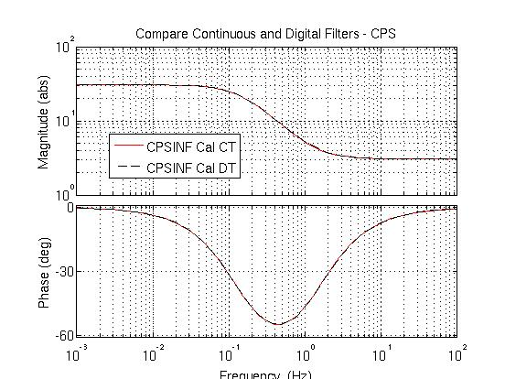

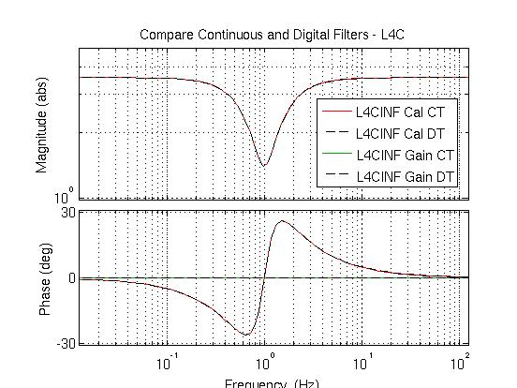

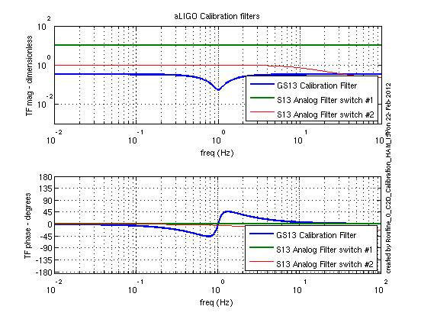

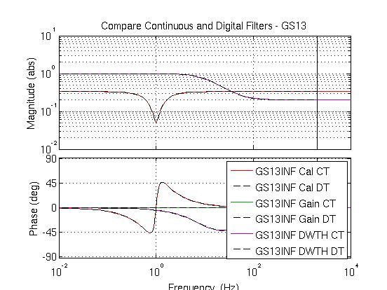

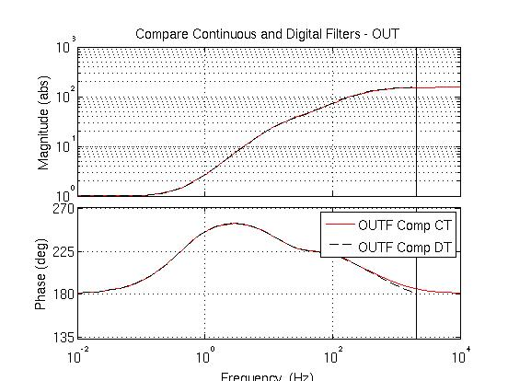

**Step 1: Local to Local Transfer Functions**

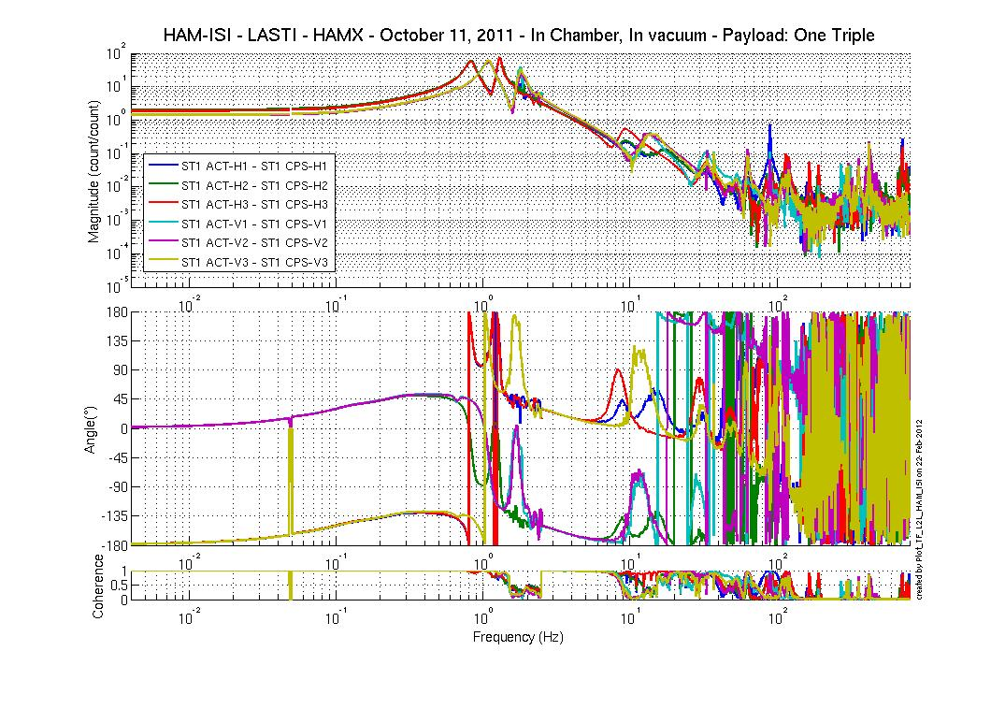

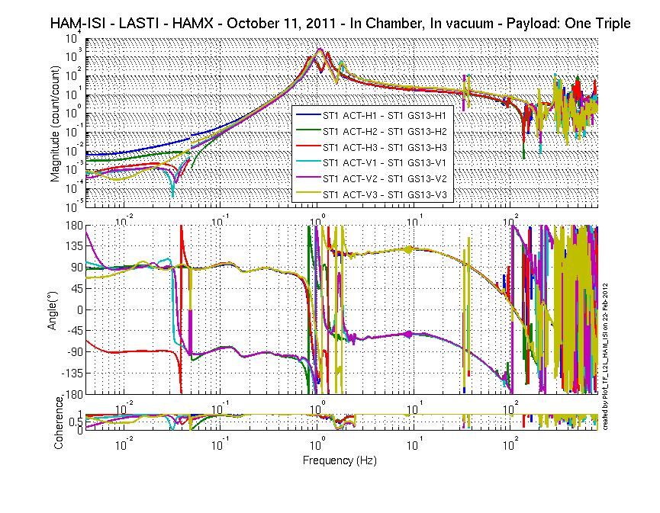

**Step 2: Symmetrization**

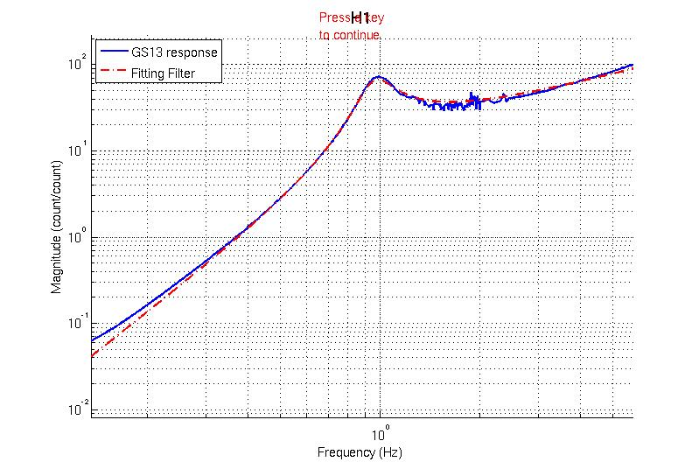

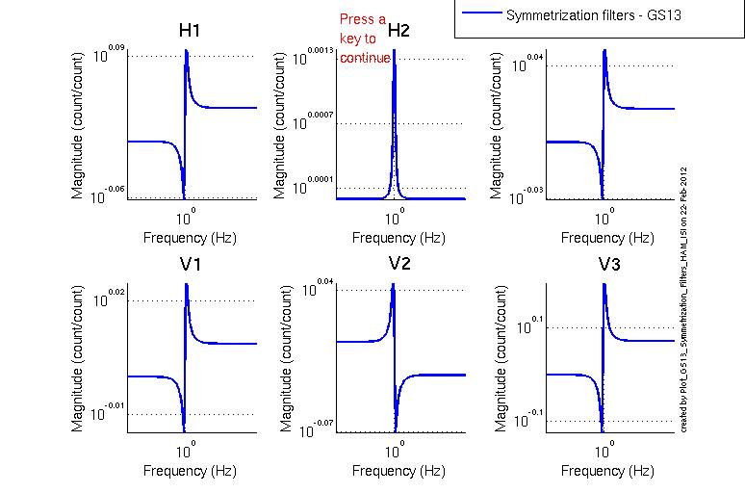

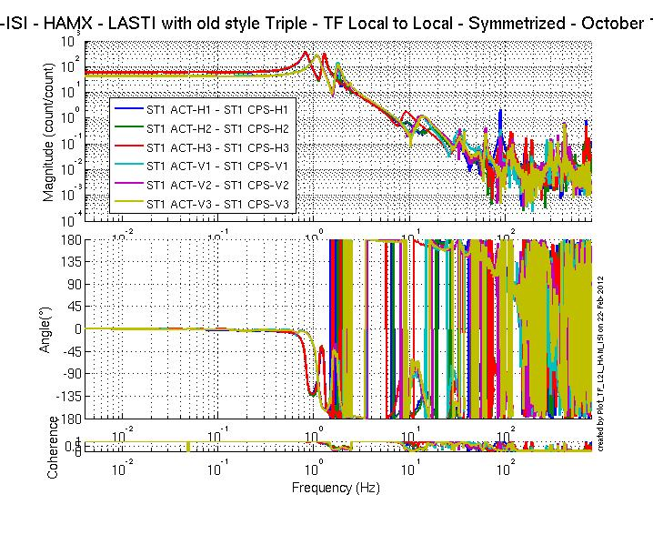

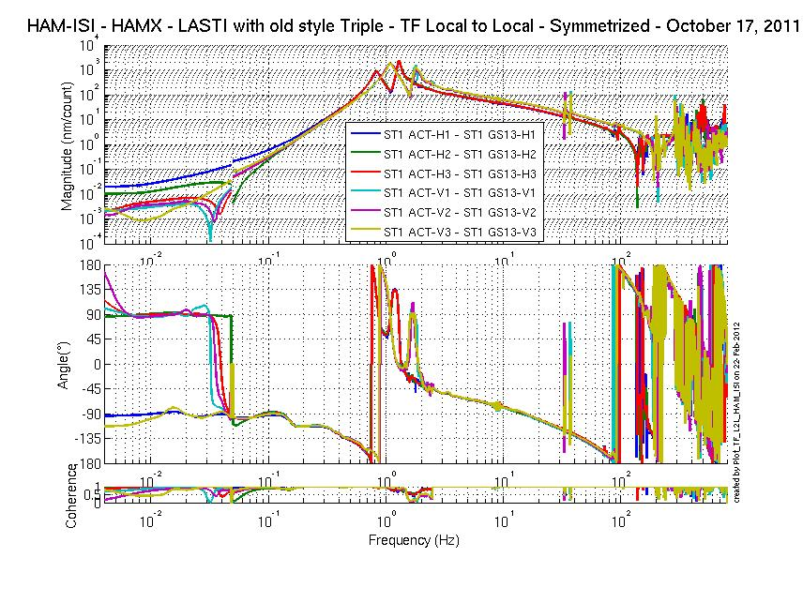

**Step 3 Cart to Cart**

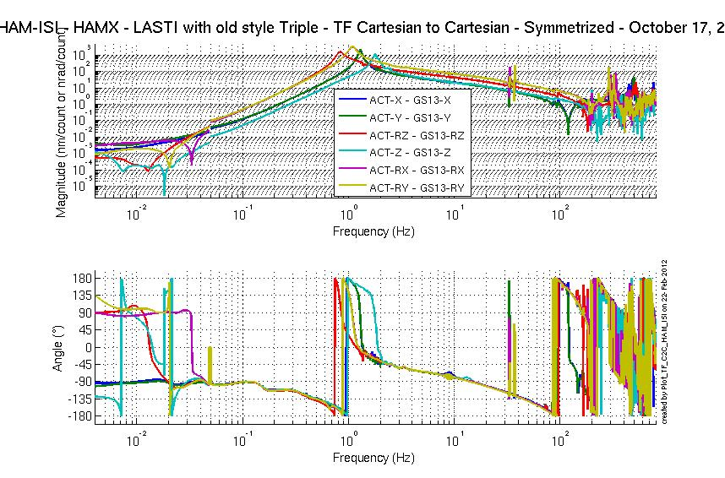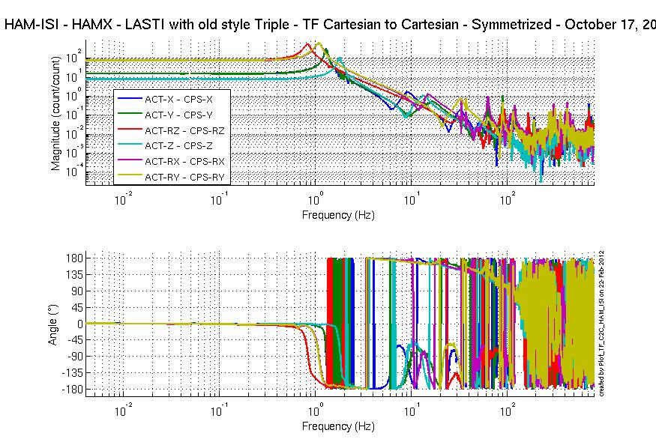

**Step 4 Damping Loop**

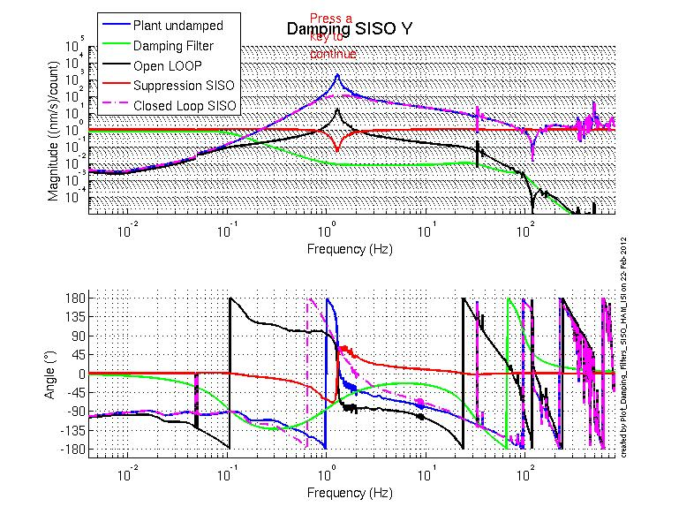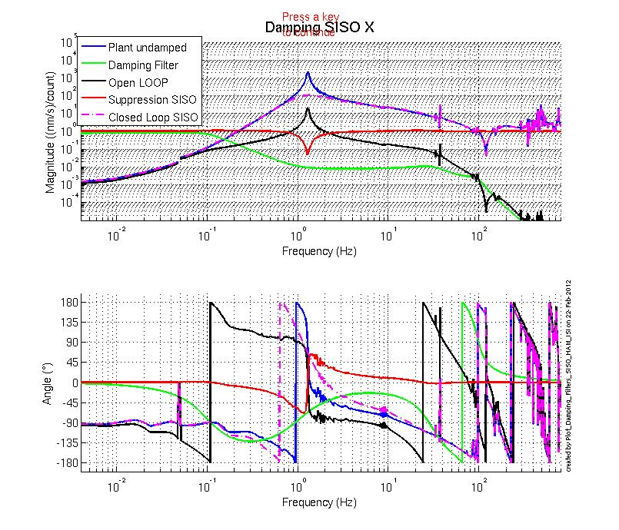

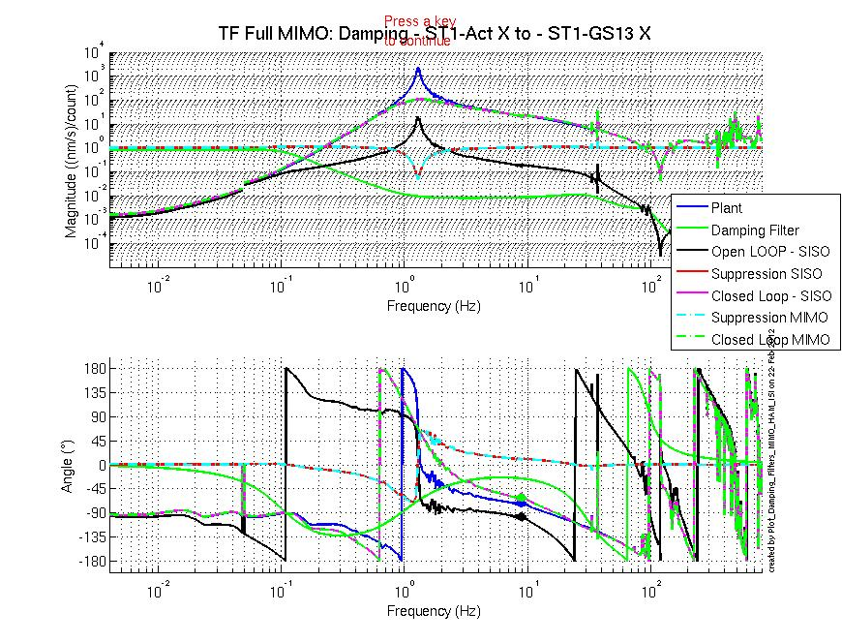

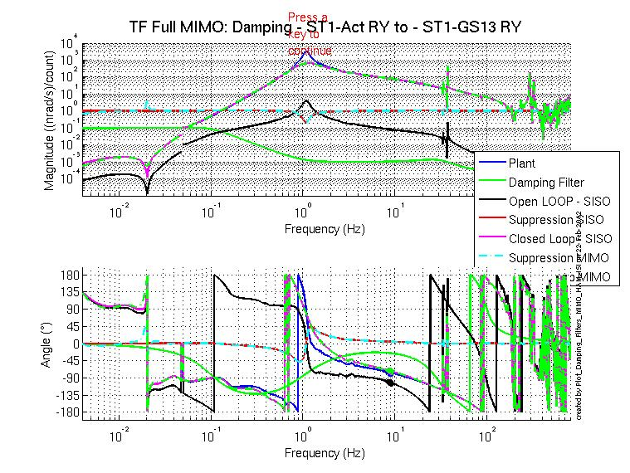

# Performance Analysis

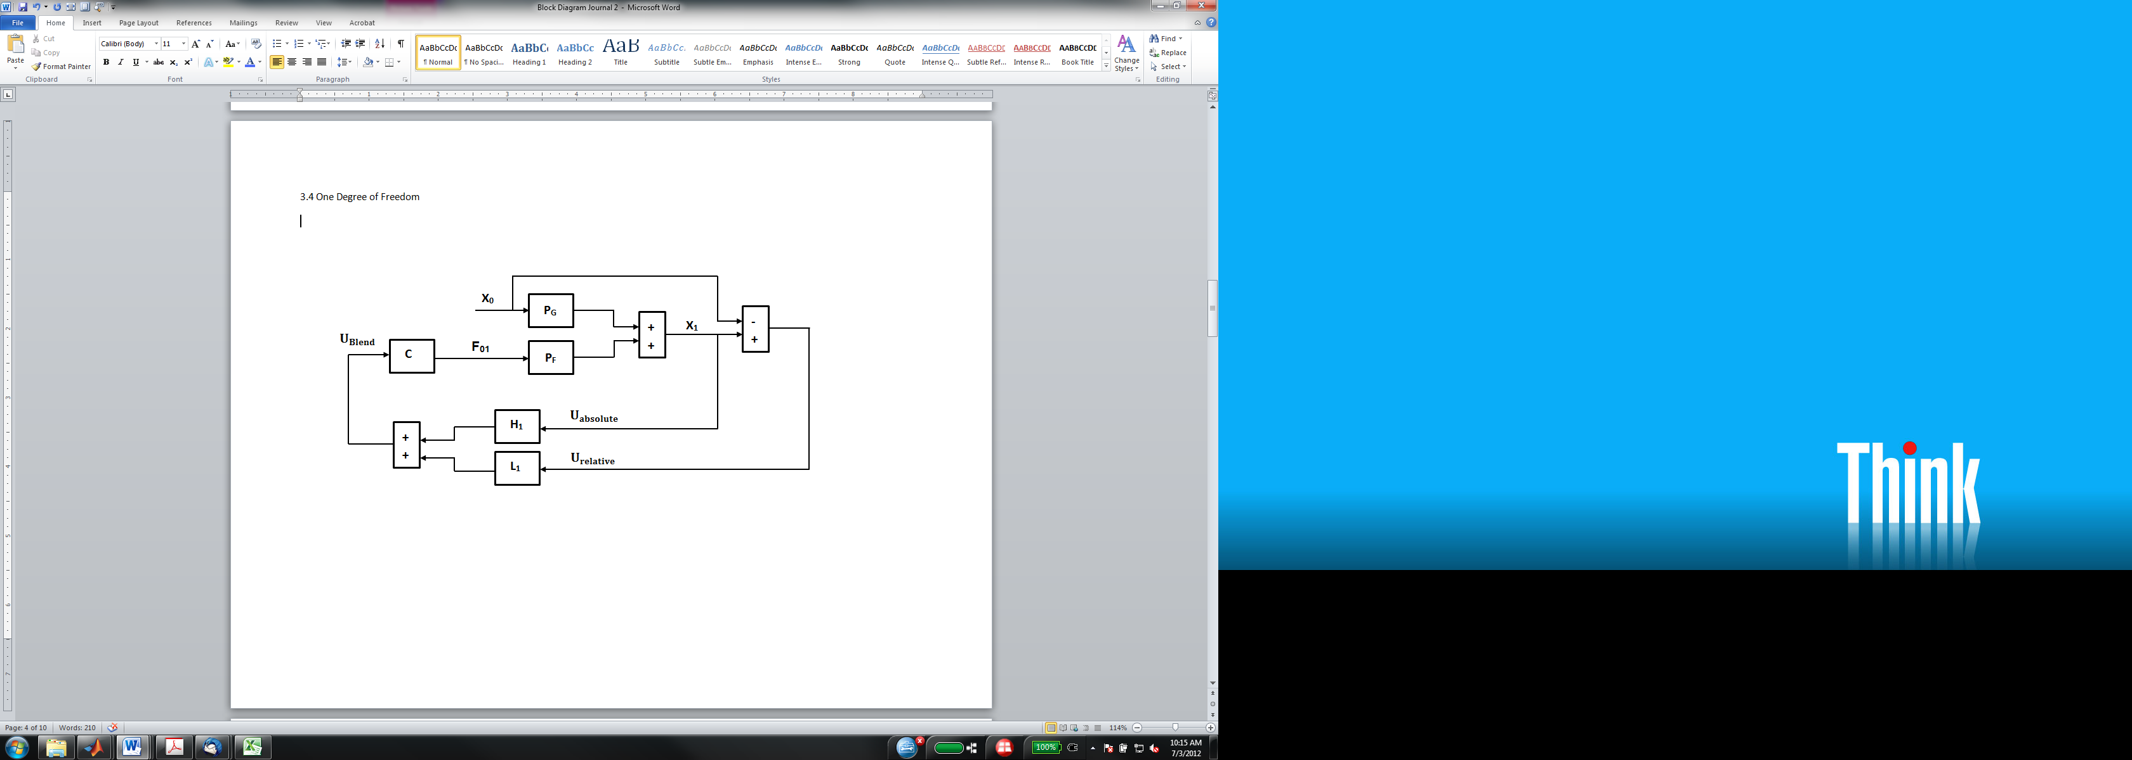

$$X_{1} =P_{G}{ X}_{0} - P_{F} F_{01}$$

Position sensors relative measurement $U_{r}$:

$$U_{r} = X_{1}-X_{0}$$

Control Force

$$F_{01} ={C U}_{b}$$

$$F_{01} =C \left[ L {(X}_{1}-X_{0}\right) + H X_{1} ]$$

$$F_{01} =C [ \left(L+H\right) X_{1}-L X_{0}]$$

Using complementary filters

$$L+H=1$$

Then

$$F_{01} =C ( X_{1}-L X_{0} )$$

Controlled Response:

$$X_{1} =P_{G}{ X}_{0} - P_{F} C ( X_{1}-L X_{0} )$$

$$X_{1} ={(P}_{G}{ + P_{F} C L) X}_{0} - {C P}_{F} X_{1}$$

$$\frac{X_{1}}{X_{0}} =\frac{P_{G}+ {L C P}_{F} }{1+C P_{F}}$$

* At low frequencies:

$$L C P_{F }≫P_{G}$$

$$C P_{F }≫1$$

Therefore

$$\frac{X_{1}}{X_{0}} =\frac{P_{G}+ {L C P}_{F} }{1+C P_{F}}≈ \frac{ {L C P}_{F} }{C P_{F}}≈L$$

* Above a few Hertz

$$L C P_{F }≪P_{G}$$

$$C P_{F }≫1$$

Therefore

$$\frac{X_{1}}{X_{0}} =\frac{P_{G}+ {L C P}_{F} }{1+C P_{F}}≈\frac{P_{G} }{1+C P_{F}}$$

Sensitivity:

$$S≈\frac{1 }{1+C P_{F}}$$