LIGO Laboratory / LIGO Scientific Collaboration

E1100867-v15 LIGO 11 September 2013

Advanced LIGO Arm Cavity Baffle Assembly Procedure

Stephany Foley, Lisa Austin, Mike Smith, Nichole Washington, Heidy Kelman

Distribution of this document:
Advanced LIGO Project

This is an internal working note
of the LIGO Laboratory.

California Institute of Technology  LIGO Project – MS 18-34  1200 E. California Blvd.  Pasadena, CA 91125  Phone (626) 395-2129  Fax (626) 304-9834  E-mail: info@ligo.caltech.edu | Massachusetts Institute of Technology  LIGO Project – NW22-295  185 Albany St  Cambridge, MA 02139  Phone (617) 253-4824  Fax (617) 253-7014  E-mail: info@ligo.mit.edu
LIGO Hanford Observatory  P.O. Box 1970  Mail Stop S9-02  Richland WA 99352  Phone 509-372-8106  Fax 509-372-8137 | LIGO Livingston Observatory  P.O. Box 940  Livingston, LA 70754  Phone 225-686-3100  Fax 225-686-7189

CHANGE LOG

Date, version | Summary of Changes
2012-05-03  V8 | - Baffle Suspension Assembly updated with notes from LHO assembly on 12/11 and CIT assembly on 5/12.
2013-03-04  V9 | - Updated Box Assembly instructions for 1 hole vs. older version 2 hole design
2013-03-05  V10 | - Added Change Log  - Shown PD Reference information
2013-03-19  V11 | - Updates and corrections to Suspension Assembly instructions.
2013-03-19  V12 | - Updates and corrections to Suspension Assembly instructions.  - Corrected Figure numbers and references.  - Added cable ties and cable testing information.
2013-03-29  V13 | - Added assembly serial number entry locations.
2013-04-01  V14 | - Updated document with assembly information for acceptance review.  - Added cable test result requirement.
2013-9-11  V3 | - Changed Upper Hinge Plate and added captive screws  - Various other corrections to distinguish ITM build

Introduction
This document details the assembly of the AOS SLC Arm Cavity Baffle ITM and its subassemblies:

I. Introduction 3
A. Clean room standards 3
B. ITM Arm Cavity Baffle Assembly 4
Table of Figures 4
II. ARM CAVITY BAFFLE BOX ASSEMBLY 6
A. Arm Cavity Baffle Hinge Assembly – D1002173 6
B. Arm Cavity Baffle Shelf Assembly – D1100391 7
C. Arm Cavity Baffle Box Assembly – 9
D. Photodetector Assembly (D1003013) & Lower Cable (D1003111) 16
E. Counter Weight Assemblies 20
F. Baffle Box Final Assembly 21
III. ARM CAVITY BAFFLE SUSPENSION ASSEMBLY 22
A. D1002582 - SLC BAFFLE TUBE UP ASSEMBLY 23
B. D1001007 - SLC ACB LO TUBE ASSEMBLY 24
C. D1002564 - SLC EDDY CURRENT DAMPING 8 DIA TUBE ASSEMBLY 26
D. D1001005 - ARM CAVITY BAFFLE BLADE ASSEMBLY 28
E. ACB SUSPENSION ASSEMBLY for BSC1 & BSC3 – 32

Clean room standards
For a clean assembly all LIGO standards should be followed, as presented in the latest version of the LIGO Contamination Control Plan (E0900047). Clean room garb including UHV gloves should be worn when working with parts.
All tools that come in contact with assembly should be cleaned to class B standards.
Assembly will be done under a portable clean room. Any time a part of the assembly is not covered by the portable clean room or not being actively worked on it should be covered with appropriate clean covers. (C3 polyester or equivalent).
All parts that will be included in the final assembly must be cleaned to LIGO standards, Class A. The list of parts to be Class A-cleaned includes screws, washers, inserts, and assorted other hardware. All tooling and other parts that are not included in the final assembly, but that contact Class A parts during assembly must be cleaned to LIGO standards, Class B.

ITM Arm Cavity Baffle Assembly

Overview of the ITM Arm Cavity Baffle Assembly

The ITM Arm Cavity Baffle is comprised of the following sub-assemblies and fixtures.

Drawing Number | Description | Image
Baffle Box Assembly (D1200314–x and D1200657–y)
Bottom Hinge Assembly | D1002173
Box Assembly
Shelf Assembly | D1100391
Extender Shelf Assembly | D1100359
Photo Detector Cable Assembly | D1001346, D1003013 and D1003111
Counter Weight Assembly (Left and Right) | D1200610 and D1200665
Suspension Assembly (D1200275)
Blade Assembly | X-Arm: D1001005-3  Y-Arm: D1001005-2
Lower Tube Assembly | D1001007
Upper Tube Assembly | D1002582
Eddy Current Damping 8” Diameter Tube Assembly | D1002564
Anti-Rotation Assembly | D1201228

Notes for all Subassembly:
- Assembly requires two people
- Watch for foil scratched surface

Table of Figures

Figure 1: Lower Hinge Assembly 6
Figure 2: Shelf Assembly 7
Figure 3: Baffle Box Assembly 9
Figure 4: "W" Order of Assembly 11
Figure 5: Middle Reinforcing Plate 11
Figure 6: Bottom Skin 12
Figure 7: PD Housing mating 12
Figure 8: Lifting Brace attachment 13
Figure 9: Lower Cable Routing 17
Figure 10: PD Assembly 17
Figure 11: Peek Insulator installation 17
Figure 12: PD locations for D1200657 (BSC1) 18
Figure 13: PD locations for D1200314 (BSC3) 18
Figure 14: Hat Section 19
Figure 15: Suspension Assembly 22
Figure 16: Baffle Tube Up Assembly 23
Figure 17: Lo Tube Assembly 24
Figure 18: Lo Tube magnet placement 25
Figure 19: Eddy Current Damping Tube Assembly 26
Figure 20: Copper Plate location 27
Figure 21: Spring Blade Loadin 29
Figure 22: Blade Mounting Bracket position 31
Figure 23: Suspension Rod 31
Figure 24: Suspension Rod Hardware 34
Figure 25: Suspension Rod and Tube Up Assembly 35

ARM CAVITY BAFFLE BOX ASSEMBLY

Arm Cavity Baffle Hinge Assembly – D1002173
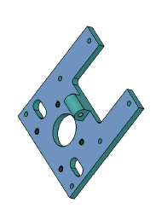
Figure 1: Lower Hinge Assembly

List of parts and tools needed:
CLASS A –
D1001622 – 1 SN:____________
1185-4EN250 – 4

CLASS B
Tool to insert Heli-Coils

Install Heli-Coil inserts into “Arm Cavity Baffle Lower Mounting Hinge” D1001622

D1002173 serial number – SAME AS D1001622.

Arm Cavity Baffle Shelf Assembly – D1100391

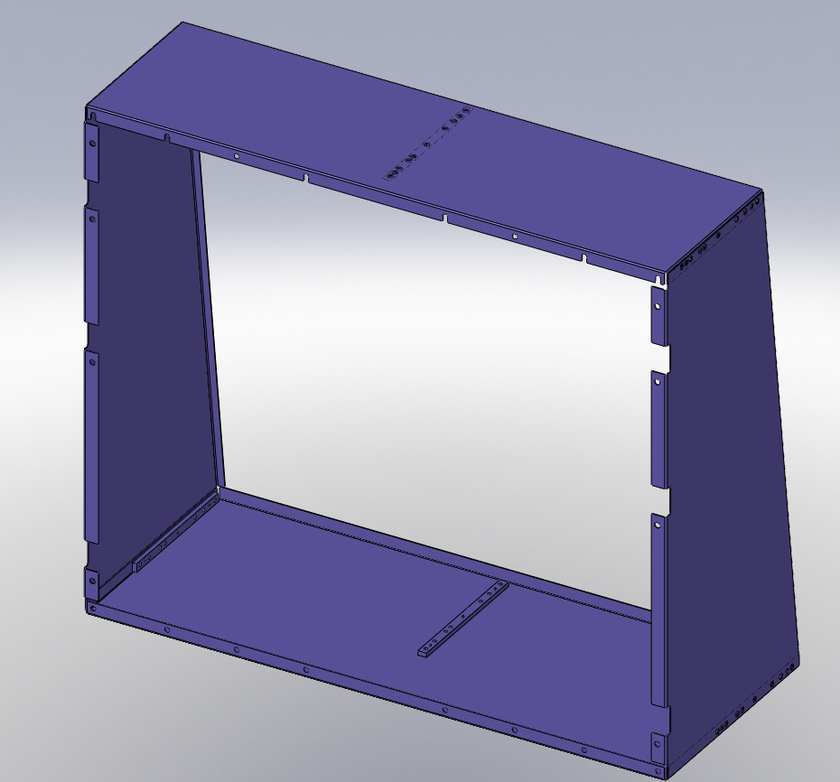
Figure 2: Shelf Assembly

List of parts and tools needed -

CLASS A PARTS
D1001026 – 1 SN:____________
D1001027 – 1 SN:____________
D1100340 – 1 SN:____________
D1100327 – 1 SN:____________
D1100347 – 3 SN:____________
D1100352 – 3 SN:____________
FA-605-NA – 18

CLASS B TOOLS
5/64” Hex Allen Tool

Attach “SLC ACB Lo Captured Plate” D1100352 (Short) to center of “SLC Arm Cavity Baffle Lower Leaf” D1001027
  - Install hardware 3 places
    - FA-605-NA, Flat Head Screw, #6-32 X .312, SSTL - Silver Plated, Qty 3

Attach “SLC ACB Right Side Panel” D1100340 to “SLC Arm Cavity Baffle Lower Leaf” D1001027 with “SLC ACB Lo Captured Plate” D1100352 (Short)
- Install hardware 3 places
- FA-605-NA, Flat Head Screw, #6-32 X .312, SSTL - Silver Plated, Qty 3

Repeat Step 3 on opposite side with “SLC ACB Left Side Panel” D1100327

Attach “SLC ACB Upper Captured Plate” D1100347 (Long) to center of “SLC Arm Cavity Baffle Upper Leaf” D1001026
- Install hardware 3 places
- FA-605-NA, Flat Head Screw, #6-32 X .312, SSTL - Silver Plated, Qty 3

Attach “SLC Arm Cavity Baffle Upper Leaf” D1001026 to “SLC ACB Right Side Panel” D1100340 with “SLC ACB Upper Captured Plate” D1100347 (Long)
- Install hardware 3 places
- FA-605-NA, Flat Head Screw, #6-32 X .312, SSTL - Silver Plated, Qty 3

Repeat Step 6 on opposite side with “SLC ACB Left Side Panel” D1100327

D1100391 serial number – SAME AS D1001026

Arm Cavity Baffle Box Assembly –

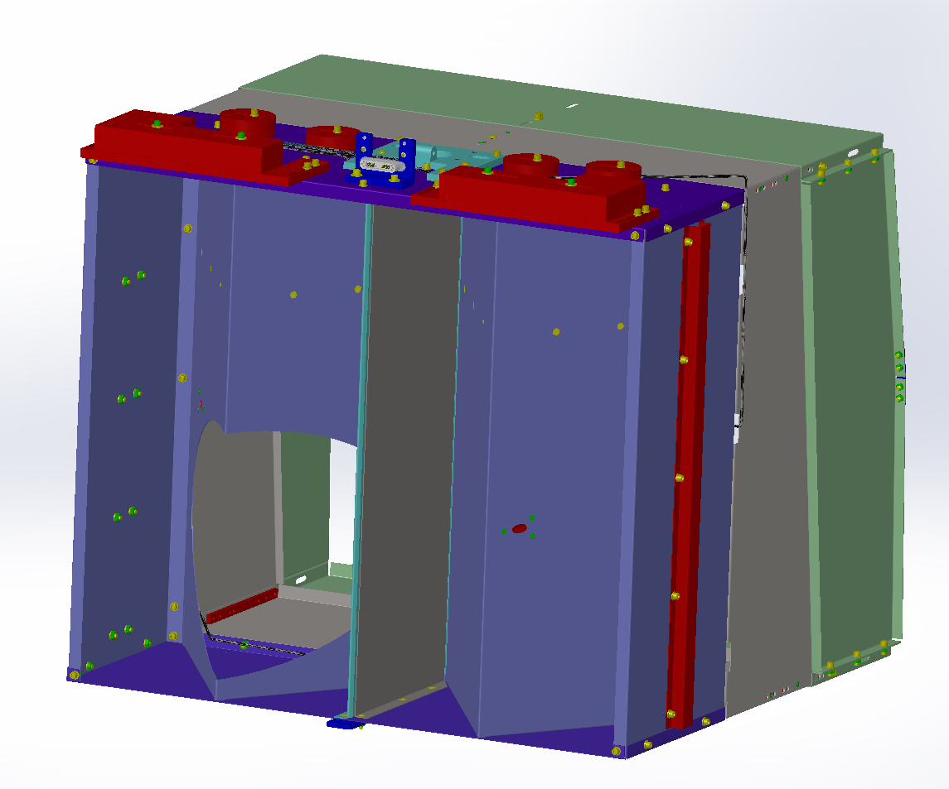
Figure 3: Baffle Box Assembly

List of assemblies, parts, hardware and tools needed -

CLASS A ASSEMBLIES
1 - D1002173 SN:____________
4 - D1003013 SN:____________
1 - D1100391 SN:____________
1 - D1100359 (will be assembled in this section) SN: SAME AS D1100288
90945A740 – 16
90945A760 – 24
92200A242 – 8
92200A537 – 12
D1100288 – 1 SN:____________
D1100353 – 1 SN:____________
D1100354 – 1 SN:____________
D1100458 – 1 SN:____________
D1101234 – 2 SN:____________
N-1024-A – 8
N-2520-A - 12

CLASS A PARTS
1 - D1000974 SN:____________
1 - D1000975 SN:____________
1 - D1000976 SN:____________
2 - D1001365 SN:____________
4 - D1003025 SN:____________
1 - D1003111 SN:____________
1 - D1101427 SN:____________
1 - D1101796 SN:____________
1 - D1200296 (for D1200657 only - BSC1) SN:____________
1 - D1200313 (for D1200314 only – BSC3) SN:____________

Balance Weights as described on LIGO-Document E1300070
D1200835 SN:____________
D1001826 SN:____________
D1200779 SN:____________
D1201230 SN:____________

CLASS A HARDWARE
2 – 92196A114
65 – 92200A537
4 – 92200A540
2 – 92200A541
18 – 98019A330
156 – 98019A355 (interchangeable with WF-25)
2 – BU-2012-N
12 – C-2008-NA
73 – C-2012-N (interchangeable with 92200A537)
81 – C-2014-N (interchangeable with 92200A537)
4 – C-2024-N
12 – FA-2412-N (must be oxidized)
12 – FA-606-NA
18 – N-1025-A
75 – N-2520-A
156 – WF-25 (interchangeable with 98019A355)

CLASS B TOOLS

Place “SLC Arm Cavity Baffle Skin” D1200296 (or D1200313) “W” upside down on build surface.


Figure 4: "W" Order of Assembly

NOTE: Order of Assembly: start at the middle “V” and work outwards.

Loosely attach “SLC Arm Cavity Baffle Middle Reinforcing Plate” D1001365 to “SLC Arm Cavity Baffle Skin” (“W”)

Install hardware 6 places

Slotted Holes (screw, SSTL, washer, nut)
    - FA-2412-N, Flat Head Screw #10-24 X 3/4”L, SSTL - oxidized, Qty 6
    - 98019A330, Flat #10 Washer, SSTL, Qty 6
    - N-1024-A, Hex Nut #10-24, SSTL - Silver Plated, Qty 6

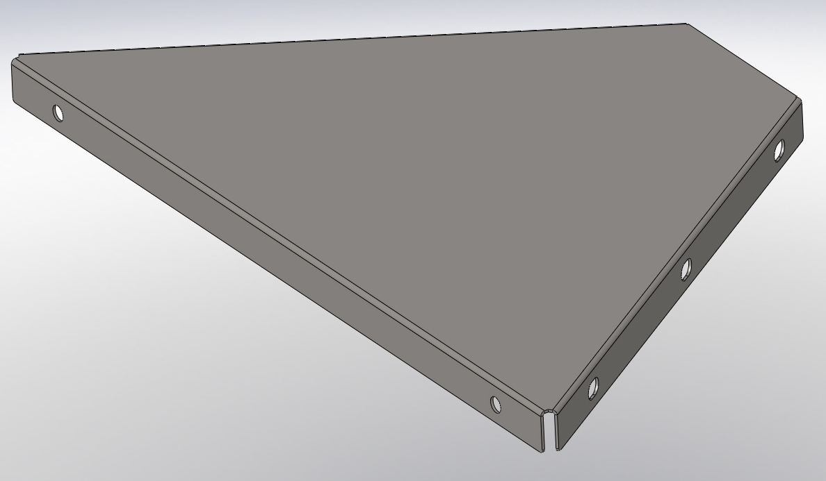
Figure 5: Middle Reinforcing Plate

Repeat Step 3 on other side

Loosely attach “SLC Arm Cavity Baffle Skin” (“W”) to “SLC Arm Cavity Baffle Bottom Skin” D1000975

Install hardware 14 places

Eight Slotted and six Round Holes (screw, washer, SSTL, washer, nut)
- 92200A537, Socket Head Cap Screw 1/4”-20 X 1/2”L, SSTL Qty 14
- 98019A355, Flat ¼” Washer, .63” OD, SSTL Qty 28
- N-2520-A, Hex Nut ¼”-20, SSTL - Silver Plated, Qty 14
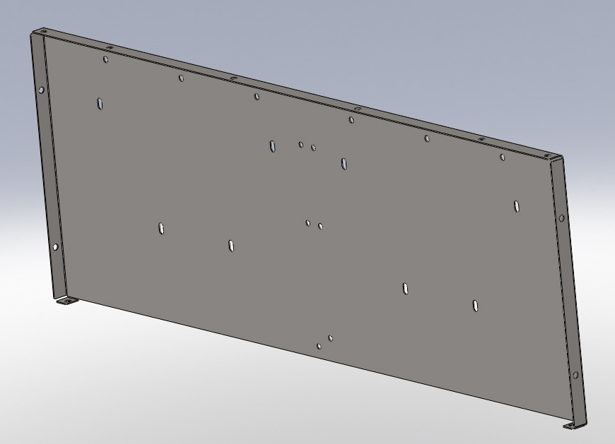
Figure 6: Bottom Skin

Attach four “Photo Detectors Housings” D1003025 to “SLC Arm Cavity Baffle Skin” (“W”)
  - Install hardware 12 places
    - FA-606-NA, Flat Head Screw #6-32 X 3/8”L, SSTL - Silver Plated, Qty 12

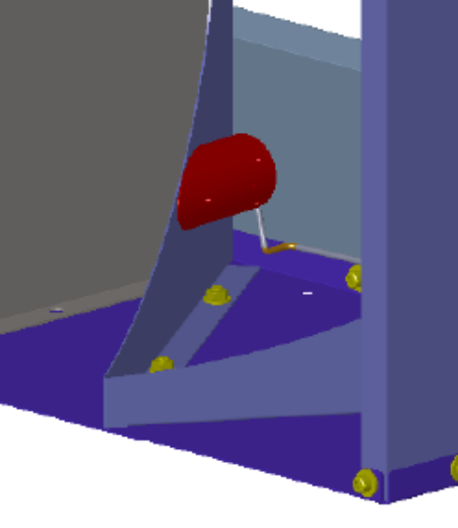
Figure 7: PD Housing mating

Lay Assembly down

Attach “SLC Arm Cavity Baffle Center Skin” D1000976 and “Arm Cavity Baffle Center, Mirror Skin” D1101796 to “SLC Arm Cavity Baffle Bottom Skin” D1000975 and “Brace, Lifting, Arm Cavity Baffle” D1101427. Refer to D1200657 or D1200314 assembly drawing Detail B on Sheet 2 for clarification.
  - Install hardware 6 places
  - Round Holes (screw, SSTL, Brace, washer, nut)
    - FA-2412-NA, Flat Head Screw #10-24 X 3/4”L, SSTL - oxidized, Qty 6
    - 98019A330, Flat #10 Washer, SSTL, Qty 6
    - N-1024-A, Hex Nut #10-24, SSTL - Silver Plated, Qty 6
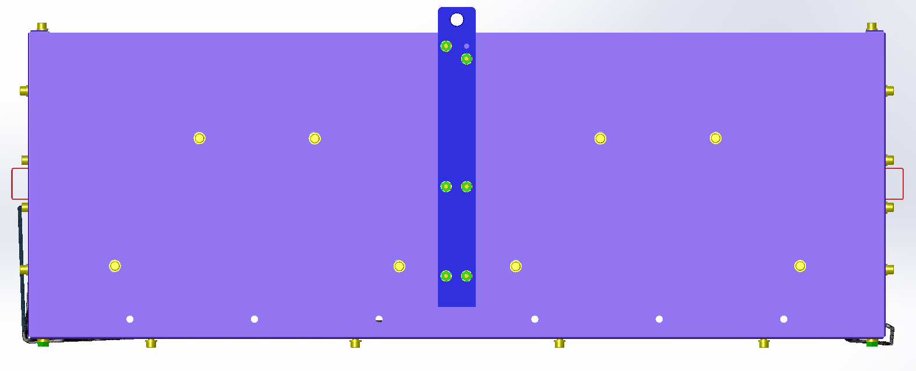
Figure 8: Lifting Brace attachment

Place assembly upright.

Loosely attach “SLC Arm Cavity Baffle Top Skin” D1000974 to “SLC Arm Cavity Baffle Skin” (“W”), “SLC Arm Cavity Baffle Center Skin” D1000976, and “Arm Cavity Baffle Center, Mirror Skin” D1101796

Install hardware 19 places

Eight Slotted and eleven Round Holes (screw, washer, SSTL, washer, nut)
- 92200A537, Socket Head Cap Screw 1/4”-20 X 1/2”L, SSTL Qty 19
- 98019A355, Flat ¼” Washer, .63” OD, SSTL Qty 38
- N-2520-A, Hex Nut ¼”-20, SSTL - Silver Plated, Qty 19

Tighten all screws.

Attach completed “ACB Shelf Assembly” D1100391 to “Arm Cavity Baffle Box Assembly” and tighten all locations.
  - Install hardware 20 places
  - Round Holes (screw, washer, SSTL (x2), washer, nut)
    - 92200A537, Socket Head Cap Screw 1/4”-20 X 1/2”L, SSTL Qty 20 – longer screws are available, if needed.
    - 98019A355, Flat ¼” Washer, .63” OD, SSTL Qty 40
    - N-2520-A, Hex Nut ¼”-20, SSTL - Silver Plated, Qty 20

Lay Baffle Box assembly flat with front facing down.

**** Assembly and attachment of D1100359 – Adjustable Extender Shelf Assembly ****

Loosely attach “SLC ACB Bottom Extender” D1100458 to bottom of “ACB Shelf Assembly” D1100391 into “SLC ACB Lo Captured Plate” D1100352

Install center hardware 2 places – Do not tighten

Slotted Holes (screw, washer, SSTL (x2), capture plate)
    - C-2008-NA, Socket Head Cap Screw, ¼-20 X 1/2”L, SSTL Silver Plated Qty 2
    - 98019A355, Flat ¼” Washer .63” OD, SSTL Qty 2

Install side hardware 4 places – Do not tighten

Slotted Holes (screw, washer, SSTL (x2), capture plate)
- C-2008-NA, Socket Head Cap Screw, ¼-20 X 1/2”L, SSTL Silver Plated Qty 4
- 98019A355, Flat ¼” Washer .63” OD, SSTL Qty 4

Loosely attach “SLC ACB Top Extender” D1100288 to top of “ACB Shelf Assembly” D1100391 into “SLC ACB Upper Captured Plate” D1100347

Install center hardware 2 places – Do not tighten

Slotted Holes (screw, washer, SSTL (x2), capture plate)
- C-2008-NA, Socket Head Cap Screw, ¼-20 X 1/2”L, SSTL Silver Plated Qty 2
- 98019A355, Flat ¼” Washer .63” OD, SSTL Qty 2

Install side hardware 4 places – Do not tighten

Slotted Holes (screw, washer, SSTL (x2), capture plate)
- C-2008-NA, Socket Head Cap Screw, ¼-20 X 1/2”L, SSTL Silver Plated Qty 4
- 98019A355, Flat ¼” Washer .63” OD, SSTL Qty 4

Loosely attach “SLC ACB Left Side Extender” D1100353 to “SLC ACB Bottom Extender” D1100458 and “SLC ACB Top Extender” D1100288

Install hardware 6 places – Do not tighten

Round Holes (screw, washer, SSTL (x2), washer, nut)
- 92200A537, Socket Head Cap Screw 1/4”-20 X 1/2”L, SSTL Qty 6
- 98019A355, Flat ¼” Washer, .63” OD, SSTL Qty 12
- N-2520-A, Hex Nut ¼”-20, SSTL - Silver Plated, Qty 6

Repeat Step 16 on opposite side with “SLC ACB Right Side Extender” D1100354

Attach “ACB Stiffener Side Extender” D1101234 to “SLC ACB Left Side Extender” D1100353

Install hardware 4 places

Round Holes (screw, washer, Aluminum, SSTL, washer, nut)
- 92200A242, Socket Head Cap Screw #10-24 X 1/2”L, SSTL Qty 4
- 98019A330, Flat #10 Washer, SSTL Qty 8
- N-1024-A, Hex Nut #10-24, SSTL - Silver Plated, Qty 4

Repeat Step 18 on opposite side with “SLC ACB Right Side Extender” D1100354

Set alignment of Extender parts and placement as defined in assembly drawing D1200657 for Y-Arm on Sheet 5 or D1200314 for X-Arm on Sheet 4. Tighten screws enough to hold measurement.

Tighten all screws. Verify placement measurements are accurate. Loosen and re-tighten, if needed, to meet requirement.

Attach “ACB Hinge Assembly” D1002173 to top of “ACB Baffle Box”

Install hardware 2 places

Round Holes (screw, Hinge, SSTL, washer, nut)
    - BU-2012-N, Button Head Screw, ¼-20 X 3/4”L, SSTL Qty 2
    - 98019A355, Flat ¼” Washer, SSTL Qty 2
    - N-2520-A, Hex Nut ¼”-20, SSTL Silver Plated, Qty 2

Install hardware 4 places

Round Holes (screw, Hinge, SSTL, washer, nut)
- 92200A540, Socket Head Cap Screw, ¼-20 X 3/4”L, SSTL Qty 4
- 98019A355, Flat ¼” Washer, SSTL Qty 4
- N-2520-A, Hex Nut ¼”-20, SSTL Silver Plated, Qty 4

Attach “SLC ACB Balancing Weight” to top of “ACB Baffle Box” as defined from selection of Suspension Assembly Spring Blade serial number. See Document E1300070 for balance weights.
- Install hardware 4 places
- Round Holes (screw, washer, Balance Weight, SSTL, washer, nut)
- C-2024-N, Socket Head Cap Screw, ¼-20 X 1.5”L, SSTL, Qty 4
- 98019A355, Flat ¼” Washer, SSTL Qty 8
- N-2520-A, Hex Nut ¼”-20, SSTL Silver Plated, Qty 4

Photodetector Assembly (D1003013) & Lower Cable (D1003111)

List of parts, subassemblies and tools needed –

CLASS A PARTS
D1001346-1 – 1 SN:____________
D1001363 – 2 SN:____________
D1003013 - 4 (will be assembled in this section) SN:____________
D1003024 – 4 SN:____________
D1101713 – 4 SN:____________
FA-410-A – 12

CLASS A HARDWARE
92196A114 – 2
92200A537 - 20
92200A541 – 2
98019A355 – 44
F442-003C – as required
F402-003C – as required
N-2520-A – 22
WF-25 – 44 (interchangeable with 98019A355)

Attach “aLIGO Cable Bracket, Ham Table Assembly” D1001346-1 to top of “ACB Baffle Box”
- Install hardware 2 places
- Round Holes (screw, washer, Bracket, SSTL, washer, nut)
- 92200A541, Socket Head Cap Screw, ¼-20 X .88”L, SSTL, Qty 2
- 98019A355, Flat ¼” Washer, SSTL Qty 4
- N-2520-A, Hex Nut ¼”-20, SSTL Silver Plated, Qty 2

Attach the two “SLC Photodetector Cable Lower Assembly” D1003111 to “aLIGO Cable Bracket, Ham Table Assembly” D1001346-1
- Install hardware 2 places
- Round Holes (screw)
- 92196A114, 4-40 X 7/8”L, SSTL Qty 2

Route cables through slots in side panels of “ACB Baffle Box”, 4 places.

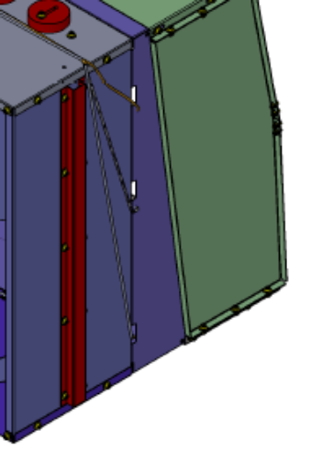
Figure 9: Lower Cable Routing

Place “PD PCB Support” D1003028 on top of “Arm Cavity Baffle ALS PD PCB” D1003239 at the ends of the “SLC Photodetector Cable Lower Assembly” D1003111, 4 places. Carefully insert “Photodiode, ACB” D1101713 into sockets in “Arm Cavity Baffle ALS PD PCB” D1003239, 4 places. Watch for bent pins and correct orientation.
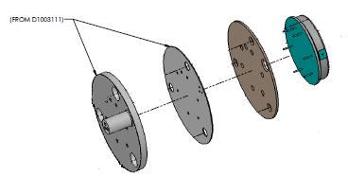
Figure 10: PD Assembly

Insert “PD Front Peek Insulator” D1003028 into “Photo Detectors Housings” D1003025 aligning holes for attachment, 4 places.
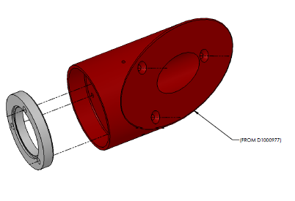
Figure 11: Peek Insulator installation

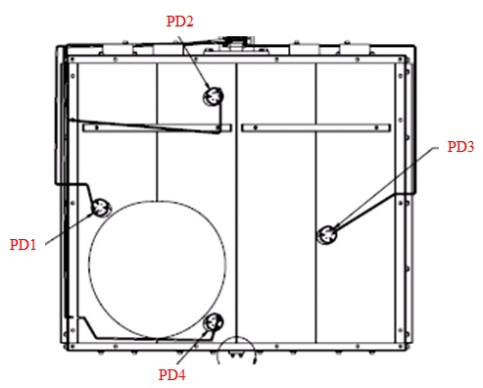
Figure 12: PD locations for D1200657 (BSC1)

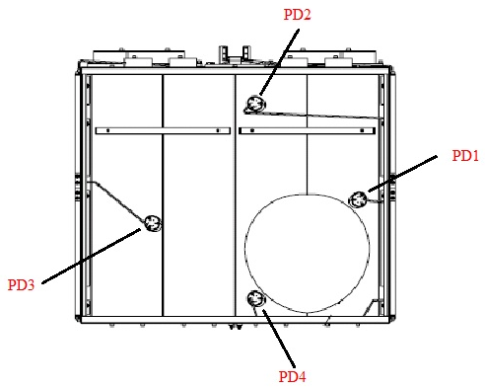
Figure 13: PD locations for D1200314 (BSC3)

Attach ends of cable to “Photo Detectors Housings” D1003025 at locations marked on “PD Back Peek” D1003014, 4 places.
- Install hardware 12 places
- Round Holes (screw, peek, PCB, kapton, PD, peek, SSTL)
- FA-410-A, 4-40 X 5/8”L, vented, silver plated SSTL Qty 12

Attach “ACB Side Reinforcing Hat Section” D1001363 to each side of the “SLC Arm Cavity Baffle Skin” (“W”) while routing cables using Clips F442-003C and F402-003C, as needed.

Install hardware 10 places each side

Round Holes (screw, washer, SSTL (x2), washer, nut)
- 92200A537, Socket Head Cap Screw 1/4”-20 X 1/2”L, SSTL Qty 20
- 98019A355, Flat ¼” Washer, .63” OD, SSTL Qty 40
- N-2520-A, Hex Nut ¼”-20, SSTL - Silver Plated, Qty 20
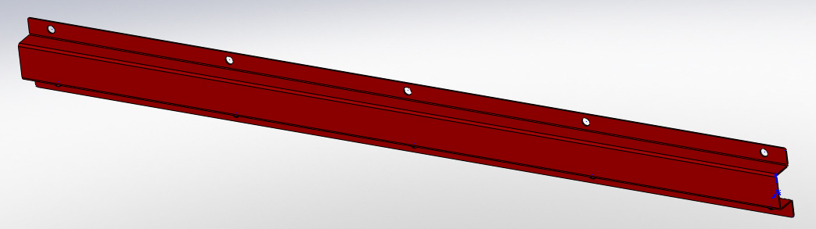
Figure 14: Hat Section

Route cables securely to “ACB Baffle Box” using cable ties F442-003C and F402-003C, as needed.

Counter Weight Assemblies

List of parts and tools needed –

CLASS A PARTS
D1200644 – 2 SN:____________
D1200686 – 2 SN:____________

CLASS A HARDWARE
C-2028-NA - 4
WF-25 – 4
C-2014-N – 8
98019A355 – 16
N-2520-A - 8

Attach right side “Counter Weight Slider” D1200644 to “Counter Weight Base” D1200686 as shown in drawing D1200665.
- Install hardware 2 places
- Slotted Holes (screw, washer, Slider, Base)
- C-2028-NA, Socket Head Cap Screw, ¼-20 X 1.75”L, Ag-plated SSTL, Qty 2
- WF-25, Flat ¼” Washer, SSTL Qty 2

Attach left side “Counter Weight Slider” D1200644 to “Counter Weight Base” D1200686 as shown in drawing D1200610.
- Install hardware 2 places
- Slotted Holes (screw, washer, Slider, Base)
- C-2028-NA, Socket Head Cap Screw, ¼-20 X 1.75”L, Ag-plated SSTL, Qty 2
- WF-25, Flat ¼” Washer, SSTL Qty 2

Attach “Counter Weight Assembly – Right Side” D1200665 to top of “ACB Box Assembly” as shown in drawing D1200657 or D1200314.
- Install hardware 4 places
- Round Holes (screw, washer, Counter Weight Assembly, SSTL, washer, nut)
    - C-2014-N, Socket Head Cap Screw 1/4”-20 X 7/8”L, SSTL Qty 4
    - 98019A355, Flat ¼” Washer, .63” OD, SSTL Qty 8
    - N-2520-A, Hex Nut ¼”-20, SSTL - Silver Plated, Qty 4

Attach “Counter Weight Assembly – Left Side” D1200610 to top of “ACB Box Assembly” as shown in drawing D1200657 or D1200314.
- Install hardware 4 places
- Round Holes (screw, washer, Counter Weight Assembly, SSTL, washer, nut)
- C-2014-N, Socket Head Cap Screw 1/4”-20 X 7/8”L, SSTL Qty 4
- 98019A355, Flat ¼” Washer, .63” OD, SSTL Qty 8
- N-2520-A, Hex Nut ¼”-20, SSTL - Silver Plated, Qty 4

Baffle Box Final Assembly

Test cables per Procedure T1100637. PASS FAIL (circle one)
Comments: ________________________________________________________________________________________________________________________________________________________________________________________________________________________________________________________________________

Torque all screws, as required.

Record serial number of applicable Box Assembly:

D1200657 (BSC1) SN: SAME AS D1000974
D1200314 (BSC3) SN: SAME AS D1000974

Weigh assembly and record: _______________ lbs. (kg/grams)

ARM CAVITY BAFFLE SUSPENSION ASSEMBLY

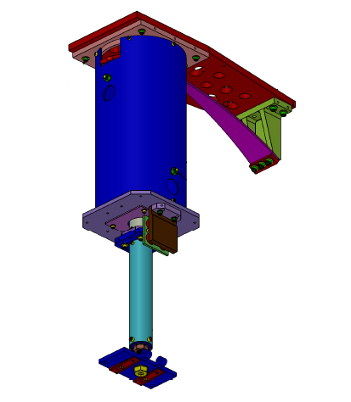
Figure 15: Suspension Assembly

D1002582 - SLC BAFFLE TUBE UP ASSEMBLY

LIGO Parts:
(1) D1002612 - SLC UPPER TUBE SN:____________
(1) D1002610 - SLC TUBE UP CONNECTOR PLATE SN:____________
(1) D1002581 - SLC SUSPENSION ROD SUPPORT SN:____________

Hardware:
(4) 92200A537 (1/4-20 x 1/2 SHCS)
(4) 92200A242 (10-24 x 1/2 SHCS)

Tools:
3/16” Hex L-Key tool (¼-20 SHCS)
5/32” Hex L-Key tool (10-24 SHCS)

Insert D1002581 – SLC SUSPENSION ROD SUPPORT into D1002612 – SLC UPPER TUBE on end closest to view holes, see Figure 16. Align with fastener holes. Parts may not slide together with ease.
  - Install hardware 4 places
    - 92200A537 (1/4-20 x 1/2 SHCS)
- Insert D1002610 – SLC TUBE UP CONNECTOR PLATE into D1002612 – SLC UPPER TUBE on end furthest from view holes, see Figure 16: Baffle Tube Up Assembly. Align with fastener holes.
  - Install hardware 4 places
    - 92200A242 (10-24 x 1/2 SHCS)

D1002582 serial number – SN___________

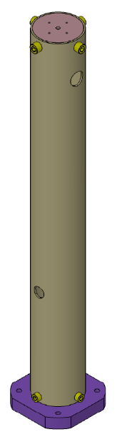
D1002581 –
SLC SUSPENSION ROD SUPPORT
D1002610 –
SLC TUBE UP CONNECTOR PLATE
D1002612 –
SLC UPPER TUBE
Figure 16: Baffle Tube Up Assembly

D1001007 - SLC ACB LO TUBE ASSEMBLY

LIGO Parts:
(1) D1001009 - ARM CAVITY BAFFLE LO TUBE SN:____________
(1) D1000684 - SLC TUBE LOWER MOUNTING PLATE SN:____________
(1) D1002618 - SLC TUBE LOWER CONNECTOR PLATE SN:____________
(1) D1000930 - SLC MAGNET HOLDER STEEL PLATE SN:____________

Other Parts:
(4) N35P500500HT - BUNTING MAGNETIC-NEODYMIUM (1.00D x .50H)
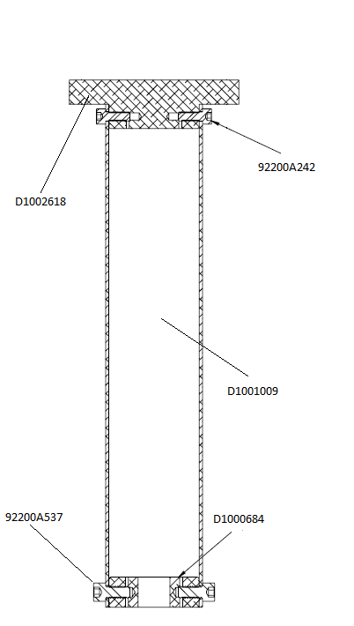

Hardware:
(4) 92200A537 (1/4-20 x ½ SHCS)
(2) 94518A510 (1/4-20 x ½ FHCS)
(4) 92200A242 (10-24 x ½ SHCS)

Tooling/Fixtures:
D1201014 – Magnet Spacer Tool
Small test magnet for Section II.B.4
D1200635 – Magnet Placement Tool

Tools:
3/16” Hex L-Key tool (¼-20 SHCS)
5/32” Hex L-Key tool (10-24 SHCS)
Philips Screwdriver

Figure 17: Lo Tube Assembly

- Insert D1000684 - SLC TUBE LOWER MOUNTING PLATE into D1001009 - ARM CAVITY BAFFLE LO TUBE, see Figure 17. Align with larger fastener holes.
  - Install hardware 4 places
    - 92200A537 (1/4-20 x ½ SHCS)
- Insert D1002618 - SLC TUBE LOWER CONNECTOR PLATE into D1001009 - ARM CAVITY BAFFLE LO TUBE, see Figure 17. Align with smaller fastener holes.
  - Install hardware 4 places
    - 92200A242 (10-24 x ½ SHCS)

- Attach D1000930 - SLC MAGNET HOLDER STEEL PLATE to D1002618 - SLC TUBE LOWER CONNECTOR PLATE, see Figure 18.
  - Install hardware 2 places
    - 94518A510 (1/4-20 x ½ FHCS)

- Attach N35P500500HT - BUNTING MAGNETIC-NEODYMIUM Magnets in 4 places.
  - Use Teflon tool D1200635 to install magnets.
  - Alternate polarity of magnets (need small test magnet to test polarity)
  - If magnets are wrong, use tool to extract the wrong magnets; then, reverse the magnets as required.

- D1001007 serial number – SN___________

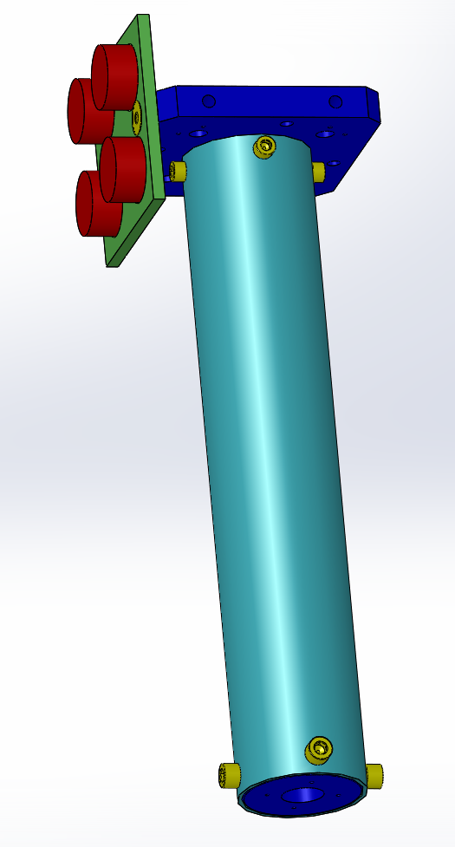
Figure 18: Lo Tube magnet placement

D1002564 - SLC EDDY CURRENT DAMPING 8 DIA TUBE ASSEMBLY

LIGO Parts:
(1) D1002560 - SLC DAMPING TUBE TOP PLATE SN:____________
(1) D1002561 - SLC DAMPING 8 INCHES DIA TUBE SN:____________
(1) D1002617 - SLC DAMPING TUBE LOWER PLATE SN:____________
(1) D1000929 - SLC COPPER SUPPORT PLATE SN:____________
(1) D1000909 - SLC COPPER PLATE SN:____________

Hardware:
(12) 92200A242 (10-24 x ½ SHCS)
(2) 90233A815 (10-24 x ½ FHCS TITANIUM)
(2) 93286A044 (#25 FLAT WASHER ALUMINUM)
(2) 95435A755 (1/4-20 x 3/4 SHCS TITANIUM)

Tools:
3/16” Hex L-Key tool (¼-20 SHCS)
5/32” Hex L-Key tool (10-24 SHCS)
Phillips screw driver
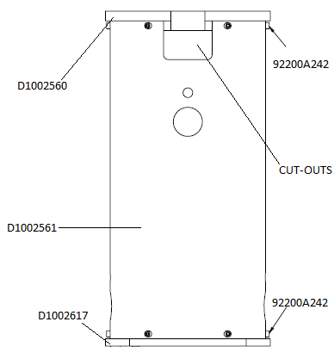
Figure 19: Eddy Current Damping Tube Assembly

- Insert D1002560 - SLC DAMPING TUBE TOP PLATE into D1002561 - SLC DAMPING 8 INCHES DIA TUBE, see Figure 19. Align with fastener holes and cut-outs.
  - Install hardware 6 places
    - 92200A242 (10-24 x ½ SHCS)

- Insert D1002617 - SLC DAMPING TUBE LOWER PLATE into D1002561 - SLC DAMPING 8 INCHES DIA TUBE, see Figure 19. Top and lower plate edges should be aligned with fastener holes.
  - Install hardware 6 places
    - 92200A242 (10-24 x 1/2 SHCS)

- Attach D1000909 – SLC COPPER PLATE to D1000929 – SLC COPPER SUPPORT PLATE.
  - Install hardware 2 places
    - 90233A815 (10-24 x 1/2 FHSC)

- Loosely attach D1000929 - SLC COPPER SUPPORT PLATE to D1002617 - SLC DAMPING TUBE LOWER PLATE in orientation shown in Figure 20. Fasteners will be tightened in Section II.E.20.
- Install hardware 2 places
- 93286A044 (#25 FLAT WASHERS ALUM)
- 95435A755 (1/4-20 x 3/4 SHCS TITANIUM)

- D1002564 serial number SN - ___________

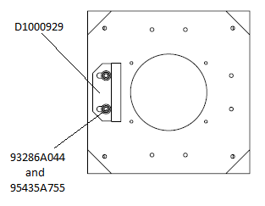
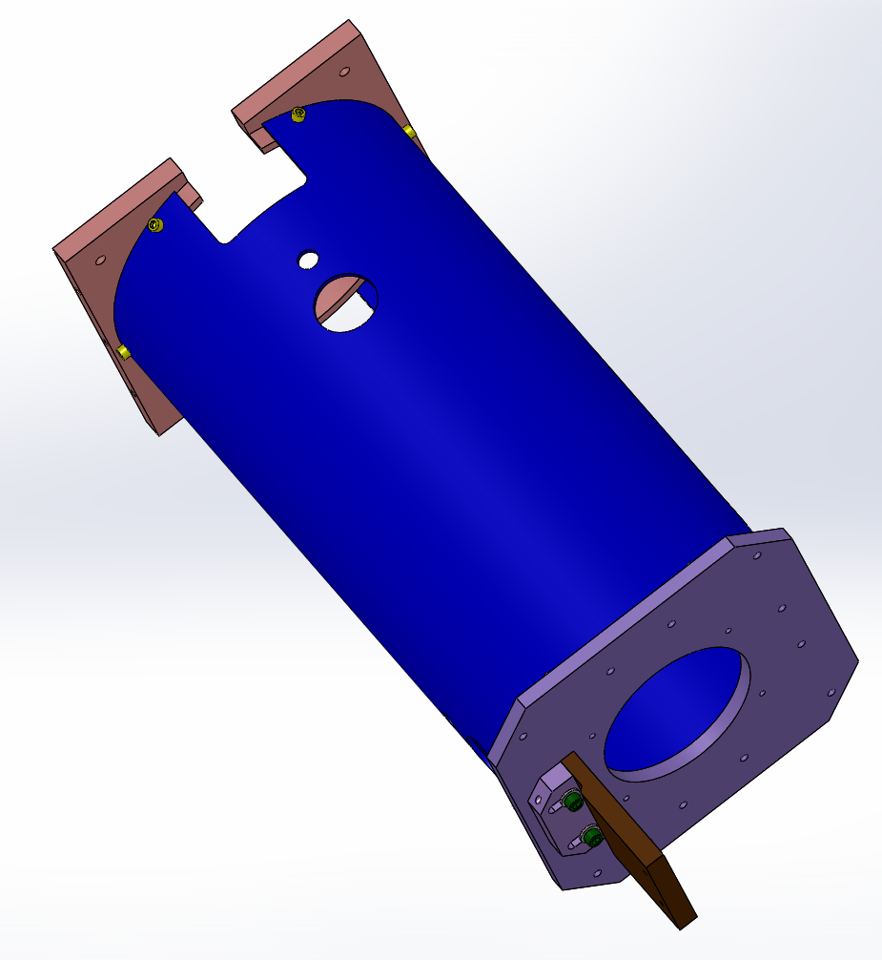

Figure 20: Copper Plate location

D1001005 - ARM CAVITY BAFFLE BLADE ASSEMBLY

Record assembly TYPE: -2 for BSC1 Record assembly serial number – SN: _____________
Record assembly TYPE: -3 for BSC3 Record assembly serial number – SN: _____________

LIGO Parts:
(1) D1002609 - SLC BLADE MOUNTING BRACKET SN:____________
(1) D1200903 - SLC ACB INTERFACE MOUNTING PLATE (BSC1) SN:____________
(1) D1200920 - SLC ACB INTERFACE MOUNTING PLATE (BSC3) SN:____________
(1) D1002608 - SLC ACB SUSPENSION BLADE SN:____________
(1) D1002844 - SLC ACB BLADE CLAMP SN:____________
(1) D1200781 - SLC ACB SUSPENSION ROD SN:____________

Hardware:
(7) C-1820-NA (5/16-18 x 1 1/4 SHCS Ag)
(7) 98019A385 (5/16 FLAT WASHER)

Tooling/Fixtures:
(1) D1101099 - ARM CAVITY BAFFLE BEND FIXTURE
(1) D1101298 - BLADE SPRING BENDING HOOK ASSEMBLY
(1) D1101184 - SLC BEND FIXTURE PLATE
(4) D1001700 - SLC INTERFACE MOUNTING CLAMP
VARIOUS 1lb-20lb WEIGHTS

Tooling/Fixture Hardware:
(4) C-2008-NA (1/4-20 x ½ SHCS Ag)
(4) 98019A355 (1/4 FLAT WASHER)
(2) C-2016-NA (1/4-20 x 1 SHCS Ag)
(2) C-2012-NA (1/4-20 x ¾ SHCS Ag)
(2) 92200A246 (10-24 x 7/8 SHCS)

Tools:
1/4” Hex L-Key tool (5/16-18 SHCS)
3/8” Wrench (#10 Hex Nut)
3/16” Hex L-Key tool (¼-20 SHCS)
5/32” Hex L-Key tool (10-24 SHCS)

SAFETY GLASSES MUST BE WORN DURING THE FOLLOWING ASSEMBLY STEPS

- Secure D1200903/ D1200920 - INTERFACE MOUNTING PLATE to table with (4) D1001700 - SLC INTERFACE MOUNTING CLAMP spread to distribute weight. Placement of clamps should allow for placement of mounting bracket in next step.
  - Install hardware 4 places
    - C-2008-NA (1/4-20 x ½ SHCS Ag)
    - 98019A355 (1/4 FLAT WASHER)

- Attach D1002609 - SLC BLADE MOUNTING BRACKET in a backwards position to top of D1200903/ D1200920 - SLC ACB INTERFACE MOUNTING PLATE using D1101290 to guide placement of bracket to measure ½” from edge of MOUNTING PLATE.
  - Install hardware 4 places
    - C-1820-N (5/16-18 x 1 ¼ SHCS)
    - 98019A385 (5/16 FLAT WASHER)

- Attach D1002844 - SLC ACB BLADE CLAMP and D1002608 - SLC ACB SUSPENSION BLADE to BLADE MOUNTING BRACKET. Blade clamp lip should line up with suspension blade.
  - Install hardware 3 places
    - C-1820-NA (5/16-18 x SHCS)
    - 98019A385 (5/16 FLAT WASHER)
Note: Guide washers out of clearance for ¼” holes.

- Attach D1101099 - aLIGO ACB BEND FIXTURE to D1002844 – SLC ACB BLADE CLAMP. Clearance holes in BEND FIXTURE fit over 3 socket head cap screws attaching BLADE CLAMP, SUSPENSION BLADE to BLADE MOUNTING BRACKET.
  - Install hardware 4 places
    - (2) C-2016-NA (1/4-20 x 1 SHCS Ag) upper placement
    - (2) C-2012-NA (1/4-20 x ¾ SHCS Ag) lower placement

- Turnover INTERFACE MOUNTING PLATE and place on table with bracket clearing edge of table, see Figure 21.

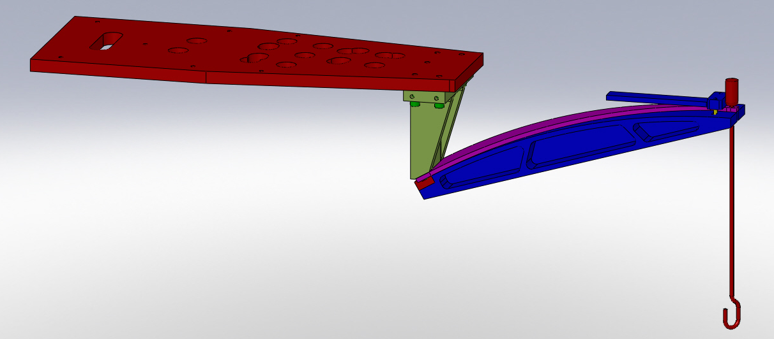
Figure 21: Spring Blade Loadin
- Secure D1200903/ D1200920 - INTERFACE MOUNTING PLATE with (4) D1001700 - SLC INTERFACE MOUNTING CLAMP spread to distribute weight. to table so that it can sustain 180 lbs. suspended from bracket.

- Attach D1101298 - BLADE SPRING BENDING HOOK ASSEMBLY to tip of D1002608 - SLC ACB SUSPENSION BLADE.

- Attach approx. 160bs of weights onto hook end of D1101298 - BLADE SPRING BENDING HOOK ASSEMBLY bending SUSPENSION BLADE to align with curve on BEND FIXTURE. Weight opening placement should be staggered.

- Record weight applied to bend blade - ________________ lbs/grams/kg

- Attach D1101184 - aLIGO ACB BEND FIXTURE PLATE to D1101099 - ARM CAVITY BAFFLE BEND FIXTURE with D1002608 - SLC ACB SUSPENSION BLADE SUSPENSION BLADE sandwiched between both parts. This should be done when spring is fully bent.
  - Install hardware in 2 places
    - 92200A246 (10-24 x 7/8 SHCS)

Note: SUSPENSION BLADE should be securely attached to BEND FIXTURE before continuing to next step.

- Slowly remove weights and D1101298 - BLADE SPRING BENDING HOOK ASSEMBLY.

- Carefully release D1200903/ D1200920 - SLC ACB INTERFACE MOUNTING PLATE from table.

- Flip assembly over and place securely on table.

- Temporarily attach (1) D1001700 – SLC INTERFACE MOUNTING CLAMP to D1200903/ D1200920 - SLC ACB INTERFACE MOUNTING PLATE - closer to the BLADE MOUNTING BRACKET to ensure clearance for removal. This will secure MOUNTING PLATE to table during assembly.

- Carefully detach the assembled D1002609 - SLC BLADE MOUNTING BRACKET from the D1200903/ D1200920 - SLC ACB INTERFACE MOUNTING PLATE, rotate 180˚ and re-attach to table.
  - Removing and installing hardware in 4 places
    - C-1820-N (5/16-18 x 1 ¼ SHCS)
    - 98019A385 (5/16 FLAT WASHER)
Note: Do not install a screw to the center hole of BLADE MOUNTING BRACKET.

- Remove D1101099 - aLIGO ACB BEND FIXTURE from D1002844 – SLC ACB BLADE CLAMP.
  - Remove hardware installed in 6 places.
    - (2) C-2016-NA (1/4-20 x 1 SHCS Ag) upper placement
    - (2) C-2012-NA (1/4-20 x ¾ SHCS Ag) lower placement
    - (2) 92200A246 (10-24 x 7/8 SHCS)

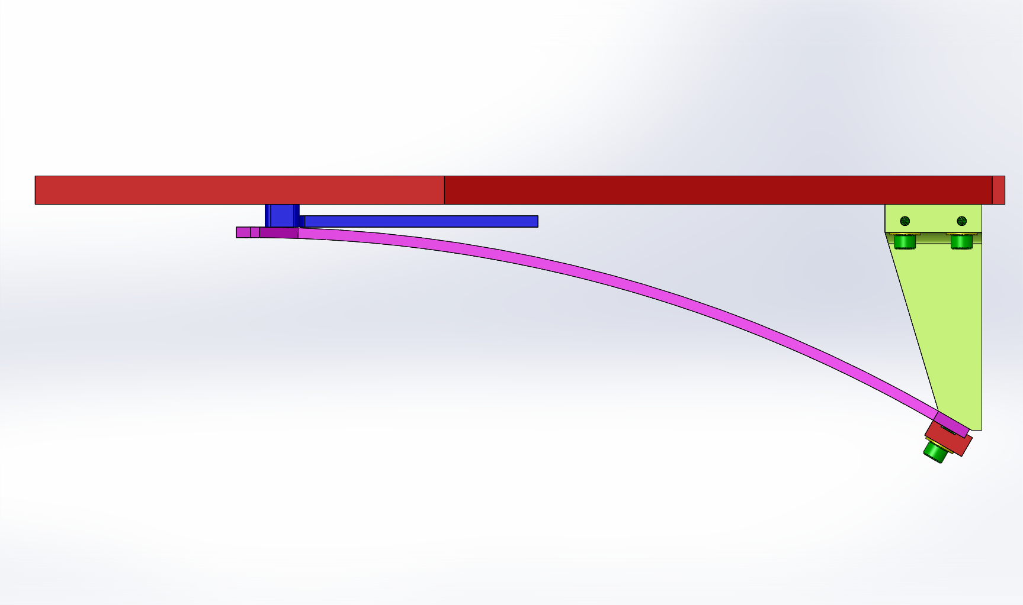

Figure 22: Blade Mounting Bracket position

- Attach D1200781 - SLC ACB SUSPENSION ROD to tip of SUSPENSION BLADE. Short threaded end into blade tip. Orient the flat of rod so that a wrench can hold the flat from the blade tip direction, see Figure 23.
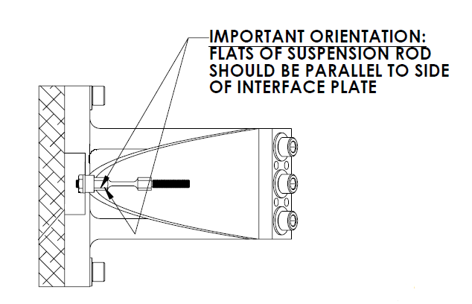

Figure 23: Suspension Rod

Note: Suspension Rod orientation is important. Make sure Suspension Rod is lined up with the center hole of the Interface Mounting Plate.

ACB SUSPENSION ASSEMBLY for BSC1 & BSC3 –

Record assembly serial number, SN: __________________

LIGO Parts and Assemblies:
(1) D1002582 - SLC BAFFLE TUBE UP ASSEMBLY SN:____________
(1) D1001005-2 – ACB BLADE ASSEMBLY (for BSC1) SN:____________
(1) D1001005-3 – ACB BLADE ASSEMBLY (for BSC3) SN:____________
(1) D1002564 - EDDY CURRENT DAMPING 8 DIA TUBE ASSY SN:____________
(2) D1201361 - EARTHQUAKE STOP SLEEVE SN:____________
(2) D1201235 – LOCKED THREADED STUD SN:____________
(2) D1001120 - SLC EARTHQUAKE STOP RING SN:____________
(1) D1001007 - ACB TUBE LO ASSEMBLY SN:____________
(1) D1300531 - ACB UPPER MOUNTING HINGE SN:____________
(4) D1300526 – UPPER HINGE CAPTIVE SCREWS
(1) D1001186 - 3/4-10 x 4 HEX HEAD SCREW, MODIFIED SN:____________
(2) D1102316 - ¾-10 x 3/8 NI-CU HEX NUT, MODIFIED SN:____________
(1) D1101285 – TRANSPORT, LOCKING BRACKET SN:____________

LIGO Assemblies:
- D1201228 – ANTI-ROTATION ASSEMBLY SN:____________
(1) D1201199– ANTI-ROTATION CLAMP SN:____________
(1) D1201198– ANTI-ROTATION BLOCK SN:____________
(6) 1185-5EN938 (HELICOIL, 5/16-18 X 0.938 LONG)
(4) 1185-4EN250 (HELI-COIL INSERT, 1/4-20 X 1/4 LG)
(6) C-1832-N (5/16-18 x 2 SHCS)
(6) WF-31 (5/16 FLAT WASHER)

Hardware:
(1) N-1024-A (10-24 HEX NUTS Ag)
(5) 98019A330 (#10 FLAT WASHER)
(4) C-2016-NA (1/4-20 x 1 SHCS Ag)
(12) 98019A355 (¼ FLAT WASHER)
(2) 98017A200 (3/8 FLAT WASHER)
(4) 92200A242 (10-24 x 1/2 SHCS)
(8) C-2016-N (1/4-20 x 1 SHCS)
(3) 98017A220 (3/4 FLAT WASHER)
(4) 98019A509 (FLAT WASHER .50 Sz)
(2) 91845A031 (3/8-16 HEX NUT)
(6) WF-25 (¼ FLAT WASHER)
(6) C-2012-N (1/4-20 x .75 SHCS)
(6) 1185-4EN250 (HELI-COIL INSERT, 1/4-20 X 1/4 LG)
(2) V1156 2-116 (2-116 FKM VITON O-RINGS 75D BLACK PARKER V747-75)

Tooling/Fixtures:
(1) D1101288 - ALIGNMENT FIXTURE, TUBE UP ASSEMBLY
(1) D1201251 - VARIABLE HEIGHT BRACKET, 9 DEGREE
(1) D1201250 – SUSPENSION ROD GAUGE
(1) D1201014 – MAGNET SPACING TOOL

Tooling/Fixture Hardware:
(4) C-2016-NA (1/4-20 x 1 SHCS Ag)
(19) 98019A355 (¼ FLAT WASHERS)
(13) 92200A540 (¼-20 x ¾ SHCS)
(1) N-2520-A (¼-20 HEX NUT Ag)

Tools:
1/4” Hex L-Key tool (5/16-18 SHCS)
1/8” Hex L-Key tool (10-24 FHCS)
3/8” Wrench (#10 Hex Nut)
3/16” Hex L-Key tool (¼-20 SHCS)
5/32” Hex L-Key tool (10-24 SHCS)
9/16” Wrench (3/8-16 Stud/Nut)
1-1/8” Wrench (¾-10 Nut)
(2) 1 1/8” Hex L-Key tool (10-32 SHCS)

Install Heli-Coil inserts into D1201198 – ANTI-ROTATION BLOCK.

Install hardware in 10 places.

(4) 1185-4EN250 (HELI-COIL INSERT, 1/4-20 X 1/4 LG)

(6) 1185-5EN938 (HELICOIL, 5/16-18 X 0.938 LONG)

Install Heli-Coil inserts into D1300531 - ARM CAVITY BAFFLE UPPER MOUNTING HINGE.

Install hardware in 6 places.

(6) 1185-4EN250 (HELI-COIL INSERT, 1/4-20 X 1/4 LG)

Add V1156 2-116 - O-Rings to D1000909 – SLC COPPER PLATE securely, 2 places.

THE FOLLOWING ASSEMBLY PROCEDURE IS PERFORMED UPSIDE DOWN WITH THE INTERFACE MOUNTING PLATE ON A TABLE

Attach hardware to D1200781 - SLC ACB SUSPENSION ROD. Located on D1001005-2/-3 - ARM CAVITY BAFFLE BLADE ASSEMBLY.

Install hardware in 1 place
    - N-1024-A (10-24 HEX NUT)
    - 98019A330 (#10 FLAT WASHER)

Using the D1201250 – SUSPENSION ROD GAUGE, install hardware on long tread of rod. Once measurement is taken loosen nut 1 ½ turns before placing tube. Be very careful not to bend the suspension rod.

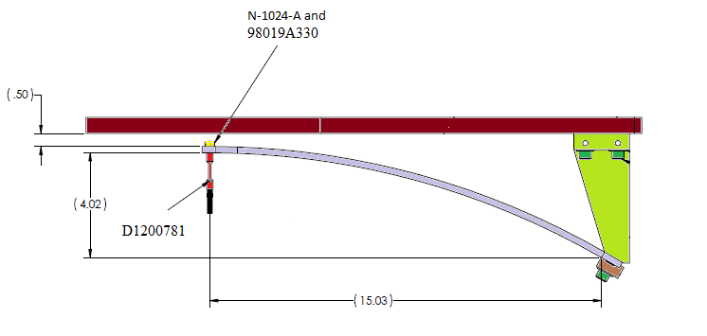

Figure 24: Suspension Rod Hardware

Temporarily place D1002564 - SLC EDDY CURRENT DAMPING 8 DIAMETER TUBE ASSEMBLY to align earthquake holes to D1002582 - SLC BAFFLE TUBE UP ASSEMBLY. Once aligned remove D1002564 - SLC EDDY CURRENT DAMPING 8 DIAMETER TUBE ASSEMBLY.

Attach D1002582 - SLC BAFFLE TUBE UP ASSEMBLY to D1200781 - SLC ACB SUSPENSION ROD located on D1001005 – ARM CAVITY BAFFLE BLADE ASSEMBLY. Screw the TUBE UP ASSEMBLY into the rod until it touches the D1201250 – SUSPENSION ROD GAUGE.

Attach D1101288 - ALIGNMENT FIXTURE, TUBE UP ASSEMBLY to D1200903/ D1200920 - SLC ACB INTERFACE MOUNTING PLATE on D1001005 – ARM CAVITY BAFFLE BLADE ASSEMBLY. Bottom slotted part must be loose to slide to the interface plate.
  - Install hardware in 2 places
    - C-2016-NA (1/4-20 x 1 SHCS Ag)
    - 98019A355 (¼ FLAT WASHER)

Align and level D1002582 - SLC BAFFLE TUBE UP ASSEMBLY. Have measuring fixture in place while twisting TUBE UP.

Attach D1101288 - ALIGNMENT FIXTURE, TUBE UP ASSEMBLY to the bottom of D1002582 - SLC BAFFLE TUBE UP ASSEMBLY.
  - Install hardware in 2 places
- C-2016-N (1/4-20 x 1 SHCS)
- 98019A355 (¼ FLAT WASHER)

Recheck measurement by holding suspension rod in place with wrench. With an addition wrench tighten the nut at correct measurement. Be sure not to let rod twist.

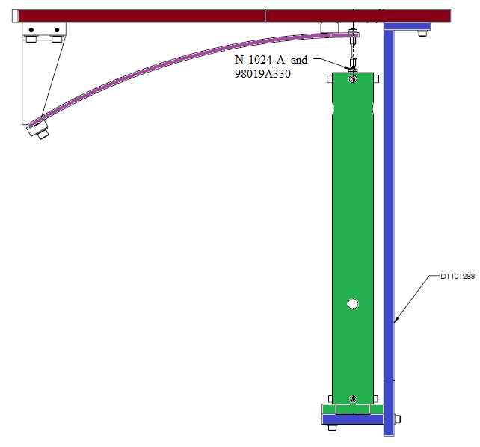
Figure 25: Suspension Rod and Tube Up Assembly

Remove D1101288 - ALIGNMENT FIXTURE, TUBE UP ASSEMBLY.
  - Remove hardware in 4 places
    - C-2016-NA (1/4-20 x 1 SHCS Ag)
    - 98019A355 (¼ FLAT WASHER)

Place D1002564 - SLC EDDY CURRENT DAMPING 8 DIAMETER TUBE ASSEMBLY on D1001005 – ARM CAVITY BAFFLE BLADE ASSEMBLY. With one person holding base of UP TUBE ASSEMBLY, then reaching inside of 8” TUBE and grabbing loose end of UP TUBE ASSEMBLY.

Insert (2) D1201235 – LOCKED THREADED STUD through D1002564 - SLC EDDY CURRENT DAMPING 8 DIAMETER TUBE ASSEMBLY and D1002582 - SLC BAFFLE TUBE UP ASSEMBLY. Mate STUD to (2) D1201361 - EARTHQUAKE STOP SLEEVE. TUBE UP ASSEMBLY needs to be held while threaded studs are getting placed.
  - Install hardware in 2 places (stud, .5 washer, tube, .5 washer, sleeve, 3/8 washer, nut).

98017A200 (3/8 FLAT WASHER)

98019A509 (FLAT WASHER .50 Sz)

91845A031 (3/8-16 HEX NUT)

Attach D1002564 - SLC EDDY CURRENT DAMPING 8 DIAMETER TUBE ASSEMBLY to D1001005 – ARM CAVITY BAFFLE BLADE ASSEMBLY. Measurement from end of mounting plate to base of 8” TUBE should be ½”. TUBE UP ASSEMBLY still being held in place until EQ RING in Step 18 is in place.
  - Install hardware in 4 places
    - C-2016-NA (1/4-20 x 1 SHCS Ag)
    - 98019A355 (¼ FLAT WASHER

Attach (2) D1001120 - SLC EARTHQUAKE STOP RING to D1002564 - SLC EDDY CURRENT DAMPING 8 DIAMETER TUBE ASSEMBLY.
  - Install hardware in 4 places
    - 92200A242 (10-24 x ½ SHCS)
    - 98019A330 (#10 FLAT WASHER)

Attach D1001007 - ACB TUBE LO ASSEMBLY to D1002582 - SLC BAFFLE TUBE UP ASSEMBLY. Loosely, do not tighten.
  - Install hardware in 4 places
    - C-2016-N (1/4-20 x 1 SHCS)

98019A355 (¼ FLAT WASHER)

Adjust distance between the magnets and COPPER PLATE to be 0.090” using D1201014 – MAGNET SPACING TOOL. Tighten screws from Section II.C.4.

Attach D1101285 - TRANSPORT, LOCKING, ACB to D1002564 - SLC EDDY CURRENT DAMPING 8 DIAMETER TUBE ASSEMBLY and D1001007 - ACB TUBE LO ASSEMBLY. Place on side next to BLADE base. Align flush to 8” TUBE edge and tighten.
  - Install hardware in 4 places

C-2016-N (1/4-20 x 1 SHCS)

98019A355 (¼ FLAT WASHER)

Tighten TUBE LO ASSEMBLY to TUBE UP ASSEMBLY and loosen D1101285 - TRANSPORT, LOCKING, ACB.

Assemble D1300531 - ARM CAVITY BAFFLE UPPER MOUNTING HINGE to D1001186 (SCREW HEX HD 3/4-10 x 4, MODIFIED)
  - Install hardware listed (screw, washer, hinge, washer, nut, nut, washer, tube)
    - (2) D1102316 (3/4-10 x 3/8 HEX NUT NI-CU, MODIFIED)
    - (3) 98017A220 (¾ FLAT WASHER)

Attach D1201198 – ANTI-ROTATION BLOCK to D1300531 - ARM CAVITY BAFFLE UPPER MOUNTING HINGE.
  - Install hardware in 6 places
    - C-2012-N (1/4-20 x ¾ SHCS)
    - WF-25 (1/4 FLAT WASHER)

Insert D1001186 (SCREW HEX HD 3/4-10 x 4, MODIFIED) into D1001007 - ACB TUBE LO ASSEMBLY. Screw in approximately 1.5 inches. Final rest should have the hinge of the D1300531 - ARM CAVITY BAFFLE UPPER MOUNTING HINGE positioned on the same side as the D1000909 – SLC COPPER PLATE.

Attach D1201251 VARIABLE HEIGHT BRACKET, 9 DEGREE to 8” TUBE. Place on side opposite to BLADE base. Edge of BRACKET should be flush with 8” TUBE base. Tighten to 8” TUBE base.
  - Install hardware in 2 places.

92200A540 (1/4-20 x 3/4 SHCS)

98019A355 (¼ FLAT WASHER)

Adjust distance between D1300531 - ARM CAVITY BAFFLE UPPER MOUNTING HINGE and D1001007 - ACB TUBE LO ASSEMBLY by Bolt and Nuts. The scribe line on D1201198 – ANTI-ROTATION BLOCK must line up with the scribe line on D1201251 VARIABLE HEIGHT BRACKET, 9 DEGREE.

Attach D1201251 VARIABLE HEIGHT BRACKET, 9 DEGREE to D1300531 - ARM CAVITY BAFFLE UPPER MOUNTING HINGE and D1201198 – ANTI-ROTATION BLOCK.
- Install hardware in 4 places

92200A540 (¼-20 x ¾ SHCS)

98019A355 (¼ FLAT WASHER)

Tighten D1001186 - SCREW HEX HD 3/4-10 x 4, MODIFIED against D1300531 - ARM CAVITY BAFFLE UPPER MOUNTING HINGE and D1001007 - ACB TUBE LO ASSEMBLY.

Attach D1201199 – ANTI-ROTATION CLAMP to the D1201198 – ANTI-ROTATION BLOCK.
- Install hardware in 6 places

C-1832-N (5/16-18 x 2 SHCS)

WF-31 (5/16 FLAT WASHER)

Set spacing between MAGNETS and COPPER PLATE to approximately 0.090 using D1201014 – MAGNET SPACING TOOL. Tighten the COPPER PLATE to the 8” TUBE.

- Insert (4) D1300526 - ACB MOUNTING HINGE CAPTIVE SCREWS to D1300531 - ARM CAVITY BAFFLE UPPER MOUNTING HINGE

Torque all screws, as required.

Weigh assembly and record: _______________ lbs. (kg/grams)

