LIGO Laboratory / LIGO Scientific Collaboration

LIGO- E1100859-V3 LIGO March 26th, 2014

L1 BSC 5 (ETMTY) BSC-ISI, Pre-integration Testing report,
Phase II
E1100859-v3

Jeremy Birch, Joe Hanson, Mike Vargas, Céline Ramet

Distribution of this document:
Advanced LIGO Project

This is an internal working note
of the LIGO Laboratory

California Institute of Technology  LIGO Project – MS 18-34  1200 E. California Blvd.  Pasadena, CA 91125  Phone (626) 395-2129  Fax (626) 304-9834  E-mail: info@ligo.caltech.edu | Massachusetts Institute of Technology  LIGO Project – NW22-295  185 Albany St  Cambridge, MA 02139  Phone (617) 253-4824  Fax (617) 253-7014  E-mail: info@ligo.mit.edu
LIGO Hanford Observatory  P.O. Box 1970  Mail Stop S9-02  Richland WA 99352  Phone 509-372-8106  Fax 509-372-8137 | LIGO Livingston Observatory  P.O. Box 940  Livingston, LA 70754  Phone 225-686-3100  Fax 225-686-7189

Table of contents:

Introduction 4
1. Phase II-a 5
1. Hardware changes 5
1. CPS – E1100369 5
2. GS13 – E1100740 5
3. L4C – E1100740 5
4. T240 – E1100740 5
5. Cables – E1100822 5
6. Misc 5
2. Electronic Inventory 6
3. Models Modifications 6
4. Mass distribution 6
1. Seismic 6
2. Suspension 6
3. Misc 7
4. Total 7
5. Basic functionalities just after installing the BSC-ISI on the test stand 7
1. Pressure sensors 7
2. Spectra 8
3. Actuators-cables resistance 9
4. Offsets CPS Unlocked vs locked 9
5. Offset local drive 10
6. Offset Cartesian drive 10
7. Range of motion 11
8. Linearity test 11
6. Transfer functions and Comparison with measurements done in the staging building. 13
1. At the end station 13
2. Comparisons with measurements in the staging building –not done yet 17
7. Conclusion Phase II-a 18
2. Phase II-b 19
1. Hardware changes 19
1. CPS – E1100369 19
2. GS13 – E1100740 19
3. L4C – E1100740 19
4. T240 – E1100740 19
5. Cables – E1100822 19
6. Misc 19
2. Electronic Inventory 19
3. Models Modifications 19
4. Mass distribution –not updated yet 20
1. Seismic 20
2. Suspension 21
3. Misc 21
4. Total 22
5. Basic functionalities just after installing the BSC-ISI on the test stand 23
5. Pressure sensors 23
6. Spectra 23
7. Actuators-cables resistance 23
8. Offsets CPS Unlocked vs locked 24
9. Offset local drive 24
10. Offset Cartesian drive 25
11. Range of motion 26
12. Linearity test 26
6. Transfer functions and Comparison with measurements done in the staging building. 27
13. At the end station 27
14. Comparisons with measurements on test stand-not done yet 28
7. Conclusion Phase II-b 29
Conclusion 31

Introduction

The BSC-ISI testing is performed in three phases:
1) BSC-ISI, Pre-integration Testing, Phase I (post-assembly, in the staging building)
2) BSC-ISI, Pre-integration Testing, Phase II: Final tests done before insertion in the chamber
3) BSC-ISI, Integration Phase Testing: Procedure and results related to the commissioning in the chamber.

The ISI-BSC5 (5th and final unit built at LLO) was moved from the Staging building to the Y end on July 11th 2013. Then the ISI was placed on the test stand a few days later, and connected to readouts within August 2013.

This document presents results from the series of tests (Phase II) performed on the ISI-BSC5 (ETMY) in the corner station. The tests were done with the ETMY quadruple suspension installed in its final version and TMS fully assembled.

First tests on test stand started on February 7th, 2014. The first testing phase (II-a validation before cartridge installation) was completed on February 13th 2014.

All results are posted on the SVN at:
https://svn.ligo.caltech.edu/svn/seismic/BSC-ISI/L1/ETMY/

The following types of documents can be found in the SVN:
- Data location
- Figures location

Phase II-a

Hardware changes

CPS – E1100369
No change.

GS13 – E1100740
GS13 have not been replaced since phase I testing in the staging building.

L4C – E1100740
L4C have not been replaced since phase I testing in the staging building.

T240 – E1100740
T240s have not been replaced since phase I testing in the staging building.

Cables – E1100822
No cable have been replaced since phase I testing in the staging building.

Misc
No hardware changes since phase I testing in the staging building.

Electronic Inventory
Final electronics were used, as recorded by the electronics group.

Models Modifications
No model modifications were done between the beginning and the end of Phase 2a testing.

Mass distribution

Seismic

Stage 1

Stage 1 | HighBay (lbs) | LVEA (lbs) | LVEA (kg)
Corner 1 | 49.22 | 43.72 | 19.83
Corner 2 | 22.86 | 40.22 | 18.24
Corner 3 | 32.22 | 34.72 | 15.75
Total | 104.3 | 118.66 | 53.82

Note: 2 vibrations absorbers are installed on all doors (their weight is included in that mass distribution)

Stage 2
The seismic masses on BSC 5 are:

- On the side and on the Keel: 895.7 lbs (=406.28 kg)
- On the Optical Table (6) D1003161: 270.43 lbs (=122.67 kg)

The total of masses on Stage 2 is: 1166.1 lbs (=528.89 kg).

Suspension
The quad and the TMS were weighed to be:

SUS | Weight (lbs) | Weight (kg)
Total | 777 | 352.44

TMS | Weight (lbs) | Weight (kg)
Total | 456.14 | 206.9

Misc
- 44 lbs = quad sleeve [Betsy’s alog 3621]
- 2 lbs = quad sleeve wedges [estimate]
- 5 lbs = cabling [estimate]
- 2 lbs cable brackets [estimate]
- 28 lbs = Vibration absorbers, quantity 4 [from E1000337-v2: 12.7 kg = 28 lbs]
- 3 lbs = Ring heater + brackets + cables [estimate]

Total Weight for Suspension: 906 lbs = 412 kg
Total Weight for TMS: 456.14 lbs = 206.9 kg

Total
Nominal mass hanging on stage 0-1 blades (without stage 2): 912Kg – 2010lb
Nominal mass hanging on stage 1-2 blades: 2830Kg – 6239lb
Nominal payload on stage 1: 109Kg – 240lb
Nominal payload on stage 2: 1185Kg – 2612lb

 |  |  | Staging Bldg | LVEA
 |  | Plan | 04/01/2013 | Detail | Overall | Difference
Stage 1 (kgs) |  | 108.86 | 53.37 | 53.82 | 53.82 | +0.45
Stage 2 (kgs) | Masses | 1183.42 | 1137.61 | 528.89 | 1139.11 | +1.5
Stage 2 (kgs) | Suspension | N/A | N/A | 559.34 | 1139.11 | +1.5
Stage 2 (kgs) | Miscellaneous | N/A | N/A | 50.88 | 1139.11 | +1.5
Total (kgs) |  | 1292.28 | 1190.98 | 1192.93 | 1192.93 | +1.95

Test result: Passed: X Failed: . W Waived: _

Basic functionalities just after installing the BSC-ISI on the test stand

Pressure sensors
All pressure sensors are working.
https://svn.ligo.caltech.edu/svn/seismic/BSC-ISI/L1/ETMY/Data/Static_Tests/
L1_ISI_ETMY_Pressure_Sensors_Check_Calibrated_2014_02_12_135144.mat

 | Pressure (KPa)
Sensors | Corner 1 | Corner 2 | Corner 3
ST1-L4C-P | 98.7 | 99.1 | 100.2
ST1-L4C-D | 0.5 | 0.1 | -0.2
ST1-GS13-P | 100.6 | 101.5 | 99.9
ST1-GS13-D | 1.0 | 0.1 | 1.4
ST1-T240-P | 101.4 | 102.0 | 101.6
Table 1 - Geophones Pressure sensors

Test result: Passed: X Failed: . W Waived: _

Spectra
Spectra of the instrument can be found in the SVN at:
seismic/BSC-ISI/L1/ETMY/Data/Spectra/Undamped/
L1_ISI_ETMY_ASD_m_LOC_CPS_T240_L4C_GS13_2014_02_12_132002.mat

seismic/BSC-ISI/L1/ETMY/Data/Figures/Spectra/Undamped/
L1_ISI_ETMY_ASD_m_LOC_CPS_T240_L4C_GS13_2014_02_12_132002.fig

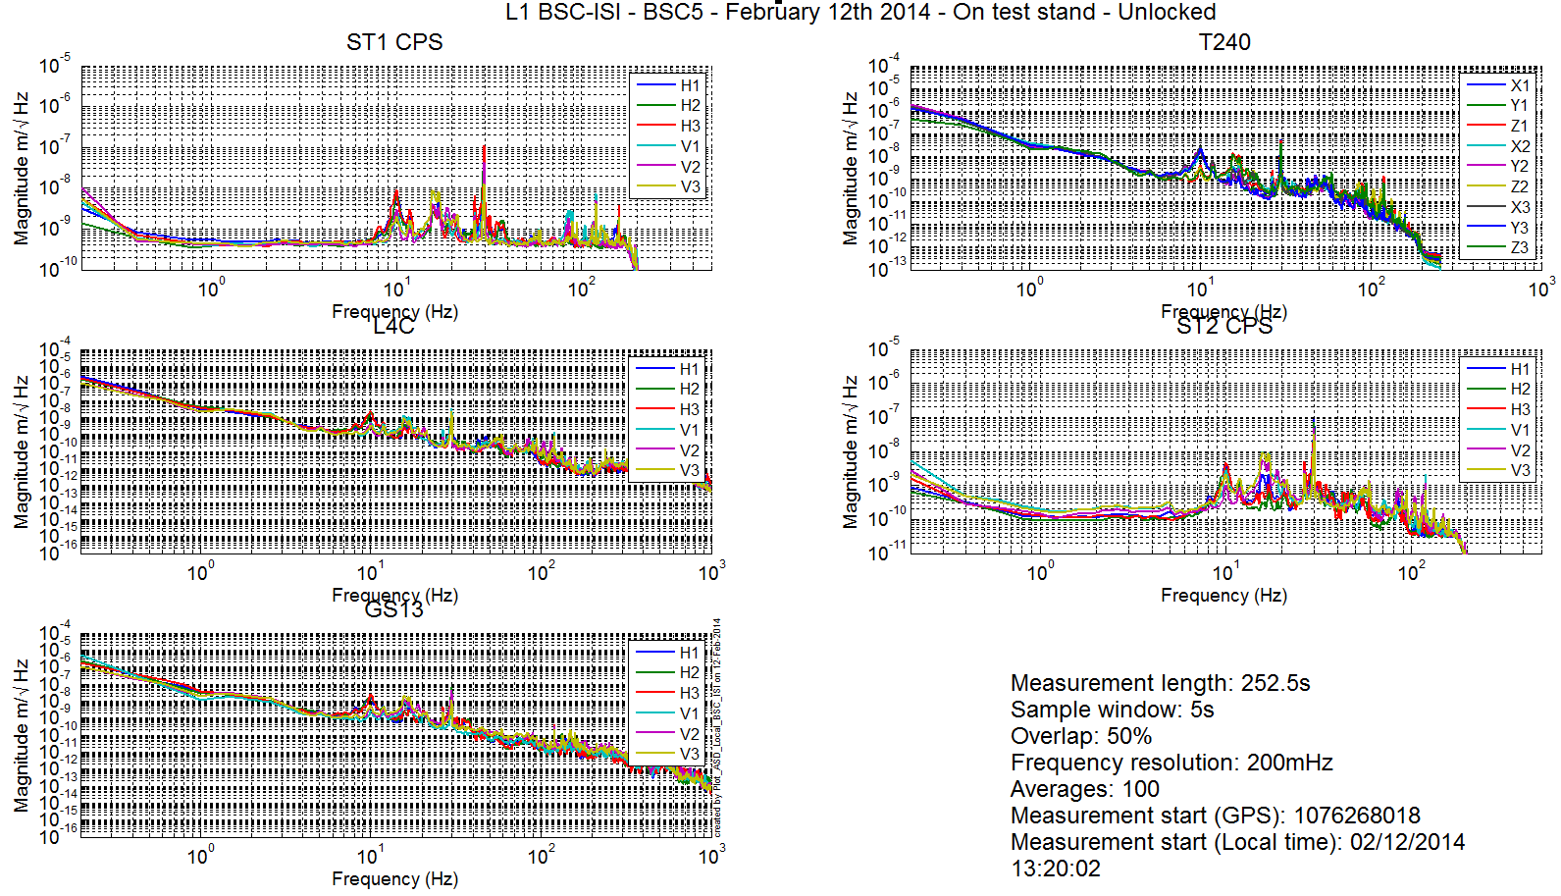
Figure 1 - Spectra inboard instruments - ISI Locked

If one zooms into the GS13 figure:

Test result: Passed: Failed: . W Waived: X

Actuators-cables resistance

Test redundant with linearity test and others. It was therefore waived by lack of time.
Test result: Passed: Failed: . W Waived: _X

Offsets CPS Unlocked vs locked
Table was balanced to allow for testing, using dial indicators. Those measurements were not taken by lack of time. This is not an issue since final balancing will be done in chamber after keel masses have been installed.

Test result: Passed: Failed: . W Waived: X

Offset local drive
Note: Due to longer cables, offsets measured by CPS for a 7000 count drive are slightly lower than offsets measured in the staging building.

Results of this test can be found in the SVN at:
https://svn.ligo.caltech.edu/svn/seismic/BSC-ISI/L1/ETMY/Data/Static_Tests/
- L1_ISI_ETMY_Offset_Local_Drive_20140210.mat

 |  | Sensors
 |  | ST1 - H1 | ST1 - H2 | ST1 - H3 | ST1 - V1 | ST1 - V2 | ST1 - V3
Actuators | ST1 - H1 | 3617.0 | 1429.0 | 1417.6 | 28.7 | -47.6 | 19.7
Actuators | ST1 - H2 | 1408.5 | 3467.7 | 1365.8 | -4.6 | -11.6 | 39.4
Actuators | ST1 - H3 | 1381.2 | 1343.6 | 3416.0 | 48.6 | -65.2 | 7.5
Actuators | ST1 - V1 | 81.0 | -112.9 | 116.4 | 2683.3 | -377.6 | -383.6
Actuators | ST1 - V2 | 23.9 | -41.5 | -193.6 | -349.7 | 2588.1 | -456.3
Actuators | ST1 - V3 | -100.6 | 121.1 | 58.6 | -374.0 | -436.7 | 2630.8
Table 2 - Static Tests – Local to Local - Stage 1

 |  | Sensors
 |  | ST2 - H1 | ST2 - H2 | ST2 - H3 | ST2 - V1 | ST2 - V2 | ST2 - V3
Actuators | ST2 - H1 | 2087.8 | 312.8 | 326.3 | -20.1 | 12.3 | 9.9
Actuators | ST2 - H2 | 286.9 | 1965.1 | 299.2 | -11.6 | 6.8 | 5.8
Actuators | ST2 - H3 | 324.9 | 303.9 | 2066.6 | -38.0 | 24.0 | -8.6
Actuators | ST2 - V1 | 67.8 | 117.8 | -164.0 | 2412.0 | 390.5 | 79.5
Actuators | ST2 - V2 | -163.0 | 86.1 | 101.2 | 56.2 | 2345.0 | 267.6
Actuators | ST2 - V3 | 102.3 | -182.1 | 62.4 | 371.1 | 17.1 | 2411.2
Table 3 - Static Tests – Local to Local - Stage 2

Test result: Passed: X Failed: . W Waived: _

Offset Cartesian drive
The test was not performed because it only tests the matrices, which can be changed at any time.

Test result: Passed: _ Failed: . W Waived: X_

Range of motion
The range of motion of the table is measured by pushing on the table in a direction collinear to the CPS. The Static tests results can be found on the SVN at:
seismic/BSC-ISI/L1/ETMY/Data/Static_Tests/
- L1_ISI_ETMY_Range_Of_Motion_20140210.mat

Sensor readout (counts) | Negative drive | no drive | Positive drive | Amplitude count | mil
ST1 - H1 | -16311 | -556 | 14621 | 30933 | 36.82
ST1 - H2 | -15391 | -176 | 14679 | 30070 | 35.79
ST1 - H3 | -14812 | 297 | 14568 | 29380 | 34.97
ST1 - V1 | -11731 | -905 | 11462 | 23193 | 27.61
ST1 - V2 | -8896 | 1600 | 13548 | 22444 | 26.72
ST1 - V3 | -10214 | 96 | 12751 | 22965 | 27.34
ST2 - H1 | -13128 | -4832 | 4743 | 17871 | 5.32
ST2 - H2 | -8093 | -282 | 8569 | 16662 | 4.96
ST2 - H3 | -5106 | 3198 | 12482 | 17587 | 5.24
ST2 - V1 | -12263 | -4225 | 8433 | 20696 | 6.16
ST2 - V2 | -5714 | 2140 | 14403 | 20117 | 5.99
ST2 - V3 | -4796 | 2547 | 15878 | 20674 | 6.15
Table 4 - Range of motion - Actuator drive in the LVEA

Test result: Passed: X Failed: . W Waived: _

Linearity test
The data of the linearity test can be found on the SVN at:
seismic/BSC-ISI/L1/ETMY/Data/Linearity_Test/
- L1_ISI_ETMY_Linearity_test_20140210.mat

The figures of the linearity test can be found on the SVN at:
seismic\BSC-ISI\H2\BS\Data\Figures\Linearity_Test\
- L1_ISI_ETMY_Linearity_test_20140210.fig

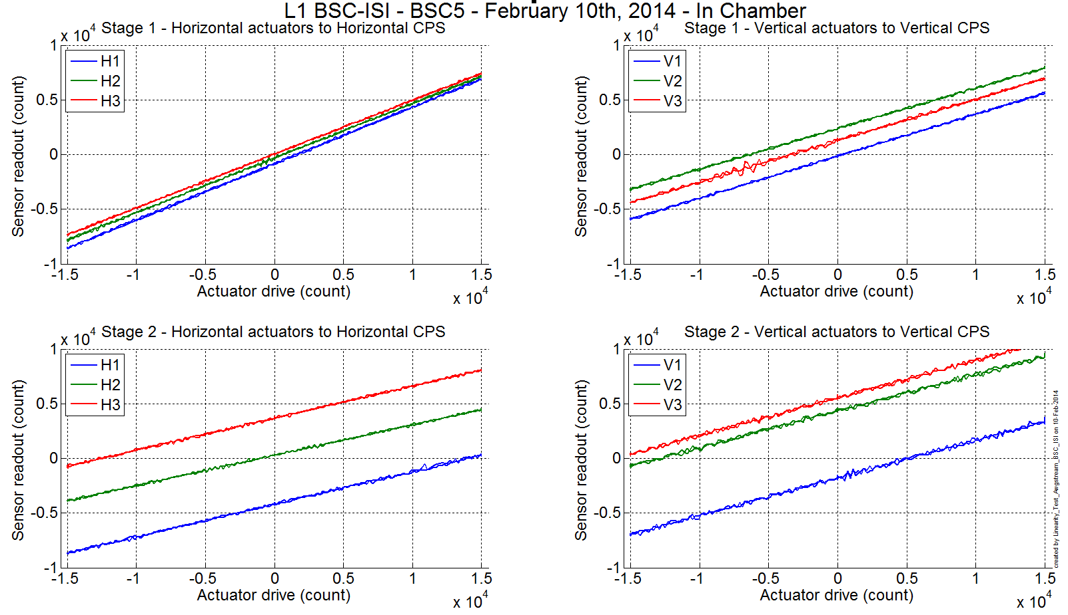
Figure 2 - Linearity test –L1 - ETMY – In Y-VEA

 |  | Slope | Offset | Average slope | Variation from  average(%)
Stage 1 | ST1 - H1 | 0.515 | -829.2 | 0.502 | 2.61
Stage 1 | ST1 - H2 | 0.499 | -321.5 | 0.502 | -0.61
Stage 1 | ST1 - H3 | 0.492 | 39.6 | 0.502 | -2.01
Stage 1 | ST1 - V1 | 0.384 | -147.8 | 0.378 | 1.67
Stage 1 | ST1 - V2 | 0.371 | 2370.8 | 0.378 | -1.89
Stage 1 | ST1 - V3 | 0.379 | 1280.5 | 0.378 | 0.22
Stage 2 | ST2 - H1 | 0.298 | -4188.5 | 0.290 | 2.91
Stage 2 | ST2 - H2 | 0.278 | 286.7 | 0.290 | -4.15
Stage 2 | ST2 - H3 | 0.294 | 3680.1 | 0.290 | 1.24
Stage 2 | ST2 - V1 | 0.344 | -1784.1 | 0.341 | 1.14
Stage 2 | ST2 - V2 | 0.334 | 4332.2 | 0.341 | -2.01
Stage 2 | ST2 - V3 | 0.344 | 5536.1 | 0.341 | 0.87
Table 5 - Slope – Offset Linearity test

Test result: Passed: _ Failed: . W Waived: X_

Transfer functions and Comparison with measurements done in the staging building.

At the end station
The parameters for the measurements in the Y-VEA are slightly different from those in the staging building. We chose to have weaker excitation but longer averages in an effort to reduce risk to the attached suspension.

At this point, only the tuned mass dampers on the ISI springs and ISI stage 1 vibration absorbers are installed.

Measurements data can be found in the SVN at:
SeiSVN/seismic/BSC-ISI/L1/ETMY/Data/Transfer_Functions/Measurements/Undamped:
- L1_ISI_ETMY_Data_L2L_10mHz_100mHz_ST1_ST2_20140213-065705.mat
- L1_ISI_ETMY_Data_L2L_100mHz_700mHz_ST1_ST2_20140219-230124.mat
- L1_ISI_ETMY_Data_L2L_700mHz_10Hz_ST1_ST2_20140219-141519.mat
- L1_ISI_ETMY_Data_L2L_10Hz_100Hz_ST1_ST2_20140219-211418.mat
- L1_ISI_ETMY_Data_L2L_100Hz_500Hz_ST1_ST2_20140213-061700.mat
- L1_ISI_ETMY_Data_L2L_500Hz_1000Hz_ST1_ST2_20140213-054420.mat

Data after processing can be found in the SVN at:
SeiSVN/seismic/BSC-ISI/L1/ETMY/Data/Transfer_Functions/Simulations/Undamped
- L1_ISI_ETMY_TF_L2L_Raw_10mHz_1000Hz_2014_02_19.mat

The transfer functions can be found in the SVN at:
seismic/BSC-ISI/L1/ETMY/Data/Figures/Transfer_Functions/Measurements/Undamped/
- L1_ISI_ETMY_TF_L2L_Raw_from_ST1_ACT_to_ST1_CPS_2014_02_19.fig
- L1_ISI_ETMY_TF_L2L_Raw_from_ST1_ACT_to_ST1_L4C_2014_02_19.fig
- L1_ISI_ETMY_TF_L2L_Raw_from_ST1_ACT_to_ST1_T240_2014_02_19.fig
- L1_ISI_ETMY_TF_L2L_Raw_from_ST2_ACT_to_ST2_CPS_2014_02_19.fig
- L1_ISI_ETMY_TF_L2L_Raw_from_ST2_ACT_to_ST2_GS13_2014_02_19.fig

Note 1: The transfer functions are measured from the Output filters bank excitation point to the input (IN1) of the input filters bank. The transfer functions presented below are raw transfer functions without any electronic compensation.

Note 2: The L4Cs are out of phase (should be -90 before 1Hz). A minus sign is added in the calibration filters that convert count to nm/s.

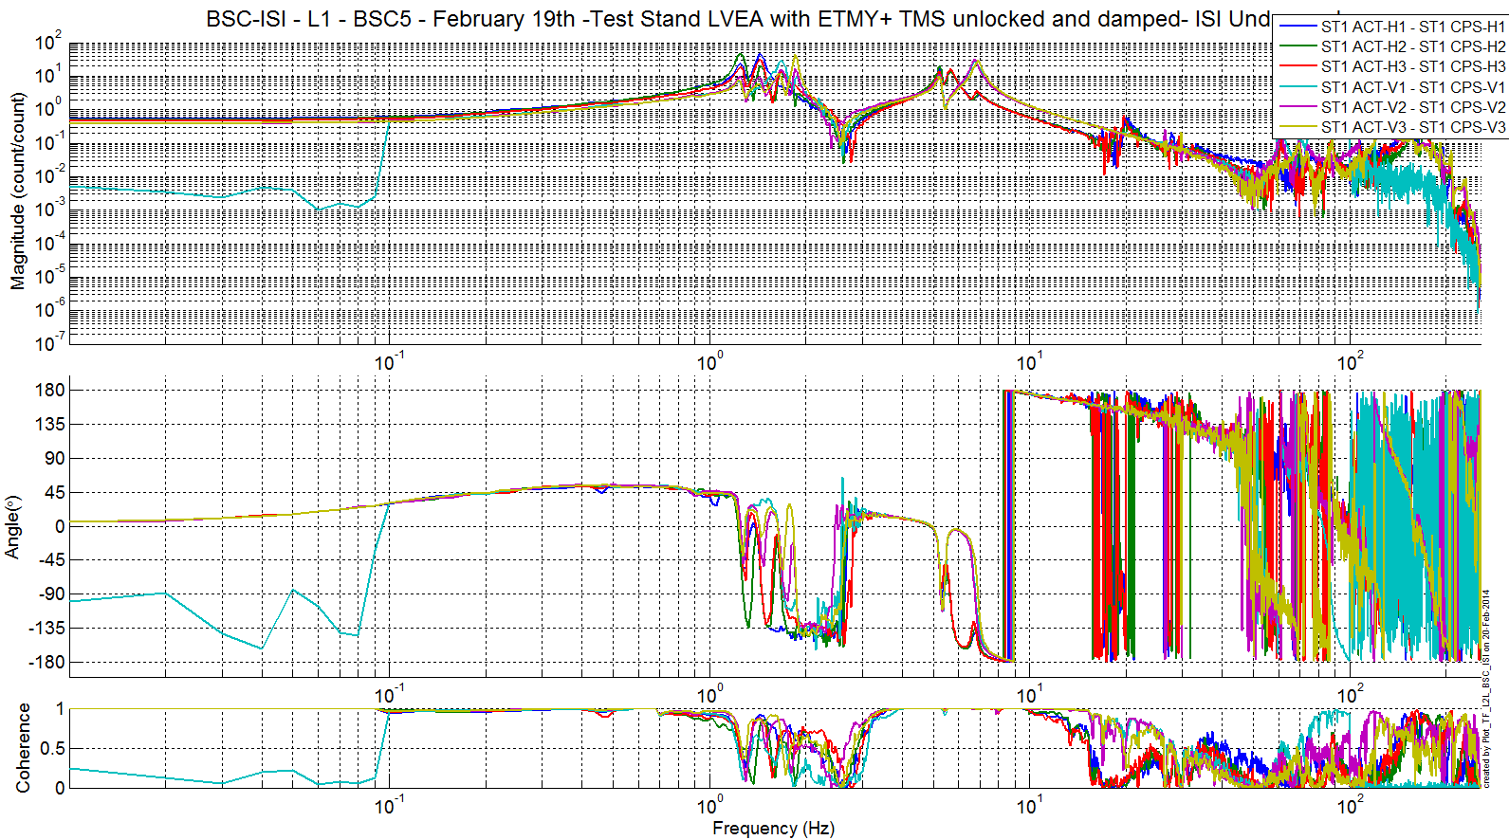
Figure 3 - ST1 ACT to ST1 CPS

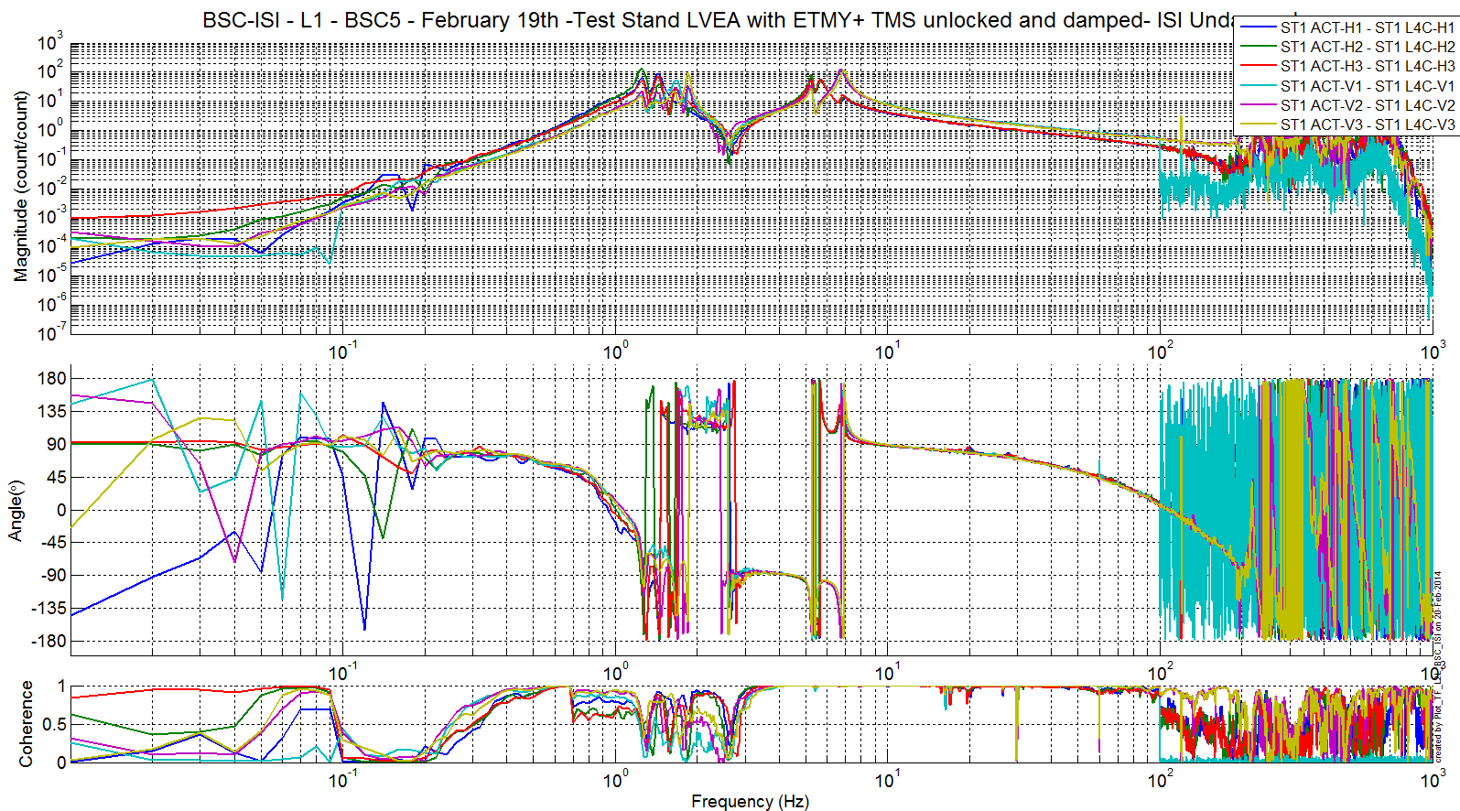
Figure 4 - ST1 ACT to ST1 L4C

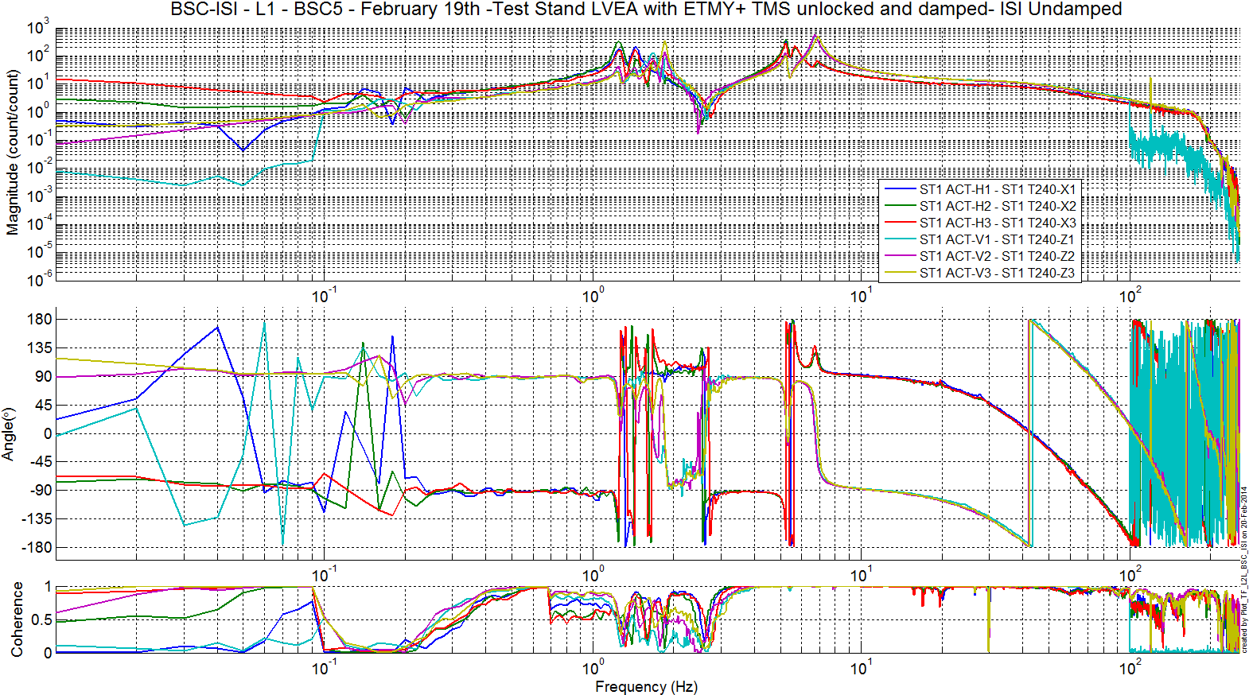
Figure 5 - ST1 ACT to ST1 T240

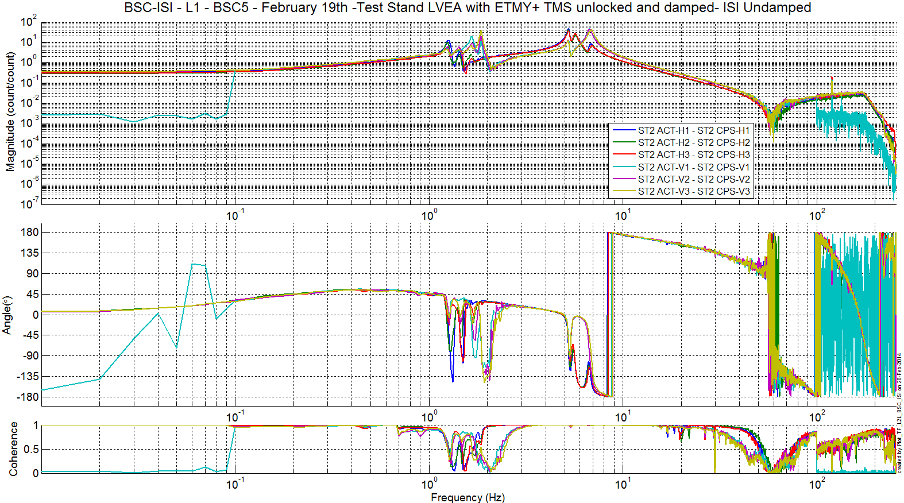
Figure 6 - ST2 ACT to ST2 CPS

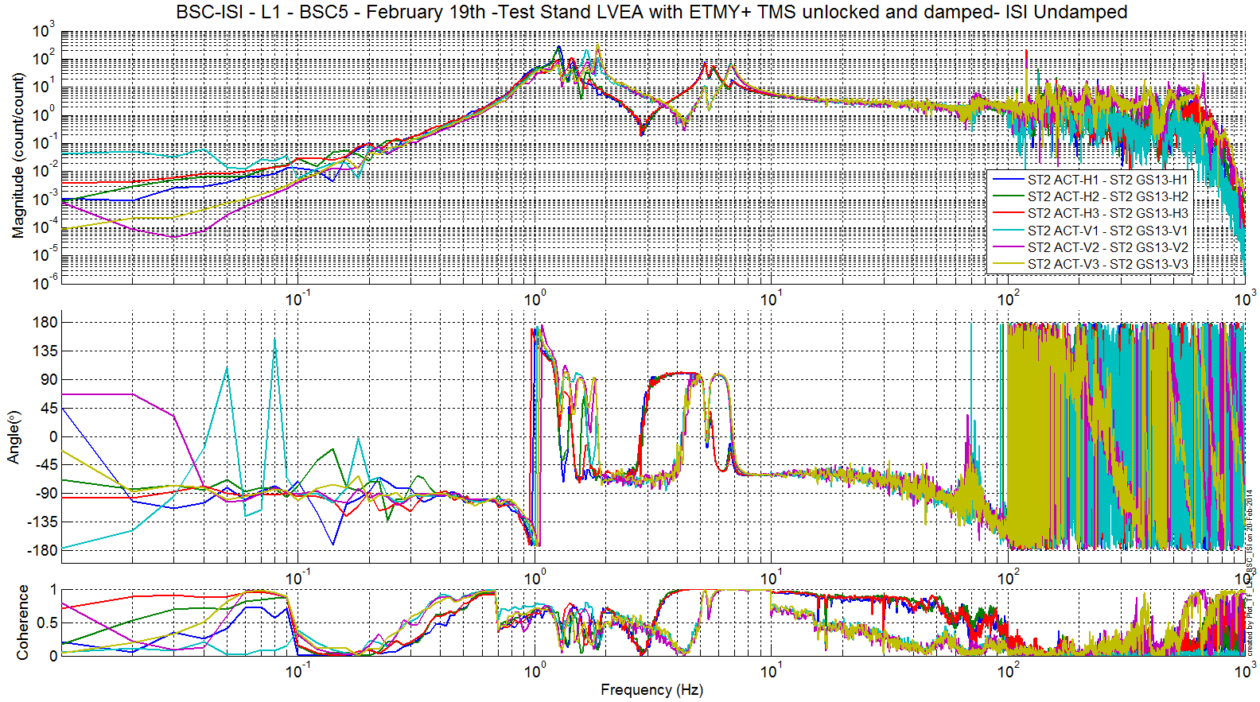
Figure 7 - ST2 ACT to ST2 GS13

Note 3: Around the first few resonances of the ISI (between 1 and 2 Hz), there seems to be some cross-coupling between the horizontal and vertical degrees of freedom. This seems to have been improved by improving the balancing of the ISI. Some cross-coupling was also visible on BSC 4 but not as strong. Too tight cables?

Note 4: st2 watchdogs tripped during part of the test.

Note 5: On the ST1-ACT-H to ST1-CPS-H transfer functions, we can see the first resonances of the LVEA test stand around 20 Hz.

Note 6: GS13 V1 issue appears to be fixed in the very latest measurements (100 mHz to 100 Hz)

Note 7: The blurry resonances at ~20 and 30 Hz on the ST1 ACT to ST1 CPS tf appears to be due to the scaffolding installed on the test stand. Those should disappear for much neater resonances of the support structure, after installation inside the chamber.

Comparisons with measurements in the staging building –not done yet
The script used to compare transfer function can be found in the SVN at:
SeiSVN/seismic/BSC-ISI/L1/ETMY/Scripts/Misc
- Comparison_TF_L2L_LLO_ISI_BSC2.m

The figure that shows the comparison between the transfer functions of the staging building and the LVEA are located in the SVN at:
SeiSVN/seismic/BSC-ISI/L1/ETMY/Data/Figures/Transfer_Functions/Measurements/Comparison/
- COMP_LVEA_L1_ISI_ETMY_ST1_CPS_2012_10_31_.fig
- COMP_LVEA_L1_ISI_ETMY_ST1_L4C_2012_10_31_.fig
- COMP_LVEA_L1_ISI_ETMY_ST2_CPS_2012_10_31_.fig
- COMP_LVEA_L1_ISI_ETMY_ST2_GS13_2012_10_31_.fig
Main differences are:
- The DC gains (cables resistance is different due to the length difference)
- Resonances of the rigid body modes [1; 10]Hz (different payload) It is especially visible from 1 to 2 Hz on all sensors.
- ST1-CPS resonances different in the staging building and EY (Test stand short legs vs long legs).
- Resonance at 20.5 Hz on stage 2 sensors (4th vertical mode of the quad? –cf https://lhocds.ligo-wa.caltech.edu/wiki/Resonances)
- Similar at high frequencies

Figure 8 - Transfer functions comparison - ST1 ACT to ST1 CPS

Figure 9 - Transfer functions comparison - ST1 ACT to ST1 L4C

Figure 10 - Transfer functions comparison - ST1 ACT to ST1 T240

Figure 11 - Transfer functions comparison - ST2 ACT to ST2 CPS

Figure 12 - Transfer functions comparison – ST2 ACT to ST2 GS13

Test result: Passed: X Failed: . W Waived: __

Conclusion Phase II-a
Most results appear satisfying, apart from a few test waived (will be done during phase II-b):
- Linearity test: some corners have slightly different slopes but nothing strikingly alarming. We have seen in the past (HAM-ISI phase 2 testing) stronger slopes different, blamed on different cable lengths inside the VEA.
- 1 GS13 appears to provide only part of the signal that it should, on part of the. After the cartridge install, we will reassess whether it is a cabling or a sensor issue. If we still suspect the sensors, we will swap them in chamber (it’s anyway easier to do once in chamber).
- Transfer functions seem to indicate some cross-coupling between the horizontal and vertical degrees of freedom around the first resonances of the ISI. Better measurements are on-going. Some cross-coupling was also visible on BSC 4 but not as strong. Too tight cables ?

Test result: Passed: X Failed: . W Waived: _

Phase II-b

Hardware changes

CPS – E1100369
St1- H1 sensor was changed after we found that the original one was working (i.e. not saturating) only when the in-vacuum cable was looped a certain way.

GS13 – E1100740
GS13s have not been replaced since phase II-a testing on the test stand.

L4C – E1100740
L4Cs have not been replaced since phase II-a testing on the test stand.

T240 – E1100740
T240s have not been replaced since phase II-a testing on the test stand.

Cables – E1100822
No cable change.

Misc
No hardware changes since II-a testing on the test stand.

Electronic Inventory
No change since phase II-a testing on the test stand.

Models Modifications
No mode change.

Mass distribution
This final mass distribution will be presented once all elements will be installed on the ISI (during phase II-b). These elements are the vibration absorbers on stage 1 and the QUAD structure.

Seismic

Stage 1

Stage 1 | HighBay (lbs) | VEA-Y (lbs) | VEA-Y (kg) | Chamber (lbs) | Chamber (kg)
Corner 1 | 49.22 | 43.72 | 19.83 | 33.72 | 15.3
Corner 2 | 22.86 | 40.22 | 18.24 | 37.22 | 16.88
Corner 3 | 32.22 | 34.72 | 15.75 | 32.72 | 14.84
Total | 104.3 | 118.66 | 53.82 | 103.66 | 47.02

Note: 2 vibrations absorbers are installed on all doors (their weight is included in that mass distribution)
Slight changes in the weight at that point can be explained by cabling changes.

Stage 2
The seismic masses on BSC 5 are:

- On the side and on the Keel: 897.05 lbs (=406.89 kg)
- On the Optical Table (6) D1003161: 270.43 lbs (=122.67 kg)

The total of masses on Stage 2 is: 1167.48 lbs (=529.56 kg).

Suspension
The quad and the TMS were weighed to be:

SUS | Weight (lbs) | Weight (kg)
Total | 777 | 352.44

TMS | Weight (lbs) | Weight (kg)
Total | 456.14 | 206.9

Misc
- 44 lbs = quad sleeve [Betsy’s alog 3621]
- 2 lbs = quad sleeve wedges [estimate]
- 5 lbs = cabling [estimate]
- 2 lbs cable brackets [estimate]
- 28 lbs = Vibration absorbers, quantity 4 [from E1000337-v2: 12.7 kg = 28 lbs]
- 3 lbs = Ring heater + brackets + cables [estimate]

Total Weight for Suspension: 906 lbs = 412 kg
Total Weight for TMS: 456.14 lbs = 206.9 kg

Total
Nominal mass hanging on stage 0-1 blades (without stage 2): 912Kg – 2010lb
Nominal mass hanging on stage 1-2 blades: 2830Kg – 6239lb
Nominal payload on stage 1: 109Kg – 240lb
Nominal payload on stage 2: 1185Kg – 2612lb

 |  |  | Staging Bldg | VEA-Y |  | Chamber
 |  | Plan | 04/01/2013 | Detail | Overall | Detail | Overall | Difference
Stage 1 (kgs) |  | 108.86 | 53.37 | 53.82 | 53.82 | 47.02 | 47.02
Stage 2 (kgs) | Masses | 1183.42 | 528.89 | 528.89 | 1139.11 | 529.56 | 1186.56
Stage 2 (kgs) | Suspension | N/A | 559.34 | 618.9 | 1139.11 | 618.9 | 1186.56
Stage 2 (kgs) | Miscellaneous | N/A | 50.88 | 35 | 1139.11 | 38.1 | 1186.56
Total (kgs) |  | 1292.28 | 1190.98 | 1236.62 | 1236.62 | 1233.58 | 1233.58

Test result: Passed: X Failed: . W Waived: _

Basic functionalities just after installing the BSC-ISI on the test stand

Pressure sensors
All pressure sensors are working.
/seismic/BSC-ISI/L1/ETMY/Data/Static_Tests/
L1_ISI_ETMY_Pressure_Sensors_Check_Calibrated_2014_03_25_145555.mat

 | Pressure (KPa)
Sensors | Corner 1 | Corner 2 | Corner 3
ST1-L4C-P | 98.3 | 98.7 | 99.8
ST1-L4C-D | .6 | 0.3 | -0.3
ST1-GS13-P | 100.34 | 101.21 | 99.75
ST1-GS13-D | 1.01 | -.31 | 1.25
ST1-T240-P | 100.7 | 101.3 | 100.8
Table 6 - Geophones Pressure sensors

Note/comment about this test: N/A.

Test result: Passed: X Failed: . W Waived: _

Spectra
Spectra of the instrument can be found in the SVN at:
seismic/BSC-ISI/L1/ETMY/Data/Spectra/Undamped/
L1_ISI_ETMY_ASD_m_LOC_CPS_T240_L4C_GS13_2014_03_27_122624.mat

https://svn.ligo.caltech.edu/svn/seismic/BSC-ISI/L1/ETMY/Data/Figures/Spectra/Undamped/
L1_ISI_ETMY_ASD_m_LOC_CPS_T240_L4C_GS13_2014_03_27_122624.fig
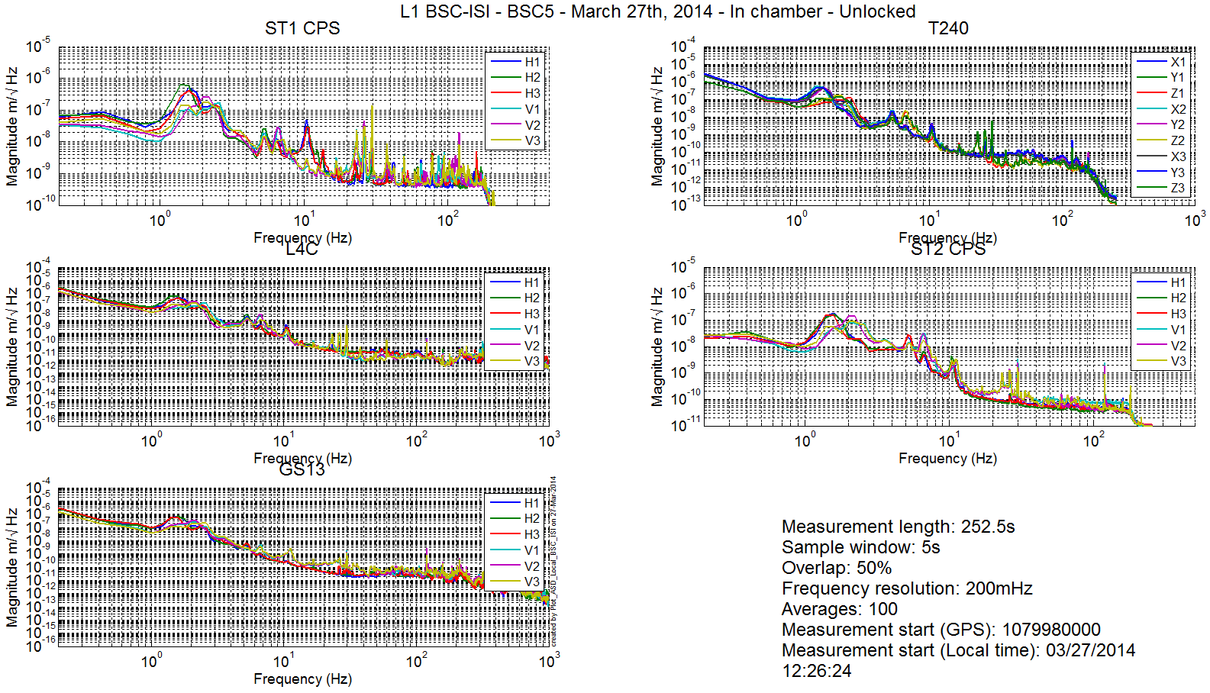
Figure 13 – Calibrated spectra inboard instruments - ISI Unlocked

Test result: Passed: X Failed: . W Waived: __

Actuators-cables resistance

Test result: Passed: Failed: . W Waived: X__

Offsets CPS Unlocked vs locked
https://svn.ligo.caltech.edu/svn/seismic/BSC-ISI/L1/ETMY/Data/Static_Tests/
- L1_ISI_ETMY_CPS_Read_Back_ISI_Locked_2012_12_17_094105.mat
- L1_ISI_ETMY_CPS_Read_Back_ISI_Unlocked_2012_12_05_171334.mat

 | Table locked |  | Table unlocked |  |  | Difference locked - unlocked
Sensors | Offset (Mean) | Std deviation | Offset (Mean) | Std deviation |  | Offset (Mean) | mil
ST1 - H1 | 428.8 | 7.7 | 355.3 |  | 20.1 | -73.6 | -0.1
ST1 - H2 | -213.4 | 7.4 | -1372.3 |  | 22.8 | -1158.9 | -1.4
ST1 - H3 | 337.9 | 10.9 | 217.3 |  | 21.2 | -120.6 | -0.1
ST1 - V1 | 268.2 | 9.7 | 1550.8 |  | 15.2 | 1282.6 | 1.5
ST1 - V2 | 204.7 | 35.1 | -730.4 |  | 22.0 | -935.0 | -1.1
ST1 - V3 | 65.3 | 24.3 | 373.0 |  | 18.2 | 307.7 | 0.4
ST2 - H1 | 340.1 | 31.7 | 4148.4 |  | 37.9 | 3808.3 | 1.1
ST2 - H2 | -217.8 | 26.4 | 3209.2 |  | 32.0 | 3427.0 | 1.0
ST2 - H3 | 284.3 | 45.4 | 1378.6 |  | 41.9 | 1094.3 | 0.3
ST2 - V1 | -114.7 | 64.1 | 1582.8 |  | 45.2 | 1697.5 | 0.5
ST2 - V2 | -195.3 | 108.1 | -494.0 |  | 46.9 | -298.7 | -0.1
ST2 - V3 | -251.4 | 88.6 | -2243.6 |  | 44.2 | -1992.1 | -0.6
Table 7 - Locked vs Unlocked Position

Test result: Passed: X Failed: . W Waived: __

Offset local drive
Note: Due to longer cables, offsets measured by CPS for a 7000 count drive are slightly lower than offsets measured in the staging building.

Results of this test can be found in the SVN at:
https://svn.ligo.caltech.edu/svn/seismic/BSC-ISI/L1/ETMY/Data/Static_Tests/
- L1_ISI_ETMY_Offset_Local_Drive_20140321.mat

 |  | Sensors
 |  | ST1 - H1 | ST1 - H2 | ST1 - H3 | ST1 - V1 | ST1 - V2 | ST1 - V3
Actuators | ST1 - H1 | 3765.3 | 1509.6 | 1516.8 | 27.0 | -47.1 | 33.8
Actuators | ST1 - H2 | 1548.0 | 3874.2 | 1552.8 | 24.7 | -2.2 | -14.8
Actuators | ST1 - H3 | 1666.5 | 1664.4 | 4126.7 | -12.3 | 4.3 | -16.5
Actuators | ST1 - V1 | 75.7 | -118.2 | 73.7 | 2951.1 | -481.0 | -496.9
Actuators | ST1 - V2 | 39.7 | -21.7 | -140.5 | -450.4 | 2968.9 | -498.0
Actuators | ST1 - V3 | -114.9 | 91.1 | 40.5 | -518.6 | -483.1 | 3019.4
Table 8 - Static Tests – Local to Local - Stage 1

 |  | Sensors
 |  | ST2 - H1 | ST2 - H2 | ST2 - H3 | ST2 - V1 | ST2 - V2 | ST2 - V3
Actuators | ST2 - H1 | 2157.1 | 323.0 | 342.6 | -28.5 | 27.0 | 3.2
Actuators | ST2 - H2 | 348.8 | 2160.0 | 348.7 | 7.0 | -4.0 | 44.9
Actuators | ST2 - H3 | 354.3 | 330.0 | 2126.0 | 19.2 | -18.3 | -21.6
Actuators | ST2 - V1 | 77.5 | 90.1 | -132.2 | 2587.9 | 363.5 | 111.2
Actuators | ST2 - V2 | -144.7 | 58.6 | 77.4 | 68.7 | 2582.4 | 313.7
Actuators | ST2 - V3 | 110.1 | -136.6 | 49.0 | 399.9 | 6.9 | 2473.1
Table 9 - Static Tests – Local to Local - Stage 2

Test result: Passed: X Failed: . W Waived: __

Offset Cartesian drive
The test was not performed because it only tests the matrices, which can be changed at any time.

Test result: Passed: _ Failed: . W Waived: X_

Range of motion
The range of motion of the table is measured by pushing on the table in a direction collinear to the CPS. The Static tests results can be found on the SVN at:
seismic/BSC-ISI/L1/ETMY/Data/Static_Tests/
- L1_ISI_ETMY_Range_Of_Motion_20121205.mat

Sensor readout (counts) | Negative drive | no drive | Positive drive | Amplitude count | mil
ST1 - H1
ST1 - H2
ST1 - H3
ST1 - V1
ST1 - V2
ST1 - V3
ST2 - H1
ST2 - H2
ST2 - H3
ST2 - V1
ST2 - V2
ST2 - V3
Table 10 - Range of motion - Actuator drive in the LVEA

Test result: Passed: X Failed: . W Waived: __

Linearity test
The data of the linearity test can be found on the SVN at:
seismic/BSC-ISI/L1/ETMY/Data/Linearity_Test/
- L1_ISI_ETMY_Linearity_test_20121206.mat

The figures of the linearity test can be found on the SVN at:
seismic\BSC-ISI\H2\BS\Data\Figures\Linearity_Test\
- L1_ISI_ETMY_Linearity_test_20121206.fig

Figure 14 - Linearity test –L1 - BS – In LVEA

 |  | Slope | Offset | Average slope | Variation from  average(%)
Stage 1 | ST1 - H1
Stage 1 | ST1 - H2
Stage 1 | ST1 - H3
Stage 1 | ST1 - V1
Stage 1 | ST1 - V2
Stage 1 | ST1 - V3
Stage 2 | ST2 - H1
Stage 2 | ST2 - H2
Stage 2 | ST2 - H3
Stage 2 | ST2 - V1
Stage 2 | ST2 - V2
Stage 2 | ST2 - V3
Table 11 - Slope – Offset Linearity test

Test result: Passed: _ Failed: . W Waived: X_

Transfer functions and Comparison with measurements done in the staging building.

At the end station
The parameters for the measurements in the LVEA are slightly different from those in the staging building. We chose to have weaker excitation but longer averages in an effort to reduce risk of the attached suspension.

Measurements data can be found in the SVN at:
SeiSVN/seismic/BSC-ISI/L1/ETMY/Data/Transfer_Functions/Measurements/Undamped:
- LLO_ISI_BSC1_Data_L2L_10mHz_100mHz_ST1_ST2_20121029-214002.mat
- LLO_ISI_BSC1_Data_L2L_100mHz_700mHz_ST1_ST2_20121029-161711.mat
- LLO_ISI_BSC1_Data_L2L_700mHz_10Hz_ST1_ST2_20121027-000402.mat
- LLO_ISI_BSC1_Data_L2L_10Hz_100Hz_ST1_ST2_20121026-212711.mat
- LLO_ISI_BSC1_Data_L2L_100Hz_500Hz_ST1_ST2_20121026-200720.mat
- LLO_ISI_BSC1_Data_L2L_500Hz_1000Hz_ST1_ST2_20121026-190253.mat

Data after processing can be found in the SVN at:
SeiSVN/seismic/BSC-ISI/L1/ETMY/Data/Transfer_Functions/Simulations/Undamped
- LLO_ISI_BSC1_TF_L2L_Raw_10mHz_1000Hz_2012_10_29.mat

The transfer functions can be found in the SVN at:
seismic/BSC-ISI/L1/ETMY/Data/Figures/Transfer_Functions/Measurements/Undamped/
- LLO_ISI_BSC1_TF_L2L_Raw_from_ST1_ACT_to_ST1_CPS_2012_12_16.fig
- LLO_ISI_BSC1_TF_L2L_Raw_from_ST1_ACT_to_ST1_L4C_2012_12_16.fig
- LLO_ISI_BSC1_TF_L2L_Raw_from_ST1_ACT_to_ST1_T240_2012_12_16.fig
- LLO_ISI_BSC1_TF_L2L_Raw_from_ST2_ACT_to_ST2_CPS_2012_12_16.fig
- LLO_ISI_BSC2_TF_L2L_Raw_from_ST2_ACT_to_ST2_GS13_2012_12_16.fig

Note 1: The transfer functions are measured from the Output filters bank excitation point to the input (IN1) of the input filters bank. The transfer functions presented below are raw transfer functions without any electronic compensation.

Note 2: The L4Cs are out of phase (should be -90 before 1Hz). A minus sign is added in the calibration filters that convert count to nm/s.

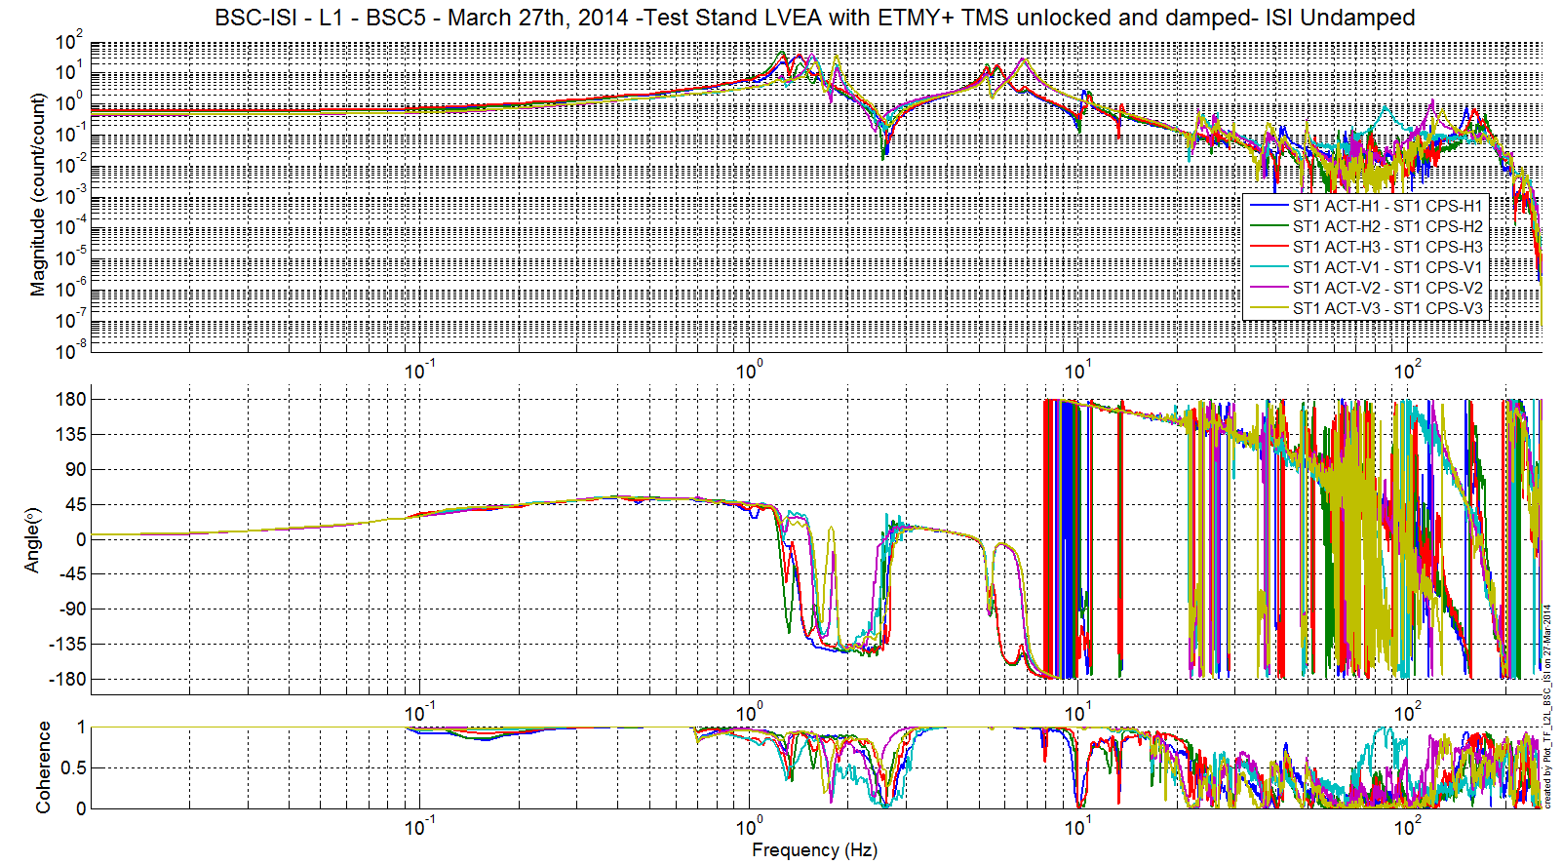
Figure 15 - TF ST1 ACT to ST1 CPS

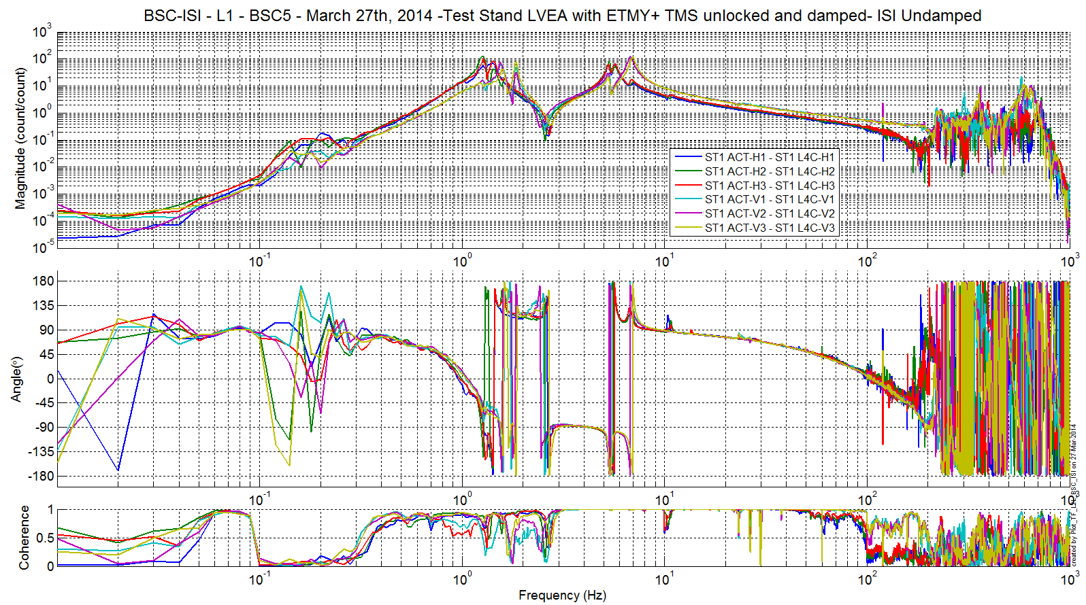
Figure 16 - TF ST1 ACT to ST1 L4C

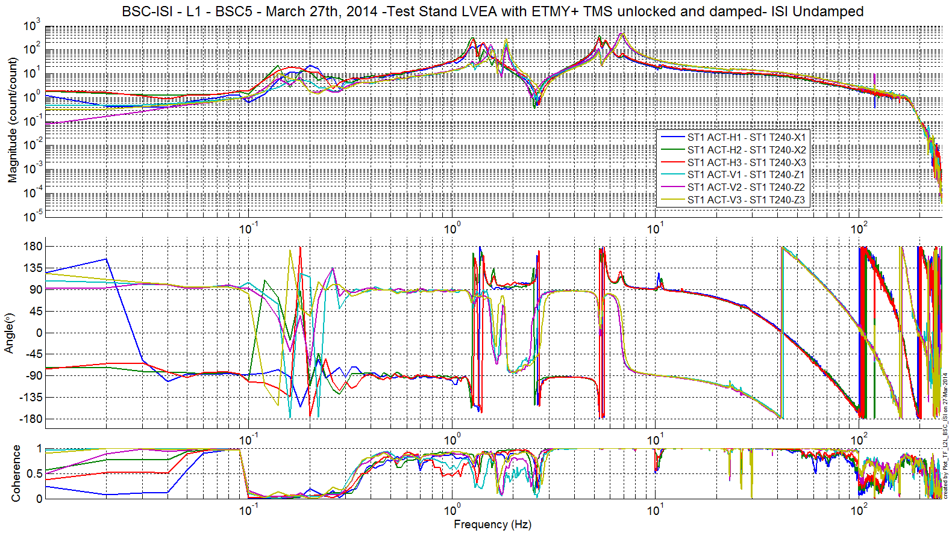
Figure 17 - TF ST1 ACT to ST1 T240

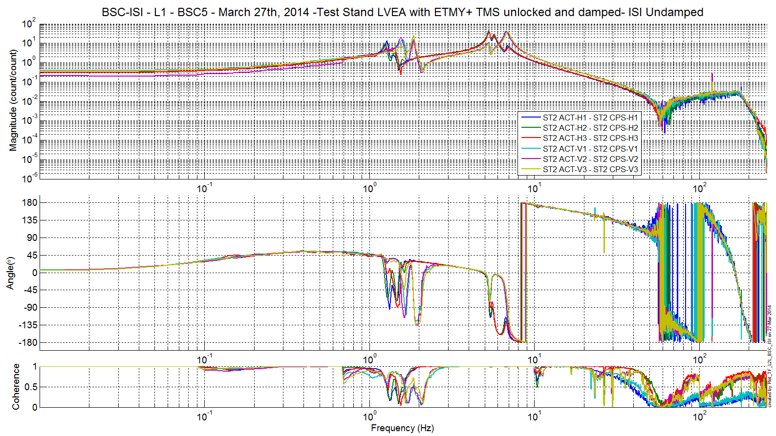
Figure 18 - TF ST2 ACT to ST2 CPS

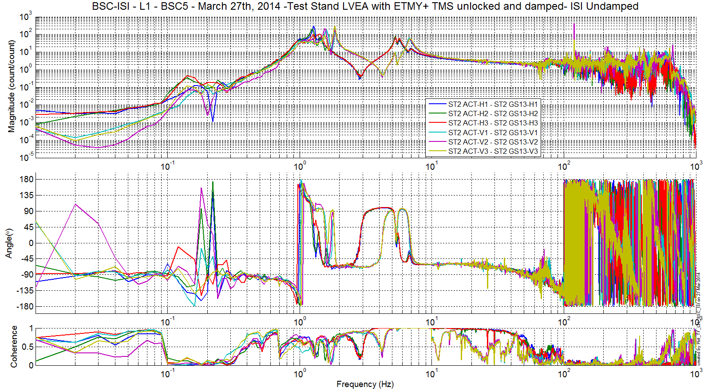
Figure 19 - TF ST2 ACT to ST2 GS13

Comparisons with measurements on test stand-not done yet
The script used to compare transfer function can be found in the SVN at:
seismic/BSC-ISI/L1/ETMY/Scripts/Control_Scripts
- Comparison_TF_C2C_LHO_ISI_BSC2.m

The figure that shows the comparison between the transfer functions of the staging building and the LVEA are located in the SVN at:
seismic/BSC-ISI/L1/ETMY/Data/Figures/Transfer_Functions/Comparisons/L2L/
- LLO_ISI_BSC1_vs_LHO_ISI_BSC8_Comparison_TF_L2L_ST1_ACT_H_to_ST1_CPS_H_20120512_vs_20121107.fig
- LLO_ISI_BSC1_vs_LHO_ISI_BSC8_Comparison_TF_L2L_ST1_ACT_H_to_ST1_L4C_H_20120512_vs_20121107.fig
- LLO_ISI_BSC1_vs_LHO_ISI_BSC8_Comparison_TF_L2L_ST1_ACT_V_to_ST1_CPS_V_20120512_vs_20121107.fig
- LLO_ISI_BSC1_vs_LHO_ISI_BSC8_Comparison_TF_L2L_ST1_ACT_V_to_ST1_L4C_V_20120512_vs_20121107.fig
- LLO_ISI_BSC1_vs_LHO_ISI_BSC8_Comparison_TF_L2L_ST2_ACT_H_to_ST2_CPS_H_20120512_vs_20121107.fig
- LLO_ISI_BSC1_vs_LHO_ISI_BSC8_Comparison_TF_L2L_ST2_ACT_H_to_ST2_GS13_H_20120512_vs_20121107.fig
- LLO_ISI_BSC1_vs_LHO_ISI_BSC8_Comparison_TF_L2L_ST2_ACT_V_to_ST2_CPS_V_20120512_vs_20121107.fig
- LLO_ISI_BSC1_vs_LHO_ISI_BSC8_Comparison_TF_L2L_ST2_ACT_V_to_ST2_GS13_V_20120512_vs_20121107.fig
Main differences are:
- The DC gains (cables resistance is different due to the length difference)
- Resonances of the rigid body modes [1; 10]Hz (different payload) It is especially visible from 1 to 2 Hz on all sensors.
- ST1-CPS resonances different on the test stand and on the HEPI piers
- Resonance at 20.5 Hz on stage 2 sensors (4th vertical mode of the quad? –cf https://lhocds.ligo-wa.caltech.edu/wiki/Resonances) that had been visible during test stand measurement with the quad locked is somewhat visible here, even though not as clearly
- High frequency behavior different due to data rate change between test stand test and cartridge test

Figure 20 - Transfer functions comparison - ST1 ACT to ST1 CPS H

Figure 21 - Transfer functions comparison - ST1 ACT to ST1 CPS V

Figure 22 - Transfer functions comparison - ST1 ACT to ST1 L4C H

Figure 23 - Transfer functions comparison - ST1 ACT to ST1 L4C V

Figure 24 - Transfer functions comparison - ST2 ACT to ST2 CPS H

Figure 25 - Transfer functions comparison - ST2 ACT to ST2 CPS V

Figure 26 - Transfer functions comparison – ST2 ACT to ST2 GS13 H

Figure 27 - Transfer functions comparison – ST2 ACT to ST2 GS13 V

Test result: Passed: X Failed: . W Waived: __

Conclusion Phase II-b
All results appear satisfying, apart from a few test waived (will be done during phase II-b):
- Range of motion
- Linearity test
- Static tests in the Cartesian basis (redundant with the static test in the local basis)

Test result: Passed: X Failed: . W Waived: _

Conclusion

The ISI-BSC5 was moved from the Staging building to the Y-VEA test stand on July 11th 2013.

This document presents series of tests (Phase II) performed on the ISI-BSC1 (ETMY) after the ETMY quad suspension (in final configuration) was mated with the ISI and the ISI rebalanced.

Phase 2b testing was conducted between March 14th and March 27th 2014..

