*LIGO Laboratory / LIGO Scientific Collaboration*

LIGO-T1100467-v2 *LIGO* March 7, 2013

aLIGO Broadband Photodetector

Matthew Evans, Koji Arai

Distribution of this document:

LIGO Scientific Collaboration

This is an internal working note

of the LIGO Laboratory.

|  |  |
| --- | --- |
| **California Institute of Technology**  **LIGO Project – MS 18-34**  **1200 E. California Blvd.**  **Pasadena, CA 91125**  Phone (626) 395-2129  Fax (626) 304-9834  E-mail: info@ligo.caltech.edu | **Massachusetts Institute of Technology**  **LIGO Project – NW22-295**  **185 Albany St**  **Cambridge, MA 02139**  Phone (617) 253-4824  Fax (617) 253-7014  E-mail: info@ligo.mit.edu |
| **LIGO Hanford Observatory**  **P.O. Box 1970**  **Richland WA 99352**  Phone 509-372-8106  Fax 509-372-8137 | **LIGO Livingston Observatory**  **P.O. Box 940**  **Livingston, LA 70754**  Phone 225-686-3100  Fax 225-686-7189 |

http://www.ligo.caltech.edu/

# Introduction

The aLIGO design call for 2 modulation frequencies (9.1 and 45.5MHz) and demodulation at the first, second and third multiples of each. The highest of these is 136.5MHz, which is challenging to meet in the context of existing aLIGO photodetectors (PDs). Furthermore, the aLIGO Arm Length Stabilization (ALS, M080371) system will require demodulation at 80 and 160MHz, also challenging in the context of aLIGO PDs.

The objective of this work is to find a solution to the detection of signals from 18MHz to 160MHz for 1064nm and 532nm optical wavelengths. It should be noted that the beams to be detected will arrive from the aLIGO interferometer, and thus will not be fixed to the table in position or angle, which makes the active area of the PD of special concern. Also of note is the fact that these detectors will not be used for low-noise “Science Mode” signals, and thus can be designed for in-air operation and modest noise performance.

# Search for an existing solution

The first approach investigated was that of simply modifying the existing Length Sensing and Control tuned RF photodetector design (T1000694) to operate at higher frequencies. While not impossible, this approach appears difficult since this design is targeted at ultra-low-noise tuned readout of frequencies below 50MHz.

A survey of commercially available detectors turns up a number of candidates all of which share a common problem: in order to operate at frequencies above 100MHz, the active area of the PDs is too small to be used in the context of a suspended interferometer (usually less than ¼ mm2). The best of these detectors, the NewFocus 1811, was used for some time in iLIGO for demodulation of the 50MHz SPOB signal, and was eventually abandoned because the small active area resulted in an unreliable signal. That is, the beam alignment on the table varied enough with time that the beam would occasionally move off the PD.

It should be mentioned that a Thorlabs PD10CF detector, which claims 150MHz bandwidth, was purchased for testing. The advantage of the PD10CF, as opposed to the 1811, is the somewhat larger active area and built-in threads for mounting lenses to the PD case. The ability to mount lenses to the PD allows us to magnify the PD by a factor of about 4, limited mostly by our lens mounting precision of about 100 micro-meters, and the ergonomically dictated maximum telescope length of 3-inchs. (Magnification also implies an angular requirement on the beam impinging on the image plane of the PD which becomes onerous for magnification factors much greater than 4.) While the resulting PD image is of respectable dimension (1 mm2 apparent active area), the PD10CF response was measured to be limited to 100MHz bandwidth, which is insufficient for our highest frequency signals. A similar approach to the 1811 is likely to fail due to its smaller size (thus requiring greater magnification), and lack of built-in lens mounting options (thus preventing precise lens-PD positioning).

# Design

The aLIGO Broadband Photodetector (BBPD) is built around a 2.5mm diameter photodiode (PerkinElmer/Excelitas FFD-100), coupled to a 50 Ohm RF amplifier (Mini-Circuits MAR-6SM+). The FFD-100 is a silicon photodiode which offers low capacitance and series resistance with a modest bias despite its large active area (12pF and 10 Ohm at 15V). The responsivity of this diode at 1064nm is low, but acceptable at 0.1A/W, while the responsivity at 532nm is good at 0.3A/W.

Using a 50 Ohm RF amplifier to provide the PD’s RF readout allows for a simple design and a good response over a wide range of frequencies. The trade-offs relative to a resonant detector are the noise performance of the PD, which is limited by this 50 Ohm transimpedance, and the ability to remove unwanted frequencies before amplification, although options to add some filtration are still available. The frontend preamplifier MAR-6SM+ has the lowest noise level (N.F. 2.3dB) among the monolithic wideband amplifiers in Mini-Circuits’ line-up. The cascade of MAR-6SM+ and GALI-6+ amplifiers provides total 32dB of amplification (i.e. 20dB+12dB), resulting in an apparent transimpedance (as seen on the output) close to 2 kOhm. This amplifier also has a high-power output with good linearity (1dB compression at 18dBm), and provides amplification from DC to 4GHz.

The DC path is made to respond up to 100kHz with 2 kOhm transimpedance. The response is non-inverting and driven by a standard op-amp (OP27). This choice of transimpedance gives a 10V output for maximal incident optical power (50mW of 1064nm, or 15mW of 532nm). It also roughly matches the RF and DC transimpedance, and matches their ranges for a typical modulation depth of 10% (1Vrms of RF for 10V of DC).



Figure 1: Circuit schematic of aLIGO Broadband photodetector

 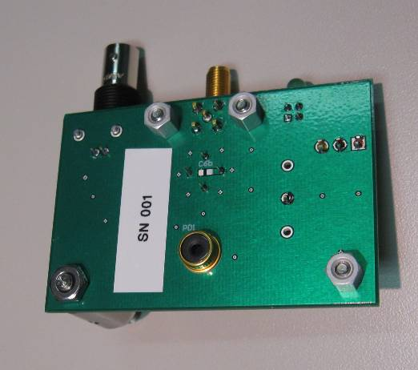

Figure 2: Design of the PCB (left) and the photo of the assembly (right)

# Response

The RF response of the BBPD is designed to be high in the region of interest to aLIGO interferometer sensing and control; 18 to 160MHz. The high frequency end of the response is, in principle, limited by the time constant determined by the junction capacitance of the diode and the transimpedance of the preamp. This yields the cutoff frequency of 160MHz. The low frequency photocurrent (f<1MHz) is guided to the audio frequency circuit by the blocking filters (C3s, C4, and L3) before the RF amplifier. It should be noted that to reach lower RF frequencies it is sufficient to replace L1 and L2 with larger inductances (e.g., 10uH), and C1, C2 and C4 with larger capacitances (e.g., 10nF), though the DC path should be modified slightly to compensate (e.g., C9 and C15 set to 1nF). Similarly, these components can be modified to reject frequencies below a given cut-off (currently 5MHz), or even to notch unwanted frequencies (e.g., 9MHz). Additional spare pads (L1, C1a, and C1b) are provided to allow further flexibility of internal filtering such as a notch filter.

Some complication is added to the DC path in order to provide a 25V bias to the PD (R12 and R13 on the schematic). The balanced design rejects noise entering via the +15V supply, but there is clearly some compromise to the DC path simplicity and noise performance required in trade for RF response above 50MHz (see figure 4, response vs. bias voltage). Therefore, the PCB is designed to allow an external high voltage bias at TP5 while the original bias is to be decoupled by removing R20. Note that the actual bias voltage across the diode is V(TP5) – 10V (i.e. the original bias voltage is –25V) as the cathode voltage is determined by the virtual short of the DC current amplifier (TP1).

Figure 3 shows the response of the BBPD. The transimpedance is 2.3 kOhm at 15MHz where the maximum response is achieved. With the default configuration, the response goes down to 890 Ohm at 160MHz. The high frequency response can be extended up to 200MHz by applying an external high-voltage reverse bias at TP5, by removing R20 to decouple the original bias voltage. This capability of extended response was demonstrated by a proof-of-principle setup circuit depicted in Figure 4.



Figure 3: Magnitude and phase response of the aLIGO broadband photodetector



Figure 4: Response of the photodiode with various bias voltages (right).   
This test was performed with a test circuit (left).

The spectral response of the BBPD was also measured. For 1064nm light, it was found to be 0.08A/W and 0.3A/W for 633nm light. These correspond to the expected spectral response of the FFD-100 only if the overall efficiency of the transmission of light into the PD is around 70% (see figure below, taken from the FFD-100 data sheet).

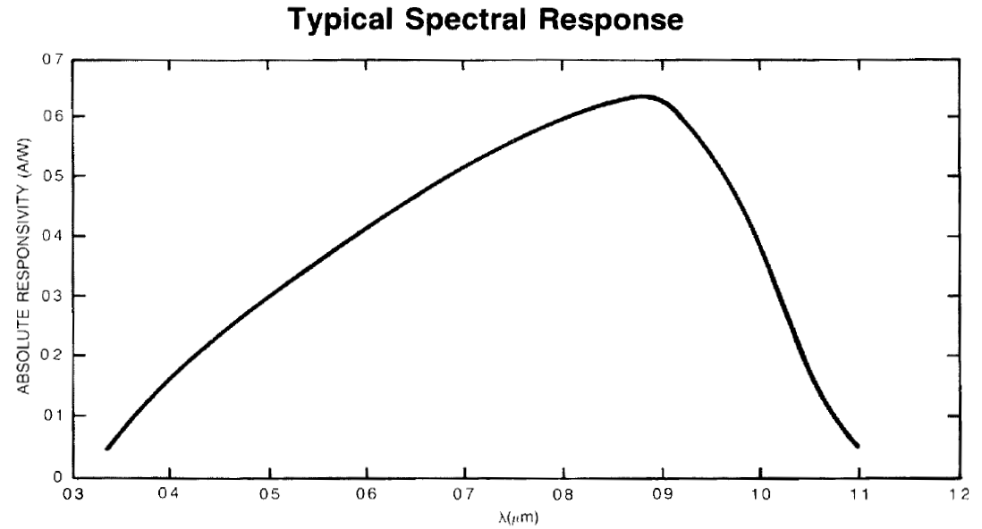

Figure 5: Spectral response of FFD-100

# Noise performance

The output noise of the BBPD was measured by changing the power of the incident light from an incandescent light bulb. The average noise levels between 15MHz and 20MHz were plotted against the DC photocurrent flowing on the diode (Figure 6). From the dependence of the noise on the DC photocurrent (*i*DC), the (average) transimpedance (*g*det) and the shot-noise intercept current[1] (*i*det) can be obtained. The measurement indicates that the BBPD will be shot-noise limited when the DC photocurrent is more than 0.22mA.

The frequency dependence of the shot noise intercept current is obtained from the dark noise current (Figure 7). This was calculated from the output noise voltage (i.e. dark noise voltage) by the transimpedance. The shot noise intercept current at 160MHz is about 3mA. Since the current noise level is limited by the reduced response of the photodetector at the high frequency, this noise level can be improved by increasing the bias voltage.

These photocurrents can be converted to input power at some wavelength with the responsivity values given in the previous section.



Figure 6: Shot noise intercept current measured with illumination from an incandescent light.



Figure 7: Frequency dependence of the input intercept current

# Interfaces

The electrical interface of the BBPD has two outputs and one input, all located on the topside of the case. The RF and DC outputs are provided by SMA and BNC connectors. These match aLIGO electronics (c.f., T1000044 and D1002932) and provide the user with a clear indication of the purpose of each output (augmented by labeling next to each). The input power, a dual-15V supply, uses an M8-3pos connector. This matches the power provided on aLIGO optical tables (see D1002932) for commercial detectors by Thorlabs and Newfocus. Green LEDs adjacent to the power connecter give a visual indication that the BBPD is properly powered.

The mechanical interface to the optical table is provided by an 8-32 threaded hole on each side of the BBPD case, which mates with standard optical posts. There are 4 additional holes provided on each side to allow for specialized adapters. None of these holes penetrates the BBPD case, so the RF shielding is not compromised and there is no risk of damage to the BBPD due to screws inserted into the case. Furthermore, the BBPD case provides a threaded bushing centered on the photodiode that matches standard lens tubes, ND filters, etc.

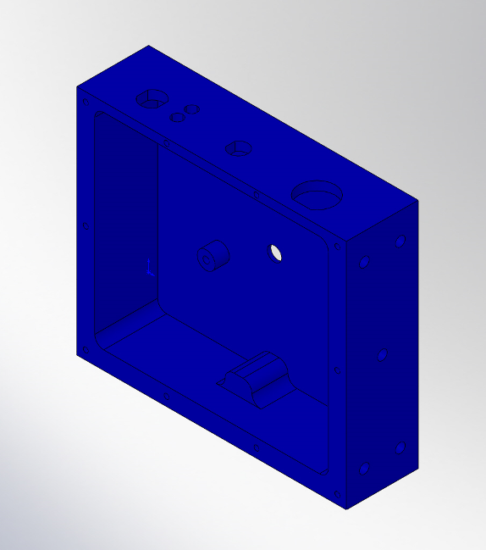 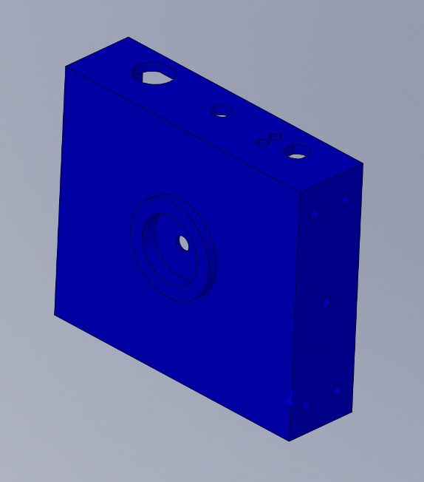

Figure 8: CAD images of the chassis for the BBPD. Backside (left) and Front side (right).

The BBPD case is attached to its electrical ground, so care must be taken to avoid ground loops. When the BBPD is mounted on an optical post, the post should be electrically isolated from the table. Electrical breaks of this sort were used in initial LIGO and took the form of a dielectric pedestal which mates to standard optical posts.

1. The shot-noise intercept current is the level of the DC photo current where the contribution of shot noise becomes comparable to the dark noise of a photodetector.