AUTHOR(S) | DATE | Document Change Notice, Release or Approval
Jason Oberling, Doug Cook, Dennis Coyne, Eric James | 22 May 2014 | see LIGO DCC record Status
Instructions on the use of this document:
1) Use, and complete, this document on a laptop computer while the work is proceeding. When operating in a cleanroom, use a cleanroom compatible laptop. This procedure must be available at all times during the alignment process. In addition, all of the applicable documents must also be available for reference during the procedure from the laptop computer.
2) Use this alignment procedure as a check list for preparation and during the alignment; As each step is completed, enter the name of the person completing the work (or approving or checking the step), as well as the date and any comments or notes. In particular, note any discrepancies or deviations and augment with any missing definition. ALL NOTES MUST BE RECORDED IN THE COMPLETED VERSION OF THIS DOCUMENT (NOT IN OTHER NOTEBOOKS OR FILES). If the additional notes are too cumbersome to include within the body of this completed procedure, then electronically attach them to the completed procedure.
3) Once completed, file the document in the LIGO Document Control Center (DCC) as the next highest version of the procedure and add a note that this is a completed/finished procedure.
4) File any significant notes or data from the completed procedure in the electronic logbook (such as any deviations); as a minimum note in the electronic logbook that the alignment was completed in accordance with this procedure (cite document number and revision).

Contents
1 SCOPE 3
2 APPLICABLE DOCUMENTS 3
3 COORDINATE SYSTEMS/REFERENCES 4
4 PREREQUISITES 4
5 REQUIRED EQUIPMENT LIST 4
6 CHAMBER ALIGNMENT PROCEDURE 5
6.1 Chamber set-up 8
6.1.1 Level table LHAM2 8
6.1.2 Level table LHAM3 8
6.1.3 Set LHAM2 and LHAM3 Table Positions 9
6.1.4 Approximately align the Suspension Structures with the templates. 10
6.2 PRM 10
6.2.1 Setup the PRM Retro-reflector Assembly 10
6.2.2 Set Total Station into position for PRM X, Y, Z positioning 11
6.2.3 Align the PRM longitudinal position 11
6.2.4 Align the PRM vertical position 12
6.2.5 Align the PRM horizontal position 13
6.2.6 Set Total Station into position for PRM pitch/yaw alignment 14
6.2.7 Set up PLX Lateral Transfer Periscope 14
6.2.8 Align the PRM in Yaw 14
6.2.9 Set PRM pitch 15
6.2.10 Iterate/re-Check 15
6.3 PR2 16
6.3.1 Setup the PR2 Retro-reflector Assembly 16
6.3.2 Set Total Station into position for PR2 X, Y, Z positioning 17
6.3.3 Align the PR2 longitudinal position 17
6.3.4 Align the PR2 vertical position 18
6.3.5 Align the PR2 horizontal position 18
6.3.6 Set Total Station into position for PR2 pitch/yaw alignment 19
6.3.7 Set up PLX Lateral Transfer Retro-Reflector 19
6.3.8 Align the PR2 in Yaw 20
6.3.9 Set PR2 pitch 20
6.3.10 Iterate/re-Check 21
6.4 PR3 21
6.4.1 Setup the PR3 Retro-reflector Assembly 21
6.4.2 Set Total Station into position for PR3 X, Y, Z positioning 22
6.4.3 Align the PR3 longitudinal position 22
6.4.4 Align the PR3 vertical position 23
6.4.5 Align the PR3 horizontal position 24
6.4.6 Set Total Station into position for PR3 pitch/yaw alignment 24
6.4.7 Set up PLX Lateral Transfer Retro-Reflector 25
6.4.8 Align the PR3 in Yaw 25
6.4.9 Set PR3 pitch 25
6.4.10 Iterate/re-Check 26
6.5 Power Recycling Cavity Alignment. 27
6.5.1 Set Total Station into position for Power Recycling Optical System 27
6.5.2 Set the iris assemblies. 27

SCOPE
The scope of this procedure is alignment of the optical elements of the LHAM2 and LHAM3 chambers that make up the Power Recycling Cavity (PRC), which includes alignment of the following optical elements:
- PRM, a part of the HAM Small Triple Suspension (HSTS) assembly (D020700).
- PR2, a part of the HSTS assembly (D0900523).
- PR3, a part of the HAM Large Triple Suspension (HLTS) assembly (D070447).
This procedure describes the preliminary alignment of the optical payload elements of the LHAM2 and LHAM3 chambers. These two chambers contain the Power Recycling Cavity Optics which are aligned as a set.

This procedure does not cover the procedures for installing assemblies onto the HAM-ISI platforms or for balancing and leveling the HAM-ISI optics tables; these procedures are defined in separate documentation.

APPLICABLE DOCUMENTS
Listed below are all of the applicable and referenced documents for the initial alignment procedures. This list gives the latest revisions of the documents; within the alignment steps, only the document number (and not the revision) is quoted.

Document No. | Document Title
E0900047 | LIGO Contamination Control Plan
T1000230 | AOS Initial Alignment Requirements Final Design Document
T080307 | Initial Alignment System Design Requirements Document
D1101233 | Installation Plate Layout, LHAM2
D1101249 | Installation Plate Layout, LHAM3
D1000143 | L1 PRM Installation Plate
D1000144 | L1 PR2 Installation Plate
D1000158 | L1/H1 PR3 Installation Plate
E1100374 | Survey Data for LLO
T1100318 | Total Station modifications for stabilizing unit when Laser Autocollimator is Attached
D0902359 | Suspension Alignment Pusher Assembly
D0900365 | HAM2-L1 Top Level Chamber Assembly
D0900520 | HAM3-L1 Top level Chamber Assembly
T1100468 | Baffle locations
E1200802 | aLIGO IAS L1 PRC Alignment Solutions

COORDINATE SYSTEMS/REFERENCES
The local HAM chamber coordinate system origin is the point where the horizontal, cylindrical axes of the main access portals meet. The local HAM chamber coordinate system axes are aligned to the local gravity vector. Z is vertical (+Z is up). X and Y are both horizontal and approximately aligned to the global coordinate axes (as defined in T980044). The local HAM chamber coordinate system origin is nominally located 9.96 in [252.9 mm] above the HAM-ISI optics table surface for LHAM2 and LHAM3.

PREREQUISITES
- An appropriate clean room should be installed over the chambers
completed, approved or checked by:
date:
comments (optional):
- Remove spool piece between HAM3 and BSC2
completed, approved or checked by:
date:
comments (optional):
- All payload assemblies must be acceptance tested (to the extent possible and planned) prior to integration into the cartridge assembly.
completed, approved or checked by:
date:
comments (optional):
- The PRM, PR2 and PR3 suspensions must be capable of being electronically damped while on the test stand and later when in the chamber.
completed, approved or checked by:
date:
comments (optional):
- Lock HAM2 and HAM3 ISI
completed, approved or checked by:
date:
comments (optional):

REQUIRED EQUIPMENT LIST
  - Total station (either a Sokkia Set2BII or a Sokkia SetX1 modified per T1100318) with tripod stand.
  - Laser autocollimator (Newport LDS Vector and LDS1000 controller)
  - Optical level (Sokkia B2o AutoLevel with micrometer option, or equivalent) with tripod stand
  - Precision bubble level
  - Mechanical locating templates for PRM suspension (D1000143), PR2 suspension (D1000144) and PR3 suspension (D1000158), cleaned to Class B per E0900047 and E960022)
  - Precision pushers (D0902359), cleaned to Class B per E0900047 and E960022)
  - Retro-reflector assembly (D1200125), cleaned to Class B per E0900047 and E960022)
  - Depth Gauge
  - Height scales
  - PLX Lateral transfer retro-reflector assembly (D1200929)
  - PLX precision periscope assembly (D1200938)
  - Iris assemblies (D1101770, two required).

CHAMBER ALIGNMENT PROCEDURE
The LHAM2 optical table assembly (D0900365) is depicted in Figure 1. The major optics assemblies integrated into the LHAM2 chamber are the Power Recycling Mirror (PRM) suspension assembly (D020700) and the Power Recycling Mirror #3 (PR3) suspension assembly (D070447). The basic alignment setup is depicted in figure 2.

The LHAM3 optical table assembly (D0900520) is depicted in Figure 2. The major optics assembly integrated into the LHAM3 chamber is the Power Recycling Mirror #2 (PR2) suspension assembly (D0900523). See E1200802 for a description of the alignment process.

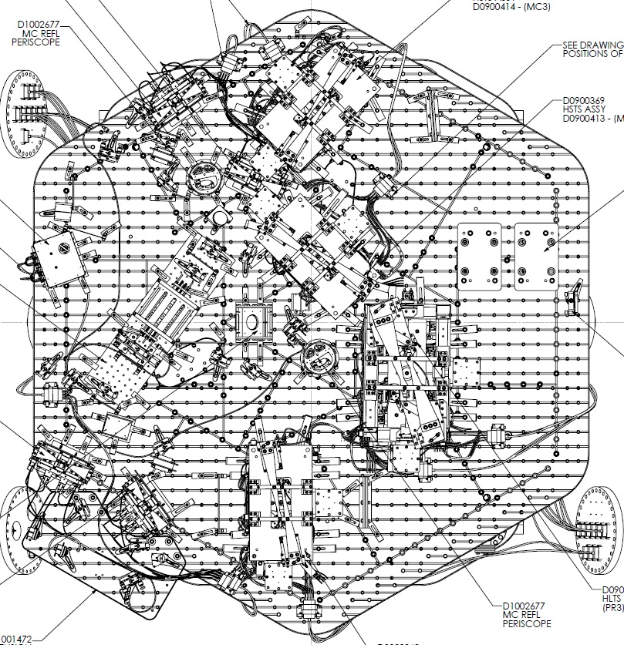
IAS Iris
Location

PRM
PR3
MC1
MC3

Figure 1: L1 HAM 2

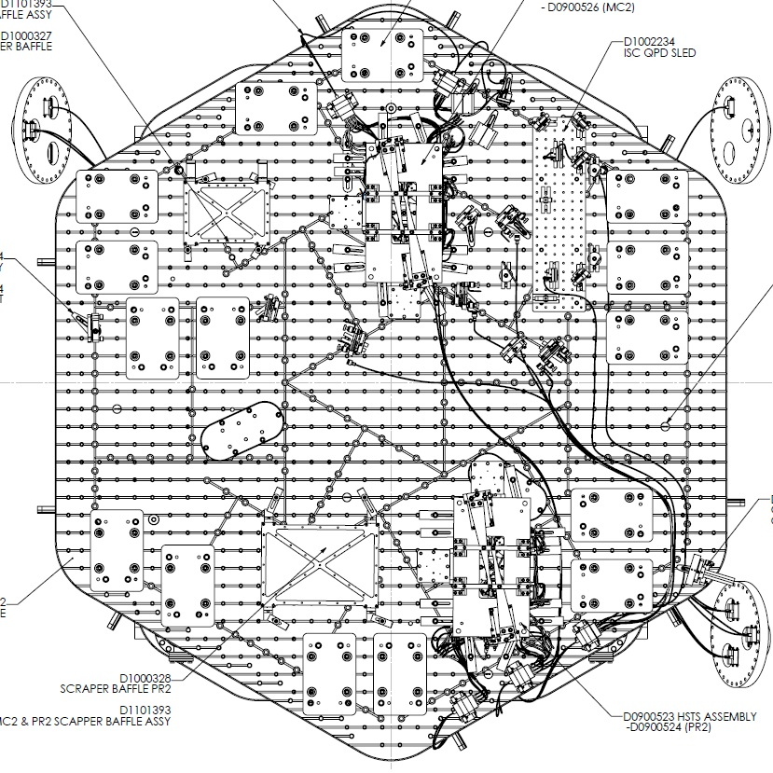
PR2
M
C
2
IAS Iris
Location

Figure 2: L1 HAM 3

Chamber set-up

Level table LHAM2
Datum: Local gravity
Equipment: Optical level on tall tripod and height scales placed on the optics table.
Accuracy: 100 microrad (0.1 mm differential height)
Procedure:
- Place height scales on the table so that they can be seen by the optical level.
- Record table height for LHAM2:
LHAM2 Height | +0.2 mm
- Record table level:
LHAM2 Level | 0.1 mm

completed, approved or checked by:
date:
comments (optional):

Level table LHAM3
Datum: Local gravity
Equipment: Optical level on tall tripod and height scales placed on the optics table.
Accuracy: 100 microrad (0.1 mm differential height)
Procedure:
- Place height scales on the table so that they can be seen by the optical level.
- Record table height for LHAM3:
LHAM3 Height | -0.5 mm
- Record table level:
LHAM3 Level | 0.3 mm
From J. Hanson – The table seems very level, just not very flat. Table height error approved by C. Torrie.
completed, approved or checked by:
date:
comments (optional):

Set LHAM2 and LHAM3 Table Positions
Datum: Monuments AM 400, AM 401, bolt hole arrays on tables
Equipment: Total Station, sight gauges, retro-reflector.
Accuracy: Longitudinal: ±1 mm
Lateral: ±2 mm
Yaw: ±400 microradians
Procedure:
- Set LHAM3 table position
  - Set up Total station along X-arm offset line adjacent to LHAM3 over monument AM 400
  - Place sight gauges on table, one on the near side of the table, and one on the far side of the table. Sight gauges reference the hole array on the table and will be ~2 m apart.
  - Record table longitudinal readings for LHAM3:
LHAM3 longitudinal reading 1 | -0.5 mm
LHAM3 Longitudinal reading 2 | -0.5 mm
  - Calculate yaw angle from longitudinal readings above:
Yaw = arctan [((Long. reading1- nominal)-(Long. reading2 - nominal))/2000]
LHAM3 yaw angle | 0 microradians
  - If longitudinal distance and/or yaw angle is outside of the above tolerances, use HEPI to move the HAM table until it is within these tolerances
  - Place retro-reflector on table at known location wrt table center.
  - Using EDM on Total station, record lateral distance:
LHAM3 lateral reading | 0 mm
  - If lateral distance is more than 2mm from the nominal value then use HEPI to properly position the HAM table
  - Repeat the above measurements until the HAM table is within all tolerances
- Set LHAM2 table position
  - Set up Total station along X-arm offset line adjacent to LHAM2 over monument AM 401
  - Place sight gauges on table, one on the near side of the table, and one on the far side of the table. Sight gauges reference the hole array on the table.
  - Record table longitudinal readings for LHAM3:
LHAM2 longitudinal reading 1 | +0.3 mm
LHAM2 Longitudinal reading 2 | +0.1 mm
  - Calculate yaw angle from longitudinal readings above:
Yaw = arctan [((Long. reading1- nominal)-(Long. reading2 - nominal))/1000]
LHAM2 yaw angle | 63.5 microradians CW
  - If longitudinal distance and/or yaw angle is outside of the above tolerances, use HEPI to move the HAM table until it is within these tolerances
  - Place retro-reflector on table at known location wrt table center.
  - Using EDM on Total station, record lateral distance:
LHAM2 lateral reading | 0 mm
  - If lateral distance is more than 2mm from the nominal value then use HEPI to properly position the HAM table
  - Repeat the above measurements until the HAM table is within all tolerances

Approximately align the Suspension Structures with the templates.
Datum: Bolt holes in optical table per D1101233 (LHAM2) and D1101249 (LHAM3).
Equipment: Alignment templates:
PRM Suspension: D1000143
PR2 Suspension D1000144
PR3 Suspension: D1000158
Accuracy: Clearance in bolt holes
Procedure:
- Install D1000143 template per D1101233.
- Install D1000144 template per D1101249
- Install D1000158 template per D1101233.
- Install pushers (D0902359) adjacent to PRM, PR2 and PR3 structures opposite the templates.
- Push PRM, PR2 and PR3 structures to contact the templates.
- Lock down suspension structures.
- Remove all templates.
completed, approved or checked by:
date:
comments (optional):

PRM

Setup the PRM Retro-reflector Assembly
Datum: Optical axis of the PRM as established by the total station.
Equipment: HAM Triple Retro-reflector assembly, Depth Gauge
Accuracy: ±1 mm
Procedure:
- Set the retro-reflector assembly in front of the HSTS in front of the PRM HR face.
N.B. If necessary for stability, use dog clamps to stabilize the retro-reflector mount
- Use the depth gauge to measure the offset distance from the retro-reflector assembly reference plate (square plate behind corner cube retro-reflector) to the PRM HR face. Do this on the right and left side of the plate and average two values to get the offset distance.
Take care to clean the depth gauge, especially the contact feature. Contact the optic either on the outer perimeter of the HR face where there is no First Contact ™ film or in the interior but only on the First Contact™ film and be sure to contact very gently.
- Record the offset distance (remember to add 10mm for the distance from the retro-reflector assembly reference plate to the corner cube reference plane)

Offset distance from the PRM HR face to the Reference Plane of the Retro-reflector | 108.3 mm

completed, approved or checked by:
date:
comments (optional):

Set Total Station into position for PRM X, Y, Z positioning
Datum: Monuments AM 501, L1 IAM 379, Wall mark Y-8 for height w/ attached scale
Equipment: Total station, height scale
Accuracy:
Procedure:
- Set the total station over monument AM 501
- Yaw the total station to sight the scale on wall mark Y-8
- Adjust total station height to -96.7 mm (global coordinate system). The total station is now at the height of the PRM.
- Back sight L1 IAM 379 with the total station. Zero the total station yaw
- Yaw the total station +88° 2’ 16” to point at the PRM
completed, approved or checked by:
date:
comments (optional):

Align the PRM longitudinal position
Datum: Total station EDM, Retro-reflector and offsets to the HR face (determined in section 6.2.1)
Equipment: Total station, retro-reflector
Accuracy: ±3 mm
Procedure:
- Use total station EDM to set position to L = 18342.4 mm (remember to account for the offset distance from the retro-reflector to the optic HR face)
- Record position.
 | Trial 1 | Trial 2 | Trial 3
Retro-reflector to HR face offset | 108.3 mm | mm | mm
EDM Distance | 18232.0 mm | mm | mm
Sum = L (PRM HR longitudinal distance) | 18340.3 mm | mm | mm

completed, approved or checked by:
date:
comments (optional):

Align the PRM vertical position
Datum: Optical axis as established by the total station.
Equipment: total station
Accuracy: ±1.0 mm (as per T0800307)
Procedure:
- With the Total Station at zero yaw angle, sight the bottom edge of the optic. Record the pitch angle.
- Sight the top edge of the optic. Record the pitch angle.
N.B. EQ stop brackets may need to be removed in order to see the top and/or bottom edges of the optic.
- Calculate the Center Error Distance (formula given in table below)
Note: Could not see the bottom edge of the optic due to the IO baffle in front of HAM2 blocking the line of sight. Measured the top edge only calculated the error; see page 30 of J. Oberling’s calculation notebook for the calculation.
 | Trial 1 | Trial 2 | Trial 3
Bottom optic edge  (-A) | N/A mrad | mrad | mrad
Top optic edge (+B) | 4.15 mrad | mrad | mrad
Center error angle  (A+B)/2 | N/A microrad | microrad | microrad
Center error distance  L * (A+B)/2 | +0.79 mm | mm | mm
- The optic height was set during the SUS assembly and should be correct. However, if it is out of tolerance then use the SUS procedures to adjust the test mass height until it is within the required accuracy
completed, approved or checked by:
date:
comments (optional):

Align the PRM horizontal position
Datum: Optical axis as established by the total station.
Equipment: total station, pusher assembly (D0902359).
Accuracy: ±2.0 mm (as per T0800307)
Procedure:
- With the Total Station at zero elevation angle, sight the left edge of the optic. Record the yaw angle.
- Sight the right edge of the optic. Record the yaw angle.
- Calculate the Center Error Distance (formula given in table below)
Note: Could not see the right edge of the optic. Measured the left edge only and calculated the error from there. See page 30 of J. Oberling’s calculation notebook for the calculation.
 | Trial 1 | Trial 2 | Trial 3
Left optic edge (-A) | 4.07 mrad | mrad | mrad
Right optic edge (+B) | N/A mrad | mrad | mrad
Center error angle  (A+B)/2 | N/A microrad | microrad | microrad
Center error distance  L * (A+B)/2 | +0.83 mm | mm | mm

- Use the “slider/supports” and “pusher assemblies” (D060052) to shift the lateral position of the quad structure as needed, so that the center error distance falls within the required accuracy
completed, approved or checked by:
date:
comments (optional):

Set Total Station into position for PRM pitch/yaw alignment
Datum: Monuments AM 403, Mark on wall, Wall mark Y-19-A for height w/ attached scale
Equipment: Total station, Newport visible laser autocollimator (LAC), height scale
Accuracy:
Procedure:
- Set the total station over monument AM 403
- Yaw the total station to sight the scale on wall mark Y-19-A
- Adjust total station height to -181.0 mm (global coordinate system). The LAC is now at the height of the PRM.
- Back sight the mark surveyed on the North wall (no number) with the total station. Zero the total station yaw
- Yaw the total station -90° 20’ 12” (total station reading of 269° 39’ 48”) and pitch it down by 55’ 50” to point at the PRM AR surface via the PLX periscope
completed, approved or checked by:
date:
comments (optional):

Set up PLX Lateral Transfer Periscope
Datum: Optical Axis as established by the Total Station
Equipment: PLX Periscope, Total station, Newport visible laser autocollimator (LAC)
Accuracy:
Procedure:
- Set the PLX Lateral Transfer Periscope assembly outside of the HAM2 North door
- Orient the PLX such that the entrance port is on the North side of the PLX facing HAM1 and the exit port is on the South side of the PLX facing HAM2
- Align the PLX to the LAC beam
  - Translate the PLX horizontally and vertically until the beam from the LAC is centered on the entrance port
  - Yaw the PLX until the beam exits the center of the exit port
  - Repeat until the beam enters and exits from the center of the respective ports on the PLX. The PLX is now directing the LAC beam at the AR surface of the PRM (just inside the –y edge)
completed, approved or checked by:
date:
comments (optional):

Align the PRM in Yaw
Datum: Optical axis as established by the total station.
Equipment: Laser autocollimator
Accuracy: ±100 microradians
Procedure:
- Use the laser autocollimator to measure the yaw angle
  - Zero the yaw using the pusher assemblies down to ±410 microradian residual error.
  - Use the top blade adjusters to reduce the residual error further, using the SUS procedures
- Record residual yaw error
PRM yaw error | 45 microrad CW
completed, approved or checked by:
date:
comments (optional):

Set PRM pitch
Datum: Optical axis as established by the total station.
Equipment: Total station
Accuracy: ±100 microradians
Procedure:
- Use the LAC to measure the initial pitch error.
PRM pitch initial error | N/A microradians
- If the pitch error is < 100 microradians, record the value and proceed to step 6.2.10
- If > 100 microradians, then adjust the upper intermediate mass pitch balance per SUS procedures until the required accuracy is met. Record the residual error
PRM pitch error | 25 microradians down
completed, approved or checked by:
date:
comments (optional):

Iterate/re-Check

Datum: Local gravity, optical axis as established by the total station.
Equipment: Optical level on tall tripod, height scales, total station
Accuracy:
levelness: ±100 microrad (0.1 mm differential height)
lateral position: ±2.0 mm
longitudinal position: ±3mm
vertical position: ±1.0 mm
yaw: ±100 microradians
pitch: ±100 microradians
Procedure:
- Re-check LHAM2 table level
- Re-check the longitudinal, lateral, and vertical position and pitch and yaw of the optic. Correct errors as necessary
- Repeat until all are within required accuracy.
completed, approved or checked by:
date:
comments (optional):

PR2

Setup the PR2 Retro-reflector Assembly
Datum: Optical axis of the PR2 as established by the total station.
Equipment: HAM Triple Retro-reflector assembly, Depth Gauge
Accuracy: ±1 mm
Procedure:
- Set the retro-reflector assembly in front of the HSTS in front of the PR2 AR face.
N.B. If necessary for stability, use dog clamps to stabilize the retro-reflector mount
- Use the depth gauge to measure the offset distance from the retro-reflector assembly reference plate (square plate behind corner cube retro-reflector) to the PR2 AR face. Do this on the right and left side of the plate and average two values to get the offset distance.
Take care to clean the depth gauge, especially the contact feature. Contact the optic either on the outer perimeter of the AR face where there is no First Contact ™ film or in the interior but only on the First Contact™ film and be sure to contact very gently.
- Record the offset distance (remember to add 10mm for the distance from the retro-reflector assembly reference plate to the corner cube reference plane)

Offset distance from the PR2 AR face to the Reference Plane of the Retro-reflector | 109.0 mm

completed, approved or checked by:
date:
comments (optional):

Set Total Station into position for PR2 X, Y, Z positioning
Datum: Monuments AM 503, L1 IAM 379, Wall mark Y-8 for height w/ attached scale
Equipment: Total station, height scale
Accuracy:
Procedure:
- Set the total station over monument AM 503
- Yaw the total station to sight the scale on wall mark Y-8
- Adjust total station height to -92.3 mm (global coordinate system). The total station is now at the height of the PR2.
- Back sight L1 IAM 379 with the total station. Zero the total station yaw
- Yaw the total station +90° 27’ 32” to point at the PR2
completed, approved or checked by:
date:
comments (optional):

Align the PR2 longitudinal position
Datum: Total station EDM, Retro-reflector and offsets to the HR face (determined in section 6.2.1)
Equipment: Total station, retro-reflector
Accuracy: ±3 mm
Procedure:
- Use total station EDM to set position to L = 1646.3 mm (remember to account for the offset distance from the retro-reflector to the optic HR face)
- Record position.
 | Trial 1 | Trial 2 | Trial 3
Retro-reflector to HR face offset | 109.0 mm | 109.0 mm | mm
EDM Distance | 1541.5 mm | 1536.8 mm | mm
Sum = L (PRM HR longitudinal distance) | 1650.5 mm | 1645.8 mm | mm

completed, approved or checked by:
date:
comments (optional):

Align the PR2 vertical position
Datum: Optical axis as established by the total station.
Equipment: total station
Accuracy: ±1.0 mm (as per T0800307)
Procedure:
- With the Total Station at zero yaw angle, sight the bottom edge of the optic. Record the pitch angle.
- Sight the top edge of the optic. Record the pitch angle.
N.B. EQ stop brackets may need to be removed in order to see the top and/or bottom edges of the optic.
- Calculate the Center Error Distance (formula given in table below)
 | Trial 1 | Trial 2 | Trial 3
Bottom optic edge  (-A) | 45.15 mrad | mrad | mrad
Top optic edge (+B) | 46.03 mrad | mrad | mrad
Center error angle  (A+B)/2 | 440.7 microrad | microrad | microrad
Center error distance  L * (A+B)/2 | +0.73 mm | mm | mm
- The optic height was set during the SUS assembly and should be correct. However, if it is out of tolerance then use the SUS procedures to adjust the test mass height until it is within the required accuracy
completed, approved or checked by:
date:
comments (optional):

Align the PR2 horizontal position
Datum: Optical axis as established by the total station.
Equipment: total station, pusher assembly (D0902359).
Accuracy: ±1.0 mm (as per T0800307)
Procedure:
- With the Total Station at zero elevation angle, sight the left edge of the optic. Record the yaw angle.
- Sight the right edge of the optic. Record the yaw angle.
- Calculate the Center Error Distance (formula given in table below)
 | Trial 1 | Trial 2 | Trial 3
Left optic edge (-A) | 44.08 mrad | 45.47 mrad | mrad
Right optic edge (+B) | 47.12 mrad | 45.93 mrad | mrad
Center error angle  (A+B)/2 | 1519 microrad | 228 microrad | microrad
Center error distance  L * (A+B)/2 | +2.5 mm | +0.37 mm | mm
- Use the “slider/supports” and “pusher assemblies” (D060052) to shift the lateral position of the quad structure as needed, so that the center error distance falls within the required accuracy
completed, approved or checked by:
date:
comments (optional):

Set Total Station into position for PR2 pitch/yaw alignment
Datum: Monuments AM 502, L1 IAM 379, Wall mark Y-8 for height w/ attached scale
Equipment: Total station, Newport visible laser autocollimator (LAC), height scale
Accuracy:
Procedure:
- Set the total station over monument AM 502
- Yaw the total station to sight the scale on wall mark Y-8
- Adjust total station height to -245.3 mm (global coordinate system). The LAC is now at the height of the PR2.
- Back sight L1 IAM 379 with the total station. Zero the total station yaw
- Yaw the total station +90° 27’ 32” to point at the PR2 via the PLX retro-reflector
completed, approved or checked by:
date:
comments (optional):

Set up PLX Lateral Transfer Retro-Reflector
Datum: Optical Axis as established by the Total Station
Equipment: PLX Retro-Reflector, Total station, Newport visible laser autocollimator (LAC)
Accuracy:
Procedure:
- Set the PLX Lateral Transfer Retro-Reflector assembly in the 5’ diameter section of the mode cleaner tube directly east of HAM3
- Orient the PLX such that the entrance and exit ports are facing HAM3
- Align the PLX to the LAC beam
  - Translate the PLX horizontally and vertically until the beam from the LAC is centered on the entrance port
  - Yaw the PLX until the beam exits the center of the exit port
  - Repeat until the beam enters and exits from the center of the respective ports on the PLX. The PLX is not directing the LAC beam at the center of the PR2
completed, approved or checked by:
date:
comments (optional):

Align the PR2 in Yaw
Datum: Optical axis as established by the total station.
Equipment: Laser autocollimator
Accuracy: ±100 microradians
Procedure:
- Use the laser autocollimator to measure the yaw angle
  - Zero the yaw using the pusher assemblies down to ±410 microradian residual error.
  - Use the top blade adjusters to reduce the residual error further, using the SUS procedures
- Record residual yaw error
PR2 yaw error | 15 microrad CCW
completed, approved or checked by:
date:
comments (optional):

Set PR2 pitch
Datum: Optical axis as established by the total station.
Equipment: Total station
Accuracy: ±100 microradians
Procedure:
- Use the LAC to measure the initial pitch error.
PR2 pitch initial error | 930 microradians down
- If the pitch error is < 100 microradians, record the value and proceed to step 6.3.10
- If > 100 microradians, then adjust the upper intermediate mass pitch balance per SUS procedures until the required accuracy is met. Record the residual error
PR2 pitch error | 50 microradians down
completed, approved or checked by:
date:
comments (optional):

Iterate/re-Check

Datum: Local gravity, optical axis as established by the total station.
Equipment: Optical level on tall tripod, height scales, total station
Accuracy:
levelness: ±100 microrad (0.1 mm differential height)
lateral position: ±1.0 mm
longitudinal position: ±3mm
vertical position: ±1.0 mm
yaw: ±100 microradians
pitch: ±100 microradians
Procedure:
- Re-check LHAM3 table level
- Re-check the longitudinal, lateral, and vertical position and pitch and yaw of the optic. Correct errors as necessary
- Repeat until all are within required accuracy.
completed, approved or checked by:
date:
comments (optional):

PR3

Setup the PR3 Retro-reflector Assembly
Datum: Optical axis of the PR3 as established by the total station.
Equipment: HAM Triple Retro-reflector assembly, Depth Gauge
Accuracy: ±1 mm
Procedure:
- Set the retro-reflector assembly in front of the HLTS in front of the PR3 HR face.
N.B. If necessary for stability, use dog clamps to stabilize the retro-reflector mount
- Use the depth gauge to measure the offset distance from the retro-reflector assembly reference plate (square plate behind corner cube retro-reflector) to the PR3 HR face. Do this on the right and left side of the plate and average two values to get the offset distance.
Take care to clean the depth gauge, especially the contact feature. Contact the optic either on the outer perimeter of the HR face where there is no First Contact ™ film or in the interior but only on the First Contact™ film and be sure to contact very gently.
- Record the offset distance (remember to add 10mm for the distance from the retro-reflector assembly reference plate to the corner cube reference plane)

Offset distance from the PR3 HR face to the Reference Plane of the Retro-reflector | 137.3 mm

Set Total Station into position for PR3 X, Y, Z positioning
Datum: Monuments AM 505, L1 IAM 379, Wall mark Y-8 for height w/ attached scale
Equipment: Total station, height scale
Accuracy:
Procedure:
- Set the total station over monument AM 505
- Yaw the total station to sight the scale on wall mark Y-8
- Adjust total station height to -87.9 mm (global coordinate system). The total station is now at the height of the PR3
- Back sight L1 IAM 379 with the total station. Zero the total station yaw
- Yaw the total station +89° 26’ 4” to point at the PR3
completed, approved or checked by:
date:
comments (optional):

Align the PR3 longitudinal position
Datum: Total station EDM, Retro-reflector and offsets to the HR face (determined in section 6.2.1)
Equipment: Total station, retro-reflector
Accuracy: ±3 mm
Procedure:
- Use total station EDM to set position to L = 17882.9 mm (remember to account for the offset distance from the retro-reflector to the optic HR face)
- Record position.
 | Trial 1 | Trial 2 | Trial 3
Retro-reflector to HR face offset | 137.3 mm | mm | mm
EDM Distance | 17746.5 mm | mm | mm
Sum = L (PRM HR longitudinal distance) | 17883.8 mm | mm | mm

completed, approved or checked by:
date:
comments (optional):

Align the PR3 vertical position
Datum: Optical axis as established by the total station.
Equipment: total station
Accuracy: ±3.0 mm (as per T0800307)
Procedure:
- With the Total Station at zero yaw angle, sight the bottom edge of the optic. Record the pitch angle.
- Sight the top edge of the optic. Record the pitch angle.
N.B. EQ stop brackets may need to be removed in order to see the top and/or bottom edges of the optic.
- Calculate the Center Error Distance (formula given in table below)
 | Trial 1 | Trial 2 | Trial 3
Bottom optic edge  (-A) | 7.52 mrad | mrad | mrad
Top optic edge (+B) | 7.27 mrad | mrad | mrad
Center error angle  (A+B)/2 | -123 microrad | microrad | microrad
Center error distance  L * (A+B)/2 | -2.2 mm | mm | mm
- The optic height was set during the SUS assembly and should be correct. However, if it is out of tolerance then use the SUS procedures to adjust the test mass height until it is within the required accuracy
completed, approved or checked by:
date:
comments (optional):

Align the PR3 horizontal position
Datum: Optical axis as established by the total station.
Equipment: total station, pusher assembly (D0902359).
Accuracy: ±3.0 mm (as per T0800307)
Procedure:
- With the Total Station at zero elevation angle, sight the left edge of the optic. Record the yaw angle.
- Sight the right edge of the optic. Record the yaw angle.
- Calculate the Center Error Distance (formula given in table below)
 | Trial 1 | Trial 2 | Trial 3
Left optic edge (-A) | 7.36 mrad | mrad | mrad
Right optic edge (+B) | 7.45 mrad | mrad | mrad
Center error angle  (A+B)/2 | 45.4 microrad | microrad | microrad
Center error distance  L * (A+B)/2 | +0.8 mm | mm | mm
- Use the “slider/supports” and “pusher assemblies” (D060052) to shift the lateral position of the quad structure as needed, so that the center error distance falls within the required accuracy
completed, approved or checked by:
date:
comments (optional):

Set Total Station into position for PR3 pitch/yaw alignment
Datum: Monuments AM 504, L1 IAM 379, Wall mark Y-8 for height w/ attached scale
Equipment: Total station, Newport visible laser autocollimator (LAC), height scale
Accuracy:
Procedure:
- Set the total station over monument AM 504
- Yaw the total station to sight the scale on wall mark Y-8
- Adjust total station height to -240.9 mm (global coordinate system). The LAC is now at the height of the PR3
- Back sight L1 IAM 379 with the total station. Zero the total station yaw
- Yaw the total station +90° 38’ 19” to point at the PR3 via the PLX periscope
completed, approved or checked by:
date:
comments (optional):

Set up PLX Lateral Transfer Retro-Reflector
Datum: Optical Axis as established by the Total Station
Equipment: PLX Retro-Reflector, Total station, Newport visible laser autocollimator (LAC)
Accuracy:
Procedure:
- Set the PLX Lateral Transfer Periscope assembly in the 5’ diameter section of the mode cleaner tube directly east of HAM3
- Orient the PLX such that the entrance port is on the south side of the PLX facing HAM3 and the exit port is on the north side of the PLX facing HAM2
- Align the PLX to the LAC beam
  - Translate the PLX horizontally and vertically until the beam from the LAC is centered on the entrance port
  - Yaw the PLX until the beam exits the center of the exit port
  - Repeat until the beam enters and exits from the center of the respective ports on the PLX. The PLX is now directing the LAC beam at the center of the PR3
completed, approved or checked by:
date:
comments (optional):

Align the PR3 in Yaw
Datum: Optical axis as established by the total station.
Equipment: Laser autocollimator
Accuracy: ±50 microradians
Procedure:
- Use the laser autocollimator to measure the yaw angle
  - Zero the yaw using the pusher assemblies down to ±100 microradian residual error.
  - Use the top blade adjusters to reduce the residual error further, using the SUS procedures
- Record residual yaw error
PR3 yaw error | 10 microrad CW
completed, approved or checked by:
date:
comments (optional):

Set PR3 pitch
Datum: Optical axis as established by the total station.
Equipment: Total station
Accuracy: ±50 microradians
Procedure:
- Use the LAC to measure the initial pitch error.
PR3 pitch initial error | N/A microradian
- If the pitch error is < 50 microradians, record the value and proceed to step 6.3.10
- If > 50 microradians, then adjust the upper intermediate mass pitch balance per SUS procedures until the required accuracy is met. Record the residual error
PR3 pitch error | 50 microradian down
completed, approved or checked by:
date:
comments (optional):

Iterate/re-Check
Datum: Local gravity, optical axis as established by the total station.
Equipment: Optical level on tall tripod, height scales, total station
Accuracy:
levelness: ±100 microrad (0.1 mm differential height)
lateral position: ±3.0 mm
longitudinal position: ±3mm
vertical position: ±3.0 mm
yaw: ±50 microradians
pitch: ±50 microradians
Procedure:
- Re-check LHAM2 table level
- Re-check the longitudinal, lateral, and vertical position and pitch and yaw of the optic. Correct errors as necessary
- Repeat until all are within required accuracy.
completed, approved or checked by:
date:
comments (optional):

Power Recycling Cavity Alignment.

Set Total Station into position for Power Recycling Optical System
Datum: Monuments am 506, L1 IAM 379, Wall mark Y-8 for height w/ attached scale
Equipment: Total station, height scale
Accuracy:
Procedure:
- Set the total station over monument am 506
- Yaw the total station to sight the scale on wall mark Y-8
- Adjust total station height to -83.1 mm (global coordinate system). The total station is now at the height of the PR3
- Back sight L1 IAM 379 with the total station. Zero the total station yaw
- Yaw the total station 90° 1’ 21” and pitch down 55” to point at the PR3
completed, approved or checked by:
date:
comments (optional):

Set the iris assemblies.
Datum: Optical axis as established by the total station.
Equipment: Iris assemblies (D1101770) (2 each).
Accuracy:
Procedure:
- Place Iris assembly (D1101770) in front of PRM at position shown in figure 1
- Using total station sighting on PR3, select appropriate aperture iris for maximum accuracy
- Adjust vertical and horizontal position of the iris so that the aperture is centered on the cross-hairs
- Lock horizontal position with fork clamp
- Lock vertical position with collar on the post
- Place Iris assembly (D1101770) in front of PR2 at position shown in figure 2
- Using total station siting on PRM, select appropriate aperture iris for maximum accuracy
- Adjust vertical and horizontal position of the iris so that the aperture is centered on the cross-hairs
- Lock horizontal position with fork clamp
- Lock vertical position with collar on the post
- Remove posts from post holders and remove yokes from posts. Take care not to disturb collar positions. The post holders and clamps are to remain on the tables
- Place posts in marked bags denoting location of each post
completed, approved or checked by:
date:
comments (optional):

