|  |  |  |
| --- | --- | --- |
| **AUTHOR(S)** | DATE | Document Change Notice, Release or Approval |
| Doug Cook, Dennis Coyne,  Eric Gustafson, Eric James,  Scott Shankle | 6 Dec 2011 | see LIGO DCC record Status |

*Instructions on the use of this document:*

*1) Use, and complete, this document on a computer while the work is proceeding. When operating in a cleanroom, use a cleanroom compatible computer. This procedure must be available at all times during the alignment process. In addition, all of the applicable documents must also be available for reference during the procedure from the laptop computer.*

*2) Use this alignment procedure as a check list for preparation and during the alignment; As each step is completed, enter the name of the person completing the work (or approving or checking the step), as well as the date and any comments or notes. In particular, note any discrepancies or deviations and augment with any missing definition. ALL NOTES MUST BE RECORDED IN THE COMPLETED VERSION OF THIS DOCUMENT (NOT IN OTHER NOTEBOOKS OR FILES). If the additional notes are too cumbersome to include within the body of this completed procedure, then electronically attach them to the completed procedure.*

*3) Once completed, file the document in the LIGO Document Control Center (DCC) as the next highest version of the procedure and add a note that this is a completed/finished procedure.*

*4) File any significant notes or data from the completed procedure in the electronic logbook (such as any deviations); as a minimum note in the electronic logbook that the alignment was completed in accordance with this procedure (cite document number and revision).*

Contents

1 SCOPE 2

2 APPLICABLE DOCUMENTS 3

3 COORDINATE SYSTEMS/REFERENCES 3

3.1 BSC Chamber 3

3.2 Mechanical Test Stand 4

4 PREREQUISITES FOR CARTRIDGE ALIGNMENT 4

5 REQUIRED EQUIPMENT LIST 4

6 PROCEDURE FOR CARTRIDGE ASSEMBLY ALLIGNMENT 5

6.1 Cartridge set-up 10

6.1.1 Check optics table level on the BSC mechanical test stand 10

6.1.2 Approximately align the Cartridge Assembly elements with the templates. 10

6.2 H2 ITMy 11

6.2.1 Setup the ITM Retro-reflector Assembly 11

6.2.2 Setup Total Station and Laser Autocollimator 13

6.2.3 Set the ITM longitudinal position 13

6.2.4 Set the ITM horizontal position 13

6.2.5 Coarse Align the ITM Yaw 14

6.2.6 Iterate/re-Check 15

6.2.7 Check the ITM vertical position 15

6.2.8 Fine Align the ITM Yaw 16

6.2.9 Align the ITM pitch 16

6.2.10 Check the CP to ITMy Gap 17

6.3 FM 17

6.3.1 Setup the FM Retro-reflector Assembly 17

6.3.2 Set the Optical Square 18

6.3.3 Setup Total Station and Laser Autocollimator 18

6.3.4 Set the FM longitudinal position 18

6.3.5 Set the FM horizontal position 19

6.3.6 Coarse Align the FM Yaw 19

6.3.7 Iterate/re-Check 20

6.3.8 Check the FM vertical position 20

6.3.9 Fine Align the FM Yaw 21

6.3.10 Align the FM pitch 21

7 ALIGN THE CARTRIDGE ASSEMBLY IN THE BSC CHAMBER 22

7.1 Notes 22

7.2 Level the Optics Table 22

7.3 Setup the Total Station and Laser Autocollimator 22

7.4 Measure Axial Position Error of ITMy 23

7.5 Measure Lateral Position Error of ITMy 24

7.6 Measure Vertical Position Error of ITMy 25

7.7 Measure Pitch & Yaw Errors 25

7.8 Translate Cartridge with HEPI to Correct Axial, Lateral, Vertical and Yaw Errors 26

7.9 Correct Pitch Error 26

7.10 Fine Pitch & Yaw Error Correction 27

8 Align Arm Cavity Baffle (ACB) Assembly 27

# SCOPE

The scope of this procedure is alignment of the optical elements of the WBSC8 chamber, which includes alignment of the following optical elements:

1. H2 ITMy (part of the quad suspension assembly, [D0901346-v6](https://dcc.ligo.org/cgi-bin/private/DocDB/ShowDocument?.submit=Number&docid=d0901346&version=))
2. FMy (part of the triple suspension assembly, [D1000392-v4](https://dcc.ligo.org/cgi-bin/private/DocDB/ShowDocument?.submit=Number&docid=d1000392&version=))
3. Arm Cavity Baffle (ACB; [D0901376](https://dcc.ligo.org/cgi-bin/private/DocDB/ShowDocument?.submit=Number&docid=D0901376&version=))
4. Elliptical Baffle ([D1000429](https://dcc.ligo.org/cgi-bin/private/DocDB/ShowDocument?.submit=Number&docid=D1000429&version=))
5. Two FM Beam Dumps ([D0901058](https://dcc.ligo.org/cgi-bin/private/DocDB/ShowDocument?docid=2589))

N.B.: For the initial WBSC8 installation the FMy optic will not be installed into the FM suspension; A dummy metal mass will be installed instead. As a consequence it is not necessary to align the elliptical baffle for this first installation. In addition the initial WBSC8 installation will be missing the ACB and FM Beam Dumps.

This procedure starts with the preliminary alignment of the optical payload elements of the WBSC8 chamber in the “cartridge assembly” and then proceeds to the alignment of these same optical payload elements within the WBSC8 chamber. The “cartridge assembly” is comprised of the BSC ISI system with all of the payload elements (which are capable of fitting onto the test stand) integrated onto the optics table and the stage 0 structure of the BSC-ISI. The cartridge assembly is integrated and aligned while on the BSC mechanical test stand. The cartridge is then lifted, flown to the chamber and lowered into position onto the BSC support tubes.

This procedure does not cover the procedures for installing assemblies onto the BSC-ISI platform or for balancing and leveling the BSC-ISI optics table; these procedures are defined in separate documentation.

# APPLICABLE DOCUMENTS

Listed below are all of the applicable and referenced documents for the initial alignment procedures. This list gives the latest revisions of the documents; Within the alignment steps, only the document number (and not the revision) is quoted.

|  |  |
| --- | --- |
| **Document No.** | **Document Title** |
| [E0900047-v12](https://dcc.ligo.org/cgi-bin/private/DocDB/ShowDocument?.submit=Number&docid=e0900047&version=) | LIGO Contamination Control Plan |
| [T1000230-v6](https://dcc.ligo.org/cgi-bin/private/DocDB/ShowDocument?.submit=Number&docid=t1000230&version=) | AOS Initial Alignment Requirements Final Design Document |
| [T080307-v6](https://dcc.ligo.org/cgi-bin/private/DocDB/ShowDocument?.submit=Number&docid=t080307&version=) | Initial Alignment System Design Requirements Document |
| [T1000445-v1](https://dcc.ligo.org/cgi-bin/private/DocDB/ShowDocument?.submit=Number&docid=t1000445&version=) | Flow Chart AOS/IAS H1 & L1 ITMy Alignment |
| [D1002651-v1](https://dcc.ligo.org/cgi-bin/private/DocDB/ShowDocument?.submit=Number&docid=d1002651&version=) | IAS Layout for H2 FMy, ITMy |
| [D1101259-v2](https://dcc.ligo.org/cgi-bin/private/DocDB/ShowDocument?.submit=Number&docid=d1101259&version=) | Rough Alignment Tool Layout, WBSC8 |
| [D1101050-v1](https://dcc.ligo.org/cgi-bin/private/DocDB/ShowDocument?.submit=Number&docid=d1101050&version=) | Template, Alignment, WBSC8 |
| [D1100291](https://dcc.ligo.org/cgi-bin/private/DocDB/ShowDocument?docid=38749) | aLIGO IAS Monuments |
| [T1100318-v1](https://dcc.ligo.org/cgi-bin/private/DocDB/ShowDocument?.submit=Number&docid=t1100318&version=) | Total Station modifications for stabilizing unit when Laser Autocollimator is Attached |
| [D1100408-v1](https://dcc.ligo.org/cgi-bin/private/DocDB/ShowDocument?.submit=Number&docid=d1100408&version=) | Test Stand Layout for LHO LVEA |
| [D1101596](https://dcc.ligo.org/cgi-bin/private/DocDB/ShowDocument?docid=68989)-v1 | Alignment Monument Layout, LHO Corner Station, BSC Mechanical Test Stands |
| [T080230](https://dcc.ligo.org/DocDB/0008/T080230/001/T080230-v1.pdf) | Quad Pendulum Structure Pushers |
| [E0900357](https://dcc.ligo.org/cgi-bin/private/DocDB/ShowDocument?docid=6437) | aLIGO BSC-ISI, General Assembly Procedure |

# COORDINATE SYSTEMS/REFERENCES

## BSC Chamber

The local BSC chamber coordinate system origin is the point where the horizontal, cylindrical axes of the main access portals meet. The local BSC chamber coordinate system axes are aligned to the local gravity vector. Z is vertical (+Z is up). X and Y are both horizontal and approximately aligned to the global coordinate axes (as defined in [T980044](https://dcc.ligo.org/cgi-bin/private/DocDB/ShowDocument?docid=2366)). The local BSC chamber coordinate system origin is nominally located 65.421 in [1661.7 mm] below the BSC-ISI optics table surface.

## Mechanical Test Stand

The local mechanical test stand coordinate system origin is located 65.421 in [1661.7 mm] below the BSC-ISI optics table surface and centered between the row of mounting holes which interface to the BSC-ISI stage-0 structure (and represent the support tubes installed into the BSC chambers). The local mechanical test stand coordinate system system axes are aligned to the local gravity vector. Z is vertical (+Z is up). X and Y are both horizontal and approximately aligned to the global coordinate axes.

# PREREQUISITES FOR CARTRIDGE ALIGNMENT

* The BSC mechanical test stand must be set so that the interface plane with the BSC-ISI stage 0 is horizontal.
* The features of the BSC mechanical test stand which interface to the BSC-ISI platform shall be used to establish a centerline and two offset lines with alignment monuments/references in the floor, as depicted in the D1101596 (see also Figure 1).
* An appropriate clean room should be installed over the test stand. For this procedure we are using BSC Test Stand #2 (see figure)



* All payload assemblies must be acceptance tested (to the extent possible and planned) prior to integration into the cartridge assembly.
* The ITMy and FMy suspensions must be capable of being electronically damped while on the test stand and later when in the chamber.
* All IAS operations on the cartridge assembly are to be made with the BSC ISI in it’s locked mode. Verify that the ISI is locked.

# REQUIRED EQUIPMENT LIST

* + Total station (either a Sokkia Set2BII or a Sokkia SetX1 modified per [T1100318](https://dcc.ligo.org/cgi-bin/private/DocDB/ShowDocument?.submit=Number&docid=t1100318&version=)) with tripod stand
  + Laser autocollimator (Newport LDS Vector and LDS1000 controller)
  + Optical level (Sokkia B2o AutoLevel with micrometer option, or equivalent) with tripod stand
  + Precision bubble level
  + Optical Transit Square (Brunson model 75-H) with stand
  + Mechanical locating templates for ITM and FMY suspensions ([D1101050](https://dcc.ligo.org/cgi-bin/private/DocDB/ShowDocument?.submit=Number&docid=d1101050&version=) -1 through -4, cleaned to Class B per [E0900047](https://dcc.ligo.org/cgi-bin/private/DocDB/ShowDocument?.submit=Number&docid=e0900047&version=) and E960022)
  + Precision pushers ([D060052](https://dcc.ligo.org/cgi-bin/private/DocDB/ShowDocument?.submit=Number&docid=d060052&version=), cleaned to Class B per [E0900047](https://dcc.ligo.org/cgi-bin/private/DocDB/ShowDocument?.submit=Number&docid=e0900047&version=) and [E960022](https://dcc.ligo.org/cgi-bin/private/DocDB/ShowDocument?.submit=Number&docid=e960022&version=))
  + Retro reflector assembly ([D1101340](https://dcc.ligo.org/cgi-bin/private/DocDB/ShowDocument?.submit=Number&docid=d1101340&version=), cleaned to Class B per [E0900047](https://dcc.ligo.org/cgi-bin/private/DocDB/ShowDocument?.submit=Number&docid=e0900047&version=) and [E960022](https://dcc.ligo.org/cgi-bin/private/DocDB/ShowDocument?.submit=Number&docid=e960022&version=))
  + Coordinate Measuring Machine (CMM, Romer model Infinite 2.0).
  + BSC table height target (D1101611).
  + Various optical or tripod stands

# PROCEDURE FOR CARTRIDGE ASSEMBLY ALLIGNMENT

The reference monuments for the cartridge assembly on test stand 2 are given in D1101596, and in Figure 1 for convenience.

The WBSC8 cartridge assembly is depicted in Figure 2. The major optics assemblies integrated into the WBSC8 cartridge are the Y Folding Mirror (FMy) suspension assembly (D0900364) and the Y Input Test Mass (ITMy) and Compensation Plate (CPy), both parts of the suspension assembly (D0900363). Of the Stray Light Control (SLC) baffles which are destined for the WBSC8 chamber, only the elliptical baffle is part of the cartridge assembly; The other SLC baffles interfere with the test stand.

There is no need (other than practice) to perform these initial alignment steps on the metal-mass versions of the suspensions as installed on the BSC-ISI optics table on the mechanical test stand. These procedure starts when all optics have been installed into the suspensions on the BSC-ISI platform on the mechanical test stand.

*N.B.: For the initial installation into WBSC8 in support of the H2 One Arm Test (H2OAT), the FMy optic will be a small mirror placed in the center of a metal mass matching the mass properties of the final FMy optic. (The FMy optic will not be ready in time for the H2OAT.) As a consequence it is not essential to install the elliptical baffle at this time. Moreover the elliptical baffle may not be available in time. The Arm Cavity Baffle (ACB) should be available for the initial WBSC8 installation. However, the ACB is not installed as part of the cartridge assembly. In this document we address the alignment of all elements of a complete WBSC8 installation for completeness. In the event that some of these elements are missing for the initial installation, this should be noted in the completed installation notes/comments fields in this document.*

The positions and Lines Of Sight (LOS) for the WBSC8 cartridge assembly alignment are depicted in Figure 3. The dimensional information associated with this alignment is depicted in Figure 4.

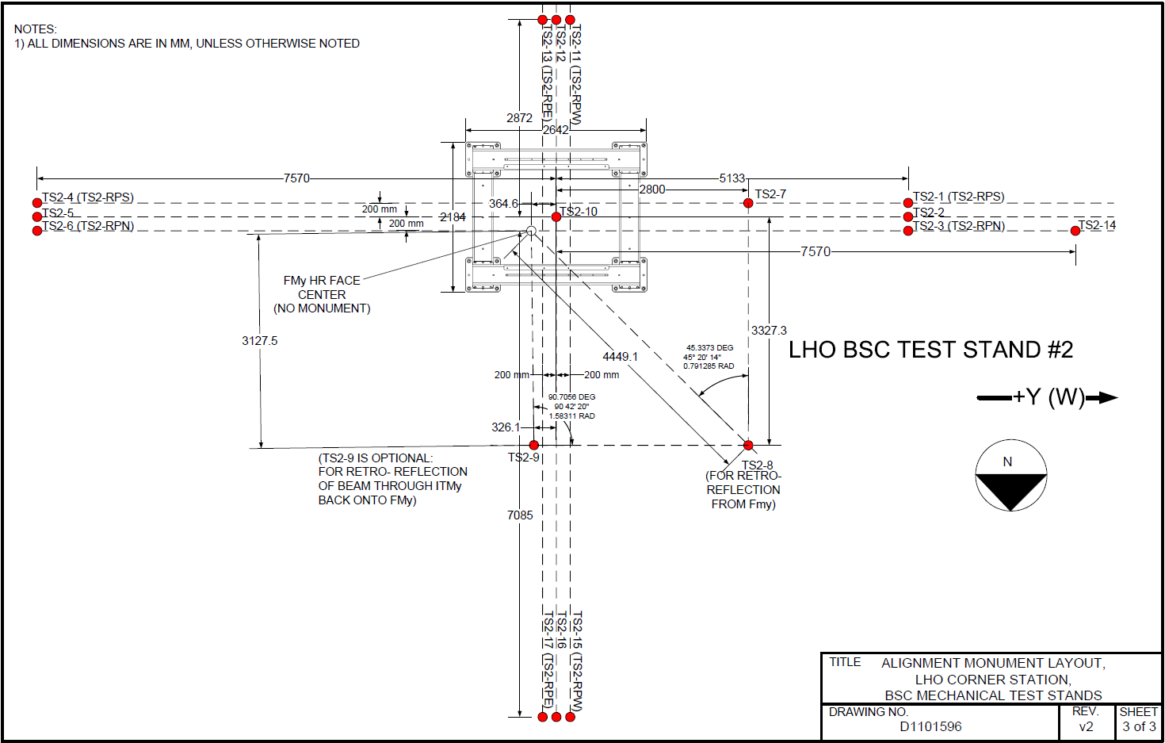

Figure : Monument Layout for Test Stand #2 (from D1101596)

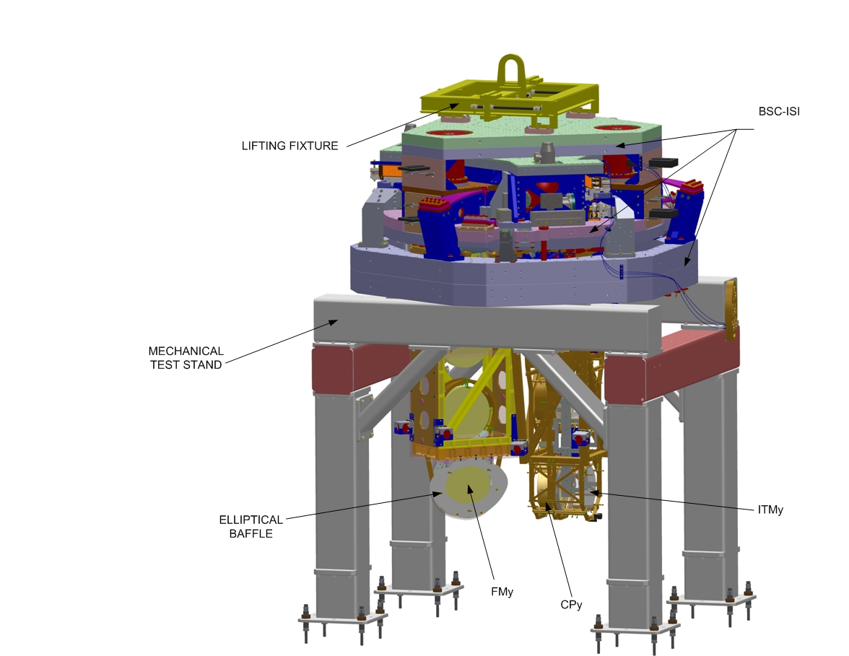

Figure : The WBSC8 cartridge assembly on the BSC Mechanical Test Stand (D1002124)

*N.B.: The configuration “full cartridge” of D0900360, SolidWorks PDMW vault version X-106 is shown, modified to not include the Arm Cavity Baffle (ACB, D0901376) since it interferes with the test stand. Note that the electrical feedthrough CF flanges are shown in this image, but are in fact installed on the chamber and are not part of the assembly while it is on the mechanical test stand.*

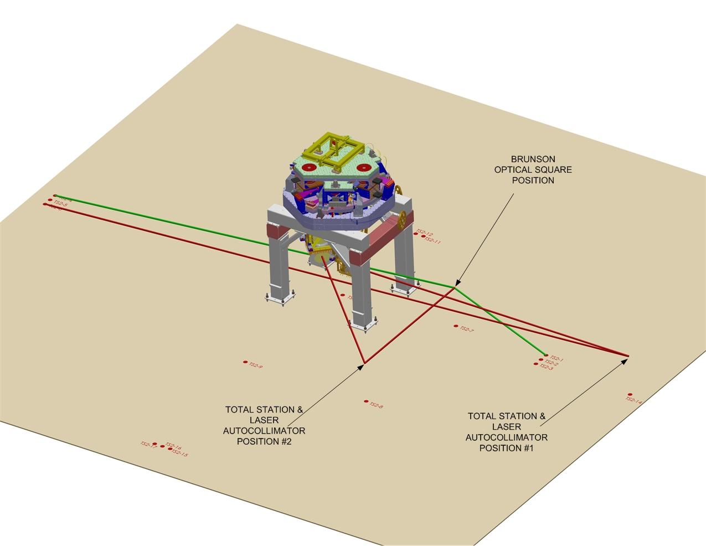

Figure : IAS Instrument Positions and Lines Of Sight (LOS) for the WBSC8 Cartridge Assembly Alignment

B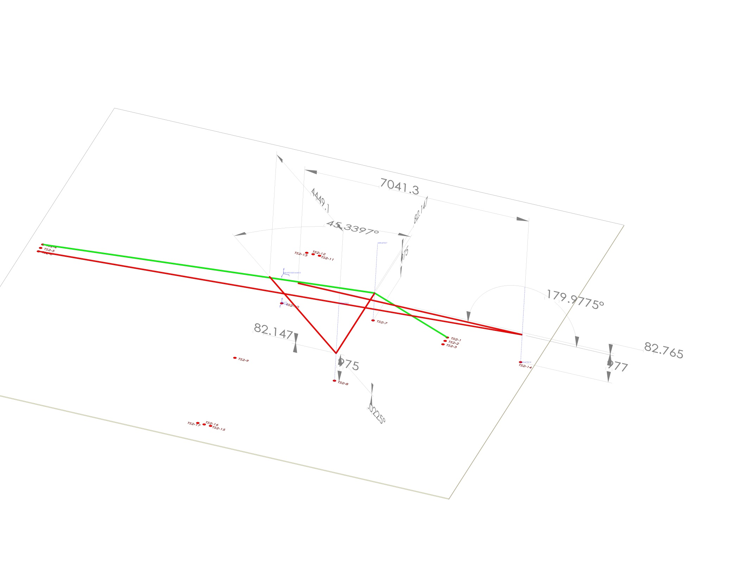

Figure : IAS Instrument Positions and LOS

**WARNING! USE THE NUMERICAL VALUES OF DISTANCES AND ANGLES IN THE TEXT OF THE PROCEDURE AND NOT THOSE SHOWN IN THIS FIGURE (SOME OF THESE VALUES ARE IN ERROR – FIGURE TO BE UPDATED**

## Cartridge set-up

### Check optics table level on the BSC mechanical test stand

Datum: Local gravity

Equipment: Optical level on tall tripod and targets on invar rods suspended from the optics table

Accuracy: ± 100 microrad (0.1 mm differential height)

Procedure:

* Attach 3 invar rods with targets to the table (equal lengths sufficient to be seen by optical level on tripod). Position the rods so that all 3 can be observed from a single optical level position.
* Place optical level on a tall tripod and sight the relative difference in target heights to determine tip and tilt of optics table.
* Adjust ISI trim/balance mass per E0900357 (v20, section 1.84)
* Record table levelness:

|  |  |
| --- | --- |
| Tip (rotation about x) | microrad |
| Tilt (rotation about y) | microrad |

### Approximately align the Cartridge Assembly elements with the templates.

Datum: Bolt holes in optical table per [D1101259-v2](https://dcc.ligo.org/cgi-bin/private/DocDB/ShowDocument?.submit=Number&docid=d1101259&version=)

Equipment: Alignment templates (D1101050). Each suspension has two sets of templates. Either set may be used but not both.

ITMy Suspension: Use either D1001050-3 or D1001050-4.

FMy Suspension: Use either D1001050-1 or D1001050-2.

Accuracy: Clearance in bolt holes

Procedure:

* Install D1101050-3 or D11050-4 template per [D1101259-v2](https://dcc.ligo.org/cgi-bin/private/DocDB/ShowDocument?.submit=Number&docid=d1101259&version=).
* Install D1101050-1 or D11050-2 template per [D1101259-v2](https://dcc.ligo.org/cgi-bin/private/DocDB/ShowDocument?.submit=Number&docid=d1101259&version=).
* If needed, install precision pushers ([D060052](https://dcc.ligo.org/cgi-bin/private/DocDB/ShowDocument?.submit=Number&docid=d060052&version=)) per [T080230](https://dcc.ligo.org/DocDB/0008/T080230/001/T080230-v1.pdf) adjacent to FM and ITM structures opposite of the templates.
* Push FM and ITM structures to contact the templates per [T080230](https://dcc.ligo.org/DocDB/0008/T080230/001/T080230-v1.pdf).
* Lock down suspension structures.
* Remove all templates.

## H2 ITMy

### Setup the ITM Retro-reflector Assembly

Datum: Optical axis of the test mass.

Equipment: Retro-reflector assembly (D1101340), CMM

Accuracy: ± 0.2 mm

Procedure:

* Attach the retro-reflector assembly to the quad structure in front of the ITM HR face.
* Lock the rotation stage so that the retroreflector is not free to move.   
  *Note: It is not necessary to center the retroreflector target to the optic centerline.*
* Use a CMM to measure the Y distance (offset) between the reflecting plane reference on the retro-reflector to the test mass HR face (see Figure 6). The CMM probe is not to contact the HR face of the optic except along the outer perimeter
* Record the Offset (Y-distance).

|  |  |
| --- | --- |
| Offset: distance from the ITM HR face to the Reflecting Plane of the Retro-reflector | mm |

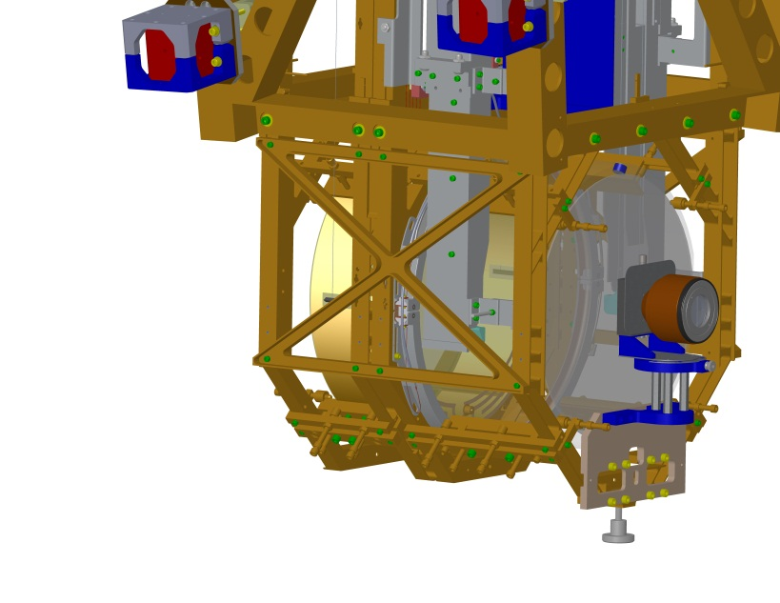

Figure : Retro-reflector Assembly attached to Quad Suspension Structure

|  |  |
| --- | --- |
|  |  |

Figure : X, Y and Z offsets between the HR face center and the Retro-Reflector Center

### Setup Total Station and Laser Autocollimator

Datum: Monuments TS2-14, TS2-3, TS2-6 – axis 200 mm shifted from the centerline; Height target is placed on the precision length rod (D1101611) to set target to optic height below the optics table.

Equipment: Total station, Newport Laser Autocollimator (mounted on top of Total Station), height target (D1101611)

Accuracy: ±1 mm, ±40 microradians rss, alignment reference transfer (see [T1000230](https://dcc.ligo.org/cgi-bin/private/DocDB/ShowDocument?docid=11150)-v6, section 17)

Procedure:

* Set the total station to approximately 977 mm above the floor
* Set the total station on TS2-14 and sight TS2-3 and TS2-6. See Figure 4
* Attach the height target to the optics table on a centerline hole near the table edge toward the total station.
* Yaw the total station to sight the height target and adjust total station height to match height target. The total station is now at the height of the test mass (i.e. -80 mm Z)

### Set the ITM longitudinal position

Datum: Total station EDM, Retro-reflector and offsets to the HR face (determined in section 6.2.1)

Equipment: Total station, retro-reflector

Accuracy: ±3mm

Procedure:

* Use total station EDM to set position to 7041.3 mm (remember to account for the offset distance from the retro-reflector to the optic HR face)
* Record position.

|  |  |  |  |
| --- | --- | --- | --- |
|  | Trial 1 | Trial 2 | Trial 3 |
| Retroreflector to HR face offset | mm | mm | mm |
| Retroreflector inherent offset | mm | mm | mm |
| EDM Distance | mm | mm | mm |
| Sum = ITM HR longitudinal distance | mm | mm | mm |

### Set the ITM horizontal position

Datum: Optical axis as established by the total station.

Equipment: Total Station, Pusher Assemblies ([D060052](https://dcc.ligo.org/DocDB/0017/D060052/000/D060052-A.pdf)), Slider/Mover Assemblies ([D1100018](https://dcc.ligo.org/DocDB/0030/D1100018/002/LIGO-D1100018-v2.pdf))

Accuracy: ± 1mm (corresponds to ± 140 microradians of yaw error when sighting the retro-reflector target)

Procedure:

* Lock-down the optics and masses, of both suspension chains, with the earthquake stops according to the SUS procedure
* With the Total Station at zero elevation angle, sight the left edge of the optic. Record the yaw angle.
* Sight the right edge of the optic. Record the yaw angle.

|  |  |  |  |
| --- | --- | --- | --- |
|  | Trial 1 | Trial 2 | Trial 3 |
| Left optic edge (-A) | mrad | mrad | mrad |
| Right optic edge (+B) | mrad | mrad | mrad |
| Center error angle  (A+B)/2 | microrad | microrad | microrad |
| Center error distance  7041.3 * (A+B)/2 | mm | mm | mm |

* Use the “slider/supports” and “pusher assemblies” ([D060052](https://dcc.ligo.org/DocDB/0017/D060052/000/D060052-A.pdf)) to shift the lateral position of the quad structure as needed, so that the retro-reflector center is centered in the theodolite (Total Station)

### Coarse Align the ITM Yaw

Datum: Optical axis as established by the total station.

Equipment: Laser autocollimator

Accuracy: ±1 milliradians goal (limited by the repeatability in the pusher and clamping method)

Procedure:

* Peel back the First Contact™ at 12 o’clock.
* Insure that the optics and masses, of the main suspension chain, are free (not clamped or on the mechanical or earthquake stops)
* Use the laser autocollimator to measure the TM optic yaw angle.
* Use the pusher assemblies to reduce the yaw angle to as close to zero as possible (< 1 mrad), using the SUS procedures. Note that the optics and masses should be clamped before attempting to move the Suspension frame/assembly on the optics table.
* Record residual yaw error.

|  |  |  |  |
| --- | --- | --- | --- |
|  | Trial 1 | Trial 2 | Trial 3 |
| ITM yaw error | millirad | millirad | millirad |

### Iterate/re-Check

Datum: Local gravity, optical axis as established by the total station.

Equipment: Optical level on tall tripod and targets on invar rods suspended from the optics table, total station

Accuracy:

levelness: ±100 microrad (0.1 mm differential height)

lateral position: ±1 mm

longitudinal position: ±3mm

yaw: ±160 microradians

Procedure:

* Re-check table level
* Re-check the lateral & longitudinal position and yaw and iterate until all are within required accuracy (coarse accuracy for the yaw).
* Remove the retroreflector and mount assembly from the ITM

Once this step has been completed, the ITM “frame” has been set; All further adjustments to the ITM are on the suspension chains.

### Check the ITM vertical position

Datum: Optical axis as established by the total station.

Equipment: Total Station

Accuracy: ± 1mm (corresponds to ± 140 microradians of pitch angle difference when sighting top and bottom edges of optic, on vertical centerline)

Procedure:

* With the Total Station at zero yaw angle, sight the bottom edge of the optic. Record the pitch angle.
* Sight the top edge of the optic. Record the pitch angle.

|  |  |  |  |
| --- | --- | --- | --- |
|  | Trial 1 | Trial 2 | Trial 3 |
| Bottom optic edge  (-A) | mrad | mrad | mrad |
| Top optic edge (+B) | mrad | mrad | mrad |
| Center error angle  (A+B)/2 | microrad | microrad | microrad |
| Center error distance  7041.3 * (A+B)/2 | mm | mm | mm |

* The optic height was set during the SUS assembly and should be correct. However, if it is out of tolerance, then use the SUS procedures, to adjust the test mass height until it is within the required accuracy

### Fine Align the ITM Yaw

Datum: Optical axis as established by the total station.

Equipment: Laser autocollimator

Accuracy: ±100 microradians (limited by air buffeting in the test stand/cleanroom environment)

Procedure:

* Insure that the optics and masses, of the main suspension chain, is free (not clamped or on mechanical or earthquake stops)
* Then use the top blade adjusters to reduce the residual error further, using SUS procedures
* Record the yaw error

|  |  |  |  |
| --- | --- | --- | --- |
|  | Trial 1 | Trial 2 | Trial 3 |
| ITM yaw error | millirad | millirad | millirad |

### Align the ITM pitch

Datum: Optical axis as established by the total station.

Equipment: Total station

Accuracy: ±100 microradians (limited by air buffeting in the test stand/cleanroom environment)

Procedure:

* Set the total station pitch to 12.5 microradians (2.58 arcsec) down. Using the LAC, measure the pitch error.

|  |  |
| --- | --- |
| Initial ITM pitch error | microradians |

* If the pitch error is < 100 microradians, record and re-adhere First Contact™
* If > 100 microradians, then adjust the upper intermediate mass pitch balance per SUS procedures

|  |  |
| --- | --- |
| Final ITM pitch error | microradians |

### Check the CP to ITMy Gap

Datum: The ITMy AR face and the opposing face of the CP.

Equipment: Keyance System and Laser Autocollimator

Accuracy: ±0.5 mm average/center distance, and ±1.47 milliradians parallelism (corresponding to ±0.25 mm over the diameter of the optic)

Procedure:

* Measure & record the gap distance between the ITMy AR face and the opposing face of the CP with the Keyance System.
* If the gap is not within the allowed tolerance of the nominal 20 mm, then adjust per SUS procedures
* Measure the parallelism between the surfaces and if not within the allowed tolerance, then adjust per SUS procedures
* Record the final gap parameters

|  |  |
| --- | --- |
| Gap Distance | mm |
| Gap Parallelism | milliradians |

## FM

### Setup the FM Retro-reflector Assembly

Datum: Optical axis as established by the total station.

Equipment: Retro-reflector assembly (D1101340), CMM,

Accuracy: ± 0.2 mm

Procedure:

* Attach the retro-reflector assembly to the FM structure in front of the FM HR face.
* Use a CMM to measure and the x-y stage to adjust the center of the retro-reflector cross-hairs to be on the optical axis of the test mass.
* Write down x,y,z coordinates of retro center to optic center.

|  |  |
| --- | --- |
| FM X, Y, Z coordinates | mm |

### Set the Optical Square

Datum: Monument TS2-7, TS2-1, and TS2-4

Equipment: Brunson optical square

Accuracy: ± 1 mm, ±10 microradians

Procedure:

* Set the Brunson optical square to approximately 975 mm above the floor over TS2-7.
* Use the optical square to sight TS2-3 and TS2-6.

### Setup Total Station and Laser Autocollimator

Datums: Monument TS2-8, optical square, ISI table surface as referenced by height target.

Equipment: Total station, retro-reflector, height target

Accuracy: ± 1 mm, ±10 microradians

Procedure:

* Set the total station to approximately 975 mm above the floor over TS2-8.
* Use the total station to retro-reflect off the optical square to set the “zero” yaw position.
* Attach the height target to the optics table near the table edge toward the total station.
* Yaw the total station to sight the height target and adjust total station height to match height target. The total station is now at the height of the FM.

### Set the FM longitudinal position

Datum: Optical axis established with the Total Station

Equipment: Total station

Accuracy: ±3 mm

Procedure:

* Use total station EDM to set position to 4449.1 mm (remember to account for the offset distance from the retro-reflector to the optic HR face)
* Record position.

|  |  |  |  |
| --- | --- | --- | --- |
|  | Trial 1 | Trial 2 | Trial 3 |
| Retroreflector to HR face offset | mm | mm | mm |
| Retroreflector inherent offset | mm | mm | mm |
| EDM Distance | mm | mm | mm |
| Sum = ITM HR longitudinal distance | mm | mm | mm |

### Set the FM horizontal position

Datum: Optical axis as established by the total station.

Equipment: total station, pusher assembly ([D060052](https://dcc.ligo.org/DocDB/0017/D060052/000/D060052-A.pdf)).

Accuracy: ± 1mm (corresponds to ± 225 microradians of pitch error when sighting FM optic top center edge)

Procedure:

* Sight the retroreflector target with the total station and use the “slider/supports” and “pusher assemblies” ([D060052](https://dcc.ligo.org/DocDB/0017/D060052/000/D060052-A.pdf)) to shift the FM structure so that the retro-reflector center is centered in the theodolite.
* Measure & record the yaw angle to null the difference in theodolite and retro-reflector cross-hairs.

|  |  |
| --- | --- |
| yaw angle to retro-reflector center | microrad |

### Coarse Align the FM Yaw

Datum: Optical axis as established by the total station.

Equipment: Laser autocollimator

Accuracy: ±1 milliradians goal

Procedure:

* Peel back the First Contact™ at 12 o’clock.
* Use the laser autocollimator to measure the FM optic yaw angle. Use the pusher assemblies to reduce the yaw angle to as close to 0.791285 radians (45.3373 degrees, or 45° 20’ 14”) as possible (< 1 mrad).
* Then use the top blade adjusters to reduce the residual error further, using SUS procedures
* Record residual yaw error.

|  |  |
| --- | --- |
| FM yaw error | microrad |

### Iterate/re-Check

Datum: Local gravity, optical axis as established by the total station.

Equipment: Optical level on tall tripod and targets on invar rods suspended from the optics table, total station

Accuracy:

levelness: ±100 microrad (0.1 mm differential height)

lateral position: ±1 mm

longitudinal position: ±3mm

yaw: ±380 microradians

Procedure:

* Re-check table level
* Re-check the lateral & longitudinal position and yaw and iterate until all are within required accuracy.

### Check the FM vertical position

Datum: Optical axis as established by the total station.

Equipment: Total station

Accuracy: ± 1mm (corresponds to ± 225 microradians of pitch error when sighting FM optic top center edge)

Procedure:

* Sight the retro-reflector target with the total station.
* Measure the vertical positional error by recording the pitch angle to null the difference between the theodolite and retro-reflector cross-hairs (A)

|  |  |
| --- | --- |
| A = pitch angle corresponding to ITM horizontal error | microrad |

* Measure the pitch angle to sight the top center edge of the FM optic (B)

|  |  |
| --- | --- |
| B = initial pitch angle to top center edge of the optic | microrad |

* Set the total station to sight the proper position of the top center edge of the FM optic (A+B)

|  |  |
| --- | --- |
| A+B = correct pitch angle to top center edge of the optic | microrad |

* Adjust the FM height by adjusting trim masses per SUS procedures until the top center edge of the FM optic is at the correct pitch angle (A+B)
* Measure & record the pitch angle to null the difference in theodolite and retro-reflector cross-hairs.

|  |  |
| --- | --- |
| pitch angle to retro-reflector center | microrad |

### Fine Align the FM Yaw

Datum: Optical axis as established by the total station.

Equipment: Total station

Accuracy: ±380 microradians goal

Procedure:

* Peel back the First Contact™ at 12 o’clock.
* Use the laser autocollimator to measure the FM optic yaw angle. Use SUS procedures to adjust the top blades to reduce the yaw angle to as close to 0.791285 radians (45.3373 degrees, or 45° 20’ 14”) as possible.
* Record residual yaw error.

|  |  |
| --- | --- |
| FM yaw error | microrad |

### Align the FM pitch

Datum: Optical axis as established by the total station.

Equipment: Total station

Accuracy: ±110 microradians

Procedure:

* Set the total station pitch to 820 microradians (2’ 49”) up. Using the LAC, measure the pitch error.

|  |  |
| --- | --- |
| Initial FM pitch error | microradians |

* If the pitch error is < 110 microradians, record and re-adhere First Contact™
* If > 10 microradians, then adjust the FM pitch balance per SUS procedures

|  |  |
| --- | --- |
| Final FM pitch error | microradians |

# ALIGN THE CARTRIDGE ASSEMBLY IN THE BSC CHAMBER

## Notes

The FM Beam Dump Assemblies do not need to be aligned; Mechanical assembly tolerances are sufficient to assure adequate alignment.

The FM Elliptical Baffle Assembly (mounted on the FM Suspension Assembly) does not need to be aligned; Mechanical assembly tolerances are sufficient to assure adequate alignment.

*N.B.: For the initial installation of the Cartridge Assembly into WBSC8, the FM Beam Dump Assemblies are not available. In addition, the FM Elliptical Baffle has no aperture (so as to block the beam transmitted through the ITM and CP from glinting from the BS metal mass).*

## Level the Optics Table

Datum: Local gravity, BSC-ISI capacitive position sensors

Equipment: Optical Level, 3 metering rods, BSC-ISI capacitive position sensors.

Accuracy: 100 microradians (0.1 mm differential height)

Procedure:

* Make sure all payload and balance/ballast weight is on the BSC-ISI Assembly
* Attach 3 metering rods onto the Optics Table so that all 3 can be viewed from a single Optical Level position, on a tall tripod, through the open BSC door.
* Check the Optics Table levelness optically before unlocking BSC-ISI.
* If needed, adjust the table to be level using HEPI static adjustment per procedure [E040011](https://dcc.ligo.org/cgi-bin/private/DocDB/ShowDocument?docid=20879), “HEPI Assembly and Installation Procedures”
* Unlock the BSC-ISI and compare the capacitive position sensors offset values to the offsets measured on the cartridge test stand. If necessary, adjust the balance mass to get the same capacitive position sensor offsets as achieved on the test stand.
* Confirm the Optics Table levelness (again) with the Optical Level

## Setup the Total Station and Laser Autocollimator

Datum:

1. Monuments LV2, LV3, LV17 (as defined in D1100291) – axis 200 mm shifted in the +X direction from the Y centerline
2. Elevation mark 504 or 202 (as defined in T1100187)

Equipment: Total Station; Newport Electronic Visible Laser Autocollimator (LAC); Initial Alignment Tooling Stand (D980429 through D980434); Brunson Optical Square; Metering Rods/Targets; 8” diameter Flat Mirror on a Newport Gimbal Mount and Tripod.

Accuracy: ±1 mm, ±40 microradians rss, alignment reference transfer (see [T1000230](https://dcc.ligo.org/cgi-bin/private/DocDB/ShowDocument?docid=11150)-v6, section 17)

Procedure:

* Remove the WA-1F Spool (on the Y-manifold adjacent to the WGV5 Gate Valve) per procedure [M1000357](https://dcc.ligo.org/cgi-bin/private/DocDB/ShowDocument?docid=25201), “Spool Manifold Removal Procedure”
* Set the Initial Alignment Tooling Stand in the space vacated by the Spool, over monument LV17
* Mount the LAC to the top of the Total Station
* Setup the Total Station/LAC on the Initial Alignment Tooling Stand at approximately 1810 mm above the floor directly over LV17
* Adjust the Total Station height to be -79.6 mm (global coordinate system) using either elevation mark 504 or 202 (see T1100187)
* Setup the large Flat Mirror with gimbal mount/tripod with an unobstructed view of, and a few meters from, the Total Station/LAC
* Co-boresight the Total Station and LAC with the Flat Mirror
* Setup the Brunson Optical Square directly over monument LV3, at the same height as the Total Station, and sight LV2 to get alignment parallel to the Y global axis
* Set the Total Station to be square to the Brunson Optical Square.
* Yaw the Total Station precisely 90 degrees and set this yaw angle reference to zero. Pitch the Total Station 12.5 microradians (2.58 arcsec) down. (The Total Station is now pointing to the center of the ITMy HR face.)

## Measure Axial Position Error of ITMy

Datum: Monument LV17

Equipment: Retro-Reflector Assembly (D1101340), Total Station, Microscribe Coordinate Measuring Machine (CMM) arm

Accuracy: ±3mm

Procedure:

*N.B.: Ideally the measurement of the distance from the Retro-Reflector to the ITM HR face would be done once while the Cartridge Assembly is on the test stand. However, the repeatability in the distance from the Retro-Reflector Assembly (D1101340-v1) to the HR face is quite poor; This mount is being redesigned. In the interim, the CMM measurement must be made in the chamber. (The alternative of making the CMM measurement at the test stand and then keeping the Retro-Reflector on the Cartridge Assembly during the flight to, and insertion into, the chamber is not feasible because it blocks the “lens cap”.)*



*Another alternative is to use a depth gauge with a soft tip or cap (or a soft rule) to measure the distance from the Retro-Reflector mounting plane to the First Contact™ layer.*

* Mount the Retro-Reflector Assembly to the ITMy Suspension Assembly structure
* Measure the distance from the Retro-Reflector reference plane to the ITM HR face using either the CMM, a depth gauge with soft tip/cap or a soft rule.  
  Take care to clean the measurement tool, especially the contact feature, (b) contact the optic either on the outer perimeter of the HR face where there is no First Contact ™ film or in the interior but only on the First Contact™ film and (c) contact very gently.
* Record the CMM measurement as well as the Retro-Reflector (corner cube) offset constant:

|  |  |
| --- | --- |
| Retro-Reflector-to-HR face distance | mm |
| Retro-Reflector (corner cube) offset constant | mm |

* Do not remove or adjust the Retro-Reflector or the mount until after the last Electronic Distance Measurement (EDM) has been completed with the Total Station.
* Use Total Station EDM to measure the axial or longitudinal (Y) position of the ITMy HR face (remember to account for the offset distance from the retro-reflector to the optic HR face). Record the distance:

|  |  |  |  |
| --- | --- | --- | --- |
|  | Trial 1 | Trial 2 | Trial 3 |
| Retroreflector to HR face distance | mm | mm | mm |
| Retroreflector inherent offset | mm | mm | mm |
| EDM distance | mm | mm | mm |
| Sum = ITM HR longitudinal distance to Total Station | mm | mm | mm |

## Measure Lateral Position Error of ITMy

Datum: Y-Arm Axis derived from LV2, LV3 and LV17

Equipment: Total Station

Accuracy: ±1mm

Procedure:

* With the Total Station, sight the left edge of the optic. Record the yaw angle.
* Sight the right edge of the optic. Record the yaw angle.
* Calculate the lateral position error:

|  |  |  |  |
| --- | --- | --- | --- |
|  | Trial 1 | Trial 2 | Trial 3 |
| Left optic edge (-A) | mrad | mrad | mrad |
| Right optic edge (+B) | mrad | mrad | mrad |
| Center error angle  (A+B)/2 | microrad | microrad | microrad |
| Center error distance  28260 * (A+B)/2 | mm | mm | mm |

## Measure Vertical Position Error of ITMy

Datum: Y-Arm Axis derived from LV2, LV3 and LV17

Equipment: Total Station

Accuracy: ±1mm

Procedure:

* With the Total Station, sight the top edge of the optic. Record the pitch angle.
* Calculate the vertical position error. (Note: The bottom edge cannot be viewed because of the Retro-Reflector mount.)

|  |  |  |  |
| --- | --- | --- | --- |
|  | Trial 1 | Trial 2 | Trial 3 |
| Top optic edge (A) | mrad | mrad | mrad |
| Center vertical position error  28260 *A - 170 | mm | mm | mm |

## Measure Pitch & Yaw Errors

Datum: Optical axis as established by the total station.

Equipment: Newport Electronic, Visible Laser Autocollimator (LAC)

Accuracy: ±10 microradians goal

Procedure:

* Peel back the First Contact™ at 12 o’clock.
* Insure that the optics and masses, of the main suspension chain, are free (not ‘clamped’ or on the mechanical stops or earthquake stops)
* Use the Laser Autocollimator to measure the TM optic yaw angle. All personnel should exit the chamber. Purge air flow should be off or minimized. Electronic damping should be active for the suspension. If necessary, use a low pass filtering amplifier and display the pitch and yaw on an oscilloscope with trace persistence and cursors to get the average angles
* Record the pitch and yaw errors:

|  |  |  |  |
| --- | --- | --- | --- |
|  | Trial 1 | Trial 2 | Trial 3 |
| Yaw error | microrad | microrad | microrad |
| Pitch error | microrad | microrad | microrad |

## Translate Cartridge with HEPI to Correct Axial, Lateral, Vertical and Yaw Errors

Datum: Optical axis as established by the total station.

Equipment: HEPI static adjusters, Total Station, Retro-Reflector Assembly, Newport Electronic Visible Laser Autocollimator

Accuracy: ±160 microradians yaw goal with HEPI, ±1 mm transverse, ±1 mm vertical, ±3 mm axial

Procedure:

* Use the HEPI static adjustment procedure (per procedure [E040011](https://dcc.ligo.org/cgi-bin/private/DocDB/ShowDocument?docid=20879), “HEPI Assembly and Installation Procedures”) to correct the axial, lateral, vertical and yaw errors until the residual errors are within the allowed tolerance.
* After, or during, HEPI adjustments measure the axial, lateral, vertical and yaw errors to guide the HEPI adjustment.

## Correct Pitch Error

Datum: Optical axis as established by the total station.

Equipment: ITM Suspension pitch adjuster, Newport Electronic Visible Laser Autocollimator

Accuracy: ±160 microradians pitch goal

Procedure:

* Use the Laser Autocollimator to measure the TM optic pitch angle. All personnel should exit the chamber. Purge air flow should be off or minimized. Electronic damping should be active for the suspension. If necessary, use a low pass filtering amplifier and display the pitch and yaw on an oscilloscope with trace persistence and cursors to get the average angles
* Use the TM Suspension static pitch adjustment procedure ([E1000006](https://dcc.ligo.org/cgi-bin/private/DocDB/ShowDocument?docid=8382)-v20, section 5, “Quad Suspension Metal-Build Assembly Procedure”) to reduce the residual pitch errors to within the allowed tolerance
* Record the residual pitch error:

|  |  |  |  |
| --- | --- | --- | --- |
|  | Trial 1 | Trial 2 | Trial 3 |
| Pitch error | microrad | microrad | microrad |

## Fine Pitch & Yaw Error Correction

Datum: Optical axis as established by the total station.

Equipment: ITM Suspension actuation (BOSEMs), Newport Electronic Visible Laser Autocollimator

Accuracy: ±10 microradians goal

Procedure:

* Use the Laser Autocollimator to measure the TM optic pitch and yaw angles. All personnel should exit the chamber. Purge air flow should be off or minimized. Electronic damping should be active for the suspension. If necessary, use a low pass filtering amplifier and display the pitch and yaw on an oscilloscope with trace persistence and cursors to get the average angles
* Use the TM Suspension controls interface to set pitch and yaw bias values to correct the residual errors
* Record the pitch and yaw bias values:

|  |  |
| --- | --- |
| Pitch bias | counts |
| Yaw bias | counts |

# Align Arm Cavity Baffle (ACB) Assembly

Datums: Optical axis as established by the total station.

Equipment: Total station, pusher assembly ([D060052](https://dcc.ligo.org/cgi-bin/private/DocDB/ShowDocument?.submit=Number&docid=d060052&version=)).

Accuracy: ±2mm

Procedure:

* Install and suspend the ACB from stage-0 of the ISI using procedure [E1100810](https://dcc.ligo.org/cgi-bin/private/DocDB/ShowDocument?docid=69833), “Arm Cavity Baffle Installation Procedure”.
* Re-level table using HEPI (see section 7.1)
* Check horizontal alignment using the Total Station to sight on left & right edges of the baffle.
* Check vertical alignment using the Total Station to sight on top & bottom edges of the baffle
* If both vertical and horizontal positional errors are < 2mm, then proceed to next step. Otherwise, reposition using the pusher assemblies ([D060052](https://dcc.ligo.org/cgi-bin/private/DocDB/ShowDocument?.submit=Number&docid=d060052&version=)) per procedure [T080230](https://dcc.ligo.org/DocDB/0008/T080230/001/T080230-v1.pdf) until the positional errors are within tolerance.