California Institute of Technology  MS 18-34, 1200 E. California Blvd.  Pasadena CA 91125 USA  TEL: 626.395.2129  FAX: 626.304.9834  www.ligo.caltech.edu |  | LIGO Livingston Observatory  P.O. Box 940  Livingston LA 70754 USA  TEL: 225.686.3100  FAX: 225.686.7189  www.ligo-la.caltech.edu | LIGO Hanford Observatory  P.O. Box 159  Richland WA 99352 USA  TEL: 509.372.8106  FAX: 509.372.8137  www.ligo-wa.caltech.edu |  | Massachusetts Institute of Technology  MIT NW22 – 295, 185 Albany St.  Cambridge MA 02139 USA  TEL: 617.253.4824  FAX: 617.253.7014  www.ligo.mit.edu
Date: | 27 Feb 2012 |  |  | Refer to: |  | T1100348-v2
Subject: | TCS Mount Modal Data (Referenced D1100911 and G1100567)
To: | Mindy Jacobson
From: | Kristen Holtz

Experimental Analysis
The mount was secured using 4 dog clamps as shown in Figure 1.1. The screws in each of the dog clamps had a torque applied of 100 inlb.

Figure 1.1: This is the clamping arrangement used for this test.

The accelerometer was attached to the structure as shown in Figures 1.2 and 1.3.

Y
X

Figure 1.2: This is a side view of the TCS Mount. The axes show the directions that the accelerometer measure. The accelerometer was placed on the back, top, center of the structure, approximately where the X axis is pointing.

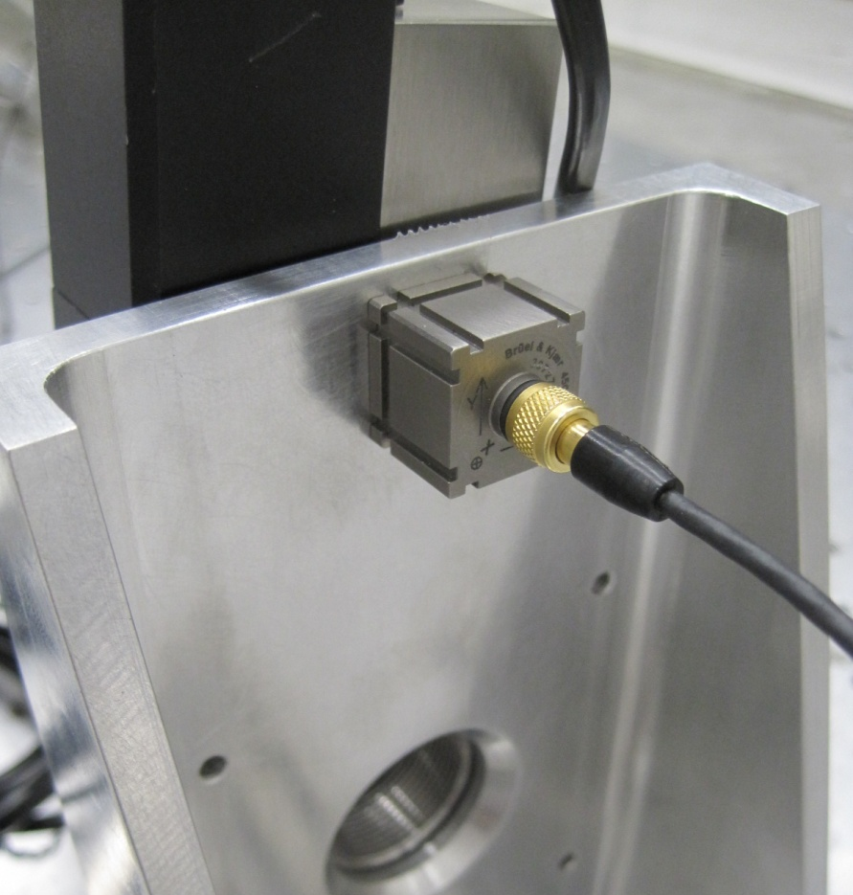

Figure 1.3: This is a picture taken of the accelerometer attached to the mount. Y is pointing up in this picture, and X into the structure.

The structure was excited in the X direction and Z direction, as shown in Figures 1.4 and 1.5, respectively.
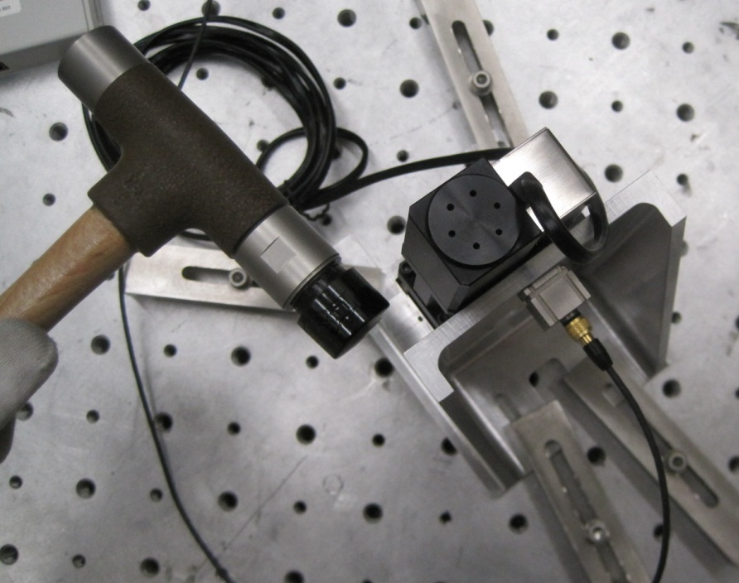

Figure 1.4: Hit placement to excite in X direction

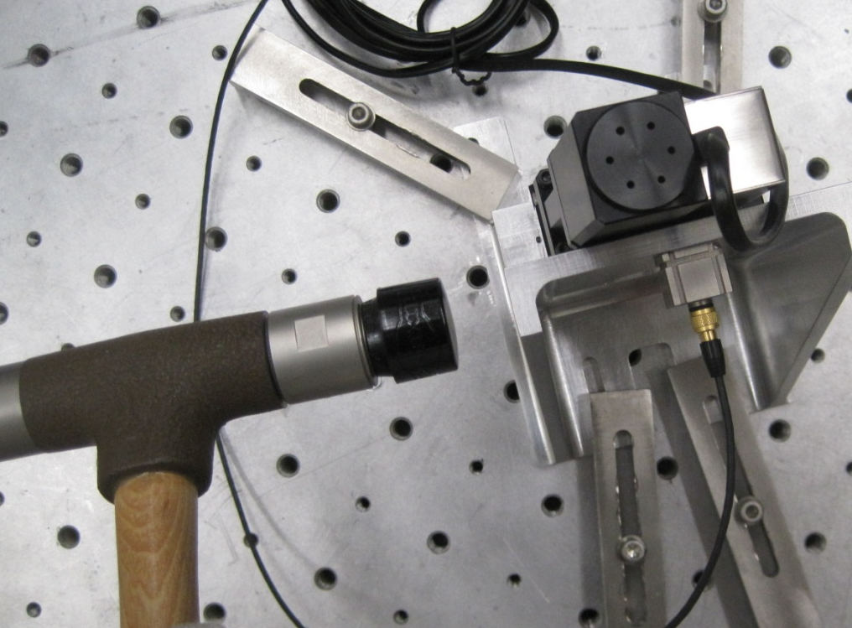

Figure 1.5: Hit placement to excite in Z direction.

Data was taken using the B&K Simple Hammer PULSE system. Figures 1.6 and 1.7 show the results of these tests.

FEA Analysis

Introduction

A model of the TCS Mount was analyzed in ANSYS 13. This model was designed specifically to match the laboratory conditions that the TCS Mount was tested under. Some more details on the FEA analysis as well as different placement of fixed supports can be found in G1100567-v2.

The model

- Model extracted from the SolidWorks model found in document D1100911-v2
- Model is made completely of Aluminum Alloy
- There is a .675kg point mass located at (0, 24.5, -35) mm with respect to the faces highlighted in Figure 2.1. This point mass represents the URS50 mass.

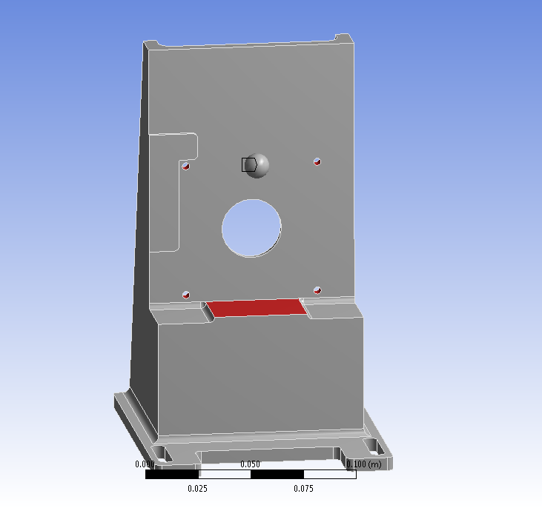
Figure 2.1: The point mass is the sphere located in the upper center of the structure. The faces highlighted in red were used in ANSYS 13 to position the point mass.

FEA results

Mesh
A refinement was added on the faces shown in Figures 2.2 and 2.3. The Mesh is shown in Figure 2.4. There were 40248 nodes and 20579 elements.
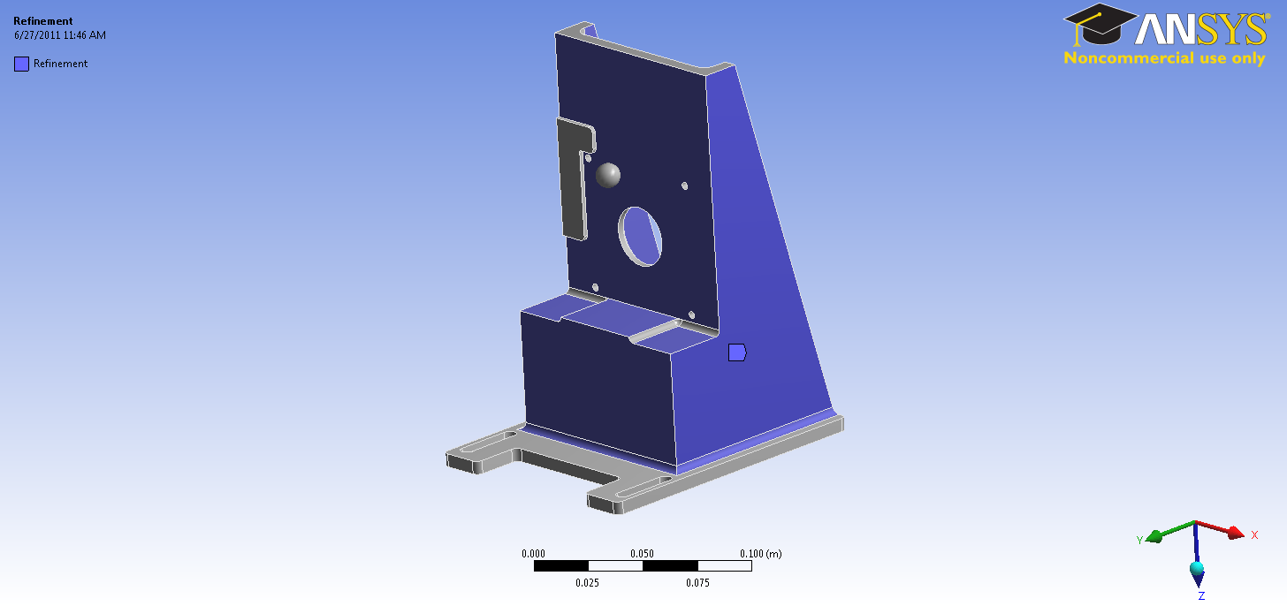
Figure 2.2: The planes that were refined for the mesh (front)

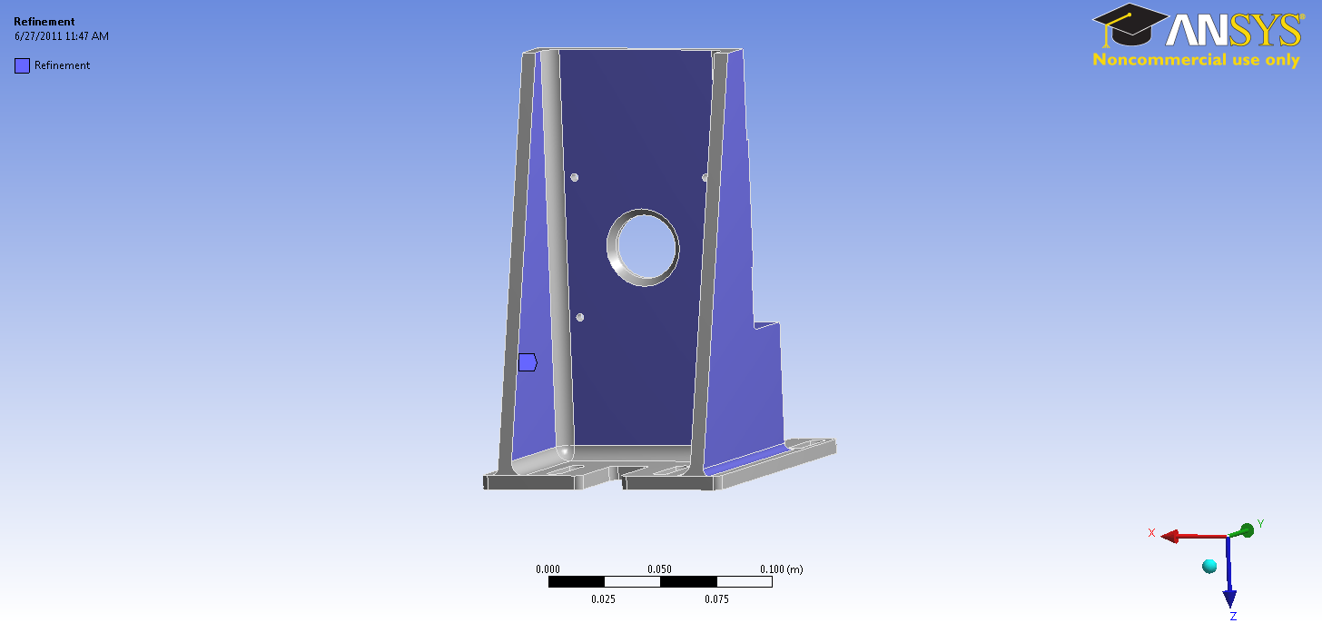
Figure 2.3: The planes that were refined for the mesh (back)

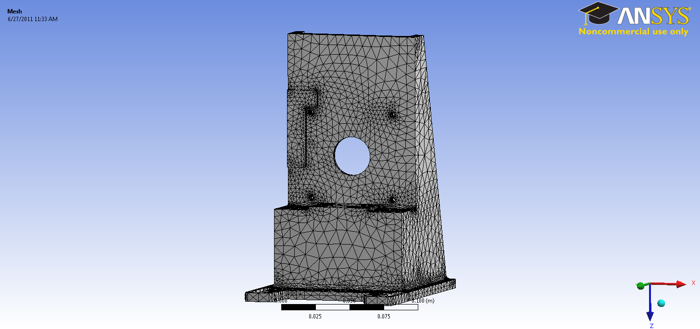
Figure 2.4: The meshed model (see appendix)

Connections
Bonded connections between the faces of the discrete sections were added.

Boundary conditions
4 fixed supports were added – each on the inside wall of the screw hole to indicate that the bottom of the structure was held tightly to the ground. (See figure 2.5).

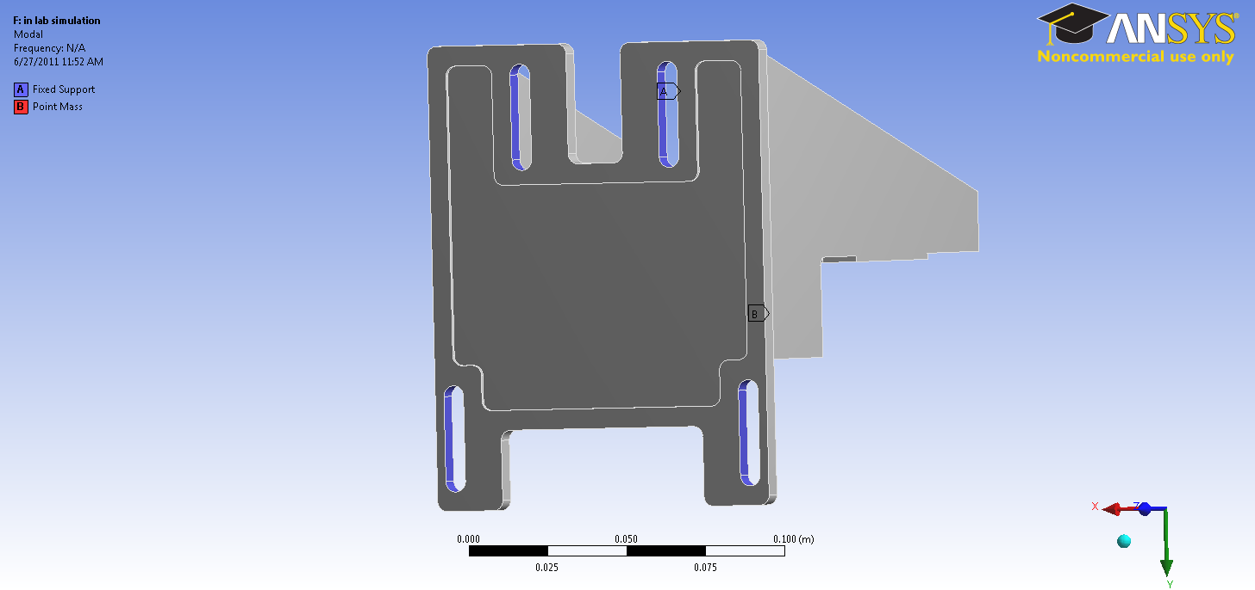
Figure 2.5: The four fixed supports are highlighted in purple above.

FEA results
Mode | Frequency [Hz]
1. | 678.
2. | 802.71
3. | 1814.7
4. | 2078.3
5. | 2466.9
6. | 2688.3

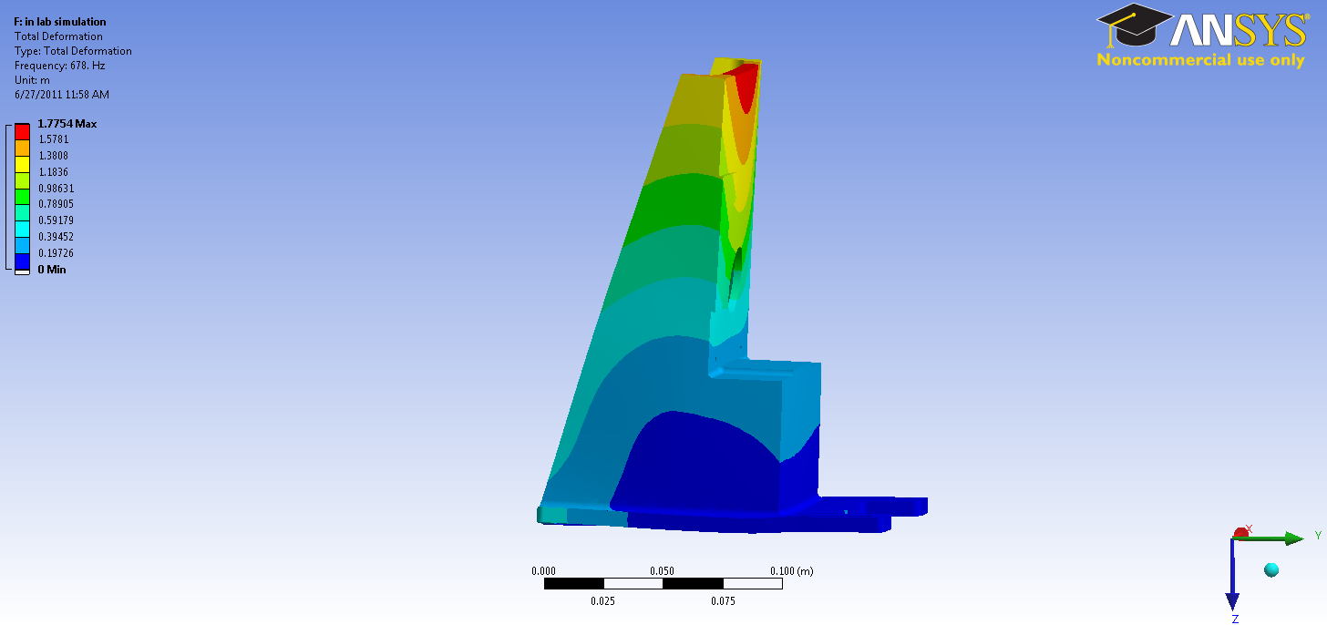
Figure 2.6: Mode 1 at 678 Hz

Conclusions

While it is difficult to model the clamping exactly as it was done in our test, it appears that the peak around 690 Hz, when excited in X, and 671 Hz, when excited in Z, correlates approximately to the peak that ANSYS predicts at 678 Hz. The first peak frequency will likely be different when the mount is attached with four screws instead of four dog clamps. However, it probably will not be too different provided that screws are put on the inside of the long extruded feet, versus the outside. Other ANSYS models show that the first peak frequency decreases substantially when the fixed support is placed on the outer edge, as opposed to the inner edge, of these feet.

Appendix

*** ELEMENT MATRIX FORMULATION TIMES
TYPE NUMBER ENAME TOTAL CP AVE CP
1 20579 SOLID187 1.856 0.000090
2 834 CONTA174 0.000 0.000000
3 1 TARGE170 0.000 0.000000
4 1 MASS21 0.000 0.000000

***** PARTICIPATION FACTOR CALCULATION ***** X DIRECTION
CUMULATIVE RATIO EFF.MASS
MODE FREQ PERIOD PARTIC.FACTOR RATIO EFFECTIVE MASS MASS FRACTION TO TOTAL MASS
1 677.998 0.14749E-02 -0.84817E-01 0.077027 0.719390E-02 0.580331E-02 0.365848E-02
2 802.708 0.12458E-02 1.1011 1.000000 1.21251 0.983929 0.616623
3 1814.73 0.55104E-03 -0.14048 0.127581 0.197358E-01 0.999850 0.100367E-01
4 2078.28 0.48117E-03 0.56659E-03 0.000515 0.321019E-06 0.999850 0.163255E-06
5 2466.86 0.40537E-03 -0.13398E-01 0.012167 0.179503E-03 0.999995 0.912866E-04
6 2688.26 0.37199E-03 0.25851E-02 0.002348 0.668251E-05 1.00000 0.339841E-05
***** PARTICIPATION FACTOR CALCULATION ***** Y DIRECTION
CUMULATIVE RATIO EFF.MASS
MODE FREQ PERIOD PARTIC.FACTOR RATIO EFFECTIVE MASS MASS FRACTION TO TOTAL MASS
1 677.998 0.14749E-02 1.0537 1.000000 1.11035 0.889853 0.564671
2 802.708 0.12458E-02 0.86259E-01 0.081860 0.744058E-02 0.895816 0.378393E-02
3 1814.73 0.55104E-03 0.61090E-02 0.005797 0.373196E-04 0.895846 0.189790E-04
4 2078.28 0.48117E-03 0.83475E-01 0.079218 0.696805E-02 0.901430 0.354362E-02s
5 2466.86 0.40537E-03 0.29552 0.280453 0.873330E-01 0.971421 0.444134E-01
6 2688.26 0.37199E-03 -0.18884 0.179212 0.356610E-01 1.00000 0.181355E-01
***** PARTICIPATION FACTOR CALCULATION ***** Z DIRECTION
CUMULATIVE RATIO EFF.MASS
MODE FREQ PERIOD PARTIC.FACTOR RATIO EFFECTIVE MASS MASS FRACTION TO TOTAL MASS
1 677.998 0.14749E-02 0.96027E-01 0.076088 0.922124E-02 0.501046E-02 0.468948E-02
2 802.708 0.12458E-02 0.60669E-02 0.004807 0.368067E-04 0.503046E-02 0.187182E-04
3 1814.73 0.55104E-03 -0.60584E-02 0.004800 0.367037E-04 0.505040E-02 0.186658E-04
4 2078.28 0.48117E-03 -1.2621 1.000000 1.59279 0.870512 0.810019
5 2466.86 0.40537E-03 -0.32831 0.260136 0.107785 0.929078 0.548145E-01
6 2688.26 0.37199E-03 -0.36128 0.286264 0.130525 1.00000 0.663788E-01

