LIGO Laboratory / LIGO Scientific Collaboration

LIGO- E1100295 LIGO October 31, 2011

aLIGO LHO BSC 6 BSC-ISI (Unit # 2),
Phase I (post-assembly, before storage)
E1100295 – V3

Vincent Lhuillier, Fabrice Matichard, Sebastien Biscans, Rich Mittleman, Celine Ramet

Distribution of this document:
Advanced LIGO Project

This is an internal working note
of the LIGO Laboratory

California Institute of Technology  LIGO Project – MS 18-34  1200 E. California Blvd.  Pasadena, CA 91125  Phone (626) 395-2129  Fax (626) 304-9834  E-mail: info@ligo.caltech.edu | Massachusetts Institute of Technology  LIGO Project – NW22-295  185 Albany St  Cambridge, MA 02139  Phone (617) 253-4824  Fax (617) 253-7014  E-mail: info@ligo.mit.edu
LIGO Hanford Observatory  P.O. Box 1970  Mail Stop S9-02  Richland WA 99352  Phone 509-372-8106  Fax 509-372-8137 | LIGO Livingston Observatory  P.O. Box 940  Livingston, LA 70754  Phone 225-686-3100  Fax 225-686-7189

Table of contents:

Introduction 4
I. Pre-Assembly Testing 5
▪ Step 1 - CPS Test and calibration – E1100369 5
▪ Step 2 - GS13 – Inspection/Assembly – E1000058 – E1100740 5
▪ Step 3 - L4C – Inspection/Assembly – E1000136 – E1100740 5
▪ Step 4 - T240 – Inspection/Assembly - E1100326 – E1100740 6
▪ Step 5 - Actuators - T0900564 - T1100234 – E1100741 6
II. Tests to be performed during assembly 8
▪ Step 1 - Test stand level 8
▪ Step 2 - Actuators Inventory 8
▪ Step 3 - Sensors Inventory 8
▪ Step 4 - Electronics Inventory 10
▪ Step 5 - Check level of Stage 0 after top-bottom plate assembly 11
▪ Step 6 - Check gaps under the blade posts 11
▪ Step 7 - Blade post shim thickness 11
▪ Step 8 - Blade 0-1 post launch angle 11
▪ Step 9 - Gap checks on actuators 11
▪ Step 10 - Mass budget 12
▪ Step 11 - Lockers adjustment 13
▪ Step 12 - Cables inventory – E1100822 13
▪ Step 13 - Cable routing – E1101027 13
III. Tests to perform after assembly 14
▪ Step 1- Geophones pressure readout 14
▪ Step 2- Set up sensors gap – Locked vs unlocked position 14
▪ Step 3 - Measure the Sensor gap 16
▪ Step 4- Performance of the limiters 17
o Step 4.1 - Test Nº1 - Push “in the general coordinates Z/RZ” 17
o Step 4.2 - Test Nº2 – Push “locally” 17
▪ Step 5 - Sensors Powerspectra 18
▪ Step 6 - Coil Driver, cabling and resistance check 21
▪ Step 7- Actuators Sign and range of motion (Local drive) 22
o Step 7.1 - Actuators sign 22
o Step 7.2 - Range of motion - Local drive 22
▪ Step 8 - Vertical Sensor Calibration 22
▪ Step 9 - Vertical Spring Constant 23
▪ Step 10 - Static Testing (Tests in the local basis) 25
▪ Step 11- Static Testing - In the general coordinate basis (Static test - CPS) 26
o Step 11.1 – Base change matrices from Cartesian to Local 26
o Step 11.2 – Base change matrices from Cartesian to Cartesian 27
▪ Step 12 - Linearity test 27
▪ Step 13 – Transfer functions – Local to Local 29
▪ Step 14 - Symmetrization – Calibration 37
▪ Step 15 - Basis change – Cartesian to Local - Simulations 37
▪ Step 16- Transfer functions - Cartesian to Cartesian - Measurements 37
▪ Step 17 - Lower Zero Moment Plan 37
o Step 17.1 - Stage 1 - LZMP 37
o Step 17.2 - Stage 2 - LZMP 37
▪ Step 18- Damping Loops – Transfer function – Simulations 37
o Step 18.1 - Damping Loops – Stage 2 37
o Step 18.2 - Damping Loops – Stage 1 37
▪ Step 19- Damping Loops – Powerspectra 37
▪ Step 20- Isolation Loops – for one unit per site 37
IV. BSC-ISI testing Summary 38

Introduction

The BSC-ISI testing is performed in three phases:
1) BSC-ISI, Pre-integration Testing, Phase I (post-assembly)
2) BSC-ISI, Pre-integration Testing, Phase II: Tests done after Transport (and possible storage), during mating phase with Suspensions, before insertion.
3) BSC-ISI, Integration Phase Testing: Procedure and results related to the commissioning in the chamber.

This document presents the series of tests (Phase I) performed on the ISI-BSC6 (ETMY) in the Staging building before its move to the End Station (Teststand). Tests started on August 5. Due to lots of issues with cabling and sensors, tests were stopped and finished on October 27, 2011. The testing procedure document E1000486-v3 was used. Some tests have been waived.

The ISI-BSC6 was moved from the Staging building to EY on October 31, 2011. The ISI left the staging building in a working state.

All results are posted on the SVN at:
https://svn.ligo.caltech.edu/svn/seismic/BSC-ISI/X1/Data/BSC6/

The following type of document can be found in the SVN:
- Excel spreadsheet (.xls)
- Data location
- Figures location
- Masses distribution scheme (ppt)

Pre-Assembly Testing

Step 1 - CPS Test and calibration – E1100369
CPS sensors are tested (calibration and noise test) at MIT before being cleaned and baked at LHO. During testing, the initial set of CPSs (12) was changed due to flux issue.

The list of installed sensors used for testing (phase I) are reported in step II.3.

All data related to the CPS testing can be found in the SVN at
/svn/seismic/ Common\Data\aLIGO_BSC_ISI_CPS\

Test result: Passed: X Failed: .

Step 2 - GS13 – Inspection/Assembly – E1000058 – E1100740
GS13 are tested and podded at LLO before being shipped to LHO. The first set of GS13s was replaced due to wrong screws (length) installed on the electrical feedthroughs.
All the data related to GS-13 post podding testing can be found in the SVN at : /svn/seismic/Common/Data/aLIGO_GS13_TestData/GeoTech_TestResults_PDFs/

The list of installed sensors used for testing (phase I) are reported in step II.3.

E1000058 spreadsheet provides the status of each individual GS-13 at LLO site for HAM-ISI and BSC-ISI. E1100740 shows the installation location of the geophones.

Test result: Passed: X Failed: .
”

Step 3 - L4C – Inspection/Assembly – E1000136 – E1100740
L4C are tested and podded at LLO before being shipped to LHO. During testing, two pods were replaced (1 non-working pressure sensor and 1 pod non vacuum compatible)

The list of installed sensors used for testing (phase I) are reported in step II.3.

All the data related to L4C post podding testing can be found in the SVN at : svn/seismic/Common/Data/aLIGO_L4C_TestData/TestResults_PDFs/

E1000136 spreadsheet provides the status of each individual GS-13 at LLO site for HAM-ISI and BSC-ISI. E1100740 shows the installation location of the geophones.

Test result: Passed: X Failed: .
”

Step 4 - T240 – Inspection/Assembly - E1100326 – E1100740
T240 are tested and podded at LLO before being shipped to LHO.
All T240s were replaced during testing to be fixed and retrofitted. On the initial set, two of the three pressure sensors were not working.
Before retrofitting the T240 pods, if the seismometer were unplugged when the interface chassis was not turned off, the surge created by the inductance of the cable could damaged the pressure sensors. Surge protectors are now added on the seismometer pressure sensors.

The list of installed sensors used for testing (phase I) are reported in step II.3.

All the data related to T240 post podding testing can be found in the SVN at :
seismic/Common/Data/aLIGO_T240_TestData/AsReceived_TestResults_PDFs.

E1100326 spreadsheet provides the status of each individual T240 at LLO site for BSC-ISI. E1100740 shows the installation location of the geophones.

Test result: Passed: X Failed: .

Step 5 - Actuators - T0900564 - T1100234 – E1100741
The list of installed sensors used for testing (phase I) are reported in step II.2

Large actuator data can be found at: T0900564. Actuator inventory is made at Section II – Step 2.
Small actuator data can be found at: T1100234. Actuator inventory is made at Section II – Step 2.

Details of the actuators testing are given in the table below.

 | Stage 0-1 |  | Stage 1-2
Corner | H | V | H | V
1 | Actuator Serial #: L051  Operator Name: Gordon, Matt  Date: 9/24/2009 Time: 8:35 AM  Actuator Coil Resistance: 6.38 Ohms, PASS  Ambient Temperature: 68.8 F  Hi Pot Test Results: 1000 MOhms, PASS  X Travel Limit (inches): 0.520  Y Travel Limit (inches): 0.205  Z Travel Limit (inches): 0.506 | Actuator Serial #: L034  Operator Name: Hartmann Donna  Date: 9/23/2009 Time: 10:57 AM  Actuator Coil Resistance: 6.43 Ohms, PASS  Ambient Temperature: 72.9 F  Hi Pot Test Results: 1000 MOhms, PASS  X Travel Limit (inches): 0.527  Y Travel Limit (inches): 0.205  Z Travel Limit (inches): 0.505 | Actuator Serial #: S054  Operator Name: Gordon, Matt  Date: 9/15/2010 Time: 1:27 PM  Actuator Coil Resistance: 10.36 Ohms, PASS  Ambient Temperature: 78.8 F  Hi Pot Test Results: 1000 MOhms, PASS  X Travel Limit (inches): 0.657  Y Travel Limit (inches): 0.205  Z Travel Limit (inches): 0.515 | Actuator Serial #: S050  Operator Name: Gordon, Matt  Date: 9/15/2010 Time: 10:06 AM  Actuator Coil Resistance: 10.29 Ohms, PASS  Ambient Temperature: 78.8 F  Hi Pot Test Results: 1000 MOhms, PASS  X Travel Limit (inches): 0.674  Y Travel Limit (inches): 0.205  Z Travel Limit (inches): 0.512
2 | Actuator Serial #: L047  Operator Name: Gordon, Matt  Date: 9/24/2009 Time: 3:34 PM  Actuator Coil Resistance: 6.34 Ohms, PASS  Ambient Temperature: 75.4 F  Hi Pot Test Results: 1000 MOhms, PASS  X Travel Limit (inches): 0.523  Y Travel Limit (inches): 0.204  Z Travel Limit (inches): 0.504 | Actuator Serial #: L048  Operator Name: Gordon, Matt  Date: 9/24/2009 Time: 3:52 PM  Actuator Coil Resistance: 6.32 Ohms, PASS  Ambient Temperature: 75.1 F  Hi Pot Test Results: 1000 MOhms, PASS  X Travel Limit (inches): 0.526  Y Travel Limit (inches): 0.205  Z Travel Limit (inches): 0.504 | Actuator Serial #: S053  Operator Name: Gordon, Matt  Date: 9/15/2010 Time: 11:43 AM  Actuator Coil Resistance: 10.23 Ohms, PASS  Ambient Temperature: 78.8 F  Hi Pot Test Results: 1000 MOhms, PASS  X Travel Limit (inches): 0.679  Y Travel Limit (inches): 0.205  Z Travel Limit (inches): 0.516 | Actuator Serial #: S056  Operator Name: Gordon, Matt  Date: 9/15/2010 Time: 2:00 PM  Actuator Coil Resistance: 10.35 Ohms, PASS  Ambient Temperature: 78.8 F  Hi Pot Test Results: 1000 MOhms, PASS  X Travel Limit (inches): 0.676  Y Travel Limit (inches): 0.205  Z Travel Limit (inches): 0.515
3 | Actuator Serial #: L053  Operator Name: Gordon, Matt  Date: 9/24/2009 Time: 4:23 PM  Actuator Coil Resistance: 6.36 Ohms, PASS  Ambient Temperature: 76.0 F  Hi Pot Test Results: 1000 MOhms, PASS  X Travel Limit (inches): 0.527  Y Travel Limit (inches): 0.205  Z Travel Limit (inches): 0.501 | Actuator Serial #: L046  Operator Name: Gordon, Matt  Date: 9/23/2009 Time: 3:31 PM  Actuator Coil Resistance: 6.375 Ohms, PASS  Ambient Temperature: 74.0 F  Hi Pot Test Results: 1000 MOhms, PASS  X Travel Limit (inches): 0.526  Y Travel Limit (inches): 0.206  Z Travel Limit (inches): 0.505 | Actuator Serial #: S055  Operator Name: Gordon, Matt  Date: 9/15/2010 Time: 1:44 PM  Actuator Coil Resistance: 10.33 Ohms, PASS  Ambient Temperature: 78.8 F  Hi Pot Test Results: 1000 MOhms, PASS  X Travel Limit (inches): 0.663  Y Travel Limit (inches): 0.206  Z Travel Limit (inches): 0.516 | Actuator Serial #: S051  Operator Name: Gordon, Matt  Date: 9/15/2010 Time: 11:11 AM  Actuator Coil Resistance: 10.18 Ohms, PASS  Ambient Temperature: 78.8 F  Hi Pot Test Results: 1000 MOhms, PASS  X Travel Limit (inches): 0.657  Y Travel Limit (inches): 0.205  Z Travel Limit (inches): 0.513
Table 1 - Actuator Testing results

Test result: Passed: X Failed: .

Tests to be performed during assembly

Step 1 - Test stand level

Test result: Passed: X Failed: .

Step 2 - Actuators Inventory
The actuators S/N are reported in the table below. Further information can be found in T0900564 and T1100234.

Stage 1 |  | Stage 2
Actuator | Actuator S/N | Actuator | Actuator S/N
H1 | 51 | H1 | 54
H2 | 47 | H2 | 53
H3 | 53 | H3 | 55
V1 | 34 | V1 | 50
V2 | 48 | V2 | 56
V3 | 46 | V3 | 51
Table 2 - Actuators' inventory

Test result: Passed: X Failed: .

Step 3 - Sensors Inventory
A first set of capacitive position sensors, initially installed was removed, due to questionable flux inside the sensor heads. The S/N of sensors and electronic boards of the final configuration are reported in the tables below.

CPS Stage 1 | CPS S/N | ADE board serial #
H1 | 13576 | 15881
H2 | 13583 | 15854
H3 | 13180 | 13066
V1 | 13572 | 12831
V2 | 13620 | 13062
V3 | 13577 | 15860
Table 3 - Capacitive position sensors' inventory – Stage 1

CPS Stage 2 | CPS S/N | ADE board serial #
H1 | 13415 | 15874
H2 | 13575 | 15864
H3 | 12901 | 12427
V1 | 13573 | 15865
V2 | 13465 | 15867
V3 | 13578 | 15863
Table 4 - Capacitive position sensors' inventory – Stage 2

A first set of GS13 installed in the ISI was replaced due to a wrong screw (length) installed in the feedthroughs. The S/N sensors of the final configuration are reported in the table below.

Location GS13 | Serial Number | POD
H1 | 711 | 95
H2 | 839 | 101
H3 | 846 | 83
V1 | 746 | 100
V2 | 734 | 75
V3 | 743 | 102
Table 5 - GS13 Inventory

The S/N sensors of the final configuration are reported in the table below. During testing, two pods were replaced (non-working pressure sensor – non vacuum compatible)

Location L4C | Serial Number | POD
H1 | 1105 | 76
H2 | 970 | 30
H3 | 819 | 129
V1 | 1085 | 37
V2 | 1089 | 127
V3 | 929 | 17
Table 6 - L4C inventory

All T240s were replaced during testing to be fixed and retrofitted. On the initial set, two of the three pressure sensors were not working.

Note: Before retrofitting the T240 pods, if the seismometer were unplugged when the interface chassis was not turned off, the surge created by the inductance of the cable could damaged the pressure sensors. Surge protectors are now added on the seismometer pressure sensors.

The S/N sensors of the final configuration are reported in the table below:

Geophones T240 | Serial Number | POD
1 | 131 | 41
2 | 110 | 22
3 | 127 | 18
Table 7 - T240 Geophones

Test result: Passed: X Failed: .

Step 4 - Electronics Inventory
Write down in the table below all serial numbers all the electronic equipment:

Hardware | Ligo reference | S/N
Interface Chassis - Corner 1 | D1002432 | S1102223
Interface Chassis - Corner 2 |  | S1102224
Interface Chassis - Corner 3 |  | S1102218
Anti-Alliasing Chassis - Corner 1 | D1002693 | S1102693
Anti-Alliasing Chassis - Corner 2 |  | S1102694
Anti-Alliasing Chassis - Corner 3 |  | S1102679
Anti-image Chassis | D070081 | S1000250
Binary Input Chassis | D1001726 | S1101309
Binary Input Chassis |  | S1101300
Binary Output Chassis | D1001728 | S1101347
T240 Interface - Corner 1 | D1002694 | S1101840
T240 Interface - Corner 2 |  | S1101838
T240 Interface - Corner 3 |  | S1101839
I/O Chassis | n/a | DTSFE0
Coil driver Pod 1 | D0902744 | S1000266
Coil driver Pod 2 |  | S1000269
Coil driver Pod 3 |  | S1102692
Table 8 - Electronic equipment

Note: During testing 2 geophone interface chassis (D1002432) were fixed (defect of operational amplifiers). The power regulator of one anti-aliasing chassis (D1002693) overheated. The location of the anti-aliasing chassis is modified to cool them down. We also took the lid off. The anti image chassis (D070081) was fixed twice. The coil drivers were retrofitted (new logic of the binary output).

Test result: Passed: X Failed: .

Step 5 - Check level of Stage 0 after top-bottom plate assembly

Note : This test has not been performed

Test result: Passed: Failed: X .

Step 6 - Check gaps under the blade posts

Test result: Passed: X Failed: .

Step 7 - Blade post shim thickness
This table shows the shims thickness installed under the lockers.

Stage 1 |  | Stage 2
Lockers | Shim thickness (mil) | Lockers | Shim thickness (mil)
A | 0,128 | A | 0,123
B | 0,121 | B | 0,129
C | 0,129 | C | 0,124
Table 9 - Shims thickness

Test result: Passed: X Failed: .

Step 8 - Blade 0-1 post launch angle

Note : This test was not performed.

Test result: Passed: Failed: X .

Step 9 - Gap checks on actuators

Test result: Passed: X Failed: .

Step 10 - Mass budget
The mass budget is reported in the tables below. Locations of stage 1 masses are presented in the figure below.
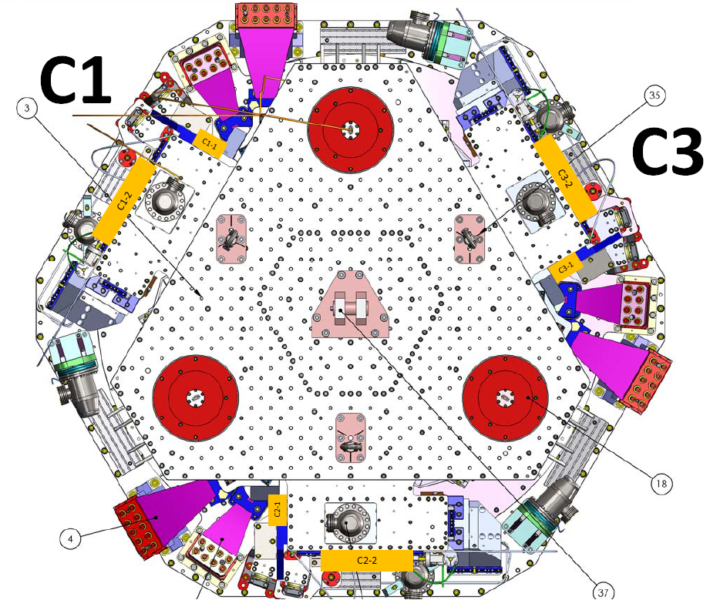
Figure 1 - Mass location legend

Stage 1:
Stage 1
Location | Weight (lb) | Weight (Kg)
C1-1 | 22 | 10
C1-2 | 28 | 12.7
C2-1 | 18 | 8.2
C2-2 | 28 | 12.7
C3-1 | 18 | 8.2
C3-2 | 15 | 6.8
Total | 129 | 58.6
Table 10 - Payload - Stage 1

Nominal payload: 109Kg – 240lb
Added masses are 50Kg – 23lb lighter than expected.
Nominal mass of stage 1=912Kg - 2010lb
Difference with the nominal mass: -5.4%
Stage 2:
Quantity | Weight (Kg) | Total Weight(Kg)
3 | 276.7 | 830.1
2 | 105.7 | 211.4
2 | 5.0 | 10.0
2 | 2.0 | 4.0
2 | 1.0 | 2.0
4 | 0.5 | 2.0
Total : |  | 1059.5
Table 11 - Payload - Stage 2
Nominal payload: 1185Kg – 2612lb
The added masses is 125Kg lighter than expected.
Total mass of Stage 2: 2830Kg – 6239lb
Error on the nominal overall mass of stage 2: 125/2830=-4%
Acceptance Criteria
The Mass budget must be:
- Nominal payload on stage 1: 109Kg – 240lb (-5% +/- 2% due to blade softness)
- Nominal payload on stage 2: 1185Kg – 2612lb (-5% +/- 2% due to blade softness)
Test result: Passed: X Failed: .

Step 11 - Lockers adjustment
 | Stage 1 |  | Stage 2
D.I at Lockers | Dial indicators V | Dial indicators H | Dial indicators V | Dial indicators H
A | -2 | 0 | -0,5 | 0
B | -2 | 0 | -2 | 0
C | 0 | 0 | -0,5 | -1
Table 12 - Dial indicators read-out (stage locked-unlocked independently)

Test result: Passed: X Failed: .

Step 12 - Cables inventory – E1100822
Initial testing was realized with a hybrid set of the HAM-ISI and BSC-ISI cables. After serializing and recleaning the cables, final testing was performed.

Test result: Passed: Failed: X .

Step 13 - Cable routing – E1101027
Cable routing is defined in E1101027.

Test result: Passed: X Failed: .

Tests to perform after assembly

Step 1- Geophones pressure readout
During the first series of tests, we noticed 2 non working T240 and 1 non working L4C pressure sensors. After replacement of 3 T240s and 1 L4C, the pressure was measured on the input channels of the IOP.
 | Raw pressure (count)
Sensors | Corner 1 | Corner 2 | Corner 3
ST1-L4C-D | -457 | -813 | -818
ST1-L4C-P | 24622 | 24701 | 24702
ST1-GS13-D | 716 | -72 | -87
ST1-GS13-D | 24502 | 24501 | 24503
ST1-T240-P | 13531 | 13140 | 13142
Table 13 - Geophones pressure readout
Acceptance criteria:
  - The absolute pressure on the L4Cs and the GS13s must be 24700 +/- 600 counts (100+/- 2 KPA)
  - The differential pressure on the L4Cs and the GS13s must be <2400 counts (2 KPa)
  - The absolute pressure on the T240 must be 14300 +/-300 counts (100 +/- 2 KPA)
Test result: Passed: X_ Failed: .

Step 2- Set up sensors gap – Locked vs unlocked position
During this step, sensors gap are adjusted. This step considers that the lockers have been finely set up during assembly.
Measurements for this test are in the SVN at:
svn/seismic/BSC-ISI/X1/Data/BSC6/Static_Tests/:
- LHO_ISI_BSC6_Locked_2011_10_27.mat
- LHO_ISI_BSC6_Unlocked_2011_10_27.mat

 | ISI locked |  | ISI unlocked |  | Difference locked - unlocked
Sensors | Offset (Mean) | Std deviation | Offset (Mean) | Std deviation | Offset (Mean) | mil
ST1 - H1 | -175.7 | 18.4 | -210.9 | 40.3 | 35 | 0.04
ST1 - H2 | -14.6 | 12.7 | -106.3 | 26.0 | 92 | 0.11
ST1 - H3 | -130.1 | 11.5 | -191.2 | 19.7 | 61 | 0.07
ST1 - V1 | 319.9 | 20.0 | 545.5 | 23.8 | -226 | -0.27
ST1 - V2 | 599.0 | 12.9 | 684.1 | 16.2 | -85 | -0.10
ST1 - V3 | -398.8 | 21.4 | 394.2 | 30.9 | -793 | -0.94
ST2 - H1 | 470.3 | 55.1 | 407.4 | 16.2 | 63 | 0.02
ST2 - H2 | 1003.1 | 40.1 | 826.9 | 42.4 | 176 | 0.05
ST2 - H3 | 608.3 | 53.8 | 982.5 | 35.4 | -374 | -0.11
ST2 - V1 | -478.3 | 46.3 | -37.9 | 62.0 | -440 | -0.13
ST2 - V2 | -466.2 | 52.1 | -323.8 | 40.7 | -142 | -0.04
ST2 - V3 | 452.8 | 76.1 | 1289.1 | 71.0 | -836 | -0.25
Table 14 - Capacitive position sensors readout after gap set-up

Note:
On BSC8 in a "locked position", we noticed large shifts in the CPS offsets after changing the type of payload (Masses on top of stage 2 vs QUAD). Unfortunately, we didn’t keep track of these shifts. During the preparation of the BSC6 move to the end station, we recorded the CPS offsets when the ISI was locked with two different payloads. We measured these CPS offsets before and after removing the masses on top of stage 2 (~1000Kg). After removing the payload, the ISI went up (up to 7 mils at the CPS locations on stage 2) without twist. Note that the CPSs are from the lockers and the clearance of the lockers in a “locked position” is 2mils.
Measurements for this test are in the SVN at svn/seismic/BSC-ISI/X1/Data/BSC6/Static_Tests/:
- LHO_ISI_BSC6_Locked_Unloaded_2011_10_27.mat

 | ISI locked - loaded | ISI locked unloaded | Difference locked - loaded vs unloaded
Sensors | Offset (Mean) | Offset (Mean) | Offset (Mean) | mil
ST1 - H1 | -175.7 | 837.1 | -1013 | -1.21
ST1 - H2 | -14.6 | 1130.6 | -1145 | -1.36
ST1 - H3 | -130.1 | 1375.3 | -1505 | -1.79
ST1 - V1 | 319.9 | 3406.6 | -3087 | -3.67
ST1 - V2 | 599.0 | 3509.3 | -2910 | -3.46
ST1 - V3 | -398.8 | 2235.1 | -2634 | -3.14
ST2 - H1 | 470.3 | 2227.3 | -1757 | -0.52
ST2 - H2 | 1003.1 | 3300.7 | -2298 | -0.68
ST2 - H3 | 608.3 | 1870.8 | -1262 | -0.38
ST2 - V1 | -478.3 | 20380.2 | -20859 | -6.21
ST2 - V2 | -466.2 | 23272.6 | -23739 | -7.07
ST2 - V3 | 452.8 | 19366.8 | -18914 | -5.63
Table 15 - CPS Offset - Locked - Loaded vs Unloaded
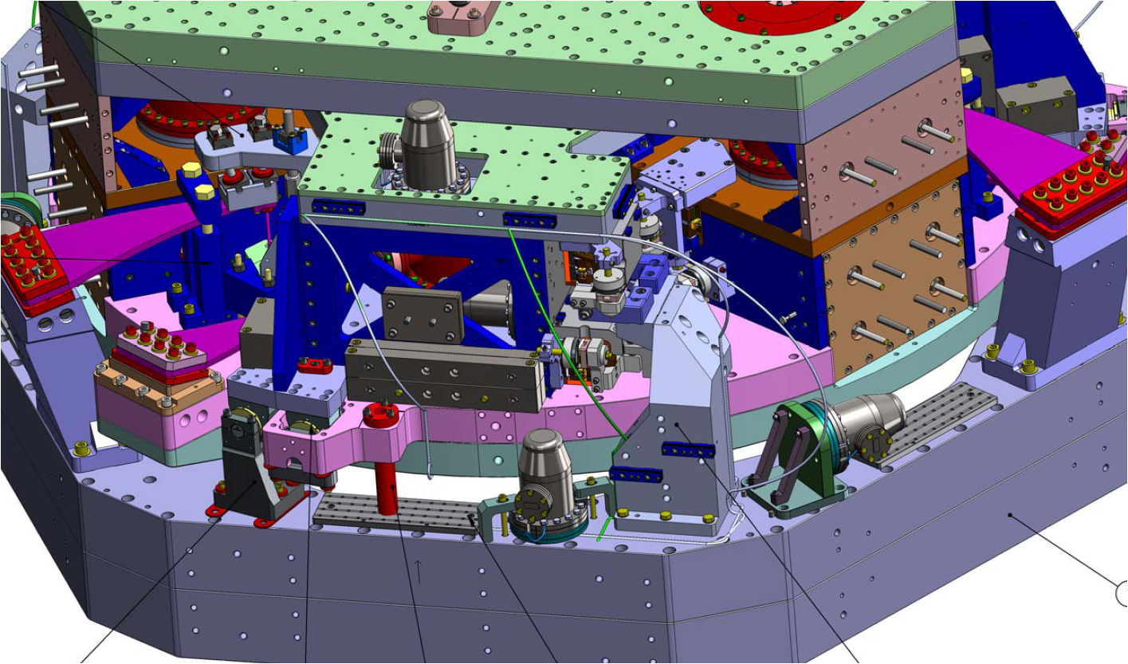
Figure 2 - BSC-ISI overview

Acceptance criteria:
- In the locked position, all mean values must be lower than 400 counts for stage 1 CPS and 1600 counts for stage 2 CPS on Dataviewer (a bit less than .0005”).
- In the locked position, all standard deviations below 5 counts for stage 1, 20 counts for stage 2
- Absolute values of the difference between the unlocked and the locked table must be below:
Stage 1
  - 1600 cts for horizontal sensors (~0.002”)
  - 1600 cts for vertical sensors (~0.002”)
Stage 2
  - 6500 cts for horizontal sensors (~0.002”)
  - 6500 cts for vertical sensors (~0.002”)
- Considering the acceptance criteria of step 2, all mean values must be lower than
Stage 1
  - 2000 cts for horizontal sensors (~0.0025”)
  - 2000 cts for vertical sensors (~0.0025”)
Stage 2
  - 8000 cts for horizontal sensors (~0.0025”)
  - 8000 cts for vertical sensors (~0.0025”)

Note: The locker offset is set to +2 mils in step I.11.

Test result: Passed: X Failed: .

Step 3 - Measure the Sensor gap
This test was not performed. The sensors were checked at LASTI. Measuring the sensor gap using a Teflon shim may increase the risk of scratching the target.

Test result: Passed: Failed: X .

Step 4- Performance of the limiters

Step 4.1 - Test Nº1 - Push “in the general coordinates Z/RZ”
This test was not performed because it is redundant with the test in the local basis.

Test result: Passed: Failed: X .

Step 4.2 - Test Nº2 – Push “locally”

Sensors | Push in positive direction | Push in negative direction | Mil (positive) | Mil (negative) | Railing | Actuator Gap Check
ST1 - H1 | 19152 | -18114 | 23 | -22
ST1 - H2 | 15689 | -17055 | 19 | -20
ST1 - H3 | 15151 | -18768 | 18 | -22
ST1 - V1 | 24745 | -27300 | 29 | -33
ST1 - V2 | 21456 | 20367 | 26 | 24
ST1 - V3 | 26439 | -25550 | 31 | -30
ST2 - H1 | 32767 | -32767 | X | X | Rail
ST2 - H2 | 32767 | -32768 | X | X | Rail
ST2 - H3 | 32767 | -32768 | X | X | Rail
ST2 - V1 | 32767 | -32768 | X | X | Rail
ST2 - V2 | 32767 | -32768 | X | X | Rail
ST2 - V3 | 32767 | -32768 | X | X | Rail
Table 16 - Stages range of motion – “Push locally”

Acceptance criteria:
- The vertical sensor readout must be positive when the optic table is pushed in the +Z direction
- The horizontal sensor readout must be negative when the optic table is pushed in the +RZ direction
- Step 4.2
  - Absolutes value of all estimated motions must be higher than 15000counts for stage 1 (~0.018”)
  - Absolutes value of all estimated motions must be higher than 32000counts for stage 2 (~0.010”)

Test result: Passed: X Failed: .

Step 5 - Sensors Powerspectra
All position sensors powerspectra have been measured can be found on the SVN:

/seismic/BSC-ISI/X1/Data/BSC6/Figures/Powerspectra/Undamped/
- LHO_ISI_BSC6_Powerspectra_m_ST1_Locked_ST2_Locked_2011_10_24.fig
- LHO_ISI_BSC6_Powerspectra_m_ST1_Unlocked_ST2_Unlocked_2011_10_24.fig
- LHO_ISI_BSC6_Tilted_Powerspectra_CT_ST1_L4C_2011_10_25.fig
- LHO_ISI_BSC6_Tilted_Powerspectra_CT_ST2_GS13_2011_10_25.fig

/seismic/BSC-ISI/X1/Data/BSC6/Powerspectra/Undamped/
- LHO_ISI_BSC6_Calibrated_PSD_CPS_T240_L4C_GS13_Unlocked_Locked_2011_10_24.mat
- LHO_ISI_BSC6_Calibrated_PSD_L4C_GS13_Stage_Tilted_2011_10_25.mat

Note :
The powerspectra presented hereinafter were measured with the last set of instruments.

Acceptance criteria:
- No cross talk on CPS (peaks at low frequencies + harmonics on measurements)
- All spectra must be similar per instrument type.
- Magnitudes of power spectra must be lower than the reference powerspectra above (not presented in the following plots)

Test result: Passed: X Failed: _ .

Stage locked – unlocked

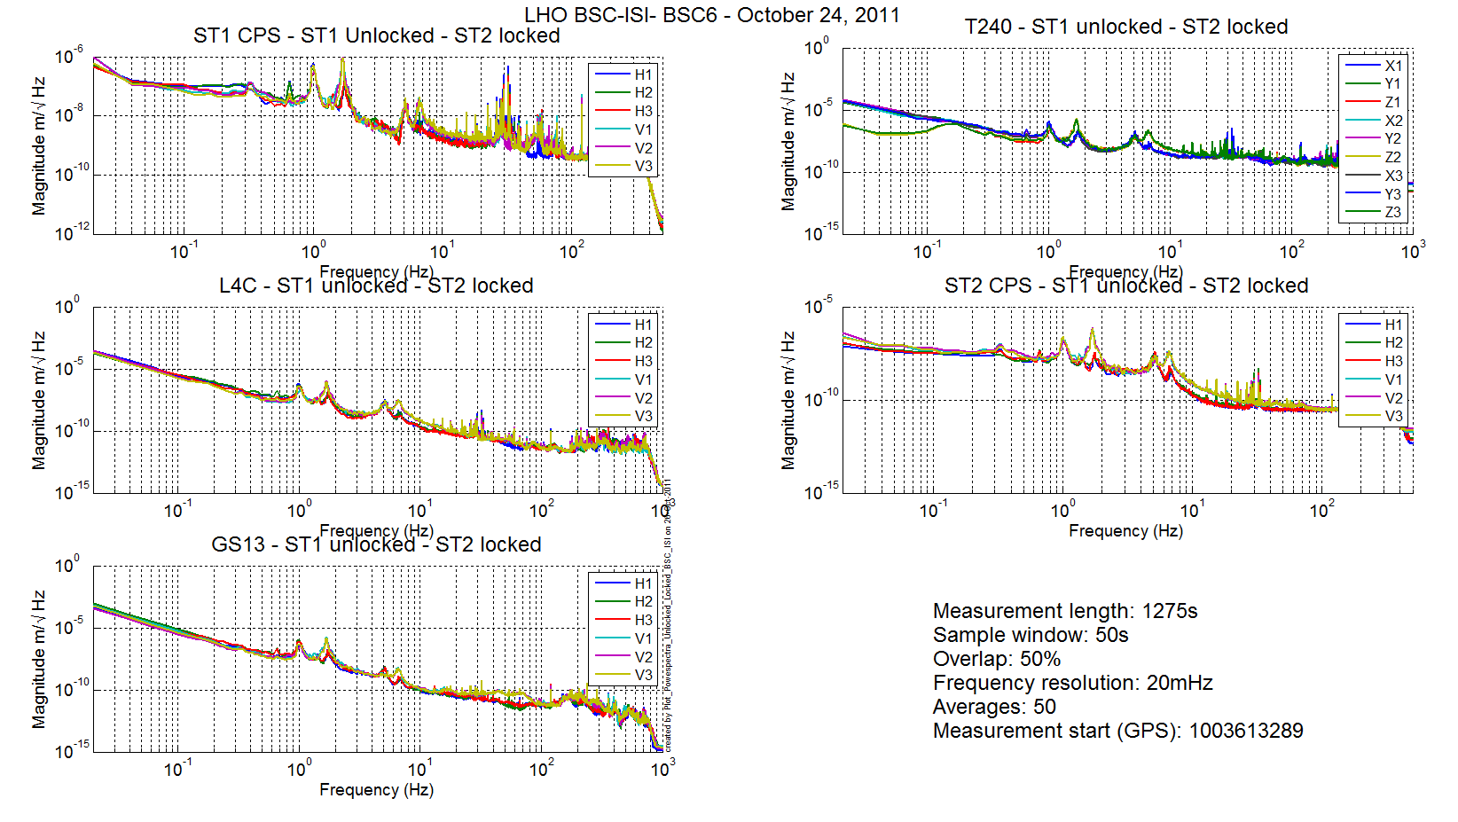
Figure 3 – ST1 & ST2 Locked

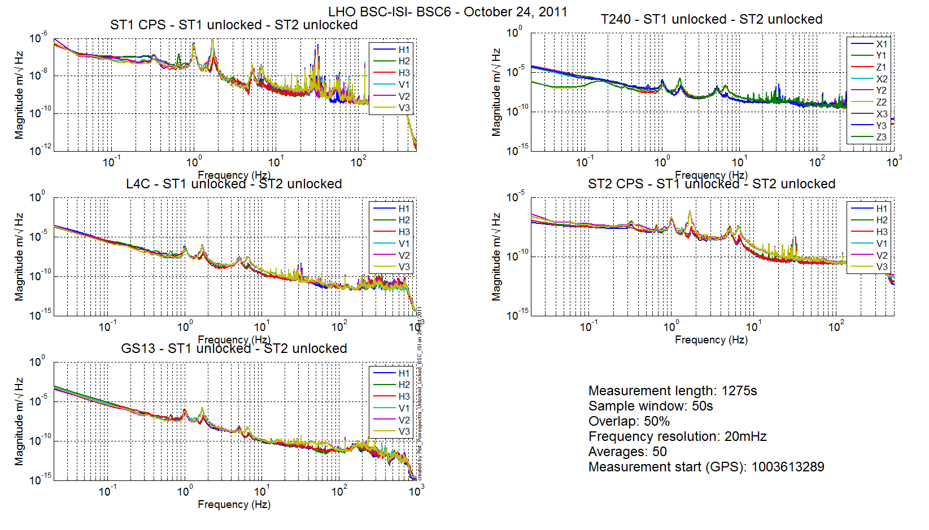
Figure 4 - ST1 & ST2 Unlocked

Stage Tilted
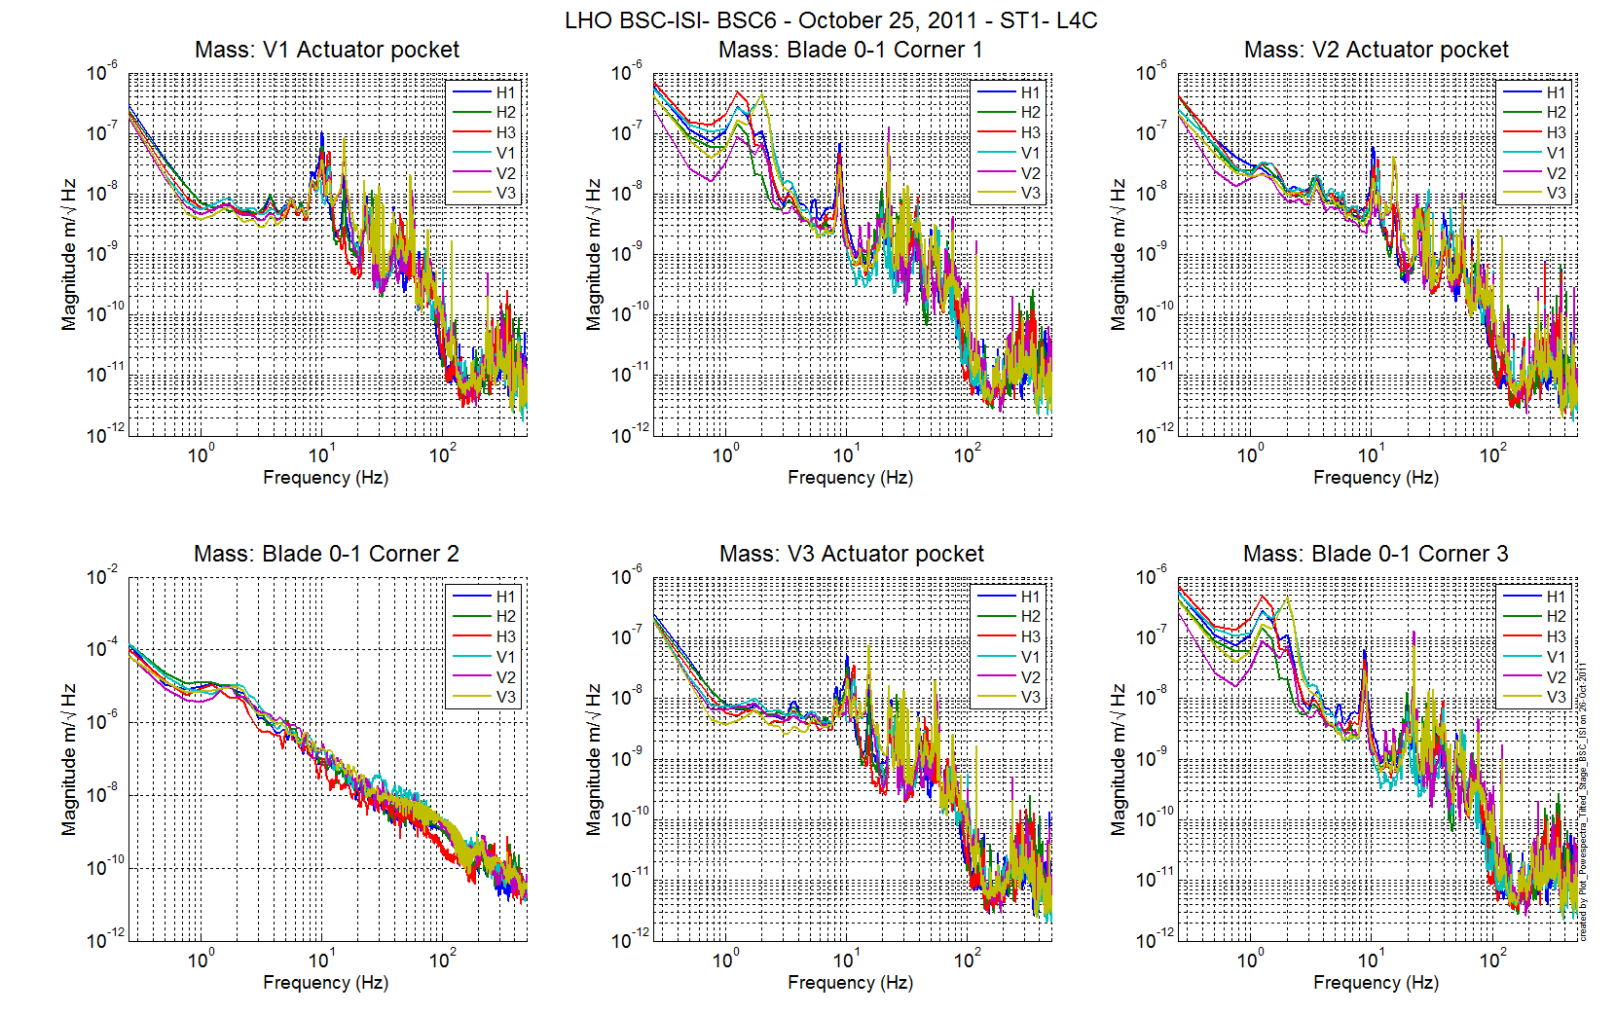
Figure 5 - ST1 L4C – Tilted

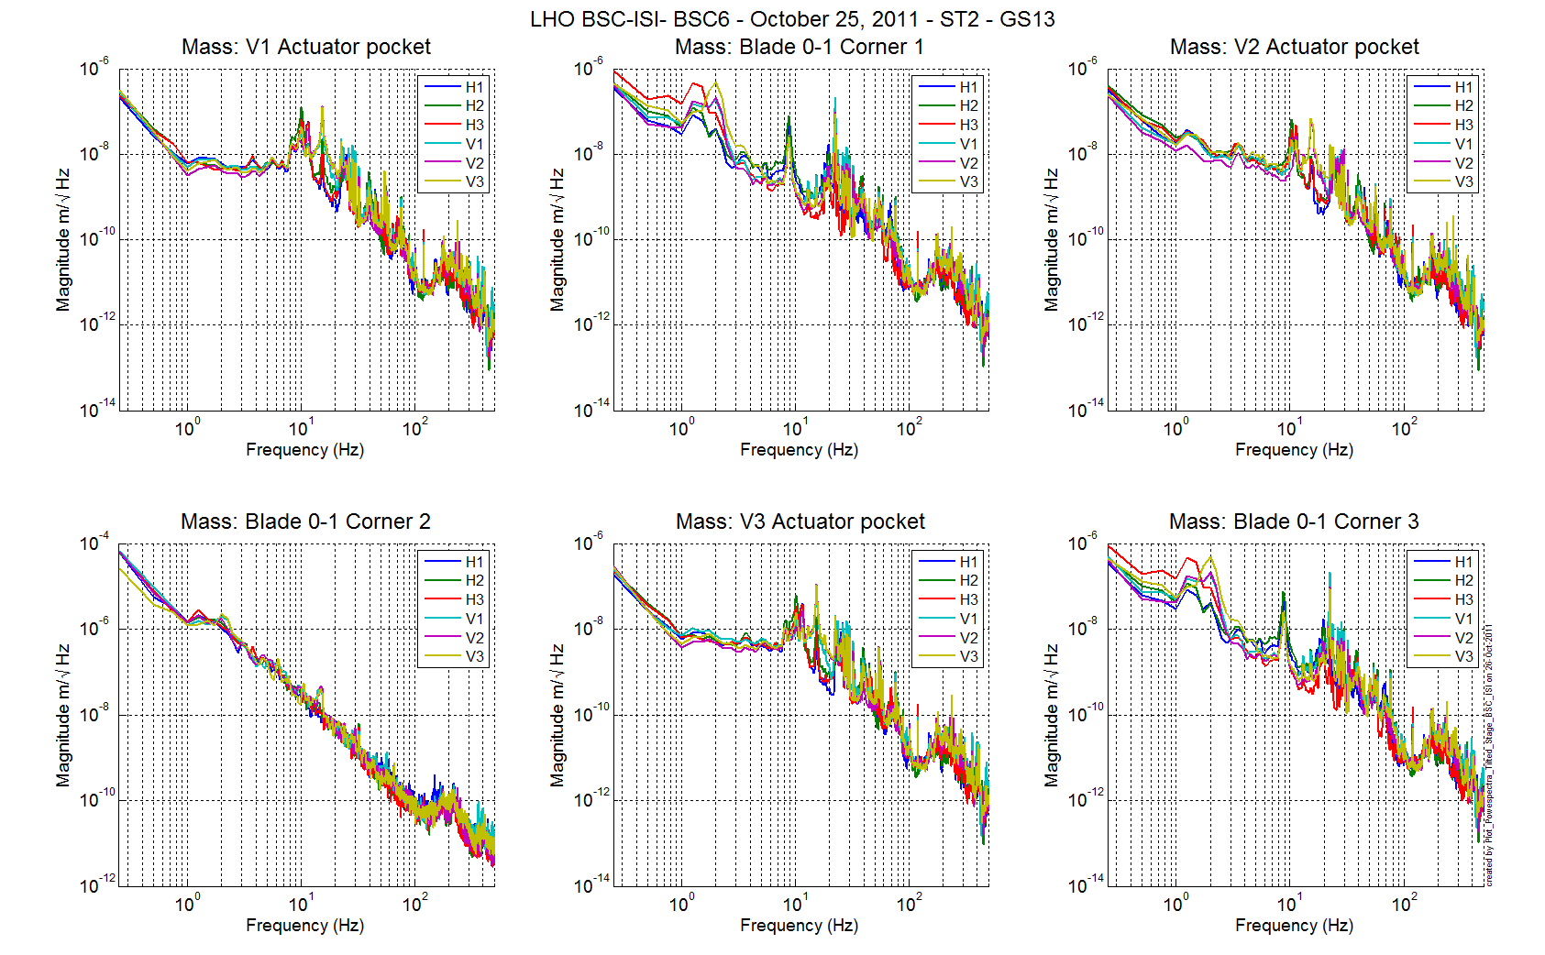
Figure 6 - ST1 GS13 – Tilted

Step 6 - Coil Driver, cabling and resistance check
The resistance of the actuator + power cables are reported in the table below:

Actuator | Coil driver name | Resistance (Ω)
ST1 H1 | Coil1 Coarse 1 | 6.8
ST2 H1 | Coil 1 Fine 1 | 10.7
ST2 V1 | Coil 1 Fine 2 | 10.8
ST1 V1 | Coil 1 Coarse 2 | 6.8
ST1 H2 | Coil 2 Coarse 2 | 6.9
ST2 H2 | Coil 2 Fine 1 | 10.7
ST2 V2 | Coil 2 Fine 2 | 10.7
ST1 V2 | Coil 2 Coarse 2 | 7
ST1 H3 | Coil 3 Coarse 1 | 7
ST2 H3 | Coil 3 Fine 1 | 10.7
ST2 V3 | Coil 3 Fine 2 | 10.6
ST1 V3 | Coil 3 Coarse 2 | 7

Acceptance criteria:

- For the actuators of stage 1, the measured resistance between the middle pin and one side pin must be 6.3 +/-0.5 ohms
- For the actuators of stage 2, the measured resistance between the middle pin and one side pin must be 10.3 +/-0.5 ohms
- Actuator neutral pins must be connected on pin #1 (left side pin of the plug)
- Actuator drive pins must be connected on pin #2 (middle pin of the plug)
- Actuator ground shield pins must be connected on pin #3 (right pin of the plug)
- All LEDs on the coil driver front panel must be green the binary input bit must be in the upper state.

Test result: Passed: X Failed: .

Step 7- Actuators Sign and range of motion (Local drive)

Step 7.1 - Actuators sign
Acceptance criteria:

- A positive offset drive on one actuator must give positive sensor readout on the collocated sensor. Signs will also be tested when measuring local to local transfer functions.

Test result: Passed: X Failed: .

Step 7.2 - Range of motion - Local drive
In this step, range of motion of the two stages is checked when applying a local drive on actuators.

Sensor readout (counts) | Negative drive | no drive | Positive drive | Amplitude count | mil
ST1 - H1 | -15290 | 250 | 16742 | 31956 | 38
ST1 - H2 | -15809 | -232 | 16818 | 32596 | 39
ST1 - H3 | -17450 | -2162 | 15166 | 32596 | 39
ST1 - V1 | -17349 | -2538 | 12273 | 29645 | 35
ST1 - V2 | -13821 | 667 | 15166 | 29078 | 35
ST1 - V3 | -16626 | -2209 | 12080 | 28596 | 34
ST2 - H1 | -8849.4 | 1252 | 11227 | 20155 | 6
ST2 - H2 | -6770.2 | 3067 | 12951 | 19970 | 6
ST2 - H3 | -9649.6 | 333 | 10313 | 19970 | 6
ST2 - V1 | -9051.7 | 3449 | 15996 | 24973 | 7
ST2 - V2 | -13136 | -787 | 11423 | 24696 | 7
ST2 - V3 | -10954 | 1231 | 13426 | 24338 | 7
Table 17 - Range of motion - Local drive

Acceptance criteria:

- Amplitude must be at least 32000 counts (+/-0.02”) for Stage 1 CPS
- Amplitude must be at least 32000 counts (+/-0.003”) for Stage 2 CPS
- Signs of actuators drive and sensors read out have to be the same

Test result: Passed: X Failed: .

Step 8 - Vertical Sensor Calibration
This test was not performed because sensors are tested at LASTI.

Test result: Passed: _ Failed: X .

Step 9 - Vertical Spring Constant
The stiffness measurements of the spring are reported in the tables below. The nominal blade stiffness are:
- Stage 1: 1241lb/in
- Stage 2: 1465lb/in

 | Unloaded |  |  |  | Loaded 3x5kg
Stage1 | Meas 1 | Meas 2 | Meas 3 | Average | Meas 1 | Meas 2 | Meas 3 | Average
V1 | 4014,1 | 4015,1 | 4014,6 | -22524 | -22751 | -22685 | -22637 | 4014,1
V2 | 561,94 | -560,94 | -561,44 | -24389 | -26052 | -26762 | -25220 | -561,94
V3 | 1962,8 | 1963,8 | 1963,3 | -23471 | -24027 | -24769 | -23749 | 1962,8

Load 3x10kg
Meas 1 | Meas 2 | Meas 3 | Average | Diff 1 | Diff 2
-16906 | -17008 | -17025 | -16980 | -7624 | -14504
-14835 | -14808 | -14807 | -14817 | -7572 | -15569
-15681 | -15686 | -15691 | -15686 | -7793 | -13897
 |  |  |  | -7663 | -14657 | count
 |  |  |  | -9,12 | -17,45 | mil
 |  |  |  | -1207 | -1262 | lb/in
 |  |  |  | Average : | -1235
 |  |  |  |  | -0,50 | %

The blades from stage 0 to stage 1 are too soft by 0.50%.

Note:
The stage 1 payload is too light by 5% which is not consistent with the measured blade stiffness. The blade stiffness is a tricky measurement. Some errors and approximation may have been done during these measurements. However, we can consider that the unit passed the test.

Acceptance criteria:
- Spring constant of stage 0-1 blades must be 229KN/m (T0900569) +/- 2%

Test result: Passed: _X_ Failed: .

 | No load |  |  | Load
Stage 2 | Meas 1 | Meas 2 | Average | Meas 1 | Meas 2 | Meas 3 | Average
V1 | 4014,1 | 4015,1 | 4014,6 | -22524 | -22751 | -22685 | -22637,5
V2 | -561,94 | -560,94 | -561,44 | -24389 | -26052 | -26762 | -25220,5
V3 | 1962,8 | 1963,8 | 1963,3 | -23471 | -24027 | -24769 | -23749,0

Diff
-26652,1
-24659,06
-25712,3
-25674 | count
-7,64 | mil
-1429 | lb/in
-2,48 | %

The blades from stage 0 to stage 1 are too soft by 2.48%.

Note:
The stage 2 payload is too light by 4% which is not consistent with the measured blade stiffness. The blade stiffness is a tricky measurement. Some errors and approximation may have been done during these measurements.

Acceptance criteria:
- Spring constant of stage 1-2 blades must be 257KN/m (T0900569) +/- 2%

Test result: Passed: X_ Failed: .

Step 10 - Static Testing (Tests in the local basis)
The table below shows the main and the cross-coupling when the actuators are driven in the local basis:
 |  | Sensors
 |  | ST1 - H1 | ST1 - H2 | ST1 - H3 | ST1 - V1 | ST1 - V2 | ST1 - V3
Actuators | ST1 - H1 | 4333 | 1716 | 1756 | -15 | -7 | 14
 | ST1 - H2 | 1715 | 4224 | 1705 | -10 | -15 | 6
 | ST1 - H3 | 1745 | 1716 | 4246 | 2 | 1 | 30
 | ST1 - V1 | 38 | -164 | 101 | 3481 | -665 | -588
 | ST1 - V2 | 132 | 87 | -135 | -609 | 3385 | -615
 | ST1 - V3 | -102 | 128 | 76 | -591 | -570 | 3347
Table 18 - Static test - Local to local - Stage 1

 |  | Sensors
 |  | ST2 - H1 | ST2 - H2 | ST2 - H3 | ST2 - V1 | ST2 - V2 | ST2 - V3
Actuators | ST2 - H1 | 2316 | 351 | 337 | 8 | -4 | 11
 | ST2 - H2 | 324 | 2338 | 349 | 7 | 3 | -12
 | ST2 - H3 | 311 | 375 | 2332 | 3 | 27 | -11
 | ST2 - V1 | 65 | 122 | -220 | 2942 | 331 | -28
 | ST2 - V2 | -244 | 101 | 94 | -12 | 2901 | 297
 | ST2 - V3 | 86 | -167 | 41 | 349 | -31 | 2846
Table 19 - Static test - Local to local - Stage 2

The static tests results are reported in the SVN at :
/seismic/BSC-ISI/X1/Data/BSC6/Static_Tests/
- LHO_ISI_BSC6_Offset_Local_Drive_20110805.mat

Acceptance criteria:
- Main couplings readout must be positive
- Comparison with the reference table:
  - Main coupling differences mustn’t exceed 200 counts
  - Cross coupling differences mustn’t exceed 50 counts

Test result: Passed: X Failed: .

Step 11- Static Testing - In the general coordinate basis (Static test - CPS)

Step 11.1 – Base change matrices from Cartesian to Local
The table below shows the main and the cross-coupling when the actuators are driven in the local basis:

 |  | Sensors
 |  | ST1 - H1 | ST1 - H2 | ST1 - H3 | ST1 - V1 | ST1 - V2 | ST1 - V3
Actuators | ST1 - X | 1752 | -839 | -812 | -26 | 0 | -8
 | ST1 - Y | -32 | 1493 | -1469 | 6 | -5 | -14
 | ST1 - Z | -33 | -14 | 3 | 753 | 709 | 711
 | ST1 - RX | 40 | 189 | -137 | -2877 | 2408 | 422
 | ST1 - RY | -162 | 77 | 86 | -1119 | -1871 | 2959
 | ST1 - RZ | 3162 | 3124 | 3166 | -13 | -23 | -5

 |  | Sensors
 |  | ST2 - H1 | ST2 - H2 | ST2 - H3 | ST2 - V1 | ST2 - V2 | ST2 - V3
Actuators | ST2 - X | 670 | -1312 | 653 | -25 | -79 | -42
 | ST2 - Y | 1144 | -20 | -1162 | -33 | -136 | -62
 | ST2 - Z | 17 | -9 | -33 | 1059 | 939 | 993
 | ST2 - RX | -312 | -3 | 270 | -2572 | 2352 | -125
 | ST2 - RY | 151 | -303 | 116 | -1558 | -1486 | 2792
 | ST2 - RZ | 1738 | 1715 | 1728 | -69 | -122 | -64
Table 20 - Static test cartesian drive – Cartesian to local

The static tests results are reported in the SVN at :
/seismic/BSC-ISI/X1/Data/BSC6/Static_Tests/
- LHO_ISI_BSC6_Offset_Local_Drive_20110805.mat

Step 11.2 – Base change matrices from Cartesian to Cartesian
The static tests results are reported in the SVN at :
/seismic/BSC-ISI/X1/Data/BSC6/Static_Tests/
- LHO_ISI_BSC6_Offset_Cartesian_Drive_20110811.mat

 |  | Sensors
 |  | ST1 - X | ST1 - Y | ST1 - Z | ST1 – RX | ST1 - RY | ST1 - RZ
Actuators | ST1 - X | 1715 | 9 | 6 | 6 | 1 | 39
 | ST1 - Y | -2 | 1720 | -3 | -10 | 3 | -4
 | ST1 - Z | -15 | 17 | 729 | -25 | -9 | -14
 | ST1 - RX | 9 | 380 | -25 | 2985 | -6 | 29
 | ST1 - RY | -342 | 16 | -6 | -5 | 2901 | 6
 | ST1 - RZ | 24 | -4 | -21 | -6 | 20 | 3276

 |  | Sensors
 |  | ST2 - X | ST2 - Y | ST2 - Z | ST2 – RX | ST2 - RY | ST2 - RZ
Actuators | ST2 - X | 1317 | 25 | -31 | -22 | 21 | 24
 | ST2 - Y | 13 | 1331 | -36 | -53 | 55 | -13
 | ST2 - Z | -6 | -1 | 1030 | -91 | 28 | -9
 | ST2 - RX | -5 | -22 | -98 | 4223 | 58 | -14
 | ST2 - RY | -8 | 30 | -44 | 15 | 4247 | -3
 | ST2 - RZ | 21 | 6 | -42 | -35 | 52 | 2509
Table 21 - Static Test - Cartesian to Cartesian

Acceptance criteria:
- Main couplings readout must be positive
- Comparison with the reference table:
  - Main coupling differences mustn’t exceed 200 counts
  - Cross coupling differences mustn’t exceed 50 counts

Test result: Passed: X Failed: .

Step 12 - Linearity test
The linearity test results are reported in the SVN at:
/seismic/BSC-ISI/X1/Data/BSC6/Linearity_Test/
- LHO_ISI_BSC6_Linearity_test_20111025.mat

The linearity test figure are reported in the SVN at:
/seismic/BSC-ISI/X1/Data/BSC6/Figures/Linearity_Test/
- LHO_ISI_BSC6_Linearity_test_20111025.fig

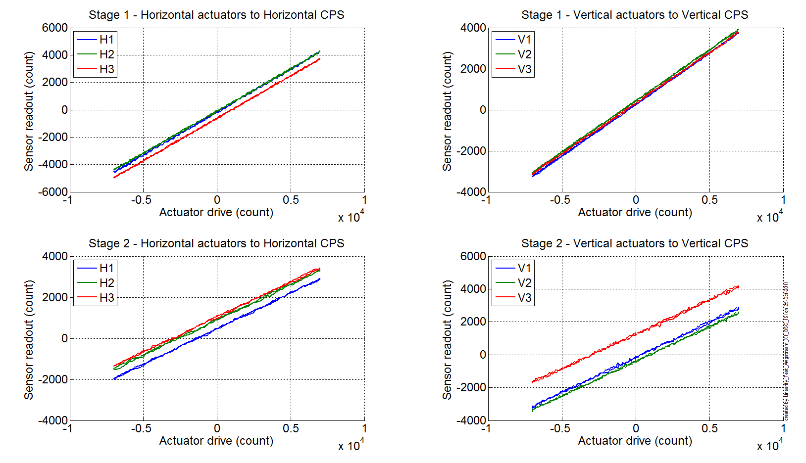
Figure 7 - Linearity Test

The slopes and the slopes are reported in the table below:

 |  | Slope | Offset | Average slope | Variation from  average(%)
Stage 1 | ST1 - H1 | 0.628 | -170 | 0.6214 | 1.06
 | ST1 - H2 | 0.616 | -85 |  | -0.89
 | ST1 - H3 | 0.620 | -618 |  | -0.17
 | ST1 - V1 | 0.501 | 252 | 0.4972 | 0.86
 | ST1 - V2 | 0.498 | 433 |  | 0.11
 | ST1 - V3 | 0.492 | 320 |  | -0.98
Stage 2 | ST2 - H1 | 0.347 | 466 | 0.3439 | 0.96
 | ST2 - H2 | 0.344 | 903 |  | -0.04
 | ST2 - H3 | 0.341 | 1039 |  | -0.91
 | ST2 - V1 | 0.428 | -166 | 0.4225 | 1.30
 | ST2 - V2 | 0.422 | -403 |  | -0.09
 | ST2 - V3 | 0.417 | 1248 |  | -1.21
Table - Slopes and offset of the triplet Actuators - BSC-ISI - Sensors

Acceptance criteria:
- Horizontal and vertical slopes of the triplet actuators x BSC-ISI x sensors: Average slope +/- 3%

Test result: Passed: X Failed: .

Step 13 – Transfer functions – Local to Local
Data files measurement of local to local transfer functions in SVN at:
/svncommon/seisvn/seismic/BSC-ISI/X1//Data/BSC6/Transfer_Functions/Measurements/Undamped
- LHO_ISI_BSC6_Data_L2L_10mHz_100mHz_ST1_ST2_20111025-185345.mat
- LHO_ISI_BSC6_Data_L2L_100mHz_700mHz_ST1_ST2_20111026-033627.mat
- LHO_ISI_BSC6_Data_L2L_700mHz_10Hz_ST1_ST2_20111025-203718.mat
- LHO_ISI_BSC6_Data_L2L_10Hz_100Hz_ST1_ST2_20111025-034700.mat
- LHO_ISI_BSC6_Data_L2L_100Hz_500Hz_ST1_ST2_20111024-174439.mat
- LHO_ISI_BSC6_Data_L2L_500Hz_1000Hz_ST1_ST2_20111025-105701.mat

Script file for processing and plotting local to local transfer functions in SVN at:
/seisvn/seismic/BSC-ISI/X1/Data/BSC6/Transfer_Functions/Measurements/Undamped
- Plot_ TF_L2L_10mHz_1000Hz_LHO_BSC6.m

Figures of local to local transfer functions (Main couplings) in SVN at:
seisvn/seismic/BSCISI/X1/Data/BSC6/Figures/Transfer_Functions/Measurements/Undamped
- LHO_BSC6_TF_L2L_Raw_from_ST1_ACT_to_ST1_CPS_2011_10_24.fig
- LHO_BSC6_TF_L2L_Raw_from_ST1_ACT_to_ST1_CPS_2011_10_24.fig
- LHO_BSC6_TF_L2L_Raw_from_ST2_ACT_to_ST2_CPS_2011_10_24.fig
- LHO_BSC6_TF_L2L_Raw_from_ST2_ACT_to_ST2_GS13_2011_10_24.fig

Measured of local to local transfer functions in the SVN at:
/svncommon/seisvn/seismic/BSC-ISI/X1//Data/BSC6/Transfer_Functions/Measurements/Undamped
- LHO_BSC6_TF_L2L_Raw_10mHz_1000Hz_2011_10_25.mat

Note 1: The transfer functions are measured from the Output filter bank (excitation variable) to the input (IN1) of the input filter bank. The transfer functions presented below are raw transfer functions without any electronic compensation of the sensor electronic. The actuator and the coil driver electronic compensation are introduced in these transfer functions.

Note 2: The L4Cs are out of phase (should be -90 before 1Hz). A minus sign is added in the calibration filters that convert count to nm/s.

Note 3: The resonance observed at 33Hz is the resonance of the teststand. When the transfer functions will be measured in the LVEA, this resonance will be observed at lower frequency (19Hz). The staging building teststand has short feet in comparison with the LVEA teststand (some comparison plots will be presented the testing report – phase II).

Note 4: The first high frequency resonance observed on stage 1 by the L4C is at 196Hz. The next resonance is observed at 248Hz. The first mode of the blade has been measured at ~250Hz at LASTI.

Note 5: There is a poor coherence on the GS13 transfer functions. It can be explained by the weak drive of the fine actuators. Moreover, the stage 2 of the ISI is strongly excited by the fans of the clean rooms. These two factors strongly affect the quality of the measurements.

Note 6: On the ST2-ACT to ST2-GS13 transfer functions, the first high frequency resonances are observed at 150Hz and 185Hz.

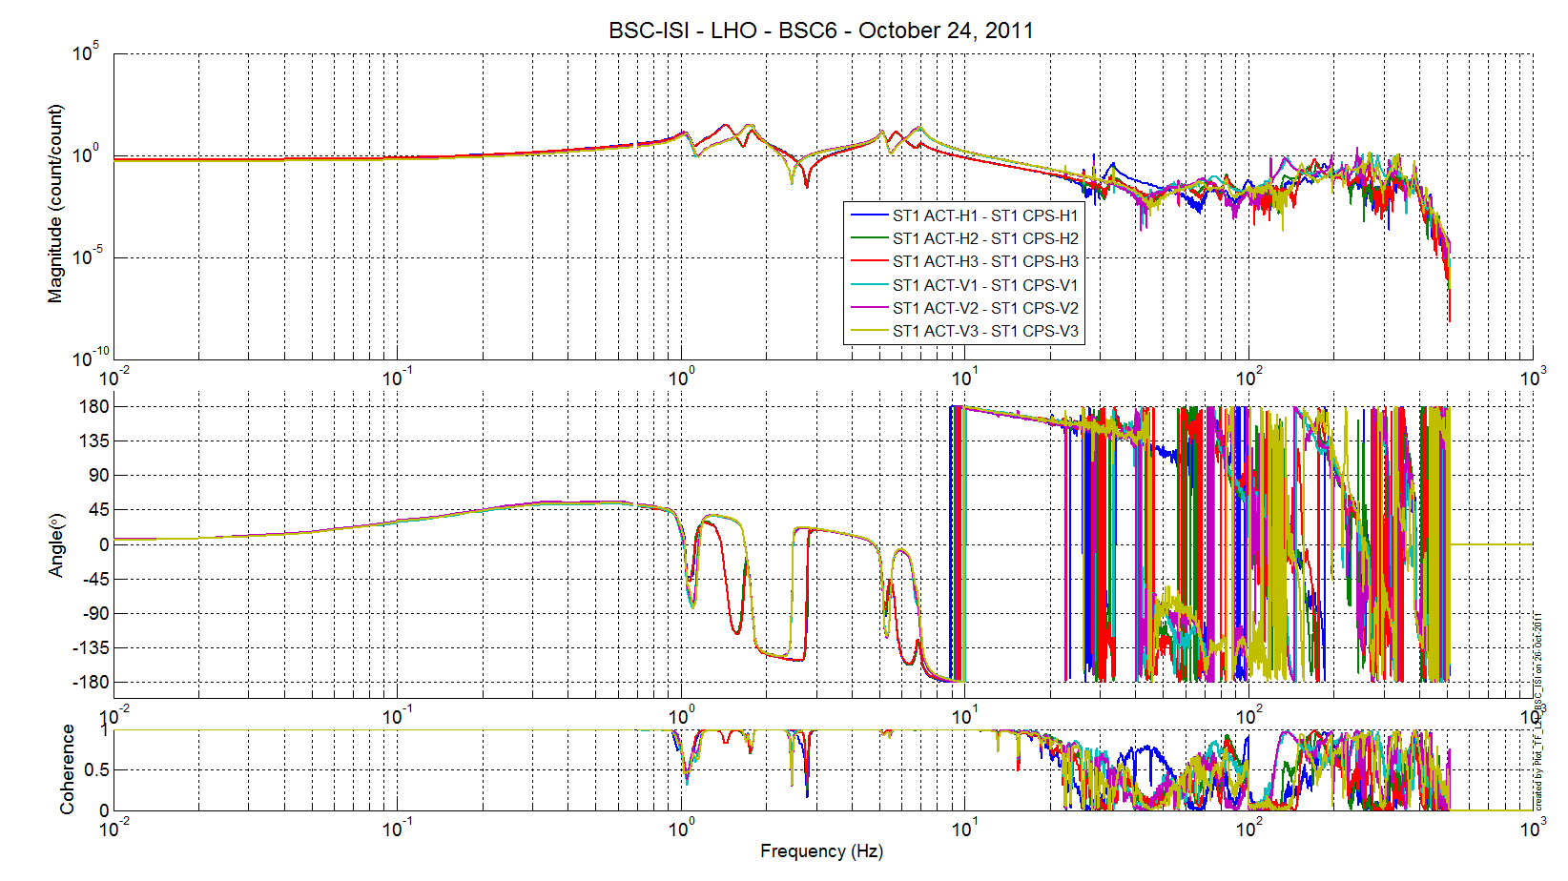
Table 22 - TF L2L Raw - ST1 Act to ST1 CPS

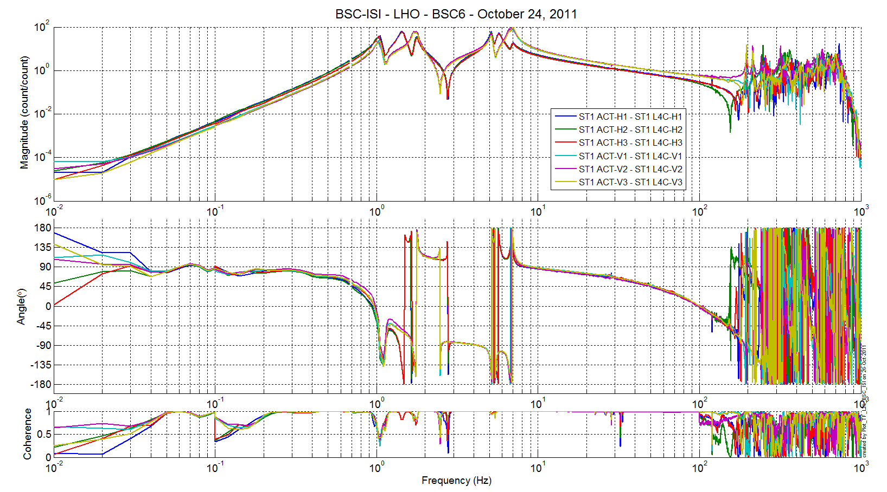
Table 23 - TF L2L Raw - ST1 Act to ST1 L4C

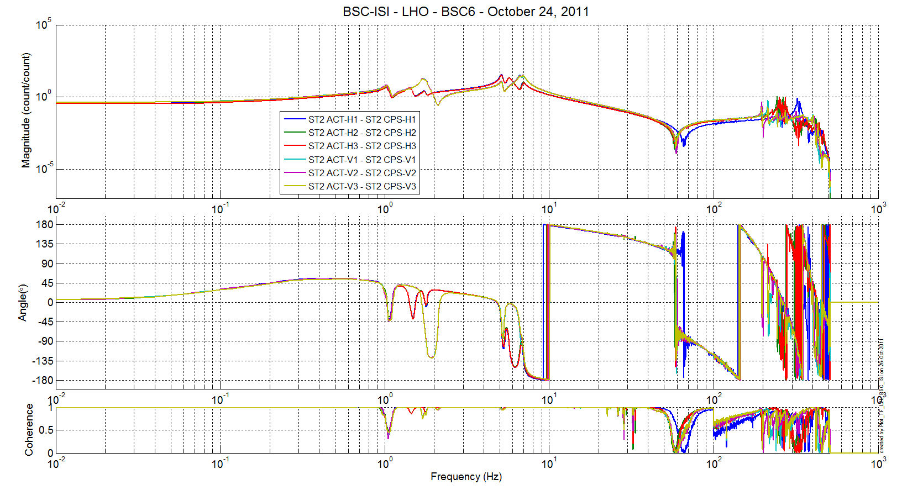
Table 24 - TF L2L Raw - ST2 Act to ST2 CPS

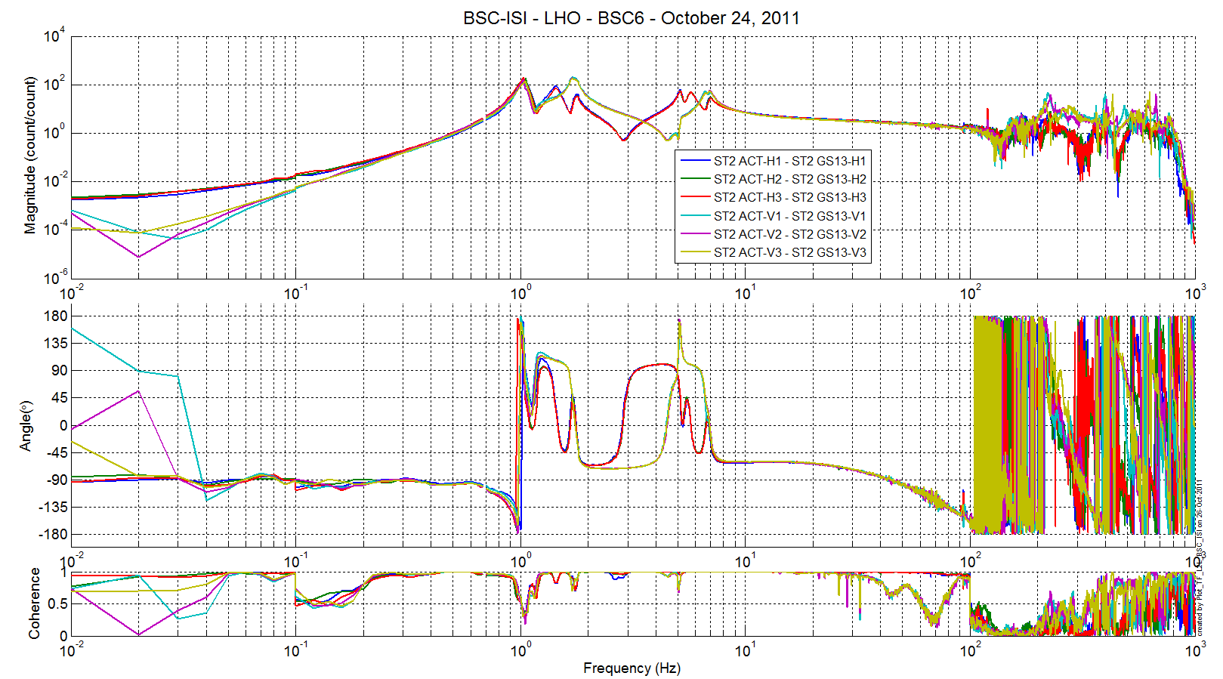
Table 25 - TF L2L Raw - ST2 Act to ST2 GS13

Note: The structural resonance frequency of stage 1 are pretty low in comparison with BSC8.

Comparison BSC6 vs BSC8 in the staging building
The figures that show the comparisons between the BSC6 and the BSC8 transfer functions can be found in the SVN at:
seismic/BSC-ISI/X1/Comparison/BSC6_vs_BSC8/
- LHO_ISI_BSC6_vs_BSC8_Comparison_ST1_ACT_H_to_ST1_CPS_H_20110622_vs_20111025.fig
- LHO_ISI_BSC6_vs_BSC8_Comparison_ST1_ACT_H_to_ST1_L4C_H_20110622_vs_20111025.fig
- LHO_ISI_BSC6_vs_BSC8_Comparison_ST1_ACT_V_to_ST1_CPS_V_20110622_vs_20111025.fig
- LHO_ISI_BSC6_vs_BSC8_Comparison_ST1_ACT_V_to_ST1_L4C_V_20110622_vs_20111025.fig
- LHO_ISI_BSC6_vs_BSC8_Comparison_ST2_ACT_H_to_ST2_CPS_H_20110622_vs_20111025.fig
- LHO_ISI_BSC6_vs_BSC8_Comparison_ST2_ACT_H_to_ST2_GS13_H_20110622_vs_20111025.fig
- LHO_ISI_BSC6_vs_BSC8_Comparison_ST2_ACT_V_to_ST2_CPS_V_20110622_vs_20111025.fig
- LHO_ISI_BSC6_vs_BSC8_Comparison_ST2_ACT_V_to_ST2_GS13_V_20110622_vs_20111025.fig

List of differences:
- ST1 ACT H to ST1 CPS H: Transfer functions of BSC6 and BSC8 look identical
- ST1 ACT H to ST1 L4C H: The first resonance measured on horizontal L4C is measured at 196Hz on BSC6 and 214Hz on BSC8 (-9% from BSC8 to BSC6)
- ST1 ACT V to ST1 CPS V: The transfer functions are similar up to 100Hz. But the first important resonance is observed at 133Hz on BSC6 whereas this resonance is observed at 154Hz on BSC8 (-15% from BSC8 to BSC6).
- ST1 ACT V to ST1 L4C V: The transfer functions are similar up to 180Hz. The first resonance of stage is observed at 196Hz on BSC6 and 214Hx on BSC8 (-15% from BSC8 to BSC6)
- ST2 ACT H to ST2 CPS H: Transfer functions of BSC6 and BSC8 look identical up to 30Hz. The first zero is observed at 58Hz on BSC6 and 64Hz on BSC8. The high frequency resonances are respectively measured at 255Hz and 322Hz on BSC6 and BSC8.
- ST2 ACT H to ST2 GS13 H: Transfer functions of BSC6 and BSC8 look identical
- ST2 ACT V to ST2 CPS V: These transfer functions shows the resonances of stage 1 when stage 2 is excited by ST2 actuators. These resonances are 196Hz for BSC6 and 214Hz for BSC8.
- ST2 ACT V to ST2 GS13 V: Transfer functions of BSC6 and BSC8 look identical

Differences sum-up:
The suspension resonances are identical on BSC6 and BSC8. However, it seems that BSC6 is softer than BSC8. It is mainly visible on stage 1 (both on CPS and L4C transfer functions) and it is particularly true on the vertical transfer functions where the first structural resonances of BSC6 are observed at frequencies 15% lower than BSC8 resonance frequencies.
Stage 2 of BSC6 and BSC8 seem more similar. A light difference is observed ST2 ACT H to ST2 CPS H transfer functions. Note that the resonances of stage 1 are visible in stage 2 transfer functions (ST2 ACT V to ST2 GS13 V).

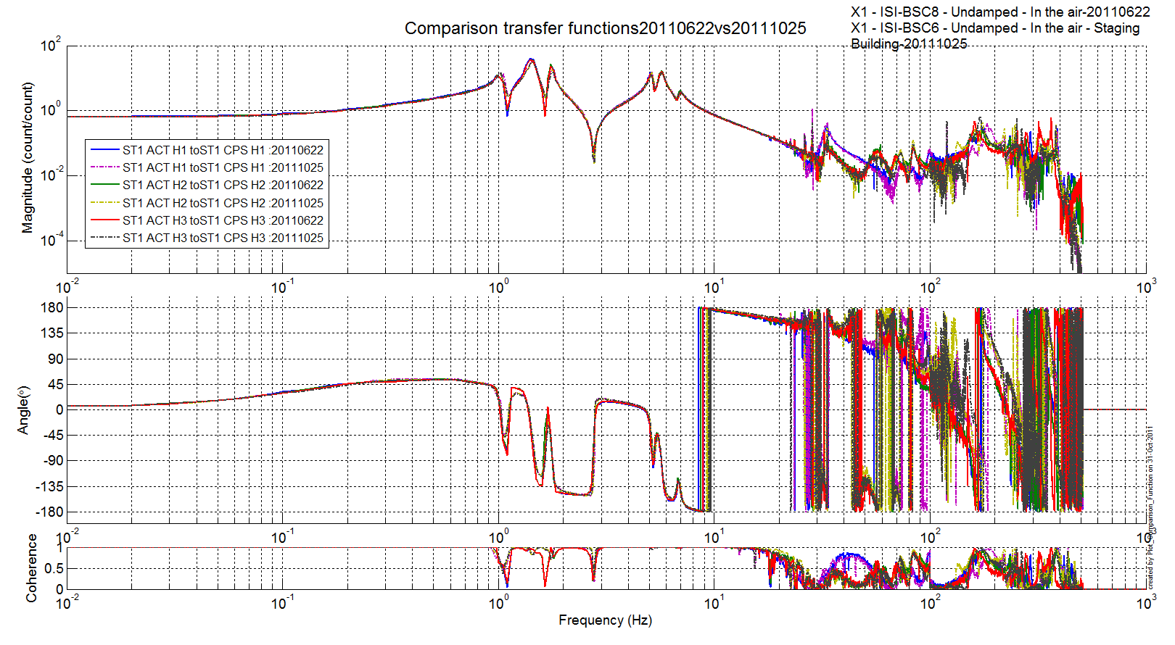
Figure 8 – Comparison BSC6 vs BSC8 - ST1 ACT H to ST1 CPS H

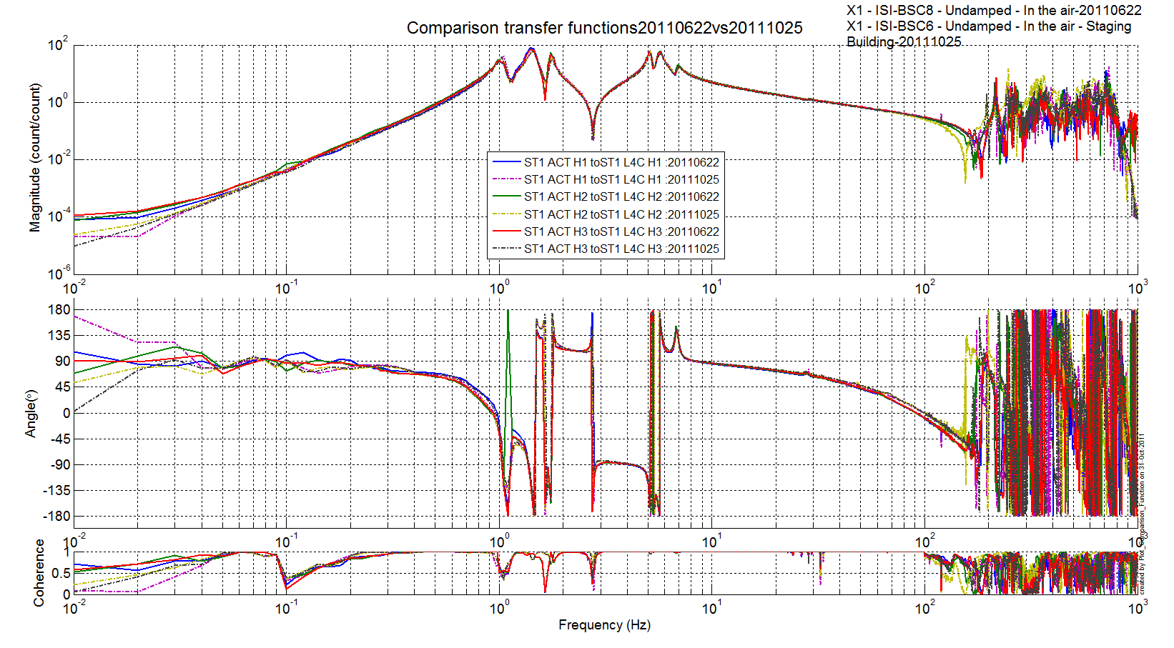
Figure 9 - Comparison BSC6 vs BSC8 - ST1 ACT H to ST1 L4C H

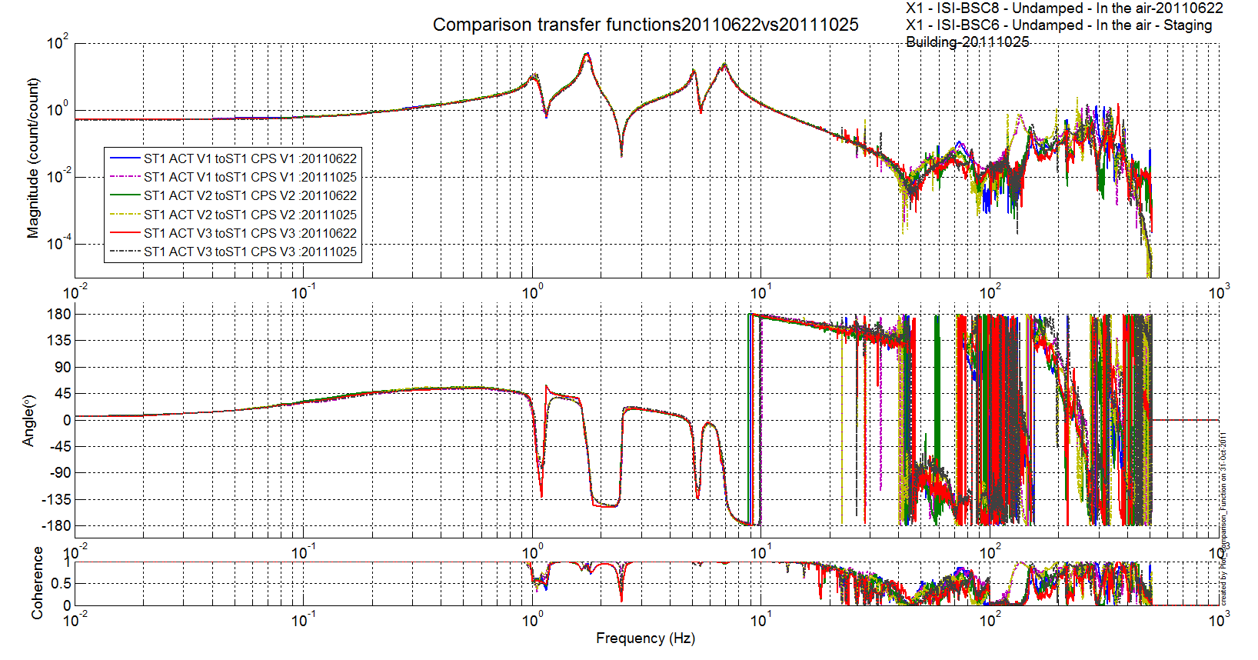
Figure 10 - Comparison BSC6 vs BSC8 - ST1 ACT V to ST1 CPS V

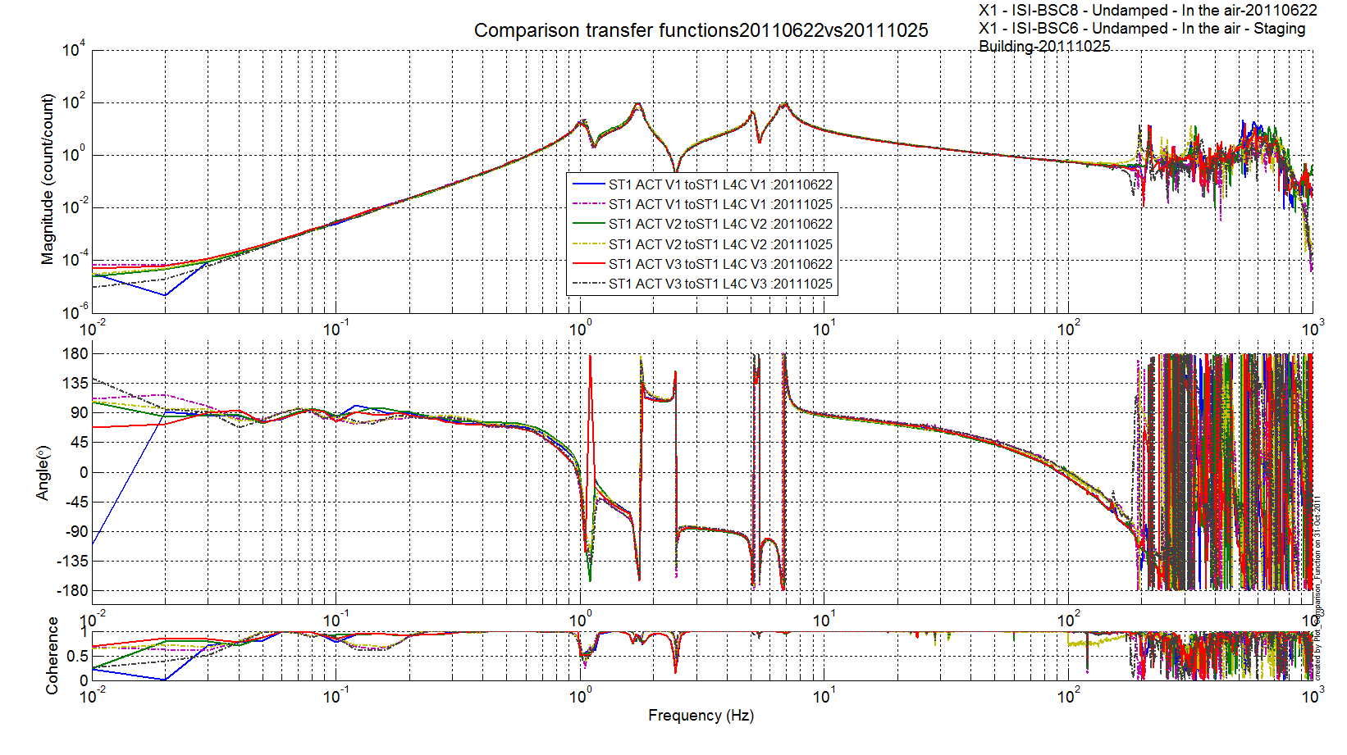
Figure 11 - Comparison BSC6 vs BSC8 - ST1 ACT V to L4C V

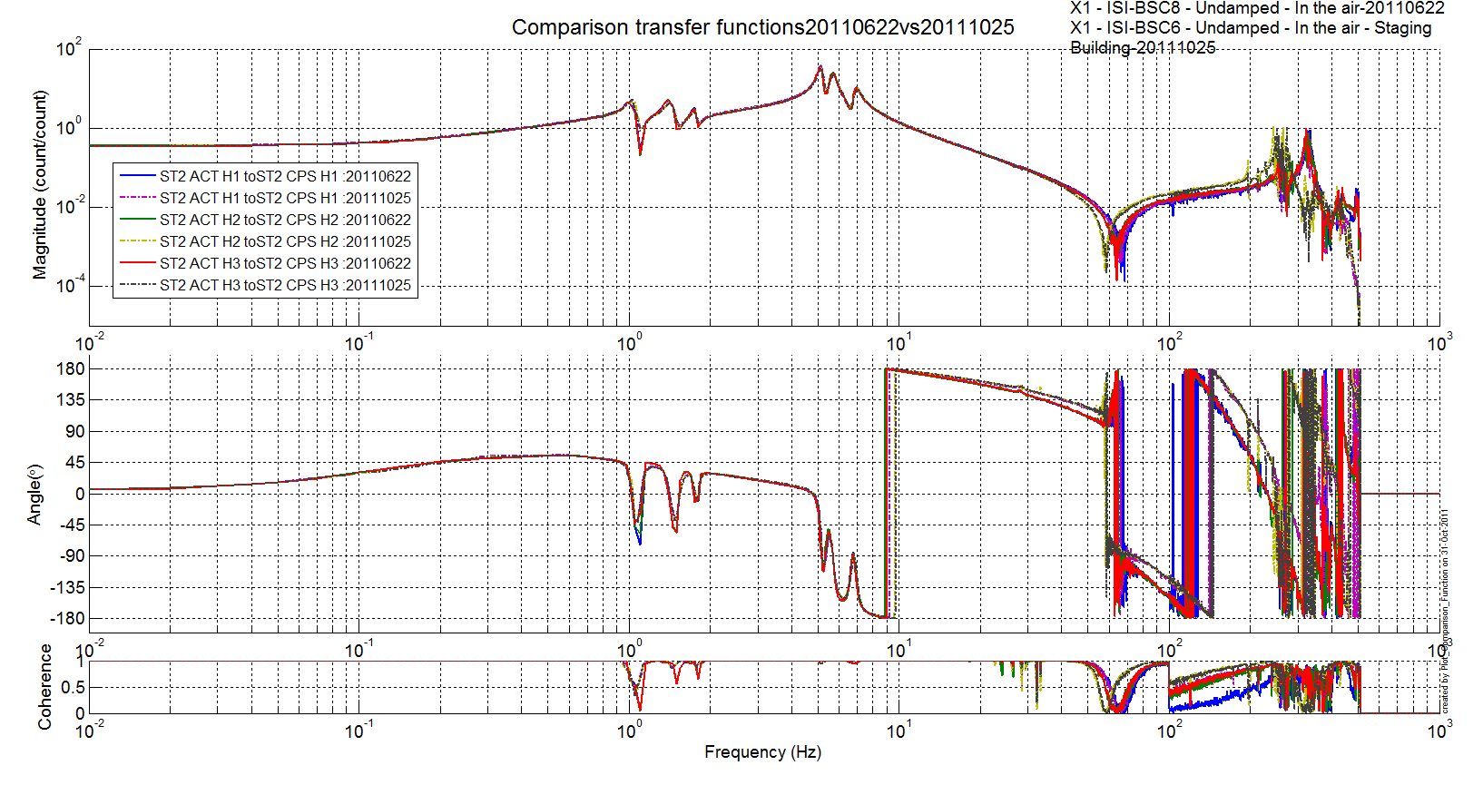
Figure 12 - Comparison BSC6 vs BSC8 - ST2 ACT H to ST2 CPS H

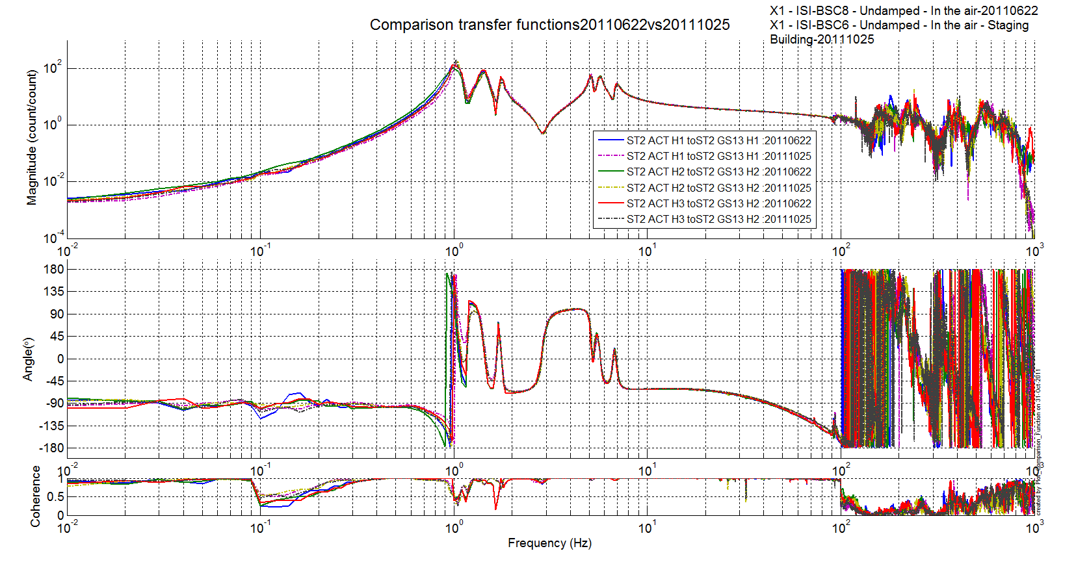
Figure 13 - Comparison BSC6 vs BSC8 - ST2 ACT H to ST2 GS13 H

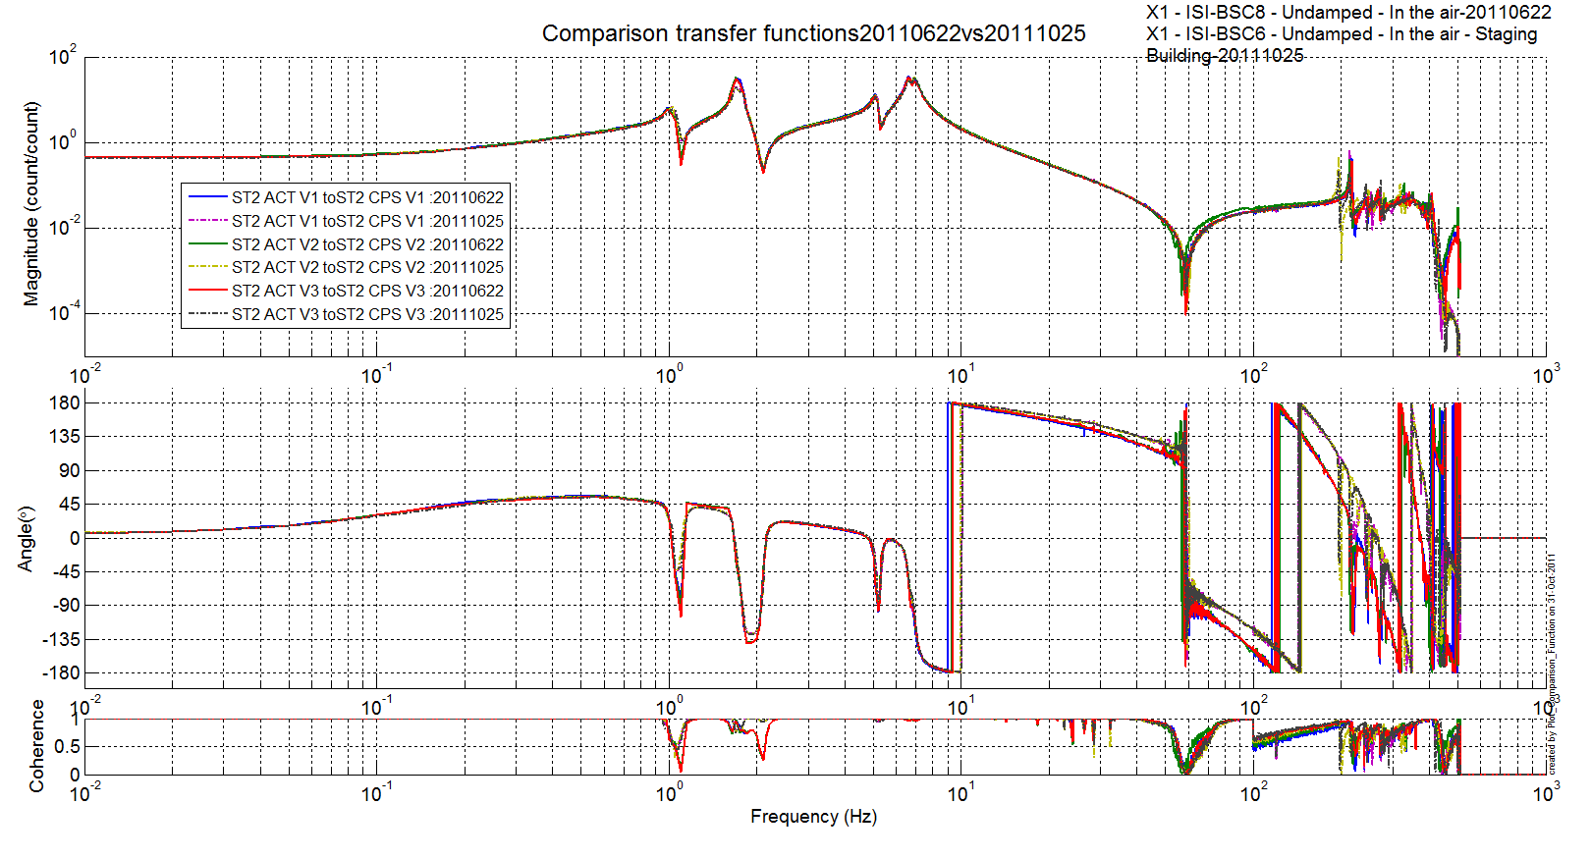
Figure 14 - Comparison BSC6 vs BSC8 - ST2 ACT V to ST2 CPS V

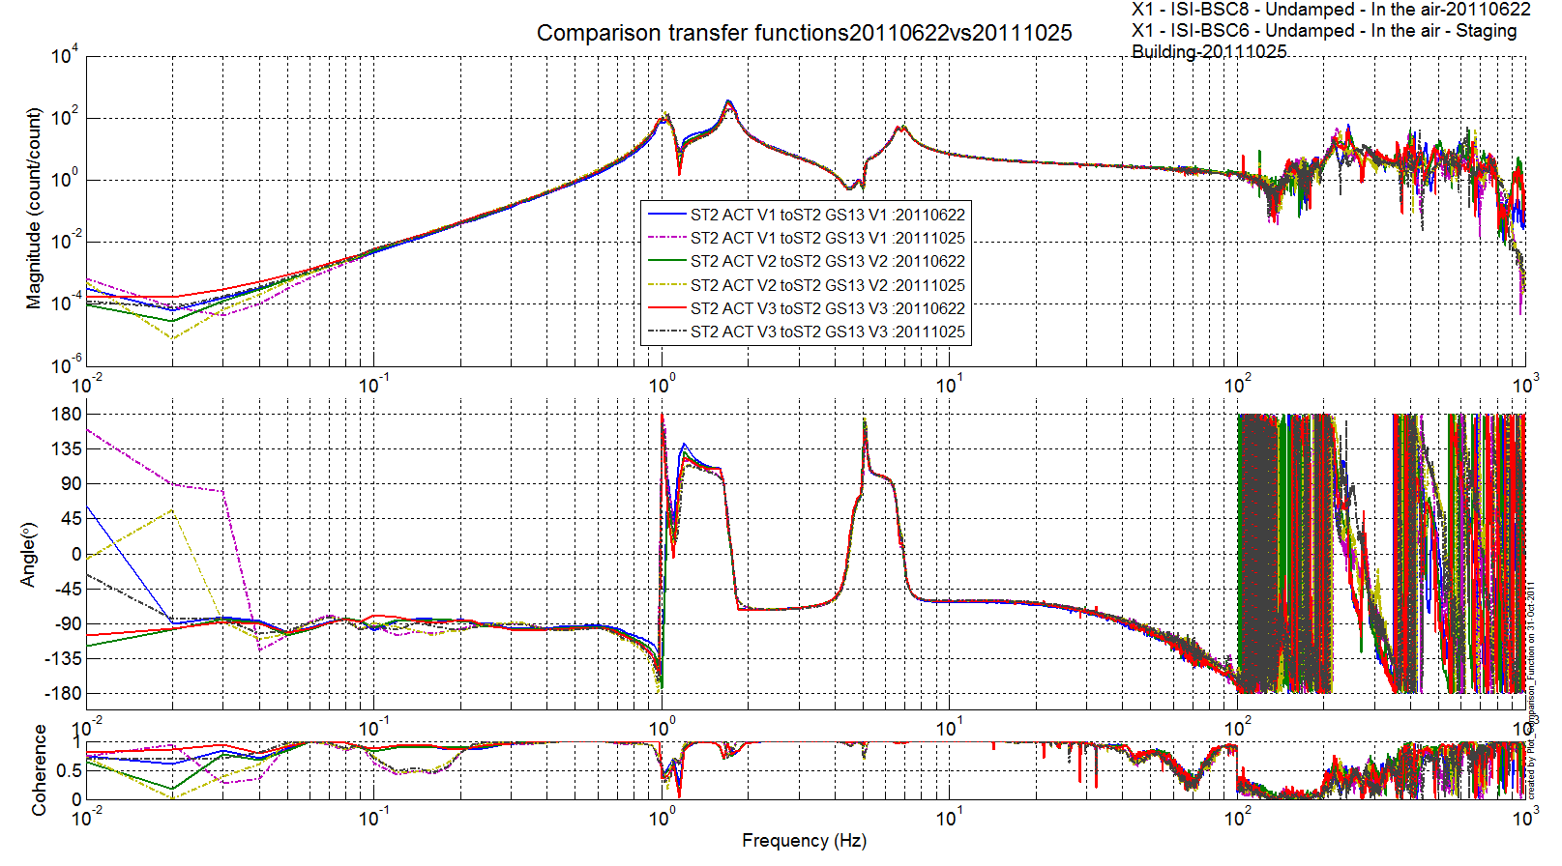
Figure 15 - Comparison BSC6 vs BSC8 - ST2 ACT V to ST2 GS13 V

Acceptance criteria:
- All sensors must be plugged
- First structural resonance of stage 1 must be above 200Hz
- First structural resonance of stage 2 must be above 200Hz

Test result: Passed: X Failed: .

Step 14 - Symmetrization – Calibration
Not performed

Test result: Passed: Failed: X .

Step 15 - Basis change – Cartesian to Local - Simulations
Not performed

Test result: Passed: _ Failed: X .

Step 16- Transfer functions - Cartesian to Cartesian - Measurements
Not performed

Step 17 - Lower Zero Moment Plan

Step 17.1 - Stage 1 - LZMP

Test result: Passed: _ Failed: X .

Step 17.2 - Stage 2 - LZMP

Test result: Passed: _ Failed: X .

Step 18- Damping Loops – Transfer function – Simulations

Step 18.1 - Damping Loops – Stage 2
Test result: Passed: _ Failed: X .

Step 18.2 - Damping Loops – Stage 1

Test result: Passed: _ Failed: X .

Step 19- Damping Loops – Powerspectra
All damping loops were turned on and were stable. No powerspectra was measured.

Step 20- Isolation Loops – for one unit per site
This test was performed on unit # 1 (BSC 8).

BSC-ISI testing Summary
This is the second “aLigo BSC-ISI” tested at LHO. The testing procedure document E1000483-v3 was used. Due to lack of time or availability of the BSC-ISI, some tests have been waived.
All results are posted on the SVN at:
https://svn.ligo.caltech.edu/svn/seismic/BSC-ISI/X1/Data/BSC6/

- List of tests that failed and won’t be redone

- List of tests that failed, that need to be re-done during phase 2
- Step II.12 – Cables inventory

- List of tests skipped that won't be performed because not feasable during phase II (i.e. stage 0 leveling)
- Step I.5 – Check level of Stage 0 after top-bottom plate assembly

- List of tests skipped that we won't do because they are not essential (i.e. redundant with another test)
- Step II.3 – Measure the Sensor gap - This test was not performed. The sensor gaps have not been measured. These sensors have already been checked at LASTI. Moreover, risks of scratching the target are so high that we preferred not performing this test. In the future, this test will be removed from the testing procedure.
- Step II.4.1 – Push “in the general coordinate Z/RZ” - This test was not performed due to lack of time. This test is redundant with step 4.2.
- Step II.8 – Vertical sensor calibration

- Lists of tests skipped that needs to be done during phase II.
- Step II.14 – Symmetrization – Calibration
- Step II.15 – Change of bases – Cartesian to local - Simulations
- Step II.16 – Transfer functions – Cartesian to Cartesian - Simulations
- Step II.17 – Lower Zero Moment Plan
- Step II.18.1 – Damping Loops – Stage 2
- Step II.18.2 – Damping Loops – Stage 1
- Step II.19 – Damping loops – Powerspectra
- Step II.20 – Isolation loops

The ISI-BSC6 was moved from the Staging building to the LVEA test stand on October 31, 2011.

