LIGO Laboratory / LIGO Scientific Collaboration

LIGO- E1000294 LIGO August 11, 2011

aLIGO BSC-ISI, Pre-integration Testing report,
Phase I (post-assembly)
E1100294 – V2

Vincent Lhuillier, Fabrice Matichard

Distribution of this document:
Advanced LIGO Project

This is an internal working note
of the LIGO Laboratory

California Institute of Technology  LIGO Project – MS 18-34  1200 E. California Blvd.  Pasadena, CA 91125  Phone (626) 395-2129  Fax (626) 304-9834  E-mail: info@ligo.caltech.edu | Massachusetts Institute of Technology  LIGO Project – NW22-295  185 Albany St  Cambridge, MA 02139  Phone (617) 253-4824  Fax (617) 253-7014  E-mail: info@ligo.mit.edu
LIGO Hanford Observatory  P.O. Box 1970  Mail Stop S9-02  Richland WA 99352  Phone 509-372-8106  Fax 509-372-8137 | LIGO Livingston Observatory  P.O. Box 940  Livingston, LA 70754  Phone 225-686-3100  Fax 225-686-7189

Table of contents:

Introduction 4
I. Pre-Assembly Testing 5
▪ Step 1 - CPS Test and calibration – E1100369 5
▪ Step 2 - GS13 – Inspection/Assembly – E1000058 – E1100740 5
▪ Step 3 - L4C – Inspection/Assembly – E1000136 – E1100740 5
▪ Step 4 - T240 – Inspection/Assembly - E1100326 – E1100740 6
▪ Step 5 - Actuators - T0900564 - T1100234 – E1100741 6
II. Tests to be performed during assembly 7
▪ Step 1 - Test stand level 7
▪ Step 2 - Actuators Inventory 7
▪ Step 3 - Sensors Inventory 7
▪ Step 4 - Electronics Inventory 9
▪ Step 5 - Check level of Stage 0 after top-bottom plate assembly 10
▪ Step 6 - Check gaps under the blade posts 10
▪ Step 7 - Blade post shim thickness 10
▪ Step 8 - Blade 0-1 post launch angle 10
▪ Step 9 - Gap checks on actuators 11
▪ Step 10 - Mass budget 11
▪ Step 11 - Lockers adjustment 13
▪ Step 12 – Cables inventory – E1100822 13
▪ Step 13 - Cable routing 13
III. Tests to perform after assembly 14
▪ Step 1- Geophones pressure readout 14
▪ Step 2- Set up sensors gap – Locked vs unlocked position 14
▪ Step 3 - Measure the Sensor gap 15
▪ Step 4- Performance of the limiters 15
o Step 4.1 - Test Nº1 - Push “in the general coordinates Z/RZ” 15
o Step 4.2 - Test Nº2 – Push “locally” 15
▪ Step 5 - Sensors Powespectra 16
▪ Step 6 - Coil Driver, cabling and resistance check 21
▪ Step 7- Actuators Sign and range of motion (Local drive) 22
o Step 7.1 - Actuators sign 22
o Step 7.2 - Range of motion - Local drive 22
▪ Step 8 - Vertical Sensor Calibration 23
▪ Step 9 - Vertical Spring Constant 24
▪ Step 10 - Static Testing (Tests in the local basis) 26
▪ Step 11- Static Testing - In the general coordinate basis (Static test - CPS) 28
o Step 11.1 – Change of basis matrices from local to Cartesian 28
o Step 11.2 – Base change matrices from Cartesian to Local 29
▪ Step 12 - Linearity test 30
▪ Step 13 – Transfer functions – Local to Local 32
▪ Step 14 - Symmetrization – Calibration 35
▪ Step 15 – Change of base – Cartesian to Local - Simulations 35
▪ Step 16- Transfer functions - Cartesian to Cartesian - Measurements 35
▪ Step 17 - Lower Zero Moment Plan 35
o Step 17.1 - Stage 1 - LZMP 35
o Step 17.2 - Stage 2 - LZMP 35
▪ Step 18- Damping Loops – Transfer function – Simulations 35
o Step 18.1 - Damping Loops – Stage 2 35
o Step 18.2 - Damping Loops – Stage 1 35
▪ Step 19- Damping Loops – Powerspectra 35
▪ Step 20- Isolation Loops – for one unit per site 35
IV. BSC-ISI testing Summary 36

Introduction

The BSC-ISI testing is performed in three phases:
1) BSC-ISI, Pre-integration Testing, Phase I (post-assembly)
2) BSC-ISI, Pre-integration Testing, Phase II: Tests done after Transport (and possible storage), during mating phase with Suspensions, before insertion.
3) BSC-ISI, Integration Phase Testing: Procedure and results related to the commissioning in the chamber.

This document presents the series of tests (Phase I) performed on the ISI-BSC8 (ITMY) in the Staging building before its move to the LVEA (Teststand). Tests were done from June 15 to June 24, 2011.

This is the first “aLigo BSC-ISI” tested with the “aLigo electronic”. The testing procedure document E1000483-v3 was used. Due to lack of time, some tests have been waived or will be done during Phase II testing. Moreover due to few sensors issues, some results are incomplete but sufficient to consider the ISI properly assembled. Tests involving sensors swaps will also be re-done during the second phase of tests.

All results are posted on the SVN at:
https://svn.ligo.caltech.edu/svn/seismic/BSC-ISI/X1/Data/BSC8/

The following type of document can be found in the SVN:
- Excell spreadsheet (.xls)
- Data location
- Figures location
- Masses distribution scheme (ppt)

The ISI-BSC8 was moved from the Staging building to the LVEA test stand on July 30, 2011.

Pre-Assembly Testing

Step 1 - CPS Test and calibration – E1100369
CPS sensors are tested (calibration and noise test) at MIT before being cleaned and baked at LHO. During assembly, two sensors (12947 - 12954) have been replaced (1 faulty probe – 1 faulty electronic board). The list of installed sensors used for testing (phase I) are reported in step II.3.

All data related to the CPS testing can be found in the SVN at
/svn/seismic/Common/Data/

Test Failure mitigation:
Six of the twelve installed sensors are not vacuum compatible. (Corrosive flux used during the device machining process). They will be replaced by good sensors during phase II."

Test result: Passed: Failed: X .

Step 2 - GS13 – Inspection/Assembly – E1000058 – E1100740
GS13 are tested and podded at LLO before being shipped to LHO. One of these 6 geophones (Vertical corner 3 – S/N 153) has been vented during testing. The moving mass of the geophone was resting at the bottom of the instrument. The spring has been translated upwards by turning the level adjustment knobs. It will be replaced before the cartridge install.
The list of installed sensors used for testing (phase I) are reported in step II.3.

All the data related to GS-13 post podding testing can be found in the SVN at : /svn/seismic/Common/Data/aLIGO_GS13_TestData/GeoTech_TestResults_PDFs/

E1000058 and E1100740 spreadsheets provide the status of each individual GS-13 at LLO site for HAM-ISI and BSC-ISI and the installation location of the geophones.

Test Failure mitigation:
One of the seismometers was not functioning when it arrived on site. It will be replaced during phase II-testing. In the future, all geophones will be tested when they will arrive on site.

Test result: Passed: Failed: X .
”

Step 3 - L4C – Inspection/Assembly – E1000136 – E1100740
L4C are tested and podded at LLO before being shipped to LHO. One of these 6 geophones (Horizontal corner 1– POD S/N 22) is labeled with a X tag. After few concerns, LLO confirms that horizontal L4C in corner 1 is vacuum compatible. The list of installed sensors used for testing (phase I) are reported in step II.3.

All the data related to L4C post podding testing can be found in the SVN at : svn/seismic/Common/Data/aLIGO_L4C_TestData/TestResults_PDFs/

E1000136 and E1100740 spreadsheets provide the status of each individual L4C at LLO site for HAM-ISI and BSC-ISI and the installation location of the geophones.

Warning:
POD S/N 22 at corner 1 is labeled with a X-tag.

Test result: Passed: X Failed: .
”

Step 4 - T240 – Inspection/Assembly - E1100326 – E1100740
T240 are tested and podded at LLO before being shipped to LHO. The list of installed sensors used for testing (phase I) are reported in step II.3.

All the data related to T240 post podding testing can be found in the SVN at :
seismic/Common/Data/aLIGO_T240_TestData/AsReceived_TestResults_PDFs.

E1100326 and E1100740 spreadsheets provide the status of each individual T240 at LLO site for BSC-ISI and the installation location of the geophones.

Test Failure mitigation:
The pressure sensors of 2 geophones (corner 2 and 3 – S/N will be noted when the geophones will be removed from the ISI before the cartridge install) are not working. They will be replaced during phase 2- testing.

Test result: Passed: Failed: X .

Step 5 - Actuators - T0900564 - T1100234 – E1100741
The list of installed sensors used for testing (phase I) are reported in step II.2

Large actuators data can be found at: T0900564. Actuator inventory is made at Section II – Step 2.
Small actuators data can be found at: T1100234. Actuator inventory is made at Section II – Step 2.

Test result: Passed: X Failed: .

Tests to be performed during assembly

Step 1 - Test stand level
The HAM-ISI Teststand was transformed and re-leveled to dock a BSC-ISI.

Test result: Passed: X Failed: .

Step 2 - Actuators Inventory
The actuators S/N are reported in the table below. Further information can be found in T0900564 and T1100234.

Stage 1 |  | Stage 2
Actuator | Actuator S/N | Actuator | Actuator S/N
H1 | 24 | H1 | 61
H2 | 41 | H2 | 57
H3 | 42 | H3 | 62
V1 | 43 | V1 | 85
V2 | 56 | V2 | 90
V3 | 63 | V3 | 68
Table 1 - Actuators' inventory

Test result: Passed: X Failed: .

Step 3 - Sensors Inventory
The sensors S/N are reported in the table below.

CPS Stage 1 | CPS S/N | ADE board serial #
H1 | 12949 | 12504
H2 | 12943 | 12372
H3 | 12952 | 12512
V1 | 12956 | 12649
V2 | 12959 | 12384
V3 | 12910 | 12640
Table 2 - Capacitive position sensors' inventory – Stage 1

CPS Stage 2 | CPS S/N | ADE board serial #
H1 | 12953 | 12580
H2 | 12940 | 12378
H3 | 12938 | 12423
V1 | 12939 | 12413
V2 | 12950 | 12381
V3 | 12960 | 12430

Warning:
Sensors 12943; 12956 ; 12959 ; 12910 12953 ; 12960 will be replaced before the cartridge install.

Geophones GS13 | Serial Number | POD
H1 | 822? | 68?
H2 | 842? | 85?
H3 | 841? | 89?
V1 | 728 | 76
V2 | 703 | 84
V3 | 719 | 98
Table 3 - GS13 inventory

Warning:
Vertical geophone in corner 3 (POD S/N 98) will be replaced before cartage install because it has been vented. The moving mass of the geophone was resting at the bottom of the instrument.

Note:
Locations of the vertical GS13 have not been noted during assembly. The locations-S/N of GS13 V1, V2 and V3 are not accurate

Geophones L4C | Serial Number | POD
H1 | 815 | 22
H2 | 1094 | 152
H3 | 968 | 150
V1 | 1068 | 155
V2 | 1070 | 151
V3 | 811 | 153
Table 4 - L4C inventory

Geophones T240 | Serial Number | POD
1 | 138? | 12?
2 | 133? | 26?
3 | 109? | 36?
Table 5 - T240 inventory

Note:
Locations of the T240 have not been noted during assembly. The locations vs S/N of the Trilliums are not accurate. These trilliums will be removed during phase 2 testing because of the non-working pressure sensors.

Test result: Passed: X Failed: .

Step 4 - Electronics Inventory
Write down in the table below all serial numbers all the electronic equipment:

Hardware | LIGO reference | S/N
Interface Chassis - Corner 1 | D1002432 | S1102222
Interface Chassis - Corner 2 | D1002432 | S1102224
Interface Chassis - Corner 3 | D1002432 | S1102218
Anti-Alliasing Chassis - Corner 1 | D1002693 | S1102693
Anti-Alliasing Chassis - Corner 2 | D1002693 | S1102694
Anti-Alliasing Chassis - Corner 3 | D1002693 | S1102679
Anti-image Chassis | D070081 | S1000250
Binary Input Chassis | D1001726 | S1101309
Binary Input Chassis | D1001726 | S1101300
Binary Output Chassis | D1001728 | S1101347
T240 Interface - Corner 1 | D1002694 | S1101840
T240 Interface - Corner 2 | D1002694 | S1101838
T240 Interface - Corner 3 | D1002694 | S1101839
I/O Chassis | n/a | DTSFE0
Coil driver Pod 1 | D0902744 | S1000266
Coil driver Pod 2 | D0902744 | S1000269
Coil driver Pod 3 | D0902744 | S1102692
Table 6 - Electronic equipment

Test result: Passed: X Failed: .

Step 5 - Check level of Stage 0 after top-bottom plate assembly

Note : This test has not been performed

Test result: Passed: Failed: X .

Step 6 - Check gaps under the blade posts

Test result: Passed: X Failed: .

Step 7 - Blade post shim thickness
This table shows the shims thickness installed under the lockers.

Stage 1 |  | Stage 2
Lockers | Shim thickness (mil) | Lockers | Shim thickness (mil)
A | 0.127” | A | 0.126”
B | 0.125” | B | 0.122”
C | 0.127” | C | 0.130”
Table 7 - Shims thickness

Test result: Passed: X Failed: .

Step 8 - Blade 0-1 post launch angle
The measurements are in good agreement with specifications. An error of 0.02° on the launch angle can be compensated by adding or removing 7 pounds per corner.

Measurement Romer Arm - Blade Post - D0901499
3-May-11
 | On the Granite table
 | SN22 |  | SN12 |  | SN14
 | Meas1 | Meas 2 | Meas1 | Meas 2 | Meas1 | Meas 2 | Units
Granite table flatness | 0.009 | 0.006 | 0.005 | 0.007 | 0.001 | 0.002 | "
Spring mount flatness | 0.001 | 0.006 | 0.003 | 0.001 | 0.001 | 0.001 | "
Inner face flatness | 0.001 | 0.001 | 0.001 | 0.001 | 0.001 | 0.002 | "
Outer face flatness | 0.001 | 0.001 | 0.001 | 0.001 | 0.002 | 0.001 | "
Launch Angle | 13.711 | 13.753 | 13.712 | 13.707 | 13.735 | 13.724 | °
Height of the post | 14.653 | 14.652 | 14.651 | 14.656 | 14.656 | 14.656 | "
Blade launch angle (Nominal) |  | 13.710 | °
Blade launch angle (Tolerance) |  | 0.030 | °
Height |  | 14.655 | "
Height (Tolerance) |  | 0.002 | "
Angle | 0.02 | °
Blade tip offset | 0.006 | "
Stiffness | 1241 | lb/in
Mass | 7.36 | lb

Test result: Passed: X Failed: .

Step 9 - Gap checks on actuators

Test result: Passed: X Failed: .

Step 10 - Mass budget
The figure below presents the location of the masses on both stages.

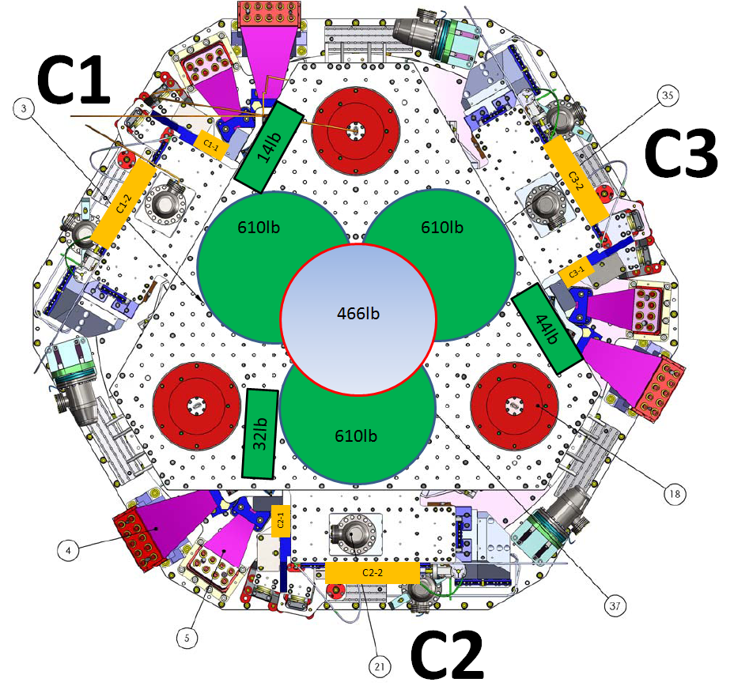
Figure - Masses distribution

Stage 1:
Stage 1
Location | Weight (lb) | Weight (Kg)
C1-1 | 12 | 5.4
C1-2 | 25.5 | 11.6
C2-1 | 12 | 5.4
C2-2 | 5.5 | 2.5
C3-1 | 12 | 5.4
C3-2 | 11.5 | 5.2
Total | 78.5 | 35.6
Table 8 - Payload Stage 1

Nominal payload: 109Kg – 240lb
Added masses are 73Kg – 160lb lighter than expected.
Total mass of stage 1=912Kg - 2010lb

Stage 2:

Stage 2
Quantity | Weight (Kg) | Total Weight(lb) | Total Weight(Kg)
3 | 276.7 | 1808.4 | 830.1
2 | 105.7 | 460.5 | 211.4
2 | 10.0 | 43.6 | 20.0
1 | 7.8 | 17.0 | 7.8
2 | 4.5 | 19.6 | 9.0
2 | 2.1 | 9.2 | 4.2
Total : |  | 2358.3 | 1082.4
Table 9 - Payload Stage 2

Nominal payload: 1185Kg – 2612lb
The added masses is 103Kg lighter than expected.
Total mass of Stage 2: 2830Kg – 6239lb
Error on the nominal overall mass of stage 2: 103/2830=3.6%
We checked that this won't be an issue for the balancing of the cartridge assembly (Stage 2+Quad+FM).

Test result: Passed: X Failed: .

Step 11 - Lockers adjustment
No value has been recorded during the locker adjustments. Measurements using the CPS sensors when the stages are locked and unlocked have been done Step III.2.

 | Stage 1 |  | Stage 2
D.I at Lockers | Dial indicators V | Dial indicators H | Dial indicators V | Dial indicators H
A
B
C
Table 10 - Dial indicators read-out (stage locked-unlocked independently)

Test failure mitigation:
Step III.2 passed. Consequently, this test can be waived.

Test result: Passed: Failed: X .

Step 12 – Cables inventory – E1100822
Class B cables were installed on Unit 2. Cables will be swapped by class A ones during phase 2 - testing. Cable inventory can be found in E1100822-V3: 8 x D1100153 – 1 x D1000225 – 9 x D1000920 – 3 x D1100150 - 6 x D1000227.

Test failure mitigation:
All cables are non-serialized and class B’d.

Test result: Passed: Failed: X .

Step 13 - Cable routing
The cables used to test the BSC-ISI in the staging building are class-B cables. It’s is an hybrid set made of HAM-ISI and BSC-ISI cables. These “testing” cables will be replaced by final class-A cables before the cartridge install. The GS13 cables are going from stage 2 to stage 1 without being clamped on stage 1.

Test failure mitigation:
Some cables were too shorts. Consequently, the cable routing was not respected.

Test result: Passed: Failed: X .

Tests to perform after assembly

Step 1- Geophones pressure readout
Test Failure mitigation:
Pressure sensors readouts were not noted but pressure sensors of 2 geophones (corner 2 and 3 – S/N will be noted when the geophones will be removed from the ISI before the cartridge install) are not working.

Test result: Passed: Failed: X .

Step 2- Set up sensors gap – Locked vs unlocked position
During this step, sensors gap are adjusted. This step considers that the lockers have been finely setup during assembly.

22-Jun-11
 | Table locked |  | Table unlocked |  | Difference locked - unlocked
Sensors | Offset (Mean) | Std deviation | Offset (Mean) | Std deviation | Offset (Mean) | mil
ST1 - H1 | 473.0 | 13.0 | 744.5 | 32.9 | -271.6 | -0.32
ST1 - H2 | 314.7 | 8.9 | 686.5 | 23.2 | -371.8 | -0.44
ST1 - H3 | -70.8 | 9.4 | 1925.3 | 21.3 | -1996.0 | -2.38
ST1 - V1 | 464.8 | 12.7 | 358.0 | 21.2 | 106.8 | 0.13
ST1 - V2 | -10.7 | 6.4 | 244.6 | 21.7 | -255.3 | -0.30
ST1 - V3 | -32.9 | 8.5 | -325.8 | 24.7 | 292.9 | 0.35
ST2 - H1 | -259.6 | 23.6 | 2679.8 | 39.0 | -2939.4 | -0.87
ST2 - H2 | 865.2 | 55.7 | 2236.3 | 40.6 | -1371.0 | -0.41
ST2 - H3 | 751.6 | 39.4 | 3813.2 | 35.6 | -3061.5 | -0.91
ST2 - V1 | 1044.8 | 43.5 | -2252.6 | 52.1 | 3297.3 | 0.98
ST2 - V2 | -1284.0 | 109.3 | -1166.8 | 51.3 | -117.2 | -0.03
ST2 - V3 | -8.0 | 160.6 | -631.2 | 58.9 | 623.2 | 0.19
Table 11 - Capacitive position sensors readout after gap set-up

Acceptance criteria:

- In the locked position, all mean values must be lower than 400 counts for stage 1 CPS and 1600 counts for stage 2 CPS (a bit less than .0005”).
- In the locked position, all standard deviations below 5 counts for stage 1, 20 counts for stage 2
- Absolute values of the difference between the unlocked and the locked table must be below:
Stage 1
  - 1600 cts for horizontal sensors (~0.002”)
  - 1600 cts for vertical sensors (~0.002”)
Stage 2
  - 6500 cts for horizontal sensors (~0.002”)
  - 6500 cts for vertical sensors (~0.002”)
- Considering the acceptance criteria of step 2, all mean values must be lower than

Stage 1
  - 2000 cts for horizontal sensors (~0.0025”)
  - 2000 cts for vertical sensors (~0.0025”)
Stage 2
  - 8000 cts for horizontal sensors (~0.0025”)
  - 8000 cts for vertical sensors (~0.0025”)

Test result: Passed: X Failed: .

Step 3 - Measure the Sensor gap
Test Failure mitigation:
This test was not performed. The sensor gaps have not been measured. These sensors have already been tested at LASTI. Moreover, risks of scratching the target are so high that we preferred not performing this test. In the future, this test will be removed from the testing procedure.

Test result: Passed: Failed: X .

Step 4- Performance of the limiters

Step 4.1 - Test Nº1 - Push “in the general coordinates Z/RZ”
This test was not performed due to lack of time. This test is redundant with step 4.2. It may be removed in the future.

Test result: Passed: Failed: X .

Step 4.2 - Test Nº2 – Push “locally”

Sensors | Push in positive direction | Push in negative direction | Mil | Mil | Railing | Actuator Gap Check
ST1 - H1 | 15000 | -20000 | 18 | -24 |  | OK
ST1 - H2 | 17000 | -19000 | 20 | -23 |  | OK
ST1 - H3 | 15500 | -20000 | 18 | -24 |  | OK
ST1 - V1 | 22500 | -27000 | 27 | -32 |  | OK
ST1 - V2 | No sensor |  |  |  |  | OK
ST1 - V3 | 24000 | -21000 | 29 | -25 |  | OK
ST2 - H1 | rail | rail |  |  | X | OK
ST2 - H2 | rail | rail |  |  | X | OK
ST2 - H3 | rail | rail |  |  | X | OK
ST2 - V1 | rail | -29000 |  | -9 | X | OK
ST2 - V2 | rail | rail |  |  | X | OK
ST2 - V3 | rail | rail |  |  | X | OK
Table 12 - Stages range of motion – “Push locally”

Test Failure mitigation:
This test was performed with a non-working sensor (ST1-V2 CPS). Even if the range of motion measured on ST2-V1 is limited; we can consider the range of motions are large enough in every directions.

Acceptance criteria:
- The vertical sensor readout must be positive when the optic table is pushed in the +Z direction
- The horizontal sensor readout must be negative when the optic table is pushed in the +RZ direction
- Step 4.1
  - Absolutes value of all estimated motions must be higher than 15000counts for stage 1 (~0.018”)
  - Absolutes value of all estimated motions must be higher than 32000counts for stage 2 (~0.010”)

Test result: Passed: Failed: X .

Step 5 - Sensors Powespectra
Some of the powerspectra have been measured with a non working capacitive positive sensor (ST1-V2 - CPS)
The geophones powerspectra have been measured and can be found in the SVN:

/seismic/BSC-ISI/X1/Data/BSC8/Figures/Powerspectra/Undamped/
- LHO_ISI_BSC8_Powerspectra_m_ST1_CPS_2011_06_21.fig
- LHO_ISI_BSC8_Powerspectra_m_ST1_L4C_2011_06_21.fig
- LHO_ISI_BSC8_Powerspectra_m_ST1_T240_2011_06_21.fig
- LHO_ISI_BSC8_Powerspectra_m_ST2_CPS_2011_06_21.fig
- LHO_ISI_BSC8_Powerspectra_m_ST2_GS13_2011_06_21.fig
- LHO_ISI_BSC8_Tilted_Powerspectra_CT_ST1_CPS_2011_06_20.fig
- LHO_ISI_BSC8_Tilted_Powerspectra_CT_ST1_L4C_2011_06_20.fig
- LHO_ISI_BSC8_Tilted_Powerspectra_CT_ST2_CPS_2011_06_20.fig
- LHO_ISI_BSC8_Tilted_Powerspectra_CT_ST2_GS13_2011_06_20.fig

/seismic/BSC-ISI/X1/Data/BSC8/Powerspectra/Undamped/
- LHO_ISI_BSC8_Calibrated_PSD_CPS_T240_L4C_GS13_Unlocked_Locked_2011_06_21.mat
- LHO_ISI_BSC8_Calibrated_PSD_L4C_GS13_Stage_Tilted_2011_06_20.mat

Stage locked – unlocked
The powerspectra are measured in four different configurations:
- Stage 1 locked – Stage 2 locked
- Stage 1 locked – Stage 2 unlocked
- Stage 1 unlocked – Stage 2 locked
- Stage 1 unlocked – Stage 2 unlocked
The series of plots below present calibrated powerspectra:
- The de-whitening filters are suppressed
- The geophones are inverted (that’s why you will not be able to see the geophones resonance at 1Hz)

Everything looks good except for ST1-V2-CPS (not working and not replaced when the measurements were performed). In the full unlocked configuration (ST1 unlocked – ST2 unlocked), all instruments powerspectra of each type are overlaid. In the partial or full locked, the powerspectra are more tricky to evaluate since each corners are locked in different ways. This is what explains the difference between powespectra.

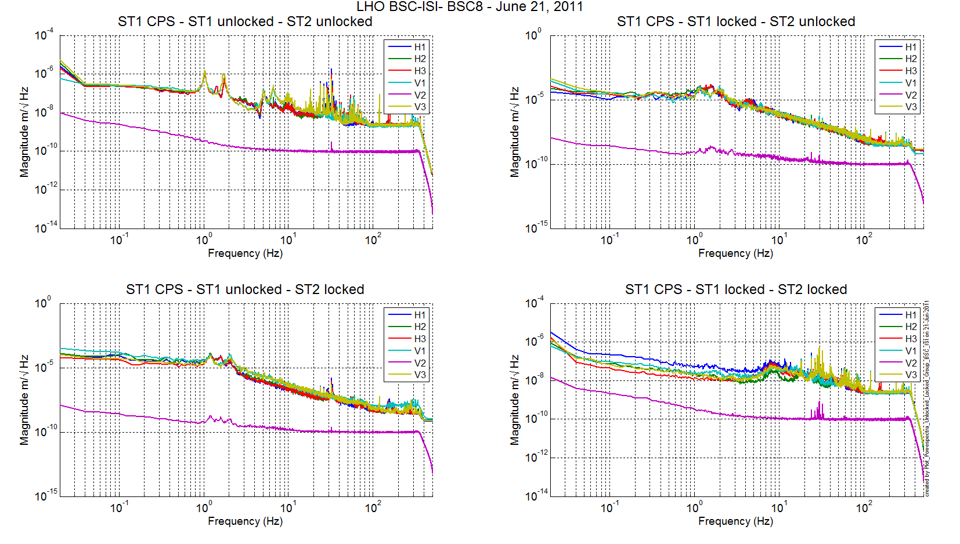
Figure 1 - ST1 CPS

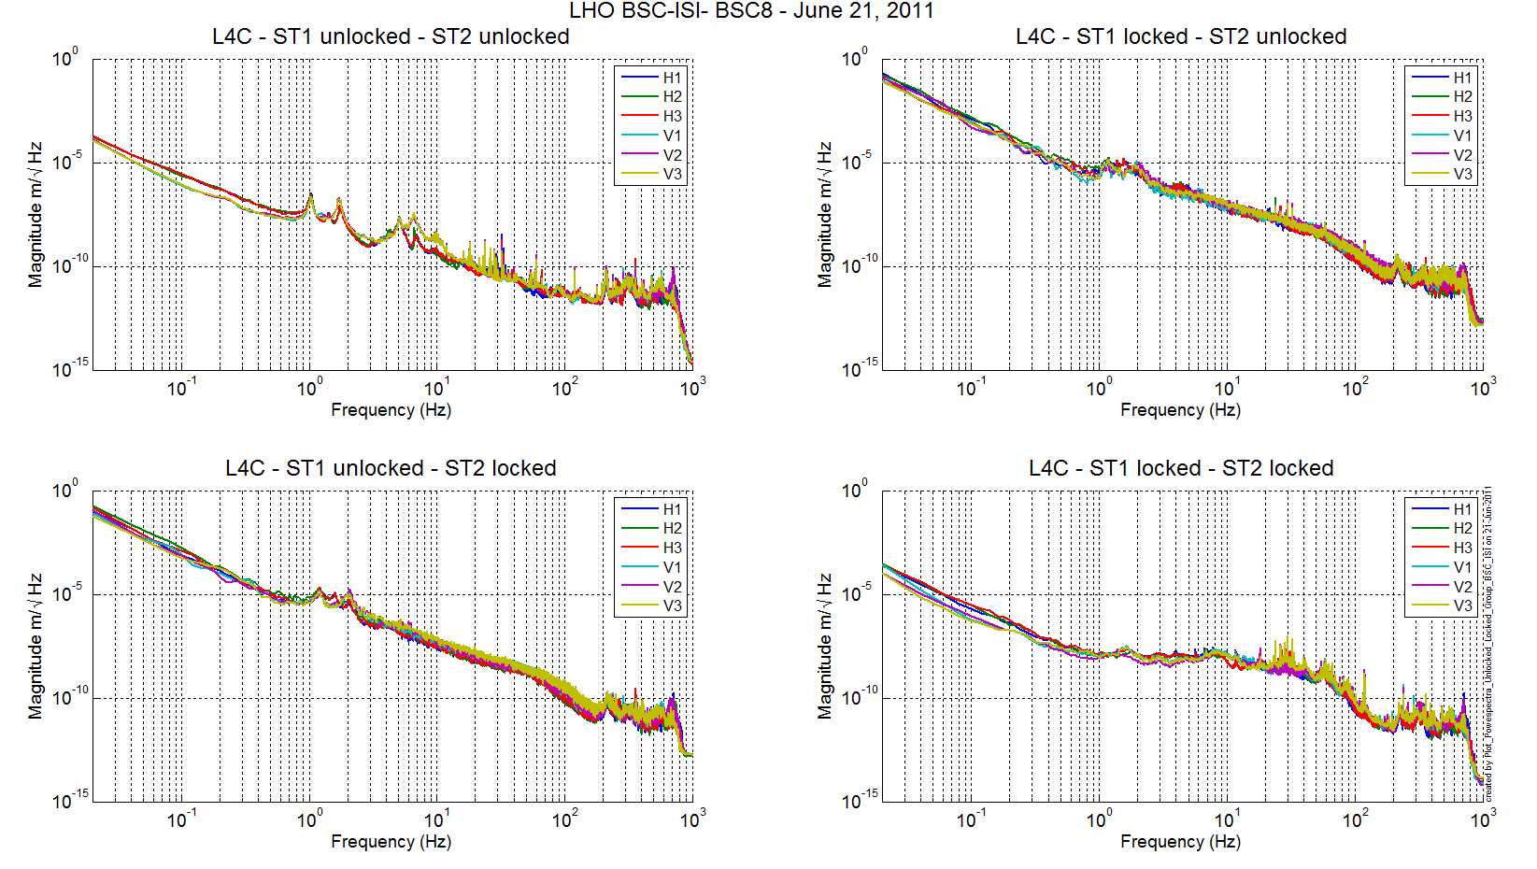
Figure 2 - ST1 L4C

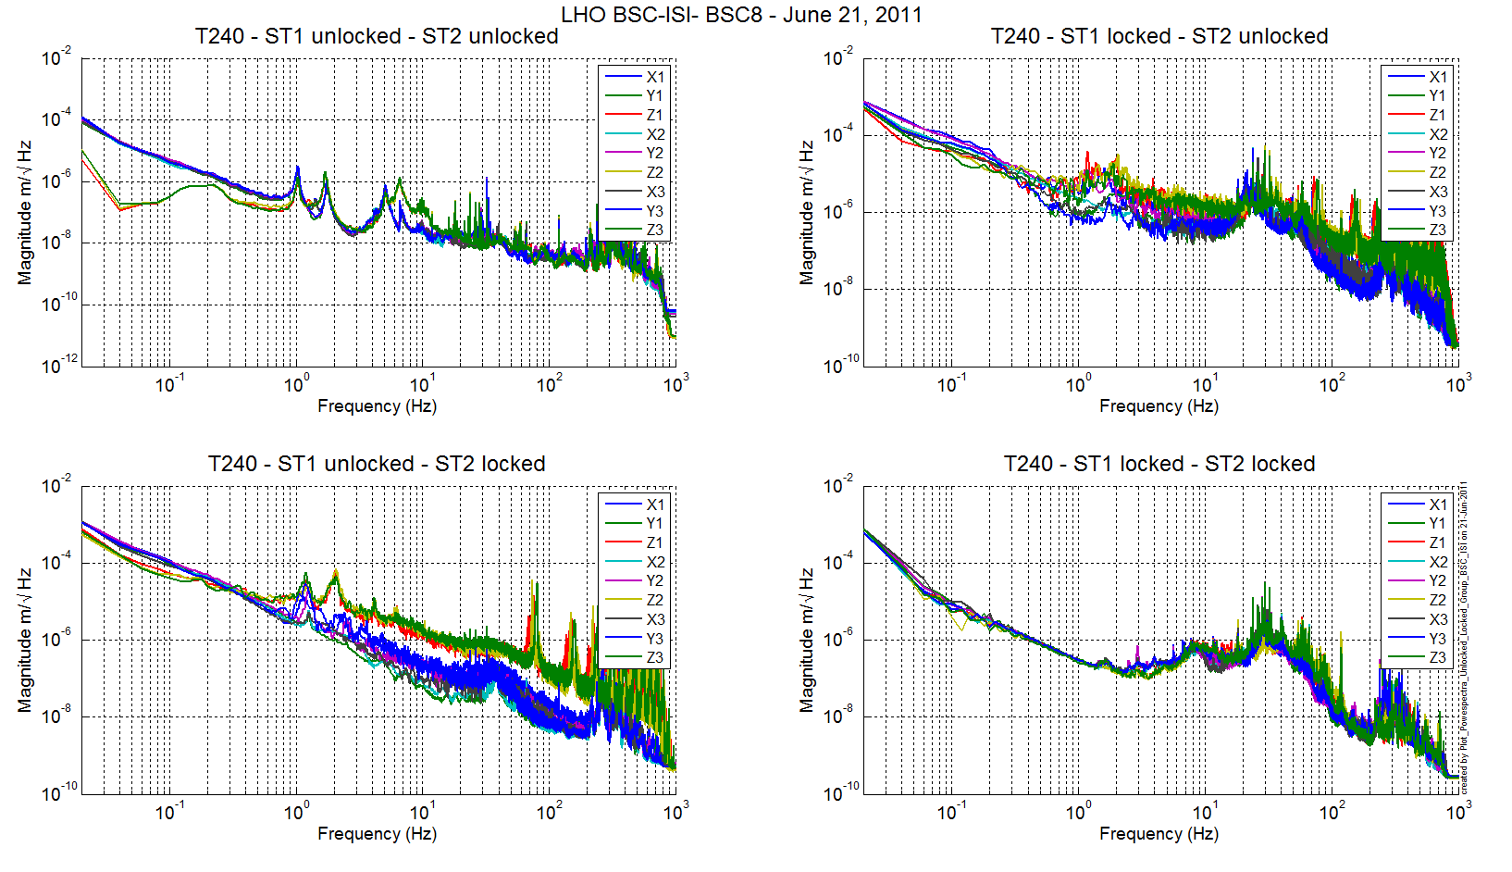
Figure 3 - ST1 T240

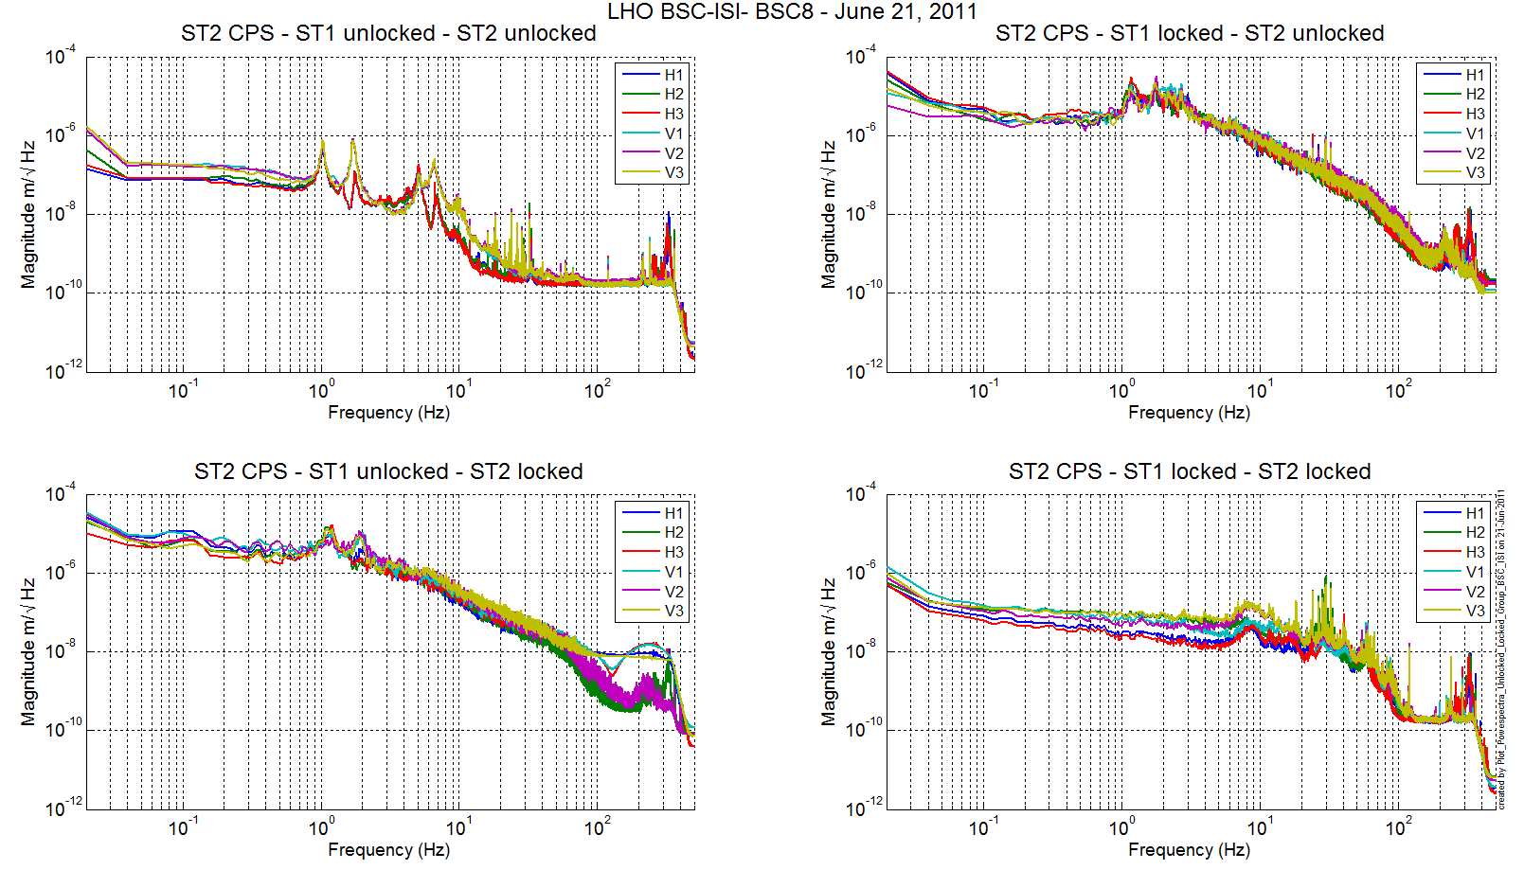
Figure 4 - ST2 CPS

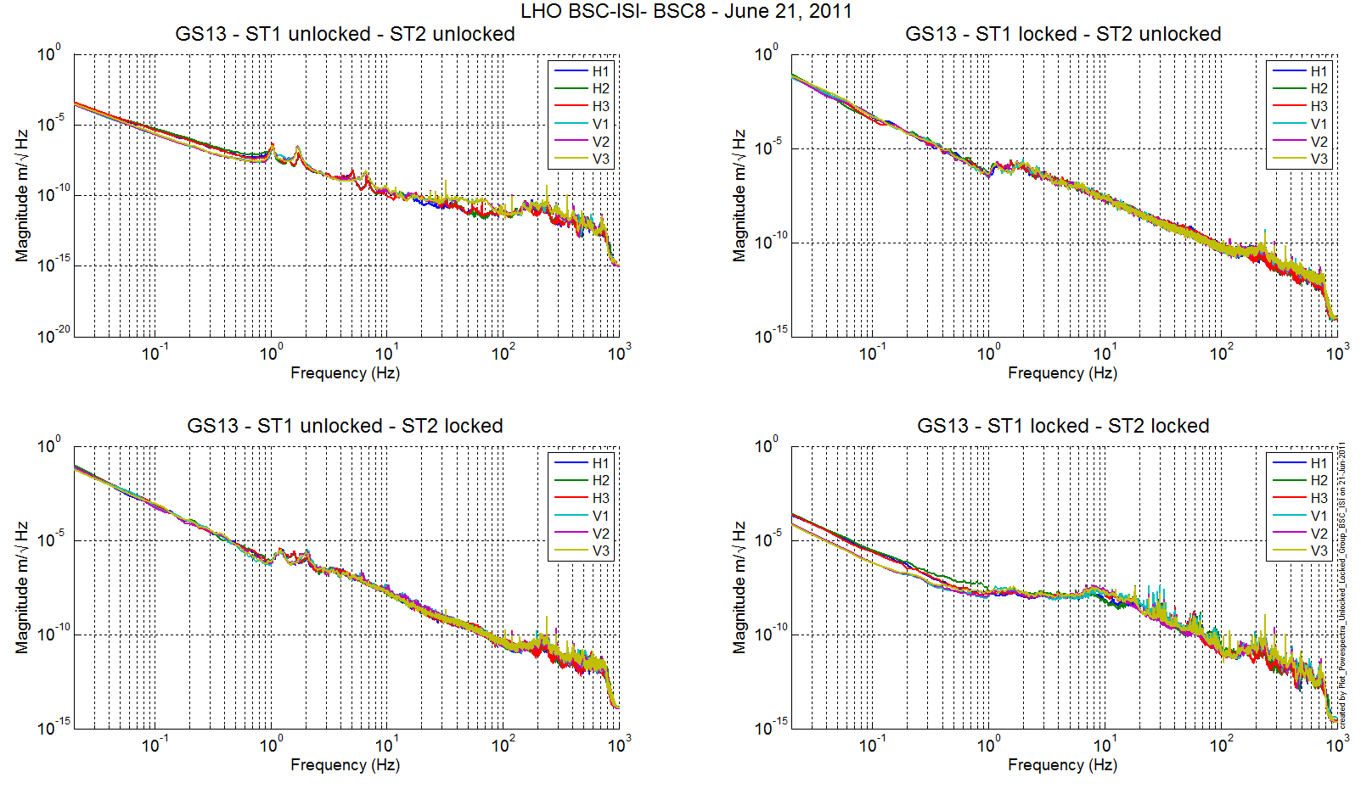
Figure 5 - ST1 GS13

Stage Tilted
The powerspectra are measured when the ISI is unlocked a mass is placed on stage 2 to tilt stage 1 and stage 2.
The six configurations are the following:in six different configurations:
- Mass placed in the actuator pocket at corner 1
- Mass placed in the pocket under the blade 0-1 at corner 1
- Mass placed in the actuator pocket at corner 2
- Mass placed in the pocket under the blade 0-1 at corner 2
- Mass placed in the actuator pocket at corner 3
- Mass placed in the pocket under the blade 0-1 at corner 3

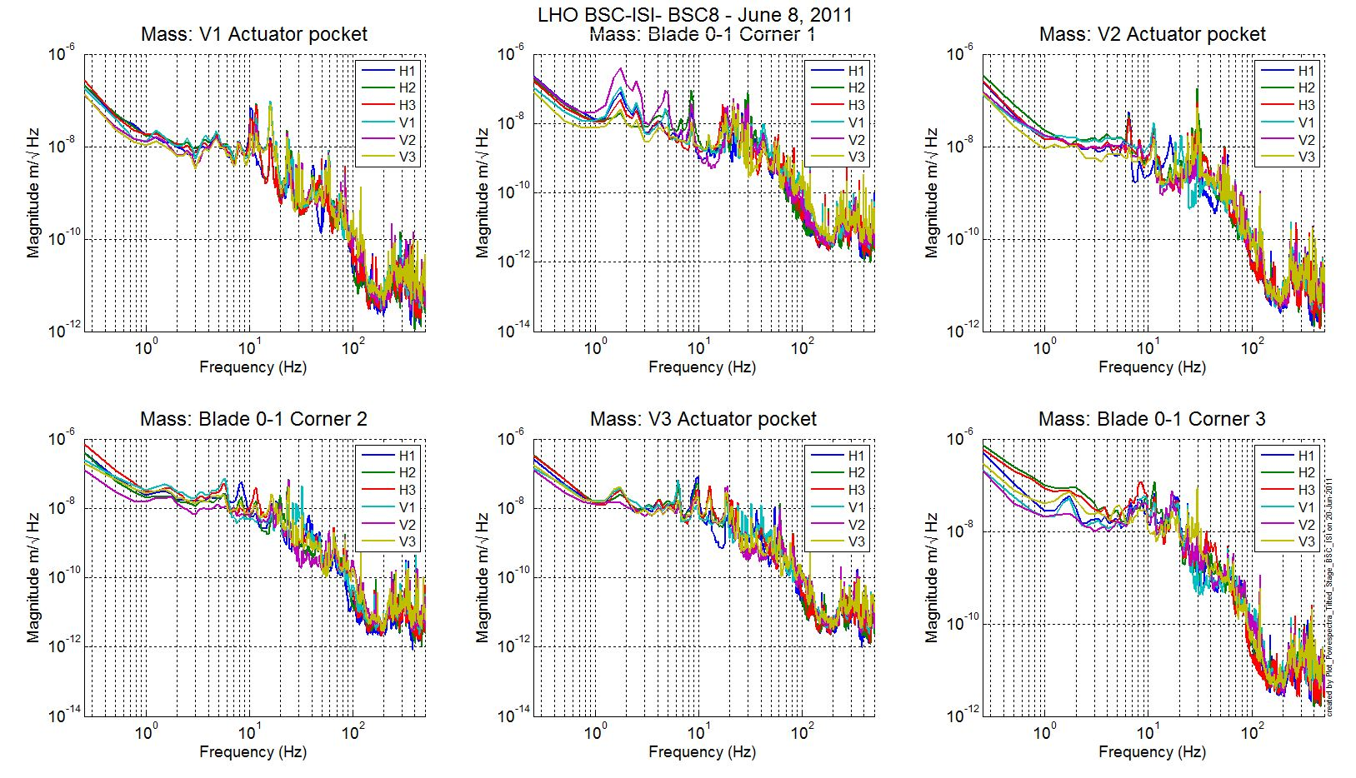
Figure 6 - ST1 L4C – Tilted

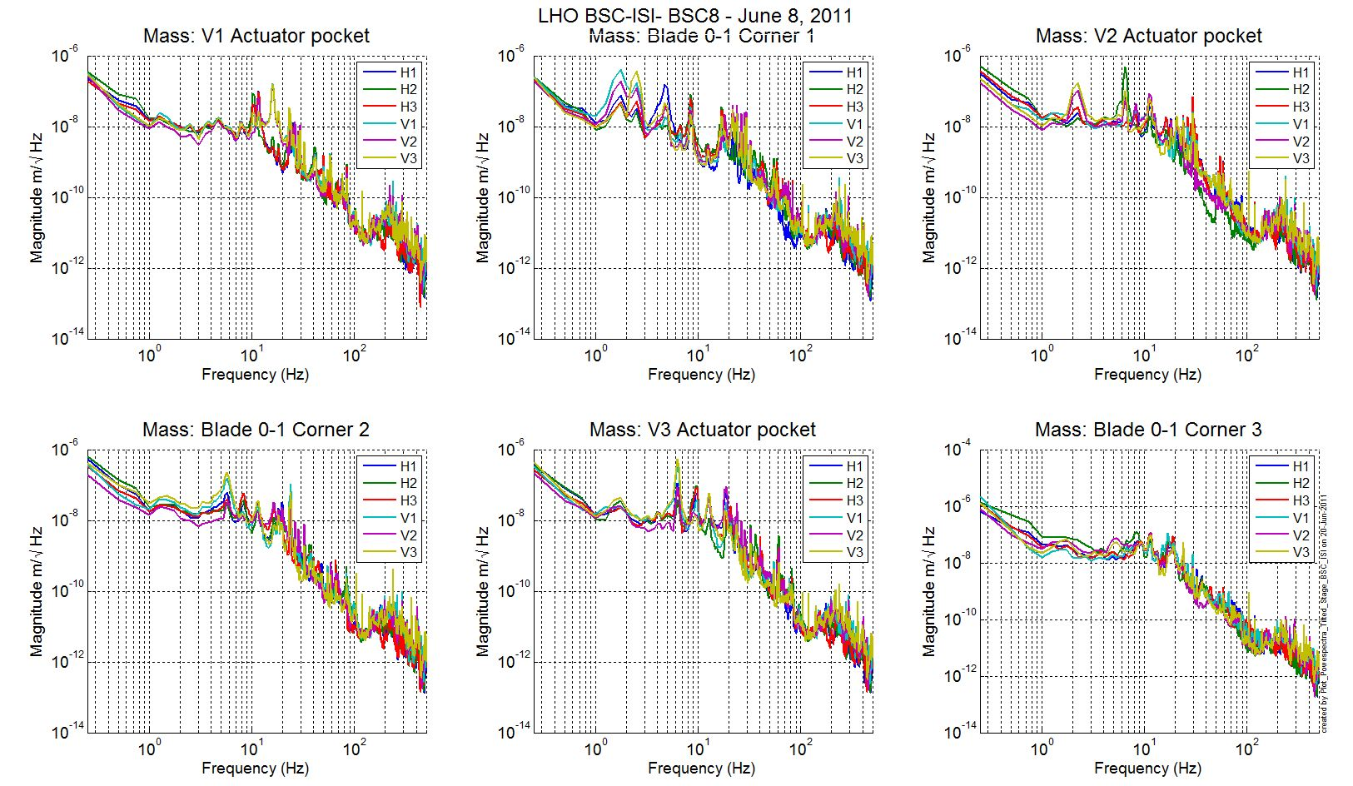
Figure 7 - ST1 GS13 – Tilted

Step 6 - Coil Driver, cabling and resistance check
Resistances of the couple actuator + cables are reported in the table below:

Actuator | Coil driver name | Resistance (Ω)
ST1 H1 | Coil1 Coarse 1 | 6.4
ST2 H1 | Coil 1 Fine 1 | 10.3
ST2 V1 | Coil 1 Fine 2 | 10.1
ST1 V1 | Coil 1 Coarse 2 | 6.4
ST1 H2 | Coil 2 Coarse 2 | 6.6
ST2 H2 | Coil 2 Fine 1 | 10.3
ST2 V2 | Coil 2 Fine 2 | 10.3
ST1 V2 | Coil 2 Coarse 2 | 6.6
ST1 H3 | Coil 3 Coarse 1 | 6.6
ST2 H3 | Coil 3 Fine 1 | 10.1
ST2 V3 | Coil 3 Fine 2 | 10.5
ST1 V3 | Coil 3 Coarse 2 | 6.6

Note: The in-air actuator cables are 16-gauge cables. The cables in the staging building are 10 meters long.

Acceptance criteria:

- For the actuators of stage 1, the measured resistance between the middle pin and one side pin must be 6.3 +/-0.5 ohms
- For the actuators of stage 2, the measured resistance between the middle pin and one side pin must be 10.3 +/-0.5 ohms
- Actuator neutral pins must be connected on pin #1 (left side pin of the plug)
- Actuator drive pins must be connected on pin #2 (middle pin of the plug)
- Actuator ground shield pins must be connected on pin #3 (right pin of the plug)
- All LEDs on the coil driver front panel must be green the binary input bit must be in the upper state.

Note: The coil drivers have been fixed such that the read back bit is in a upper state when the coil driver is working properly (upper state when everything is fine).

Test result: Passed: X Failed: .

Step 7- Actuators Sign and range of motion (Local drive)

Step 7.1 - Actuators sign
Test result: Passed: X Failed: .

Step 7.2 - Range of motion - Local drive
In this step, range of motion of the two stages is checked when applying a local drive (30000 counts) on actuators.

Sensor readout (counts) | Negative drive | no drive | Positive drive | Amplitude count | mil
ST1 - H1 | -16724 | 468 | 16130 | 32854 | 39
ST1 - H2 | -15639 | 269 | 17089 | 32728 | 39
ST1 - H3 | -16397 | 1703 | 15693 | 32089 | 38
ST1 - V1 | -14874 | 400 | 15665 | 30539 | 36
ST1 - V2 | -14181 | 743 | 15635 | 29815 | 35
ST1 - V3 | -14244 | 436 | 15122 | 29366 | 35
ST2 - H1 | -7819 | 2493 | 12795 | 20614 | 6
ST2 - H2 | -8111 | 2058 | 12252 | 20363 | 6
ST2 - H3 | -6411 | 3654 | 13704 | 20115 | 6
ST2 - V1 | -13874 | -1145 | 11540 | 25414 | 8
ST2 - V2 | -12416 | 6 | 12376 | 24791 | 7
ST2 - V3 | -12108 | 440 | 12987 | 25095 | 7
Table 13 - Range of motion - Local drive

Acceptance criteria:
- Amplitude must be at least 32000 counts (+/-0.02”) for Stage 1 CPS
- Amplitude must be at least 32000 counts (~0.010”) for Stage 2 CPS
- Signs of actuators drive and sensors read out have to be the same

Note: The motion of the platform can be computed. For a 30000 counts drive in the +Z direction, the platform should move by 12.6 mil on stage 1 and 3.6mil on stage 2. We observed this range of motion on stage 2 but not on stage 1. The discrepancies between the calculation and the measurements are currently under investigations.

In the Cartesian basis, the platform should move (calcultaion) by:
Stage 1 - Platform move for 32K counts drive: | 12.63 | mil
Stage 2 - Platform move for 32K counts drive: | 3.59 | mil

Test result: Passed: Failed: X .

Step 8 - Vertical Sensor Calibration
This test is inaccurate due to the important hysteresis introduced by the dial indicators. Moreover, the sensors calibrations have been checked at LASTI. This test will be probably suppressed in the future.

A quick test has been done on the vertical sensors of stage 2 using a 15 Kg load (stage 1 locked and stage 2 unlocked – Dial indicators installed between stage 0 and stage 2). The platform moves downward by ~9mils+/-0.75mil .

ST1 locked - ST2 unlocked |  | No load | Load | Diff
3x5Kg | V1 | 59 | -27014 | -27073
 | V2 | 1306 | -26257 | -27563
 | V3 | 1262 | -26202 | -27464
 |  |  |  | -27367 | counts
Stage 2 CPS calibration measurement : 3040count/mil +/-200cout/mil
Stage 2 CPS nominal calibration: 3330count/mil

Test Failure mitigation:
The test is not realized in a proper way to evaluate accurately the calibration of the vertical CPS.

Test result: Passed: Failed: X .

Step 9 - Vertical Spring Constant
This test is realized by loading the ISI when one stage is locked and using the capacitive position sensors as reference.

The stiffness measurements of the spring are reported in the tables below. The nominal blade stiffness are:
- Stage 1: 1241lb/in
- Stage 2: 1465lb/in

Blade Stage 0-1
Stage 1 is loaded with 3 x 7Kg masses and the measurements are repeated three times (by rotating the masses).

 |  |  | Unloaded |  |  |  |  |  | Loaded
Stage1 |  |  | Meas 1 | Meas 2 |  | Meas 3 |  | Average | Meas 1 | Meas 2 | Meas 3 | Average | Diff
V1 |  |  | 300 | 315 |  | 308 |  | 308 | -10579 | -10571 | -10638 | -10596 | -10904
V2 |  |  | 731 | 705 |  | 721 |  | 719 | -10079 | -10126 | -10094 | -10100 | -10819
V3 |  |  | 374 | 376 |  | 343 |  | 364 | -10576 | -10528 | -10505 | -10536 | -10901
 |  |  |  |  |  |  |  |  |  |  |  |  | -10874 | count
 |  |  |  |  |  |  |  |  |  |  |  |  | -13.07 | mil
 | Mass | 21133 |  |  | g
 |  | 46.59 |  |  | lb
 | K | 1188.65 |  |  | lb/in
 |  | -4.22 |  |  | %
The blades from stage 0 to stage 1 are too soft by 4.22%.

Blade Stage 1-2
Stage 1 is loaded with 3 x 5Kg masses and the measurements are repeated three times (by rotating the masses).

 |  | Unloaded |  |  |  |  |  | Loaded
Stage 2 |  | Meas 1 | Meas 2 | Meas 3 |  | Average |  | Meas 1 |  | Meas 2 | Meas 3 | Average | Diff
V1 |  | -1143 | -1187 | -1170 |  | -1167 |  | -27898 |  | -27921 | -27919 | -27913 | -26746
V2 |  | -110 | -75 | -120 |  | -102 |  | -27386 |  | -27328 | -27320 | -27345 | -27243
V3 |  | 377 | -120 | 324 |  | 194 |  | -26517 |  | -26468 | -26533 | -26506 | -26700
 |  |  |  |  |  |  |  |  |  |  |  |  | -26896 | count
 |  |  |  |  |  |  |  |  |  |  |  |  | -8.079 | mil
 | Mass |  |  |  | 15006 |  | g
 |  |  |  |  | 33.08 |  | lb
 | K |  |  |  | 1364.99 |  | lb/in
 |  |  |  |  | -6.83 |  | %
The blades from stage 1 to stage 2 are too soft by 6.83%.

Note:
A dirty assembly was build at LASTI for fit-check and testing purpose before the first assembly at LHO. During balancing, the total added mass on top of stage 2 to simulate the payload was far from nominal. Investigations on the blades stiffness showed an extra softness of the blade of both stages. But the mass deduction to compensate this extra softness didn’t explain the difference with the nominal payload. In order to be closer from the nominal payload, the angles of the blade spacers were corrected (correction equivalent to +253lb on stage 0-1 blade and +507lb on stage 1-2 blade). These discrepancies between the initial design and assembly can be explained by:
- Inaccuracy in Solidworks estimation. It might underestimate masses of actual components (metal parts, hardware, instruments...)
- Measurement errors of the blade stiffness
- Machining errors (launch angles, assembly stack up...)
- Extra compliance due to the stages deformation

Facts:
- Nominal load on Stage 0-1 blades is 8240 lb (per initial design estimation)
- -4.2% of 8240 lb is -346 lb.
- +253 lb are compensated per ST1 - launch angle correction (E1100284, line 9)
- So we should be at +253-346= -93 lb under nominal (-42 kg).

Comparison with mass budget:
We estimate we are 392 lb (177 kg) under nominal (-162 lb on Stage 1, -230 lb on stage 2) (see Section II - Step 10)

Conclusion: There is a difference between the mass budget estimated using the blade stiffness measurement (-42 kg) and the mass budget using the actual balancing values (-177 kg) .

Test result: Passed: X Failed: .

Step 10 - Static Testing (Tests in the local basis)
The table below shows the main and the cross-coupling when the actuators are driven in the local basis:

The static tests results are reported in the SVN at :
/seismic/BSC-ISI/X1/Data/BSC8/Static_Tests/
- LHO_BSC8_Offset_Local_Drive_20110624.mat

 |  | Sensors
 |  | ST1 - H1 | ST1 - H2 | ST1 - H3 | ST1 - V1 | ST1 - V2 | ST1 - V3
Actuators | ST1 - H1 | 4462 | 1780 | 1794 | 29 | -11 | -6
Actuators | ST1 - H2 | 1755 | 4327 | 1752 | -8 | 18 | 7
Actuators | ST1 - H3 | 1734 | 1727 | 4305 | 2 | -12 | 29
Actuators | ST1 - V1 | 79 | -163 | 109 | 3587 | -665 | -637
Actuators | ST1 - V2 | 94 | 34 | -176 | -625 | 3503 | -648
Actuators | ST1 - V3 | -169 | 93 | 31 | -639 | -601 | 3460
Table 14 - Static test - Local to local - Stage 1

 |  | Sensors
 |  | ST2 - H1 | ST2 - H2 | ST2 - H3 | ST2 - V1 | ST2 - V2 | ST2 - V3
Actuators | ST2 - H1 | 2425 | 372 | 371 | 18 | 8 | 36
Actuators | ST2 - H2 | 363 | 2401 | 373 | 27 | 10 | -19
Actuators | ST2 - H3 | 364 | 358 | 2377 | -4 | 18 | 18
Actuators | ST2 - V1 | 79 | 136 | -203 | 3013 | 349 | -28
Actuators | ST2 - V2 | -206 | 76 | 127 | -33 | 2937 | 333
Actuators | ST2 - V3 | 135 | -215 | 97 | 331 | -2 | 2960
Table 15 - Static test - Local to local - Stage 2

Acceptance criteria:

- Main couplings readout must be positive
- Comparison with the reference tables:
  - Main coupling differences mustn’t exceed 200 counts
  - Cross coupling differences mustn’t exceed 50 counts

Reference tables for acceptance criteria:

 |  | Sensors
 |  | ST1 - H1 | ST1 - H2 | ST1 - H3 | ST1 - V1 | ST1 - V2 | ST1 - V3
Actuators | ST1 - H1 | 4380 | 1750 | 1750 | 0 | 0 | 0
Actuators | ST1 - H2 | 1750 | 4380 | 1750 | 0 | 0 | 0
Actuators | ST1 - H3 | 1750 | 1750 | 4380 | 0 | 0 | 0
Actuators | ST1 - V1 | 50 | -170 | 90 | 3500 | -650 | -650
Actuators | ST1 - V2 | 90 | 50 | -170 | -650 | 3500 | -650
Actuators | ST1 - V3 | -170 | 90 | 50 | -650 | -601 | 3500
Table - Main couplings – Static – Stage 1

 |  | Sensors
 |  | ST2 - H1 | ST2 - H2 | ST2 - H3 | ST2 - V1 | ST2 - V2 | ST2 - V3
Actuators | ST2 - H1 | 240 | 360 | 360 | 0 | 0 | 0
Actuators | ST2 - H2 | 360 | 2401 | 360 | 0 | 0 | 0
Actuators | ST2 - H3 | 360 | 360 | 2377 | 0 | 0 | 0
Actuators | ST2 - V1 | 80 | 130 | -200 | 3050 | 330 | 0
Actuators | ST2 - V2 | -200 | 800 | 130 | 0 | 2950 | 330
Actuators | ST2 - V3 | 130 | -200 | 80 | 330 | 0 | 2950
Table - Main couplings – Static – Stage 2

Test result: Passed: X Failed: .

Step 11- Static Testing - In the general coordinate basis (Static test - CPS)

Step 11.1 – Change of basis matrices from Cartesian to Local
The table below shows the main and the cross-coupling when the actuators are driven in the Cartesian basis:

The static tests results are reported in the SVN at :
/seismic/BSC-ISI/X1/Data/BSC8/Static_Tests/
- LHO_BSC8_Cartesian_Local_Drive_20110624.mat

 |  | Sensors
 |  | ST1 - H1 | ST1 - H2 | ST1 - H3 | ST1 - V1 | ST1 - V2 | ST1 - V3
Actuators | ST1 - X | 1803 | -829 | -818 | 23 | -8 | -11
Actuators | ST1 - Y | -30 | 1522 | -1484 | -4 | 18 | -9
Actuators | ST1 - Z | -10 | -5 | -18 | 772 | 752 | 727
Actuators | ST1 - RX | -21 | 157 | -170 | -2949 | 2469 | 452
Actuators | ST1 - RY | -209 | 111 | 69 | -1167 | -1890 | 3068
Actuators | ST1 - RZ | 3230 | 3197 | 3195 | 18 | 23 | 27
 |  | Sensors
 |  | ST2 - H1 | ST2 - H2 | ST2 - H3 | ST2 - V1 | ST2 - V2 | ST2 - V3
Actuators | ST2 - X | 716 | -1342 | 676 | 31 | 15 | 44
Actuators | ST2 - Y | 1198 | 18 | -1153 | 42 | 10 | 15
Actuators | ST2 - Z | -3 | 6 | 14 | 1133 | 1135 | 1104
Actuators | ST2 - RX | -277 | 2 | 288 | -2523 | 2574 | -49
Actuators | ST2 - RY | 200 | -313 | 189 | -1514 | -1410 | 2972
Actuators | ST2 - RZ | 1797 | 1822 | 1792 | 46 | 7 | 37
Table 16 - Static test cartesian drive – Cartesian to local

Reference table static test Cartesian to local:

 |  | Sensors
 |  | ST1 - H1 | ST1 - H2 | ST1 - H3 | ST1 - V1 | ST1 - V2 | ST1 - V3
Actuators | ST1 - X | 1800 | -820 | -820 | 0 | 0 | 0
Actuators | ST1 - Y | 0 | 1500 | -1500 | 0 | 0 | 0
Actuators | ST1 - Z | 0 | 0 | 0 | 772 | 750 | 700
Actuators | ST1 - RX | 0 | 160 | -160 | -2950 | 2450 | 450
Actuators | ST1 - RY | -200 | 110 | 70 | -1150 | -2000 | 3050
Actuators | ST1 - RZ | 3200 | 3200 | 3200 | 0 | 0 | 0
Table 17 - Reference table - Cartesian to Local - Stage 1

 |  | Sensors
 |  | ST2 - H1 | ST2 - H2 | ST2 - H3 | ST2 - V1 | ST2 - V2 | ST2 - V3
Actuators | ST2 - X | 700 | -1350 | 650 | 0 | 0 | 0
Actuators | ST2 - Y | 1200 | 0 | -1150 | 0 | 0 | 0
Actuators | ST2 - Z | 0 | 0 | 0 | 1100 | 1100 | 1100
Actuators | ST2 - RX | -300 | 0 | 300 | -2500 | 2500 | -50
Actuators | ST2 - RY | 200 | -300 | 200 | -1500 | -1400 | 3000
Actuators | ST2 - RZ | 1800 | 1800 | 1800 | 40 | 40 | 40
Table 18 - Reference table - Cartesian to Local - Stage 2

Acceptance criteria:

- Comparison with the reference tables:
  - Differences mustn’t exceed 100 counts

Test result: Passed: X Failed: .

Step 11.2 – Base change matrices from Cartesian to Cartesian
The static tests results are reported in the SVN at :
/seismic/BSC-ISI/X1/Data/BSC8/Static_Tests/
- LHO_BSC8_Cartesian _Local_Drive_20110624.mat

 |  | Sensors
 |  | ST1 - X | ST1 - Y | ST1 - Z | ST1 - RY | ST1 - RY | ST1 - RZ
Actuators | ST1 - X | 1744 | -4 | 6 | -11 | -10 | 59
Actuators | ST1 - Y | 3 | 1720 | 11 | 10 | -15 | 16
Actuators | ST1 - Z | 6 | 7 | 753 | -25 | -27 | -4
Actuators | ST1 - RX | -6 | 375 | -15 | 3058 | 7 | -9
Actuators | ST1 - RY | -380 | 4 | 5 | 17 | 2987 | -2
Actuators | ST1 - RZ | 2 | 2 | 16 | 2 | -2 | 3330
 |  | Sensors
 |  | ST2 - X | ST2 - Y | ST2 - Z | ST2 - RY | ST2 - RY | ST2 - RZ
Actuators | ST2 - X | 1356 | 12 | 29 | -5 | 24 | 13
Actuators | ST2 - Y | -10 | 1358 | 20 | -26 | -6 | 34
Actuators | ST2 - Z | 0 | 2 | 1114 | -12 | -33 | 14
Actuators | ST2 - RX | 8 | -14 | 22 | 4306 | 31 | 13
Actuators | ST2 - RY | 27 | 2 | 30 | 38 | 4319 | 24
Actuators | ST2 - RZ | -1 | 9 | 29 | -26 | -17 | 2602
Table 19 - Static Test - Cartesian to Cartesian

Reference table static test Cartesian to Cartesian:

 |  | Sensors
 |  | ST1 - X | ST1 - Y | ST1 - Z | ST1 - RY | ST1 - RY | ST1 - RZ
Actuators | ST1 - X | 1750 | 0 | 0 | 0 | 0 | 0
Actuators | ST1 - Y | 0 | 1750 | 0 | 0 | 0 | 0
Actuators | ST1 - Z | 0 | 0 | 750 | 0 | 0 | 0
Actuators | ST1 - RX | 0 | 375 | 0 | 3000 | 0 | 0
Actuators | ST1 - RY | -375 | 0 | 0 | 0 | 3000 | 0
Actuators | ST1 - RZ | 0 | 0 | 0 | 0 | 0 | 3300
 |  | Sensors
 |  | ST2 - X | ST2 - Y | ST2 - Z | ST2 - RY | ST2 - RY | ST2 - RZ
Actuators | ST2 - X | 1350 | 10 | 30 | 0 | 25 | 20
Actuators | ST2 - Y | -10 | 1350 | 20 | -25 | 0 | 20
Actuators | ST2 - Z | 0 | 0 | 1100 | -10 | -30 | 20
Actuators | ST2 - RX | 10 | -15 | 20 | 4300 | 30 | 20
Actuators | ST2 - RY | 30 | 0 | 30 | 40 | 4300 | 20
Actuators | ST2 - RZ | 0 | 10 | 30 | -25 | -15 | 2600

Acceptance criteria:

- Main couplings readout must be positive
- Comparison with the reference tables:
  - Main coupling differences mustn’t exceed 200 counts
  - Cross coupling differences mustn’t exceed 50 counts

Test result: Passed: X Failed: .

Step 12 - Linearity test
The linearity test figure are reported in the SVN at :
/seismic/BSC-ISI/X1/Data/BSC8/Figures/Linearity_Test/
- LHO_BSC8_Linearity_Test_2011_06_22.fig

Note 1: In the top right figure, there are significant offsets on the stage 1 vertical capacitive position sensors. For this linearity test, masses (used for the blades stiffness measurements) have been left on stage 1.

Note 2: In the bottom right figure, the quality of the measurement (ST2-V2) is not as good as the other measurements. This measurement is the only one done during the day. The output gain was set to 0 during the night/quiet measurements.

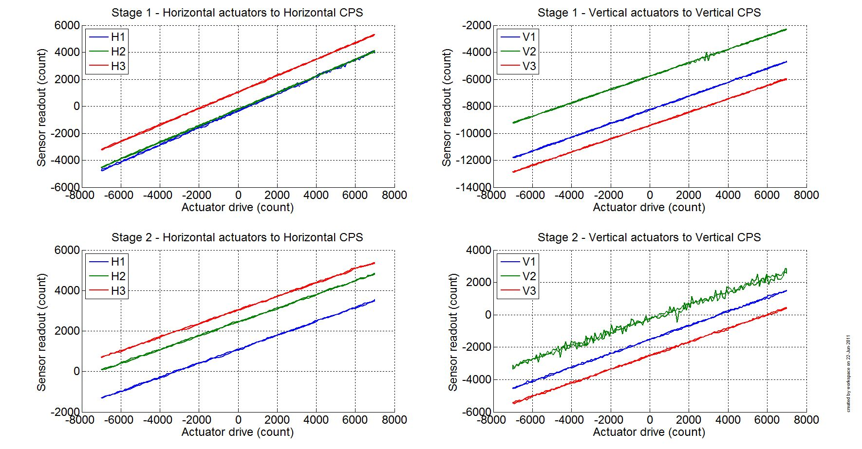
Figure 8 - Linearity Test

Slope – Offset:

 |  | Slope | Offset | Average slope | Variation from  average(%)
Stage 1 | ST1 - H1 | 0.637 | 513 | 0.6228 | 2.21
Stage 1 | ST1 - H2 | 0.618 | 343 | 0.6228 | -0.75
Stage 1 | ST1 - H3 | 0.614 | 1774 | 0.6228 | -1.46
Stage 1 | ST1 - V1 | 0.512 | 576 | 0.5010 | 2.10
Stage 1 | ST1 - V2 | 0.499 | 922 | 0.5010 | -0.36
Stage 1 | ST1 - V3 | 0.492 | 594 | 0.5010 | -1.74
Stage 2 | ST2 - H1 | 0.346 | 2557 | 0.3423 | 1.20
Stage 2 | ST2 - H2 | 0.343 | 2136 | 0.3423 | 0.05
Stage 2 | ST2 - H3 | 0.338 | 3776 | 0.3423 | -1.25
Stage 2 | ST2 - V1 | 0.428 | -846 | 0.4217 | 1.53
Stage 2 | ST2 - V2 | 0.416 | 310 | 0.4217 | -1.25
Stage 2 | ST2 - V3 | 0.420 | 693 | 0.4217 | -0.29
Table - Slopes and offset of the triplet Actuators - BSC-ISI - Sensors

Acceptance criteria:

- Horizontal and vertical slopes of the triplet actuators x BSC-ISI x sensors: Average slope +/- 3%

Test result: Passed: X Failed: .

Step 13 – Transfer functions – Local to Local
Data files measurement of local to local transfer functions in SVN at:
/svncommon/seisvn/seismic/BSC-ISI/X1//Data/BSC8/Transfer_Functions/Measurements/Undamped
- LHO_ISI_BSC8_Data_L2L_10mHz_100mHz_ST1_ST2_20110622-082015.mat
- LHO_ISI_BSC8_Data_L2L_100mHz_1Hz_ST1_ST2_20110622-040646.mat
- LHO_ISI_BSC8_Data_L2L_1Hz_10Hz_ST1_ST2_20110621-225529.mat
- LHO_ISI_BSC8_Data_L2L_10Hz_100Hz_ST1_ST2_20110621-210815.mat
- LHO_ISI_BSC8_Data_L2L_100Hz_500Hz_ST1_ST2_20110622-182052.mat

Script file for processing and plotting local to local transfer functions in SVN at:
/seisvn/seismic/BSC-ISI/X1/Data/BSC8/Transfer_Functions/Measurements/Undamped
- Plot_ TF_L2L_10mHz_1000Hz_LHO_BSC8.m

Figures of local to local transfer functions (Main couplings) in SVN at:
seisvn/seismic/BSCISI/X1/Data/BSC8/Figures/Transfer_Functions/Measurements/Undamped
- LHO_BSC8_TF_L2L_Raw_from_ST1_ACT_to_ST1_CPS_2011_06_22.fig
- LHO_BSC8_TF_L2L_Raw_from_ST1_ACT_to_ST1_CPS_2011_06_22.fig
- LHO_BSC8_TF_L2L_Raw_from_ST2_ACT_to_ST2_CPS_2011_06_22.fig
- LHO_BSC8_TF_L2L_Raw_from_ST2_ACT_to_ST2_GS13_2011_06_22.fig

Measured of local to local transfer functions in the SVN at:
/svncommon/seisvn/seismic/BSC-ISI/X1//Data/BSC8/Transfer_Functions/Measurements/Undamped
- LHO_BSC8_TF_L2L _Raw_10mHz_1000Hz_2011_06_22.mat

Note 1: The transfer functions are measured from the Output filter bank (excitation variable) to the input (IN1) of the input filter bank. The transfer functions presented below are raw transfer functions without any electronic compensation of the sensor electronic. The actuator and the coil driver electronic compensation are introduced in these transfer functions.

Note 2: The L4Cs are out of phase (should be -90 before 1Hz). A minus sign is added in the calibration filters that convert count to nm/s.

Note 3: The resonance observed at 33Hz is the resonance of the teststand. When the transfer functions will be measured in the LVEA, this resonance will be observed at lower frequency (19Hz). The staging building teststand has short feet in comparison with the LVEA teststand (some comparison plots will be presented the testing report – phase II).

Note 4: The first high frequency resonance observed on stage 1 by the L4C is at 214Hz. The next resonance is observed at 255Hz. The first mode of the blade has been measured at ~250Hz at LASTI.

Note 5: There is a poor coherence on the GS13 transfer functions. It can be explained by the weak drive of the fine actuators. Moreover, the stage 2 of the ISI is strongly excited by the fans of the clean rooms. These two factors strongly affect the quality of the measurements.

Note 6: On the ST2-ACT to ST2-GS13 transfer functions, the first high frequency resonances are observed at 150Hz and 185Hz.

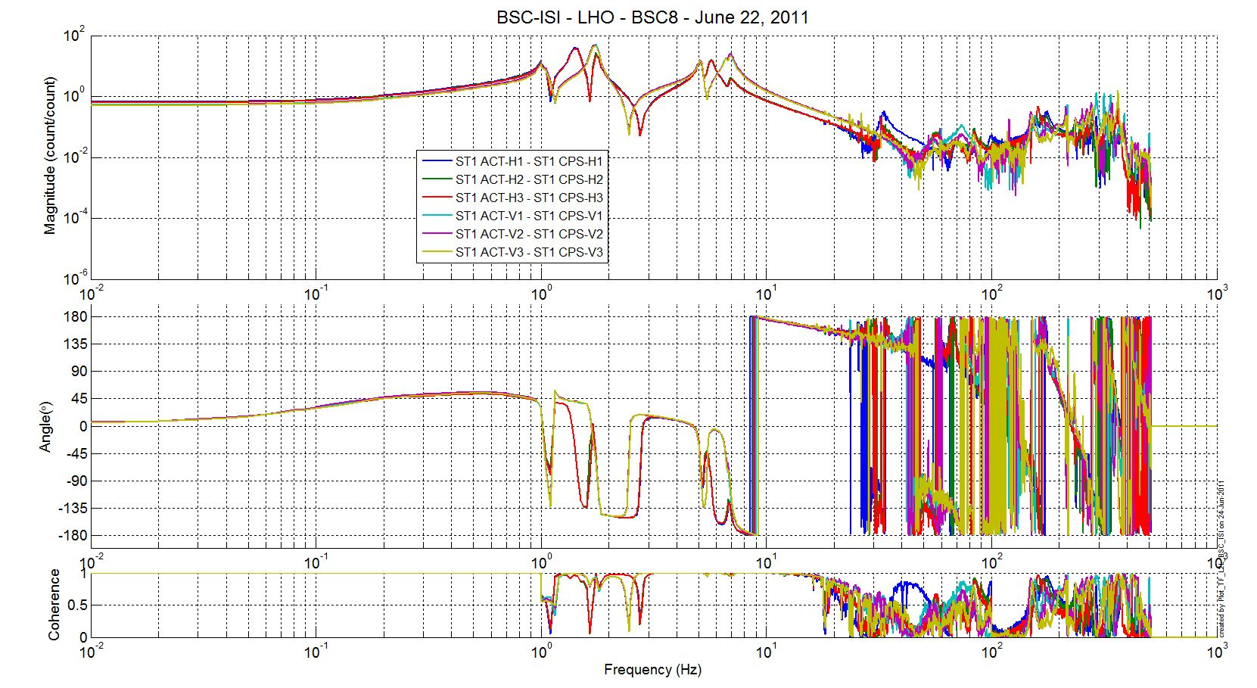
Figure 9 - TF L2L Raw - ST1 Act to ST1 CPS

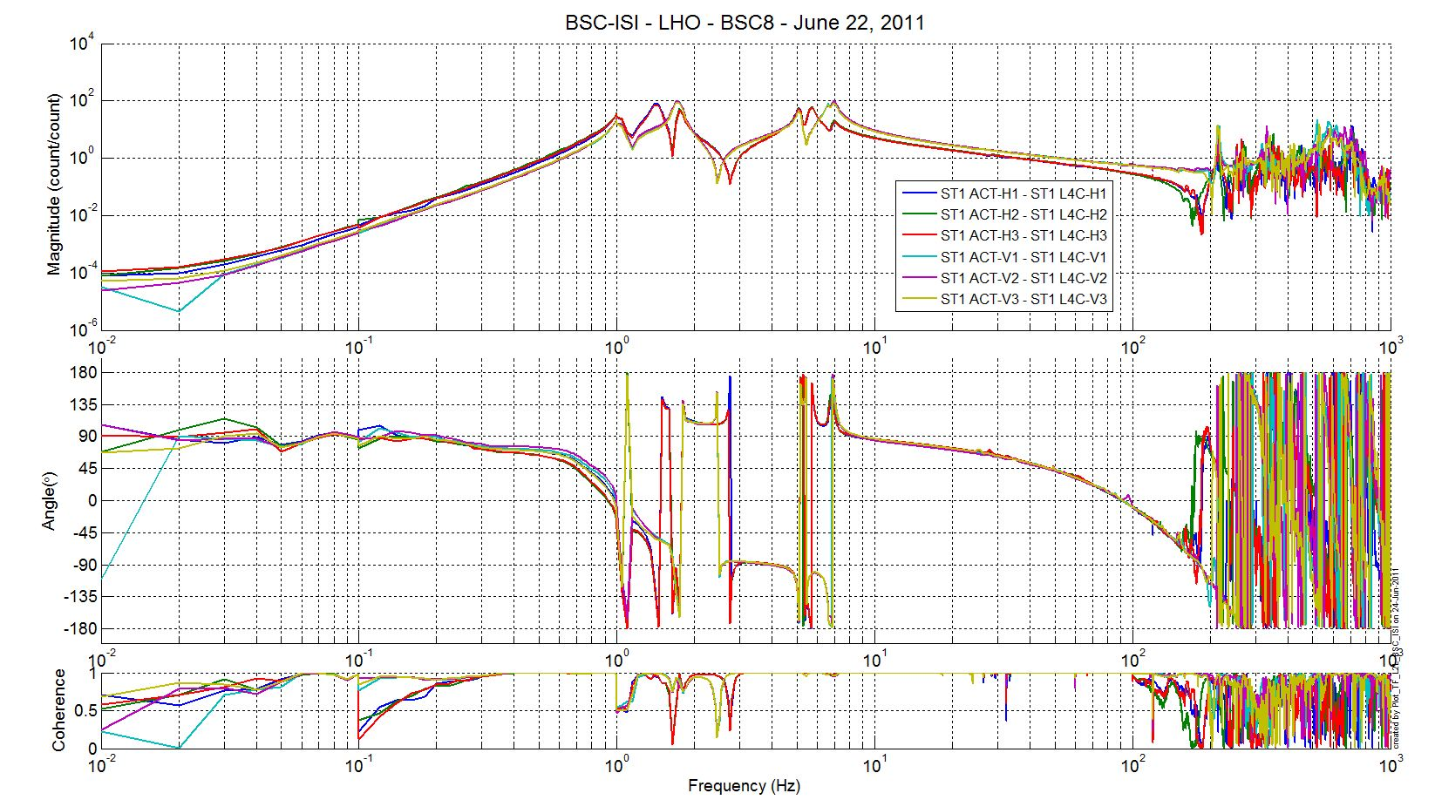
Figure 10 - TF L2L Raw - ST1 Act to ST1 L4C

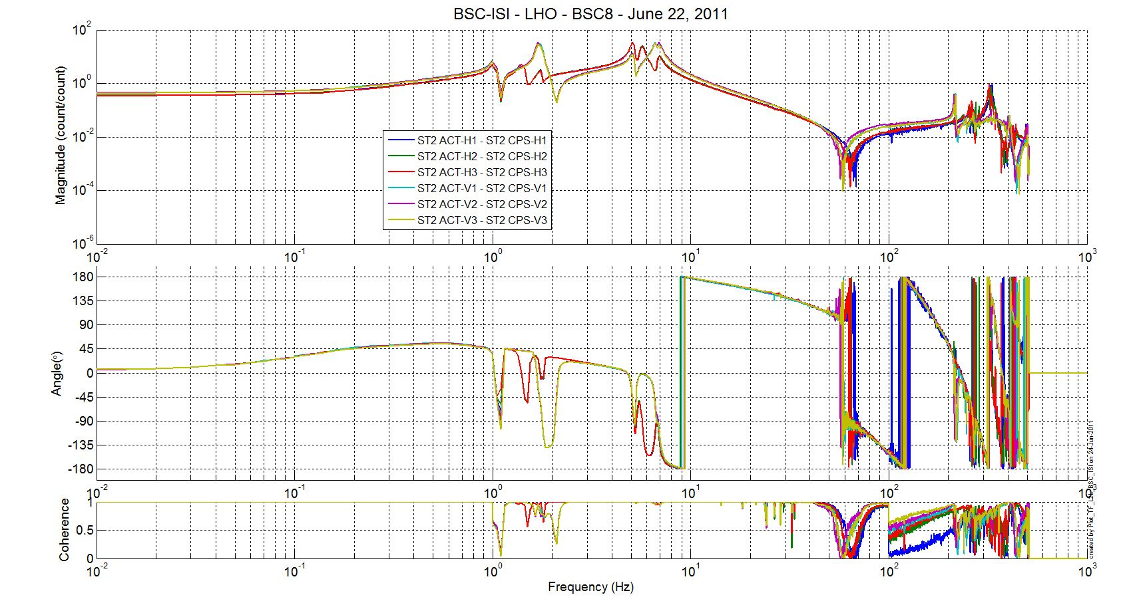
Figure 11 - TF L2L Raw - ST2 Act to ST2 CPS

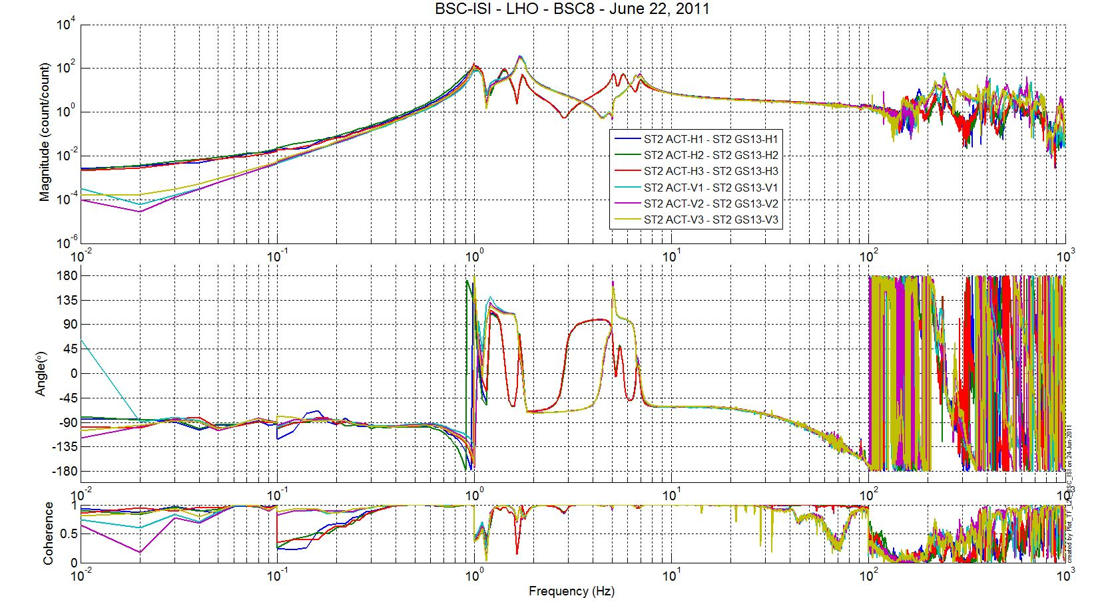
Figure 12 - TF L2L Raw - ST2 Act to ST1 GS13

Test result: Passed: X Failed: .

Due to schedule pressure, it was decided it was reasonable to postpone the following tests. They will be performed during Phase II.

Step 14 - Symmetrization – Calibration
Not performed

Test result: Passed: X Failed: .

Step 15 – Change of base – Cartesian to Local - Simulations
Not performed

Step 16- Transfer functions - Cartesian to Cartesian - Measurements
Not performed

Step 17 - Lower Zero Moment Plan

Step 17.1 - Stage 1 - LZMP
Not performed

Step 17.2 - Stage 2 - LZMP
Not performed

Step 18- Damping Loops – Transfer function – Simulations

Step 18.1 - Damping Loops – Stage 2
Not performed

Step 18.2 - Damping Loops – Stage 1
Not performed

Step 19- Damping Loops – Powerspectra
Not performed

Step 20- Isolation Loops – for one unit per site
Not performed

BSC-ISI testing Summary
This is the first “aLigo BSC-ISI” tested with the “aLigo electronic”. The testing procedure document E1000483-v3 was used. Tests were done from June 15 to June 24, 2011.

Due to lack of time, some tests have been postponed or waived. Moreover due to few sensors issues, some results are incomplete but sufficient to consider the ISI properly assembled. Tests will be redone during testing phase II.

The ISI-BSC8 is officially validated per the tests presented in the report. All results are posted on the SVN at:
https://svn.ligo.caltech.edu/svn/seismic/BSC-ISI/X1/Data/BSC8/

FAILED AND WAIVED TESTS

- List of tests that failed and won’t be redone
- Step I.11 – Lockers adjustment – No value has been recorded during the locker adjustments. Measurements using the CPS sensors when the stages are locked and unlocked have been done Step III.2.

- List of tests that failed, that need to be re-done during phase 2
- Step I.1 – CPS Test and calibration – CPS sensors with the bad flux will be changed during phase 2
- Step I.2 – GS13 – Inspection/Assembly – One of the seismometers was not functioning when it arrived on site. It will be replaced during phase 2-testing.
- Step I.4 – T240 – Inspection/Assembly – One of the seismometers was not functioning when it arrived on site. It will be replaced during phase 2-testing.
- Step I.12 – Cables inventory – The cables used for testing are class B cables. Cables will be swapped by class A ones during phase 2 - testing.
- Step I.13 – Cable routing - The GS13 cables are going from stage 2 to stage 1 without being clamped on stage 1.
- Step II.1 – Geohones pressure readout - Pressure sensors of 2 T240 are not working.
- Step II.7 – Range of motion – Local drive - The discrepancies between the calculation and the measurements are currently under investigations.

- List of tests skipped that won't be performed because not feasable during phase II (i.e. stage 0 leveling)
- Step I.5 – Check level of Stage 0 after top-bottom plate assembly

- List of tests skipped that we won't do because they are not essential (i.e. redundant with another test)
- Step II.3 – Measure the Sensor gap - This test was not performed. The sensor gaps have not been measured. These sensors have already been checked at LASTI. Moreover, risks of scratching the target are so high that we preferred not performing this test. In the future, this test will be removed from the testing procedure.
- Step II.4.1 – Push “in the general coordinate Z/RZ” - This test was not performed due to lack of time. This test is redundant with step 4.2.

- Step II.8 – Vertical sensor calibration - The test is not realized in a proper way to evaluate accurately the calibration of the vertical CPS.

- Lists of tests skipped that needs to be done during phase II.
- Step II.14 – Symmetrization – Calibration
- Step II.15 – Change of bases – Cartesian to local - Simulations
- Step II.16 – Transfer functions – Cartesian to Cartesian - Simulations
- Step II.17 – Lower Zero Moment Plan
- Step II.18.1 – Damping Loops – Stage 2
- Step II.18.2 – Damping Loops – Stage 1
- Step II.19 – Damping loops – Powerspectra
- Step II.20 – Isolation loops

The ISI-BSC8 was moved from the Staging building to the LVEA test stand on July 30, 2011.

