Loosen these two screws Slide the two slots on the top of the Power Board

under them, and retighten.

Plug 10-pin IDC in the 6-32 screws go through this hole, into

threaded PEM

Connector that’s here:

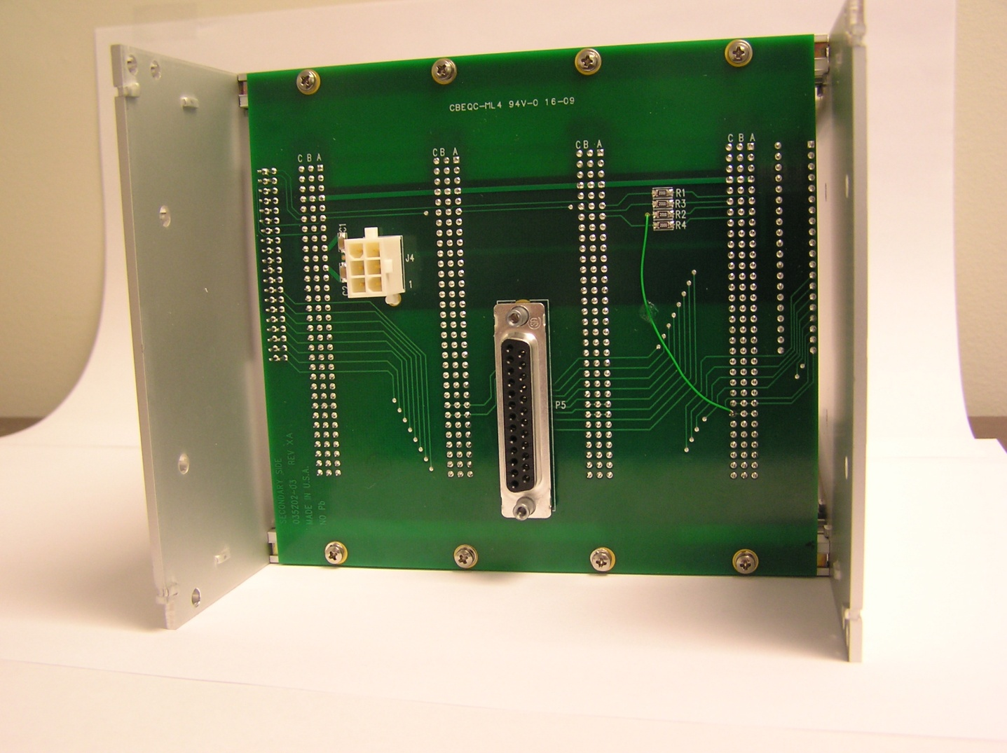

6-32 screw

goes through

this hole

Power plugs in here: Signals come out here: (pinout is attached).