LIGO Laboratory / LIGO Scientific Collaboration

LIGO-T1100044-v19 Advanced LIGO December 15, 2011

Photon Calibrator Design Requirements

Jonathan Berliner, Rick Savage

Distribution of this document:
LIGO Scientific Collaboration

This is an internal working note
of the LIGO Laboratory.

California Institute of Technology  LIGO Project – MS 18-34  1200 E. California Blvd.  Pasadena, CA 91125  Phone (626) 395-2129  Fax (626) 304-9834  E-mail: info@ligo.caltech.edu | Massachusetts Institute of Technology  LIGO Project – NW22-295  185 Albany St  Cambridge, MA 02139  Phone (617) 253-4824  Fax (617) 253-7014  E-mail: info@ligo.mit.edu
LIGO Hanford Observatory  P.O. Box 159  Richland WA 99352  Phone 509-372-8106  Fax 509-372-8137 | LIGO Livingston Observatory  P.O. Box 940  Livingston, LA 70754  Phone 225-686-3100  Fax 225-686-7189
http://www.ligo.caltech.edu/

Table 1 – Reference Documents Cited in Document
DCC references in italics refer to external documents.
Title | LIGO-DCC#:
aLIGO Calibration White Paper | T1100122
Calibration in the Advanced Detector Era | G1000274
Optimal calibration accuracy for gravitational-wave detectors | PRD-Aug 2009
Advanced LIGO Anticipated Sensitivity Curves | T0900288

Introduction
This document defines the requirements and subsystem interfaces of the aLIGO Photon Calibrator (Pcal) subsystem. Pcal induces reference displacements of the End Test Masses (ETMs), which can be used to calibrate the interferometer length response and timing. Pcal can also be used to assess the stability of the electro-static drive (ESD) actuators of the ETMs. Pcal is capable of inducing several simultaneous sinusoidally-modulated displacements with SNRs indicated in Table 2 on page 3.

Scope
The Pcal subsystem includes the hardware necessary to induce reference displacements of the ETMs that can be used for calibrating the LIGO interferometers and ETM actuators. It includes absolute power calibration such that the required accuracy can be achieved. Each arm of each interferometer includes a Pcal system. Each system includes a transmitter pylon, laser, acousto-optic modulator for power modulation, power sensors, opto-mechanical components, enclosures, and associated electronics. Each system also includes in-vacuum periscopes to direct the beams to the ETM, minimizing interference with baffles that are part of the Stray Light Control (SLC) subsystem, and directing the beams that are reflected from the ETMs to receiver modules that are mounted in the Optical Lever receiver pylons.
The Pcal subsystem includes cameras and analysis software necessary for precise beam localization on the ETM surfaces. It also includes the facilities necessary to transfer the absolute power calibration from a Gold standard that is calibrated at the National Institute of Standards in Boulder, CO to Working standards that are used to calibrate the internal power sensors of each Pcal transmitter and receiver module.
The Pcal subsystem does not include the viewport windows, viewport window adapter flanges, and viewport protectors. Additionally, it does not include the Laser Emergency Stop system hardware or the Laser Access Control hardware that is external to the transmitter and receiver modules.

Performance Requirements

Accuracy of Induced Displacements
The amplitude of the sinusoidal radiation-induced displacements of the ETMs shall be accurate within 5% and 16µs over 2σ confidence intervals. This requirement considers a study conducted by Lee Lindblom on the optimal calibration accuracy required to detect a typical binary black-hole signal and a presentation by the LSC Calibration Committee on aLIGO calibration requirements (LIGO-G1000274).

Amplitude of Excitation Lines
Each Pcal shall operate continuously, simultaneously inducing periodic displacements of the ETMs at several frequencies. Table 2, below, indicates the required SNRs of Pcal’s calibration lines. These requirements apply to the “zero-detuning, high power” sensitivity curve (LIGO-T0900288).
Table 2 – Required Pcal Calibration Lines
Frequency | DFT length | Signal-to-Noise Ratio | Displacement (m_{rms}Hz^{-1/2})
50 Hz | 1 second | 20 | $$4.02×{10}^{-19}$$
350 - 450 Hz | 1 second | 20 | $$3.07×{10}^{-19}$$
1,000 – 1,200 Hz | 1 second | 20 | $$4.60×{10}^{-19}$$
1,900 – 2,100 Hz | 60 second | 10 | $$3.67×{10}^{-19}$$

Swept-Sine Measurements
Pcal shall be capable of performing swept-sine measurements of the interferometer length response from 10 Hz to 1 kHz in less than 1 hour with coherence of 99% or better using CDS software.

UTC Synchronization
All excitations shall be independently and directly synchronized to UTC via GPS.

Reliability
Mean Time Between Failure for out-of-vacuum components, including lasers and electronics, shall be at least 10,000 hours. Pcal does not have active in-chamber components.

Displacement Noise (ISC)
Amplitude spectral displacement noise from Pcal, other than intentional reference displacements, shall not exceed 10% of the design sensitivity of the interferometer (“zero-detuning, high power” curve, LIGO-T0900288).

Interfaces

Location of Receiver Pylons (AOS Optical Levers)
The Pcal receiver modules will be mounted within the Optical Lever receiver pylons. The location of the Pcal receiver module mounting surface (part of the Optical Lever receiver pylon) with respect to the center of the ConFlat flange for the Pcal receiver beam will have a tolerance of ±⅛” in both the vertical and lateral dimensions.
Normal operation and regular work within the Pcal receiver module shall not disrupt operation of the Optical Lever during science mode, misalign the Optical Lever beam, or contribute angular instability to the support structure.

Vacuum Manifold (VE)
The periscopes within the vacuum manifold will be held in place by aluminum compression rings which are expanded against the cylindrical walls of the vacuum manifold.

End Station VEA – Stay-Clear Zones (SYS, VE)
The Pcal transmitter pylons will be bolted and grouted to the floor of the VEAs. Stay-clear zones are approximately 36” in front and 18” on both sides of the transmitter module. The pylon locations are shown in Figure 1.
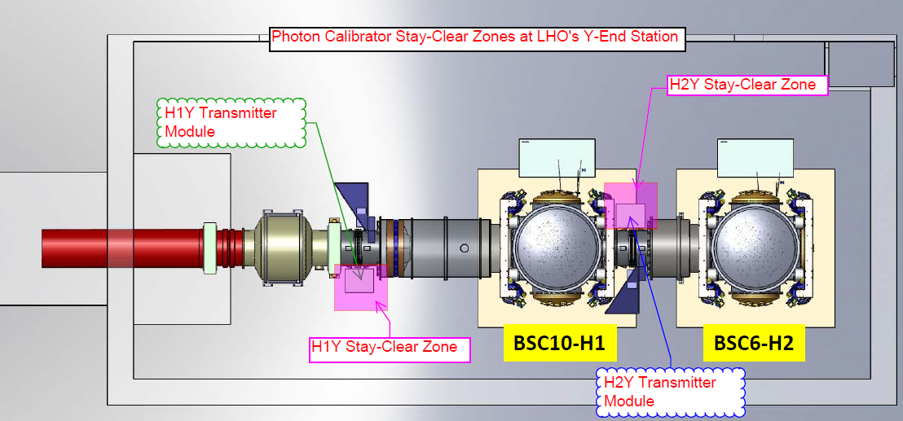
Figure 1 – Locations of Pcal transmitter module stay-clear zones, based on LIGO-D0901477. Stay-clear zones are indicated as boxes that are shaded in pink.

Viewports (VE, AOS Viewports)
The Pcal beams will pass through viewports mounted in vacuum adapters (see Figure 2) and be directed to the ETMs via input periscopes, reflect from the HR surfaces of the ETMs, and be directed by output periscopes within the vacuum system and directed to receiver modules.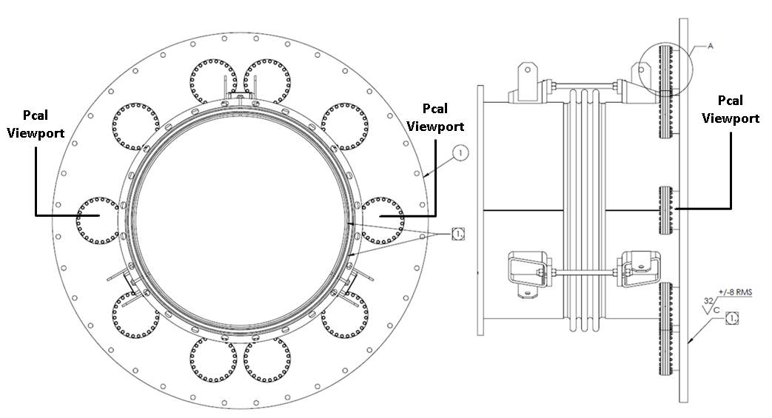
Figure 2 – Mechanical drawing of A-17 adapter separating WBSC6 and WBSC10 at LHO’s Y-End VEA (LIGO-C1001346). In all instances, Pcal’s beams will be transmitted and received through the viewports oriented as shown.

First Contact Surface Solution on ETM (SYS, COC and SUS)
During initial alignment of the Pcal beam, First Contact solution will still be on the surface of the ETM. Alignment of the Pcal system will involve temporarily peeling back the First Contact approximately 7cm from the top and bottom of the ETM. SYS has approved this part of the procedure.

Wavelength of Main Interferometer Beam (SYS)
The wavelength of the Pcal laser shall be at least 0.3 nm (90 GHz) away from the main interferometer beam wavelength, 1064.5nm, to minimize interference between the Pcal beam and the main interferometer beam.

Stay-Clear Zones (IAS)
All components within the vacuum system shall stay clear of the main interferometer beam, with a stay clear zone defined as a cylinder with a radius that is 2mm larger than the radius of the ETM and concentric with the ETM.

Baffles (SLC)
The Pcal beams shall be directed around physical obstructions within the vacuum manifold. Cryopump and Arm-Cavity Baffles will allow a 3” diameter clearance around the Pcal beams.

CDS Interfaces (CDS)
Pcal requires at least six fast channels for data read-back and eight slow channels for diagnostics and system control. At least 48 DMT channels are also required for off-line processing. These requirements apply to each arm of each interferometer.

Assumptions

Position of ETM (IAS)
We assume that the ETMs’ position shall be located within ±3mm longitudinally, ±1mm vertically, and ±1mm laterally of their design location, as specified in LIGO-E1100690.

HR Surface Reflectivity of ETM (COC)
We assume that the reflectivity of the HR surface of the ETM at the wavelength and incidence angles of the Pcal beams on the ETM, which are 8.75° for H1 and L1, and 5° for H2, will be 99.5% or better. These results are published in LIGO-C1000251. (Note: This does not impact the overall accuracy of the Photon Calibrator).

Mass of ETM (COC and SUS)
We assume that the masses of the ETMs, including bonded objects to the ETMs, shall be known by the COC and SUS systems within$\frac{σ}{μ}<0.1\%$. COC publishes the ETMs’ masses on the aLIGO Optics Website, and their uncertainties in LIGO-T1100174 (under A&D GP 60K on p. 83). SUS publishes the masses of the ears that are bonded to the ETMs and their uncertainties in LIGO-D080751.

Transmissivity of Viewport Windows (AOS Viewports)
Viewport windows, meeting the requirements specified in LIGO-E1100267, will be installed and leak-tested by others. They shall have a transmission coefficient greater than 0.995 at the Pcal laser wavelength.

Main Interferometer Beam: Position (ISC)
The position of the main interferometer beam on the ETM shall have a vertical and lateral tolerance of ±1 mm with respect to the center of the ETM to minimize elastic deformation errors in the calibration.

Potential Operational Hazards

Damage to Viewport Glass
Calibrating the output power of the Pcal boxes will require work adjacent to the viewport window. Accordingly, standard aLIGO viewport protectors (provided by others) shall be installed to prevent accidental physical contact with the viewport glass while working on the Pcal transmitter and receiver modules.

Laser Safety
The Pcals will have Class 4 lasers and will comply with all applicable requirements and standards.

L. Lindblom, Phys. Rev. D 80, 042005, pp. 1-7 (2009).

