LIGO Laboratory / LIGO Scientific Collaboration

LIGO- T1000746-v1 ADVANCED LIGO 3/13/11

Viewports Subsystem
Final Design Document

Michael Smith, Lisa C. Austin

Distribution of this document:
LIGO Science Collaboration

This is an internal working note
of the LIGO Project.

California Institute of Technology  LIGO Project – MS 18-34  1200 E. California Blvd.  Pasadena, CA 91125  Phone (626) 395-2129  Fax (626) 304-9834  E-mail: info@ligo.caltech.edu | Massachusetts Institute of Technology  LIGO Project – NW17-161  175 Albany St  Cambridge, MA 02139  Phone (617) 253-4824  Fax (617) 253-7014  E-mail: info@ligo.mit.edu
LIGO Hanford Observatory  P.O. Box 1970  Mail Stop S9-02  Richland, WA 99352  Phone 509-372-8106  Fax 509-372-8137 | LIGO Livingston Observatory  P.O. Box 940  Livingston, LA 70754  Phone 225-686-3100  Fax 225-686-7189
http://www.ligo.caltech.edu/

Table of Contents
1 Introduction 9
1.1 Scope and Introduction 9
1.2 Final Design Review Checklist 9
1.2.1 Final requirements – any changes or refinements from PDR? 9
1.2.2 Subsystem block and functional diagrams 9
1.2.3 Final Parts Lists and Drawing Package (assembly drawings and majority of remaining drawings) 9
1.2.4 Final specifications 9
1.2.5 Final interface control documents 10
1.2.6 Relevant RODA changes and actions completed 10
1.2.7 Signed Hazard Analysis 10
1.2.8 Final Failure Modes and Effects Analysis 10
1.2.9 Risk Registry items discussed 10
1.2.10 Design analysis and engineering test data 10
1.2.11 Software detailed design 10
1.2.12 Final approach to safety and use issues 10
1.2.13 Production Plans For Acquisition Of Parts, Components, Materials Needed For Fabrication 10
1.2.14 Installation Plans and Procedures 10
1.2.15 Final hardware test plans 10
1.2.16 Final software test plans 11
1.2.17 Cost compatibility with cost book 11
1.2.18 Fabrication, installation and test schedule 11
1.2.19 Lessons Learned Documented, Circulated 11
1.2.20 Problems and concerns 11
1.3 Definitions 11
1.4 Acronyms 11
1.5 Applicable Documents 12
1.5.1 LIGO Documents 12
1.5.2 Non-LIGO Documents 12
2 General description 13
3 Viewport Naming Conventions 14
3.1 BSC Chambers 14
3.1.1 D980227 - BSC Chamber Orientation for Viewport Names 14
3.1.2 D980229 - BSC Viewport designation for Doors 15
3.1.3 BSC Viewport Door designations by Elevation 16
3.1.4 BSC Viewport designation for End Doors 20
3.2 HAM Chambers 21
3.2.1 D980226 - HAM Chamber Viewport Names 21
3.2.2 HAM Chamber End Door Viewport Names 22
3.3 Mode Cleaner Tubes 23
3.3.1 Mode Cleaner Tube Positions 23
3.3.2 D0902632 Mode Cleaner Tube A Viewports 24
3.3.3 D0902631 Mode Cleaner Tube B Viewports 25
3.4 Adapter A-1 and Adapter A-17 Flanges 26
3.4.1 Spool B-9 - Adapter A-1, ITM-X and ITM-Y 26
3.4.2 L1 End - Adapter A-1, ETM-X and ETM-Y 26
3.4.3 H1, H2 End - Adapter A-1 and Adapter A-17, ETM-X and ETM-Y 27
3.4.4 D980228 Adapter A-1 Viewport Naming Convention 28
3.4.5 D0900947 Adapter A-17 Viewport Naming Convention 29
3.5 Septum Plates 30
3.5.1 H1, L1 Input Septum Plate Port Naming Convention 30
3.5.2 H2 Input Septum Plate Port Naming Convention 31
3.5.3 H1, L1 Output Septum Plate Port Naming Convention 32
3.5.4 H2 Output Septum Plate Port Naming Convention 33
3.6 Temporary Septum Plates 34
3.6.1 H1, L1 Temporary PRC Septum Plate 34
3.6.2 H2 Temporary PRC Septum Plate 34
4 Requirements and General Constraints 35
4.1 Refer to T1000022 Viewports Subsystem Requirements Document 35
5 Final Design 36
5.1 Protective Cover 36
6 Viewport Locations 37
6.1 H1, L1 IFO 37
6.1.1 WBSC2/LBSC2 38
6.1.2 WBSC1/LBSC1 39
6.1.3 WBSC3/LBSC3 40
6.1.4 WBSC9 41
6.1.5 LBSC4 42
6.1.6 WBSC10 43
6.1.7 LBSC5 44
6.1.8 WHAM1/LHAM1 45
6.1.9 WHAM2/LHAM2 46
6.1.10 WHAM3/LHAM3 47
6.1.11 WHAM4/LHAM4 48
6.1.12 WHAM5/LHAM5 49
6.1.13 WHAM6/LHAM6 50
6.1.14 WAMCA1/LAMCA1 51
6.1.15 WAMCB1/LAMCB1 52
6.1.16 WAMCA2/LAMCA2 53
6.1.17 WAMCB2/LAMCB2 54
6.1.18 ITM-X Adapter A-1 FLANGE 55
6.1.19 ITM-Y Adapter A-1 FLANGE 56
6.1.20 H1, H2 ETM-X Adapter A-1 FLANGE 57
6.1.21 L1 ETM-X Adapter A-1 FLANGE 58
6.1.22 H1, H2 ETM-Y Adapter A-1 FLANGE 59
6.1.23 L1 ETM-Y Adapter A-1 FLANGE 60
6.1.24 D1001661 - H1, L1 Input Septum Plate Port Locations 61
6.1.25 D1001662 H1, L1 Output Septum Plate Port Locations 62
6.1.26 D1003343 H1, L1 Temporary PRC Septum Plate Port Location 63
6.2 H2, Folded IFO 64
6.2.1 WBSC4 65
6.2.2 WBSC7 66
6.2.3 WBSC8 67
6.2.4 WBSC5 68
6.2.5 WBSC6 69
6.2.6 WHAM7 70
6.2.7 WHAM8 71
6.2.8 WHAM9 72
6.2.9 WHAM10 73
6.2.10 WHAM11 74
6.2.11 WHAM12 75
6.2.12 WAMCA3 76
6.2.13 WAMCB3 77
6.2.14 WAMCA4 78
6.2.15 WAMCB4 79
6.2.16 H2 Adapter A-1 FLANGE Viewports 80
6.2.17 H2 ETM-X Adapter A-17A 80
6.2.18 H2 ETM-Y Adapter A-17B 81
6.2.19 D1001665 H2 Input Septum Plate Port Locations 82
6.2.20 D1001666 H2 Output Septum Plate Port Locations 83
6.2.21 D1003344 H2 Temporary PRC Septum Plate Port Location 84
7 Summary of Viewports 85
7.1 Viewport System Characteristics 100
7.1.1 Viewport Performance Characteristics 100
7.1.2 Viewport Physical Characteristics 100
7.1.3 Viewport Interface Definitions 107
7.1.4 Viewport Reliability 107
7.1.5 Viewport Transportability 108
7.2 Viewport Design and Construction 108
7.2.1 Materials and Processes 108
7.2.2 Workmanship 109
7.2.3 Interchangeability 109
7.2.4 Safety 109
7.2.5 Human Engineering 109
7.2.6 Assembly and Maintenance 109
7.3 Documentation 109
7.3.1 Specifications 109
7.3.2 Design Documents 109
7.3.3 Engineering Drawings and Associated Lists 109
7.3.4 Technical Manuals and Procedures 109
7.3.5 Documentation Numbering 110
7.3.6 Test Plans and Procedures 110
7.4 Logistics 110
7.4.1 Spare Parts 110
7.4.2 Special Test Equipment 110
7.5 Precedence 110
7.6 Qualification 110
8 Quality Assurance Provisions 111
8.1 General 111
8.1.1 Responsibility for Tests 111
8.1.2 Special Tests 111
8.1.3 Configuration Management 111
8.2 Quality conformance inspections 111
8.2.1 Inspections 111
8.2.2 Demonstration 112
8.2.3 Test 112
9 Safety 113
9.1 Hazard Analysis 113
9.2 Working Covers 113
10 Preparation for Delivery 114
10.1 Preparation 114
10.2 Packaging 114
10.3 Marking 114
11 Notes 115

Appendices
Appendix A Quality Conformance Inspections 115

Table of Tables
Table 1: H1 Viewports 86
Table 2: H2 Viewports 90
Table 3: L1 Viewports 95
Table 4 Environmental Performance Characteristics 108
Table 5 Quality Conformance Inspections 115

Table of Figures
Figure 1: BSC orientation to reference viewport location 14
Figure 2: BSC Door Viewport Generic Names 15
Figure 3: BSC viewport names, 0 deg elevation side 16
Figure 4: BSC viewport names, 90 deg elevation side 17
Figure 5: BSC viewport names, 180 deg elevation side 18
Figure 6: BSC viewport names, 270 deg elevation side 19
Figure 7: BSC End Door Viewport 20
Figure 8: HAM Chamber Viewport Names 21
Figure 9: HAM Chamber Back Cover Viewport Names 22
Figure 10: Mode Cleaner Tube Placement Naming Convention 23
Figure 11: D0902632 Mode Cleaner Tube A Viewport Names 24
Figure 12: D0902631 Mode Cleaner Tube B Viewport Names and Clock Position 25
Figure 13: Spool B-9, Adapter A-1 26
Figure 14: L1 End - Adapter A-1 26
Figure 15: H1, H2 End - Adapter A-1 and Adapter A-17 27
Figure 16: D980228 Adapter A-1 28
Figure 17: D0900947 Adapter A-17A 29
Figure 18: H1, L1 Input Septum Plate Port Naming Convention 30
Figure 19: H2 Input Septum Plate Port Naming Convention 31
Figure 20: H1, L1 Output Septum Plate Port Naming Convention 32
Figure 21: H2 Output Septum Plate Port Naming Convention 33
Figure 22: Viewport Protective Cover 36
Figure 23: WBSC2/LBSC2 Viewports 38
Figure 24: WBSC1/LBSC1 Viewports 39
Figure 25: WBSC3/LBSC3 Viewports 40
Figure 26: WBSC9 Viewports 41
Figure 27: LBSC4 Viewports 42
Figure 28: WBSC10 Viewports 43
Figure 29: LBSC5 Viewports 44
Figure 30: WHAM1/LHAM1 45
Figure 31: WHAM2/LHAM2 Viewports 46
Figure 32: WHAM3/LHAM3 Viewports 47
Figure 33: WHAM4/LHAM4 Viewports 48
Figure 34: WHAM5/LHAM5 Viewports 49
Figure 35: WHAM6/LHAM6 50
Figure 36: WAMCA1/LAMCA1 Viewports 51
Figure 37: WAMCB1/LAMCB1 Viewports 52
Figure 38: WAMCA2/AMCA2 Viewports 53
Figure 39: WAMCB2/LAMCB2 Viewports 54
Figure 40: ITM-X Adapter WA-1C and LA-1A Viewports 55
Figure 41: ITM-Y Adapter WA-1F and LA-1B Viewports 56
Figure 42: H1, H2 ETM-X Adapter A-1 WA-1E 57
Figure 43: L1 ETM-X Adapter A-1 LA-1C 58
Figure 44: H1, H2 ETM-Y Adapter A-1 WA-1B 59
Figure 45: L1 ETM-Y Adapter A-1 LA-1D 60
Figure 46: H1, L1 Input Septum Plate Port Locations 61
Figure 47: H1, L1 Output Septum Plate Port Locations 62
Figure 48: H1, L1 Temporary PRC Septum Plate Port Location 63
Figure 49: WBSC4 Viewports 65
Figure 50: WBSC7 Viewports 66
Figure 51: WBSC8 Viewports 67
Figure 52: WBSC5 Viewports 68
Figure 53: WBSC6 Viewports 69
Figure 54: WHAM7 70
Figure 55: WHAM8 Viewports 71
Figure 56: WHAM9 Viewports 72
Figure 57: WHAM10 Viewports 73
Figure 58: WHAM11 Viewports 74
Figure 59: WHAM 12 75
Figure 60: WAMCA3 Viewports 76
Figure 61: WAMCB3 Viewports 77
Figure 62: WAMCA4 Viewports 78
Figure 63: WAMCB4 Viewports 79
Figure 64: H2 ETM-X Adapter A-17A 80
Figure 65: H2 ETM-Y Adapter A-17B 81
Figure 66: H2 Input Septum Plate Port Locations 82
Figure 67: H2 Output Septum Plate Port Locations 83
Figure 68: H2 Temporary PRC Septum Plate Port Location 84
Figure 69: Video Imaging Assembly ASC Alignment 100
Figure 70: MDC series VPxxx Kovar-sealed viewport 101
Figure 71: Illuminator Assembly 102
Figure 72: 7.8 Diameter Viewport 103
Figure 73: 6.0 in Optical Lever Viewport 104
Figure 74: Septum Window Flange Assembly 105
Figure 75: Septum Window 106

Abstract
This document will present the final design for the Viewports Subsystem. The Viewports subsystem provides optical viewports for the passage of all optical beams in and out of the vacuum region(s) of the IFO. The optical beams include the following: optical lever beams, CO2 laser beams for thermal compensation (TCS viewports are not part of this design), chamber illumination beams, video camera beams, and optical beams used for interferometer sensing and control.

Introduction

Scope and Introduction
The Viewports subsystem provides optical viewports for the passage of all optical beams in and out of the vacuum region(s) of the IFO. The optical beams include the following: optical lever beams, CO2 laser beams for thermal compensation, chamber illumination beams, video camera beams, and optical beams used for interferometer sensing and control.
TCS viewports are not part of this design.

Final Design Review Checklist

Final requirements – any changes or refinements from PDR?
Errors in some chamber and adapter flange viewport names were changed to reflect the LIGO naming convention.
The TCS CO2 laser viewports and the Hartmann viewports in HAM4 and HAM10 are the responsibility of the TCS subsystem.

Subsystem block and functional diagrams
See section Error: Reference source not found.

Final Parts Lists and Drawing Package (assembly drawings and majority of remaining drawings)

Final specifications
The following viewports are standard catalog items with specifications guaranteed by the manufacturer:
2.7 DIA, MDC450004-AR635
5.4 DIA VP800/450009
5.4 DIA VP800-AR1064
5.4 DIA VP800-AR532
7.8 DIA, ISI 9722012-AR635
The dimensions and physical details can be found at the following web-site: MDC Vacuum Products. They require AR coatings at the specified wavelengths
The 6.0 in-AR800-900 and 6.0 in-AR1064/532 viewports are custom viewports purchased from a commercial vendor to the following specification: 6.0 inch Vacuum Viewport Specification

Final interface control documents
All viewports, except for the septum viewports, interface to standard conflat flanges that are attached to nozzles on the vacuum chambers, vacuum equipment connecting tubes and adapters. The details of these viewport attachment nozzles are described in the LIGO Vacuum Equipment drawings by GNB Corporation, and Process Systems International.
The septum viewports are sealed with o-rings around the openings of the septum plates.

Relevant RODA changes and actions completed
Not applicable

Signed Hazard Analysis
E1000890-v1 ACB Hazard Analysis

Final Failure Modes and Effects Analysis
Not Required

Risk Registry items discussed
None for this subsystem

Design analysis and engineering test data
See Error: Reference source not found and Error: Reference source not found.

Software detailed design
Not applicable, ISC will handle this.

Final approach to safety and use issues
No operational safety issues

Production Plans For Acquisition Of Parts, Components, Materials Needed For Fabrication
E1100247-v1_Viewport production plan.

Installation Plans and Procedures
This will be deferred until after FDR

Final hardware test plans
See E1000892-v1 Fabrication, Installation, and Test Plan
Suspended baffle balancing before installation
See E1000892-v1 Fabrication, Installation, and Test Plan

Final software test plans
Not applicable.

Cost compatibility with cost book
See E1000891-v1_ACB production plan.

Fabrication, installation and test schedule
See E1000892-v1 Fabrication, Installation, and Test Plan

Lessons Learned Documented, Circulated
TBD

Problems and concerns
TBD

Definitions

Acronyms
LIGO - Laser Interferometer Gravity Wave Observatory
IO - Input Optics
PRM, PR2, and PR3 – Power Recycling Mirrors
SRM, SR2, and SR3 – Signal Recycling Mirrors
BS - Beam Splitter
ITMx, ITMy - Input Test Mass in the interferometer ‘X’ or ‘Y’ arm
ETMx, ETMy - End Test Mass in the interferometer ‘X’ or ‘Y’ arm
AR - Antireflection mirror coating
HR – Hi-reflectance mirror coating
ppm - parts per million
ISC- Interferometer Sensing and Control
IFO - LIGO interferometer
HAM - Horizontal Access Module
WHAM – Hanford, Washington Horizontal Access Module
LHAM – Livingston, Louisiana Horizontal Access Module
BSC - Hanford, Washington Beam Splitter Chamber
WBSC - Hanford, Washington Beam Splitter Chamber
LBSC - Livingston, Louisiana Beam Splitter Chamber
TBD - To Be Determined
rms - root-mean-square
p-v, peak to valley
OPTLEV- optical lever

Applicable Documents

LIGO Documents
- M950046-F LIGO Project System Safety Management Plan
- L060068-00 ASC Vacuum Viewports
- E960022-B LIGO Vacuum Compatibility, Cleaning Methods and Qualification Procedures
- D970211-B Video Imaging Assembly ASC Alignment
- D970212-B Illuminator Assembly ASC Alignment
- E080501 Enhanced LIGO TCS Hazard Analysis
- E070253-A ELI Septum Window Assembly And Installation Procedure
- D0901109 ZnSe Protector Plate Front View
- D0901110 ZnSe Protector Plate Back
- D0901477 Vacuum Chamber Designations for LHO aLIGO
- D0901490 Vacuum Chamber Designations for LLO Aligo
- D980227 Naming Conventions, BSC Ports
- D980226 Naming Conventions for Ports on HAM Chamber
- D980228 Naming Conventions for Ports on Adapter
- E1000890-v1 ACB Hazard Analysis
- E1000891-v1_ACB production plan
- E1000892-v1 Fabrication, Installation, and Test Plan

Non-LIGO Documents

General description
Viewports are mounted to flanges in the nozzles of the vacuum chambers. The viewport material and the AR coatings on the viewport surfaces are chosen to maximize the transmissivity of the light passing through the viewport. Previous viewports from Initial LIGO and Enhanced LIGO may be re-used as appropriate.

Viewport Naming Conventions

BSC Chambers

D980227 - BSC Chamber Orientation for Viewport Names
The BSC orientation is shown in Figure 1. Ports are numbered clockwise from 0˚ datum distinguished by the Ion Pump Assembly location.

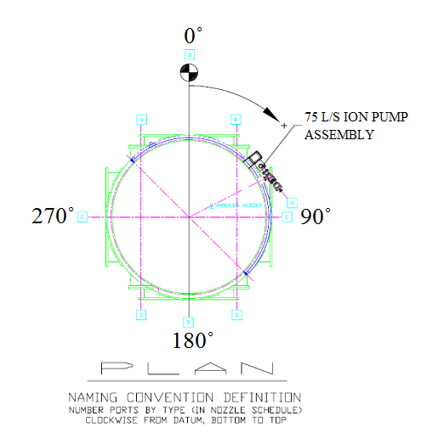
Figure 1: BSC orientation to reference viewport location

D980229 - BSC Viewport designation for Doors
The BSC Door Viewport Names are shown in Figure 2.

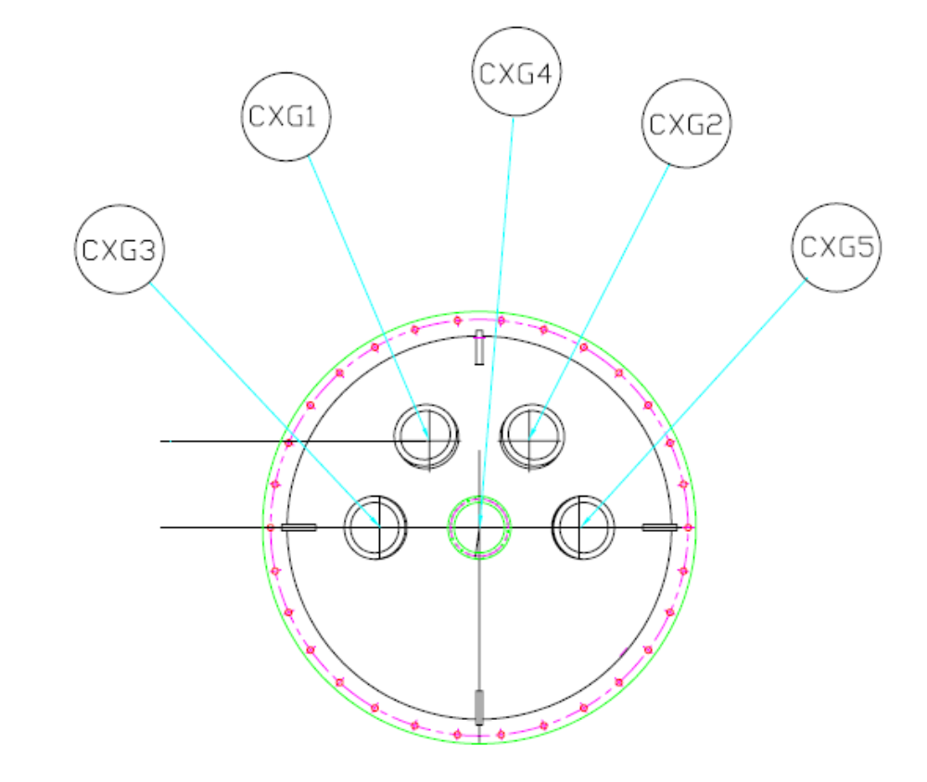
Figure 2: BSC Door Viewport Generic Names

BSC Viewport Door designations by Elevation
The BSC viewport names are shown in Figure 3, Figure 4, Figure 5 and Figure 6.

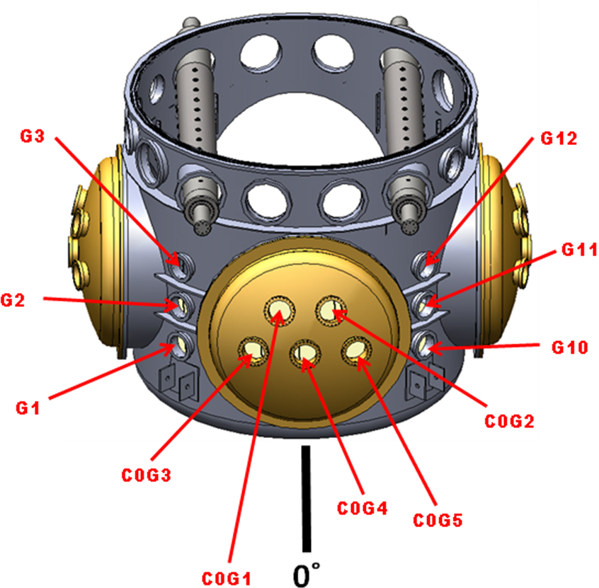
Figure 3: BSC viewport names, 0 deg elevation side

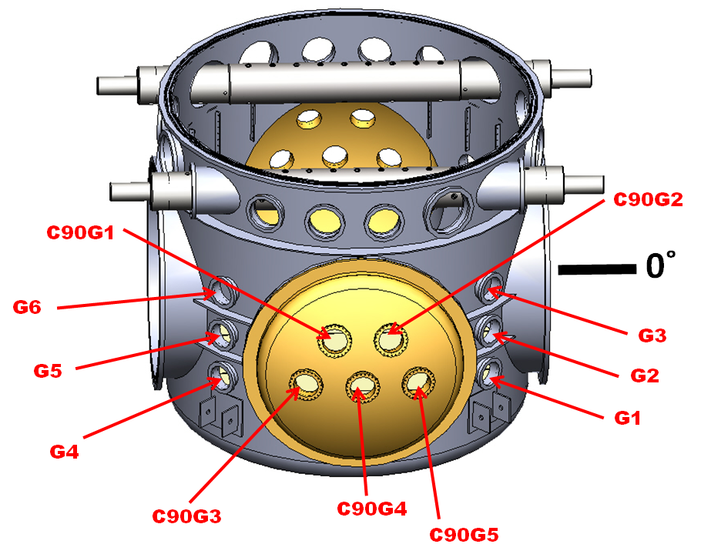
Figure 4: BSC viewport names, 90 deg elevation side

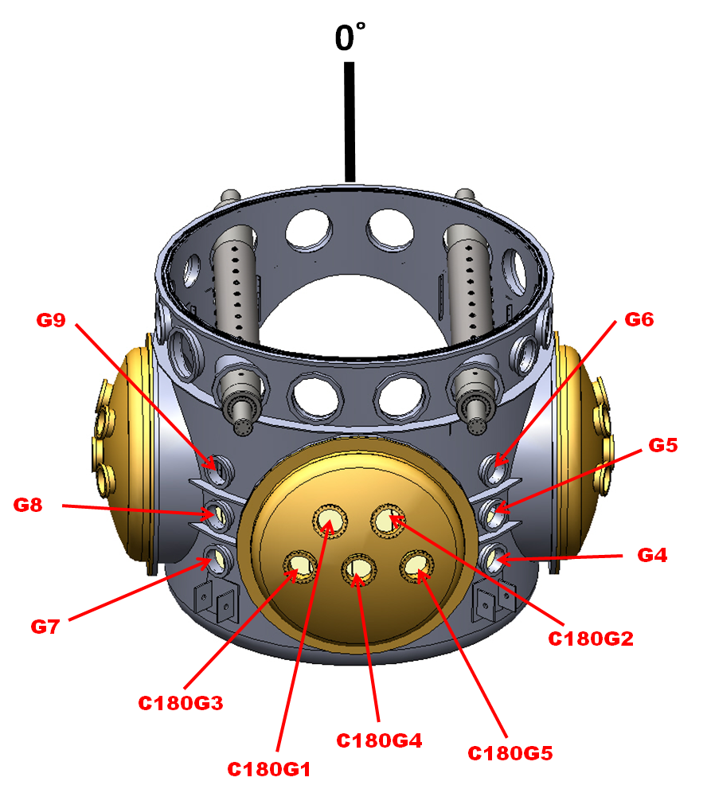

Figure 5: BSC viewport names, 180 deg elevation side

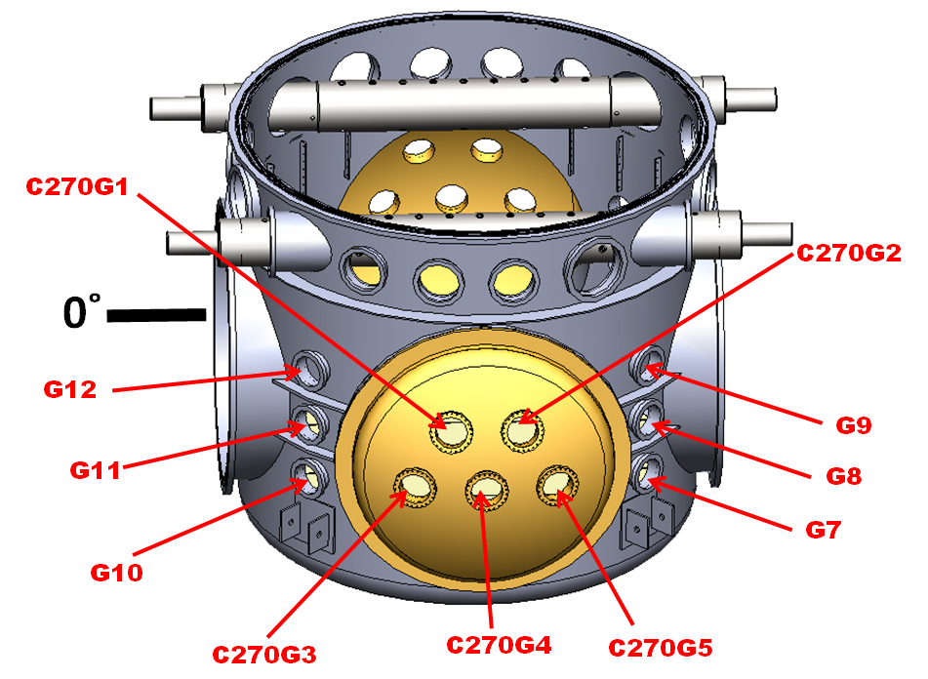

Figure 6: BSC viewport names, 270 deg elevation side

BSC Viewport designation for End Doors

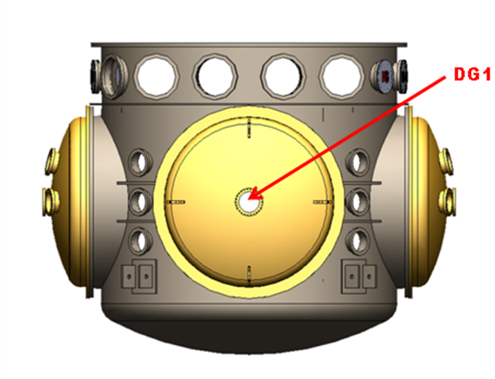

Figure 7: BSC End Door Viewport

HAM Chambers

D980226 - HAM Chamber Viewport Names
The HAM Chamber orientation and viewport names are shown in Figure 8.

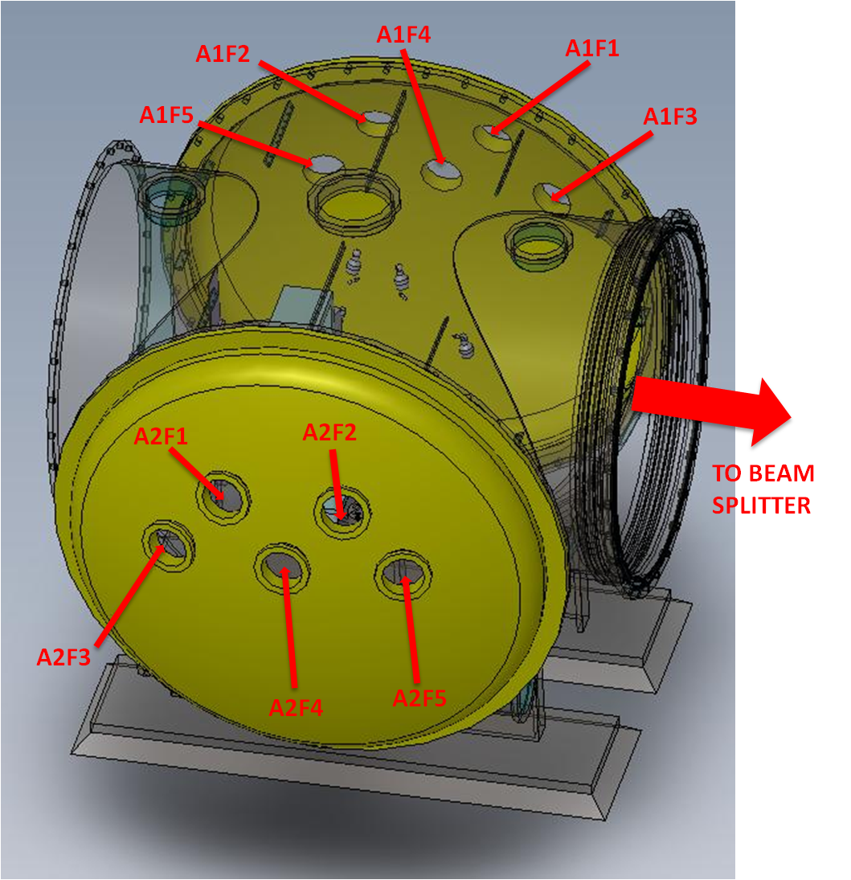

Figure 8: HAM Chamber Viewport Names

HAM Chamber End Door Viewport Names
The D060158 HAM Chamber Back Cover viewport names are shown in Figure 9.

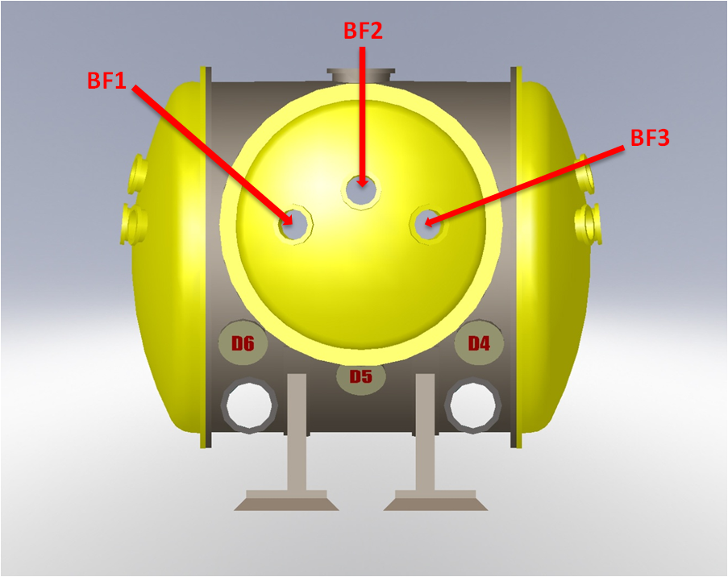

Figure 9: HAM Chamber Back Cover Viewport Names

Mode Cleaner Tubes

Mode Cleaner Tube Positions
The naming convention for the Mode Cleaner Tubes is shown in Figure 10.

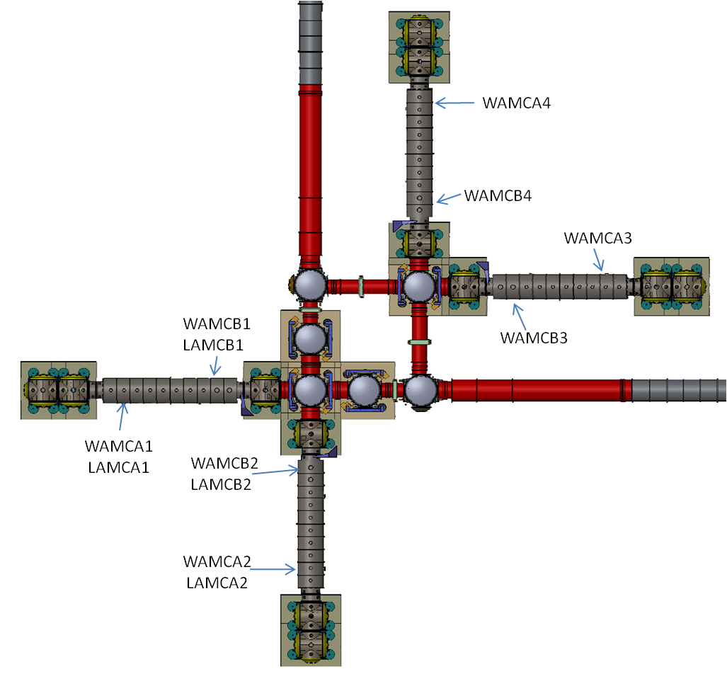

Figure 10: Mode Cleaner Tube Placement Naming Convention

D0902632 Mode Cleaner Tube A Viewports
The naming convention for the Mode Cleaner Tube A Viewports is shown in Figure 11.

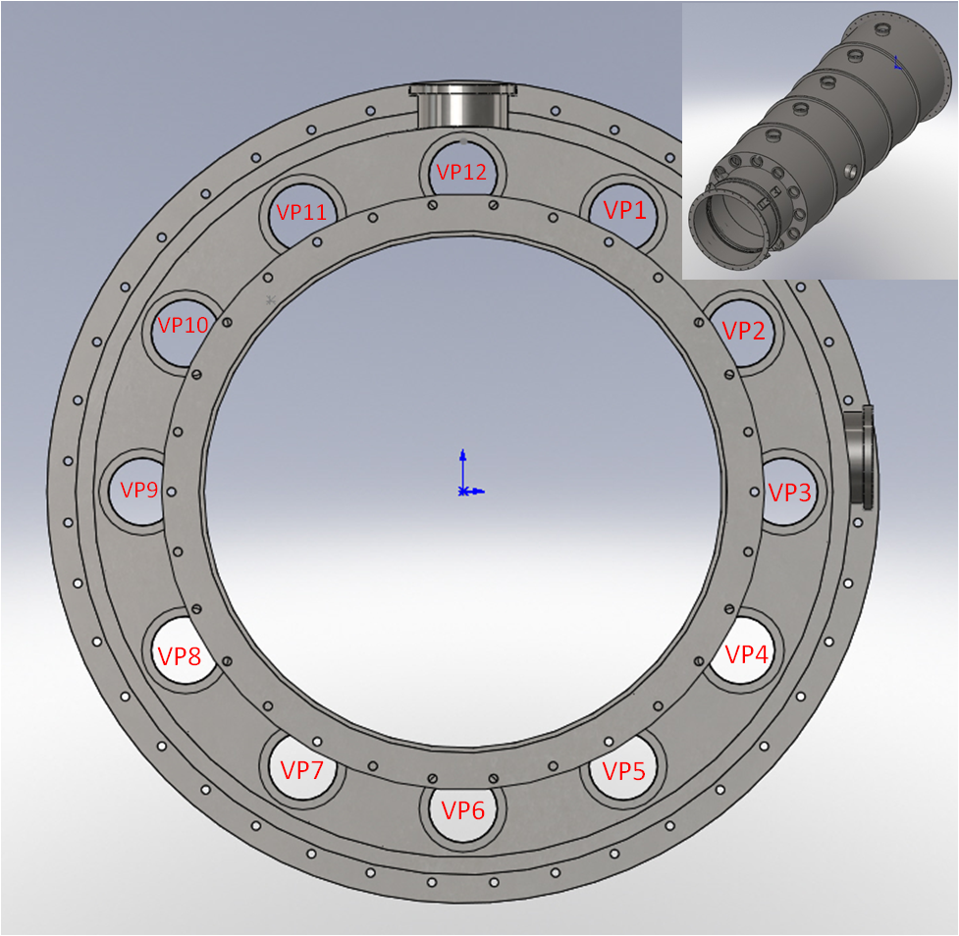

Figure 11: D0902632 Mode Cleaner Tube A Viewport Names

D0902631 Mode Cleaner Tube B Viewports
The naming convention for the Mode Cleaner Tube B Viewports is shown in Figure 12, see table for Hole Clock Positions.

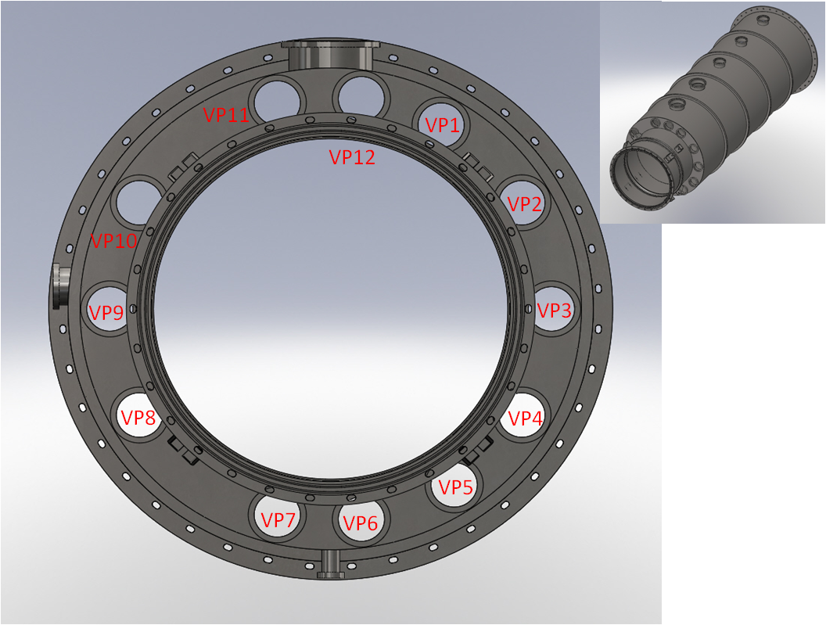

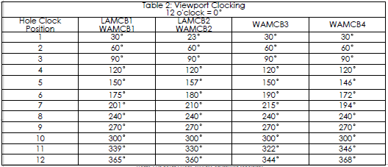

Figure 12: D0902631 Mode Cleaner Tube B Viewport Names and Clock Position

Adapter A-1 and Adapter A-17 Flanges

Spool B-9 - Adapter A-1, ITM-X and ITM-Y
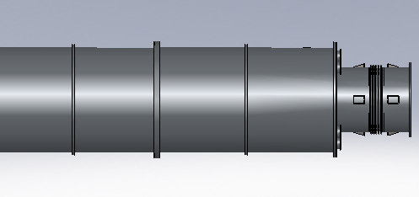
A-1 Adapter

Figure 13: Spool B-9, Adapter A-1

L1 End - Adapter A-1, ETM-X and ETM-Y

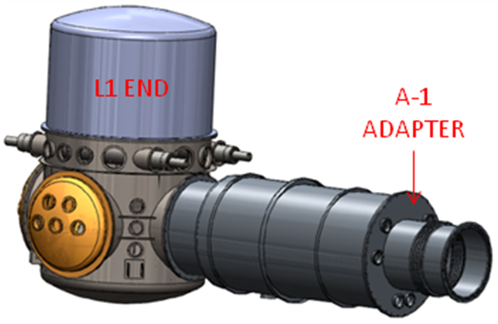

Figure 14: L1 End - Adapter A-1

H1, H2 End - Adapter A-1 and Adapter A-17, ETM-X and ETM-Y

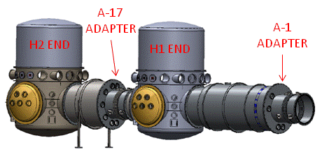

Figure 15: H1, H2 End - Adapter A-1 and Adapter A-17

D980228 Adapter A-1 Viewport Naming Convention
The Adapter A-1 viewport designators are shown in Figure 16.

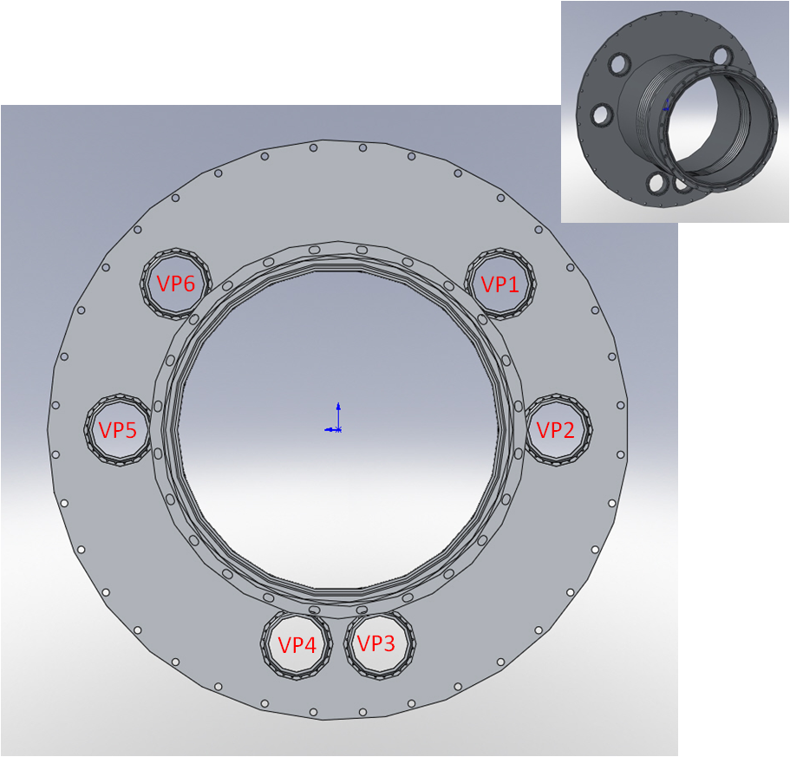

Figure 16: D980228 Adapter A-1

D0900947 Adapter A-17 Viewport Naming Convention
The Adapter A-17 viewport designators are shown in Figure 17

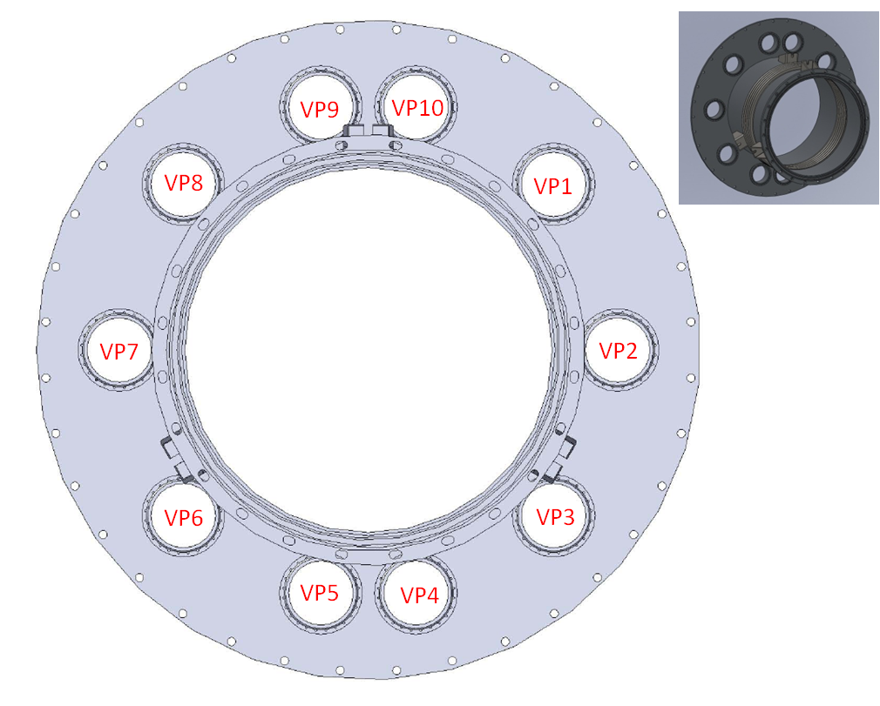

Figure 17: D0900947 Adapter A-17A

Septum Plates

H1, L1 Input Septum Plate Port Naming Convention
The H1, L1 Input Septum Plate Assembly D1002461 is shown in Figure 18.

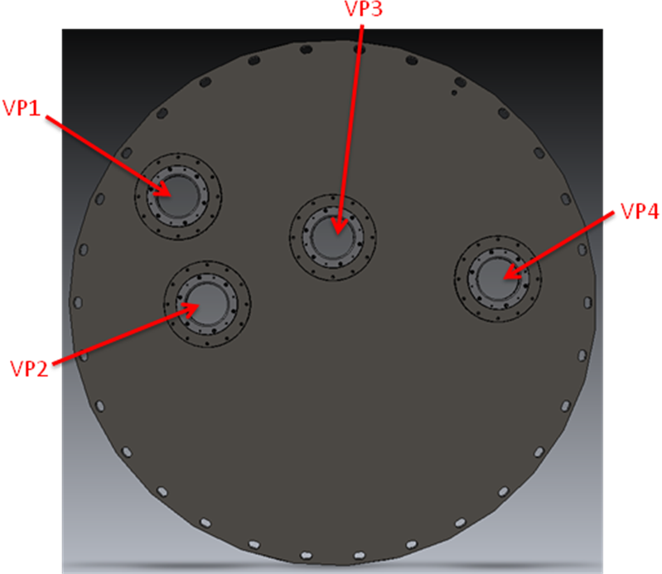

Figure 18: H1, L1 Input Septum Plate Port Naming Convention

H2 Input Septum Plate Port Naming Convention
The H2 Input Septum Plate Assembly D1002463 is shown in Figure 19.

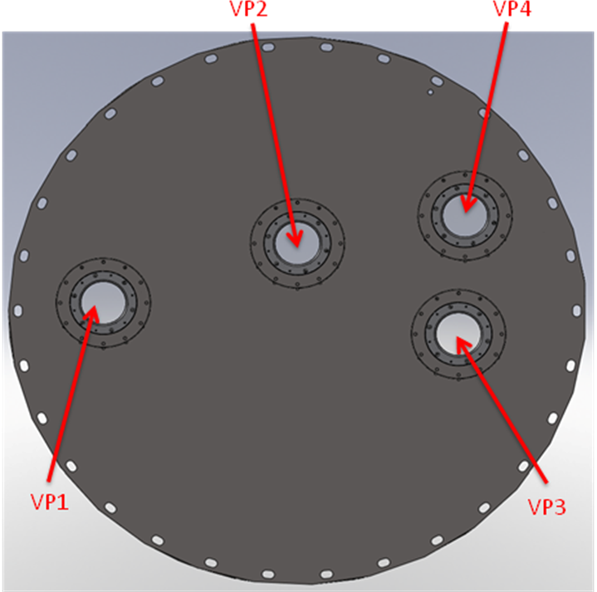

Figure 19: H2 Input Septum Plate Port Naming Convention

H1, L1 Output Septum Plate Port Naming Convention
The H1, L1 Output Septum Plate Assembly D1002462 is shown in Figure 20.

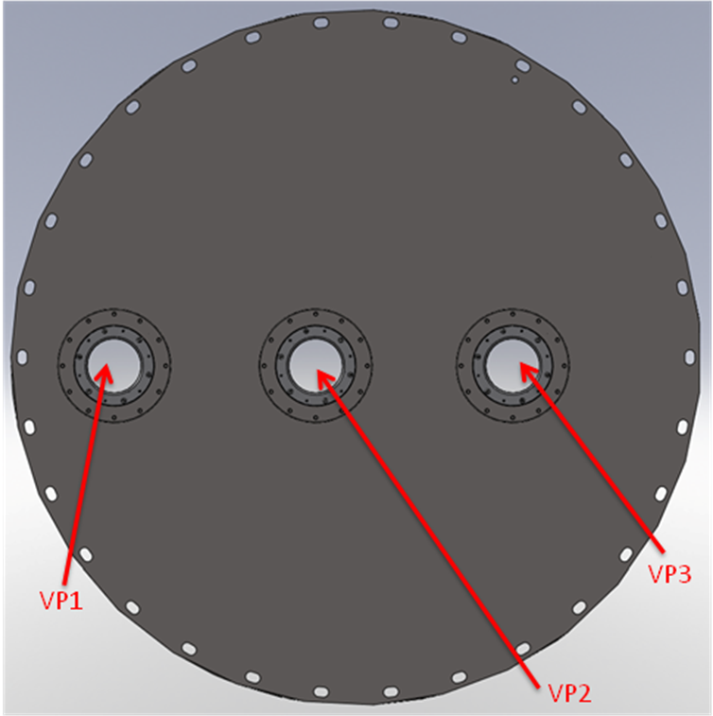

Figure 20: H1, L1 Output Septum Plate Port Naming Convention

H2 Output Septum Plate Port Naming Convention
The H2 Output Septum Plate Assembly D1002464 is shown in Figure 21.

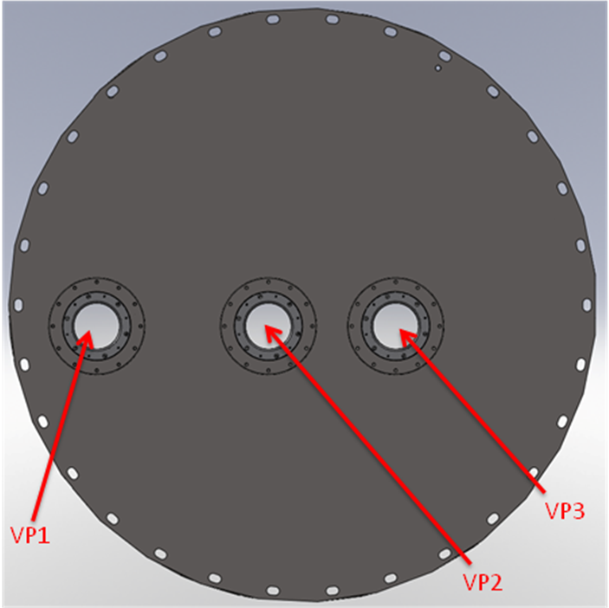

Figure 21: H2 Output Septum Plate Port Naming Convention

Temporary Septum Plates

H1, L1 Temporary PRC Septum Plate
See Section 6.1.26: D1003343 H1, L1 Temporary PRC Septum Plate Port Location

H2 Temporary PRC Septum Plate
See Section 6.2.21: D1003344 H2 Temporary PRC Septum Plate Port Location

Requirements and General Constraints

Refer to T1000022 Viewports Subsystem Requirements Document

Final Design
Various types of viewports are used for providing access to optical beams into and out of the IFO.
Video camera viewports are used to provide a visible access from outside the chambers for video cameras to view the IFO optics.
Optical lever viewports are used to provide entry and exit for optical lever beams from outside the chambers to measure the tilt of the IFO suspended optics.
Illumination viewports are used to provide illumination of the vacuum chambers with an outside illumination lamp.
TCS viewports are used to provide transmission of CO2 laser beams for heating certain core optics.
Hartmann viewports are used to provide entry and exit ports for the Hartmann wavefront sensing beams.
The Transmon viewports are used for entry and egress of the 532 nm arm length stabilization beam, the 532 nm Hartmann beam and the 1064 nm Transmon beam.

Protective Cover
All viewports will have a protective cover, similar to the one shown in Figure 22 which will cover the viewport whenever any physical activity occurs that might damage the viewport and cause a hazardous situation to nearby personnel.
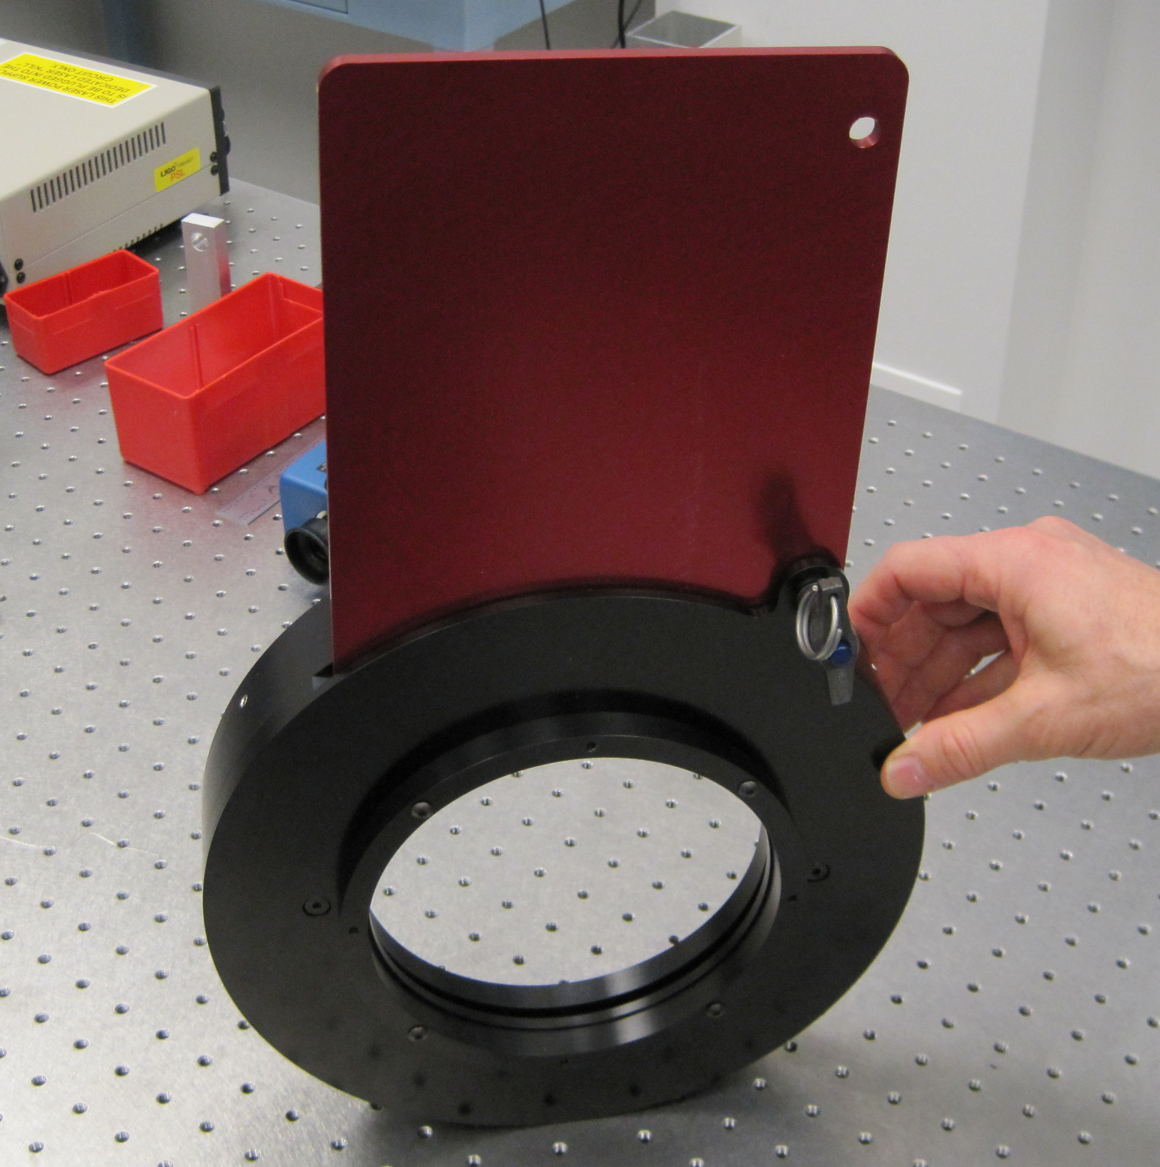
Figure 22: Viewport Protective Cover

Viewport Locations

H1, L1 IFO

WBSC2/LBSC2
The locations of the WBSC2/LBSC2 Chamber Viewports are shown in Figure 23.

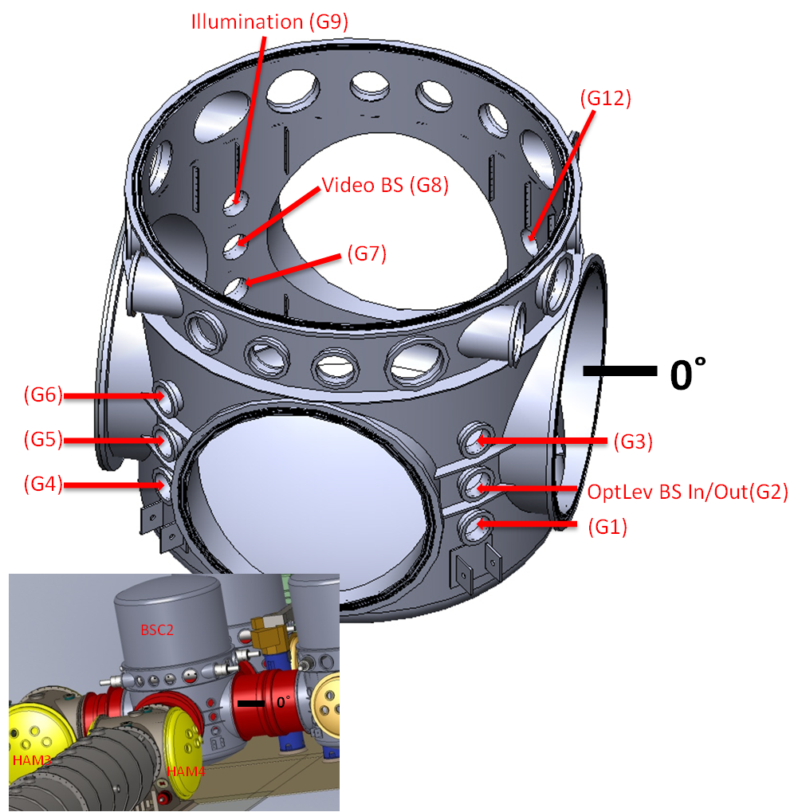

Figure 23: WBSC2/LBSC2 Viewports

WBSC1/LBSC1
The locations of the WBSC1/LBSC1 Chamber Viewports are shown in Figure 24.

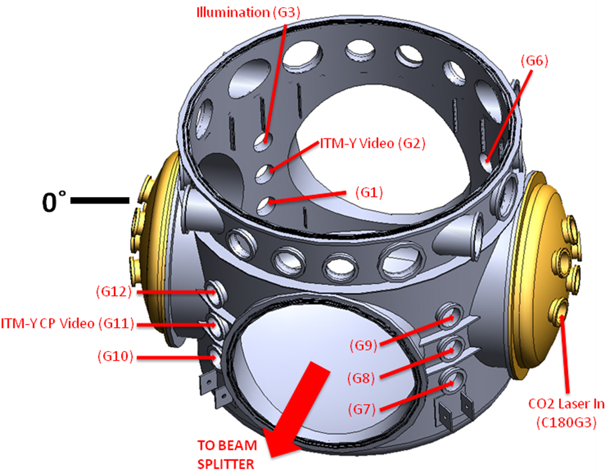

Figure 24: WBSC1/LBSC1 Viewports

WBSC3/LBSC3
The locations of the WBSC3/LBSC3 Chamber Viewports are shown in Figure 25.

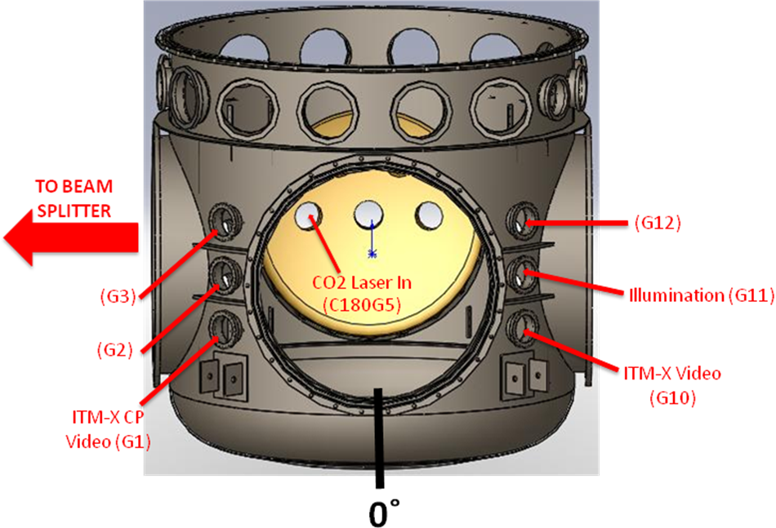

Figure 25: WBSC3/LBSC3 Viewports

WBSC9
The locations of the WBSC9 Chamber Viewports are shown in Figure 26.

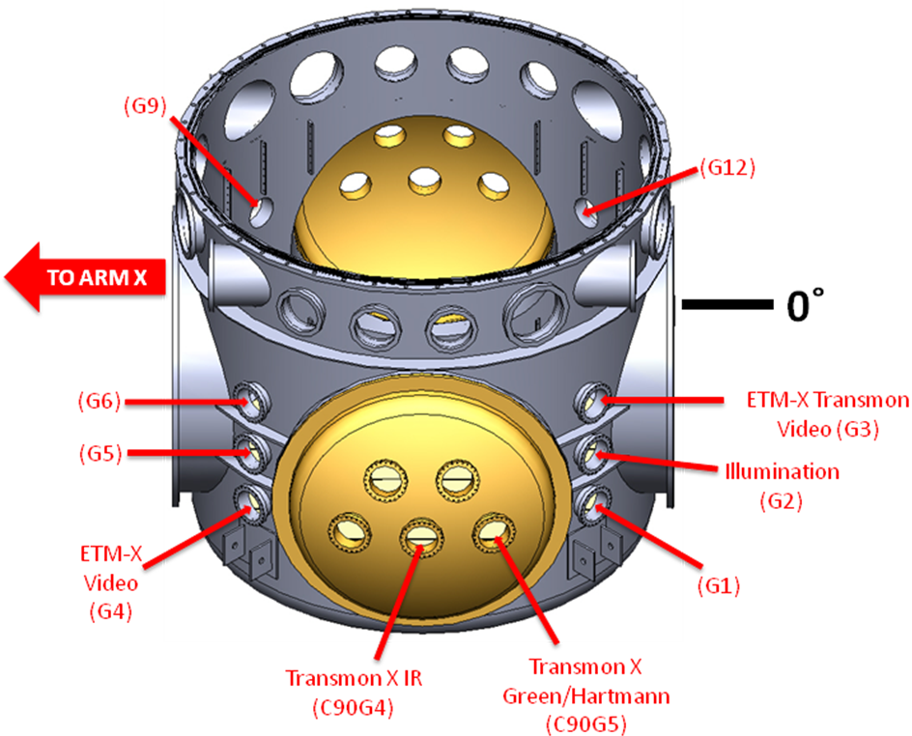

Figure 26: WBSC9 Viewports

LBSC4
The locations of the LBSC4 Chamber Viewports are shown in Figure 27.

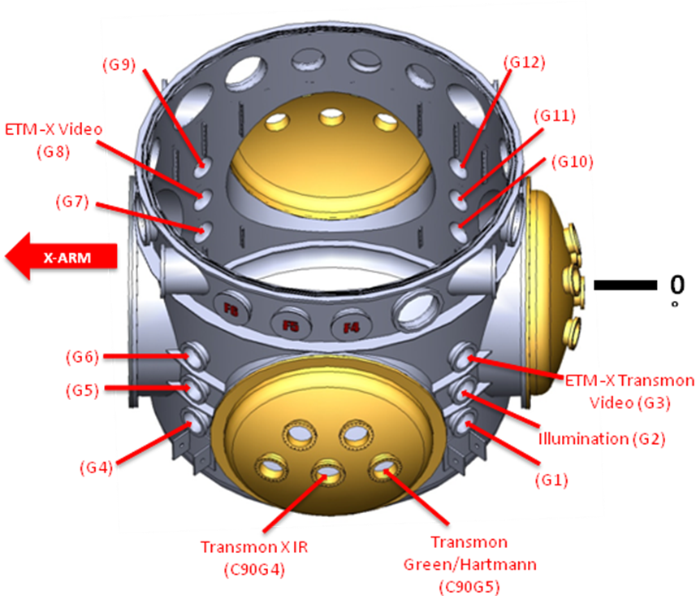

Figure 27: LBSC4 Viewports

WBSC10
The locations of the WBSC10 Chamber Viewports are shown in Figure 28

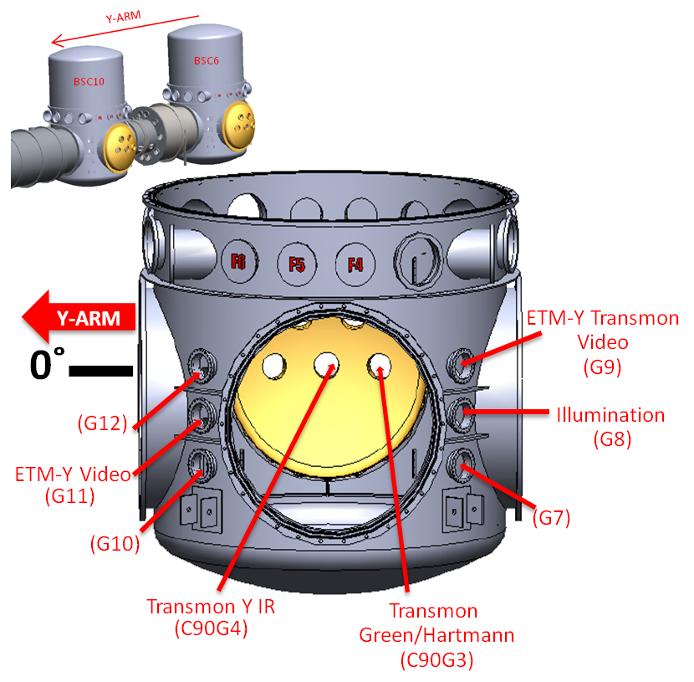
Figure 28: WBSC10 Viewports

LBSC5
The locations of the LBSC5 Chamber Viewports are shown in Figure 29.

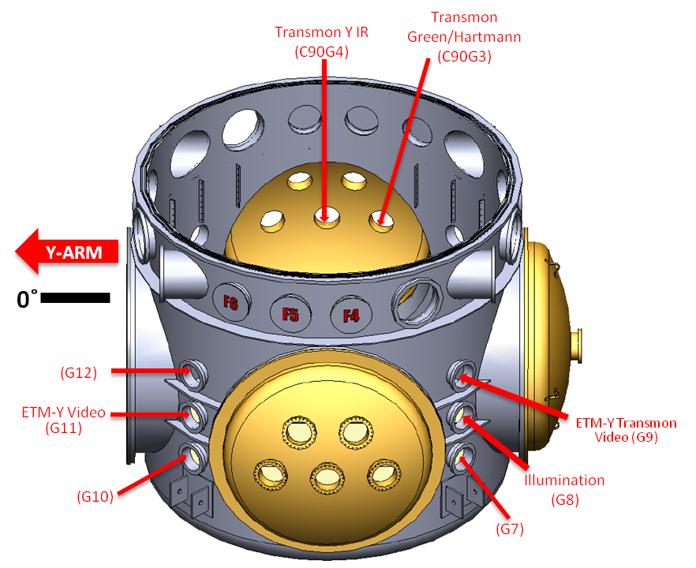
Figure 29: LBSC5 Viewports

WHAM1/LHAM1

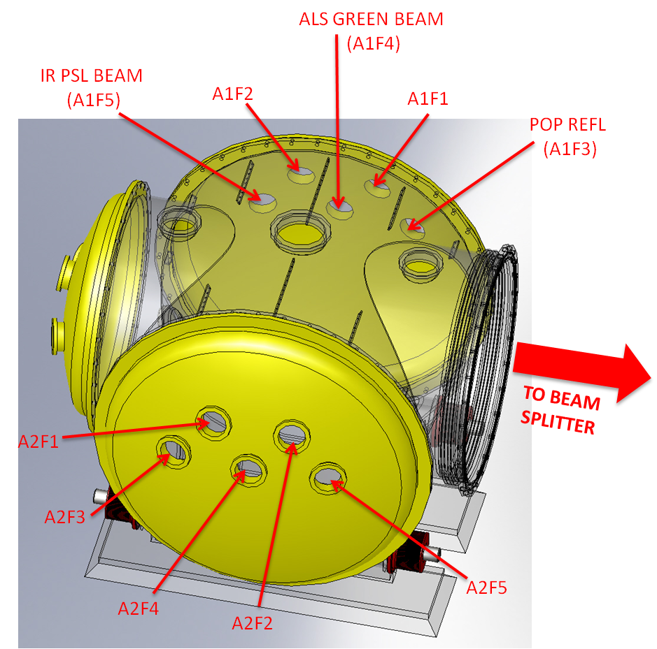

Figure 30: WHAM1/LHAM1

WHAM2/LHAM2
The locations of the WHAM2/LHAM2 viewports are shown in Figure 31.

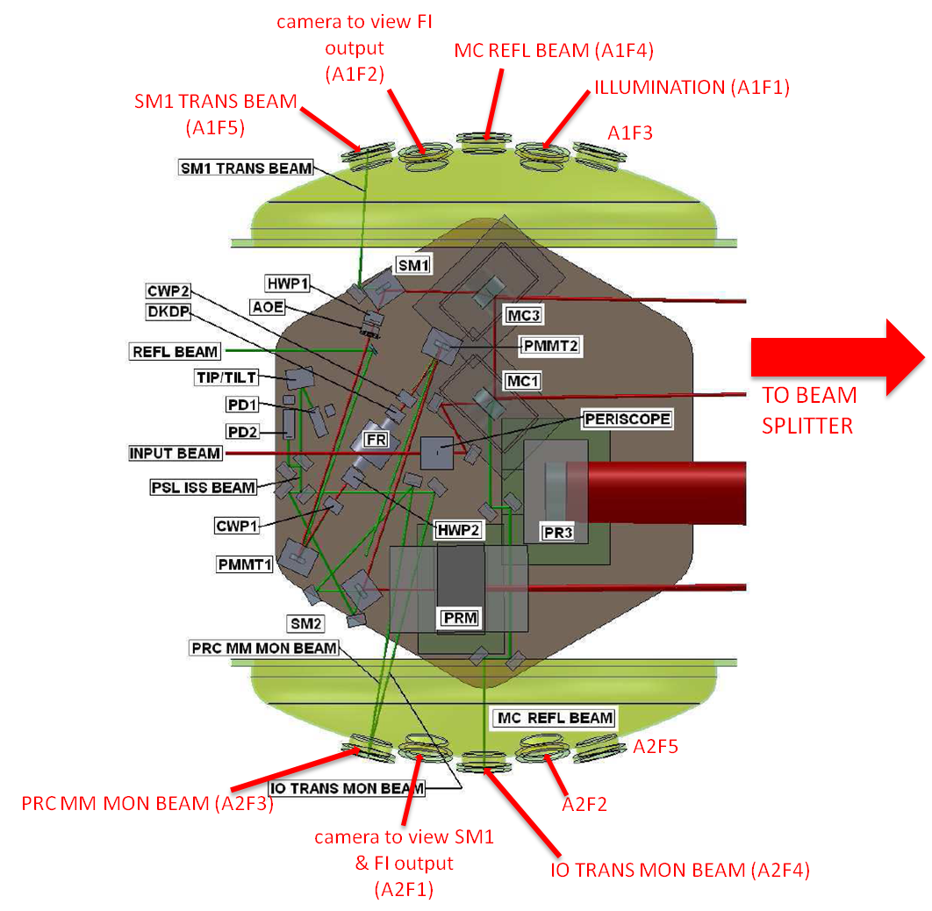

Figure 31: WHAM2/LHAM2 Viewports

WHAM3/LHAM3
The locations of the WHAM3/LHAM3 viewports are shown in Figure 32.

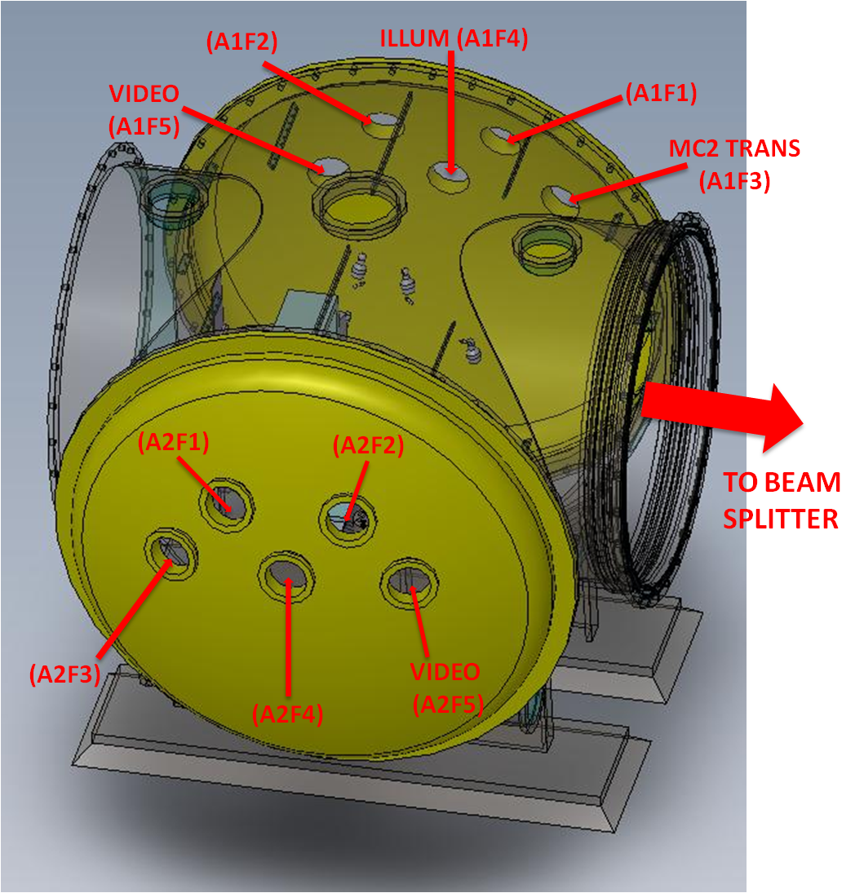
Figure 32: WHAM3/LHAM3 Viewports

WHAM4/LHAM4
The locations of the WHAM4/LHAM4 viewports are shown in Figure 33.

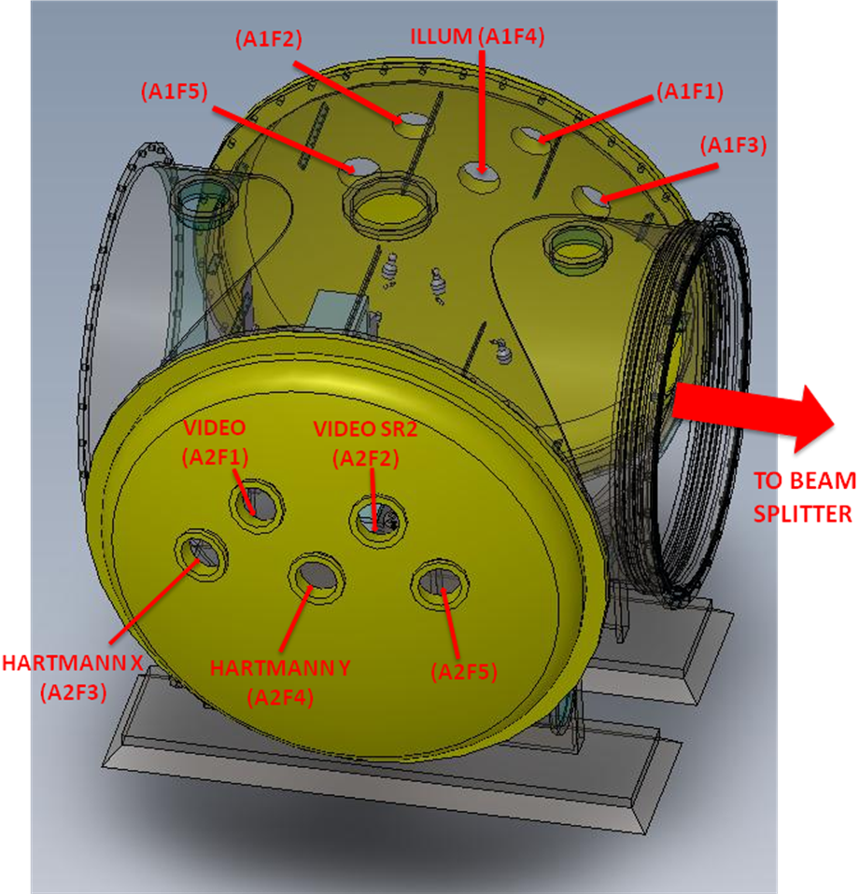
Figure 33: WHAM4/LHAM4 Viewports

WHAM5/LHAM5
The locations of the WHAM5/LHAM5 viewports are shown in Figure 34.

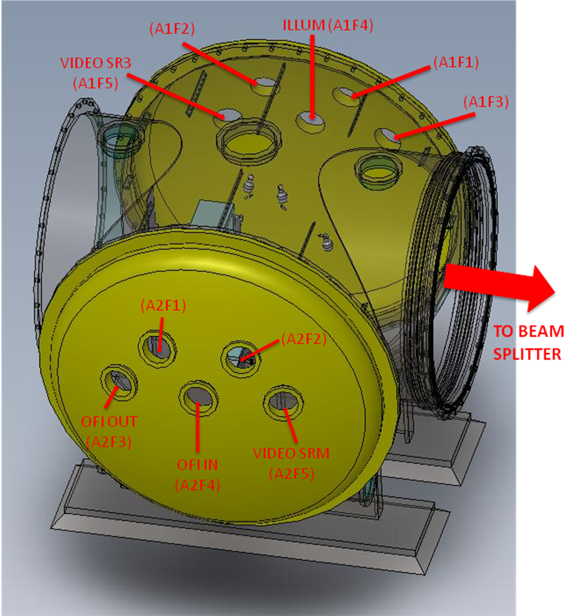
Figure 34: WHAM5/LHAM5 Viewports

WHAM6/LHAM6

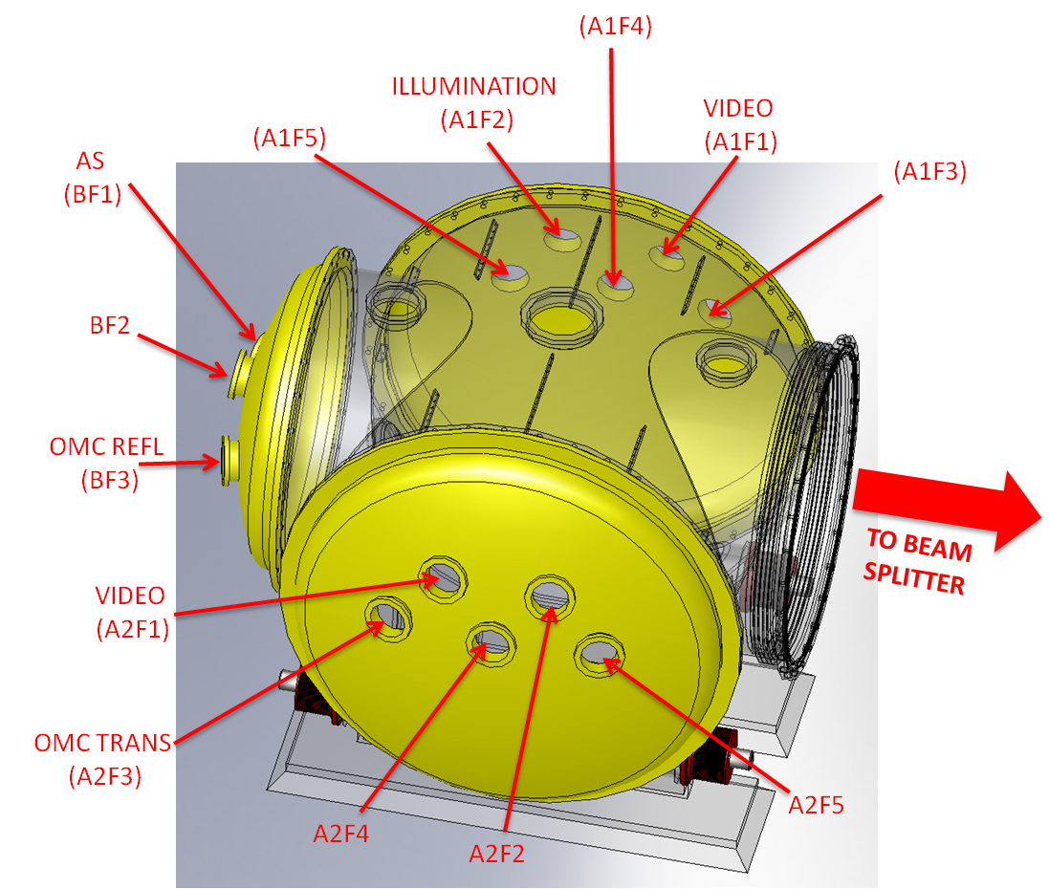
Figure 35: WHAM6/LHAM6

WAMCA1/LAMCA1
The locations of the WAMCA1/LAMCA1 viewports are shown in Figure 36.

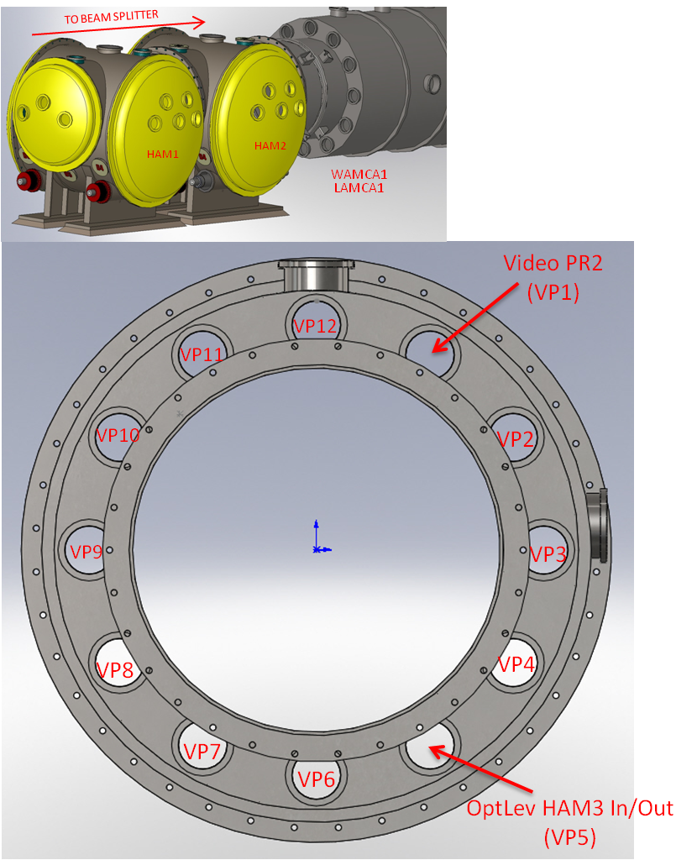

Figure 36: WAMCA1/LAMCA1 Viewports

WAMCB1/LAMCB1
The locations of the WAMCB1/LAMCB1 viewports are shown in Figure 37.

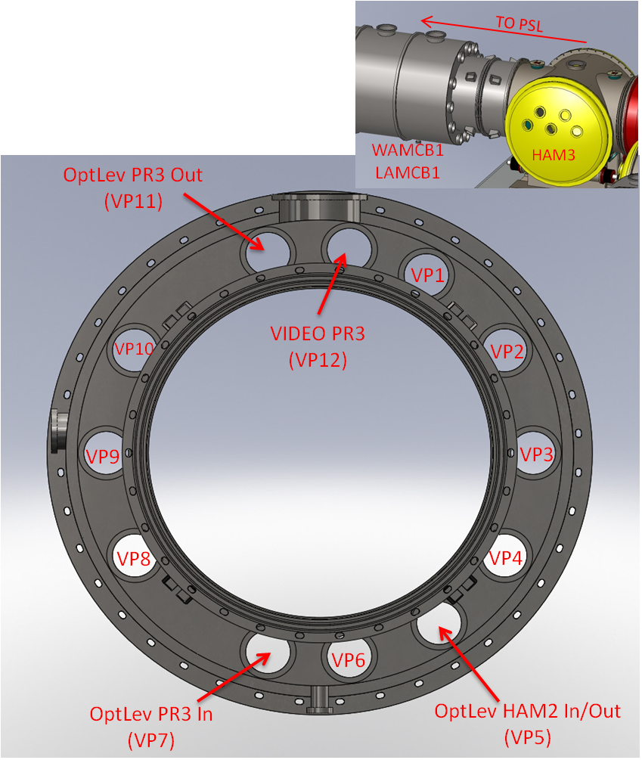

Figure 37: WAMCB1/LAMCB1 Viewports

WAMCA2/LAMCA2
The locations of the WAMCA2/LAMCA2 viewports are shown in Figure 38.

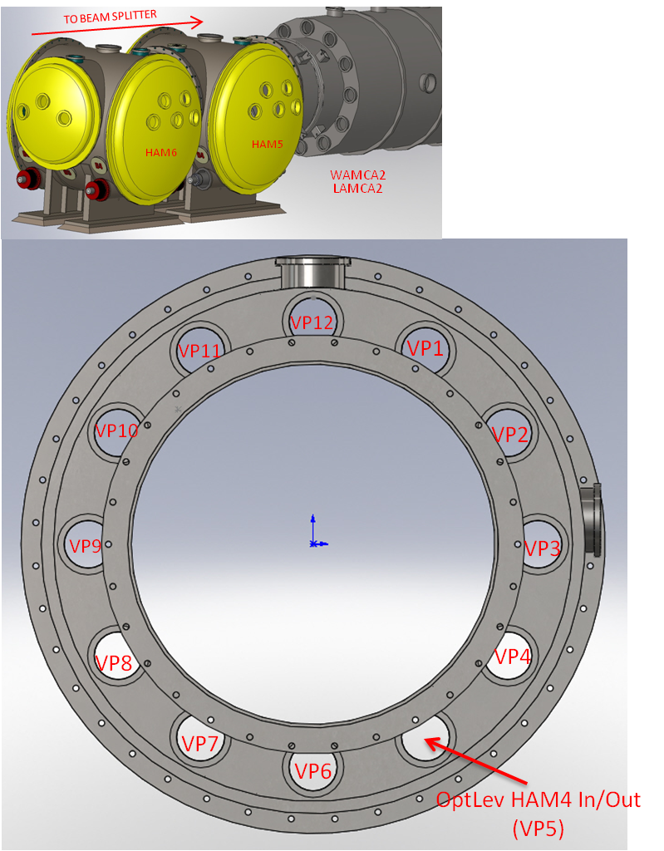

Figure 38: WAMCA2/AMCA2 Viewports

WAMCB2/LAMCB2
The locations of the WAMCB2/LAMCB2 viewports are shown in Figure 39.

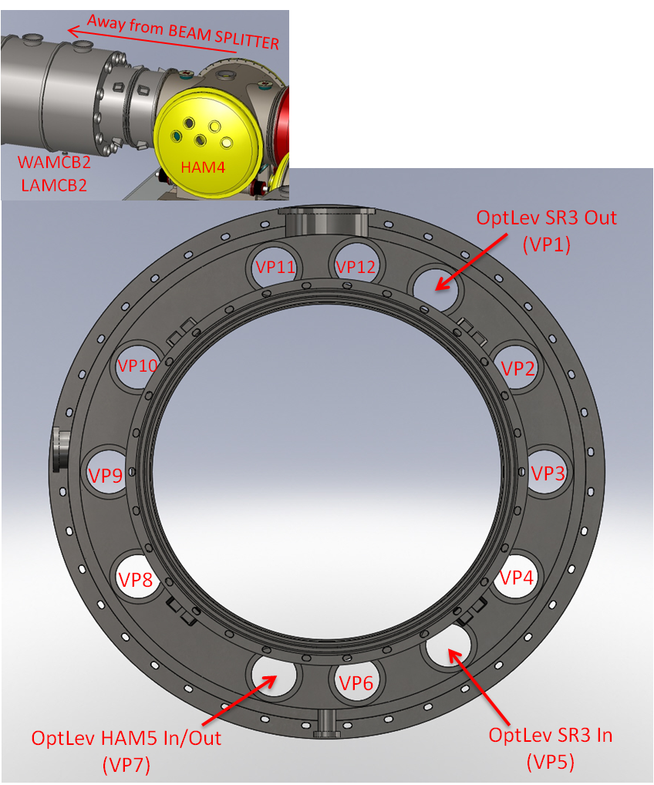

Figure 39: WAMCB2/LAMCB2 Viewports

ITM-X Adapter A-1 FLANGE
The locations of the ITM-X Adapters WA-1C and LA-1A Viewports are shown in Figure 40.

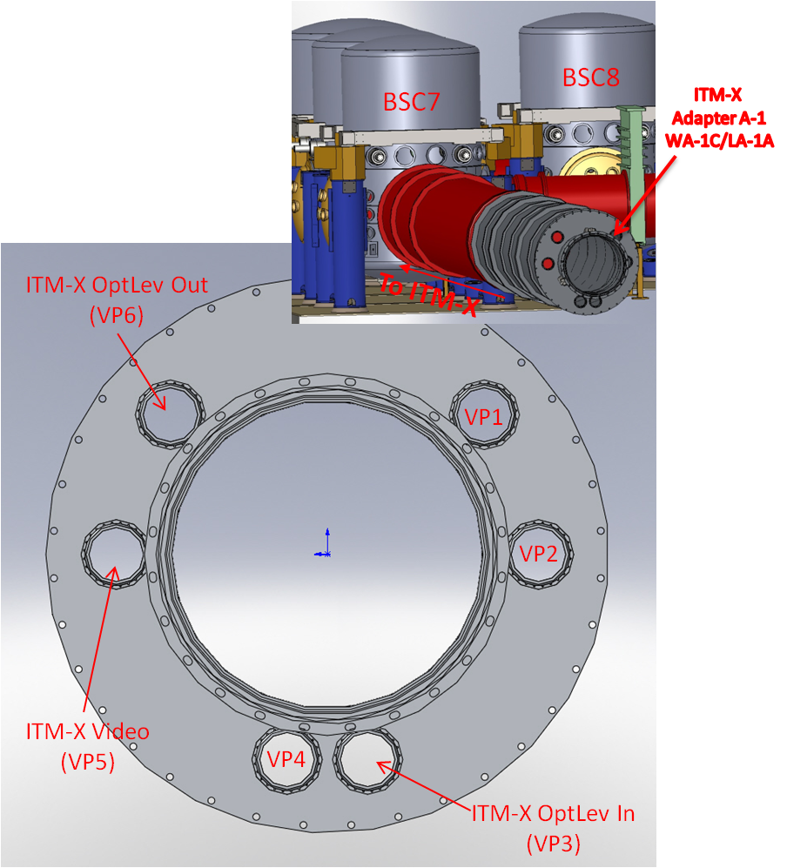

Figure 40: ITM-X Adapter WA-1C and LA-1A Viewports

ITM-Y Adapter A-1 FLANGE
The locations of the ITM-Y Adapters WA-1F and LA-1B Viewports are shown in Figure 41.

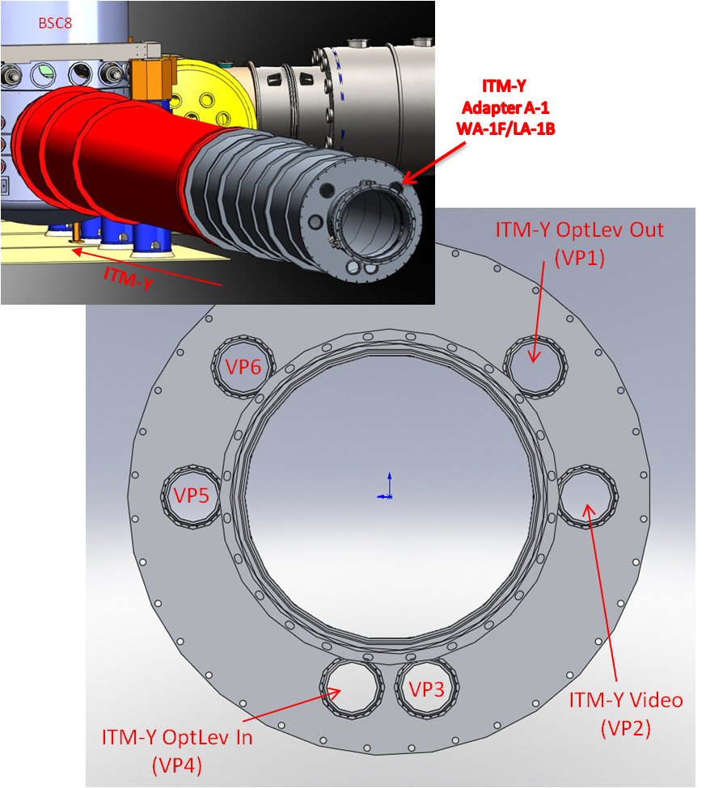

Figure 41: ITM-Y Adapter WA-1F and LA-1B Viewports

H1, H2 ETM-X Adapter A-1 FLANGE
The locations of the H1, H2 ETM-X Adapter A-1 WA-1E Viewports are shown in Figure 42.

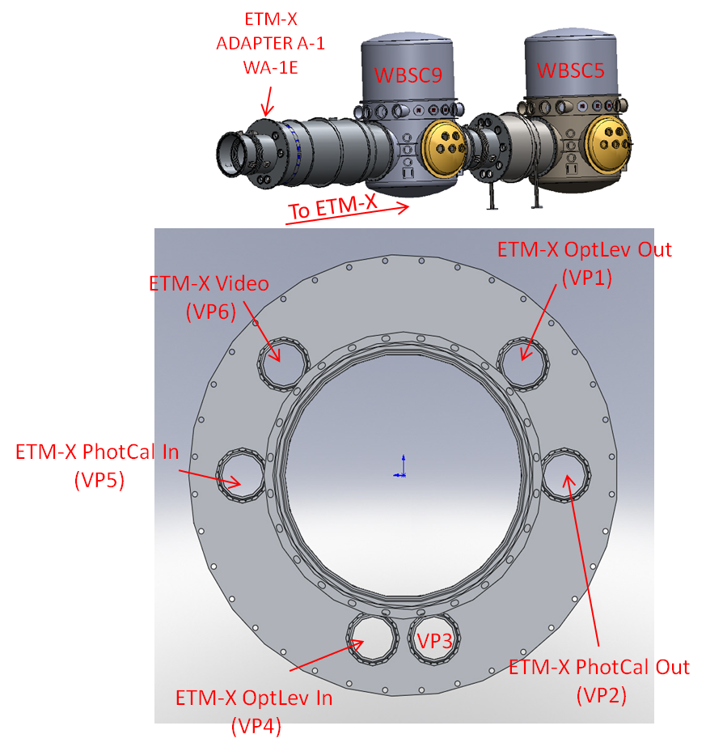

Figure 42: H1, H2 ETM-X Adapter A-1 WA-1E

L1 ETM-X Adapter A-1 FLANGE
The locations of the L1 ETM-X Adapter A-1 LA-1C Viewports are shown in Figure 43.

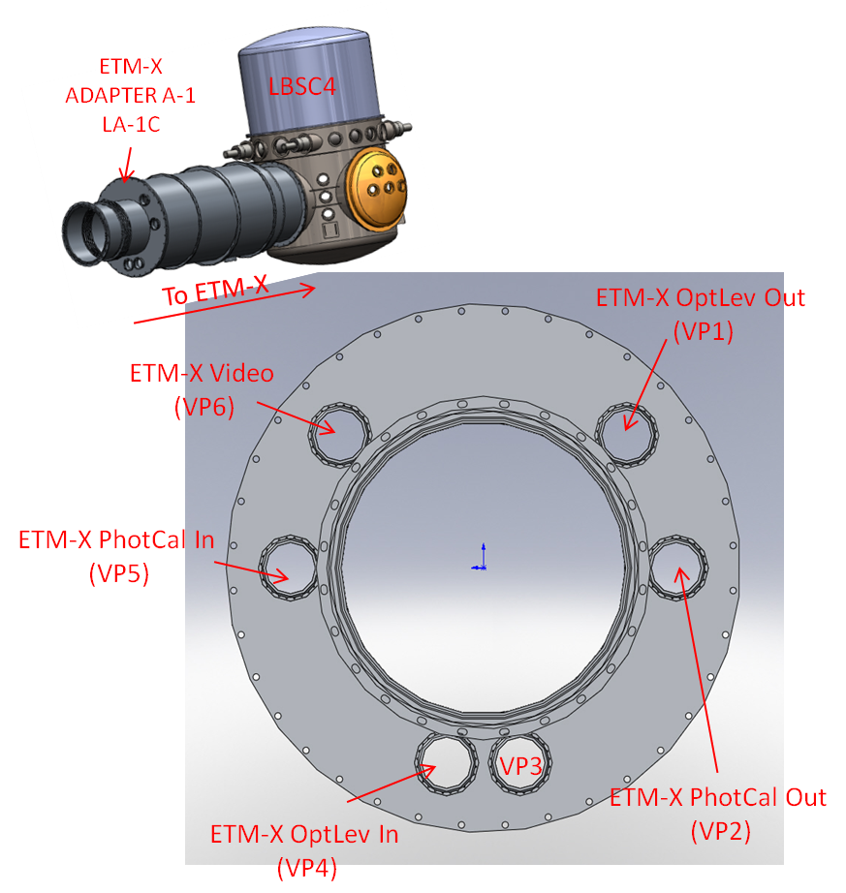

Figure 43: L1 ETM-X Adapter A-1 LA-1C

H1, H2 ETM-Y Adapter A-1 FLANGE
The locations of the H1, H2 ETM-Y Adapter A-1 WA-1B Viewports are shown in Figure 44.

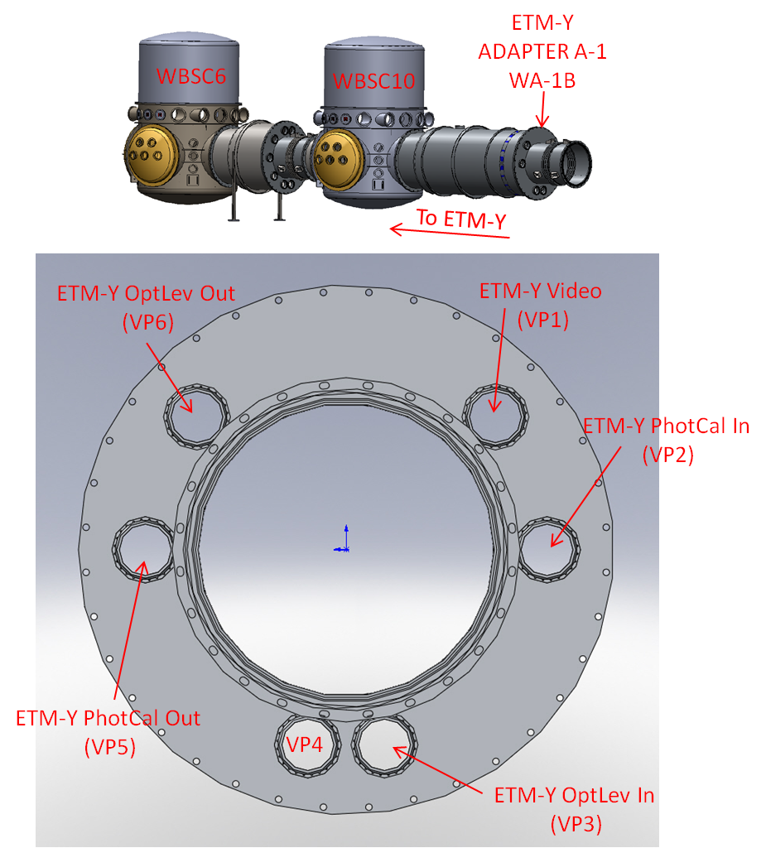

Figure 44: H1, H2 ETM-Y Adapter A-1 WA-1B

L1 ETM-Y Adapter A-1 FLANGE
The locations of the L1 ETM-Y Adapter A-1 LA-1D Viewports are shown in Figure 45.

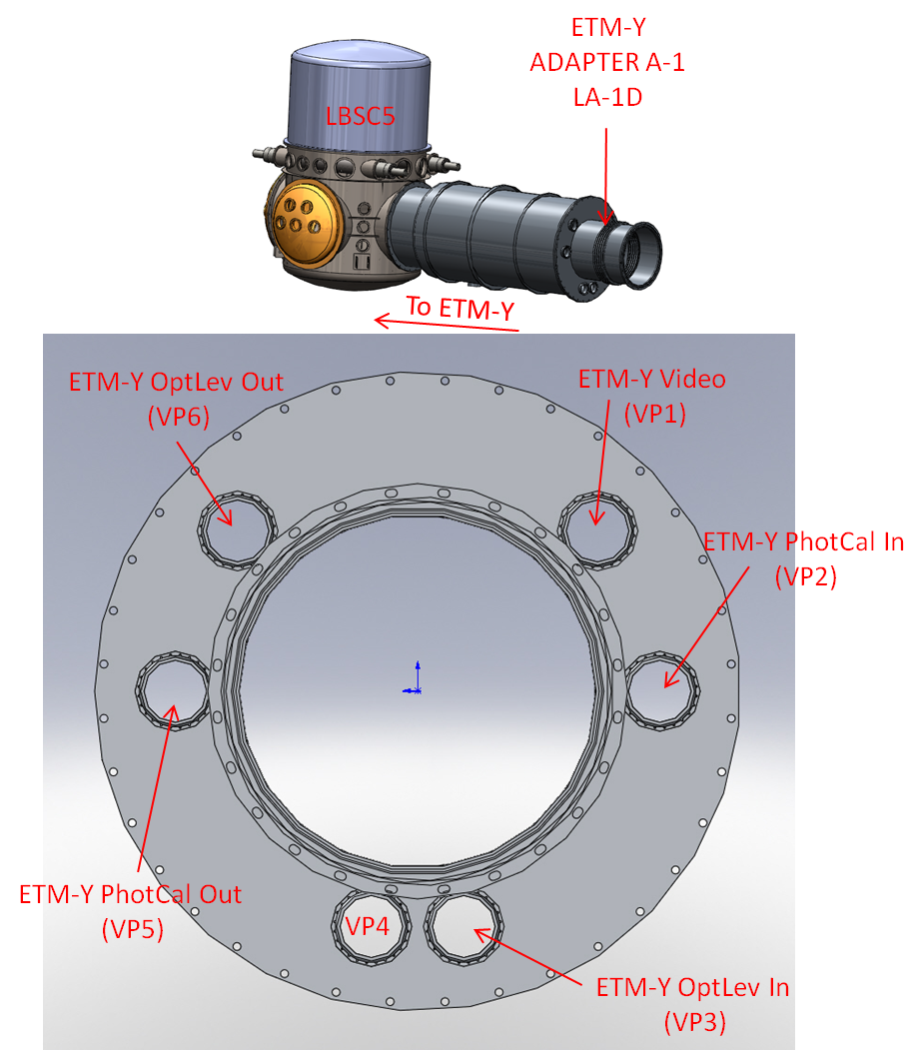

Figure 45: L1 ETM-Y Adapter A-1 LA-1D

D1001661 - H1, L1 Input Septum Plate Port Locations
The septum viewports between HAM1 and HAM2 allow passage of 1) PSL input beam, 2) REFL beam, 3) POB reference beam, and 4) the Arm Length Stabilization beam.

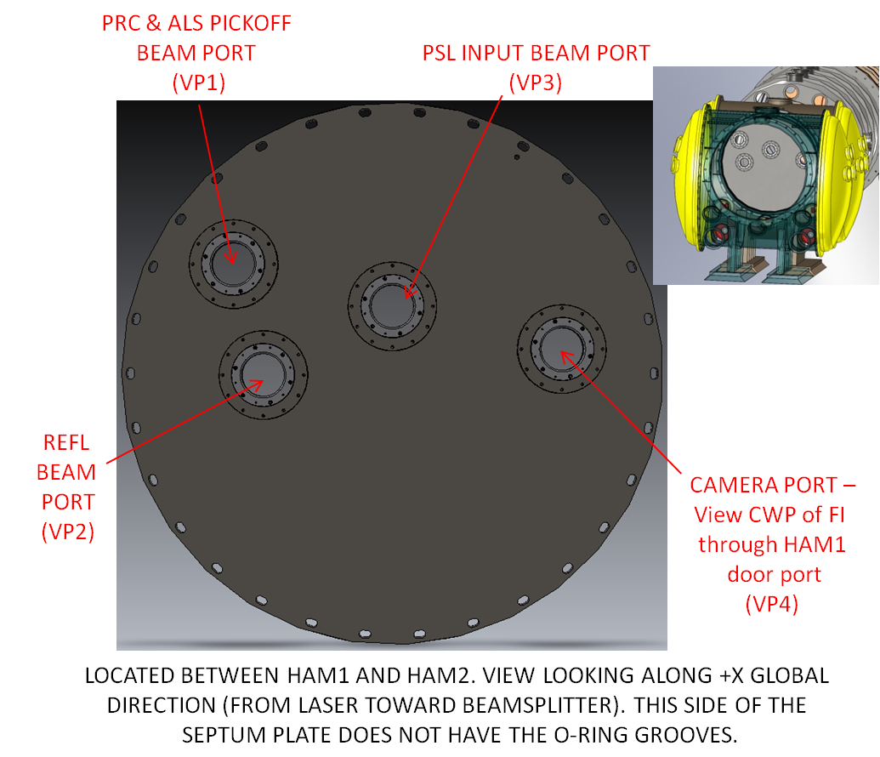

Figure 46: H1, L1 Input Septum Plate Port Locations

D1001662 H1, L1 Output Septum Plate Port Locations
The septum viewports between HAM5 and HAM6 allow passage of the 1) Signal beam, 2) TBD beams.
The septum plate viewports that were installed in Enhanced LIGO will be re-used for Advanced LIGO.

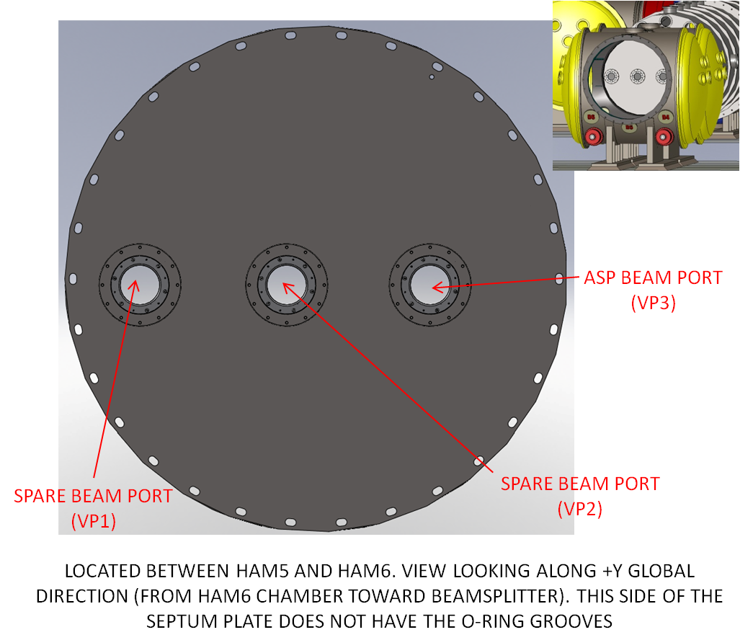

Figure 47: H1, L1 Output Septum Plate Port Locations

D1003343 H1, L1 Temporary PRC Septum Plate Port Location
This power recycling cavity (PRC) Septum Plate will be installed at the beam tube flange of HAM3 that faces BSC2. The H1, L1 PRC Septum Plate viewport name and location is shown in Figure 48.

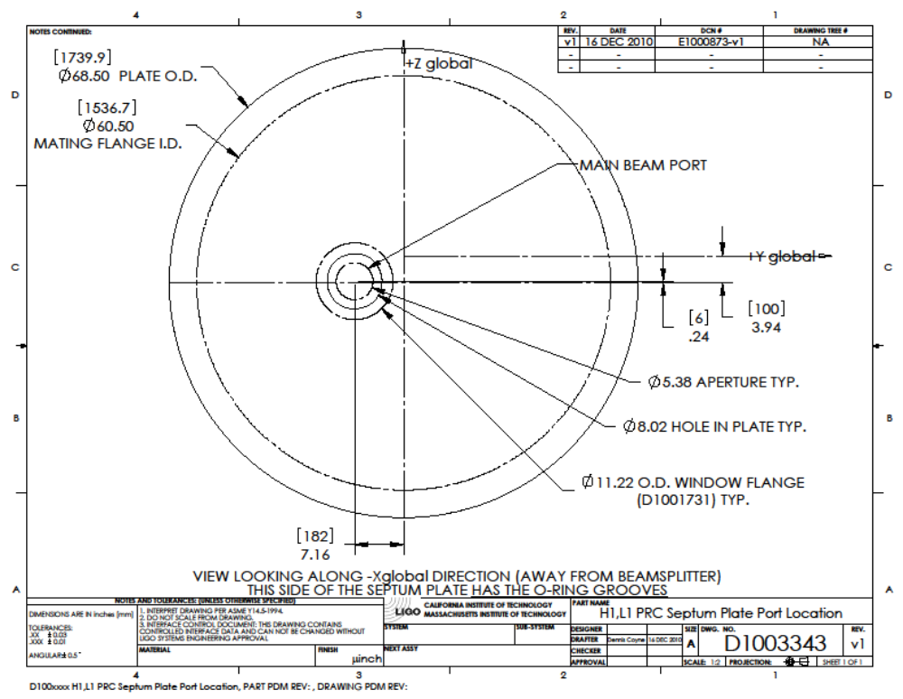

Figure 48: H1, L1 Temporary PRC Septum Plate Port Location

H2, Folded IFO

WBSC4
The locations of the WBSC4 viewports are shown in Figure 49.

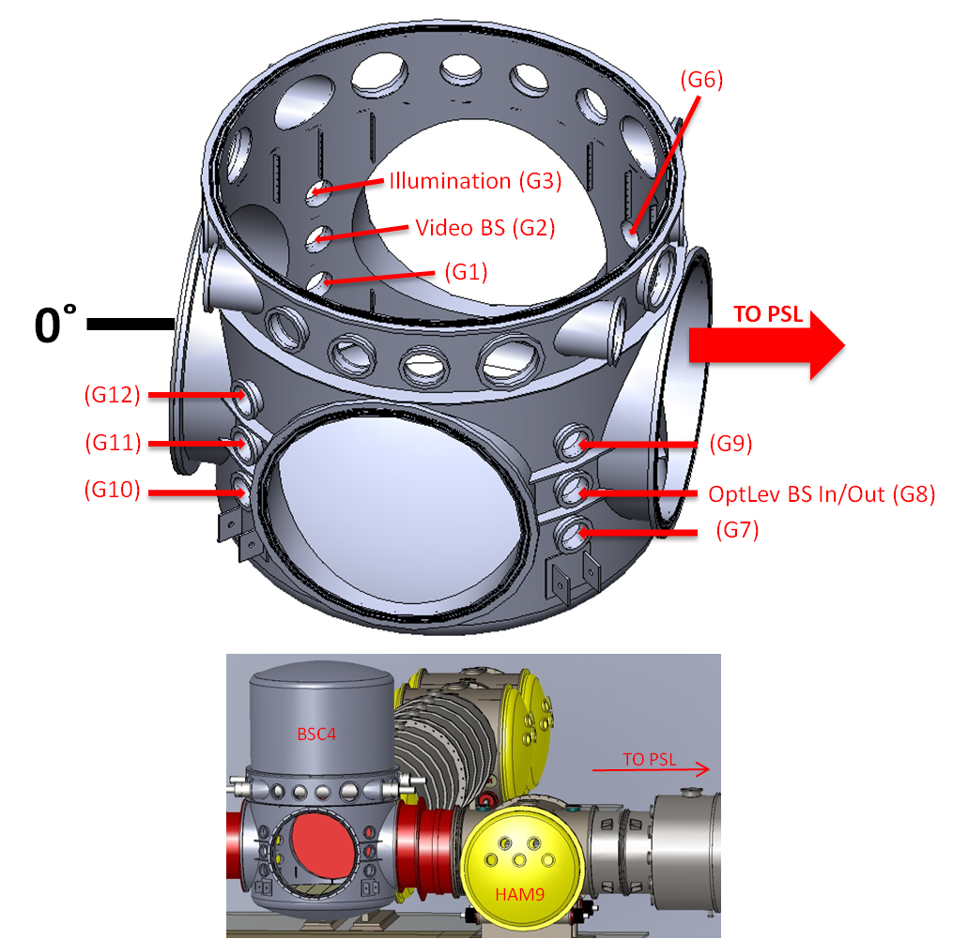
Figure 49: WBSC4 Viewports

WBSC7
The locations of the WBSC7 viewports are shown in Figure 50.

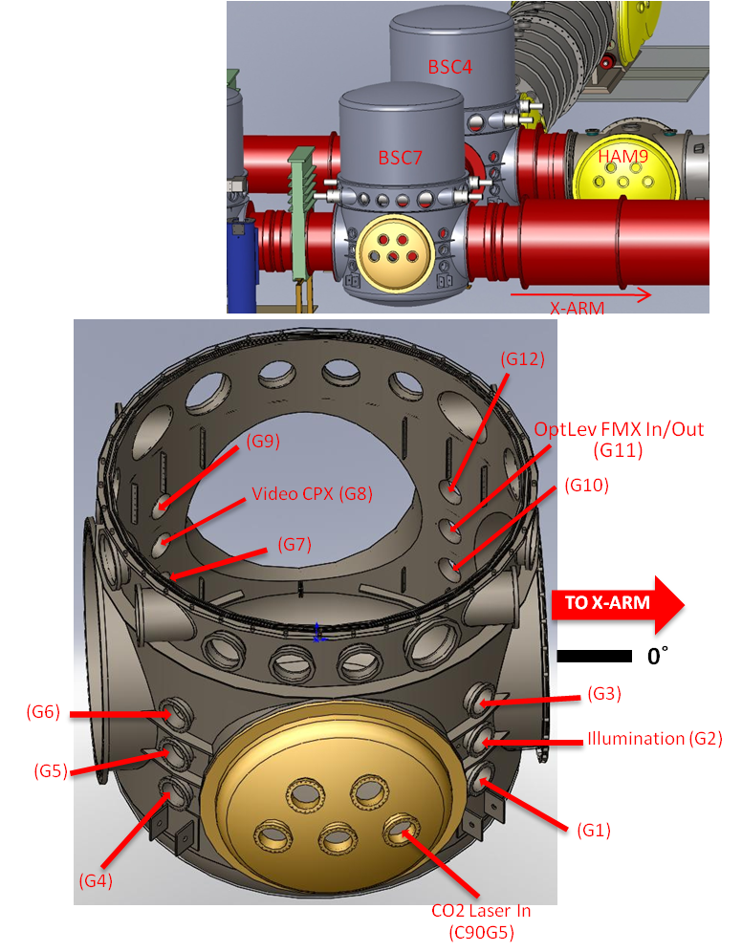
Figure 50: WBSC7 Viewports

WBSC8
The locations of the WBSC8 viewports are shown in Figure 51.

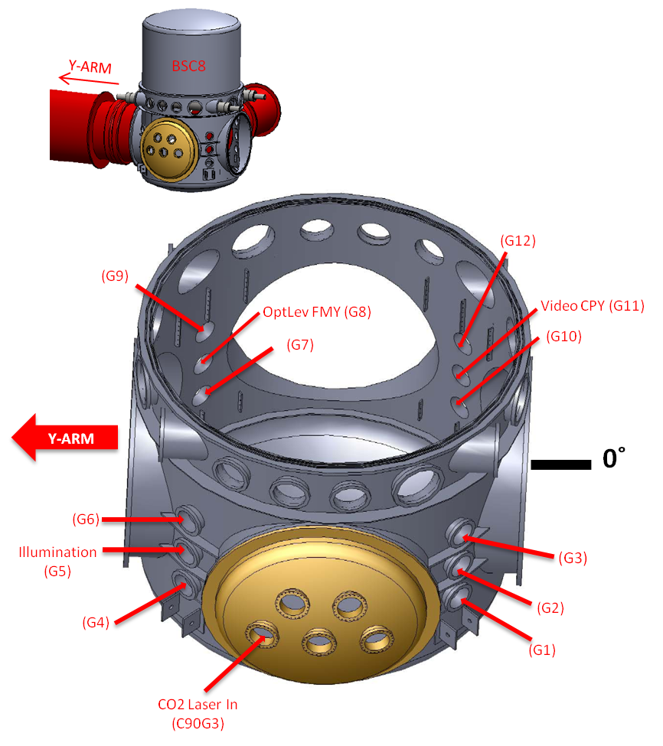

Figure 51: WBSC8 Viewports

WBSC5
The locations of the WBSC5 viewports are shown in Figure 52.

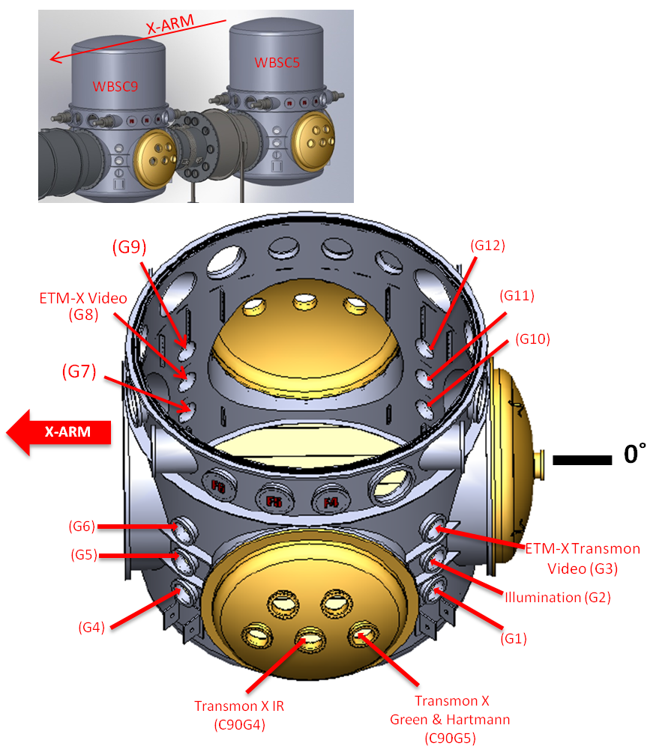
Figure 52: WBSC5 Viewports
.

WBSC6
The locations of the WBSC6 viewports are shown in Figure 53.

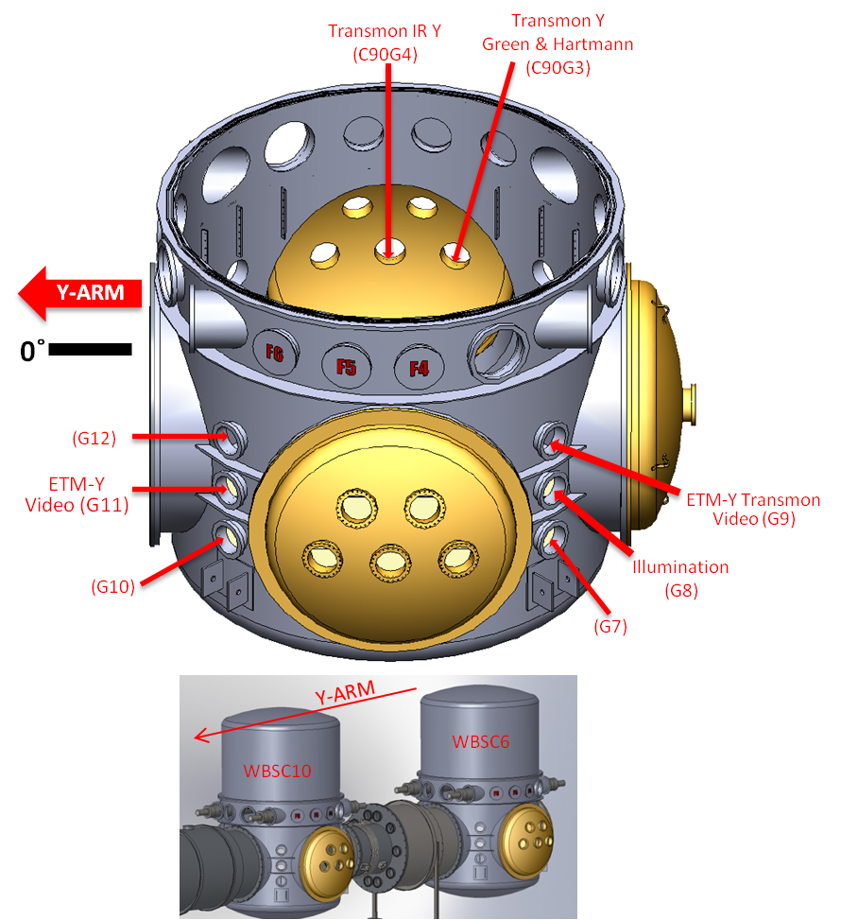
Figure 53: WBSC6 Viewports

WHAM7

Figure 54: WHAM7

WHAM8
The locations of the WHAM8 viewports are shown in Figure 55.

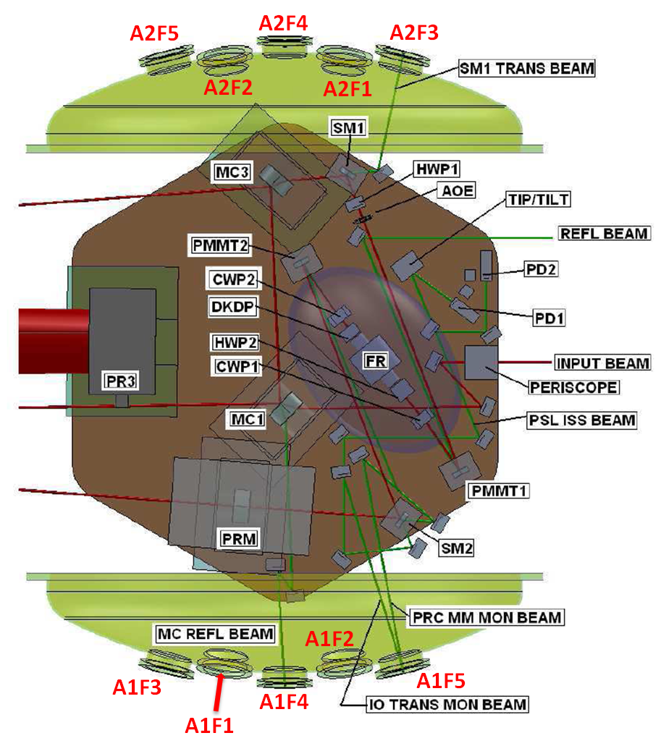

Figure 55: WHAM8 Viewports

WHAM9
The locations of the WHAM9 viewports are shown in Figure 56.

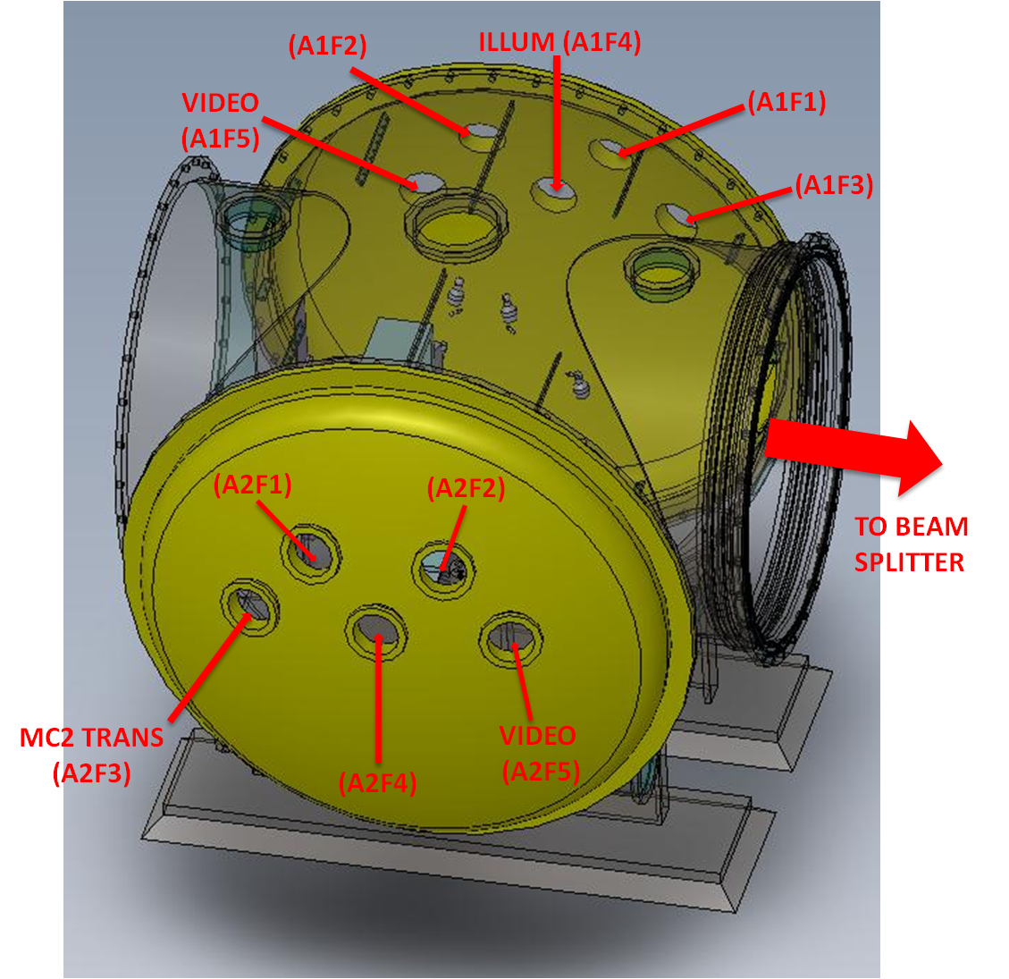
Figure 56: WHAM9 Viewports

WHAM10
The locations of the WHAM10 viewports are shown in Figure 57.

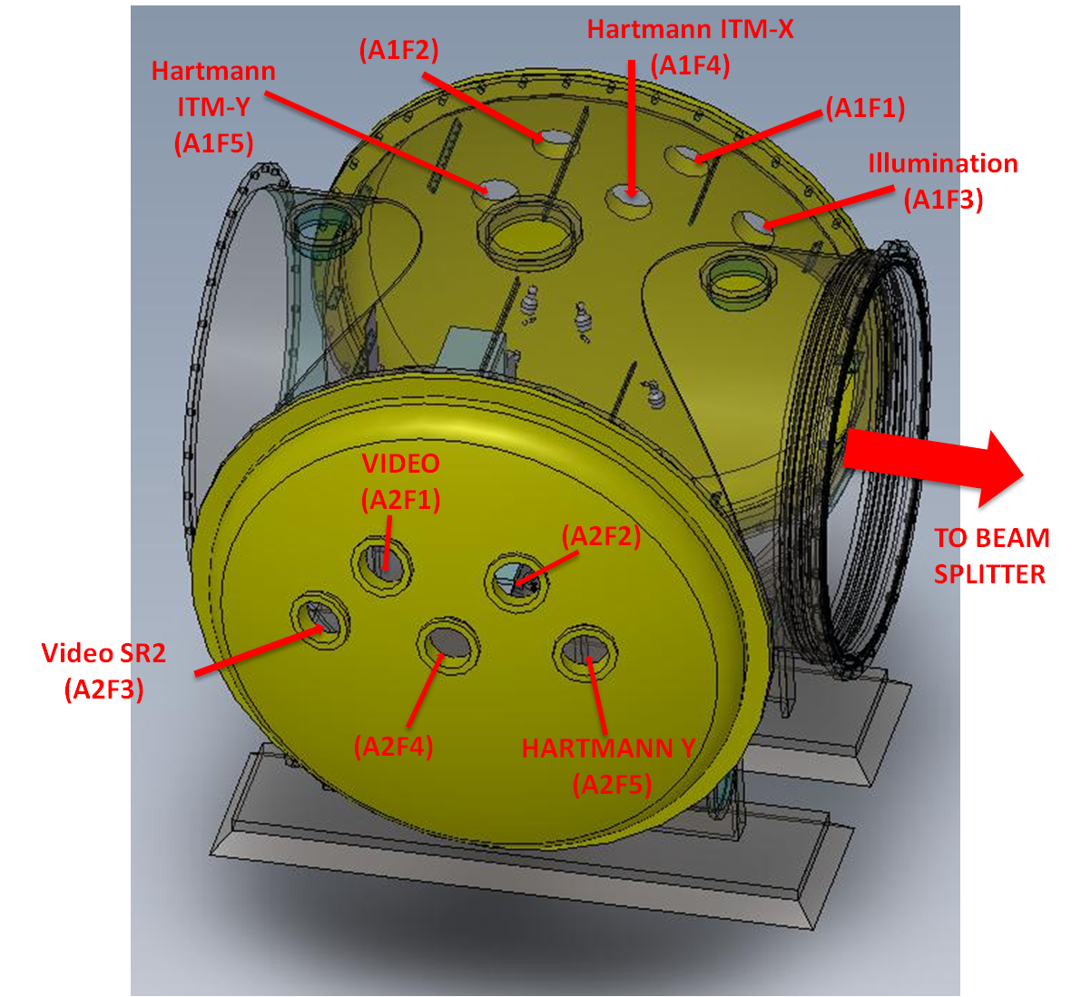
Figure 57: WHAM10 Viewports

WHAM11
The locations of the WHAM11 viewports are shown in Figure 58.

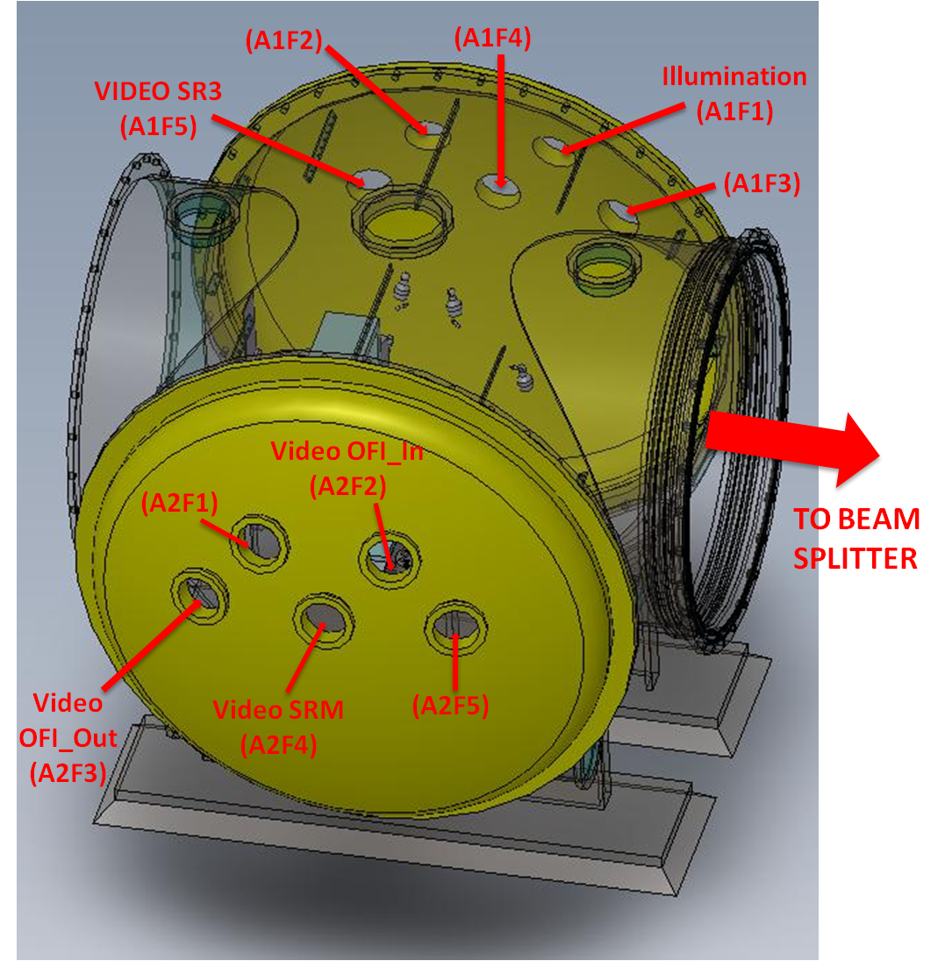
Figure 58: WHAM11 Viewports

WHAM12

Figure 59: WHAM 12

WAMCA3
The locations of the WAMCA3 viewports are shown in Figure 60.

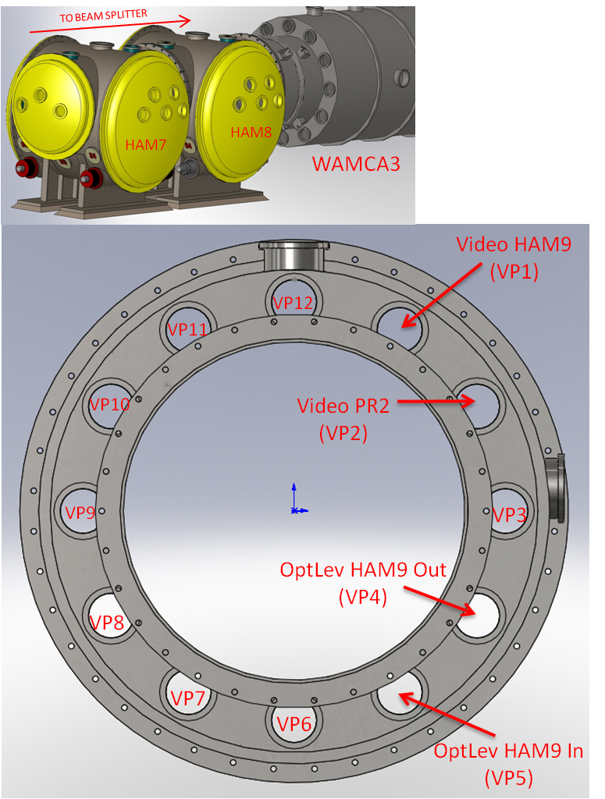

Figure 60: WAMCA3 Viewports

WAMCB3
The locations of the WAMCB3 viewports are shown in Figure 61.

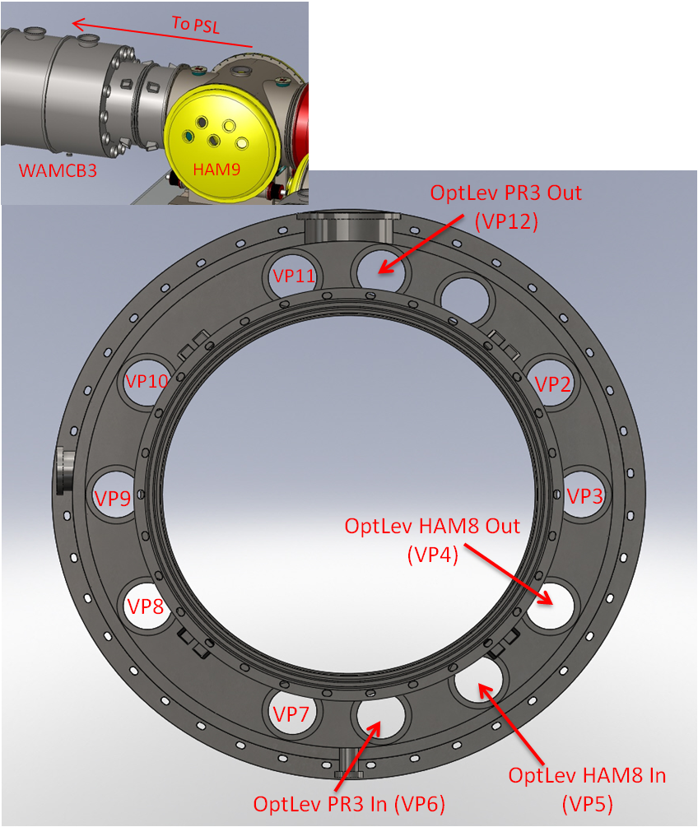

Figure 61: WAMCB3 Viewports

WAMCA4
The locations of the WAMCA4 viewports are shown in Figure 62.

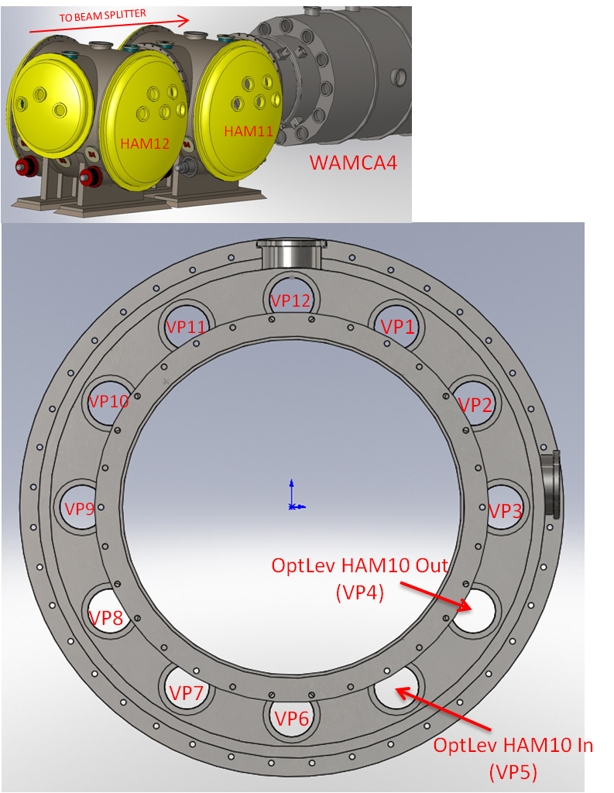

Figure 62: WAMCA4 Viewports

WAMCB4
The locations of the WAMCB4 viewports are shown in Figure 63.

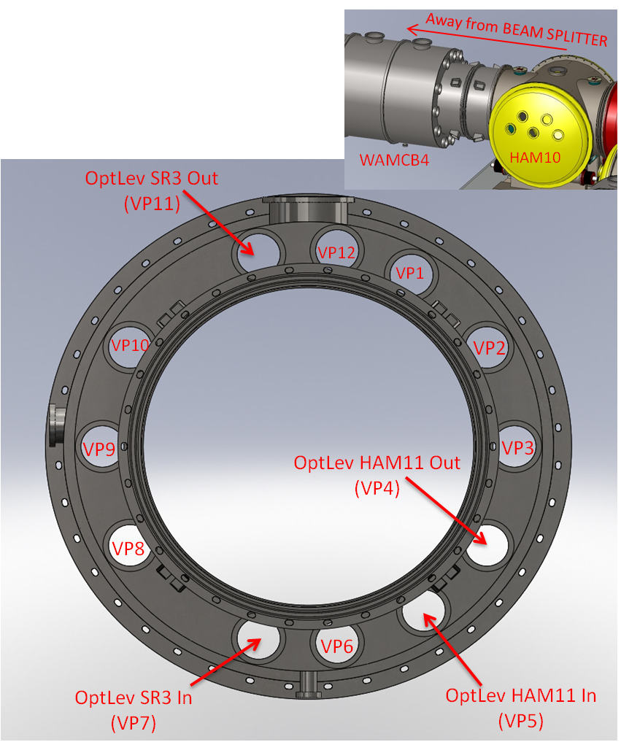

Figure 63: WAMCB4 Viewports

H2 Adapter A-1 FLANGE Viewports
H2 ETM-X Adapter A-1 viewports are identified in Section 6.1.20.
H2 ETM-Y Adapter A-1 viewports are identified in Section 6.1.22.

H2 ETM-X Adapter A-17A
The locations of the H2 ETM-X Adapter A-17A viewports are shown in Figure 64.

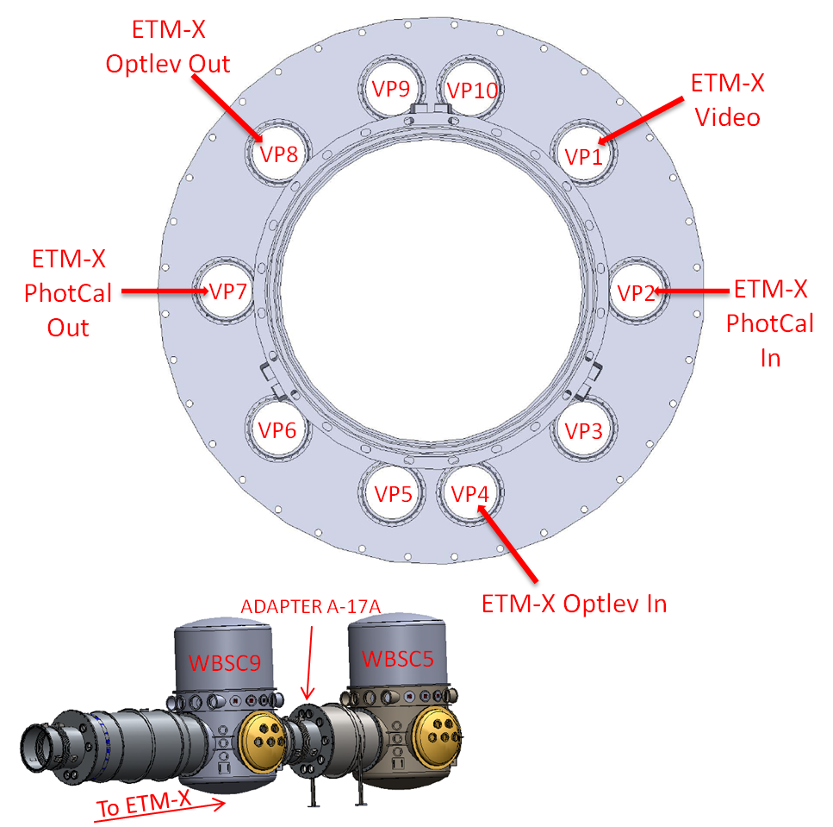

Figure 64: H2 ETM-X Adapter A-17A

H2 ETM-Y Adapter A-17B
The locations of the H2 ETM-Y Adapter A-17B viewports are shown in Figure 65.

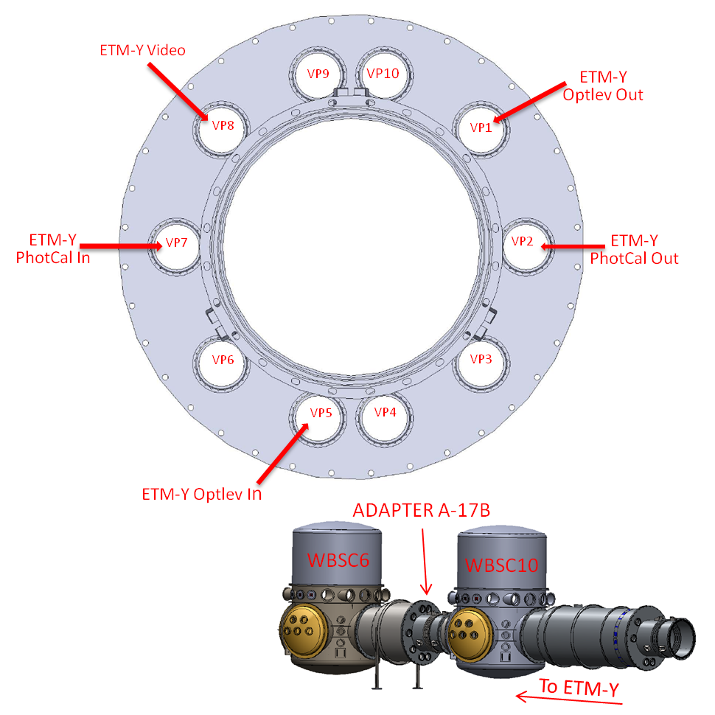

Figure 65: H2 ETM-Y Adapter A-17B

D1001665 H2 Input Septum Plate Port Locations
The septum viewports between HAM7 and HAM8 allow passage of 1) PSL input beam, 2) REFL beam, 3) POB reference beam, and 4) the Arm Length Stabilization beam.

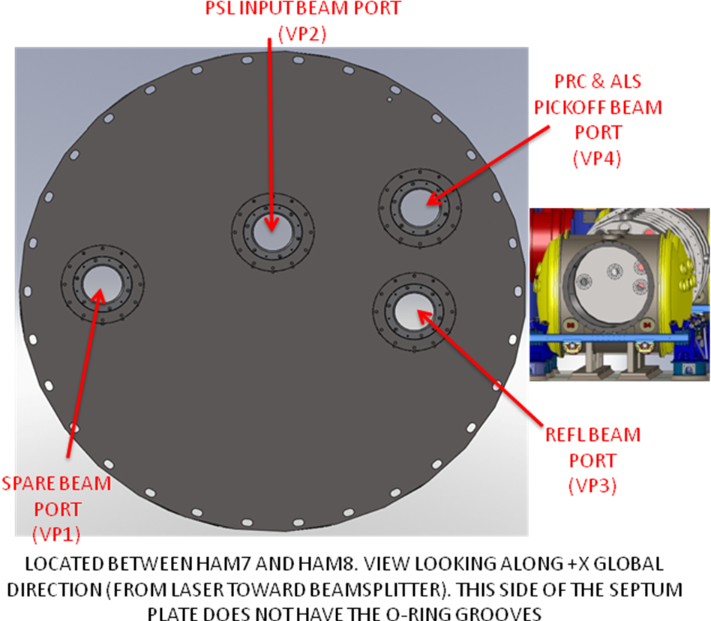

Figure 66: H2 Input Septum Plate Port Locations

D1001666 H2 Output Septum Plate Port Locations
The septum viewports between HAM11 and HAM12 allow passage of the 1) Signal beam, 2) TBD beams.

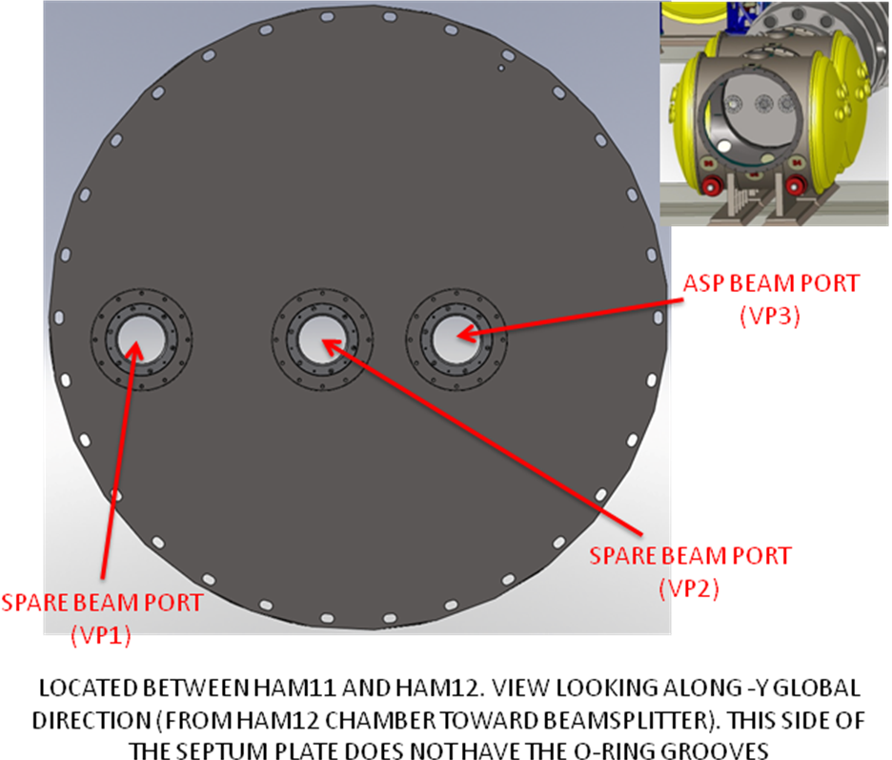

Figure 67: H2 Output Septum Plate Port Locations

D1003344 H2 Temporary PRC Septum Plate Port Location
This PRC Septum Plate will be installed at the beam tube flange of HAM9 that faces BSC4. The H2 PRC Septum Plate viewport name and location is shown in Figure 68.

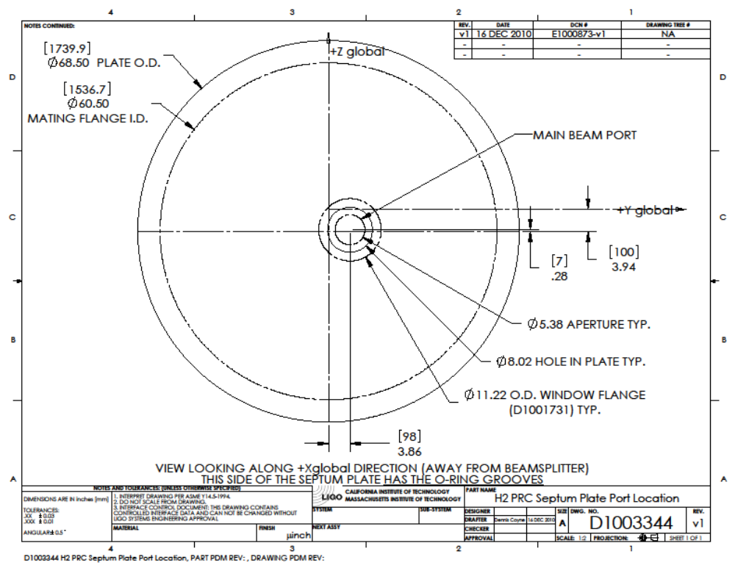
Figure 68: H2 Temporary PRC Septum Plate Port Location

Summary of Viewports
The viewport descriptions for H1, H2, and L1 interferometers are presented in the following tables.

Table 1: H1 Viewports
IFO | CHAMBER | VIEWPORT | FUNCTION | DESCRIPTION | VIEWPORT P/N
H1 | A1-B | VP2 | PHOTCAL1-2 | ETMY-IN | 6.0 in-AR1064/532
H1 | A1-B | VP5 | PHOTCAL1-2 | ETMY-OUT | 6.0 in-AR1064/532
H1 | A-1B | VP3 | OPTLEV | ETMY-IN | 7.8 DIA, ISI 4.9722012-AR635
H1 | A-1B | VP6 | OPTLEV | ETMY-OUT | 7.8 DIA, ISI 4.9722012-AR635
H1 | A1-C | VP1 | OPTLEV | F-ITMX-OUT | 7.8 DIA, ISI 4.9722012-AR635
H1 | A1-C | VP3 | OPTLEV | ITMX-IN | 7.8 DIA, ISI 4.9722012-AR635
H1 | A1-C | VP4 | OPTLEV | F-ITMX-IN | 7.8 DIA, ISI 4.9722012-AR635
H1 | A1-C | VP5 | VIDEO | ITMX | 5.4 DIA VP800/450009
H1 | A1-C | VP6 | OPTLEV | ITMX-OUT | 7.8 DIA, ISI 4.9722012-AR635
H1 | A1-E | VP1 | OPTLEV | ETMX-OUT | 7.8 DIA, ISI 4.9722012-AR635
H1 | A1-E | VP2 | PHOTCAL1-2 | ETMX-OUT | 6.0 in-AR1064/532
H1 | A1-E | VP4 | OPTLEV | ETMX-IN | 7.8 DIA, ISI 4.9722012-AR635
H1 | A1-E | VP5 | PHOTCAL1-2 | ETMX-IN | 6.0 in-AR1064/532
H1 | A1-F | VP1 | OPTLEV | ITMY-OUT | 7.8 DIA, ISI 4.9722012-AR635
H1 | A1-F | VP2 | VIDEO | ITMY | 5.4 DIA VP800/450009
H1 | A1-F | VP3 | OPTLEV | F-ITMY-IN | 7.8 DIA, ISI 4.9722012-AR635
H1 | A1-F | VP4 | OPTLEV | ITMY-IN | 7.8 DIA, ISI 4.9722012-AR635
H1 | A1-F | VP6 | OPTLEV | F-ITMY-OUT | 7.8 DIA, ISI 4.9722012-AR635
H1 | BSC1 | G11 | VIDEO | ITMY-CP | 5.4 DIA VP800/450009
H1 | BSC1 | G2 | VIDEO | ITMY | 5.4 DIA VP800/450009
H1 | BSC1 | G3 | ILLUMINATION |  | 5.4 DIA VP800/450009
H1 | BSC10 | G11 | VIDEO | ETMY | 5.4 DIA VP800/450009
H1 | BSC10 | G8 | ILLUMINATION |  | 5.4 DIA VP800/450009
H1 | BSC10 | G9 | VIDEO | TRANSMONY | 5.4 DIA VP800/450009
H1 | BSC10-S | C90G3 | DIAGNOSTIC | TRANSMONY GREEN-HARTMANN | 6.0 in-AR1064/532
H1 | BSC10-S | C90G4 | DIAGNOSTIC | TRANSMONY-IR | 5.4 DIA VP800-AR1064
H1 | BSC1-S | C180G3 | CO2-LASER | ITMY-IN | TCS
H1 | BSC2 | G2 | OPTLEV | BS-IN/OUT | 2.7 DIA, MDC450004-AR635
H1 | BSC2 | G8 | VIDEO | BS | 5.4 DIA VP800/450009
H1 | BSC2 | G9 | ILLUMINATION |  | 5.4 DIA VP800/450009
H1 | BSC3 | G1 | VIDEO | ITMX-CP | 5.4 DIA VP800/450009
H1 | BSC3 | G10 | VIDEO | ITMX | 5.4 DIA VP800/450009
H1 | BSC3 | G11 | ILLUMINATION |  | 5.4 DIA VP800/450009
H1 | BSC3-S | C180G5 | CO2-LASER | ITMX-IN | TCS
H1 | BSC9 | G2 | ILLUMINATION | RMX | 5.4 DIA VP800/450009
H1 | BSC9 | G3 | VIDEO | TRANSMONX | 5.4 DIA VP800/450009
H1 | BSC9 | G4 | VIDEO | ETMX | 5.4 DIA VP800/450009
H1 | BSC9-S | C90G4 | DIAGNOSTIC | TRANSMONX-IR | 5.4 DIA VP800-AR1064
H1 | BSC9-S | C90G5 | DIAGNOSTIC | TRANSMONX GREEN-HARTMANN | 6.0 in-AR1064/532
H1 | HAM1 | VPA1F3 | DIAGNOSTIC | POP-REFL | 5.4 DIA VP800-AR1064
H1 | HAM1 | VPA1F4 | DIAGNOSTIC | ALS-GREEN-BEAM | 5.4 DIA VP800-AR532
H1 | HAM1 | VPA1F5 | DIAGNOSTIC | IR-PSL-BEAM | 5.4 DIA VP800-AR1064
H1 | HAM1 | VPA2F4 | ILLUMINATION |  | 5.4 DIA VP800/450009
H1 | HAM2 | VPA1F1 | ILLUM |  | 5.4 DIA VP800/450009
H1 | HAM2 | VPA1F2 | VIDEO | FI-OUT | 5.4 DIA VP800/450009
H1 | HAM2 | VPA1F4 | DIAGNOSTIC | MC-REFLBEAM | 5.4 DIA VP800-AR1064
H1 | HAM2 | VPA1F5 | VIDEO | SM1-TRANSBEAM | 5.4 DIA VP800/450009
H1 | HAM2 | VPA2F1 | VIDEO | SM1_FI-OUTPUT | 5.4 DIA VP800/450009
H1 | HAM2 | VPA2F3 | DIAGNOSTIC | PRC-MM-MONBEAM | 5.4 DIA VP800-AR1064
H1 | HAM2 | VPA2F4 | DIAGNOSTIC | IO-TRANS-MONBEAM | 5.4 DIA VP800-AR1064
H1 | HAM3 | VPA1F3 | DIAGNOSTIC | MC2-TRANS | 5.4 DIA VP800-AR1064
H1 | HAM3 | VPA1F4 | ILLUM |  | 5.4 DIA VP800/450009
H1 | HAM3 | VPA1F5 | VIDEO | MC2 | 5.4 DIA VP800/450009
H1 | HAM3 | VPA2F5 | VIDEO | PR2 | 5.4 DIA VP800/450009
H1 | HAM4 | VPA1F4 | ILLUM |  | 5.4 DIA VP800/450009
H1 | HAM4 | VPA2F2 | VIDEO | SR2 | 5.4 DIA VP800/450009
H1 | HAM4 | VPA2F3 | DIAGNOSTIC | HARTMANN_ITMX | 6.0 in-AR800-900
H1 | HAM4 | VPA2F4 | DIAGNOSTIC | HARTMANN_ITMY | 6.0 in-AR800-900
H1 | HAM5 | VPA1F4 | ILLUM |  | 5.4 DIA VP800/450009
H1 | HAM5 | VPA1F5 | VIDEO | SR3 | 5.4 DIA VP800/450009
H1 | HAM5 | VPA2F3 | SQUEEZE |  | 6.0 in-AR1064/532
H1 | HAM5 | VPA2F4 | VIDEO | OFI-IN | 5.4 DIA VP800/450009
H1 | HAM5 | VPA2F5 | VIDEO | SRM | 5.4 DIA VP800/450009
H1 | HAM6 | VPA1F1 | VIDEO | OMC-2 | 5.4 DIA VP800/450009
H1 | HAM6 | VPA1F2 | ILLUMINATION |  | 5.4 DIA VP800/450009
H1 | HAM6 | VPA2F1 | VIDEO | OMC-1 | 5.4 DIA VP800/450009
H1 | HAM6 | VPA2F3 | DIAGNOSTIC | OMC-TRANS | 5.4 DIA VP800-AR1064
H1 | SEPTUM | VP4 | DIAGNOSTIC | CAMERA PORT | SEPTUM VP
H1 | SEPTUM-IO | VP1 | DIAGNOSTIC | PRC & ALS PICKOFF BEAM PORT | SEPTUM VP
H1 | SEPTUM-IO | VP2 | DIAGNOSTIC | REFL BEAM PORT | SEPTUM VP
H1 | SEPTUM-IO | VP3 | DIAGNOSTIC | PSL INPUT BEAM PORT | SEPTUM VP
H1 | SEPTUM-OUT | VP1 | OUT | SPARE BEAM PORT | SEPTUM VP
H1 | SEPTUM-OUT | VP2 | OUT | SPARE BEAM PORT | SEPTUM VP
H1 | SEPTUM-OUT | VP3 | OUT | ASP BEAM PORT | SEPTUM VP
H1 | A1-B | VP2 | PHOTCAL1-2 | ETMY-IN | 6.0 in-AR1064/532
H1 | A1-B | VP5 | PHOTCAL1-2 | ETMY-OUT | 6.0 in-AR1064/532
H1 | A-1B | VP3 | OPTLEV | ETMY-IN | 7.8 DIA, ISI 4.9722012-AR635
H1 | A-1B | VP6 | OPTLEV | ETMY-OUT | 7.8 DIA, ISI 4.9722012-AR635
H1 | A1-C | VP1 | OPTLEV | F-ITMX-OUT | 7.8 DIA, ISI 4.9722012-AR635
H1 | A1-C | VP3 | OPTLEV | ITMX-IN | 7.8 DIA, ISI 4.9722012-AR635
H1 | A1-C | VP4 | OPTLEV | F-ITMX-IN | 7.8 DIA, ISI 4.9722012-AR635
H1 | A1-C | VP5 | VIDEO | ITMX | 5.4 DIA VP800/450009
H1 | A1-C | VP6 | OPTLEV | ITMX-OUT | 7.8 DIA, ISI 4.9722012-AR635
H1 | A1-E | VP1 | OPTLEV | ETMX-OUT | 7.8 DIA, ISI 4.9722012-AR635
H1 | A1-E | VP2 | PHOTCAL1-2 | ETMX-OUT | 6.0 in-AR1064/532
H1 | A1-E | VP4 | OPTLEV | ETMX-IN | 7.8 DIA, ISI 4.9722012-AR635
H1 | A1-E | VP5 | PHOTCAL1-2 | ETMX-IN | 6.0 in-AR1064/532
H1 | A1-F | VP1 | OPTLEV | ITMY-OUT | 7.8 DIA, ISI 4.9722012-AR635
H1 | A1-F | VP2 | VIDEO | ITMY | 5.4 DIA VP800/450009
H1 | A1-F | VP3 | OPTLEV | F-ITMY-IN | 7.8 DIA, ISI 4.9722012-AR635
H1 | A1-F | VP4 | OPTLEV | ITMY-IN | 7.8 DIA, ISI 4.9722012-AR635
H1 | A1-F | VP6 | OPTLEV | F-ITMY-OUT | 7.8 DIA, ISI 4.9722012-AR635
H1 | BSC1 | G11 | VIDEO | ITMY-CP | 5.4 DIA VP800/450009
H1 | BSC1 | G2 | VIDEO | ITMY | 5.4 DIA VP800/450009
H1 | BSC1 | G3 | ILLUMINATION |  | 5.4 DIA VP800/450009
H1 | BSC10 | G11 | VIDEO | ETMY | 5.4 DIA VP800/450009
H1 | BSC10 | G8 | ILLUMINATION |  | 5.4 DIA VP800/450009

Table 2: H2 Viewports
IFO | CHAMBER | VIEWPORT | FUNCTION | DESCRIPTION | VIEWPORT P/N
H2 | A-17A | VP3 | PHOTCAL | FETMX-IN | 6.0 in-AR1064/532
H2 | A-17A | VP5 | OPTLEV | FETMX-IN | 7.8 DIA, ISI 4.9722012-AR635
H2 | A-17A | VP8 | PHOTCAL | FETMX-OUT | 6.0 in-AR1064/532
H2 | A-17A | VP9 | OPTLEV | FETMX-OUT | 7.8 DIA, ISI 4.9722012-AR635
H2 | A-17B | VP2 | OPTLEV | FETMY-OUT | 7.8 DIA, ISI 4.9722012-AR635
H2 | A-17B | VP3 | PHOTCAL | FETMY-OUT | 6.0 in-AR1064/532
H2 | A-17B | VP6 | OPTLEV | FETMY-IN | 7.8 DIA, ISI 4.9722012-AR635
H2 | A-17B | VP8 | PHOTCAL | FETMY-IN | 6.0 in-AR1064/532
H2 | A1-C | VP1 | OPTLEV | FITMX-OUT | 7.8 DIA, ISI 4.9722012-AR635
H2 | A1-C | VP2A | C02-LASER | FITMX-IN | TCS
H2 | A1-C | VP2B | VIDEO | FITMX | TCS
H2 | A1-C | VP3 | OPTLEV | ITMX-IN | 7.8 DIA, ISI 4.9722012-AR635
H2 | A1-C | VP4 | OPTLEV | FITMX-IN | 7.8 DIA, ISI 4.9722012-AR635
H2 | A1-C | VP6 | OPTLEV | ITMX-OUT | 7.8 DIA, ISI 4.9722012-AR635
H2 | A1-F | VP1 | OPTLEV | ITMY-OUT | 7.8 DIA, ISI 4.9722012-AR635
H2 | A1-F | VP3 | OPTLEV | FITMY-IN | 7.8 DIA, ISI 4.9722012-AR635
H2 | A1-F | VP4 | OPTLEV | ITMY-IN | 7.8 DIA, ISI 4.9722012-AR635
H2 | A1-F | VP5A | C02-LASER | FITMY-IN | TCS
H2 | A1-F | VP5B | VIDEO | FITMY | TCS
H2 | A1-F | VP6 | OPTLEV | FITMY-OUT | 7.8 DIA, ISI 4.9722012-AR635
H2 | BSC4 | G2 | VIDEO | BS | 5.4 DIA VP800/450009
H2 | BSC4 | G8 | OPTLEV | BS_IN/OUT | 2.7 DIA, MDC450004-AR635
H2 | BSC5 | G2 | VIDEO | RMX | 5.4 DIA VP800/450009
H2 | BSC5 | G3 | VIDEO | ETMX_TRANSMON | 5.4 DIA VP800/450009
H2 | BSC5 | G4 | VIDEO | ETMX | 5.4 DIA VP800/450009
H2 | BSC5 | G8 | ILLUMINATION |  | 5.4 DIA VP800/450009
H2 | BSC5-S | C90G4 | DIAGNOSTIC | TRANSMONX-IR | 5.4 DIA VP800-AR1064
H2 | BSC5-S | C90G5 | DIAGNOSTIC | TRANSMONX-GREEN-HARTMANN | 6.0 in-AR1064/532
H2 | BSC6 | G11 | VIDEO | ETMY | 5.4 DIA VP800/450009
H2 | BSC6 | G8 | ILLUMINATION |  | 5.4 DIA VP800/450009
H2 | BSC6 | G9 | VIDEO | TRANSMONY | 5.4 DIA VP800/450009
H2 | BSC6-S | C90G3 | DIAGNOSTIC | TRANSMONY-GREEN-HARTMANN | 6.0 in-AR1064/532
H2 | BSC6-S | C90G4 | DIAGNOSTIC | TRANSMONY-IR | 5.4 DIA VP800-AR1064
H2 | BSC7 | G11 | OPTLEV | FMX-IN/OUT | 2.7 DIA, MDC450004-AR635
H2 | BSC7 | G2 | ILLUMINATION |  | 5.4 DIA VP800/450009
H2 | BSC7 | G8 | VIDEO | CPX | 5.4 DIA VP800/450009
H2 | BSC8 | G11 | VIDEO | CPY | 5.4 DIA VP800/450009
H2 | BSC8 | G5 | ILLUMINATION |  | 5.4 DIA VP800/450009
H2 | BSC8 | G8 | OPTLEV | FMY_IN/OUT | 2.7 DIA, MDC450004-AR635
H2 | HAM1 | VPA1F3 | DIAGNOSTIC | POP-REFL | 5.4 DIA VP800-AR1064
H2 | HAM1 | VPA1F4 | DIAGNOSTIC | ALS-GREEN-BEAM | 5.4 DIA VP800-AR532
H2 | HAM1 | VPA1F5 | DIAGNOSTIC | IR-PSL-BEAM | 5.4 DIA VP800-AR1064
H2 | HAM1 | VPA2F4 | ILLUMINATION |  | 5.4 DIA VP800/450009
H2 | HAM10 | VPA1F3 | ILLUMINATION |  | 5.4 DIA VP800/450009
H2 | HAM10 | VPA1F4 | DIAGNOSTIC | HARTMANN_ITMX | 6.0 in-AR800-900
H2 | HAM10 | VPA1F5 | DIAGNOSTIC | HARTMANN_ITMY | 6.0 in-AR800-900
H2 | HAM10 | VPA2F1 | VIDEO |  | 5.4 DIA VP800/450009
H2 | HAM10 | VPA2F3 | VIDEO | SR2 | 5.4 DIA VP800/450009
H2 | HAM11 | VPA1F1 | ILLUMINATION |  | 5.4 DIA VP800/450009
H2 | HAM11 | VPA1F5 | VIDEO | SR3 | 5.4 DIA VP800/450009
H2 | HAM11 | VPA2F1 | SQUEEZE |  | 6.0 in-AR1064/532
H2 | HAM11 | VPA2F2 | VIDEO | OFI_IN | 5.4 DIA VP800/450009
H2 | HAM11 | VPA2F3 | VIDEO | OFI_OUT | 5.4 DIA VP800/450009
H2 | HAM11 | VPA2F4 | VIDEO | SRM | 5.4 DIA VP800/450009
H2 | HAM12 | VPA1F1 | VIDEO | OMC2 | 5.4 DIA VP800/450009
H2 | HAM12 | VPA1F2 | VIDEO | OMC3 | 5.4 DIA VP800/450009
H2 | HAM12 | VPA1F3 | VIDEO | OMC4 | 5.4 DIA VP800/450009
H2 | HAM12 | VPA1F4 | VIDEO | OMC5 | 5.4 DIA VP800/450009
H2 | HAM12 | VPA2F1 | VIDEO | OMC1 | 5.4 DIA VP800/450009
H2 | HAM12 | VPA2F3 | VIDEO | OMC_REFL | 5.4 DIA VP800/450009
H2 | HAM12 | VPA2F4 | DIAGNOSTIC | OMC_REFL | 5.4 DIA VP800-AR1064
H2 | HAM12 | VPA2F5 | DIAGNOSTIC | OMC_TRANS | 5.4 DIA VP800-AR1064
H2 | HAM6 | VPBF1 | DIAGNOSTIC | AS | 5.4 DIA VP800-AR1064
H2 | HAM6 | VPBF3 | DIAGNOSTIC | OMC-REFL | 5.4 DIA VP800-AR1064
H2 | HAM8 | VPA1F1 | VIDEO |  | 5.4 DIA VP800/450009
H2 | HAM8 | VPA1F2 | VIDEO |  | 5.4 DIA VP800/450009
H2 | HAM8 | VPA1F3 | DIAGNOSTIC | SM1_TRANS | 5.4 DIA VP800-AR1064
H2 | HAM8 | VPA1F4 | VIDEO |  | 5.4 DIA VP800/450009
H2 | HAM8 | VPA1F5 | ILLUMINATION |  | 5.4 DIA VP800/450009
H2 | HAM8 | VPA2F1 | VIDEO |  | 5.4 DIA VP800/450009
H2 | HAM8 | VPA2F2 | VIDEO |  | 5.4 DIA VP800/450009
H2 | HAM8 | VPA2F3 | VIDEO |  | 5.4 DIA VP800/450009
H2 | HAM8 | VPA2F4 | DIAGNOSTIC | MC_REFL | 5.4 DIA VP800-AR1064
H2 | HAM8 | VPA2F5 | DIAGNOSTIC | IO_TRANSMON | 5.4 DIA VP800-AR1064
H2 | HAM8 | VPA2F5 | DIAGNOSTIC | PRC_MM_MON | 5.4 DIA VP800-AR1064
H2 | HAM9 | VPA1F4 | ILLUMINATION |  | 5.4 DIA VP800/450009
H2 | HAM9 | VPA1F5 | VIDEO | MC2 | 5.4 DIA VP800/450009
H2 | HAM9 | VPA2F3 | DIAGNOSTIC | MC2-TRANS | 5.4 DIA VP800-AR1064
H2 | HAM9 | VPA2F5 | VIDEO | PR2 | 5.4 DIA VP800/450009
H2 | WAMCA3 | VP2 | VIDEO | PR2 | 5.4 DIA VP800/450009
H2 | WAMCA3 | VP5 | OPTLEV | HAM9_IN/OUT | 7.8 DIA, ISI 4.9722012-AR635
H2 | WAMCA4 | VP5 | OPTLEV | HAM10-IN/OUT | 7.8 DIA, ISI 4.9722012-AR635
H2 | WAMCB3 | VP12 | OPTLEV | PR3_OUT | 7.8 DIA, ISI 4.9722012-AR635
H2 | WAMCB3 | VP5 | OPTLEV | HAM8_IN/OUT | 7.8 DIA, ISI 4.9722012-AR635
H2 | WAMCB3 | VP6 | OPTLEV | PR3_IN | 7.8 DIA, ISI 4.9722012-AR635
H2 | WAMCB4 | VP11 | OPTLEV | SR3-OUT | 7.8 DIA, ISI 4.9722012-AR635
H2 | WAMCB4 | VP12 | VIDEO | SR3 | 5.4 DIA VP800/450009
H2 | WAMCB4 | VP5 | OPTLEV | HAM11-IN/OUT | 7.8 DIA, ISI 4.9722012-AR635
H2 | WAMCB4 | VP7 | OPTLEV | SR3-IN | 7.8 DIA, ISI 4.9722012-AR635
H2 | A-17A | VP3 | PHOTCAL | FETMX-IN | 6.0 in-AR1064/532
H2 | A-17A | VP5 | OPTLEV | FETMX-IN | 7.8 DIA, ISI 4.9722012-AR635
H2 | A-17A | VP8 | PHOTCAL | FETMX-OUT | 6.0 in-AR1064/532
H2 | A-17A | VP9 | OPTLEV | FETMX-OUT | 7.8 DIA, ISI 4.9722012-AR635
H2 | A-17B | VP2 | OPTLEV | FETMY-OUT | 7.8 DIA, ISI 4.9722012-AR635
H2 | A-17B | VP3 | PHOTCAL | FETMY-OUT | 6.0 in-AR1064/532
H2 | A-17B | VP6 | OPTLEV | FETMY-IN | 7.8 DIA, ISI 4.9722012-AR635
H2 | A-17B | VP8 | PHOTCAL | FETMY-IN | 6.0 in-AR1064/532
H2 | A1-C | VP1 | OPTLEV | FITMX-OUT | 7.8 DIA, ISI 4.9722012-AR635
H2 | A1-C | VP2A | C02-LASER | FITMX-IN | TCS
H2 | A1-C | VP2B | VIDEO | FITMX | TCS
H2 | A1-C | VP3 | OPTLEV | ITMX-IN | 7.8 DIA, ISI 4.9722012-AR635
H2 | A1-C | VP4 | OPTLEV | FITMX-IN | 7.8 DIA, ISI 4.9722012-AR635
H2 | A1-C | VP6 | OPTLEV | ITMX-OUT | 7.8 DIA, ISI 4.9722012-AR635
H2 | SEPTUM | VP4 | DIAGNOSTIC | PRC & ALS PICKOFF BEAM PORT | SEPTUM VP
H2 | SEPTUM-IO | VP1 | DIAGNOSTIC | SPARE BEAM PORT | SEPTUM VP
H2 | SEPTUM-IO | VP2 | DIAGNOSTIC | PSL INPUT BEAM PORT | SEPTUM VP
H2 | SEPTUM-IO | VP3 | DIAGNOSTIC | REFL BEAM PORT | SEPTUM VP
H2 | SEPTUM-OUT | VP1 | OUT | SPARE BEAM PORT | SEPTUM VP
H2 | SEPTUM-OUT | VP2 | OUT | SPARE BEAM PORT | SEPTUM VP
H2 | SEPTUM-OUT | VP3 | OUT | ASP BEAM PORT | SEPTUM VP

Table 3: L1 Viewports

IFO | CHAMBER | VIEWPORT | DESCRIPTION |  | VIEWPORT P/N
L1 | A1-A | VP1 | OPTLEV | F-ITMX-OUT | 7.8 DIA, ISI 4.9722012-AR635
L1 | A1-A | VP3 | OPTLEV | ITMX-IN | 7.8 DIA, ISI 4.9722012-AR635
L1 | A1-A | VP4 | OPTLEV | F-ITMX-IN | 7.8 DIA, ISI 4.9722012-AR635
L1 | A1-A | VP5 | VIDEO | ITMX | 5.4 DIA VP800/450009
L1 | A1-A | VP6 | OPTLEV | ITMX-OUT | 7.8 DIA, ISI 4.9722012-AR635
L1 | A1-B | VP1 | OPTLEV | ITMY-OUT | 7.8 DIA, ISI 4.9722012-AR635
L1 | A1-B | VP2 | PHOTCAL1-2 | ETMY-IN | 6.0 in-AR1064/532
L1 | A1-B | VP2 | VIDEO | ITMY | 5.4 DIA VP800/450009
L1 | A1-B | VP3 | OPTLEV | F-ITMY-IN | 7.8 DIA, ISI 4.9722012-AR635
L1 | A1-B | VP3 | OPTLEV | ETMY-IN | 7.8 DIA, ISI 4.9722012-AR635
L1 | A1-B | VP4 | OPTLEV | ITMY-IN | 7.8 DIA, ISI 4.9722012-AR635
L1 | A1-B | VP5 | PHOTCAL1-2 | ETMY-OUT | 6.0 in-AR1064/532
L1 | A1-B | VP6 | OPTLEV | F-ITMY-OUT | 7.8 DIA, ISI 4.9722012-AR635
L1 | A1-B | VP6 | OPTLEV | ETMY-OUT | 7.8 DIA, ISI 4.9722012-AR635
L1 | A1-E | VP1 | OPTLEV | ETMX-OUT | 7.8 DIA, ISI 4.9722012-AR635
L1 | A1-E | VP2 | PHOTCAL1-2 | ETMX-OUT | 6.0 in-AR1064/532
L1 | A1-E | VP4 | OPTLEV | ETMX-IN | 7.8 DIA, ISI 4.9722012-AR635
L1 | A1-E | VP5 | PHOTCAL1-2 | ETMX-IN | 6.0 in-AR1064/532
L1 | BSC1 | G11 | VIDEO | ITMY-CP | 5.4 DIA VP800/450009
L1 | BSC1 | G2 | VIDEO | ITMY | 5.4 DIA VP800/450009
L1 | BSC1 | G3 | ILLUMINATION |  | 5.4 DIA VP800/450009
L1 | BSC1-S | C180G3 | CO2-LASER | ITMY-IN | TCS
L1 | BSC2 | G2 | OPTLEV | BS-IN/OUT | 2.7 DIA, MDC450004-AR635
L1 | BSC2 | G8 | VIDEO | BS | 5.4 DIA VP800/450009
L1 | BSC2 | G9 | ILLUMINATION |  | 5.4 DIA VP800/450009
L1 | BSC3 | G1 | VIDEO | ITMX-CP | 5.4 DIA VP800/450009
L1 | BSC3 | G10 | VIDEO | ITMX | 5.4 DIA VP800/450009
L1 | BSC3 | G11 | ILLUMINATION |  | 5.4 DIA VP800/450009
L1 | BSC3-S | C180G5 | CO2-LASER | ITMX-IN | TCS
L1 | BSC4 | G2 | ILLUMINATION | RMX | 5.4 DIA VP800/450009
L1 | BSC4 | G3 | VIDEO | TRANSMONX | 5.4 DIA VP800/450009
L1 | BSC4 | G4 | VIDEO | ETMX | 5.4 DIA VP800/450009
L1 | BSC4-S | C90G4 | DIAGNOSTIC | TRANSMONX-IR | 5.4 DIA VP800-AR1064
L1 | BSC4-S | C90G5 | DIAGNOSTIC | TRANSMONX GREEN-HARTMANN | 6.0 in-AR1064/532
L1 | BSC5 | C90G4 | DIAGNOSTIC | TRANSMONY-IR | 5.4 DIA VP800-AR1064
L1 | BSC5 | G11 | VIDEO | ETMY | 5.4 DIA VP800/450009
L1 | BSC5 | G8 | ILLUMINATION |  | 5.4 DIA VP800/450009
L1 | BSC5 | G9 | VIDEO | TRANSMONY | 5.4 DIA VP800/450009
L1 | BSC5-S | C90G3 | DIAGNOSTIC | TRANSMONY GREEN-HARTMANN | 6.0 in-AR1064/532
L1 | HAM1 | VPA1F3 | DIAGNOSTIC | POP-REFL | 5.4 DIA VP800-AR1064
L1 | HAM1 | VPA1F4 | DIAGNOSTIC | ALS-GREEN-BEAM | 5.4 DIA VP800-AR532
L1 | HAM1 | VPA1F5 | DIAGNOSTIC | IR-PSL-BEAM | 5.4 DIA VP800-AR1064
L1 | HAM1 | VPA2F4 | ILLUMINATION |  | 5.4 DIA VP800/450009
L1 | HAM2 | VPA1F1 | ILLUM |  | 5.4 DIA VP800/450009
L1 | HAM2 | VPA1F2 | VIDEO | FI-OUT | 5.4 DIA VP800/450009
L1 | HAM2 | VPA1F4 | DIAGNOSTIC | MC-REFLBEAM | 5.4 DIA VP800-AR1064
L1 | HAM2 | VPA1F5 | VIDEO | SM1-TRANSBEAM | 5.4 DIA VP800/450009
L1 | HAM2 | VPA2F1 | VIDEO | SM1_FI-OUTPUT | 5.4 DIA VP800/450009
L1 | HAM2 | VPA2F3 | DIAGNOSTIC | PRC-MM-MONBEAM | 5.4 DIA VP800-AR1064
L1 | HAM2 | VPA2F4 | DIAGNOSTIC | IO-TRANS-MONBEAM | 5.4 DIA VP800-AR1064
L1 | HAM3 | VPA1F3 | DIAGNOSTIC | MC2-TRANS | 5.4 DIA VP800-AR1064
L1 | HAM3 | VPA1F4 | ILLUM |  | 5.4 DIA VP800/450009
L1 | HAM3 | VPA1F5 | VIDEO | MC2 | 5.4 DIA VP800/450009
L1 | HAM3 | VPA2F5 | VIDEO | PR2 | 5.4 DIA VP800/450009
L1 | HAM4 | VPA1F4 | ILLUM |  | 5.4 DIA VP800/450009
L1 | HAM4 | VPA2F2 | VIDEO | SR2 | 5.4 DIA VP800/450009
L1 | HAM4 | VPA2F3 | DIAGNOSTIC | HARTMANN_ITMX | 6.0 in-AR800-900
L1 | HAM4 | VPA2F4 | DIAGNOSTIC | HARTMANN_ITMY | 6.0 in-AR800-900
L1 | HAM5 | VPA1F4 | ILLUM |  | 5.4 DIA VP800/450009
L1 | HAM5 | VPA1F5 | VIDEO | SR3 | 5.4 DIA VP800/450009
L1 | HAM5 | VPA2F3 | SQUEEZE |  | 6.0 in-AR1064/532
L1 | HAM5 | VPA2F4 | VIDEO | OFI-IN | 5.4 DIA VP800/450009
L1 | HAM5 | VPA2F5 | VIDEO | SRM | 5.4 DIA VP800/450009
L1 | HAM6 | VPA1F1 | VIDEO | OMC-2 | 5.4 DIA VP800/450009
L1 | HAM6 | VPA1F2 | ILLUMINATION |  | 5.4 DIA VP800/450009
L1 | HAM6 | VPA2F1 | VIDEO | OMC-1 | 5.4 DIA VP800/450009
L1 | HAM6 | VPA2F3 | DIAGNOSTIC | OMC-TRANS | 5.4 DIA VP800-AR1064
L1 | SEPTUM | VP4 | DIAGNOSTIC | CAMERA PORT | SEPTUM VP
L1 | SEPTUM-IO | VP1 | DIAGNOSTIC | PRC & ALS PICKOFF BEAM PORT | SEPTUM VP
L1 | SEPTUM-IO | VP2 | DIAGNOSTIC | REFL BEAM PORT | SEPTUM VP
L1 | SEPTUM-IO | VP3 | DIAGNOSTIC | PSL INPUT BEAM PORT | SEPTUM VP
L1 | SEPTUM-OUT | VP1 | OUT | SPARE BEAM PORT | SEPTUM VP
L1 | SEPTUM-OUT | VP2 | OUT | SPARE BEAM PORT | SEPTUM VP
L1 | SEPTUM-OUT | VP3 | OUT | ASP BEAM PORT | SEPTUM VP
L1 | A1-A | VP1 | OPTLEV | F-ITMX-OUT | 7.8 DIA, ISI 4.9722012-AR635
L1 | A1-A | VP3 | OPTLEV | ITMX-IN | 7.8 DIA, ISI 4.9722012-AR635
L1 | A1-A | VP4 | OPTLEV | F-ITMX-IN | 7.8 DIA, ISI 4.9722012-AR635
L1 | A1-A | VP5 | VIDEO | ITMX | 5.4 DIA VP800/450009
L1 | A1-A | VP6 | OPTLEV | ITMX-OUT | 7.8 DIA, ISI 4.9722012-AR635
L1 | A1-B | VP1 | OPTLEV | ITMY-OUT | 7.8 DIA, ISI 4.9722012-AR635
L1 | A1-B | VP2 | PHOTCAL1-2 | ETMY-IN | 6.0 in-AR1064/532
L1 | A1-B | VP2 | VIDEO | ITMY | 5.4 DIA VP800/450009
L1 | A1-B | VP3 | OPTLEV | F-ITMY-IN | 7.8 DIA, ISI 4.9722012-AR635
L1 | A1-B | VP3 | OPTLEV | ETMY-IN | 7.8 DIA, ISI 4.9722012-AR635
L1 | A1-B | VP4 | OPTLEV | ITMY-IN | 7.8 DIA, ISI 4.9722012-AR635
L1 | A1-B | VP5 | PHOTCAL1-2 | ETMY-OUT | 6.0 in-AR1064/532
L1 | A1-B | VP6 | OPTLEV | F-ITMY-OUT | 7.8 DIA, ISI 4.9722012-AR635
L1 | A1-B | VP6 | OPTLEV | ETMY-OUT | 7.8 DIA, ISI 4.9722012-AR635
L1 | A1-E | VP1 | OPTLEV | ETMX-OUT | 7.8 DIA, ISI 4.9722012-AR635
L1 | A1-E | VP2 | PHOTCAL1-2 | ETMX-OUT | 6.0 in-AR1064/532
L1 | A1-E | VP4 | OPTLEV | ETMX-IN | 7.8 DIA, ISI 4.9722012-AR635
L1 | A1-E | VP5 | PHOTCAL1-2 | ETMX-IN | 6.0 in-AR1064/532
L1 | BSC1 | G11 | VIDEO | ITMY-CP | 5.4 DIA VP800/450009
L1 | BSC1 | G2 | VIDEO | ITMY | 5.4 DIA VP800/450009
L1 | BSC1 | G3 | ILLUMINATION |  | 5.4 DIA VP800/450009
L1 | BSC1-S | C180G3 | CO2-LASER | ITMY-IN | TCS
L1 | BSC2 | G2 | OPTLEV | BS-IN/OUT | 2.7 DIA, MDC450004-AR635

Viewport System Characteristics

Viewport Performance Characteristics
The viewports will have antireflection coatings to provide high transmissivity at the appropriate wavelengths. The optical quality of the viewports will not significantly degrade the resolution of the video cameras and of the TCS heating pattern. The Septum plate viewports will have low scattering and reflection losses @ 1064 nm wavelength.

Viewport Physical Characteristics

Video Camera Viewport
The video camera viewport will be the same as was used for Initial LIGO (see D970211-B Video Imaging Assembly ASC Alignment), MDC VP-800, 5.4 in clear viewing diameter, zero-length 10.0 in diameter flange, Kovar-sealed viewport, made of Corning 7056 glass.
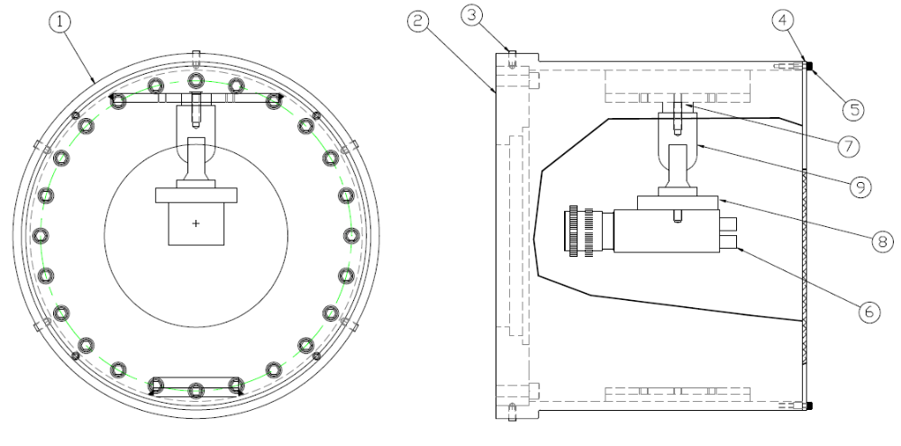
Figure 69: Video Imaging Assembly ASC Alignment

The experience of Initial LIGO showed that these video camera viewports maintained the resolution of the video cameras > 250 TV lines vertical and horizontal. This resolution was adequate for measuring the beam centroid with respect to the rim of the COC mirrors to a precision < 1 mm.
The viewport will be AR coated for minimum reflection @ 1064 nm (specified R<0.25% per surface at normal incidence).

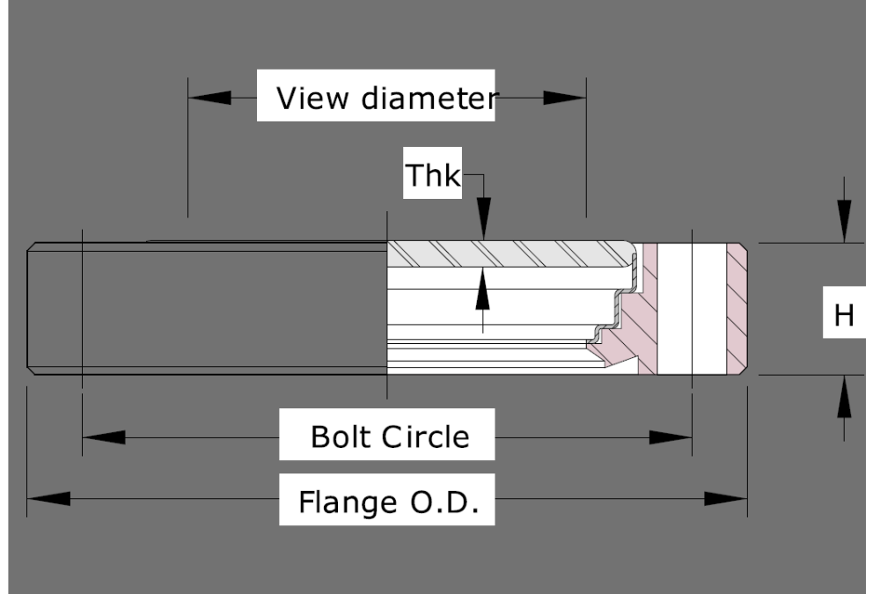
Figure 70: MDC series VPxxx Kovar-sealed viewport

Illuminator Viewport
The chamber illuminator assemblies from Initial LIGO will be re-used for aLIGO. (See D970212-B Illuminator Assembly ASC Alignment).
The illuminator viewport will be the same as the camera viewport, without any AR coating.
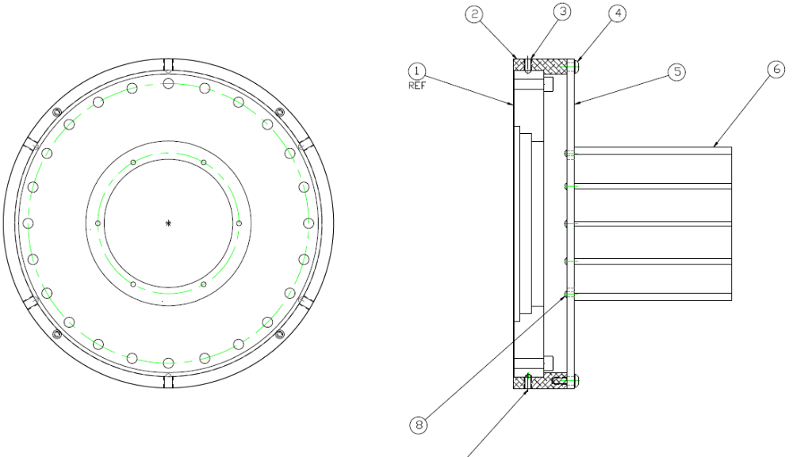
Figure 71: Illuminator Assembly

Optical Lever Viewport
The 2.7 in and 5.4 in viewing diameter viewports will be of the MDC series VPxxx Kovar-sealed, viewport designed for vacuum sealing, made of Corning 7056 glass.
The 7.8 diameter viewports will be fused silica viewports made by Insulator Seal, P/N ISI 4.9722012 designed for vacuum sealing, shown in Figure 72.
The 6.0 in viewing diameter viewports will be fused silica viewports, sealed with o-rings into conflat flange adapters similar to the septum viewports, as shown in Figure 73
The surface finish will be the same as specified in E070069 for enhanced LIGO.
All Optical Lever viewports will have an AR coating @ TBD nm wavelength, normal incidence with a specified total reflectivity < 0.5%.

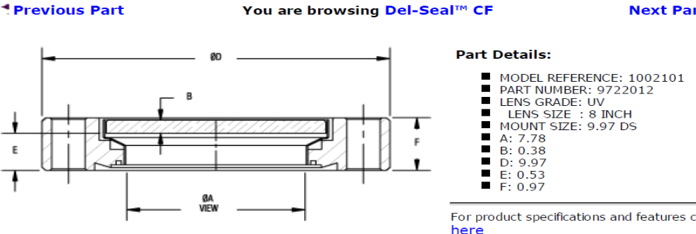
Figure 72: 7.8 Diameter Viewport

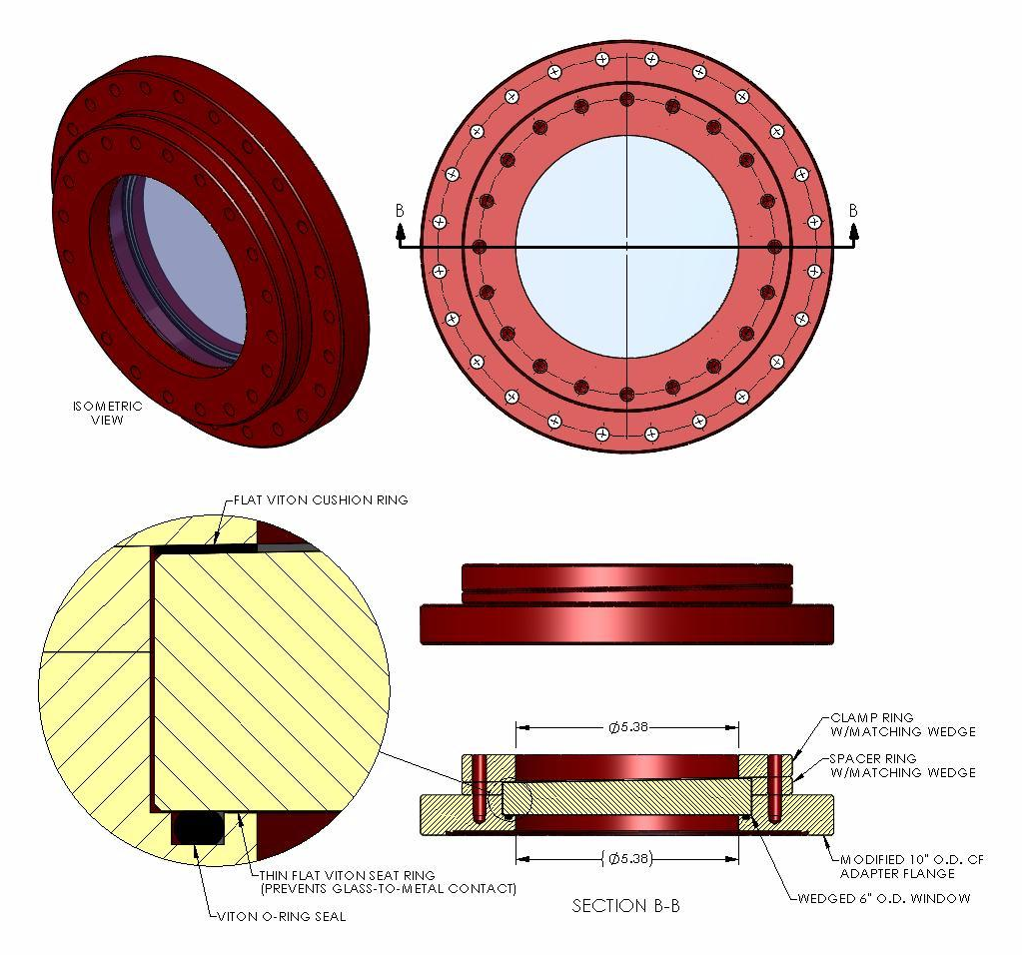
Figure 73: 6.0 in Optical Lever Viewport

Septum Viewport
The septum viewports will have a viewing diameter of 6.0 in, and will be made from fused silica, sealed with o-rings into conflat flange adapters as shown in Figure 74.
The polishing for the Septum viewport substrate, shown in Figure 75, is specified in LIGO E070069.
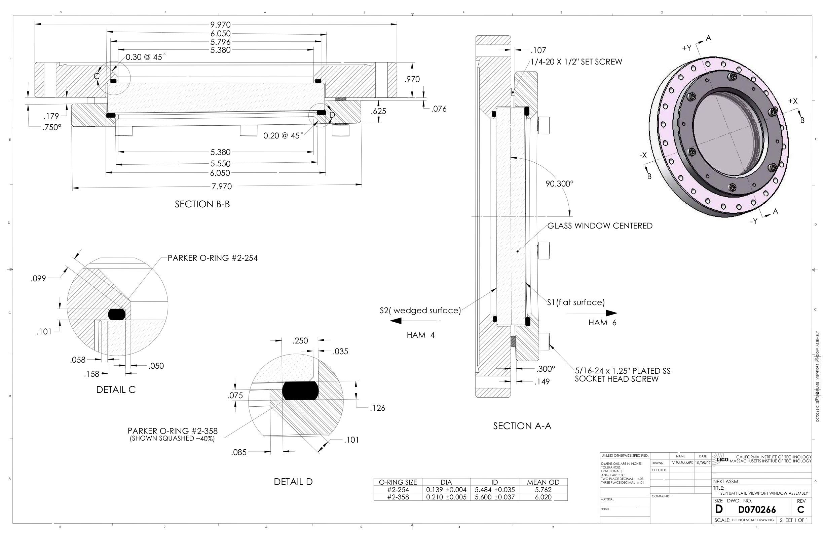
Figure 74: Septum Window Flange Assembly

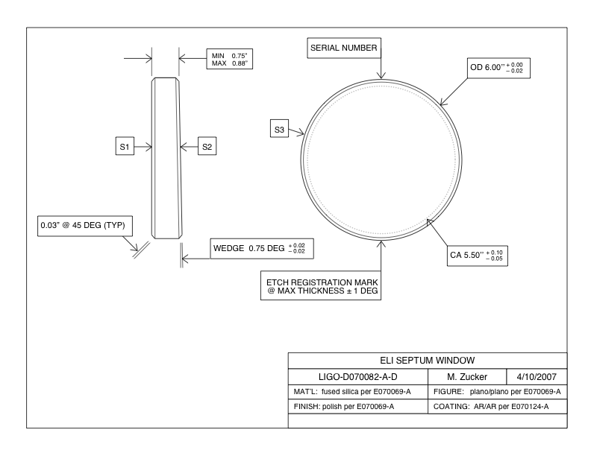
Figure 75: Septum Window

TCS Viewport
This is not part of this scope.

Hartmann Viewport
This is not part of this scope.

Transmon Viewport
The Transmon IR viewport will be the 5.4 in viewing diameter MDC series VP800 Kovar-sealed, viewport designed for vacuum sealing, made of Corning 7056 glass with an AR coating for 1064 nm
The Transmon Green Hartmann viewport will be a special 6.0 in viewport with AR coating for two wavelengths, 1064 nm and 532 nm per the specification 6.0 inch Vacuum Viewport Specification.

Viewport Interface Definitions

Interfaces to other LIGO detector subsystems
The viewports are mounted to vacuum flanges that mount to the existing nozzles on the HAM and BSC chambers, and to the viewport adapters that are attached to the various manifolds and vacuum tubes between vacuum chambers.

Septum Plate Installation
The septum window assembly and installation procedure is described in E070253.

Stay Clear Zones
Viewport safety covers - the optical path of the light beams passing from the optical lever transmitters and receivers, and to the video cameras will be enclosed by a suitable means to define the stay clear zone.

Viewport Reliability

Mean Time before Failure
Viewports are durable optical components that have an essentially unlimited lifetime.

Viewports Maintainability
The viewports will be handled and maintained using the E960022-B LIGO Vacuum Compatibility, Cleaning Methods and Qualification Procedures cleaning procedures and protocols. The viewports will be replaced if they fail.

Viewports Environmental Conditions

Natural Environment

Temperature and Humidity
The viewports are designed to function with vacuum conditions on the inside surface, and with the humidity and temperature controlled environment of the enclosed LIGO LVEA on the outer surface.
Table 4 Environmental Performance Characteristics
Operating | Non-operating (storage) | Transport
+20C to +25C,  20-70% RH,  non- condensing | 0C to +60C,  10-90% RH,  non-condensing | 0C to +60C,  10-90% RH,  non- condensing

Atmospheric Pressure
The viewports are designed to function with a differential pressure between faces of one atmospheric pressure.

Viewport Transportability
All items will be transportable by commercial carrier without degradation in performance. As necessary, provisions will be made for measuring and controlling environmental conditions (temperature and accelerations) during transport and handling. Special shipping containers, shipping and handling mechanical restraints, and shock isolation will be utilized to prevent damage. All containers shall be movable by forklift.

Viewport Design and Construction

Materials and Processes
The in-vacuum materials and processes used in the fabrication of the viewports will be compatible with the LIGO approved materials list.

Materials
A list of currently approved materials for use inside the LIGO vacuum envelope can be found in E960022-B LIGO Vacuum Compatibility, Cleaning Methods and Qualification Procedures. All materials used inside the vacuum chamber will comply with LIGO-E960022-00-D.

Processes

Cleaning
All materials used inside the vacuum chambers will be cleaned in accordance with Specification Guidance for Seismic Component Cleaning, Baking, and Shipping Preparation (LIGO-L970061-00-D).

Component Naming
All components will be identified using the LIGO naming convention. This will include identification (part or drawing number, revision number, serial number) physically stamped on all components, in all drawings and in all related documentation. The flange edges of the glass-to-metal sealed viewports will be marked to indicate the AR coating.

Workmanship
All components will be manufactured according to good commercial practice.

Interchangeability
Viewports with like dimensions and like coatings will be interchangeable.

Safety
This item will meet all applicable NSF and other Federal safety regulations, plus those applicable State, Local and LIGO safety requirements.

Human Engineering
Viewport Safety Covers, similar to the one shown in Figure 22, will cover the viewport whenever any physical activity occurs that might damage the viewport and cause a hazardous situation to nearby personnel.

Assembly and Maintenance
TBD

Documentation

Specifications
Manufacturer’s specifications for standard MDC VP-xxx series viewports, and Insulator Seal 9722012 series viewports, as well as special specifications published by LIGO for custom viewports, will apply.

Design Documents
Same as 7.3.1

Engineering Drawings and Associated Lists
Same as 7.3.1

Technical Manuals and Procedures
Not applicable.

Documentation Numbering
All documents will be numbered and identified in accordance with the LIGO documentation control numbering system LIGO document TBD

Test Plans and Procedures
A test plan and procedure will be developed for testing those viewports that use an o-ring for vacuum sealing to assure that the vacuum leak rate is acceptable.

Logistics

Spare Parts
The spare viewports are included in the Viewport Production Plan.

Special Test Equipment
TBD

Precedence

Qualification

Quality Assurance Provisions
This section includes all the examinations and tests to be performed for ascertaining that the viewports conform to the requirements in section 3.

General

Responsibility for Tests
AOS will conduct tests to verify the as-delivered performance specifications of the viewports.

Special Tests

Engineering Tests
TBD

Reliability Testing

Viewports
The reliability of the viewports that will be used in aLIGO was evaluated during Initial LIGO. Therefore, no further reliability testing will be conducted.

Configuration Management
Configuration control of specifications and designs will be in accordance with the LIGO Detector Implementation Plan.

Quality conformance inspections
Design and performance requirements identified in this specification and referenced specifications shall be verified by inspection, analysis, demonstration, similarity, test or a combination thereof per the Verification Matrix, Appendix 1 (See example in Appendix). Verification method selection shall be specified by individual specifications, and documented by appropriate test and evaluation plans and procedures. Verification of compliance to the requirements of this and subsequent specifications may be accomplished by the following methods or combination of methods:

Inspections
Manufactured parts with LIGO identification numbers or marks will be inspected to determine conformity with the procurement specification.
A witness sample will be acceptable proof of the properties of anti-reflection coatings applied to viewports

Demonstration
A demonstration of the visual quality of the video camera image of the optics in the chamber will be acceptable as verification of the resolution characteristics of the video camera and the acceptable intensity level of the illumination lamp.

Test
TBD

Safety

Hazard Analysis
A hazard analysis for the TCS viewports is presented in E1100246-v1

Working Covers
Protective covers for all viewports will be provided to protect personnel from possible implosion hazards of the viewport.

Preparation for Delivery
Packaging and marking of equipment for delivery will be in accordance with the Packaging and Marking procedures specified herein.

Preparation
• Vacuum preparation procedures as outlined in E960022-B LIGO Vacuum Compatibility, Cleaning Methods and Qualification Procedures will be followed for all components intended for use in vacuum. After wrapping vacuum parts as specified in this document, an additional, protective outer wrapping and provisions for lifting shall be provided.
• Electronic components will be wrapped according to standard procedures for such parts.

Packaging
Procedures for packaging will ensure cleaning, drying, and preservation methods adequate to prevent deterioration, appropriate protective wrapping, adequate package cushioning, and proper containers. Proper protection will be provided for shipping loads and environmental stress during transportation, hauling and storage. The shipping crates used for large items will use for guidance military specification MIL-C-104B, Crates, Wood; Lumber and Plywood Sheathed, Nailed and Bolted. Passive shock witness gauges will accompany the crates during all transits.
For the viewports, the shipping preparation will include double bagging with Ameristat 1.5TM plastic film (heat sealed seams as practical, with the exception of the inner bag, or tied off, or taped with care taken to insure that the tape does not touch the cleaned part). The bag will be purged with dry nitrogen before sealing.

Marking
Appropriate identification of the product, both on packages and shipping containers; all markings necessary for delivery and for storage, if applicable; all markings required by regulations, statutes, and common carriers; and all markings necessary for safety and safe delivery will be provided.
Identification of the material will be maintained through all manufacturing processes. Each component will be uniquely identified. The identification will enable the complete history of each component to be maintained (in association with Documentation “travelers”). A record for the optical lever support structures will indicate all weld repairs and fabrication abnormalities.
The specification for marking the viewports will state that marking fluids, die stamps and/or electro-etching is not permitted. A vibratory tool with a minimum tip radius of 0.005" is acceptable for marking on surfaces that are not hidden from view. Engraving and stamping are also permitted.

Notes
Appendix A Quality Conformance Inspections
Appendix A contains a table that lists the requirements and the method of testing requirements. TBD

Table 5 Quality Conformance Inspections
Paragraph | Title | I | A | D | S | T
 | Performance Characteristics
 | Controls Performance
 | Timing Performance‘

