LIGO Laboratory / LIGO Scientific Collaboration

LIGO-T1000705-v2 Advanced LIGO Date: 13-Jan-11

Hartmann Wavefront Sensor (HWS) delta-Preliminary Design Review (PDR)

Author(s): Aidan Brooks, Phil Willems, Mindy Jacobson, Steve O’Connor, Peter Veitch, Jesper Munch, Won Kim, Cheryl Vorvick, Christopher Guido.

Distribution of this document:
LIGO Scientific Collaboration

This is an internal working note
of the LIGO Laboratory.

California Institute of Technology  LIGO Project – MS 18-34  1200 E. California Blvd.  Pasadena, CA 91125  Phone (626) 395-2129  Fax (626) 304-9834  E-mail: info@ligo.caltech.edu | Massachusetts Institute of Technology  LIGO Project – NW22-295  185 Albany St  Cambridge, MA 02139  Phone (617) 253-4824  Fax (617) 253-7014  E-mail: info@ligo.mit.edu
LIGO Hanford Observatory  P.O. Box 159  Richland WA 99352  Phone 509-372-8106  Fax 509-372-8137 | LIGO Livingston Observatory  P.O. Box 940  Livingston, LA 70754  Phone 225-686-3100  Fax 225-686-7189
http://www.ligo.caltech.edu/

Table of Contents
1 Introduction and Scope 3
2 Significant Changes to HWS since the TCS PDR 3
3 HWS Requirements 3
4 aLIGO HWS General Overview 4
4.1 HWS system block diagram 4
4.2 The HWS measures a wavefront 5
4.3 Imprinting the ITM+CP/ETM thermal lens onto a probe beam wavefront 6
4.4 Analyzing the data from the camera 6
4.5 Secondary beams 6
4.6 List of HWS in Advanced LIGO 7
5 HWS Subsystem Descriptions 9
5.1 Optical Design. Layout, Source Wavelength and Transmitted Power. 9
5.1.1 Relevant Documents 9
5.2 Optical, Mechanical and Opto-Mechanical 9
5.2.1 Relevant Documents 10
5.3 Electrical 10
5.3.1 Relevant Documents 10
5.4 Software/CDS 10
5.4.1 Relevant Documents 10
5.5 Infrastructure 10
5.6 Issues 13
6 Interfaces 13
6.1 Optical 13
6.1.1 COC 13
6.1.2 ALS 13
6.2 Mechanical 14
6.2.1 Facilities 14
6.2.2 Vacuum System 14
6.2.3 SUS/SEI 15
6.3 Electrical 15
6.3.1 Facilities 15
6.3.2 CDS 15
7 Installation and Commissioning 15
7.1 Initial Alignment 15
7.2 Final Alignment 16
7.3 Operation 16

Introduction and Scope
The purpose of this document is to describe the Hartmann Wavefront Sensor (HWS) design at a Preliminary Design Review Stage.

Significant Changes to HWS since the TCS PDR
- Since the TCS-PDR the coating designs for all the core optics have been finalized. This allowed an optimum wavelength to be chosen for the HWS but led to significantly lower transmission than desired. Subsequently the measurement rate for the HWS was reduced from 1 measurements per second to 0.2 measurements per second.
- Probe beam sources have been selected (see T1000682)
- The concept of the “floating” Hartmann sensor for the ETMs is very nearly obselete as much of the equipment required for ETM HWS will need to be permanently installed at each end.
- The limiting aperture of the HWS system in the ITM case is set by the elliptical baffles by the interferometer beam-splitter (BS) and is 210mm diameter.

HWS Requirements
The requirements for the Hartmann sensor are:
- Spatial resolution on the ITM of at least 1cm x 1cm [T060068]
- Wavefront sensitivity of λ/467 for λ = 632.8nm, or sensitivity of 1.4nm [T060068]
- In section 3.1.2.6 the TCS Design Requirements Document states that the wavefront sensor shall probe the central region of the ITM and CP to a radius not less than 112 mm. [T000092]

aLIGO HWS General Overview
The purpose of Hartmann sensors in Advanced LIGO TCS is to continually measure the spatial profile of absorption-induced optical path distortion on transmission through each ITM and compensation plate arrangement and periodically measure the optical path distortion on transmission of each ETM. Each ITM therefore requires its own Hartmann sensor and probe beam. One “floating” Hartmann sensor is required per site for diagnostics on the ETMs. We recommend that this is upgraded to one permanent Hartmann sensor per ETM.

HWS system block diagram
Figure 1: A generalized block diagram illustrating the components of the HWS system and their relative locations. The HWS Probe Beam Source launches a probe beam through some imaging optics and through the Optic Under Test (ITM+CP/ETM) where the beam is retro-reflected. The retro-reflected beam is incident on the HWS and raw data (a Hartmannogram) is recorded. This data/image is transferred to the HWS computer and is analyzed to determine the discrete gradient field of the probe beam. This is parameterized in terms of low spatial frequency optical aberrations (prism, coma, defocus, astigmatism, etc) and these parameters are made available to other systems via the EPICS network.

The HWS measures a wavefront
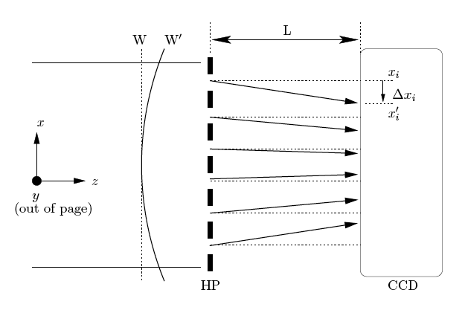
Figure 2: Illustration of Hartmann sensor sampling the gradient of wavefront dW = W' - W
Stated simply, a Hartmann sensor measures the change in the gradient of a wavefront relative to a reference wavefront. The gradient change is numerically integrated to give the wavefront change.

A Hartmann sensor consisting of an opaque plate containing an array of apertures (a Hartmann plate), a series of rays propagating from the apertures and incident on CCD is shown in Figure 1. The basic operation of a Hartmann sensor is:

1. The wavefront, W’, or wavefront change, DW = W’−W, to be measured is incident on the Hartmann plate (HP) which divides it into a set of rays, known as Hartmann rays.
2. The rays propagate a known distance L, normal to the wavefront, and are incident on the CCD.
3. The pattern of spots on the CCD is recorded as a digital image.
4. The position of the ith spot, x’_{i}, is determined by a centroiding algorithm.
5. The displacement of each spot, Dx’_{i}, from a previously measured reference position, x_{i}, for wavefront W is calculated.
6. The gradient of the wavefront change is calculated using dDW/dL = Dx/L
7. The wavefront change, DW, is calculated by integrating the discrete
gradient field.

The performance of the Hartmann sensor has been investigated and demonstrated on previous occasions and is discussed in the following references [Brooks 07, Brooks 09].
Brooks et al, “Ultra-sensitive wavefront measurement using a Hartmann sensor”, Opt. Express.

Imprinting the ITM+CP/ETM thermal lens onto a probe beam wavefront
The probe beams for the Hartmann sensor, created by fiber-coupled laser/super-luminscent diodes (ITM+CPs) and green lasers (ETMs), are injected into the interferometer beam path and pass through the optics under test (ITM+CP/ETM) accumulating wavefront distortion from thermal lenses in those optics. The probe beams are then extracted from the interferometer where the optics under test are imaged onto the Hartmann sensors. As the thermal lenses change the accumulated wavefront distortions change and are measured by the Hartmann sensors.
The injection of the probe beams for the ITM+CPs is illustrated in Figure 3. The beams injected and measured on ISCT4. They are retro-reflected at the ITM HR surfaces. The injection and extraction of the probe beam is conceptually the same for the ETMs.

Analyzing the data from the camera
After an image from the HWS camera is recorded (Step 3 in Section 4.2) the data is transferred via optical fiber to a frame-grabber on a remote computer (in the mass storage room). The data is extracted from the frame-grabber and analyzed by the MATLAB based HWS software developed by Adelaide. The centroids of the Hartmann spots are located, the discrete gradient field of the wavefront, relative to some pre-determined reference, is calculated and recorded to LIGO-type frames on that computer. Additionally, low spatial frequency optical aberrations (prism, defocus, coma, etc) are determined and broadcast to EPICS channels.

Secondary beams
In addition to the probe beams illustrated in Figure 3, secondary beams are produced that are injected into the vacuum. The purpose of these beams is to measure the defocus induced on the probe beam by changes in the displacement between HAM4 and HAM5 causing defocus of the telescope that spans those chambers.

List of Hartmann Sensors Used in Advanced LIGO
Number | Name | Test Optic | HWS Location
1x | H1-HWS-ITMX | H1:ITMX | H1: HAM4 and ISCT4
1x | H1-HWS-ITMY | H1:ITMY | H1: HAM4 and ISCT4
1x | H1-HWS-ETMX | H1:ETMX | H1: X End station, transmon in-vacuum and extra-vacuum tables
1x | H1-HWS-ETMY | H1:ETMY | H1: Y End station, transmon in-vacuum and extra-vacuum tables
1x | L1-HWS-ITMX | L1:ITMX | L1: HAM4 and ISCT4
1x | L1-HWS-ITMY | L1:ITMY | L1: HAM4 and ISCT4
1x | L1-HWS-ETMX | L1:ETMX | L1: X End station, transmon in-vacuum and extra-vacuum tables
1x | L1-HWS-ETMY | L1:ETMY | L1: Y End station, transmon in-vacuum and extra-vacuum tables
1x | H2-HWS-ITMX | H2:ITMX | H2: HAM10 and ISCT4
1x | H2-HWS-ITMY | H2:ITMY | H2: HAM10 and ISCT4
1x | H2-HWS-ETMX | H2:ETMX | H2: X End station, transmon in-vacuum and extra-vacuum tables
1x | H2-HWS-ETMY | H2:ETMY | H2: Y End station, transmon in-vacuum and extra-vacuum tables
3x | Spares for project |  | (one per interferometer)

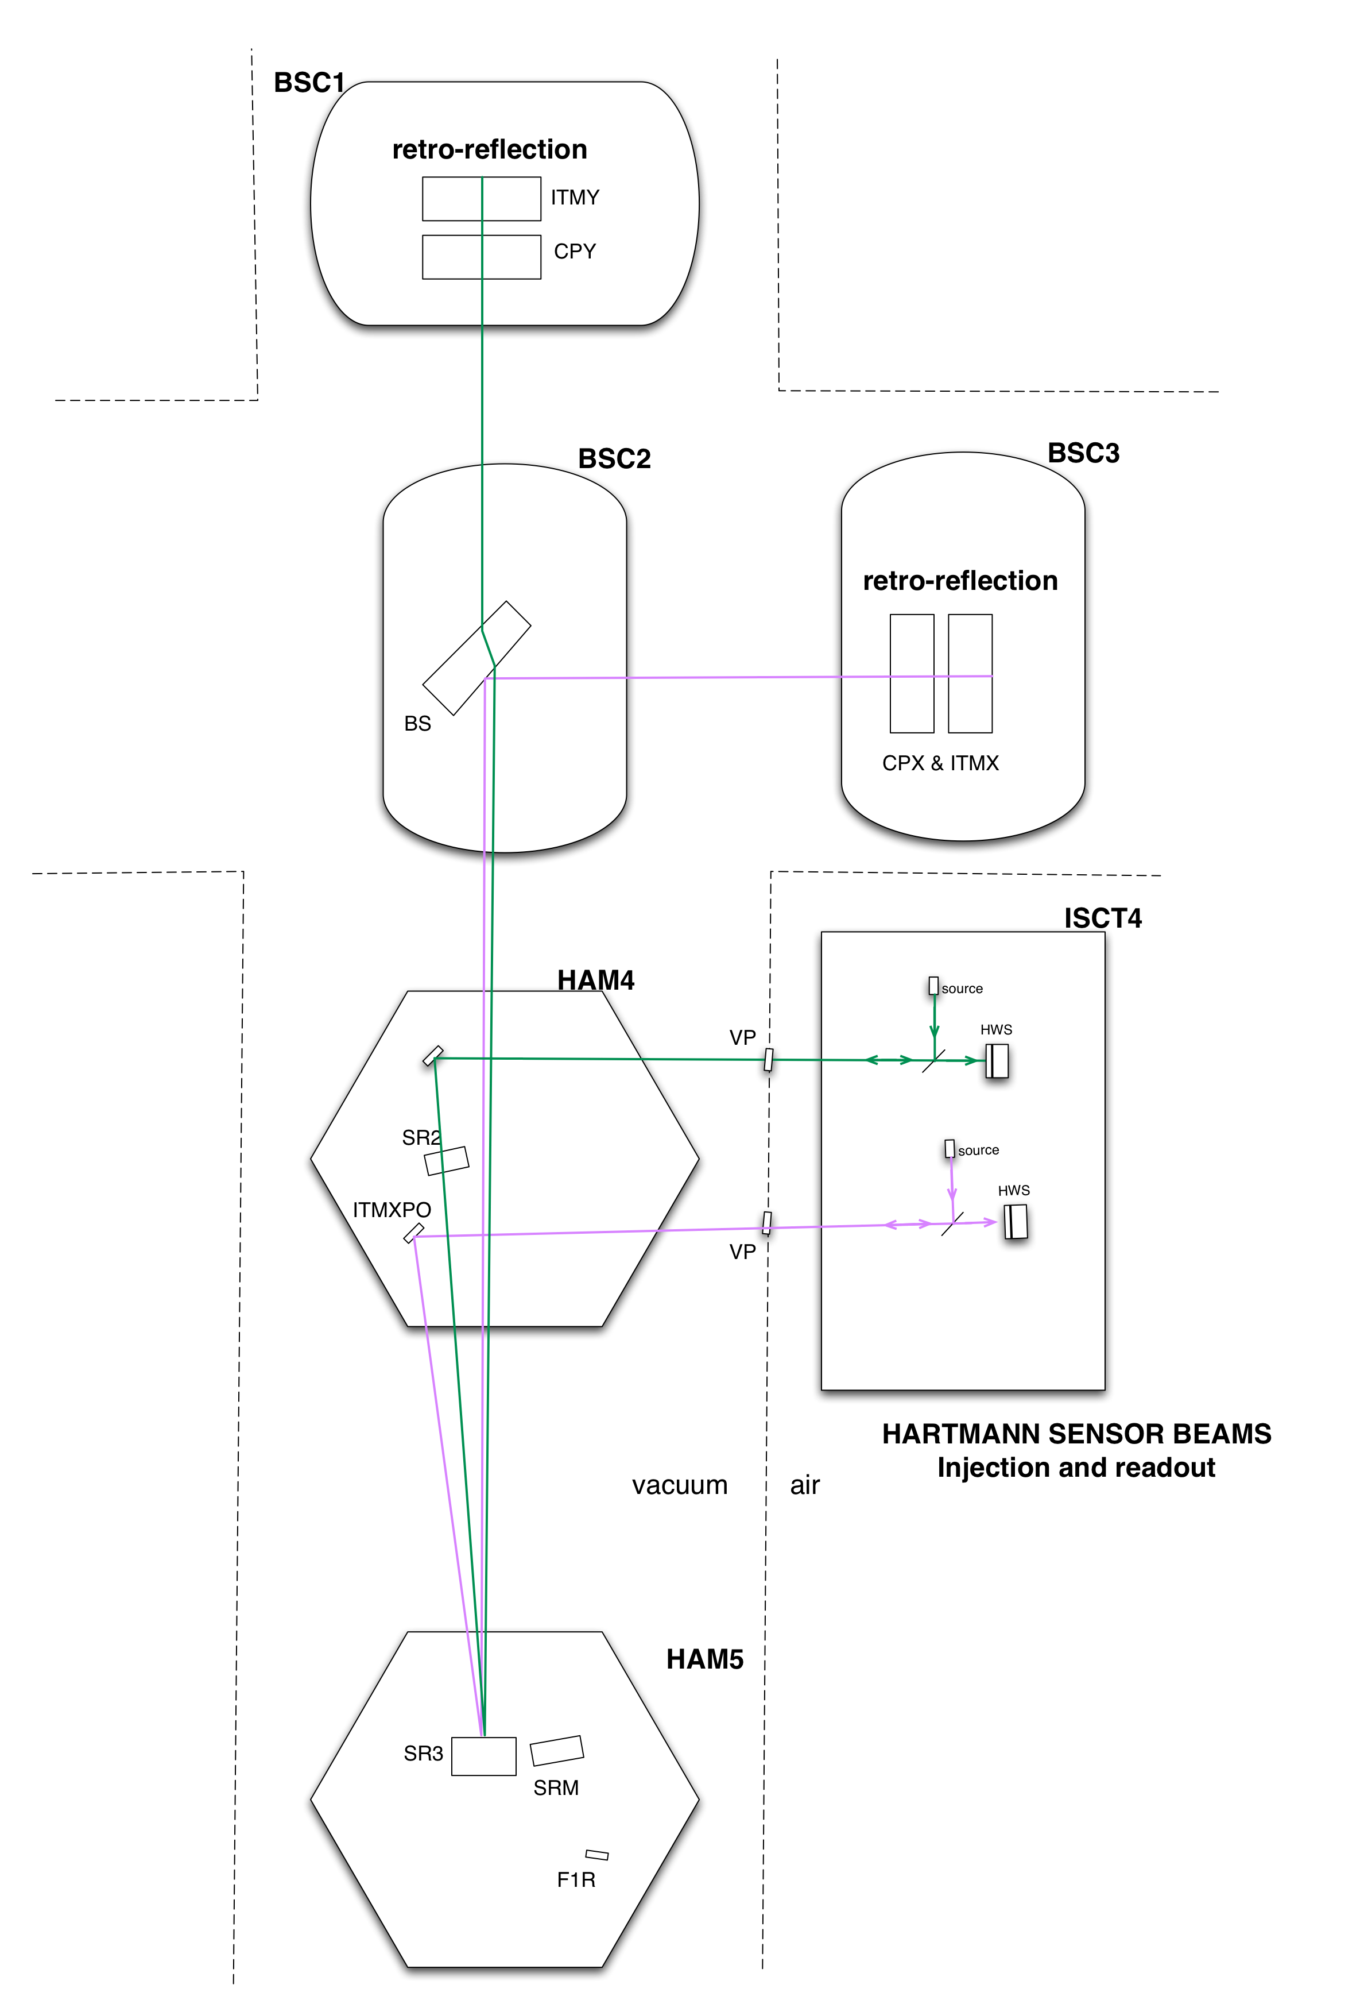
Figure 3: Injection of probe beams into vacuum system (of unfolded IFOs). The beams are injected into the vacuum system and onto the IFO cavity axis, retro-reflected at the ITMs, extracted from the vacuum and measured by a Hartmann sensor on the external table.

HWS Subsystem Descriptions
The full HWS system is comprised of multiple parts that are summarized below.
- The Optical Design. Layout, Source Wavelength and Transmitted Power: A description of the analytic solution that images the Optic Under Test with the correct magnification onto the Hartmann sensor allowing for the necessary distances between optics and tables.
- Mechanical and Opto-Mechanical: A detailed listing of all the mechanical, opto-mechanical and optical parts that are necessary to build the Optical Design
- Electrical: A description of all the Electrical interfaces into the HWS system.
- Software/CDS: A description of the HWS analysis software and CDS/computing designs that are relevant to the HWS.
- Infrastructure: A description of the supporting infrastructure not covered in the above documentation
- Issues. A description of various issues associated with running the HWS on a full-scale interferometer.

Optical Design. Layout, Source Wavelength and Transmitted Power.
The optical design/layout for the Hartmann sensor is summarized in the following documents. The document T1000715 summarizes the requirements for the ITM optical layout and the T1000179 describes the selected solutions.
The optical layouts for the ETMs are not finalized due to uncertainty in the positions of the exterior tables relative to the in-vacuum Transmon tables. A general and flexible optical layout is described in T1000717.
The required transmitted power for the Hartmann sensor is described in T0900655 and the selection of sources for the ITMs is described in T1000682.

Relevant Documents
- T0900655 – Required probe beam power and in-vacuum system transmitted power for the vertex Hartmann Wavefront Sensor (dependent on wavelength)
- T1000682 – Technical Note for the aLIGO TCS Hartmann Sensor Camera and Sources
- T1000715 – Requirements for the ITM Hartmann Wavefront Sensor Optical Layout
- T1000179 – aLIGO Hartmann Sensor Optical Layouts (H1, L1, H2): Input Test Masses
- T1000717 – aLIGO Hartmann Sensor Optical Layouts (H1, L1, H2): End Test Masses

Optical, Mechanical and Opto-Mechanical
The properties of all the optical, mechanical and opto-mechanical elements are described in T100718 for the ITMs and T1000719 for the ETMs.

Relevant Documents
- T1000718 – aLIGO Hartmann Sensor Optics and Opto-Mechanical components (H1, L1, H2): Input Test Masses
- T1000719 – aLIGO Hartmann Sensor Optics and Opto-Mechanical components (H1, L1, H2): End Test Masses
- D1000657 – TCS Hartmann Sensor Assembly
- E1000604 – In vacuum viewport for Hartmann Sensor Beams
- D1003125 – In-vacuum Hartmann steering optics platforms

Electrical
The electrical requirements for the Hartmann sensor are summarized in T0900597.

Relevant Documents
- T0900597 – aLIGO TCS Electronics and Controls Requirements (Section 2.3)
- D1002851 – Hartmann Sensor Power Supply
- D1000892 – Laser Diode Controller Driver Board
- T1000662 – LDTC0520 laser diode temperature controller

Software/CDS
The Hartmann sensor analysis software design is summarized in T1000155.

Relevant Documents
- T0900597 – aLIGO TCS Electronics and Controls Requirements (Section 2.3)
- T1000484 – Hartmann Sensor Data Storage Requirements
- T1000155 – TCS Hartmann Sensor Software Architecture
- T1000702 – Hartmann Wavefront Sensor (HWS) Signal Processing Computer Specification
- T1000703 – Hartmann Wavefront Sensor Software beta version

Infrastructure
All mechanical components necessary to integrate Hartmann sensors at the corner station for each interferometer are collected in two assemblies:
- D1000635 – TCS HWS Table Assembly, HAM4
(vacuum components are not yet represented)
- D1000636 – TCS HWS Table Assembly, HAM10
(vacuum components are not yet represented)

These assemblies are indentured to the overall assembly of aLIGO TCS mechanical envelopes, D1001227 (for LHO). aLIGO Systems engineers incorporate this upper level TCS assembly into facility 3D models in order to coordinate electrical and mechanical interfaces.

Figure 4: Assembly D1000635 for HAM4 (a child of D1001227), in context of the
LHO Corner Station, D0901469
Figure 5: Assembly D1000636 for HAM10 (a child of D1001227), in context of the
LHO Corner Station, D0901469

Issues
This section describes some operational issues associated with running the Hartmann sensor.
- Measurements of the temperature dependence of the HWS [T1000492]
- Scattering analysis of the in-vacuum HWS [T1000707]
- Spurious defocus signals and in the aLIGO HWS [T1000722]

Interfaces

Optical

COC
The ITM Hartmann sensor probe beams interact with several core optics: FM, SR3, SR2, BS, CP and ITM.
- HWS Coating requirements for the core optics are defined in E0900489. These were ultimately dropped from the CSIRO requirements due to risk management issues.
- Alignment of core-optics will affect the alignment of the HWS probe beam

ALS
The Hartmann sensor probe beam for the ETMs is a pick-off from the ALS green laser on reflection from the ETM. This requires a beam-splitter to be inserted into the ALS green beam optical layout. Additionally, the operation of the Hartmann sensor and the ALS system needs to be coordinated.
- The ETM HWS layout is described in T1000717. The proposed location of the HWS pick-off is shown in that layout.
- The block diagram in Figure 6 shows the proposed operation of the HWS with the green ALS laser. The HWS should not record or analyze data until the green laser is unlocked from the FP cavity and should start recording data before increasing the power of the IR beam in the FP cavity.

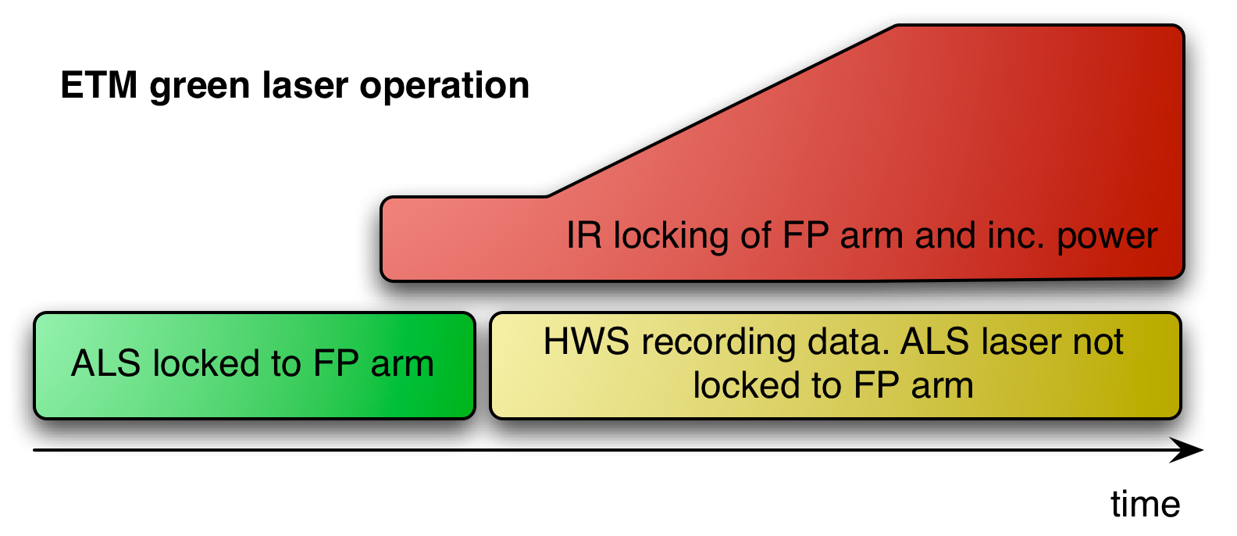
Figure 6: A block diagram showing the proposed operation of the ETM green laser for ALS and HWS usage

Mechanical

Facilities
Cables serving Hartmann sensor components are incorporated into the Systems engineering Rack & Cable Tray Layout for LHO (D1002704). Items associated with H1 are to be repeated for the LLO Layout.
In-air optical tables are commercially available designs, 3-ft x 8-ft x 2-ft deep, with intrinsically high damping properties. The table supports are a custom design for achieving high rigidity, 1.5-ft in height. This custom design must also allow facility personnel to rapidly move the entire table without breaking the optical configuration. Therefore, a cable bulkhead for quick-disconnects is to be incorporated into each of the table assemblies (D100635 and D100636).
Periscopes enclosing the beams, traveling between viewports and the in-air table, are mechanically connected to enclosures on each side of the interface by a mechanical joint with a spherical bearing for ease of alignment.

Vacuum System
The HWS probe beam is injected into the vacuum system for both the ITM and ETM cases. The ETM beam injection is handled by the ALS system. The ITM probe beam must be injected through a viewport on HAM4/HAM10.
- The requirements and design for the HAM4/HAM10 viewport are specified in E1000604.
- The viewport enclosure assembly for HWS, D1100053, is indentured to each of the parent HWS mechanical assemblies, D1000635 and D1000636

SUS/SEI
The in-vacuum ISI tables need to be populated with Hartmann sensor optics and opto-mechanics. The tables will need to be balanced appropriately.

Electrical

Facilities
- DC power is required for the electronics on the HAM4/HAM10 optical table. The requirements for the DC power are summarized below:
  - +/- 18V for the HWS Camera/RCX C-Link power supply [D1002851]
  - +24V DC power for picomotor controllers
  - +9V DC power for flipper mirrors
- Hartmann sensor probe beam source [diodes], which reside in the laser diode room, require power and enclosures. [ref doc?]
- Optical fibers connecting the HWS Cameras to the frame-grabbers in the HWS computers need to be pulled to the mass storage room [ref communication]

CDS
Summarized in T1000484
- HWS on-board temperature sensor ADC
- Control of flipper mirrors
- Control of steering mirrors
- Laser diode ADC/DAC
- HAM table temperature
- Racks are required in the Mass Storage Room to house the HWS analysis computers.
- HWS Analysis computers are of the same type as all CDS workstations. [ref]
- EPICS interfaces to HWS analysis computers

Installation and Commissioning
The installation and commissioning of the HWS in aLIGO is described in the following documents.

Initial Alignment
TBD, requiring inputs from IAS, SYS, and the updated integration schedule.

Final Alignment
TBD, requiring resolution of content in Section 7.1.

Operation
TBD, requiring collaboration with facility Operators.

