Evaluation of possible interference problems between pylons and the vacuum chambers. **LIGO-T1000640-v2**

Each pylons will sit on three threaded rod stilts, pulled down by three rock bolts.

The space between the bottom plate and the ground is eventually filled with grout.

The main danger is that the pylon may be too tall and not fit. Because it would be unfeasible to dig into the concrete of the LVEA and End stations, we evaluate risks and the tolerances.

We start from the nominal beam height (given by Z-max). We calculate the global position and vertical distance from ground after extending the beams 250 mm out of the viewport (see table in next page). In addition to this there is tolerance in the assembly.

Discussion of tolerance of assembly

Five cases:

1. Test mass receiver
2. Recycler receiver
3. Test mass launcher
4. Recycler receiver
5. HAM transmitter/receiver

Case 1 and 2. Test mass and recycler receivers, these pylons are safely above the pipes, can be moved sideways or raised further (adding more grout) at time of implementation.

The quadrant photodiodes are mounted on a breadboard and we have essentially unlimited freedom of moving the pylons out and bringing the quadrant photodiodes back in the desired position.

Case 3 and 4. The launchers have been designed with a 2” spacer, which is a safety factor for vertical positioning. A shorter ring or no ring can be used if the concrete floor is found to be higher than the 73” nominal distance from the vertical zero of the global coordinates. Fine tuning of the vertical position is obtained using threaded rods screwed in the base plate and pushing it up. Laterally we expect no problems because we can position the pylon where needed, mark the position, and then drill and bolt it in place with better than ¼” precision. A slotted mount of the telescope allows ¾” fine tuning f horizontal position.

Case 5. The transmitter receiver can be positioned anywhere in the 7 ¾” optical aperture of the viewport. An effective ±3” vertical freedom is possible, no fine vertical tuning is foreseen.

In all cases we should have plenty of safety margin.

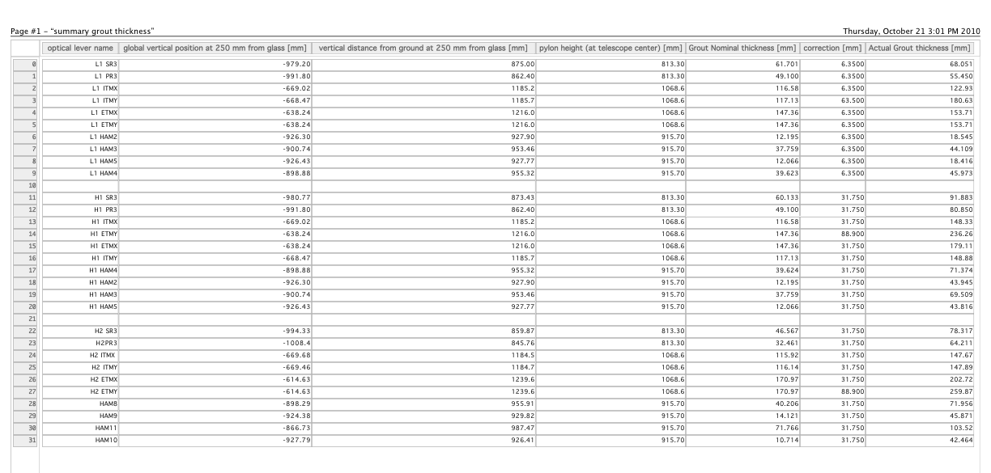

Notes:

1- The nominal grout thickness (column five of table) is the difference between the vertical height of the beam where it will encounter the telescope center (column three) minus the physical pylon height, measured from the center of the telescope to the bottom of the base plate (column four).

It is called “nominal” grout thickness because it is calculated using the nominal ground height (-73 inches below the zero of the global coordinates).

To get to the actual (expected) grout thickness (column seven) a correction factor (column six) is added. This factor is obtained as the difference between the nominal floor height (73”) and the floor height MEASURED in Hanford by Craig and Eduardo (74.25” in the LVEA, 76.5” in one end station). For Livingston the correction factor is taken as equal to that of Hanford minus one inch.

2- The most critical positioning are the two recycler beams because their launching and receiving height might change due to changes of interferometer configuration. It is important to understand how much adjustment is available. One needs to distinguish between before pouring grout, and after pouring grout.

After pouring grout the only vertical adjustment can be obtained by changing the 50 mm spacer.

Before pouring grout, one can reduce the grout thickness by an additional 50 mm in the worst case of column seven.

If one wants to maintain the maximum of flexibility one can put the minimum amount of grout (~5 mm) and increase the spacer ring height (100 mm flexibility).

3- There is never a worry of positioning of the receiver pylons or the HAMS pylons, the receivers because repositioning at the breadboard level allows almost arbitrary repositioning, the HAMs because the returning mirror on the HAM optical table can be pointed arbitrarily.