LIGO Laboratory / LIGO Scientific Collaboration

LIGO-T1000561-v2 LIGO April 3, 2013

aLIGO CDS
Software Test Plan

R. Bork

Distribution of this document:
LIGO Scientific Collaboration

This is an internal working note
of the LIGO Laboratory.

California Institute of Technology  LIGO Project – MS 18-34  1200 E. California Blvd.  Pasadena, CA 91125  Phone (626) 395-2129  Fax (626) 304-9834  E-mail: info@ligo.caltech.edu | Massachusetts Institute of Technology  LIGO Project – NW22-295  185 Albany St  Cambridge, MA 02139  Phone (617) 253-4824  Fax (617) 253-7014  E-mail: info@ligo.mit.edu
LIGO Hanford Observatory  P.O. Box 1970  Mail Stop S9-02  Richland WA 99352  Phone 509-372-8106  Fax 509-372-8137 | LIGO Livingston Observatory  P.O. Box 940  Livingston, LA 70754  Phone 225-686-3100  Fax 225-686-7189
http://www.ligo.caltech.edu/
Table of Contents
1 Introduction 3
2 Scope 3
3 Software Flow 3
4 Test System Equipment 3
4.1 Stand-alone System 3
4.2 Production Test Systems 4
5 Software Builds 5
6 Test Procedures 6
6.1 General Code Categories 8
6.2 Test of Built-In Diagnostics 8
6.3 System Tolerance to Hardware Faults 8
7 Real-time Code Generator (RCG) 8
8 Real-time Control Software 8
8.1 Timing 8
8.1.1 IOP 9
8.1.2 User Application 9
8.2 IOC 9
8.2.1 ADC/DAC tests 10
8.2.2 Binary I/O tests 10
8.3 Code Functional Tests 10
8.4 Real-time Inter-Process Communications (IPC) 10
8.5 Real-time Data Acquisition 11
8.6 DAQ Data Transmission 11
8.7 Arbitrary Waveform Generator / Test Point Manager (awgtpman) 11
9 DAQ System 11
9.1 DAQDC Testing 12
9.1.1 Load Testing 12
9.1.2 Timing 12
9.1.3 Data Error Detection 12
9.1.4 EPICS Channels 12
9.1.5 Data broadcast 12
9.2 Data Storage 12
9.3 Data Distribution 13
10 Integrated System Tests 13
11 Test Procedures 14

Introduction
The purpose of this document is to describe the overall test plan for aLIGO CDS developed and supported software.

Scope
The scope of the CDS test plan is primarily limited to software developed and/or maintained by CDS staff. This includes:
- Real-time code generator and its products.
- Real-time core software ie software ‘wrapper’ included in every aLIGO real-time application, which includes I/O drivers, network drivers, DAQ and GDS capabilities, etc.
- Real-time support software ie awgtpman and EPICS and DAQ network interface to real-time applications.
- DAQ software, including receiving, storing, distributing and viewing data, with the two latter items limited to LIGO control room access only.
- Global Diagnostic System (GDS) software, limited to DTT and foton.
That having been said, the test plan does provide for integrated testing with commonly used LIGO control room tools. This testing will be limited to verification that CDS core code changes have not adversely affected the interface to and use of these other tools. ‘Other’ tools includes:
- Conlog
- Scripts, of various sorts, which have been used to automate LIGO control processes.
- EPICS extensions used in operations, such as MEDM, BURT, ALH, etc.
- Matlab based ligoDV.

Software Flow
Software development to production follows the following basic steps:
- Development on single computer platform.
- Initial testing on stand-alone system. Most software features can be tested in this configuration (see section 4). Where the code to be tested requires multiple computers, such as network data communication tests, it is moved directly to the production test system.
- Final testing and integration occurs on the production test system. This system provides a much larger scale of computers and networking.

Test System Equipment

Stand-alone System
A stand-alone system consists of a single CDS computer connected to a single I/O Chassis (IOC). It is self-contained, in that is capable of running all CDS software, including real-time, DAQ and operator support software. This is the configuration typically deployed to support aLIGO subsystem testing.

Production Test Systems
Two distributed control test systems are in place, one at LHO and one at LLO. These systems contain a subset of the equipment used for IFO control and data acquisition, configured in the same manner. It is intended that, after initial code modules are separately tested, code be moved to these systems for integrated testing.
Equipment included in these systems are:
- Computers
  - Real-time control
  - Boot/Build machines
  - EPICS gateway
  - Data Acquisition, along with disk storage systems
  - Operator workstations
- I/O Chassis
  - Various configurations of supported I/O modules
- Networking equipment
  - EPICS data network
  - DAQ network
  - Real-time deterministic networks
- Test electronics
  - Loopback chassis for signal testing
  - AA/AI chassis for signal injection/output

Software Builds
Software builds take place daily on the aLIGO CDS test systems. The Jenkins continuous integration tool set is used to control and record this process (sample web page below). Daily, at midnight, the Jenkins tool automatically:
- Downloads the latest code from the CDS SVN repository. This includes both the CDS core software and the aLIGO user applications.
- Compiles and installs all applications against this latest SVN revision.
Information on the build process and success/failure information is maintained in the Jenkins logs.

Test Procedures
Standard CDS software test procedures are being developed to cover testing in both stand-alone and production test facility configurations. For code releases through version 2.5, testing was performed manually for group staff (see LIGO-T1200393 and LIGO-T1200394). For new code releases, test scripts are to be used to automate this process. The Jenkins tool is used to initiate these tests on CDS test systems and record the test results. An example Jenkins screen and test report are shown in the figures below.

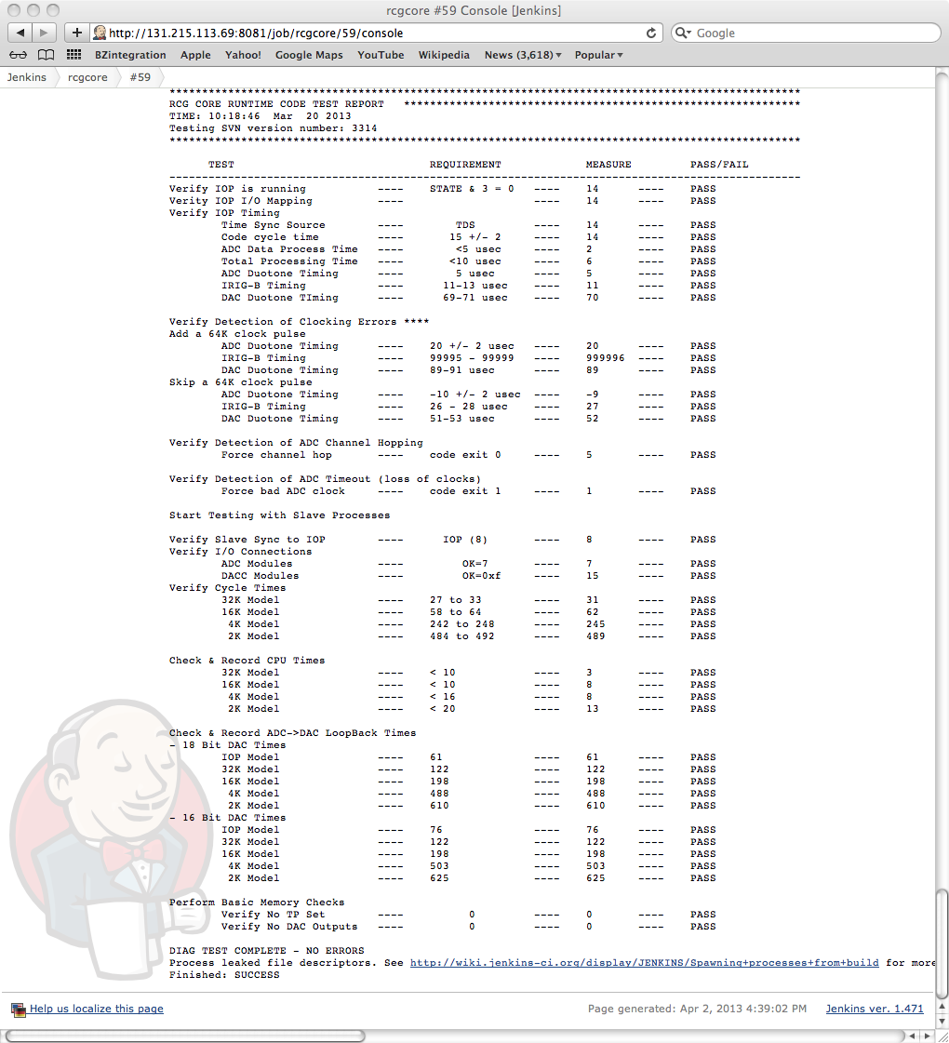

General Code Categories
The following major sections of this document list the testing to be done by major CDS subsystems, which include:
- Real-time Code Generator (RCG)
- Real-time Executable Software
- Data Acquisition (DAQ) System Software
The final section includes integrated system testing, which includes the above, plus testing with operator interface software and other software tools.

Test of Built-In Diagnostics
Many of the CDS core software components contain various system diagnostics, such as timing and network error detection. Since these diagnostics will be used in various tests, it is important to first verify the proper operation of these diagnostics. Therefore, a single test procedure will be provided to do this verification.

System Tolerance to Hardware Faults
To the extent possible, the CDS software should be built to detect and recover from hardware faults. Therefore, “destructive” testing shall be included in all test procedures.

Real-time Code Generator (RCG)
The RCG is to be tested in two primary fashions:
- Detection and reporting of model errors. Some test models are to be developed that have deliberate errors built in, such as missing input/output links, etc. These will be used to verify that the RCG correctly identifies and reports these errors.
- Proper code generation. The CDS test and subsystem production models used in the test systems will be verified for proper operation on each code change and subsequent rebuild.

Real-time Control Software
Real-time control includes the CDS real-time core and user models compiled into single executable kernel object. This code is to be subjected to a number of primary tests, as categorized in the following subsections. In general, this code must be tested to meet the requirements defined in LIGO-T0900603.

Timing
Proper timing is a critical component of the real-time software. Two categories of real-time code run on each CDS real-time Front End (FE) computer, both of which require timing tests:
- I/O Process (IOP): This process performs startup synchronization and continuous communication of data between user applications and the ADC/DAC modules. One IOP runs on each CDS FE computer.
- User Applications: This is real-time software built by the RCG from user models. The number of user applications that may be run on a single FE computer is dependent on the number of CPU cores available. Typical loading is expected to be 4 to 6 user applications per FE computer.

IOP
The IOP synchronizes all other real-time tasks on an FE computer. Timing tests are to include:
- Proper startup synchronization. All real-time code is to start synchronous with the first ADC sample coincident with the GPS one second marker. Verification of this startup timing is to be done by making use of the duotone signal applied to one ADC channel and an IRIG-B time code receiver module and the following software:
  - Built in line fit routine
  - Matlab based duotone test software
  - IRIG-B card time readings
- Time required to pass ADC data to user applications. The goal is <5usec, with maximum limit of 10usec. At no point shall this application run longer than 14usec, including any DAQ and other housekeeping activities.
- Proper synchronization of data written to DAC modules. Requirement is that all data is written to DAC modules between 65KHz clock cycles.
- Cycle to cycle code timing stability. Code execution time should not vary by more than a few useconds from cycle to cycle.
- Stable timing as more user applications are added to the FE computer. IOP execution time should not change considerably as more applications are loaded on the computer.

User Application
The user application is synchronized by the IOP. Timing tests are to include:
- Proper startup synchronization. Requirement is that all real-time applications start on the ADC sample coincident with the GPS one second marker.
- Long-term drift. Requirement is no drift ie application detects every ADC sample on time.
- Timing of DAC writes. The user application must pass data, at the appropriate time, to the IOP for writing of data to the DAC hardware. A diagnostic exists in the IOP software for timing verification. It shall be ensured that the application DAC writes occur before the IOP time to write that information to the DAC hardware.
- Cycle time stability. The time to read ADC data, run the user application and write DAC data shall not vary by more than a few useconds from cycle to cycle.
- Effects of new core software. A record of timing information for standard test models will be maintained for comparison when user applications are rebuilt against new core software to detect either improvements or degradation in performance.

IOC
The CDS real-time core software provides interfaces to hardware mounted in IOC. A test procedure is to be developed to verify these interfaces, as listed in the following subsections.

ADC/DAC tests
The test procedure shall verify proper operation of the IOP software in regards to proper interfacing of ADC and DAC modules:
- Timing synchronization, as described previously.
- Proper card and channel addressing. IOCs typically contain multiple ADC and DAC modules. It must be verified that the code addresses and reads/writes the correct modules, as designated in the user applications.
- Proper module type identification. The code is required to support a number of standard I/O modules and properly map them to user applications.
- Load testing ie verification that the IOP software maintains a minimum time to read/write data. The IOP is required to handle a minimum of 10 ADC/DAC modules in a single IOC.

Binary I/O tests
Binary I/O modules are detected by the IOP, with address information passed to user applications, which subsequently read/write data to these modules. Tests are to include:
- Proper detection and address passing by the IOP.
- Proper read/write by user applications.
- Read/write performance testing. Binary I/O modules typically take longer (as musch as a couple of useconds) per read/write operation. Therefore, this task has been delegated to the user application to keep IOP performance up.

Code Functional Tests
All of the code modules produced by the RCG are to be tested for proper operation on the real-time systems. Particular attention is to be given to test of the CDS standard IIR and FIR filters, which are the basic building block of control applications.

Real-time Inter-Process Communications (IPC)
The CDS core software contains a standard module to perform all IPC communications, either between two processes on the same computer or processes on different computers via real-time networks. Testing is to include:
- IPC between tasks between processes on the same computer.
- IPC via Long Range Reflected Memory (RFM-LR). This communication is via GEFanuc PCIe reflected memory cards used to communicate real-time data between the LIGO corner station and end station computers.
- IPC via Short Range Reflected Memory (RFM-SR): This communication is via Dolphinics PCIe networks between computers co-located in the MSR.
Requirements to be verified:
- Proper data passing ie data is received correctly.
- Time synchronization: Built-in IPC timing diagnostics are to be verified to function properly, then used to support further testing.
- Load: The exact number and rates of IPCs to be supported in aLIGO are TBD. Therefore, testing will be done to determine upper performance limits.

Real-time Data Acquisition
Part of the real-time code ‘wrapper’ is a standard data acquisition function, which runs at the same rate as the user application. Testing is to include:
- Verification of proper decimation filtering. Requirement is that software properly decimates data in 2^{n} steps from the application native rate down to a lower limit of 256Hz.
- Data transmission to shared memory. Each applications must be capable of transmitting data to shared memory at up to 2MByte/sec. This is a combination of permanent DAQ channels and test point channels.
- Code must properly detect GDS test point signals, from AWGTPMAN, and inject/transmit data, as appropriate.
- Limits: Tests shall include DAQ and test point channel count limitations, including proper diagnostics to prevent overloading faults.
- Timing benchmarks: For subsequent comparisons among code revisions, standard benchmarks will be developed and result recorded.

DAQ Data Transmission
A separate DAQ network transmission task is provided for each real-time application to communicate DAQ data to the DAQ system Data Concentration (DAQDC). Testing of this module is to include:
- Proper timing ie data must arrive at DAQDC within a 60msec window.
- Load testing: Must handle up to 2MByte/sec of data transmissions at 16Hz intervals.
- Detection of and recovery from network errors, including hardware faults.

Arbitrary Waveform Generator / Test Point Manager (awgtpman)
A separate awgtpman task exists for each real-time application for purposes of setting test points and injecting test signals. Tests are to include:
- Proper setting of test points, along with proper detection of these settings by the real-time applications.
- Proper injection of test signals including signal verification.
- Synchronization with real-time application. Awgtpman must be properly synchronized in time to interface properly with the real-time application.
To accommodate this testing, standard DTT test configuration files are to be developed for re-use in testing.

DAQ System
The DAQ system consists of the following major components:
- DAQ Data Concentrator (DAQDC)
- DAQ Frame Writer (DAQFW)
- DAQ Network Data Server (NDS)

The Production Test System will be used to test DAQ hardware and software. Real-time applications, running on the various production test computers, will provide the data load.

DAQDC Testing

Load Testing
The DAQDC must be capable of receiving, and subsequently broadcasting, a minimum of:
- 15MByte/sec of data destined for data archival.
- Additional 15MByte/sec of test point data ie temporary channel data.
- Up to 100K slow (EPICS) channel data.

Timing
The DAQDC must run synchronous with the real-time DAQ applications, though timing requirements are much less stringent (measured in msec instead of μsec). Testing is to include:
- The DAQDC must receive, combine and broadcast DAQ data within a 62msec window (16Hz).
- DAQDC must detect and report late data transmissions by real-time computers.
- Time information is to be provided by an IRIG-B receiver card installed in the DAQDC computer. As part of the testing, the interface software to this module shall be tested along with proper time verification.

Data Error Detection
All real-time systems include a CRC checksum as part of their data transmission. The DAQDC must run its own CRC check on the data and compare to the sent CRC. A test shall be developed to verify that both:
- DAQDC properly detects the error.
- DAQDC properly reports the error.

EPICS Channels
The DAQDC is responsible for acquiring EPICS channel data from the FE control Ethernet. A test procedure is to include:
1) Load limits. Goal is provide ability to record all aLIGO EPICS channels (estimated at about 100K channels) at a one Hz rate.

Data broadcast
The DAQDC combines all of the DAQ data and broadcasts it, every sixteenth of a second, to all subsequent DAQ computers. Testing shall include verification that data broadcasts perform properly at rates >=30Mbytes/sec.

Data Storage
DAQFW are responsible for:
- Receiving DAQ data broadcasts from the DAQDC.
- Organizing the data into standard LIGO Frame format, using the LDAS supplied Frame.cpp library.
- Performing data compression, employing the compression algorithm provided as part of the LIGO Frame library.
- Writing the Frame data to disk.
Testing to be performed on the DAQFW software includes:
- Proper data reception and error detection.
- Proper data formatting, compression and writing at >15Mbytes/sec to 32 second Frame files.
- Data compression and storage time. At present, the Frame file covers 32 seconds of data. Therefore, all data compression and writing must be completed within that time frame. As part of this testing, longer frame file times will be tested for comparison.
NOTE: Because of the anticipated large number of EPICS channels and the high, non-compressible Frame overhead for each channel, it is still TBD if EPICS channels will or will not be written to Frames independent of the fast data channels with file lengths on the order of minutes.

Data Distribution
CDS requirements include the ability to send ‘real-time’ or archived data, on request, to support software running on CDS control room computers. This functionality is provided by the Network Data Server (NDS) software, which runs on separate computers in the DAQ system.
Testing is to include:
- Proper network connections (interface) to all supported CDS control room tools, such as dataviewer, DTT, Matlab, etc.
- Data validation ie NDS accurately transmits both real-time and archived data.

Integrated System Tests
Integrated system testing is to be performed on the production test system. This system contains a fair fraction of the total computing and networking equipment associated with a single IFO and therefore lends itself to detecting software/hardware problems associated with large scale systems. For example, effects on various code due to high network usage, high I/O rates, high channel counts and rates of IPC, etc.
Using this system, various integrated operational tests are to be performed:
  - Interaction of many real-time applications. Each of the nine FE computers in the system can be loaded with as many as nine real-time applications at once to test for adverse interactions under heavy loading.
  - Large scale IPC transmissions. The system contains both RFM-LR and RFM-SR to accommodate these tests.
  - Heavy DAQ traffic. With the number of FE computers available, it is possible to load the DAQ system at well beyond the 15MByte/sec DAQ plus 15MByte/sec GDS data traffic.
Operator computer systems may also be added to run and verify the system using the various operator interface software components. Operator interface software, such as DTT and dataviewer, along with scripts, will be employed to both verify data from the system and heavily load the CDS system with data requests to find break points.

Test Procedures
The following table describes the individual test procedures to be developed.

Test Procedure | Description
ADC/DAC Test | Characterize all ADC/DAC modules to be installed in aLIGO
Real-time Software TIming | Verify timing and timing diagnostics of real-time software
Real-time IPC | Verify performance and timing of real-time Inter-Process Communications (IPC) via all IPC interfaces.
Real-time DAQ | Verify real-time Data Acquisition (DAQ) from ADC input to data Frames
EPICS DAQ | Verify DAQ properly acquires EPICS data.
DAQ Core | Test DAQ Data concentrator and Framewriter software.
Real-time GDS | Verify proper operation of real-time code with AWGTPMAN.
Network Data Server | Test operation of DAQ NDS.
GDS | Test of GDS tools supported by CDS for control room use.
Compatibility Testing | Verify that interfaces are maintained to existing operations support tools, such as awgstream, Matlab , scripts, etc.
CDS Diagnostics | Verify operation of all built-in CDS diagnostics.
Fault Tolerance | Procedure(s) to test system tolerance to hardware fault conditions.
Code Generator | Verify that RCG produces proper real-time source code and proper compilation.  Provide a test case for each RCG ‘part’, such that individual code components may be verified.
Signal Integrity | Verify data at source matches data at archive including verification that DAQ system does not introduce any data anomalies.

