Purpose:
The purpose of this procedure is to provide step-by-step instruction in the assembly of the “Gold Power Box” DCC# D070124.

Materials and Tools:
- BOM (Power Box Hardware List)
- Phillips Head Screwdriver
- Adjustable wrench or pliers
- Wire strippers
- 1/8” inch shrink wrap
- Heat gun

Instructions:
- Prepare the LEDS:
  - Cut the Red LED lead approx. 1 ½ ” from the diode and strip the insulation from the two ends approx 1/8”
  - Trim the leads of the 1N5314 current regulating diode to approx. ½”
  - Solder the diode in between the Red lead pieces with the Cathode (-) towards the LED as shown.
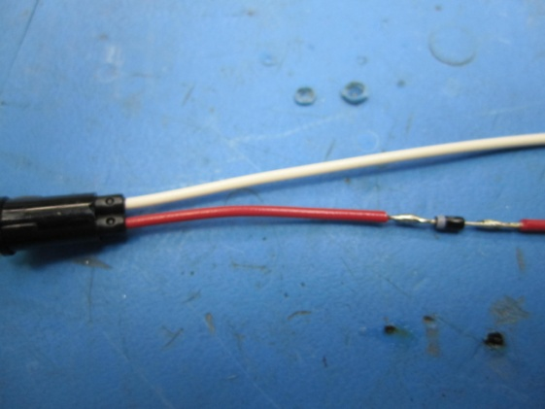
  - Slide a 1 ½ piece of 1/8 “shrink wrap over diode and exposed conductor and apply heat.

- Mount the Tie-Wrap holders(7) to the inside of the Hamilton box with 6/32 x ¼ Phillips flat machine screws
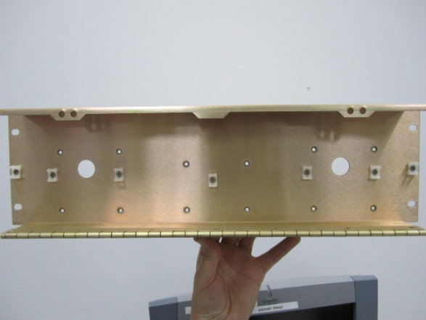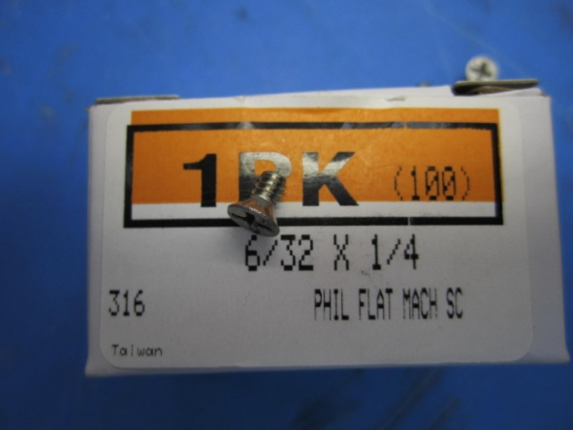
- Next attach Ground Bars (6) to inside of box using 2ea. 8/32 x 7/16 Phillips Pan head screws.
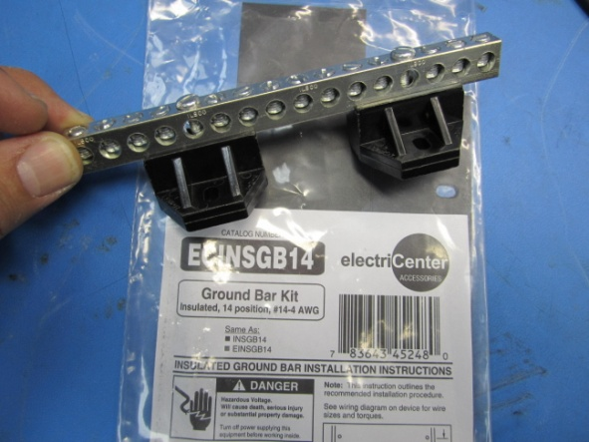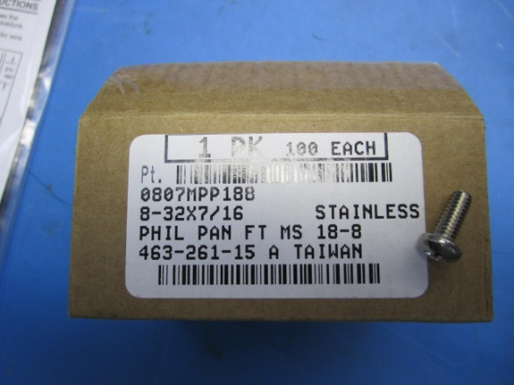
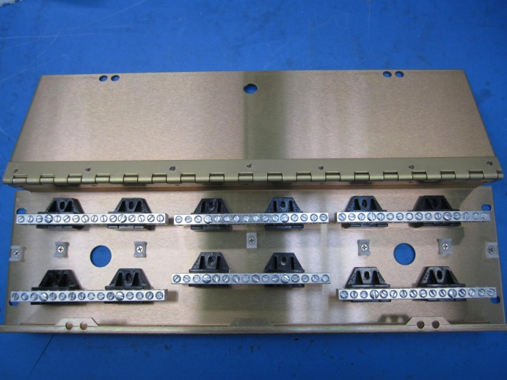

- Mount 90° elbow conduit onto the exterior of the box and apply washer and nut to inside and tighten. Openings in elbows should point towards hinge on box.
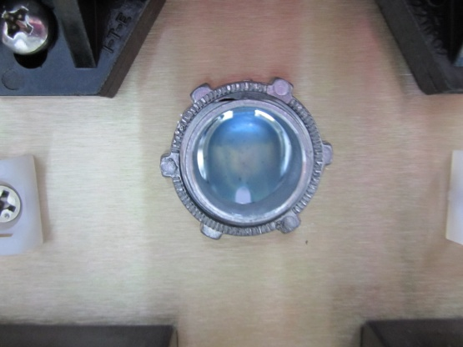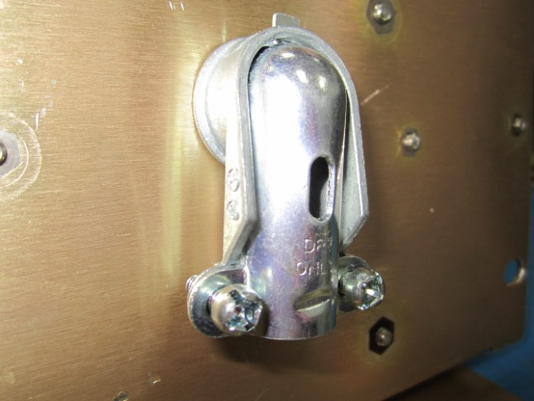
- Insert the adjustable cam latch through the keyed hole on the lid, slide the nut over the latch and tighten.
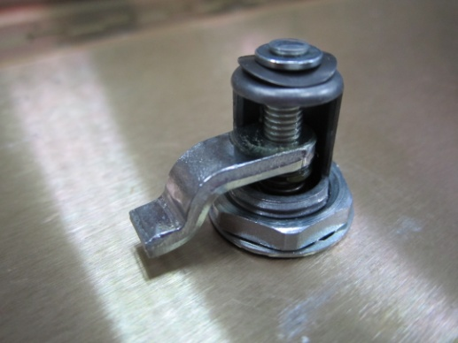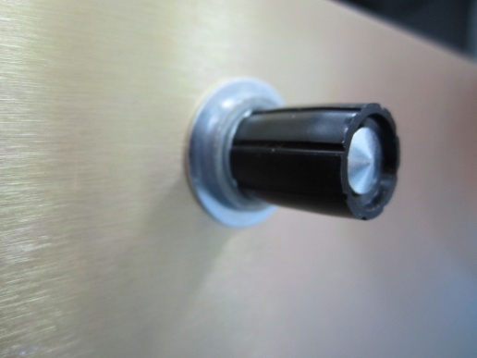
- Insert LEDs through holes in lips of box and press down flush.
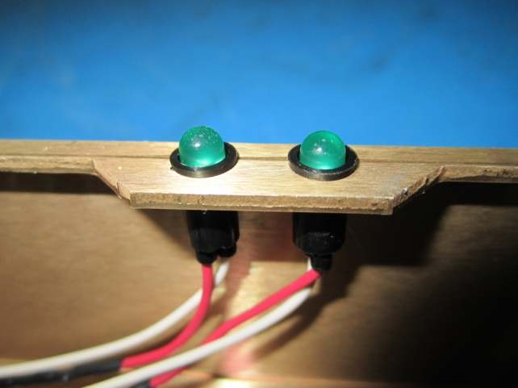

Wiring:
Note: Box may be mounted either side up. For our purposes it is mounted with the hinge down.
- With box mounted in rack (hinge down), the polarity orientation is as follows:
-- + return -- +
+ +

- Correct wiring for Negative voltage LEDs:
  - Positive (Red) wires are connected to their respective return bars.
  - Negative (White) wires are connected to their respective negative- voltage bars.
- Correct Wiring for Positive voltage LEDs:
  - Negative (White) wires are connected to their respective return bars.
  - Positive (Red) wires are connected to their respective positive-voltage bars.

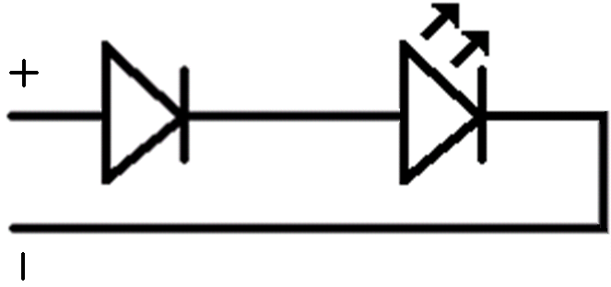

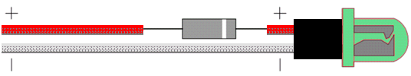

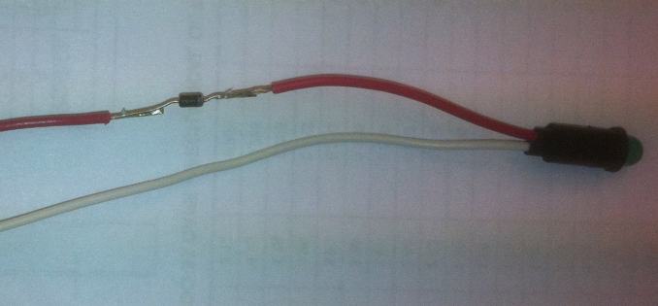

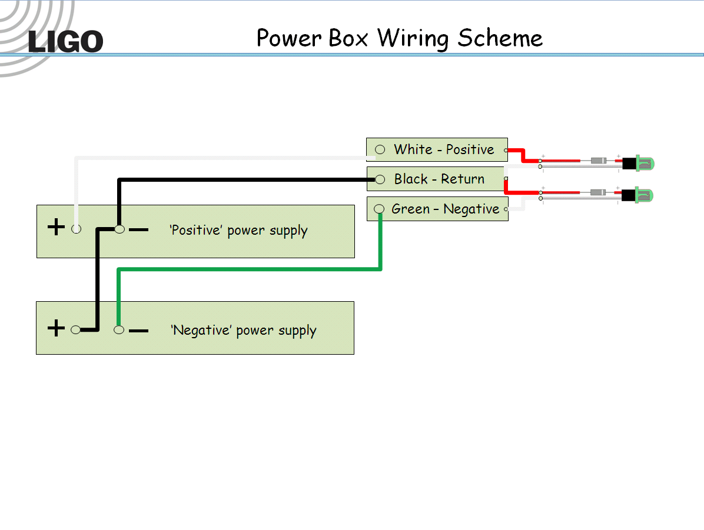

Finished Product:

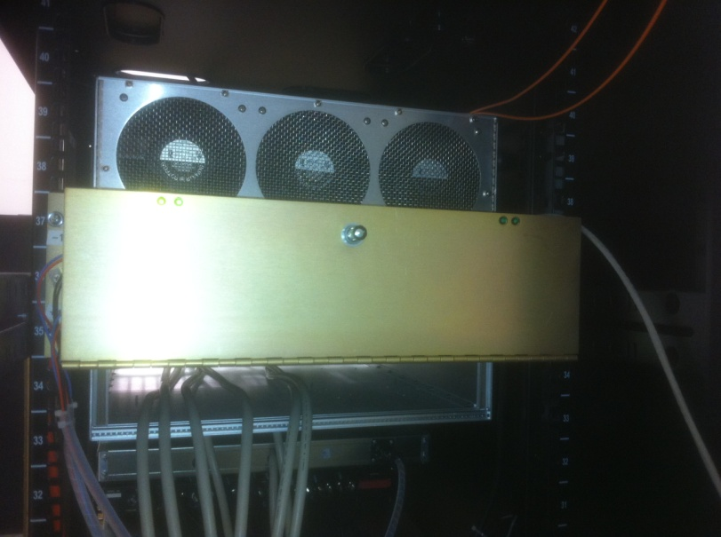

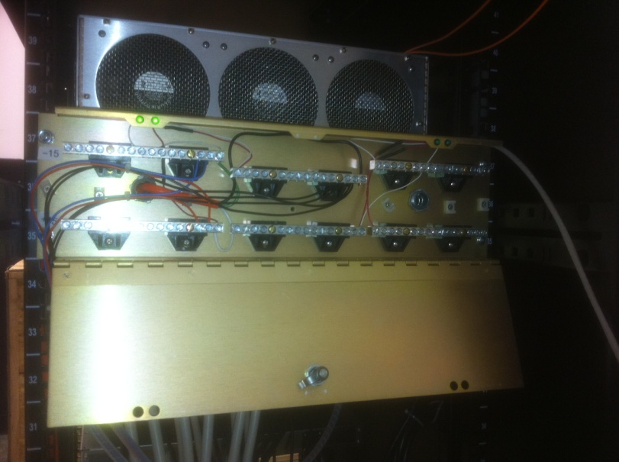

Bill of Materials:
 | D070124 (Power Box) (aka Gold Box)
Item | Part Type | Description | Designator | Manufacturer | Supplier | Supplier Part Number | Quantity | Unit
1 | Fitting | 90 Deg Die Cast Zinc Flexible Metal Conduit Fitting 90 Degree Elbow Connector, 3/8" Trade Sizeree Conduit Fitting |  |  | McMaster-Carr | 7267K33 | 2 | @
2 | Latch | Adjustable Compression Miniature Cam Latch, Zinc-plated Steel, Knob Head, 3/32" - 3/8" Grip |  |  | McMaster-Carr | 1887A52 | 1 | @
3 | Screw | 18-8 SS Pan Head Phillips Machine Screw, 8-32 thread, 7/16" Length |  |  | McMaster-Carr | 91772A193 | 12 | @
4 | Screw | Type 316 SS Flat Head Phillips Machine Screw, 6-32 Thread, 1/4" Length |  |  | McMaster-Carr | 91500A144 | 7 | @
5 | Diode | Current Regulator Diode 4.7mA |  | Central Semiconductor | Mouser Electronics | 1N5314 | 4 | @
6 | LED | Green LED, Leaded, Panel mount |  | Chicago Miniature Lighting | Digi-Key | L10005-ND | 4 | @
7 | Bus Bar | Power Box Bus Bar |  | Seimens | Solar Electric Distributor | ECINSGB14 | 6 | @
8 | Tie-down | Tie Hold Flat Rivet |  |  | Digi-Key | FTH-13R-01-ND | 7 | @
9 | Power Box | Rack Input Power Box |  | Hamilton Metalcraft, Inc. | Hamilton | D070124-A | 1 | @
10 | Solder |  | Lab Supplies |  |  |  | 1 | @
11 | Flux |  | Lab Supplies |  |  |  | 1 | @
12 | Heat Shrink | Heat Shrink Insulation | Lab Supplies |  |  |  | 1 | @

