LIGO Laboratory / LIGO Scientific Collaboration

LIGO- E1000324 LIGO August 16th, 2012

aLIGO HAM-ISI, Pre-integration Test Report, Phase I,
LHO Unit #7 (post-assembly, before storage)
E1000324 – v1

Hugo Paris, Fabrice Matichard, Vincent Lhuillier
Hugh Radkins, Jim Warner, Robinson Mitchell, Corey Gray, Gregory Grabeel, Eric Allwine

Distribution of this document:
Advanced LIGO Project

This is an internal working note
of the LIGO Laboratory

California Institute of Technology  LIGO Project – MS 18-34  1200 E. California Blvd.  Pasadena, CA 91125  Phone (626) 395-2129  Fax (626) 304-9834  E-mail: info@ligo.caltech.edu | Massachusetts Institute of Technology  LIGO Project – NW22-295  185 Albany St  Cambridge, MA 02139  Phone (617) 253-4824  Fax (617) 253-7014  E-mail: info@ligo.mit.edu
LIGO Hanford Observatory  P.O. Box 1970  Mail Stop S9-02  Richland WA 99352  Phone 509-372-8106  Fax 509-372-8137 | LIGO Livingston Observatory  P.O. Box 940  Livingston, LA 70754  Phone 225-686-3100  Fax 225-686-7189

Table of contents:
Introduction 4
I. Pre-Assembly Testing 5
▪ Step 1: Position Sensors 5
▪ Step 2: GS13 testing prior to shippement 7
▪ Step 2.1 – Horizontal GS-13s 8
▪ Step 2.2 – Vertical GS-13s 9
▪ Step 3: Actuators 11
▪ Step 5 – Seismometer inspection after shipping 12
II. Tests to be performed during assembly 14
▪ Step 1: Parts Inventory (E1000052) 14
▪ Step 2: Check torques on all bolts 15
▪ Step 3: Check gaps under Support Posts 15
▪ Step 4: Pitchfork/Boxwork flatness before Optical Table install 15
▪ Step 5: Blade spring profile 16
▪ Step 6: Gap checks on actuators-after installation on Stage 1 17
▪ Step 7: Check level of Stage 0 18
▪ Step 8: Check level of Stage 1 Optical Table 19
▪ Step 9: Mass budget 20
▪ Step 10: Shim thickness 23
▪ Step 11: Lockers adjustment 23
III. Tests to be performed after assembly 24
▪ Step 1 - Electronics Inventory 24
▪ Step 2 - Set up sensors gap 24
▪ Step 3 - Measure the Sensor gap 25
▪ Step 4 - Check Sensor gaps after the platform release 25
▪ Step 5 – Performance of the limiter 26
▪ Step 5.1 - Test Nº1 - Pushing “in the general coordinates” 26
▪ Step 5.2 - Test Nº2 – Pushing “locally” 26
▪ Step 6 - Position Sensors unlocked/locked Power Spectra 28
▪ Step 7 - GS13 power spectra -tabled tilted 30
▪ Step 8- GS13 pressure readout 31
▪ Step 9 - Coil Driver, cabling and resistance check 32
▪ Step 10 - Actuators Sign and range of motion (Local drive) 33
▪ Step 11 - Vertical Sensor Calibration 34
▪ Step 12 - Vertical Spring Constant 35
▪ Step 13 - Static Testing (Tests in the local basis) 35
▪ Step 14 - Linearity test 36
▪ Step 15 - Cartesian Basis Static Testing 38
▪ Step 16- Frequency response 39
▪ Step 16.1 - Local to local measurements 39
▪ Step 16.2 – GS13 Response extraction 42
▪ Step 16.3 GS13 response fitting 47
▪ 16.4 Symmetrization Filters 51
▪ Step 16.4 - Cartesian to Cartesian TF computation 53
▪ Step 17 - Transfer function comparison with Reference 55
▪ Step 17.1 - Local to local - Comparison with Reference 55
▪ Step 17.2 - Cartesian to Cartesian - Comparison with Reference 58
▪ Step 17.3 - Cartesian to Cartesian - Comparison with other Units 61
▪ Step 18 - Lower Zero Moment Plane 65
IV. HAM-ISI Unit #7 testing summary 67
▪ List of tests that failed and don’t need to be redone: 67
▪ Tests that failed and need to be done during phase II 67
▪ List of test that were skipped and that we will not do because they are not essential 67

Introduction

HAM-ISI Unit #7 was assembled during July-August 2012. It is the last HAM-ISI Unit built at LHO. The testing of this Unit is presented here. It started on August 8th and lasted until August 16th. Production GS13s and Stage-0 L4Cs were installed during tests.

The procedure document used to perform these tests is:
- E1000309–V12 - aLIGO HAM-ISI, Pre-Integration Testing Procedure, Phase I (post assembly, before storage)
Other useful information can be found in:
- E1000300 - HAM-ISI LLO test stand: software and electronic check

Remark regarding SVN paths:
Units need to be tested under a folder that matches medm channels’ names. Since MEDM channels’ names all refer to HAMX during this phase of testing, units are all tested under:
/SeiSVN/seismic/HAM-ISI/X1/HAMX/
Once a unit is tested, a folder called after its order of assembly is created. For Unit #6, the name of this folder will be:
/SeiSVN/seismic/HAM-ISI/X1/Unit_6/
Test data is then moved from HAMX testing folder to this final folder. All the data related to the Phase I testing of this unit is then stored in this folder. The data set names, the location of the test results, and the locations of the programs used to obtain them are specified along this document.
Even if they are tested under HAMX, units are called per their order of assembly in programs, figures and data files.

Pre-Assembly Testing

Step 1: Position Sensors
S/N sensor | S/N board | ADE Gap Standoff (mm) | Location on the Jig | Gap Standoff on Jig (mm/in) | Voltage before zeroing | Voltage after zeroing. Prebake | Voltage after zeroing. Post bake
12009 | NR | NR | x | ~2.057 | x | ~.01 | x
12025 | NR | NR | x | ~2.057 | x | ~.01 | x
12012 | NR | NR | x | ~2.057 | x | ~.01 | x
12016 | NR | NR | x | ~2.057 | x | ~.01 | x
12036 | 11867 | NR | 1 | 2.057mm/0.081" | NR | *.01 | -4.7
12030 | 11893 | NR | 1 | 2.057mm/0.081" | NR | *.01 | -5.2
NR: Not Recorded

Sensors noise spectra measured before baking E1000257, and before shielding per procedure T1000636:

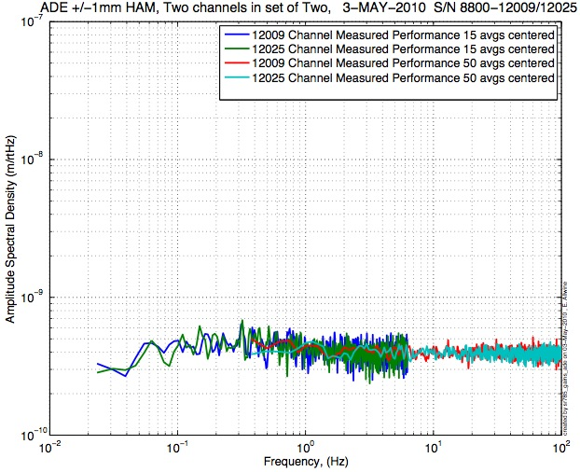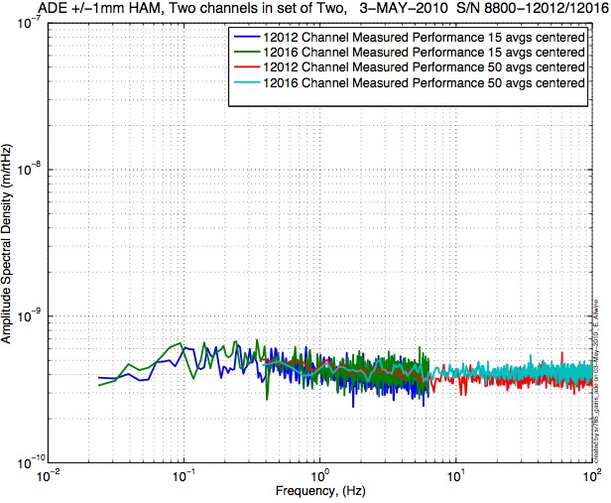
Figure - H1 and V1 sensor noise Figure - H2 and V2 sensor noise

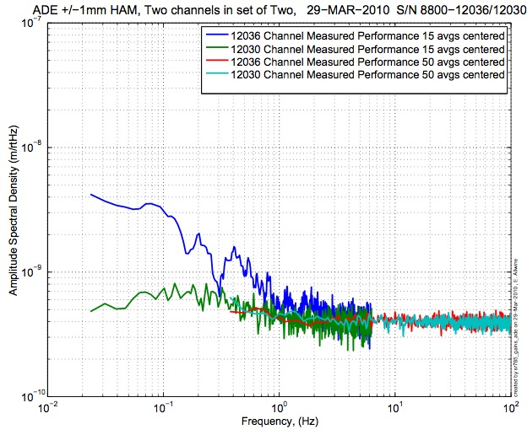
Figure - H3 and V3 sensor noise

Issues/difficulties/comments regarding this test:
- Sensors #12036 was initially discarded because of its high noise level below 1Hz. This sensors was then sent back to be repaired. The spectra presented here were measured before reparations. No spectrum was taken on a jig afterward.

Acceptance Criteria:
- Power spectrum magnitudes must be lower than:
  - 9.e-10 m/√Hz at 0.1Hz
  - 6.e-10 m/√Hz at 1Hz

Test result: Passed: Failed: X .

Comment: Test failed due to the lack of information available. However, further tests (i.e. step 6, spectra of CPSs) show that the instruments are functional.

Step 2: GS13 testing prior to shippement
Data related to GS-13 post podding testing can be found in the SVN at: \SeismicSVN\seismic\Common\Data\aLIGO_GS13_TestData\PostMod_TestResults_PDFs.
Power spectra measured at reception, after shipment from LLO, can be found at
\SeismicSVN\ seismic\Common\Data\aLIGO_GS13_TestData_LHO\
aLIGO GS13 Testing page is E1100367. It contains links to:
- LIGO-E1000058: aLIGO GS-13 Status Chart
- LIGO-24: aLIGO GS-13 as received testing results
- LIGO-E1100394: aLIGO GS-13 prior shipping testing results
- LIGO-E1100395: aLIGO GS-13 Post Modification testing results
- LIGO-F0900070: GS-13 Inspection Checklist

 |  | Corner 1 | Corner 2 | Corner 3
V | Pod | 3 | 50 | 53
 | Instrument | 757 | 773 | 705
H | Pod | 9 | 61 | 78
 | Instrument | 831 | 791 | 812
Table- GS13 instrument and Pod S/Ns

Step 2.1 – Horizontal GS-13s
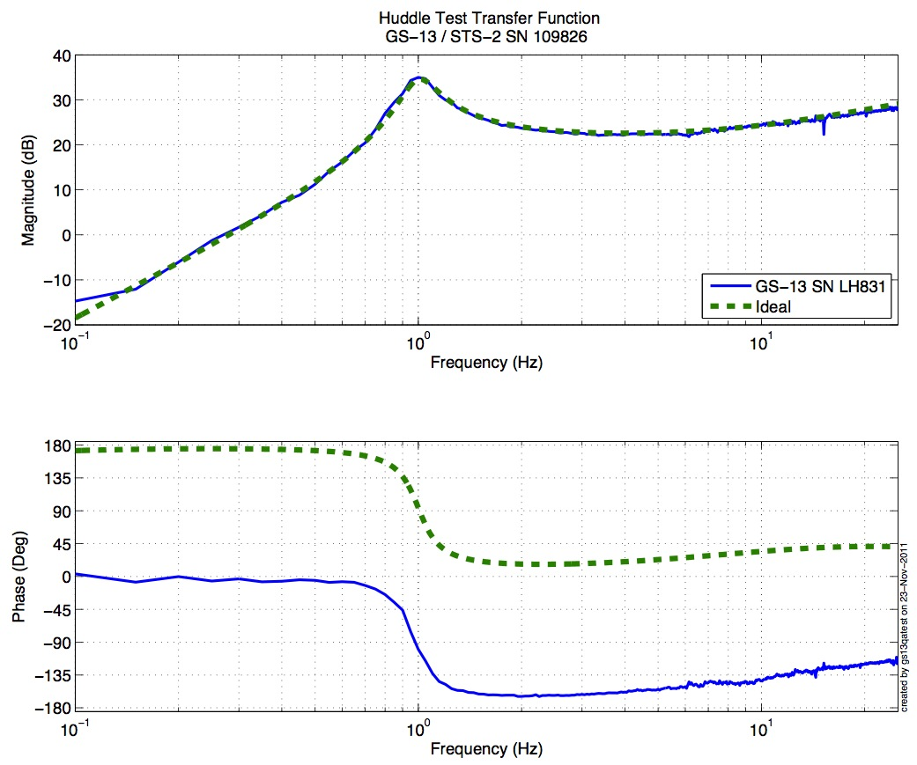
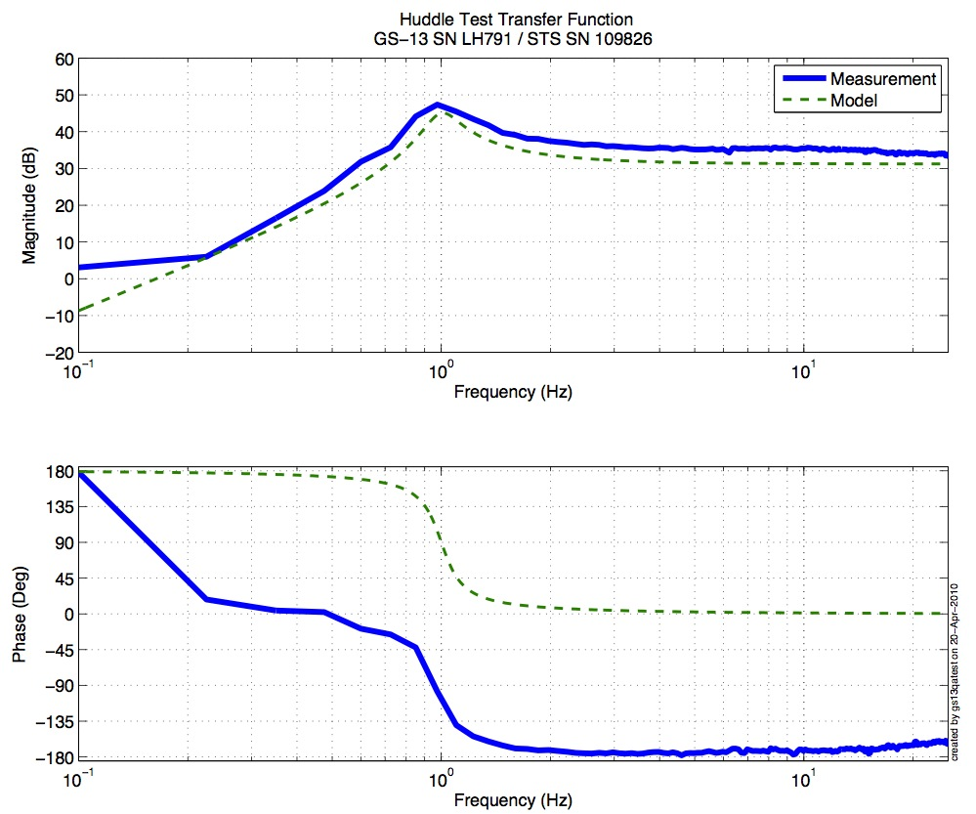
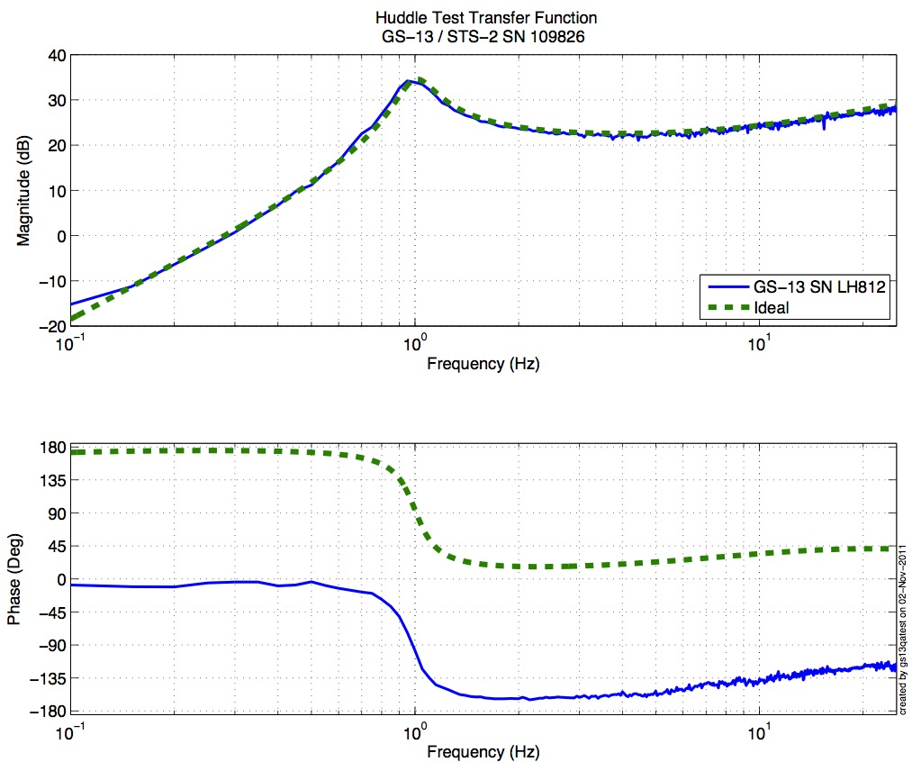

Figure - Huddle testing of Vertical GS-13 831(H1), 791(H2), and 812(H3) after aLIGO modifications

Step 2.2 – Vertical GS-13s

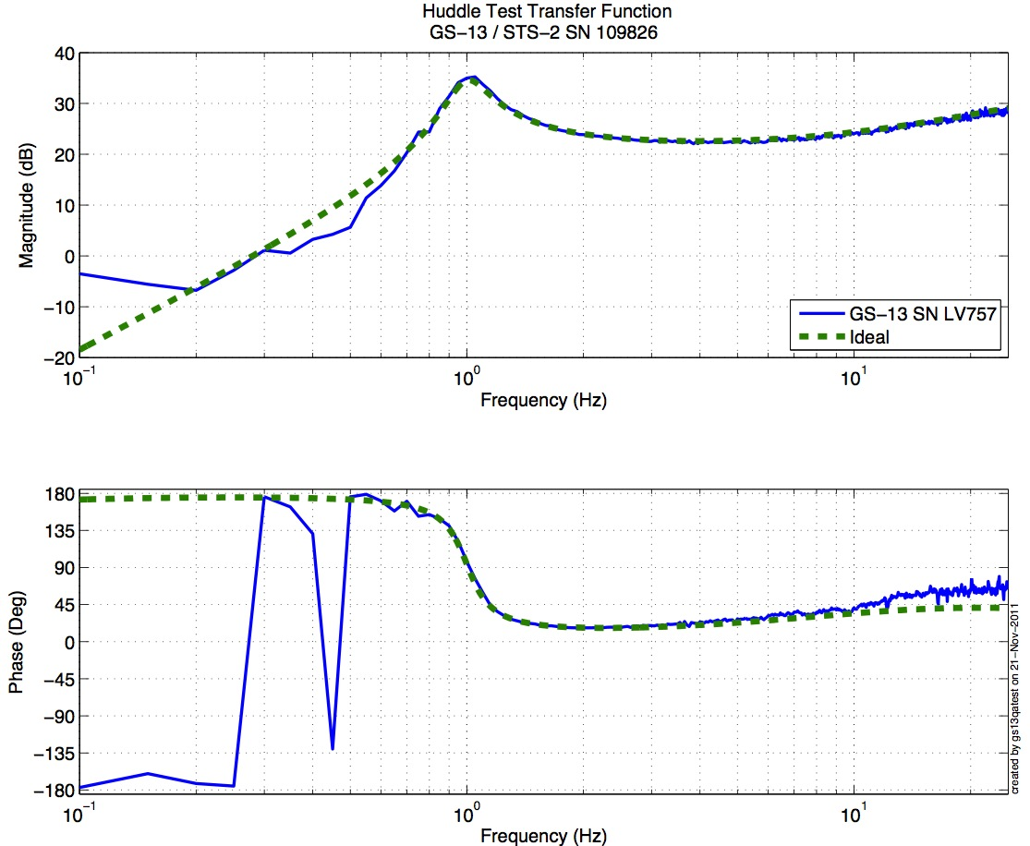
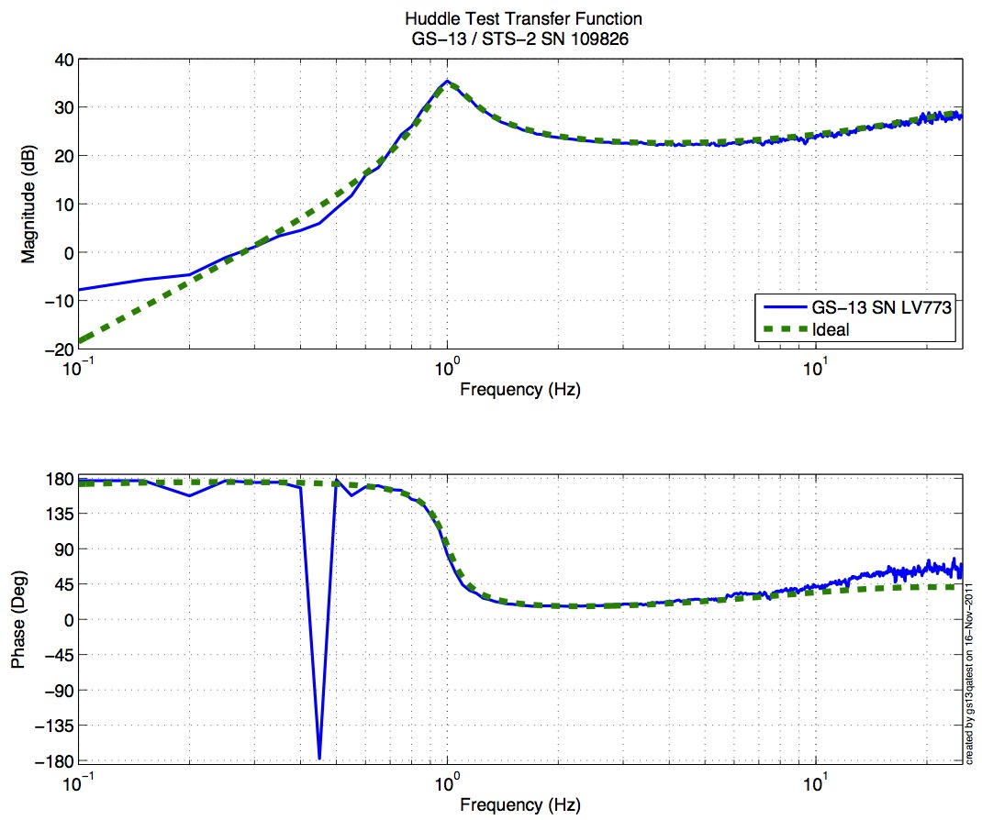
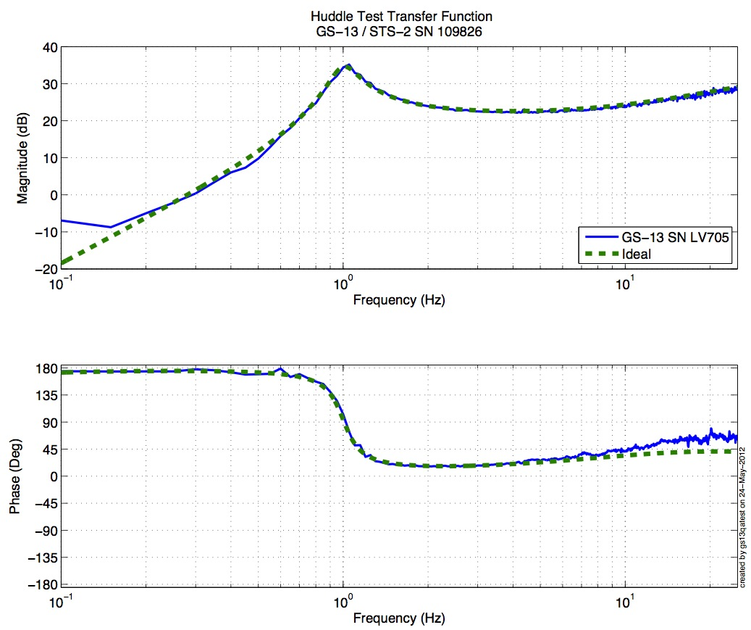

Figure - Huddle testing of Vertical GS-13 757(V1), 773(V2), and 705(V3) after aLIGO modifications
Driven testing

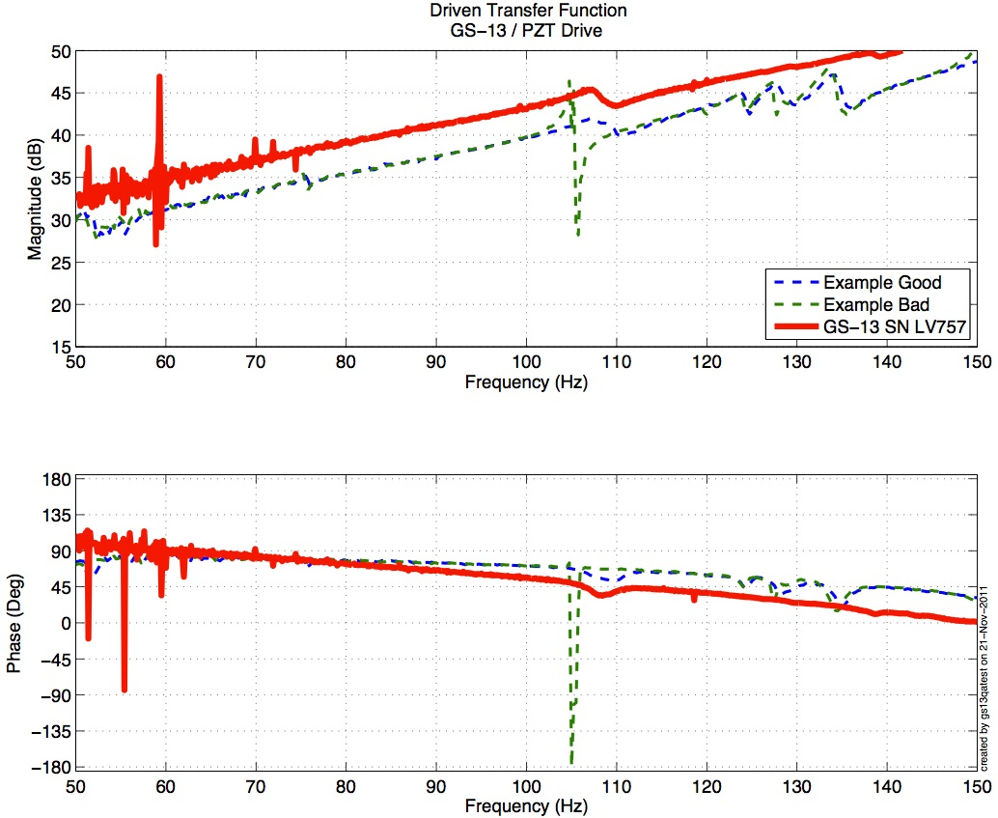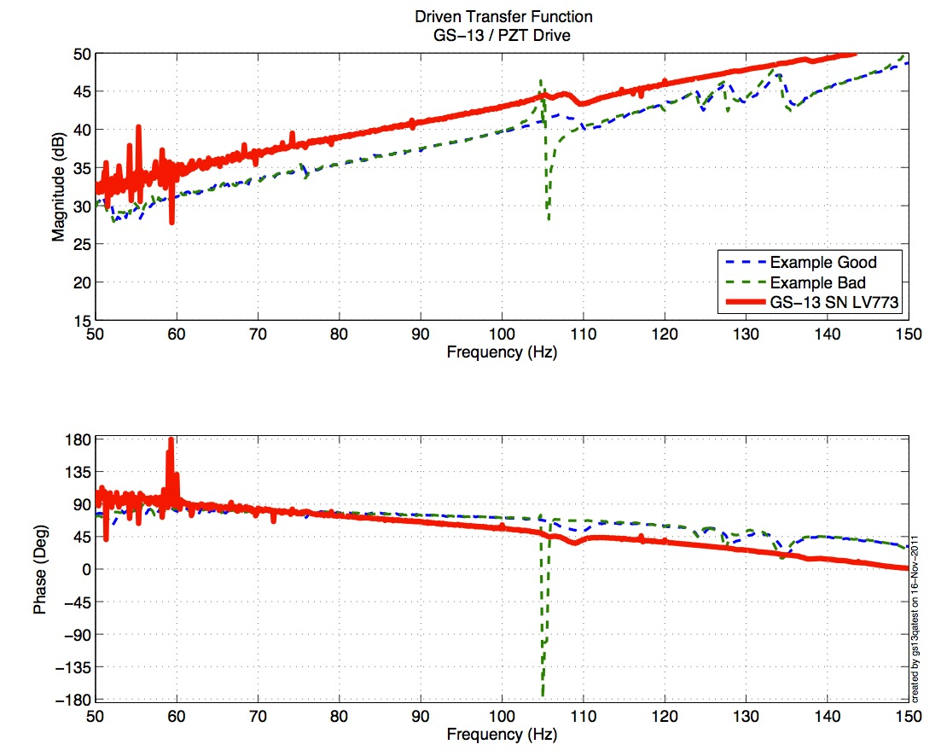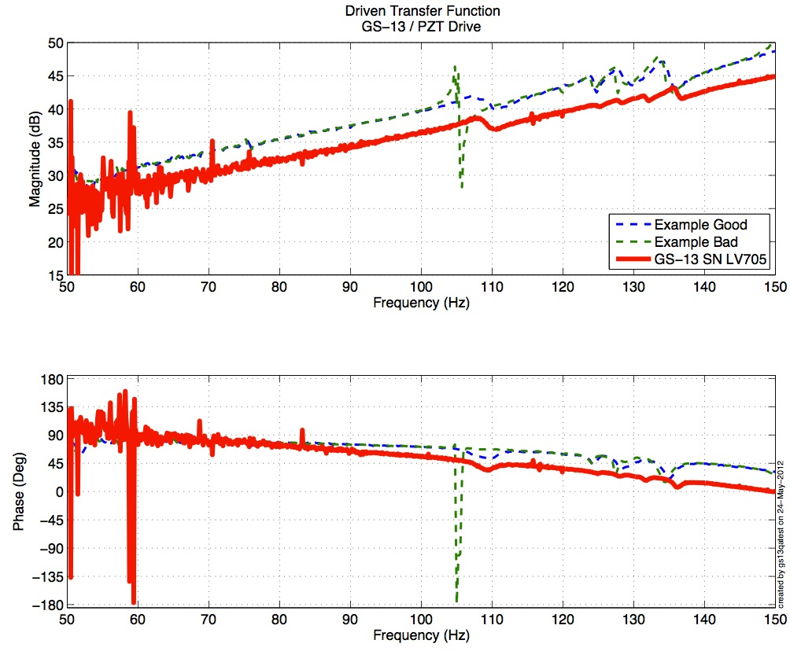
Figure - Driven testing of Vertical GS-13 757(V1), 773(V2), and 705(V3) after aLIGO modifications

Acceptance Criteria:
- GS13 have already been tested at LLO. GS13 Inspection/Pod Assembly is described in document D047810. Checklist is defined in F090070-v6

Test result: Passed: X Failed: .

Step 3: Actuators
Horizontal Actuator data can not be found in: T0900564-V2. Actuator inventory is made at Section II – Step 1.

Actuator Serial #: L179  Test data missing… | Actuator Serial #: L097  Operator Name: Gordon, Matt  Date: 1/30/2010 Time: 12:35 PM  Actuator Coil Resistance: 6.33 Ohms, PASS Ambient Temperature: 65.2 F Hi Pot  Test Results: 1000 MOhms, PASS X  Travel Limit (inches): 0.527  Y Travel Limit (inches): 0.205  Z Travel Limit (inches): 0.506
Actuator Serial #: L178  Test data missing… | Actuator Serial #: L118  Operator Name: Gordon, Matt  Date: 1/29/2010 Time: 3:09 PM  Actuator Coil Resistance: 6.40 Ohms, PASS Ambient Temperature: 70.7 F Hi Pot  Test Results: 1000 MOhms, PASS  X Travel Limit (inches): 0.537  Y Travel Limit (inches): 0.205  Z Travel Limit (inches): 0.504
Actuator Serial #: L176  Test data missing… | Actuator Serial #: L007  Operator Name: Smith, Lane  Date: 8/11/2009 Time: 2:47 PM  Actuator Coil Resistance: 6.33 Ohms, PASS Ambient Temperature: 76.9 F Hi Pot  Test Results: 1000 MOhms, PASS  X Travel Limit (inches): 0.511  Y Travel Limit (inches): 0.196  Z Travel Limit (inches): 0.483

TBC: To Be Completed once horizontal actuators’ S/N are retrieved (GS13 door opened)

Issues/difficulties/comments regarding this test:
- Actuators S/Ns were recorded after assembly.

Acceptance Criteria:
- Actuators were previously tested and results are reported in T0900564-V2.

Test result: Passed: Failed: X .

Step 5 – Seismometer inspection after shipping

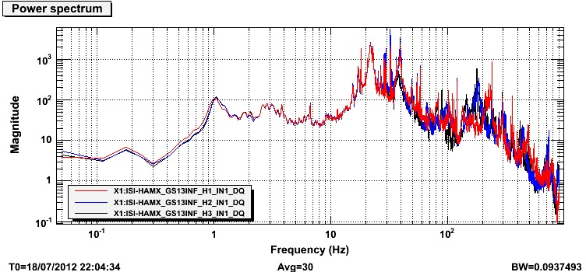
Figure – Horizontal Geophones inspection after reception at LHO

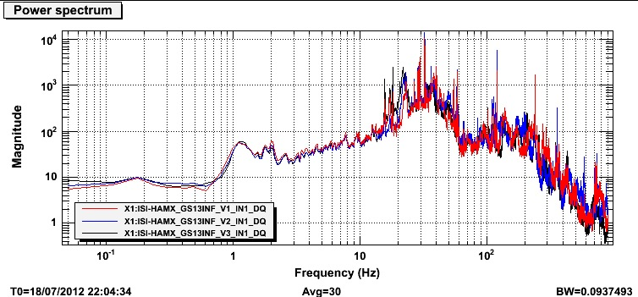
Figure – Vertical Geophones inspection after reception at LHO

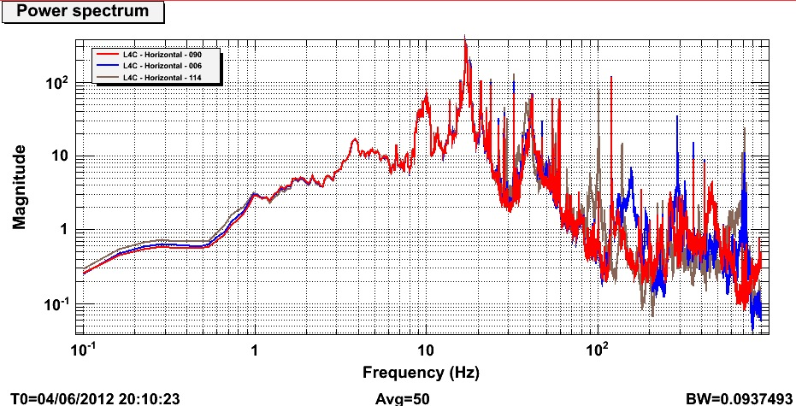
Figure – Horizontal L4C inspection after reception at LHO

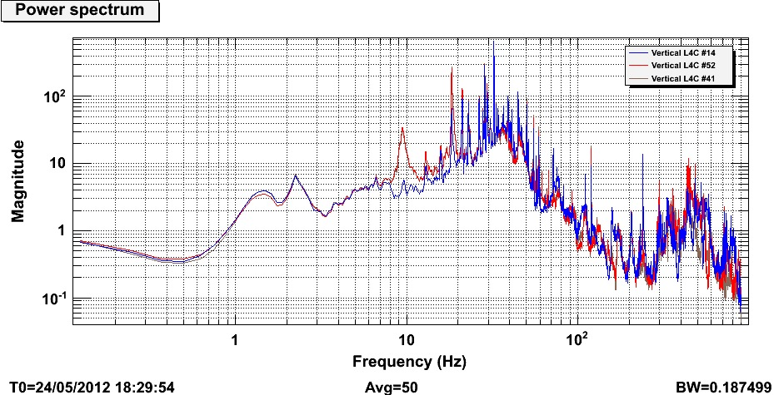
Figure – Vertical L4C inspection after reception at LHO

Results saved under the SVN at:
/SeiSVN/seismic/Common/Data/aLIGO_GS13_TestData_LHO/
/SeiSVN/seismic/Common/Data/aLIGO_L4C_TestData_LHO/

Acceptance Criteria:
- Geophones must have been tested after reception the geophones at LHO
- ASDs of the geophones must confirm that they are still functioning after shipping.
- Results must be available in the SVN

Test result: Passed: X Failed: .

Note:
Horizontal GS13s have nylon patches on their flexure’s screws.

Tests to be performed during assembly

Step 1: Parts Inventory (E1000052)
DCC Number | Part name | Configuration | Corner 1 S/N | Corner 2 S/N | Corner 3 S/N
D071001 | Stage 0 base | NA | 14
D071051 | Stage 1 base | NA | 10
D071050 | Optical table | NA | 9
D071002 | Spring Post | NA | 31 | 17 | 32
D071100 | Spring | NA | 30 | 41 | 45
D071102 | Flexure | NA | 41 | 46 | 40
ADE | Position sensor | Horizontal | 12009 Master 0 | 12012 slave 180 | 12036 slave 0
 |  | Vertical | 12025 slave 180 | 12016 slave 0 | 12030 slave 180
D047812 | GS-13 pod | Horizontal | 9 | 61 | 78
 |  | Vertical | 3 | 50 | 53
D047823 | L4C pod | Horizontal | 6 | 114 | 90
 |  | Vertical | 41 | 52 | 14
D0902749 | Actuator | Horizontal | 179 | 178 | 176
 |  | Vertical | 97 | 118 | 7
Table – Parts inventory

Cable Connects |  | Cable S/N
Part Name | Configuration | Corner 1 | Corner 2 | Corner 3
GS13 | Horizontal | S1104700 | S1106656 | S1104705
GS13 | Vertical
L4C | Horizontal | S1106651 | S1106650 | S1104706
L4C | Vertical
Actuator | Horizontal | S1104095 | S1104098 | S1106675
 | Vertical | S1106677 | S1106682 | S1107761
Table – Cables inventory

Step 2: Check torques on all bolts
Acceptance Criteria:
- All bolts should trip the wrench, and start moving immediately after. If any bolts in a pattern move before torque is reached, recheck after all bolts are brought to spec.

Test result: Passed: X Failed: .

Step 3: Check gaps under Support Posts
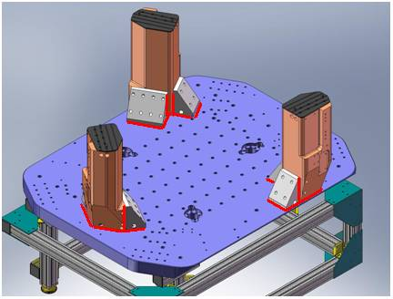
Figure - Showing edges that need checked on support posts and gussets

Acceptance Criteria:
- A 0.001 inch shim cannot be passed freely through any connection to Stage 0 or between post and gussets. If shim can pass through, loosen all constraining bolts, and then retighten iteratively from the center of the part to the edges. Retest.
Test result: Passed: X Failed: .

Step 4: Pitchfork/Boxwork flatness before Optical Table install
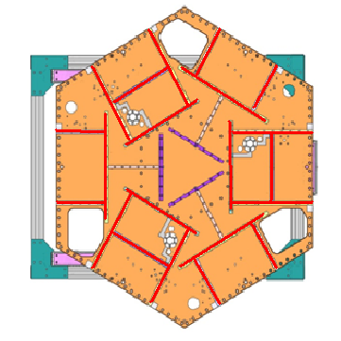
Figure – Showing what needs to be checked on Boxworks and Pitchforks

Acceptance Criteria:
- Shim inserted won’t pass between parts.
Test result: Passed: X Failed: .

Step 5: Blade spring profile

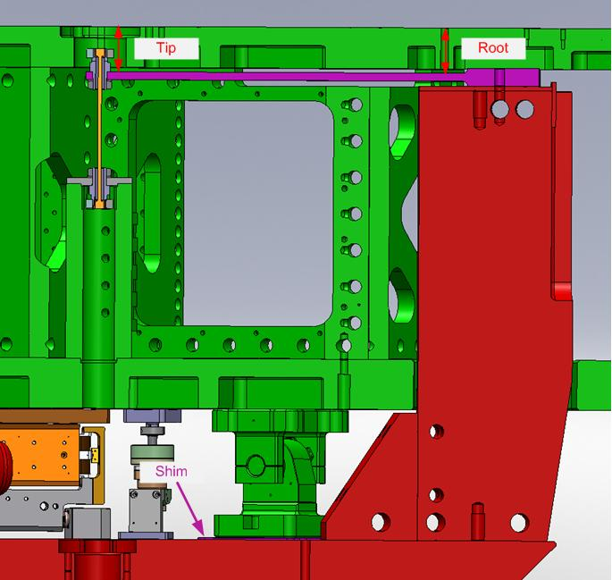
figure – Blade spring profile measurement points

Blade # | Root (Mils) | Tip (Mils) | Flatness (mils)
1 | 619 | 624 | 5
2 | 610 | 622 | 12
3 | 610 | 623 | 13
Table - Blade profile

Acceptance Criteria:
- Blades must be flat within 0.015" inches.

Note that the tip measurement should be constant and that root value can be impacted by shims change.

Test result: Passed: X Failed: .

Step 6: Gap checks on actuators-after installation on Stage 1

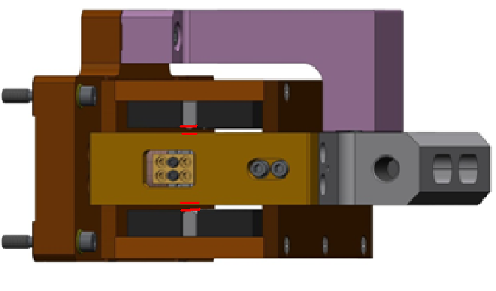
Figure - Showing gaps that need to be checked on actuators.

Issues/difficulties/comments regarding this test:
Since layers of shims are difficult to use accurately, a Go (70mils shim set) vs. No Go (90 mils shim set) technique was used for this test. To pass the test an actuator gap has to allow the 70mils shim set to be inserted and refuse the 90mils shim set.
The gaps on the backside of horizontal actuators are hard to access.

Acceptance Criteria
- Gaps must be within 0.010” of design (i.e. 0.090” and .070” pass, but 0.095” and 0.065” doesn’t).

Test result: Passed: X Failed: .

Step 7: Check level of Stage 0

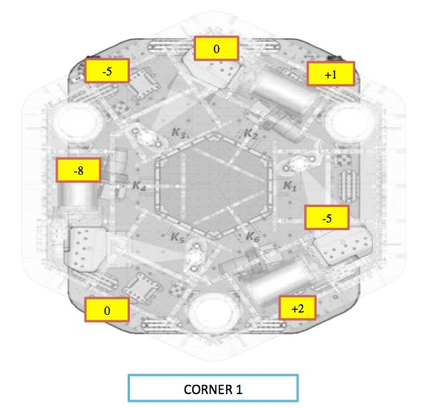
Figure – Level measured on Stage 0

Issues/difficulties/comments regarding this test:
The accuracy of the measurement limited by the measurement tool: optical level + ruler on a block. The ruler only has 1/100” graduations. Values are deduced from the relative distance to graduations. The uncertainty is about 1mil.
Max angle is calculated between the opposite points that have the most different level.
Max angle=0.007/73 (± 0.001/73) = 95.9 (±13.7) µrad

Acceptance Criteria
- The maximum angle of the table with the horizontal mustn’t exceed ~100µrad

Test result: Passed: X Failed: .

Step 8: Check level of Stage 1 Optical Table

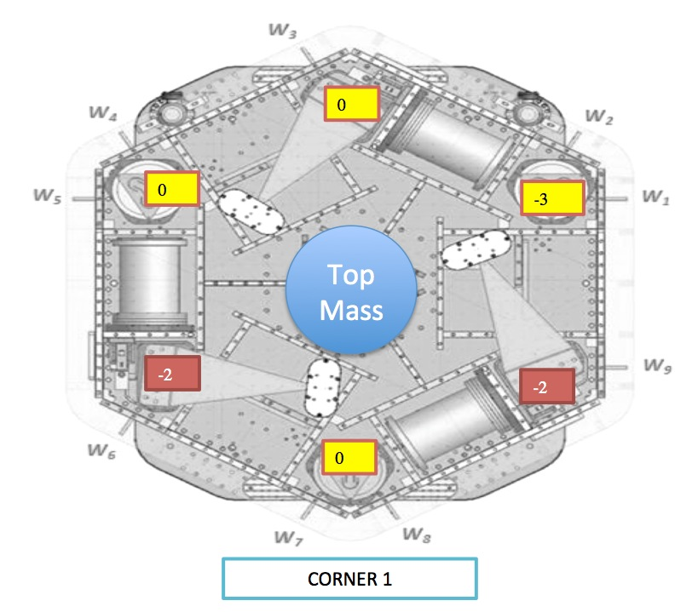
Figure – Level measured on Stage 1

Issues/difficulties/comments regarding this test:
The accuracy of the measurement is limited by the measurement tool: optical level + ruler on a block. The ruler only has 1/100” graduations. Values are deduced from the relative distance to graduations. The uncertainty is about 1mil.
The points marked in red are controversial. They were recorded as way out of spec (-8/-10mils) when measured from close range (distance < 3ft), but were absolutely fine (as displayed) when measured from further away (other side of the optical table). We suspected the optical level we were using to be biased and tried with another one. Same observation was made. We supposed the optical levels available could not be used in close range (distance < 3ft). If this hypothesis is not true, the optical table could have flatness irregularities, up to -10mils, on two edges.
Max angle is calculated between the opposite points that have the most different level.
Max angle = 0.002/86 (± 0.001/86) = 23.26 (± 11.7) µrad

Acceptance Criteria
- The maximum angle of the table with the horizontal mustn’t exceed ~100µrad

Test result: Passed: X Failed: .

Step 9: Mass budget
 | 00 | 01 | 02 | 03 | 04 | 05 | 06
 | 0.6 | 1.1 | 2.2 | 4.5 | 7.9 | 15.6 | 27.2 | lbs | kgs
W9 |  |  | 1 | 1 | 1 |  |  | 14.6 | 6.62
W1 | 2 | 3 | 1 | 1 | 1 |  |  | 19.1 | 8.66
W2 | 2 | 2 | 1 | 3 |  |  |  | 19.1 | 8.66
W3 |  | 1 | 1 | 2 | 1 |  |  | 20.2 | 9.16
W4 | 3 | 3 | 1 | 1 | 1 |  |  | 19.7 | 8.94
W5 | 4 | 3 | 1 | 3 |  |  |  | 21.4 | 9.71
W6 |  |  | 1 | 1 | 1 |  |  | 14.6 | 6.62
W7 |  | 1 | 1 | 2 | 1 |  |  | 20.2 | 9.16
W8 | 2 | 1 | 1 | 1 | 1 |  |  | 16.9 | 7.67
Side Masses Total | 13 | 14 | 9 | 15 | 7 | 0 | 0 | 165.8 | 75.21
Table – Wall masses distribution

 | 00 | 01 | 02 | 03 | 04 | 05 | 06
 | 0.6 | 1.1 | 2.2 | 4.5 | 7.9 | 15.6 | 27.2 | lbs | kgs
K1 |  |  |  |  |  | 2 |  | 31.2 | 14.15
K2 |  |  |  |  | 1 |  | 1 | 35.1 | 15.92
K3 |  |  |  |  |  | 2 |  | 31.2 | 14.15
K4 |  |  |  |  | 1 |  | 1 | 35.1 | 15.92
K5 |  |  |  |  |  | 2 |  | 31.2 | 14.15
K6 |  |  |  |  | 1 |  | 1 | 35.1 | 15.92
Keel Masses Total | 0 | 0 | 0 | 0 | 3 | 6 | 3 | 198.9 | 90.22
Table – Keel masses distribution

 | Mass (kg)
T1 | 45.00
T2 | 270.79
T3 | 45.00
T4 | 50.00
Total | 410.79
Table – Optic table masses distribution
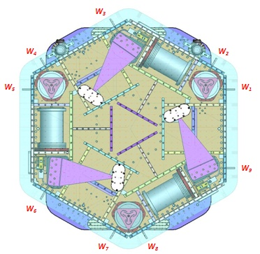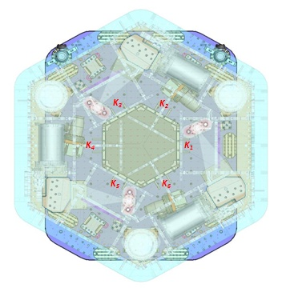
Figure – Wall Masses (W) and Keel masses (K) location. South of picture = corner 1

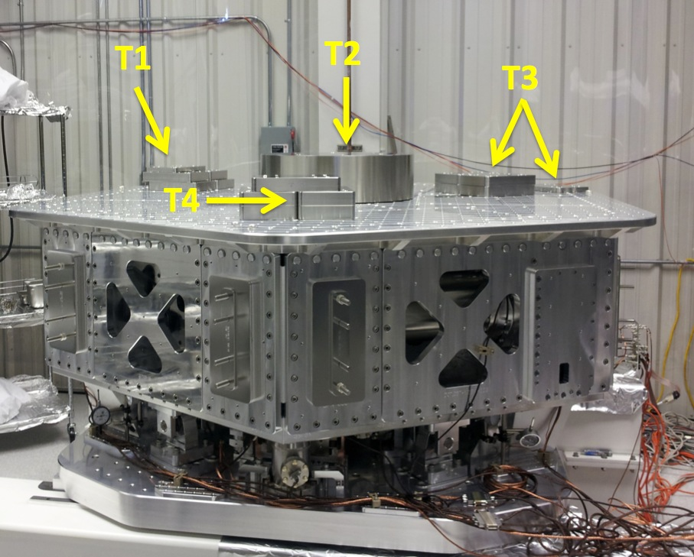
Figure – Optic table masses distribution

 | Side | Keel | Top | Total
Weigh (kg) | 75.21 | 90.22 | 410.79 | 576.22
Table – Mass budget sum up

Issues/difficulties/comments regarding this test:
- T2’s big mass evaluated at nominal value: 270.79kg. Gauge not available for measurement.
- A few shims were used for balancing. Their weight is negligible in comparison with the mass budget. Hence their weight is not reported in the mass budget.

Acceptance Criteria
The Mass budget must be
- 579.1 Kg (cf. E1100427)+/-25Kg (5%)

Test result: Passed: X Failed: .

Step 10: Shim thickness
Lockers | Shim thickness (mils)
A | 124
B | 127
C | 125
D | 123
Table – Shims Thickness

Acceptance Criteria
- The shim thickness should be 125 mils +/-5

Test result: Passed: X Failed: .

Step 11: Lockers adjustment
D.I. at Locker | Vertical D.I. | Horizontal D.I.
A | 1.5 | 0.2
B | -0.5 | -1
C | 1 | -1
D | -1 | -0.5
Table – Dial indicators read-out (in thousands of an inch)

Issues/difficulties/comments regarding this test:
Lockers might have to be reset once the ISI is installed in the interferometer.

Acceptance Criteria
- Vertical and horizontal displacement near the lockers must be lower than 2 mils (0.002”)

Test result: Passed: X Failed:

Tests to be performed after assembly

Step 1 - Electronics Inventory
Hardware | LIGO reference | S/N
Coil driver | D0902744 | S1000266
 |  | S1000269
Anti Image filter | D070081 | S1000250
Anti aliasing filter | D1000269 | S1102694
 |  | S1102679
Interface chassis | D1000067 | 1102223
 |  | 1102224
 |  | 1102214
Table - Inventory electronics

Step 2 - Set up sensors gap
Locked /no mass
ADE boxes on
Offset (Mean) | Std deviation
48.54 | 7.80
165.67 | 7.91
-282.18 | 9.12
215.49 | 8.91
42.68 | 11.73
131.62 | 8.77
Capacitive position sensor readout after gap set-up

Issues/difficulties/comments regarding this test:
Sensor Gaps might have to be reset once the ISI is installed in the interferometer.

Acceptance criteria:
- All mean values must be lower than +/-400 cts (a bit less than .0005”).
- All standard deviations below 20 counts.
- No cross talk

Test result: Passed: X Failed: .

Step 3 - Measure the Sensor gap
Issues/difficulties/comments regarding this test:
Measured in the previous step. Waived to avoid scratching targets.

Test result: Passed: Failed: . Waived: X_

Step 4 - Check Sensor gaps after the platform release

 | Table locked |  | Table unlocked
Sensors | Mean | Std Deviation | Mean | Std Deviation | Difference
H1 | 48.54 | 7.80 | 931.52 | 17.01 | 882.99
H2 | 165.67 | 7.91 | 1172.40 | 14.43 | 1006.73
H3 | -282.18 | 9.12 | 524.93 | 21.51 | 807.11
V1 | 215.49 | 8.91 | 1215.10 | 16.96 | 999.61
V2 | 42.68 | 11.73 | 642.26 | 21.77 | 599.59
V3 | 131.62 | 8.77 | 951.40 | 29.26 | 819.78
Table – Sensor gaps after platform release

Acceptance criteria:

- Absolute values of the difference between the unlocked and the locked table must be below:
  - 1600 cts for horizontal sensors (~0.002”)
  - 1600 cts for vertical sensors (~0.002”)
- All mean values must be lower than:
  - 2000 cts for horizontal sensors (~0.0025”)
  - 2000 cts for vertical sensors (~0.0025”)

Test result: Passed: X Failed: .

Step 5 – Performance of the limiter

Step 5.1 - Test Nº1 - Pushing “in the general coordinates”
Pushing Z,-Z | CPS read out |  | Calculated after calibration |  | ROM
Sensors | UP (Counts) | Down (Counts) | UP (mil) | Down (mil)
V1 | 21100 | -19000 | 25.4 | -22.9 | 40100
V2 | 18900 | -18750 | 22.7 | -22.6 | 37650
V3 | 20400 | -20100 | 24.6 | -24.2 | 40500
Pushing RZ, -RZ | CPS read out |  | Calculated after calibration |  | ROM
Sensors | CCW (+RZ) | CW(-RZ) | CW (mil) | CCW (mil)
H1 | -23000 | 22200 | -27.7 | 26.7 | 45200
H2 | -21500 | 22500 | -25.9 | 27.1 | 44000
H3 | -21500 | 20000 | -25.9 | 24.1 | 41500
Table - Optic table range of motion

Step 5.2 - Test Nº2 – Pushing “locally”
Pushing Locally | Push in positive direction | Push in negative direction | Railing | Actuator Gap Check | ROM
H1 | -25000 | 25800 |  | X | 50800
H2 | -25000 | 20600 |  | X | 45600
H3 | -26100 | 23500 |  | X | 49600
V1 | 21300 | -19800 |  | X | 41100
V2 | 32267 | -32267 | X | X | 64534
V3 | 24000 | -25800 |  | X | 49800
Table - Optic table range of motion
ROM = Range of motion

Issues/difficulties encountered during this test:
- Contact points are difficult to check on vertical actuators.
- V2 railing.
- Horizontal motion (Rz) was computed in mils from the vertical CPS calibration (Step 11).

Acceptance criteria:
- The vertical sensor readout must be positive when the optic table is pushed in the +Z direction
- The horizontal sensor readout must be negative when the optic table is pushed in the +RZ direction
- Step 5.1
  - Absolutes value of all estimated motions must be higher than 16000counts (~0.020”)
- Step 5.2
  - No contact point on sensors
  - Absolute value of sensor read out must be higher than 16000counts (~0.020”)
  - No contact point on actuators

Test result: Passed: X Failed: .

Step 6 - Position Sensors unlocked/locked Power Spectra
Locked/Unlocked Power Spectra are presented below.

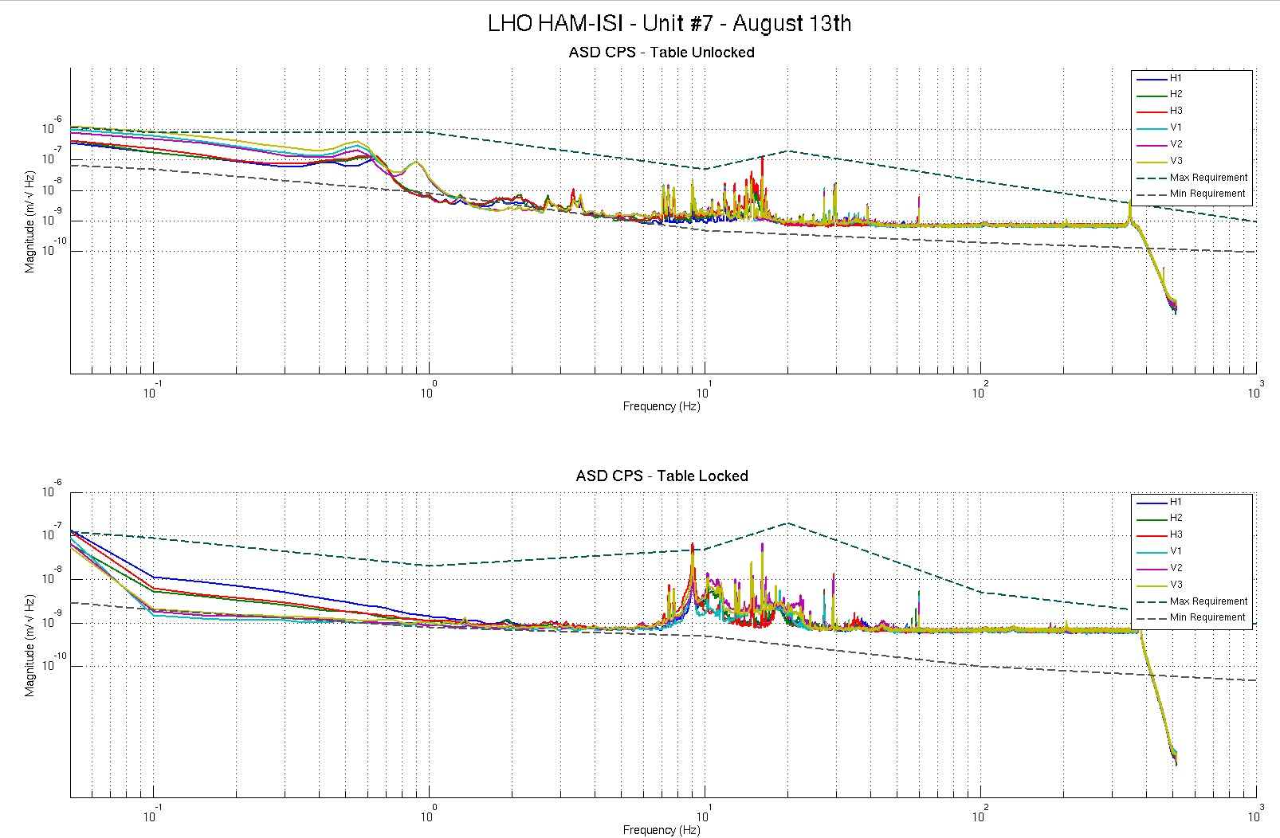
Figure - Calibrated CPS power spectra

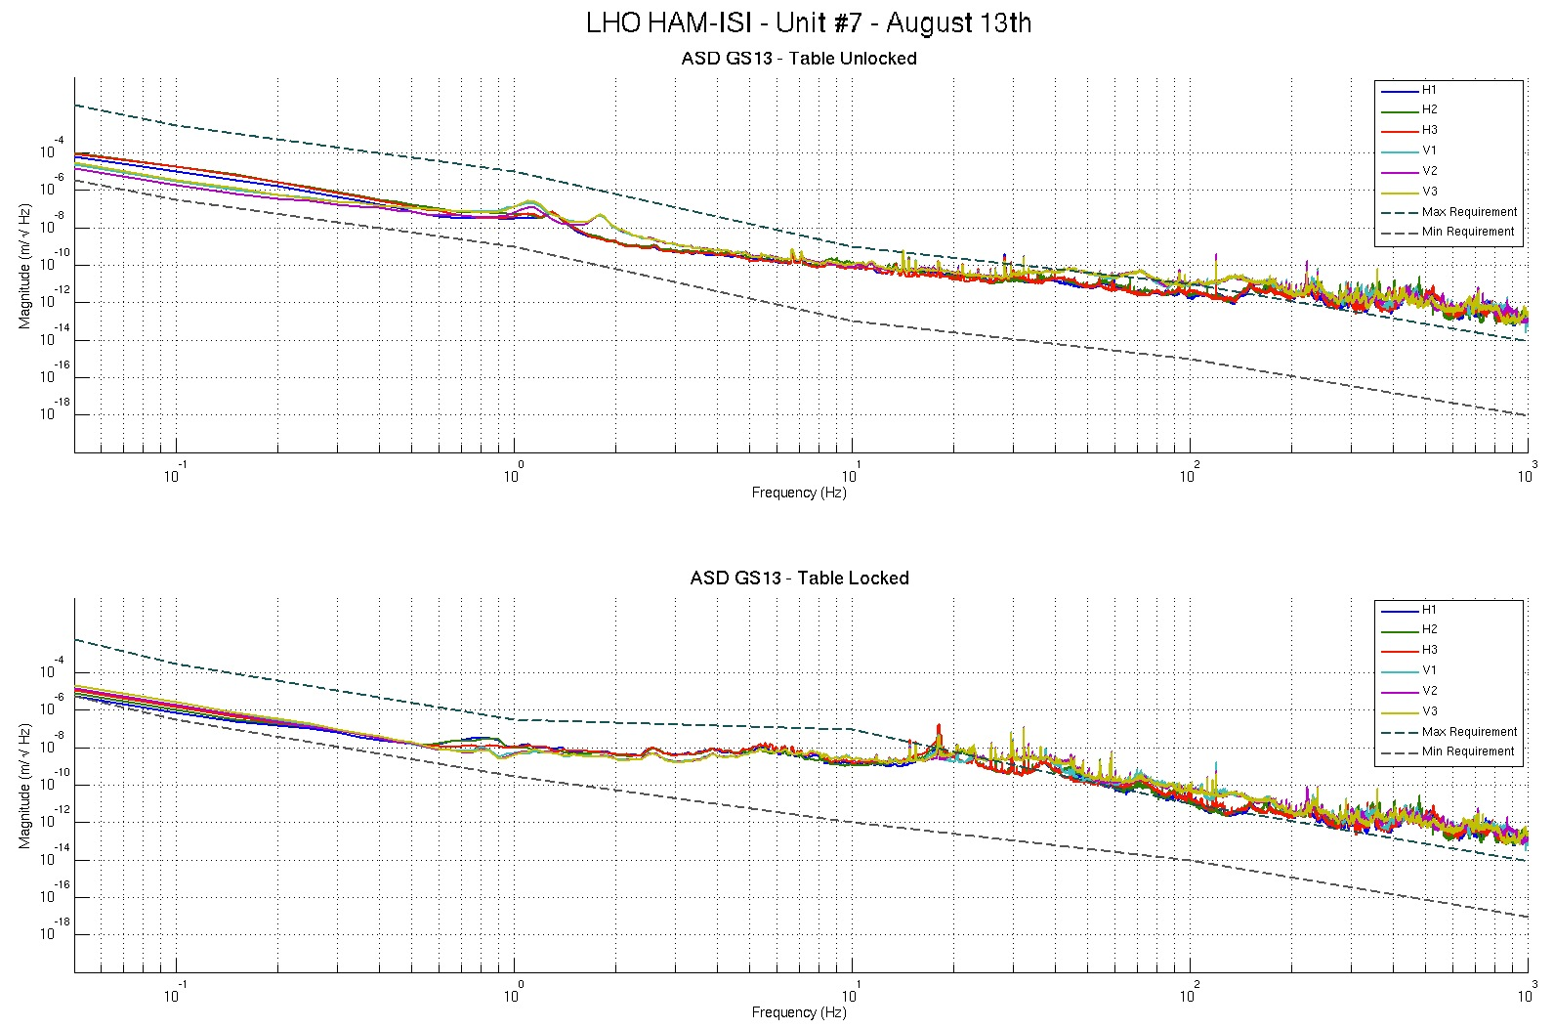
Figure – Calibrated GS13 Power spectra

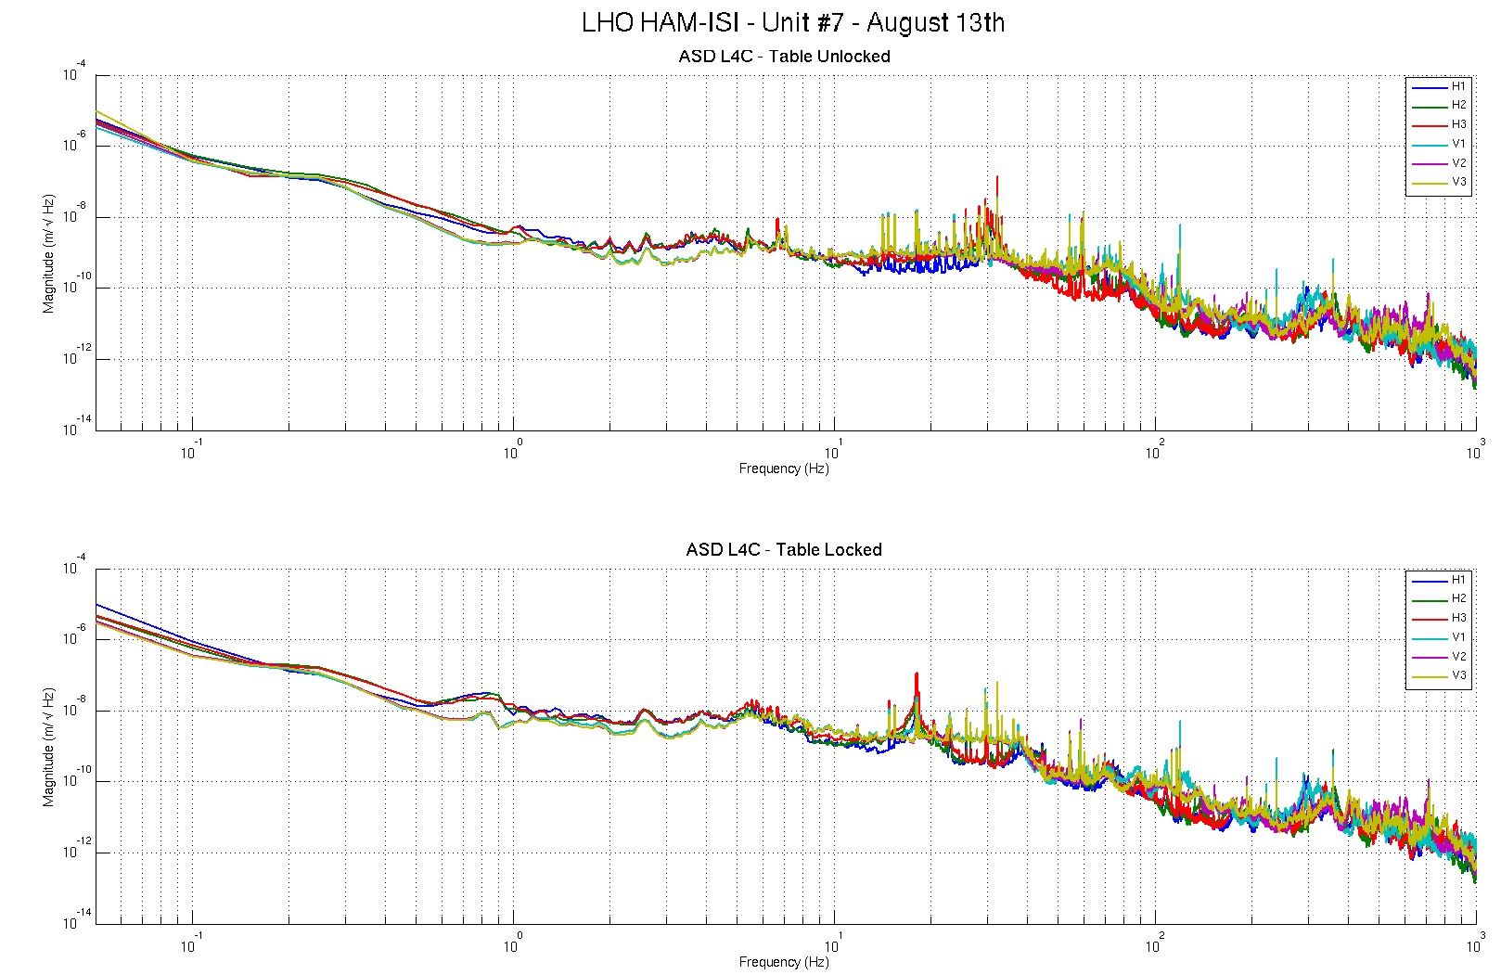
Figure – Calibrated L4C Power spectra

Scripts files for processing and plotting in SVN at:
/SeiSVN/seismic/HAM-ISI/Common/Testing_Functions_HAM_ISI/
- ASD_Measurements_Locked_Unlocked_HAM_ISI.m

Data in SVN at:
SeiSVN/seismic/ HAM-ISI/X1/HAMX/Data/Spectra/Undamped/
- LHO_ISI_UNIT_7_ASD_m_CPS_T240_L4C_GS13_Locked_vs_Unlocked_2012_08_13.mat
Figures in SVN at:
/SeiSVN/seismic/HAM-ISI/X1/HAMX/Data/Figures/Spectra/Undamped
- LHO_ISI_UNIT_7_ASD_m_L4C_Requirements_Locked_vs_Unlocked_2012_08_13
- LHO_ISI_UNIT_7_ASD_m_GS13_Requirements_Locked_vs_Unlocked_2012_08_13
- LHO_ISI_UNIT_7_ASD_m_CPS_Requirements_Locked_vs_Unlocked_2012_08_13

Issues/difficulties/comments regarding this test:
- 10Hz-100Hz peaks on CPS spectra were investigated for the testing phase I of Unit #3, and reported in Part 1, last step: Capacitive Position Sensor Investigation, of the related report (Document #E1000312-v3)

Acceptance criteria:
- No cross talk (peaks at low frequencies + harmonics on measurements)
- Magnitudes of power spectra must be between requirement curves

Test result: Passed: X Failed: .

Note: When a seismometer fails, its low frequency response is affected. Spectra are within requirements in low frequency. The production GS13s installed on this unit are functional.

Step 7 - GS13 power spectra -tabled tilted
GS13 spectra when the table is tilted are presented below.

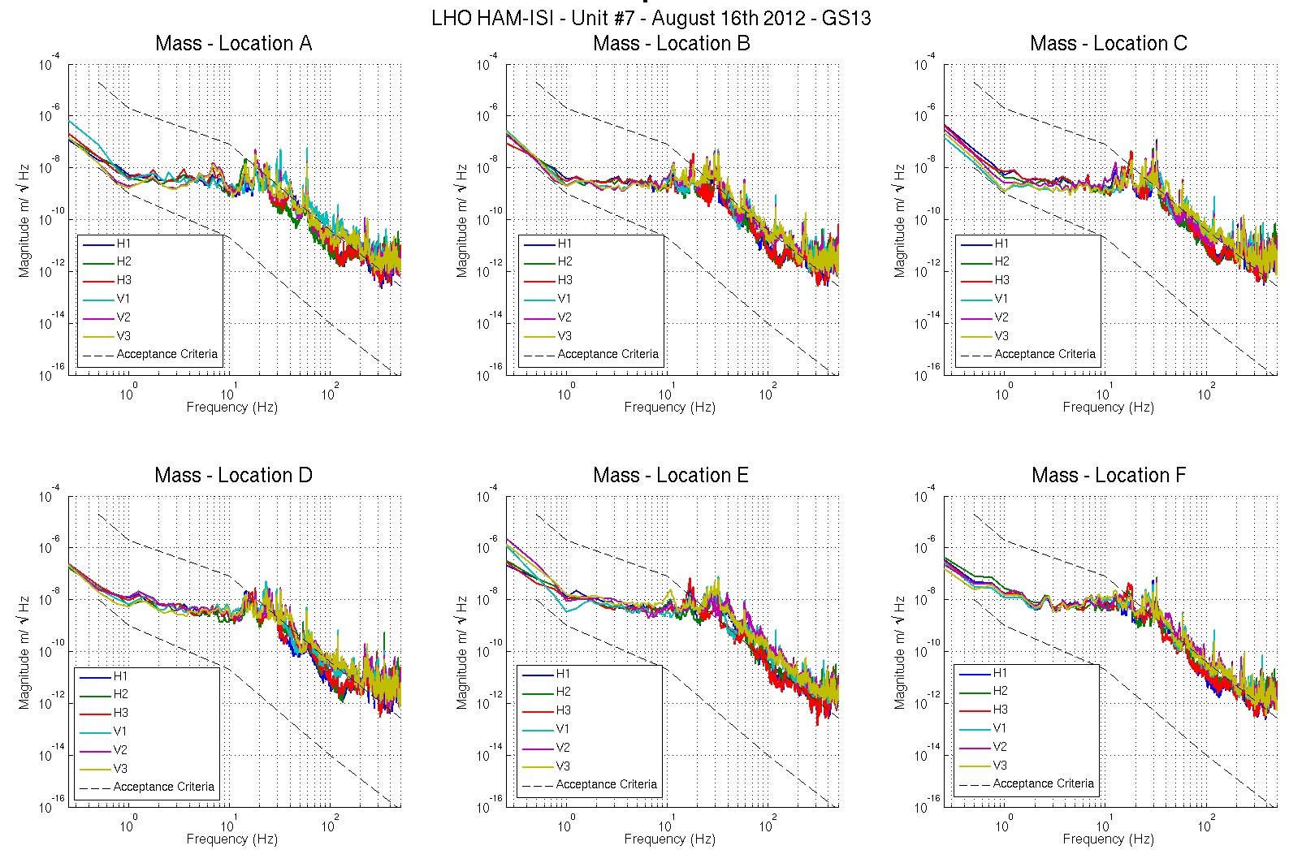
Figure – Power spectrum Calibrated GS13 with mass at corners A to F

Scripts files for processing and plotting in SVN at:
SeiSVN/seismic/HAM-ISI/Common/Testing_Functions_HAM_ISI/
- ASD_Measurements_Stages_Tilted_HAM_ISI.m

Data in SVN at:
SeiSVN/seismic/ HAM-ISI/X1/HAMX/Data/Spectra/Undamped/
- LHO_ISI_UNIT_7_ASD_m_GS13_Stage_Tilted_2012_08_16.mat
Figures in SVN at:
SeiSVN/seismic/HAM-ISI/X1/HAMX/Data/Figures/Spectra/Undamped
- LHO_ISI_UNIT_7_m_PSD_GS13_Tilted_2012_08_16.fig

Acceptance criteria:
- With table unlocked and tilted, magnitudes of power spectra must be fully included within requirement curves.

Test result: Passed: X Failed: .
Note:
When a seismometer fails, its low frequency response is affected. Spectra are within requirements in low frequency. The production GS13s installed on this unit are functional.

Step 8- GS13 pressure readout

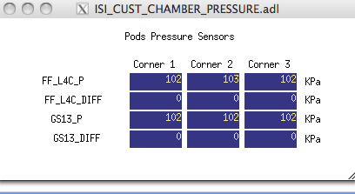
Figure – Pressure Readouts (08/14/2012)

Acceptance criteria:
- The pressure on GS13_P channels must be 102KPa +/-8 KPa (25000 counts +/- 3000 counts)
- GS13_P must vary the same way in each corner and GS13_DIFF must be constant (channels follow comparable trend)

Test result: Passed: X Failed: .

Step 9 - Coil Driver, cabling and resistance check
Actuator | V1 |  | H1 |  | V2
Coil driver | S1000266 - Coarse 2 |  | S1000266 - Coarse 1 |  | S1000269 - Coarse 2
Cable # | S1104760 |  | S1104762 |  | S1104773
Resistance | P1 - P2 | P2 - P3 | P1 - P2 | P2 - P3 | P1 - P2 | P2 - P3
(Ohm) | O.L (infinity) | 6.7 | O.L (infinity) | 6.4 | O.L (infinity) | 6.7
MEDM offset | Measurement P2 (+) ; P1&P3 (-) |  | Measurement P2 (+) ; P1&P3 (-) |  | Measurement P2 (+) ; P1&P3 (-)
(1000 counts) | 0.3070V |  | 0.3117V |  | 0.3115V
Actuator | H2 |  | V3 |  | H3
Coil driver | S1000269 - Coarse 1 |  | S1102692 - Coarse 2 |  | S1102692 - Coarse 1
Cable # | S1104776 |  | S1104494 |  | S1104493
Resistance | P1 - P2 | P2 - P3 | P1 - P2 | P2 - P3 | P1 - P2 | P2 - P3
(Ohm) | O.L (infinity) | 6.5 | O.L (infinity) | 6.8 | O.L (infinity) | 6.7
MEDM offset | Measurement P2 (+) ; P1&P3 (-) |  | Measurement P2 (+) ; P1&P3 (-) |  | Measurement P2 (+) ; P1&P3 (-)
(1000 counts) | 0.3138V |  | 0.3044V |  | 0.3106V
Table - Actuators resistance check

Issues/difficulties/comments regarding this test:
- Voltages measured from Pin #2 (+) to pin #3 (-) with compensation filters engaged.
- Resistances are given +/-0.1V

Acceptance criteria:
- The measured resistance between the middle pin and one side pin must be 6.5 +/-1 ohms
- Actuator neutral pins must be connected on pin #3 (left side pin of the plug)
- Actuator drive pins must be connected on pin #2 (middle pin of the plug)
- Actuator ground shield pins must be connected on pin #1 (right pin of the plug)
- All LEDs on the coil driver front panel must be green

Test result: Passed: X Failed: .

Step 10 - Actuators Sign and range of motion (Local drive)
 | Negative drive | No Drive | Positive drive | ROM (Counts)
H1 readout (count) | -24088 | 564 | 24401 | 48489
H2 readout (count) | -24182 | 837 | 23954 | 48136
H3 readout (count) | -25034 | 250 | 24764 | 49798
V1 readout (count) | -18803 | 1217 | 20645 | 39448
V2 readout (count) | -25539 | 622 | 26806 | 52345
V3 readout (count) | -22450 | 1038 | 22203 | 44653
Table - Range of motion - Local drive

Issues/difficulties/comments regarding this test:
- Compensation filters are ON.
- Symmetrization filters are OFF

Acceptance criteria:
- Main couplings sensors readout must be at least 16000 counts (~0.02”)
- A positive offset drive on one actuator must give positive sensor readout on the collocated sensor. Signs will also be tested when measuring local-to-local transfer functions.

Test result: Passed: X Failed: .

Step 11 - Vertical Sensor Calibration
Lockers | D.I readout with for  a negative drive | D.I readout with for  a positive drive
A | -18.50 | 19.00
B | -19.00 | 19.00
C | -19.50 | 19.50
D | -18.50 | 18.50
Average | -18.88 | 19.00
Sensors | Counts | Counts | Difference
V1 | -15562.00 | 16494.00 | 32056.00
V2 | -14904.00 | 15868.00 | 30772.00
V3 | -15197.00 | 16375.00 | 31572.00
Vertical Sensibility
830.80 | Count/mil
0.51 | V/mil
30.57 | nm/count
-1.09 | % from ref (840count/mil)

Acceptance criteria:

- Deviation from nominal value < 2%. Nominal value is 840 count/mil.

Test result: Passed: X Failed: .

Step 12 - Vertical Spring Constant
Sensors | Mean diff counts | Mean diff m | K (N/m) | Error with average
V1 | -19420 | -5.937E-04 | 82614 | -0.52%
V2 | -20182 | -6.170E-04 | 79496 | -4.27%
V3 | -18438 | -5.637E-04 | 87016 | 4.79%
 |  | Average (N/m) | 249125
 |  |  | 0.84 | % variation from nominal
Table - Vertical spring constant
Acceptance criteria:
- +/-2 % of 2.4704e5 N/m (i.e. between 2.421e5 and 2.520e5 N/m)
- +/- 5% of variation between each spring and the average

Test result: Passed: X Failed:

Step 13 - Static Testing (Tests in the local basis)
 | Sensors (counts)
 | H1 | H2 | H3 | V1 | V2 | V3
H1 | 2039 | 1294 | 1282 | -15 | 3 | 6
H2 | 1252 | 2001 | 1253 | 0 | -4 | -9
H3 | 1255 | 1257 | 1986 | -14 | 3 | -13
V1 | 181 | 193 | -375 | 1421 | -35 | -640
V2 | -360 | 202 | 190 | -660 | 1422 | -48
V3 | 201 | -369 | 186 | -76 | -626 | 1446
Table - Main couplings and cross couplings

Acceptance criteria:
- Vertical
For a +1000 count offset drive on vertical actuators
  - Collocated sensors must be 1400 counts +/- 10%

- Horizontal
For a +1000 count offset drive on horizontal actuators
  - Collocated sensors must be 2000 counts +/- 10%
  - Non-collocated horizontal sensors must be 1250 counts +/-10%

Test result: Passed: X Failed: .

Step 14 - Linearity test
 | Slope | Offset | Average slope | Variation from  average(%)
H1 | 2.0702 | 665.9 | 2.04 | 1.72
H2 | 2.0213 | 924.9 |  | -0.69
H3 | 2.0143 | 293.38 |  | -1.03
V1 | 1.4797 | 1502.1 | 1.47 | 0.70
V2 | 1.4509 | 915.58 |  | -1.26
V3 | 1.4777 | 1240.2 |  | 0.56
Table - Slopes and offset of the triplet ‘Actuators - HAM-ISI – Sensors’

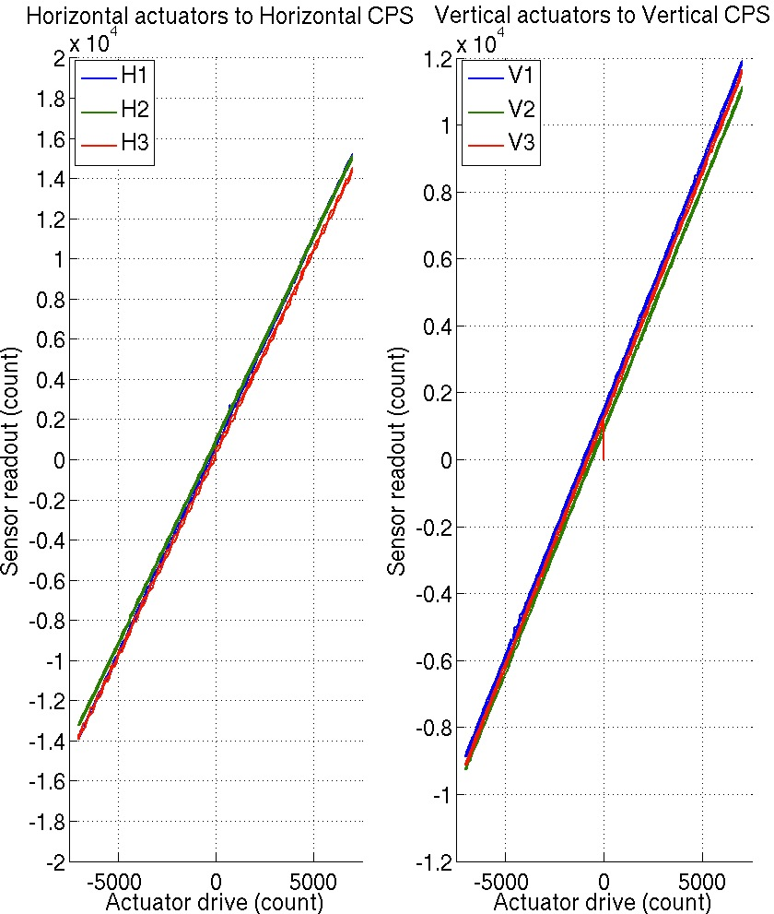
Figure - Linearity test on the triplet ‘actuators - HAM-ISI – sensors’
in both Horizontal and vertical directions

Issues/difficulties encountered during this test:
- H1, slightly out of requirements.
- The tendencies on linearity test slopes seem to match the tendencies on cable resistance (coildriver to feedthrough section). Cable resistance, which is proportional to cable length, would then be a possible explanation for the linearity results obtained.

Acceptance criteria:
- Horizontal and vertical slopes of the triplet actuators x HAM-ISI x sensors: Average slope +/- 1.5%

Test result: Passed: Failed: X .

Note: we will check that these values are within tolerance when we’ll use the final field cables.

Step 15 - Cartesian Basis Static Testing
1000 counts Drive | H1 | H2 | H3 | V1 | V2 | V3 | Direction read out
X Drive | 264.4 | 260.81 | -479.17 | -63.07 | 32.439 | 6.8052 | 500.74
Y Drive | -467.83 | 418.22 | -30.844 | -27.794 | 24.759 | -3.5428 | 506.59
Z Drive | -1.7542 | 9.1196 | -1.7742 | 231.61 | 273.51 | 260.84 | 242.34
Rx Drive | -453.18 | 468.8 | 3.215 | -524.24 | 1692 | -1228.5 | 2598.6
Ry Drive | -259.55 | -255.96 | 531.92 | -1723.1 | 401.36 | 1239.1 | 2606.2
Rz Drive | -1942.2 | -1940.7 | -1938.9 | -50.905 | 11.317 | -8.2448 | 2462.1
1000 counts Drive | H1 | H2 | H3 | V1 | V2 | V3 | Direction read out
X Drive | + | + | - |  |  |  | +
Y Drive | - | + | 0 |  |  |  | +
Z Drive |  |  |  | + | + | + | +
Rx Drive |  |  |  | - | + | - | +
Ry Drive |  |  |  | - | + | + | +
Rz Drive | - | - | - |  |  |  | +
1000 counts Drive | X | Y | Z | RX | RY | RZ | Direction read out
X Drive | 500.74 | -2.8672 | -13.884 | 40.809 | 35.65 | -19.067 | 500.74
Y Drive | -18.569 | 506.59 | -14.959 | -5.7106 | 18.622 | 27.636 | 506.59
Z Drive | 19.733 | 0.34116 | 242.34 | -11.093 | 42.193 | -4.0242 | 242.34
Rx Drive | 10.402 | 3.2181 | -21.483 | 2598.6 | 15.407 | -10.62 | 2598.6
Ry Drive | 17.648 | 7.7229 | -25.17 | -11.003 | 2606.2 | -10.639 | 2606.2
Rz Drive | -3.2331 | 10.464 | -18.819 | 8.8443 | 37.37 | 2462.1 | 2462.1
Table – Cartesian static testing reference table

Acceptance criteria:
For a positive drive in the Cartesian basis:
- Local sensor readout must have the same sign that the reference table
- Cartesian sensors read out must be positive in the drive direction

Test result: Passed: X Failed: .

Step 16- Frequency response

Step 16.1 - Local to local measurements

FREQ. RANGE |  |  | DRIVE |  | MEAS. TIME
Min | Max | Freq. Res. (Hz) | H | V | Time for 1 Rep. (s) | Number of Reps | Estimated duration (min)
0.01 | 0.1 | 0.01 | 3500 | 3500 | 620 | 10 | 103.3
0.1 | 0.5 | 0.02 | 420 | 420 | 320 | 30 | 160
0.5 | 5 | 0.025 | 24.5 | 24.5 | 260 | 55 | 238.3
5 | 200 | 0.1 | 140 | 140 | 80 | 50 | 66.7
200 | 1000 | 0.2 | 140 | 140 | 50 | 150 | 125
 |  |  |  |  | Estimated Measurement Time (h) |  | 11.6
Table – Transfer function settings, by frequency band

Data collection script files:
/SeiSVN/seismic/HAM-ISI/Common//Transfer_Function_Scripts/
- Run_TF_L2L_10mHz_100mHz.m
- Run_TF_L2L_100mHz_500mHz.m
- Run_TF_L2L_500mHz_5Hz.m
- Run_TF_L2L_5Hz_100Hz.m
- Run_TF_L2L_100Hz_1000Hz.m

Data files in SVN at:
/SeiSVN/seismic/HAM-ISI/X1/HAMX/Data/Transfer_Functions/Measurements/Undamped/
- LHO_ISI_HAM_Unit_7_Data_TF_L2L_200Hz_1000Hz_20120810-161601.mat
- LHO_ISI_HAM_Unit_7_Data_TF_L2L_5Hz_200Hz_20120810-184834.mat
- LHO_ISI_HAM_Unit_7_Data_TF_L2L_500mHz_5Hz_20120810-221211.mat
- LHO_ISI_HAM_Unit_7_Data_TF_L2L_100mHz_500mHz_20120811-020150.mat
- LHO_ISI_HAM_Unit_7_Data_TF_L2L_10mHz_100mHz_20120811-044326.mat
Scripts files for processing and plotting in SVN at:
/SeiSVN/seismic/HAM-ISI/X1/HAMX/Scripts/Control_Scripts/Version_0/
- Step_1_TF_Loc_to_Loc_X1_ISI_HAMX

Figures in SVN at:
/SeiSVN/seismic/HAM-ISI/X1/HAMX/Data/ Figures/Transfer_Functions/Measurements/Undamped/
- X1_ISI_HAMX_TF_L2L_Raw_from_ACT_to_CPS_2012_08_10.fig
- X1_ISI_HAMX_TF_L2L_Raw_from_ACT_to_GS13_2012_08_10.fig

Storage of measured transfer functions in the SVN at:
/SeiSVN/seismic/HAM-ISI/X1/HAMX/Data/Transfer_functions/ Simulations/Undamped/
- X1_ISI_HAMX_TF_L2L_Raw_2012_07_13.mat

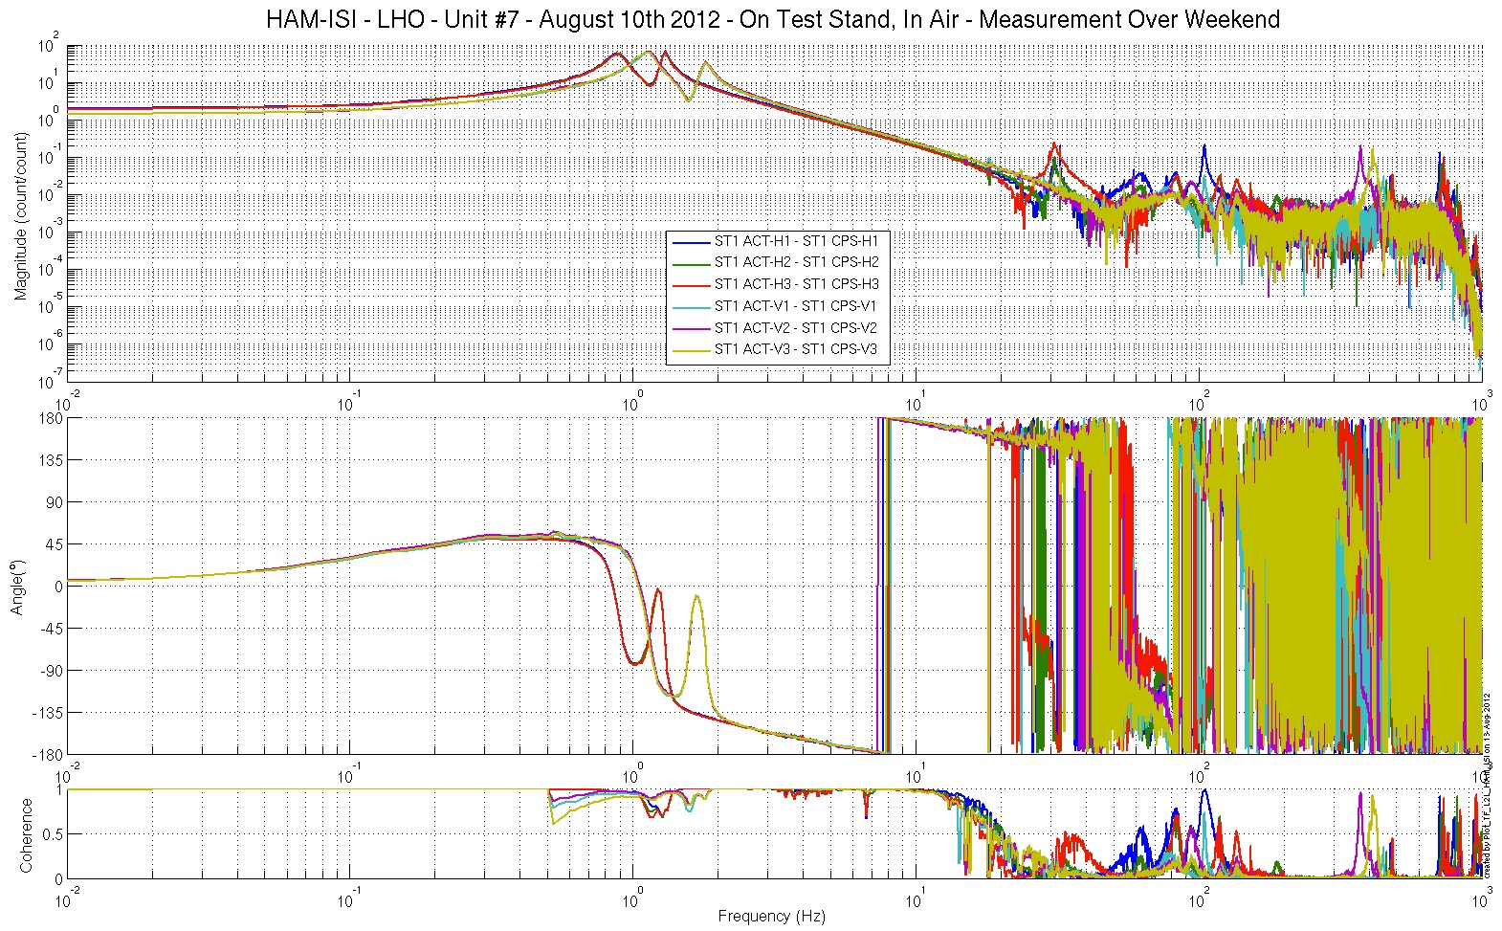
Figure - local-to-Local Measurements – Capacitive sensors

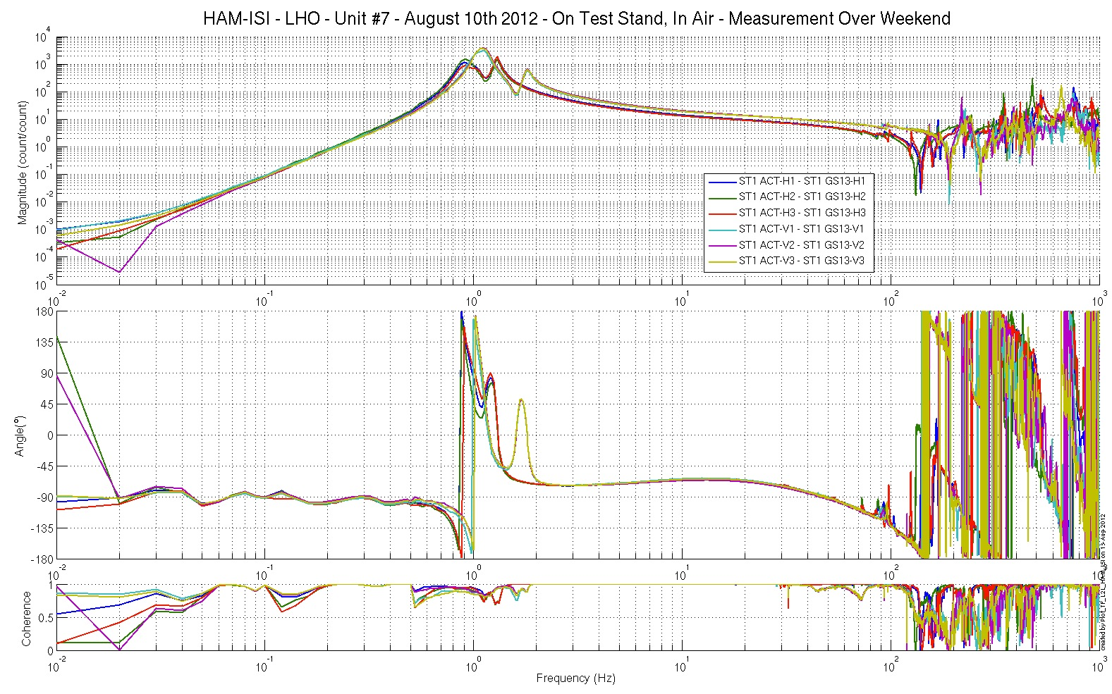
Figure - local-to-Local Measurements – Inertial sensors
Acceptance criteria:
- Local to local measurements
  - On CPS, the phase must be 0º at DC
  - On Geophones, the phase must be -90º at DC
  - Identical shape in each corner

Test result: Passed: X Failed: .

Step 16.2 – GS13 Response extraction
Plots for the extracted responses are presented below.

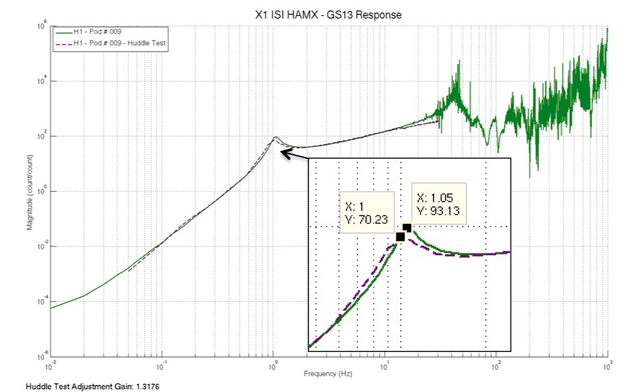

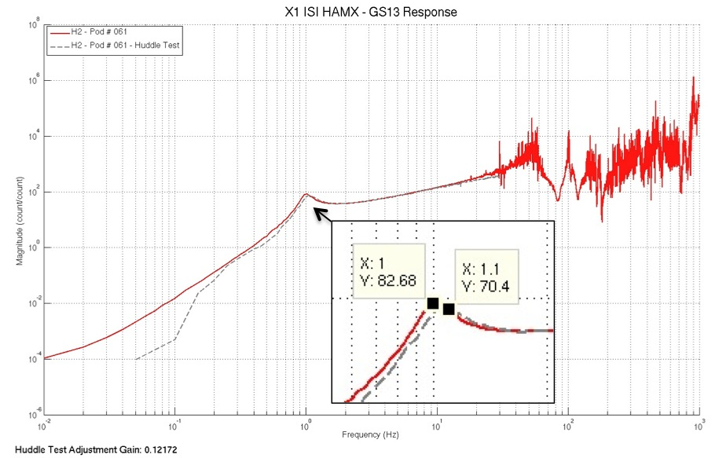

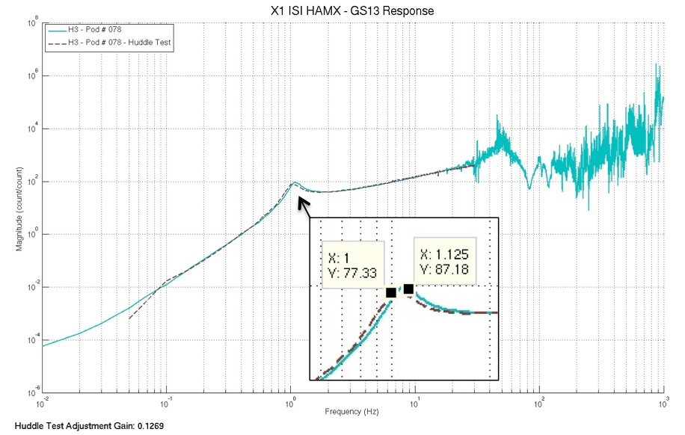

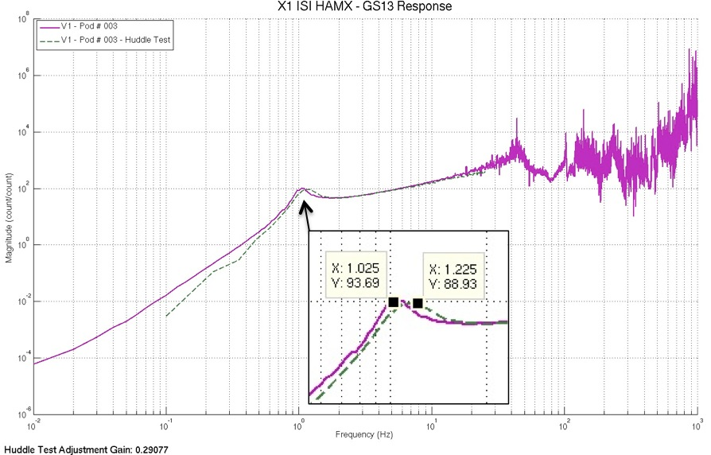

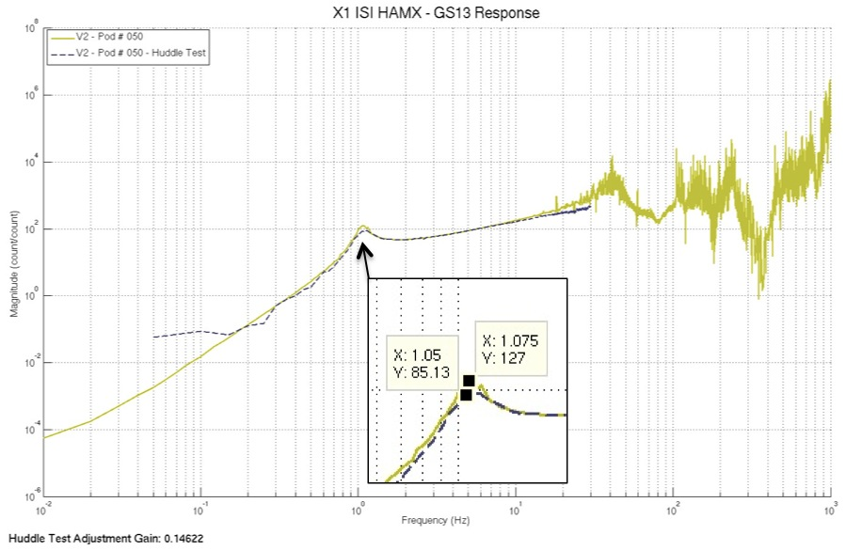

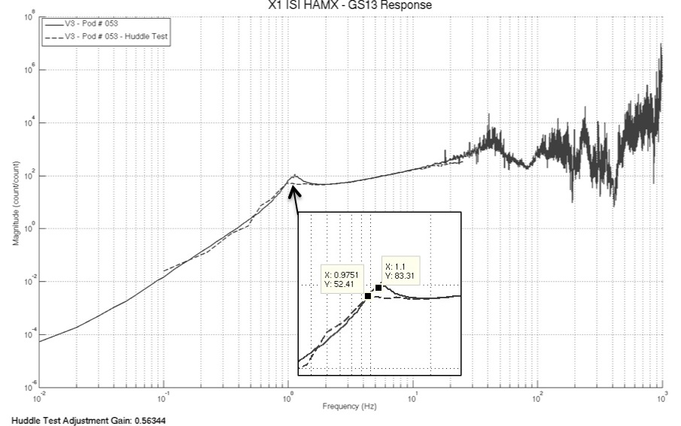

figure – GS13 extracted responses VS Huddle test responses
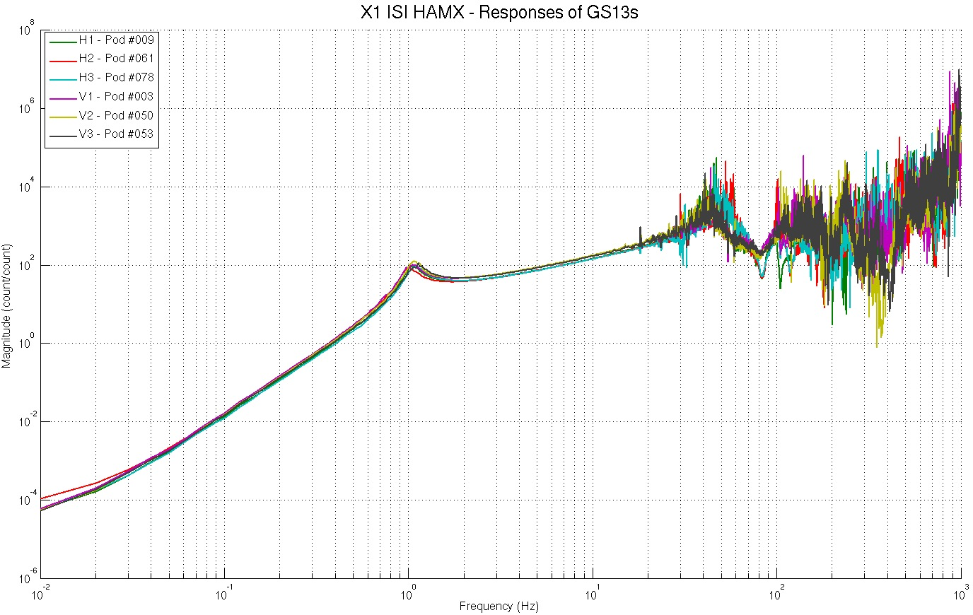

figure – Extracted GS13 responses comparison

Issues/difficulties encountered during this test:
- Horizontal GS13s were taken apart and reassembled after their initial huddle test to install Nylon Patch Screws on the flexures mounts.
- Vertical GS13s were taken apart and reassembled after their initial huddle test to insert Loctite® on the screws holding the flexures.
- The Electronics and/or Digital filters used for the initial huddle testing seem to have varied along the huddle testing campaign. Gains vary from one sensor to another. Resonance frequencies are, however, unaffected which allow us to analyze their evolution.
- Lots of pods have encountered rework since the huddle testing campaign. The rework operations, such as flexure replacement or preamplifier replacement, did most likely affect the frequency responses of the instruments. Hence, these modifications would be a good explanation for the resonance frequency shifts observed between the huddle test and the extracted response of some pods.

Scripts files for processing and plotting in SVN at:
/SeiSVN/seismic/HAM-ISI/X1/HAMX/Scripts/Data_Collection/
- X1_HAMX_Unit_7_GS13_Resp_Extraction_Fitting

GS13 response extraction plots under the SVN at:
/SeiSVN/seismic/HAM-ISI/X1/HAMX/Data/Figures/Instrument_Responses/GS13/
- X1_ISI_HAMX_Fitted_Responses_Comparison.fig
- X1_ISI_HAMX_GS13_H1_Pod_009_Extracted_Response_VS_Huddle.fig
- X1_ISI_HAMX_GS13_H2_Pod_061_Extracted_Response_VS_Huddle.fig
- X1_ISI_HAMX_GS13_H3_Pod_078_Extracted_Response_VS_Huddle.fig
- X1_ISI_HAMX_GS13_V1_Pod_003_Extracted_Response_VS_Huddle.fig
- X1_ISI_HAMX_GS13_V2_Pod_050_Extracted_Response_VS_Huddle.fig
- X1_ISI_HAMX_GS13_V3_Pod_053_Extracted_Response_VS_Huddle.fig

Acceptance criteria:
- The resonance frequency shift between the initial huddle test measurement and the extracted response must be lower than 15%

Test result: Passed: X Failed: .

Step 16.3 GS13 response fitting
Fitted responses for the GS13s are presented below.

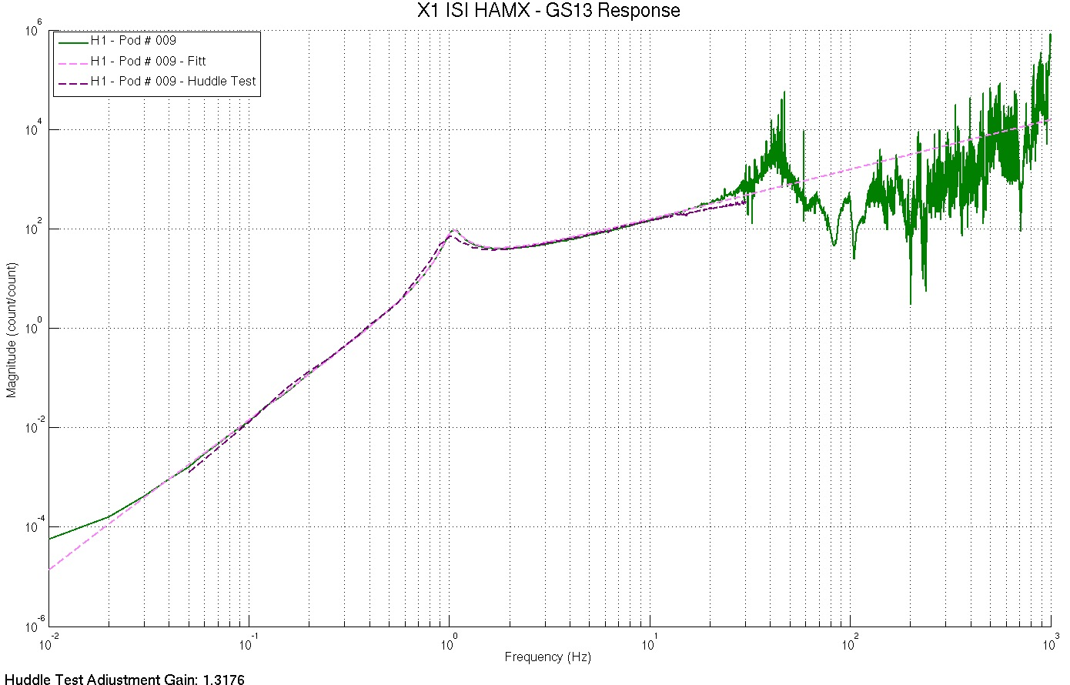

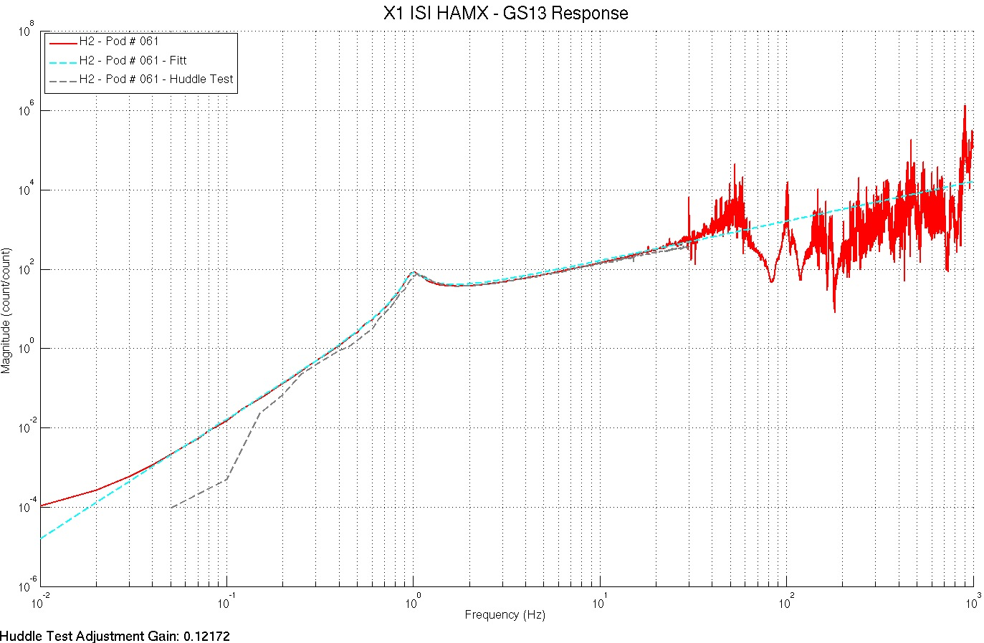
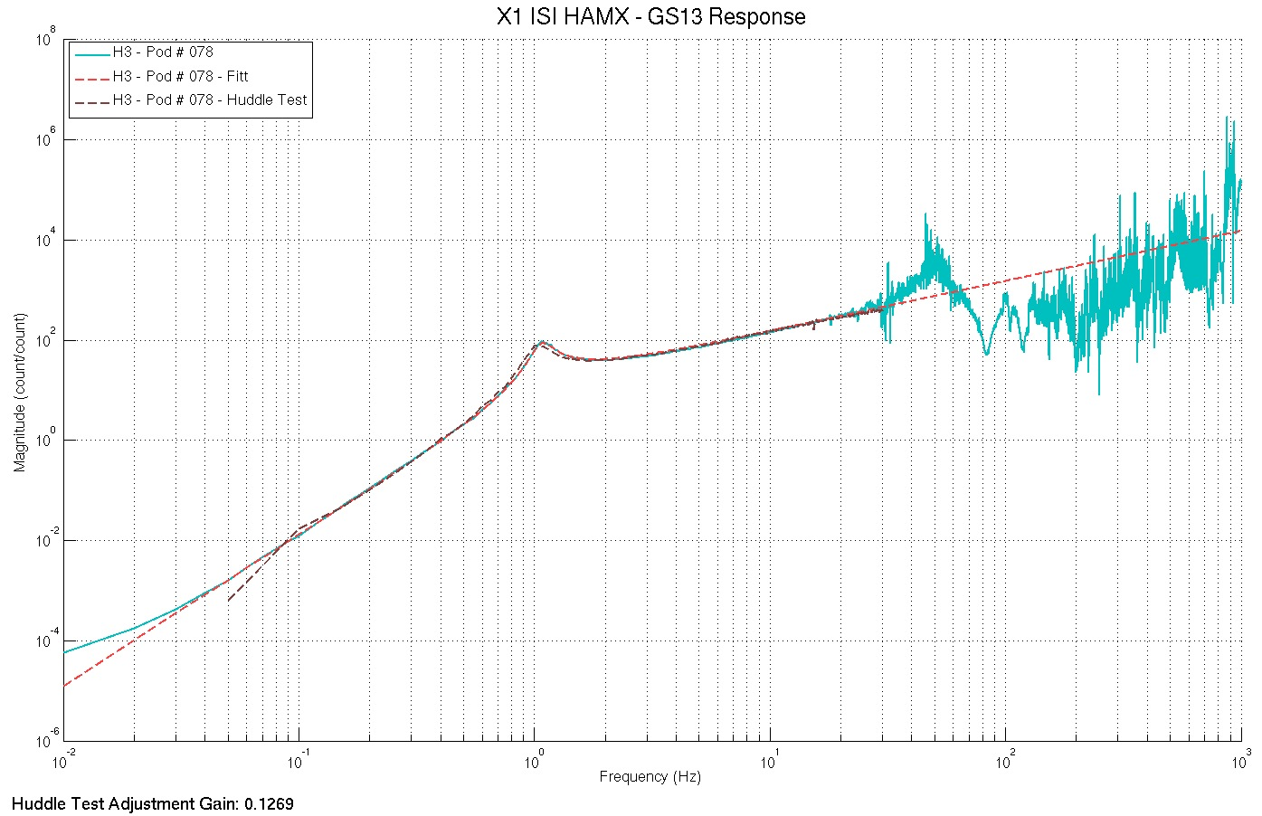
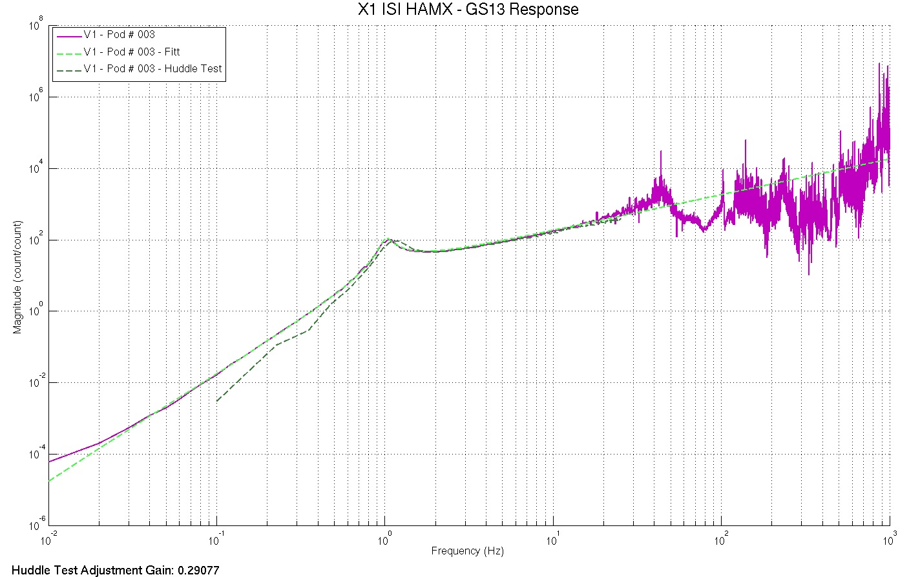
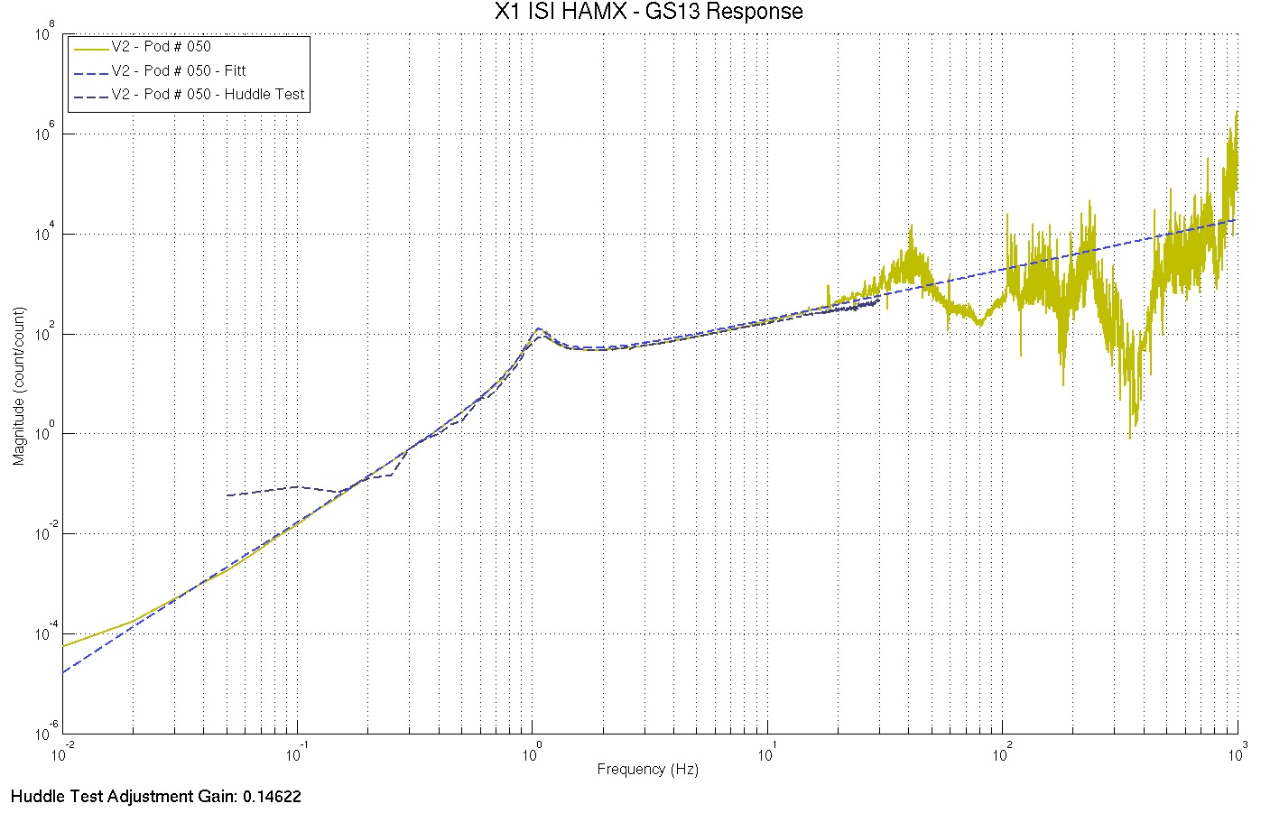

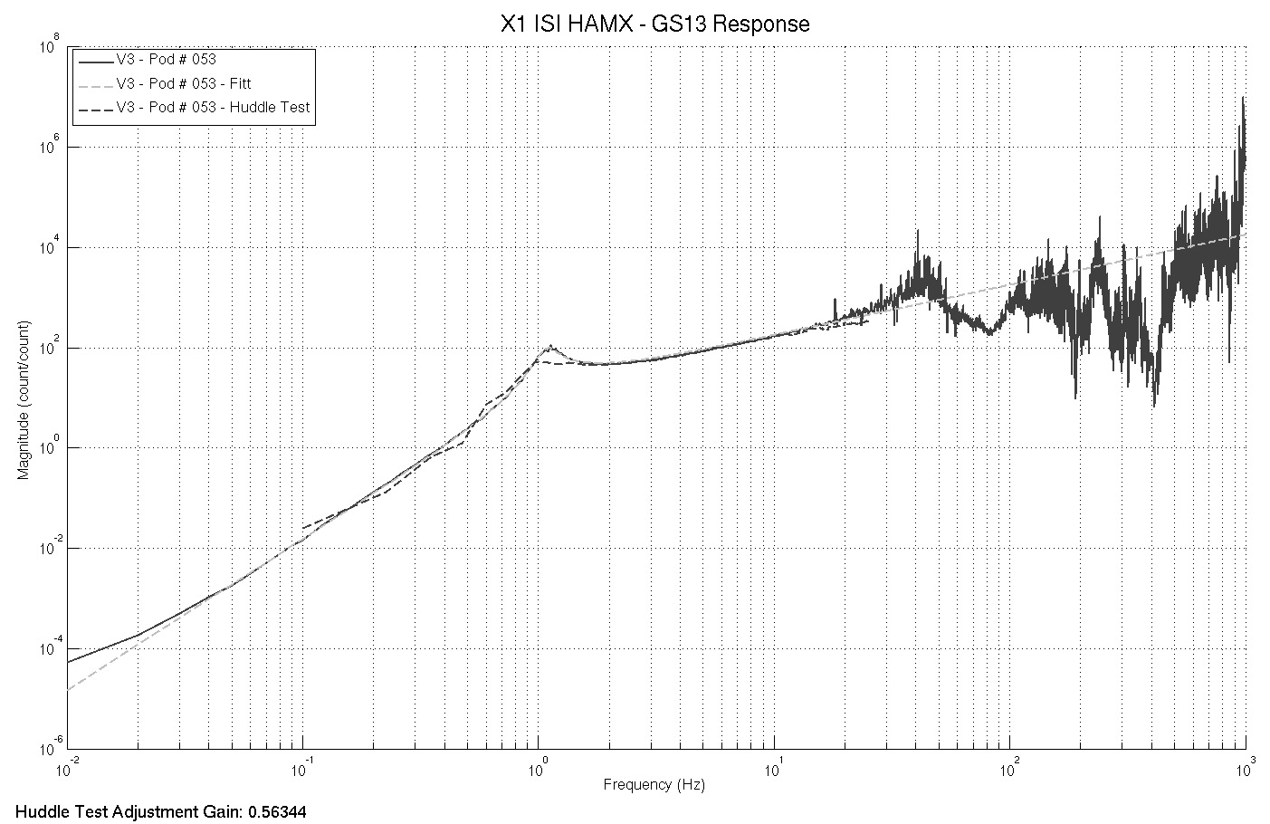
figure – Fitted responses of the GS13s

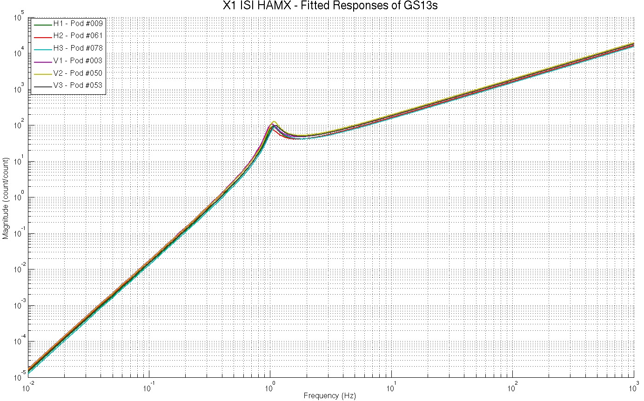
figure – Comparison of the fitted responses for the GS13s

Scripts files for processing and plotting in SVN at:
/SeiSVN/seismic/HAM-ISI/X1/HAMX/Scripts/Data_Collection/
- X1_HAMX_Unit_7_GS13_Resp_Extraction_Fitting

GS13 response fitting plots under the SVN at:
/SeiSVN/seismic/HAM-ISI/X1/HAMX/Data/Figures/Instrument_Responses/GS13/
- X1_ISI_HAMX_Fitted_Responses_Comparison.fig
- X1_ISI_HAMX_GS13_H1_Pod_009_Extracted_Response_VS_Fitt_VS_Huddle.fig
- X1_ISI_HAMX_GS13_H2_Pod_061_Extracted_Response_VS_Fitt_VS_Huddle.fig
- X1_ISI_HAMX_GS13_H3_Pod_078_Extracted_Response_VS_Fitt_VS_Huddle.fig
- X1_ISI_HAMX_GS13_V1_Pod_003_Extracted_Response_VS_Fitt_VS_Huddle.fig
- X1_ISI_HAMX_GS13_V2_Pod_050_Extracted_Response_VS_Fitt_VS_Huddle.fig
- X1_ISI_HAMX_GS13_V3_Pod_053_Extracted_Response_VS_Fitt_VS_Huddle.fig

Acceptance criteria:
- The resonance frequency difference between the extracted response and the fitted response must be less than 5%
- The amplitude shift between the extracted response and the fitted response must be less than 10% between 0.1Hz and 100Hz.

Test result: Passed: X Failed: .

16.4 Symmetrization Filters
Symmetrized Local to Local TFs are presented below.

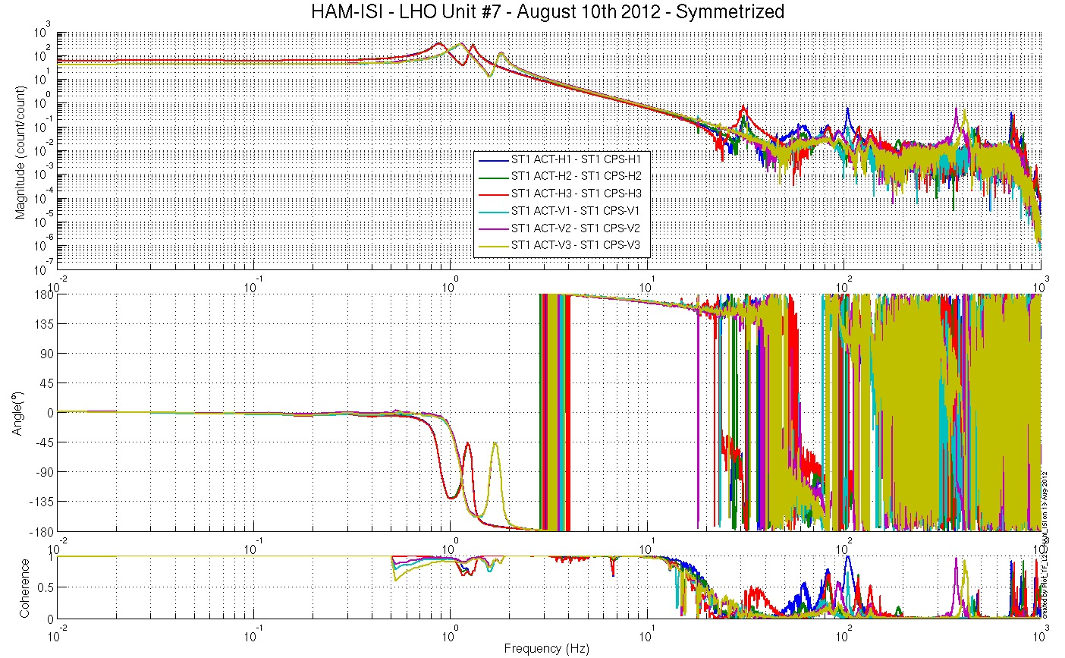
figure – Symmetrized L2L – Computed TFs – Capacitive sensors

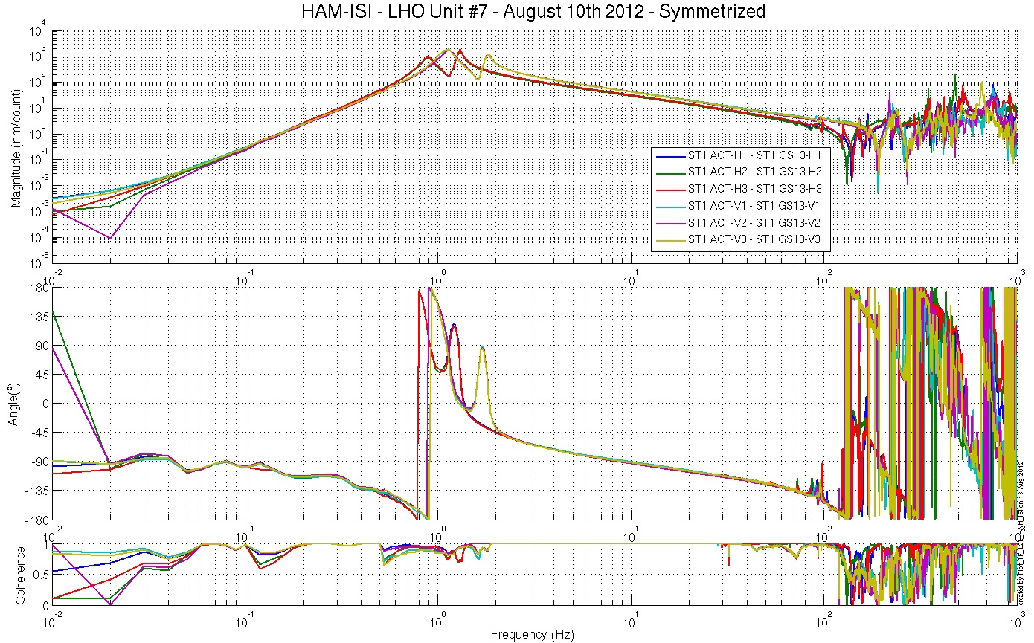
figure – Symmetrized L2L – Computed TFs – Inertial sensors
Symmetrized L2L TFs under the SVN at:
/SeiSVN/seismic/HAM-ISI/X1/HAMX/Data/Figures/Transfer_Functions/Simulations/Undamped/
- X1_ISI_HAMX_TF_L2L_Symmetrized_from_ACT_to_CPS_08_10_2012.fig
- X1_ISI_HAMX_TF_L2L_Symmetrized_from_ACT_to_GS13_08_10_2012.fig

Issues/difficulties encountered during this test:
- Symmetrization filters improved the symmetry of the GS13 Transfer Functions.

Test result: Passed: X Failed: .

Step 16.4 - Cartesian to Cartesian TF computation
The Cartesian to Cartesian transfer functions are presented below:

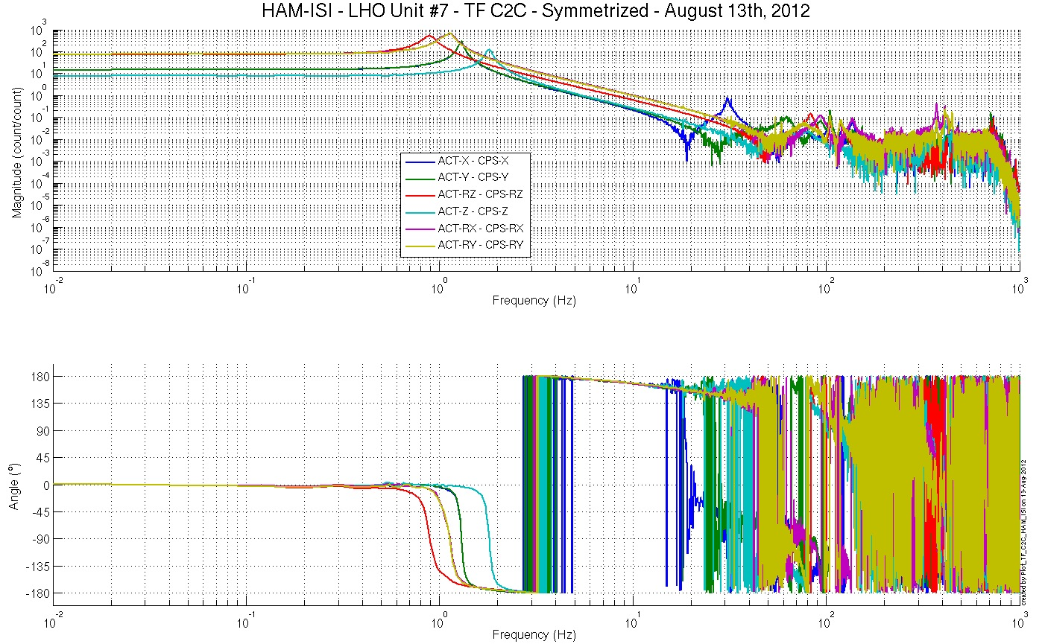
Figure – Cartesian to Cartesian – computed - Capacitive sensors

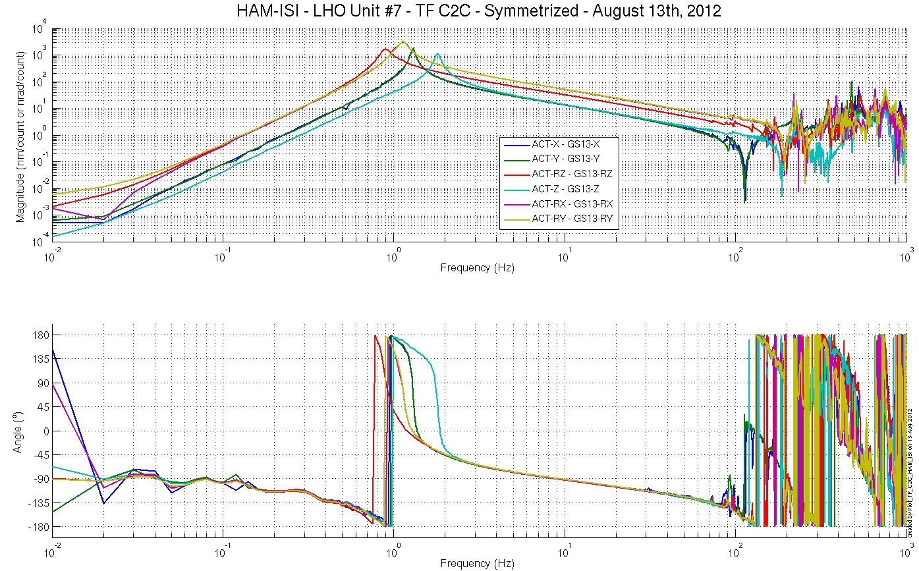
Figure – Cartesian to Cartesian - computed - Inertial sensors
Scripts files for processing and plotting in SVN at:
/SeiSVN/seismic/HAM-ISI/X1/HAMX/Scripts/Control_Scripts/
- Step_3_TF_Cart_to_Cart_X1_ISI_HAMX.m
Figures in SVN at:
/SeiSVN/seismic/HAM-ISI/X1/HAMX/Data/ Figures/Transfer_Functions/Simulations/Undamped/
- X1_ISI_HAMX_TF_C2C_Symmetrized_from_ACT_to_GS13_08_10_2012.fig
- X1_ISI_HAMX_TF_C2C_Symmetrized_from_ACT_to_CPS_08_10_2012.fig
Storage of measured transfer functions in the SVN at:
/SeiSVN/seismic/HAM-ISI/X1/HAMX/Data/Transfer_functions/Simulations/Undamped/
- X1_ISI_HAMX_TF_C2C_Raw_2012_08_10.mat

Acceptance criteria:
- Cartesian to Cartesian measurements
  - On CPS, the phase must be 0º at DC
  - On Geophones, the phase must be -90º at DC
  - Identical shape X/Y and RX/RY

Test result: Passed: X Failed: .

Step 17 - Transfer function comparison with Reference

Step 17.1 - Local to local - Comparison with Reference
Scripts files for processing and plotting in SVN at:
/SeiSVN/seismic/HAM-ISI/X1/HAMX/Scripts/Control_Scripts/Version_0/
- Step_1_TF_Loc_to_Loc_X1_ISI_HAMX
/SeiSVN/seismic/HAM-ISI/Common/Plot_Functions_HAM_ISI
- Plot_TF_L2L_HAM_Testing_With_LHO_Unit_1_Reference.m

Local to local comparison figures in SVN at:
/SeiSVN/seismic/ HAM-ISI/X1/HAMX/Data/ Figures/Transfer_Functions/Measurements/Comparisons/L2L/
- X1_ISI_HAMX_TF_L2L_Raw_from_ACT_H_to_CPS_H_vs_UNIT_1_2012_02_02_With_3_Washers_Under_Top_Mass.fig
- X1_ISI_HAMX_TF_L2L_Raw_from_ACT_H_to_CPS_H_vs_UNIT_1_2012_02_02_With_3_Washers_Under_Top_Mass.pdf
- X1_ISI_HAMX_TF_L2L_Raw_from_ACT_H_to_GS13_H_vs_UNIT_1_2012_02_02_With_3_Washers_Under_Top_Mass.fig
- X1_ISI_HAMX_TF_L2L_Raw_from_ACT_H_to_GS13_H_vs_UNIT_1_2012_02_02_With_3_Washers_Under_Top_Mass.pdf
- X1_ISI_HAMX_TF_L2L_Raw_from_ACT_V_to_CPS_V_vs_UNIT_1_2012_02_02_With_3_Washers_Under_Top_Mass.fig

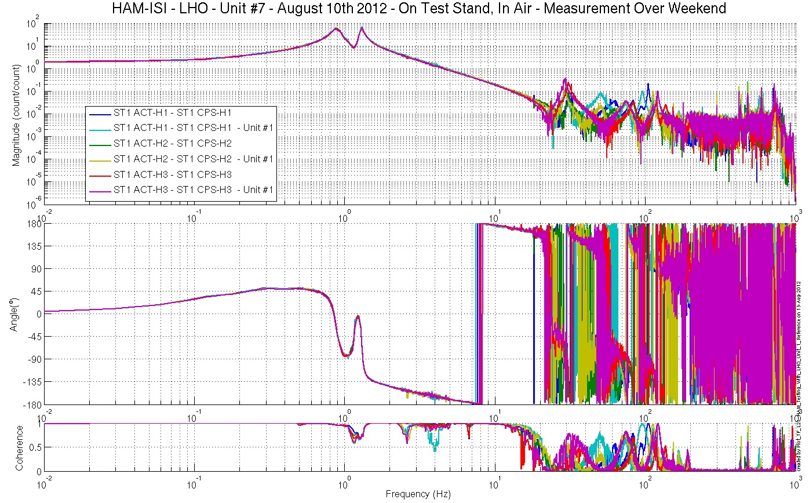
Figure – local-to-Local measurements, comparison with Unit #1 reference
Capacitive Position Sensors - Horizontal motion
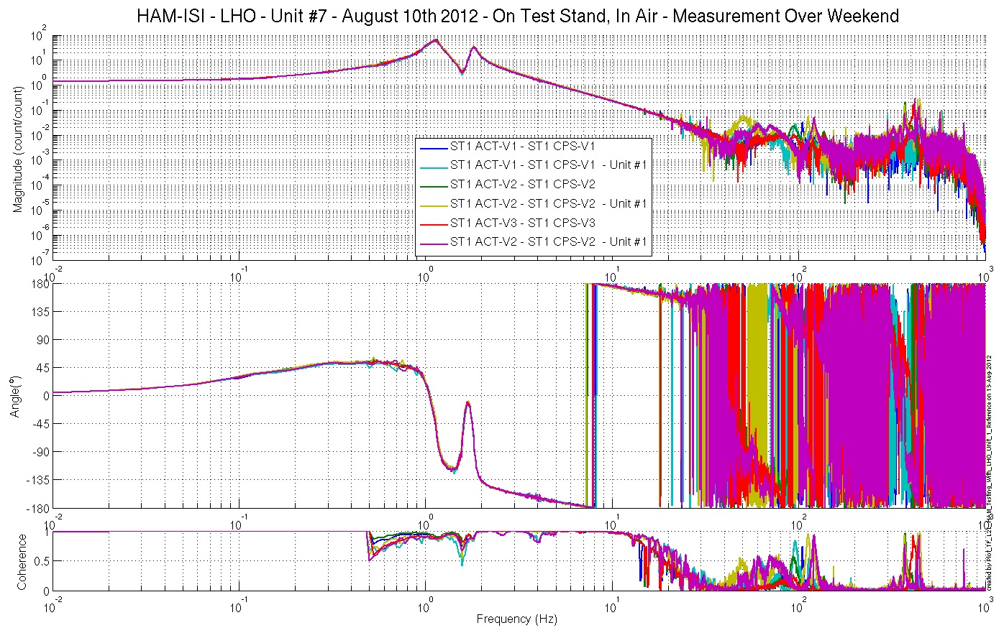
Figure – local-to-Local measurements, comparison with Unit #1 reference
Capacitive Position Sensors - Vertical motion

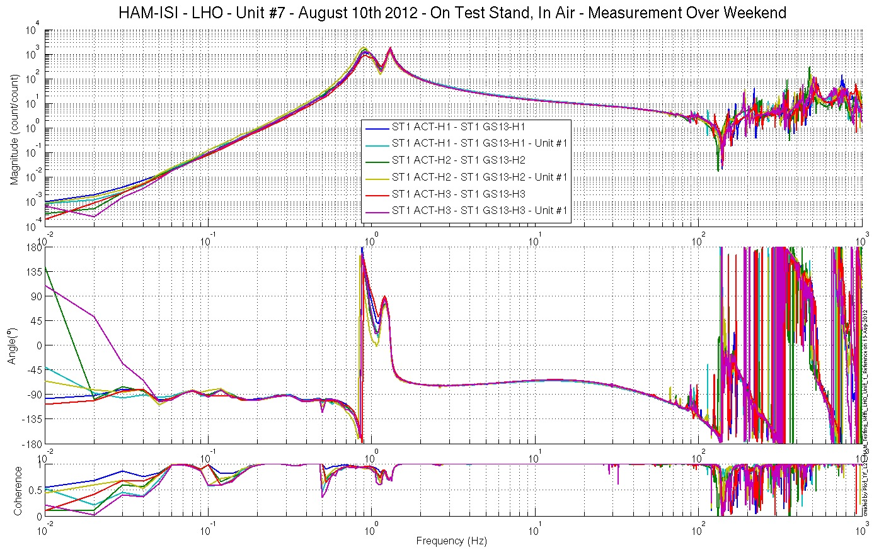
Figure – local-to-Local measurements, comparison with Unit #1 reference
Inertial Sensors - Horizontal motion

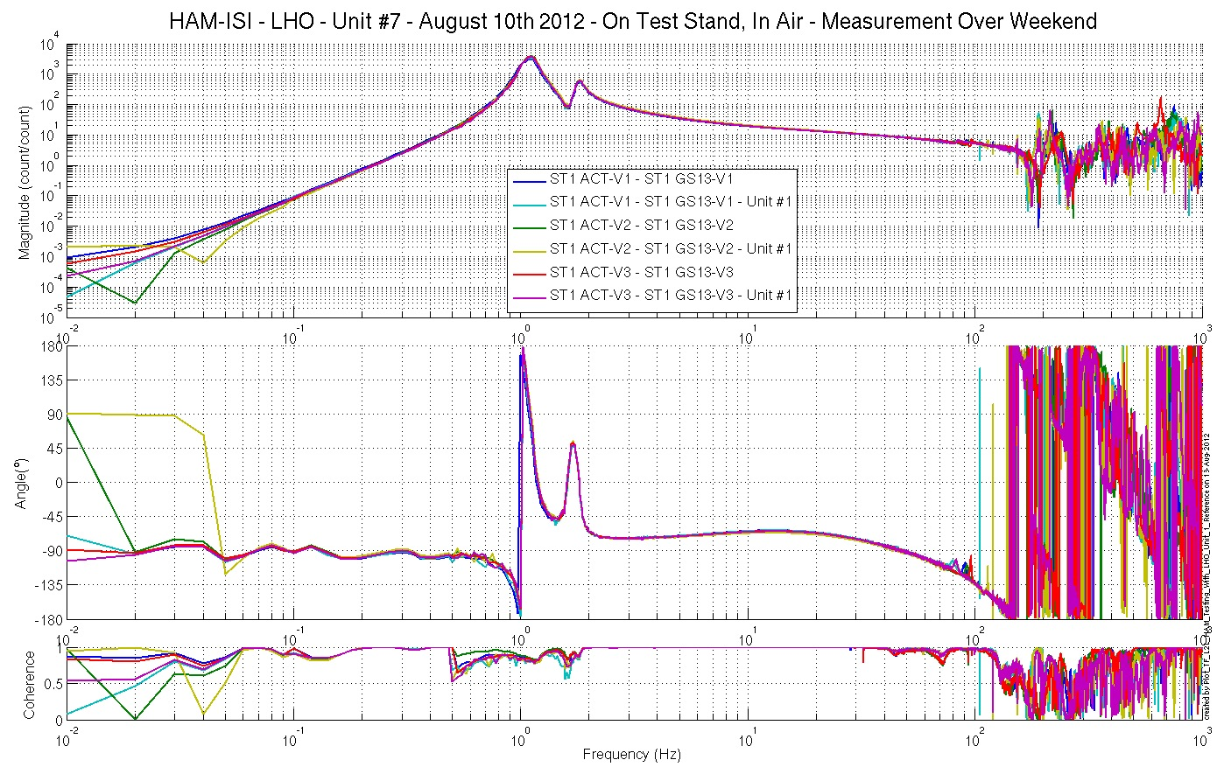
Figure – local-to-Local measurements, comparison with Unit #1 reference
Inertial Sensors - Vertical motion

Acceptance criteria:
No difference with the reference transfer functions (Unit #1)
  - Phase – less than 10º - In Phase – Out of Phase
  - Damping (fit by eye with Reference transfer functions)
  - DC gain
  - Eigen frequencies shift less than 10%

Test result: Passed: X Failed: .

Step 17.2 - Cartesian to Cartesian - Comparison with Reference

Scripts files for processing and plotting in SVN at:
/SeiSVN/seismic/HAM-ISI/X1/HAMX/Scripts/Control_Scripts/
- Step_3_TF_Cart_to_Cart_M1_ISI_HAMX.m
/SeiSVN/seismic/HAM-ISI/Common/Plot_Functions_HAM_ISI
- Plot_TF_C2C_HAM_Testing_With_LHO_Unit_1_Reference.m

Cartesian to Cartesian figures in SVN at:
/SeiSVN/seismic/ HAM-ISI/X1/HAMX/Data/ Figures/Transfer_Functions/Measurements/Comparisons/C2C/
- X1_ISI_HAMX_TF_C2C_Raw_from_ACT_H_to_CPS_V_Symmetrized_vs_Unit_1_08_10_2012
- X1_ISI_HAMX_TF_C2C_Raw_from_ACT_V_to_CPS_V_Symmetrized_vs_Unit_1_08_10_2012
- X1_ISI_HAMX_TF_C2C_Raw_from_ACT_H_to_GS13_V_Symmetrized_vs_Unit_1_08_10_2012
- X1_ISI_HAMX_TF_C2C_Raw_from_ACT_V_to_GS13_V_Symmetrized_vs_Unit_1_08_10_2012

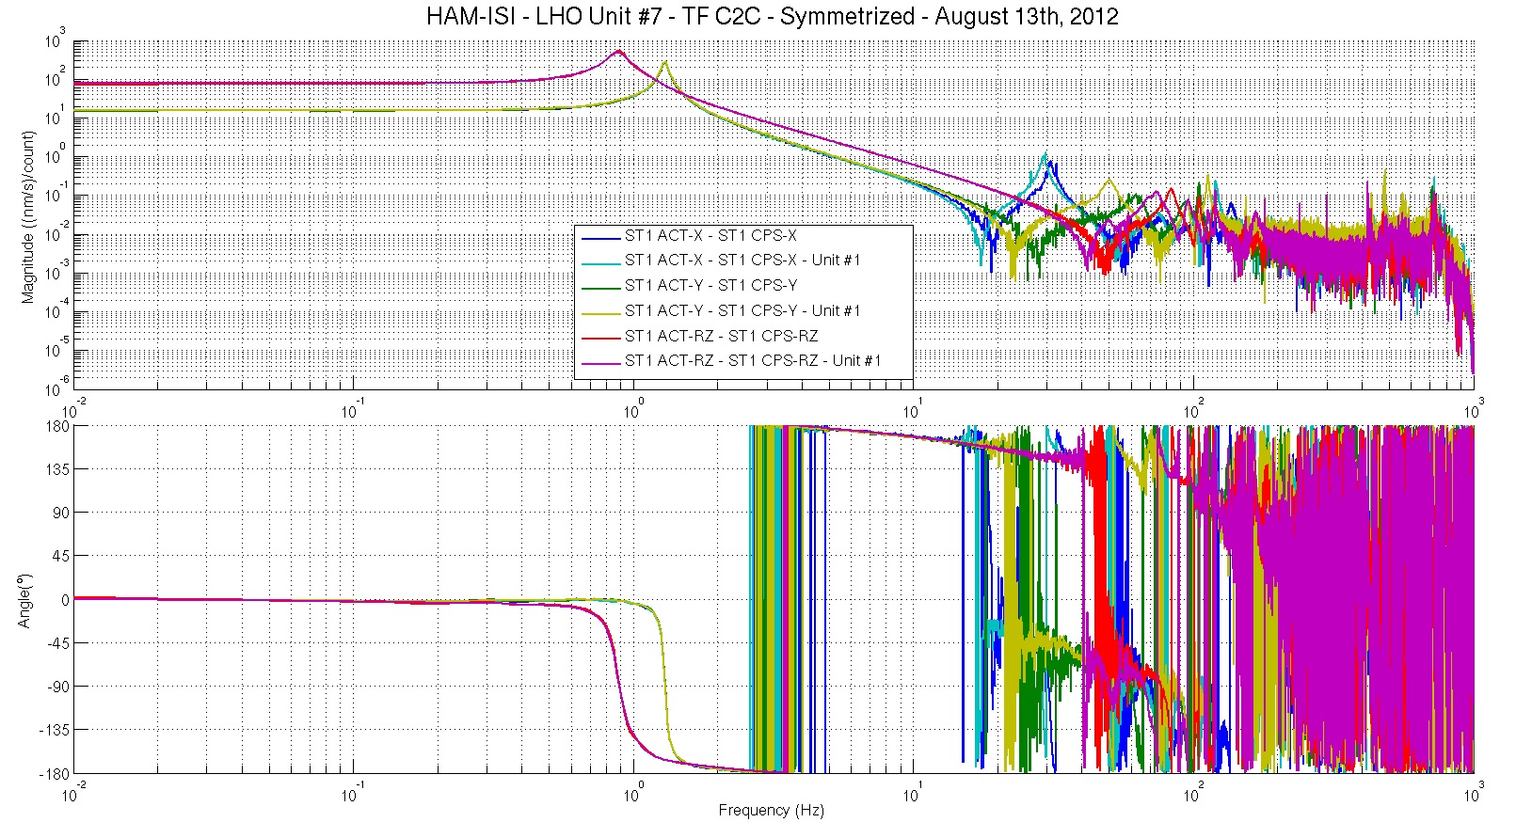
Figure – Cartesian to Cartesian measurements, comparison with Unit #1 reference
Capacitive Position Sensors - Horizontal motion

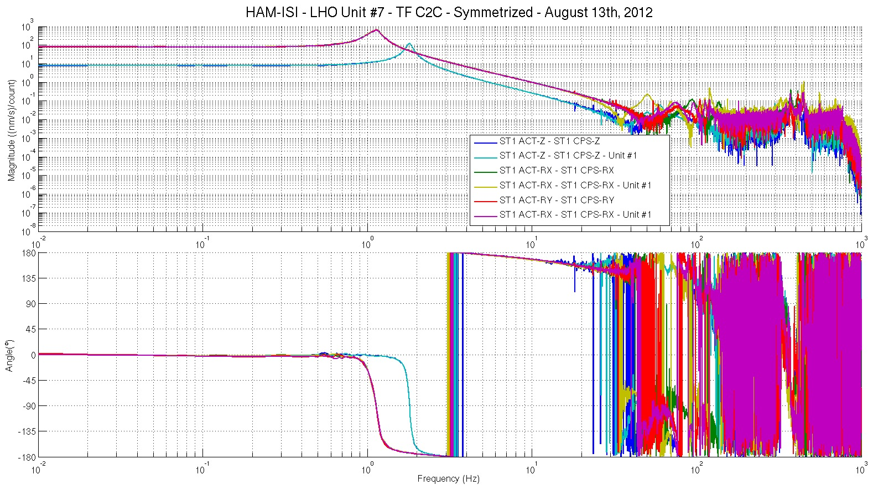
Figure – Cartesian to Cartesian measurements, comparison with Unit #1 reference
Capacitive Position Sensors - Vertical motion

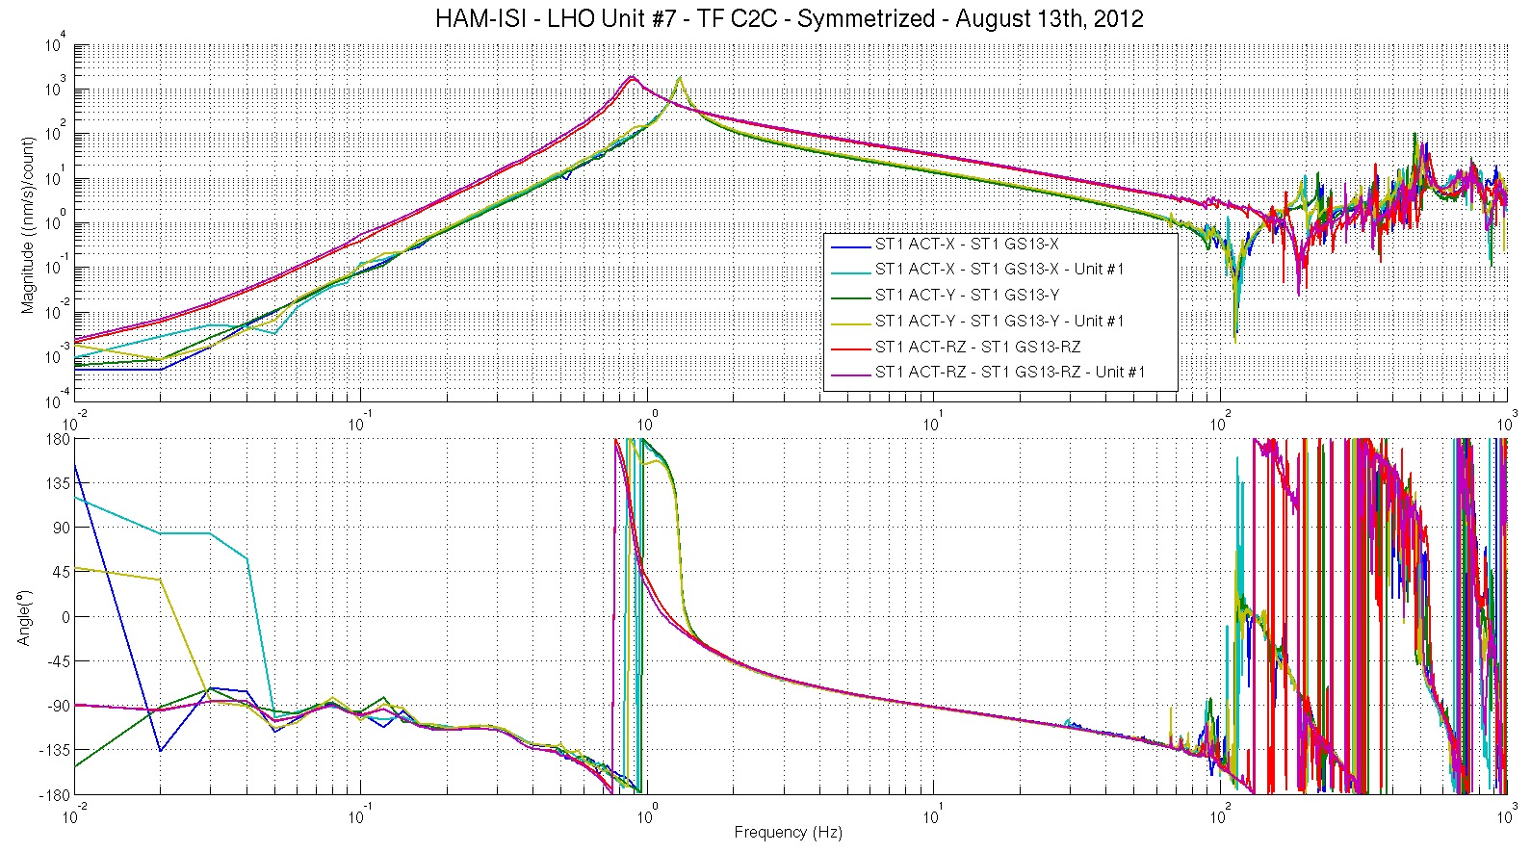
Figure – Cartesian to Cartesian measurements, comparison with Unit #1 reference – Inertial Sensors
Horizontal motion

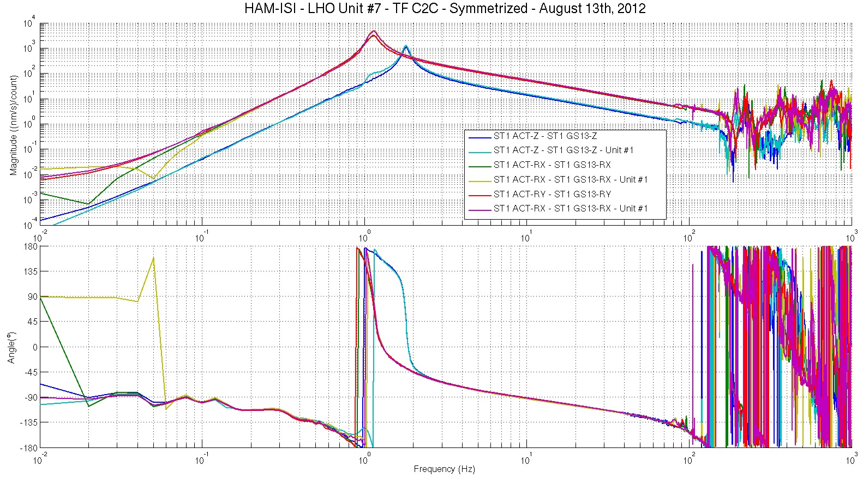
Figure – Cartesian to Cartesian measurements, comparison with Unit #1 reference
Inertial Sensors - Vertical motion

Issues/difficulties encountered during this test:
Cartesian-TFs were simulated. Coherence is not available.

Acceptance criteria:
- No difference with the reference transfer functions (SVN)
  - Phase – less than 10º - In Phase – Out of Phase
  - Damping (fit by eye with Reference transfer functions)
  - DC gain
  - Eigen frequencies shift less than 10%

Test result: Passed: X Failed: .

Step 17.3 - Cartesian to Cartesian - Comparison with other Units
Scripts files for processing and plotting in SVN at:
/SeiSVN/seismic/HAM-ISI/Common/Plot_Functions_HAM_ISI/
- Plot_HAM_ISI___Cartesian_Result_Comparison.m

Cartesian to Cartesian figures in SVN at:
/SeiSVN/seismic/ HAM-ISI/X1/ Data/
All_Units_Compared/Transfer_Functions/C2C/
- CPS_X.fig
- CPS_Y.fig
- CPS_Z.fig
- CPS_RX.fig
- CPS_RY.fig
- CPS_RZ.fig
- GS13_X.fig
- GS13_Y.fig
- GS13_Z.fig
- GS13_RX.fig
- GS13_RY.fig
- GS13_RZ.fig

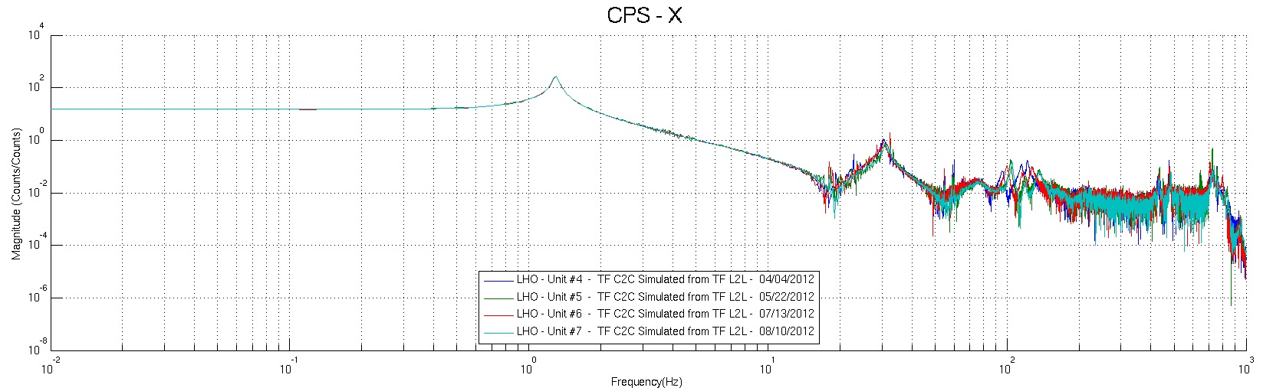
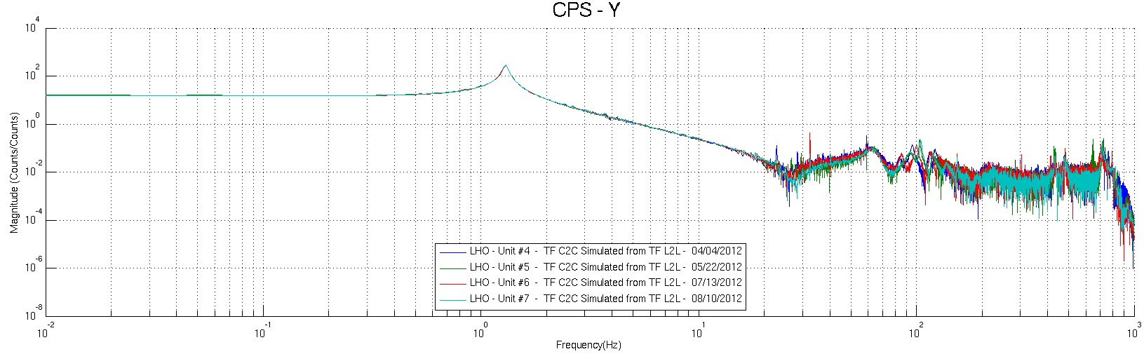
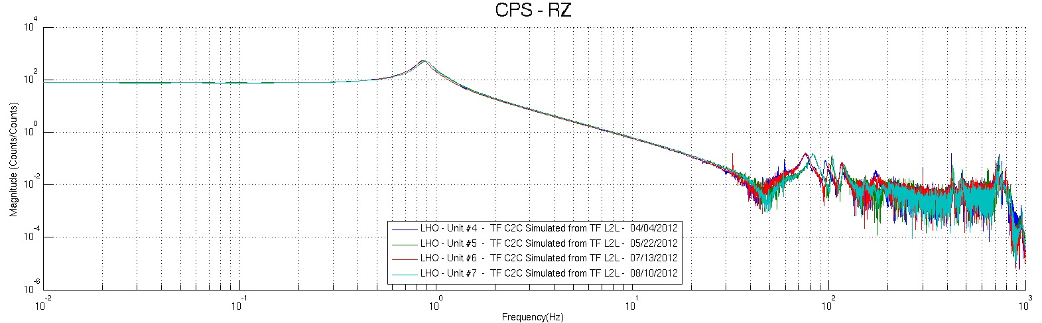
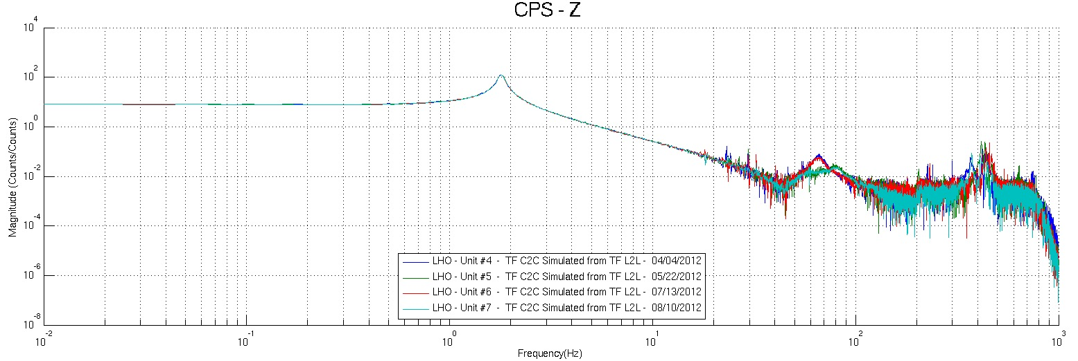
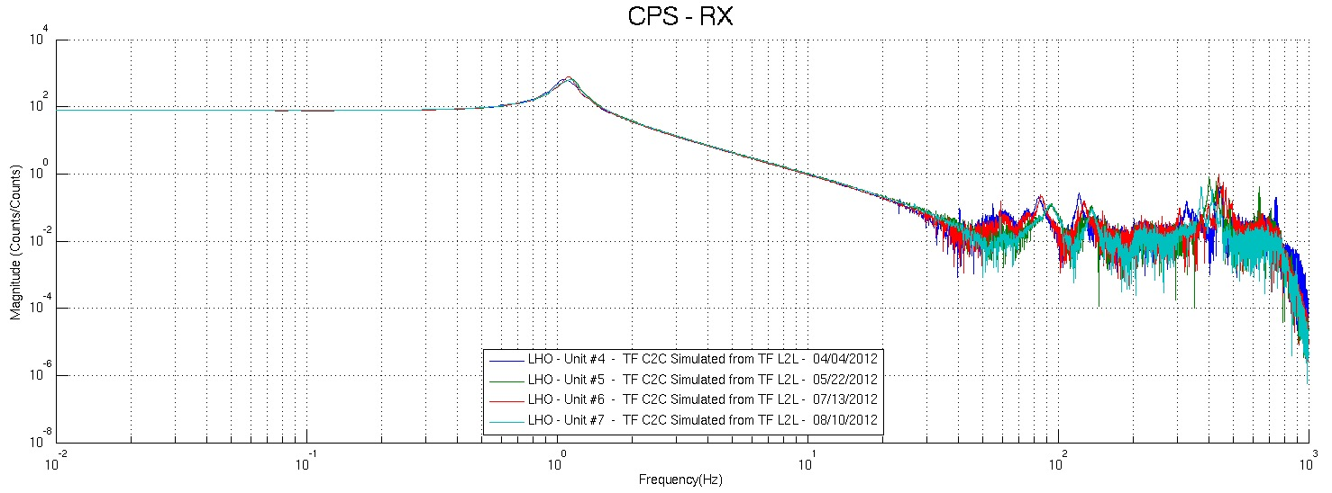
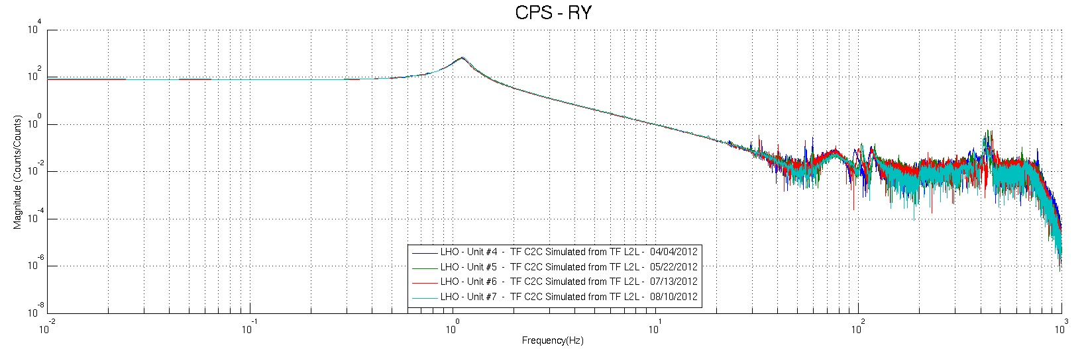
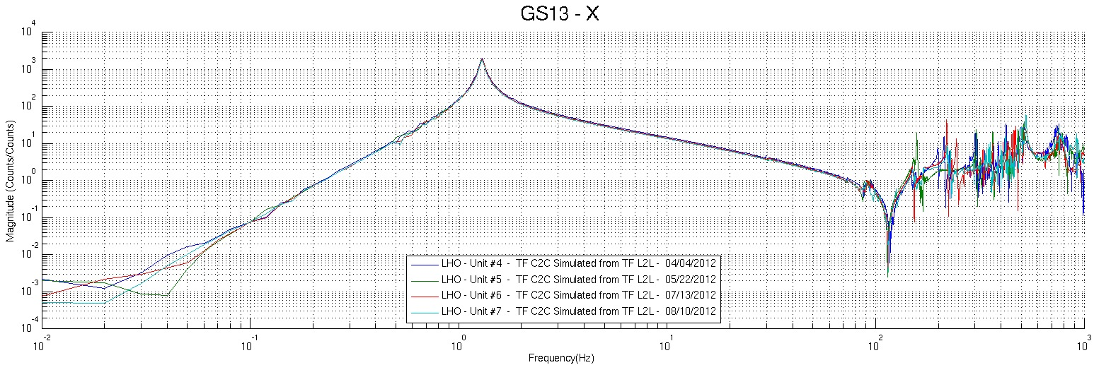
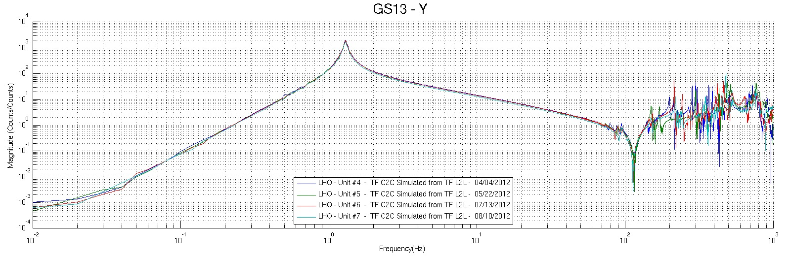
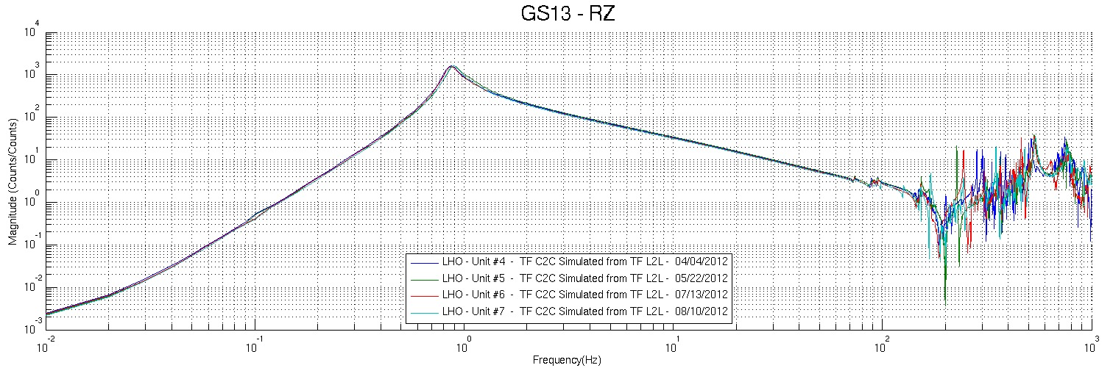
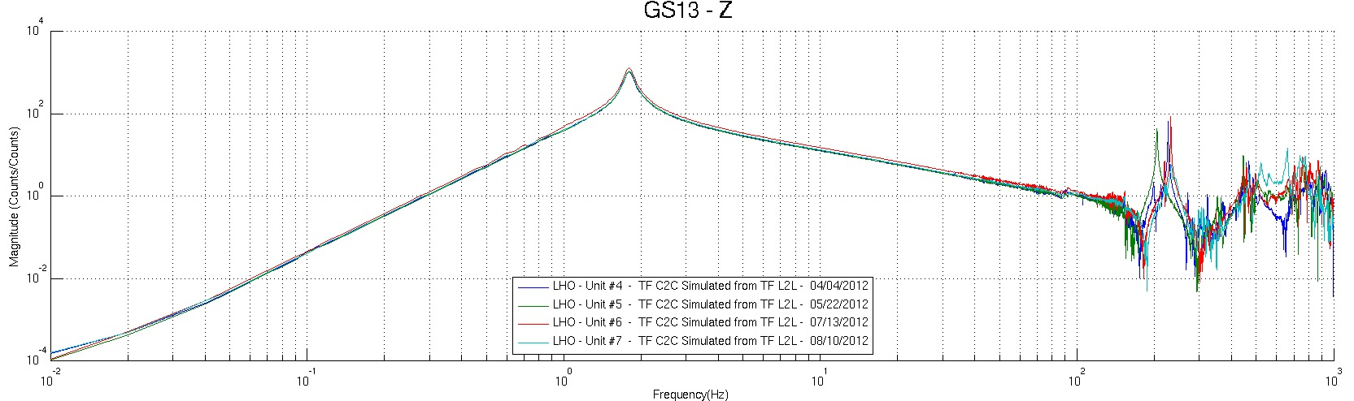
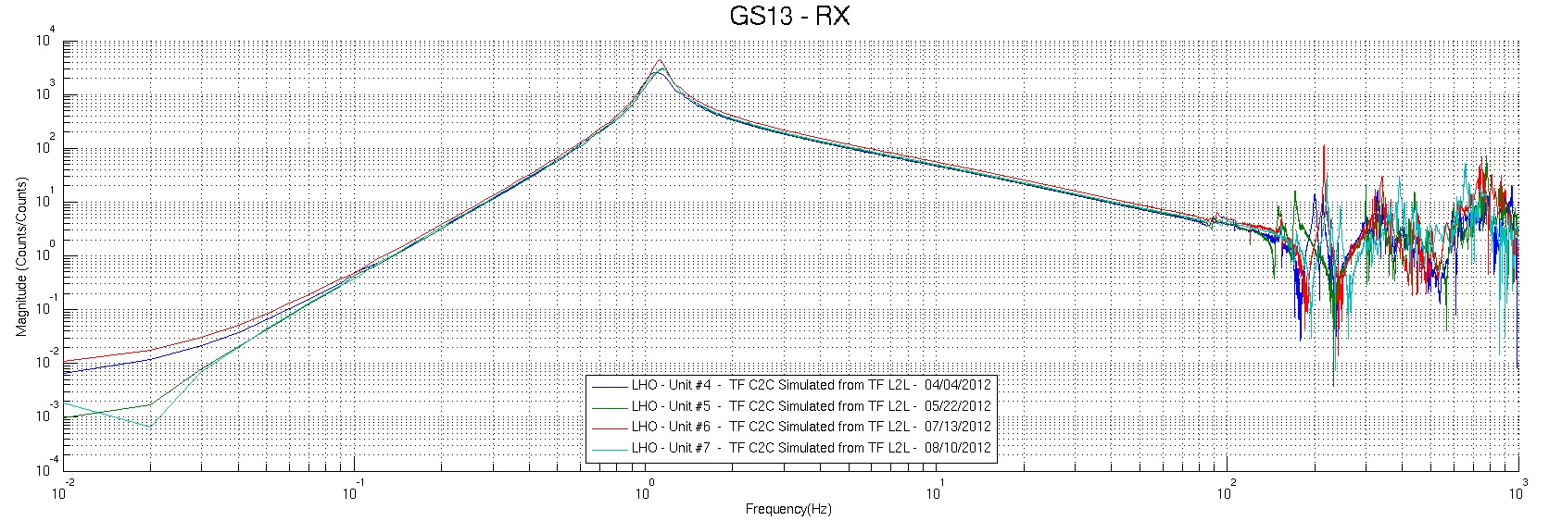
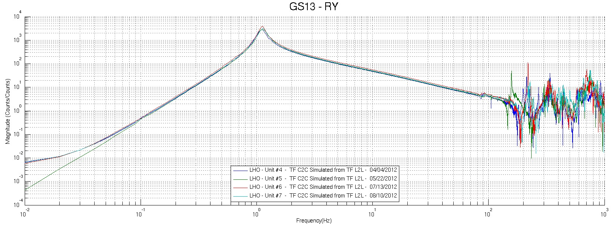
Figure – Cartesian to Cartesian TF, comparison with other Units

Step 18 - Lower Zero Moment Plane

Data collection script files:
/SeiSVN/seismic/HAM-ISI/Common/Transfer_Function_Scripts/
- Run_TF_C2C_10mHz_100mHz_LZMP_HAM_ISI.m
Data files in SVN at:
/SeiSVN/seismic/HAM-ISI/X1/HAMX/Data/Transfer_Functions/Measurements/Undamped/
- LHO_ISI_HAM_Unit_7_Data_TF_C2C_10mHz_100mHz_LZMP_20120814-164208.mat
Scripts files for processing and plotting in SVN at:
/SeiSVN/seismic/HAM-ISI/Common/Testing_Functions_HAM_ISI/
- LZMP_HAM_ISI.m

Figures in SVN at:
/SeiSVN/seismic/HAM-ISI/X1/HAMX/Data/ Figures/Transfer_Functions/Measurements/Undamped/
- LHO_ISI_UNIT_7_LZMP_20120814.fig

The result of the measurement performed is presented below. Symmetrization filters are not engaged. Measurement was performed overnight with 250 averages.

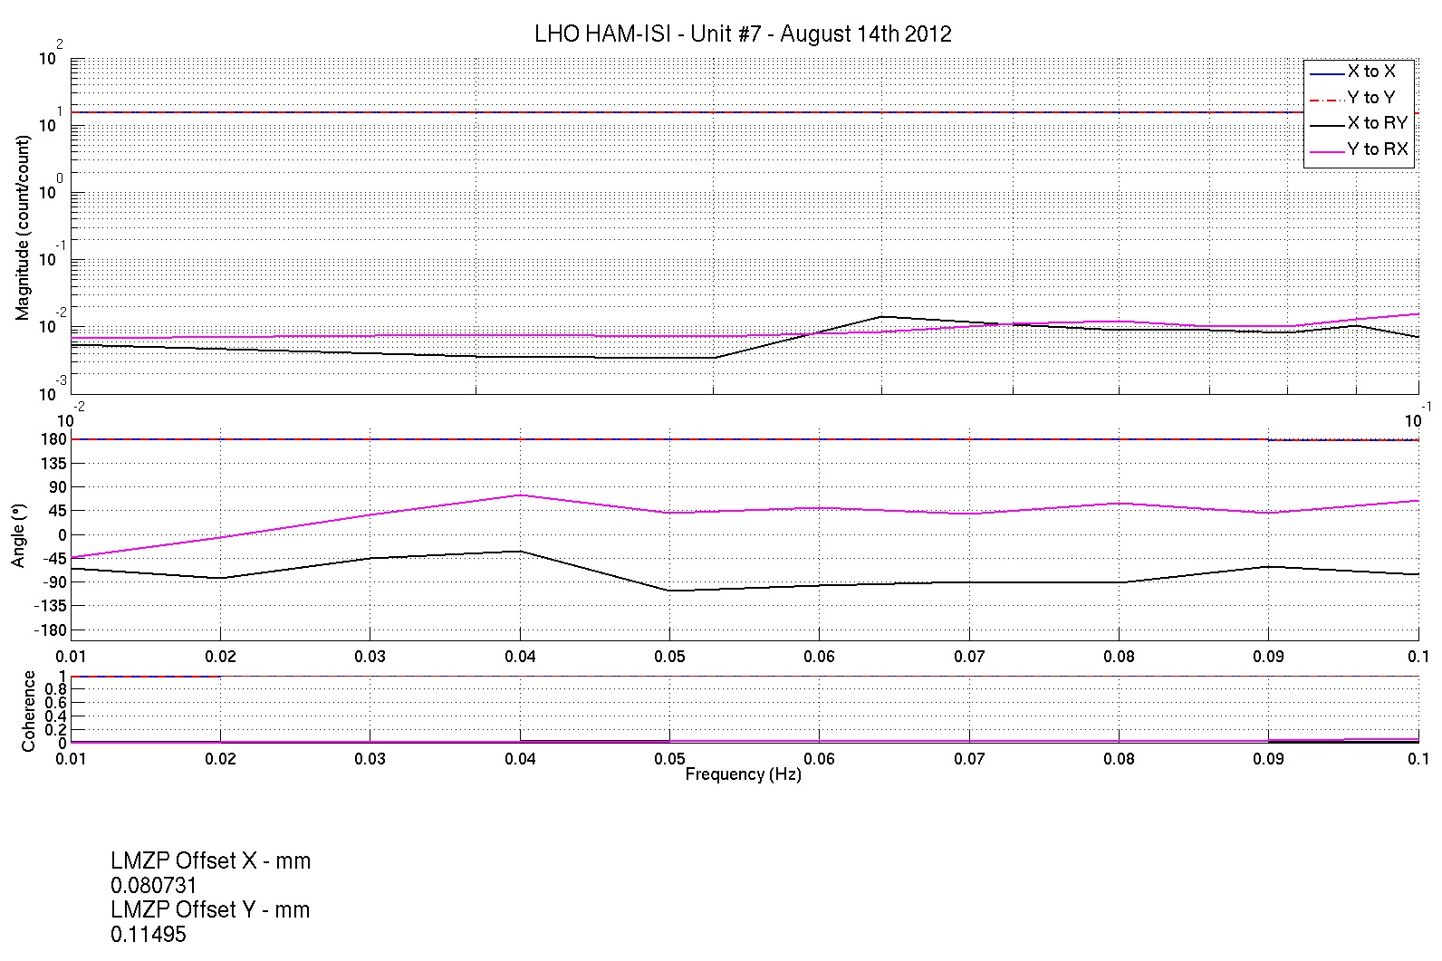
Figure - Lower Zero Moment Plane – Main and cross couplings at low frequency

Issues/difficulties encountered during this test:
- Coherence is low.

Acceptance criteria:
- X offset must be less than 2 mm
- Y offset must be less than 2 mm

Test result: Passed: X Failed: .

HAM-ISI Unit #7 testing summary
HAM-ISI Unit #7 was assembled during July-August 2012. It is the last HAM-ISI Unit built at LHO. The testing of this Unit is presented here. It started on August 8th and lasted until August 16th. Production GS13s and Stage-0 L4Cs were installed during tests.

Particularities:
- Full set of production GS13s
- L4Cs and brackets installed

FAILED AND WAIVED TESTS

List of tests that failed and don’t need to be redone:
Step I.1: Initial testing data missing/obsolete on CPSs. CPSs spectra were validated with up to date measurements anyway (step 6)
Step I.3: QinetiQ test data missing for horizontal actuators. Actuators work properly though, as it can be seen on Linearity Tests and Transfer Functions

Tests that failed and need to be done during phase II
Step III.14: Actuators appear to be linear on measurements. However, deviation from average slope is out of spec. It seems to correlate with cable+actuator resistance measurements. Make sure that linearity test results correlate with the final field cables.
This scale factor, which varies from an actuation point to another, could be corrected with an adjustment gain applied on the excitation signal sent to the actuators.
Step III.19: The simulation, and implementation, of the damping loops represent a “bonus test” and was not performed because of delays caused by omissions in assembly, instrument failure and temperature changes.

List of test that were skipped and that we will not do because they are not essential
Step III.3: Sensor gap measurement with a jig. Waved to avoid scratching targets. Distance between sensor and target has also been checked during the assembly while adjusting target distance.

Important note:
Step III.8
Two points appeared to be controversial while measuring the level of the optical table. They were recorded as out of spec (-8/-10mils) when measured from close range (distance < 3ft), but were absolutely fine (as displayed) when measured from further away (other side of the optical table). We suspected the optical level we were using to be biased and tried with another one. Same observation was made. We supposed the optical levels available could not be used in close range (distance < 3ft). If this hypothesis is not true, the optical table could have flatness irregularities, up to -10mils, on two edges.

