LIGO Laboratory / LIGO Scientific Collaboration

LIGO- E1000312 LIGO February 14th, 2012

aLIGO HAM-ISI, Pre-integration Test Report, Phase I,
LHO Unit #1 (post-assembly, before storage, after replacement of faulty parts)
E1000310 – V7

Eric Allwine, Gregory Grabeel, Corey Gray, Robinson Mitchel, Hugh Radkins, Jim Warner
Fabrice Matichard, Vincent Lhuillier, Hugo Paris

Distribution of this document:
Advanced LIGO Project

This is an internal working note
of the LIGO Laboratory

California Institute of Technology  LIGO Project – MS 18-34  1200 E. California Blvd.  Pasadena, CA 91125  Phone (626) 395-2129  Fax (626) 304-9834  E-mail: info@ligo.caltech.edu | Massachusetts Institute of Technology  LIGO Project – NW22-295  185 Albany St  Cambridge, MA 02139  Phone (617) 253-4824  Fax (617) 253-7014  E-mail: info@ligo.mit.edu
LIGO Hanford Observatory  P.O. Box 1970  Mail Stop S9-02  Richland WA 99352  Phone 509-372-8106  Fax 509-372-8137 | LIGO Livingston Observatory  P.O. Box 940  Livingston, LA 70754  Phone 225-686-3100  Fax 225-686-7189

Table of contents:
Introduction 2
I. Pre-Assembly Testing 3
▪ Step 1: Position Sensors 3
▪ Step 2: GS13 4
▪ Step 3: Actuators 5
II. Tests to be performed during assembly 6
▪ Step 1: Parts Inventory (E1000052) 6
▪ Step 2: Check torques on all bolts 7
▪ Step 3: Check gaps under Support Posts 7
▪ Step 4: Pitchfork/Boxwork flatness before Optical Table install 8
▪ Step 5: Blade spring profile 9
▪ Step 6: Gap checks on actuators-after installation on Stage 1 10
▪ Step 7: Check level of Stage 0 11
▪ Step 8: Check level of Stage 1 Optical Table 12
▪ Step 9: Mass budget 13
▪ Step 10: Shim thickness 15
▪ Step 11: Lockers adjustment 15
III. Tests to be performed after assembly 16
▪ Step 1 - Electronics Inventory 16
▪ Step 2 - Set up sensors gap 16
▪ Step 3 - Measure the Sensor gap 17
▪ Step 4 - Check Sensor gaps after the platform release 17
▪ Step 5 – Performance of the limiter 18
▪ Step 5.1 - Test Nº1 - Push “in the general coordinates” 18
▪ Step 5.2 - Test Nº2 – Push “locally” 18
▪ Step 6 - Position Sensors unlocked/locked Power Spectrum 19
▪ Step 7 - GS13 power spectrum -tabled tilted 21
▪ Step 8- GS13 pressure readout 22
▪ Step 9 - Coil Driver, cabling and resistance check 22
▪ Step 10 - Actuators Sign and range of motion (Local drive) 23
▪ Step 11 - Vertical Sensor Calibration 24
▪ Step 12 - Vertical Spring Constant 25
▪ Step 13 - Static Testing (Tests in the local basis) 25
▪ Step 14 - Linearity test 27
▪ Step 15 - Cartesian Basis Static Testing 29
▪ Step 16- Frequency response 30
▪ Step 16.1 - Local to local measurements 34
▪ Step 16.2 - Cartesian to Cartesian measurements 36
▪ Step 17 - Transfer function comparison with Reference 39
▪ Step 17.1 - Local to local - Comparison with Reference 39
▪ Step 17.2 - Cartesian to Cartesian - Comparison with Reference 42
▪ Step 18 - Lower Zero Moment Plane 45
IV. HAM-ISI Unit #1 testing summary 47
▪ List of tests that failed and don’t need to be redone: 47
▪ Tests that failed and need to be done during phase II 47
▪ List of test that were skipped and that we will not do because they are not essential 48
▪ List of test that were skipped and need to be done during phase II: 48

Introduction
HAM-ISI Unit #1 (installation planned in Ham-8 chamber) was initially built and tested in June 2010. Since then, it has been disassembled and reassembled due to faulty parts that needed to be replaced. The replacement of these parts implied the need of going through the testing process again, which has been performed during January 2012, and is presented here.
Final GS13s were not available during tests. Test GS13s were used instead. The GS13 set used is the same as the one used for the testing of Unit #3. The GS13 distribution over the ISI has been copied from Unit #3 to Unit #1. Test GS13s will be replaced before the in-vacuum installation.
Stage-0 L4Cs were not installed during tests. If installed in chamber 8, as planned, this unit will not need feedforward L4Cs.
The procedure document used to perform these tests is:
- E1000309–V9 - aLIGO HAM-ISI, Pre-Integration Testing Procedure, Phase I (post assembly, before storage)
The report done prior to HAM-ISI Unit #1 disassembly/reassembly is posted under V1:
- E1000312_aLIGO_SEI_Testing_Report_HAM-ISI_LHO_Unit_1_V1
Other useful information can be found in:
- E1000300 - HAM-ISI LLO test stand: software and electronic check
Remark regarding SVN paths:
Units need to be tested under a folder that matches medm channels’ names. Since MEDM channels’ names all refer to HAMX during this phase of testing, units are all tested under:
/SeiSVN/seismic/HAM-ISI/X1/HAMX/
Once a unit is tested, a folder called after its order of assembly is created. For Unit #1 the name of this folder will be:
/SeiSVN/seismic/HAM-ISI/X1/Unit_1/
Test data is then moved from HAMX testing folder to this final folder. All the data related to the Phase I testing of this unit is then stored in this folder. The data set names, the location of the test results, and the locations of the programs used to obtain them are specified along this document.
Even if they are tested under HAMX, units are called per their order of assembly in programs, figures and data files.

Pre-Assembly Testing

Step 1: Position Sensors

Note: The back panel reads 0.508V/0.001"
S/N sensor | S/N board | ADE Gap Standoff (mm) | Location on the Jig | Gap Standoff on Jig (mm/in) | Voltage before zeroing | Voltage after zeroing. Prebake | Voltage after zeroing. Post bake
11979 | 11828 | 2.044mm/0.0805" | NR | *2.057mm/0.081" | NR | *.01 | NR
19991 | 11863 | 2.004mm/0.0789" | NR | *2.057mm/0.081" | NR | *.01 | NR
11986 | 11855 | 2.172mm/0.0855" | NR | *2.057mm/0.081" | NR | *.01 | NR
12017 | 11859 | 2.064mm/0.08126" | NR | *2.057mm/0.081" | NR | *.01 | NR
12033 | 11865 | 2.175mm/0.0856" | NR | *2.057mm/0.081" | NR | *.01 | NR
12038 | 11884 | 2.164mm/0.0852" | NR | *2.057mm/0.081" | NR | *.01 | NR

NR: not recorded
*: not recorded. Estimation based on nominal value. Will be measured for the next units.

Sensors noise spectra measured before baking, and before shielding per procedure T1000636:

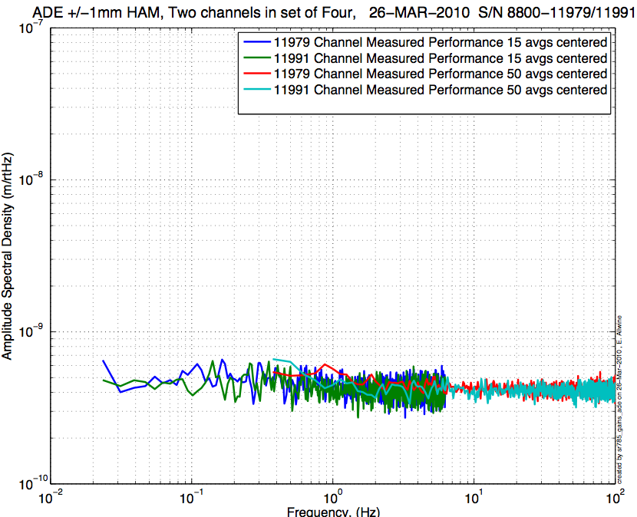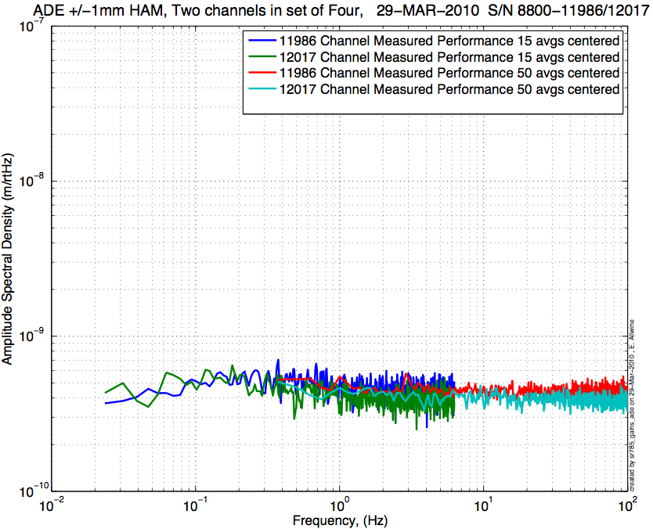
Figure - H1 and V1 sensor noise Figure - H2 and V2 sensor noise

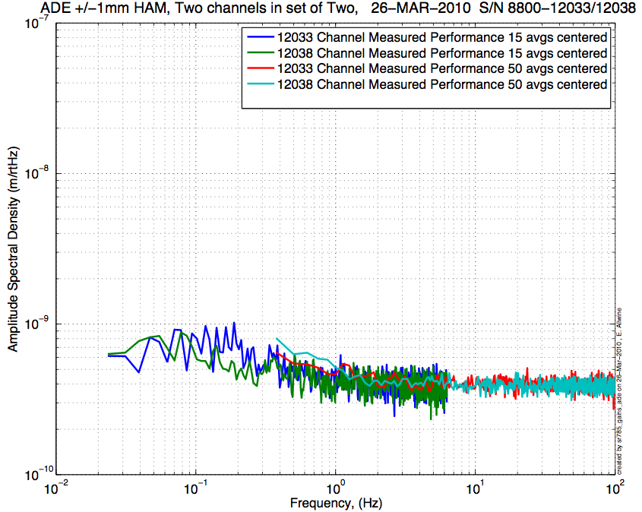
Figure - H3 and V3 sensor noise

Issues/difficulties/comments regarding this test:
The CPS #12033 and the CPS #12038 (H3, V3) are borderline.

Acceptance Criteria:
- Power spectrum magnitudes must be lower than:
  - 9.e-10 m/√Hz at 0.1Hz
  - 6.e-10 m/√Hz at 1Hz

Test result: Passed: X Failed: .

Step 2: GS13
All the data related to GS-13 post podding testing can be found in the SVN at:
\SeismicSVN\ Common\Data\aLIGO_GS13_TestData_LHO\
aLIGO GS13 Testing page is E1100367. It contains links to:
- LIGO-E1000058: aLIGO GS-13 Status Chart
- LIGO-E1100393: aLIGO GS-13 as received testing results
- LIGO-E1100394: aLIGO GS-13 prior shipping testing results
- LIGO-E1100395: aLIGO GS-13 Post Modification testing results
- LIGO-F0900070: GS-13 Inspection Checklist

Issues/difficulties/comments regarding this test:
The GS13s used for this testing are the same as those used on Unit #3 (HAM10)testing.
They are not referenced in the post-podding testing spreadsheet (E1000058-V39) because they are temporary test GS13s. However they have already been successfully used for the 3 previous HAM-ISI testings.

Acceptance Criteria:
- GS13 have already been tested at LLO. GS13 Inspection/Pod Assembly is described in document D047810. Checklist is defined in F090070-v6
- After reception the geophones at LHO, ASDs of the geophones must confirm that they are still functioning after shipping.

Test result: Passed: Failed: X .

These pods will be replaced prior insertion.

Step 3: Actuators
Actuator data can be found at: T0900564-V2. Actuator inventory is made at Section II – Step 1.

Actuator Serial #: L052  Operator Name: Gordon, Matt  Date: 9/25/2009 Time: 11:02 AM  Actuator Coil Resistance: 6.36 Ohms, PASS Ambient Temperature: 74.8 F  Hi Pot Test Results: 1000 MOhms, PASS  X Travel Limit (inches): 0.528  Y Travel Limit (inches): 0.205  Z Travel Limit (inches): 0.503 | Actuator Serial #: L048  Operator Name: Gordon, Matt  Date: 9/24/2009 Time: 3:52 PM  Actuator Coil Resistance: 6.32 Ohms, PASS Ambient Temperature: 75.1 F  Hi Pot Test Results: 1000 MOhms, PASS  X Travel Limit (inches): 0.526  Y Travel Limit (inches): 0.205  Z Travel Limit (inches): 0.504
Actuator Serial #: L061  Operator Name: Gordon, Matt  Date: 9/23/2009 Time: 5:09 PM  Actuator Coil Resistance: 6.35 Ohms, PASS Ambient Temperature: 72.5 F  Hi Pot Test Results: 1000 MOhms, PASS  X Travel Limit (inches): 0.526  Y Travel Limit (inches): 0.205  Z Travel Limit (inches): 0.506 | Actuator Serial #: L060  Operator Name: Gordon, Matt  Date: 9/23/2009 Time: 3:01 PM  Actuator Coil Resistance: 6.37 Ohms, PASS Ambient Temperature: 74.3 F  Hi Pot Test Results: 1000 MOhms, PASS  X Travel Limit (inches): 0.518  Y Travel Limit (inches): 0.205  Z Travel Limit (inches): 0.506
Actuator Serial #: L065  Operator Name: Gordon, Matt  Date: 9/25/2009 Time: 10:09 AM  Actuator Coil Resistance: 6.36 Ohms, PASS Ambient Temperature: 73.6 F  Hi Pot Test Results: 1000 MOhms, PASS  X Travel Limit (inches): 0.531  Y Travel Limit (inches): 0.204  Z Travel Limit (inches): 0.500 | Actuator Serial #: L062  Operator Name: Gordon, Matt  Date: 9/25/2009 Time: 9:15 AM  Actuator Coil Resistance: 6.35 Ohms, PASS Ambient Temperature: 71.6 F  Hi Pot Test Results: 1000 MOhms, PASS  X Travel Limit (inches): 0.526  Y Travel Limit (inches): 0.204  Z Travel Limit (inches): 0.505

Issues/difficulties/comments regarding this test:
V1 actuator’s SN (L048) hardly readable. The information was retrieved from alog entry # 1838.

Acceptance Criteria:
- Actuators were previously tested and results are reported in T0900564-V2.

Test result: Passed: X Failed: .

Tests to be performed during assembly

Step 1: Parts Inventory (E1000052)
DCC Number | Part name | Configuration | Corner 1 S/N | Corner 2 S/N | Corner 3 S/N
D071001 | Stage 0 base | NA | 003
D071051 | Stage 1 base | NA | 004
D071050 | Optical table | NA | 004
D071002 | Spring Post | NA | 32486-014 | 32486-021 | 32486-018
D071100 | Spring | NA | 22 | 12 | 5
D071102 | Flexure | NA | 50 (G) | 13 | 25 (G)
ADE | Position sensor | Horizontal | 11979 Master 0 | 11986 Slave 180 | 12033 Slave 0
 |  | Vertical | 11991 Slave 180 | 12017 Slave 0 | 12038 Slave 180
D047812 | GS-13 pod | Horizontal | 058 | 013 | 066
 |  | Vertical | 049 | 040 | 059
D047823 | L4C pod | Horizontal | NA | NA | NA
 |  | Vertical | NA | NA | NA
D0902749 | Actuator | Horizontal | L048 (H) | L060 | L062
 |  | Vertical | L052 | L061 | L065
Table – Parts inventory

Cable Connects |  | Cable S/N
Part Name | Configuration | Corner 1 | Corner 2 | Corner 3
GS13 | Horizontal | S1104678 | S1104689 | S0114688
GS13 | Vertical
L4C | Horizontal | NA | NA | NA
L4C | Vertical | NA | NA | NA
Actuator | Horizontal | S1104762 | S1104767 | S1104493
 | Vertical | S1104760 | S1104763 | S1104494
Table – Cables inventory

NR: Not recorded; NA: Not applicable
(G) 2 of 3 Flexures were installed upside-down. Scribed s/n are on the bottom of the Flexures and are now not very visible. We tried using a mirror and a flashlight to view the flexures from under Stage1, but the flexures are fairly high up, and the scribed marks are also hard to read. With that, we can only say we have "best guesses" at s/n's for Corner 1 & 3. LHO-alog entry #1838
(H) V1 actuator’s SN (L048) hardly readable. The information was retrieved from alog entry # 1838.
Highlighted cable S/N need to be double checked at the beginning of the chamber-side testing.
Issues/difficulties/comments regarding this test:
If installed in HAM8, as planned, this unit should not need feedforward L4Cs.

The serial numbers given for the GS13s correspond to test versions of the sensor. They will be replaced as soon as the permanent GS13s are installed.

The test GS13s used on Unit #1 were taken from Unit #3 (HAM10). These GS13s were associated with the same corner as previously. The test GS13 #68 (H3) was malfunctioning. We already had issues with it on HAM-ISI Unit #3*. It has been replaced with GS13 #66. It is the only one that differs from the set used for UNIT #3 testing.

*For more information, please refer to:
- Vincent Lhuillier, alog #1801: Detection of a malfunctioning horizontal GS13 and description of it symptoms.
- Greg Grabeel, alog #1832: Repairing the horizontal GS13. It seems that the instrument was tilted inside its pod by whether a loose jam nut or an insufficiently tightened crossbar.

Step 2: Check torques on all bolts

Acceptance Criteria:
- All bolts should trip the wrench, and start moving immediately after. If any bolts in a pattern move before torque is reached, recheck after all bolts are brought to spec.

Test result: Passed: X Failed: .

Step 3: Check gaps under Support Posts
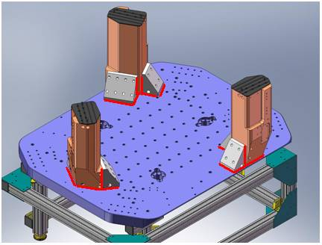
Figure - Showing edges that need checked on support posts and gussets

Acceptance Criteria:
- A 0.001 inch shim cannot be passed freely through any connection to Stage 0 or between post and gussets. If shim can pass through, loosen all constraining bolts, and then retighten iteratively from the center of the part to the edges. Retest.

Test result: Passed: X Failed: .

Step 4: Pitchfork/Boxwork flatness before Optical Table install
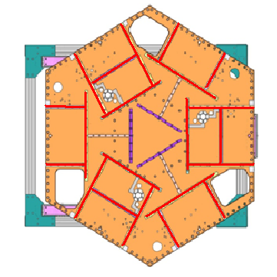
Figure – Showing what needs to be checked on Boxworks and Pitchforks

Acceptance Criteria:
- Shim inserted won’t pass between parts.

Test result: Passed: X Failed: .

Step 5: Blade spring profile
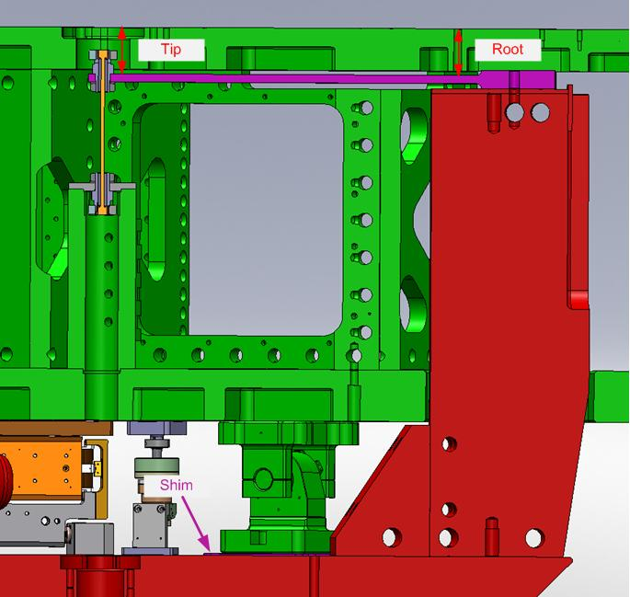
figure – Blade spring profile measurement points

Blade # | Root (") | Tip(") | Flatness (mils)
1 | 651 | 667 | 16
2 | 651 | 662.5 | 11.5
3 | 649 | 661 | 12

Table 1 - Blade profile

Issues/difficulties/comments regarding this test:
The weight of the plunge micrometer lowers Stage1 by up to 0.002”. This should reduce the Root level making the flatness over-evaluated by 0.002”. Hence, the result on blade #1 should be discussed.

Acceptance Criteria:
- Blades must be flat within 0.015" inches.

Note that the tip measurement should be constant and that root value can be impacted by shims change.

Test result: Passed: Failed: X .

Step 6: Gap checks on actuators-after installation on Stage 1
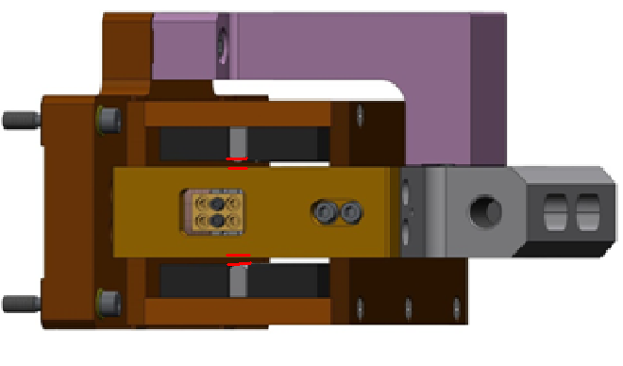
Figure - Showing gaps that need to be checked on actuators.

Issues/difficulties/comments regarding this test:
Actuator alignment was lost during disassembly/storing and had to be redone (LHO-aLog entry # 1851)

Since layers of shims are difficult to use accurately, a Go (70mils shim set) vs. No Go (90 mils shim set) technique was used for this test. To pass the test an actuator gap has to allow the 70mils shim set to be inserted and refuse the 90mils shim set.
The gaps on the backside of horizontal actuators are hard to access. Horizontal actuators appeared borderline on that side.

Acceptance Criteria
- Gaps must be within 0.010” of design (i.e. 0.090” and .070” pass, but 0.095” and 0.065” doesn’t).

Test result: Passed: X Failed: .

Step 7: Check level of Stage 0
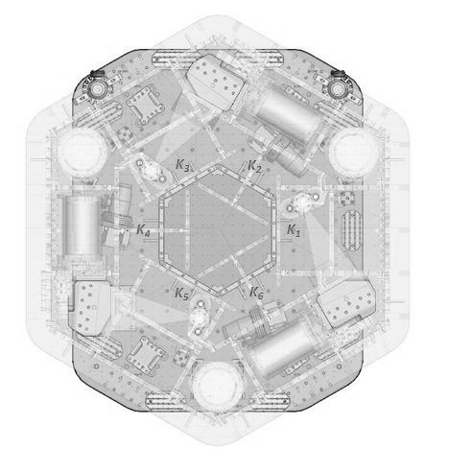
7
CORNER 1
8
3
5
0
3
2
0
Figure – Level measured on Stage 0

Issues/difficulties/comments regarding this test:
The accuracy of the measurement limited by the measurement tool: optical level + ruler on a block. The ruler only has 1/64” graduations. Values are deduced from the relative distance to graduations. The uncertainty is about 1mil.
Max angle is calculated between the opposite points that have the most different level.
Optical level was set up, and measurement was performed again, since previous version of this report.
Max angle=0.008/57 (± 0.001/57) = 140.4 (±17.4) µrad
Acceptance Criteria
- The maximum angle of the table with the horizontal mustn’t exceed ~100µrad

Test result: Passed: Failed: X .

Note:
This test doesn't meet our stringent requirement, however this leveling value is sufficient for all the tests being performed.

Step 8: Check level of Stage 1 Optical Table

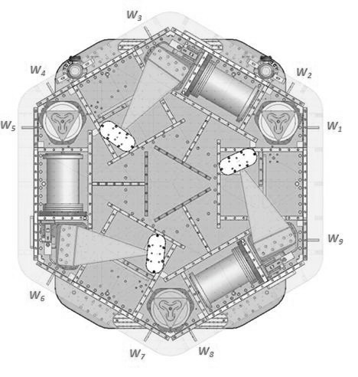
2
4
4
5
CORNER 1
-2
0
Figure – Level measured on Stage 1

Issues/difficulties/comments regarding this test:
The accuracy of the measurement is limited by the measurement tool: optical level + ruler on a block. The ruler only has 1/64” graduations. Values are deduced from the relative distance to graduations. The uncertainty is about 1mil.
Max angle is calculated between the opposite points that have the most different level.
Optical level was set up, and measurement was performed again, since previous version of this report.
Max angle = 0.003/ 71 (± 0.001/71) = 42.25 (± 14.1) µrad

Acceptance Criteria
- The maximum angle of the table with the horizontal mustn’t exceed ~100µrad

Test result: Passed: X Failed: .

Step 9: Mass budget

 | 00 | 01 | 02 | 03 | 04 | 05 | 06
 | 0.6 | 1.1 | 2.2 | 4.5 | 7.9 | 15.6 | 27.2 | lbs. | kg
W9 |  |  |  |  | 2 |  |  | 15.8 | 7.17
W1 |  |  |  | 1 |  |  | 1 | 31.7 | 14.38
W2 |  |  |  |  |  |  | 1 | 27.2 | 12.34
W3 |  |  |  |  |  |  |  | 0 | 0.00
W4 |  |  |  |  | 1 |  | 1 | 35.1 | 15.92
W5 | 1 |  | 1 | 1 | 1 |  | 1 | 42.4 | 19.23
W6 |  |  |  |  |  |  |  | 0 | 0.00
W7 |  |  |  | 1 |  |  | 1 | 31.7 | 14.38
W8 |  | 1 | 1 |  | 1 |  | 1 | 38.4 | 17.42
Side Masses Total | 1 | 1 | 2 | 3 | 5 | 0 | 6 | 222.3 | 100.83
Table – Wall masses distribution

 | 00 | 01 | 02 | 03 | 04 | 05 | 06
 | 0.6 | 1.1 | 2.2 | 4.5 | 7.9 | 15.6 | 27.2 | lbs. | kg
K1 |  |  |  |  | 1 |  | 1 | 35.1 | 15.92
K2 |  |  |  |  |  | 2 |  | 31.2 | 14.15
K3 |  |  |  |  | 1 |  | 1 | 35.1 | 15.92
K4 |  |  |  |  |  | 2 |  | 31.2 | 14.15
K5 |  |  |  |  | 1 |  | 1 | 35.1 | 15.92
K6 |  |  |  |  |  | 2 |  | 31.2 | 14.15
Keel Masses Total | 0 | 0 | 0 | 0 | 3 | 6 | 3 | 198.9 | 90.22
Table – Keel masses distribution

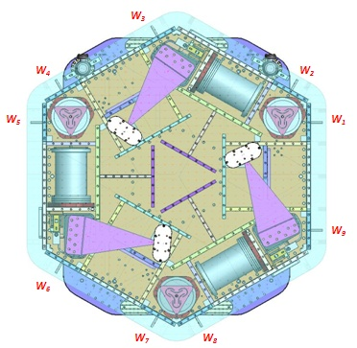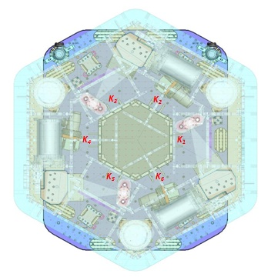
Figure – Wall Masses(W) and Keel masses (K) location. South of picture = corner 1
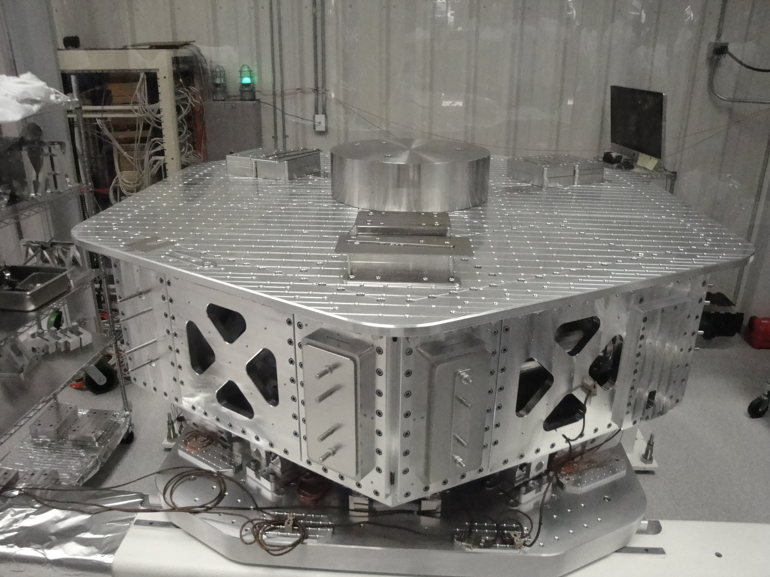
T4
T1
T2
T3
Corner 1
Figure – Optical table masses distribution

 | Mass (kg)
T1 | 42.59
T2 | 270.79
T3 | 40.27
T4 | 37.04
Total | 390.69
Table – Optic table masses distribution

 | Side | Keel | Top | Total
Weigh (kg) | 100.83 | 90.22 | 390.69 | 581.75
Table – Mass budget sum up

Issues/difficulties/comments regarding this test:
- T2 mass evaluated at nominal value: 597lbs. Gauge not available for measurement.
- A few shims were used for balancing. Their weight is negligible in comparison with the mass budget. Hence their weight is not reported in the mass budget.
- The first version of this report (E1000310-V1, before disassembly/reassembly of the unit) featured a total mass of 584.38kgs. The current mass budget is 2.63kg lower. This mass budget difference could be associated with the parts changed during disassembly/reassembly.
- The previous version of this report (E1000310-V2) featured a total mass of 588.24kgs. The current mass budget is 6.949kg lower.
  - It has been noticed that most of the bolts on the GS13 doors, and some on the door’s brackets, were missing (most likely to accelerate the process of switching the GS13s from test to permanent version). These bolts have been added since the previous report. Their weigh is very likely to justify most the mass budget difference.
  - The top mass has been moved to a centered position since previous report. This operation implied a new distribution of the mass budget.

Acceptance Criteria
The Mass budget must be
- 579.1 Kg (cf. E1100427)+/-25Kg (5%)

Test result: Passed: X Failed: .

Step 10: Shim thickness

Lockers | Shim thickness (mils)
A | 122
B | 122
C | 120
D | 120
Table – Shims Thickness

Issues/difficulties/comments regarding this test:
Lockers C and D are borderline.

Acceptance Criteria
- The shim thickness should be 125 mils +/-5

Test result: Passed: X Failed: .

Step 11: Lockers adjustment

D.I. at Locker | Vertical D.I. | Horizontal D.I.
A | -1 | 0.2
B | 0.2 | -1.2
C | -1 | 0.2
D | -2 | -0.2
Table – Dial indicators read-out (in thousands of an inch)

Issues/difficulties encountered during this test:
Vertical adjustment appears borderline on locker D.

Acceptance Criteria
- Vertical and horizontal displacement near the lockers must be lower than 2 mils (0.002”

Test result: Passed: Failed: X .

Tests to be performed after assembly

Step 1 - Electronics Inventory

Hardware | LIGO reference | S/N
Coil driver | D0902744 | S1000266
 |  | S1000269
Anti Image filter | D070081 | S1000250
Anti aliasing filter | D1000269 | S1102694
 |  | S1102679
Interface chassis | D1000067 | 1102223
 |  | 1102224
 |  | 1102214
Table - Inventory electronics

Acceptance Criteria
- Inventory is complete
Test result: Passed: X Failed: .

Step 2 - Set up sensors gap

 | Locked, 10 Kg masses at each corners |  | Locked /no mass |  | Unlocked /no mass
Table locked | ADE boxes on |  | ADE boxes on |  | ADE boxes on
Sensors | Offset (Mean) | Std deviation | Offset (Mean) | Std deviation | Offset (Mean) | Std deviation
H1 | -45.13 | 9.53 | -267.10 | 10.04 | -24.10 | 21.04
H2 | -78.05 | 9.19 | -177.38 | 9.04 | -25.29 | 19.94
H3 | 321.97 | 8.85 | 297.33 | 8.59 | 122.58 | 31.79
V1 | -287.25 | 10.61 | -26.29 | 15.33 | 216.75 | 32.63
V2 | -377.70 | 9.78 | -112.13 | 13.55 | 232.15 | 29.49
V3 | -260.28 | 9.68 | 73.38 | 10.58 | 253.67 | 27.53
Capacitive position sensor readout after gap set-up

Issues/difficulties encountered during this test :
- Vertical CPSs’ zero has been reset since previous version of the report (DCC # E1000312_v2). The results for this test have been updated since then.

Acceptance criteria:
- All mean values must be lower than 400 cts (a bit less than .0005”).
- All standard deviations below 5 counts.
- No cross talk

Test result: Passed: Failed: X .

Note: Failed because of standard deviation. However, a CPS was set on a test-jig and featured 4.3 counts of standard deviation, which is within specs. Hence, the high standard deviation observed is correlated to the 10Hz-100Hz peaks observed on the locked/unlocked GS13 and CPS ASDs. As shown in SEI Logbook entry #15, these peaks are caused by ground motion. Hence, high standard deviations should not be associated with sensor noise.

Step 3 - Measure the Sensor gap
Issues/difficulties/comments regarding this test:
Measured in the previous version of this report (E1000312-V1, p11). Waived to avoid scratching targets.

Acceptance criteria:
Sensors gap measured on the jig and on the optic table must be:
- 0.080” +/-0.002”

Test result: Passed: Failed: X .

Step 4 - Check Sensor gaps after the platform release

 | Table locked |  | Table unlocked
Sensors | Offset (Mean) | Std deviation | Offset (Mean) | Difference | Difference
H1 | -267.10 | 10.04 | -24.10 | 21.04 | 243.01
H2 | -177.38 | 9.04 | -25.29 | 19.94 | 152.09
H3 | 297.33 | 8.59 | 122.58 | 31.79 | 174.75
V1 | -26.29 | 15.33 | 216.75 | 32.63 | 243.04
V2 | -112.13 | 13.55 | 232.15 | 29.49 | 344.28
V3 | 73.38 | 10.58 | 253.67 | 27.53 | 180.29
Table – Sensor gaps after platform release

Issues/difficulties encountered during this test :
Vertical CPSs’ zero has been reset since previous version of the report. The results for this test have been updated since then.

Acceptance criteria:

- Absolute values of the difference between the unlocked and the locked table must be below:
  - 1600 cts for horizontal sensors (~0.002”)
  - 1600 cts for vertical sensors (~0.002”)
- Considering the acceptance criteria of step 4, all mean values must be lower than
  - 2000 cts for horizontal sensors (~0.0025”)
  - 2000 cts for vertical sensors (~0.0025”)

Test result: Passed: X Failed: .

Step 5 – Performance of the limiter

Step 5.1 - Test Nº1 - Push “in the general coordinates”
Pushing Z,-Z | CPS read out |  | Calculated after calibration |  | Range of Motion
Sensors | UP (Counts) | Down (Counts) | UP (mil) | Down (mil)
V1 | 20080 | -20090 | 24.0 | -24.0 | 40170
V2 | 20800 | -19760 | 24.8 | -23.6 | 40560
V3 | 20700 | -20220 | 24.7 | -24.1 | 40920
Pushing RZ,  -RZ | CPS read out |  | Calculated after calibration |  | ROM
Sensors | CCW (+RZ) | CW(-RZ) | CW (mil) | CCW (mil)
H1 | -21600 | 23990 | -25.8 | 28.6 | 45590
H2 | -22900 | 19780 | -27.3 | 23.6 | 42680
H3 | -20300 | 20340 | -24.2 | 24.3 | 40640
Table - Optic table range of motion

Step 5.2 - Test Nº2 – Push “locally”
Pushing Locally | Push in positive direction | Push in negative direction | Railing | Actuator Gap Check | Range Of Motion
H1 | -22800 | 32767 | X | X | 55567
H2 | -23900 | 23700 |  | X | 47600
H3 | -20800 | 22086 |  | X | 42886
V1 | 20750 | -20330 |  | X | 41080
V2 | 32767 | -32768 | X | X | 65535
V3 | 26300 | -25375 |  | X | 51675
Table - Optic table range of motion

Issues/difficulties encountered during this test:
Vertical CPSs’ zero has been reset since previous version of the report. The results for this test have been updated since then.
Contact points hard to check on vertical actuators.

Acceptance criteria:
- The vertical sensor readout must be positive when the optic table is pushed in the +Z direction
- The horizontal sensor readout must be negative when the optic table is pushed in the +RZ direction
- Step 5.1
  - Absolutes value of all estimated motions must be higher than 16000counts (~0.020”)
- Step 5.2
  - No contact point on sensors
  - Absolute value of sensor read out must be higher than 16000counts (~0.020”)
  - No contact point on actuators

Test result: Passed: X Failed: .

Step 6 - Position Sensors unlocked/locked Power Spectrum

Scripts files for processing and plotting in SVN at:
/SeiSVN/seismic/HAM-ISI/Common/Testing_Functions_HAM_ISI/
- ASD_Measurements_Locked_Unlocked_HAM_ISI.m

Data in SVN at:
SeiSVN/seismic/ HAM-ISI/X1/HAMX/Data/Spectra/Undamped/
- LHO_ISI_UNIT_1_ASD_m_CPS_T240_L4C_GS13_Locked_vs_Unlocked_2012_02_07.mat

Figures in SVN at:
/SeiSVN/seismic/HAM-ISI/X1/HAMX/Data/Figures/Spectra/Undamped
- LHO_ISI_UNIT_1_ASD_m_GS13_Requirements_Locked_vs_Unlocked_2012_02_07.fig
- LHO_ISI_UNIT_1_ASD_m_CPS_Requirements_Locked_vs_Unlocked_2012_02_07.fig

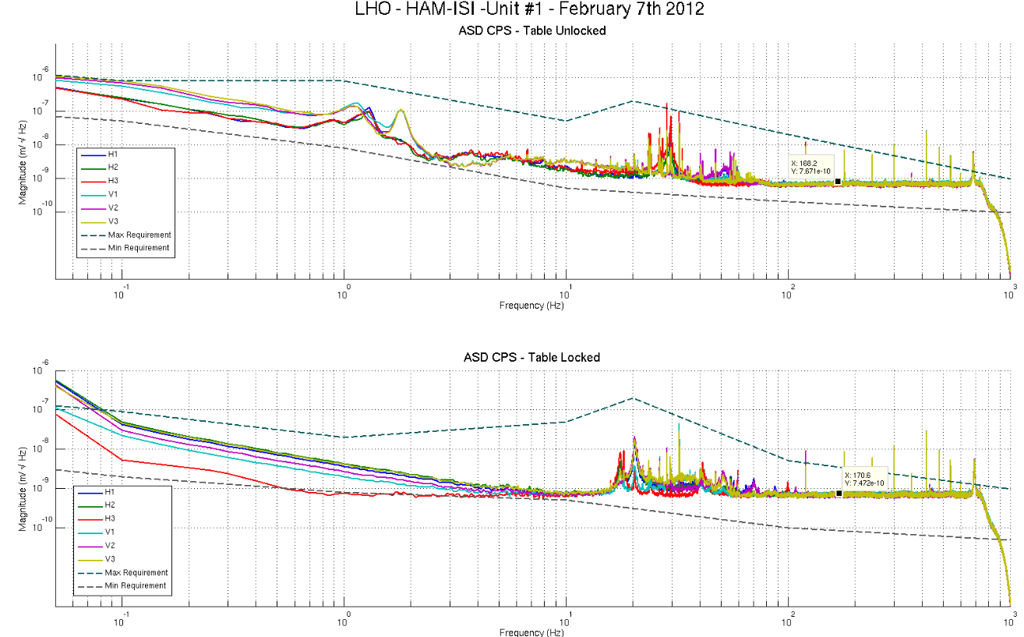
Figure - Calibrated CPS power spectra

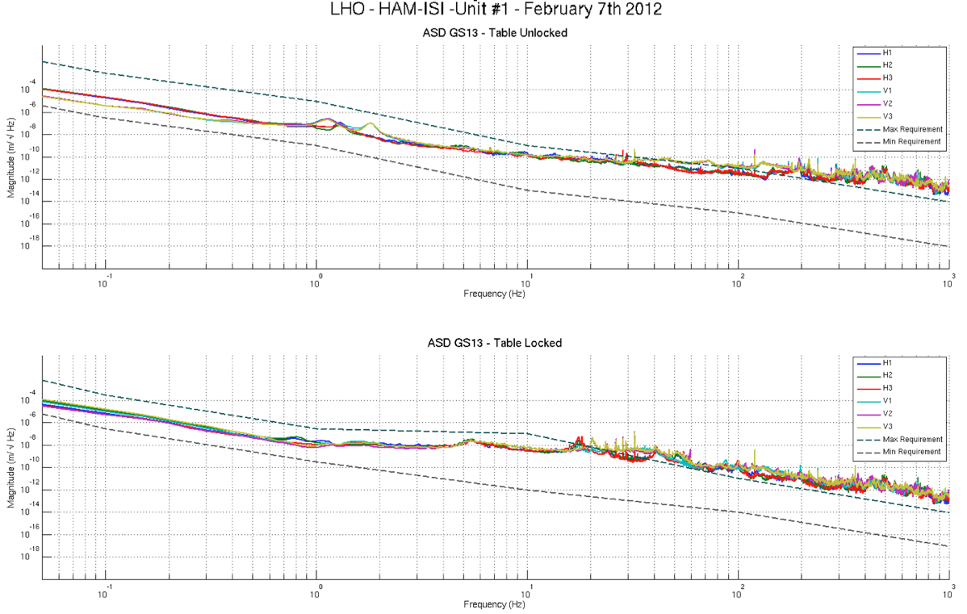
Figure – Calibrated GS13 Power spectra

Issues/difficulties/comments regarding this test:
- Measurements were performed with all PreFilters ON.
- 10Hz-100Hz peaks were investigated for the testing phase I of Unit #3 (HAM10), and reported in Part 1, last step: capacitive position sensor investigation, of the related report (Document #E1000312-v3)
- Vertical CPSs’ zero has been reset since previous version of the report. The results for this test have been updated since then.

Acceptance criteria:
- No cross talk (peaks at low frequencies + harmonics on measurements)
- Magnitudes of power spectra must be between requirement curves

Test result: Passed: X Failed: .

Step 7 - GS13 power spectrum -tabled tilted

Scripts files for processing and plotting in SVN at:
SeiSVN/seismic/HAM-ISI/Common/Testing_Functions_HAM_ISI/
- ASD_Measurements_Stages_Tilted_HAM_ISI.m

Figures in SVN at:
SeiSVN/seismic/HAM-ISI/X1/HAMX/Data/Figures/Spectra/Undamped
- LHO_ISI_UNIT_1_m_PSD_GS13_Tilted_2012_01_12.fig

The figure below presents the GS13 power spectrum when the table is unlocked and loaded with a 10Kg mass at each of its corner.

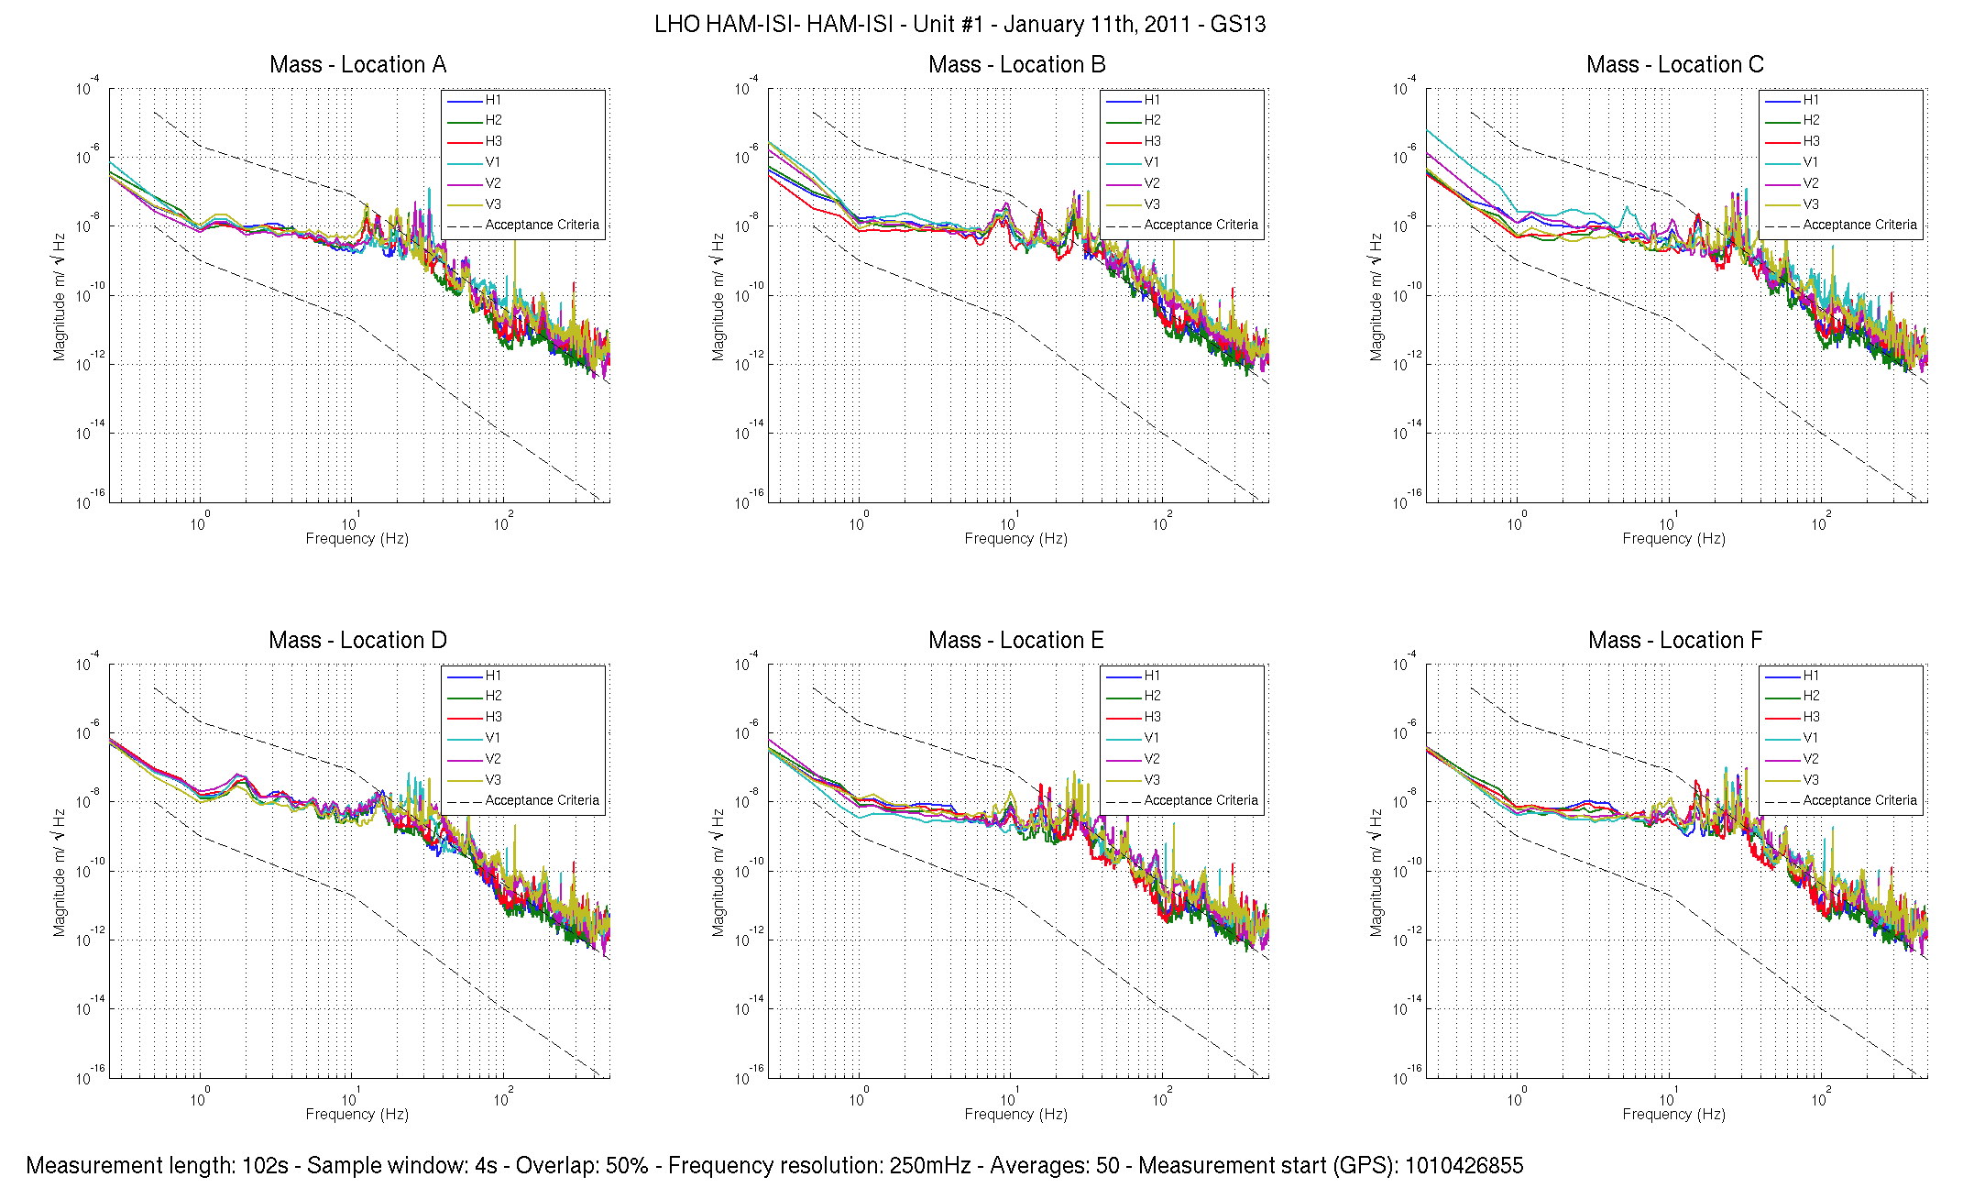

Figure – Power spectrum Calibrated GS13 with mass at corners A to F

Issues/difficulties/comments regarding this test:
- Test GS13 are used, so borderline values are acceptable.

Acceptance criteria:
- With table unlocked and tilted, magnitudes of power spectra must be fully included within requirement curves.

Test result: Passed: X Failed: .

Step 8- GS13 pressure readout

Test GS13 used. Step to be performed o the final GS13s

Step 9 - Coil Driver, cabling and resistance check

Actuator | V1 |  | H1 |  | V2
Coil driver | S1000266 - Coarse 2 |  | S1000266 - Coarse 1 |  | S1000269 - Coarse 2
Cable # | S1104760 |  | S1104762 |  | S1104773
Resistance  (Ohm) | P1 - P2 | P2 - P3 | P1 - P2 | P2 - P3 | P1 - P2 | P2 - P3
 | O.L (infinity) | 6.38 | O.L (infinity) | 6.32 | O.L (infinity) | 6.52
MEDM offset  (1000 counts) | Measurement P2 (+) ; P1&P3 (-) |  | Measurement P2 (+) ; P1&P3 (-) |  | Measurement P2 (+) ; P1&P3 (-)
 | 0.3070V |  | 0.3117V |  | 0.3115V
Actuator | H2 |  | V3 |  | H3
Coil driver | S1000269 - Coarse 1 |  | S1102692 - Coarse 2 |  | S1102692 - Coarse 1
Cable # | S1104776 |  | S1104494 |  | S1104493
Resistance  (Ohm) | P1 - P2 | P2 - P3 | P1 - P2 | P2 - P3 | P1 - P2 | P2 - P3
 | O.L (infinity) | 6.54 | O.L (infinity) | 6.58 | O.L (infinity) | 6.68
MEDM offset  (1000 counts) | Measurement P2 (+) ; P1&P3 (-) |  | Measurement P2 (+) ; P1&P3 (-) |  | Measurement P2 (+) ; P1&P3 (-)
 | 0.3138V |  | 0.3044V |  | 0.3106V
Table - Actuators resistance check

Issues/difficulties/comments regarding this test:
- Voltages measured from Pin #2 (+) to pin #3 (-) with compensation filters engaged.
- Precise measurements have been achieved by using an Agilent 34401A multimeter.
- 10kgs masses are sitting on each corner of the locked ISI to avoid current to appear in the actuators due to ISI motion.

Acceptance criteria:
- The measured resistance between the middle pin and one side pin must be 6.5 +/-1 ohms
- Actuator neutral pins must be connected on pin #3 (left side pin of the plug)
- Actuator drive pins must be connected on pin #2 (middle pin of the plug)
- Actuator ground shield pins must be connected on pin #1 (right pin of the plug)
- All LEDs on the coil driver front panel must be green

Test result: Passed: X Failed: .

Step 10 - Actuators Sign and range of motion (Local drive)

 | Negative drive | No Drive | Positive drive
H1 readout (count) | -24483 | -37 | 24156
H2 readout (count) | -23949 | -53 | 24319
H3 readout (count) | -24690 | 76 | 25499
V1 readout (count) | -19566 | 30 | 19466
V2 readout (count) | -25877 | -11 | 26424
V3 readout (count) | -21837 | 83 | 22694
Table - Range of motion - Local drive

Issues/difficulties/comments regarding this test:
- Compensation filters are ON.
- Vertical CPSs’ zero has been reset since previous version of the report. The results for this test have been updated since then.

Acceptance criteria:
- Main couplings sensors readout must be at least 16000 counts (~0.02”)
- A positive offset drive on one actuator must give positive sensor readout on the collocated sensor. Signs will also be tested when measuring local-to-local transfer functions.

Test result: Passed: X Failed: .

Step 11 - Vertical Sensor Calibration

Lockers | D.I readout with for  a negative drive | D.I readout without any drive | D.I readout with for  a positive drive
A | 19.20 | 0.00 | -19.20
B | 19.10 | 0.00 | -19.20
C | 18.50 | 0.00 | -18.10
D | 18.20 | 0.00 | -18.20
Average | 18.75 | 0.00 | -18.68
Sensors | Counts | Counts | Counts | Difference
V1 | -14189.00 | 821.00 | 16005.00 | 30194.00
V2 | -15065.00 | 960.00 | 16862.00 | 31927.00
V3 | -15889.00 | 222.00 | 16031.00 | 31920.00
Vertical Sensibility
837.60 | Count/mil
0.51 | V/mil
30.32 | nm/count
-0.29 | % from ref (840nm/count)

Table - Calibration of capacitive position sensors

Issues/difficulties/comments regarding this test:
- Vertical CPSs’ zero has been reset since previous version of the report. The results for this test have not been updated since then.
- However, Sensor’s calibration should not be affected by this modification.

Acceptance criteria:

- Deviation from nominal value < 2%. Nominal value is 840 count/mil.

Test result: Passed: X Failed: .

Step 12 - Vertical Spring Constant

Results presented below are obtained after the initial sensors calibration.

Sensors | Mean diff counts | Mean diff m | K (N/m) | Variation from average
V1 | -7986 | -2.412E-04 | 8.135E+04 | -0.29%
V2 | -7889 | -2.383E-04 | 8.235E+04 | 0.94%
V3 | -8016 | -2.421E-04 | 8.104E+04 | -0.66%
 |  | Average (N/m) | 2.447E+05
Table - Vertical spring constant

Issues/difficulties/comments regarding this test:
- Vertical CPSs’ zero has been reset since previous version of the report. The results for this test have not been updated since then.

Acceptance criteria:
- +/-2 % of 2.4704e5 N/m (i.e. between 2.421e5 and 2.520e5 N/m)
- +/- 5% of variation between each spring and the average

The measured error on the vertical stiffness is -0.93 %

Test result: Passed: X Failed:

Step 13 - Static Testing (Tests in the local basis)

 | Sensors (counts)
 | H1 | H2 | H3 | V1 | V2 | V3
H1 | 2106 | 1310 | 1319 | -38 | 2 | 26
H2 | 1285 | 2062 | 1276 | -5 | 0 | 13
H3 | 1273 | 1274 | 2030 | -15 | 34 | 19
V1 | 203 | 201 | -391 | 1473 | -5 | -637
V2 | -376 | 202 | 166 | -621 | 1495 | -15
V3 | 185 | -361 | 211 | -35 | -618 | 1465
Table - Main couplings and cross couplings

Issues/difficulties encountered during this test:
- Vertical CPSs’ zero has been reset since previous version of the report. The results for this test have been updated since then.
- H1 and V2 have the most sensitive excitation/measurement chain in their direction.

Acceptance criteria:
- Vertical
For a +1000 count offset drive on vertical actuators
  - Collocated sensors must be 1400 counts +/- 10%

- Horizontal
For a +1000 count offset drive on horizontal actuators
  - Collocated sensors must be 2000 counts +/- 10%
  - Non-collocated horizontal sensors must be 1250 counts +/-10%

Test result: Passed: X Failed: .

Step 14 - Linearity test

 | Slope | Offset | Average slope | Variation from  average(%)
H1 | 2.1099 | -293.75 | 2.07 | 1.93
H2 | 2.0571 | -274.49 |  | -0.62
H3 | 2.0426 | -136.64 |  | -1.32
V1 | 1.4892 | 278.92 | 1.47 | 0.97
V2 | 1.4757 | 284.92 |  | 0.06
V3 | 1.4597 | 289.52 |  | -1.03
Table - Slopes and offset of the triplet ‘Actuators - HAM-ISI – Sensors’

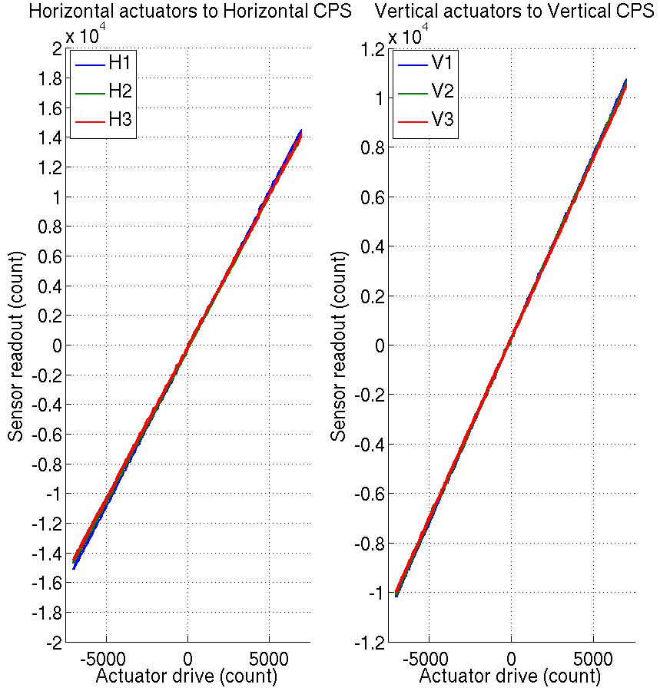
Figure - Linearity test on the triplet ‘actuators - HAM-ISI – sensors’
in both Horizontal and vertical directions

Cable leading to actuator | Resistance (Ohm)
H1 | 0.114
H2 | 0.189
H3 | 0.209
V1 | 0.113
V2 | 0.176
V3 | 0.209

Table – Cable Resistance, cable section going from the coildriver to the feedthrough

Issues/difficulties encountered during this test:
- H1, H3 and V3 do not meet our requirements.
- The results obtained on this unit are similar to the ones obtained on LHO-BSC-ISI Unit #1 (E1100294-v2) and LHO-BSC-ISI Unit #2 (E1100295-v3). However, acceptance criteria for BSC-ISI was: Average slope +/- 3% which is 3 times less restrictive than it is for the HAM-ISI.
- The tendencies on linearity test slopes seem to match the tendencies on cable resistance (coildriver to feedthrough section). Cable resistance, which is proportional to cable length, would then be a possible explanation for the linearity results obtained.

Acceptance criteria:
- Horizontal and vertical slopes of the triplet actuators x HAM-ISI x sensors: Average slope +/- 1%

Test result: Passed: Failed: X .

Step 15 - Cartesian Basis Static Testing

1000 counts Drive | X | Y | Z | RX | RY | RZ | Direction read out
X Drive | 511.45 | -5.8981 | 5.1799 | 24.9 | 3.3336 | -25.416 | 511.45
Y Drive | -7.7679 | 523.08 | -11.614 | -1.582 | 23.46 | 26.225 | 523.08
Z Drive | 0.10612 | 8.6821 | 260.96 | -5.0433 | 19.352 | -6.1982 | 260.96
Rx Drive | 25.227 | -7.4319 | 10.962 | 2600.6 | -10.489 | 7.9001 | 2600.6
Ry Drive | -0.39454 | 6.9385 | -7.5726 | -19.115 | 2617.9 | 4.6392 | 2617.9
Rz Drive | -4.5903 | 11.384 | -2.4089 | -12.301 | -9.158 | 2528.3 | 2528.3
Table – Static testing: Drive in the Cartesian basis, response in the Cartesian basis

1000 counts Drive | H1 | H2 | H3 | V1 | V2 | V3 | Direction read out
X Drive | 274.11 | 273.73 | -494.38 | -3.9689 | 19.505 | -3.1605 | 511.45
Y Drive | -485.83 | 414.31 | -13.011 | -22.116 | -15.873 | 10.024 | 523.08
Z Drive | 4.6923 | -9.3493 | 13.693 | 264.02 | 278.37 | 292.07 | 260.96
Rx Drive | -453.95 | 456.01 | -28.122 | -462.48 | 1715.6 | -1210 | 2600.6
Ry Drive | -270.91 | -269.96 | 530.88 | -1692.2 | 444.14 | 1268.6 | 2617.9
Rz Drive | -2009.9 | -2001.6 | -1992.7 | 9.8958 | -22.399 | -7.8055 | 2528.3
Table – Static testing: Drive in the Cartesian basis, response in the Local basis

1000 counts Drive | H1 | H2 | H3 | V1 | V2 | V3 | Direction read out
X Drive | + | + | - |  |  |  | +
Y Drive | - | + | 0 |  |  |  | +
Z Drive |  |  |  | + | + | + | +
Rx Drive |  |  |  | - | + | - | +
Ry Drive |  |  |  | - | + | + | +
Rz Drive | - | - | - |  |  |  | +
Table – Cartesian static testing reference table

Issues/difficulties/comments regarding this test:
- Calibration filters engaged on CPSs
- Vertical CPSs’ zero has been reset since previous version of the report. The results for this test have been updated since then.

Acceptance criteria:
For a positive drive in the Cartesian basis:
- Local sensor readout must have the same sign that the reference table
- Cartesian sensors read out must be positive in the drive direction

Test result: Passed: X Failed: .

Step 16- Frequency response
Preliminary work
Unusual resonances were initially observed a bit below 100Hz and above on LHO HAM-ISI Unit#1. It appeared, after inspection, that GS13 doors and their brackets were not fully bolted and torqued.

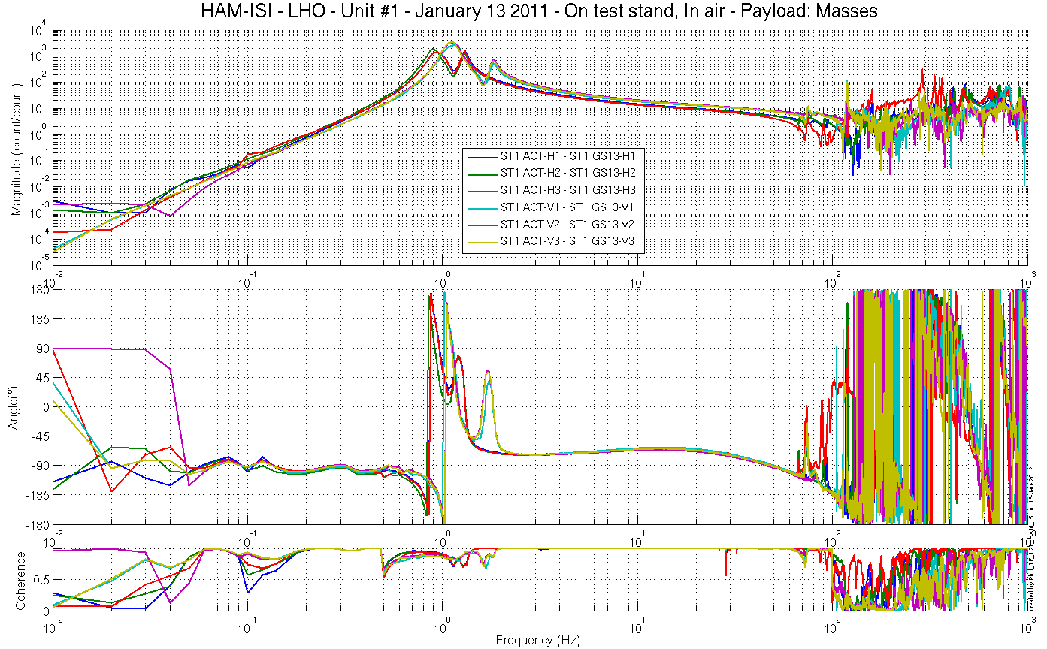
Figure - local-to-Local Measurements – Inertial sensors – GS13 Doors partially bolted/torqued

These mistakes were corrected, however, the resonances observed only disappeared when Viton pads were added under the ISI‘s Top Mass.

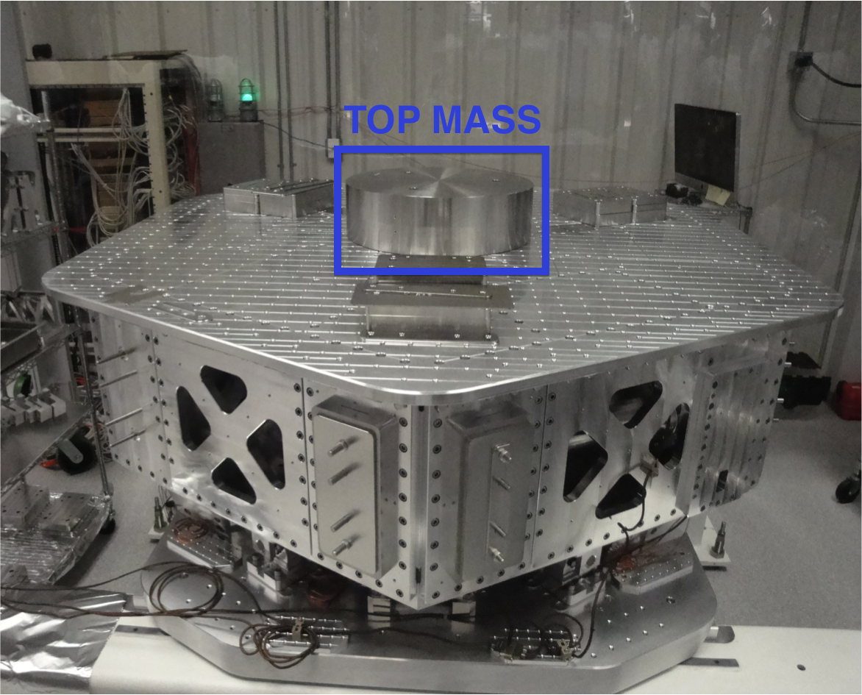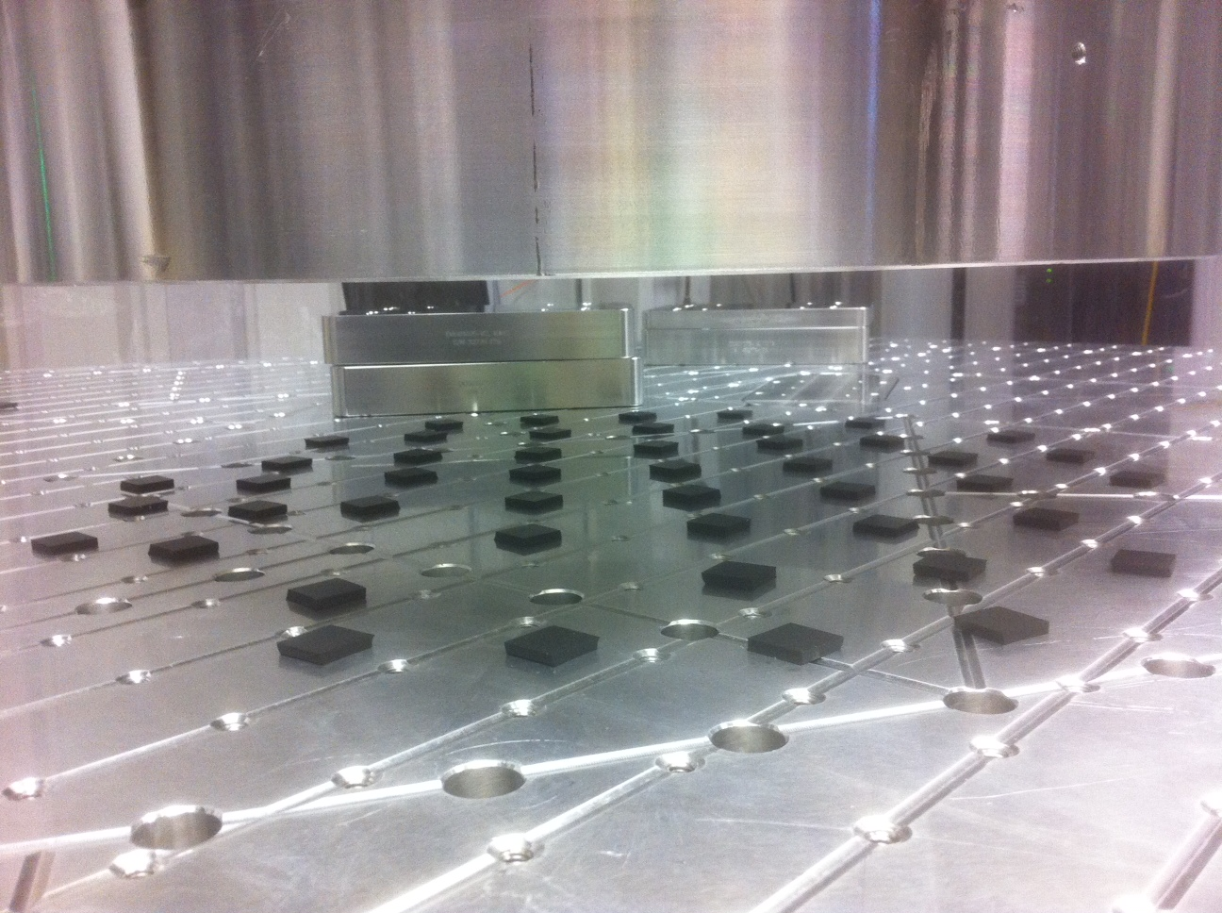
Figure – Top Mass and Viton pads checker

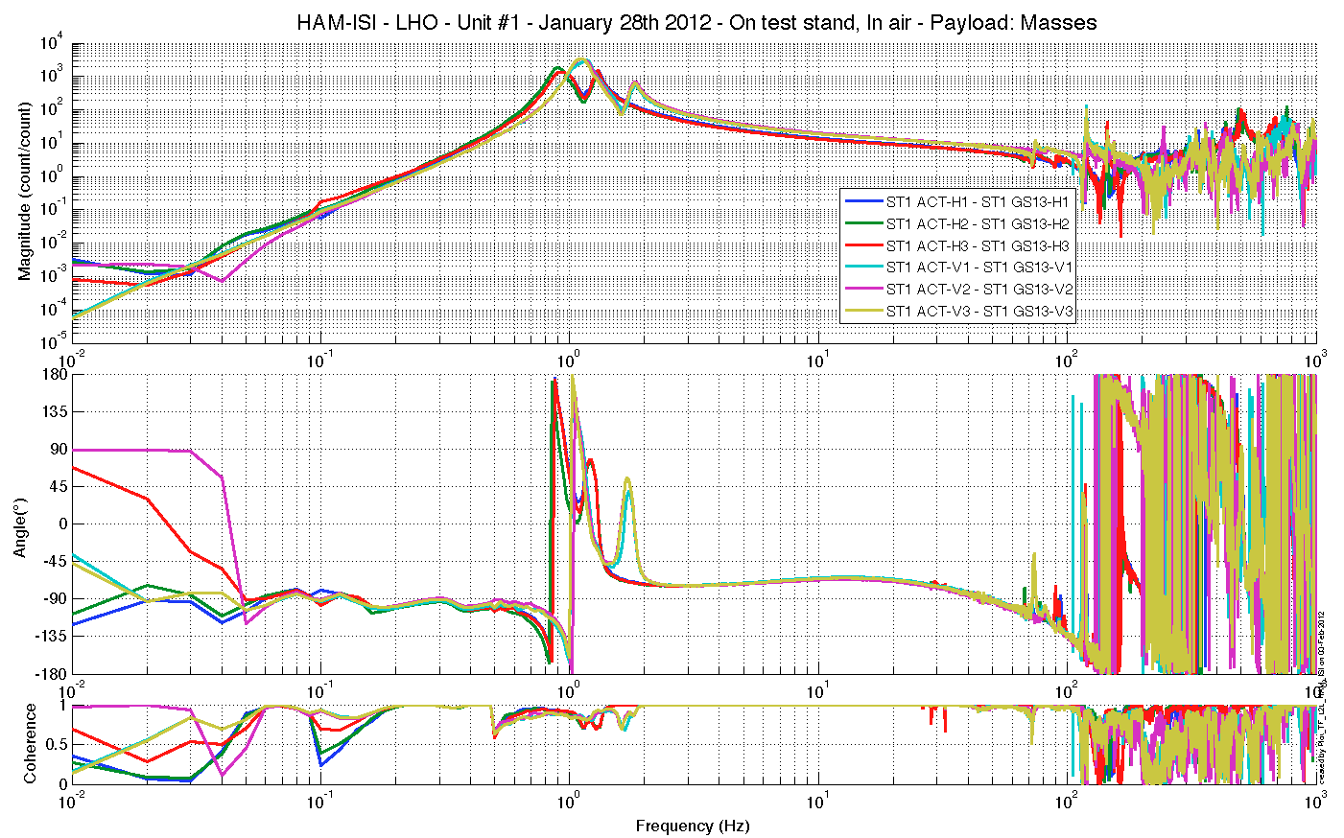
Figure - local-to-Local Measurements – Inertial sensors – GS13 Doors fully bolted/torqued

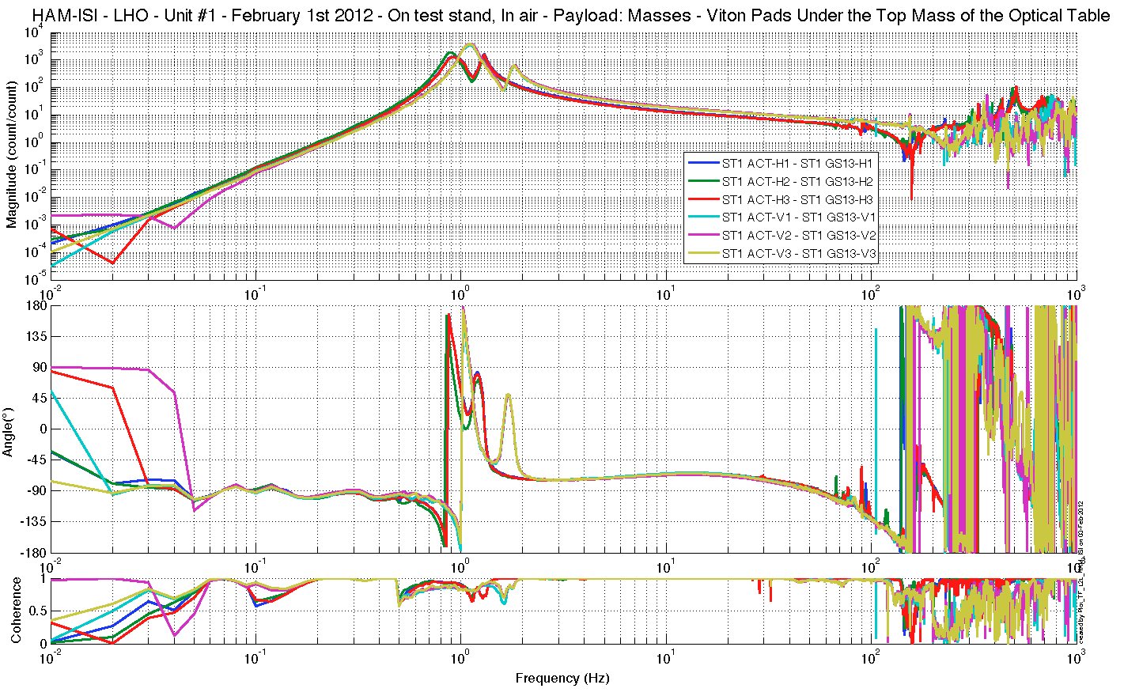
Figure - local-to-Local Measurements – Inertial sensors – Top Mass on Viton pads

It is possible that the top mass/optical table boundary conditions were not constraining enough for the top mass, allowing the it to ring and disturb measurements.

However, we wanted to make sure that the resonances were not reduced by the couple "Viton+Top mass" behaving as a mass damper.

Transfer functions were then taken on HAM-ISI Unit #1 with its top mass sitting on a kinematic mounting. The unusual high Q resonances observed above 100Hz were also gone under this configuration. This result tends to confirm that the resonances observed came from the contact between the top mass and the optical table, and not from the ISI itself.

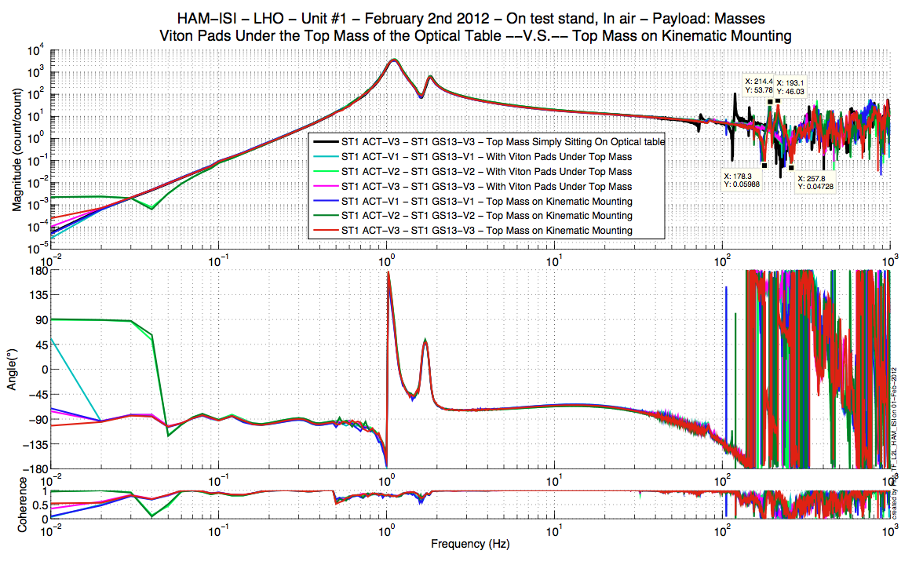
Figure – Comparison of Top Mass configurations, vertical motion.

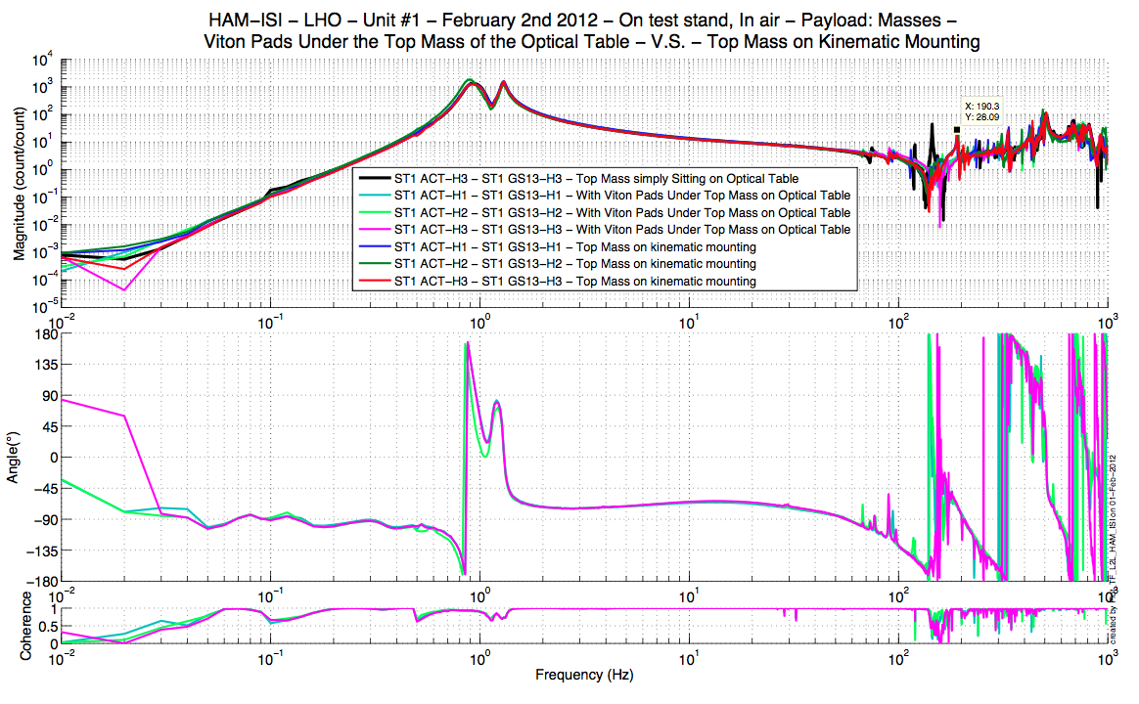 Figure – Comparison of Top Mass configurations, horizontal motion.

Resonances appeared between 170 and 260Hz when switching to kinematic mounting. They are mostly visible on vertical measurements. These resonances were not here initially, when the top mass was directly sitting on the optical table. They are caused by the changes applied on the boundary conditions of the Top Mass and shall not be associated with the ISI’s mechanical response.

Furthermore all the transfer functions presented in this report, including LZMP, were taken with the ISI top mass sitting on a kinematic mounting.

Concatenated TF data can be found under the SVN at:
SeiSVN/seismic/HAM-ISI/X1/HAMX/Data/Transfer_Functions/Simulations/Undamped/
- GS13 doors partially bolted/torqued:
  - LHO_ISI_Unit_1_TF_L2L_Raw_2012_01_13.mat
- GS13 doors fully bolted/torqued
  - LHO_ISI_Unit_1_TF_L2L_Raw_2012_01_28.mat
- Viton pads under top mass
  - LHO_ISI_Unit_1_TF_L2L_Raw_2012_02_01_With_Viton_Pads_Under_Top_Mass.mat
- Top mass on kinematic mounting
  - LHO_ISI_Unit_1_TF_L2L_Raw_2012_02_02_With_3_Washers_Under_Top_Mass.mat

Step 16.1 - Local to local measurements

FREQ. RANGE |  |  | DRIVE |  | MEAS. TIME
Min | Max | Freq. Res. (Hz) | H | V | Time for 1 Rep. (s) | Number of Reps | Time (min)
0.01 | 0.1 | 0.01 | 10500 | 10500 | 620.0 | 4 | 41.3
0.1 | 0.5 | 0.02 | 600 | 600 | 320.0 | 8 | 42.7
0.5 | 5 | 0.025 | 35 | 35 | 260.0 | 16 | 69.3
5 | 200 | 0.1 | 300 | 300 | 80.0 | 40 | 53.3
200 | 1000 | 0.2 | 135 | 135 | 50.0 | 90 | 75.0
 |  |  |  |  | Total Meas. Time(h) |  | 4.7
Table – Transfer function settings, by frequency band

Data files in SVN at:
/SeiSVN/seismic/HAM-ISI/X1/HAMX/Data/Transfer_Functions/Measurements/Undamped/
- LHO_ISI_HAM_Unit_1_Data_TF_L2L_200Hz_1000Hz_20120201-174407.mat
- LHO_ISI_HAM_Unit_1_Data_TF_L2L_5Hz_200Hz_20120201-183140.mat
- LHO_ISI_HAM_Unit_1_Data_TF_L2L_500mHz_5Hz_20120201-191513.mat
- LHO_ISI_HAM_Unit_1_Data_TF_L2L_100mHz_500mHz_20120201-202848.mat
- LHO_ISI_HAM_Unit_1_Data_TF_L2L_10mHz_100mHz_20120201-212025.mat
Data collection script files:
/SeiSVN/seismic/HAM-ISI/Common//Transfer_Function_Scripts/
- Run_TF_L2L_10mHz_100mHz.m
- Run_TF_L2L_100mHz_500mHz.m
- Run_TF_L2L_500mHz_5Hz.m
- Run_TF_L2L_5Hz_100Hz.m
- Run_TF_L2L_100Hz_1000Hz.m
Scripts files for processing and plotting in SVN at:
/SeiSVN/seismic/HAM-ISI/X1/HAMX/Scripts/Control_Scripts/
- Step_1_Plot_TF_L2L_HAM_Testing.m
Figures in SVN at:
/SeiSVN/seismic/HAM-ISI/X1/HAMX/Data/ Figures/Transfer_Functions/Measurements/Undamped/
- LHO_ISI_Unit_1_TF_L2L_Raw_from_ACT_to_CPS_2012_02_02_With_3_Washers_Under_Top_Mass.fig
- LHO_ISI_Unit_1_TF_L2L_Raw_from_ACT_to_GS13_2012_02_02_With_3_Washers_Under_Top_Mass.fig
Storage of measured transfer functions in the SVN at:
/SeiSVN/seismic/HAM-ISI/X1/HAMX/Data/Transfer_functions/ Simulations/Undamped/
- LHO_ISI_Unit_1_TF_L2L_Raw_2012_02_02_With_3_Washers_Under_Top_Mass.mat

The local-to-local transfer functions are presented below.

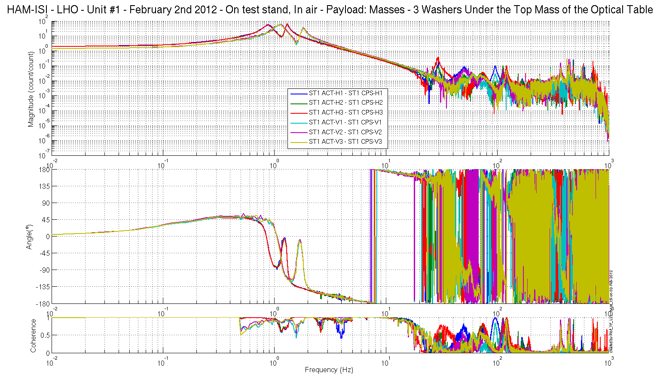
Figure - local-to-Local Measurements – Capacitive sensors

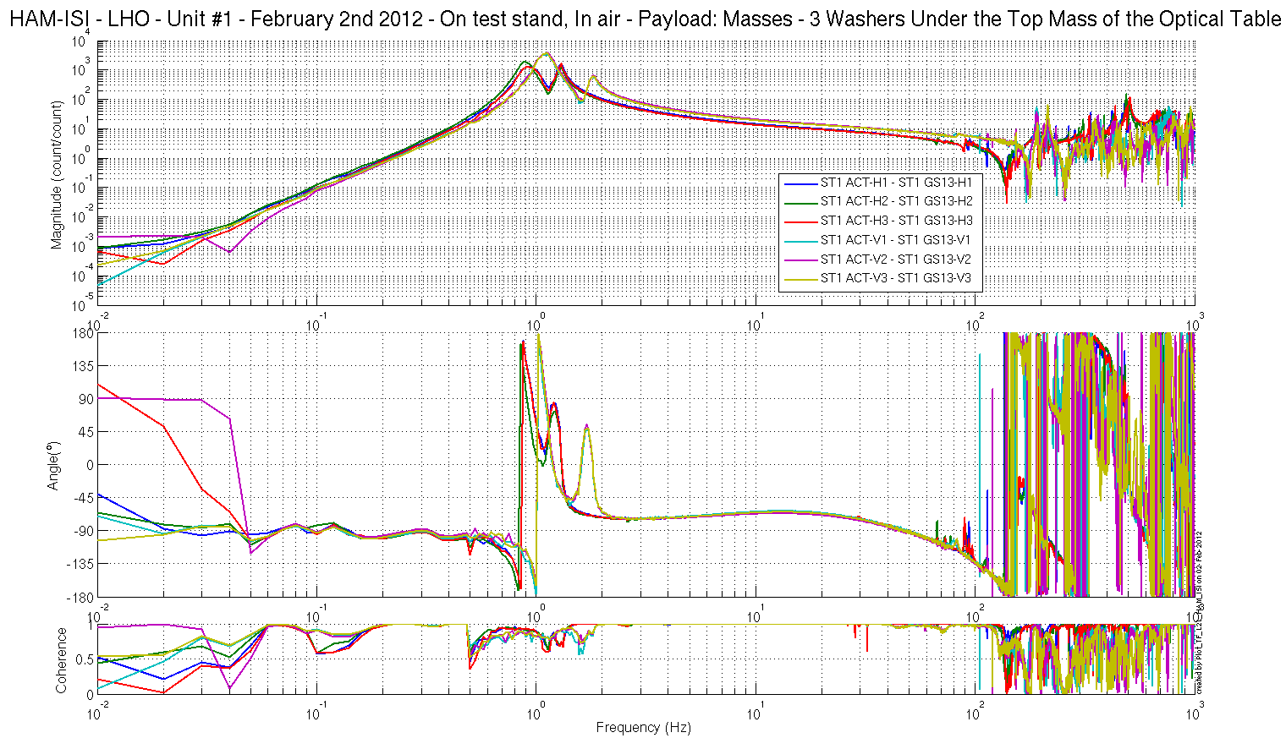
Figure - local-to-Local Measurements – Inertial sensors

Step 16.2 - Cartesian to Cartesian measurements

FREQ. RANGE |  |  | DRIVE |  |  |  |  |  | MEAS. TIME
Min | Max | Freq. Res. (Hz) | X | Y | RZ | Z | RX | RY | Time for 1 Rep. (s) | Number of Reps | Time (min)
0.01 | 0.1 | 0.01 | 7000 | 7000 | 7000 | 7000 | 7000 | 7000 | 620.0 | 10 | 103.3
0.1 | 0.5 | 0.02 | 740 | 740 | 740 | 740 | 740 | 740 | 320.0 | 30 | 160.0
0.5 | 5 | 0.025 | 30 | 30 | 35 | 45 | 12 | 12 | 260.0 | 55 | 238.3
5 | 100 | 0.1 | 680 | 680 | 450 | 1200 | 560 | 450 | 80.0 | 50 | 66.7
100 | 1000 | 0.2 | 300 | 300 | 360 | 525 | 225 | 200 | 50.0 | 150 | 125.0
 |  |  |  |  |  |  |  |  | Total Meas. time(h) |  | 11.6

Table – Transfer function settings, by frequency band

Data files in SVN at:
SeiSVN/seismic/HAM-ISI/X1/HAMX/Data/Transfer_Functions/Measurements/
Undamped/
- LHO_ISI_HAM_Unit_1_Data_TF_C2C_100Hz_1000Hz_20120202-201119.mat
- LHO_ISI_HAM_Unit_1_Data_TF_C2C_5Hz_100Hz_20120202-212852.mat
- LHO_ISI_HAM_Unit_1_Data_TF_C2C_500mHz_5Hz_20120202-222227.mat
- LHO_ISI_HAM_Unit_1_Data_TF_C2C_100mHz_500mHz_20120203-021207.mat
- LHO_ISI_HAM_Unit_1_Data_TF_C2C_10mHz_100mHz_20120203-045347.mat
Data collection script files:
/SeiSVN/seismic/HAM-ISI/Common//Transfer_Function_Scripts/
- Run_TF_C2C_10mHz_100mHz.m
- Run_TF_C2C_100mHz_500mHz.m
- Run_TF_C2C_500mHz_5Hz.m
- Run_TF_C2C_5Hz_100Hz.m
- Run_TF_C2C_100Hz_1000Hz.m
Scripts files for processing and plotting in SVN at:
/SeiSVN/seismic/HAM-ISI/X1/HAMX/Scripts/Control_Scripts/
- Step_1_Plot_TF_C2C_HAM_Testing.m
Figures in SVN at:
/SeiSVN/seismic/HAM-ISI/X1/HAMX/Data/ Figures/Transfer_Functions/Measurements/Undamped/
- LHO_ISI_Unit_1_TF_C2C_Raw_from_ACT_to_CPS_2012_02_03.fig
- LHO_ISI_Unit_1_TF_C2_Raw_from_ACT_to_GS13_2012_02_03.fig
Storage of measured transfer functions in the SVN at:
/SeiSVN/seismic/HAM-ISI/X1/HAMX/Data/Transfer_functions/ Simulations/Undamped/
- LHO_ISI_Unit_1_TF_C2C_Raw_2012_02_03.mat

The Cartesian to Cartesian transfer functions are presented below:

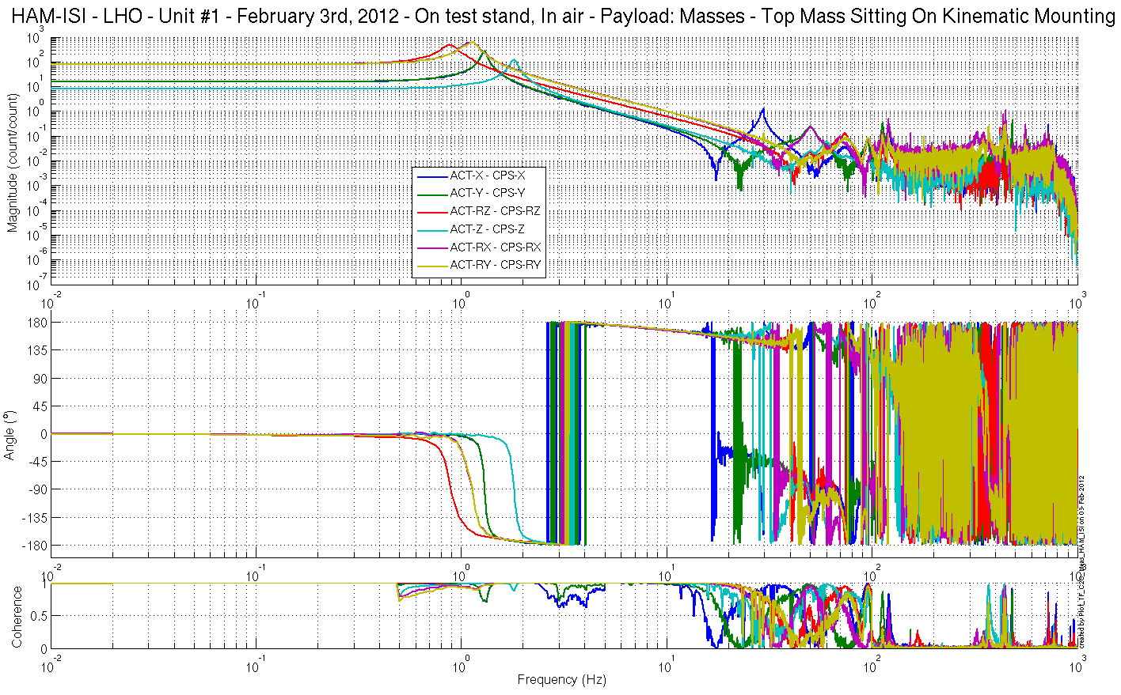
Figure – Cartesian to Cartesian Measurements – Capacitive sensors

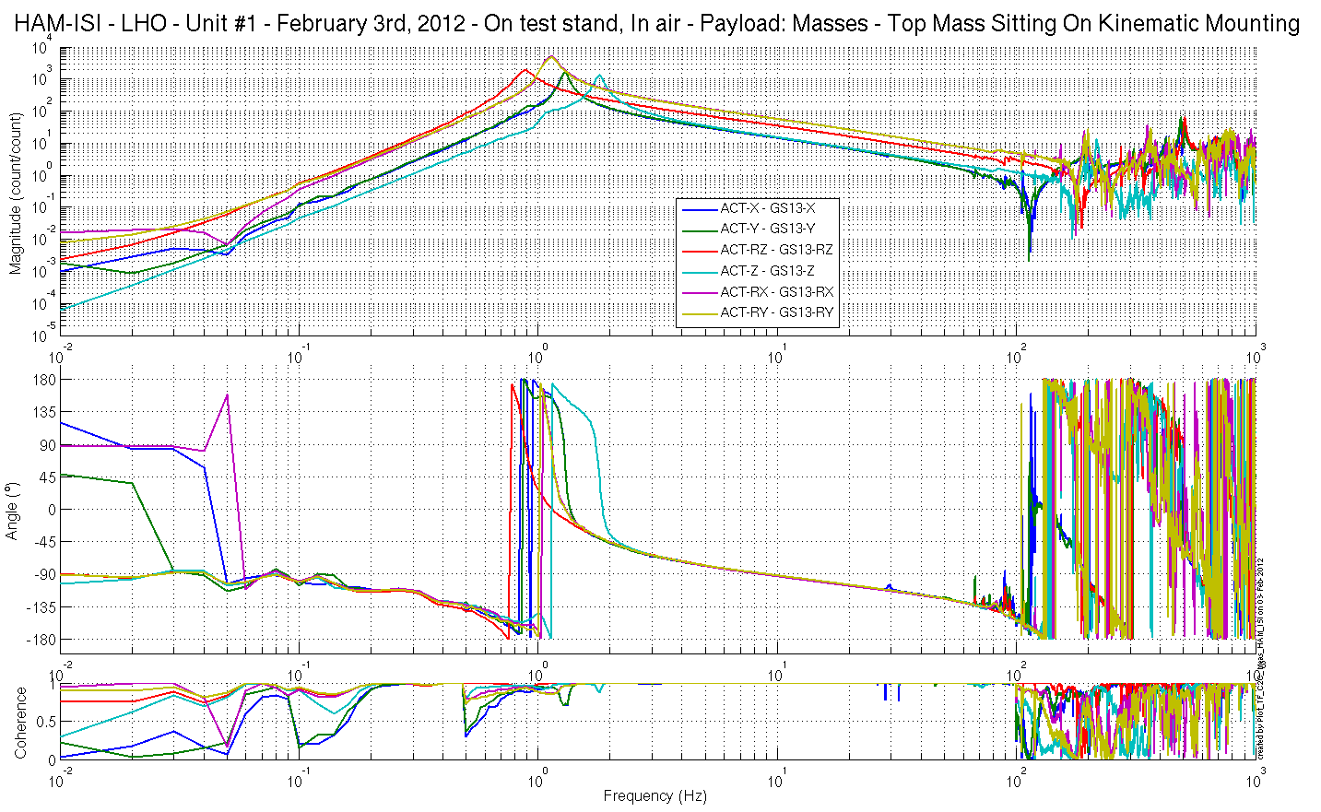
Figure – Cartesian to Cartesian Measurements – Inertial sensors

Issues/difficulties/comments regarding this test:
Phase on GS13-H3 and GS13-V2 is at 90º below 0.05Hz. This feature also appears on Unit #3 measurements (see Step 17).

Acceptance criteria:
- Local to local measurements
  - On CPS, the phase must be 0º at DC
  - On Geophones, the phase must be -90º at DC
  - Identical shape in each corner
- Cartesian to Cartesian measurements
  - On CPS, the phase must be 0º at DC
  - On Geophones, the phase must be -90º at DC
  - Identical shape X/Y and RX/RY

Test result: Passed: X Failed: .

Step 17 - Transfer function comparison with Reference

Step 17.1 - Local to local - Comparison with Reference
Scripts files for processing and plotting in SVN at:
/SeiSVN/seismic/HAM-ISI/X1/HAMX/Scripts/Control_Scripts/
- Step_1_Plot_TF_L2L_HAM_Testing.m
/SeiSVN/seismic/HAM-ISI/Common/Testing_Functions_HAM_ISI/
- Plot_TF_L2L_HAM_Testing_With_Unit_3_Reference.m

Local to local figures in SVN at:
/SeiSVN/seismic/ HAM-ISI/X1/HAMX/Data/ Figures/Transfer_Functions/Measurements/Comparisons/L2L/
- LHO_ISI_Unit_1_TF_L2L_Raw_from_ACT_H_to_GS13_H_vs_UNIT_3_2012_02_02_With_3_Washers_Under_Top_Mass.fig
- LHO_ISI_Unit_1_TF_L2L_Raw_from_ACT_H_to_CPS_H_vs_UNIT_3_2012_02_02_With_3_Washers_Under_Top_Mass.fig
- LHO_ISI_Unit_1_TF_L2L_Raw_from_ACT_V_to_GS13_V_vs_UNIT_3_2012_02_02_With_3_Washers_Under_Top_Mass.fig
- LHO_ISI_Unit_1_TF_L2L_Raw_from_ACT_V_to_CPS_V_vs_UNIT_3_2012_02_02_With_3_Washers_Under_Top_Mass.fig

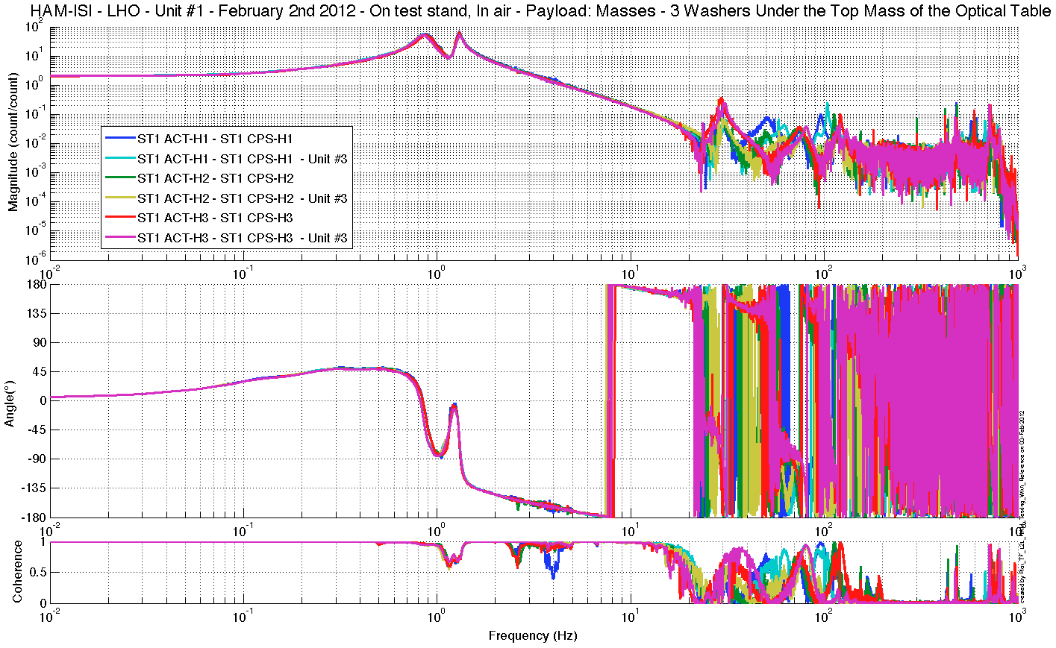
Figure – local-to-Local measurements, comparison with Unit #3 reference
Capacitive Position Sensors - Horizontal motion

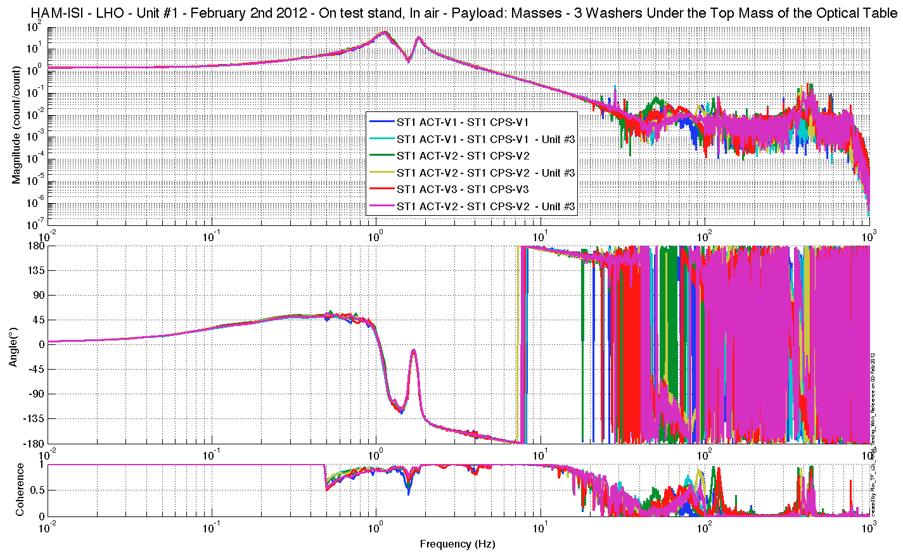
Figure – local-to-Local measurements, comparison with Unit #3 reference
Capacitive Position Sensors - Vertical motion

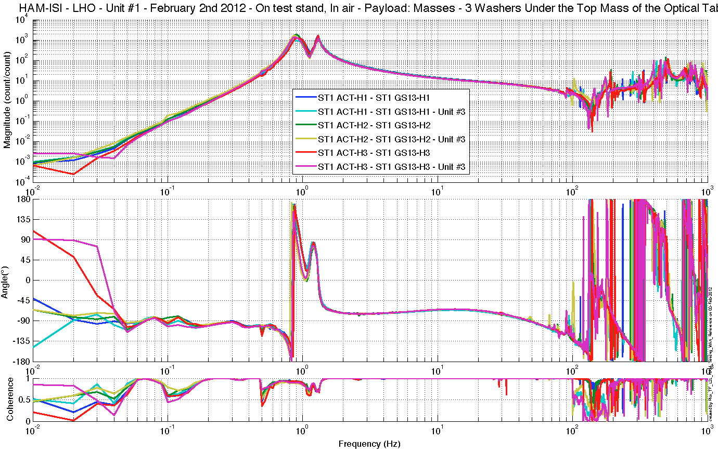
Figure – local-to-Local measurements, comparison with Unit #3 (HAM10) reference
Inertial Sensors - Horizontal motion

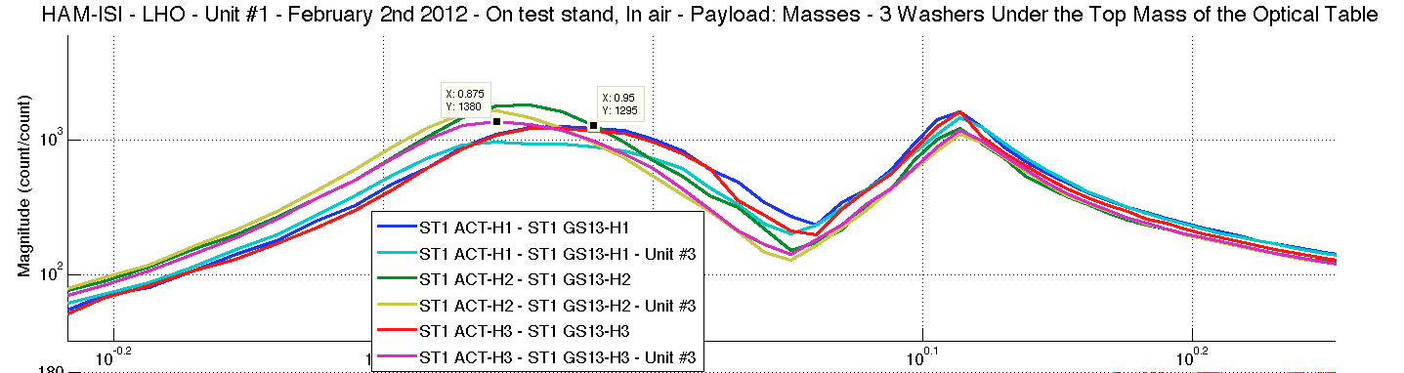
Figure – local-to-Local measurements, comparison with Unit #3 (HAM10) reference
Inertial Sensors - Horizontal motion - Zoomed

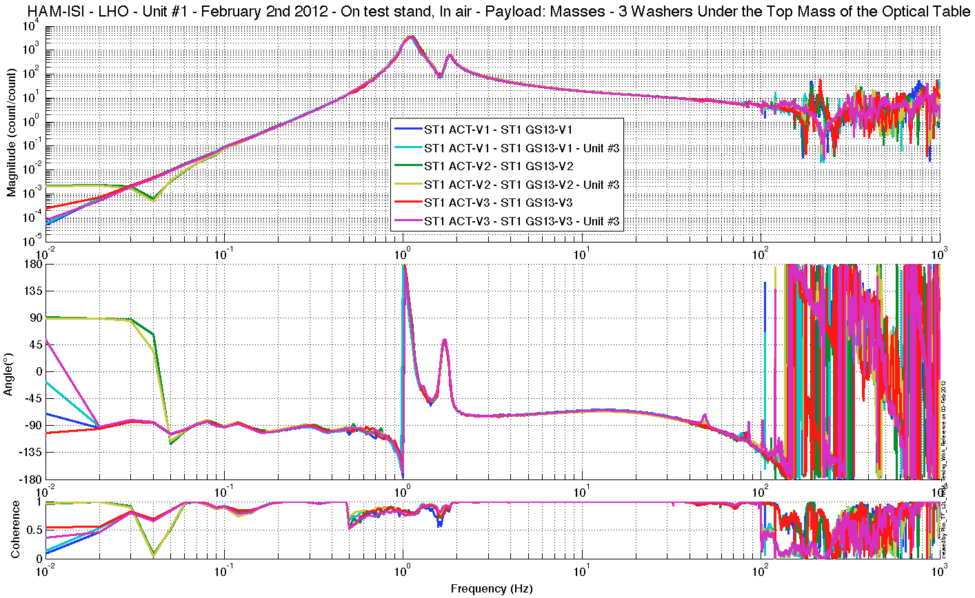
Figure – local-to-Local measurements, comparison with Unit #3 reference
Inertial Sensors - Vertical motion

Step 17.2 - Cartesian to Cartesian - Comparison with Reference

Scripts files for processing and plotting in SVN at:
/SeiSVN/seismic/HAM-ISI/X1/HAMX/Scripts/Control_Scripts/
- Step_3_Plot_TF_C2C_HAM_Testing.m
/SeiSVN/seismic/HAM-ISI/Common/Testing_Functions_HAM_ISI/
- Plot_TF_C2C_HAM_Testing_With_ Unit_3_Reference.m

Cartesian to Cartesian figures in SVN at:
/SeiSVN/seismic/ HAM-ISI/X1/HAMX/Data/ Figures/Transfer_Functions/Measurements/Comparisons/C2C/
- LHO_ISI_Unit_1_TF_C2C_Raw_from_ACT_H_to_CPS_H_vs_Unit_3_2012_02_03.fig
- LHO_ISI_Unit_1_TF_C2C_Raw_from_ACT_V_to_CPS_V_vs_Unit_3_2012_02_03.fig
- LHO_ISI_Unit_1_TF_C2C_Raw_from_ACT_H_to_GS13_H_vs_Unit_3_2012_02_03.fig
- LHO_ISI_Unit_1_TF_C2C_Raw_from_ACT_V_to_GS13_V_vs_Unit_3_2012_02_03.fig

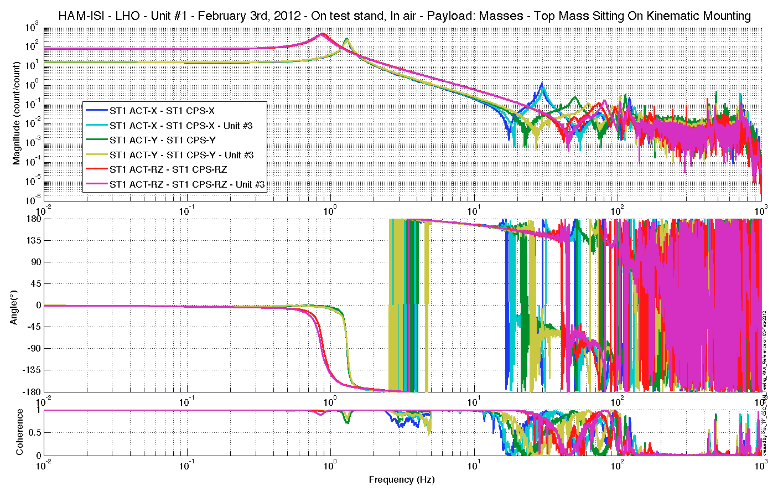
Figure – Cartesian to Cartesian measurements, comparison with Unit #3 reference
Capacitive Position Sensors - Horizontal motion

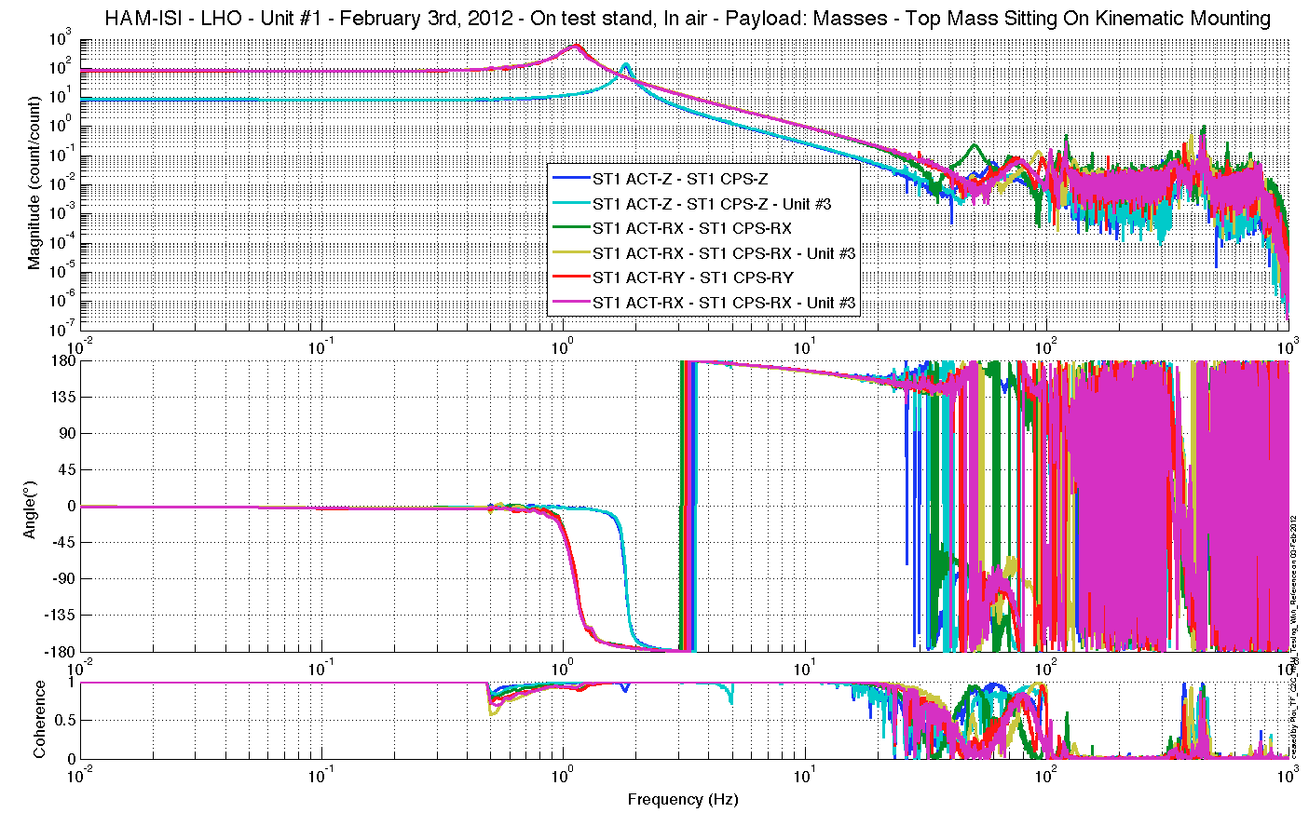
Figure – Cartesian to Cartesian measurements, comparison with Unit #3 (HAM10)reference
Capacitive Position Sensors - Vertical motion

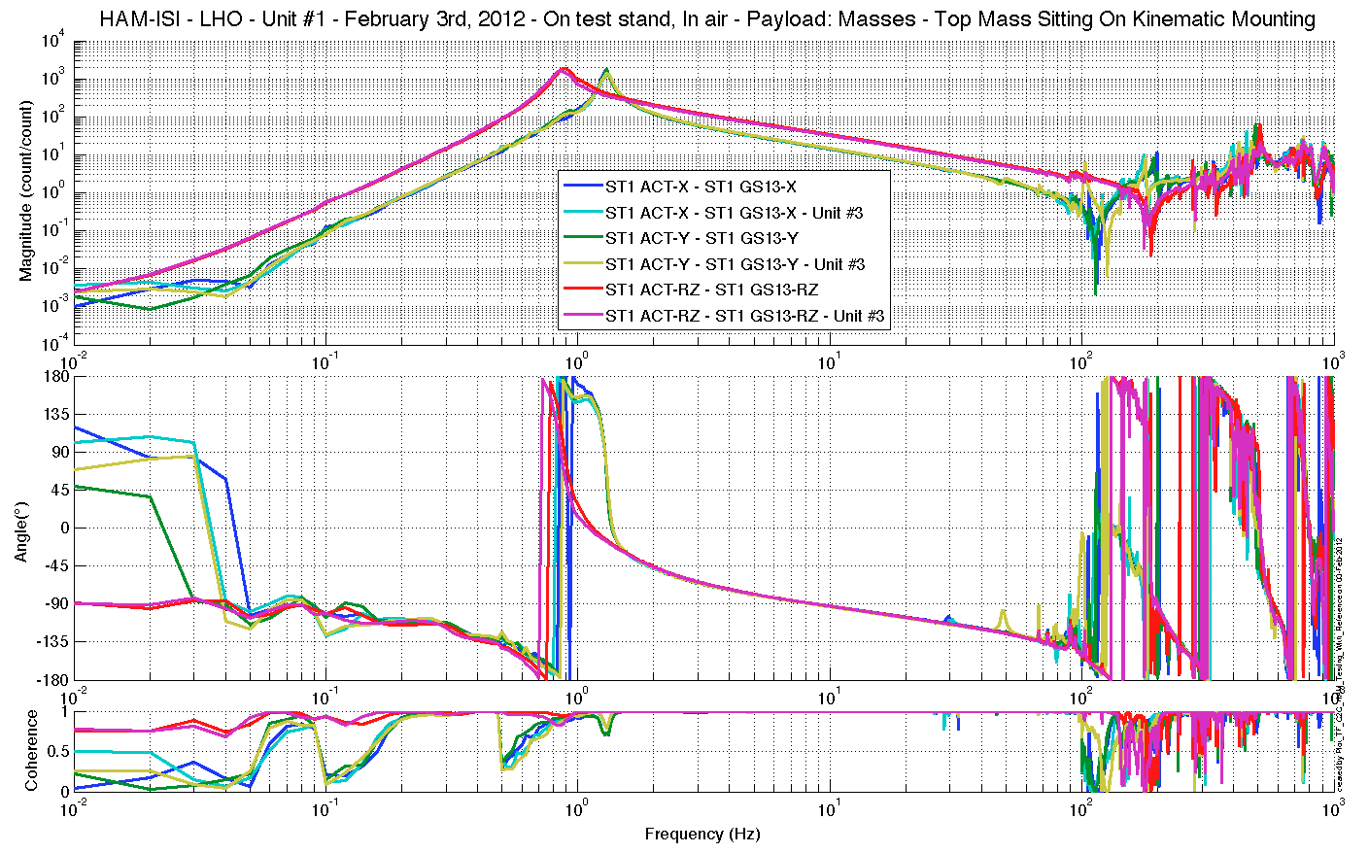
Figure – Cartesian to Cartesian measurements, comparison with Unit #3reference – Inertial Sensors
Horizontal motion

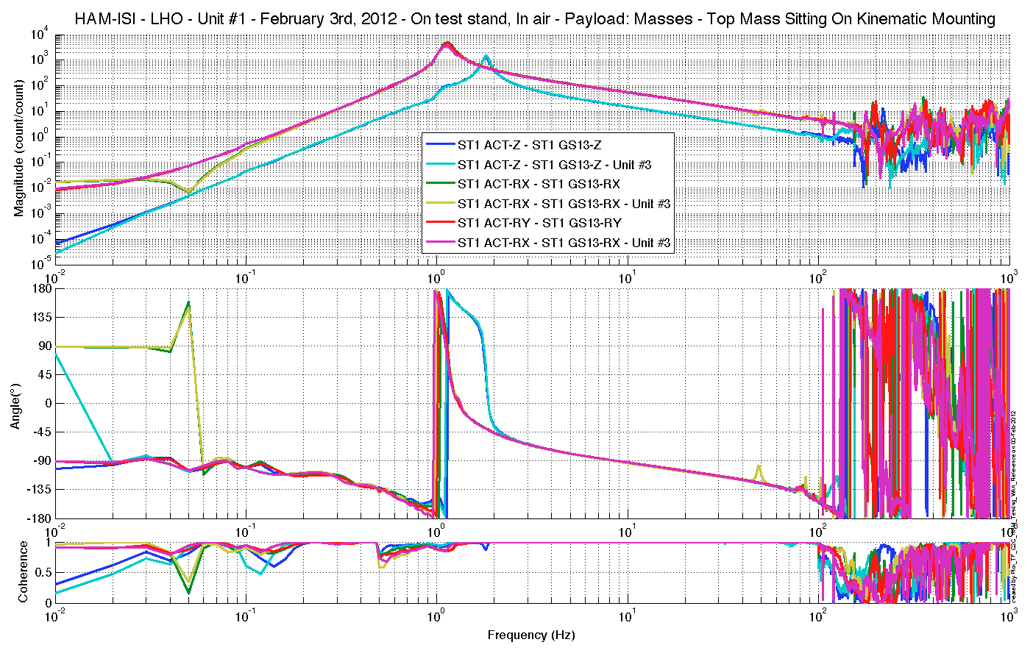
Figure – Cartesian to Cartesian measurements, comparison with Unit #3reference
Inertial Sensors - Vertical motion

“Post-processing”:
- The gain of the CPS calibration filters has been changed since Unit #3 measurements. Unit #3 Cartesian measurement has been updated (multiplied by a gain of 0.625) to be compared with the current unit.
- Unit #3 Cartesian measurement was made with the excitation channel’s (Damp) gain set to -1. A gain of -1 was re-applied to this measurement to compensate for that mistake.

Acceptance criteria:
- No difference with the reference transfer functions (SVN)
  - Phase – less than 10º - In Phase – Out of Phase
  - Damping (fit by eye with Reference transfer functions)
  - DC gain
  - Eigen frequencies shift less than 10%

Test result: Passed: X Failed: .

Step 18 - Lower Zero Moment Plane
Data collection script files:
/SeiSVN/seismic/HAM-ISI/Common/Transfer_Function_Scripts/
- Run_TF_C2C_10mHz_100mHz_LZMP_HAM_ISI.m
Data files in SVN at:
/SeiSVN/seismic/HAM-ISI/X1/HAMX/Data/Transfer_Functions/Measurements/Undamped/
- LHO_ISI_HAM_Unit_1_Data_TF_C2C_10mHz_100mHz_LZMP_20120201-222206.mat
Scripts files for processing and plotting in SVN at:
/SeiSVN/seismic/HAM-ISI/Common/Testing_Functions_HAM_ISI/
- LZMP_HAM_ISI.m

Figures in SVN at:
/SeiSVN/seismic/HAM-ISI/X1/HAMX/Data/ Figures/Transfer_Functions/Measurements/Undamped/
- LHO_ISI_UNIT_1_LZMP_20120201.fig

Issues/difficulties/comments regarding this test:
LZMP test results improved to meet requirements after centering and installing the top mass on a kinematic mounting.

X & Y offsets:
X offset (mm) | 1.322
Y offset (mm) | 0.29293
Table – Offset of the Lower Zero Moment Plane

The results from two measurements are presented on the figure below:

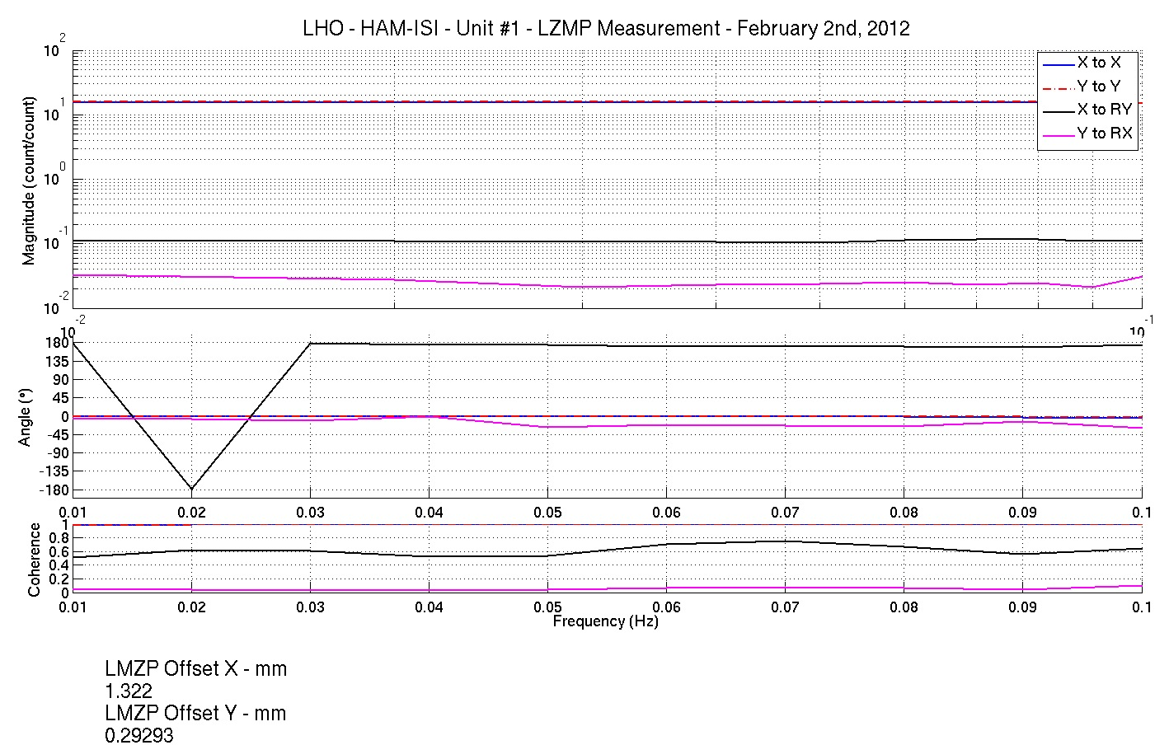
Figure - Lower Zero Moment Plane – Main and cross couplings at low frequency

Acceptance criteria:
- X offset must be less than 2 mm
- Y offset must be less than 2 mm

Test result: Passed: X Failed: .

HAM-ISI Unit #1 testing summary

HAM-ISI unit #1 was built and tested in June 2010. Faulty part replacement implied the need of disassembling and reassembling the unit. Once reassembled, the unit had to be re-tested. Tests presented here were performed between January 10th and February 13th 2012. Tests were performed in accordance with E1000309-V9 procedure.

Particularities:
Test versions of the GS13 were used. Permanent GS13 will replace them when received from LLO. L4Cs were not installed for this first phase of testing. They will not be needed if the unit is installed in HAM8 chamber, as planned.

Evolution from initial testing (prior to disassembly/reassembly):
Mass budget is now lower of 2.63kg in comparison with the mass budget measured prior to disassembly/reassembly.

Evolution from previous versions of the report:
- GS13 doors and associated brackets are fully bolted and torqued down. The mass budget is 6.949kg lower now. This is mostly due to the mass added on the unit by the blots.
- Vertical CPSs zero has been reset.
- The top mass was sitting directly on the optical table of the ISI. It is now sitting on a kinematic mounting.

Complementary inquiries:
Investigation of the effect of top mass’ boundary conditions on HAM-ISI’s TF. Top mass contact with the ISI’s optical table appeared to be critical. The comparison of Direct contact, Viton pads checker and kinematic mounting under the top mass shown that kinematic mounting should be preferred for testing.

FAILED AND WAIVED TESTS

List of tests that failed and don’t need to be redone:
Step II.5: Blade spring profile slightly out of requirements on corner 1. However, it did not appear to seriously affect the response of the ISI.
Step II.11: Locker D adjustment is borderline along the vertical axis. However, all the ranges of motions measured remain within acceptance criteria and step III.4 shows that CPSs record very little difference (lower than 0.002”) between locked and unlocked positions.
The result of this measurement along the vertical axis is also highly dependent on the balancing. The balancing was perfected between the measurement done with the dial indicators (this step) and the measurement done with the CPSs (Step III.4). The evolution observed on the related the results comes from the improvements made on the balancing.
Step III.2: Excessive standard deviation on CPSs is associated to ground motion (SEI logbook, entry #15). Sensor noise is acceptable.

Tests that failed and need to be done during phase II
Step I.2: It must be checked that final GS13 have already been tested at LLO and that their Inspection/Pod Assembly is described in document D047810.
Step II.7: The level of stage 0 is out of requirements. However, it does not prevent stage 1 to be leveled. These results are good enough for this phase of testing.
This measurement should be redone on phase 2. If needed, adjustments should be made to meet our requirements.
The level of the test stand will be checked once the ISI is pulled out.
Step III.6-7: GS13 ASDs locked, unlocked and table tilted should be performed again once final GS13s are installed.
Step III.14: Actuators appear to be linear on measurements. However, deviation from average slope is out of spec. It seems to correlate with cable+actuator resistance measurements. Make sure that linearity test results correlate with the final field cables.
This scale factor, which varies from an actuation point to another, could be corrected with an adjustment gain applied on the excitation signal sent to the actuators.

List of test that were skipped and that we will not do because they are not essential
Step III.3: Sensor gap measurement with a jig. Waved to avoid scratching targets. Distance between sensor and target has also been checked during the assembly while adjusting target distance.

Damping loops implementation and testing were skipped and need to be done during phase II:
Step III.19: During this phase of testing, we want to implement HAM6 damping loops on the unit tested, simulate their stability/efficiency, and measure their performances experimentally.
The TFs of HAM-ISI Unit #1 are very close to the TFs of HAM-ISI Unit #3, themselves close to HAM6 TFs. Hence, the damping loops developed for HAM6 should apply well on HAM-ISI Unit #1 and this test can be postponed to phase 2.
Step III.19.1: Evaluation of damping loops’ stability/performances by simulation.
Step III.19.2: Implementation of the damping loops. Measurement of powerspectra with, and without, damping. Computation of damping loops’ performances. Comparison with the theoretical results obtained during step III.19.1

