LIGO Laboratory / LIGO Scientific Collaboration

LIGO- E1000309 LIGO May 1st , 2012

aLIGO HAM-ISI
Integration Testing procedure (Phase II)
In-Chamber Testing
E1000309 – V12

Ben Abbott, Eric Allwine, Corey Gray, Celine Ramet, Michael Vargas
Vincent Lhuillier, Fabrice Matichard, Hugh Radkins, Jim Warner, Richard Mittleman, Hugo Paris

Distribution of this document:
Advanced LIGO Project

This is an internal working note
of the LIGO Laboratory

California Institute of Technology  LIGO Project – MS 18-34  1200 E. California Blvd.  Pasadena, CA 91125  Phone (626) 395-2129  Fax (626) 304-9834  E-mail: info@ligo.caltech.edu | Massachusetts Institute of Technology  LIGO Project – NW22-295  185 Albany St  Cambridge, MA 02139  Phone (617) 253-4824  Fax (617) 253-7014  E-mail: info@ligo.mit.edu
LIGO Hanford Observatory  P.O. Box 1970  Mail Stop S9-02  Richland WA 99352  Phone 509-372-8106  Fax 509-372-8137 | LIGO Livingston Observatory  P.O. Box 940  Livingston, LA 70754  Phone 225-686-3100  Fax 225-686-7189

Table of contents:

Introduction 4
I. Pre-Assembly Testing 6
▪ Step 1: Position Sensors 6
▪ Step 2: GS13 - E1000058 – E1200081 – Testing prior to shipping 7
▪ Step 3: L4C - E1000058 – E1200081 7
▪ Step 4: Actuators – E1000136 8
▪ Step 5 – Seismometer inspection after shipping 9
II. Tests to be performed during assembly 10
▪ Step 1 - Parts Inventory (E1000052) 10
▪ Step 2 - Check torques on all bolts 11
▪ Step 3 - Check gaps under Support Posts 11
▪ Step 4 – Pitchfork/Boxwork flatness before Optical Table install 12
▪ Step 5 - Blade spring profile 13
▪ Step 6 - Gap checks on actuators-after installation on Stage 1 14
▪ Step 7 - Check level of Stage 0 15
▪ Step 8 - Check level of Stage 1 Optical Table 17
▪ Step 9 - Mass budget 18
▪ Step 10 - Shim thickness 20
▪ Step 11 - Lockers adjustment 21
III. Tests to be performed after assembly 23
▪ Step 0.1 - Testing folder set up 23
▪ Step 0.2 - MEDM set-up for testing 23
▪ Step 1 - Electronics Inventory 25
▪ Step 2 - Set up sensors gap 26
▪ Step 3 - Measure the gaps on the CPSs 27
▪ Step 4 - Check Sensor gaps after the platform release 28
▪ Step 5 – Performance of the limiter 29
▪ Step 5.1 - Test Nº1 - Push “in the general coordinates” 29
▪ Step 5.2 - Test Nº2 – Push “locally” 30
▪ Step 6 - Position Sensors unlocked/locked Power Spectrum 32
▪ Step 7 - GS13 power spectrum -tabled tilted 34
▪ Step 8- GS13 pressure readout 36
▪ Step 9 - Coil Driver, cabling and resistance check 37
▪ Step 10 - Actuators Sign and range of motion (Local drive) 39
▪ Step 11 - Vertical Sensor Calibration 40
▪ Step 12 - Vertical Spring Constant 42
▪ Step 13 - Static Testing (Tests in the local basis) 43
▪ Step 14 - Linearity test 45
▪ Step 15 - Cartesian Basis Static Testing 46
▪ Step 16- Transfer function Measurement 48
▪ Step 16.1 - Local to local TF measurement 51
▪ Step 16.2 – GS13 Response Extraction 53
▪ Step 16.3 – GS13 Response Fitting 54
▪ Step 16.4 –Symmetrization Filters 55
▪ Step 16.5 - Cartesian to Cartesian TF Computation 56
▪ Step 17 - Transfer function comparison with Reference 57
▪ Step 17.1 - Local to local - Comparison with Reference 57
▪ Step 17.2 - Cartesian to Cartesian - Comparison with Reference 58
▪ Step 18 - Lower Zero Moment Plane 59
▪ Step 19 - Damping loops 61
▪ Step 19.1 – Simulation of damping performance - TF 61
▪ Step 19.2 – Experimental evaluation of damping performance - Spectra 63
Appendix A: Dial indicators location 65
Appendix B: Sensor calibration 67
Appendix C: SVN arborescence 68
Appendix D: Matrices 70
Appendix E: CPS pre-bake testing procedure 71
Appendix F: Investigation of peaks in the CPS ASDs 73

Introduction

The HAM-ISI testing will be made in three phases:
1) HAM-ISI, Pre-integration Testing, Phase I: post-assembly, before storage
2) HAM-ISI, Pre-integration Testing, Phase II: Final tests done after storage and before insertion
3) HAM-ISI, Integration Phase Testing: Procedure and results related to the commissioning in the chamber.

This document describes the test to be done on the HAM-ISI Pre-integration Testing, Phase I. All the units have to be tested per this procedure prior storage. Due to the several procedure releases, each test report must mention the procedure version used during testing.

Tests reports and results for each unit, including the data (one test report per HAM-ISI):
- E1000310, aLIGO HAM-ISI, Pre-integration Test Report, Phase I, LHO Unit #1.
- E1000311, aLIGO HAM-ISI, Pre-integration Test Report, Phase I, LHO Unit #2.
- E1000312, aLIGO HAM-ISI, Pre-integration Test Report, Phase I, LHO Unit #3.
- E1000313, aLIGO HAM-ISI, Pre-integration Test Report, Phase I, LHO Unit #4.
- E1000314, aLIGO HAM-ISI, Pre-integration Test Report, Phase I, LHO Unit #5.
- E1000323, aLIGO HAM-ISI, Pre-integration Test Report, Phase I, LHO Unit #6.
- E1000324, aLIGO HAM-ISI, Pre-integration Test Report, Phase I, LHO Unit #7.
- E1000325, aLIGO HAM-ISI, Pre-integration Test Report, Phase I, LLO Unit #1.
- E1000326, aLIGO HAM-ISI, Pre-integration Test Report, Phase I, LLO Unit #2.
- E1000327, aLIGO HAM-ISI, Pre-integration Test Report, Phase I, LLO Unit #3.
- E1000328, aLIGO HAM-ISI, Pre-integration Test Report, Phase I, LLO Unit #4.
- E1000329, aLIGO HAM-ISI, Pre-integration Test Report, Phase I, LLO Unit #5.
- E1000330, aLIGO HAM-ISI, Pre-integration Test Report, Phase I, LLO Unit #6.
- E1000331, aLIGO HAM-ISI, Pre-integration Test Report, Phase I, LLO Unit #7.

SVN
- Excel spreadsheet (.xls)
- SVN Masses distribution scheme (.ppt)

DCC documents
- E1000300 HAM-ISI LLO test stand software check
- E1000052 aLIGO HAM-ISI Assembly Serial Number Registration
- T1100261 aLIGO SEI Testing, HAM-ISI, Weight Recording Example
- E1100427 aLIGO SEI Testing, HAM-ISI, Results Compilations

Useful information such as sign conventions or calibration numbers are highlighted in green.

This is a living document. If you notice that modifications or corrections are needed, they should be carried on, provided that their validity is checked.

SVN architecture for HAM-ISI testing:

Testing functions are all called from a single Matlab® script (Master_TEST_xxx.m) that we call the master script. These testing functions are generic. They are stored in the common folders of HAM-ISI SVN. More details can be found in the DCC document #E1101166.

Testing functions automatically store results in the local version of the SVN. Consequently, the SVN structure must not be changed, and measurement data must be committed on the SVN at the end of testing.

In the SVN, units are called by their assembly order, not by their destination chamber.
SVN Paths are given in green and Matlab® scripts/functions are given in blue. Here, they are given for the LHO HAM-ISI Unit #1. Fields that need to be updated (site, unit, test) are colored in grey.

Main Testing Script in the svn at:
/SeiSVN/seismic/HAM-ISI/X1/Unit_1/Scripts/Data_Collection/
- Master_TEST_X1_ISI_Unit_1.m
Testing funtions in the SVN at:
/SeiSVN/seismic/HAM-ISI/Common/Testing_Functions_HAM_ISI/

Main SVN Rule:
Two types of files (functions/scripts/routines) are used for testing.
- Common files:
They are shared for all units and stored under the common folder of the SVN.
- Specific files:
They are stored in the folder of the Unit they are related to.

Specific calls Common. Specific should be modified when contents needs to be updated. Common should only be modified after approval of the SEI testing and commissioning lead.

Pre-Assembly Testing

Step 1: Position Sensors
We want to make sure that all CPS sensors have been tested prior to installation. Testing procedure is described in appendix E: pre-bake CPS testing.

Procedure to follow for this test:
- Pre-installation test data can be found in the DCC document #E1000257-v2
- Fill out the table below
- Paste the pre-bake powerspectra and make sure they meet the requirements

S/N sensor | S/N board | ADE Gap Standoff(mm) | Location on the Jig | Gap Standoff on Jig(mm/in) | Voltage before zeroing | Voltage after zeroing. Prebake | Voltage after zeroing. Post bake
Table – Zeroing the offset of capacitive position sensors
The back panel reads 0.508V/0.001"

Acceptance Criteria:
- Power spectrum magnitudes must be lower than:
9.e-10 m/√Hz at 0.1Hz
6.e-10 m/√Hz at 1Hz
The tests report must contain:
- The table “Zeroing the offset of capacitive position sensors”
- Capacitive position sensors Spectra
- Issues/difficulties/comments regarding this test
- Recall of the acceptance criteria
- Test results (Passed: Failed: ).”

Note:
Investigation proved that the peaks seen on the ASD of the CPS, when mounted on the locked HAM-ISI, are due to ground motion. Please refer to appendix F for more details.

Step 2: GS13 - E1000058 – E1200081 – Testing prior to shipping
During this test, we want to make sure that the GS13s have already been tested at LLO and that the test data has been made available on the SVN.

All the data related to GS-13 post podding testing can be found in the SVN at: SeismicSVN\seismic\Common\Data\aLIGO_GS13_TestData\PostMod_TestResults_PDFs\

Procedure to follow for this test
- E1000058 spreadsheet provides the status of each single GS-13 at LLO site during aLIGO HAM assembly. Make sure the pods that are going to be installed have already been tested
- Paste test results in the report
- Report Installation location in E1200081

Acceptance Criteria:
- GS13 should have been already tested. GS-13 Inspection/Pod Assembly (D047810). Checklist is defined in F090070-v6. Testing procedure is defined in T0900342
- Installation location was reported in E1200081
The tests report must contain:
- Test results (Passed: Failed: ).””

Step 3: L4C - E1000058 – E1200081
This step is only for the units with feedforward L4Cs: HAM 4, HAM 5, HAM 10 and HAM 11. We want to make sure that The L4Cs have already been tested at LLO and that the test data has been made available on the SVN.

Procedure to follow for this test
- E1200081 spreadsheet provides the status of each single L4C at LLO. Make sure the pods that are going to be installed have already been tested
- Paste test results in the report
- Report Installation location in E1200081

All the data related to L4C post podding testing can be found in the SVN at :
svn/seismic/Common/Data/aLIGO_L4C_TestData/TestResults_PDFs/

Acceptance Criteria:
- L4C should have been already tested. L4C Inspection/Pod Assembly (D047820)
- Installation location was reported in E1200081
The tests report must contain:
- Test results (Passed: Failed: ).”

Step 4: Actuators – E1000136
In this step we want to make sure that the actuators have already been tested and that the test data has been made available.

Procedure to follow for this test:
- Actuator data can be found at: T0900564.
- Make sure the actuators that are going to be installed are already tested
- Paste test results in the table below

Actuator Serial #: -----------  Operator Name: -----------  Date: ------------ Time: -----------  Actuator Coil Resistance: --- Ohms, PASS/FAIL Ambient Temperature: --- F  Hi Pot Test Results: ----- MOhms, PASS/FAIL  X Travel Limit (inches): -------  Y Travel Limit (inches): -------  Z Travel Limit (inches): ------- | Actuator Serial #: -----------  Operator Name: -----------  Date: ------------ Time: -----------  Actuator Coil Resistance: --- Ohms, PASS/FAIL Ambient Temperature: --- F  Hi Pot Test Results: ----- MOhms, PASS/FAIL  X Travel Limit (inches): -------  Y Travel Limit (inches): -------  Z Travel Limit (inches): -------
Actuator Serial #: -----------  Operator Name: -----------  Date: ------------ Time: -----------  Actuator Coil Resistance: --- Ohms, PASS/FAIL Ambient Temperature: --- F  Hi Pot Test Results: ----- MOhms, PASS/FAIL  X Travel Limit (inches): -------  Y Travel Limit (inches): -------  Z Travel Limit (inches): ------- | Actuator Serial #: -----------  Operator Name: -----------  Date: ------------ Time: -----------  Actuator Coil Resistance: --- Ohms, PASS/FAIL Ambient Temperature: --- F  Hi Pot Test Results: ----- MOhms, PASS/FAIL  X Travel Limit (inches): -------  Y Travel Limit (inches): -------  Z Travel Limit (inches): -------
Actuator Serial #: -----------  Operator Name: -----------  Date: ------------ Time: -----------  Actuator Coil Resistance: --- Ohms, PASS/FAIL Ambient Temperature: --- F  Hi Pot Test Results: ----- MOhms, PASS/FAIL  X Travel Limit (inches): -------  Y Travel Limit (inches): -------  Z Travel Limit (inches): ------- | Actuator Serial #: -----------  Operator Name: -----------  Date: ------------ Time: -----------  Actuator Coil Resistance: --- Ohms, PASS/FAIL Ambient Temperature: --- F  Hi Pot Test Results: ----- MOhms, PASS/FAIL  X Travel Limit (inches): -------  Y Travel Limit (inches): -------  Z Travel Limit (inches): -------
Figure – Example of the Actuator pre-assebly test report table

Actuator inventory is made at Section II – Step 1.

Acceptance Criteria:
- Actuators were previously tested and results are reported in T900564.
The tests report must contain:
- Test results (Passed: Failed: ).”

Step 5 – Seismometer inspection after shipping
Seismometers are checked after reception at LHO by measuring an ASDs and by recording the pressure that is read by the IOP model (raw). In the case of the L4C and the GS13, pressure measurements have to be done using the horizontal instruments.

Procedure to follow for this test:
- Open a DTT window
- Run power spectra for all geophones
- Make sure that the power spectra are the same between seismometers of the same type, for each direction
- Open an MEDM screen and make sure the pressure readout is within specs (see Step. 8) for the horizontal seismometers
- Save test results under:
/SeiSVN/seismic/Common/Data/aLIGO_GS13_TestData_LHO/

Note:
As an alternative to DTT, the Matlab® script called TEST_Seismometer_After_Reception.m can be used for this test.

The Matlab® script used for the measurements is located in the SVN at: /seismic/Common/MatlabTools/Seismometer_Test/TEST_Seismometer_After_Reception.m

Reference spectra are located in the SVN at:
/SeiSVN/seismic/HAM-ISI/Common/Testing_Reference_Results_HAM_ISI/
Reference_Spectra/aLIGO_Reference_Spectra_HAM_ISI.mat

Results are automatically saved in the SVN at:
/SeiSVN/seisvn/seismic/Common/Data/aLIGO_GS13_TestData_LHO/
aLIGO_GS13_POD_POD#_PODdirection_LHO_Reception_YYYY_MM_DD.mat

Acceptance Criteria:
- Geophones must have been tested
- Results must be available in the SVN at:
/SeiSVN/seismic/Common/Data/aLIGO_GS13_TestData_LHO/
The tests report must contain:
- ASD figures
- Test results (Passed: Failed: ).”

Tests to be performed during assembly

Step 1 - Parts Inventory (E1000052)
Procedure to follow for this test:
- Check the S/N of the parts mentioned in the tables below
- Fill out the tables below

DCC/Vendor number | Part name | Configuration | S/N | S/N | S/N
D071001 | Stage 0 base
D071051 | Stage 1 base
D071050 | Optical table
D071002 | Spring Post
D071100 | Spring
D071102 | Flexure
ADE | Position sensor | Horizontal
 |  | Vertical
D047812 | GS-13 pod | Horizontal
 |  | Vertical
D047823 | L4C pod | Horizontal
 |  | Vertical
D0902749 | Actuator | Horizontal
 |  | Vertical
Table – Parts inventory

Cable Connects |  | Cable S/N
Part Name | Configuration | Corner 1 | Corner 2 | Corner 3
GS13 | Horizontal
GS13 | Vertical
L4C | Horizontal
L4C | Vertical
Actuator | Horizontal
 | Vertical
Table – Cables inventory

Step 2 - Check torques on all bolts
Procedure to follow for this test:
Once bolts and bolt patterns were torqued, check the torque by reapplying the torque wrench to the bolts. For bolt patterns, torque the whole group to final spec, then start the pattern over again. The wrench should trip, and then the bolt should start moving.

Acceptance Criteria:
- All bolts should trip the wrench, and start moving immediately after. If any bolts in a pattern move before torque is reached, recheck after all bolts are brought to spec.
The tests report must contain:
- Test result (Passed: Failed: ).””

Step 3 - Check gaps under Support Posts
Procedure to follow for this test:
- Try inserting a 0.001 inch shim between the Support Post, Gussets and Stage 0 along the edges highlighted in red (picture below)
- If a shim can be inserted:
- loosen all constraining bolts
- retighten iteratively from the center of the part to its edges
- Retest.

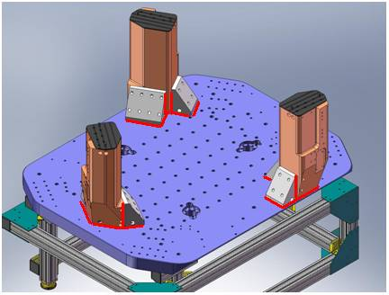
Figure - Showing edges that need checked on support posts and gussets

Acceptance Criteria:
- A 0.001 inch shim cannot be passed freely through any connection to Stage 0 or between post and gussets.
The tests report must contain:
- Test result (Passed: Failed: ).””

Step 4 – Pitchfork/Boxwork flatness before Optical Table install
Procedure to follow for this test:
- Lay a straight-edge on edge across top edge of each subassembly where wall pieces intersect
- Try to insert shims between parts

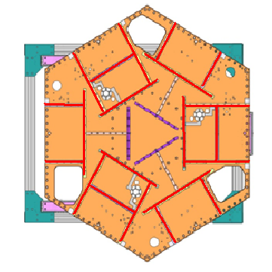
Figure - Showings that need check on Boxworks and Pitchforks

Acceptance Criteria:
- Shim inserted won’t pass between parts.
The tests report must contain:
- Test result (Passed: Failed: ).””

Step 5 - Blade spring profile

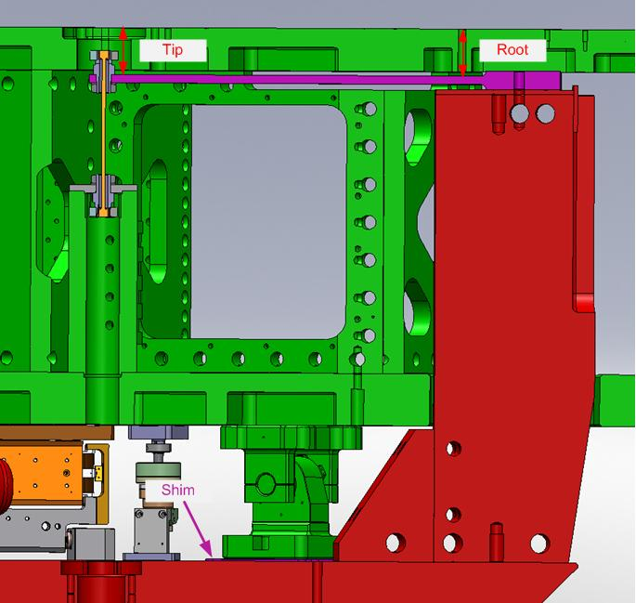
figure – Blade Spring Profile Measurement

Procedure to follow for this test:
- Get a depth gauge or plunge micrometer
- Measure the level of the tip of each blade
- Measure the level of the root of each blade
- The blalde spring profile is the difference between these two values
- Fill out the table below

Blade # | Base (") | Tip(") | Flatness (mils)
1
2
3
Table – Blades profile

Notes:
- The weight of the plunge micrometer can lower Stage-1 by up to 2mils. Such situation would impact the root level measurement causing the flatness to be over-evaluated by up to 2mils.
- The adjustments in blade profile are performed by changing the shims under the lockers. These adjustments only impact the root level.

Acceptance Criteria:
- Blades must be flat within 0.015" inches.
The tests report must contain:
- The table “Blades’ profile”
- Issues/difficulties/comments regarding this test
- Test result (Passed: Failed: ).””

Step 6 - Gap checks on actuators-after installation on Stage 1

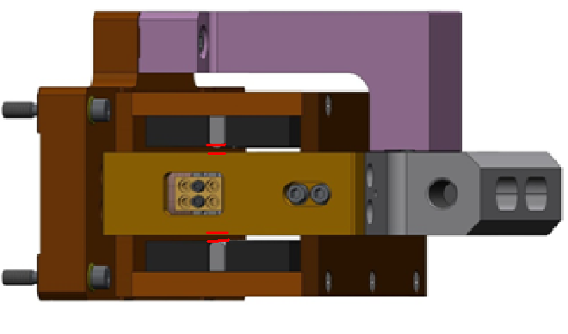
Figure - Gaps that need to be checked on actuators

Procedure to follow for this test:
- Actuators must be installed on the ISI
- Horizontal actuator doors must be opened
- Lock The ISI
- Use sized Teflon shims to measure gaps between stops and coils. Start with 0.080” and stack shims until they barely fit between the coils and stops
- Measure, and record, the thickness of the stack of shims (figure below)
- Repeat this process for both sides of each actuators

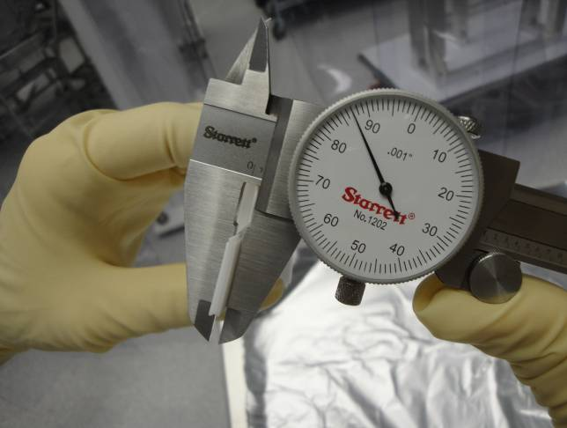
Figure - Stack of Teflon shims being measured

Acceptance Criteria
- Gaps must be within 0.010” of design value (0.080”)
The tests report must contain:
- Test result (Passed: Failed: ).””

Step 7 - Check level of Stage 0
Procedure to follow for this test:
- Get an optical level and a rule graduated in 1/100”.
- Set the rule on a monument (See figure below).
- Choose two locations for your optical level. These two viewpoints should allow you to cover the 8 points that will be recorded on stage 0 (see below, stage-0 level figure).
- Make sure that at least 3 points can be reached from both viewpoints
- Set up the Optical Level at its first location. Make sure you have a good visibility of Stage 0.
- Level the instrument and make sure it is stable
- Set the rule at the first measurement point.
- Aim the optical level towards the rule.
- Adjust the height of the optical level so the level line is right in the middle of a graduation: This is your 0.
- Move the rule to the next measurement point and record the difference with the previous measurement point.
- Do this for all 8 measurement points.
- Switch to the other measurement location, and redo steps 3 to 9. The point of zeroing must be the same.
- Combine the results taken from both measurement locations and paste them in the stage-0 level figure (see below)
- The level of stage 0 (maximum angle) is computed from the most difference of height recorded between two opposite points on the table.

Maximum angle = [biggest_difference_opposite_points] / [distance_opposite_points]

Figure – 1/100” rule on monument

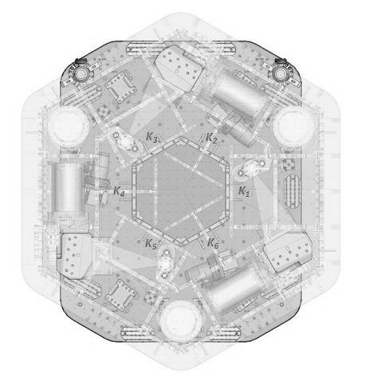
CORNER 1

Figure – Stage 0 Level

Note: If possible, two people should do this measurement. Their measurements should be close within 0.001”.

Acceptance Criteria
- The maximum angle of the table with the horizontal mustn’t exceed ~100µrad
The tests report must contain:
- A schematic showing the measurements
- Tilt computation
- Issues/difficulties/comments regarding this test
- Test result (Passed: Failed: ).

Step 8 - Check level of Stage 1 Optical Table

Procedure to follow for this test:
Same procedure as for Stage 0, but on stage 1, with the 6 measurement points displayed in the figure below.

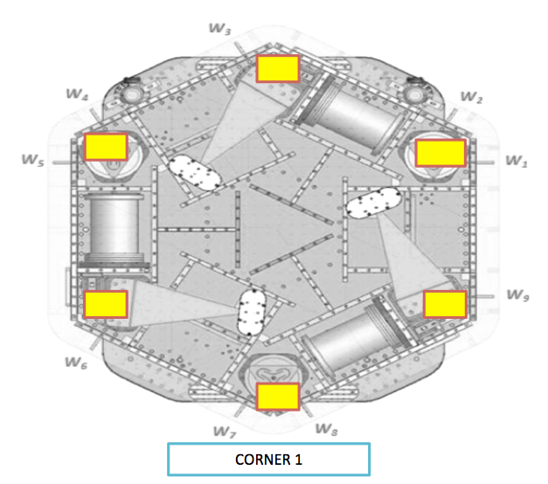
Figure – Stage 1 Level

Acceptance Criteria
- The maximum angle of the table with the horizontal mustn’t exceed ~100µrad
The tests report must contain:
- A schematic showing the measurements
- Tilt computation
- Issues/difficulties/comments regarding this test
- Test result (Passed: Failed: ).

Step 9 - Mass budget
During this phase of testing, we make sure that the ISI can take enough payload for the optics to be installed later on.

Procedure to follow for this test:
- The ISI must be balanced
- Record the amount of mass used for each location (Optical table, walls, keel)
- Report results in the tables below
- Add a picture of the optic table to the report
- If the mass distribution is complex, draw a map of it

 | 00 | 01 | 02 | 03 | 04 | 05 | 06
 | 0.6 | 1.1 | 2.2 | 4.5 | 7.9 | 15.6 | 27.2 | lbs | kgs
W9
W1
W2
W3
W4
W5
W6
W7
W8
Side Masses Total
Table – Wall masses distribution

 | 00 | 01 | 02 | 03 | 04 | 05 | 06
 | 0.6 | 1.1 | 2.2 | 4.5 | 7.9 | 15.6 | 27.2 | lbs | kgs
K1
K2
K3
K4
K5
K6
Keel Masses Total
Table – Keel masses distribution

Mass (kg)
T1
T2
T3
T4
Total
Table – Optic table masses distribution (T is for top)

 | Side | Keel | Top | Total
Weigh (kg)
Table – Mass budget Sum Up

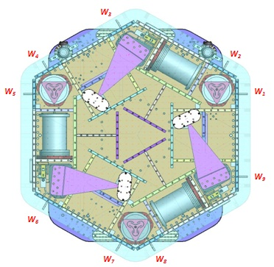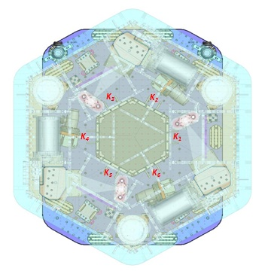
Figure – Keel Masses and Wall masses location

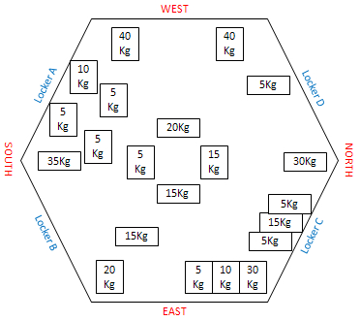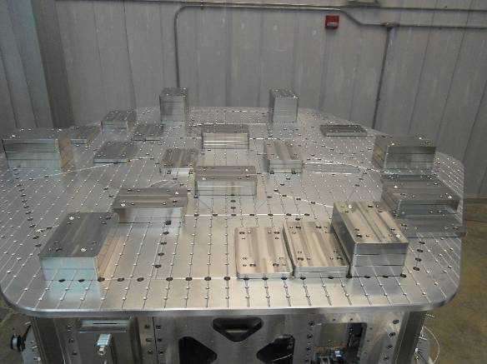

Figure - Masses distribution example (HAM-ISI-LLO – unit#1)

 | Side | Keel | Optical table | Total
Torque x at O (N.m)
Torque y at O (N.m)
Table - Masses distribution (can be computed using T1100261)

Acceptance Criteria
- The Mass budget must be: 579.1 Kg (cf E1100427)+/-25Kg (5%)
The tests report must contain:
- The 3 “Masses distributions” table
- The mass budget sum up table
- Map or table of the mass location on the optic table (if needed)
- A Picture of the optic table
- Torque estimation
- Issues/difficulties/comments regarding this test
- Test result (Passed: Failed: ).

Step 10 - Shim thickness
Procedure to follow for this test:
- Record the shim thickness on each locker
- Report the shim thicknesses in the table below

Lockers | Shim thickness (mil)
A
B
C
D
Table – Shims Thickness

The tests report must contain:
- The table “Shim thickness”
- Issues/difficulties/comments regarding this test
- Test result (Passed: Failed: ).

Step 11 - Lockers adjustment
During this test, we want to make sure that the lockers are set correctly. Lockers position is set on the unlocked position. Lockers are set properly when the unlocked-locked difference is less than 2mils.

Procedure to follow for this test:
- Wait for the assembly team to be done with setting the lockers
- Lock the table
- Set the dial indicators to zero
- Unlock the table
- Read the value on the dial indicators and report them in the table below

D.I at Lockers | Dial indicators V | Dial indicators H
A
B
C
D
Table – Dial indicators read-out (table locked-unlocked)

! ALWAYS lock and unlock the same way. For instance, lock ABCD and unlock DCBA !
The figure below shows the location of each dial indicator (yellow, more details in appendix A) and lockers (blues dots and blue lines). Vertical Dial indicator read negative for increasing height of the Optical Table. Horizontal dial indicators depend on their location. Lockers A & C read negative for +RZ rotation of Stage 1 relative to Stage 0. B & D read positive for +RZ rotation.
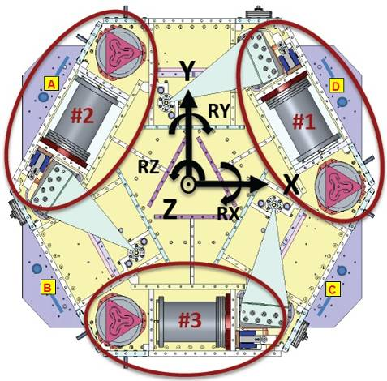
Figure - Top view of the HAM-ISI and dial indicators’ locations for lockers adjustment

Acceptance Criteria
- Vertical and horizontal displacement near the lockers must be lower than 2 mils (0.002”)
The tests report must contain:
- The table “Dial indicators read-out (table locked-unlocked)”
- Issues/difficulties/comments regarding this test
- Test result (Passed: Failed: ).

▪ Step 12 – Cables inventory – E1100822
During this test we want to make sure that we inventory or cables correctly. This will allow us to know what is available and/or needed and save precious time by avoiding shortages. This step MUST NOT BE SKIPPED. This cable inventory is reused when chamber-side testing and in-chamber testing.

Procedure to follow for this test:
- Record the S/N of in-vacuum cables
- Fill out the table below with the SN recorded
- Update the spreadsheet E1100822.

Cable Connects |  | Cable S/N
Part Name | Configuration | Corner 1 | Corner 2 | Corner 3
GS13 | Horizontal
GS13 | Vertical
L4C | Horizontal
L4C | Vertical
Actuator | Horizontal
 | Vertical
Table – Cables inventory

Acceptance Criteria
- Cable inventory completed
- E110082 spreadsheet updated
The tests report must contain:
- The table “Cable Inventory”
- Issues/difficulties/comments regarding this test
- Test result (Passed: Failed: ).

Tests to be performed after assembly
This section describes the tests performed to check, and validate, the good functioning of both the subassemblies and the overall assembly. Scripts, data and figures related to testing must be saved under the local copy of the SVN. Folders are organized as in appendix C.
This phase of testing is performed on a test stand, in the staging building. Hanford’s test stand is called X1. Livingston’s test stand is called X2.
It is good practice to run an "svn update" for all folders before starting work and finish the day with an "svn commit".

Step 0.1 - Testing folder set up
- Update from the seismic SVN (svn up path)
Make sure you update the following folders:
- /SeiSVN/seismic/Common/
- /SeiSVN/seismic/HAM-ISI/Common
- /SeiSVN/seismic/HAM-ISI/X1/
- Prepare your local folder:
- Open Arborescence_HAM_ISI.m from:
/SeiSVN/seismic/HAM-ISI/Common/Misc/
- Update the variables IFO, Chamber, Site and Unit
- Run Arborescence_HAM_ISI.m
Data Collection Scripts and Control Scripts are automatically copied and renamed into the local folder

Step 0.2 - MEDM set-up for testing
- Open MEDM from the terminal with the following commands:
- cd opt/rtcds/tst/x1/userapps/release/isi/x1/medm/
- medm
- Load Coordinate Transform Matrices and set the MEDM screen to default state:
- Open Matlab®
- Go to: /SeiSVN/seismic/HAM-ISI/X1/HAMX/Scripts/Data_Collection/
- Open Master_TEST_X1_ISI_Unit_1.m
- Update fields
- Run Populate_MEDM_Screen_HAM_ISI.m
- Prepare the calibration filters
Open, and run, the control script Step_0_Calibration_X1_ISI_HAMX.m from its folder
/SeiSVN/seismic/HAM-ISI/X1/HAMX/Scripts/Control_Scripts/
- Load the calibration filters under Foton
- Open Prepare_X1_HAMX.m from the same folder to load the filters under foton
- The Autoquack_case to 1 (line
- Run Prepare_X1_HAMX.m
- Load the filters from Foton to MEDM (see figure below)
- Open the TOP-IOP screen (arrow)
- Click on the Coeff Load button on the bottom left of that screen (circle)

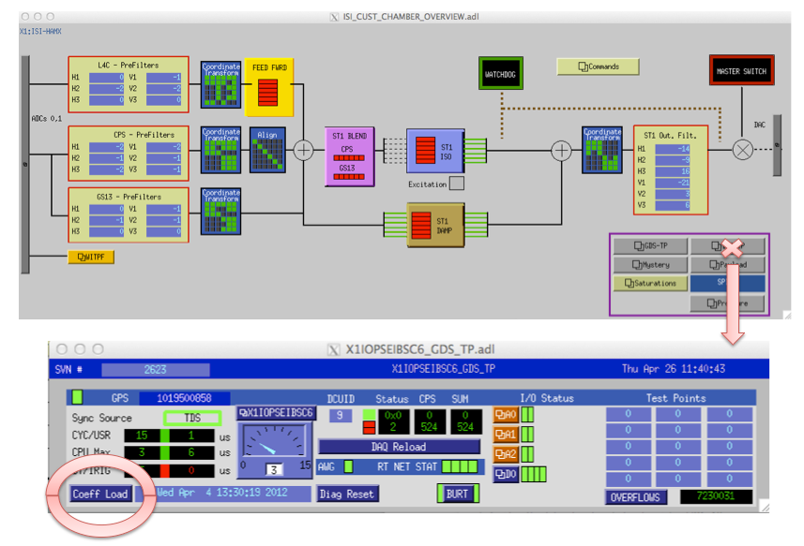
Figure – Loading filters under MEDM

Notes:
- See the document E1100995-v7, called commisionning process review, for more details regarding phases 4 and 5.
- WD values are automatically loaded by the Populate_MEDM function. As it happens that WD values are modified along testing, the function Set_Watchdogs_HAM_ISI.m can be used to reset the WD values.

Step 1 - Electronics Inventory

Procedure to follow for this test
Use the table below to report the serial numbers of the electronics for:
- The coil drivers
- The anti-image chassis
- The anti-aliasing chassis
- The main interface chassis

Hardware | LIGO reference | S/N
Coil driver | D0902744
Anti Image filter | D070081
Anti aliasing filter | D1000269
Interface chassis | D1000067
Table - Inventory electronics

The tests report must contain:
- The table “Inventory electronics”
- Issues/difficulties/comments regarding this test
3- Test result (Passed: Failed: ).

Step 2 - Set up sensors gap
During this step, CPS gaps are adjusted.

Procedure to follow for this test:
- Lock the table
- Add 10 Kg masses at each corner (A, B, C ,D ,E, F)

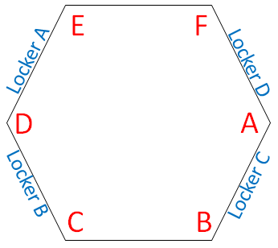
Figure – Corners location
- Display the capacitive position sensors (CPS) signals in a data viewer or MEMD window
- Adjust the CPS targets* so that the readout seen on dataviewer is less than 400 counts (a bit less than .0005”)
- Run Offset_STD_CPS_HAM_ISI.m from the master script (No data is saved)
- Copy the content of the variable Offset_STD_CPS and paste it, as is, in the table below

Table Locked | ADE boxes on |  | ADE boxes on/off
Sensors | Offset (Mean) | Std deviation | Offset (Mean) | Std deviation
H1
H2
H3
V1
V2
V3
Table – Capacitive position sensor readout after gap set-up
*Notes:
- Before starting the gap set up, the targets are typically far from their target and consequently out of range. The signal should be +32000 counts. However, when the ADC saturates it can go to 0. The bottom line is that a 0 count signal doesn’t mean that the sensor is broken.
- When the target to sensor gaps gets larger, the MEDM count value increases (maximum gap is positive). When the target to sensor gaps gets smaller, the MEDM count value decreases (minimum gap is negative).

Offset_STD_CPS_HAM_ISI.m:
This function computes the offset and the standard deviation on the CPS signals, at the execution time. Related data is stored (not saved!) under the variable Offset_STD_CPS. The first column of Offset_STD_CPS corresponds to the offsets. The second column corresponds to the Standard deviations. Lines correspond to the sensors as follow: H1, H2, H3, V1, V2, V3.
A 30s delay is required before accessing the data from the frame builder.
Function in the SVN at:
/seisvn/seismic/HAM-ISI/Common/Testing_Functions_HAM_ISI/
Acceptance criteria:
- All mean values must be lower than +/-400 cts (a bit less than .0005”).
- All standard deviations below 20 counts.
- No cross talk
The tests report must contain:
- The table “Capacitive position sensors readout after gap set-up”
- Issues/difficulties/comments regarding this test
- Test result (Passed: Failed: ).

Note: Standard deviation above 5counts was correlated to ground motion at LHO. Please see SEI Logbook entry #15 for more information

Step 3 - Measure the gaps on the CPSs
During this test we verify that the sensor gaps measured on the Jig did not change after the assembly.

Procedure to follow for this test:
Once CPSs have been installed on the ISI
- Measure the gaps between probes and targets using Teflon shims on the Jig.
- Try to measure the gap at the edge of the sensor to avoid scratches on the target.
- Fill out the table below.

Sensors | Gap measured on the Jig | Gap measured on the table | % of change | Offset sensors (counts)
H1
H2
H3
V1
V2
V3
Table - Measured sensors gap

Acceptance criteria:
- Sensors gap measured on the jig and on the optic table must be: 0.080” +/-0.005”
The tests report must contain:
- The table “Measured sensors gap”
- Issues/difficulties/comments regarding this test
- Test result (Passed: Failed: ).

Step 4 - Check Sensor gaps after the platform release
During this test we monitor the motion of the table from the locked to the unlocked position. Dial indicators are off and the measurement is performed with the CPSs.

Procedure to follow for this test:
- Lock the ISI
- Use Offset_STD_CPS_HAM_ISI.m to compute the offset and the STD for the CPS signals.
- Paste the result, as is, in the table below
- Unlocked the table
- Use Offset_STD_CPS_HAM_ISI.m to compute the offset and the STD for the CPS signals.
- Paste the result, as is, in the table below and compute de difference between the mean values

 | Table locked |  | Table unlocked
Sensors | Mean | Std Deviation | Mean | Std Deviation | Difference
H1
H2
H3
V1
V2
V3
Table – Sensors readout before and after optic table release

Acceptance criteria:
- Absolute values of the difference between the unlocked and the locked table must be below:
  - 1600 cts for horizontal sensors (~0.002”)
  - 1600 cts for vertical sensors (~0.002”)
- Considering the acceptance criteria of step 4, all mean values must be lower than
  - 2000 cts for horizontal sensors (~0.0025”)
  - 2000 cts for vertical sensors (~0.0025”)
The tests report must contain:
- The table “Sensors readout before and after optic table release”
- Issues/difficulties/comments regarding this test
- Test result (Passed: Failed: ).

Step 5 – Performance of the limiter
The two following tests allows checking on three points:
- Sensors signs
- Sensors range of measurement
- To double check the optical table range of motion

Step 5.1 - Test Nº1 - Push “in the general coordinates”
Procedure to follow for this test:
- This test requires two persons in the clean room and one person in front of the computer.
- Unlock the optic table
- Display the CPS signals on DataViewer/MEDM
- The two operator in the clean room push simultaneously on the optic table in one direction until the table touches the lockers, and hold the table in this position
- The operator in front of DataViewer/MEDM reports the sensor-readouts into the table below
- The operators release the ISI and start pushing in another direction
- Repeat phases 3 to 6 until completion of two first columns of the table below.
- Compute the ROM (Range Of Motion) which is the difference between the two first columns
- The columns “calculated after calibration” will be updated at step 11.

Pushing Z,-Z | CPS read out |  | Calculated after calibration |  | ROM
Sensors | UP (Counts) | Down (Counts) | UP (mil) | Down (mil)
V1
V2
V3
Pushing RZ, -RZ | CPS read out |  | Calculated after calibration |  | ROM
Sensors | CCW (+RZ) | CW(-RZ) | CW (mil) | CCW (mil)
H1
H2
H3
Table - Optic table range of motion
Note:

Vertical displacement sensors:
At each corner, push down gently (uniformly) on the optic table and watch the response in dataviewer. While pushing up/down, you have to make sure that the table is not rotating. All sensors should respond with the same sign. When the table is going down (-Z), the gap between the probe and the sensor decreases. Consequently vertical sensor readout is going in the negative direction. Push up/down until the optic table is in contact with the locker. Report the MEDM count values in the table below.

Horizontal displacement sensors:
At each corner, push the structure tangentially to the plane of the sensors in one direction. While rotating, you have to make sure that the table is not going up/down. All sensors should respond with the same sign. When the table is turning -RZ or clockwise (viewed from top), the gap between the probe and the sensor decreases. Consequently, horizontal sensor readout is going in the positive direction.

Step 5.2 - Test Nº2 – Push “locally”
The main thing here is that we want to make sure that our Actuators & Sensors have zero chance of ever contacting. The lockers should always limit the Actuators/Sensors from closing their gaps.

Procedure to follow for this test:
- Apply a force collinear to the sensor axis you are testing (+ and - directions) manually
- For displacement sensors check
- Move the table such that the target is as close as you can get it form the Sensor Head. This motion is monitored visually in dataviewer and Sensor counts are recorded.
- Move the table such that the target is as far as you can get it to the Sensor Head. This motion is monitored visually in dataviewer and Sensor counts are recorded.
- For the Actuators, checking all possible contacts points is difficult. One person watches the actuator while two people move the table in every direction possible. If there is no contact give the Actuator a positive “X”/PASS.

Pushing Locally | Push in positive direction | Push in negative direction | Railing | Actuator Gap Check | ROM
H1
H2
H3
V1
V2
V3
Table - Sensors and Actuators gap check

Acceptance criteria:
- The vertical sensor readout be positive when the optic table is pushed in the +Z direction
- The horizontal sensor readout be negative when the optic table is pushed in the +RZ direction
Step 7.1
- Absolutes value of all estimated motions must be higher than 16000counts (~0.020”)
Step 7.2
- No contact point on sensors
- Absolute value of sensor read out must be higher than 16000counts (~0.020”)
- No contact point on actuators
The tests report must contain:
- The table “Optic table range of motion”
- The table “Sensors and actuators gap check”
- Issues/difficulties/comments regarding this test
- Test result (Passed: Failed: ).

Step 6 - Position Sensors unlocked/locked Power Spectrum
During the following test, we verify the good functioning of the CPSs. We also check for potential crosstalk between the CPS satellite boxes.

The functioning of the GS13s is also checked, now they are installed in the HAM-ISI.

To perform these tests, Spectra are measured in both configurations: table locked and table unlocked for both type of sensors: CPSs and GS13s. Spectra are computed on the data from the pre-filter inputs channels (for example X1:ISI-HAMX_CPSINF_H1_IN1_DQ - X1:ISI-HAM_GS13INF_H1_IN1_DQ) .

Procedure to follow for this test
- Connect the CPS Satellite boxes with a synchronization cable
- Turn both CPS Satellite boxes 1 and 2 ON
- Unlock the ISI
- Record the GPS time (gps_now.m)
- Wait for 45 minutes
- Lock the ISI and add 10kg masses at each of the 6 corners of the optical table
- Record the GPS time (gps_now.m)
- Wait for 45 minutes
- Paste the GPS times in the master script, line 62, as content of the variable GPS_TIME_Unlocked_Locked
- Update fields
- Run the paragraph Comparison configuration locked vs unlocked from the master script (lines 48 to 66) with the following parameters:
- BW = 0.02Hz
- Averages = 50
- Overlap = 50%
- Paste the power spectra figures in the report

ASD_Measurements_Locked_Unlocked_HAM_ISI.m:
This Matlab® function is used to calibrate and plot the power spectra for both the CPSs and the GS13s, when the table is unlocked and locked.

Function in the SVN at:
/SeiSVN/seismic/HAM-ISI/Common/Testing_Functions_HAM_ISI/

Data files in SVN at:
/SeiSVN/seismic/HAM-ISI/X1/Unit_1/Data/Spectra/Undamped
LHO_ISI_Unit_1_ASD_m_CPS_T240_L4C_GS13_Locked_vs_Unlocked_YYYY_MM_DD.mat

Figures in SVN at:
/SeiSVN/seismic/HAM-ISI/X1/Unit_1/Data/Figures/Spectra/Undamped
- LHO_ISI_Unit_1_ASD_m_CPS_Locked_Unlocked_YYYY_MM_DD.fig
- LHO_ISI_Unit_1_ASD_m_GS13_Locked_Unlocked_YYYY_MM_DD.fig

Notes:
- As shown in Appendix F, some spectra peaks are due to ground motion in the 10-100Hz frequency band
- Capacitive sensors use electric field for sensing. When multiple, independent capacitive sensors are used simultaneously, the electric field from one probe may be trying to add charge to the target, while another sensor is trying to remove charge. This conflicting interaction with the target will create errors in the sensors’ outputs. This problem is easily solved by synchronizing the sensors. Synchronization sets the drive signal of all sensors to the same phase so that all probes are adding or removing charge simultaneously and the interference is eliminated. Interferences between ADE boxes can be roughly estimated by measuring standard deviation when one out of two satellite boxes is off.

Acceptance criteria:
- No cross talk (peaks at low frequencies + harmonics on measurements)
- Magnitudes of power spectra must be between requirement curves such as in the following figures (dashed lines).

Sensors | ISI state | Frequency (Hz) | 2x10⁻² | 1x10⁻¹ | 1 | 10 | 20 | 100 | 1000
GS-13 | Table locked | Max | 3x10⁻¹ | 3x10⁻⁴ | 3x10⁻⁷ | 10⁻⁷ |  | 10⁻¹¹ | 10⁻¹⁴
 |  | Min | 3x10⁻⁴ | 3x10⁻⁷ | 3x10⁻¹⁰ | 10⁻¹² |  | 10⁻¹⁴ | 10⁻¹⁷
 | Table unlocked | Max | 1 | 3x10⁻³ | 10⁻⁵ | 10⁻⁹ |  | 10⁻¹¹ | 10⁻¹⁴
 |  | Min | 10⁻⁴ | 3x10⁻⁷ | 10⁻⁹ | 10⁻¹³ |  | 10⁻¹⁵ | 10⁻¹⁸
CPS | Table locked | Max | 2*10⁻⁷ | 2x10⁻⁸ | 10⁻⁸ | 5x10⁻⁸ | 2x10⁻⁷ | 5x10⁻⁹ | 10⁻⁹
 |  | Min | 5x10⁻⁹ | 2x10⁻⁹ | 8x10⁻¹⁰ | 5x10⁻¹⁰ |  | 10⁻¹⁰ | 5x10⁻¹¹
 | Table unlocked | Max | 2x10⁻⁶ | 8x10⁻⁷ | 8x10⁻⁷ | 5x10⁻⁸ | 2x10⁻⁷ | 2x10⁻⁸ | 10⁻⁹
 |  | Min | 10⁻⁷ | 5x10⁻⁸ | 8x10⁻⁹ | 5x10⁻¹⁰ |  | 2x10⁻¹⁰ | 10⁻¹⁰
Table - Step 6 -Normal conditions-Sensors Spectra requirements

The tests report must contain:
- The calibrated Spectra of capacitive position sensors
- SVN paths of
  - Data files (with date label)
  - Figures
- Issues/difficulties/comments regarding this test
- Test result (Passed: Failed: ).

Step 7 - GS13 power spectrum -tabled tilted
The good functioning of the GS-13s in the full range of motion of the ISI is tested hereafter. Each corner of the table is successively grounded, and we measure power spectra in these various tilt positions. The Pre-filter output channels (e.g. G1:ISI-HAM_GEOPF_H1_IN1_DAQ) are recorded for these measurements.

Procedure to follow for this test:
- Set a 10 kg mass at one corner of the optical table (see figure below)
- Write down the GPS Time with gps_now
- Wait for 120s
- Repeat phases 1 to 3 for each of the 6 corners
- Update GPS_TIME_TILTED line 87 of the master script
- Updated fields
- Run the paragraph Comparison configuration tilted (A - F) of the master script with the following parameters:
- BW = 0.5Hz
- Averages = 50
- Overlap = 50%
- Paste the figures in the report

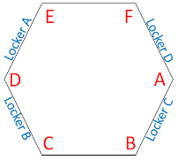
Figure – Corners location

ASD_Measurements_Stages_Tilted_HAM_ISI.m
Is the Matlab® function which is used to plot the power spectra of the Geophones when the table is tilted.

Function in the SVN at:
/SeiSVN/seismic/HAM-ISI/Common/Testing_Functions_HAM_ISI/.

Data files saved in the SVN at:
/SeiSVN/seismic/HAM-ISI/X1/Unit_1/Data/ Spectra/Undamped/
LHO_ISI_Unit_1_ASD_m _GS13_Stage_Tilted_YYYY_MM_DD.mat

Figures saved in the SVN at:
/SeiSVN/seismic/HAM-ISI/X1/Unit_1/Data/Figures/Spectra/Undamped
LHO_ISI_Unit_1_m_PSD_ GS13_Tilted_YYYY_MM_DD.fig

Acceptance criteria:
- With table unlocked and tilted, magnitudes of power spectra must be lower than:

Sensor | ISI State | Frequency | 5x10⁻¹ Hz | 1 | 10 | 100 | 1000
GS-13 | Table Tilted | Max | 2x10⁻⁻⁵ | 2x10⁻⁻⁶ | 8x10⁻⁸ | 4x10⁻¹¹ | 3x10⁻¹⁴
 |  | Min | 10⁻⁸ | 10⁻⁹ | 2x10⁻¹¹ | 10⁻¹⁴ | 10⁻¹⁷
Table - Table Tilted- Sensors Spectra requirements

The tests report must contain:
- The calibrated Spectra of geophones
  - When the table is locked
  - When the table is unlocked
  - When the table is unlocked with a mass at one corner (A, B, C, D, E, F)
- SVN paths of
  - Data files (with date label)
  - Script file use for calibration (with date-label)
  - Figures
- Issues/difficulties/comments regarding this test
- Test result (Passed: Failed: )
.

Step 8- GS13 pressure readout

Procedure to follow for this test:
- Open the main HAM-ISI MEDM screen: ISI_CUST_CHAMBER_OVERVIEW.adl
- Find the link to the pressure readout screen on the bottom right of ISI_CUST_CHAMBER_OVERVIEW.adl
- Open ISI_CUST_CHAMBER_PRESSURE.adl. See figure below.
- Make sure the values displayed meet the acceptance criteria.
- Add any discarded pod to the Seismometer and Pod Issue Tracking spreadsheet: DCC document # Q11000073.

Note:
If the pressure varies a lot locally, in one corner, within a short period of time, it means that one of the pods is leaking. This pod cannot be inserted in vaccum and needs to be discarded.

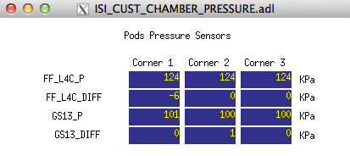
Figure – Pressure Readouts Medm Screen

Acceptance criteria:
- The pressure on GS13_P channels must be 102KPa +/-8 KPa (25000 counts +/- 3000 counts)
- GS13_P must vary the same way in each corner and GS13_DIFF must be constant (channels follow comparable trend)

The tests report must contain:
- The plot
- Test result (Passed: Failed: ).

Step 9 - Coil Driver, cabling and resistance check
Before driving actuators, a few tests have to be carried out to check for shorts.

The actuator cable (vacuum side of the feedthrough)
The actuator cable has a 3 pins connector. All three pins are connected to a voltage drive, even though only two pins are used to drive the actuators.
Pins are connected such as:
- Pin #1 (left pin in the figures below) is the neutral return
- Pin #2 (middle pin) is the drive pin
- Pin #3 (right pin) is the shield ground.
Make sure the shield ground is not connected to the middle pin of the plug. If it is, swap middle pin with pin #3.

Procedure to follow for this test:
- Turn the coil drivers (D0902744) off
- Disconnect the actuator cable at the back side of the coil driver
- Measure the resistance between the side pins and the middle pin of the actuator cable
- Turn the coil drivers back on
- Make sure all LEDs on the front panel are green
- Set a 1000 counts offset drive with MEDM
- Measure the coil driver output. If no voltage, check the anti-image pin.
- Reconnect actuator cable to the coil driver
- Fill out the table below

Actuator | V1 |  | H1 |  | V2
Coil driver
Anti image pin # | 1 |  | 2 |  | 3
Cable #
Resistance  (Ohm) | P1 - P2 | P2 - P3 | P1 - P2 | P2 - P3 | P1 - P2 | P2 - P3
MEDM offset  (1000 counts) | Measurement P2 (+)  P1&P3 (-) |  | Measurement P2 (+)  P1&P3 (-) |  | Measurement P2 (+)  P1&P3 (-)
Actuator | H2 |  | V3 |  | H3
Coil driver
Anti image pin # | 4 |  | 5 |  | 6
Cable #
Resistance  (Ohm) | P1 - P2 | P2 - P3 | P1 - P2 | P2 - P3 | P1 - P2 | P2 - P3
MEDM offset  (1000 counts) | Measurement P2 (+)  P1&P3 (-) |  | Measurement P2 (+)  P1&P3 (-) |  | Measurement P2 (+)  P1&P3 (-)
Table - Actuators resistance check

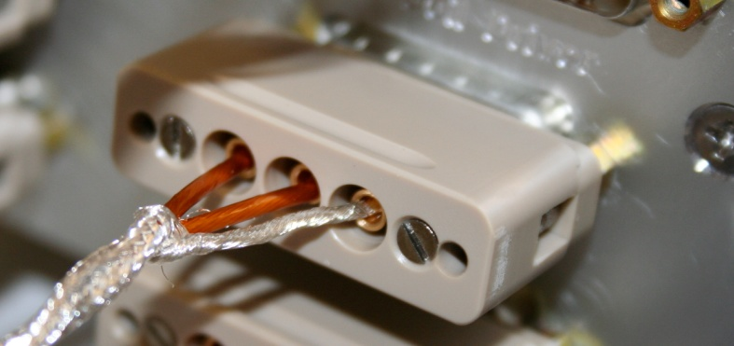
Figure – Actuator cable plugged on the feedthrough

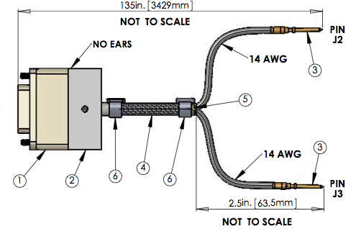
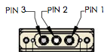
Figure – Actuator cable between feedthrough and actuator (DCC document #: D1000920)

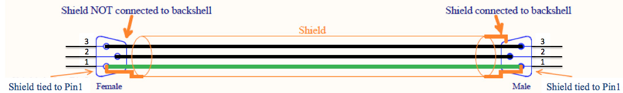
Figure – Actuator cable between feedthrough and test rack

Acceptance criteria:
- The resistance measured between the pin #2 and pin #3 must be 6.5 +/-1 ohms
- The resistance measured between the pin #1 and the pin #2 must be infinite
- Actuator neutral pins must be connected on pin #3 (left side pin of the plug)
- Actuator drive pins must be connected on pin #2 (middle pin of the plug)
- Actuator ground shield pins must be connected on pin #1 (right pin of the plug)
- All LEDs on the coil driver front panel must be green

The tests report must contain:
- The table “Actuators resistance check”
- Issues/difficulties/comments regarding this test
- Test result (Passed: Failed: ).

Step 10 - Actuators Sign and range of motion (Local drive)
In this step, actuators signs are verified. The range of motion is also measured when moving the optical table by applying a local drive on the actuators.

Procedure to follow for this test
- Run the Range_Motion_HAM_ISI.m from the master script (line 26)
- Copy and paste the outputted table, as it is, in the table below
- Make sure that a positive offset drive gives a positive sensor offset
- If not, it can be corrected as follows:
- Turn the coil drivers (D0902744) OFF
- Swap pins on the actuator side of the actuator cables
- Turn the coil drivers back ON
- Retest

 | Negative drive | Positive drive
H1 readout (count)
H2 readout (count)
H3 readout (count)
V1 readout (count)
V2 readout (count)
V3 readout (count)
Table - Range of motion - Local drive

Range_Motion_HAM_ISI.m
This Matlab® funtion drives a +/-30000 counts offset in a single actuator and get the Local CPS readouts. This function is saved under the SVN at:
/SeiSVN/seismic/HAM-ISI/Common/Testing_Functions_HAM_ISI/

Acceptance criteria:
- Main couplings sensors readout must be at least 16000 counts (~0.02”)
- A positive offset drive on one actuator must give positive sensor readout on the collocated sensor. Signs will also be tested when measuring local to local transfer functions.
The tests report must contain:
- The table “Range of motion-Local drive”
- Issues/difficulties/comments regarding this test
- Test result (Passed: Failed: ).

Step 11 - Vertical Sensor Calibration
During this test, the vertical sensitivity of the position sensors is measured.

Procedure to follow for this test:
- Install exclusively vertical dial indicators as described in appendix A
- Set actuators watchdog to 25000counts
- In the Isolation filters bank
- Set the gain to 0 on Z direction
- Set the ramp time to 20s
- Set a 10000 counts offset on Z direction
- Change the gain to 6
- Make sure there is no contact between the table and the lockers (dial indicator needle moves constantly until ramping time is over). If the table is touching, reduce the offset.
- Get the CPS mean values with Offset_STD_CPS_HAM_ISI.m, from the master script. Refer to step 2 if you need information regarding this Matlab ® function.
- Set the 0 of the dial indicators
- Change the gain to 0.
- Read the offset on the dial indicators
- Change the gain to -6
- Make sure there is no contact between the table and the lockers
- Get the CPS mean values with Offset_STD_CPS_HAM_ISI.m
- Set the 0 of the dial indicators
- Change the gain to 0. Read the offset on the dial indicators
- Complete the table below
- Compute sensitivity using ADC calibration:
2¹⁵ Count/20V = 32768 Count/20 V = 1638 Count/Volt
- Compute the change in calibration:
Change (%) = (Measured-Nominal)/Nominal
- Reset the actuators watchdog to 20000counts
- Update step 5.1

D.I at Lockers | D.I readout with for  a negative drive | D.I readout without any drive | D.I readout with for  a positive drive
A |  | 0
B |  | 0
C |  | 0
D |  | 0
Average |  | 0
Sensors | Read out (Counts) | Readout (Counts) | Readout (Counts) | Difference (Counts)
V1
V2
V3
 |  |  | Average

Table - Calibration of capacitive position sensors
Vertical sensitivity units/conversions:
count/mil
count/mil * 1/ 1638V/count = V/mil
25400nm/mil * 1/ mil/count = nm/count

Nominal Calibration
CPS Sensitivity: 20V/0.039" = 20V/39mils = 0.513V/mil

Calibration in counts: 2¹⁵ / 20 * 20/39 = 840 count/mil
25400 nm/mil * 1/840 mil/count = 30.2nm/count

Acceptance criteria:
- Deviation from nominal value < 2%. Nominal value is 840 count/mil.
The tests report must contain:
- The table “Calibration of capacitive position sensors”
- Fill vertical sensibility values
- Issues/difficulties/comments regarding this test
- Test result (Passed: Failed: ).

Step 12 - Vertical Spring Constant
This test verifies the vertical spring constant.

Procedure to follow for this test
- Remove dial indicators
- Record the mean values of the CPS readouts with Offset_STD_CPS_HAM_ISI.m
- Place calibrated weights (3 x 2Kg) at various positions on Stage (see figure below). The masses must be placed at equal radii from the center of Stage 1, at symmetric angles around the table. If possible, use the hatches as reference points. (A,B,C)
- Make sure the optic table is not touching the lockers
- Record the mean values of the CPS readouts with Offset_STD_CPS_HAM_ISI.m
- Repeat the measurement after swapping masses (A,B,C=>B,C,A=>C,A,B)
- Fill out the table below and compute the averages

Sensors | Mean diff counts | Mean diff m | K (N/m) | Error with average
V1
V2
V3
 |  | Average (N/m)
 |  | Total Stiffness (N/m)

Table - Vertical spring constant
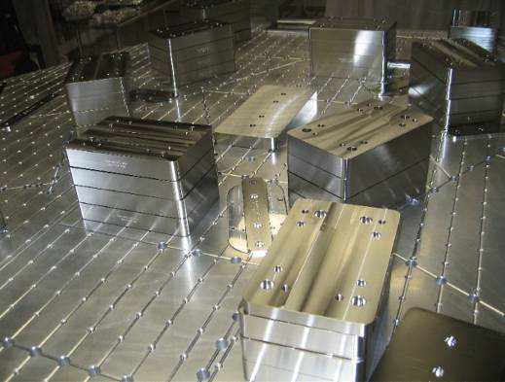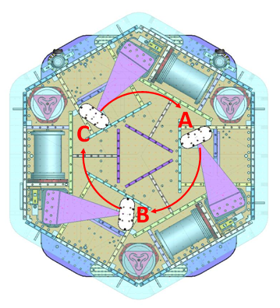
Figure – Vertical spring constant measurement – Hatches as reference points

Acceptance criteria:
- 2.4704e5 N/m +/-2 % N/m (i.e. between 2.421e5 and 2.520e5 N/m)
- +/- 5% of variation between each spring and the average
The tests report must contain:
- The table “Vertical spring constant”
- Issues/difficulties/comments regarding this test
- Test result (Passed: Failed: ).

Step 13 - Static Testing (Tests in the local basis)
This test verifies three points:
- Actuators-sensors readout chains
- Static main couplings and cross-couplings
- Actuator power (driving signal and actuator response)
Measurements are performed with CPSs.

Procedure to follow for this test:
- Run Static_Test_Local_Basis_HAM_ISI.m from the master script
- Copy Offset_Local_Report and paste, as is, in the table below
- Make sure the measurement matches with the anticipated couplings

 |  | Sensors (counts)
 |  | H1 | H2 |  | H3 |  | V1 |  | V2 |  | V3
Actuators  (1000 counts) | H1
 | H2
 | H3
 | V1
 | V2
 | V3
 | Main coupling
 | Important cross coupling

Table - Main and cross coupling - Static

Static_Test_Local_Basis_HAM_ISI.m
This Matlab® function drives a 1000 counts positive offset on the local actuators and reads all the CPS sensors.

Function n the SVN at:
/seisvn/seismic/HAM-ISI/Common/Testing_Functions_HAM_ISI/

Data related to this test is automatically saved under the SVN at:
/seisvn/seismic/HAM-ISI/X1/HAMX/Data/Static_Tests/

Vertical actuators
A positive offset drive on one vertical actuator creates a positive offset readout on the collocated sensor and a negative offsets readout on other vertical sensors. For a 1000 counts positive offset drive on vertical actuators, the collocated sensor readout should be about 1400 counts.

Horizontal actuators
A positive offset on one horizontal actuator drive creates a positive offset readout on every horizontal sensor. For a 1000 counts positive offset on horizontal actuators, the collocated sensor readout should be about 2000 counts and about 1250 counts on the other horizontal sensors.

Acceptance criteria:
Vertical
For a +1000 count offset drive on vertical actuator,
- Collocated sensors must be 1400 counts +/- 10%
Horizontal
For a +1000 count offset drive on horizontal actuators
- Collocated sensors must be 2000 counts +/- 10%
- Non-collocated horizontal sensors must be 1250 counts +/-10%
The tests report must contain:
- The table “Main and cross coupling -Static”
- Issues/difficulties/comments regarding this test
- Test result (Passed: Failed: ).

Step 14 - Linearity test
The linearity of the triplet Actuators-Structure-sensors is evaluated during the following test.

Procedure to follow for this test
- Open the DAMP MEMD screen
- Set all gains to 1
- Run Linearity_Test_Awgstream_HAM_ISI.m from the master script
- Report the slopes and offsets by copying the variable Slopes_Offset, as is, in this table below.
- Paste the linearity test figure in the report
- Set all gains back to -1

Note:
The slope of the linearity test should be impacted by the length/resistance of the actuator cables.

 | Slope | Offset | Average slope | Variation from  average (%)
H1
H2
H3
V1
V2
V3
Table - Slopes and offset of the triplet Actuators - HAM-ISI – Sensors

Run Linearity_Test_Awgstream_HAM_ISI.m
This function performs the linearity test. It also displays the plot, the slopes and the offsets for this test.

Function in the SVN at
/seisvn/seismic/HAM-ISI/Common/Testing_Functions_HAM_ISI/

Test data is automatically saved under:
/seisvn/seismic/HAM-ISI/X1/Unit_4/Data/Linearity_Test/

Acceptance criteria:
- Horizontal and vertical slopes of the triplet actuators x HAM-ISI x sensors: Average slope +/- 1.5%
The tests report must contain:
- The table “Linearity of the triplet Actuators – HAM – ISI - Sensors”
- The table “Slopes and offsett of the triplet Actuators – HAM – ISI - Sensors”
- Figures that shows linearity on vertical and horizontal axis
- Issues/difficulties/comments regarding this test
- Test result (Passed: Failed: ).

Step 15 - Cartesian Basis Static Testing

Procedure to follow for this test:
- Basis-transformation-matrices (appendix D) must have been loaded during step 0.2 MEDM set up for testing
- Check the matrices on MEMD screens (figure below) and load/update them if needed
- Engage all CPS, GS13, and Actuator filter banks but symmetrization
- Disable the inputs of the ISO channels and enable their outputs
- Run the function Static_Test_Cartesian_Basis_HAM_ISI.m from the master script
- Copy the variables Offset_Local_Report and Offset Cartesian_Report and past them, as is, in the table below:

1000 counts Drive | X | Y | Z | RX | RY | RZ | Direction read out
X Drive
Y Drive
Z Drive
Rx Drive
Ry Drive
Rz Drive
Table - Tests in the local coordinate basis

1000 counts Drive | X | Y | Z | RX | RY | RZ | Direction read out
X Drive
Y Drive
Z Drive
Rx Drive
Ry Drive
Rz Drive
Table - Tests in the general coordinate basis

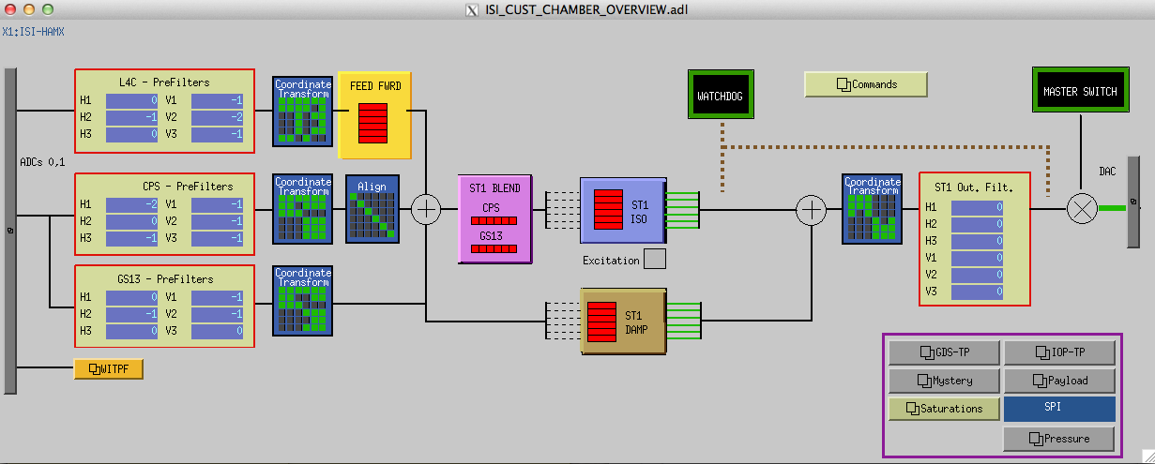
Figure – MEDM screen with the proper set up
Static_Test_Cartesian_Basis_HAM_ISI.m
Static_Test_Cartesian_Basis_HAM_ISI.m drives a 1000 counts positive offset on the local actuators and reads all the CPS sensors.

Function in the SVN at:
/seisvn/seismic/HAM-ISI/Common/Testing_Functions_HAM_ISI/

Data related to this test is automatically saved under the SVN at:
/seisvn/seismic/HAM-ISI/X1/HAMX/Data/Static_Tests/

Acceptance criteria:
- For a positive drive in the Cartesian basis Local sensor readout must have the same sign that in the following table:

1000 counts Drive | H1 | H2 | H3 | V1 | V2 | V3 | Direction read out
X Drive | + | + | - |  |  |  | +
Y Drive | - | + | 0 |  |  |  | +
Z Drive |  |  |  | + | + | + | +
Rx Drive |  |  |  | - | + | - | +
Ry Drive |  |  |  | - | + | + | +
Rz Drive | - | - | - |  |  |  | +
Table – Reference table

- Cartesian sensors read out must be positive (DISP2CEN check) in the drive direction

The tests report must contain:
- The table “Tests in the general coordinate basis”
- If signs issues – report CONTACT and DISP2CEN used for this test
- Issues/difficulties/comments regarding this test
- Test result (Passed: Failed: ).

Step 16- Transfer function Measurement

Introduction:
Local to Local Transfer functions are measured and processed via Matlab®, in 3 steps:
- The excitation is launched and saved with Run_Exc_Batch_X1_HAMX.m. This script is specific to each unit.
- The time series are retrieved and TFs are processed with Run_Get_Batch.m. The transfer function data files are saved under the testing folder. This script is common to all ISIs.
- TFs are Concatenated/displayed/saved with Step_1_Plot_TF_Loc_to_Loc_X1_ISI_HAMX.m

Note:
Excitations can be launched from one Matlab® session while time series are simultaneously processed under another Matlab® session. Proceeding this way saves precious time.

Cartesian to Cartesian TFs are computed from the Local to Local TFs.
- Actuator/GS13 symmetrization filters are applied to the local to local TF with: Step_2_Symmetrization_X1_ISI_HAMX.m
Symmetrized local to local TFs are displayed and saved.
- Cartesian to Cartesian TFs are computed and displayed, based on the symmetrized Local to Local TFs. This task is performed with Step_3_Plot_TF_Cart_to_Cart_X1_ISI_HAMX.m

- Run_Exc_Batch_X1_HAMX.m
This script runs and saves the excitation for the TF. There is a given amplitude range for the excitation within which measurements of TFs can be performed. Passed this range, sensors will saturate or watchdog will trip. The frequency response of the excitation/measurement chain is not flat. Hence, the amplitude range available for the excitation varies from one frequency band to another. The excitation performed by Run_Exc_Batch is divided into 5 frequency bands to optimize excitations and to ensure maximal coherence. Run_Exc_Batch calls one function per frequency band. These functions are common to all HAM-ISIs.
- In the local basis, these excitation functions are called: Run_TF_L2L_[Section’s_bandwitdh]_[subsystem].m

Run_Exc_Batch creates two files:
- The excitation file contains specific data such as the excitation signals, GPS start time, frequency resolution, etc...
- The batch file is an “exchange file”. It carries general information such as data locations, data names, response channels, etc…
The current batch file is automatically saved under:
Seisvn/seismic/HAM-ISI/X1/HAMX/Data/Transfer_Functions/Measurements/
When Run_Exc_Batch is run, the existing batch file is moved to:
seismic/HAM-ISI/X1/HAMX/Data/Transfer_Functions/Measurements/Batch_file_Archive/
…and the new batch file is saved instead.

- Run_Get_Batch.m
This script retrieves the time series and computes the TFs. By default, Run_Get_Batch computes the TFs using the latest batch file. Old data can be processed by specifying an old batch file as a fourth argument.

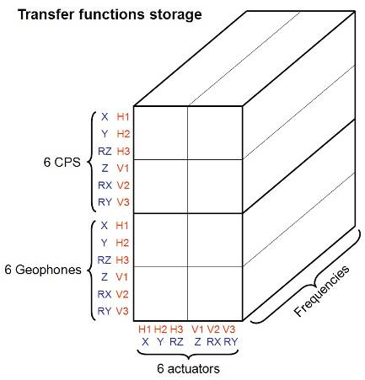
Figure – Transfer functions storage

Run_Exc_Batch_X1_HAMX.m in SVN at:
/SeiSVN/seismic/HAM-ISI/X1/Unit_1/Scripts/Data_Collection/

Run_Get_Batch.m in SVN at:
/SeiSVN/seismic/Common/MatlabTools/Schroeder_Phase_Scripts/

Step_1_Plot_TF_Loc_to_Loc_X1_ISI_HAMX.m in SVN at:
/SeiSVN/seismic/HAM-ISI/X1/Unit_1/Scripts/Control_Scripts/

Step_3_Plot_TF_Cart_to_Cart_X1_ISI_HAMX.m in SVN at:
/SeiSVN/seismic/HAM-ISI/X1/Unit_1/Scripts/Control_Scripts/

Excitation Matlab® functions in the SVN at:
/SeiSVN/seismic/HAM-ISI/Common/Transfer_Functions_Scripts/
- Run_TF_L2L_10mHz_100mHz_HAM_ISI.m
- Run_TF_L2L_100mHz_500mHz_HAM_ISI.m
- Run_TF_L2L_500mHz_5Hz_HAM_ISI.m
- Run_TF_L2L_5Hz_100Hz_HAM_ISI.m
- Run_TF_L2L_100Hz_1000Hz_HAM_ISI.m

Channel lists in the SVN at:
/SeiSVN/seismic/HAM-ISI/Common/Channels_List/
- Chan_Exc_List_Cartesian_HAM_ISI.m
- Chan_Exc_List_Local_HAM_ISI.m
- Chan_Resp_List_Cartesian_HAM_ISI.m
- Chan_Resp_List_Local_HAM_ISI.m

The table below presents the convention chosen for the excitation channels lists (type 1, 2, 3)

 | # | 1 | 2 | 3 | 4 | 5 | 6
type = 1 | Actuator | H1 | H2 | H3 | V1 | V2 | V3
type = 2 | Actuator | X | Y | RZ | Z | RX | RY
type = 3 | Actuator | X | Y
Table – Excitation list

The table below presents the convention chosen for the response channels lists (type 1, 2)

 | # | 1 | 2 | 3 | 4 | 5 | 6 | 7 | 8 | 9 | 10 | 11 | 12
resplist = 1 | Actuator | CPS  H1 | CPS  H2 | CPS  H3 | CPS  V1 | CPS  V2 | CPS  V3 | GS13  H1 | GS13  H2 | GS13  H3 | GS13  V1 | GS13  V2 | GS13  V3
resplist = 2 | Actuator | CPS  X | CPS  Y | CPS  RZ | CPS  Z | CPS  RX | CPS  RY | GS13  X | GS13  Y | GS13  RZ | GS13  Z | GS13  RX | GS13  RY
Table – Response channel list

Step 16.1 - Local to local TF measurement

Procedure to follow for this test
Preliminary work:
- Make sure that the HAMX folder arborescence is correct (Refer to Appendix C)
- Open two Matlab® sessions and define paths for both of them
- In Session #1:
  - Open the master script
  - Open Run_Exc_Batch from it
  - Set the automatic email alerts to 1 and update the recipient list if needed
  - Set the number of repetitions for the kind of test you are intending to make: quick or full-length
  - Run Run_Exc_Batch from the master Script
- In Session #2:
  - Open the master script.
  - Run Run_Get_Batch from there
  - Once measurement is over, stop Run_Get_Batch with [Ctrl + C]
- Process/Plot/save TF:
- Open Step_1_Plot_TF_Loc_to_Loc_X1_ISI_HAMX.m
- Create a new case for your new measurement data
- Update fields
- Run Step_1_Plot_TF_Loc_to_Loc_X1_ISI_HAMX.m

The table below summarizes the data acquisition parameters used for the local to local measurements (LHO, at night). The recommended number of repetitions is presented below. It is good practice to run a quick check with fewer repetitions before launching the whole measurement.

FREQ. RANGE |  |  | DRIVE |  | MEAS. TIME
Min | Max | Freq. Res. (Hz) | H | V | Time for 1 Rep. (s) | Number of Reps | Estimated duration (min)
0.01 | 0.1 | 0.01 | 10500.0 | 10500.0 | 620.0 | 10.0 | 103.3
0.1 | 0.5 | 0.02 | 600.0 | 600.0 | 320.0 | 30.0 | 160.0
0.5 | 5 | 0.025 | 35.0 | 35.0 | 260.0 | 55.0 | 238.3
5 | 100 | 0.1 | 300.0 | 300.0 | 80.0 | 50.0 | 66.7
100 | 1000 | 0.2 | 135.0 | 135.0 | 50.0 | 150.0 | 125.0
 |  |  |  |  | Estimated Measurement Time (h) |  | 11.6

Table - Measurement parameters – Local to local

Figures of local to local transfer functions in SVN at:
/SeiSVN/seismic/HAMISI/X1/HAMX/Data/Figures/Transfer_Functions/Measurements/Undamped/
LHO_ISI_Unit_1_TF_L2L_Raw_from_ACT_to_GS13_yyyy_mm_dd.fig
LHO_ISI_Unit_1_TF_L2L_Raw_from_ACT_to_CPS_yyyy_mm_dd.fig

Data files for measurement of local to local transfer functions in SVN at:
/SeiSVN/seismic/HAM-ISI/X1/HAMX/Data/Transfer_Functions/Measurements/Undamped/
- LHO_ISI_Unit_1_Data_TF_L2L_10mHz_100mHz_yyyy_mm_dd.mat
- LHO_ISI_Unit_1_Data_TF_L2L_100mHz_500mHz_yyyy_mm_dd.mat
- LHO_ISI_Unit_1_Data_TF_L2L_500mHz_5Hz_yyyy_mm_dd.mat
- LHO_ISI_Unit_1_Data_TF_L2L_5Hz_200Hz_yyyy_mm_dd.mat
- LHO_ISI_Unit_1_Data_TF_L2L_200Hz_1000Hz_yyyy_mm_dd.mat

Concatenated TF data under the SVN at:
/SeiSVN/seismic/HAM-ISI/X1/HAMX/Data/Transfer_Functions/Simmulation/Undamped/
- X1_ISI_HAMX_TF_L2L_Raw_yyyy_mm_dd.mat

Acceptance criteria:
- On CPS, the phase must be 0º at DC
  - On Geophones, the phase must be -90º at DC
  - Identical shape in each corner

Test report must contain:
- Figures of local to local measurements
  - Local to local vertical position sensors transfer functions
  - Local to local horizontal position sensors transfer functions
  - Local to local vertical geophones transfer functions
  - Local to local horizontal geophones transfer functions
- Path in SVN of local to local measurements
  - Data (4 sections)
  - Scripts used for processing
  - Figures
  - Data storage (concatenate)
- Figures of Cartesian to cartesian measurements
  - Cartesian to Cartesian vertical position sensors transfer functions
  - Cartesian to Cartesian horizontal position sensors transfer functions
  - Cartesian to Cartesian vertical geophones transfer functions
  - Cartesian to Cartesian horizontal geophones transfer functions
- Path in SVN of Cartesian to Cartesian measurements
  - Data (4 sections)
  - Scripts used for processing
  - Figures
  - Data storage (concatenate)
- Issues/difficulties/comments regarding this test
- Test result (Passed: Failed: ).

Step 16.2 – GS13 Response Extraction
During this step, we extract the responses of the GS13s from the Local to Local TFs, we compare them to the responses measured during the initial Huddle test and we make sure that the instruments’ responses remain consistent with time/handling.

Procedure to follow for this test:
- Open X1_HAMX_GS13_Response_Fitting.m from its folder:
/ligo/svncommon/SeiSVN/seismic/HAM-ISI/X1/HAMX/Scripts/Data_Collection/
- Update all fields* but fit_GS13
- Choose the following parameters:
fitting = false
Autosave_Plot = true
- Run X1_HAMX_GS13_Response_Fitting.m
- Plots are automatically saved under the SVN

*: Instrument S/Ns can be retrieved from shipment loads on ICS.

GS13 response extraction plots under the SVN at:
/SeiSVN/seismic/HAM-ISI/X1/HAMX/Data/Figures/Instrument_Responses/GS13/
- X1_ISI_HAMX_Extracted_Responses_Comparison.fig
- X1_ISI_HAMX_GS13_Pod_PodNumber_Extracted_Response_VS_Huddle.fig

Acceptance criteria:
- The resonance frequency shift between the initial huddle test measurement and the extracted response must be lower than 10%

Test report must contain:
- Plots of the GS13 extracted responses
- Plot of GS13 extracted response comparison figure
- Path to these plots
- Issues/difficulties/comments regarding this test
- Test result (Passed: Failed: ).

Step 16.3 – GS13 Response Fitting
During this test, we want to establish a model (poles and zeros) for the response of each GS13.

Procedure to follow for this test:
- Open X1_HAMX_GS13_Response_Fitting.m from its folder:
/SeiSVN/seismic/HAM-ISI/X1/HAMX/Scripts/Data_Collection/
- Choose the following parameters:
fitting = true
Autosave_Plot = true
- Tweak the fit_GS13 fields until the model matches the extracted response for each of the six GS13s
- Plots are automatically saved under the SVN

GS13 response fitting plots under the SVN at:
- X1_ISI_HAMX_Fitted_Responses_Comparison.fig
- X1_ISI_HAMX_GS13_Pod_PodNumber_Extracted_Response_VS_Fitt_VS_Huddle.fig

Acceptance criteria:
- The resonance frequency difference between the extracted response and the fitted response must be less than 5%
- The amplitude shift between the extracted response and the fitted response must be less than 10% between 0.1Hz and 100Hz.

Test report must contain:
- Plots of the GS13 fitted responses figures
- Plots of the GS13 fitted responses comparisons
- Paths for those plots
- Issues/difficulties/comments regarding this test
- Test result (Passed: Failed: ).

Step 16.4 –Symmetrization Filters
During this step, the models (poles an zeros) that were previously established are used for the symmetrization of the Local to Local transfer functions.

Procedure to follow for this test:
- Open X1_HAMX_GS13_Response_Fitting.m from its folder:
/SeiSVN/seismic/HAM-ISI/X1/HAMX/Scripts/Data_Collection/
- Copy/Paste the variable Fitt_GS13 into Step_2_Symmetrization_X1_ISI_HAMX.m, under:
/SeiSVN/seismic/HAM-ISI/X1/HAMX/Scripts/Control_Scripts/
- Run Step_2_Symmetrization_X1_ISI_HAMX.m
- Load the Symmetrization filters under Foton*
- Load the filters from Foton to MEDM *

*: See Step 0.1 for more details regarding phases 4 and 5.

Symmetrization filters are automatically saved under the SVN at:
/SeiSVN/seismic/HAM-ISI/X1/HAMX/Filters/
X1_ISI_HAMX_Filters_date.mat

Symmetrized L2L TFs are automatically plotted and saved under the SVN at:
/SeiSVN/seismic/HAM-ISI/X1/HAMX/Data/Figures/Transfer_Functions/Simulations/Undamped/

Test report must contain:
- Plots of the Symmetrized L2L TFs
- Paths for those plots
- Paths for the filters
- Issues/difficulties/comments regarding this test
- Test result (Passed: Failed: ).

Step 16.5 - Cartesian to Cartesian TF Computation
Cartesian to Cartesian TFs are computed and displayed, based on the symmetrized Local to Local TFs.

Procedure to follow for this test:
- Open Step_3_Plot_TF_Cart_to_Cart_X1_ISI_HAMX.m from:
/SeiSVN/seismic/HAM-ISI/X1/HAMX/Scripts/Control_Scripts/
- Update fields
- Run Step_3_Plot_TF_Cart_to_Cart_X1_ISI_HAMX.m

Figures of cartesian to cartesian transfer functions in SVN at:
/SeiSVN/seismic/HAM-ISI/X1/Unit_1/Data/Figures/Transfer_Functions/Simulations/Undamped/
- X1_ISI_HAMX_TF_C2C_Symmetrized_from_ACT_to_CPS_yyyy_mm_dd.fig
- X1_ISI_HAMX_TF_C2C_Symmetrized_from_ACT_to_GS13_yyyy_mm_dd.fig

Acceptance criteria:
  - On CPS, the phase must be 0º at DC
  - On Geophones, the phase must be -90º at DC
  - Identical shape X/Y and RX/RY

The tests report must contain:
- Figures of local to local measurements
  - Local to local vertical position sensors transfer functions
  - Local to local horizontal position sensors transfer functions
  - Local to local vertical geophones transfer functions
  - Local to local horizontal geophones transfer functions
- Path in SVN of local to local measurements
  - Data (4 sections)
  - Scripts used for processing
  - Figures
  - Data storage (concatenate)
- Figures of Cartesian to cartesian measurements
  - Cartesian to Cartesian vertical position sensors transfer functions
  - Cartesian to Cartesian horizontal position sensors transfer functions
  - Cartesian to Cartesian vertical geophones transfer functions
  - Cartesian to Cartesian horizontal geophones transfer functions
- Path in SVN of Cartesian to Cartesian measurements
  - Data (4 sections)
  - Scripts used for processing
  - Figures
  - Data storage (concatenate)
- Issues/difficulties/comments regarding this test
- Test result (Passed: Failed: ).

Step 17 - Transfer function comparison with Reference
For this test we compare the TFs measured on the current Unit with the ones measured for Unit #1.

Functions to plot TFs with LHO Unit #1 as reference, in the SVN at:
/SeiSVN/seismic/HAM-ISI/Common/Plot_Functions_HAM_ISI/
- Plot_TF_L2L_HAM_Testing_With_LHO_Unit_1_Reference.m
- Plot_TF_C2C_HAM_Testing_With_LHO_Unit_1_Reference.m

Reference main results (3D matrix format) are located in the SVN at:
/SeiSVN/seismic/HAM-ISI/X1/Unit_1/Data/Transfer_Functions/Simulation/Undamped/
LHO_ISI_Unit_1_TF_L2L_Raw_2012_02_02_With_3_Washers_Under_Top_Mass.mat
/svn/seismic/HAM-ISI/X1/Data/Old_Unit_2/Transfer_functions/Cartesian_to_cartesian/
LHO_ISI_Unit_1_TF_C2C_Raw_2012_02_03.mat

Step 17.1 - Local to local - Comparison with Reference

Procedure to follow for this test
- Open Step_1_TF_Loc_to_Loc_X1_ISI_HAMX.m from
/SeiSVN/seismic/HAM-ISI/X1/HAMX/Scripts/Control_Scripts/
- Set the variable Display_With_Unit_1 to “true”
- Run Step_1_TF_Loc_to_Loc_X1_ISI_HAMX.m
- Comparison Plots are automatically displayed and saved under:
/SeiSVN/seismic/HAM-ISI/X1/HAMX/Data/Figures/Transfer_Functions/Comparisons/L2L/

Acceptance criteria:
No difference with the reference transfer functions (Unit #1)
  - Phase – less than 10º - In Phase – Out of Phase
  - Damping (fit by eye with Reference transfer functions)
  - DC gain
  - Eigen frequencies shift less than 10%
The tests report must contain:
- Figures of local to local measurements
  - Local to local vertical position sensors transfer functions
  - Local to local horizontal position sensors transfer functions
  - Local to local vertical geophones transfer functions
  - Local to local horizontal geophones transfer functions
- Path in SVN of local to figures for the local measurements
- Report main differences with Reference
- Issues/difficulties/comments regarding this test

Step 17.2 - Cartesian to Cartesian - Comparison with Reference

Procedure to follow for this test
- Open Step_3_TF_Cart_to_Cart_X1_ISI_HAMX.m from
/SeiSVN/seismic/HAM-ISI/X1/HAMX/Scripts/Control_Scripts/
- Set the variable Display_With_Unit_1 to “true”
- Run Step_3_TF_Cart_to_Cart_X1_ISI_HAMX.m
- Comparison Plots are automatically displayed saved under:
/SeiSVN/seismic/HAM-ISI/X1/HAMX/Data/Figures/Transfer_Functions/Comparisons/C2C/

Acceptance criteria:
No difference with the reference transfer functions (Unit #1)
  - Phase – less than 10º - In Phase – Out of Phase
  - Damping (fit by eye with Reference transfer functions)
  - DC gain
  - Eigen frequencies shift less than 10%
The tests report must contain:
- Figures of Cartesian to Cartesian measurements
  - Cartesian to Cartesian vertical position sensors transfer functions
  - Cartesian to Cartesian horizontal position sensors transfer functions
  - Cartesian to Cartesian vertical geophones transfer functions
  - Cartesian to Cartesian horizontal geophones transfer functions
- Path in SVN of Cartesian to figures for the Cartesian to Cartesian
- Report the main differences with Reference
- Issues/difficulties/comments regarding this test
- Test result (Passed: Failed: ).

Step 18 - Lower Zero Moment Plane
This test aims at measuring the distance between the horizontal actuator plane and the lower zero moment plane. That distance is calculated from Cartesian to Cartesian transfer functions measured at low frequencies between 10mHz and 100mHz. The way to get this transfer function is very similar to the one used in step16 - Frequency Response.

Procedure to follow for this test:
Open two Matlab® sessions
- In session #1:
Run Run_TF_C2C_10mHz_100mHz_LZMP.m from the Master script
- In session #2:
Run Run_Get_Batch from it
- Wait for Run_TF_C2C_10mHz_100mHz_LZMP.m to be done
- Stop Run_Get_Batch with a [Ctrl+C]
- Run LZMP_HAM_ISI.m from the master script to compute and plot the LZMP
- Plots are automatically saved under:
/SeiSVN/seismic/HAM-ISI/X1/Unit_1/Data/Figures/Transfer_Functions…
…/Measurement/Undamped/
- Paste plots into the report
- Copy the offsets into the table below:

X offset (mm)
Y offset (mm)
Table – Offset of the Lower Zero Moment Plane

Notes:
The spring constants from the Final Review Document defined in “Nov 13, 2007 LIGO+HPD eLog entry 287” are used to compute the LZMP.

The table below summarizes the data acquisition parameters used for the Cartesian to Cartesian. The recommended number of repetitions is 200 but for quick measurements 100 repetitions are sufficient.

Run # | 1
Fmin | 0.01 Hz
Fmax | 0.1 Hz
F Res | 0.01 Hz
N rep | 100 - 200
X Drive Amp | 7000Cts
Y Drive Amp | 7000Cts
Est Duration | 10.5h
Table - Measurement parameters – Cartesian to Cartesian

Excitation Matlab® functions in the SVN at:
/SeiSVN/seismic/HAM-ISI/Common/Transfer_Functions_Scripts/
Run_TF_C2C_10mHz_100mHz_LZMP_HAM_ISI.m

LZMP figures in the SVN at:
/SeiSVN/seismic/HAMISI/X1/HAMX/Data/Figures/Transfer_Functions/Measurements/Undamped/
LHO_ISI_UNIT_1_LZMP_date.fig

Data files in the SVN at:
/SeiSVN/seismic/HAM-ISI/X1/Unit_1/Data/Transfer_Functions/Undamped
LHO_ISI_Unit_1_Data_TF_C2C_10mHz_100mHz_LZMP_DATE.mat

LZMP_HAM_ISI.m in the SVN at:
seisvn/seismic/HAM-ISI/Common/Testing_Functions_HAM_ISI/

Acceptance criteria:
- X offset must be less than 2 mm
- Y offset must be less than 2 mm
The tests report must contain:
- Figure of Cartesian to Cartesian measurements (X to X, Y to Y, X to RY, Y to RX)
- Path in SVN of Cartesian to Cartesian measurements
  - Data
  - Scripts used for processing
  - Figures
- The Table “Offset of the lower zero moment plan”
- Issues/difficulties/comments regarding this test
- Test result (Passed: Failed: ).

Step 19 - Damping loops
In this step, HAM6 damping loops are implemented. First, damping performances are evaluated in simulation. Second, Damping loops are implemented and performance is experimentally measured.

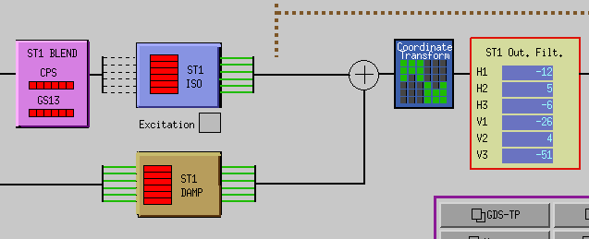
Figure – Medm sceen with damping loops on

Important note!
A gain of -1 is necessary for stable damping loops.

Step 19.1 – Simulation of damping performance - TF

Procedure to follow for this test:
- Open Step_4_Damping_Filters_X1_ISI_HAMX.m from its folder:
/SeiSVN/seismic/HAM-ISI/X1/HAMX/Scripts/Control_Scripts/
- Update fields
- Run Step_4_Damping_Filters_X1_ISI_HAMX.m
- Test data is automatically saved under the local copy of the SVN:
- The continuous and digital filters
- The parameters needed for the next steps
- Data and figures related to the damping simulations

Step_4_Damping_Filters_X1_ISI_HAMX:
- Loads the symmetrized Cartesian to Cartesian data
- Applies the generic damping filters designed by the user
- Simulates the SISO and MIMO response with the damping filters engaged
- Saves the damping filters in the structure: aLIGO_HAM_ISI_Damping_CT

The filters structure in the SVN at:
/ligo/svncommon/SeiSVN/seismic/HAM- ISI/M1/HAMX/Filters/X1_ISI_HAMX_Filters.mat

The parameters will be saved at:
/SeiSVN/seismic/HAM- ISI/X1/HAMX/Data/Transfer_Functions/Simulations/Parameters/ X1_ISI_HAMX_Parameters_date.mat

The frd structure in the SVN at:
/SeiSVN/seismic/HAM- ISI/X1/HAMX/Data/Transfer_Functions/Simulations/Damping/

The damping simulation figures in the SVN at:
/SeiSVN/seismic/HAM- ISI/X1/HAMX/Data/Figures/Transfer_Functions/Simulations/Damping/

Continuous HAM6 filters in the SVN at:
/SeiSVN/seismic/HAM-ISI/Common/HAM6_Main_Results/
HAM6_LLO_Damping_Filters.mat

Acceptance criteria:
- HAM6 damping loops must stable with
  - Phase margin must be at least 45º
  - Gain margin must be at least 20dB
The tests report must contain:
- Figures Damping loop (horizontal and vertical filters)
- Path in SVN of Cartesian to Cartesian measurements
  - Data
  - Scripts used for processing
  - Figures
- Issues/difficulties/comments regarding this test
- Test result (Passed: Failed: ).

Step 19.2 – Experimental evaluation of damping performance - Spectra
The stability of the damping loops was verified, in simulation, during the previous step. The HAM6 digital damping filters can now be loaded in MEDM.
Damping filters should not be modified at this time. Don’t forget to create bac-up files if you decide to modify them.

Procedure to follow for this test:
- Load the damping filters under Foton
- Load the damping filters under MEDM
- Set the gain of the DAMP channels to -1
- Make sure the banks of the damping filters are disabled
- Get the GPS time in Matlab® (gps_now)
- Paste it as the first argument of GPS_TIME Controlled, line 118 of the Master script
- Wait for 35 minutes
- Enable the damping filters’ banks
- Get the GPS time in Matlab®
- Paste it as the second argument of GPS_TIME Controlled, line 119 of the Master script
- Wait for 35 minutes
- Run the paragraph of the Master script called Comparison configuration undamped vs damped or controlled
- Figures are automatically saved. Paste them in the report.

Filters used by Damping loops in SVN at:
/SeiSVN/seismic/HAM-ISI/X1/Unit_1/Data/
- G1ISIHAM_LHO_Unit_1_DATE.txt
(digitalized filters copied and rename to G1ISIHAM.txt in /opt/rtcds/geo/g1/chans)
- HAM6_LHO_Damping_Filters.mat
(continuous filters)

Scripts files for processing and plotting in SVN at:
/SeiSVN/seismic/HAM-ISI/X1/Scripts/Data_Collection/
Spectra_Measurement_HAM_ISI_Undamped_Damped.m

/SeiSVN/seismic/HAM-ISI/X1/Unit_1/Data/ Spectra/Damping/
LHO_HAM_ISI_Unit_1_Damping_Spectra_DATE.m

Data files in SVN at:
/SeiSVN/seismic/HAM-ISI/X1/Unit_1/Data/ Spectra/Damping/
LHO_HAM_ISI_Unit_1_Calibrated_PSD_CPS_GS13_Undamped_Damped_DATE.mat

Figures in SVN at:
seisvn/seismic/HAM-ISI/X1/Unit_1/Data/Figures/ Spectra/Damping/
- LHO_HAM_ISI_Unit_1_Calibrated_PSD_GS13_Undamped_Damped_DATE.fig
- LHO_HAM_ISI_Unit_1_Suppression_Exp_vs_Sim_DATE.fig

Acceptance criteria:
- HAM6 damping loop must stable when all damping loops are engaged
- Similar damping effect than in simulated plots
The test report must contain:
- Figures of Dampimg loops controller (vertical and horizontal)
- Figures of suppression Measurement vs simulation vs HAM6
- Path in SVN of Cartesian to Cartesian measurements
  - Data
  - Scripts used for processing
  - Figures
- Issues/difficulties/comments regarding this test
- Test result (Passed: Failed: ).

Appendix A: Dial indicators location

In order to ensure repeatable measurements from one unit to another, dial indicators have to be installed properly in the right locations. This section describes how to do it.

Dial indicators are used to monitor actual table motions & offer a back-up position measurement to the Capacitive Position Sensors. Breadboards on Stage 0 are used to mount the dial indicators. Dial indicators should resolve to at least 0.001”. Try to avoid using complicated or long mounting hardware; we do not want to have the Dial Indicator mounted on a long post and possibly being easily “bump-able”.

We have chosen to use horizontal & vertical dial indicators near each of our four Lockers. The vertical dial indicator registers on a bottom surface of Stage 1. The horizontal dial indicator registers on one of the radial surfaces on the Top Mount of the Locker.

Dial indicators should be pulled away from the ISI system when one wants to take noise measurements.

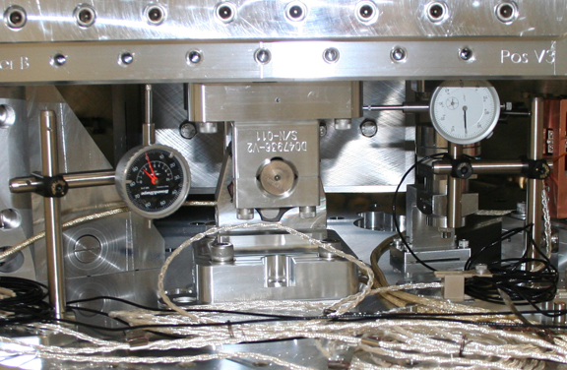
Figure - Vertical & Horizontal dial indicators installed near locker B

Dial indicators positions are presented in the figure below (blues dots and blue lines). Horizontal dial indicators A & C read negative for CCW rotation of Stage1 wrt Stage 0 whereas B & D read negative for CW rotation.

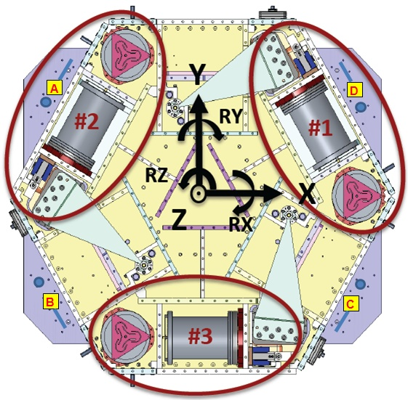
Figure - Top view of the HAM-ISI

Appendix B: Sensor calibration

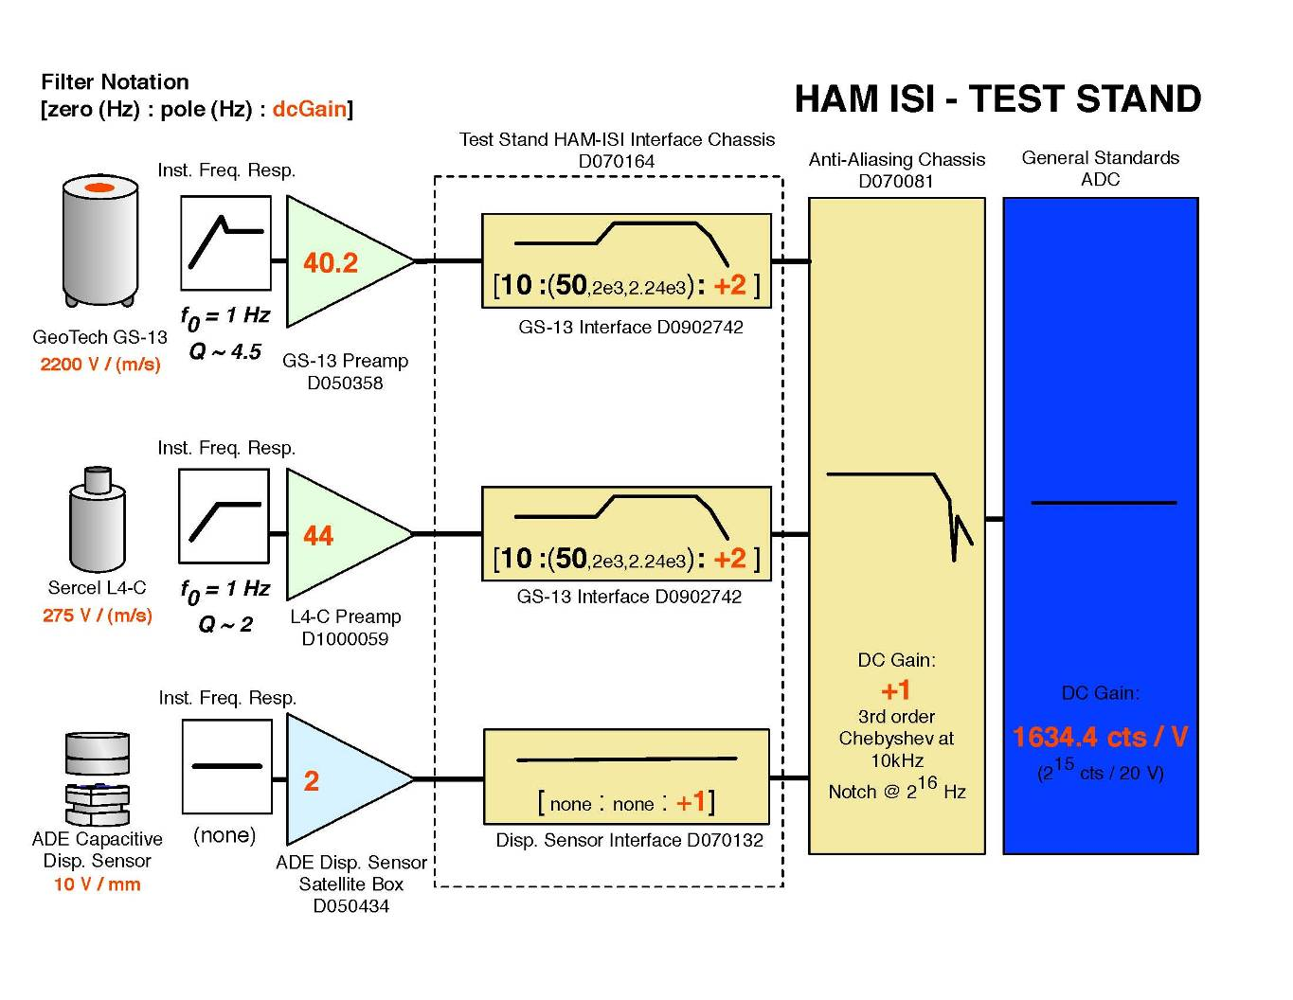

Appendix C: SVN arborescence

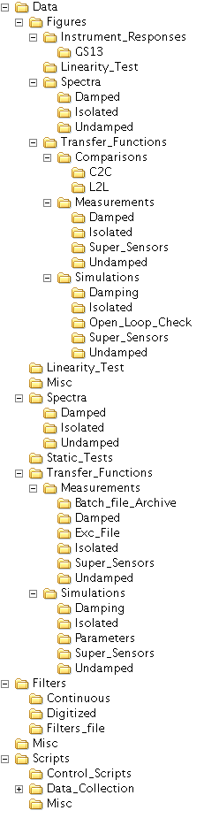
Figure - SVN arborescence - HAMX
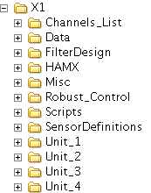

Figure - SVN arborescence - HAM-ISI overall on IFO

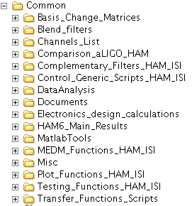
Figure - SVN arborescence - HAM-ISI common folder

Appendix D: Matrices

- GEO2CEN : from local to Cartesian (GS13 Geophones)
- DISP2CEN : from local to Cartesian (Capacitive displacement sensors)
- CONT2ACT : from cartesian to local (Actuators)

For example, CONT2ACT matrix is the following matrix
 | X | Y | Z | RX | RY | RZ
H1 | 0.333 | -0.577 | 0 | 0 | 0 | -0.431
H2 | 0.333 | 0.577 | 0 | 0 | 0 | -0.431
H3 | -0.667 | 0 | 0 | 0 | 0 | -0.431
V1 | 0 | 0 | 0.333 | 0 | -0.937 | 0
V2 | 0 | 0 | 0.333 | 0.812 | 0.469 | 0
V3 | 0 | 0 | 0.333 | -0.812 | 0.469 | 0

with Local_vector = CONT2ACT x Cartesian_vector

DISP2CEN is the following matrix
 | H1 | H2 | H3 | V1 | V2 | V3
X | 0.333 | 0.333 | -0.667 | -0.194 | 0.049 | 0.145
Y | -0.577 | 0.577 | 0 | 0.056 | -0.196 | 0.140
Z | 0 | 0 | 0 | 0.333 | 0.333 | 0.333
RX | 0 | 0 | 0 | -0.273 | 0.961 | -0.688
RY | 0 | 0 | 0 | -0.952 | 0.240 | 0.712
RZ | -0.422 | -0.422 | -0.422 | 0 | 0 | 0

with Cartesian_vector = DISP2CEN x Local_vector

Appendix E: CPS pre-bake testing procedure

Set up the offset on the jig. The test jig is shown on the picture below. Shim washers are used to set up the gap between the position sensor and the jig. A caliper is used to measure the jig cutout depth and the shims thickness.

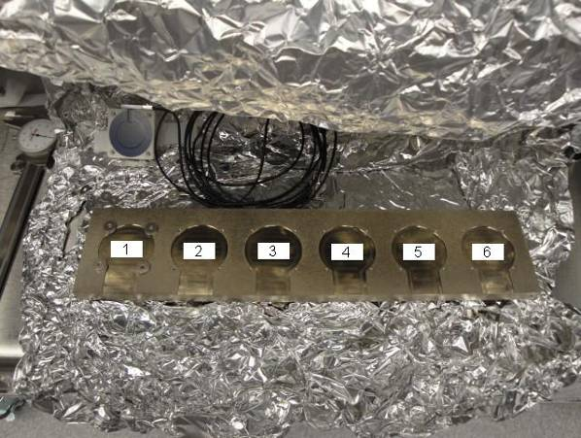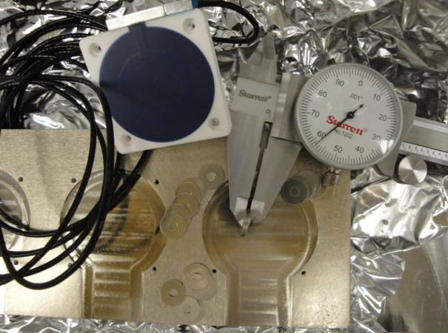

6 shims are measured at 0.058”. The cutout in the jig is 0.030” deep. The sensor extends out approximately 0.007” away from the surface where the shims are placed. So the gap is set up to be 0.081" nominal.
0.058"
Position sensors and shim washers prior installation:

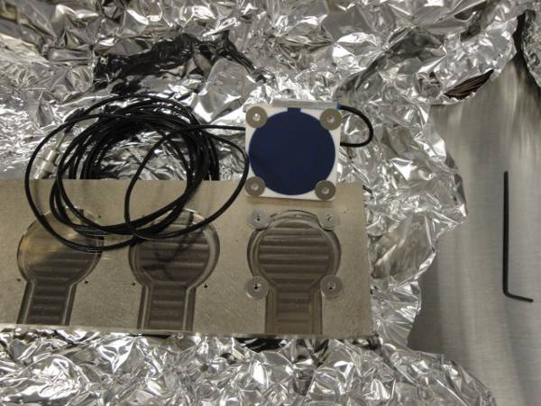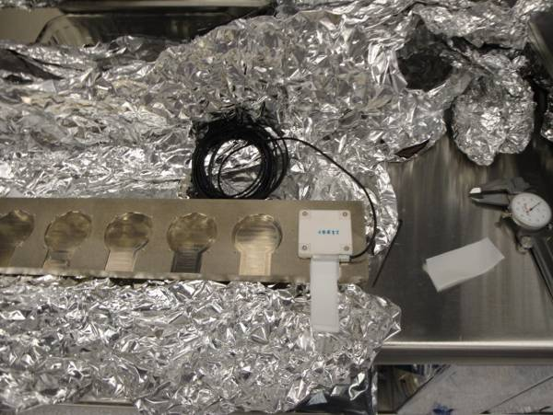

The displacement sensor mounted on the 6th spot of the test jig. Use teflon shims to check the gap.

1- Zeroing the offset of capacitive position sensors:
The range of the zeroing potentiometer is estimated to be + 5.5V and – 5.5V with a +-0.2V uncertainty from the differential outputs on the back of the satellite box. The counterclockwise rotation of the potentiometer was the direction most of the time it was turned when adjusted. So if the voltage read negative then the potentiometer was turned counterclockwise until the voltage was at about +-0.01V.

2- Measure power spectrum of the capacitive position sensor (V1/H1, V2/H2 and V3/H3) before baking.

Appendix F: Investigation of peaks in the CPS ASDs

Subject of investigation:
After measuring few amplitude spectral densities of CPS and GS13 on the HAM-ISI (HAM10), we were surprised by the high density of narrow peaks between 10Hz and 100Hz (cf figure ASD CPS on locked HAM-ISI). Since these peaks are less visible on GS13 spectra (cf step 6, GS13 ASD figure), we thought that electronic noise could create the high Q peaks on the CPSs. Since measurements are taken with the HAM-ISI in the so-called “locked” position, we should not see any stage 0 to stage 1 relative motion. Hence, we got concerned by the grounding of the new shielding installed on the CPS cables.

Data in SVN at:
/SeiSVN/seismic/HAM-ISI/X1/HAM10/Data/Spectra/Undamped/
- LHO_ISI_HAM10_ASD_m_CPS_T240_L4C_GS13_Locked_vs_Unlocked_2011_12_14.mat

Figures in SVN at:
/SeiSVN/seismic/HAM-ISI/X1/HAM10/Data/Figures/Spectra/Undamped
- LHO_ISI_HAM10_ASD_m_CPS_Locked_Zoom_2011_12_14.fig

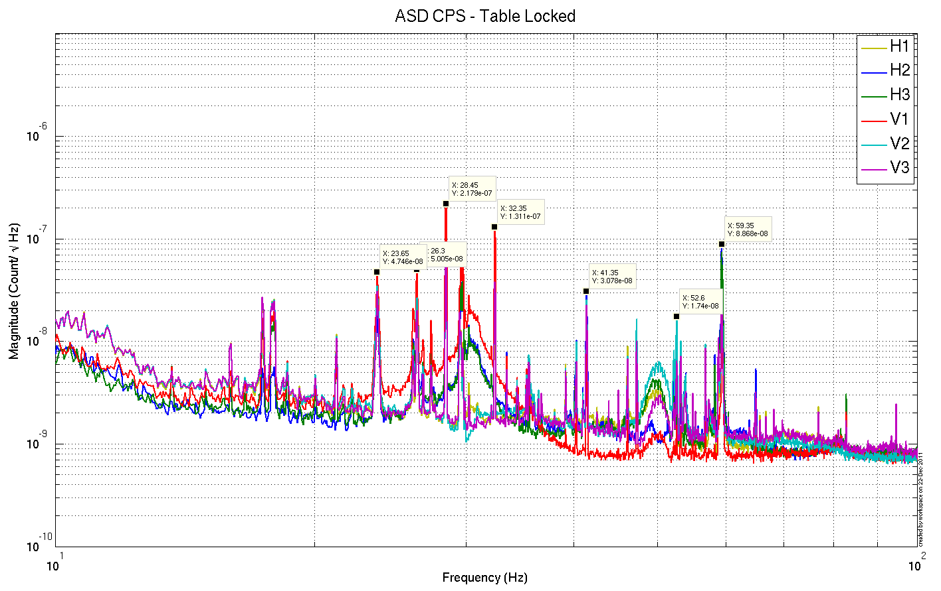
Figure –ASD CPS on locked HAM-ISIs

Extra tests:
We took measurements in different configurations to find the source of the peaks:
- CPS spectra fans ON vs fans OFF: We only saw minor differences
- Spectra of a locked CPS using the jig in several configurations:
  - Shield not connected to the ground
  - Shield connected to the ground

The two spectra (shield not grounded, and shield grounded) are identical and without any features in the 10-100Hz bandwidth (Noise floor at 5e-10 m/sqrt Hz). It confirms that CPSs are not picking up electric noise but are actually seeing a real motion.

The figure below is the calibrated ASD of the CPS on the jig.

- 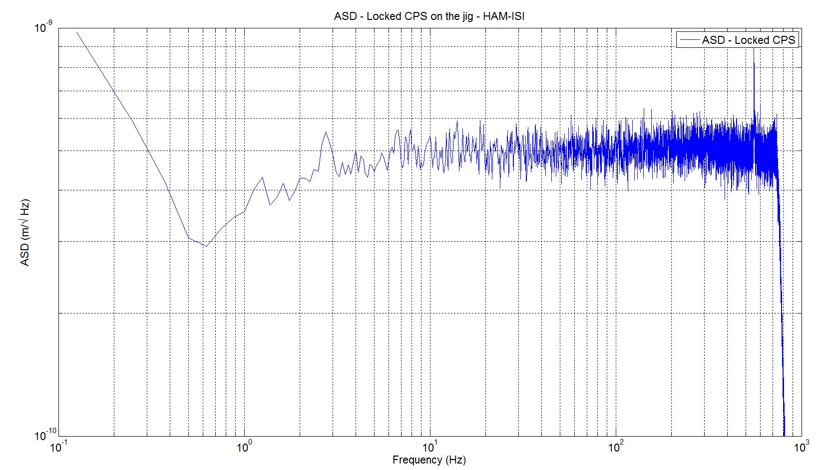
Figure –ASD locked CPS on the jig

Ground motion measurement
A L4C was set on the ground to confirm that the peaks seen on HAM-ISI CPS ASD, in the so-called “locked” position, comes from ground motion itself. Due to the passive isolation provided by the ISI above 1Hz, amplitudes of the narrow peaks (probably motors) are reduced on GS13 (in the unlocked and the so-called locked configurations).

Narrow peaks agree with ASD of CPS in “locked configuration”

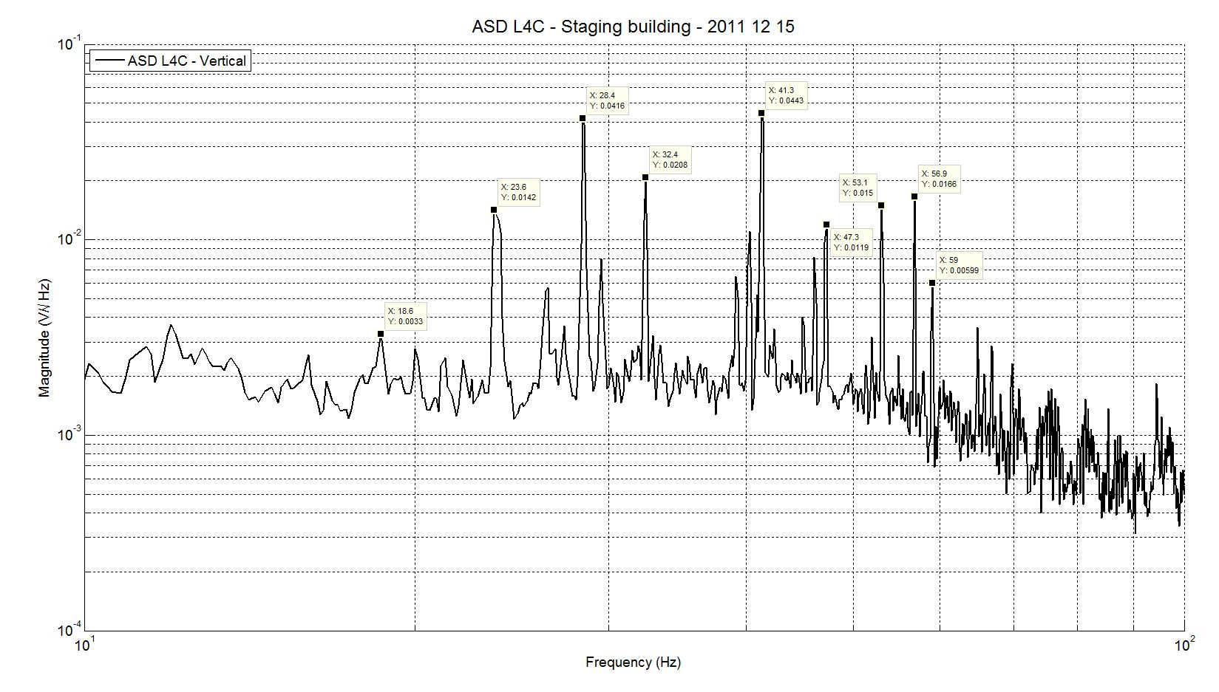
Figure – ASD of L4C on the ground in LHO staging building

Conclusions regarding this test:
This last measurement confirms that the peaks seen on the ASD of the CPS when the HAM-ISI is locked are due to ground motion.

