*LIGO Laboratory / LIGO Scientific Collaboration*

LIGO-T1000338-v4 *ADVANCED LIGO*

HAM Auxiliary Suspensions Final Design

Giacomo Ciani, Luke Williams, David Reitze

Distribution of this document:

LIGO Science Collaboration

This is an internal working note

of the LIGO Project.

|  |  |
| --- | --- |
| **California Institute of Technology**  **LIGO Project – MS 18-34**  **1200 E. California Blvd.**  **Pasadena, CA 91125**  Phone (626) 395-2129  Fax (626) 304-9834  E-mail: [info@ligo.caltech.edu](mailto:info@ligo.caltech.edu) | **Massachusetts Institute of Technology**  **LIGO Project – NW17-161**  **175 Albany St**  **Cambridge, MA 02139**  Phone (617) 253-4824  Fax (617) 253-7014  E-mail: [info@ligo.mit.edu](mailto:info@ligo.mit.edu) |
| **LIGO Hanford Observatory**  **P.O. Box 1970**  **Mail Stop S9-02**  **Richland WA 99352**  Phone 509-372-8106  Fax 509-372-8137 | **LIGO Livingston Observatory**  **P.O. Box 940**  **Livingston, LA 70754**  Phone 225-686-3100  Fax 225-686-7189 |

<http://www.ligo.caltech.edu/>

Contents

1 Introduction 3

1.1 Purpose 3

1.2 Scope 3

1.3 Acronyms 3

1.4 Applicable Documents 3

1.4.1 LIGO Documents 3

2 HAM Aux design 4

2.1 General description 4

2.2 Suspension Configuration 5

2.3 Mechanical design 8

2.3.1 Support structure 8

2.3.2 Blades 8

2.3.3 Wires and wire clamps 9

2.3.4 Optic Holder 9

2.4 Sensing/Actuation/Damping 10

2.4.1 AOSEMs 10

2.4.2 Eddy current dampers 11

2.5 Performance 12

2.5.1 Alignment and dynamic range 12

2.5.2 Transfer functions 13

2.5.3 Noise and damping 17

# Introduction

## Purpose

This is the Final Design Document (FDD) describing the HAM Auxiliary suspension (HAM Aux) and demonstrating their compliance with requirements as per [LIGO-T1000526](https://dcc.ligo.org/cgi-bin/private/DocDB/ShowDocument?docid=15165).

## Scope

This document describes the mechanical design of the HAM Aux as well as the integration of AOSEMs, passive damping and mechanical balancing systems both to damp the local resonances and to align the beam. It also summarizes results of modeling and experiments (described in detail in [LIGO-T1000339](https://dcc.ligo.org/cgi-bin/private/DocDB/ShowDocument?docid=12837)) that show that the design meets the noise and pointing range requirements.

## Acronyms

AOSEM Another Optical Sensor Electromagnetic Motor

CoM Center of Mass

DoF Degree(s) of Freedom

HAM Horizontal Access Module

HAM Aux HAM Auxiliary Suspensions

IO Input Optic

SOS Small Optics Suspension

## Applicable Documents

### LIGO Documents

[LIGO-T1000526](https://dcc.ligo.org/cgi-bin/private/DocDB/ShowDocument?docid=15165), “HAM Auxiliary Suspensions Design Requirements”

[LIGO-T0900495](https://dcc.ligo.org/cgi-bin/private/DocDB/ShowDocument?docid=6269), “HAM Auxiliary Suspensions Electronics Requirements”

[LIGO-T1000339](https://dcc.ligo.org/cgi-bin/private/DocDB/ShowDocument?docid=12837), “HAM Auxiliary Suspension modeling and test results”

[LIGO-D1000120](https://dcc.ligo.org/cgi-bin/private/DocDB/ShowDocument?docid=8638) "ALIGO IO HAM AUX SUS ASSEMBLY"

[LIGO-T970135-02](http://www.ligo.caltech.edu/docs/T/T970135-02.pdf), “Small Optic Suspension Final Design”

[LIGO T1000100-v2](https://dcc.ligo.org/cgi-bin/private/DocDB/ShowDocument?docid=9510), “Parametric Study of AOSEM Sensor Noise”

[LIGO-T1200049-v1,](https://dcc.ligo.org/LIGO-T1200049-v1) “HAM Auxiliary Suspensions magnet holder retrofit”

# HAM Aux design

## General description

The HAM auxiliary (HAM Aux) suspensions are used for suspended mirrors located in the IO on HAM 2 (straight) and HAM 8 (folded). HAM Aux suspensions are not planned for use in any aLIGO cavities. Mirrors suspended in HAM Aux suspensions are steering and focusing mirrors up to 3” in diameter.

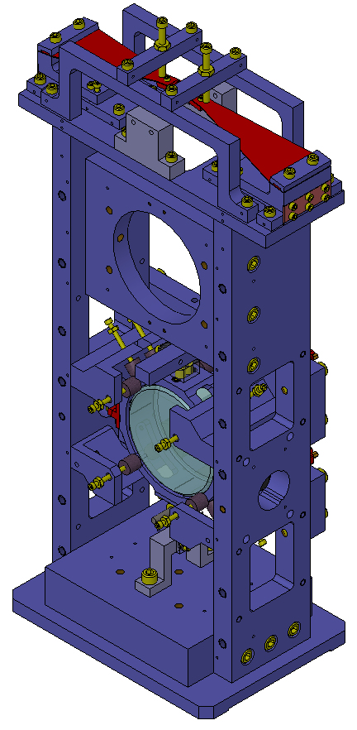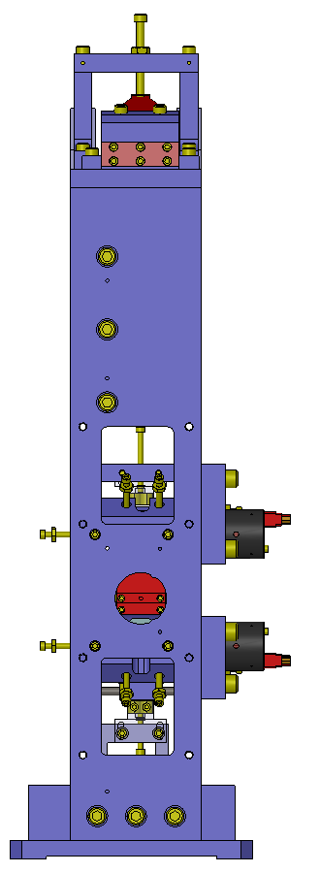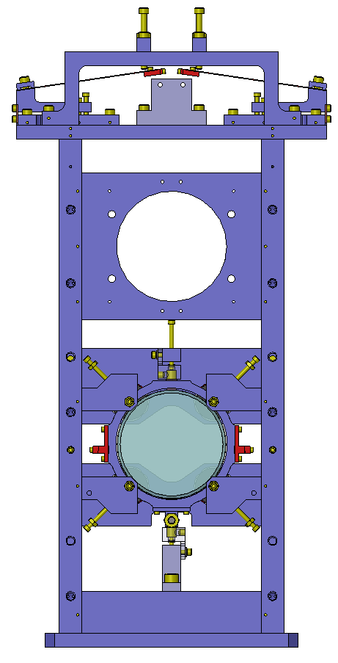

x

y

z

**Figure 1. SolidWorks model of the HAM Aux Suspensions. Coordinate system is taken to have the x axis coincident with optic axis, pointing from the back of the suspension (the one with the AOSEMs) towards the front of the suspension (where the HR side of the optic is), and z one in vertical, pointing upwards (see the small axes at the left of the figure).**

The design of the HAM Aux suspension, shown in , is based on a modified SOS design ([LIGO-T970135-02](http://www.ligo.caltech.edu/docs/T/T970135-02.pdf)). While the suspension characteristics (overall size, number of suspending wires, resonant frequencies, etc…) has been maintained close to the original SOS design, the main modification has been the introduction of a blade-based vertical isolation stage. In addition, a number of other modifications have been incorporated. In particular:

* An aluminum ring to hold the optic and accommodate all the mounting and AOSEM fixtures (magnets, cable clamps, etc). As a result, no gluing is performed on the optic anymore.
* A balancing threaded bar for high range, low resolution DC pitch pointing of the optic.
* The AOSEM used for damping of the swing motion orthogonal to the optical axis has been removed.
* Introduction of eddy-current dampers to reduce the Q of the vertical, roll and lateral swing DoF.
* Aluminum structure to reduce the weight.

## Suspension Configuration

The suspension chain is schematically explained below, and illustrated in Figure 2:

* The upper wire suspension points are represented by the tips of two blades that provide vertical isolation.
* Two wires, one per side, depart from the blade tips and are clamped at the lower end to the side of an aluminum barrel.
* The aluminum barrel hosts the optic and all the auxiliary fixtures (clamps, magnets for the AOSEMs, etc…)



Figure 2. A schematic of the suspension chain showing relevant parameters. (Refer to Table 1 for their values.) The blue circle represents the optic and the blue cross its center. The surrounding grey ring is the optic’s holder. The four small circles around the optics represent the position of the AOSEMs magnets. The red cross is the center of mass of the suspended assembly. Upper and lower ending points of the wires represent the blade tips in nominal (loaded) position and the wire break-off points at the optic barrel, respectively.

Relevant suspension parameters, as well as overall dimensions, have been maintained as close as possible to those of the SOS, thus obtaining similar pitch, yaw and swing resonances. They are summarized in Table 1.

Table 1. Suspension relevant dimensions

|  |  |  |
| --- | --- | --- |
| ***Name*** | ***Description*** | ***Nominal Value*** |
| dYaw | Distance between upper wire attachment points (at blade tips) | 15.7 mm |
| dClamp | Distance between lower wire attachment points (at clamps on Al barrel) | 100.3 mm |
| hWires | Vertical distance between upper and lower wire attachment points | 249.3 mm |
| lPitch | Vertical distance between lower wire attachment points and suspended assembly CoM (CoM is lower) | 1.0 mm |
| lPend | Vertical distance between upper wire attachment points and suspended assembly CoM (=hWires+lPitch) | 259.3 mm |
| hCoM | Vertical distance between optic axis and suspended assembly CoM (CoM is lower) | 2.65 mm |
| lAOSEM | AOSEMs’ arm length (both horizontal and vertical) with respect to optic geometric center | 29.09 mm |
| hBeam | Height of the optic axis above reference plane | 140.06 mm |

Table 2 lists the first six resonant modes of the suspension chain[1]. For each of these, the design value estimated using Mark Barton’s Mathematica toolbox is compared with the value measured on a prototype (without magnetic dampers installed, see also Table 4).

Table 2. Suspension modes and corresponding frequencies.

|  |  |  |  |
| --- | --- | --- | --- |
| Name | Description | Design value | Measured value |
| fPitch1 | Frequency of lower pitch/x normal mode | 0.98 Hz | 0.95 Hz |
| fPitch2 | Frequency of higher pitch/x normal mode | 1.12 Hz | 1.04 Hz |
| fYaw | Frequency of yaw mode | 0.76 Hz | 0.80 Hz |
| fBounce | Frequency of vertical motion | 7.19 Hz | 6.14 Hz |
| fRoll1 | Frequency of lower roll/y normal mode | 1.00 Hz | 1.00 Hz |
| fRoll1 | Frequency of higher roll/y normal mode | 10.63 Hz | 8.97 Hz |

The relatively big discrepancy between the modeled and measured resonant frequencies in the vertical and higher roll/y modes is briefly discussed in section 2.3.2.

For details on the modeling of the blades and the suspension chain see [LIGO-T1000339](https://dcc.ligo.org/cgi-bin/private/DocDB/ShowDocument?docid=12837).

## Mechanical design

The HAM Aux mechanical design is given in [LIGO-D1000120](https://dcc.ligo.org/cgi-bin/private/DocDB/ShowDocument?docid=8638). A brief description of each relevant subassembly follows.

### Support structure

The support structure has been maintained very close to the one of the SOS, the main modifications being the use of aluminum instead of stainless steel to reduce total weight (from about 27 lbs down to about 12 lbs), and the adaptation of the upper part to support the blades. Redesigning the upper part required the envelope to be slightly increased from 127x156x417 to 127x217x441 mm (in x, y and z directions respectively, as defined in ). Other minor modifications include support for lateral eddy current dampers and repositioning of earthquake stoppers and AOSEMs to conform to the presence of the Al barrel. The upper part also includes security stoppers for the blades.

### Blades

The suspension employs two 0.020” thick, 76.8 mm long (portion free to flex) stainless steel blades. The shape of a blade is represented in Figure 3.



Figure 3. The approximate shape of one of the two blades used for vertical isolation. *l* has been chosen to be 76.8 mm, while *w* is 40.6 mm.

The requirements of the HAM Aux are more relaxed than for other suspensions. Hence, 304 stainless steel has been chosen because of easiness of procurement, handling and machining as compared to maraging steel or Be-Cu. Dimensions of the blades have been the result of a tradeoff between low vertical resonant frequency (not to exceed 10 Hz) and compact design. (Indeed, lowering the resonant frequency generally requires longer blades.)

According to analytical calculations and FEA simulations (see [LIGO-T1000339](https://dcc.ligo.org/cgi-bin/private/DocDB/ShowDocument?docid=12837)), the maximum stress of the blades under load will not exceed 90 MPa, less than 45% of the nominal yield strength of 304 stainless still (215 MPa).

Each blade is secured to an aluminum support that, in turn, is connected to the main structure via a flexible, yet stiff, steel plate. Two pair of screws on the support allow for pushing/pulling against the main structure, thus bending the flexible steel joint to finely adjust the position of the blade tip. This mechanism is shown in Figure 4.



Figure 4. Sketch of the blade adjusting mechanism. The pull and pushing screws force the flexible joint to bend, thus modifying angle of the blade.

As shown in Table 2, resonant frequencies for modes involving the bending of the blades (i.e. bounce and higher roll/y modes) are noticeably lower than expected. This leads us to conclude that blades are somehow softer springs than expected. The reason for this discrepancy has not been identified (it may be due to imprecise or uneven thickness of the blades, or previous stress in the material, etc.). However the blades have been verified not to yield after a few weeks under load.

### Wires and wire clamps

The optic holder is suspended by means of two wires, one on each side, connecting it to the blade tips. Piano wire[2] of the same kind employed in the SOS is used for the HAM Aux. However, as thermal noise is not an issue for this suspensions and a vertical spring is already provided by the blades, a bigger diameter (0.006” instead of 0.0016”) has been chosen for easy handling and improved strength.

The wires are clamped both at the tip of the blades and at the Al barrel. In both cases, clamps are designed so to hold the wires at the nominal angle they will have once the suspension is assembled and the optic released, so not to induce any bending at the wire release point (see [LIGO-D1000120](https://dcc.ligo.org/cgi-bin/private/DocDB/ShowDocument?docid=8638) for details). Moreover, the clamps on the optic barrel feature a series of closely spaced grooves in case varying the nominal suspension point is needed to compensate for tolerances in optic’s CoM position.

### Optic Holder

Employing an aluminum ring holder around the mirror alleviates the need for gluing OSEM magnets and wire standoff to the optic to be suspended.

The holder, shown in Figure 5 (see [LIGO-D1000120](https://dcc.ligo.org/cgi-bin/private/DocDB/ShowDocument?docid=8638) for details), has the shape of an aluminum ring that contacts the optic along two lines parallel to the axis at 4 and 8 o’clock, and two PEEK set screws at 12 o’clock. The optic holder structure, designed to be as light as possible, also features standoffs for the AOSEM magnets, mounting points for the wire clamps and a through tapped hole at 6 o’clock. The tapped hole is used to install a copper threaded bar of the approximate weight of 6.5 grams, that can be translated back and forth to move the center of mass of the suspended assembly with respect to the wire clamping points, thus adjusting the DC pitch of the optic.

The AOSEM magnets are attached to the aluminum optic holder via press-fit stainless steel posts to which they stick magnetically, as described in [LIGO-T1200049](https://dcc.ligo.org/LIGO-T1200049).

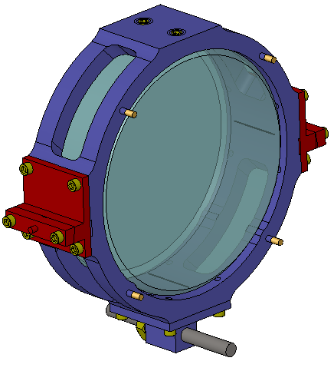

Optic SN is visible through here

Balancing bar

Contact line with optic

(2x)

Wire clamps

(2x)

Set screws to secure optic

(2x)

Magnets for AOSEMs

(4x)

Figure The aluminum barrel that holds the optic and hosts all the mounting fixtures. Some of them are indicated in the picture.

## Sensing/Actuation/Damping

Both AOSEMs and eddy current dampers are employed to provide active and passive damping of the suspension resonances. AOSEMs also provide beam pointing ability by controlling the pitch and yaw of the optic.

### AOSEMs

Four AOSEMs are installed on the back of the optic, with axes parallel to the optic axis and following a 58.17 mm square pattern centered with the optic. The OSEMs are mounted on two independent support plates; each of them accommodates two OSEMs and can be adjusted in both y and z position for a more accurate centering with respect to the optic.

Figure 6 shows the naming conventions for the AOSEMs as seen from the back of the suspension, while Table 3 summarizes the magnets employed and the consequent force coefficient.

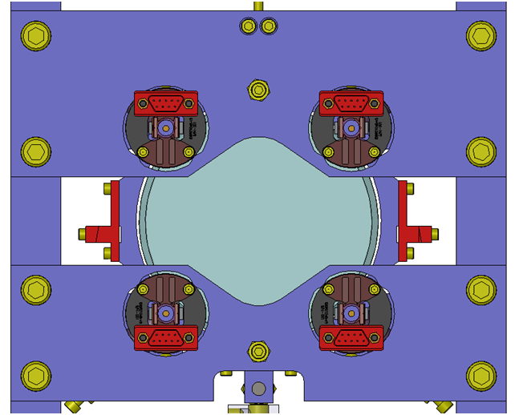

LOWER RIGHT

LOWER LEFT

UPPER LEFT

UPPER RIGHT

Figure 6. Naming conventions for AOSEMS for the HAM Aux suspensions.

Table 3. Magnet and OSEM properties

|  |  |  |  |
| --- | --- | --- | --- |
| NAME | OSEM | MAGNET SIZE/DIPOLE MOMENT | FORCE COEFF |
| UPPER LEFT | AOSEM | 3.175 mm long, 0.9525 mm radius, 0.075 A/m2 | 0.016 N/A |
| UPPER RIGHT | “ | “ | “ |
| LOWER LEFT | “ | “ | “ |
| LOWER RIGHT | “ | “ | “ |

The AOSEMs provide signals used to sense the optic pitch, yaw and displacement along the optic axis. They will be also used in a control loop to actively damp suspension resonances in the 0.1-10 Hz band. See [LIGO-T0900495](https://dcc.ligo.org/cgi-bin/private/DocDB/ShowDocument?docid=6269) for an example of the control loop and its performances.

### Eddy current dampers

Eddy current damping is provided by two pairs of anti-parallel neodymium magnets installed on the suspension structure above and below the aluminum ring supporting the optic. The magnetic axes of the magnets are aligned with the vertical direction, and they are disposed along the x direction (see Figure 7).



Figure 7. A conceptual drawing showing a lateral view of how the magnets are positioned for eddy current damping. The top part of the optic holder is shown. The two white rectangles represent the two cylindrical magnets, and the arrows indicate the direction of magnetization. The magnetic field in the region of the Al ring next to the magnets is almost parallel to the optic axis, thus effectively damping the bounce, roll and y movement of the suspended assembly.

In this way, eddy currents are induced in the aluminum ring itself when it moves with respect to the magnets. Installing the magnets on the structure has the advantage of making the suspended assembly less sensitive to varying environmental magnetic fields, or to the presence of magnetic material in the surroundings, even when strong magnets are used. Moreover, measurements have shown that using pairs of anti-parallel magnets doesn’t compromise damping performance, while greatly reducing the net field already at a few centimeters from the magnets.

This solution has proven to be effective in damping all the three DoF that are not actively controlled by the AOSEMs, as reported in 2.5.3.

## Performance

### Alignment and dynamic range

Machining tolerances, especially in the optic thickness, can cause the CoM of the suspended assembly to be displaced with respect to the nominal position. To compensate for this, the groove in which the wire is clamped at the bottom end can be chosen from among a group of 6, distributed over about 1.7 mm. This allow for correcting displacement of the CoM up to about 1 mm in both directions along the optic axis and have a residual pitch imbalance < 150 mrad.

Once the optic is suspended, initial pitch imbalance (due to finite resolution of the abovementioned mechanism or to other machining and assembling tolerances) and intentional DC pitch offset, if needed, can be adjusted by means of the threaded bar at the bottom of the Al ring. The bar can be screwed or unscrewed, modifying the position of the center of mass in a continuous fashion. While the range of adjustment is about ±350 mrad, estimating the resolution is more difficult as it depends on how good the operator is in both rotating the bar by small amount and securing it with the bolts without further moving it. However, a resolution better than 1 mrad seems easy to obtain.

Yaw pointing can be corrected by carefully positioning the suspension on the table. Considering a base width of about 160mm and assuming to be able to control a minimum displacement not bigger than 0.2 mm, a pointing accuracy better than 1 mrad is attainable.

Both these estimates are conservative, and the residual DC imbalance can be compensated actuating with the OSEMs using a fraction of their actuation range. Assuming a maximum current of 35 mA, as per [LIGO-T0900495](https://dcc.ligo.org/cgi-bin/private/DocDB/ShowDocument?docid=6269), they provide a DC actuation range of +- 10 mrad.

### Transfer functions

Cross-transfer functions between the theoretically coupled DoF of the suspension structure and of the optic have been calculated in [LIGO-T1000339](https://dcc.ligo.org/cgi-bin/private/DocDB/ShowDocument?docid=12837). They are illustrated in the following figures for reference.











### Noise and damping

Pitch, yaw and x DoF are actively controlled using the AOSEMs. This allows not only for DC pointing corrections, but also for active damping of the resonances. Figure 8 illustrates the projected pitch and yaw noise for an example feedback loop with calculated suspensions transfer functions. It demonstrates compliance with the requirements expressed in [LIGO-T1000526](https://dcc.ligo.org/cgi-bin/private/DocDB/ShowDocument?docid=15165).

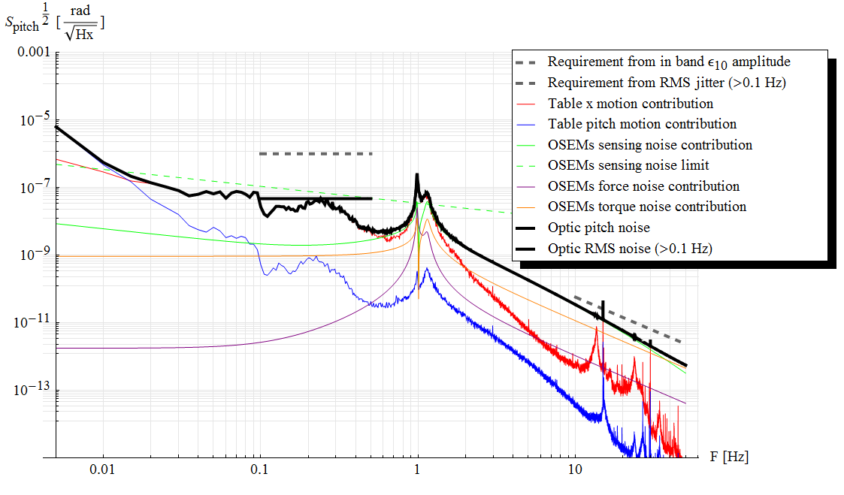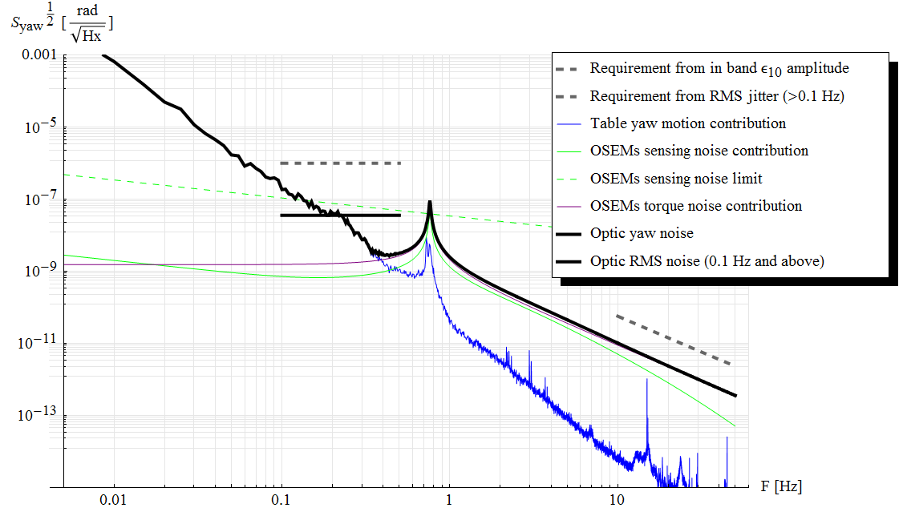

Figure 8. Overall closed loop HAM Aux pitch and yaw noise calculated using the Mathematica model mentioned in the text (see [LIGO-T1000339](https://dcc.ligo.org/cgi-bin/private/DocDB/ShowDocument?docid=12837)). Contributions from individual noise sources are also shown.

For the others degrees of freedom, nominally y, z and roll, passive damping is obtained via eddy current dampers described in 2.4.2. Measured quality factor for the corresponding modes, with and without dampers in place, are reported in Table 4 .

Table 4. Measured quality factors

|  |  |  |  |
| --- | --- | --- | --- |
| ***DOF*** | ***Q no damping (in air)*** | ***Q with damping*** | ***F with damping*** |
| Roll1 (around optic axis) | 6000 ± 1000 | 74 ± 2 | 1.02 Hz |
| Roll2 (lateral swing) | 500 ± 25 | 33 ± 3 | 8.98 Hz |
| Bounce | 420 ± 20 | 43 ± 3 | 6.12 Hz |

1. If we think of the suspended assembly as the only oscillating massive body in the suspension (thus neglecting the mass of wires, blades and blade tips), we have a total of six DoF (x, y, z, yaw, pitch and roll). These DoF are partially combined in an equal number of normal modes of oscillation, each one oscillating at a single, definite frequency: two of these modes (here labeled lower and higher pitch/x modes) mix the pitch and x motion, two other (labeled lower and higher roll/y modes) the roll and y, and the other two are modes involving a single DoF each (yaw and z).
2. California Fine Wire, music wire, hard temper, round cross-section, from a CFW812 spool.