LASER INTERFEROMETER GRAVITATIONAL WAVE OBSERVATORY
- LIGO –
CALIFORNIA INSTITUTE OF TECHNOLOGY
MASSACHUSETTS INSTITUTE OF TECHNOLOGY
Document Type  White Paper  Proposal | LIGO-M1000115-v5 | 3 June 2010

Expanding the LIGO Network:
The Case for Installing an
Advanced LIGO Detector in Australia

J. Marx, S. Whitcomb,
D. Blair, J. Davidson, A. Lazzarini, D. McClelland, J. Munch,
D. Reitze, D. Shoemaker, R. Weiss

California Institute of Technology  LIGO Laboratory - MS 18-34  Pasadena CA 91125  Phone (626) 395-212  Fax (626) 304-9834  E-mail: info@ligo.caltech.edu | Massachusetts Institute of Technology  LIGO Laboratory - MS NW22-295  Cambridge, MA 01239  Phone (617) 253-4824  Fax (617) 253-7014  E-mail: info@ligo.mit.edu

www: http://www.ligo.caltech.edu/

Expanding the LIGO Network:
The Case for Installing an
Advanced LIGO Detector in Australia
TABLE OF CONTENTS
1. Executive Summary and Introduction 4
2. Scientific ARGUMENT FOR A LIGO-Australia 8
3. Implementation of LIGO-Australia 17
4. Management 23
5. Australian Funding Needs and Approach 26
5.1. Construction Funding Needs 27
5.2. Potential Funding Sources for Construction 28
5.3. Operations Costs 30
5.4. Potential Funding Sources for Operations 30
5.5. Current Status of Funding Efforts 31
6. Staffing 31
7. Impact on the Advanced LIGO Project 33
8. Risks, possible impact and mitigation 36
8.1. Funding risks 36
8.2. Facility implementation risks 37
8.3. Staffing risks 38
8.4. Management risks 39
APPENDIX A. LIGO conditions for LIGO-Australia collaboration 41
APPENDIX B. Back-up Options 45
APPENDIX C. Advanced Virgo status and schedule 48
APPENDIX D. Weiss Committee report 49

LIST OF TABLES

Table 1: Network search volume ratios relative to the ideal HHL network. The second column shows the volume ratios assuming Gaussian noise for all networks. The third column shows the degradation of the search volume due to non-Gaussian and non-stationary noise for a False Alarm Rate (FAR) of less than 1/5 year. The FAR calculation for AHLV was not fully completed but is known to be very close to A₄₅HLV. 15

LIST OF FIGURES
Figure 1. Angular response (antenna pattern) of a LIGO detector. This pattern is the amplitude response, and assumes an unpolarized source. 11
Figure 2. Error boxes for the HHLV (left) and AHLV (right) networks. The plots show the 90% confidence contours. The red X’s are points in the sky where the signal would be poorly detected with an SNR < 12 for the combined network. 13
Figure 3. Two dimensional probability density contours for the model parameters of a binary neutron star system’s luminosity distance and orbital inclination angle (iota) relative to the line of site in the two networks. The green dot shows the input value of the model parameter (iota is symmetric about π ). The solution using the HHLV network is bimodal. The degeneracy is broken in the AHLV network. The color coding indicates the amplitude of the probability density in units of 1/(Mpc*radian). 14
Figure 4. Strawman schedule for steps leading to a decision to proceed. Some of the activities will be influenced by as-yet unknown factors (e.g., the schedule for an EIF proposal round) and the durations of other activities (e.g., NSF evaluation of the proposed plan), for which best guesses have been made. 20
Figure 5. Strawman schedule of steps following a decision to proceed. 23
Figure 6. WBS for the LIGO-Australia Project. 27

Executive Summary and Introduction
This white paper describes an important opportunity to extend the LIGO network of gravitational wave interferometers and so to significantly increase the scientific payoff from the NSF’s investment in Advanced LIGO.
The Gravitational Wave International Committee (GWIC), under the International Union of Pure and Applied Physics (IUPAP) has recently developed a 30-year strategic roadmap for the field of gravitational wave science. That roadmap gives the highest priority for ground-based gravitational wave science to extending the global network of advanced gravitational wave interferometers anchored by Advanced LIGO and the French-Italian-Dutch Advanced Virgo with an instrument of comparable capabilities in the Southern Hemisphere. This global network of advanced detectors separated by continental distances would, using the measured time-of-arrival of a gravitational wave signal, be able to identify the position on the sky of gravitational wave sources to an accuracy of ten square degrees or better over most of the sky, an accuracy well matched, for example, to wide-field optical telescopes and other instruments that could do rapid follow-up observations of gravitational wave sources across the electromagnetic spectrum. Without an instrument in the southern hemisphere the needed pointing accuracy could only be achieved over a limited portion of the sky, essentially perpendicular to the plane formed by the two LIGO sites in the US and the Virgo site in Italy.
In addition, an optimally aligned instrument in the southern hemisphere would allow the network to provide important information about the polarization of the gravitational waves leading to improving the accuracy that parameters of astrophysical sources such as neutron-star or black-hole binary inspirals can be determined as well as improving the duty cycle of the network.
The benefit of an instrument in the southern hemisphere has been apparent for some time, but with the construction of Advanced LIGO and Advanced Virgo now in full swing, it has become more crucial that such an instrument come online within the next decade. Given the cost, complexity, site requirements and need for a cadre of experienced scientists and engineers, the only feasible way to implement a detector in the southern hemisphere in the needed time frame is to utilize the well-characterized site at Gingin in Western Australia and to install the technical components from one of the three Advanced LIGO instruments into a vacuum system constructed at the Gingin site utilizing Australian resources. This instrument, designated LIGO-Australia, would be operated as part of the LIGO network.
The concept for LIGO-Australia may be summarized as follows: to move one of the three Advanced LIGO interferometers to Australia, , thus establishing a southern hemisphere node in the global gravitational wave telescope. It is feasible to expect construction and acceptance of this instrument can be completed as early as 2017, only a few years later than the expected acceptance of the Advanced LIGO and Advanced Virgo instruments. For this vision to become reality, the key first milestone occurs in the third quarter of 2011 when a go/no-go final decision to proceed with LIGO-Australia must be made. Soon after this date installation of the components for the target instrument, the second interferometer at Hanford, must begin.
A committee of the LIGO Scientific Collaboration (LSC), chaired by Prof. Rai Weiss (MIT), has been charged with evaluating both the scientific benefits of the LIGO-Australia concept as well as any loss of capability or negative impact to early detection of gravitational waves by Advanced LIGO. The Weiss Committee identified many advantages of having the third Advanced LIGO interferometer sited in Australia instead of Hanford and no significant disadvantages. The Weiss Committee finds that the ability to determine the position of a source in the sky is improved by a factor of 5-10 over significant portion of the sky. In many places on the sky, using reasonable signal to noise, the uncertainty in position approaches 1 square degree -- sufficiently small to enable electromagnetic astronomical identification of the source. In addition, source parameter estimation and waveform reconstruction is improved by including the Australian instrument. The full Weiss committee report is attached in Appendix D.
LIGO-Australia would be a second-generation gravitational wave interferometer assembled with Advanced LIGO components in a vacuum system and other infrastructure (site, roads, buildings, etc.) to be provided by Australia. Australia would also provide the staff for assembly, installation, testing and scientific operation of the instrument as well as operations costs for at least a ten-year period. Other ancillary costs such as shipping of components from the US, management costs, duties, etc. would also be the responsibility of Australia. As a result, LIGO-Australia would not require additional funds or equipment from the US beyond the Advanced LIGO components for either construction or operations.
During the construction phase of LIGO-Australia, the primary governing management agreement will be between the US and Australia only. Other international partners may be by Australia with joint US/Australian approval. The construction will be managed as a “big science” project within Australia. The Australian International Gravitational-Wave Observatory (AIGO) Laboratory that will be created by a multi-university consortium in Australia with the University of Western Australia as the lead institution. The selection of the AIGO Director, LIGO-Australia project head, project manager and other key staff will require the concurrence of the LIGO Laboratory Director.
In order to assure that LIGO-Australia fully meets the scientific capabilities needed to match those of the Advanced LIGO instruments in the US, any changes to the design, configuration, technical implementation or other aspects of LIGO-Australia will be limited and will require the written approval of the LIGO Laboratory Director; if these rise to the level where they affect top-level performance parameters, approval of NSF will also be required. Also, staff from LIGO Laboratory will participate in all major design and progress reviews of LIGO-Australia as well as consult on a limited as-needed basis.
During the operations phase of LIGO-Australia the AIGO facility will be managed jointly by US and Australia institutions as an integral part of the LIGO network. LIGO-Australia will operate as the equivalent of a third LIGO observatory site, subject to overall programmatic direction and oversight by the LIGO Laboratory Director in consultation with the AIGO Director, in analogy to the relationship between the LIGO Laboratory Director and the US LIGO site heads. In order to assure close coordination of the whole LIGO network, the AIGO Director and the AIGO operations leader will become members of the LIGO Laboratory Executive Committee as are the heads of the US sites. There will also be an oversight body for the AIGO Laboratory that should include representatives of major stakeholders as members, including LIGO Laboratory, Caltech, MIT, the NSF, Australian stakeholders and other overseas stakeholders.
The LIGO-Australia effort will be configured to assure that any impact on the Advanced LIGO project is minimal. Staff from Advanced LIGO will not be involved in LIGO-Australia so long as they have active project responsibilities. The only burden on active Advanced LIGO Project staff will involve the project management effort to reconfigure the project plan to accommodate the changes due to LIGO-Australia and a small amount of time spent by some on reviews and in consultation.
The scope of work for the Advanced LIGO MREFC construction project will be reduced as there will no longer be a need to install and test a third interferometer by project staff. As a result, the cost of the Advanced LIGO Project could be reduced by up to $4-8 million (depending on when the decision to proceed with LIGO-Australia is made) and the time to acceptance of the last interferometer (now the 2nd) would be reduced by up to 6 months. These cost and time savings should be utilized to increase the project’s funding and schedule contingencies in order to reduce risk to the project being completed on time and within budget. Some of the cost savings can be used to support appropriate pre-operational activities as part of the MREFC utilizing staff made available by the reduction in installation and test activities.
A number of possible uncertainties that could result in risk to the success of LIGO-Australia have been considered and measures to mitigate them have been adopted by LIGO Laboratory and the Australia consortium. These uncertainties are related to non-US funding of construction and operations, construction and project management capabilities, experienced scientific and technical staffing in Australia, unnecessary technical changes that could compromise performance, and management of operations so that LIGO-Australia operates as part of a coherent LIGO network.
A set of conditions and requirements have been communicated to and accepted by ACIGA (the Australian Consortium for Interferometric Gravitational Astronomy) and the Deputy Vice Chancellors for research of the five Australian Universities working towards LIGO-Australia (see Appendix A). These conditions and requirements are meant to assure:
- that solid funding commitments by Australia to build LIGO-Australia and operate it are in place before a final commitment to send Advanced LIGO components to Australia is made,
- that a management structure is put in place that will successfully complete the construction of the infrastructure and then the installation, testing, commissioning and operations for science of LIGO-Australia,
- that LIGO Laboratory personnel will participate in design and progress reviews for LIGO-Australia and that no changes in design can take place without approval of LIGO Laboratory,
- that the choice of key leadership personnel requires the concurrence of the LIGO Laboratory Director,
- that a staffing plan will be presented to and approved by LIGO Laboratory,
- that a contingent of Australian scientists and engineers will travel to the US to work directly on Advanced LIGO to assure that they become well trained and familiar with the installation, testing, commissioning and operations of an advanced gravitational wave interferometer,
- that LIGO-Australia will operate as the equivalent of a third LIGO observatory site, subject to overall programmatic direction and oversight by the LIGO Laboratory Director in consultation with the AIGO Director,
- that LIGO-Australia adheres to the data management plan that the LIGO Laboratory is establishing for open data release to the broader research community.

We must ensure that the LIGO-Australia effort has no negative impact on Advanced LIGO by distracting people from the US effort. Since each phase of LIGO-Australia will occur after the corresponding phase for Advanced LIGO, this will allow some experienced personnel from LIGO Laboratory to consult with and advise our Australian colleagues without negatively impacting the Advanced LIGO Project.
With this white paper the LIGO Laboratory hereby seeks NSF input, approval and support to pursue this plan along with our Australian colleagues and university supporters. We ask for NSF input on what conditions must be met (and by when) in order to achieve a positive decision and that a process leading to such a decision be pursued.
On the Australian side, the next step is for the ACIGA universities to establish a management entity that can direct efforts towards the project and also to seek funding in Australia for their portion of the project. AIGO must also secure commitments for operations funding. It is likely that multiple sources of funds will be required to secure the necessary support. Contributions from the Western Australia State Government, the ACIGA universities, and the Australian Research Council (ARC) may be sufficient, but the complexity of multiple funding sources will make this task a challenge.
In parallel with the above pursuits of funding, it will be important for all the involved parties -- LIGO Laboratory, NSF, Caltech, MIT, the ACIGA universities, AIGO Laboratory, and relevant Australian authorities -- to develop a common understanding of what formal agreements are required and how to provide sufficient future assurances of commitment. At a working level, this would at a minimum require a Memorandum of Understanding between the LIGO Laboratory and the AIGO Laboratory.
In spite of the many challenges and uncertainties, the very important extension of the scientific capabilities of the ground based gravitational wave network that would be provided by LIGO-Australia, especially in astronomy and astrophysics, have motivated the gravitational wave community in the US, Australia and elsewhere to work towards making LIGO-Australia a reality.

Scientific ARGUMENT FOR A LIGO-Australia
In this section we will first describe the rationale for the current LIGO baseline. This will be followed by a quick overview of the interfaces to astronomy that drive the need to increase the international network, provide a heuristic explanation of why good all-sky angular resolution requires a southern hemisphere detector, and finally summarize the detailed findings of the LIGO Scientific Collaboration report comparing the current baseline with the proposed change to move the second LIGO Hanford detector to Australia.
The initial and Advanced LIGO network configurations
The initial LIGO proposal made to the NSF in 1989 envisaged a configuration consisting of 4km interferometers at both sites with a 2km at Hanford. The motivation for three interferometers, and in particular for the 2km interferometer at Hanford, was to:
- Provide an additional detector to reduce the accidental coincidence rate for gravitational waves, particularly in the face of non-Gaussian noise. It was recognized that there would be some correlation between the 4km and the 2km from environmental effects: nevertheless, the ability to veto events observed in the main 4km detectors was the key function.
- Provide an additional consistency test for candidate gravitational wave events through the amplitude ratio proportionality with length between the 2 and 4km detectors.
However, the decision to locate two interferometers in the Hanford vacuum system was also largely driven by cost. Adding a third site to the initial LIGO project would have increased costs by on the order of 30%. If money were no issue, the clear preference would have been to locate the third LIGO detector at a third well-separated site from the other two detectors.
Our experience with initial LIGO has added to our understanding of these potential benefits. The amplitude and waveform consistency tests were very valuable, until Virgo brought us a third interferometer site without the potential noise correlations and with less of an intrinsic limit on interferometer sensitivity. Also, in practice the correlated noise sources identified to date have tended to originate in the corner station; thus sharing the same corner station appears to have overwhelmed any advantage of not sharing common end stations.
The baseline for Advanced LIGO program continued to have three detectors: however, the 2km detector at Hanford is to be converted to become a second 4km instrument. There are excellent scientific and programmatic reasons to do this. At the time Advanced LIGO was proposed and approved, there were no firm plans to up-grade Virgo, and no commitment from their funding agencies for further support. Thus it was thought at the time that for Advanced LIGO to have a robust capacity to make a first detection of gravitational waves, the second Hanford detector was very desirable. Because short-duration non-Gaussian noise is extremely difficult to predict for any particular instrument, the ability to perform triple coincidence measurements was felt to be essential. In the past year, CNRS and INFN have approved the Advanced Virgo Project, an up-grade to Virgo with similar sensitivity and similar construction schedule to Advanced LIGO. Because of the LIGO-Virgo collaborative agreement, begun during the initial detector era but negotiated an the basis of continuing into the Advanced Detector era, the need for the third interferometer to be operational in the same configuration and at the same time as the first two Advanced LIGO detectors is reduced. Further information about the Virgo plans for Advanced Virgo is contained in Appendix C.
With the Virgo interferometer in the network, the second Advanced LIGO detector at Hanford becomes much less important for ensuring a secure first detection. The false alarm rate of a network depends critically on the character of the noise, particularly any non-Gaussian component. Once the data has been made close to Gaussian by either improvements in the detector or by more restrictive strategies in the data analysis, the addition of another detector improves the network SNR by the square root of the number of detectors, not dramatically. This has become the case for binary neutron star inspirals, but not yet for the unmodeled bursts.
The third Advanced LIGO detector continues to be important, but its importance is increasingly due to its role in the era of regular detections when gravitational wave astrophysics will be the primary scientific focus. It offers the opportunity to be operated in a different mode to explore different types of sources; for example it can be configured to operate in a narrow band mode to provide a higher sensitivity probe of particular sources such as neutron star oscillations, while continuing broadband observations with the first two LIGO interferometers. It can also be used for exploratory development, as a testbed for enhancements or improvement to the Advanced LIGO detectors. It will still be possible to use one of the Advanced LIGO interferometers for these purposes regardless of its location; during such activities, the network will revert back to a three site configuration, the same configuration as it would have had if one of three US LIGO detectors were taken out of observational mode.
Gravitational waves as a component in multi-messenger astronomy
As the reality of Advanced LIGO and its sister projects in the world has become more evident, the number of scientists, particularly astronomers outside the gravitational wave community with an interest in gravitational wave observations has grown. The growing trend in astronomy is to use all available observational channels to tackle specific problems, and gravitational waves have a special role to play in this process.
The complementary information contained in the gravitational wave signals can be combined with electromagnetic observations in many ways:
- The inspiral signal of a compact binary (composed of neutron stars and/or black holes) in the minutes before merger is a self-calibrating distance indicator, independent from any other astrophysical distance ladder. By correlating these sources with their host galaxies, the redshift-distance relationship can be given a new test.
- Short Gamma Ray Burst (GRB) sources are widely thought to be the product of binary neutron star (or neutron star-black hole) mergers. The simultaneous observation of a localized gravitational wave and a gamma ray would definitively establish that neutron star binary mergers are the progenitors of short hard GRBs, and give the masses of the progenitors. The polarization of the gravitational wave signal can be used to determine the inclination angle of the orbit, and this can be combined with gamma ray observations to constrain the beaming of the gamma rays.
- Combined observations of gravitational waves, neutrinos and the electromagnetic spectrum can give new insights into core collapse supernovas.
- One of the more interesting cases would come when the gravitational wave network discovers something truly unexpected, and one requires the EM observation to try to understand the astrophysical process that generated the gravitational wave.
The growing interest in combined gravitational wave/electromagnetic observations is evidenced by the number of papers submitted to the US Astronomy Decadal Survey Panel.
However, this synergism with other astronomical observations depends critically on correlating gravitational wave data with electromagnetic data from the same events, and that is facilitated by having gravitational wave source locations with error boxes of a few degrees or less, to permit rapid follow-up across the electromagnetic spectrum.
The Gravitational Wave International Committee (GWIC) has recently developed a 30-year strategic roadmap for the field of gravitational wave science. The GWIC roadmap recognized and emphasized the need to integrate gravitational wave observations with the rest of astrophysics. In the area of ground-based detectors, the GWIC roadmap places its highest priority on creating a truly global network of second generation (Advanced) detectors capable of observing the entire sky. Key to that network is a detector in the southern hemisphere.
The need for a Southern Hemisphere detector
The need for a global scale network to achieve this level of angular resolution has a simple heuristic explanation. The LIGO detectors operate in the limit where the detector size is much smaller than the wavelength of the gravitational waves, and as a result they have a very broad angular response function. This is in many ways analogous to a small dipole antenna response to a long wavelength electromagnetic wave, with its familiar sin(θ) amplitude response. A full calculation of the antenna pattern using the tensor nature of Einstein’s gravitational theory produces the peanut-like angular detector response shown in Figure 1. The final difference between a gravitational wave detector and an electromagnetic dipole is that the earth is completely transparent to gravitational waves, and thus the gravitational wave detector cannot even distinguish waves coming from above and those coming from below.

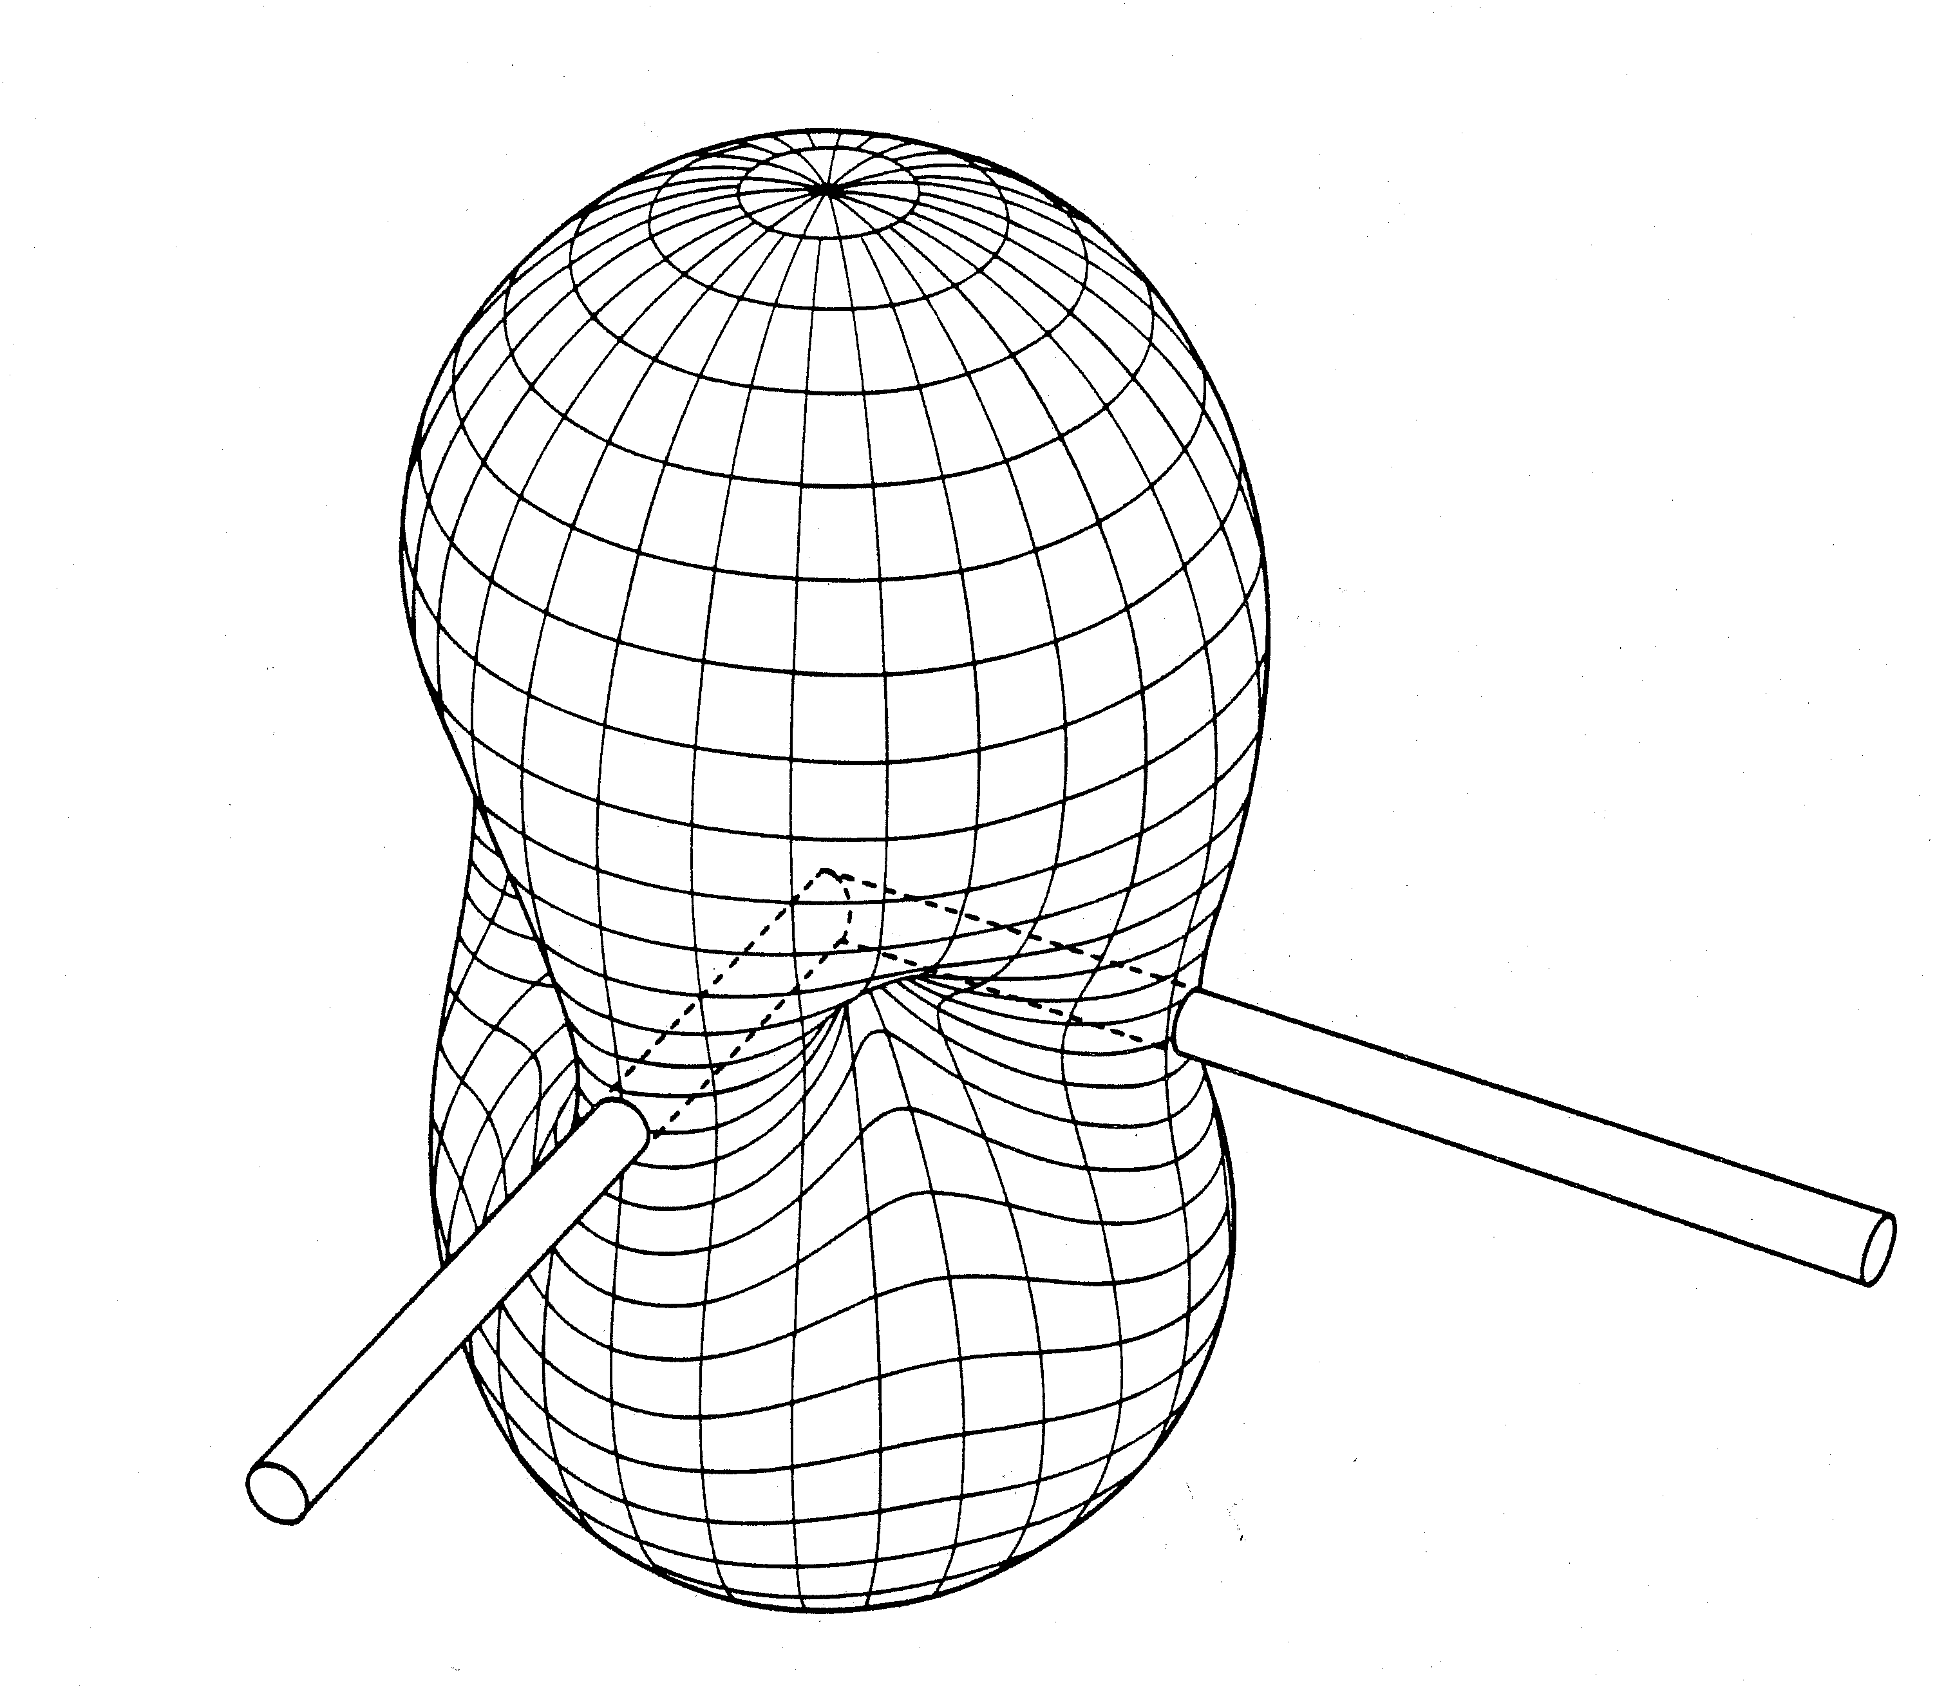
Figure 1. Angular response (antenna pattern) of a LIGO detector. This pattern is the amplitude response, and assumes an unpolarized source.
Continuing the analogy with electric dipoles, the way to improve the directional sensitivity is to combine the outputs of multiple detectors, creating a phased array. By looking at the time of arrival of the wave at two different detectors, one can resolve the direction to the source relative to the line connecting the detectors. The scale of the angular resolution is given by the familiar diffraction formula λ/D where λ is the wavelength of the gravitational wave and D is the projected distance between the detectors. Careful signal analysis can improve on this by a factor on the order of the signal-to-noise ratio. Locating the source in the transverse direction requires one more detector. Thus a three detector network provides its best angular resolution for sources perpendicular to the plane of the triangle connecting them (on either side of the plane), and poor resolution for sources in the plane. Global separations (~10,000 km) and signal-to-noise ratios on the order of 8 give angular resolution on the order of 2 degrees for gravitational waves with a frequency of 100 Hz (λ = 3,000 km).
The LIGO-Virgo network will have its best angular resolution for sources perpendicular to the triangle they form, a direction approximately 37 degrees from the polar axis over the northern Atlantic Ocean (and 180 degrees away over the Indian Ocean). The optimal location for an addition to this array would be as far away as possible, perpendicular to this triangle, i.e, in the middle of the Indian Ocean. This optimal location is only a few hundred kilometers west of the proposed LIGO-Australia location in the Indian Ocean, making this site almost ideal for the southern hemisphere node of the array.
Summary of the Weiss Committee findings
The qualitative discussion above ignores many important factors. Real detector locations on a spherical earth impose constraints on the orientation of the individual antenna patterns (oriented with their maxima perpendicular to the surface of the earth), which couples sensitivity to angular resolution in a complicated way. To study the advantages of the proposed reconfiguration of the LIGO network in a realistic and quantitative way, the LIGO Scientific Collaboration appointed an ad hoc committee, chaired by Prof. Rai Weiss. The charge to this committee was to use the experience gained from initial and enhanced LIGO and to compare in particular two networks, the first being the network composed of the current baseline LIGO detectors plus the Virgo detector (dubbed “HHLV”) and the proposed network composed of one interferometer at Hanford, one at Livingston and one in Australia, along with Virgo (dubbed “AHLV”). An equally important part of their charge was to identify and investigate any disadvantages.
The full report of the Weiss committee is appended to this white paper (Appendix D). Here we extract and expand briefly on the main points made in the executive summary:
“Ability to determine the position of a source in the sky: The AHLV network offers a significant improvement in establishing the sky location of gravitational wave sources with both modeled and unmodeled waveforms (time series). Depending on signal to noise and the location on the sky, the ratio of the uncertainties in the position of a source can be 5 to 10 times smaller for the AHLV than for the HHLV network. In many places on the sky, using reasonable signal to noise, the uncertainty in position approaches 1 degree; sufficiently small to enable electromagnetic astronomical identification of the source. Furthermore, the shapes of the uncertainty contours on the sky are closer to circular rather than elongated. …”
As expected, this was the strongest argument for LIGO-Australia. Figure 2 is typical of the results found by the Weiss Committee. It illustrates the improvement that can be expected in the determination of source location. This particular figure compares the error boxes for the reconstructed source positions with the HHLV and AHLV networks for what is expected to be one of the most frequently observed sources for Advanced LIGO, the inspiral and merger of two 1.4 solar mass neutron stars. This figure is plotted for a realistic case; the incident wave would have a signal to noise ratio of ~8 in an optimally oriented detector, which is near the expected level for most detected sources of this type.

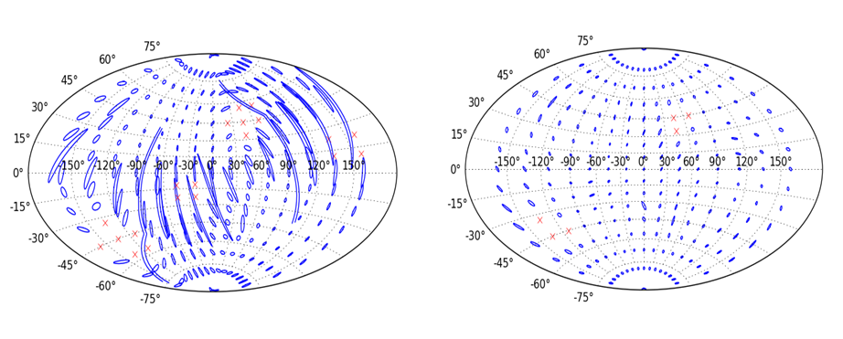
Figure 2. Error boxes for the HHLV (left) and AHLV (right) networks. The plots show the 90% confidence contours. The red X’s are points in the sky where the signal would be poorly detected with an SNR < 12 for the combined network.
“Source parameter estimation and waveform reconstruction: The AHLV network offers some improvement over HHLV in determining the physical parameters at the source. The study has been done primarily for the NS/NS coalescence sources in which degeneracies in the fitting matrices are resolved by the AHLV network. One dramatic example is the ability to separate the solution for the source distance and the source inclination of the orbit relative to the observer. Another study has shown improvement in determining the polarization of the gravitational wave at the Earth with the AHLV network. The improvement in part comes from the possibility of choosing an optimum orientation for the Australian detector. ….
Extracting the relevant astrophysical parameters from the observed signals is crucial to the use of gravitational waves for astrophysics. For any given source direction, each L-shaped interferometer has one linear polarization for which is has maximal sensitivity, and the orthogonal polarization for which it has zero sensitivity. Since the two Hanford detectors share a common orientation, they sample the same polarization, and give a factor of √2 improvement in sensitivity to that polarization. The AHLV configuration gives a different orientation for the LIGO-Australia detector, and thus provides a more equal sampling of the different polarizations. It is not obvious a priori that this would produce better parameter estimation, but the detailed studies performed by the Weiss committee confirm that is does produce an improvement, modest in many cases, but substantial in a few.
In particular, for the compact binary inspiral waveform, the HHLV network suffers from a degeneracy in the inclination angle-distance parameter space. Figure 3 illustrates this for the reconstructed distance-inclination angle probability distribution function.
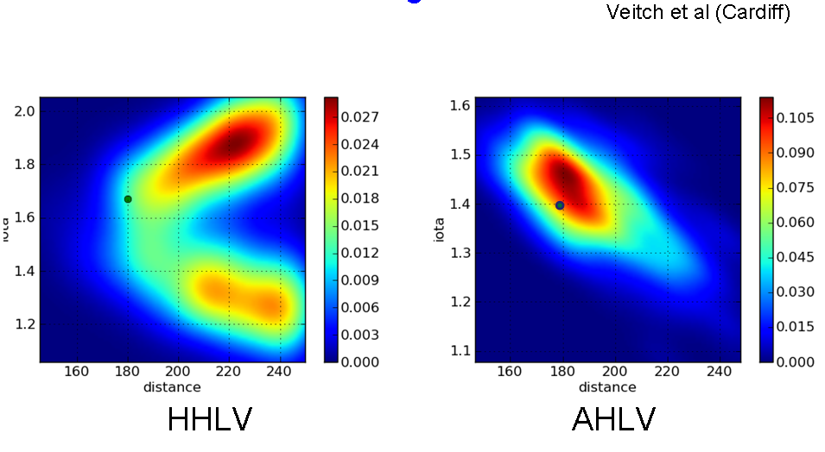
Figure 3. Two dimensional probability density contours for the model parameters of a binary neutron star system’s luminosity distance and orbital inclination angle (iota) relative to the line of site in the two networks. The green dot shows the input value of the model parameter (iota is symmetric about π ). The solution using the HHLV network is bimodal. The degeneracy is broken in the AHLV network. The color coding indicates the amplitude of the probability density in units of 1/(Mpc*radian).
This large improvement in parameter estimation is not universal, and many parameters are estimated with comparable accuracy with both networks. However, the HHLV network never has such a significant advantage over the AHLV network, and the AHLV network often has an advantage over the HHLV network.
“Network sensitivity and false detection probability: For a specific astrophysical source, the sensitivity, the minimum amplitude gravitational wave signal one can detect, depends primarily on the noise spectrum of the detectors and the probability distribution of the noise. For equal detectors in a network, the sensitivity improves with the reciprocal square root of the number of detectors. Our study shows little difference between the gravitational wave sensitivity of the HHLV and AHLV networks.
“An important finding is that the false detection probabilities vs threshold signal to noise for unmodeled bursts in the two networks are not greatly different with non-Gaussian data and become almost the same for data that has been reduced to Gaussian statistics. The conclusion comes from using algorithms that trade on the coherence of the waveforms in the different detectors and the improved ability to determine the sky position in the AHLV network. …”
A concern with the move of the instrument from Hanford to Australia could be that the sensitivity of the network, at a constant False Alarm Rate (FAR), might be reduced. Because the sensitivity of the network depends much more strongly on the details of the noise at each instrument, it is harder to make firm statements comparing the different configurations. The Weiss committee made a simplifying assumption that all detectors are the same, including their non-Gaussian noise components. This does not take into account differences in the LIGO-Virgo design that will produce different spectral shapes and features, and might not even be correct for the nominally identical LIGO detectors which may have different non-Gaussian noise. However, there is little basis for other choices.
The Weiss Committee determined that although the false alarm rate (FAR) does indeed increase, it causes a relatively minor loss in sensitivity, because of the steepness of the distribution of strong false events. Using equal detector assumption, the committee calculated the volume of space to which different networks would be sensitive using two noise models: pure Gaussian, and Gaussian with a non-Gaussian component representative of the initial LIGO science runs S5 and S6. (Because of the normalization to HHL, this measure is insensitive to the particular sources or algorithms used.) These volumes are given in Table 1, normalized to the HHL network. HHLV was somewhat more sensitive than AHLV, but the committee concluded that the sensitivity differences were not large, and may not be significant given the uncertainties in the projected detector performance.
Table 1: Network search volume ratios relative to the ideal HHL network. The second column shows the volume ratios assuming Gaussian noise for all networks. The third column shows the degradation of the search volume due to non-Gaussian and non-stationary noise for a False Alarm Rate (FAR) of less than 1/5 year. The FAR calculation for AHLV was not fully completed but is known to be very close to the configuration with the Australian detector rotated by 45 degrees (A₄₅HLV).
Network | Volume ratio for Gaussian noise | Volume ratio for non-Gaussian noise, FAR < 1/5 y
HHL | 1 | 0.22
HL | 0.54 | 0.05
HLV | 0.93 | 0.32
HHLV | 1.44 | 0.74
AHLV | 1.43 | (~0.5)
A₄₅HLV | 1.43 | 0.51

“Environmental correlation between detectors: The AHLV network does not suffer from local correlated environmental perturbations while the HHLV network is vulnerable to them. The gravitational wave search for all classes of sources is disturbed by these correlations; …
A factor of a different nature than those given earlier, favoring the AHLV over the HHLV network, is the reduction in the risk of failure and probability of increased duty cycle when two of the network detectors are no longer situated at the same location.”
The searches for burst sources of gravitational waves with poorly modeled waveforms are particularly sensitive to local noise sources at the Hanford site. Acoustic noise penetrating or generated in the corner station, ground vibrations, power line fluctuations, and magnetic field transients are some of the sources which have been identified. A very large part of the data analysis effort has gone into identifying and flagging such sources of correlated noise, but the residual events are still a limitation for burst searches.
More generally, experience with initial LIGO has shown that the variations in noise levels are to some extent correlated with human activity levels (a distinct day-night-weekday-weekend effect) and large scale weather patterns (ocean storms causing increased microseism at both US LIGO sites). Although the two LIGO sites are separated by two timezones and 3000 km, this does produce a correlation in the noise level which requires careful attention in the analysis. Locating LIGO-Australia in a distant time-zone, and on a different continent surrounded by a different ocean and by different weather systems is likely to decrease this correlation in noise level across the network (much as the addition of Virgo does).
Lastly, it is less likely that two of the network detectors would be simultaneously unavailable with the AHLV network; a storm, a power failure, or an earthquake could remove both Hanford detectors in the HHLV network for a shorter or longer time. An AHLV network provides a more robust network for GW astronomy in the epoch of regular detections.
“Detection of compact binary sources before an Australian detector would be available: A question that arose early in the committee and in the Collaboration was whether making a decision to move one Advanced LIGO detector to an Australian site would preclude the ability to make detections of known gravitational wave sources early in the Advanced detector era. In particular, would it still be possible to make a detection of NS/NS binary coalescences with HLV or at worst a detector pair such as HL. A significant result of the studies done for the committee was the finding that with a new detection statistic that weighs the signal-to-noise with how closely the data matches the expected chirp waveform and the application of the same type of vetoes as in prior science runs, it was possible to approach Gaussian statistics despite the non-Gaussian noise in the detectors. For a chirp amplitude signal to noise (SNR) of 8 in a single detector, it is possible to achieve an accidental detection rate with a pair of detectors less than 1/30 years and correspondingly even lower rates with three detectors.”
The question of being able to make a credible claim of a first detection in the face of the inevitable 2+ year later start of observation expected for LIGO-Australia is of prime importance.
The initial decision to build three Advanced LIGO detectors was, in some measure, insurance to improve the ability to make a secure detection. As discussed above, this decision was made at a time when Advanced Virgo was not well-defined and was still far from funded. Today, Advanced Virgo is an active project, and with the significant cooperation between the two projects, we believe it will see a timely completion. The HLV network will have comparable sensitivity to the HHL network (Table 1 above), and because of the absence of correlated noise, would deliver a more convincing case for discovery.
The most likely sources for a first detection are compact binary inspirals and mergers. These systems have well-modeled waveforms and the ability to do template matching and network coherence tests makes the output of these analyses very nearly Gaussian. Three widely separated detectors showing good matches to the expected waveforms (or even two at somewhat higher signal-to-noise ratio) should be sufficient to convince the broader scientific community.
Moreover, a first detection is likely to be accompanied by an electromagnetic confirmation. The willpower to search 10-100 square degree regions of sky for an x-ray or optical afterglow to confirm a first detection is likely to be present in the astronomy community, even if such searches are not attractive for subsequent studies.
The only case where we see a clear advantage in a first detection scenario for HHLV over HLV is the case of an unmodeled burst source without an electromagnetic or neutrino counterpart. This would be a challenging first-detection claim to make with confidence, even with HHLV. The expected range for a supernova (one of the chief posited sources of unmodeled bursts) is not large enough to make this a likely first detection, and much of the volume that the HHLV network can see would be also visible in neutrinos.
We therefore conclude that for the most likely credible source for a first detection, a binary neutron star inspiral, there is little change in the likelihood of observation if there is only one interferometer at Hanford, whether or not Advanced Virgo is in operation. Similarly, for a periodic source (e.g. a pulsar), the second Hanford interferometer does little to increase the likelihood of detection. For the case of an unmodeled burst with no accompanying EM or neutrino signal, there is some added significance to having a second Hanford detector, but this class of source is relatively unlikely compare with inspirals. Furthermore, discussions with astronomers and astrophysicists have indicated that detection of an unmodeled GW burst with no accompanying EM or neutrino signal would not be considered by them to be a credible basis for a first detection claim, without detection of multiple events well above background.

Implementation of LIGO-Australia
There are two phases to the implementation strategy. The first is to define the steps that need to be taken to bring the project to the point where a responsible decision to proceed can be made. The second is to define how the project will actually be carried out if it is funded and approved. This section will outline both of these aspects, although the latter will necessarily be somewhat less detailed than the former.
An over-riding constraint on the timing is the Advanced LIGO schedule currently in execution. Advanced LIGO is on schedule to begin assembly of the third interferometer by mid-2011, and installation at the end of the third quarter of 2011. Any delay of installation activities past this point will cause overall project delay. All necessary conditions for LIGO-Australia (commitments funding for construction and for operation, agreements on responsibilities, management agreements, etc.) must be met in time to secure formal approvals. We have identified September 30, 2011 as the deadline for agreement (see the discussion in section 6 below). This challenging schedule may not be achievable, but the unique opportunity makes it important that we try. In Appendix B, we discuss two less preferable back-up options that can be pursued if for any reason the approach proposed in this white paper cannot be achieved. We have not studied these two back-up options in as much detail, but we note that in both cases there are significant disadvantages in terms of a long delay before an Australian interferometer is operational, disruption of Advanced LIGO science operations due either to shutting down Hanford to remove an installed interferometer for shipment to Australia or the need for key operations personnel as part of a new project to build new interferometer components for Australia. Furthermore, there is very significant additional cost associated with the back-up options as compared with the base plan.
Because of the shortness of this window for action, the first steps in Australia are already underway. The Deputy Vice-Chancellors for Research at the five leading Australian universities in ACIGA have agreed to work together and have committed funds to pursue this opportunity. The first step is to create a laboratory or Centre to act as the host organization (in the remainder of this document this will be referred to as the AIGO Laboratory). The University of Western Australia has been chosen to lead this effort because of its proximity to the proposed AIGO site.
A second high priority is to refine cost estimates for the facilities, which must be provided by Australia. A solid cost estimate is essential for any approach to government to secure construction funds. The LIGO Laboratory has made available the detailed fabrication drawings for the vacuum system and beamtubes, and these are being costed without modification by Australian firms with the required capabilities. The LIGO Lab has also provided the architectural drawings for the buildings. Although the building design will have to be altered in detail to account for different building practices and requirements, the basic footprint and functional requirements are an accurate reflection of what is needed. Together with staffing costs these two activities will represent the bulk of the construction costs, with modest additional cost for project management, furnishings and support equipment, and interfacing and training with the Advanced LIGO project. Equally important is the development of a cost estimate for operations. This will be based on the LIGO model including staffing and non-personnel operations costs, again adapted for local practices and constraints.
Another high priority is to identify key positions and to begin to identify candidates for these posts. Obviously, recruiting is hampered by the still speculative reality of the proposed project, but the goal is to identify qualified candidates and to elicit expressions of interest, should the project go forward. The responsibility for identifying and approaching candidates lies with ACIGA and UWA. However, LIGO Lab approval is also required for all key personnel. In the interim, the project will rely on acting personnel to prepare the groundwork.
In parallel with these activities in Australia, with this document the LIGO Lab is seeking NSF input, approval and support to pursue this plan in Australia along with our colleagues and university supporters. Although there are too many unknowns to ask for full approval for the project at this time, we do ask for NSF input on what conditions must be met (and by when) in order to achieve a positive decision and that a process leading to a decision be pursued. It may also be prudent at this stage to provide informational notifications to the NSB, OMB, and relevant Congressional staff. These briefings should highlight the scientific benefit, but should also emphasize the preliminary nature of the discussions and especially that the project is not yet sufficiently advanced for formal approval. It could be important to learn from these offices any items that they see that must be addressed before approval, so that these issues can be resolved in the short time available. We intend to use this white paper as the basis to inform our Advanced LIGO partners (the UK’s Science and Technology Funding Council, the Max Planck society and the Australian Research Council) for their agreement to divert their equipment contributions to Advanced LIGO to this purpose.
With these inputs in hand, the next step is for the ACIGA universities to establish the AIGO Laboratory to direct efforts towards the project and to seek funding in Australia for their portion of the project. Rough estimates place the required Australian construction contribution in AU$100M class. With a population and domestic economy approximately 7% of that of the US, a project of this scale represents a very large investment for the Australian government. Nonetheless, discussions with senior university and government officials have given some hope that it might be possible. In the past few years, the Australian federal government has funded university infrastructure projects in education and research through the Education Investment Fund (EIF). This program solicits proposals from universities for capital construction projects. Typical projects are in the AU$40M range, but at least one project has been funded at the level of AU$90M. With multiple-university support and evidence of a significant international contribution (through the proposed detector components), the AIGO facility cost may be acceptable under EIF. However, there is no clear indication from the Australian government when or if there will be another round of EIF funding, although based on past rounds, the call for proposals might come late in the third quarter of 2010. If there is no EIF round this year, then the only other possibility seems to be a direct request to the government. Success in such a direct approach would lie in the prestige and commitment of the ACIGA universities, and would likely be made at the Vice-Chancellor level. Under either scenario, a positive indication from NSF that it supports the project, subject to whatever conditions are needed, would be extremely important, perhaps even essential, for Australian funding to be secured.
AIGO must also secure commitments for operations funding, as the EIF program provides no continuing operations funding. It is likely that multiple sources of funds will be required to secure the necessary level. Contributions from the Western Australia State Government, the ACIGA universities, and the Australian Research Council (ARC) may be sufficient, but the complexity of multiple funding sources will make this task a challenge.
In parallel with the above pursuits of funding, it will be important for all the involved parties -- LIGO Laboratory, NSF, Caltech, MIT the ACIGA universities, AIGO Laboratory, and relevant Australian authorities -- to develop a common understanding of what formal agreements are required and how to provide sufficient future assurances of commitment. At a working level, this would at a minimum require a Memorandum of Understanding between the LIGO Laboratory and the AIGO Laboratory.
These steps leading to a decision to proceed (or not) are shown in the following figure, with strawman times and durations.
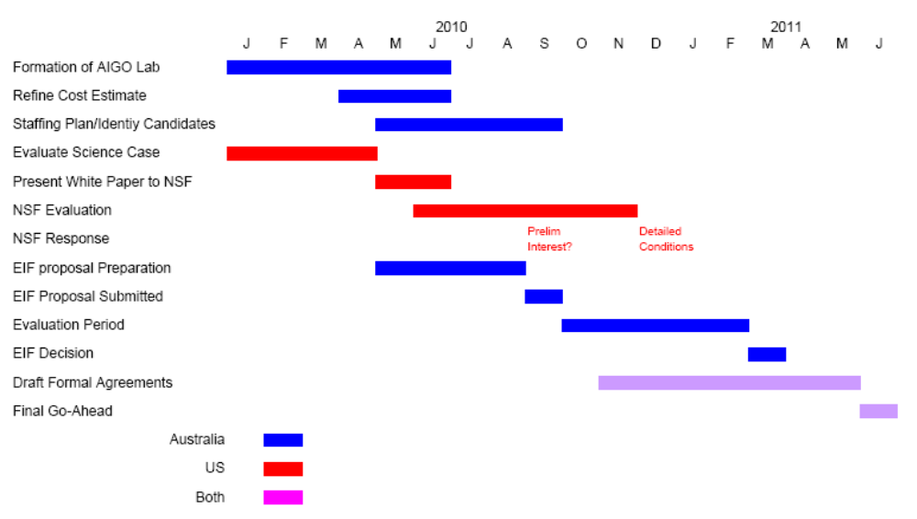
Figure 4. Strawman schedule for steps leading to a decision to proceed. Some of the activities will be influenced by as-yet unknown factors (e.g., the schedule for an EIF proposal round) and the durations of other activities (e.g., NSF evaluation of the proposed plan), for which best guesses have been made. This particular timeline results in a July 1, 2011 decision, giving a few months of schedule contingency compared with Advanced LIGO latest possible decision date.
If the conditions needed for a favorable decision on this project cannot be achieved by the third quarter of 2011, then the LIGO Laboratory will proceed with its planned installation of the third Advanced LIGO interferometer at Hanford. The need for a southern hemisphere component to the global gravitational wave network will still exist, and the community will continue to try to find a way to expand there. However, the time to achieve full coverage will be delayed by many years, and the overall cost will be increased considerably.
If funding can be secured and the other conditions met, final NSF approval would be sought before the third quarter of 2011. If granted, then the formal documents would need to be finalized and signed. It is important to remember that an announcement of such a major scientific collaboration would provide an opportunity for public outreach in both the US and Australia that would be richly exploited.
Immediately upon approval of the LIGO-Australia project, Advanced LIGO management will replan its activities to take out installation, verification and test of the third interferometer. Components for the third interferometer will have to go into clean storage pending shipment to Australia. The LIGO Laboratory and the AIGO Laboratory will have to investigate and determine import/export requirements which must be satisfied.
One of the first steps in Australia after the decision to proceed will be to staff the organization. In addition to the project leadership in Australia, a high priority will be to recruit key detector scientists, the ones who will lead the installation, testing and commissioning activities at AIGO. These scientists will work with Advanced LIGO staff in the US for familiarization and training. It is planned that a number of these staff members will relocate temporarily to the LIGO sites for hands-on participation in Advanced LIGO installation, subsystem testing, and commissioning. It is reassuring to recognize that there are a number of Australian detector scientists who have gain considerable experience as part of LIGO and other GW projects and who have expressed interest in joining LIGO-Australia if it proceeds.
AIGO will have to adapt the LIGO building and vacuum system designs to meet both Advanced LIGO requirements and local conditions. LIGO vacuum system and site architectural drawings have already been provided to AIGO for costing purposes. These can serve as the basis for AIGO-specific designs. New building and site construction drawings, compliant to local building codes and practices and with site specific features, will have to be prepared and checked. In addition, AIGO will have to create up-dated drawing package for the vacuum system. Minimal changes to the vacuum system are expected, but some parts and components (particularly in the area of the control system where the gauge models and control modules specified in the mid-90’s) will be unavailable.
LIGO Laboratory will have to review and approve the final designs for the vacuum system and the site buildings. This review is to ensure that all facilities met the requirements to properly house and operate a sensitive Advanced LIGO detector. In particular, the following guidelines must be observed:
- LIGO Laboratory to be involved in the technical evaluation of site selection and orientation decisions whether or not the site is Gingin.
- LIGO site civil and vacuum designs will be provided and should be replicated to the extent possible except for site-specific alterations and optimizations agreed to by the AIGO Laboratory and the LIGO Laboratory.
- The design and construction of all infrastructure at the site (e.g. site buildings, vacuum system, internet connectivity, etc.) will meet the appropriate technical requirements developed by LIGO Laboratory for initial and Advanced LIGO.
- Other differences in AIGO and LHO/LLO should be limited to site-specific or necessary alterations. LIGO Laboratory will arrange for timely review of any proposed changes
- Appropriate LIGO Laboratory experts shall be included on all reviews (e.g. design reviews, procurement reviews, etc.) for the AIGO infrastructure (e.g. building, vacuum system, etc.).
- The quality of the AIGO infrastructure shall be equivalent to that of the other LIGO sites so that long-term efficient operations can be sustained.
A realistic schedule might allocate nine months to this design/design update activity. Assuming a mid 2011 start, completed bid packages might be ready by second quarter 2012. At that point a Call for Tender on facilities and vacuum system could be issued, in accordance with Australian requirements. Allocating three months to such a complex and expensive procurement is again aggressive, but possible, giving a mid-2012 start to construction.
The next stage is the AIGO construction. Site preparation and building construction can go on in parallel with the fabrication of the vacuum chambers that house the sensitive interferometer components at the corner and end stations. Beam tube manufacturing and installation would need to wait until grading of the arms and foundation preparation along the arms is complete. AIGO project staff will interface with the selected contractors and monitor the progress and quality of the work. These staff will also coordinate closely with responsible LIGO Lab staff to ensure that Advanced LIGO needs are being met.
Detailed construction schedules would need to be prepared to estimate durations, but a top-down estimate can be made based on corresponding time to construct the LIGO facilities. Including acceptance testing and bake-out of the vacuum system (necessary to achieve the cleanliness of the vacuum required), a realistic schedule might be three years.
In parallel with the AIGO construction, the Advanced LIGO team (including AIGO staff who are participating for familiarization and training) will assemble, install and test the components for the first two Advanced LIGO detectors. Science data-taking will begin in 2015, interspersed with periods to improve the detectors and bring them to full design sensitivity. These early science runs will be coordinated with Virgo, and will likely yield the first detection of gravitational waves and produce interesting astrophysics results.
Installation of the LIGO-Australia detector will begin as soon as the AIGO facility is ready to accept it, in 2015 under the strawman scenario outlined above. Some parts of the detector installation can go on in parallel with the last stages of facility construction (for example, installation of suspended components in the corner and mid station can be carried out in parallel with bake-out of the beam tubes). Installation and testing should proceed quickly, with the vast majority of problems already discovered and resolved during the installation of the first two Advanced LIGO interferometers. The trained staff from AIGO will be supported remotely by the Advanced LIGO staff that have recently completed their local commissioning tasks, and/or during breaks in commissioning for astrophysical observation with the US instruments..
The LIGO-Australia detector itself will be exactly the same as the Advanced LIGO detectors at Hanford and Livingston, built using components supplied by the LIGO Laboratory. The Requirements Document (Appendix A) spells out this condition: “Any proposed deviations from the Advanced LIGO design will be considered only under exceptional circumstances and will require review and approval by LIGO Laboratory. No changes to the LIGO-Australia interferometer will be undertaken unless such changes are required by LIGO.” This condition is required to ensure that the data from LIGO-Australia are as similar to the other LIGO detectors as possible, and to take maximum advantage of the commissioning experience from the first two LIGO detectors.
In this scenario, LIGO-Australia would be ready to join with the other two LIGO interferometers and the Virgo interferometer by 2017. This network would give the full scientific benefits described in section 2 of this report, years ahead of any other plausible scenario.
These steps following a decision to proceed are shown in the following figure.

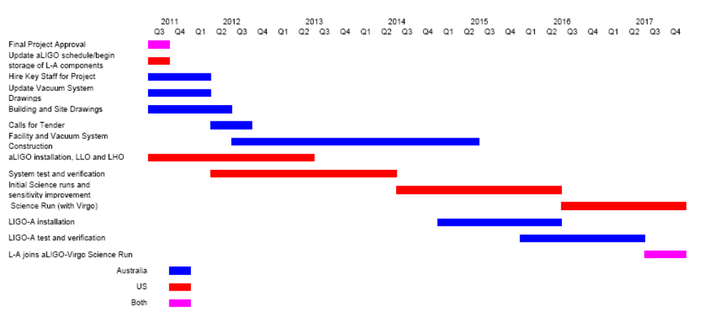
Figure 5. Strawman schedule of steps following a decision to proceed.
Once LIGO-Australia detector is fully operational, detector run planning will be done jointly with the other LIGO sites and Virgo. Data will be collected and consolidated into a single dataset, distributed to computational centers around the world for processing and analysis. Detector enhancements and upgrades will be researched and developed through the LIGO scientific Collaboration (of which ACIGA and the LIGO Laboratory are members), and implemented in a coordinated fashion to optimize the scientific returns.

Management
The management of the LIGO-Australia enterprise can best be considered in three phases: the preconstruction phase, the construction phase and the operations phase. The following describes the management approach the LIGO Laboratory and AIGO partners are taking in the current preconstruction phase and the approaches that we would see being implemented in the following phases.
A LIGO document (LIGO-M1000009-v2; January 18, 2010) referred to below as the Requirements Document, authored by the LIGO Laboratory Director in consultation with senior Laboratory and Advanced LIGO staff and provided to the Chair of ACIGA and the cognizant Australian university officials describes the “… conditions and requirements that must be negotiated and fulfilled from both sides. The requirements from the LIGO Laboratory are considered as needed to assure the success of the considerable US and Australian investments that would be made…” Many of the management approaches described in the following were discussed in that document. The document is appended to this white paper (Appendix A). An MOU between LIGO Laboratory or an appropriate US government agency and the governing Australian agency will be developed, addressing the conditions and requirements in the Requirements Document.
To avoid delays due to complexity in the international arrangements needed for the construction of AIGO and LIGO-Australia, we believe that the primary governing agreement should be between the US and Australia only, as de facto leaders of this effort. The addition of other international participants at the scientific, technical or resource level is both possible and encouraged, but they will be joining into a framework established the two leading contributors. Any additional partners will require joint US/Australian approval.
Preconstruction phase--During the preconstruction phase the management of the effort in Australia will be under the auspices of the AIGO Laboratory, a management entity being set up within the University of Western Australia with support and oversight from the five major Australian Universities (University of Western Australia, Australian National University, Monash University, University of Adelaide, University of Melbourne) belonging to ACIGA. UWA, with the support of the other ACIGA universities and the AIGO Laboratory will be responsible for securing the funding commitments related to construction and operation of LIGO-Australia and for identifying and hiring key staff including the AIGO Director, the project leader and the project manager for LIGO-Australia. In order to assure that the key staff have the needed skills and experience for success, the LIGO Laboratory will participate in evaluating the key staff and the concurrence of the LIGO Laboratory Director will be required for all key project staff and the AIGO Director.
On the LIGO Laboratory side, all management responsibilities related to LIGO-Australia are in the hands of the LIGO Laboratory Director who is also the Principal Investigator for Advanced LIGO. The LIGO Director has delegated responsibility for day to day interactions with ACIGA to the LIGO Laboratory Chief Scientist who has extensive experience with the Australian gravitational wave community and the Australian universities in the AIGO consortium. The LIGO Director also consults with the head of the Advanced LIGO MREFC Project about potential impacts of LIGO-Australia on the Advanced LIGO Project.
Construction phase:
The construction phase will involve two distinct, but dependent activities:
- designing and implementing the AIGO site infrastructure, including roads and buildings, developing, constructing and testing the extensive vacuum system, and
- completing assembly of LIGO-Australia components and then installing and testing the assemblies, subsystems and the full interferometer in the AIGO facilities.
The construction phase of the AIGO facilities will be managed by AIGO Laboratory using the usual project management structures which apply to Australian federally funded projects, augmented as needed to protect the interests of other stakeholders, including the LIGO Laboratory and the NSF. We anticipate that this structure will include a project head, a lead project engineer, formal project management, subsystem leads, design reviews, a change control process, periodic progress reviews, reporting, etc. Responsibility for all these activities will rest with AIGO Laboratory, and with the overseeing ACIGA university leaders. LIGO laboratory personnel should be included in all reviews, and copies of formal reports must be provided to LIGO Laboratory. The AIGO construction management plan must be approved by the LIGO Laboratory and NSF.
The construction of the LIGO-Australia detector utilizing components from Advanced LIGO supplied to AIGO by the LIGO laboratory will be carried out by the AIGO Laboratory with funding from non-US sources; however, the management of these activities will be integrated with the Advanced LIGO project management to ensure success and to take maximal advantage of the lessons learned during the installation and commissioning in the US. AIGO personnel will participate in the installation, testing and commissioning of Advanced LIGO in order to build the needed level of experience and expertise of the Australian team. During their time at the US sites, their technical oversight will be through the Advanced LIGO project organization. During the assembly, and installation in AIGO, the LIGO-Australia project leader will direct activities and will report on technical matters to the Advanced LIGO project leadership. Formal supervision, including all personnel and employment aspects will be the responsibility of the AIGO Laboratory.
The construction project will also have several advisory panels (e.g., a project advisory panel, an oversight panel and perhaps a management advisory panel). Membership of these bodies will be made of international experts and will report to the AIGO Laboratory Director and/or the project head as appropriate. Institutions that are stakeholders in AIGO (including LIGO Laboratory and NSF) will have representation on the oversight panel.
In order to assure that the construction of LIGO-Australia is carried out in a manner that will produce an instrument meeting the performance and operational requirements needed by the LIGO network, there will be extensive use of LIGO designs in the construction of buildings and the vacuum system, and knowledgeable LIGO staff will participate in key design and other reviews.
Because the success of this project will depend critically on the abilities and experience of the AIGO Laboratory staff, the staffing plan should be developed as soon as possible after the AIGO Laboratory is established and a Director appointed. This plan must be submitted to LIGO Laboratory for review and approval. The construction project staff must be fully capable of successfully carrying out the construction project and subsequently operating LIGO-Australia without substantial on-site assistance from LIGO laboratory. Wherever possible, key scientists and engineering candidates should be explicitly named to help demonstrate that there exists an appropriate manpower pool to staff AIGO.
Operations phase
Although the operations phase of LIGO-Australia is 7 years or so in the future, it is important that a number of the basic management principles be established and these have been address in the Requirements Document (Appendix A). They are:
- Australia would be fully responsible for funding the operation of the AIGO facility. The US will provide no funding for the operation of the facility.
- In order that LIGO-Australia contributes most effectively as a key element of the global array of ground-based interferometers, LIGO-Australia will ultimately operate as a third LIGO observatory, subject to overall programmatic direction and oversight by the LIGO Laboratory Directorate in consultation with the AIGO Director, exactly in same way as are LHO and LLO, the US LIGO observatory sites. This operating mode will be carried out in full consultation with Australian management and will need to recognize any local constraints in the same way that is done in operation of the US sites. The day-to-day operations of LIGO-Australia will be under the direction of the AIGO site director. AIGO Laboratory will have full representation in LIGO Laboratory management structures, equivalent to that held by the US LIGO observatory sites, to facilitate communications and decision-making. LIGO-Australia data will be fully integrated with the data from the other two LIGO sites (and Virgo), to be utilized and accessed by the LSC and the Virgo Collaboration. This step is insured by the fact that ACIGA is a member of the LSC and already has full access rights to all LIGO data.
- LIGO-Australia would fully conform to the LIGO data management plan that the LIGO Laboratory is establishing for open data release to the broader research community.
- AIGO must provide an adequate team of staff to accomplish the installation, test and commissioning of LIGO-Australia. LIGO Laboratory will provide advice, assistance, and oversight through regular remote contacts and hands-on visits, but cannot plan to provide sustained on-site manpower to support these activities.

There are a number of possible approaches to the overall management structures in the operations phase of AIGO Laboratory, that is the advisory and oversight structure of the AIGO Laboratory that would assure effective operations, support for science and effective integration into the international gravitational wave community. These structures will need to take account of the responsibility for the operation AIGO Laboratory by the Australian university consortium and other stakeholders. These stakeholders may include the funding agencies which contributed to the AIGO facilities and the LIGO-Australia detector (e.g., the NSF), and overseas partners contributing operating resources, manpower, equipment or other support for the facility, in addition to the Australian authorities. With advice from LIGO Laboratory and other stakeholders, the governing Australian institution(s) will identify and develop the most appropriate management structures several years ahead of the operations phase. Possible structures include a governing board, an oversight function, and advisory committees, all of which could include representatives from stakeholders including LIGO Laboratory. LIGO Laboratory will thus have a strong voice in the overall management and operation of the LIGO-Australia detector while allowing issues concerning the AIGO facility to be dealt with in a local context.

Australian Funding Needs and Approach
As described above, obtaining funding is a crucial prerequisite for the LIGO-Australia concept. In this section we will describe the funding needs, the approach which is being used, and the progress and status. ACIGA will seek funding through AIGO-Lab, a University Centre at UWA, which will build and operate the LIGO-Australia detector.

Construction Funding Needs
The LIGO-Australia concept envisions an Advanced LIGO interferometer provided by LIGO/NSF to be assembled, installed, tested and commissioned by AIGO in buildings, vacuum systems and site infrastructure supplied by AIGO.
To estimate the costs and to manage the work most efficiently with the Advanced LIGO Project, ACIGA has adopted the Work Breakdown Structure (WBS) shown in Figure 2. This WBS has five second-level elements; one of these will be partially delivered in a LIGO package from the US, while the other four must be covered in full by the AIGO Laboratory.

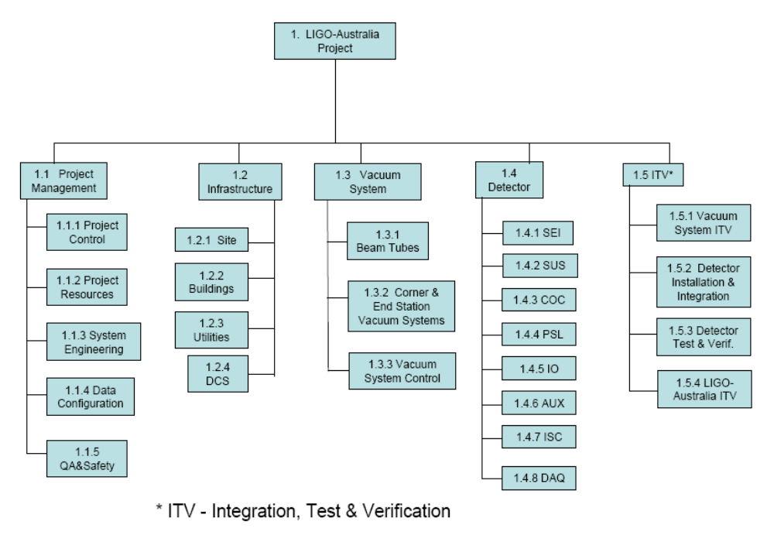
Figure 6. WBS for the LIGO-Australia Project.

For the LIGO-Australia detector itself, this WBS is similar to that used by the Advanced LIGO Project. Under this WBS there are 8 third-level elements: the Seismic Isolation Sub-systems (SEI); the Suspension Sub-systems (SUS); the Core Optics Components (COC); the Pre-Stabilized Laser (PSL); the Input Optics System (IO); the Auxiliary Optics Sub-systems (AOS); the Interferometer Sensing and Control (ISC); and the Data Acquisition, Diagnostic, & Control (DAQ). LIGO will provide the finished and complete components for these eight elements of the Detector WBS. LIGO will be responsible for the safe packaging of the components for shipment. AIGO Laboratory will cover the costs of shipping these products to the AIGO site in Western Australia. LIGO-Australia shipment costs are based on weight and size of components to be shipped to Australia.
Each of these eight WBS elements under the Detector WBS has been studied to identify any elements which might not be provided by LIGO. This occurs in cases such as the DAQ subsystem: front end interfaces and computers, which reside adjacent to the detectors components, will be supplied by LIGO to AIGO, but other elements, such as the Frame builder and the control room workstation computers, which are planned to be shared between the two Hanford detectors, will not be. Similarly, some installation fixtures will be retained at Hanford after the completion of installation in case any removal of components and rework is required, and these items will need to be replicated by AIGO Laboratory.
AIGO laboratory is responsible for the cost of shipment to Australia and all the cost to assemble the components of each Detector sub-product and to integrate these completed sub-products into the full detector. Using data supplied by LIGO, ACIGA has estimated the assembly, test and verification costs for these elements using local labor rates.
The other 4 second-level WBS products are provided completely by AIGO Laboratory. These are: the Project Management (PM) for the Australian portion of the project; the Infrastructure (INF) which includes buildings, site and all infrastructure to house and operate LIGO-Australia including the Data Computing System; the Vacuum System (VAC) which includes the 4 km beam tubes, all the vacuum components in the Corner and End Stations, and the vacuum control systems; and the overall Integration, Test and Verification (ITV) of the whole observatory.
The Advanced LIGO cost estimate was used as a basis of estimate for the Australian costs covering the ITV element, using Advanced LIGO hours and labor types, and Australian rates. A bottom-up approach was used to estimate the construction costs of and staffing for the INF and VAC construction. LIGO building designs were used by the UWA facilities branch to estimate the FAC costs, while LIGO vacuum system fabrication drawings were used by a commercial vacuum firm for the vacuum system cost estimation. A bottom-up approach was also used to estimate the costs and staffing for project management (PM) to accomplish the Australian tasks in the fabrication, integration, test and verification of LIGO-Australia.
Contingency was included on each WBS element. Where contingency estimates were available from the corresponding Advanced LIGO cost estimate the same percentages were applied. For the site preparation and building construction, a contingency of 15% was used. For the vacuum system, the contingency used was 25%, based on the experience of the LIGO Laboratory during the construction of its vacuum systems.
Based on the above described estimation process, the total funds required by AIGO Laboratory to construct an operating gravitational wave observatory using the LIGO-Australia detector will be ~ AU$80M. LIGO is planning to review the cost estimates for completeness and accuracy prior to the submission of any proposal for funding.

Potential Funding Sources for Construction

ACIGA is actively pursuing four avenues of funding for the construction phase of LIGO-Australia.
(A) Australian Federal Government funding. The most promising mechanism available is a multi-institutional bid to the Education Investment Fund (EIF), a fund established by the Australian Government in 2008. EIF is a multi-billion dollar fund for “projects that create or develop significant infrastructure in … research institutions … in order to … invigorate the growth of Australia’s research capabilities and enhance Australia’s international competitiveness in … research”. LIGO-Australia fits into this funding category, particularly due to the involvement of and contribution from LIGO. Since 2008, there have been three EIF rounds announced. The results of the last EIF round have yet to be released, but the results of the second round distributed AU$934M to thirty-one projects nationwide, the largest project receiving AU$90M. If the government makes another call for proposals, it will likely be with a deadline of October. There is also the possibility of an out-of-round EIF bid, or of a direct approach to government for a special allocation of funds. Success in the EIF process requires significant co-investments and guarantees of operation costs by other stakeholders. The Australian consortium plans to apply for a nominal AU$60-70M from EIF.
(B) Funding from the West Australian State Government: The WA State Government has previously supported significant projects such as the International Centre for Radio Astronomy Research (ICRAR) situated at UWA. Such funding is allotted on an ad hoc basis, so the prospects depend on timing, the state of the WA government finances, and the political benefits. The Australian consortium plans to ask UWA to seek AU$10-15M towards the construction costs from WA.
(C) Funding from ACIGA Universities: The ACIGA universities include The University of Western Australia (UWA), The Australian National University (ANU), The University of Adelaide (UA), The University of Melbourne, and Monash University. All universities have expressed interest in contributing to the AIGO project. Most significantly, these universities will be able to contribute both manpower (the technical and scientific expertise required to construct AIGO) and funding. The Australian consortium plans a total contribution of AU$5-10M from these sources.
(D) Funding from International Partners: There is the possibility of significant non-US international participation in LIGO-Australia. The gravitational wave research communities in India and China have indicated that they would like to contribute personnel during construction; however, any such contribution will require new funding. Any contributions from non-US international partners are expected to be “in-kind”. At this time, we are supporting our colleagues in their attempts to secure funding from their respective governments and would use these contributions to augment the project and to reduce risk, but we have not counted them in the funding estimates.
At present, funding the construction remains the single largest uncertainty in the LIGO-Australia concept. Informal meetings with relevant government officials indicate that LIGO-Australia has some significant positive factors (international collaboration, multi-University usage, significant investment from sources other than the federal government, etc.) but that no decision has been made whether or not there will be an EIF round in 2010. A direct approach to government may have a lower probability of success, but if there is no new round of EIF funding or if an EIF proposal fails, this may be the only option. Timing will also affect the choice of approach, since the award must be finalized by early- to mid- 2012 to be relevant.

Operations Costs
Operating costs were estimated in a top-down way using the existing operations of the two LIGO sites as a model. For comparison, a bottom-up approach was also used in regards to staffing levels where the full scope of AIGO operations was included. AIGO operations thus include some management of outreach and R&D which are different from that of a U.S. LIGO site. The two estimates produced consistent results in regards to staffing levels. Other costs (power, cryogens, maintenance and other services) were estimated using local costs. The annual operating budget of the AIGO site is estimated to be ~ AU$6M (AUD) per year; about 90% of this will be directed towards operating LIGO-Australia. The remainder covers the broader scope of AIGO operations. About 70% of the operations costs are staffing costs.

Potential Funding Sources for Operations
At this stage of discussions, it appears that multiple sources of funding must be used to secure the required level of operations funding. ACIGA is actively pursuing the following funding sources for operations.
(A) Australian Federal Government: The Australian Research Council (ARC) can provide funds for participation in international collaborations through its Linkage Infrastructure and Equipment Fund (LIEF) funding scheme. We believe that operational expenses for AIGO would meet the criteria for LIEF funding. We project AU$1M per year from this source. In addition, other ARC funding schemes (fellowships, discovery grants) can provide some support for the broader AIGO site activities. These will be pursued to open additional flexibility.
(B) The Western Australian State Government: The WA State Government has supported scientific activities in the past including the International Centre for Radio Astronomy Research (ICRAR). However, this support is not through an established regular funding scheme, but it is generally awarded on an ad hoc basis, and is thus uncertain. An application will be made but funding from this source is not included now.
(C) ACIGA Universities: We expect the participating ACIGA universities to play a major role in funding the operating staffing needs, including AU$2M per year from UWA and AU$2M per year from the other ACIGA partners.
(D) International Partnerships: Manpower contributions with an equivalent value in excess of AU$1M per year may come from non-US international partners, including India and China. The Australian consortium has signed MOUs with groups in China and India who are beginning to explore possible funding to support these contributions. Scientific partnerships with Asian neighbors have a high priority for the Australian government, and the Australian consortium expects the support of the government to help bring about these contributions.

Current Status of Funding Efforts
Senior ACIGA University administrators have indicated interest and are currently discussing the above funding approach to help ACIGA to realize these goals in a timely manner. The goal is to have the funding commitments negotiated by the end of 2010 or very early 2011 in order to be in time to meet the required LIGO/NSF schedule.

Staffing

The staffing model for AIGO construction and LIGO-Australia installation, commissioning and operation has been developed with three distinct stages: construction; detector installation and commissioning; and operation. Staffing requirements have been developed using the experience from LIGO.
Key positions and responsibilities:
The following key staff appointments require the approval of the LIGO laboratory Director:
AIGO Laboratory Director: Physicist or astronomer responsible for the overall AIGO Laboratory which will build and operate LIGO-Australia; its relationships with Australian funding bodies, universities and university research groups; industry partnerships, and international collaborations. Will be a member of the LIGO Laboratory Directorate.
Project Leader: Physicist with overall responsibility for the LIGO-Australia detector, including interfacing with the Advanced LIGO Project leadership. Reports to AIGO Laboratory Director.
Project Manager: Responsible for management of budgets, procurements, schedules, timelines, staffing. Reports to Project Leader.
Lead Detector System Scientist: Responsible for providing technical guidance to the detector subsystem leaders, and for technical coordination of testing and verification. Will lead commissioning of the LIGO-Australia detector. Reports to the Project Leader.
Project Engineer: Systems engineer overall responsibility for all engineering practices, systems integration and interferometer installation. Reports to the Project Leader.
Other critical positions are the responsibility of the AIGO laboratory and do not require LIGO approval. These include:
Vacuum Engineer: Technical responsibility for oversight of vacuum infrastructure design update, fabrication contract(s), equipment procurements, installation and test. Reports to AIGO Laboratory Director.
Civil Engineer: Technical responsibility for oversight of site development and civil construction, including building design, construction contract(s), facility equipment procurements, and acceptance. Reports to AIGO Laboratory Director.
Detector Subsystem Leaders: Each of these subsystem leaders is responsible tobe intimately familiar with their subsystem and to lead its installation integration and test in Australia. Subsystem leaders are required for Seismic, Suspensions, Lasers and Optics, Input Optics, Control and Data Systems, and Computing. Report to Lead Detector System Scientist.
Staffing Needs:
These key positions will be augmented with other scientists, engineers and technical officers, with the staffing profile varying as the project evolves.
The construction phase refers to the construction of all infrastructure required, including the site, buildings, laboratories, vacuum system and interfaces. The workforce would be provided by contracted companies and overseen by the Vacuum Engineer and Civil Engineer, and under the overall direction of the AIGO Laboratory Director.
Detector installation and commissioning will be undertaken by specialists employed by the Project under the supervision of the Project Leader and the Lead Detector System Scientist. Approximately 5 scientists, 5 engineers and 10 technical officers will be employed on site, and there will be additional short term staff from LIGO Lab and from the international collaborators. The scientists and engineers must be qualified and experienced in detector installation and commissioning and with detailed background in the technology of their particular subsystem (e.g., vacuum, optics, lasers etc). To establish this expertise, many of them will spend time at the US LIGO sites during Advanced LIGO installation and commissioning to familiarize themselves with the design and commissioning techniques, so that they can quickly and efficiently perform the similar work for Advanced LIGO.
Once fully operational the facility will run with a team of dedicated scientists and operators, similar to the US LIGO sites. The organizational structure will evolve from a hierarchical project structure to a flatter scientific operations structure. We expect to have a total of 30 permanent employees on site, including the Director, Chief Scientist, Operations Manager, detector scientists and engineers, administrative staff, and 10 operators, with the staffing modeled on current LIGO Laboratory requirements.
Staffing Resources and Availability:
The requirements in Appendix 1 include that AIGO Laboratory is responsible to recruit and provide the workforce to build, commission and operate LIGO-Australia. Australia has a long history of research into laser interferometry for gravitational wave detection dating back to an initial collaboration between the University of Western Australia and The Australian National University in 1990 with the University of Adelaide joining in 1995 to form the Australian Consortium for Interferometric Gravitational Astronomy (ACIGA). ACIGA now consists of 5 universities and has over 50 scientists, technicians and PhD students. It has expertise across the main interferometer subsystems - suspension and isolation at UWA, high power lasers at Adelaide and optical, quantum optical and control systems at ANU. At its Gingin site, ACIGA operates 80m long suspended cavity interferometers for testing high optical power effects. It has active data analysis groups at The ANU, UWA, The University of Melbourne and Monash University. ACIGA is already a partner in Advanced LIGO, contributing designs and components for optical and suspension systems using funds granted by the Australian Research Council.
Since its formation, ACIGA has produced 50 PhD graduates. Many of them (17) are still in the field working for LIGO, GEO, Virgo and in Australian institutions in faculty or research only positions. Others have moved into related fields now occupying positions in institutions such as JPL or holding posts at Australian universities (16). A number of former ACIGA students, postdocs and visitors have indicated their enthusiasm for the project and a possible interest to join the project to help build LIGO-Australia.
We expect that past and present members of ACIGA will form the nucleus of the LIGO-Australia team, but we also expect some interest from overseas scientists who might join the effort. During the construction of the LIGO-Australia facility and vacuum system, Australian scientists, engineers and technical staff will participate in the installation and commissioning of the US Advanced LIGO detectors, acquiring first hand knowledge of the Advanced LIGO systems and the critical expertise required to build LIGO-Australia.
The success of LIGO-Australia depends crucially on the leadership appointments. We are encouraged by the fact that we are able to identify a number of candidates for the AIGO Laboratory Director, Project Leader, Lead Detector Scientist, subsystem leaders and engineering positions. On approval of funds, an interim Director will be appointed while an international search is conducted. Following this selection, other leadership positions will be filled, securing approval from the LIGO Laboratory Director when required.

Impact on the Advanced LIGO Project
LIGO-Australia represents a significant opportunity for the long-term astrophysical impact of LIGO, but the top priority for the Advanced LIGO Project is that the introduction of LIGO-Australia not delay the first detection of gravitational waves, where we assume that this will be using the US Advanced LIGO instruments in concert with the Advanced Virgo detector. In the near term, while the possibility is in discussion, the Advanced LIGO team is proceeding without distraction on the original baseline plan to build, install, and bring to project completion, three US-based instruments. Minimal change in the Project effort will be made before an official decision is made.
The Project management has considered the potential impact of the relocation of the 3rd Advanced LIGO instrument to Australia in three separate but related ways: cost, schedule and risk. Assuming that the decision to include an Australian detector can be made in a timely way (discussed below), it would result in modest cost savings to the Project, and a potential earlier completion. More attention could be focused on the two US detectors, with potential to bring them (post-Project) more quickly to the design sensitivity. There is potential for distraction from the Australian effort, which requires careful management; a mitigating factor is that there would be a significant offset in time for similar activities between the US and Australian LIGO. These conclusions are elaborated in turn below.
Because the labor for installing and testing the third interferometer would be provided by AIGO, there will be a net cost and schedule savings to the US Advanced LIGO Project. No significant change in cost is anticipated for the procurement, incoming inspection, inventory, cleaning, and ‘kitting’ with some assembly, as the equipment to be sent to Australia would undergo this level of preparation. However, there are labor and schedule savings due to not having to perform final assembly of many parts, and to test, install, integrate, and bring to acceptance the third US detector. No detailed estimate of this has been made (to minimize the impact of the pre-decision LIGO-Australia discussion on the Project), but a first top-down estimate leads to a maximum of $7-8M in savings to the Project, and Project completion (acceptance of the two US instruments and the computing system) roughly 4-6 months earlier than the current final date. The net savings is a function of timing of the decision, as a later decision could require some disassembly or de-installation of equipment. The funds saved could be used to reduce risk to the Project through additional personnel and/or addition of equipment. Note that some of the Project labor savings would be due to an early return of staff to the Operations budget, with a cost impact to LIGO Lab Operations of $2.5-3M.
An important positive consequence of the schedule savings and reduced integration effort is that more, and earlier, attention can be focused on the first two Advanced LIGO instruments. This gives the potential for these instruments reaching an astrophysically interesting sensitivity and stability earlier, which would earlier searches for gravitational waves.
A number of the conditions imposed by LIGO on the LIGO-Australia partnership (Appendix A) were formulated to mitigate the possible risks to Advanced LIGO. These conditions help ensure we do not negatively impact the schedule for the remaining two US instruments:
- The AIGO infrastructure (buildings and vacuum system) must be identical to the US Observatories in its interface with the instrument and in the environment that it provides to the detector. Changes, even if they appear to be improvements, must be held to a minimum due to the Advanced LIGO project manpower required to review and analyze differences.
- LIGO-Australia must be constructed with the original Advanced LIGO designed parts, and where additional copies of parts are needed, they will be made to the US Advanced LIGO drawings. Again, this is to minimize the effort by experienced Advanced LIGO engineers and scientists to review changes.
- The Australian effort must be documented using the same tools for inventory control, document control, and laboratory logbooks as used by Advanced LIGO in the US. This again will minimize US effort to transfer information during the Project phase, and help in the later tuning, and continued integration of the Australian effort with the US Advanced LIGO instruments.
- The Australian endeavor must construct a team with sufficient management, scientific, and technical strength, to allow the Australian effort to proceed effectively without continued demands on US Advanced LIGO Project staff.
- Some support to help in planning (establishing staffing needs, timing of activities, etc.) the Australian effort, and training Australian staff, will be needed. Because of the ~3 year delay anticipated for readiness of the Australian infrastructure, it is anticipated that this will take place after the intense installation phase of Advanced LIGO is completed. However, in the measure possible, Australian staff will travel to the US to work with the US staff for these planning and training needs, and offer complementary support to the US effort; the objective is to ‘break even’ for the US effort.
- In all phases of Advanced LIGO, we expect AIGO Laboratory to send people to the US with the parallel aims to assist in US Advanced LIGO installation and testing and to train the Australian participants for their subsequent effort. This exchange can potentially allow the Advanced LIGO project staff to complete their Project activities early, allowing them to provide later support for the Australians. Completion of US Project activities for a given individual is a pre-requisite for significant involvement in the Australian initiative.

According to the Advanced LIGO Project Execution plan, the tuning of the US instruments is planned to take place after acceptance. These tuning activities are necessary to reach the design sensitivity of the Advanced LIGO instruments, both in the US and in the potential Australian instrument. Because LIGO-Australia will be identical to the Advanced LIGO detectors in the US, the tuning and debugging procedures developed for the US instrument will be applicable to the Australian instrument, and clearly the Advanced LIGO staff will be quite expert. It will be in the overall interest of LIGO to have significant participation by the US ‘tuning’ staff in the post-Project era active on the Australian instrument. We will need to manage these resources carefully, and work to cultivate skills in the Australian team, to ensure that progress on the US instruments’ sensitivity does not suffer from the greater geographical distribution of the instruments. Again, the later start of LIGO-Australia installation will facilitate this.
The Australian team has a number of highly skilled and capable scientists, many of whom have previously worked in the LIGO Laboratory. There is also significant interest in other nations to contribute to the activities of an Australian LIGO detector. With the approaches outlined above to manage LIGO-Australia’s impact on the US Advanced LIGO activities, the Advanced LIGO leader believes that we can start the epoch of regular detections no later, and perhaps earlier, than we would otherwise, and that the real potential for gravitational wave observation as a useful astrophysical tool will be greatly enhanced with the addition of this instrument in the southern hemisphere.
The chief factor driving the accelerated schedule for making a decision on this project is the determination of a “drop-dead” date for making the commitment to proceed with the LIGO-Australia project. The Advanced LIGO project management has evaluated the impact on the Project, based on the current (May 2010) internal Project schedule (which is in advance of NSF milestones for the activities), for different dates by which a decision could be taken to pursue the LIGO-Australia option.
- If a decision can be taken by mid-2011, this is early enough to incur no lost effort in the organization of the assembly and installation process.
- If a decision is delayed to third quarter 2011, assembly of some components for the 3rd instrument will have started, and a change to send the components to Australia would require minor backtracking.
- If a decision is not made until late 2011, a number of major seismic isolation system units would have been assembled; they will require some disassembly for safe shipping to Australia, and we begin to see a cost and/or schedule impact compared with an earlier decision.
After this point, a decision would require significant backtracking on installation effort already made. For this reason, we have chosen September 30, 2011 as the deadline date for a decision on LIGO-Australia. Two other back-up options, with a later decision and correspondingly significant cost, schedule and programmatic impact, are discussed in more detail in Appendix B.

Risks, possible impact and mitigation
The process of identifying risks to placing an Advanced LIGO interferometer in Australia, and measures to mitigate their possible impact is based on the experience LIGO Laboratory has gained since the mid 1990s in building and operating the two US LIGO sites. Four broad classes of risks include funding, facilities implementation, finding sufficient numbers of scientific and technical staff to fruitfully operate an Australian interferometer, and management risks. These are addressed below.

Funding risks
Risk: The main funding risk is that after the effort goes forward, it is found that insufficient funding for completing the infrastructure is available. This could happen for a number of reasons; e.g.
- Australia is unable to provide sufficient funding to completely build the requisite infrastructure at the selected observatory site.
- The facilities construction cost estimate carries insufficient contingency to cover unexpected cost growth once the project begins and contracts have been signed.
- The level of effort or duration estimates to complete the construction are underestimated, leading to schedule overruns and standing army costs.
- Australia experience unexpected fiscal pressures that lead to a significant reduction in committed funding levels, causing the program to stretch out well beyond the currently envisioned timeline.
- Large fluctuations in commodity costs that could impact cost of steel and building materials, leading to cost overruns.

Impact: AIGO facilities could be stretched out, delaying LIGO-Australia’s contribution to the global network, or LIGO-Australia’s sensitivity could have to be degraded which could endanger it having the capabilities needed to fully match those of Advanced LIGO and Advanced Virgo
Mitigation: Because obtaining sufficient funding is so crucial to the success of LIGO-Australia, the most important risk control factor on which LIGO is insisting is that there be firm commitments from the appropriate Australian funding sources prior to the date when the third interferometer can be installed within the Advanced LIGO schedule. If robust commitments for adequate funding, including prudent levels of contingency for both for construction and follow-on operations, are not assured by the agreed-upon decision point, LIGO Laboratory will recommend to NSF that we proceed along the original Advanced LIGO baseline.
Ensuring that the cost and labor estimates are accurate and that adequate contingency and robust staffing are included has been a high priority for the LIGO laboratory since the concept of LIGO-Australia was first raised. LIGO Laboratory will review any cost/labor estimates before they are submitted, to ensure that realistic plans are put forth, and we will provide the results of any such reviews to the NSF. LIGO Laboratory has significant experience with the construction of the facilities and vacuum systems—many of the staff who managed the construction activities at LHO and LLO are still with LIGO—and thus has the in-house ability to assess the cost and contingency realism.
Fluctuations in the cost of commodities are a concern, particularly since the past few years have seen sudden and large changes. The cost of stainless steel is particularly important because it is a large portion of the vacuum system cost, but other construction materials are also significant. Australia is a major exporter of raw materials, and as such, its currency has strengthened over the past few years, and may be expected to strengthen further when the world economy recovers, which may relieve some cost pressure for commodities which are tied more strongly to the US dollar. Sufficient contingency will be allocated to cover these potential price changes.

Facility implementation risks
Risk: Technical, management, safety or other failures during the implementation of the LIGO-Australia facility (see below for examples) could lead to schedule delays, increased cost, and the need for support from LIGO Laboratory facility knowledgeable personnel to help diagnose and fix the problems. For example:
- The critical interfaces between civil construction, beam tubes and vacuum chambers are specified incorrectly. Schedule hits are sustained due to equipment redesign and rework.
- Not understanding sufficiently the possible sources of contamination leads to equipment that cannot be cleaned adequately without large, unexpected efforts.
- Unit conversion issues affect engineering design and/or implementation, leading to rework (e.g., meters-to-feet conversion errors; kilogram-to-pounds conversion errors; 50 Hz/220VAC vs. 60Hz/120VAC incompatibilities) of major equipment due to conflicting specifications for components coming from the US and which must be interfaced/operate with Australian-provided subsystems.

Impact: Implementation failures could result in increased costs and schedule slippage putting strain on fiscal and human resources. Delays could mean that LIGO-Australia data will not be available as early as desired by the astronomy and gravitational wave communities.
The potential for a negative impact on the two US Advanced LIGO detectors would be minimal because all US Advanced LIGO Project activities will be completed before LIGO-Australia installation begins, and the post-project tuning phases will be separated by a generous time interval.
Mitigation: The impact on LIGO Laboratory activities, particularly US Advanced LIGO installation and tuning, would be mitigated by management decisions that would limit impact on higher priority activities. Each phase of LIGO-Australia will be several years behind the corresponding Advanced LIGO activities and all so that experts from LIGO Laboratory may be available to help with problems without compromising US advanced LIGO operations.
The Advanced LIGO detector was designed for installation in the LIGO facilities. To minimize the risk of problems with the interfaces, the LIGO Laboratory has insisted that the AIGO facilities must be compatible, and moreover that to the extent possible the AIGO designs should reproduce the LIGO facilities and vacuum system as exactly as possible. Any deviation is subject to LIGO Laboratory review, and must be approved in writing. Certainly some changes will be required, particularly for the buildings where different building standards and codes apply in Australia, but the main critical interfaces will be with the vacuum system and that system must have minimal changes.
All LIGO experience with cleaning and all cleanliness procedures will be shared with AIGO, and LIGO procedures must be followed. Many of the key AIGO staff will gain hands-on experience with clean working conditions from extended visits during the installation of the first two interferometers.
Accurate translation of LIGO drawings and specifications into metric units will be a high priority during the early project phases. The majority of the ACIGA scientists have worked at some point in their career in the US, and much of their day-to-day laboratory equipment is of US origin. Thus, they are somewhat familiar with the US systems of measure.
LIGO laboratory will provide its expertise, advice and oversight in all LIGO-Australia activities. The ACIGA universities have experienced and capable staff, and Australia is a scientifically and technologically capable nation. We are confident that with proper attitudes and processes, the LIGO-Australia team can succeed.

Staffing risks
Risk: Insufficient experienced staff to support the schedule and/or effective commissioning, tuning and operation of the interferometer
- Insufficient numbers of local (Australian) scientists and technical staff are available sufficiently early in the construction process to allow schedule to be maintained.
- Key personnel needed from abroad to fill positions cannot be recruited.

Impact: Inexperienced or unqualified staff could result in schedule delays and/or cause the LIGO-Australia detector not to reach its design sensitivity. This would result in lower scientific output, and possibly require LIGO Laboratory staff to devote more effort to training and/or commissioning in Australia.
Mitigation: The selection of Australia for this proposal, while nearly ideal in the geographic sense, was motivated much more by the availability of a community of capable and experienced scientists. Gravitational wave groups have been active in Australia for more than 20 years, and there is a pool of Australian scientists working in Australia and for other projects around the world. If a significant proportion of these “expatriates” can be induced to return to Australia, then a core team of skilled scientists will be formed around which it will be possible to guarantee that the project has a strong start. Informal discussions with some of the key Australian candidates residing abroad have indicated a great deal of enthusiasm for the project and the opportunity to pursue the research they love in their own land. Anecdotally, we know of several very capable scientists who were key personnel on GW projects in the US or Europe, who elected to leave the research that they enjoyed in order to move back to uncertain futures in Australia because of family ties there.
While the largest part of the team is expected to be Australian, we plan to seek international candidates as well. Just like the US of the past century, Australia has a rich tradition as an immigrant nation, attracting capable people from around the world who want to take advantage of opportunity and contribute.
Attracting these candidates will require not only salaries that are competitive with foreign salaries, but also positions with long-term potential for career growth. Over the past decade, the strengthening of the Australian dollar described above (by more than 50% over the past eight years) has made Australian salaries much more attractive. The ACIGA universities have agreed to work with AIGO to make the positions in this effort as attractive as possible.

Management risks
Risk: Management of LIGO-Australia as an element of the LIGO network will require skill and judgment to weigh the different demands that are made on resources, and to select the most effective course of action. Risks to good management include:
1. Poor coordination between AIGO personnel, Advanced LIGO and other LIGO Laboratory personnel.
2. Poor choice of key personnel to staff the AIGO Laboratory organization.
Impact: Poor management decisions can cause wasted effort, create bad will among staff and collaborators, and disrupt effective construction and operations. The result could be delays, reduced science observation time, or less useful science data
Mitigation:
Management risk can be mitigated by strong oversight and good communication with the stakeholders. The AIGO Laboratory will be established by UWA which will hold lead responsibility. UWA will be aided in its oversight by an Oversight Committee with broad representation and expertise, which will meet regularly to stay up-to-date on all aspects of the AIGO effort. Other ACIGA universities will participate in the AIGO Laboratory Oversight Committee as will the LIGO Laboratory and other stakeholders. By building cooperative relationships among the various partners, problems can be raised early and dealt with before they become more difficult.
At a working level, senior AIGO management will be added in the LIGO Laboratory Executive Committee, the principal forum for management discussions and decisions. Regular participation in Executive Committee meetings will ensure that AIGO management is fully informed of any significant new developments, and vice versa.
The Australian team has a number of talented scientists, many of whom we already know would make excellent AIGO leaders. LIGO Laboratory has required that it have approval rights for key staff, and will have a seat on the oversight body for AIGO Laboratory. If it is found that a particular individual is not performing adequately, LIGO Laboratory will work with UWA to effect a change.
Maintaining clear and effective communication will be crucial to the success of this effort. The LIGO Scientific Collaboration already uses a variety of communication tools: email, of course, but also network conferencing software (EVO, Enabling Virtual Organizations). EVO supports large, repeating meetings, as well as spontaneous meetings for small to large groups. The time difference will be a challenge, but we have already operated for many years under a similar situation between the US and Europe. The fact that the key ACIGA detector personnel will spend time working with Advanced LIGO in the US will help facilitate communications through the establishment of interpersonal and professional relationships which are crucial to successful long-distance collaboration.
- LIGO conditions for LIGO-Australia collaboration
Jay Marx
January 18, 2010
LIGO-M1000009-v2
LIGO Laboratory requirements for LIGO-South

Basic Concept: For purely scientific reasons, it is extremely desirable to locate one interferometer in Australia. The instrument should have capabilities matched to the Advanced LIGO interferometers at the two US LIGO sites. The proposed concept involves building such an interferometer (LIGO-South) at a suitable Australian site (AIGO) utilizing instrument components fabricated for the one of the Advanced LIGO interferometer (currently planned to be installed at the LIGO Hanford site) and installing this interferometer in new infrastructure provided by Australia. Specifically Australia will supply all of the infrastructure required, including the developed site, vacuum system, clean rooms, buildings, etc, and be responsible for developing a working observatory. The proposed concept would be accomplished at no new cost to NSF/LIGO beyond that of the Advanced LIGO project. Australia will gain a major role in gravitational astronomy at a fraction of the total observatory cost.

Scientific impact and Australian participation:
This approach will result in important contributions from Australia to the new field of gravitational wave astronomy due to the ideal location of Australia and, in large part due a very productive and long-standing productive collaboration between LIGO Laboratory and ACIGA. The development of this critical element of a global array of gravitational wave detectors will place Australia among the nations leading the scientific exploration of this new window on the universe.

ACIGA has excellent gravitational wave scientists who have contributed to the field at a high level, and the technical experience required for this concept to succeed. The proposed plan fits well into the Australian/international effort to develop an Australian detector for the global array. This requires an advanced instrument in Australia that would be operational early in the lifetime of the instruments no under construction in Europe and the US.

Conditions and Requirements:
To succeed, there will be conditions and requirements that must be negotiated and fulfilled from both sides. The requirements from the LIGO Laboratory are considered as needed to assure the success of the considerable US and Australian investments that would be made and are as follows:

Over-arching requirements: An MOU between LIGO Laboratory or an appropriate US government agency and the governing Australian agency will be developed, addressing the following requirements.
- The primary governing agreement will be between the US and Australia only. Addition of other international AIGO participants at the scientific and technical level is possible and encouraged. They will require joint US/Australian approval.
- The proposed facility, henceforth referred to as AIGO, will be managed jointly by the US and Australia as an integrated part of LIGO.
- The LIGO-South instrument will be a clone of the Advanced LIGO interferometer.
- Australia will bear all costs of relocating, installing and operating the LIGO-South interferometer in Australia, including establishing a suitable site, AIGO National Laboratory.
- Australia would be fully responsible for operating the AIGO facility.
- A binding commitment from Australia, including identification of the source for all funding, will be needed by early 2011 (otherwise LIGO Laboratory will be obligated by Advanced LIGO Project commitments to install the second interferometer at its Hanford site.)
- Assurance of availability of sufficient experienced staff in Australia to install, test and operate AIGO to be provided to LIGO Laboratory.

Detailed Requirements:
- Any proposed deviations from the Advanced LIGO design will be considered only under exceptional circumstances and will require review and approval by LIGO Laboratory:
  - No changes to the LIGO-South interferometer unless such changes are required by LIGO.
  - Other differences in AIGO and LHO/LLO should be limited to site-specific, necessary or desired alterations (e.g. optimized vacuum chamber, need for concrete envelope etc ). LIGO Laboratory will arrange for timely review of any proposed changes
- Australia will provide all infrastructure required to house and operate the interferometer:
- Timely site selection consistent with a rapid construction schedule (i.e. site selection by late 2010)
- LIGO Laboratory to be involved in the technical evaluation of site selection and orientation decisions whether or not the site is Gingin.
  - The design and construction of all infrastructure at the site (e.g. site buildings, vacuum system, internet connectivity, etc.) will meet the appropriate technical requirements developed by LIGO Laboratory for initial and Advanced LIGO.
  - LIGO site civil and vacuum designs will be provided and should be replicated to the extent possible except for site-specific alterations and optimizations agreed to by the AIGO Laboratory and the LIGO Laboratory.
  - A LIGO Laboratory expert shall be included on reviews (e.g. design reviews, procurement reviews, etc.) for the AIGO infrastructure (e.g. building, vacuum system, etc.).
  - The scope and quality of the AIGO infrastructure shall be equivalent to that of the other LIGO sites so that long-term efficient operations can be sustained.

Funding requirements:
- ACIGA will provide the Australian government with a realistic cost estimate and funding profile for total Australian funding commitment required. These costs will need LIGO Laboratory approval. The funds should provide for:
  - Civil construction, buildings, roads, maintenance equipment, power and utilities.
  - Vacuum system and its commissioning
  - Fabrication/procurement of hardware equivalent to that from initial LIGO that is reused for Advanced LIGO-—e.g. optical tables, piers, support stands, etc.
  - Staffing for installation/test and commissioning and supporting equipment.
  - Packing, shipping, customs and all other costs related to sending the LIGO-South hardware to Australia
  - Systems needed for data storage and transmission
  - Project manpower, the Directors office staff, business functions etc.
  - A realistic contingency budget
- AIGO staff will be expected to work for some time in the US on Advanced LIGO for training. Australia will pay salaries, travel costs, living expenses for these staff.
- Australia must make a commitment to fully fund AIGO operations for at least 10 years following construction, including salaries of any LIGO staff on long term loan to the Australian facility---no US support for operations will be provided
- Australia must commit to completing its scope of work, even if initial funding is insufficient.

Detailed operational requirements:
- In order that AIGO contributes most effectively as a key element of the global array of ground-based interferometers, AIGO will ultimately operate as a third LIGO observatory, subject to overall programmatic direction and oversight by the LIGO Laboratory Directorate in consultation with the AIGO Director, exactly in same way as are LHO and LLO, the US LIGO observatory sites. This operating mode will be carried out in full consultation with Australian management and will need to recognize any local constraints in the same way that is done in operation of the US sites. The day-to-day operations of AIGO will be under the direction of the AIGO site director.
- AIGO will have full representation in LIGO Laboratory management structures, equivalent to that the US LIGO observatory sites, to facilitate communications and decision-making.
- AIGO data will be fully part of the data utilized and accessed by the LSC and ACIGA will have full access rights to all data that is accessible to LSC members.
- Early embedding of AIGO in a suitable Australian institutional setting is essential—e.g. under one of the ACIGA universities and/or as a new National Laboratory so that the AIGO head and key project and operations staff can be hired and given appropriate authority and so the necessary business, employment, administrative functions, etc. can be provided.
  - Concurrence of the LIGO Laboratory Executive Director is required for all key project staff in Australia, including the AIGO director, construction project leader, project manager and subsystem leaders.
- The LIGO Laboratory will endeavor to help realize the instrument and to bring it to operation through advice and visits, but Australia must provide a complete stand-alone team that the LIGO Laboratory can complement.
  - AIGO personnel will participate in the installation, testing and commissioning of Advanced LIGO in order to build the needed level of experience and expertise of the Australian team.
  - A staffing plan, including personnel for construction and operations should be developed quickly to guide funding, hiring, and assigning staff to work in the US with Advanced LIGO for training related to installation, testing and commissioning. Wherever possible key scientists and engineering candidates should be explicitly named to help demonstrate that there in an appropriate manpower pool to staff AIGO. The staffing plan should be submitted to LIGO Laboratory for review and approval.

- Back-up Options
The very short timescale for a decision to proceed outlined in the main part of the document is a consequence of the date at which installation of the third interferometer starts (section 6). This naturally raises the questions: Are there any back-up options that allow for a later decision? What are the consequences if the necessary commitments (funding and organizational) and approvals cannot be obtained before the mid-2011 deadline?
There are a large number of variations if the September 30, 2011 deadline cannot be met. To explore this phase-space fully is impossible, but the following two specific back-up plans provide a reasonable set for comparison with the baseline proposal presented in the main document.
- “Plan B” would involve installing the third LIGO detector at Hanford, commissioning it, and operating it for some period of time (we will use 12 months in what follows), as planned in the baseline Advanced LIGO schedule. With a firm commitment by the US to move a detector to Australia once the infrastructure in Australia is complete, AIGO would seek Australian funding and build the facilities to accommodate a detector. When the agreed upon conditions have been met, the LIGO Lab would de-install the detector, and ship it to AIGO for installation and commissioning, and eventual operation.
- “Plan C” would involve completing the Advanced LIGO Project as planned. Instead of later de-installing and moving the third Advanced LIGO detector, a fourth detector would be built as a part of a new project and delivered to Australia under similar terms to those proposed in the main document.

We will explore in a little more detail the advantages and disadvantages of these two alternate approaches.
Back-up “Plan B”
A key issue under Plan B would be negotiating the conditions that would need to be met for the move of the detector to Australia to take place. After making a large investment in the facility, the Australian funding entities are going to want to have a firm date for the move. They will not want to incur significant operating costs for an empty facility. On the other hand, LIGO and NSF will likely want a scientific trigger, e.g., first detection or a certain amount of full sensitivity observing time. The most likely outcome of this negotiation would be that Australia waits until first detection to approve its funding. With an expected facility construction time of three years, in addition to the de-installation, transfer, reinstallation, and commissioning time, the first observations with LIGO-Australia would likely be delayed by at least four years compared to the baseline proposal described in the body of this white paper.
Other potential problems with Plan B include:
- This plan has added cost. The cost savings of ~$8M in the baseline plan (and the schedule savings) would not be realized, and the effort to de-install the third interferometer (while protecting sensitive components for both the departing and remaining instruments and maintaining cleanliness) is only somewhat less than the effort to install it. A very rough guess is that the cost to de-install and prepare for shipping to Australia might be between one-half and 2/3 the cost to install and check out, or $4-5M. Thus the direct costs of this option would be in the range $12-15M higher than the plan proposed in the body of the paper.
- More problematic is the time to de-install. Again, no detailed estimate has been made, but a very rough guess might be nine months from start to finish -- including an optimistic estimate for the time required to return the remaining detector at a good sensitivity. During this interval, large parts of the Hanford vacuum system would have to be vented, heavy equipment would be in use, and it would be impossible to maintain science operations at Hanford. In the scenario, outlined above, this period of disruption would take place about a year after serious science data-taking begins and presumably after discoveries have been made, and would be very detrimental to the new field of gravitational wave astronomy. One way to quantify the dollar-equivalent “cost” of this lost observation time would be to use one-half of the LIGO operations cost for the shut-down period (since one-half of the LIGO interferometers would be off-the-air). By this measure, the lost opportunity cost might be ~$15M. The scientific cost is difficult to assess, but would be very significant.
- The de-installation step increases risks for possible damage of the hardware either for the LIGO-Australia components or for the remaining Hanford detector. Some interferometer components are necessarily delicate and any extra handling involves some added risk—either direct breakage or from contamination. An accident which damaged e.g., a vacuum chamber flange could take the Hanford site off-line for an extended period. The longer time between the installation and testing of the US Advanced LIGO interferometers and LIGO-South also increases the difficulty of a successful LIGO-Australia implementation. The baseline plan outlined in the main body of the document has a period of about two years between these two activities, so the experience of the first installation will still be relatively fresh. Under Plan B, that gap increases to 4 or more years, and some expertise may be lost because of this larger gap.

Balancing against these disadvantages, Plan B has one potential advantage:
- In the event that Virgo suffers from delays or other problems, the early operation of the third LIGO interferometer could help make a first detection claim more secure. While the Weiss report concluded that two Advanced LIGO detectors would likely be sufficient to make a confident first detection, there is always some chance of unforeseen problems that a third interferometer could mitigate.

In summary, Plan B is a poor substitute for the baseline plan. However, in the event that the current effort fails to find sufficient support to make a positive decision to proceed by the mid-2011 deadline, then in spite of its problems, Plan B is probably the best back-up option for the gravitational wave community to get a southern hemisphere detector to complete the global network.
We emphasize that Plan B is a backup plan and should only be undertaken if the baseline plan cannot be carried out due to timing problems. To prematurely promote Plan B to the base plan would be very detrimental to the field, leading to significant delay in having the Australian detector operating while requiring significant additional funds.
Back-up “Plan C”
Plan C as avoids some of the complications of Plan B—by not requiring removal of the second Hanford detector it does not interfere with observations and does not require the downtime to deinstall. However, this advantage comes with much higher cost and the potential for serious programmatic impact on LIGO operations due to the need to reconstruct an experienced project team including scientific and technical experts, project management and procurement experise.
Plan C requires a careful coordination of the project approvals in the US and Australia. Both parties have to make large financial commitments together. Neither the US nor Australia will want to make a major financial commitment without a firm indication that the other party is equally committed, and it seems likely that serious negotiations between the two countries would not begin until after the first detection. The funding processes are sufficiently different in the two countries that it would be a difficult process to manage. and this will almost certainly result in a very long delay relative to the baseline schedule outlined in the main text. We estimate that this plan would put first operation of LIGO-Australia into the early- to mid-2020’s.
As mentioned, Plan C has a much higher cost for NSF than either the baseline plan or Plan B. It requires that NSF commit the full cost of an Advanced LIGO interferometer. A quick estimate would be one-third of the Advanced LIGO Project cost, or $75M, in current year dollars. In any funding environment this amount of money is a challenge.
Finally would be the daunting task for LIGO to establish a new project team to carry out the procurement, and assembly of the components for a new detector. LIGO Laboratory is a relatively small organization and the expertise realized for the Advanced LIGO project will be re-deployed for various aspects of LIGO operations by the time a new project would be launched. Staffing a new project without serious impact on Advanced LIGO operations would be a serious challenge.
Against these difficulties, Plan C does have a few advantages over Plan B:
- It avoids the need to de-install and ship the third Advanced LIGO interferometer, and thus does not disrupt LIGO observations, nor risk damage during the de-installation procedure.
- It retains two interferometers at Hanford, as in the current Advanced LIGO plan. The second interferometer can be configured differently for observations (central frequency and bandwidth, for example), or used for development activities.
Of the three different plans considered, Plan C is the least attractive from a scientific point of view because of the long delay, and from a programmatic point of view because of the cost and the challenge of assembling a project team. It is however worth considering if it both the baseline plan and Plan B prove to be impossible to implement.
- Advanced Virgo status and schedule
(provided by Francesco Fidecaro, Virgo Spokesperson)
Virgo detector status
The Virgo detector is an interferometer with 3 km long arms equipped with Fabry-Perot cavities. The nominal laser power is 20 W and the apparatus was designed since the very beginning to incorporate sufficient seismic isolation to allow operation down to a frequency of 10 Hz. Between July 2009 and January 2010, Virgo collected data in coincidence with the LIGO interferometers operating as a network to detect events in coincidence and reconstruct the sky position of the source candidate. This is performed under an agreement for data sharing established in May 2007 between the Virgo Collaboration and the LIGO Scientific collaboration.
An enhanced version, Virgo+, equipped with silica fibers to suspend mirrors, is planned to resume data taking in coincidence with LIGO in July this year, and represents also a benchmark for several Advanced Virgo technologies.
The Advanced Virgo detector project
The Advanced Virgo detector will result from a significant upgrade of the existing Virgo+ detector resulting in a gain in sensitivity one order of magnitude with respect to the Virgo design, over the frequency band 10 Hz – 10 kHz.
The goal of the Advanced Virgo project is to deliver an instrument ready for commissioning and noise hunting that has the capability of achieving this sensitivity. The temporal frame has to be such that full use of the scientific potential of joint observations with the Advanced LIGO interferometers can be made.
The main dates for the project are the following:
- Project plan (scientific and financial) approved by INFN and CRNS: Oct. 2009
- Start of the installation: July 2011
- End of assembly, integration and subsystem precommissioning: March 2014
- End 2014: interferometer robustly locked
- Weiss Committee report

Report of the Committee to Compare the Scientific Cases for Two Gravitational-wave Detector Networks: (AHLV) Australia, Hanford, Livingston, VIRGO; and (HHLV) two detectors at Hanford, one at Livingston, and VIRGO

May 10, 2010

Table of Contents
Introduction | 2
Executive Summary of Results | 2
Committee Mechanics | 4
Scientific Strategies after the First Detections | 5
Incremental Improvements to Advanced LIGO | 5
Comparison of the Two Networks | 9
Antenna Patterns and Network Sensitivity | 9
Determination of Source Sky Position | 13
Source Parameter Estimation | 17
Robust Detection: False Alarm Rate | 21
Issues Surrounding First Detections | 23
References | 25
Appendices | 25
Initial LIGO Rationale for H1 and H2 | 25
Committee Charter | 26

- Committee members:
Sam Finn Pennsylvania State University
Peter Fritschel LIGO-MIT
Sergey Klimenko University of Florida at Gainesville
Fred Raab LIGO-Hanford
B. Sathyaprakash Cardiff University
Peter Saulson Syracuse University
Rainer Weiss LIGO-MIT (Chair)

- Introduction:
The committee has compared the scientific merits of two gravitational-wave detector networks, HHLV and AHLV. HHLV consists of the proposed Advanced LIGO network of two 4km detectors at Hanford, Washington and one at Livingston, Louisiana coupled with the Advanced VIRGO, a French-Italian detector at Cascina, Italy. AHLV is a concept in which one of the Hanford detectors is moved to Australia. For modeling purposes we have assumed the location of the Australian detector is at Gingin near Perth, the site already developed by the Australian Collaboration. The orientation of the Australian detector relative to the others in the network has been considered a variable in the modeling.

The main emphasis of the study is to assess the scientific merits of the two networks in the epoch after the initial gravitational wave detections have been made and the field has become a regular branch of observational astrophysics. One can imagine such a situation after 2017. A secondary, though no less important, study is to establish the ability of a two and three element network to make the initial detections before 2017 while an Australian detector is being constructed. We were specifically asked not to make a recommendation for future action but to serve in a fact finding mode.

Although our primary charge is the comparison of the two networks, we also were asked to set the context for the comparison by imagining the field of gravitational wave astrophysics at the time when the networks would be operative. Some notions of the new astrophysical science from the advanced detectors and the development of the detectors are presented in the first two sections of the body of the report. This is followed by the main section of the report on the comparison of the networks in their ability to carry out the astrophysical program. That section is based on the studies done by and for the committee and is organized by scientific topic with each section divided into the results for compact binary coalescences (CBC) and unmodeled burst sources. A section on making the first detections ends the report. In an appendix, we give a brief description of the rationale for placing a 2km and a 4km detector at the Hanford site in initial LIGO and finally for completeness, present the committee charge.

Executive Summary of Results:

Ability to determine the position of a source in the sky: The AHLV network offers a significant improvement in establishing the sky location of gravitational wave sources with both modeled and unmodeled waveforms (time series). Depending on signal to noise and the location on the sky, the ratio of the uncertainties in the position of a source can be 5 to 10 times smaller for the AHLV than for the HHLV network. In many places on the sky, using reasonable signal to noise, the uncertainty in position approaches 1 degree; sufficiently small to enable electromagnetic astronomical identification of the source. Furthermore, the shape of the uncertainty contours on the sky are closer to being circular rather than elongated. Both factors are critical for the epoch once detections have become common place, enabling gravitational wave observations to become a branch of astrophysics and cosmology.

Source parameter estimation and waveform reconstruction: The AHLV network offers some improvement over HHLV in determining the physical parameters at the source. The study has been done primarily for the NS/NS coalescence sources in which degeneracies in the fitting matrices are resolved by the AHLV network. One dramatic example is the ability to separate the solution for the source distance and the source inclination of the orbit relative to the observer. Another study has shown improvement in determining the polarization of the gravitational wave at the Earth with the AHLV network. The improvement in part comes from the possibility of choosing an optimum orientation for the Australian detector. The ability to “reconstruct” arbitrary waveforms was also investigated. In this as well, the AHLV network is able to infer the waveform of an incident burst with significantly smaller uncertainty.

Network sensitivity and false detection probability: For a specific astrophysical source, the sensitivity, the minimum amplitude gravitational wave signal one can detect, depends primarily on the noise spectrum of the detectors and the probability distribution of the noise. For equal detectors in a network, the sensitivity improves with the reciprocal square root of the number of detectors. Our study shows little difference between the gravitational wave sensitivity of the HHLV and AHLV networks.

An important finding is that the false detection probabilities vs threshold signal to noise for unmodeled bursts in the two networks are not greatly different with non-Gaussian data and become almost the same for data that has been reduced to Gaussian statistics. The conclusion comes from using algorithms that trade on the coherence of the waveforms in the different detectors and the improved ability to determine the sky position in the AHLV network. The false alarm probability for modeled sources, such as chirp waveforms from binary neutron star coalescences, may not be the same for the two networks when using the currently developed detection algorithms. These algorithms filter the data with chirp templates and then search for coincidence between the detectors after the filtering. The sky position information is not used directly to establish consistency although one could use the data streams from collocated detectors to provide a veto independent of source sky position and polarization. Algorithms for modeled sources that coherently detect the chirps in the different detectors and solve for the sky position need to be incorporated into the VIRGO/LIGO analysis pipeline. With such improved analyses, the false detection rates for the two networks are expected to be comparable.

Environmental correlation between detectors : The AHLV network does not suffer from local correlated environmental perturbations while the HHLV network is vulnerable to them. The gravitational wave search for all classes of sources is disturbed by these correlations; most affected is the search for a stochastic background of gravitational waves both from cosmological and unresolved “foreground” sources. Here it is worth noting that with the improvements in the low frequency performance of the advanced detectors, the overlap of the responses to an isotropic background of stochastic gravitational waves will be larger for widely separated detectors than it was for the initial detectors.

A factor of a different nature than those given earlier, favoring the AHLV over the HHLV network, is the reduction in the risk of failure and probability of increased duty cycle when two of the network detectors are no longer situated at the same location.

Detection of compact binary sources before an Australian detector would be available : A question that arose early in the committee and in the Collaboration was whether making a decision to move one Advanced LIGO detector to an Australian site would preclude the ability to make detections of known gravitational wave sources early in the Advanced detector era. In particular, would it still be possible to make a detection of NS/NS binary coalescences with HLV or at worst a detector pair such as HL. A significant result of the studies done for the committee was the finding that with a new detection statistic that weighs the signal-to-noise with how closely the data matches the expected chirp waveform and the application of the same type of vetoes as in prior science runs, it was possible to approach Gaussian statistics despite the non-Gaussian noise in the detectors. For a chirp amplitude signal to noise (SNR) of 8 in a single detector, it is possible to achieve an accidental detection rate with a pair of detectors less than 1/30 years and correspondingly even lower rates with three detectors.

- Committee Mechanics:
The committee met 15 times by telephone and had one face to face meeting. Early on the committee interviewed chairs and chair designees of all the VIRGO/LIGO Scientific Collaboration data analysis search groups. We asked the following questions:

A) What might be the situation in the field of gravitational wave astrophysics after 2017?

B) How to respond both in observing programs and in incremental improvements of the detectors to the discoveries that have been made?

C) How well would the two alternative networks:
1) determine position on the sky,
2) determine the gravitational wave time series and the polarization,
3) determine the parameters of the source (mass, spin, inclination, distance...),
4) determine source statistics and populations?

D) Is there an advantage for either network to make the first detection?

It is worth noting that in our interviews there was universal agreement concerning the scientific value of the AHLV over the HHLV network. The primary concerns were about logistics and timing associated with moving one of the Advanced LIGO detectors to Australia. It became clear that by charging our committee to analyze only the scientific case, we were given the easy job.

Notes of the meetings and the interviews are kept on the committee website:
https://gwastro.psu.edu/wiki/LIGOSouth/index.php?title=LIGO_South
- Scientific strategies after the first detections
We considered the choices that might confront us after the first GW detections are made and how the location of a third LIGO interferometer might interact with these choices. Since the differential volume of space is greatest near the limits of detection for any source, we expect that most signals detected in the early post-discovery phase will have low signal to noise.

We expect that the first detections will be transient sources. These may very well be compact binary coalescences, but both burst and CBC search techniques will be important in uncovering the physics. We expect such sources will dominate detections in the years following the first discoveries. However, we must maintain vigilance for periodic and stochastic sources as well during these years. We frame the discussion below in three distinct stages:
- a first discoveries stage that will cover the first few published detections;
- an astronomical census and population modeling stage
- a stage targeting new classes of sources.

First-Discoveries Stage In the first discoveries stage, the emphasis will be to identify as accurately as possible the nature of each source and to exploit the first discoveries to test General Relativity under strong-field conditions. Recovery of waveform information in both polarizations will be the primary concern. However, it should be noted that sky location and event time will likely be essential elements of detection confidence, for cases in which an electromagnetic signal is associated with the event.

Astronomical Census and Population Modeling Stage After the first 3 or 4 detections are made from a class of sources, attention likely will shift to statistical astronomy, based on measuring the spatial distribution of the events and trying to identify the source populations and the history of the progenitors behind the GW signals. Waveform information from both polarizations will still be important, but sky localization will be essential to identify host galaxies and to look for statistical trends among a number of detected sources. The history of gamma-ray astronomy with BATSE aboard the Compton Gamma-Ray Telescope is a good analogy for this important stage of GW astronomy. The most compact error ellipses on the sky – as parameterized by area and ellipticity – will yield the best science outcomes during this stage.

Targeting New Classes of Sources Once the number of detected sources in a given class is measured in the dozens, trading off sensitivity to an already detectable class of signals in favor of optimizing detector characteristics for an as yet undiscovered class of sources is a reasonable strategy. For example, one might tailor the response of one or more interferometers to optimize sensitivity to a compact binary inspiral endpoint or to an LMXB, such as Sco-X1.
- Incremental Improvements to Advanced LIGO
The observing program associated with Advanced LIGO, both during its construction and in the years following, is more varied than that of initial and enhanced LIGO and is expected to be driven by the discoveries that are made. The range of observations and optimizations that can be performed is important in considering and designing a new observing program which includes a sensitive detector in Australia. We consider here some of the possibilities and the technical developments being considered.

The Advanced LIGO detectors will be brought into operation much in the same manner as the initial detectors were, with periods of commissioning followed by short engineering and science runs. Figure 1 shows a set of operating modes for the Advanced Detector.
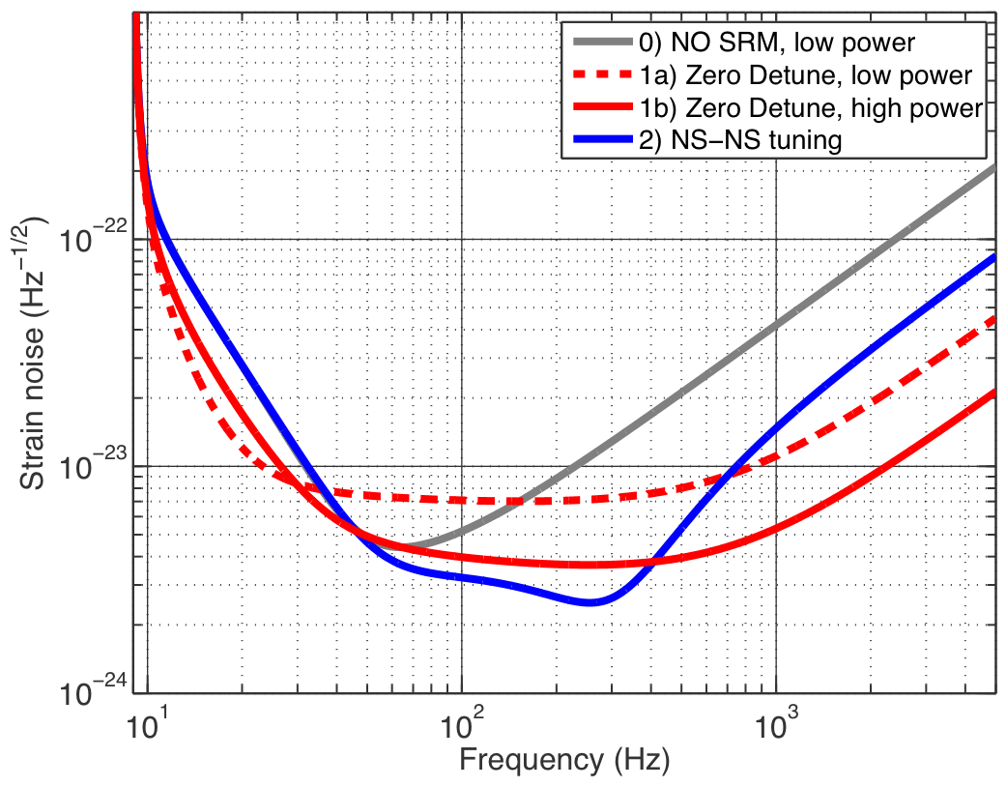
P. Fritschel
Figure 7 Different modes of operation for the Advanced LIGO Detectors

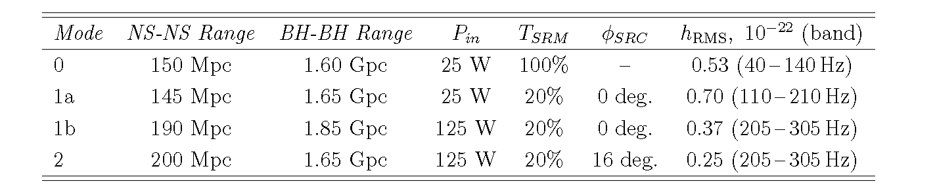
Table 2 Parameters for the different modes. The NS/NS and BH/BH range is for one detector with
source location averaged over the sky and averaged over polarization. Power in is measured at the input to
the power recycling mirror. T_{SRM} is the transmission of the signal recycling mirror and φ_{SRC} is the phase shift of the carrier after a round trip in the amplitude recycling cavity. Figure and table come from “Advanced LIGO Systems Design” LIGO T1010075-V2, P. Fritschel, editor, 09/18/2009.

The modes are associated with different configurations of the instrument as well as different parameters and tunings, see Table 1. Early in the Advanced LIGO development, once the new seismic isolation and suspensions have been installed, it will be possible to make a run in mode “0”. This mode has a reasonable probability of being able to detect NS/NS binary coalescences at rates as great as a few per month.

The formal Advanced LIGO construction project incorporates the full set of improvements consisting of the new seismic isolation systems, new suspensions, higher power laser and the inclusion of a signal recycling mirror. Developmental research is now being carried out to enable incremental improvements in the Advanced Detector in response to astrophysical observations or to improve the depth of the searches. Current research includes the following programs.

Non-invasive incremental improvements
Regression of Newtonian gravitational gradients : The concept is to use external seismometers and tilt sensors to measure the seismic compression and expansion of the ground leading to the fluctuating Newtonian gravitational gradients on the interferometer test masses and then with this information to remove the perturbing forces. The idea in a primitive form is now being used in enhanced LIGO to significantly reduce the dynamic range of the interferometric control systems against seismic excitations. In Advanced LIGO the scheme will improve the low frequency sensitivity of the instrument and may extend the search for BH/BH binaries below the 10Hz region where Newtonian gravitational gradient noise begins to compromise the performance.

Application of “squeezed” light to the Advanced LIGO detector : The ability to use “”squeezed” light injected at the antisymmetric port of the interferometer to reduce the phase noise of the interferometer is being developed in several laboratories around the world. In LIGO, a demonstration and development experiment will be mounted between the end of the enhanced LIGO program and the full deployment of Advanced LIGO. The experiment is designed to establish the ability to reduce the phase noise at hundreds of Hz up to several kHz while not destroying the performance at lower frequencies. The application of “squeezed” light is not in the current Advanced LIGO program but is being considered as a moderately non-invasive incremental improvement. The observational improvements will occur in the several hundred to several kHz region of the spectrum which includes the end point of NS/NS coalescences and significant energy in the gravitational wave spectrum of supernova models. “Squeezed” light will also offer a hedge to improve the phase noise if operation at high power proves to be troublesome.

Invasive incremental improvements
Lower frequency vertical modes for the fused silica suspensions : The coupling of thermal noise of the vertical suspension to the horizontal motions of the test mass comes about because of the curvature of the Earth. The test mass suspensions at the two ends of the 4km arms do not hang parallel. The amount of vertical thermal noise projected into the horizontal (the sensitive axis) can be reduced by lowering the resonance frequency of the vertical suspensions. This can be accomplished by using more compliant vertical support springs in the new suspensions. The interferometer sensitivity improvements would be at frequencies below 150Hz.

Variable reflectivity signal recycling mirror : The signal recycling mirror for the currently designed Advanced LIGO interferometer has a fixed reflectivity so that operating in the various modes shown in Figure 1 would require opening the apparatus and replacing the mirror. It is also possible to make a variable reflectivity signal recycling mirror by using a cavity which could be tuned while in place in the interferometer. This is one example of being able to tune the spectral response of the instrument by varying parameters in situ and will become part of the standard operations in the epoch when gravitational wave detections are common place.

Larger spot size on mirrors : The contribution of mirror coating thermal noise is reduced by increasing the light beam spot size on the test masses. The reduction in the noise comes about by taking larger averages over the mirror surface and is most important in the spectral region around 100 Hz, the critical region for NS/NS binary coalescences. Various types of beam wavefronts have been modeled in optical propagation programs which exhibit larger spot sizes without significant increase in the diffraction loss. The application of such beams will require repolishing and recoating some of the optics in the interferometer.

- Comparison of the two networks
Modeling to answer a variety of questions was carried out for the committee by several groups. B. Sathyaprakash guided a group which studied the issues for modeled sources, in particular, for binary neutron stars and low mass BH binary systems. The results given here are for a pair of 1.4 Mo neutron stars. They have looked at two versions of the Australian network AHLV with the orientation along the current planning at Gingin and A45 HLV rotated by 45 degrees.

Another group guided by Sergey Klimenko studied the networks for the detection of unmodeled sources using the coherent burst algorithm. Modeling for waveform reconstruction was done by Sam Finn. The results of the modeling are gathered together in this section of the report under a set of common headings. The individual groups will publish their more extensive results separately. The results below are presented separately for modeled and unmodeled sources.

The light travel time between various detectors is given in Table 2.

Table 2 Light travel time between various detectors in milliseconds
Detector pair | AH | AL | AV | HH | HL | HV | LV
Distance (ms) | 39.3 | 41.6 | 37.0 | 0.0 | 10.0 | 27.3 | 26.4

Antenna Patterns and Network Sensitivity
Modeled sources (compact binary systems)
A primary question concerning the various networks is their detectability of sources and their sky coverage. These two questions were addressed by looking at the combined antenna patterns of the various networks. Figure 2 compares the joint antenna patterns of networks HHLV, AHLV and A₄₅HLV. The three networks have all similar joint antenna patterns, with A₄₅HLV showing a slightly improved sky coverage. We computed the average reach of each of these networks for a sample of three different binaries. We posed the question of sky coverage by computing the total area of the antenna pattern at 50% of the average sensitivity. The results are shown in Table 3. We see that there is not much difference in the range of these networks nor their sky coverage. We have confirmed these analytical calculations by a large scale Monte-Carlo simulation.
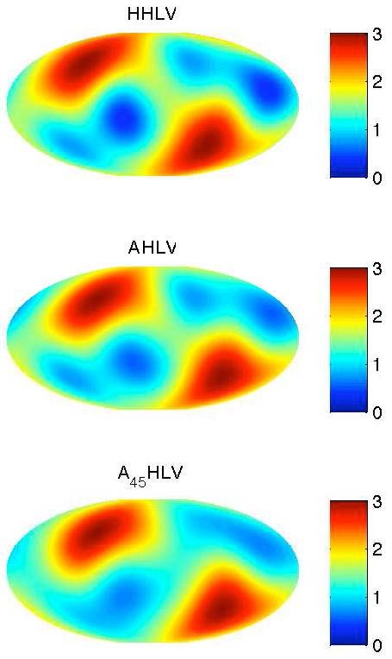
Figure 2 Joint antenna pattern of HHLV, AHLV and
A₄₅HLV networks. The color coding indicates the detected
energy in the sum of the polarizations. The maximum value is 4
for an optimally located and oriented source. The change in blue
area between the networks is worth noting.

Network \ Source | (1.4, 1.4) M_{o} | (1.4, 5) M_{o} | (1.4, 10) M_{o} | Sky Coverage
HHLV | 259.30.2 Mpc | 427.00.5 Mpc | 548.30.7 Mpc | 50.4%
AHLV | 259.70.4 Mpc | 427.20.7 Mpc | 549.00.8 Mpc | 48.6%

Table 3 The reach is computed by demanding that the network SNR is 12 and at least two detectors have an SNR of 6 or more. The last column gives the fractional area of the sky for which the antenna response F 2 = F₊ 2 + F_{x} 2 is more than half of the maximum response. Note: the distances are given in terms of the horizon distance for an optimally polarized source and are larger than the averaged distances used in Table 1 by a factor of 2.8. The average distances are used by the experimenters and the horizon distances by the modelers.

Unmodeled sources
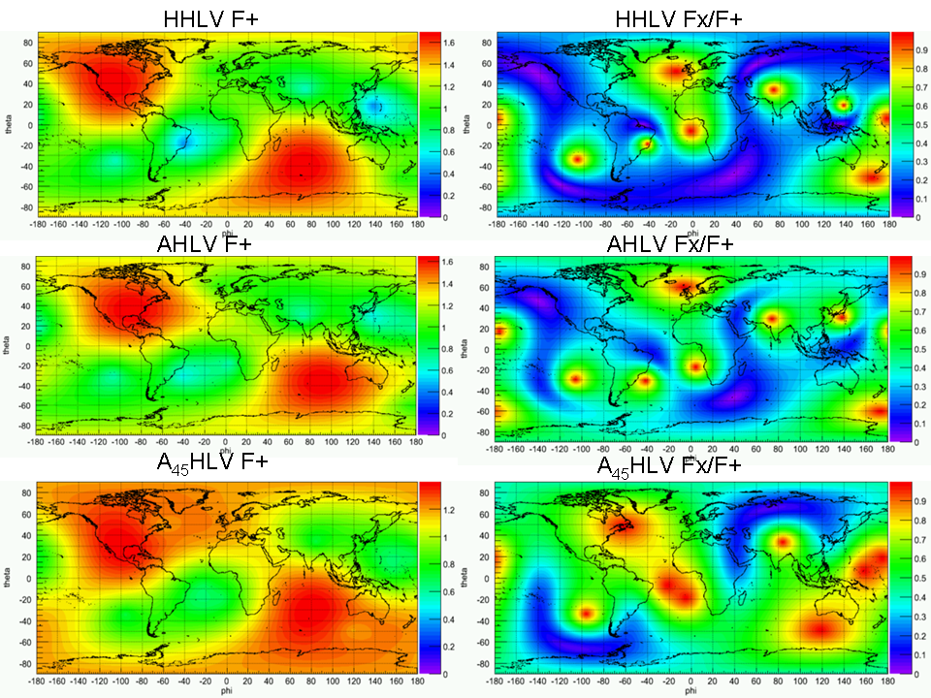
Figure 3 Comparison of network sensitivity for gravitational waves with equal amplitude of the polarization at the source. The plot shows the sensitivity of the networks for the magnitude of the dominant detected polarization, F+ (left), and the ratio of magnitudes of the Fx/F+ (right) for unmodeled burst sources as a function of sky coordinates.

The norms of the antenna pattern vectors |F+ | and |F× | characterize the network sensitivity to the GW polarizations. Closely aligned networks (like HHL) have poor sensitivity to the second polarization: |F+ | >>|F× | which makes full reconstruction of the GW signal difficult. Figure 3 show the |F+ | and the ratio |F× |/|F+ | for HHLV, AHLV and A₄₅HLV networks. The ratio |F_{x}|/|F₊| gives the ratio of the SNRs produced by each gravitational wave component assuming equal amplitude in each polarization at the source. The red spots on the |F_{x}|/|F₊| plots indicate the network has equal sensitivity for both gravitational wave components. The blue spots indicate that the smaller gravitational wave component is not measurable for a moderate SNR (a network SNR < 30).

Another study of the ability to determine the polarization of the gravitational waves from the two networks was carried out with the intent of evaluating waveform reconstruction.
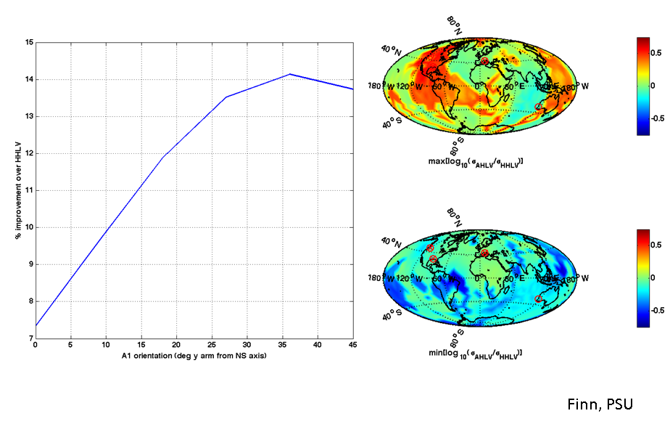
Figure 4 The ability of the AHLV relative to the HHLV network to determine the polarization of burst sources distributed over the sky. At each location in the map the source is overhead and has equal polarization components. The left plot shows the improvement of AHLV relative to HHLV averaged over the sky as a function of the orientation of the Australian detector. The plots on the right show the (log) ratio of the statistical uncertainty in the recovered waveform. The two plots show different extremes; in the upper plot the ratio for the source orientation that most favors HHLV is shown; in the lower plot the source orientation that most favors AHLV is shown. Nowhere over the sky is HHLV significantly more sensitive than AHLV and, over large parts of the sky, AHLV is more sensitive than HHLV.

To identify the incident strain requires an antenna array whose elements are sufficiently independent in their response to permit the inference of the radiation “field” incident on the ensemble. Correspondingly, the AHLV and HHLV antenna arrays will be different in their ability to infer h from observations d.

Finn & Lommen (2010) describe how to infer an arbitrary h from antenna array observations d. The result of this analysis may be summarized as
h = (h⁰₊ σ₊)e₊ + (h⁰_{x} σ_{x}) e_{x} ,where h⁰₊, h⁰_{x}, σ₊, and σ_{x} are all functions of the antenna array observations d, the array element noise power (cross)spectral densities, array element response functions, and wave propagation direction. The σ are understood to describe the 68% probability bounds.

To investigate the relative ability of the AHLV and HHLV antenna arrays to infer the waveforms of an arbitrary source we have simulated antenna array datasets (signal + noise) and applied the Finn & Lommen analysis to them. Varying source orientation and location on the sky, but holding all else fixed, we find that median sensitivity of the AHLV network is superior to the HHLV network: i.e., the median of (σ₊ σ_{x})^{1/2} over all source orientations, is smaller for AHLV than for HHLV. The advantage varies with source amplitude and AHLV orientation. The best advantage corresponds to AHLV oriented with arms ~+36 deg from the NS and EW axes. Preliminary investigations indicate that for this orientation the error bars may be 15% smaller for AHLV than for HHLV. Figure 4 shows the principal results of the analysis of the two networks.

A measure of the sensitivity of the networks is provided by the search volume, the volume of space defined by enclosing an isotropic distribution of equal strength sources at the network limiting sensitivity. The useful quantity is the ratio of the volumes for different networks as this becomes independent of the search algorithm and the nature of the source. Table 4 shows the volume ratios for a variety of networks with respect to the HHL network. The calculations assume the SNR thresholds are the same for all the networks. The table also shows the reduction in effective search volume, and thereby increases in the SNR needed for detection, due to non-stationary and non-Gaussian noise in the detectors. The excess noise causes extended non-Gaussian tails in the estimates for the false alarm rates as a function of SNR (see Figure 11).

Network | V ratio Gaussian noise | V ratio FAR < 1/5 y
HHL | 1 | 0.22
HL | 0.54 | 0.05
HLV | 0.93 | 0.32
HHLV | 1.44 | 0.74
A₄₅HLV | 1.43 | 0.51
Table 4 Network search volume ratios relative to the ideal HHL network. The second column
shows the volume ratios assuming Gaussian noise for all networks. The third column shows
degradation of the search volume due to non-Gaussian and non-stationary noise. The calculation was made over the full 64 to 2048Hz band in the S5/S6 runs . The low frequencies are the major source of the non-Gaussianity.

Determination of Source Sky Position
Modeled Sources
Figure 5 Left: Sky localization with the HHLV network. Right: Sky localization with the AHLV network. The plots show the 90% confidence contours for binary NS sources face on and at a horizon distance of 200Mpc. The plot assumes that the advanced detectors would achieve a SNR =8 for these sources at a horizon distance of 180Mpc. The red X’s are points in the sky where the signal would be poorly detected with a network combined SNR < 12 .

For a three-site network, one can only constrain the location of the source within the plane of the detectors. This gives the well-known degeneracy in localization, giving two sky patches one above and one below the detectors. In what follows, we will assume that this degeneracy can be broken by considerations of the relative observed amplitudes. In reality, however, this will not always be possible. In the case of three detectors, the best case scenario has the source overhead the plane of the detectors. The worst case is with the source in the plane of the detectors. For the four-site network, the sky-localization degeneracy is broken. Furthermore, there is no longer a particularly bad sky location.
In this study, we use only the timing of binary neutron star coalescences to triangulate a source on the sky. In the case of Advanced LIGO, the time of arrival of a signal can be determined to within 0.13 ms for a signal that produces an SNR of 10. A Monte Carlo with 1,000,000 potential sources distributed uniformly in the sky, uniform in volume, and with a uniform orientation distribution was performed. A source is said to be found by requiring that:

- the combined (root sum square) SNR was at least 12, and

- the SNR in at least two detectors was 6 or more.

Table 5 compares the detection ability and sky localization of a three-site network with a four-site network. For both 3- and 4-detector networks, the number of sources found by the network containing a detector in Australia is the same as the one without it. However, as expected, sky localization improves significantly in a network that contains an Australian detector. For example, in the case of a four-detector network, the AHLV network localizes four times as many sources within 5 sq deg as does the HHLV network. The better sky localization of an AHLV network means that it is necessary to survey a volume that is a factor 3 to 4 smaller than in a network that doesn’t include the Australian network.

Network | Fraction found | 5 deg² | 10 deg² | 20 deg²
ALV/HLV | 1.04 | 3.4 | 2.0 | 1.3
AHLV/HHLV | 1.03 | 4.1 | 2.6 | 1.7
Table 5 Comparison of HLV vs ALV and HHLV vs AHLV with regard to number of found sources, fraction of sources with 90% confidence sky-localization to better than 5, 10 and 20 square degrees.

One of the important goals for gravitational astronomy is to be able to follow-up potential events with astronomical telescopes. Observing events with optical, radio, X-ray and other EM telescopes can give further information that is very crucial to the scientific payoffs. For example, by measuring the red-shift of the host galaxy of a binary neutron star merger (which would require optical observations) it would be possible to confirm the Hubble flow and make measurement of the Hubble parameter that is completely independent of the cosmic distance ladder. This is because, inspiraling binaries are self-calibrating standard candles, that allow a very precise measurement of their luminosity distance from a knowledge of their gravitational wave amplitude in three or more detectors.

An important question in relation to follow-up is not only the size of the sky-localization error ellipses but also their shape. Figure 5 shows 90% confidence sky-localization error ellipses for binary neutron star mergers at 200 Mpc whose orbit is face-on with respect to the line-of-sight. The left panel corresponds to a three-site HLV network and the right panel corresponds to a four-site AHLV network. The error ellipses are pretty elongated for sources that are roughly in the plane of the three-site network (left panel) and they get significantly smaller and more rounded in the four-site AHLV network.
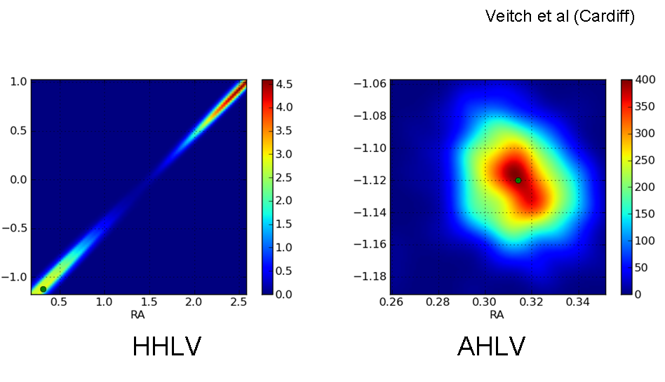
Figure 6 Examples of the sky localization contours in the two networks. The green dot shows the true position of the source in the modeling. The color coding indicates the probability density in units of 1/steradian

Figure 6 presents another comparison of the relative ability of the two networks to determine a source location on the sky. The probability distribution for the sky position is shown as part of the multi-parameter fits for the modeling of NS/NS coalescences . The modeling is described later in this document. The green dot is the injected position of the source. The HHLV network suffers a degeneracy in the sky position which is resolved in the AHLV network. Furthermore, the AHLV network provides uncertainty contours that are more circular and smaller.

Unmodeled sources
The coordinate reconstruction depends on the signal waveforms, polarization content, characteristic frequency and constraints used for the reconstruction. In this study we consider the least constrained case of burst searches (un-modeled all-sky search) used for reconstruction of 10 different ad-hoc GW signals uniformly distributed over the sky. Figure 7 shows the reconstructed error angles (averaged over the sky) as a function of SNR. In general the pointing performance is increased with the SNR, but as shown on the 90% confidence plot, for the HHLV network a significant fraction of even high SNR events is not well reconstructed.
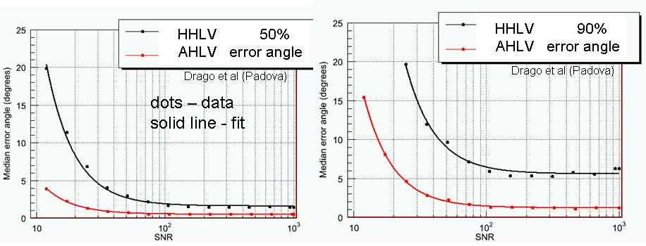
Figure 7 Error angles in degrees for 50% (left) and 90% (right) confidence as a function of the network SNR.

Figure 8 shows pointing capabilities of both networks as a function of sky coordinates. It shows the average median error angle for events with SNR < 30. These plots show that for expected low SNR signals the 4-site A₄₅HLV network has significantly better
pointing performance than the HHLV network. The improvement is due to the two main effects:

- The pointing is based on the triangulation and the HHLV network has zero redundancy. In many cases due to a particular polarization content of the signal or un-favorable sky location one detector may drop out of the measurement effectively reducing the network to two sites. The AHLV network is more robust if one detector is lost from the reconstruction.
- In many cases (particularly for un-modeled burst searches) the HHLV network can not resolve the actual-mirror location degeneracy which results in larger error regions. There is no such degeneracy for the AHLV network.

Another advantage of the AHLV network is that the coordinate reconstruction is much
less affected by calibration errors.

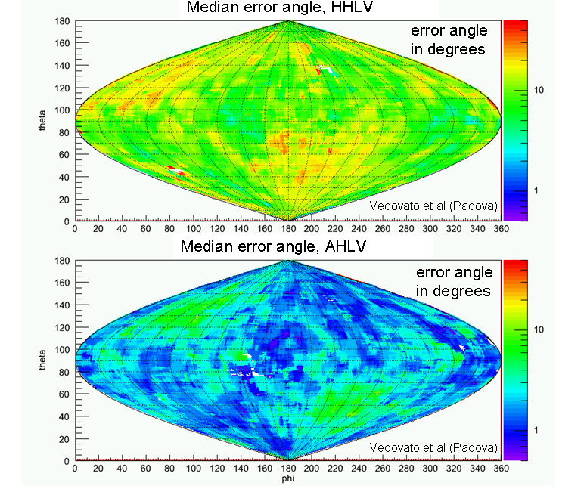
Figure 8 Average error angle as a function of sky coordinates for the two networks.

Source Parameter Estimation
Modeled sources
Parameter estimation studies based on arrival times neglect the correlations among different parameters that are known to exist in the case of binary inspiral signals. We have, therefore, used Bayesian methods to characterize the posterior probability density function of all the signal parameters. We assumed our source to consist of a pair of non-spinning neutron stars on a quasi-circular orbit. In this approximation, the source is characterized by nine parameters: Luminosity distance D_{L}, sky location, θ,φ, polarization angle ψ source inclination ι, the masses M,η, epoch of coalescence t_{C} and phase at that epoch φ_{C} .
Table 6 compares the performance of the two networks, averaged over 625 different sky locations, polarizations and inclinations, in terms of the area of the sky to which an individual source can be localized to within 67%, 90% and 95% confidence intervals. We have also listed the fractional error in the measurement of the luminosity distance Δd_{L}/d_{L} . At 90% confidence interval the AHLV network resolves a source a factor of 2 to 3 better than the HHLV network. However, the estimation of the luminosity distance remains unchanged.

Network | 67% confidence deg² | 90% confidence deg² | 95% confidence deg² | Δd_{L}/d_{L}
HHLV | 16.6 | 29.4 | 33.9 | 0.15
AHLV | 8.1 | 15.2 | 17.7 | 0.18
A₄₅HLV | 7.4 | 13.4 | 15.8 | 0.14
Table 6 The mean resolution of each network in square degrees, averaged over RA, dec, ι and φ.

The most important advantage of the AHLV network is its ability to break the degeneracy of the source location that we mentioned before. As another example of the advantage of a four-site network, let us look at the degeneracy between inclination angle and luminosity distance. A three-site network does not have the ability to resolve these variables uniquely, especially for edge-on binaries. In Figure 9 we have plotted the two-dimensional probability distribution function for a source at (D, ι ) = (180 Mpc, 1.68rad). The HHLV network obtains a bimodal distribution for these two variables while the AHLV network shows a unimodal distribution and the degeneracy seen in HHLV is broken.

A second MCMC study was performed in order to confirm the results. This uses an independent code and a somewhat different algorithm to compute the posterior distribution. An agreement between the two approaches will be a useful way of confirming the overall results.

Figure 9 Two dimensional probability density contours for the model parameters of a binary neutron star system’s luminosity distance and orbital inclination angle relative to the line of site in the two networks. The green dot shows the input value of the model parameter (iota is symmetric about π ). The solution using the HHLV network is bimodal. The degeneracy is broken in the AHLV network. The color coding
indicates the amplitude of the probability density in units of 1/(Mpc*radian).

Table 7 lists 2 - σ confidence intervals for the AHLV and the A₄₅HLV network configurations as fractions of the same widths for the HHLV configuration, averaged over all runs. The table shows the mean values, and the minimum and maximum interval ratios to indicate the spread due to different locations, and orientations as well as different noise realizations.

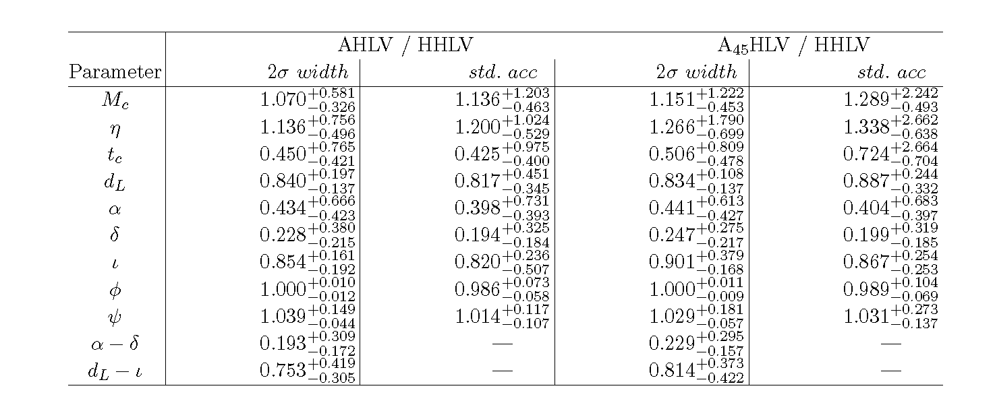
Table 7 Errors ratios in the fit parameters. Comparative 2σ interval widths and standard accuracies for one dimensional probability distribution functions and comparative 2σ areas for two dimensional probability distribution functions (bottom two rows) averaged over all injections. All values for the AHLV and A₄₅HLV network configurations are given as fractions of the corresponding values for the HHLV network. The mean values of the ratios across all injections are computed; the error bars correspond to the spread between the minimum and maximum values of these ratios.

We should particularly point out the next-to-last line of the Table 7, α−δ row. The area of this 2-dimensional probability distribution function is a direct measure of the uncertainty in estimating the position of the source on the sky. The error box shrinks by a factor of ~ 3 - 5, similar to the improvements we found in the previous study and with timing.
Observe that the time-of-arrival of the signal at the center of the Earth improves by a factor of two in a four-site network as compared to a three-site network. This improvement is the reason why a four-site network has a greater sky resolution of the incoming gravitational wave signal. Moderate improvements are also seen in estimation of inclination and luminosity distance. However, the main point, as noted before, is that a four-site network gives one dimensional probability density functions that are unimodal. This is illustrated in Figure 10.
On the other hand, perhaps unexpectedly, the accuracy with which mass parameters are measured does not improve when we go from a three-site to a four-site network. We can speculate that the reason for this is that masses do not strongly correlate with extrinsic parameters (with the exception of the time of coalescence), so their estimation is not significantly improved by better sky localization or inclination measurements. On the other hand, the evolution of the phasing of the waveform is very sensitive to the masses—and the accuracy with which the phase can be measured by a given detector is sensitive to the SNR in that detector. Having two detectors at Hanford, which should see identical signals (up to noise), effectively increases the SNR in that detector, potentially making better phase measurements possible. This may be the reason for the comparable or better measurement of chirp mass and mass ratio with the HHLV network configuration.
Given our limited statistics, the AHLV and A₄₅HLV network configurations appear to give comparable improvements to parameter-estimation accuracy. The sky localization appears to improve more with the A Australian detector than with the A₄₅ detector; however, this may not be statistically significant.
The large spread in the improvements in parameter-estimation accuracy for a network with an Australian interferometer (see the spread between minimum and maximum ratios for individual parameters in Table 7) may be indicative of the different effects of the network configuration on injections corresponding to particular choices of sky locations, inclinations, and orientations of the binary, rather than statistical fluctuations due to noise differences. However, we do not currently have a sufficiently dense grid of injections to test this hypothesis.
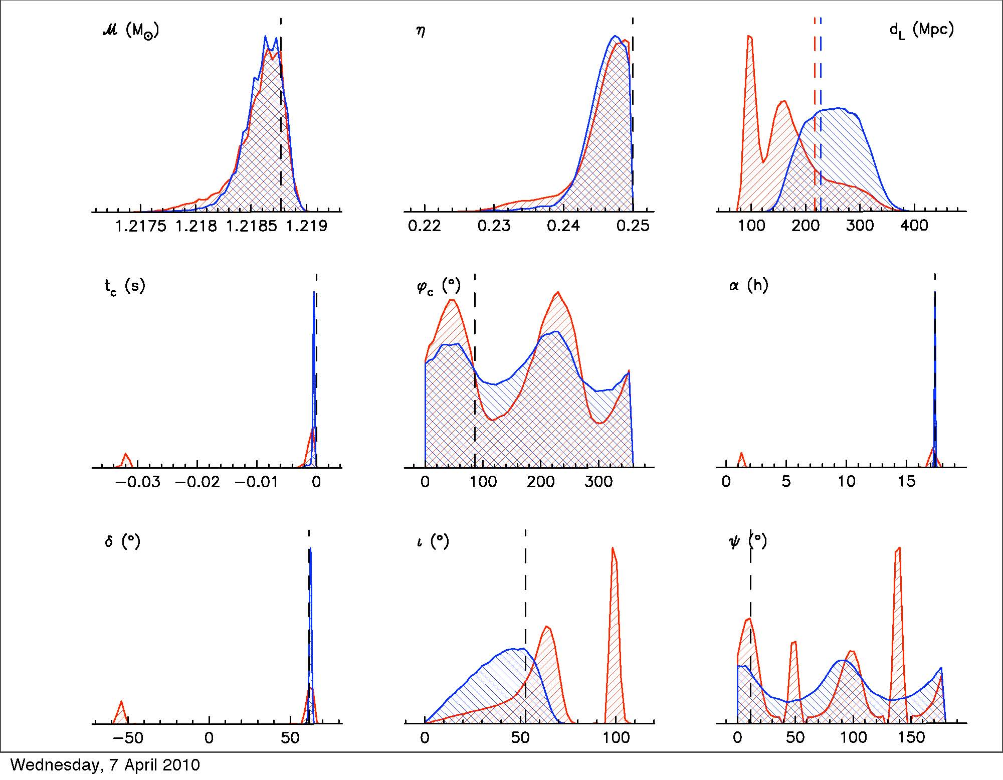
Figure 10 Comparison of the one-dimensional probability distribution functions for a typical source’s parameters as detected by the HHLV (red) and AHLV (blue) networks. Note the bimodal posteriors in right ascension and declination for the HHLV vs the unimodal ones for the AHLV network. The latter network also allows for better estimates of the posteriors for inclination and luminosity distance. Dashed lines indicate the injected values (note that different injected values of the luminosity distance were used for the HHLV and AHLV so that the total network SNR is 15 in both cases).

The general conclusion of this study is that in a three-site network a number of parameters are strongly correlated with one another and, for certain regions of the parameter space, there is a strong degeneracy that makes parameter estimation quite ambiguous. In fact, the posterior probability density functions of some of the parameters happen to exhibit a bimodal (and sometimes multi-modal) distribution. In a four-site network, most of the degeneracies are broken and the probability density functions tend to be uni-modal. For some of the parameters, like the luminosity distance and inclination angle, the variance in parameter estimation is the same for both networks. However, for AHLV there is generally no bias in the estimation of parameters. While the angular parameters and the luminosity distance improve qualitatively and quantitatively, the estimation of the chirp mass and mass ratio of the binary is literally the same in both AHLV and HHLV networks.

Robust Detection: False Alarm Rate
Unmodeled sources
We define a robust detection with a given network when the search volume V is sufficient to detect few GW events during the observation time with the significance greater than 5σ. The significance of the observation is determined by the false alarm rate achievable with the network. For example, if the rate of detection times the volume, RV>5, for a one year run, the network false alarm rate should be less that 1/5 per year using Poisson statistics. If the astrophysical rates are much lower (for example, RV ~ 0.5), then for robust detection the observation time should be much longer (~10 years) and the achievable false alarm rate should be much less (< 1/50 per year).
With the non-stationary and non-Gaussian data from the interferometers it will be difficult in a search for unmodeled bursts to obtain false alarm rates of less than 1/10 per year and simultaneously maintain the search volume of an ideal (Gaussian) network. Figure 11 shows why. It is due to the tail of non-Gaussian background events for which the rate does not change much as the threshold on SNR increases.

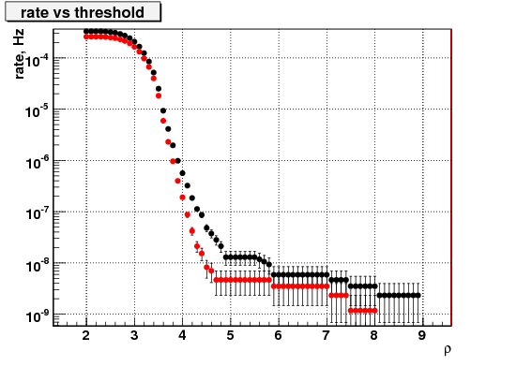 Figure 11 False alarm rate vs the correlated amplitude (proportional to SNR) for background triggers produced by the coherent waveburst algorithm in a search for unmodeled burst sources during the S6a run with the three detector HLV network. The black dots are for low frequencies (64-200Hz) and the red dots for high frequencies (200-2048Hz). The analysis was carried out with one week of data using 1000 time slides.

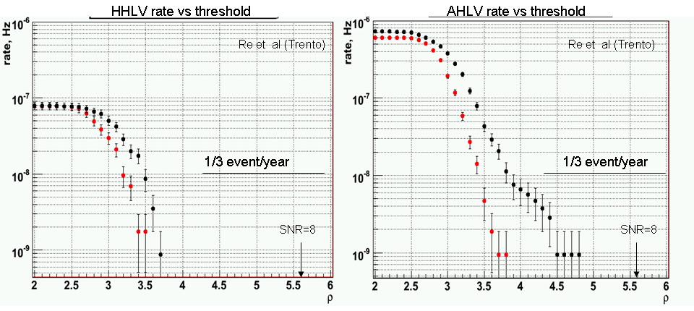
Figure 12 Background rate vs detection threshold for the two networks in a search for unmodeled burst sources. Black dots represent the low frequency band (64 -200Hz) and red dots the high frequency (200 – 2048 Hz) band. The significant change in the non-Gaussian tails relative to Figure 11 is due to having four rather than three detectors in the network.

An estimate for the false alarm rate in burst searches with the advanced detectors for the AHLV and HHLV networks is shown in Figure 12. The analysis was carried out with the coherent wave burst algorithm. For both networks data collected during the S5/VSR1 and S6/VSR2 runs was used. During the S5 run two detectors were operational in Hanford H1 and H2, with H2 at half the sensitivity. To emulate a second advanced detector in Hanford, the H2 noise was rescaled to match the H1 sensitivity. To emulate the A detector, in the analysis we pretended that the rescaled H2 data stream originates from Australia. Most of the background events are produced by a random coincidence of noise transients in the detectors. To make the background estimates, the data streams were shifted by random time with respect to each other. In the HHLV network, because of the correlated noise between the two H interferometers, no time shifts were used for the H1H2 pair. In the AHLV network no correlation is expected between the A detector and the other detectors, therefore random time shifts were used between all detectors. To accumulate sufficient live time, a large number of the time shift configurations were used (~2000). The total accumulated background time was 36.4 years for the HHLV and 33.7 years for the AHLV networks.
In the analysis we used the likelihood method combining data from all detectors. Such a coherent approach takes into account the locations of the detectors, their antenna patterns and strain noise to reconstruct the individual detector responses as a function of sky coordinates. Since there is no true sky location associated with a random coincidence of noise transients, in most cases the reconstructed responses are inconsistent with each other, which helps to rule out many of the background events.
Figure 12 shows several important results. The first is the benefit derived from having a fourth detector in the network, best seen by comparing the change in the non-Gaussian tails between Figure 11 and 12. The second result, not obvious at the start of the study, is that the two networks do not differ greatly in the false alarm rates associated with a range of SNR values. It had been guessed that the false alarm rate for the HHLV network could have been significantly less than that of the AHLV. The basis for this guess was the the idea that one could make a simple veto independent of sky location (allowing a small delay time) and polarization with signals from the two collocated detectors in the HHLV network and thereby provide a large reduction in the false alarm rate over the AHLV network. The modeling does not show this. The reason is that the coherent wave burst algorithm provides a similar but sky dependent veto for the AHLV network. This does a good job in reducing the long non-Gaussian tails by demanding consistency in the signals at the four detectors as it solves for the position on the sky. The high frequency data in Figure 12 has come close to Gaussian while the low frequency data, which is considerably less stationary and initially more non-Gaussian, does show a difference between the networks. Additional modeling may demonstrate that there are benefits in detection confidence with the AHLV over the HHLV network because the unique position solutions provide more stringent consistency conditions on the signals.
Further modeling may show that the false alarm rate for AHLV is always a factor of a few larger than for the HHLV network (neglecting the correlations between H1 and H2). However, once the data remaining after the analysis approaches Gaussian, the difference becomes academic. In Gaussian data, the false alarm rate is a steep function of the threshold SNR. For example, at an SNR of 5, a few percent change makes an order of magnitude change in the false alarm rate. The key job for a detection algorithm used on non-Gaussian data originating in the instruments is to make the analyzed data as close to Gaussian as possible. A good example of the power of this statement is given in the next section of the report where the false alarm rates for modeled sources are dramatically reduced by a new analysis technique that removes the non-Gaussian tails.
Given the demonstrated power of the coherent network analysis, the committee strongly urges the Compact Binary Coalescence search group to implement a coherent detection algorithm to be ready for the Advanced LIGO epoch.

Issues surrounding first detections
The science case for LIGO South is based mainly on the desire for a network that yields the best science from a set of detected signals. Nevertheless, it is important to consider the issue of how we will achieve the first detections of gravitational wave signals. Given that the deployment of LIGO South would likely be delayed by as much as two years compared with the time for completion at the U.S. sites, a key question becomes, can we expect to detect signals with only the LHV network and at worst with only two U.S. interferometers?

The CBC group examined the extreme case: only two U.S. interferometers available. The examination consisted of study of the statistics of 0.43 years of time from the second year of S5, using data from H1 and L1, but not from either H2 or V1. Histograms of signals from the search for Binary Neutron Stars (i.e., chirp mass less that 3.48 Solar Masses) were made under a variety of conditions. By using 100 time slides to estimate background statistics, the question was asked whether the data was free enough of a non-Gaussian tail of glitches that a detection could be confidently made at SNR = 8. This is a key issue, because estimates of Advanced LIGO range are based on the assumption that we will claim detections for signals with SNR of 8 or above.

The group examined the results at two levels of data quality, CAT2 and CAT3. They also explored the use of two signal strength measures, SNR and the CBC group’s scaled version called NewSNR. NewSNR reduces the SNR by a factor that grows as the chi-squared value grows. It produces a number that is very close to SNR for signals that match well the templates, but that can be dramatically reduced below the SNR if the chi-squared value is high (indicating bad match between signal and best-fitting template.)

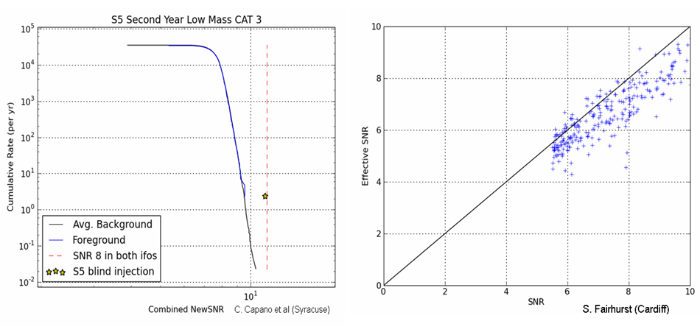
Figure 13 (Left) Rate of accidental detections with H and L detectors vs New SNR which includes a modification for the chi2. (Right) Shows the relation between the standard SNR and the newSNR for injections made during S5. The detection efficiency is not strongly affected by the use of the new SNR.

What was found is shown in Figure 13(left). Using the (chi-squared weighting) NewSNR and CAT3 vetoes, the histogram shows no sign of any non-Gaussian tail as far as this data set could reveal it, to a false alarm rate of about 0.03 per year. An artificial signal injected at about SNR 8 (NewSNR about 7.5) in each detector stands strongly above the background, making it easily detectable. Thus, the use of the signal-detection ranges based on a criterion of SNR = 8 seems eminently reasonable.

It is important to note that any relaxation of the chosen conditions introduces a non-Gaussian tail to the statistics that would call first signal detection into question. Use of SNR instead of NewSNR, use of only CAT2 vetoes, or use of the broader template set used to search for more massive binary systems, each produces a histogram with a substantial non-Gaussian tail, that could make it necessary to substantially raise the detection threshold. Thus, our prediction of successful detection at SNR = 8 with two detectors depends on having data quality not substantially worse in Advanced LIGO than in initial LIGO. Although not guaranteed, we think that this is a reasonable assumption for planning purposes.

The scaling between SNR and NewSNR for artificially injected signals is shown in
Figure 13(right). At the benchmark value of SNR = 8, NewSNR is slightly below the value of SNR. This needs to be taken into account when comparing search results (that use NewSNR) with theoretical range predictions that use SNR. However, the difference is small and well paid back by the elimination of the non-Gaussian tail in the accidental event rate.

References
“Bayesian Coherent Analysis of In-Spiral Gravitational Wave Signals with a Detector Network” J. Veitch and A. Vecchio, Phys Rev D V81 062003 (2010)

“Geometrical Expression for the Angular Resolution of a Network of Gravitational-Wave Detectors” L. Wen and Y. Chen, LIGO Document P1000017-v3, Feb 8, 2010.

“Detection, Localization and Characterization of Gravitational Wave Bursts in a Pulsar Timing Array” L.S.Finn and A.N. Lommen, arXiv: 1004,3499
(2010) submitted to Ap.J

“ Constraint Likelihood Analysis for a Network of Gravitational Wave Detectors “
S. Klimenko, S. Mohanty, M Rakhmanov, G. Mitselmakher Phys Rev D V72 122002 (2005)

Appendices

Initial LIGO rationale for H1 and H2
The idea that one could multiplex the beam tubes with several interferometers of both full and half length arms was incorporated in the initial LIGO proposal made to the NSF in 1989. With final approval of initial LIGO, the decision was made to construct the minimum configuration, initially consisting of 4km interferometers at both sites with a 2km at Hanford. To not preclude additional instruments later, the buildings at Hanford were designed to allow both two 4km and one 2km while those at Livingston to accommodate two 4km instruments.

The motivation for the 2km interferometer at Hanford was to:

- Provide an additional detector to reduce the accidental coincidence rate for gravitational waves in the face of both Gaussian and non-Gaussian noise. It was recognized that there would be some correlation between the 4km and the 2km from environmental noise, nevertheless, the ability to veto events observed in the main 4km detectors was the key function.

- Provide an additional consistency test for candidate gravitational wave events through the amplitude ratio proportionality with length between the 2 and 4km detectors. It was recognized that the value of the consistency test would be a strong function of the signal to noise of the gravitational wave signals.

- Provide diagnostics for a variety of environmental perturbations observed in the main interferometer output that could then be eliminated with further development of the detector and facilities.

Not all of the initial precepts have been realized during the LIGO science runs. The amplitude and waveform consistency tests were very valuable, especially in burst searches, until Virgo brought us a third interferometer site without the potential noise correlations and with less of an intrinsic limit on interferometer sensitivity. Since the most likely detection candidates are expected to have low signal to noise, a twofold sensitivity compromise is a large price to pay. Also, in practice the correlated noise sources identified to date have tended to be at points in the corner station that lacked the very high seismic and acoustic isolation of the core optics chambers; thus sharing the same corner station appears to have overwhelmed any advantage of not sharing common end stations.

The baseline network for the Advanced LIGO program is to move the 2km detector at Hanford to a length of 4km. This does not remove the correlations between the detectors but does make the detectors at Hanford comparable in sensitivity.

Committee Charter

DATE: January 4, 2010

TO: | Sam Finn, Peter Fritschel, Sergei Klimenko, Fred Raab, Bangalore  Sathyaprakash, Peter Saulson, Rai Weiss (chair)
FROM: | Jay Marx, Albert Lazzarini, David Reitze
SUBJECT: | LIGO South Scientific Evaluation Committee
Refer to: | LIGO- M1000003-v1

Funding limitations in Australia are such that the possibility of building an Australian interferometer is essentially non-existent without substantial in-kind support from the international gravitational wave community. Thus, LIGO Laboratory is very seriously considering the possibility of offering one of the Advanced LIGO interferometers slated for installation at Hanford for alternate installation at a suitable location/facility in Australia.
From a scientific standpoint, a third Advanced LIGO interferometer in Australia together with the Advanced Virgo interferometer in Italy would constitute a larger global worldwide network, with four comparably sensitive interferometers distributed worldwide. While the feasibility of a move depends on many factors that go beyond purely scientific motivations, the decision must rest ultimately on an objective evaluation of the astrophysics gains that come from having a third LIGO interferometer located in Australia as opposed to the current baseline of having two collocated interferometers at Hanford.
We ask you to serve on an evaluation committee whose charge is to compare the scientific benefits of relocating the third Advanced LIGO interferometer to Australia against those of maintaining two interferometers at Hanford. Fundamentally, the question to be addressed is “How much more gravitational wave astronomy could be enabled by moving an interferometer to Australia?” The charge should be viewed in the context of our expectations that i) once they are operating at design sensitivity, the Advanced LIGO and Virgo detectors will go beyond detections and usher in the era of gravitational wave astronomy, and ii) the Advanced LIGO and Virgo detectors will have a scientific lifetime extending through 2030 and possibly beyond.
Consider the charge as broadly as possible, and quantitatively to the extent possible. Specific issues which should be studied include, but are not limited to:
- What new astrophysics is enabled by placing an interferometer in Australia? Generally, how might gravitational wave astronomy evolve over a twenty year time scale by installing an interferometer in Australia when compared with leaving both interferometers at Hanford?
- Consider what impact a move would have on the science goals in the Advanced LIGO era. Specifically, how might each of the search groups’ science goals be enhanced or diminished with such a move?
- Assuming no detections in S6/VSR2, would relocating an interferometer have a positive or negative effect on the time to a first detection?- With two co-located tunable interferometers, it is possible to separately tailor each of their sensitivities, for example, to effectively provide a broader bandwidth in a single location or to search for a specific pulsar. Would any science be compromised by losing the capability of doing this at a single site? (Presumably the third Advanced LIGO detector could be operated in narrowband regardless of its location.)
- What impact would the loss of co-located interferometers have on background suppression for transient burst and inspiral searches?
- What advantages would a move have on multi-messenger (joint GW-EM and GW- neutrino) searches? (e.g. in sky localization vs SNR; in sky coverage, etc.)
- Assuming that the interferometer would be located at Gingin near Perth, what would be the preferred orientation of an Australian interferometer?
- What impact would installing an interferometer in Australia have on GW source parameter estimation (eg, polarization analysis)? Are there any disadvantages?

Note that we are not asking you to address construction, commissioning, operations, or management issues in this study. However, you should comment upon these or any other issues to the extent that they influence the primary scientific considerations.

The final report, not more than 10 pages, should be delivered by April 15, 2010. A preliminary report should be provided to the LIGO Directorate by March 15. Your report should not make any endorsements, but should clearly state the positive and negative scientific consequences of installing an Advanced LIGO interferometer in Australia. If needed, feel free to consult with others in developing the report, but please keep the Directorate informed of whom else is being consulted.

It is expected that NSF will retain ownership of the LIGO-South interferometer components supplied to LIGO-Australia, in the same way that it holds ownership of the US LIGO facilities. This will be spelled out in the formal agreements which must still be negotiated.
In this white paper, costs or funds associated with LIGO or Advanced LIGO are given in US dollars and are denoted with a dollar sign ($). Costs which are incurred primarily in Australia or are paid by Australian sources are quoted in Australian dollars, denoted AU$. As of June 1, the exchange rate is $1.00 = AU$1.18. In the past year, the exchange rate has varied between 1.06 and 1.30.
Even though (as an already funded effort) Advanced LIGO was not being evaluated by the Astro2010 Decadal Survey, a number of the science white papers submitted by the astronomy community cited the links to gravitational waves in their discussions of the important science they see for the next decade. These white papers include: Bloom et al. http://www8.nationalacademies.org/astro2010/DetailFileDisplay.aspx?id=18 Kulkarni et al. http://www8.nationalacademies.org/astro2010/DetailFileDisplay.aspx?id=191 Phinney et al. http://www8.nationalacademies.org/astro2010/DetailFileDisplay.aspx?id=350 Soderberg et al. http://www8.nationalacademies.org/astro2010/DetailFileDisplay.aspx?id=220 Stamatikos et al. http://www8.nationalacademies.org/astro2010/DetailFileDisplay.aspx?id=373 Wozniak et al. http://www8.nationalacademies.org/astro2010/DetailFileDisplay.aspx?id=281 Nelemans et al. http://www8.nationalacademies.org/astro2010/DetailFileDisplay.aspx?id=376
GWIC was formed in 1997 to facilitate international collaboration and cooperation in the construction, operation and use of the major gravitational wave detection facilities world-wide. It is affiliated with the International Union of Pure and Applied Physics (IUPAP) as a sub-committee of IUPAP's Particle and Nuclear Astrophysics and Gravitation International Committee (PaNAGIC). GWIC is also affiliated with the International Society on General Relativity and Gravitation.
This discussion only applies to relatively short duration gravitational waves, where the detectors can be considered as approximately stationary relative to each other during the passage of the wave. For long-lived sources, such as the continuous sinusoidal waves from a rapidly rotating neutron star, we can use the signal from a single detector to sweep out and fill the aperture as the earth rotates and moves around the sun. This modulation can be used to locate the source to arc-second scale resolution with a single detector.
The committee included a cross-section of experimenters and data analysts with particular expertise in short duration gravitational wave signals (“compact binary inspirals and bursts). The members were: Sam Finn Pennsylvania State University Peter Fritschel LIGO-MIT Sergey Klimenko University of Florida at Gainesville Fred Raab LIGO-Hanford B. Sathyaprakash Cardiff University Peter Saulson Syracuse University Rainer Weiss LIGO-MIT (Chair)
EIF, http://www.deewr.gov.au/HigherEducation/Programs/EIF/Pages/default.aspx
The most likely failure mode is that funding of this scale cannot be secured in Australia on this short time-scale. However, other insurmountable obstacles are possible, such as irreconcilable differences in the management arrangements or legal hurdles that cannot be resolved.
Steve Fairhurst, B.S. Sathyaprakash, P.J. Sutton, John Veitch (Cardiff University), Ben Farr, Vivien Raymond, Ilya Mandel, Vicky Kalogera, Marc van der Sluys (Northwestern University), Sukanta Bose (University of Washington)
Sergey Klimenko (University of Florida at Gainesville), G.Vedovato. INFN, Padova, Italy, M.Drago, University of Padova, Padova, Italy , V.Re, Trento University, Trento, Italy, I.Yakushin, LLO.
? CAT2 and CAT3 are acronyms designating two different kinds of vetoes applied to the intereferometer output data. The CAT2 vetoes are indicators for bad data determined by straightforward criteria. The CAT3 vetoes are more subtle using statistical relations observed between the interferometer output data and many other channels monitoring the interferometer performance and the environment.

