AUTHOR(S) | DATE | Document Change Notice, Release or Approval
Eric James | 26 June, 2012 | see LIGO DCC record Status
This document is intended to serve as a description of this assembly until a real assembly drawing can be made.

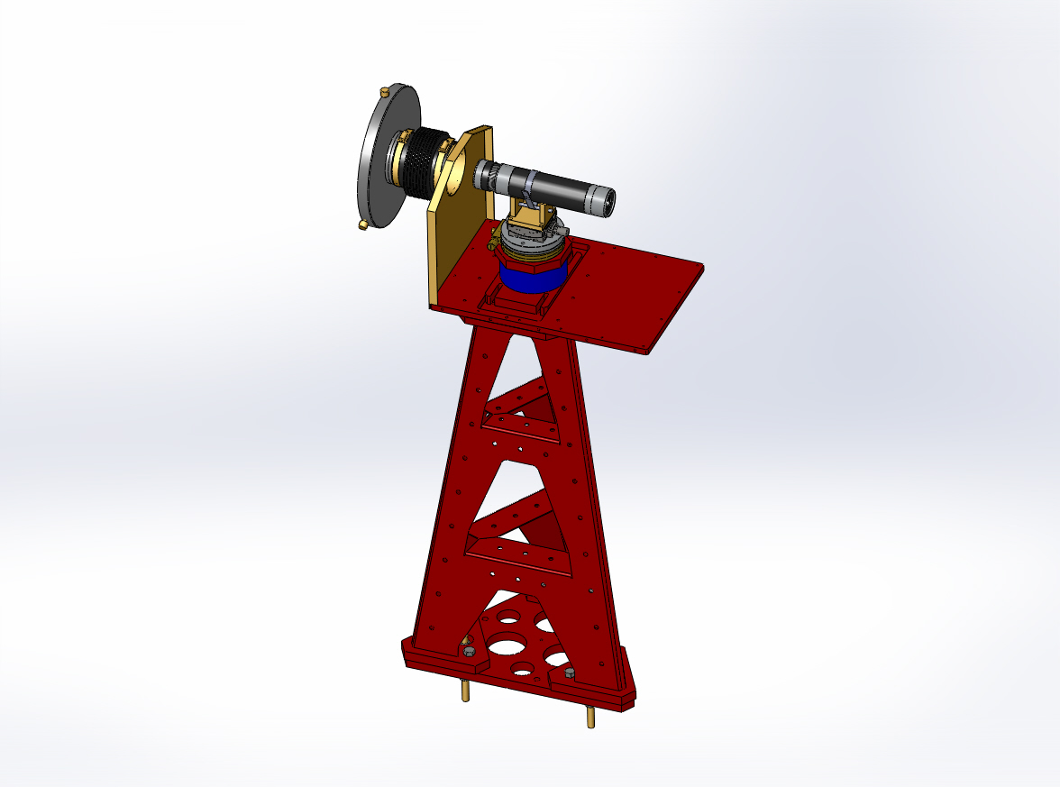

Figure 1: ITM/ETM Transmitter Pier Assembly. Shown with cover removed.

Bill of Material
Item | Part number | Description | Quant.
1 | D1000452 | Pier Weldment | 1
2 | D1000434 | Pier Footing | 1
3 | D1001452 | TX Enclosure Base | 1
4 | D1000428 | TX Mounting Base | 1
5 | D1000502 | Height Tube | 1
6 | D1000509 | TX Mounting Plate | 1
7 | 126-6526 | OptoSigma Goniometer | 1
8 | 124-0090 | OptoSigma Rotary Stage | 1
9 |  | OptoSigma 70 mm Pitch-Yaw Adapter Plate | 1
10 | D1102243 | Transmitter Telescope Mount | 1
11 | D0901362 | Projection Telescope Assembly, Long | 1
12 | D1100209 | Transmitter Enclosure Assembly | 1
13 | D1200528 | 4-inch Reducer | 1
14 | CT-4 | Gortiflex 4" Rubber Bellows | 1
15 |  | 1/2-20 x 1.5" Hex head cap screw | 9
16 |  | 1/4-20 x 1" SHCS | 10
17 |  | 5/16-18 x 1: SHCS | 4
18 |  | 5/16 Flat Washer | 4
19 |  | 7/16-14 x 3" SHCS | 4
20 |  | M6 x 12 SHCS | 4
21 |  | M4 x 8 SHCS | 4
22 |  | 1/4-20 x 3" SHCS | 1
23 |  | 3" Band Clamp | 1
24 |  | #10-24 x 1/2" SHCS | 16
25 |  | #10 Flat Washer | 16
26 | 45945K35 | McMaster Carr 4" Band Clamp | 2
27 | 92421A540 | McMaster Carr 1/4-20 Brass Thumb Screw | 3
28 | 9600K62 | McMaster-Carr Rubber Grommet | 1
29 | F12 635S | Fermion Laser w/ 10m fiber | 1
30 | D1200461 | Laser Power Board | 1
31 | D1100013 | Whitening Chassis | 1
32 | D1101248 | Anti-aliasing Chassis | 1
33 |  | 9-pin M-F, Anti-aliasing Chassis Cable | 1
34 |  | BNC M-M, Laser Cable | 1
35

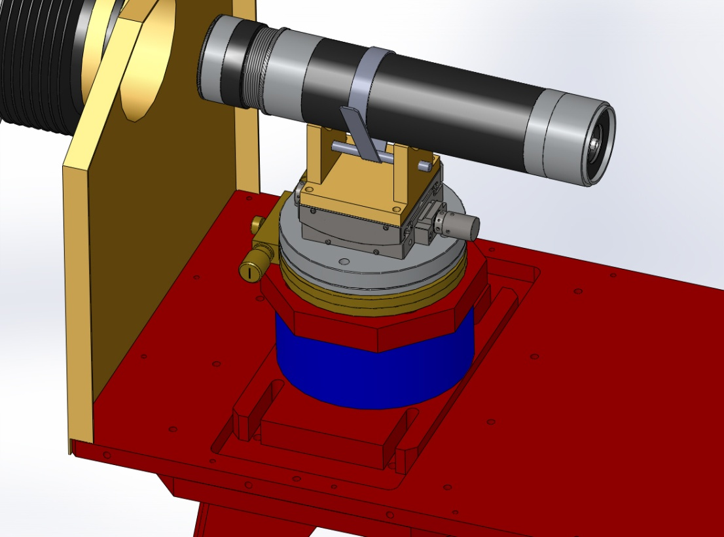
Figure 2: Telescope mounting hardware
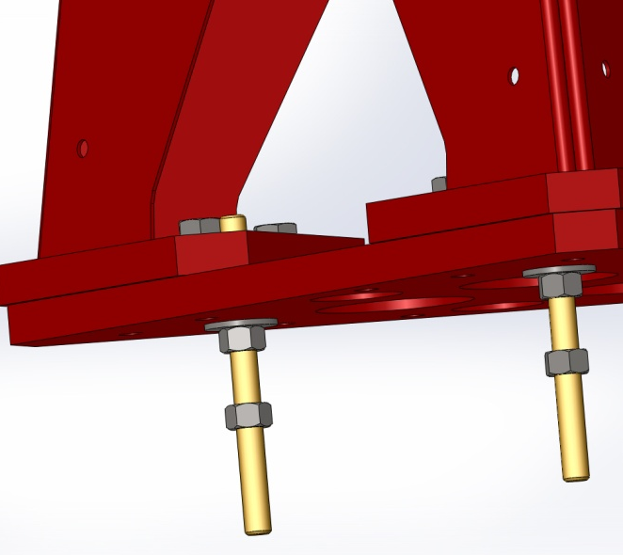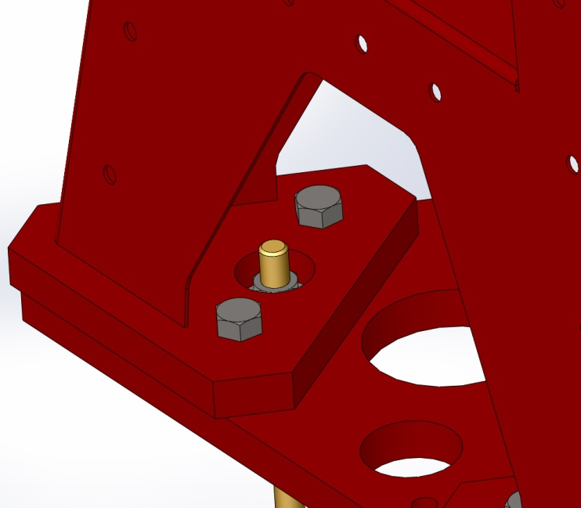
Figure 3:Base plate details

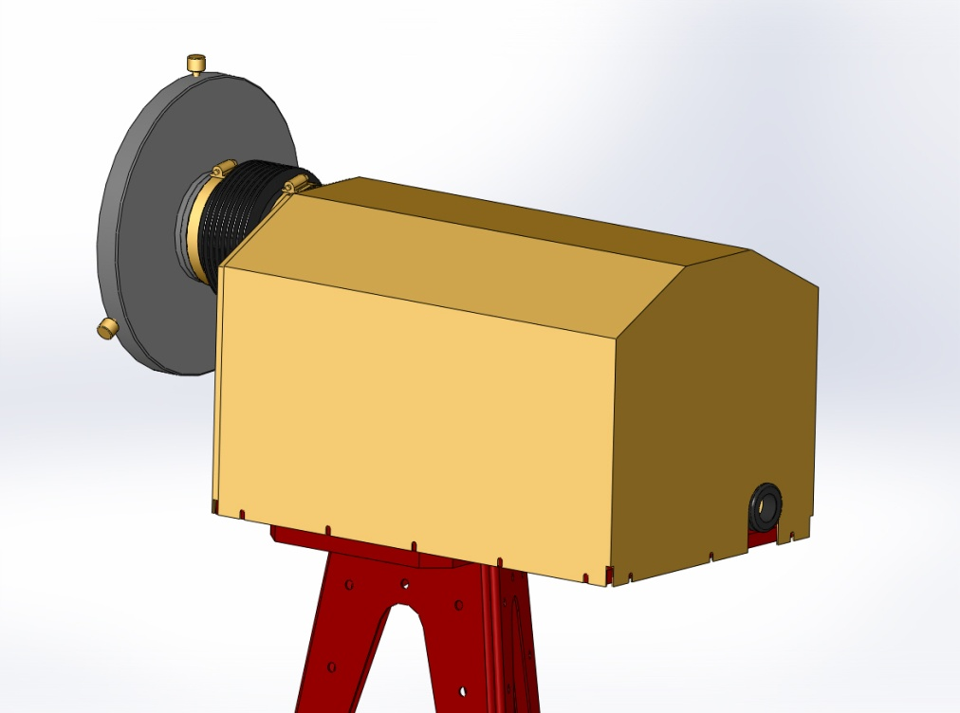
Figure 4: Cover installed

