**Parametric Study of AOSEM Sensor Noise**

**LIGO T1000100-v1**

**R. Abbott, Z. Korth, C. Osthelder, N. Robertson**

**23 February, 2010**

1. **Overview and Background** –In November, 2009, Zach Korth performed measurements on the spectral noise of the AOSEM photodiode when illuminated by its companion LED (Honeywell Inc. SME2470 and SME2420 respectively). The results are recorded in the SUS Lab eLog under various AOSEM log entries, and summarized in figure 1. Sufficient unit to unit variation was seen in the spectra of the photodiode photocurrent to prompt further investigation. The SUS Lab observations are shown in figure 1, AOSEM serial number 1 stands out as having up to 10 times less noise than the remaining units. Some variability can be seen for serial numbers 2 through 6.

Figure

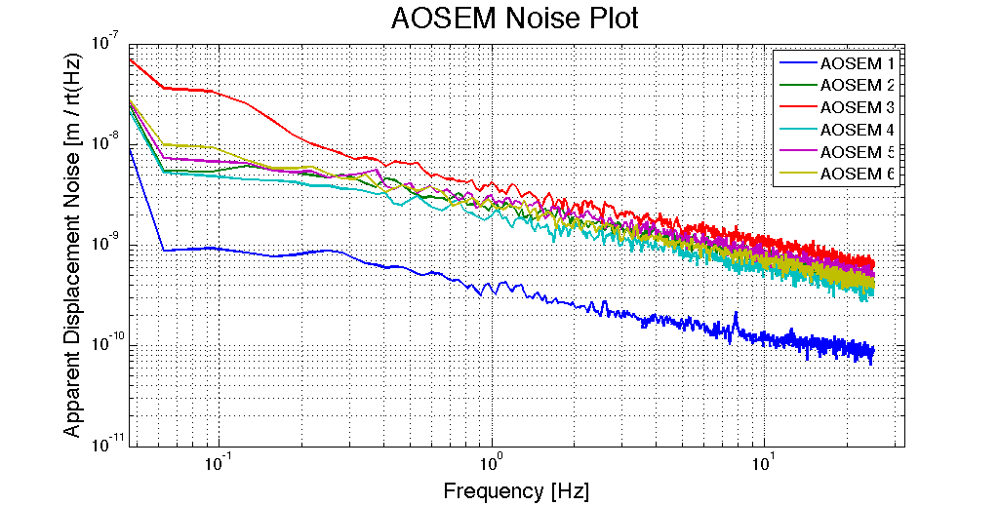

The question arises as to which of the two components, LED or Photodiode, is responsible for the variability in the results. It was also possible that both elements contributed to the variability. A test was proposed wherein the original observations were to be duplicated, and a parametric study varying one element at a time would be conducted. A fixture was prepared that allows several LEDs to be measured against a single photodiode, and similarly, several photodiodes to be measured against a single LED.

Finally, how do the measured displacement noise results compare with respect to the required noise for this sensor.

1. **Duplication of AOSEM Displacement Noise Measurement** – As described in Table 1, Figure 3 shows measured displacement noise for a batch of 10 prototype AOSEMs. A requirement curve generated by Dave Reitze has been added as well as a curve showing the noise floor of the measurement as seen with no LED illumination.

The data shown in Figure 3 reflects some differences from the previous measurement. The amplifier used to take Figure 3 data had a 100k ohm transimpedance (same as before) but no output whitening filtration; this is the same transimpedance amplifier configuration as that of the aLIGO ETM Transmission Monitor Photodetector. The LED was driven from a battery powered transistor current source, although this didn’t contribute any observable change to the data as compared to a voltage source through a several hundred ohm resistor. Perhaps more significant, was that the data are corrected based on the observed photocurrent for the particular head under test.

The original conversion factor of photocurrent to meters was obtained for a full scale photocurrent (OSEM magnet flag removed) of ~30µA. An example current vs. position curve taken by Zach Korth is shown in Figure 2.

Figure

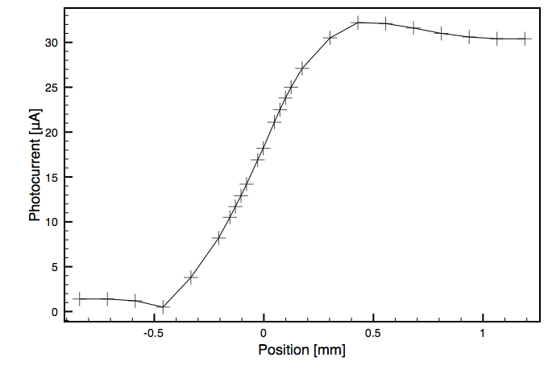

Using 30uA scale photocurrent, a conversion factor of 0.05 amperes per meter has been recorded (LIGO-T990089-00, and Zach Korth’s 2009 SUS Lab observations). A change in the observed full scale photocurrent constitutes a corresponding linear change in the conversion factor, so a gain correction was applied to the data.

Conversion Factor = 0.05 A/m * Observed PD Current / 30uA

Table 1 summarizes the test results and conversion factors used for the results shown in Figure 3.

Table

| **Head Serial Number** | **PD current (A)** | **LED Current (mA)** | **Conversion Factor** |
| --- | --- | --- | --- |
| **sn1** | 2.5E-9 | 29 | 0.05 A/m * **0.83** |
| **sn2** | 3.0E-05 | 29 | 0.05 A/m * **1.01** |
| **sn3** | 4.5E-05 | 29 | 0.05 A/m * **1.51** |
| **sn4** | 2.4E-05 | 28.7 | 0.05 A/m * **0.79** |
| **sn5** | 3.3E-05 | 28.7 | 0.05 A/m * **1.11** |
| **sn6** | 3.8E-05 | 28.7 | 0.05 A/m * **1.25** |
| **sn7** | 3.1E-05 | 28.6 | 0.05 A/m * **1.02** |
| **sn8** | 3.1E-05 | 28.6 | 0.05 A/m * **1.02** |
| **sn9** | 2.7E-05 | 28.5 | 0.05 A/m * **0.89** |
| **sn10** | 3.4E-05 | 28.4 | 0.05 A/m * **1.14** |

Figure

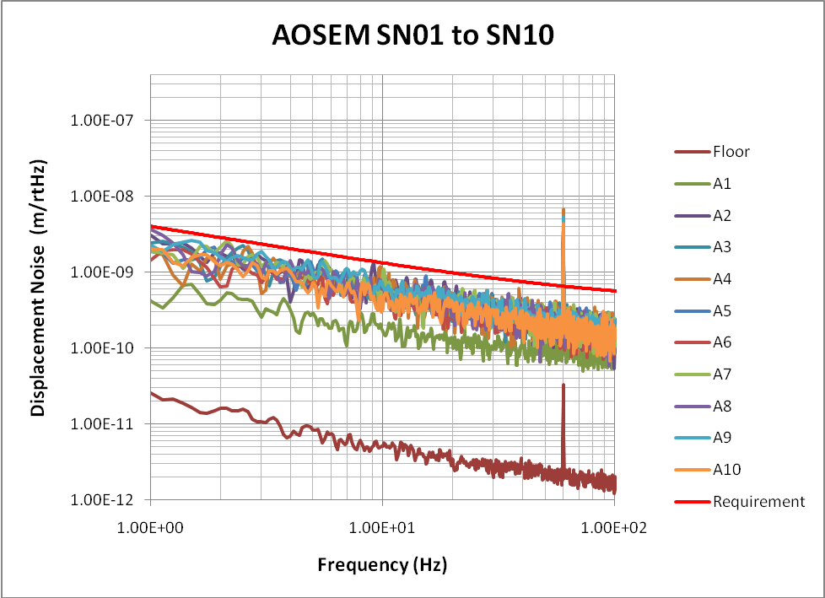

Some of the variability in the initial results appear to have been reduced by the modified conversion factor. All of the units measured in Figure 3 exhibit displacement noise less than the required performance line shown in red.

A result taken from a document which describes the final design for the LIGO1 OSEMs (LIGO-T990089-00) is shown in Figure 4. The measured displacement noise at 10 Hz is approximately 10-10 m/√Hz, a factor of 2 to 10 times better than that shown in Figure 3.

Figure



1. **Parametric Analysis of LEDs and Photodiodes** – To determine the source of variability of LEDs and photodiodes, a fixture was created that allowed quick itteration of components. The fixture is shown in Figure 5 and Figure 6

Figure

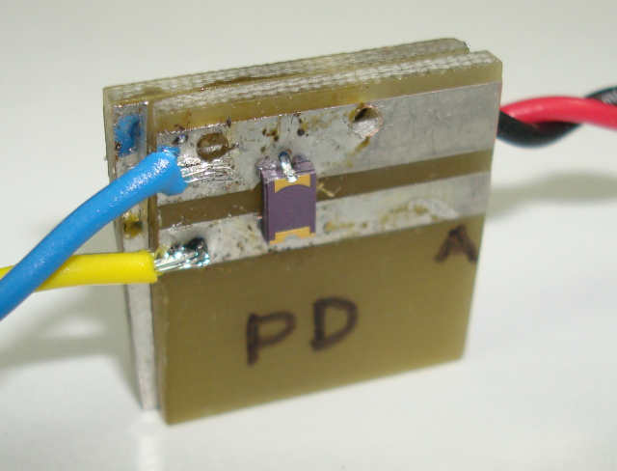

Figure

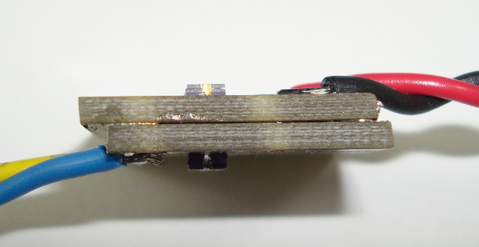

A hole drilled through the circuit boards aligns the lens of the photodiode to the adjacent LED. The lens to lens spacing is small enough that angular, or positional misalignment is not a factor. The results of various PDs are summarized in Table 2 and shown in Figure 7, the shot noise is calculated from the indicated photocurrent.

Table

|  |  |  |  |
| --- | --- | --- | --- |
| **Description** | **LED Current (mA)** | **Photocurrent (A)** | **Shot Noise (A/√Hz)** |
| PD2 and LED5 | 4.35 | 1.4E-05 | 2.1E-12 |
| PD3 and LED5 | 4.32 | 1.4E-05 | 2.1E-12 |
| PD4 and LED5 | 4.32 | 1.5E-05 | 2.2E-12 |
| PD5 and LED5 | 4.29 | 1.3E-05 | 2.0E-12 |
| PD5 and LED5 | 8.44 | 3.0E-05 | 3.1E-12 |

Figure

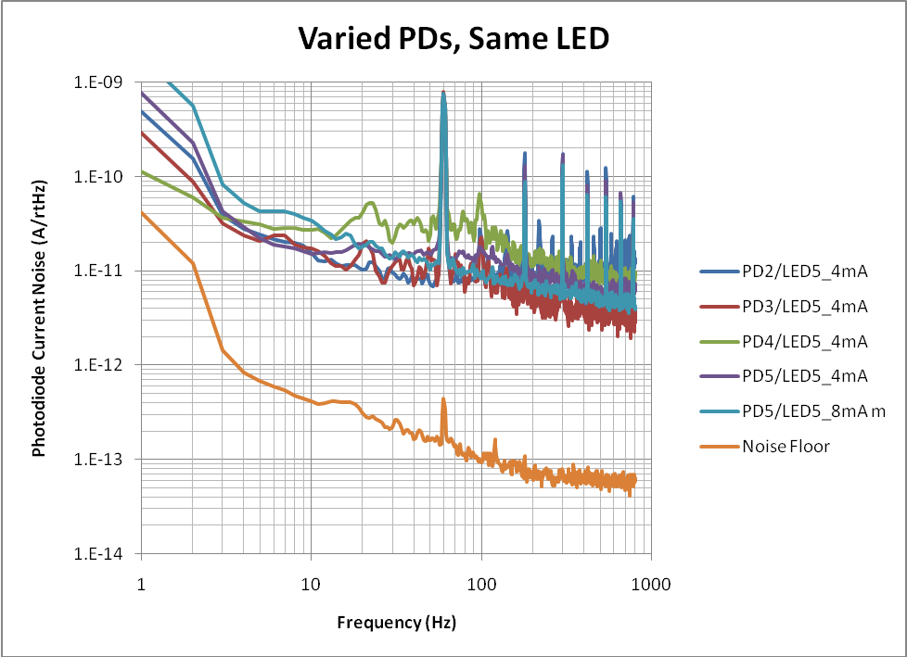

The results of various LEDs are summarized in Table 3 and shown in Figure 8, shot noise calculated from indicated photocurrent.

Table

|  |  |  |  |
| --- | --- | --- | --- |
| **Description** | **LED Current (mA)** | **Photocurrent (A)** | **Shot Noise (A/**√**Hz)** |
| LED1 and PD1 | 4.2 | 1.5E-05 | 2.2E-12 |
| LED2 and PD1 | 4.2 | 1.4E-05 | 2.1E-12 |
| LED3 and PD1 | 4.2 | 1.3E-05 | 2.1E-12 |
| LED4 and PD1 | 4.2 | 1.5E-05 | 2.2E-12 |
| LED5 and PD1 | 4.18 | 1.4E-05 | 2.1E-12 |

Figure

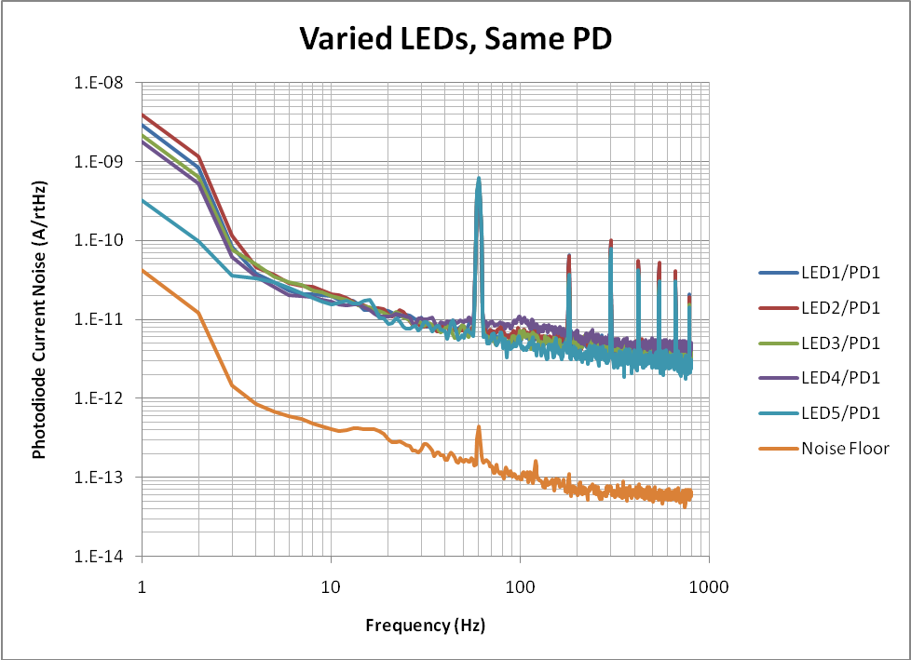

1. **Conclusion –** There appears to be more variability in the noise characteristics of the photodetectors than in the LEDs as can be seen by comparing Figure 7 and Figure 8. Although not clear from the figures, all devices show the expected shot noise asymptote above ~1kHz. There doesn’t appear to be a strong relationship between LED current and excess low frequency (<1kHz) noise, but the data in the comparison of Figure 7 PD5 at 4 and 8 mA show results that are not intuitive, and are a good starting point for further tests where noise as a function of current (LED and PD) are parametrically studied.

Given the variability in the AOSEM displacement data, it would be prudent to screen 100% of the AOSEM heads for equivalent displacement noise after the circuit boards are populated, but prior to cleaning. There is no data to suggest that cleaning has an impact on displacement noise, but the AOSEMs should undergo a full functional test once assembled into a clean unit. A dedicated *clean* cable and associated measurement procedure can be created.