1 Safety 2
2 Objective and Scope 2
3 Documents 3
4 Documenting the Assembly Process 4
5 Vacuum Compatibility 5
6 Fasteners 6
7 Overview of Assembly Process 7
8 Handling Suspension Wire 8
9 Assembling Upper Wires 9
10 Assembling Intermediate Wires 12
11 Assembling Lower Loop Wire 15
12 Assembling Upper Blade Guards 18
13 Assembling the Rotational Adjusters 19
14 Assembling Magnets – Upper Mass 23
15 Assembling Upper Mass and Coil Holder (M1) 25
16 Assembling Intermediate Mass (M2) 32
17 Assembling Bottom Mass and Optic (M3) 34
18 Assembling EQ Stops For Intermediate and Bottom Masses 36
19 Preparing The Weldment 38
20 Installing the Mounting Pads 39
21 Installing EQ Stop Mounts and Brackets 40
22 Installing Rotational Adjusters and Top Blade Guards 42
23 Installing Upper Mass and Coil Holder 45
24 Installing the Intermediate Mass 47
25 Installing Wire Assemblies 48
26 Assembling AOSEM Brackets 51
27 Installing Bottom Mass 54
28 Suspension and Alignment of Masses 55
29 Assembling Magnets To Intermediate Mass 59
30 Assembling Magnets To Bottom Mass 62
31 Installing the BOSEMs 65
32 Installing AOSEM Brackets 65
33 Aligning OSEMs 67

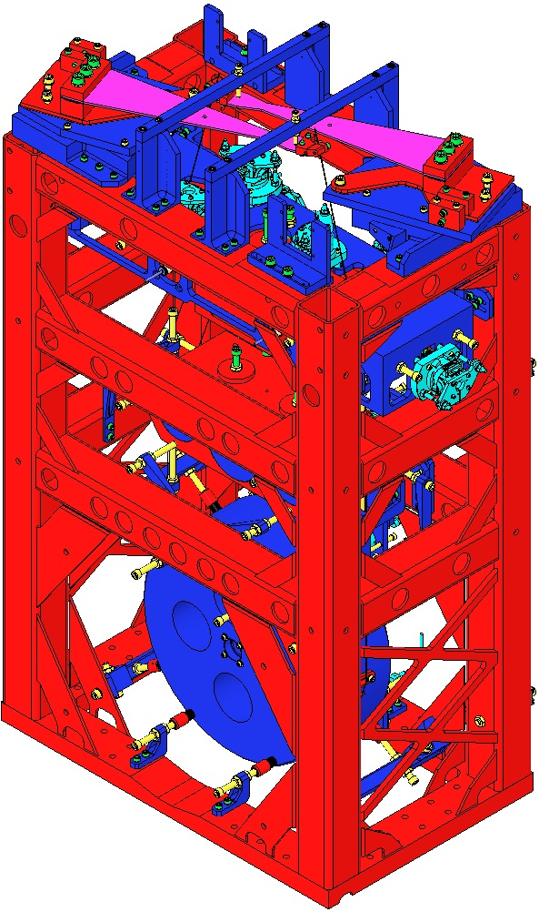  Fig 1: HLTS | 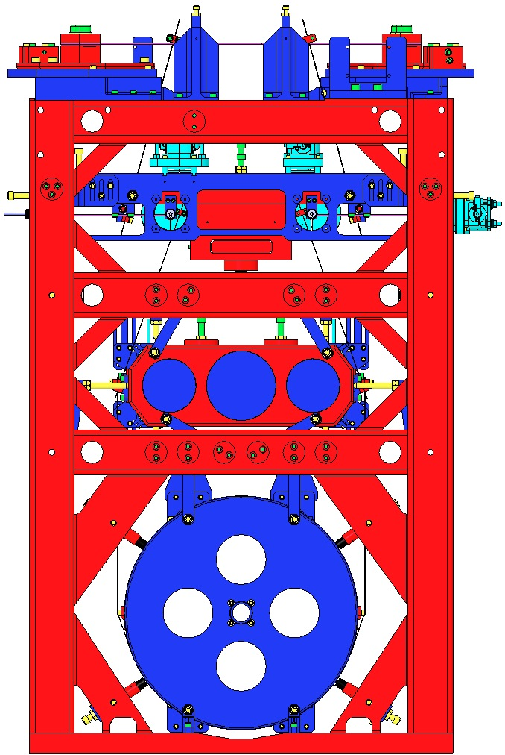  Fig 2: Front | 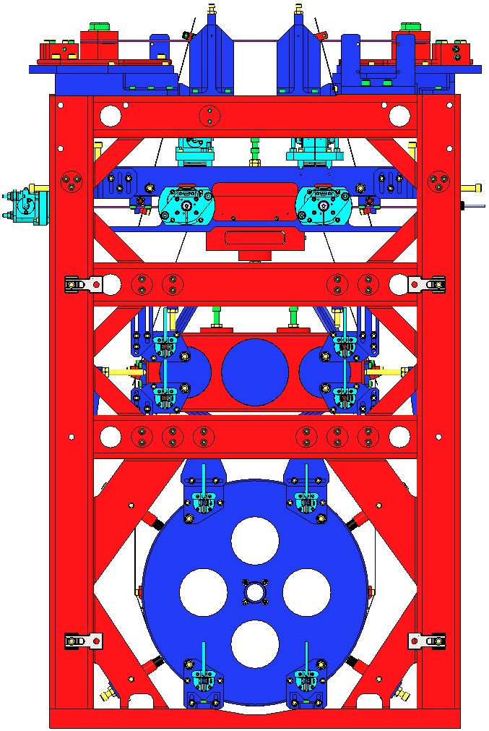  Fig 3: Rear
 | Note: Front vs. Rear of Weldment is identified by 3 hole patterns.

Safety
Please review E0900332 for concerns related to safe assembly and installation.

Objective and Scope
Subassembly and Final Assembly of the aLIGO HAM Large Triple Suspension, including:
- General considerations for assembly
- Use of the assembly fixtures shown in D080718

Documents
D070308 HLTS Top Blade Guard Assembly
D070319 HLTS Bridge EQ Stops
D070326 HLTS Rotational Adjuster
D070334 HLTS Intermediate Mass Assembly
D070335 HLTS Upper Mass Assembly
D070337 HLTS Bottom Mass Assembly
D070340 HLTS Upper Wire Assembly
D070393 HLTS Intermediate Wire Assembly
D070436 HLTS Lower Loop Wire Assembly
D070442 HLTS Overall Assembly
D070447 HLTS Assembly Drawings
D080677 HLTS Coil Holder Assembly
D080718 HLTS Assembly Fixtures
D080726 HLTS EQ Stop, Long Mount
D080727 HLTS EQ Stop, Long Bracket
D0900626 HLTS Mounting Pad Assembly
D1001695 Magnet and Flag Assembly, BOSEM
D1002821 HLTS EQ Stop Assembly, Bottom Mass, Lower
D1102071 HLTS EQ Stop, Bridge, Upper
E080208 HLTS Assembly Instructions (this document)
E0900047 Contamination Control Plan
E1000043 HLTS Assembly and Installation Hazard Analysis
E1000045 HLTS Installation Procedure
E1100109 Suspensions Controls Arrangement
E960022 LIGO Vacuum Compatibility, Cleaning Methods and Qualification Procedures
E990196 Magnet/Standoff Assembly Preparation
E1100472 HLTS Assembly and Installation Documentation
G1100147 HLTS Introduction
M0900034 RODA - Use of Magnets in Suspensions
T000053 Advanced LIGO Universal Suspension Subsystem Design Requirements
T010007 Cavity Optics Suspension Subsystem Design Requirements
T010103 aLIGO Suspension System Conceptual Design
T1000012 HLTS Final Design Document
T1000089 HLTS Test Plan
T1100066 General Torque Recommendations for Socket Head Cap Screws
T1100003 Building Suspensions Subassemblies in ICS

Documenting the Assembly Process

Documents
T1100003 Building Suspensions Subassemblies in ICS.

Procedure
- See the above document.
- Data for each Final Assembly will be stored in ICS; using a Process Traveler is optional:
Item | Assembly 1  Part Name | Assembly 1  Part Number | Serial Number | Position | Variant | Weight
Each Mass | X | X | X | X |  | X
Each Blade | X | X | X | X
Each Blade Clamp | X | X | X | X | X
Each OSEM | X | X | X | X
Each Optic | X | X | X |  |  | X
Note regarding Subassembly weights: Each Subassembly must have 3 distinct weights recorded:
- Estimated Weight Calculated by SolidWorks;
- Actual Weight Measured by a lab scale after built to the nominal mass;
- Balanced Weight Totaled after Suspension is balanced (i.e. Actual Weight + Add-On Weights).
When Addable weights are used, note their location on the Mass.

Vacuum Compatibility

General Handling
All procedures must be performed in a clean room environment while suited up in:
- Coverall with Hood
- Boot style shoe covers
- LIGO-approved latex gloves
- Glove Liners and Safety Glasses when working with Wire

All Tables surfaces used for Class A components should be wiped down daily with Isopropanol.

Review E0900047 Contamination Control Plan for details. All HSTS parts are Class A hardware and once cleaned and baked should not come into contact with anything but Class A or B hardware.

Cleaning Components
Clean items per E960022.

Inspection
After baking, sample check the cleanliness of blind-tapped and through-tapped holes with a clean swab dampened with alcohol for a minimum of 10% of the holes in case any material has leached out during baking. If any discoloration of the swab is evident, then the part must go through at least one more wash cycle before repeating the bake. After inspection, wrap items per E960022.

Fasteners

Documents
T1100066 General Torque Recommendations for Socket Head Cap Screws

Helicoils
Helicoils are specified for:
- Certain SSTL applications to avoid using AgPlated fasteners;
- Certain applications where assembly / disassembly recurs.
Helicoils are cleaned, baked and installed with Class B clean tools in a Class 100 clean room.

Silver Plated Stainless Steel
All Silver Plated fasteners are also SSTL, and so are labeled simply “AgPlated”, not “AgPlated SSTL”.

Jam Nuts
All ¼-20 Jam (thin) Nuts have been replaced with ¼-20 AgPlated SSTL Hex Nuts (standard thickness).

Screw Applications
Screw Type | Screw Description | Receiver Application
AgPlated SSTL | Silver-Plated Stainless Steel | - Stainless Steel threads
SSTL | Stainless Steel | - Aluminum Threads  - Helicoil Threads
Vented | SSTL Screw with holes | - Rare Vacuum Compatibility situations

Torque Values
- Except where noted, Socket Head Cap Screws are to be tightened per the following table.
- “Generic” applies to Screws that are non-plated, non-vented, and not marked as Holokrome.
- Holokrome Screws are marked as such on the Screw.
- UC (UC Components, Supplier) Screws are AgPlated.
- All Screws are UNC (coarse threaded).
 | Torque (in-lb)
Supplier | Generic  (unmarked) | Holokrome  UC | UC
Type | Unplated | Unplated  AgPlated | Vented
Size
2 | 3 | 4 | 3
4 | 5 | 6 | 7
8 | 20 | 30 | 25
¼” | 75 | 100 | 86
5/16” | 132 | 184

Overview of Assembly Process
General sequence:
- Subassemblies are built first, in any convenient order.
- Main Assembly is built, mostly from Subassemblies.
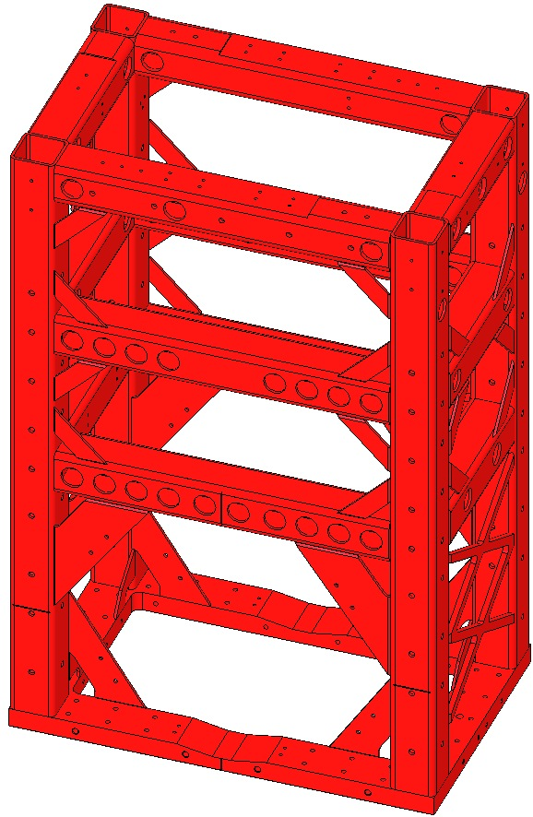
Main Assembly sequence:
- Rotational Adjusters
- Intermediate Mass
- Lower Wire
- Lower Mass
- Upper Mass + Upper and Intermediate Wires
- Balancing
- OSEMS

Frame of Reference
Using the Right-Hand-Rule when viewed from behind the Weldment, with the origin at the center bottom of the Weldment, the positive X, Y and Z directions are shown at right. | +Z  +Y  +X  Front  Fig 4: Frame of Reference

Handling Suspension Wire
The Wire used for all Suspensions is a hard temper carbon steel, delivered on large spools. When unwound for cleaning, cutting and preparation for clamp-wire-clamp assembly, care must be taken such that the wire’s strong potential energy (making it act like a coiled spring) does not cause injury.
- Safety Glasses, provided in all Clean Room garbing areas, must be worn during all wire work.
- Glove Liners must be worn under the latex clean-room gloves as a protective layer and extra barrier. The E0900047 Contamination Control Plan, p. 13, provides further information on Glove Liners.
- For easier holding, bend a small section (~3”) of the end of the Wire. The bent section can be hooked around your thumb and held by your index finger. Un-spool the proper length of Wire – including extra for handling – and control the area of the Wire that will be cut. Add a 2nd bend at the newly cut end for easier handling.
- Change your gloves and wipe each Wire at least 3 times each, and until no residue appears on each Wipe, using:
  - A Cleaning Wipe with Methanol;
  - A Cleaning Wipe with Acetone;
  - A Cleaning Wipe with Isopropanol;
changing Wipes until the wire is completely clean. Clean the Wire while it is coiled; do not stretch the wire until it is taut for cleaning. It can be laid down on a clean surface during this process. Clean one section at a time.
- Transfer the Wire to the Assembly Jig. Use the Jig clamps to hold the Wire in place, and then cut off and discard the bent Wire ends.

Assembling Upper Wires

Documents
D070340 HLTS Upper Wire Assembly

Materials
Qty | U | ID | Description
1 | Ea | D0900594 | HLTS Upper Wire Assembly Jig
4 | Ea | D980184 | LOS Clamps, Long
1 | Ea | D020611 | Upper Clamp, Upper Wire, Inside
1 | Ea | D020652 | C-Clamp, Upper Mass
1 | Ea | D070341 | Upper Clamp, Upper Wire, Outside
1 | Ea | D020610 | Upper Wire, Lower Clamp, Inside
4 | Ea | NA | Socket Head Cap Screw 8-32 x 0.625” SSTL
4 | Ea | NA | Socket Head Cap Screw 8-32 x 0.5” AgPlated
4 | Ea | NA | Flat Washer #8 Vented SSTL
4 | Ea | 1185-2EN246 | Helicoil 8-32 x .246”
1 | Ea | NA | Hang Weight, 1 Kg, or D020660 Blade Pulldown Device
4 | Ea | NA | Large Test Weights, 10, 5, 2, 1 Kg
1 | Ea | NA | Small Test Weight Set, 1 to 500 g
1 | Btl | NA | Methanol
1 | Btl | NA | Acetone
1 | Btl | NA | Isopropanol
 |  |  | Steel Music Wire, 0.024” dia.
 |  |  | Lint-Free Wipes
 |  |  | Class B Wire Cutters

Procedure
LOS Clamp

2 Assemblies are required per HLTS.  Use safety glasses per E0900332.  - Ensure the D0900594 Assembly Jig has been cleaned Class B per E960022.  - Ensure Jig is fully assembled per the drawing.  - Attach the D0900594 Jig to an Optical Table using the 4 D980184 LOS Clamps. The end of the Jig with the Clevis and Pin must hang over the edge of the Table enough to provide clearance for the hanging weight. | 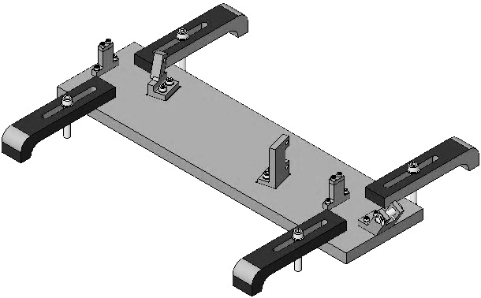  Clevis  Class B  Class A  Table Edge  Fig 5: Jig
- Assemble all the Clamps you’ll need; do not tighten the clamps.  Upper Wire Upper Clamp includes:  - 1 D020611 Upper Wire Upper Clamp, Inside  - 2 1185-2EN246 Helicoils 8-32 x .246”  - 1 D070341 Upper Wire Upper Clamp, Outside  - Socket Head Cap Screw  2 8-32 x 0.5” AgPlated  - 2 Flat Washer #8 Vented SSTL  Upper Wire C-Clamp Assembly includes:  - 1 D020652 Upper Mass C-Clamp  - 1 D020610 Upper Wire Lower Clamp, Inside  - 2 1185-2EN246 Helicoil 8-32 x .246”  - 1 D020624 Upper Wire Lower Clamp, Outside  - 2 Socket Head Cap Screws  8-32 x 0.5625” SSTL  - 2 Flat Washer #8 Vented SSTL |  | 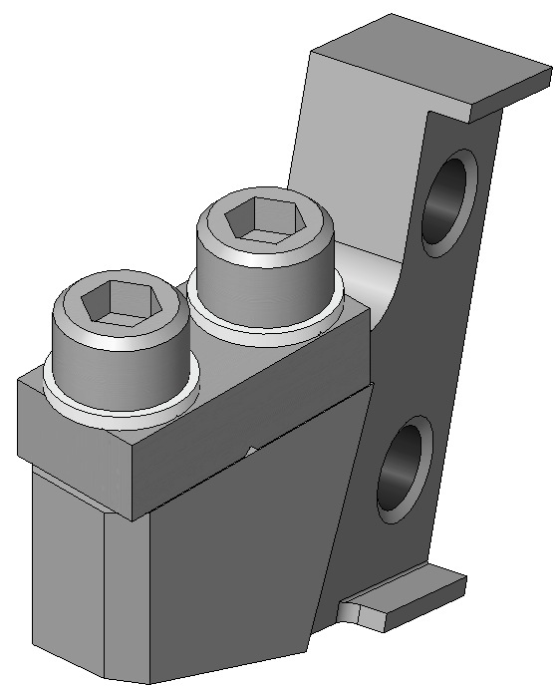  D070341  (2)  D020611  Fig 6: Upper Clamp  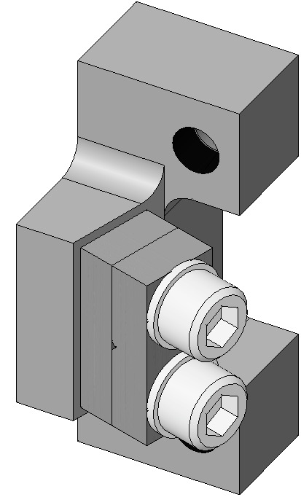  D020624  (2)  D020652  D020610  (2)  Fig 7: C-Clamp
- Attach to the Jig:  - 1 Upper Clamp Assembly  - 2 Socket Head Cap Screws  8-32 x 0.625” SSTL  - 1 C-Clamp Assembly with  - 2 Socket Head Cap Screws  8-32 x 0.625” SSTL | 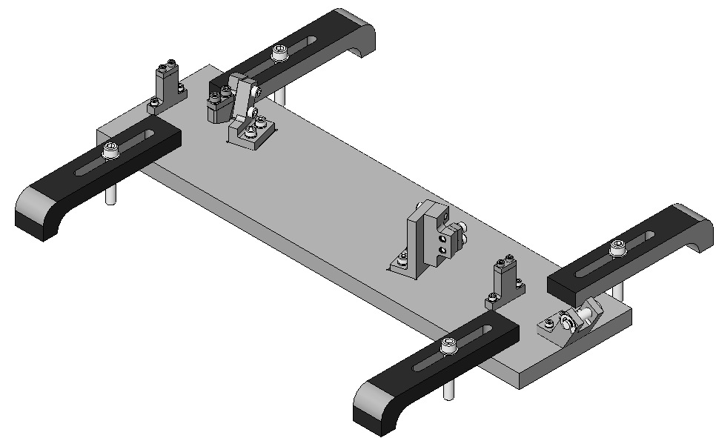  Upper Clamp  C-Clamp  Fig 8: Clamps on Jig
- Cut a 36” of 0.024” diameter Wire from the spool.  - Clean the Wire per Section 12.4.  - Feed the Wire through the Clevis and Clamps, as shown:  Over Clevis Pin  1st Start Post;  L-Clamp;  C-Clamp;  2nd Start Post  - Tighten the 2nd Start Post Clamp, after feeding through about ½” of wire.  Ensure Wire is secured within the Clamp groove. | 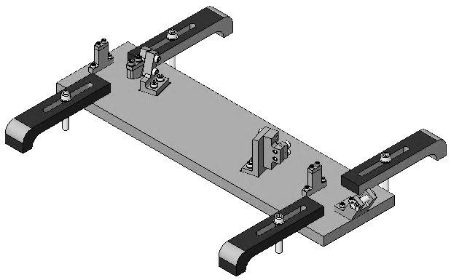  Tighten  first  Fig 9: Wire Path
- Tie a small loop in the end of the wire hanging off the Table and hang the 1 kg Hang Weight. Add large and small weights for a total of 18.252 kg. Then change gloves, since the weights are not clean. | 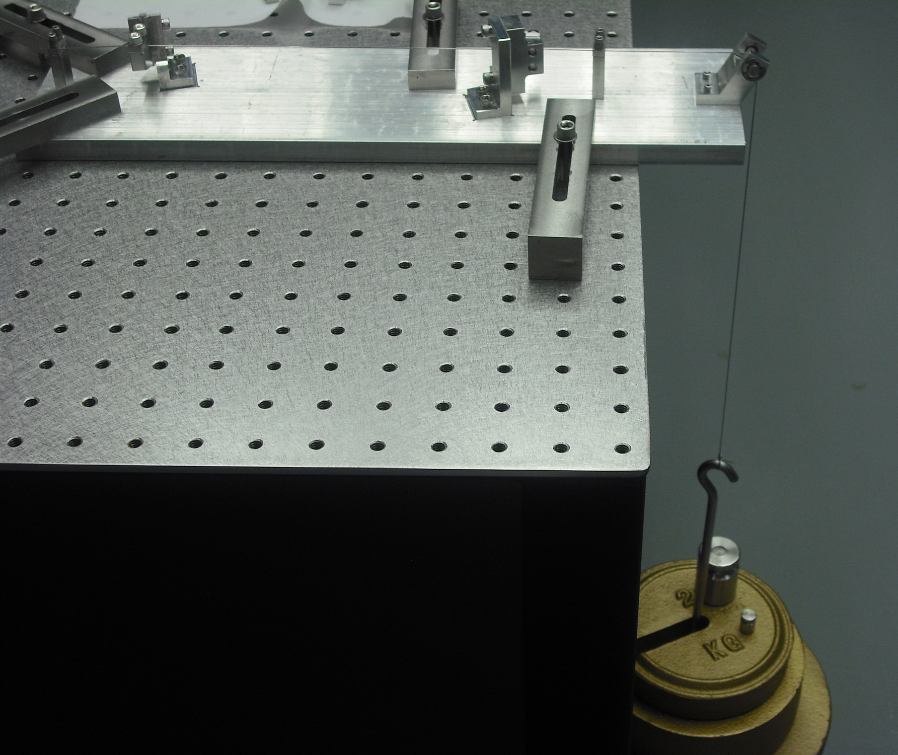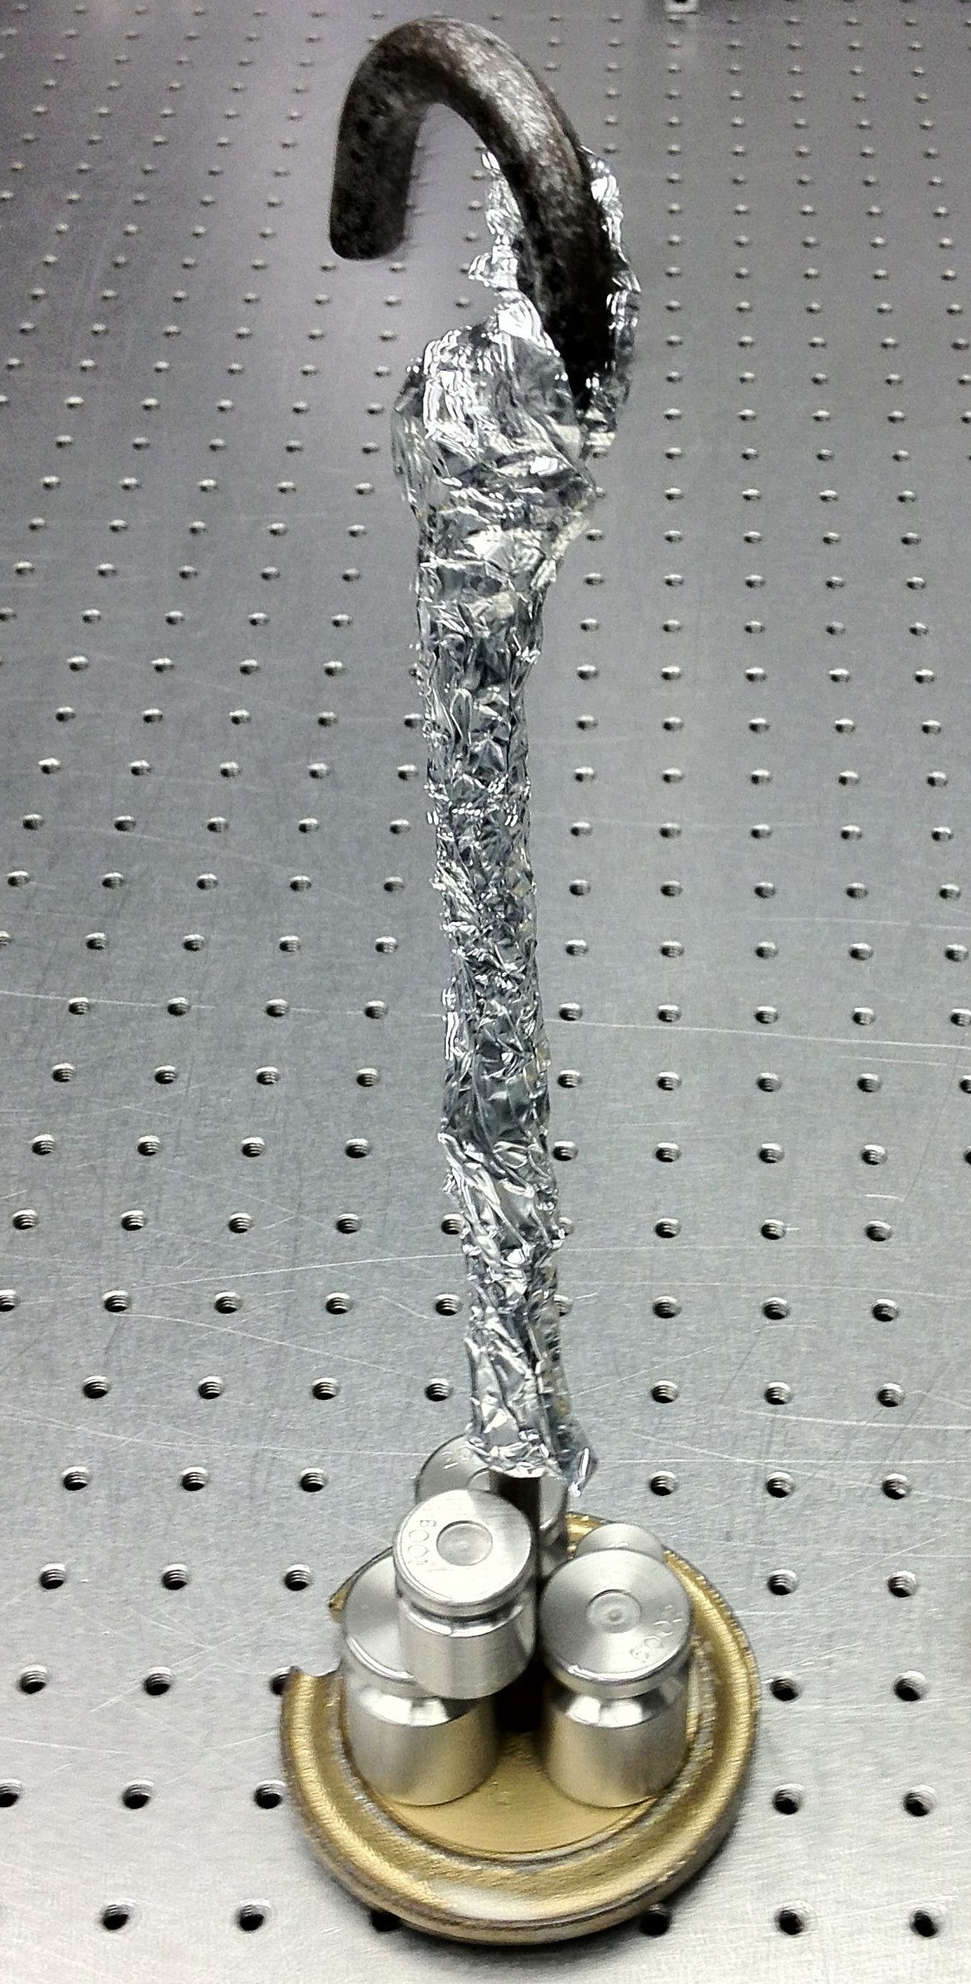  Fig 10: Hang Weight in use
- Wait 5 minutes for the wire to come to equilibrium. Tighten the screws on each of the 3 remaining wire clamps in the order shown. Torque to 30 in-lb.  During tightening:  - Ensure Wire is secured within the grooves of each Clamp.  - Ensure Clamp halves are aligned with each other by using a Precision Square.  - Remove the Hang Weight and cut the Wire in the locations shown. Change gloves since the weights are not clean.  - Loosen the Screws on the Wire Clamps on the jig and discard the leftover Wire. | 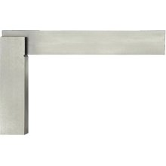  Precision  Square  Cut here  Cut here  3  2  1  Fig 11: Cutting the Wires
- Remove the Screws holding the Upper Wire Assembly to the Upper Wire Jig. Bend back the ends of the wire to eliminate sharp points.  - Measure the Wire length between Clamps to confirm that it is 202.50mm. | Fig 12: Upper Wire Assembly complete

Assembling Intermediate Wires

Documents
D070393 HLTS Intermediate Wire Assembly

Materials
Qty | U | ID | Description
1 | Ea | D0900630 | HLTS Intermediate Wire Jig
4 | Ea | D980184 | LOS Clamps, Long
1 | Ea | D070585 | Inside Upper Clamp
1 | Ea | D070394 | Outside Intermediate Wire Upper Clamp
1 | Ea | D030149 | Intermediate Wire Breakoff
1 | Ea | D070405 | Inside Intermediate Wire Lower Clamp
1 | Ea | D070406 | Outside Intermediate Wire Lower Clamp
2 | Ea | NA | Socket Head Cap Screw 4-40 x 0.5” SSTL
3 | Ea | NA | Socket Head Cap Screw 8-32 x 0.5” SSTL
2 | Ea | NA | Socket Head Cap Screw 4-40 x 0.375 AgPlated
2 | Ea | NA | Flat Washer #4 Vented SSTL
2 | Ea | NA | Socket Head Cap Screw 8-32 x 0.625” SSTL
2 | Ea | NA | Flat Washer #8 Vented SSTL
2 | Ea | 1185-2EN164 | Helicoil 8-32 x .164” Nitronic 60
2 | Ea | 1185-04EN224 | Helicoil 4-40 x .224” Nitronic 60
1 | Btl | NA | Methanol
1 | Btl | NA | Acetone
1 | Btl | NA | Isopropanol
1 | Spl | NA | Steel Music Wire, 0.0134” dia.
1 | Pkg | NA | Lint-Free Wipes
1 | Ea | NA | Class B Wire Cutters
1 | Ea | NA | Hang Weight, 1 Kg, or D020660 Blade Pulldown Device
4 | Ea | NA | Large Test Weights, 10, 5, 2, 1 Kg
1 | Ea | NA | Small Test Weight Set, 1 to 500 g

Procedure
4 Assemblies are required per HLTS.  Use safety glasses per E0900332.  - Attach the D0900630 Jig to an Optical Table using the 4 D980184 LOS Clamps. The end of the Jig with the Clevis and Pin must hang over the edge of the Table enough to provide clearance for the hanging weight. | 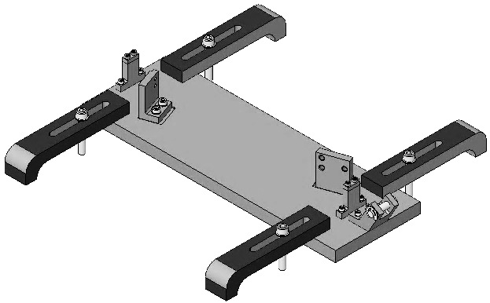  Edge of Table  Fig 13: Jig
- Assemble all the Clamps you’ll need; do not tighten the clamps.  Intermediate Wire Upper Clamp includes:  - 1 D070585 Intermediate Wire Upper Clamp, Inside  - 2 1185-04EN224 Helicoil 4-40 x .224”  - 1 D070394 Intermediate Wire Upper Clamp, Outside  - Socket Head Cap Screw  2 4-40 x 0.375” AgPlated  - 2 Flat Washer #4 SSTL  Intermediate Wire Breakoff Assembly includes:  - 1 D030149 Intermediate Wire Breakoff  - 1 D070405 Intermediate Wire Lower Clamp, Inside  - 2 1185-2EN164 Helicoil 8-32 x .164”  - 1 D070406 Intermediate Wire Lower Clamp, Outside  - 2 Socket Head Cap Screw  8-32 x 0.625” SSTL  - 2 Flat Washer #8 SSTL |  | 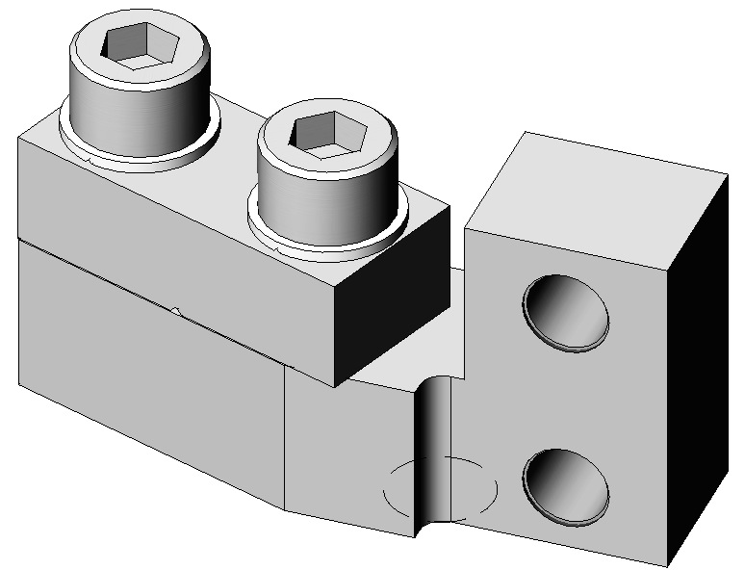  D070394  D070585  (2)  Fig 14: Upper Clamp  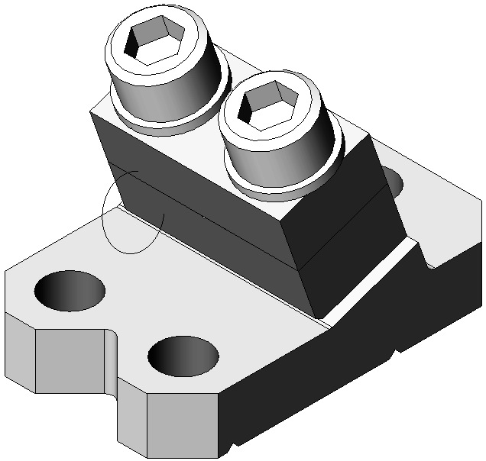  D070406  (2)  D070405  (2)  D030149  (2)  Fig 15: Breakoff
- Attach to the Jig:  - 1 Upper Clamp Assembly  - 2 Socket Head Cap Screw  4-40 x 0.5” SSTL  - 1 Breakoff Assembly  - 3 Socket Head Cap Screw  8-32 x 0.5” SSTL | 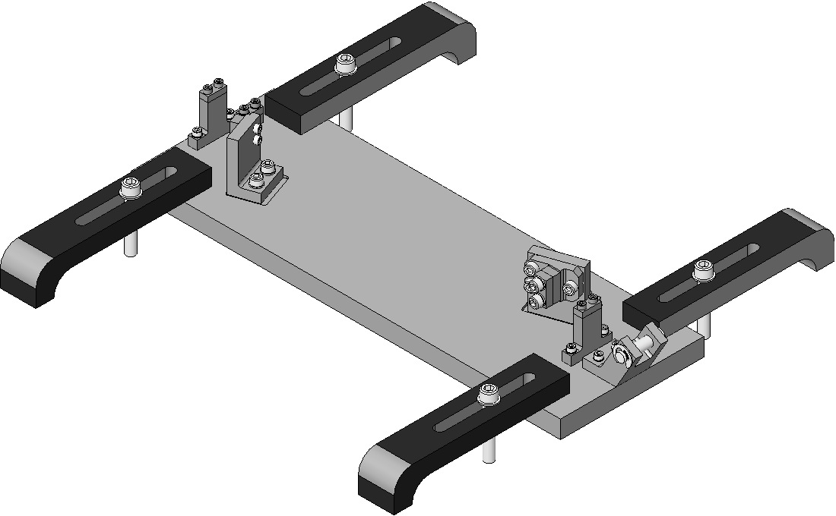  Upper Clamp Assembly  Breakoff Assembly  Fig 16: Clamps Attached to Jig
- Cut 24” of 0.0134” diameter Steel Music Wire.  - Clean the Wire per Section 12.4.  - Feed the Wire through each set of 4 Clamps. Allow the extra Wire to hang over the edge of the Table.  - Tighten the Screws on the Wire Start Clamp farthest from the Table edge.  Ensure Wire is secured within the Clamp groove. | Edge of Table  Fig 17: Wire Path
- Tie a small loop in the end of the Wire hanging off the Table and hang the 1 kg Hang Weight or Pulldown Device from the loop. Add additional weights to the Hanger for a total of 6.092 kg. Then change gloves, since the weights are not clean. | 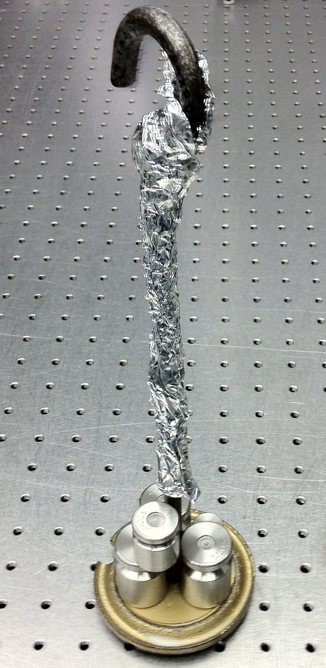  Fig 18: Hang Weight in use
- Wait 5 minutes for the wire to come to equilibrium. Tighten the screws on each of the 3 remaining wire clamps in the order shown.  - 4-40 Screws: Torque to 6 in-lb  - 8-32 Screws: Torque to 30 in-lb  During tightening:  - Ensure Wire is secured within the grooves of each Clamp.  - Ensure Clamp halves are aligned with each other by using a Precision Square.  - Remove the Hang Weight and cut the Wire in the locations shown. Change gloves since the weights are not clean.  - Loosen the Screws on the Wire Clamps on the jig and discard the leftover Wire. | 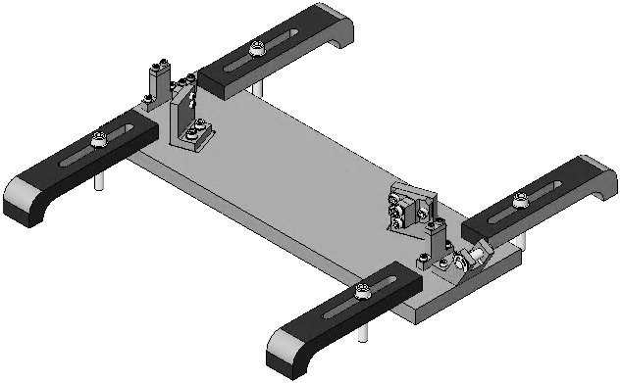  Precision  Square  Cut here  Cut here  1  3  2  Fig 19: Cutting the Wires
- Remove the screws holding the Intermediate Wire Assembly to the Intermediate Wire Jig. Bend back the ends of the wire to eliminate sharp points.  - Measure the Wire length between Clamps to confirm that it is 203.60mm. | Fig 20: Completed Intermediate Wire Assembly

Assembling Lower Loop Wire

Documents
D070436 HLTS Lower Loop Wire Assembly

Materials
Qty | U | ID | Description
1 | Ea | D0901419 | HLTS Lower Loop Wire Jig
4 | Ea | D980184 | LOS Clamps, Long
2 | Ea | D030148 | Lower Loop Wire Intermediate Mass Breakoffs
6 | Ea | NA | Socket Head Cap Screw 8-32 x 0.5” SSTL
4 | Ea | D070438 | Lower Loop Wire Clamps
4 | Ea | NA | Socket Head Cap Screw 8-32 x 0.5625” SSTL
4 | Ea | NA | Flat Washer #8 Vented SSTL
4 | Ea | 1185-2EN164 | Helicoil 8-32 x .164”
1 | Btl | NA | Methanol
1 | Btl | NA | Acetone
1 | Btl | NA | Isopropanol
1 | Spl | NA | Steel Music Wire, 0.0106” dia.
1 | Pkg | NA | Lint-Free Wipes
1 | Ea | NA | Wire Cutters, cleaned Class B
1 | Ea | NA | Hang Weight, 1 Kg, or D020660 Blade Pulldown Device
4 | Ea | NA | Large Test Weights, 10, 5, 2, 1 Kg
1 | Ea | NA | Small Test Weight Set, 1 to 500 g

Procedure
One Assembly is required per HLTS.  Use safety glasses per E0900332.  - Attach the D0901419 Lower Loop Wire Jig to an Optical Table using 4 D980184 Long LOS Clamps arranged so both ends of the Jig hang over the edges of the Table. |  | 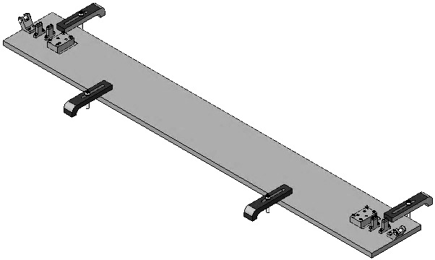  Table Edge  Fig 21: Jig
- Assemble loosely the Lower Loop Breakoffs, each using:  - 1 D030148 Breakoff  Ensure the vent groove faces downward  - 2 D070438 Lower Loop Wire Clamp  - 2 Socket Head Cap Screw  8-32 x .5625” SSTL  - 2 Flat Washer #8 Vented SSTL |  |  | 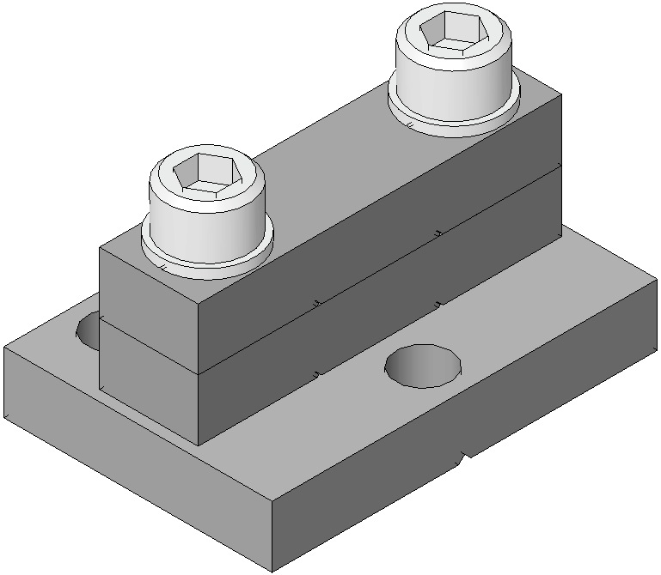  Vent Groove  (2)  D030148  (2)  D070438  (2)  Fig 22: Breakoff
- Attach the D030148 Lower Loop Wire Intermediate Mass Breakoffs, vent grooves facing down.  - 6 Socket Head Cap Screw  8-32 x 0.5” SSTL  Tighten the screws. |  | 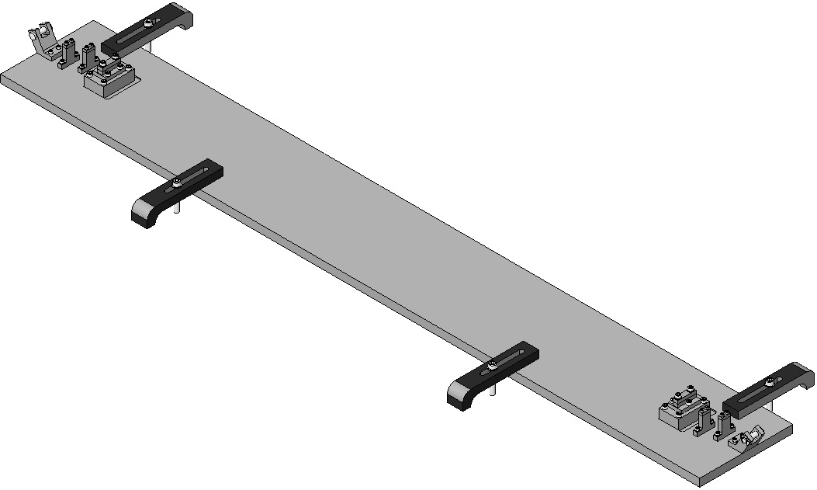  Breakoff  Breakoff  Fig 23: Attaching the Breakoffs
- Cut one length of 0.0106” diameter Steel Music Wire.  - Clean the Wire per Section 12.4.  - Feed the Wire through a set of Wire Clamps in the order shown. Allow the long end of the wire to hang over the edge of the Table passing over the Wire Jig Pin Support.  - Tighten Wire Start Clamp farthest from the corresponding Wire Jig Pin Support.  Ensure the wire is secured within the groove of the clamp.  - Repeat Steps 4-7 for the second wire, but feed the Wire through the Clamp in the opposite direction. |  | 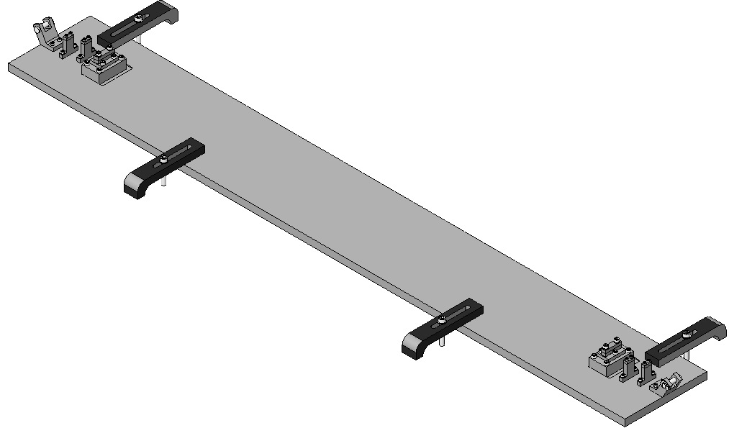  3  4  2  1  Fig 24: Loading the Wires
- Tie a small loop in each Wire, at the end of the wire hanging off the Table. Hang a 1 kg Hang Weight from each loop. Add more weights to each hanger for a total of 6.071 kg per Wire. Then Change gloves since the weights are not clean. | 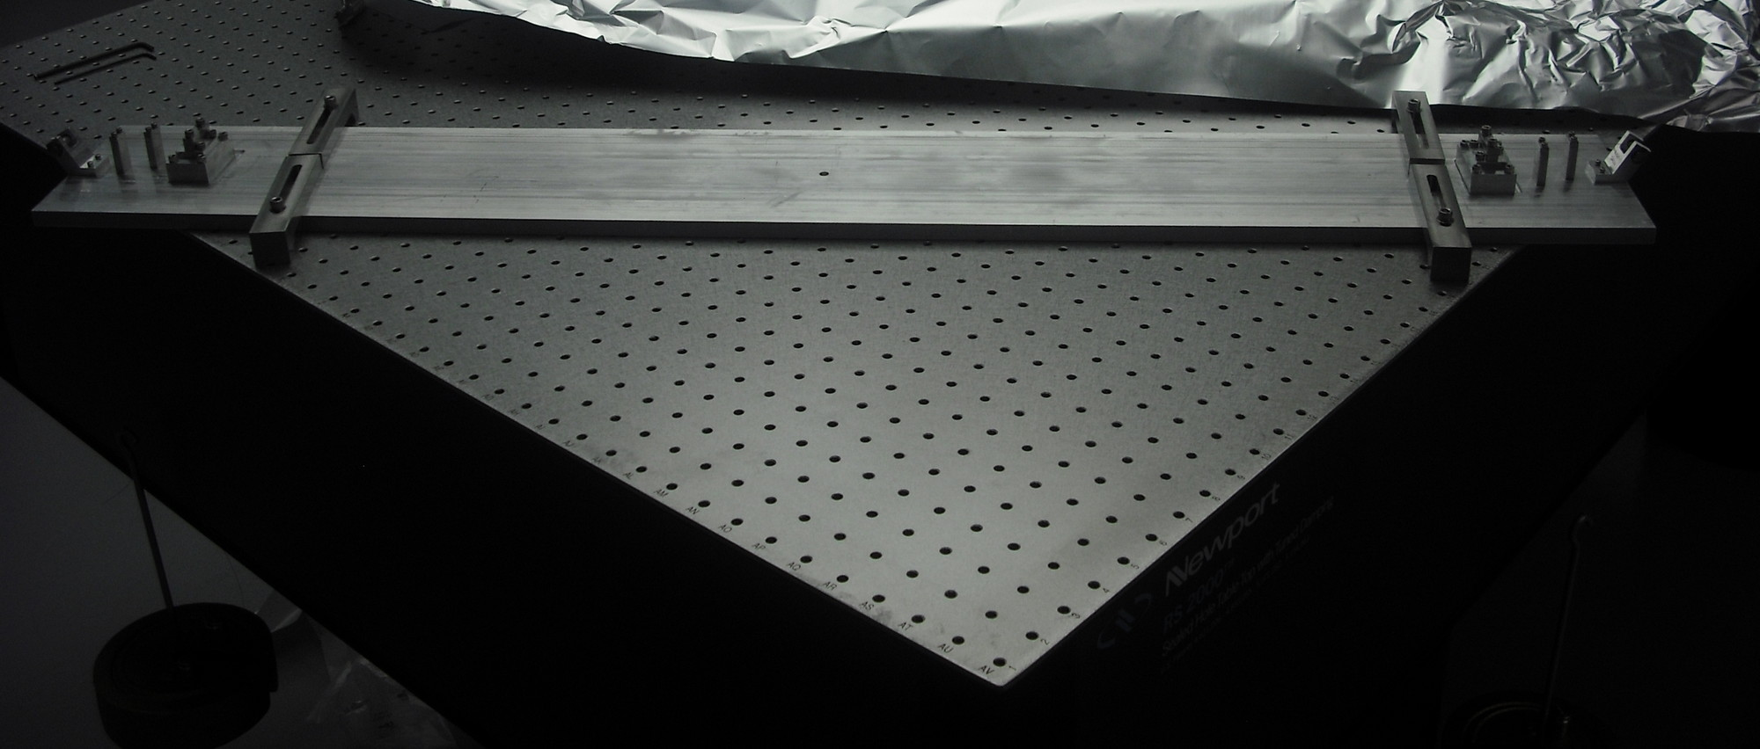  Fig 25: Hang Weight in position
- Wait 5 minutes for the wires to come to equilibrium. Tighten the Screws on the Lower Loop Wire Clamps, then tighten the screws on the remaining Wire Start Clamps. Torque to 30 in-lb.  During tightening:  - Ensure Wire is secured within the grooves of each Clamp.  - Ensure Clamp halves are aligned with each other by using a Precision Square.  - Cut the wires between the Lower Loop Wire Clamps and the Wire Start Clamps.  - Remove the weights on both ends. Change gloves since the weights are not clean. |  | Fig 26: Tightening and Cutting the Wires  Precision  Square
- Loosen the screws on the Wire Start Clamps on the Jig and discard the leftover pieces of wire.  - Remove the Screws holding the Lower Loop Wire Assembly to the Jig.  - Bend back the ends of the wires to eliminate sharp points. |  | 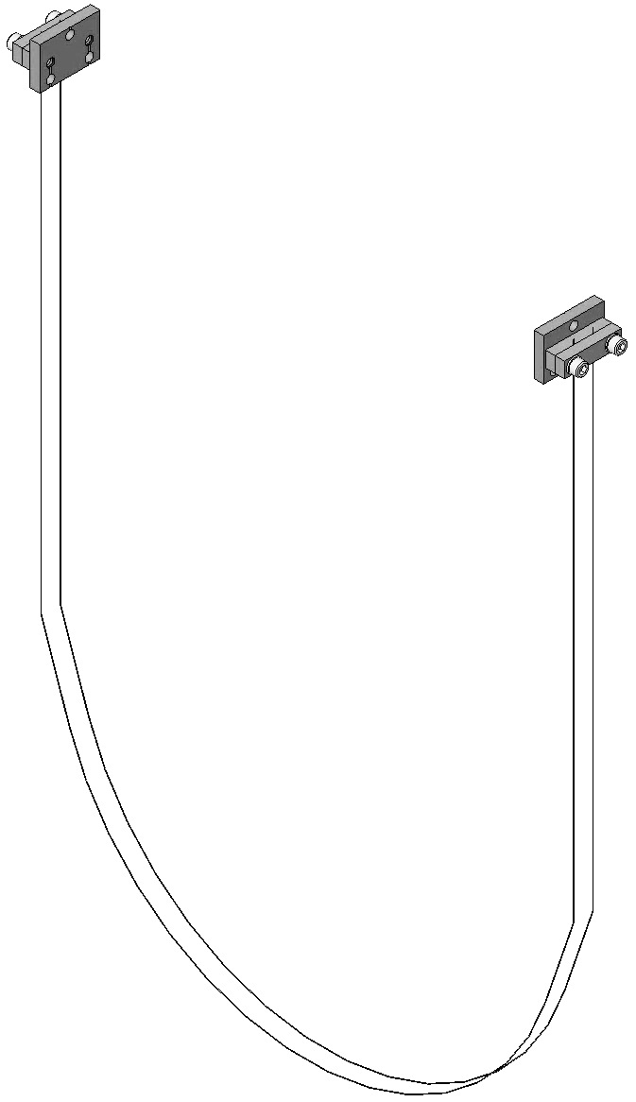  Fig 27: Lower Loop Wire complete Assembly

Assembling Upper Blade Guards

Documents
D070308 HLTS Top Blade Guard Assembly

Materials
Qty | U | ID | Description
4 | Ea | D070309 | Top Blade Guard Riser
2 | Ea | D070310 | Top Blade Guard Bar
8 | Ea | NA | Socket Head Cap Screw ¼-20 x 1.0” SSTL
8 | Ea | NA | Flat Washer, ¼” Vented SSTL
4 | Ea | D0900999 | Socket Head Cap Screw ¼-20 x 2.0” SSTL Round-Tip
4 | Ea | NA | Hex Nut ¼-20 AgPlated

Procedure
- Assemble 2 D070308 Top Blade Guard Assemblies, each with:  - 2 D070309 Top Blade Guard Riser  - 1 D070310 Top Blade Guard Bar  - 4 Socket Head Cap Screws  ¼-20 x 1.0” SSTL  - 4 Flat Washers, ¼-20 Vented SSTL  - 2 D0900999 Socket Head Cap Screw  2 ¼-20 x 2.0” SSTL Round-Tip  - 2 Hex Nut ¼-20 AgPlated | 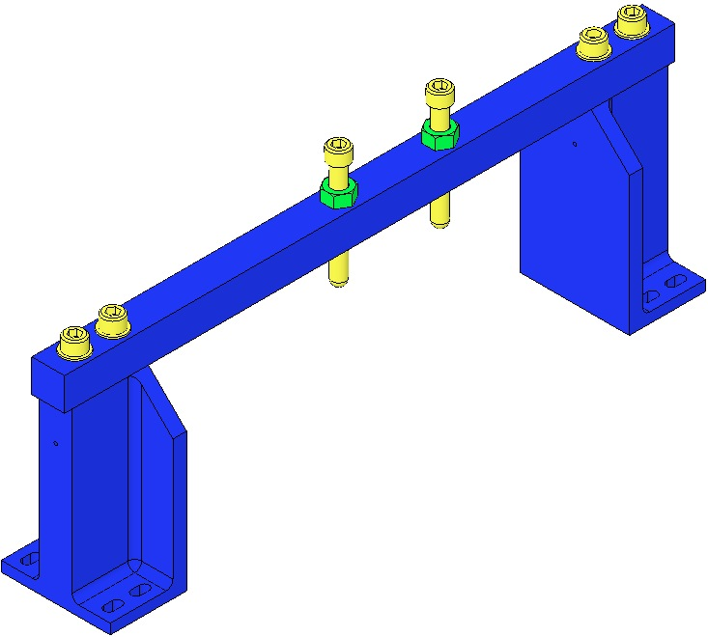  Fig 28: Top Blade Guard Assembly

Assembling the Rotational Adjusters

Documents
D070326 HLTS Rotational Adjuster
E1000169 Blade Characterization Spreadsheet
T0900559 Blade Pairings Spreadsheet

Materials
Qty | U | ID | Description
1 | Ea | D080265 | HLTS Upper Blade Bake Fixture
1 | Ea | D070327 | HLTS RA Base Plate
1 | Ea | D070328 | HLTS RA Rotating Plate
3 | Ea | NA | Socket Head Cap Screw ¼-20 x 0.625” SSTL
3 | Ea | NA | Flat Washer ¼”
1 | Ea | D070329 | HLTS RA Pull Plate
2 | Ea | NA | Socket Head Cap Screw 8-32 x 1.0” AgPlated
1 | Ea | D070330 | HLTS RA Push Plate
2 | Ea | NA | Socket Head Cap Screw 8-32 x 1.25” AgPlated
1 | Ea | NA | Socket Head Cap Screw 8-32 x 1.5” Fully-Threaded SSTL
1 | Ea | NA | Flat Washer #8 Vented SSTL
1 | Ea | NA | Socket Head Cap Screw 8-32 x 1.5” Full-Thread Round-Tip SSTL
3 | Ea | NA | Socket Head Cap Screw 5/16-18 x 1.75” AgPlated
3 | Ea | NA | Flat Washer 5/16” Vented SSTL
1 | Ea | D0900665 | HLTS Upper Blade Library of Clamps
2 | Ea | D020617 | Upper Blade
2 | Ea | Various | Upper Blade Clamp Inside
2 | Ea | D070331 | Upper Blade Clamp Shim, 1.0mm
 |  |  | Consult with a Suspension Design Engineer to verify that 1.0 is appropriate; Shim height needed depends upon actual Weldment height.
1 | Ea | D020660 | Blade Pulldown Device
1 | Ea | NA | Machinist’s Square

Procedure
- Prepare a D020660 Blade Pulldown Device with:  - 1 D0901814 Upper Clamp, Inside  - 1 D070341 Upper Clamp, Outside  - Socket Head Cap Screw  8-32 x 0.5” AgPlated  - Flat Washer #8 Vented, SSTL  - 2’ of 0.024” Wire. | 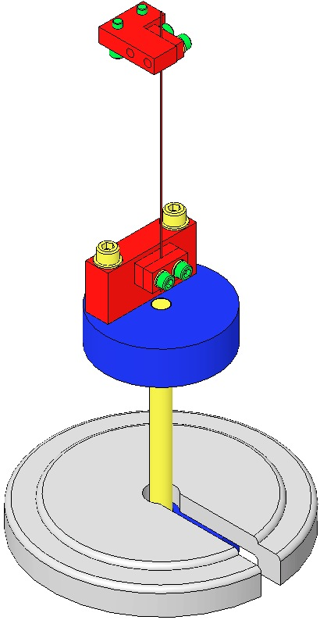  Fig 29: Blade Pulldown Device
- Remove the Bridges and Side Supports from the D080268 Upper Blade Bake Fixture Base Plate.  - Mount the Base Plate to an Optics Table, leaving one end of the Plate extending beyond the Table Edge to accommodate the Blade Pulldown Device.Assemble 2 D070328 Rotational Adjuster Rotating Plates to the Fixture Base Plate using:  - 4 Socket Head Cap Screws  ¼-20 x .625” SSTL  - 4 Flat Washers ¼” Vented SSTL  Tighten the Screws firmly.  Square the edge of the Rotational Adjuster Rotating Plate against the Fixture Stop Block.  - Assemble the D1003307 Hold Down Bar to the Fixture using:  - 2 Socket Head Cap Screws  ¼-20 x 1.00” SSTL  - 2 Flat Washer ¼” Vented SSTL  Tighten the Screws firmly. | 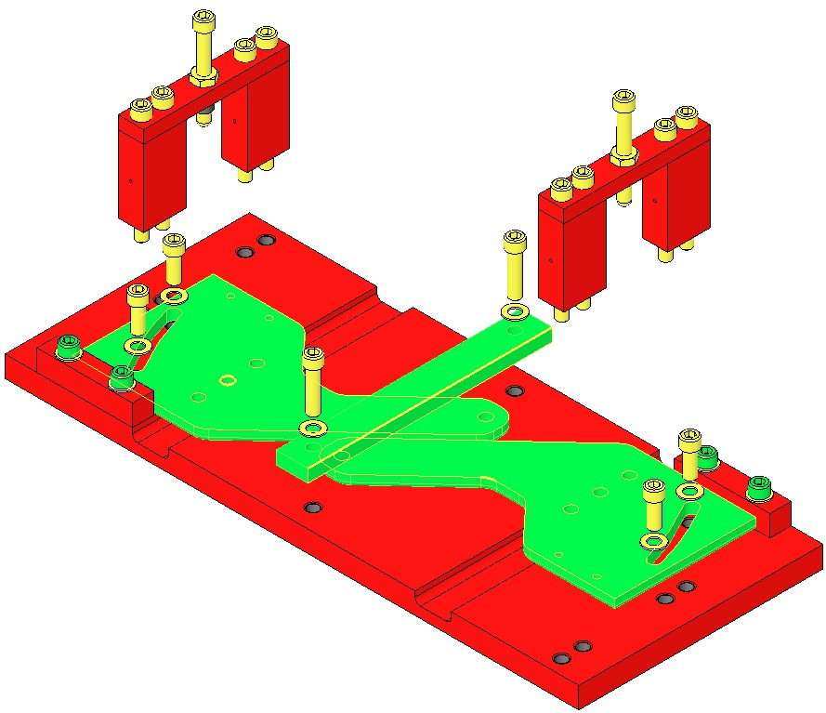  Table Edge  Bridges and Supports  Stop Block  Fig 30: Rotating Plates & Hold Down Bar
- Select a matching pair of Upper Blades and Clamps per the E1000169 Blade Characterization Spreadsheet:  - Blade launch angle is set by Blade Clamps. These range from 0-3.5 deg. in .5 deg. increments.  - Select Clamps from the D0900665 HLTS Upper Blade Library of Clamps  - Select Clamps according to Blade Characterization data for stiffness and expected load.  - Select Blades in pairs according to Blade Characterization data.  - Align the Blade, Clamps and Shim using a Precision Square.  - Record the Blade serial numbers and Blade clamp angles and orientations within ICS. | 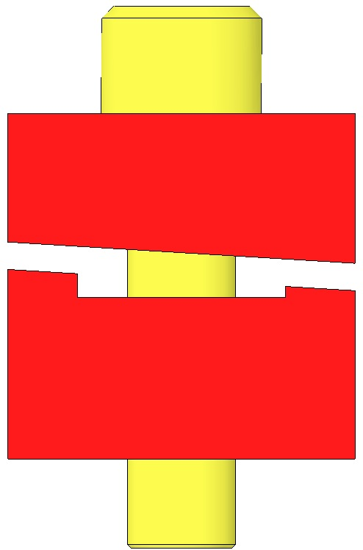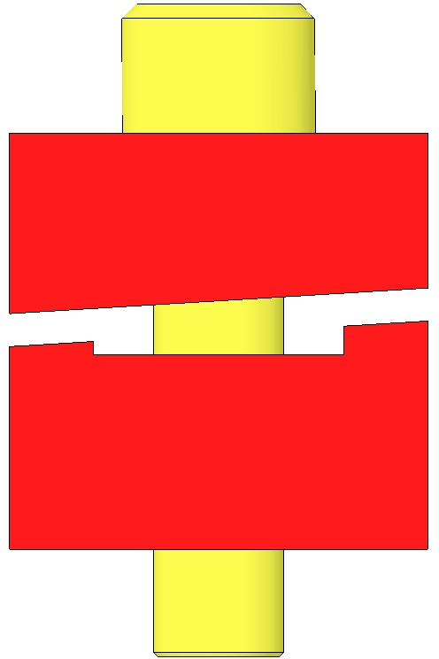  Fig 31: Clamps Control Launch Angle  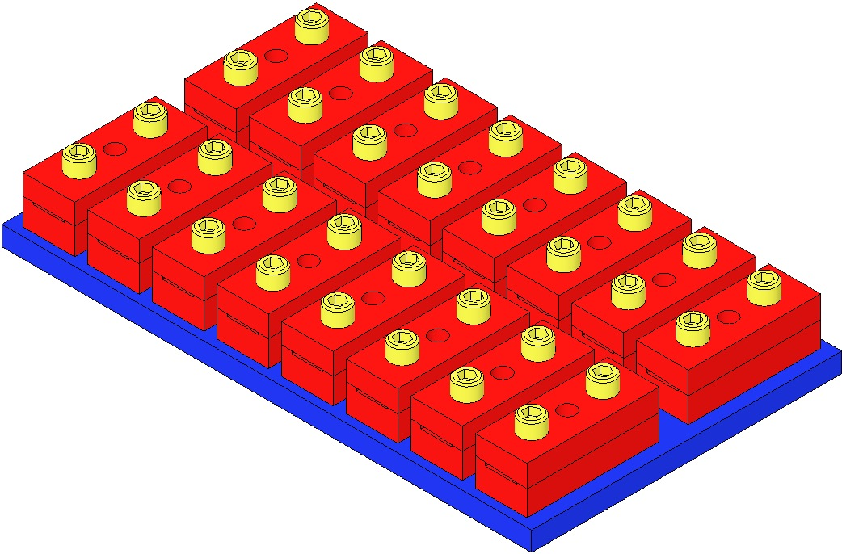  Fig 32: Upper Blade Library of Clamps
- Assemble to the Rotational Adjuster Blade Rotating Plate furthest from the Table edge:  - 3 Socket Head Cap Screws  5/16-18 x 1.75” AgPlated  - 3 Flat Washers 5/16” Vented SSTL  - D09006XX Upper Blade Clamp Outside  - D020617 Upper Blade  - D09006XX Upper Blade Clamp Inside  - D070331 Upper Blade Clamp Shim 1.0mm  Consult with a Suspension Design Engineer to verify that 1.0mm is appropriate; Shim height needed depends upon actual Weldment height.  Using the Machinist’s Square, Square the Blade, Clamps, and Shim to  each other and to the Rotating Plate and hand-tighten the 3 Screws  - Hang the 18.252 kg Pulldown Weight from the Blade Tip  - Assemble to the Bake Fixture Base Plate:  - 2 D1003306 Side Support  - 1 D080267 Top Bridge  - 4 Socket Head Cap Screws  ¼-20 x 2.5” SSTL  Tighten the Screws firmly  - D0900999 Socket Head Cap Screw  ¼-20 x 2.0” Round-Tip  - Hex Nut ¼-20 AgPlated  - Turn down the Round Tip Screw until the weighted Blade tip is level with the Blade root.  Be careful not to damage the nickel plating on the blade | 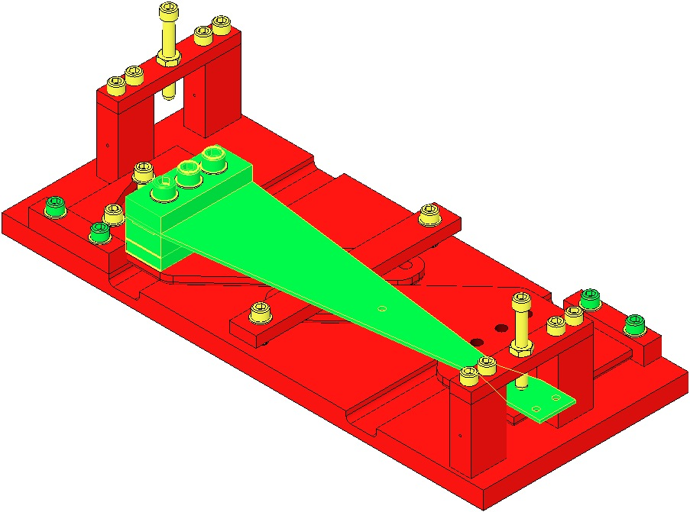  Table Edge  Machinists  Square  Fig 33: Blade & Clamps Assembled
- Leaving the Wire Clamp attached to the Blade, remove the rest of the Blade Pulldown Device.
- Tighten the 5/16” Screws to 184 in-lb.
- Re-attach the Blade Pulldown Device to the Wire Clamp.
- Turn back the Round Tip Screw and remove the Top Bridge and Side Supports.
- Slowly lift and then remove the Blade Pulldown Device, allowing the Blade to curve fully upward.
- Detach the Bake Fixture from the Optics Table, rotate it 180 deg., and remount it on the Optics Table, leaving one end of the Plate extending beyond the Table Edge to accommodate the Blade Pulldown Device.
- Repeat steps 7-15 to assemble the second Upper Blade to the Bake Fixture.
- Remove the Hold-down Bar.
- Disassemble both Rotational Adjusters from the Upper Blade Bake Fixture.
- Assemble the D070328 Rotating Plate to the D070327 HLTS Rotational Adjuster Base Plate using:  - 3 Socket Head Cap Screw  ¼ – 20 x 0.625” SSTL  - 3 Flat Washer ¼”  Hand-tighten only, for now. | 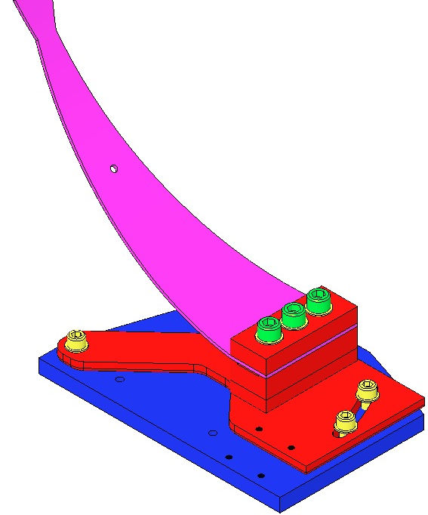  Base Plate  Rotating Plate  Fig 34: Attaching Base Plate
- Assemble to the Base Plate:  - 1 D070329 Pull Plate  - 2 Socket Head Cap Screws  8-32 x 1.0” AgPlated  - 1 D070330 Push Plate  - 2 Socket Head Cap Screws  8-32 x 1.25” AgPlated  - 1 Socket Head Cap Screw  8-32 x 1.5” Fully Threaded SSTL  - 1 Flat Washer #8 Vented SSTL  - 1 Socket Head Cap Screw  8-32 x 1.5” Fully Threaded, Round Tip SSTL | 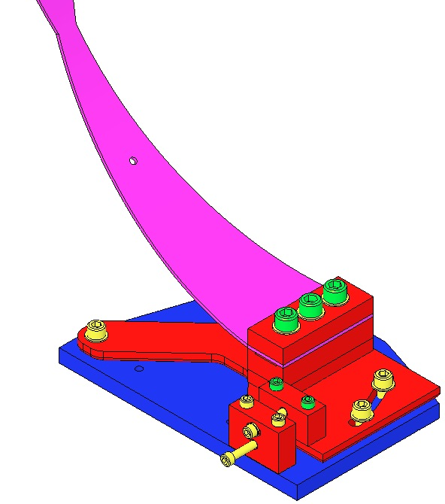  8-32 x 1.5” Round Tip  8-32 x 1.5” & Washer  8-32 x 1.25”  8-32 x 1.0”  Pull Plate  Push Plate  Fig 35: Assembling Push & Pull Plates

Assembling Magnets – Upper Mass

Documents
M0900034 RODA - Use of Magnets in Suspensions
D1001695 Magnet and Flag Assembly, BOSEM

Materials
Qty | U | ID | Description
9 | Ea | D1100573 | BOSEM Flat Magnet Flag
9 | Ea | D1100574 | BOSEM Flat Magnet Flag Disk
9 | Ea | NA | Flat Head Socket Screw 4-40 x 0.1875” SSTL
9 | Ea | DCNI 01888N | Sintered NdFeB Magnet, Ni Plated, 10mm x 5mm
9 | Ea | D1001534 | BOSEM Magnetic Plug
9 | Ea | D1001697 | HLTS BOSEM Magnet Retainer

Procedure – Assembly
- Assemble 9 D1001695 BOSEM Magnet / Flag Assemblies, each with (shown left-to-right):  - D1100573 BOSEM Flat Magnet Flag  - D1100574 BOSEM Flat Magnet Flag Disk  - Flat Head Socket Screw  4-40 x 0.1875” SSTL  - Magnet D394394N35UHP Sintered NdFeB Ni-Plated 10 mm x 10 mm  - D1001534 BOSEM Magnetic Plug  - D1001697 HLTS BOSEM Magnet Retainer | Magnet Retainer  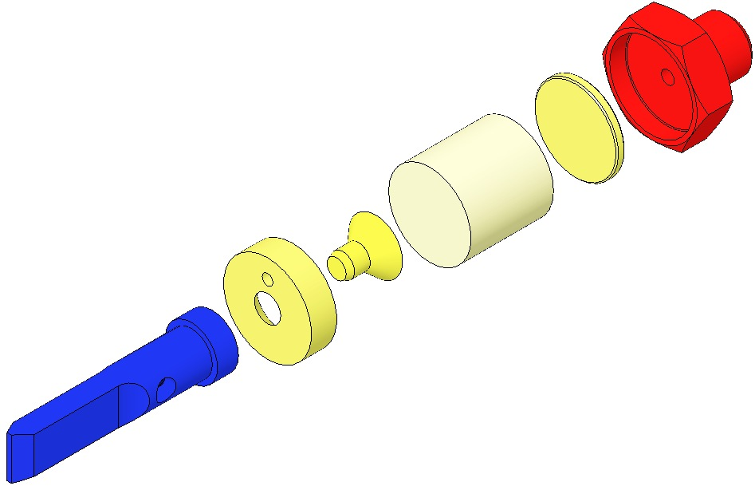  Plug  Magnet  Screw  Disk  Flag  Fig 36: HLTS BOSEM Magnet/Flag Assembly
The Magnets attach the Flags to the Upper Mass. Since the Flags are aluminum and the Magnet Retainers are non-magnetic stainless steel, a magnetic 416 stainless steel Magnetic Plug is press-fit into each Flag and Magnet Retainer. The press-fitting operation must be done after all parts are cleaned and baked. The Press itself must be cleaned and/or wrapped in UHV foil.

Procedure – Plug Insertion
Procedure for assembling D1001534 Plug to Magnet Holder:  - Heat Air Bake Oven to 70 c;  - Attach Magnet Holders to Heating Fixture with:  - Socket Head Cap Screw  8-32 x 0.3125” SSTL  Screws must be Class A or B clean  - Place Heating Fixture in Oven for 10 min. minimum;  - Remove Heating Fixture from Oven and inspect Magnet Holders for out-of-round condition, using tapered end of the Disk Insertion Tool to address any out-of-round conditions.  - Place Disk on a Magnet Holder, Place non-tapered end of Disk Insertion Tool on Disk, and tap Insertion Tool until Disk is fully seated within Holder.  - Return Heating Fixture to Oven for another 5 minutes, minimum.  - Remove Heating Fixture from Oven, and repeat Step 5, above.  - Remove Magnet Holders from Heating Fixture. | 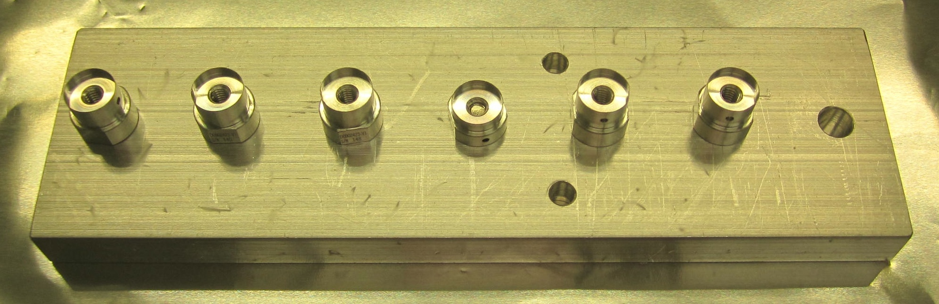  Fig 37: Heating Fixture with Holders  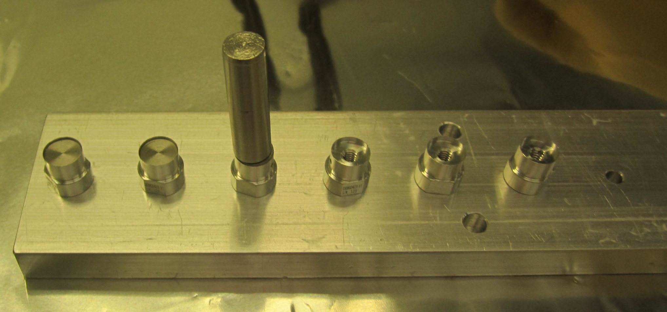  Fig 38: Insertion Tool in position  Note: Tapered end of Tool is up  Note: Seated Disks on left 2 Holders

Assembling Upper Mass and Coil Holder (M1)

Documents
D070335 Upper Mass Assembly
D080677 Coil Holder Assembly

Materials
Qty | U | ID | Description
1 | Ea | D040259 | Upper Mass Jig
1 | Ea | D020605 | HLTS Upper Mass Main Section
1 | Ea | D020607 | Upper Mass T-Piece
8 | Ea | NA | Socket Head Cap Screw ¼-20 x 1.25” AgPlated SSTL
1 | Ea | D1001669 | Pitch Insert
1 | Ea | NA | Socket Set Screw ½-20 x 3.5” AgPlated
2 | Ea | NA | Socket Set Screw ¼-20 x 2.0” Fully-Threaded SSTL
2 | Ea | D080221 | HLTS Lower Blade Guards
4 | Ea | D030025 | Socket Head Cap Screws 8-32 x 1.0” SSTL Fully-Threaded Round-Tip
8 | Ea | NA | Hex Nuts 8-32 AgPlated
4 | Ea | NA | Socket Head Cap Screws 4-40 x 0.375” AgPlated SSTL
12 | Ea | NA | Flat Washers #8 Vented SSTL
4 | Ea | Various | HLTS Blade Clamp, Lower Blade, Inside
4 | Ea | D020615 | Lower Blade
4 | Ea | Various | HLTS Blade Clamp, Lower Blade, Outside
10 | Ea | NA | Flat Washer ¼” SSTL
4 | Ea | D020653 | Screwdrive Block
8 | Ea | NA | Socket Head Cap Screw 8-32 x 1.0” AgPlated
4 | Ea | NA | Socket Head Cap Screw ¼-20 x 1.125” AgPlated
1 | Ea | D030139 | Roll Offset, Upper Mass T-Piece
2 | Ea | NA | Socket Set Screw ¼-20 x 0.5” AgPlated
4 | Ea | NA | Socket Head Cap Screw ¼-20 x 2.0” SSTL
4 | Ea | NA | Hex Nut ¼-20 AgPlated
9 | Ea | D1001699 | Magnet Holder, HLTS BOSEM
18 | Ea | NA | Socket Head Cap Screw 4-40 x 0.625” AgPlated
9 | Ea | D1001695 | Magnet / Flag Assembly
2 | Ea | D070340 | HLTS Upper Wire Assemblies
4 | Ea | D070393 | HLTS Intermediate Wire Assemblies
1 | Ea | NA | Machinist’s Square
 |  |  | Components Added Only for Weighing
2 | Ea | D020652 | Upper Mass C-Clamp
2 | Ea | D020610 | Inside Upper Wire Lower Clamp
2 | Ea | D020624 | Outside Upper Wire Lower Clamp
4 | Ea | NA | Socket Head Cap Screw 8-32 x 0.5” AgPlated
4 | Ea | NA | Socket Head Cap Screw 8-32 x 1.125” SSTL
4 | Ea | NA | Flat Washer #8 SSTL
1 | Ea | D070449 | HLTS Coil Holder
8 | Ea | NA | Socket Head Cap Screw 4-40 x 0.25” AgPlated
4 | Ea | NA | Flat Washer #4, Vented, SSTL
Qty | U | ID | Description
2 | Ea | D020660 | Lower Blade Pulldown Device  - 6.092 kg Hang Weight  - Lower Blade Wire Clamp from Intermediate Wire Assembly  - 8 Socket Head Cap Screw  4-40 x 0.25” AgPlated  - Music wire .008” dia. minimum, about 18” long, clamped at one end, and with a small loop tied in the other.)

Procedure
- Assemble to the  D020605 Upper Mass Main Section:  - D020607 Upper Mass T-Piece  - 4 Socket Head Cap Screws  ¼-20 x 1.125” AgPlated  Torque to 100 in-lb  - Assemble to the D1001669 Pitch Insert:  - 1 Socket Set Screw  ½-20 x 3.5” AgPlated  - Assemble to the T-Piece:  - 1 D1001669 Pitch Insert  Center the Insert within the T-Piece  - 2 Socket Set Screws  ¼-20 x 1.5” AgPlated |  | 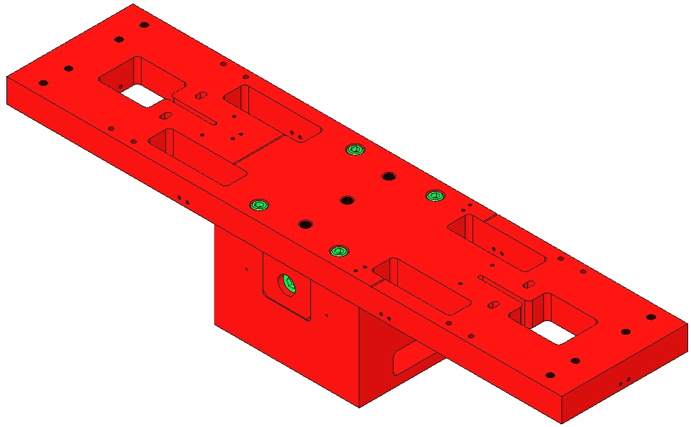  Main Section  ¼-20 x 1.125”  T-Piece  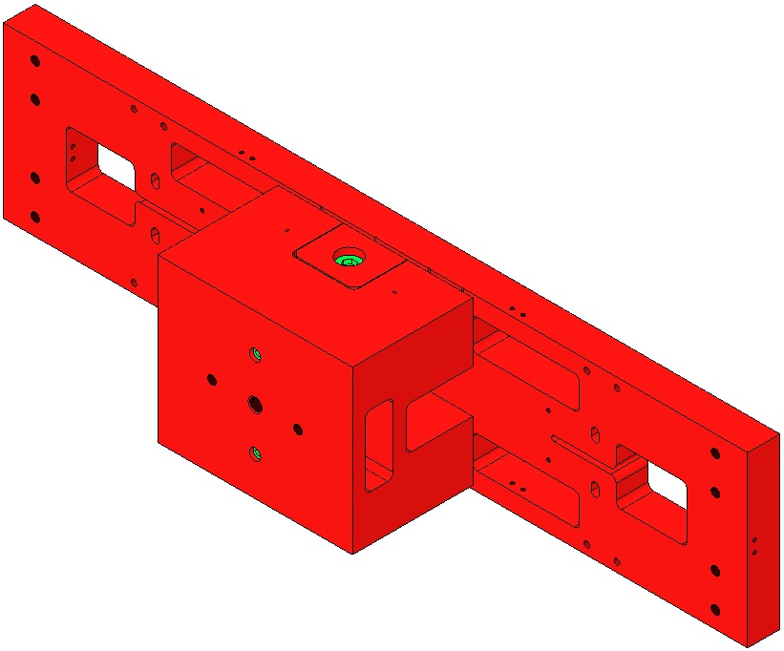  1.5” Set Screws  Pitch Insert  3.5” Set Screw  Fig 39: T-Piece Assembled to Main Section
- Attach the D040259 Upper Mass Jig to an Optics Table with a ¼-20 Ag-Plated Bolt.  - Thread the T-Piece onto the ¼-20 stud at the top of the Jig.  The Jig will not be shown for the remainder of the assembly steps, but is necessary to secure the Upper Mass during the assembly process. |  | 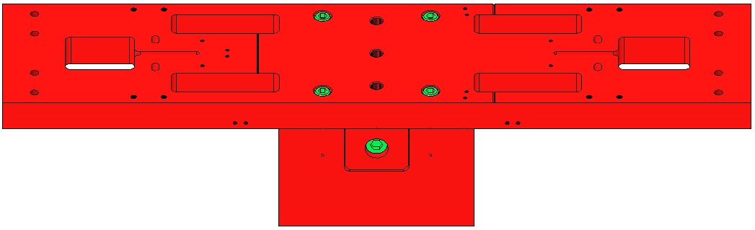  Jig  53  Fig 40: Upper Mass mounted on Jig
Use safety glasses per E0900332.  Note: Blades are shown here as flattened, but are actually curved until weighted.  - Per data in T0900559 Blade Pairings, retrieve:  - 4 matched D020615 Lower Blades.  - 4 pair (Upper/Lower) of Lower Blade Clamps, each pair with a Clamp angle corresponding to the Matched Blades chosen above. The D0900681 Library of Clamps lists all Blade Clamp angles and part numbers.  - Identify the placement of the blades as follows:  - Blade with highest tip in +X, +Y corner  - Blade with next to highest tip in –X, +Y corner  - Blade with next to lowest tip in +X, -Y corner  - Blade with lowest tip in –X, -Y corner  - Attach the 2 Clamp/Wire Assemblies from the Lower Blade Pulldown Device to the tip of each Blade.  - 2 D0901815 Upper Clamp, Int. Wire, Inside  - 2 D0901813 Upper Clamp, Int. Wire, Outside  - 4 Socket Head Cap Screw  4-40 x .375” AgPlated  - 4 Flat Washer #4 Vented SSTL  - 4 Socket Head Cap Screw  4-40 x .25” AgPlated  - Assemble each Lower Blade as shown:  - 2 Socket Head Cap Screws  ¼-20 x 1.25” AgPlated SSTL  - 2 Flat Washer ¼ Vented SSTL  - 1 Lower Blade Clamp, Lower  - 1 D020615 Lower Blade  - 1 Lower Blade Clamp, Upper |  | 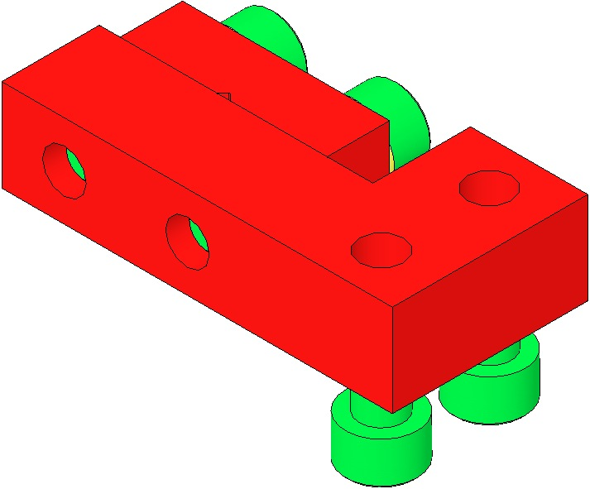  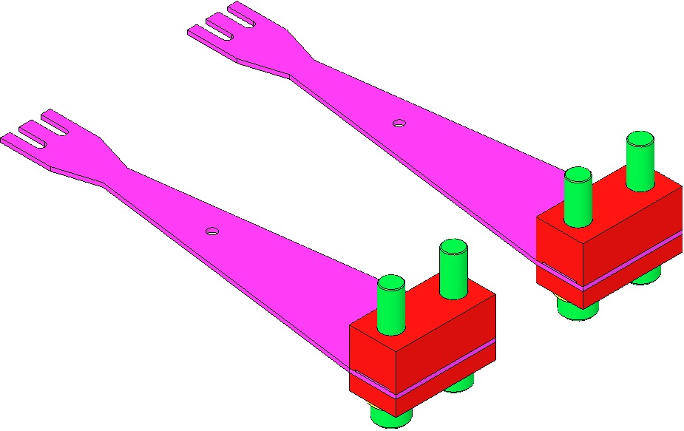  Blade Clamp  Lower Side  Blade  D0901815 & D0901813 Clamps Assembly  ¼-20 x 1.25”  AgPlated  Blade Clamp  Upper Side  Fig 41: Weighting the Blades
- Attach the 2 Blade assemblies to the Upper Mass Main Section and snug the bolts finger- tight. Ensure the Blades are aligned such that the Blade tips can move through the oval cutouts without touching the cutout walls.  - Use the Machinist’s Square to ensure the Blades and Blade Clamps are square with the Main Section. | 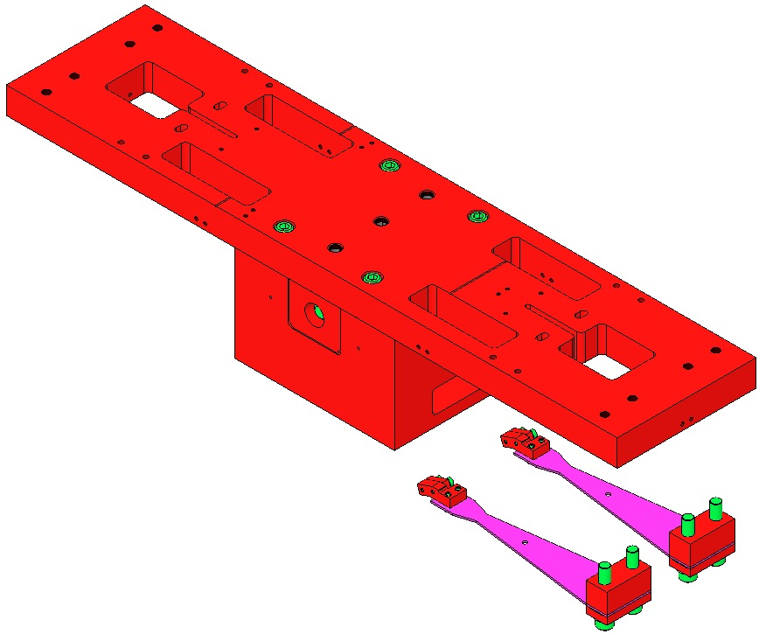  Blade tips must not touch walls of oval cutouts as the Blades are straightened.  Square these  surfaces  Machinists  Square  Fig 42: Attaching the Blades
- Hang the 2 D020660 Pulldown Device Weights on the wire loops. The weight will pull the blade tip through the oval slot in the Upper Mass Main Section until the Blade is essentially flat.  Torque the 4 Screws to 100 in-lb.  Be sure to Torque the Screws only after the Blades have been pulled down. |  |  | 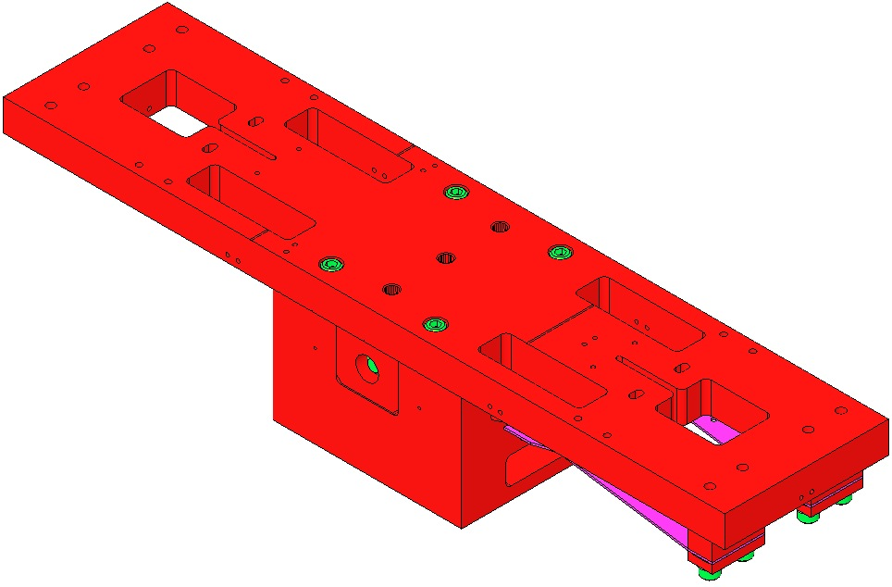  Machinists  Square  Fig 43: Adding Weight to the Blades
- Visually verify that the profiles of pairs of Blades match + 0.5 mm.  If the Blades are not of identical flatness within 1 mm, either the Blades or Blade Clamps must be replaced to achieve this flatness. Blade Clamps are available in angles from 0 – 3.5 deg.  When using Blade Clamp pairs other than 0 deg., CAREFULLY INSPECT CLAMP ORIENTATION to ensure the pairs are aligned so that the Clamp sidewalls are parallel (and therefore, the bolt holes are concentric). |  | Fig 44: Verifying Blade Matching  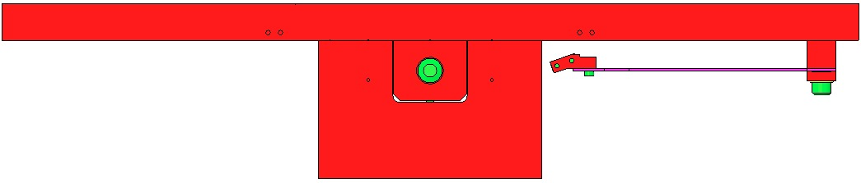  Sight across here  Correct  Incorrect  or  or  Fig 45: Upper & Lower Blade Clamp Alignment
- Assemble to 2 D080221 Lower Blade Guards:  - 4 D030025 Socket Head Cap Screws  8-32 x 1.0” Round Tip SSTL  - 4 Hex Nuts 8-32 AgPlated  - Attach the Blade Guards to the D020605 Main Section using:  - 4 Socket Head Cap Screws  4-40 x 0.375” AgPlated  - 4 Flat Washers #8 Vented SSTL |  | 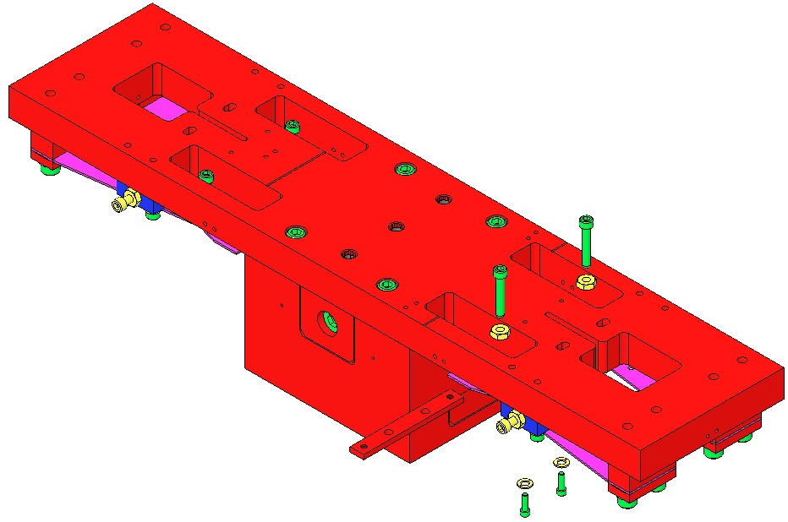  4-40 x 0.375” &  Vented Washer  Blade Guard  8-32 x 1.0”  Hex Nut  Fig 46: Main Section with Blade Guards
- Assemble 4 sets of Screw Drives to the Upper Mass Main Section:  - 1 D020653 Screwdrive Block  - 2 Socket Head Cap Screw  8-32 x 1.00” AgPlated  - 2 Flat Washer #8 SSTL  - 1 Socket Head Cap Screw  8-32 x 1.50” SSTL Round Tipped  - 1 Hex Nut 8-32 AgPlated  Tighten Finger-Tight |  | 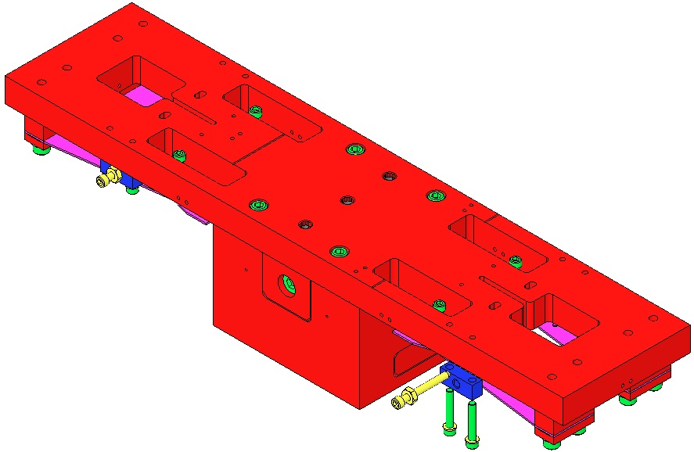  Screwdrive  Block  8-32 x 1.0”  & Washer  8-32 x 1.5”  Round Tipped  & Hex Nut  Fig 47: Screw Drives Installed
- Assemble to the T-Piece:  - D030139 Roll Offset  Center the Offset within the T-Piece  - 2 Socket Set Screw  ¼-20 x 0.5”AgPlated  - D1001669 Pitch Insert  - 1 Socket Set Screw  ½-20 x 3.0” AgPlated  - 2 Socket Set Screw  ¼-20 x 1.5” AgPlated  - 2 Socket Head Cap Screw  ¼-20 x 2.0” SSTL  - 2 Hex Nut ¼-20 AgPlated |  | 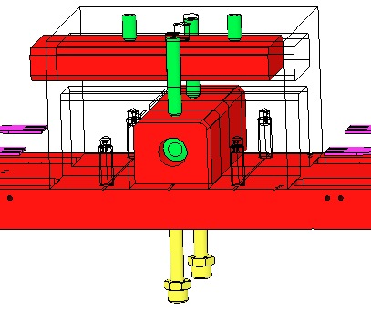  ¼-20 x 2.0”  ¼-20 x 1.5”  ½-20 x 3.0”  ¼-20 x 0.5  D030139  Fig 48: Roll Offset and Pitch Insert added
- Assemble 9 assemblies to the Upper Mass Main Section, each with:  - 1 D1001699 Magnet Holder  - 2 Socket Head Cap Screws  4-40 x 0.625” AgPlated  Torque to 6 in-lb  - 1 D1001695 Magnet / Flag Assembly  Leave off one of the end Magnet Flag assemblies until the Coil Holder has been assembled to the Upper Mass. | 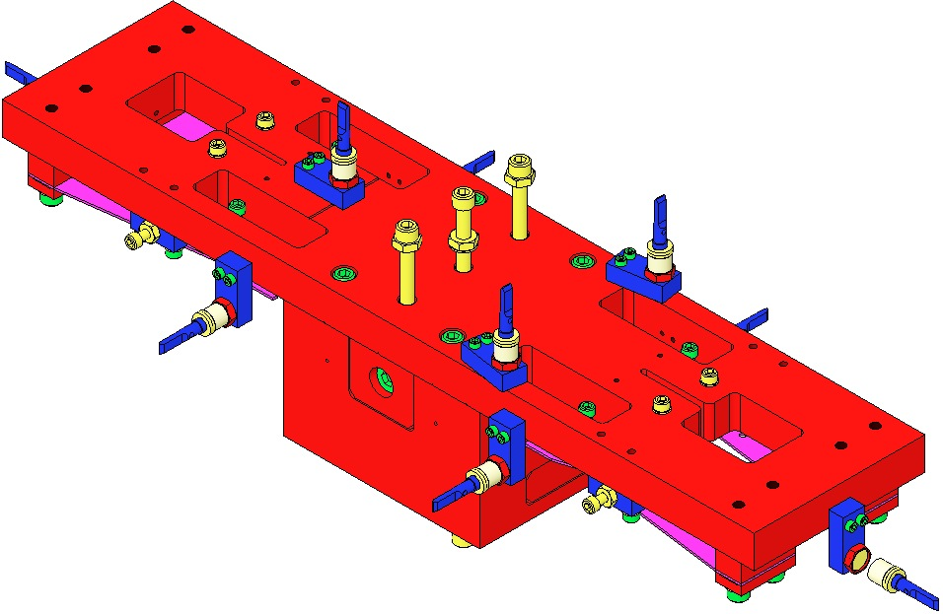  Fig 49: Magnet Assemblies added
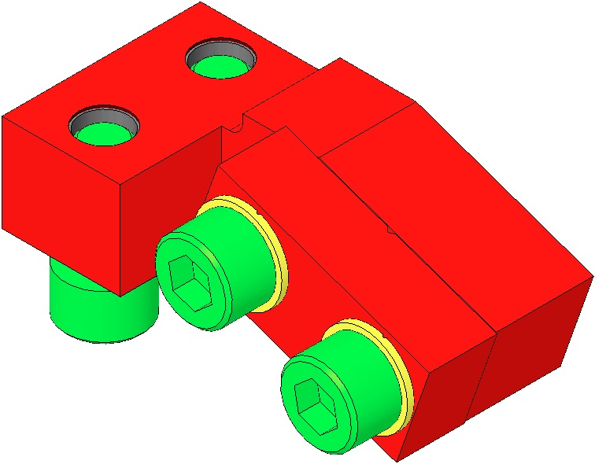  - Weigh the Upper Mass Assembly (including all 9 Magnet/Flag assemblies) along with these additional mass components:  2 Upper Wire, Lower Clamp Assemblies  - 2 D020652 Upper Mass C-Clamps  - 2 D020610 Inside Upper Wire Lwr Clamp  - 2 D020624 Outside Upper Wire Lwr Clamp  - 4 Socket Head Cap Screw  8-32 x 0.5” AgPlated  - 4 Flat Washer #8 Vented SSTL  - 4 Socket Head Cap Screw  8-32 x 1.125” SSTL  - 4 Flat Washer #8 SSTL  4 Int. Wire, Upper Clamp Assemblies  - 4 D070585 Upper Clamp, Inside  - 4 D070394 Upper Clamp, Outside  - 8 Socket Head Cap Screws  4-40 x .375” AgPlated  - 8 Flat Washer #4 Vented  - 8 Socket Head Cap Screws  4-40 x 0.25” AgPlated  Hardware for Additional Mass Disks  - 2 Socket Head Cap Screw  ¼-20 x 2.0” SSTL  - 2 ¼-20 Hex Nut AgPlated  - 2 Flat Washer ¼” SSTL  - Additional Mass Disks sufficient to bring the total mass to 12.087 kg. The additional mass should be divided equally between top disks and bottom disks. | 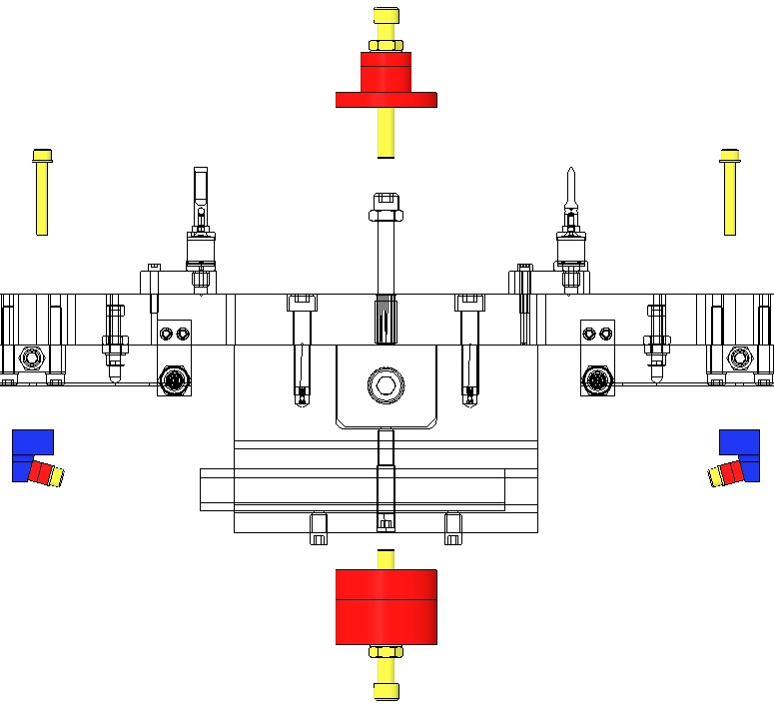  Fig 50: Weighing the Assembly
- Record the actual mass, and the actual additional mass amount and locations, in ICS.
- Attach 2 Upper Wire Assemblies. Grasp the Upper Clamp end of each D070340 Upper Wire Assembly and feed the Assemblies upwards through the outboard openings toward either end of the Upper Mass. Attach to the Upper Mass with:  - 4 Socket Head Cap Screws  8-32 x 1.125” SSTL  - 4 D1100785 Flat Washer #8 Nitronic 60  If any Wire becomes bent during assembly, replace with another Wire Assembly.  - Attach 4 D070393 Intermediate Wire Assemblies to the 4 Lower Blades, with:  - 8 Socket Head Cap Screw  4-40 x 0.25” AgPlated  Torque to 6 in-lb  Fit the tab on the bottom of the Upper Clamp into a slot on the Lower Blade.  If any Wire becomes bent during assembly, replace with another Wire Assembly. | 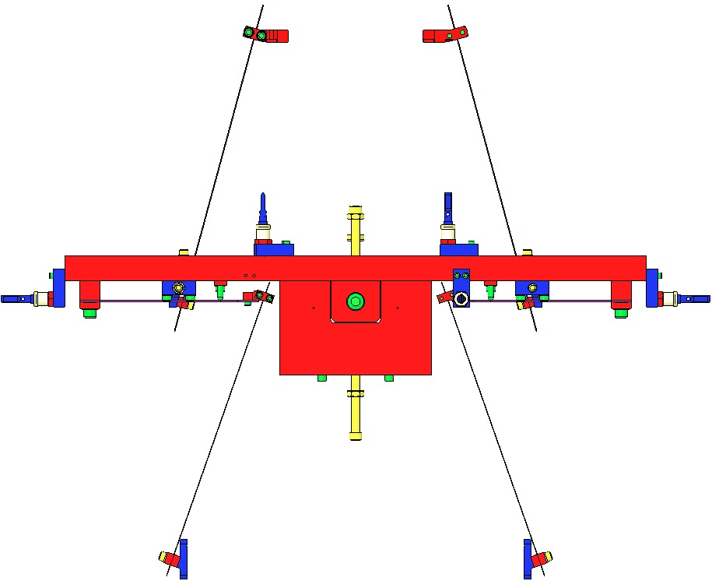  Fig 51: Intermediate Wire Assemblies added
- Assemble 12 EQ Stops to the D070449 Coil Holder:  - 12 Socket Head Cap Screws  ¼-20 x 1.0” Fully-Threaded Round-Tip SSTL  - Hex Nut ¼-20 AgPlated  - Place the Coil Holder over the Upper Mass. Feed the Upper Wire Assemblies through the Coil Holder; feed the Intermediate Wires through the holes on the ends of the Coil Holder.  - Assemble to the Upper Mass:  - 2 Socket Head Cap Screws  - ¼-20 x 2.0” Fully-Threaded SSTL  - 4 Hex Nuts, ¼-20 AgPlated  Tighten the Hex Nuts to secure the Upper Mass to the Coil Holder. | 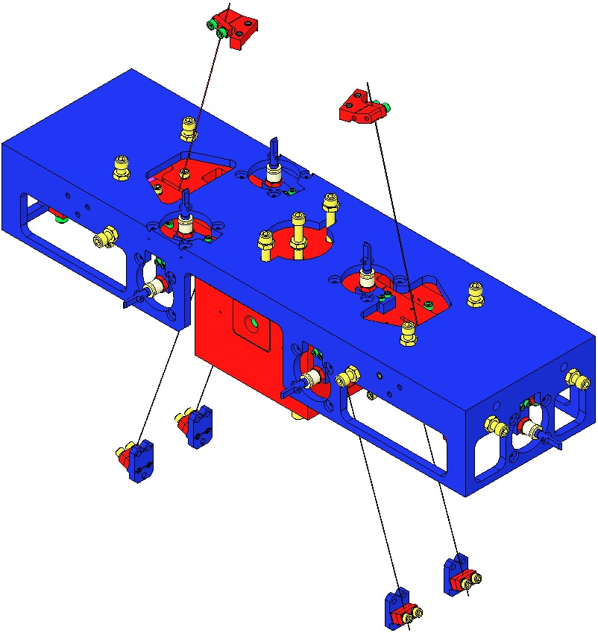  2 ¼-20 x 2.0”  Feed Intermediate Wire ends through 4 end openings  12 EQ Stops  Fig 52: Coil Holder added

Assembling Intermediate Mass (M2)

Documents
D070334 HLTS Intermediate Mass Assembly

Materials
Qty | U | ID | Description
1 | Ea | D070336 | Main Section, Intermediate Mass
1 | Ea | D080181 | Changer Assembly, Intermediate Mass
1 | Ea | D030155 | Center Offset, Intermediate Mass
2 | Ea | NA | Socket Head Cap Screw 8-32 x 0.75” SSTL
2 | Ea | NA | Socket Head Cap Screw 8-32 x 0.75” AgPlated
X | Ea | D1001230 | HLTS Additional Mass Disk 10g
X | Ea | D1001229 | HLTS Additional Mass Disk 20g
X | Ea | D0901405 | HLTS Additional Mass Disk 50g
X | Ea | D070333 | HLTS Additional Mass Disk 100g
2 | Ea | D030156 | Side Offset, Intermediate Mass
4 | Ea | NA | Socket Head Cap Screw ¼-20 x 1.5” Fully-Threaded SSTL
4 | Ea | NA | Hex Nut ¼-20 AgPlated
4 | Ea | NA | Flat Washer ¼ Vented SSTL
4 | Ea | NA | Socket Head Set Screw ¼-20 x 0.50” AgPlated
2 | Ea | NA | Socket Head Set Screw ¼-20 x 0.25” AgPlated
 |  |  | Components for Weighing
4 | Ea | D030149 | Breakoff, Intermediate Wire
4 | Ea | D070406 | Lower Clamp, Intermediate Wire, Outside
4 | Ea | D070405 | Lower Clamp, Intermediate Wire, Inside
8 | Ea | NA | Socket Head Cap Screw 8-32 x 0.625” SSTL
8 | Ea | NA | Flat Washer #8 Vented SSTL
2 | Ea | D030148 | Lower Wire Breakoff
4 | Ea | D070438 | Upper Clamp, Lower Wire, Outside
4 | Ea | NA | Socket Head Cap Screw 8-32 x 0.5625” SSTL
4 | Ea | NA | Flat Washer #8 Vented SSTL

Procedure
- Assemble the D080181 Changer Assembly:  - D030155 Center Offset  - 300g nominal Upper Collar D080223  - 300g nominal Lower Collar D080232  100g Collars shown  - Socket Head Cap Screw  8-32 x 0.75” SSTL or AgPlated  Use SSTL with Aluminum Collars  Torque SSTL Screws to 20 in-lb  Use AgPlated with SSTL Collars  Torque AgPlated Screws to 30 in-lb | 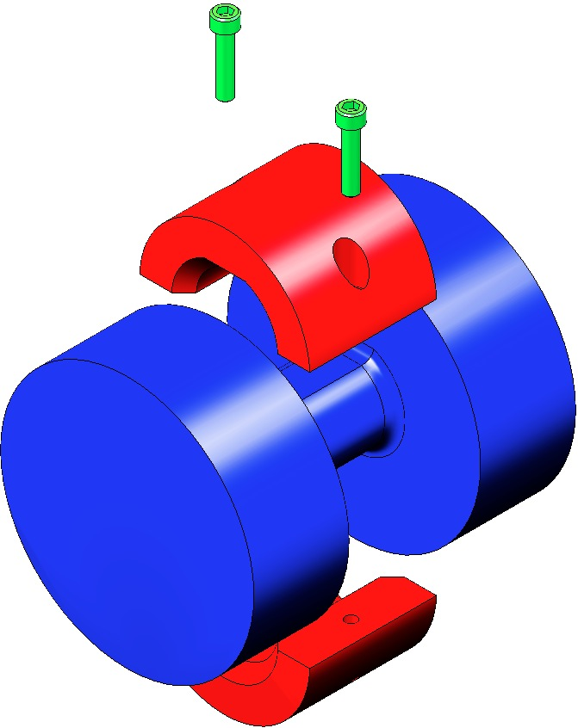  100g Collar  Fig 53: Changer Assembly
- Assemble 2 Side Offset assemblies, each with:  - 1 Side Offset D030156  - 2 Mass Disk D070333 100g nominal  - 2 Flat Washer ¼” Vented SSTL  - 2 Hex Nut ¼-20 AgPlated  - 2 Socket Head Cap Screw  ¼-20 x 1.5” SSTL | 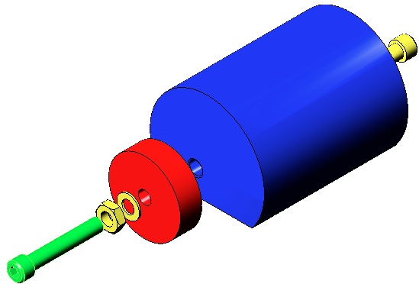  Fig 54: 1 of 2 Side Offset Assemblies
- Slide the Changer Assembly and 2 Side Offsets into the D070336 Main Section and secure with:
- 4 Socket Head Set Screw ¼-20 x 0.50” AgPlated
- 2 Socket Head Set Screw ¼-20 x 0.25” AgPlated
Rotate Side Offsets so Mass Disks are toward the center, and Scribe Lines are aligned.
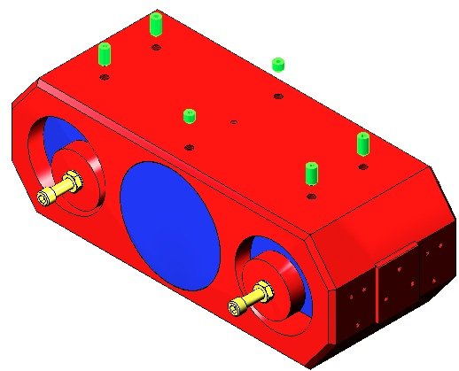  Fig 55: Changer and Offsets in Main Section | 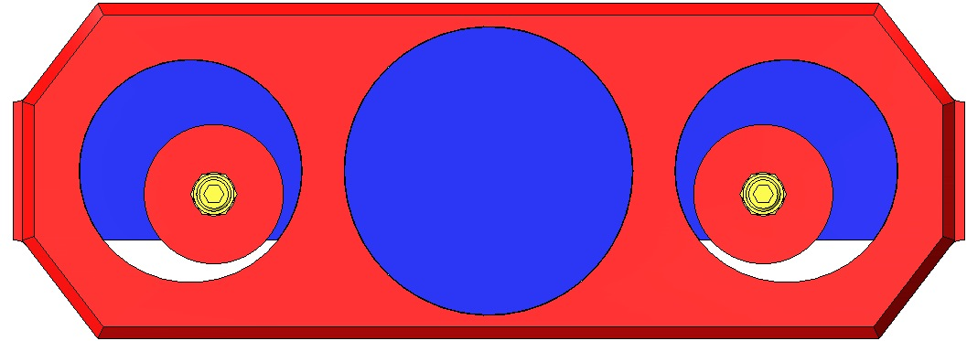  Scribe Lines  Fig 56: Completed Intermediate Mass Assembly
- Weigh the completed Assembly along with:  - 4 D030149 Breakoff, Intermediate Wire  - 4 D070406 Lower Clamp, Intermediate Wire, Outside  - 4 D070405 Lower Clamp, Intermediate Wire, Inside  - 8 Socket Head Cap Screw  8-32 x 0.625” SSTL  - 8 Flat Washer #8 Vented SSTL  - 12 Socket Head Cap Screw  8-32 x .625” SSTL AgPlated  - 2 D030148 Lower Wire Breakoff  - 4 D070438 Upper Clamp, Lower Wire, Outside  - 4 Socket Head Cap Screw  8-32 x 0.5625” SSTL  - 4 Flat Washer #8 Vented SSTL  - 6 Socket Head Cap Screw  8-32 x .625” SSTL AgPlated  - 4 D0901927 Magnets  - 4 D970075 Magnet Standoffs |  | 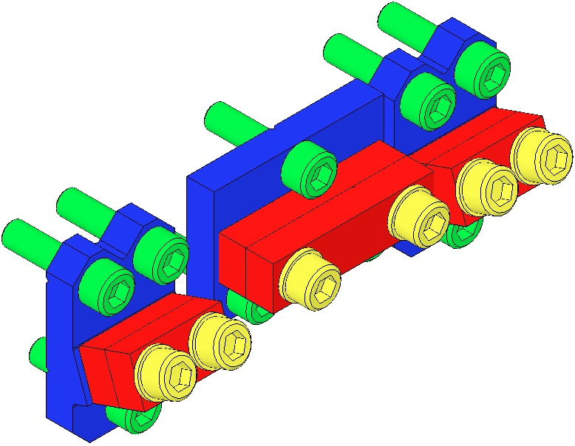  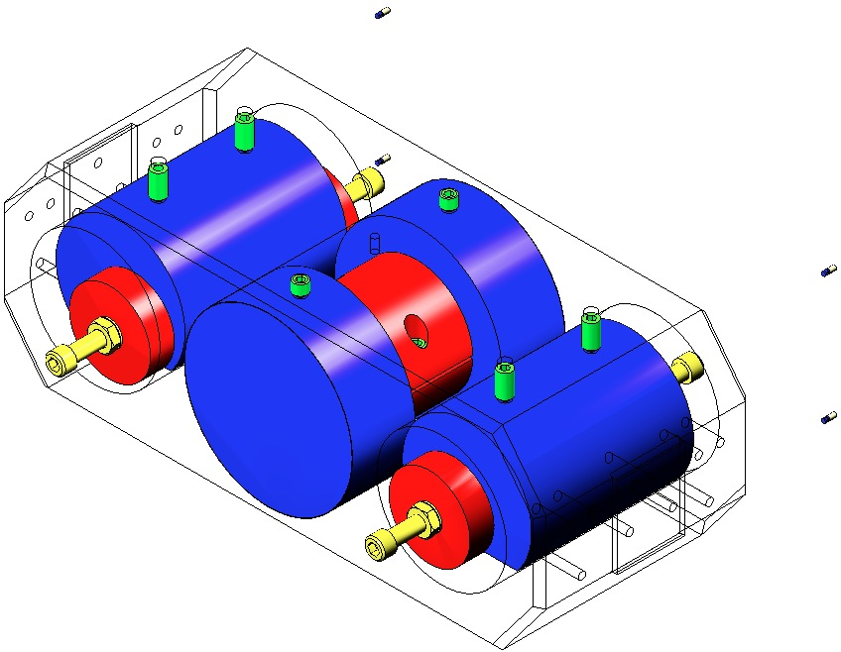  Fig 57: Items to Weigh
- Swap Collars and Disks (red) to reach a total weight of 12.227 kg. Record the total weight, noting changes in Disks or Collars. Record the size and location of the added weights within ICS.

Assembling Bottom Mass and Optic (M3)

Documents
D070337 HLTS Bottom Mass Assembly

Materials
Qty | U | ID | Description
1 | Ea | D070338 | Metal Bottom Mass
1 | Ea | D0902658 | Optic Holder
1 | Ea | D0902661 | Sapphire Prism Bonding Jig
4 | Ea | D980184 | LOS Clamps, Long
2 | Ea | D1100197 | Spacer
2 | Ea | 033-0280 | Optosigma Mirrors
8 | Ea | NA | Socket Head Cap Screw 4-40 x 0.5” Vented SSTL
2 | Ea | D080124 | Prism Breakoff, Lower Wire, Lower Mass
4 | Ea | NA | Socket Head Cap Screw 8-32 x 0.75” SSTL
12 | Ea | NA | Flat Washer #8 Vented SSTL
8 | Ea | NA | Flat Washer #4 Vented SSTL
2 | Ea | D0901286 | Secondary Metal Prism Breakoff
2 |  | D070441 | Sapphire Prism Breakoff

Procedure
- Place the D070338 Metal Bottom Mass, with the inscribed arrow on top of the Mass, pointing away from the glued-on Dumbbell Magnets, into the D0902658 Optic Holder. |  | 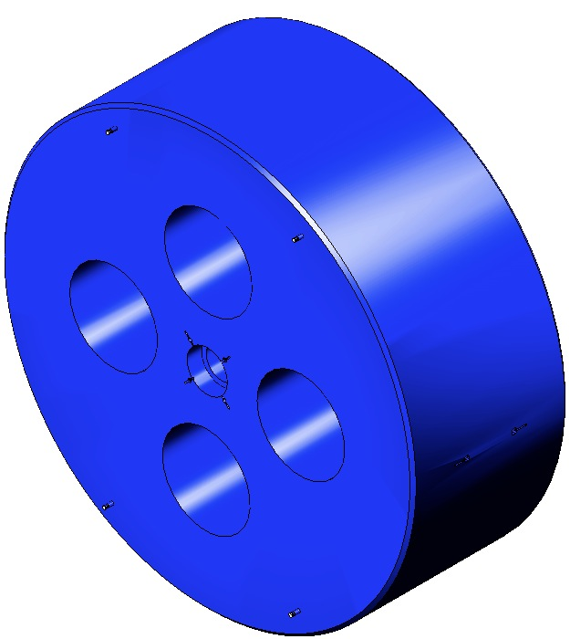  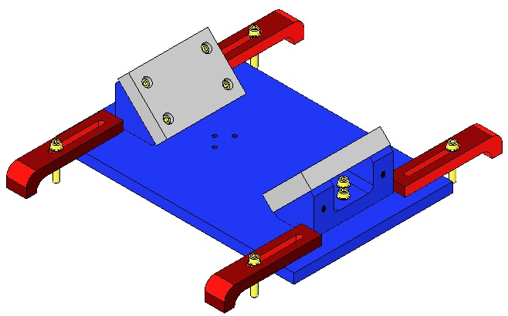  Fig 58: Optic Holder and Bottom Mass
- Assemble to the Bottom Mass:  - 2 D1100197 Spacers  - 2 033-0280 Optosigma Mirrors  - 8 Socket Head Cap Screws  4-40 x 0. 5” Vented SSTL  - 8 Flat Washer # 4 Vented SSTL  Torque to 7 in-lb  - 2 D080124 Prism Breakoffs  - 4 Socket Head Cap Screws  8-32 x 0.75 SSTL  - 4 Flat Washers #8 Vented SSTL  Torque to 25 in-lb  The Spacer wings must be aligned with the Screw locations.  Mirror Arrow must face outwards.  Be especially careful not to damage the glued magnet/dumbbell assemblies. |  | 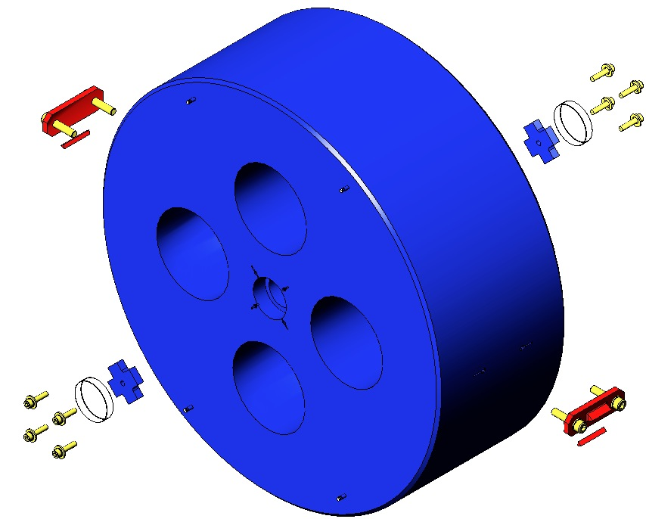  8-32  4-40  Secondary  Prism  Breakoff  Prism  Breakoff  Spacer  Mirror  Fig 59: Bottom Mass  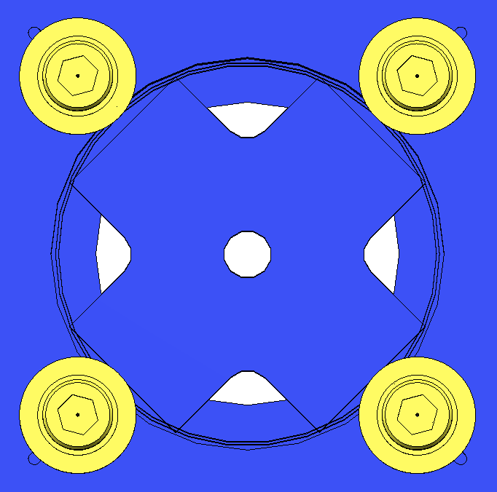  Fig 60: Orientation of Spacer
The fixture is used to attach the Sapphire Prism Breakoff (D070441) to the fused silica optics. The Sapphire Prism Placement Fixture is made up of the Optic Holder (D0902658) and the Sapphire Prism Bonding Jig (D0902661). The Sapphire Prism Bonding Jig itself is made up of the Sapphire Prism Bonding Fixture (D0902662) and the Sapphire Prism Holder Assembly (D0902663). | 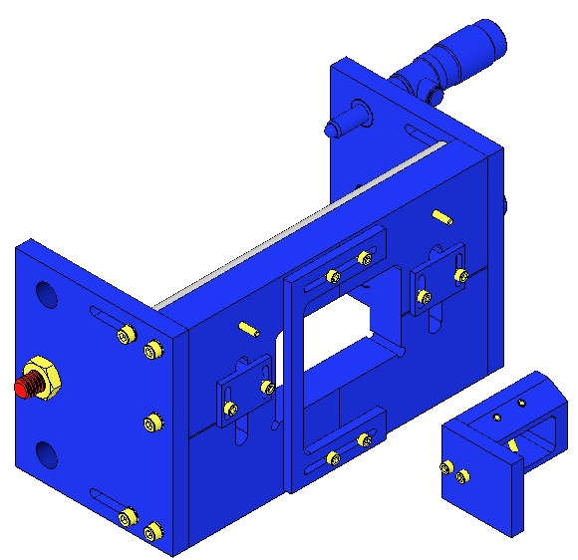  D0902662  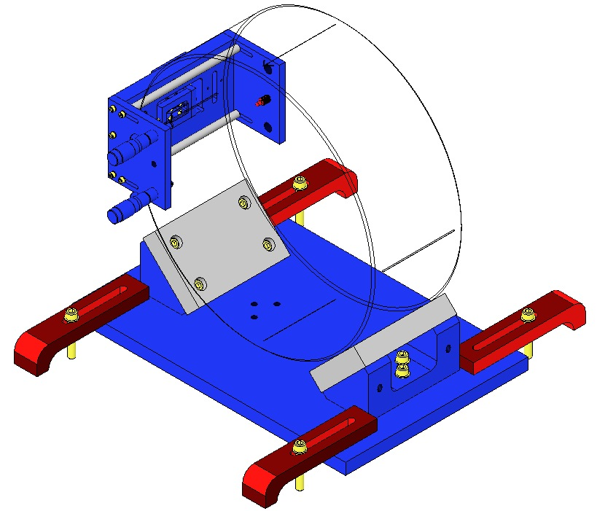  D0902663  Fig 61: Sapphire Prism Bonding Jig
- With the assembly process complete, weigh the Bottom Mass Assembly with the D0901286 Secondary Metal Prism Breakoffs; the combined weight should be 12.142 kg. Record this value in ICS. The Bottom Mass is not designed to be weight-adjusted; weight is added to or subtracted from the Intermediate Mass. So adjusting Bottom Mass weight is actually adjusting the combined weight of the Intermediate and Bottom Masses, a total of 12.227 + 12.142 kg = 24.369 kg.

Assembling EQ Stops For Intermediate and Bottom Masses

Documents
D070447 HLTS Overall Assembly
D080726 HLTS EQ Stop, Long Mount
D080727 HLTS EQ Stop, Long Bracket
D1002821 HLTS EQ Stop Assembly, Bottom Mass, Lower
D1102071 HLTS EQ Stop, Bridge, Upper
D070319 HLTS Bridge EQ Stops

Materials
Qty | U | ID | Description
10 | Ea | D070460 | Long EQ Stop Mount
8 | Ea | D070322 | Long EQ Stop Bracket
4 | Ea | D1002823 | EQ Stop Bracket Back, Bottom Mass, Lower
4 | Ea | NA | Socket Head Cap Screws 8-32 x 1.0” SSTL
4 | Ea | NA | Flat Washer #8 Vented SSTL
4 | Ea | D070321 | EQ Stop Bridge Crossbar
8 | Ea | D1102072 | Bridge EQ Stop Mount, Upper
28 | Ea | D080725 | EQ Stop for Metal or Glass
28 | Ea | NA | Hex Nut ¼-20 AgPlated
8 | Ea | NA | Socket Head Cap Screw ¼-20 x 0.75” SSTL
8 | Ea | D1100785 | Flat Washer, ¼”, Nitronic 60

Procedure
- Assemble 10 D080726 Long Mount EQ Stops, each using:  - 1 D070460 Long EQ Stop Mount  - 1 D080725 EQ Stop for Metal or Glass  - 1 Hex Nut ¼-20 AgPlated | 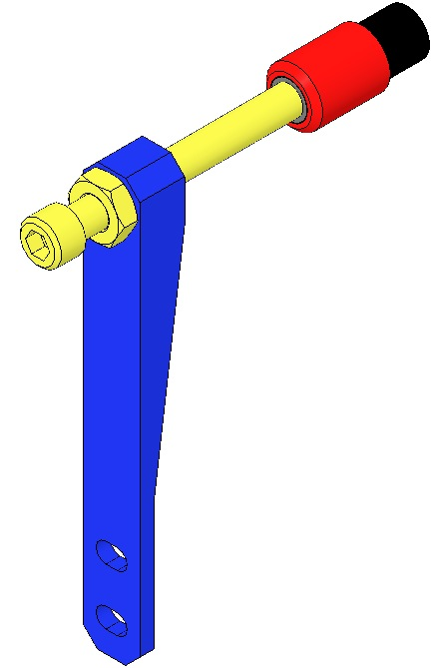  Fig 62: D080726 Long Mount EQ Stop
- Assemble 8 D080727 Long Bracket EQ Stops, each using:  - 1 D070322 Long EQ Stop Bracket  - 1 D080725 EQ Stop for Metal or Glass  - 1 Hex Nut ¼-20 AgPlated | 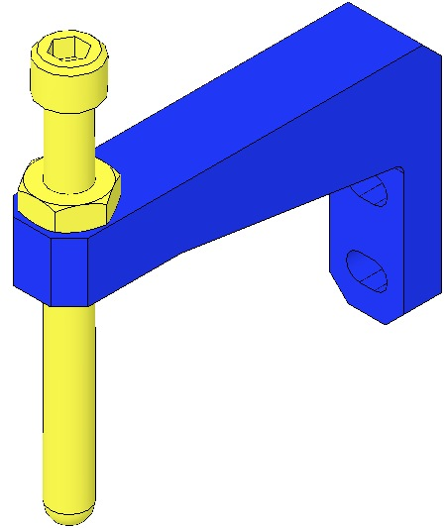  Fig 63: D080727 Long Bracket EQ Stop
- Assemble 2 D1002822 EQ Stop Bracket Assemblies, 1 LH and 1 RH version, each using:  - 1 D1002823 EQ Stop Bracket, Back  - 1 D1002824 EQ Stop Bracket, Side  - 2 Socket Head Cap Screw  8-32 x 1.00” SSTL  - 2 Flat Washer #8 SSTL Vented  - Assemble 2 D1002821 EQ Stop Assemblies, 1 LH and 1 RH version, each using:  - 1 D1002822 EQ Stop Bracket (see above)  - 1 D080725 EQ Stop for Metal or Glass  - 1 Hex Nut ¼-20 AgPlated | 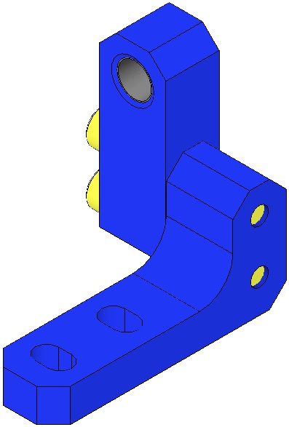  Fig 64: D1002822 Left |  | 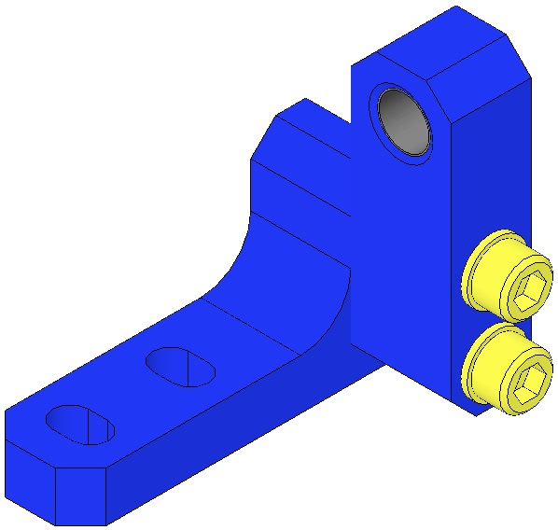  Fig 65: D1002822 Right
 | 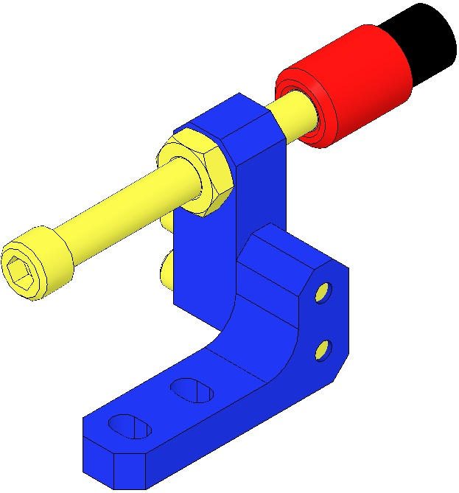  Fig 66: D1002821 Left |  | 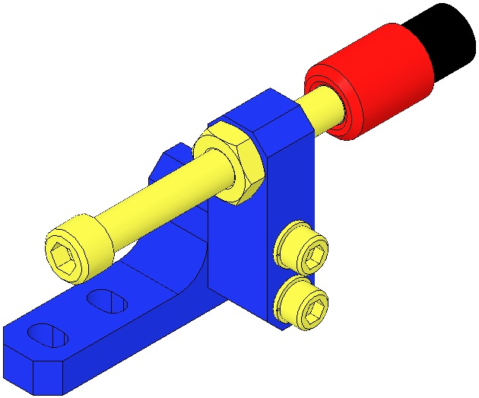  Fig 67: D1002821 Right
- Assemble 4 D1102071 Bridge EQ Stops in 2 configurations.  Initial Build:  - Upper RH diagram: 2 above Metal;  - Lower RH diagram: 2 beneath Metal.  Optic Installation:  - Reconfigure existing assembly (lower RH diagram) as upper RH diagram.  Assemble all 4 with:  - 1 D070321 Crossbar  - 2 D1102072 Mount  - 2 Socket Head Cap Screw  ¼-20 x 0.75” SSTL  - 2 D1100785 Flat Washer, ¼” Nitronic 60  - 2 D080725 EQ Stop for Metal or Glass  The tips (shown red & black) are not used for the Metal Mass  - 2 Hex Nut ¼-20 AgPlated  Hand-tighten all fasteners at this point |  | 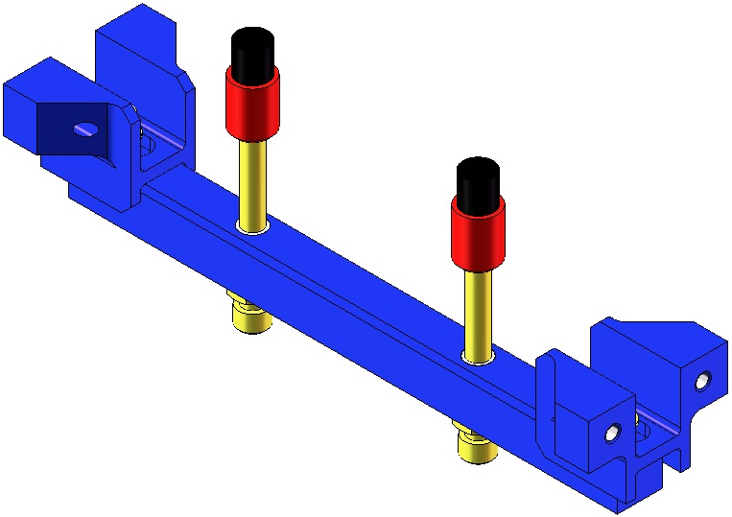  Tips not used for Metal Mass  Fig 68: Above Metal / Optic & beneath Optic  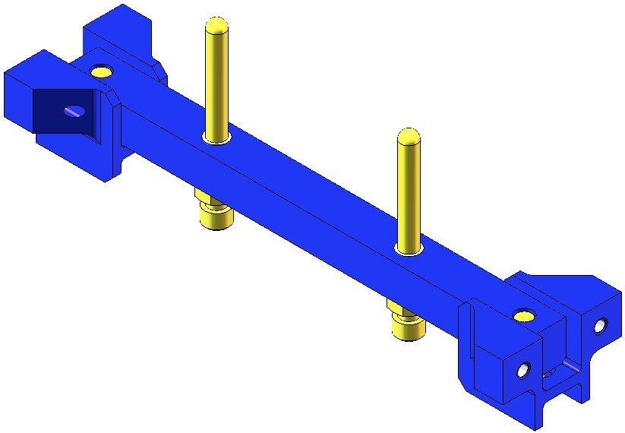  Fig 69: Use beneath the Metal Mass

Preparing The Weldment

Materials
Qty | U | ID | Description
8 | Ea | 1185-2EN492 | Helicoil 8-32 x 3.0D
8 | Ea | D980184 | LOS Clamps
8 | Ea | NA | Socket Head Cap Screw ¼-20 x 1.5” AgPlated

Procedure
- Identify the Front vs Rear of the Weldment. The front has 4 pairs of adjacent, large-diameter through-holes.  - Install at the base of the Weldment:  - 8 1185-2EN492 Helicoils  8-32 x 3.0D  Install these BEFORE securing the Weldment to the Optical Table! | 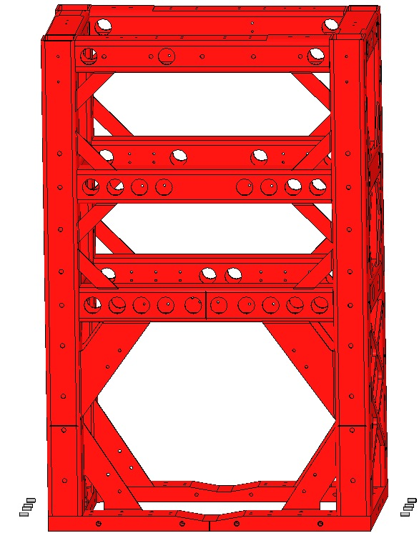  Fig 70: Helicoils in Weldment
- Secure the D070442 Structural Weldment to the Optical Table with:  - 8 D980184 LOS Clamps, 2 per corner  - 8 Socket Head Cap Screws  ¼-20 x 1.5” AgPlated | 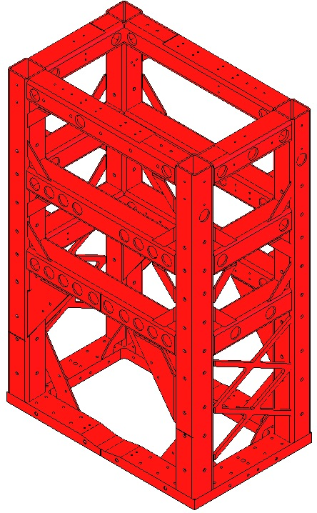  Fig 71: Securing the Weldment

Installing the Mounting Pads

Documents
D0900626 HLTS Mounting Pad Assembly

Materials
Qty | U | ID | Description
1 | Ea | D070442 | HLTS Structural Weldment
8 | Ea | D980184 | LOS Clamps
2 | Ea | D070374 | HLTS Mounting Pad
8 | Ea | NA | Helicoil 8-32 x 0.246”
4 | Ea | 1185-2EN246 | Helicoil 8-32 2B x 2.0D
2 | Ea | D0900628 | HLTS Mounting Pad Side Bracket
2 | Ea | D0900627 | HLTS Mounting Pad Front Bracket
4 | Ea | NA | Socket Head Cap Screw 8-32 x 0.5” SSTL
14 | Ea | NA | Socket Head Cap Screw 8-32 x 0.5” AgPlated
18 | Ea | NA | Flat Washer #8 SSTL

Procedure
- Assemble to each of the 2 D070374 Mounting Pads:  Top of the Pad  - 4 Helicoil 8-32 x 0.246  or longer  Side of the Pad  - 2 1185-2EN246 Helicoils  8-32 2B x 2.0D | 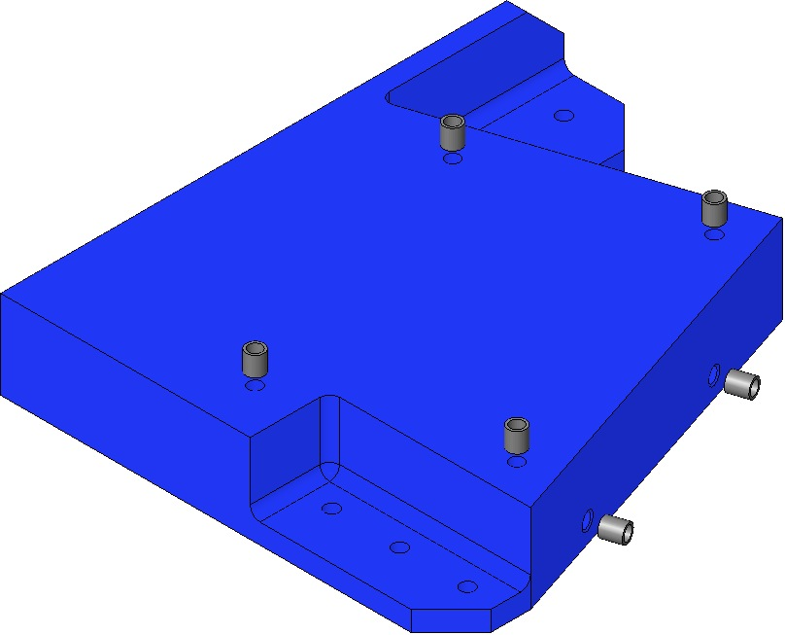  Fig 72: Helicoils in 1 of 2 Mounting Pads
- Create 2 D0900626 Mounting Pad Assemblies:  - 2 D070374 Mounting Pad Body  - 2 D0900628 Mounting Pad Side Bracket  - 4 Socket Head Cap Screw  8-32 x 0.5” SSTL  - 4 Flat Washer #8 SSTL  Torque to 20 in-lb | 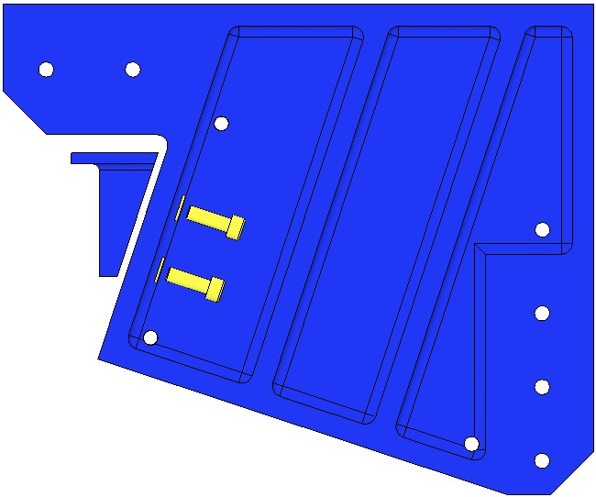  Fig 73: Mounting Pad Assembly
- Assemble the Mounting Pad Assembly to the Structural Weldment using:  - 2 D0900627 Front Bracket  - 14 Socket Head Cap Screw  8-32 x 0.5” AgPlated  - 14 Flat Washer #8 SSTL  Torque to 30 in-lb  The Serial Number for each Pad is stamped on a specific Weldment corner. Ensure each Pad is mounted on the correct Weldment location. | 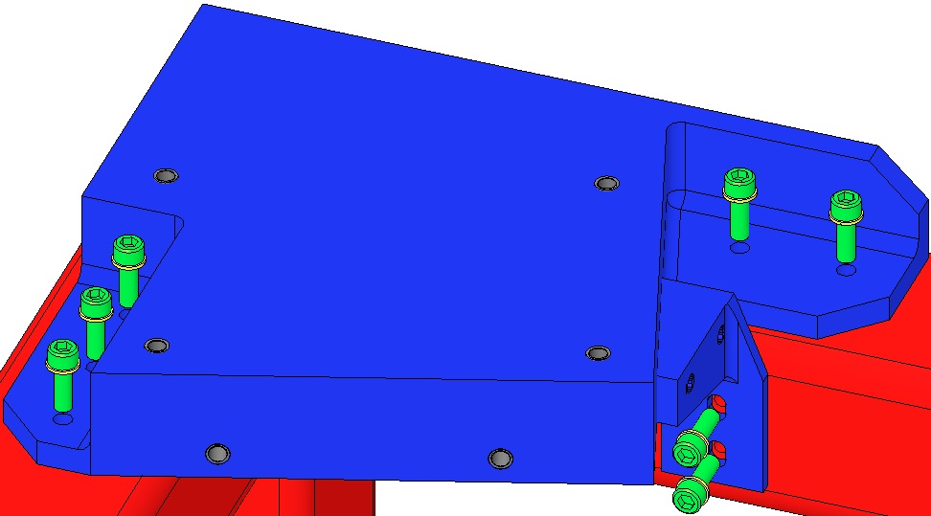  Fig 74: Mounting Pad on Weldment

Installing EQ Stop Mounts and Brackets

Documents
D070442 HLTS Overall Assembly

Materials
Qty | U | ID | Description
10 | Ea | D080726 | HLTS EQ Stop, Long Mount
8 | Ea | D080727 | HLTS EQ Stop, Long Bracket
4 | Ea | D070319 | HLTS EQ Stop, Bridge
4 | Ea | D1002821 | EQ Stop Assembly, Bottom Mass, Lower
4 | Ea | D1102071 | EQ Stop Assembly, Upper
52 | Ea | NA | Socket Head Cap Screws 8-32 x 0.5” AgPlated
52 | Ea | NA | Flat Washers #8 SSTL
4 | Ea | NA | Socket Head Cap Screws 8-32 x 0.5” Vented AgPlated
4 | Ea | NA | Flat Washers #8 Vented SSTL

Procedure
- Attach 2 D1002821 Short Brkt EQ Stops to the inside front of the Weldment, using:  - 4 Socket Head Cap Screw  8-32 x .5” Vented, AgPlated  - 4 Flat Washer #8 SSTL  Torque to 30 in-lb  - Attach the following, using:  - 52 Socket Head Cap Screws 8-32 x 0.5” AgPlated  - 52 Flat Washers #8 SSTL  Torque to 30 in-lb  - 8 D080726 Long Mount EQ Stops to the inside front of the Weldment  - 2 D080726 Long Mount EQ Stops to the inside rear of the Weldment  - 4 D080727 Long Brkt EQ Stops to the inside front of the Weldment  - 4 D080727 Long Brkt EQ Stops to the inside rear of the Weldment  - 4 D1102071 Bridge EQ Stops to the Weldment.  - At the Bridge EQ Stops, torque the 8 ¼-20 Screws (assembled earlier) that attach the Crossbars to the Bridge pieces, to 75 in-lb. | 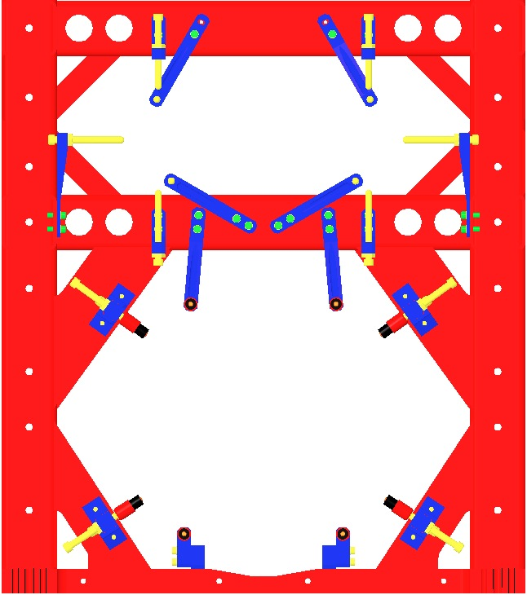  D080726  D080727  D080727  D1102071  D1002821  D080727  D080727  Fig 75: Facing Front from Inside of Weldment  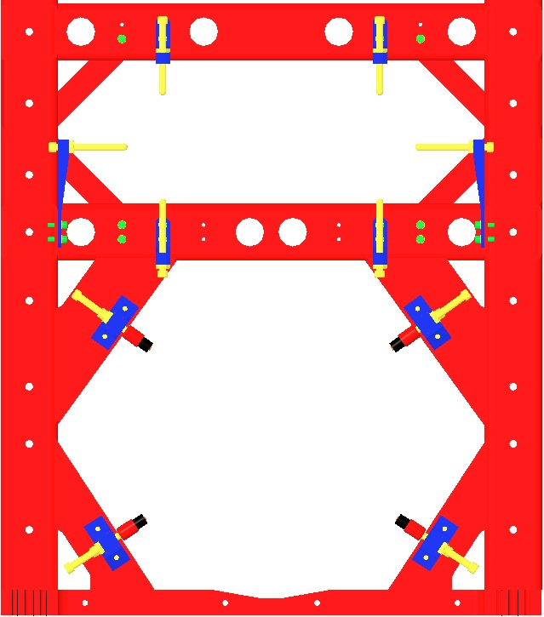  D080726  D1102071  D080727  Fig 76: Facing Rear from Inside of Weldment

Installing Rotational Adjusters and Top Blade Guards

Documents
D070442 HLTS Overall Assembly

Materials
Qty | U | ID | Description
2 | Ea | D020660 | Blade Pulldown Device
2 | Ea | D0901814 | Upper Clamp, Inside, Class B Clean
2 | Ea | D070341 | Upper Clamp, Outside, Class B Clean
1 | Roll | NA | Music Wire 0.024” dia.
1 | Btl | NA | Methanol
1 | Btl | NA | Acetone
1 | Btl | NA | Isopropanol
1 | Spl | NA | Steel Music Wire, 0.0106” dia.
1 | Pkg | NA | Lint-Free Wipes
8 | Ea | NA | Socket Head Cap Screw 8-32 x 0.50” AgPlated
4 | Ea | NA | Flat Washer #8 Vented SSTL
2 | Ea | D1102119 | Blade Pulldown Support
1 | Roll | NA | UHV Aluminum Foil
2 | Ea | D070308 | HLTS Top Blade Guard Assembly
16 | Ea | NA | Socket Head Cap Screw 8-32 x 0.50” AgPlated
16 | Ea | NA | Flat Washer #8 Vented SSTL
2 | Ea | D070326 | HLTS Rotational Adjuster
4 | Ea | NA | Socket Head Cap Screw 8-32 x 0.75” SSTL HoloKrome
4 | Ea | NA | Flat Washer #8 Vented SSTL

Procedure
- Prepare 2 D020660 Blade Pulldown Devices, each with:  - 1 D0901814 Upper Clamp, Inside  - 1 D070341 Upper Clamp, Outside  - 2 Socket Head Cap Screw  8-32 x 0.5” AgPlated  - 2 Flat Washer #8 Vented, SSTL  - 3’ of 0.024” Wire.  Clean the Wire per Section 12.4. | Fig 77: Blade Pulldown Device
- Assemble the D070308 Top Blade Guard Assembly to the D070442 Structural Weldment using:  - 16 Socket Head Cap Screws  8-32 x 0.5” AgPlated  - 16 Flat Washers #8 Vented, SSTL  Torque to 30 in-lb | 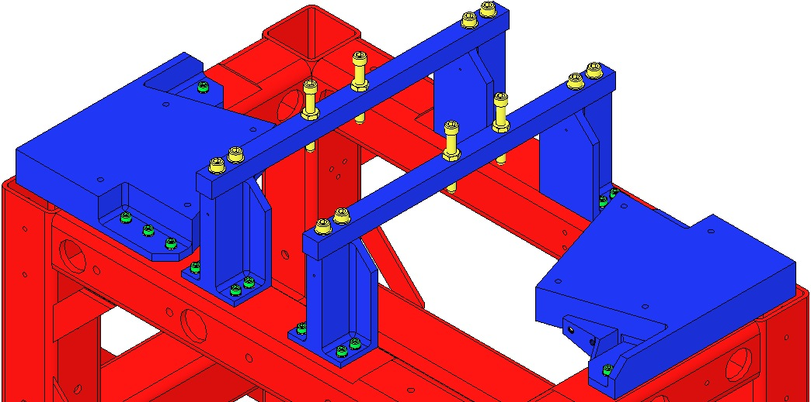  Fig 78: Top Blade Guards installed
- Remove the D070310 Bars. | 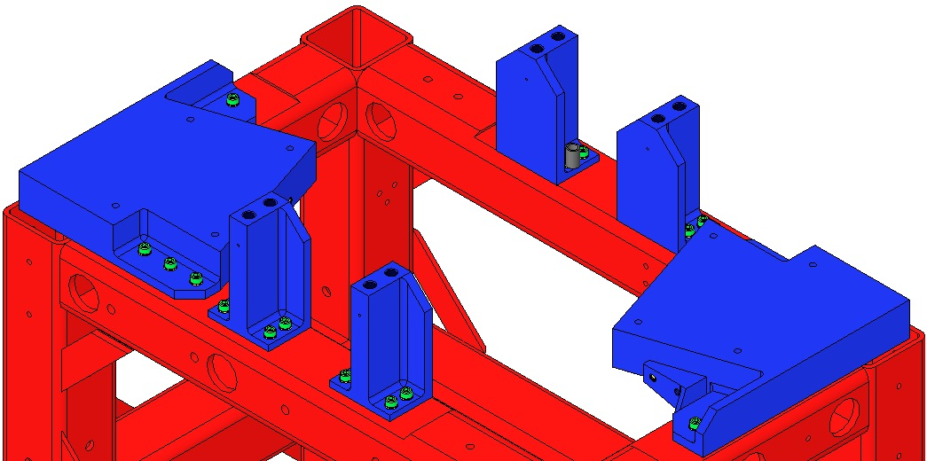  Fig 79: Bars removed
- Install the 2 D070326 Rotational Adjusters to the Mounting Pads, using for each:  - 4 Socket Head Cap Screws  8-32 x 0.75” SSTL  Use HoloKrome Screws  - 4 Flat Washer #8 Vented, SSTL  Torque to 30 in-lb  Record the serial number and location of both Upper Blades in ICS in the RA assembly load.  The Blades are shown here as flat, but are actually curved upward. | 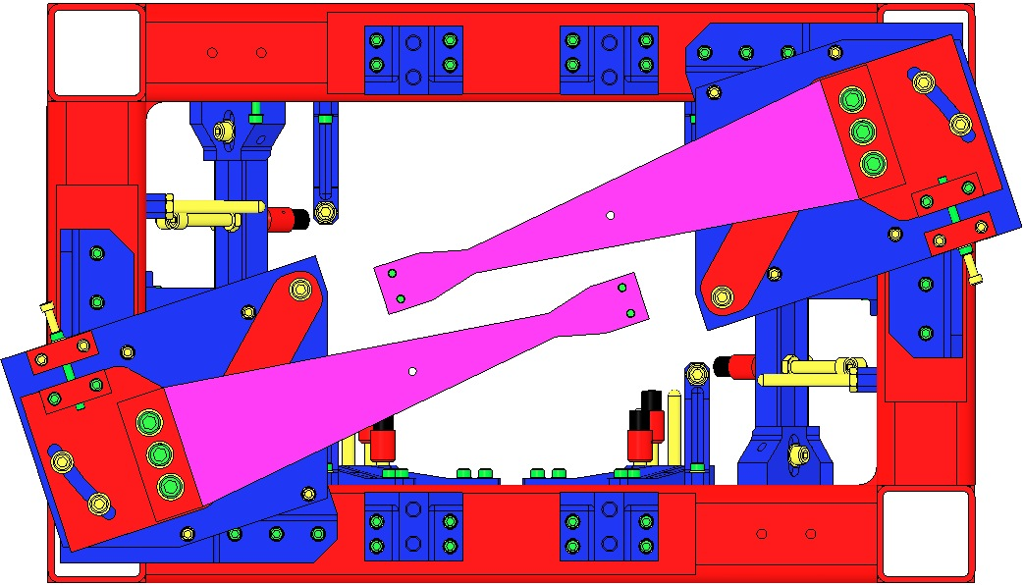  Fig 80: Rotational Adjusters Installed
Wear proper safety glasses per E1000043.  - Attach the 2 D1102119 Blade Pulldown Supports to the Weldment location shown; that is, in the center of the end Weldment cross member, with the Clevis extending outboard.  - Cover each end of the Weldment Structure and surrounding Optical Table areas with UHV Aluminum Foil, to protect them from the dirty Pulldown Device.  2 workers required:  - 1st person holds the Pulldown Weight.  - 2nd person passes Wire Clamp of the Pulldown Device through the Weldment side opening, up toward the Upper Blade Tip, then attaches the Clamp to the Blade tip with:  - 2 Socket Head Cap Screws  8-32 x 0.50” AgPlated  - 1st person gently drapes the wire over the Clevis, and slowly releases the Weight.  - Repeat Steps 7-9 for the second Pulldown Device. | 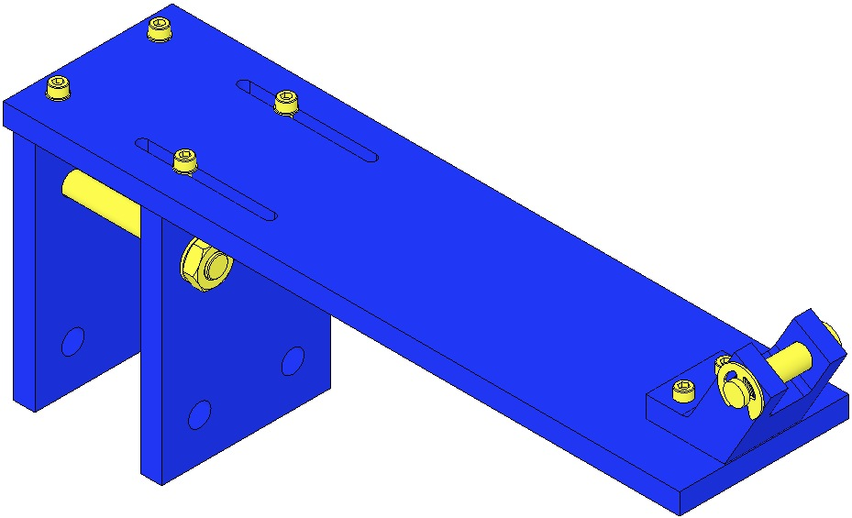  Fig 81: Blade Pulldown Support  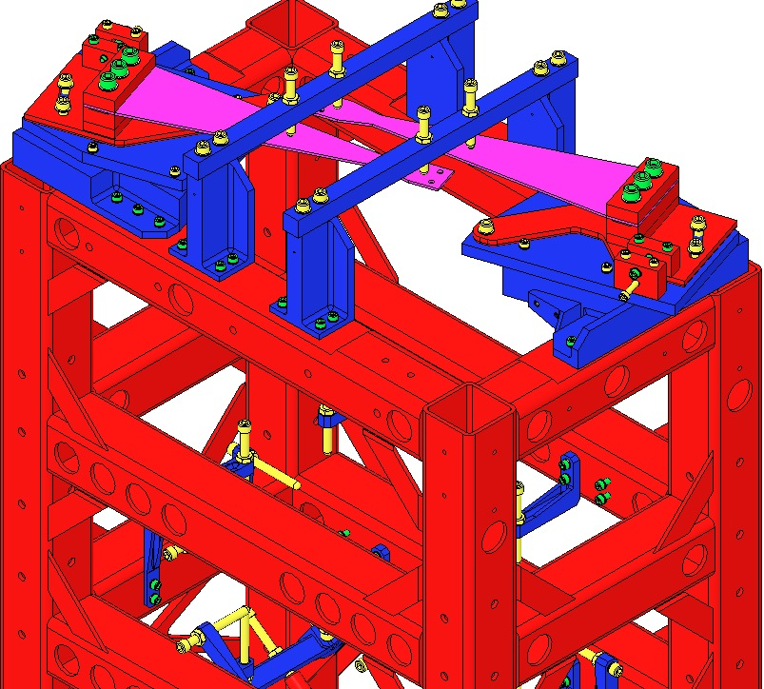  Attach Blade Pulldown Supports here  Fig 82: Location of Blade Pulldown Support
- Re-Assemble the 2 D070310 Top Blade Guard Bars to the Risers, using for each:  - 4 Socket Head Cap Screws  ¼-20 x 1.0” SSTL  Torque to 75 in-lb  Ensure the Bars are oriented with the EQ Stop Screws directly over the Blades.  The EQ Stop Screws should be adjusted so the Blades are flat. Once adjusted, the Screws should be secured with the Hex Nuts.  - Carefully remove the 2 Blade Pulldown Devices.  - Remove the 2 Blade Pulldown Supports. | 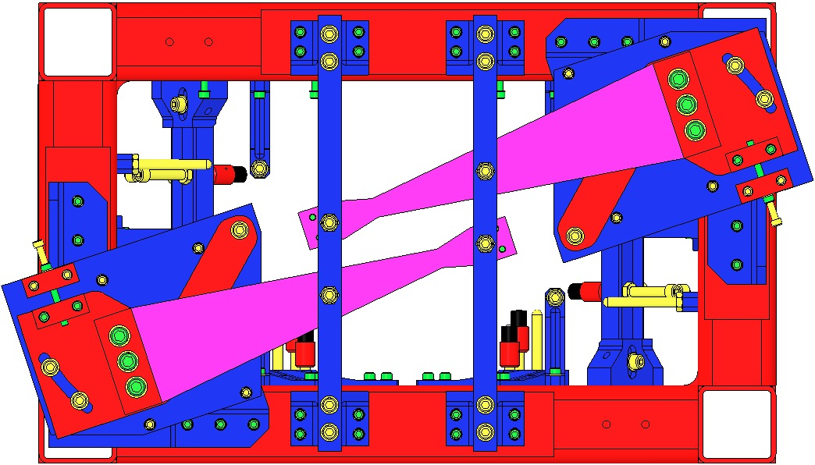  Fig 83: Top View: Screws centered over Blades  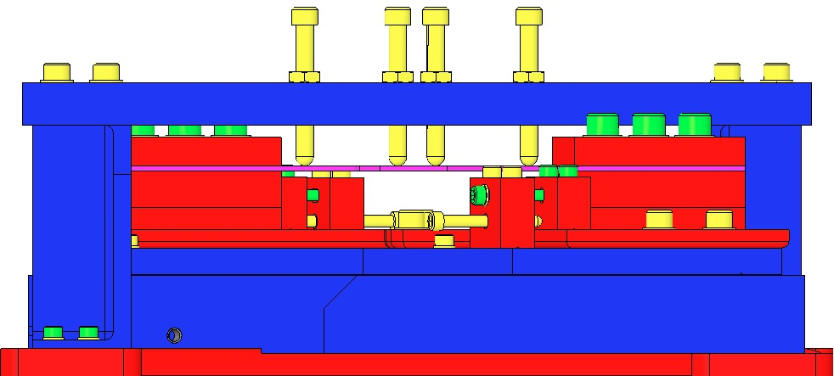  Fig 84: End View: Screws adjusted and secured

Installing Upper Mass and Coil Holder

Documents
D070442 HLTS Overall Assembly
D1101493 HSTS / HLTS / OMCS OSEM Orientations

Materials
Qty | U | ID | Description
1 | Ea | D040259 | Upper Mass Jig
1 | Ea | NA | HLTS Upper Mass and Coil Holder Assembly from section 17, above
12 | Ea | NA | Socket Head Cap Screws ¼-20 x 1.0” Round-Tip SSTL
14 | Ea | NA | Hex Nut ¼-20 AgPlated
5 | Ea | Several | HLTS Additional Mass Disks (10g, 20g 50g 100g)
2 | Ea | NA | Socket Head Cap Screw ¼-20 x 2.0” SSTL
2 | Ea | NA | Flat Washer ¼” Vented SSTL
NA | Ea | D1002133 | HLTS Coil Holder Bracket Assemblies
4 | Ea | D1002134 | Bracket Lateral Section
4 | Ea | D1002135 | Bracket Longitudinal Section
8 | Ea | NA | Socket Head Cap Screws 4-40 0.75” SSTL
8 | Ea | NA | Flat Washer #4 Vented SSTL
12 | Ea | NA | Socket Head Cap Screw 8-32 x 0.75” AgPlated
12 | Ea | NA | Socket Head Cap Screw 8-32 x 0.625” SSTL
24 | Ea | NA | Flat Washer #8 Vented SSTL

Procedure
The corner Brackets are shown here only for orientation and are not yet attached. Note the (2) Bracket Screws used for vertical adjustments.  - Attach the D040259 Jig to an Optics Table.  - Remove but keep all Add-On hardware from the bottom of the Upper Mass T-Piece.  - Attach the previously-assembled Upper Mass and Coil Holder (with 6 Wire assemblies) to the Jig. (Jig not shown here, but in section on Assembling Upper Mass).  - Using the pair of ¼-20 Screws at the top center, raise the Upper Mass completely into the Coil Holder, then tighten the Hex Nuts.  - Remove the 4 side EQ Stop Screws and Hex Nuts.  - Lock down the Upper Mass with the remaining 8 EQ Stop Screws and Hex Nuts. | 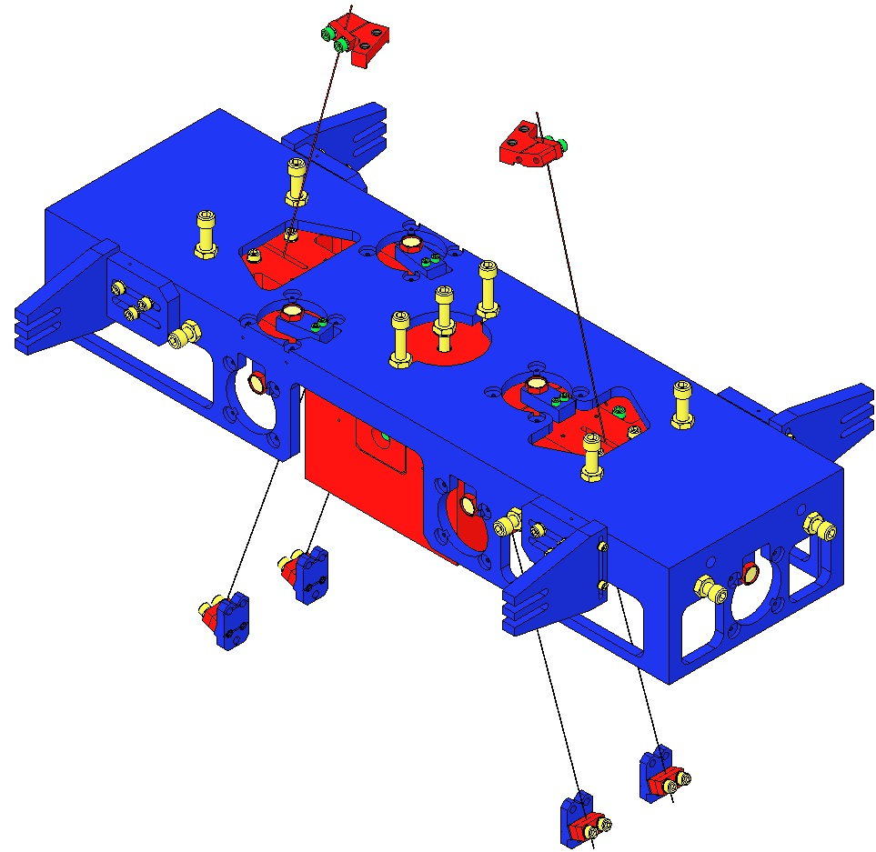  Lock down Upper Mass  Remove 4 Side Screws  Bracket with 2 vertical adjustment Screws  Raise the Upper Mass  Fig 85: D1002133 Coil Holder Brackets (4)  Screws for vertical adjustment
- Assemble 4 D1002133 HLTS Coil Holder Bracket Assemblies, each with:  - 1 D1002134 Lateral Section  - 1 D1002135 Longitudinal Section  - 2 Socket Head Cap Screws  4-40 0.75” SSTL  - 2 Flat Washer #4 Vented SSTL  - Torque to 5 in-lb |  | 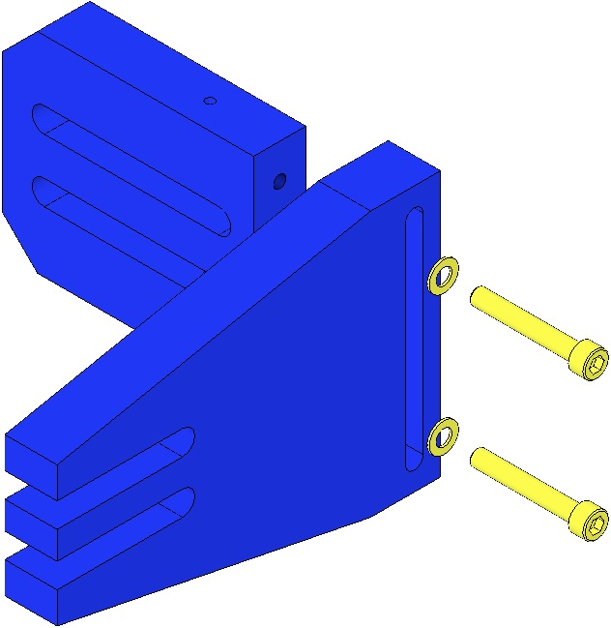  Fig 86: Bracket Assembly
- Attach the 4 Brackets to the Weldment, using for each:  - 3 Socket Head Cap Screws  8-32 x 0.75” AgPlated  - 3 Flat Washer #8 Vented SSTL  Torque Screws after Coil Holder is installed and aligned. |  | 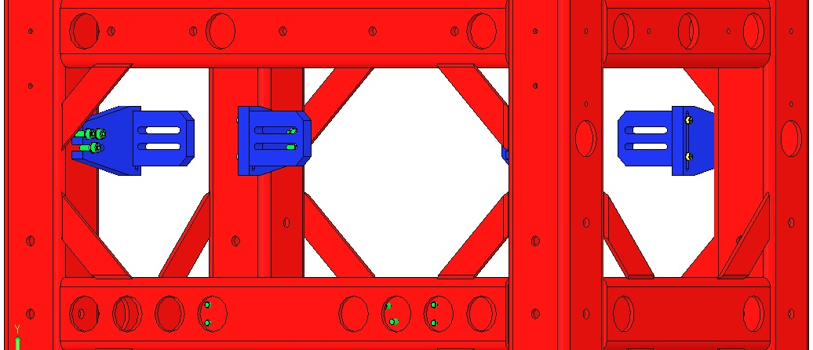  Fig 87: Coil Holder Brackets Installed
- Insert the Upper Mass / Coil Holder Assembly through either narrow opening in the top section of the Weldment. The pair of BOSEMS on top of the Assembly must be at the –Y side of the Suspension per D1101493 OSEM Orientations.
- Assemble the Coil Holder to the 4 Brackets using at each Bracket:  - 3 Socket Head Cap Screws  8-32 x 0.625” SSTL  - 3 Flat Washer #8 Vented SSTL  Torque to 20 in-lb  - Back out each of the 4 lower Clamps of the Intermediate Wire Assemblies, back through the 4 end openings in the Coil Holder.  - Re-assemble 4 EQ Stop Screws to the long sides of the Coil Holder, each using:  - 1 Socket Head Cap Screw  ¼-20 x 1.0” Round Tip SSTL  - 1 Hex Nut ¼-20 AgPlated |  | 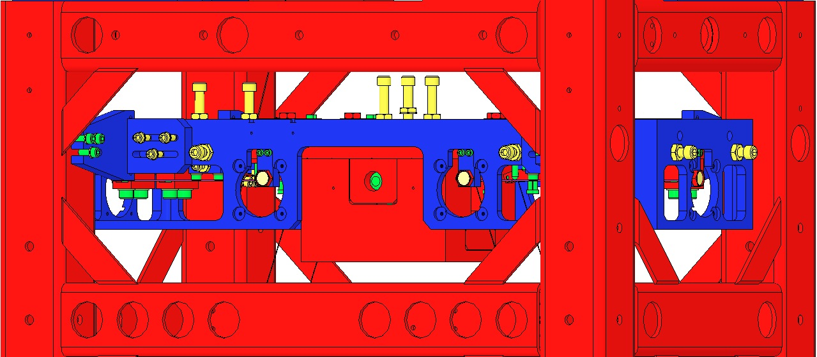  Side  EQ Stop Screw  Fig 88: Upper Mass & Coil Holder Installed
- Install the Additional Mass Disks on the top and bottom of the Upper Mass, as equally divided as possible; tighten the Hex Nuts to secure the Disks. Use:  - 2 Socket Head Cap Screw  ¼-20 x 2.0” SSTL  - 2 ¼-20 Hex Nut AgPlated  - 2 Flat Washer ¼” SSTL |  | 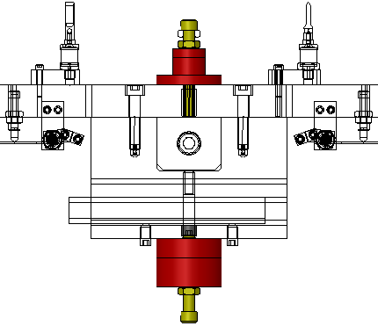  Fig 89: Additional Mass Disks Added

Installing the Intermediate Mass

Documents
D070442 HLTS Overall Assembly

Materials
Qty | U | ID | Description
1 | ea | D070334 | HLTS Intermediate Mass
1 | Ea | D1102344 | HLTS Intermediate Mass Lifting Plate Assembly

Procedure
- Raise the 4 bottom EQ Stops as far as possible.  - Back off the 12 top, front and side EQ Stops | 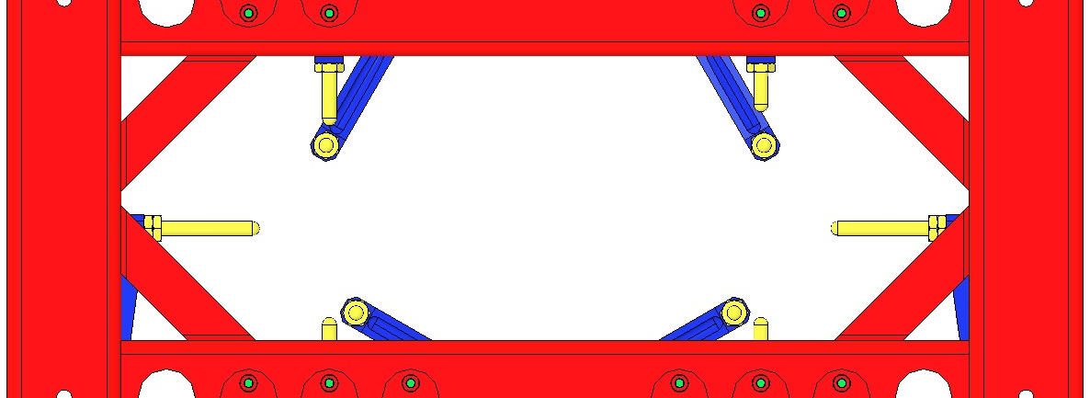  Fig 90: Rear View; EQ Stops prepared
- Using the D1102344 Lifting Plate Assembly, insert the D070334 Intermediate Mass assembly through the rear of the Weldment, ensuring the 4 Magnet assemblies are facing the rear. Center the assembly front-to-back and left-to-right on the bottom EQ Stops. | 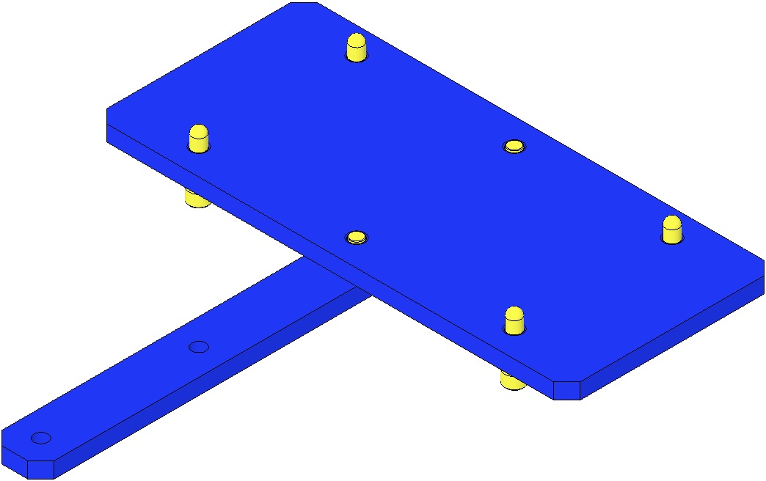  Fig 91: Lifting Plate  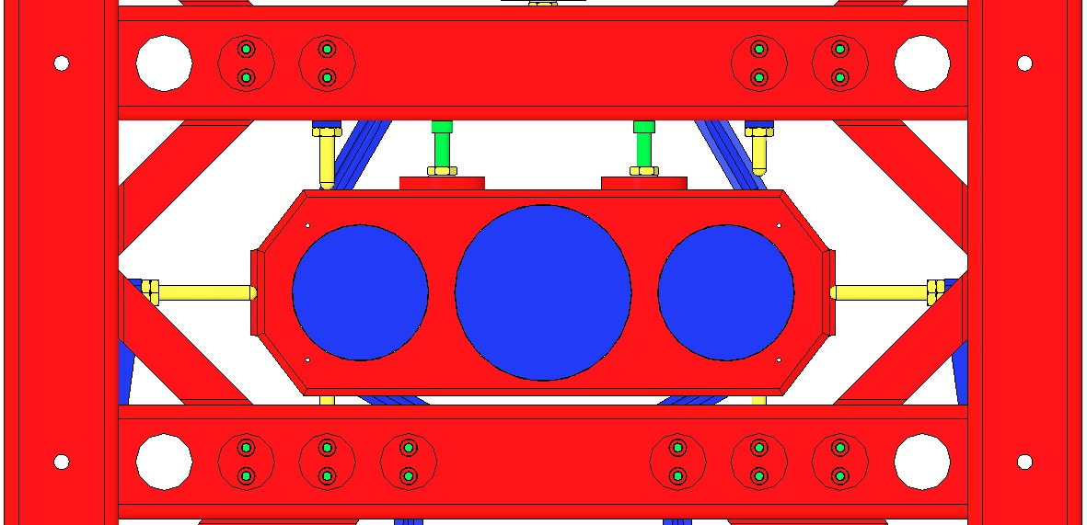  Fig 92: Rear View; Magnets facing rear
- Lock down the Intermediate Mass assembly using the 8 top and side EQ Stops. | Fig 93: Rear View; Mass locked down

Installing Wire Assemblies

Documents
D070442 HLTS Overall Assembly

Materials
Qty | U | ID | Description
4 | Ea | NA | Socket Head Cap Screws 8-32 x .50” AgPlated
18 | Ea | NA | Socket Head Cap Screws 8-32 x .625” AgPlated

Procedure
Upper Wire Assemblies fully installed. |  |  |  | 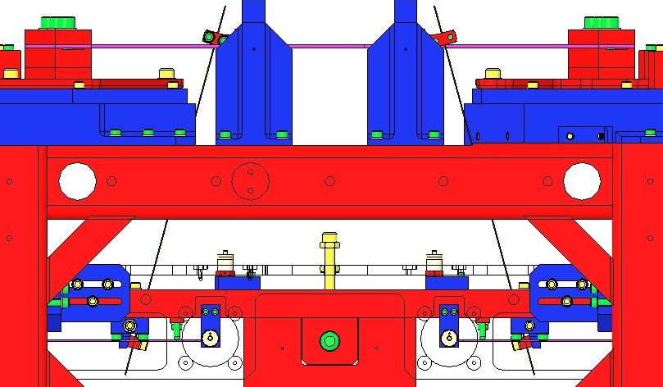  Fig 94: Upper Wire Assemblies installed
- Raise the Upper Mass/Tablecloth Assembly on its brackets as high as possible and secure it in place. |  | 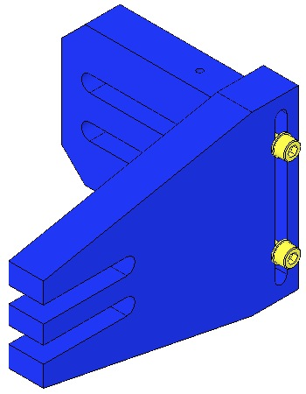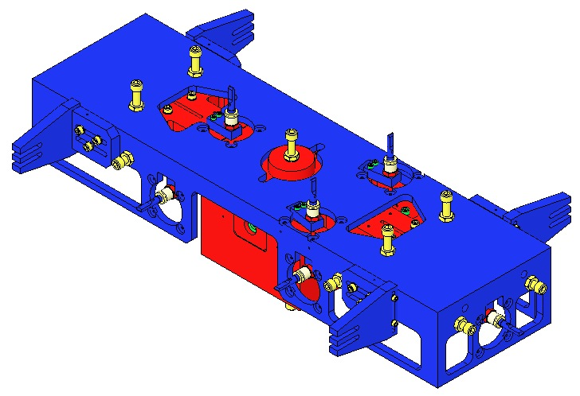  Loosen Screws to allow vertical adjustment  Fig 95: Raising Coil Holder on its Brackets
Be careful not to kink or twist the wires.  - Attach the 2 Upper Wire Upper Clamps to the 2 Upper Blades using:  - 4 Socket Head Cap Screws  8-32 x 0.50” AgPlated  Torque to 30 in-lb |  |  | 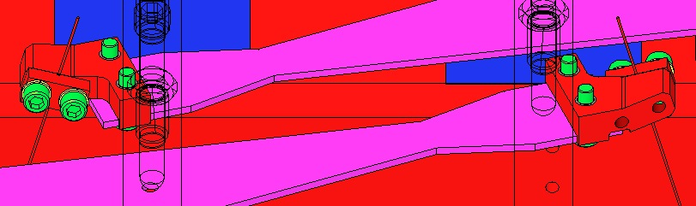  Fig 96: Upper Clamps attached to Upper Blades
- Center the C-Clamps using the 4 Screwdrive System Screws, then tighten the Hex Nuts to lock the Screws.  Torque the eight 8-32 x 1.125” C-Clamp Screws to 30 in-lb. |  |  |  | 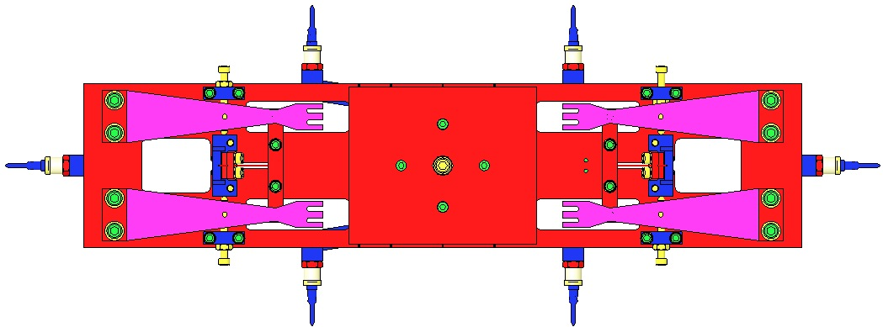  Fig 97: Centering C-Clamps with Screw Drives
- Adjust the height of the Upper Mass/Tablecloth Assembly on its brackets to remove slack in the Upper Wires. | Loosen Screws to allow vertical adjustment  Fig 98: Lowering Coil Holder to eliminate slack in Wires
- Attach the 4 Intermediate Wire Lower Clamps to each end of the Intermediate Mass Assembly using:  - 12 Socket Head Cap Screws  8-32 x .625” AgPlated  Torque to 30 in-lb |  |  |  | 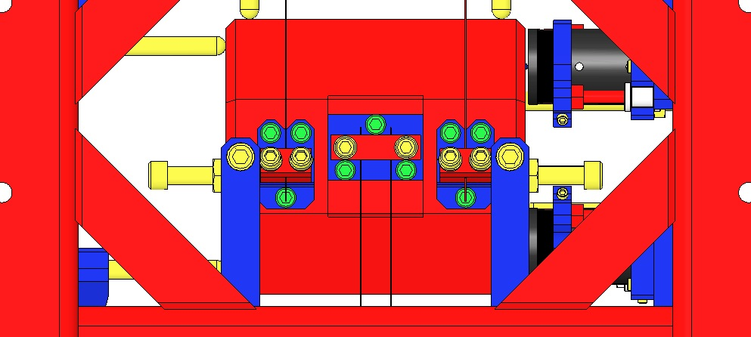  Fig 99: End of Intermediate Mass
- Remove the 2 Screws and Hex Nuts at the top center of the Upper Mass Assembly that are holding the Upper Mass Assembly against the Coil Holder. The Upper Mass Assembly should still be locked relative to the Coil Holder using the top and side earthquake stops. |  |  |  | 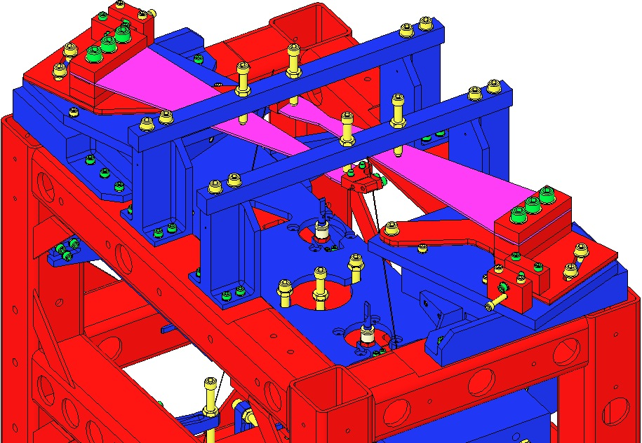  Fig 100: Screws to remove
- Adjust any or all of the 16 top, bottom and side intermediate EQ Stops to remove slack in the Intermediate Wires. |  |  |  | 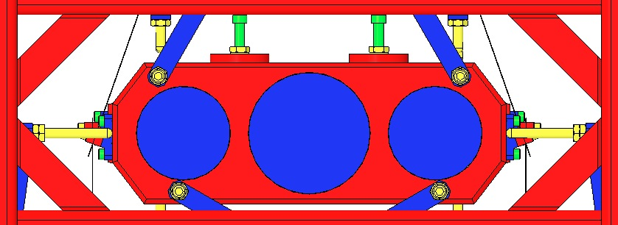  Fig 101: Front View, EQ Stops
- Attach the Lower Loop Wire to the Intermediate Mass Assembly using:  - 6 Socket Head Cap Screws  8-32 x .625” AgPlated  Torque to 30 in-lb  Be careful not to kink, twist or tangle the wires. Use silver-plated SHCS. |  |  |  | Fig 102: End View of Intermediate Mass

Assembling AOSEM Brackets
1 of each configuration is required. The difference between LH / RH is simply the orientation of the Mounting and / or Alignment Brackets.
D0902024  AOSEM Alignment Assembly  Upper Side of Intermediate Mass | 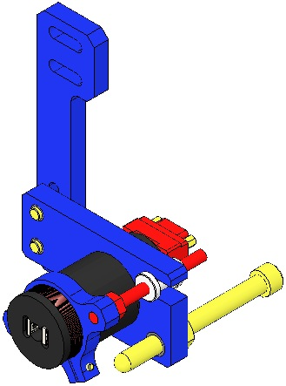  Fig 103: D0902024 | 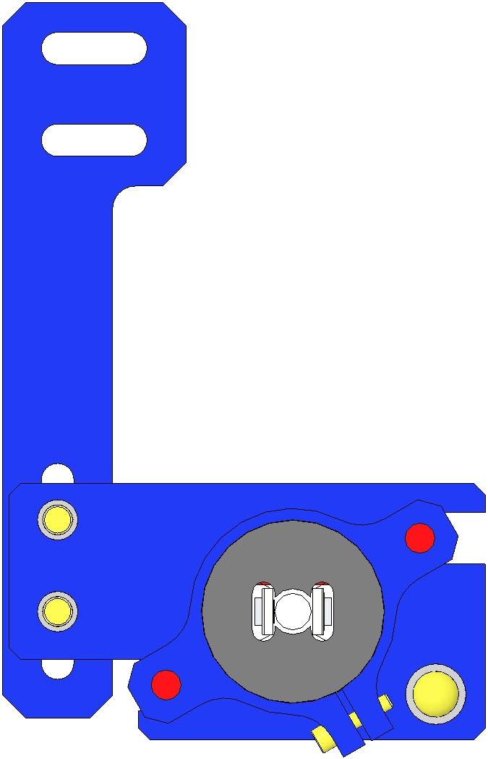  Alignment  Bracket  Mounting  Bracket  Fig 104: LH Config | 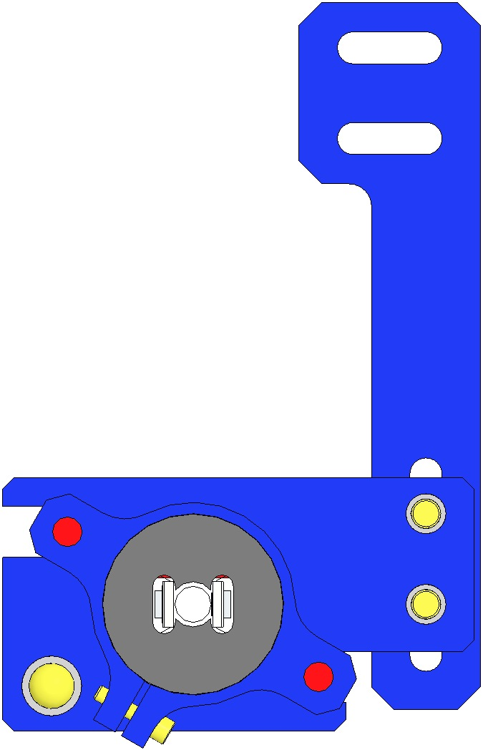  Fig 105: RH Config
D0901551  AOSEM Alignment Assembly  Lower Side of Intermediate Mass | 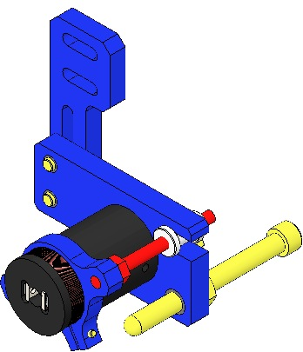  Fig 106: D0901551 | 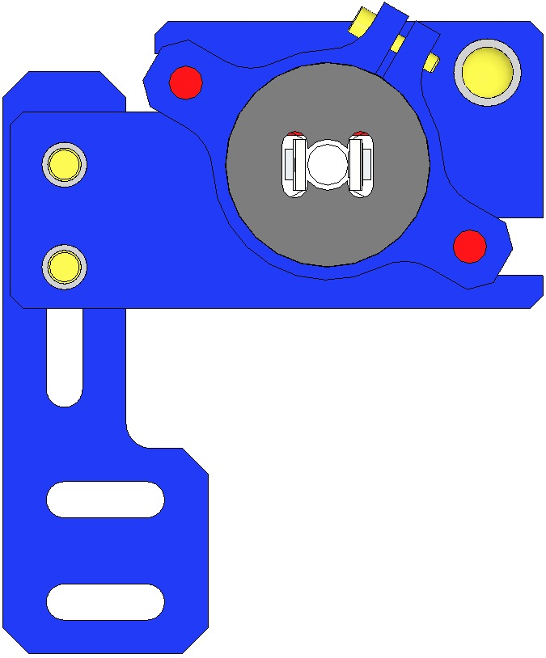  Fig 107: LH Config | 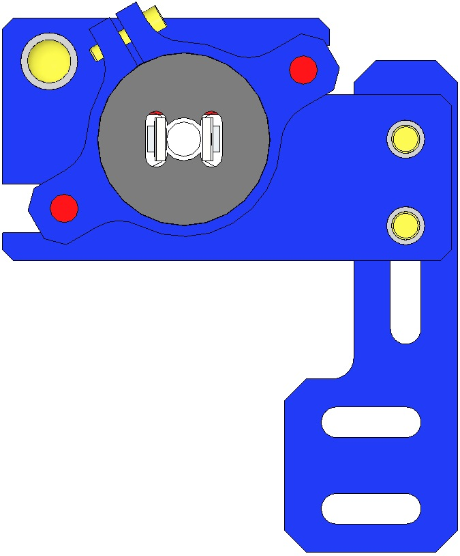  Fig 108: RH Config
D0901552  AOSEM Alignment Assembly  Upper Side of Bottom Mass | 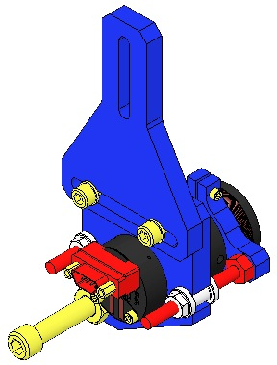  Fig 109: D0901552 | 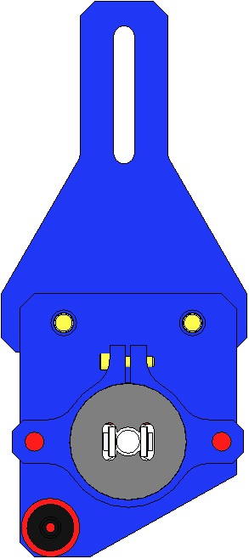  Fig 110: LH Config | 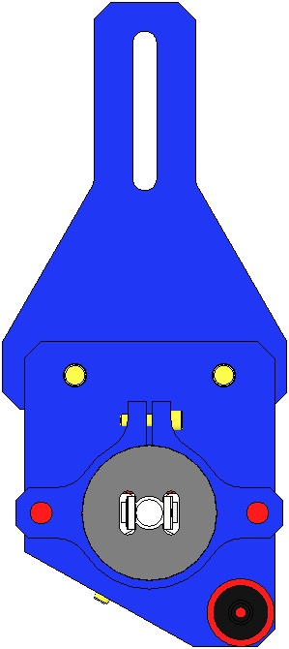  Fig 111: RH Config
D0901553  AOSEM Alignment Assembly  Lower Side of Bottom Mass | 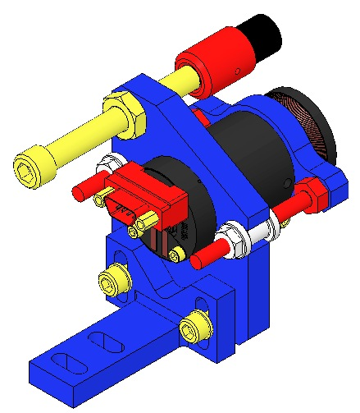  Fig 112: D0901553 | 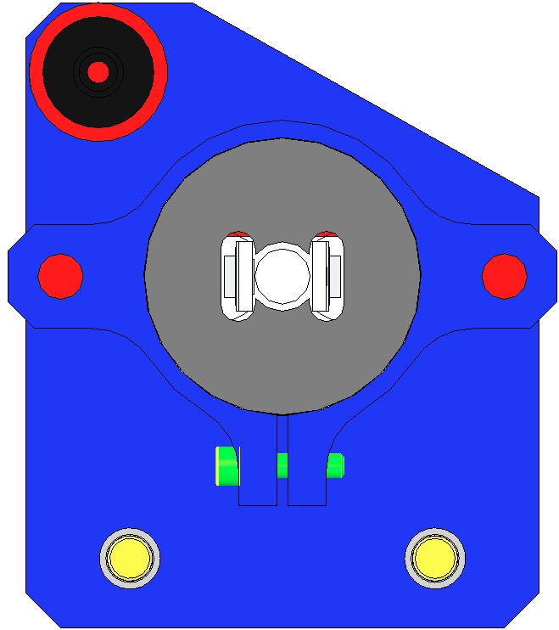  Fig 113: LH Config | 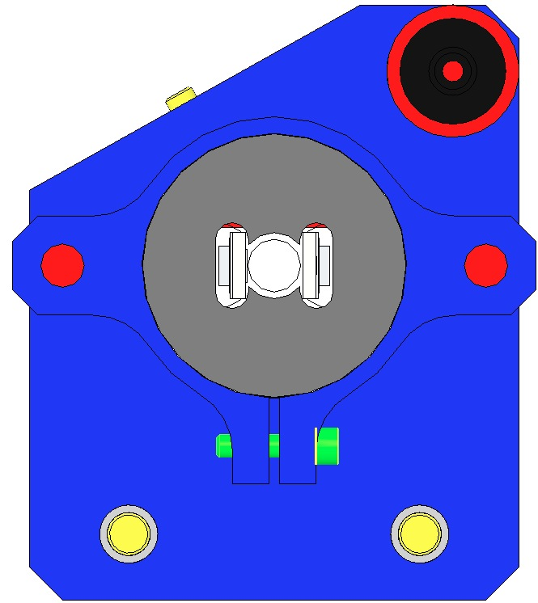  Fig 114: RH Config

Documents
D070442 HLTS Overall Assembly

Materials
D0902024
Qty | U | ID | Description
1 | Ea | D0902025 | HLTS AOSEM Mounting Bracket, Upper Side of Intermediate Mass
1 | Ea | D0901492 | HLTS AOSEM Alignment Bracket, Intermediate Mass
1 | Ea | D0901065 | AOSEM Assembly
1 | Ea | D1002858 | AOSEM Adjustment Collar, Reverse Side
2 | Ea | D1000659 | Adjuster Shaft
2 | Ea | D1002865 | Adjustment Nut, Thick
2 | Ea | NA | Socket Head Cap Screw, 8-32 x 0.625”, SSTL
2 | Ea | 1185-2EN246 | Helicoil, 8-32 x 0.246”
2 | Ea | NA | Flat Washer, Vented, #8
1 | Ea | NA | Socket Head Cap Screw, 2-56 x 0.375” SSTL
1 | Ea | D030021 | Socket Head Cap Screw, ¼-20 x 2.5”, Round Tip SSTL
1 | Ea | 1185-4EN250 | Helicoil, ¼-20 x 0.25”
1 | Ea | NA | Hex Nut, ¼-20 AgPlated
D0901551
Qty | U | ID | Description
1 | Ea | D0901493 | Lower AOSEM Mounting Bracket, Intermediate Mass
1 | Ea | D0901492 | HLTS AOSEM Alignment Bracket, Intermediate Mass
1 | Ea | D0901065 | AOSEM Assembly
1 | Ea | D1002858 | AOSEM Adjustment Collar, Reverse Side
2 | Ea | D1000659 | Adjuster Shaft
2 | Ea | D1002865 | Adjustment Nut, Thick
2 | Ea | NA | Socket Head Cap Screw, 8-32 x 0.625”, SSTL
2 | Ea | 1185-2EN246 | Helicoil, 8-32 x 0.246”
2 | Ea | NA | Flat Washer, Vented, #8
1 | Ea | NA | Socket Head Cap Screw, 2-56 x 0.375” SSTL
1 | Ea | D030021 | Socket Head Cap Screw, ¼-20 x 2.5”, Round Tip SSTL
1 | Ea | 1185-4EN250 | Helicoil, ¼-20 x 0.25”
1 | Ea | NA | Hex Nut, ¼-20 AgPlated
D0901552
Qty | U | ID | Description
1 | Ea | D0901550 | AOSEM Mounting Bracket, Upper Position of Bottom Mass
1 | Ea | D0901549 | AOSEM Alignment Bracket, Bottom Mass
1 | Ea | D0901065 | AOSEM Assembly
1 | Ea | D1002858 | AOSEM Adjustment Collar, Reverse Side
2 | Ea | D1000659 | Adjuster Shaft
2 | Ea | D1002865 | Adjustment Nut, Thick
1 | Ea | D080725 | EQ Stop for Metal or Glass
2 | Ea | NA | Socket Head Cap Screw, 8-32 x 0.625”, SSTL
2 | Ea | 1185-2EN246 | Helicoil, 8-32 x 0.246”
2 | Ea | NA | Flat Washer, Vented, #8
1 | Ea | NA | Socket Head Cap Screw, 2-56 x 0.375” SSTL
1 | Ea | 1185-4EN250 | Helicoil, ¼-20 x 0.25”
1 | Ea | NA | Hex Nut, ¼-20 AgPlated
D0901553
Qty | U | ID | Description
1 | Ea | D0900340 | AOSEM Mounting Bracket, Lower Position of Bottom Mass
1 | Ea | D0901549 | AOSEM Alignment Bracket, Bottom Mass
1 | Ea | D0901065 | AOSEM Assembly
1 | Ea | D1002858 | AOSEM Adjustment Collar, Reverse Side
2 | Ea | D1000659 | Adjuster Shaft
2 | Ea | D1002865 | Adjustment Nut, Thick
1 | Ea | D080725 | EQ Stop for Metal or Glass
2 | Ea | NA | Socket Head Cap Screw, 8-32 x 0.625”, SSTL
2 | Ea | 1185-2EN246 | Helicoil, 8-32 x 0.246”
2 | Ea | NA | Flat Washer, Vented, #8
1 | Ea | NA | Socket Head Cap Screw, 2-56 x 0.375” SSTL
1 | Ea | 1185-4EN250 | Helicoil, ¼-20 x 0.25”
1 | Ea | NA | Hex Nut, ¼-20 AgPlated

Procedure
Assembly procedure is similar for all 4 units, but varies by the Mount Bracket and Alignment Bracket.
- Assemble Adjustment Collar to AOSEM  - Assemble SHCS 2-56 to Collar  - Assemble Adjuster Shafts to Collar  - Assemble AOSEM w/Adjuster Shafts to Alignment Bracket, paying close attention to part number and orientation of Bracket  - Assemble Mount to Alignment Bracket  - Assemble EQ Stop to Alignment Bracket with a Hex Nut | 5  4  3  6  2  1  Fig 115: Assembly

Installing Bottom Mass

Documents
D070442 HLTS Overall Assembly

Materials
Qty | U | ID | Description
2 | Ea | D0901286 | HLTS Secondary Metal Prism Breakoff

Procedure
- Adjust the Lower Bridge EQ Stops (4 Screws) as far in as possible.  - Back off the Upper Bridge EQ Stops (4 Screws) and Front EQ Stops (4 Screws). | 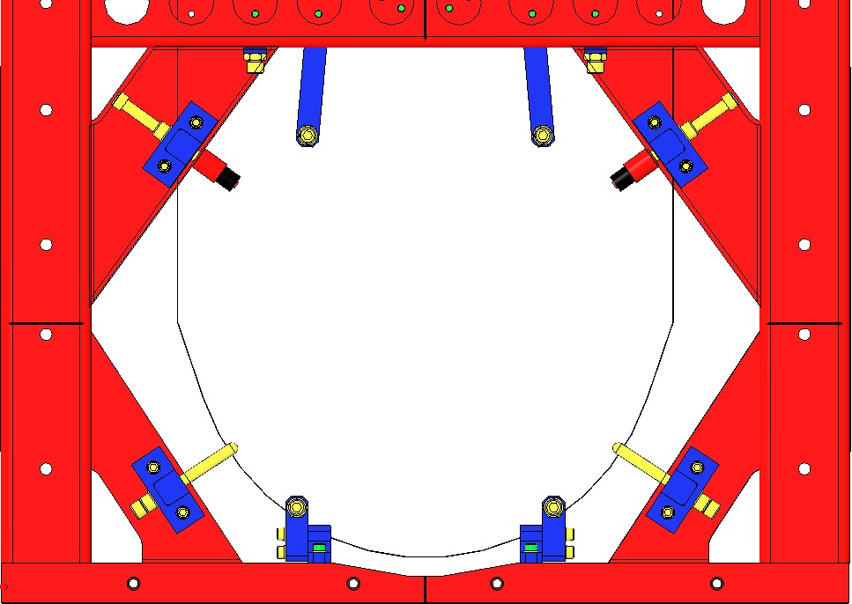  Fig 116: EQ Stops Adjusted
- Install the Bottom Mass Assembly through the back of the HLTS Structure. Place the Bottom Mass Assembly above the Lower Wire Assembly, resting on the Lower Bridge EQ Stops, making sure that the 2 Wires are straight and fit in the 2 grooves of each Prism Breakoff.  Be sure not to kink, twist or tangle the wires.  - Install the 2 D0901286 Secondary Metal Prism Breakoffs. Insert the breakoffs between the Bottom Mass Assembly and the Lower Loop Wire at the points where the breakoffs just touch the wires. | 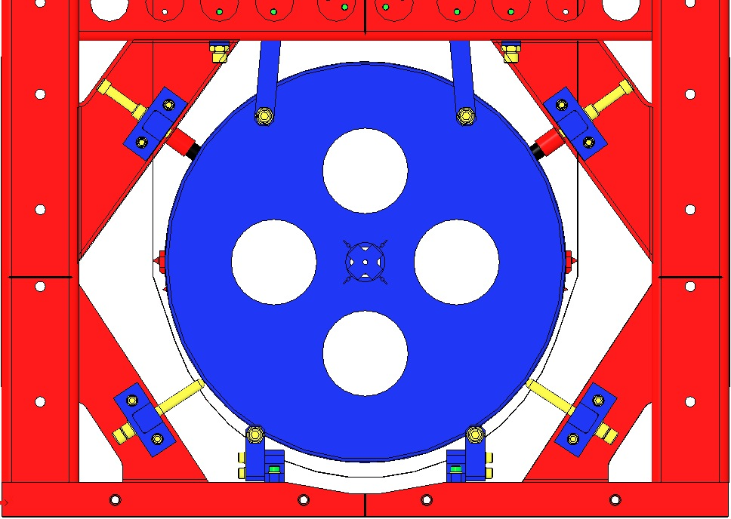  Fig 117: Lower Mass Placed on Bridge EQ Stops

Suspension and Alignment of Masses
Note: “Level” as referenced below, is defined as being within the visual indicators on the Bubble Levels used (Carpenter’s Level for Optical Table, Single Bubble for Suspension Masses).

Materials
Qty | U | ID | Description
1 | Ea | NA | Bubble Level
1 | Ea | NA | Optical Level
1 | Ea | NA | Lower Loop Wire Comb

Procedure
- Unlock all Stops to allow the Suspension to hang freely:  Bottom Mass  - 4 Face EQ Stops  - 8 Bridge EQ Stops  Intermediate Mass  - 16 EQ Stops  Upper Mass  - 4 Lower Blade Stops  - 12 Coil Holder Stops  Upper Blades  - 4 Upper Blade Stops |  | 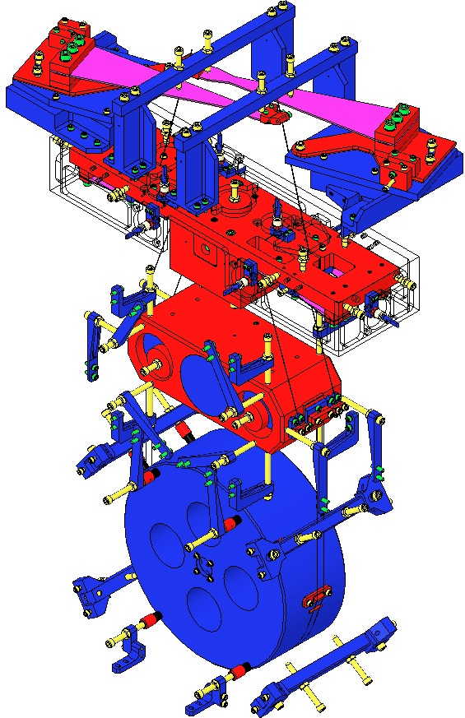  Bridge EQ Stops  Face EQ Stops  EQ Stops  Coil Holder Stops  Lower Blade Stops  Upper Blade Stops  Fig 118: Unlock all Stops
Lock the Intermediate Mass  - Lock the Intermediate Mass with the 16 EQ Stops such that the Mass is level. Use a Bubble Level, and then an Optical Level. The Mass height is unimportant at this point.  Adjust Bottom Mass Roll  - Using the Lower Loop Wire Comb, ensure the Lower Wires are parallel and 10mm apart.  - Measure and compare the heights of the bottom of the side bores, on the with side of the front of the Bottom Mass. Rotate the Mass until the heights are equal.  Adjust Bottom Mass Pitch  - Measure and compare the heights of the bottom of the bores on the front and back of the Mass. If unequal, first repeat Step 3, above. Then verify that the Lower Wire Clamps are attached squarely to the Intermediate Mass. If the heights remain unequal, the lengths of the Lower Wires are unequal, and need to be replaced.  Unlock the Intermediate Mass  - Once the Bottom Mass is level, unlock the Intermediate Mass. |  | 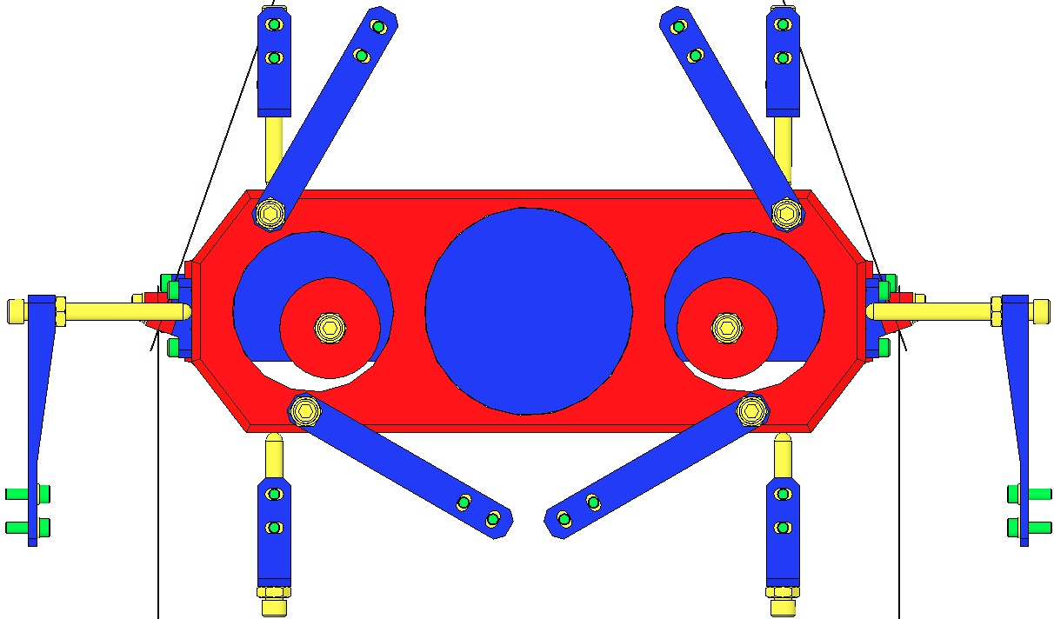  2X  2X  2X  2X  2X  2X  4X  Fig 119: Intermediate Mass Leveling  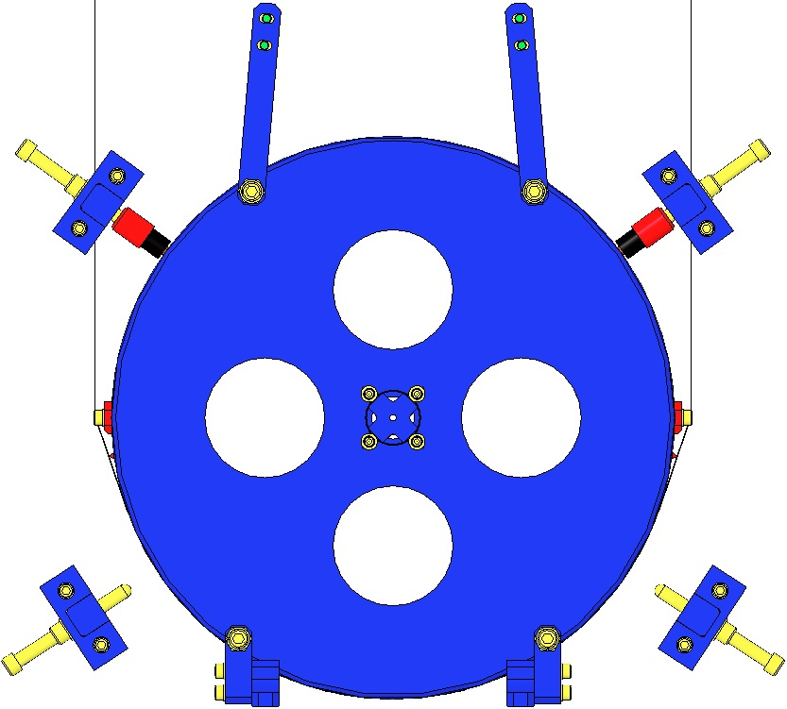  Fig 120: Adjust Roll and Pitch
Adjust Yaw  - Using a Ruler while adjusting the Corner Brackets, center the Coil Holder within the Weldment, in the X direction (front-to-back).  - Adjust the Rotational Adjusters as needed to center the Magnet Holders at either end of the Upper Mass within the Coil Holder Openings.  To adjust the Rotational Adjusters, loosen the 3 screws attaching the RA to its base, then adjust the Push and Pull Screws, then tighten the 3 screws. |  | 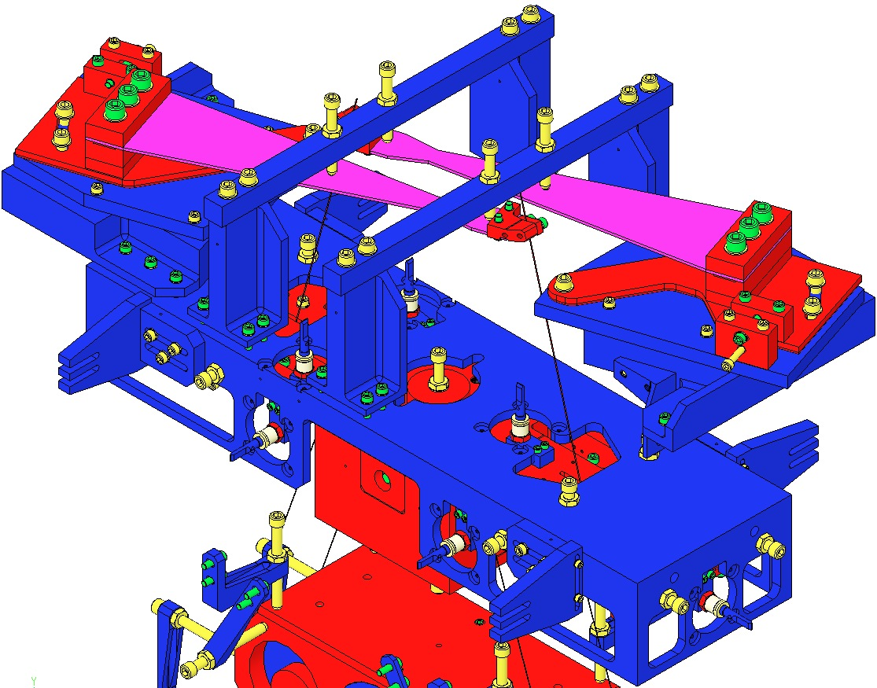  Loosen 3 Screws  Center Magnet Holders within opening  Push & Pull Screws  Fig 121: Adjusting Yaw
Adjust Upper Mass Pitch  - Measure the heights of either the bottom of the T-Piece or the bottoms of the Screw Drive Blocks, front and back (+X & - X). To adjust Pitch, manipulate the Screw Drives to shift the location of the Upper Wire Lower Clamps.  Diagram shows Upper Mass without Coil Holder nor Blades, for visibility. |  | 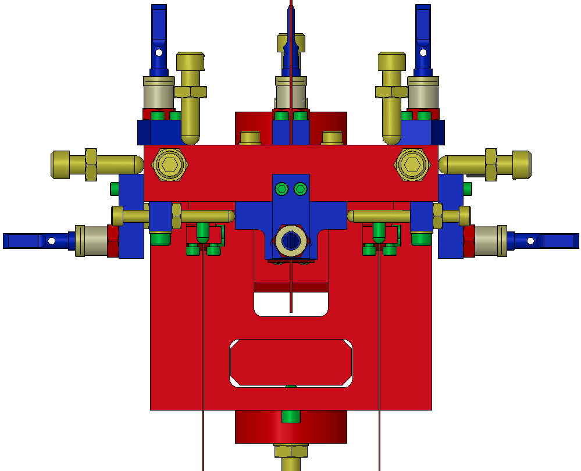  Screw Drive  Measuring Points  Fig 122: Upper Mass Pitch, End View
- Measure heights in mm from the Optical Table surface of these points.  *Not measurable with Optical Level | Upper Blade Wire Breakoffs (2) NOT Blade tip 806.120  Coil Holder Upper surface 658.587  Upper Mass – Screwdrive Blocks (4) Bottom surface 613.181  Upper Mass – T-Piece Bottom surface 552.228  Lower Blade Wire Breakoff (4) NOT Blade tip 608.838  Intermediate Mass Upper surface 461.620  Intermediate Mass Lower surface 371.620  Bottom Mass Metal – Side Bores (2) Bottom 130.243  Bottom Mass Metal or Optic Centerline* 158.500  Bottom Mass Metal Bottom 25.984  * Not measurable using an Optical Level
Perform the following on the 28 ¼-20 EQ Stop Screws shown at right:  - Adjust each Screw so that it contacts the Mass, but applies no pressure.  - Rotate each Screw ¾ turn counterclockwise to leave a 1 mm gap between the Screw Tip and the Mass.  - Tighten the Hex Nuts at each of the Screws, to lock the Screws in position. |  | 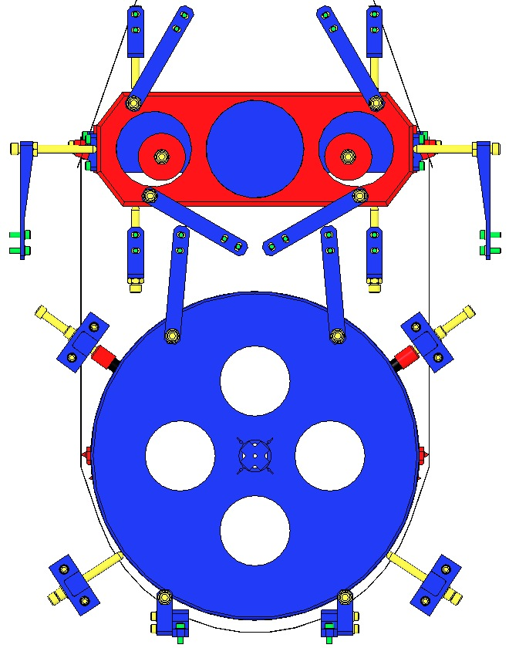  4X  4X  2X  2X  2X  4X  2X  2X  2X  2X  2X  Fig 123: 1 mm gap at EQ Stops
- Adjust the 4 Lower Blade Guard Screws so they contact the Lower Blades but apply no pressure.  - Rotate the Screws 1 ¼ turns counterclockwise, to leave a 1 mm gap at the Lower Blades.  - Repeat these 2 steps with the 2 Upper Blade Guard Screws, but with only a ¾ turn counterclockwise. |  | 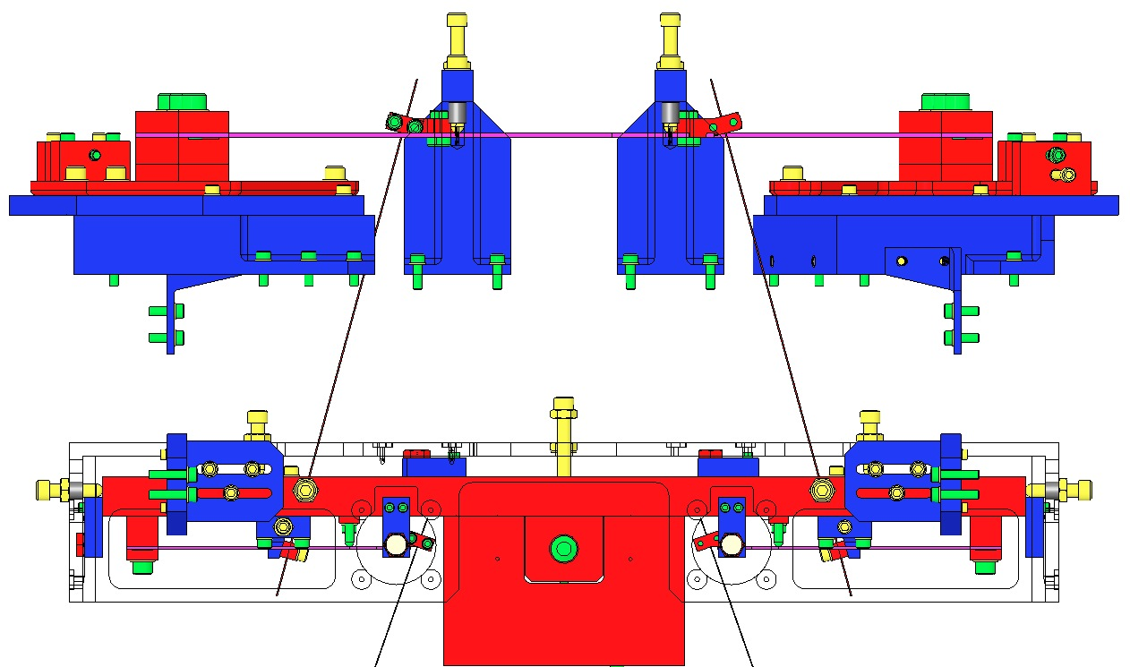  Fig 124: Blade Guard Screws

Assembling Magnets To Intermediate Mass

Documents
E990196 Magnet / Standoff Assembly Preparation

Materials
Qty | U | ID | Description
1 | Ea | D0901461 | HLTS Magnet Placement Fixture, Intermediate Mass
4 | Ea | D980184 | LOS Clamps
4 | Ea | NA | Socket Head Cap Screw ¼-20 x 1.5” AgPlated
4 | Ea | D020661 | Magnet/Standoff Assemblies, 2 N and 2 S configurations
1 | Ea | NA | Machinist Square, approx. 6” in length
1 | Ea | TBD | Epoxy Gun Applicator, MasterBond
1 | Ea | EP30-2 | Epoxy, Double Barrel Cartridge with Mix Tube, MasterBond
1 | Ea | NA | Tweezers
1 | Btl | NA | Isopropanol
X | Ea | NA | Lint Free Wipes
X | Ea | TBD | Sewing Needle
X | Ea | TBD | Razor Blade
X | Roll | NA | UHV Aluminum Foil
1 | Ea | NA | Heat Lamp, 120w Bulb

Procedure
- Prepare 2 “N” and 2 “S” D020661 Magnet/Standoff assemblies per E990196 Preparation procedure. |  | 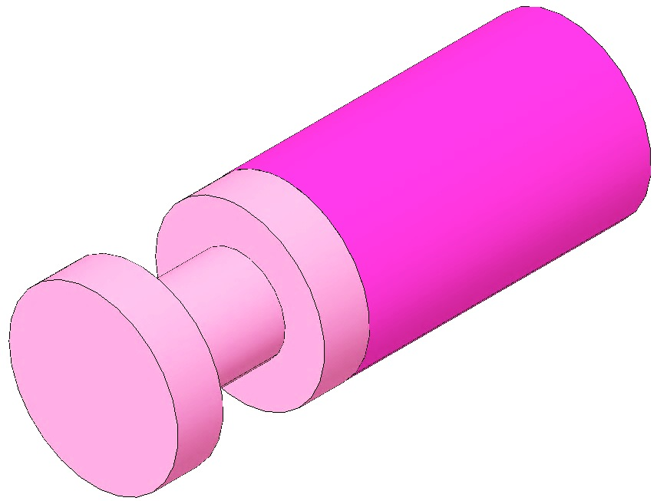  Fig 125: D020661 Magnet/Standoff Assembly
Place the Mass or Optic  - Mount the Base Plate of the D0901461 Magnet Placement Fixture on an Optics Table using the 4 D980184 LOS Clamps.  - Place the Intermediate Mass Assembly on the Base Plate with the back side facing up.  The Intermediate Mass is symmetric; front/back is identified only after the Mass is balanced within the Weldment.  - Place the Positioning Standoff over the Mass. Using a Machinist’s Square, carefully align the engraved markings on the D0902452 Side Plates with those on the main Standoff Plate D0902445 (see red dashed lines at right). The Sides and Standoff Plate together form the D0902444 Positioning Standoff. | 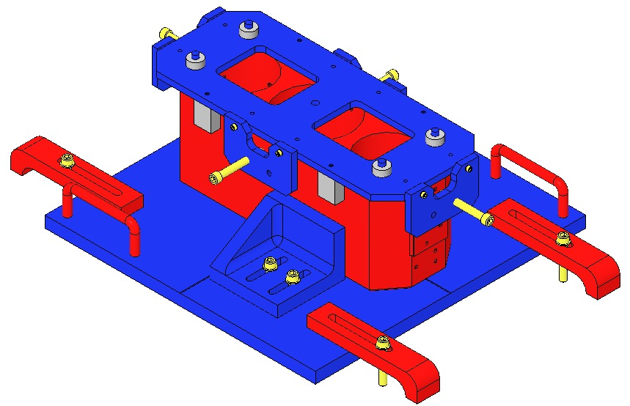  Positioning Standoff  Base Plate  Fig 126: Magnet Placement Fixture  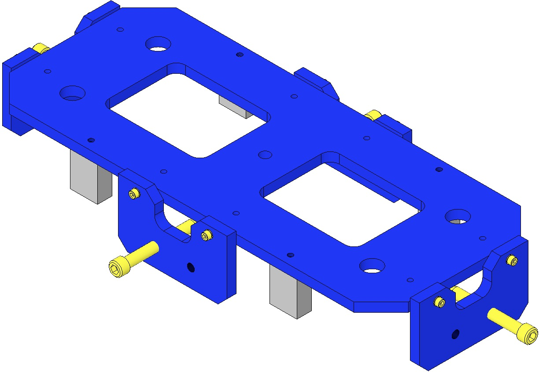  Fig 127: Aligning Side Plates with Main Plate  Machinist’s  Square
Load Plungers  - Wipe the counterbore end of each plunger with Isopropanol and a Wipe.  - Using the Tweezers, load 4 Magnet/Standoff assemblies into the 4 Plungers, 2 North Magnets and 2 South Magnets. The Magnet end of each assembly rests within the Plunger counterbore.  The Magnet/Standoffs are held to the Plungers magnetically. |  | 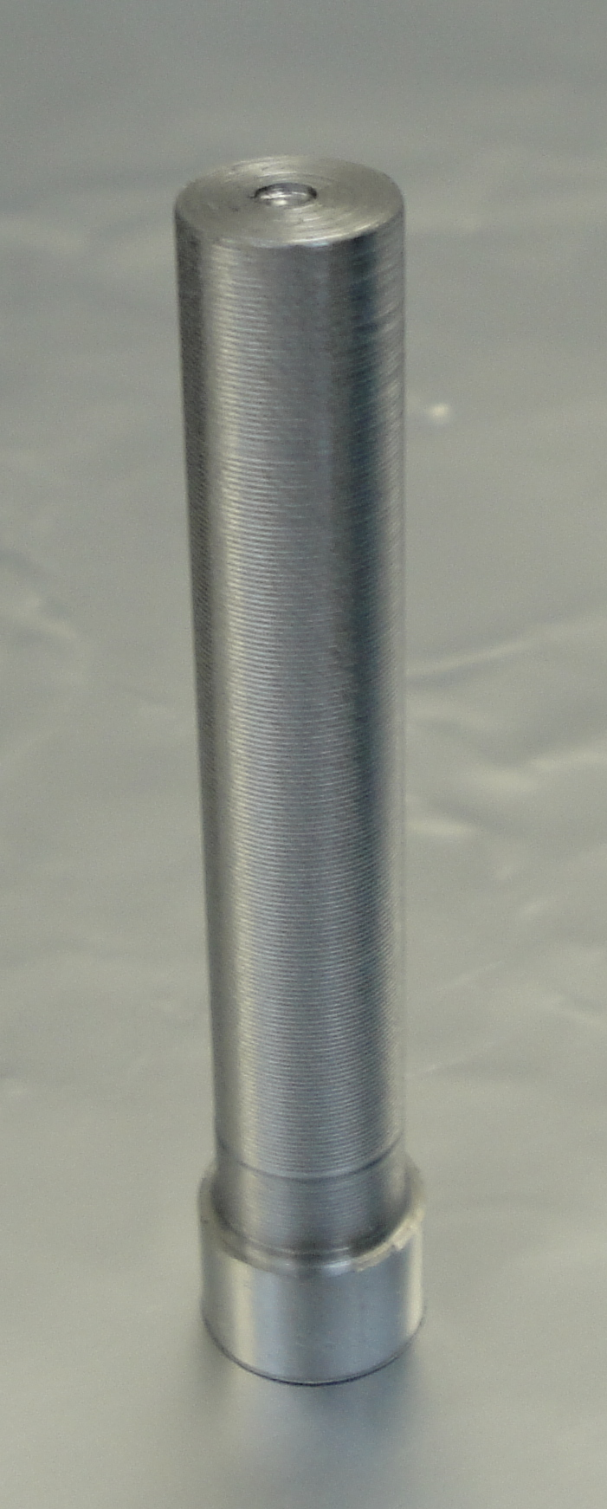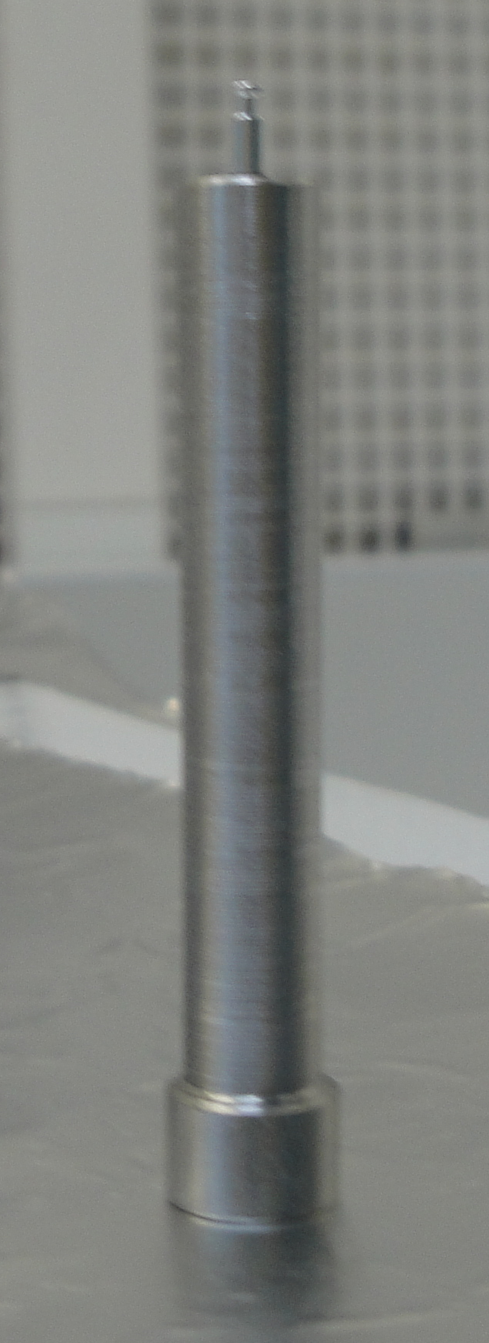  Counterbore  Assembly held to Plunger Magnetically  Fig 128: Plungers Empty and Loaded
- Lay the loaded Plungers on the Optics Table around the Fixture per the Magnetic Polarity layout shown. |  | 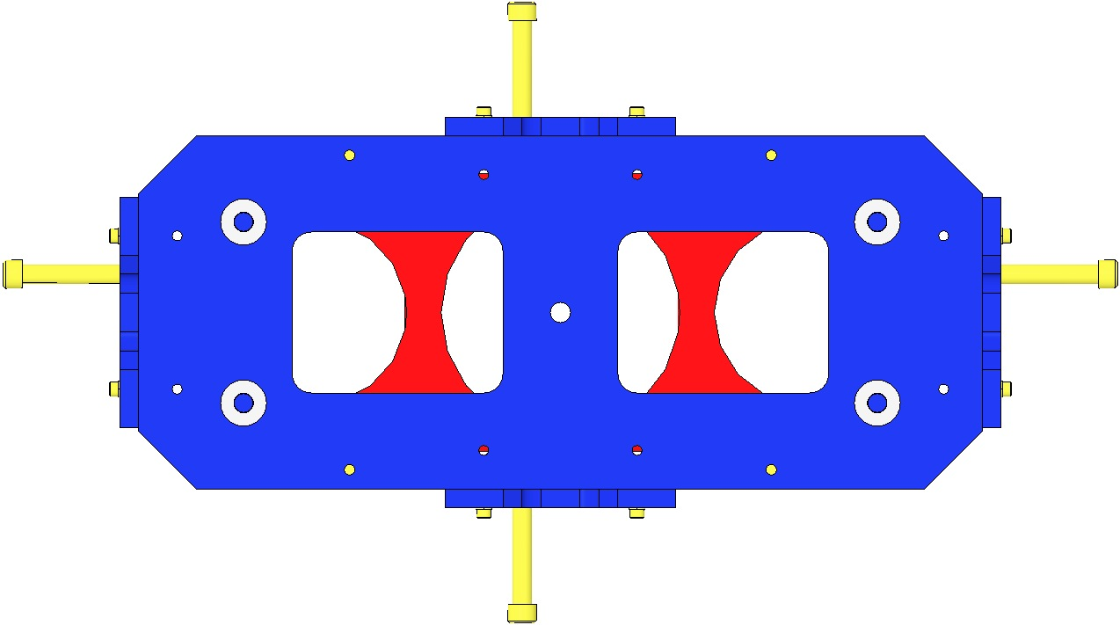  Bottom of Mass  Top of Mass  N  S  N  S  Fig 129: Magnet Polarity Layout
Bond Magnets to Mass  - Load the EP30-2 Cartridge with Mix Tube attached, into the Gun Applicator.  - Pull the trigger on the Gun Applicator 1 full stroke, to purge the Mix Tube of under-mixed adhesive.  - Dispense a “quarter-sized” pool of Adhesive onto a small piece of clean UHV aluminum foil.  - Pick up a Plunger loaded with a Magnet/Standoff assembly and hold it vertically, with the Magnet/Standoff end facing up. Clean the Standoff with Isopropanol and a Wipe.  - Dip the end of a Sewing Needle in the pool of Epoxy and withdraw it, leaving a tiny drop on the Needle tip. Apply approximately ½ mm of Epoxy to the center of the Standoff end.  - Load the Plunger, Magnet/Standoff down, into the appropriate Bushing in the MPF. Slide the Plunger down within the Bushing until the Standoff contacts the Mass. Press down on the Plunger lightly with one finger for about 2 seconds, then release.  - Repeat steps 11-13 to load all 4 Plungers into the Placement Fixture.  - Allow the Epoxy to cure within the Fixture at room temperature for 24 hours. |  | 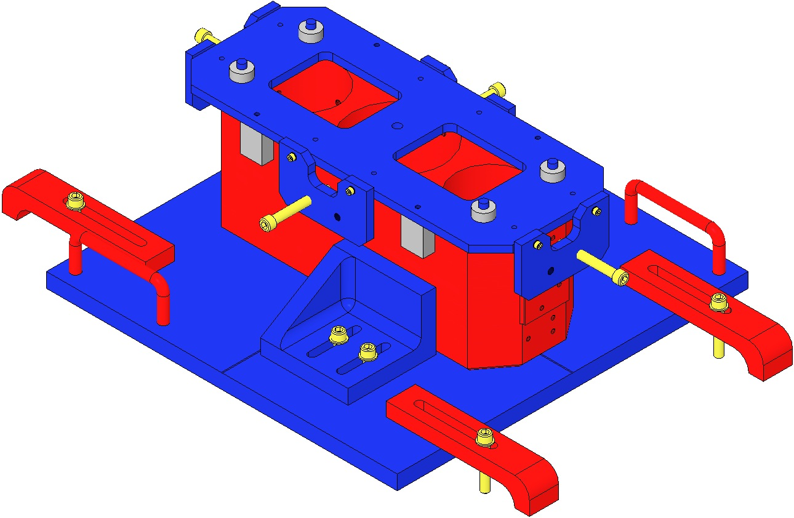  Plunger in Bushing  Fig 130: Loading Magnets into Fixture
- Carefully remove the 4 Plungers from the Magnet Placement Fixture, and remove the Positioning Standoff from the Mass.  - Center the Heat Lamp over the Fixture and adjust the height such that the Fixture surface is receiving 60°C, then allow the adhesive to cure for 4hr. |  | 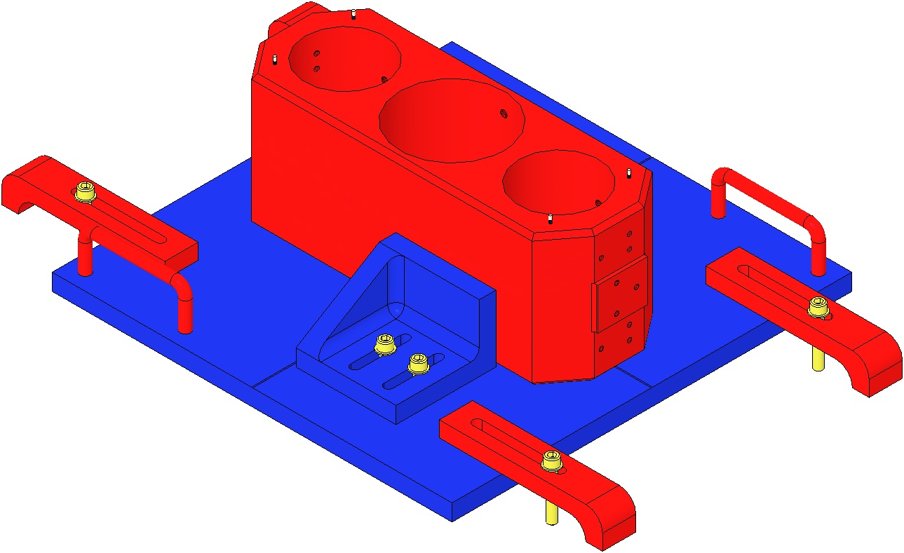  Fig 131: Heat Lamp Cure

Assembling Magnets To Bottom Mass

Documents
E990196 Magnet / Standoff Assembly Preparation

Materials
Qty | U | ID | Description
1 | Ea | D0901460 | HLTS Magnet Placement Fixture, Bottom Mass
4 | Ea | D980184 | LOS Clamps
4 | Ea | NA | Socket Head Cap Screw ¼-20 x 1.5” AgPlated
1 | Ea | D070338 | HLTS Bottom Mass
1 | Ea | Various | HLTS Optic
4 | Ea | D0902432 | Magnet/Standoff Assemblies, 2 N and 2 S configurations
1 | Ea | NA | Machinist Square, approx. 6” in length
1 | Ea | NA | Depth Gage; either Vernier Calipers or Spring-Type Needle Gage
1 | Ea | EP30-2 | Epoxy, Double Barrel Cartridge with Mix Tube, MasterBond
1 | Ea | TBD | Gun Applicator, MasterBond
1 | Ea | NA | Tweezers
1 | Btl | NA | Isopropanol
X | Ea | NA | Lint Free Wipes
X | Ea | TBD | Sewing Needle
X | Ea | TBD | Razor Blade
X | Roll | NA | UHV Aluminum Foil
1 | Ea | NA | Heat Lamp, 120w Bulb

Procedure
- Glass Optics and Metal Masses will not be Air Baked.
- Glue Magnets before gluing Prisms (primary and secondary).
- Ensure the Main Section of the Mass has been cleaned and baked before attaching the Magnet/Dumbbell assemblies.
- Thoroughly Class B clean all parts of the Magnet Placement Fixture.
- Prepare 2 “N” and 2 “S” D0902432 Magnet/Standoff assemblies per E990196 Preparation procedure. | 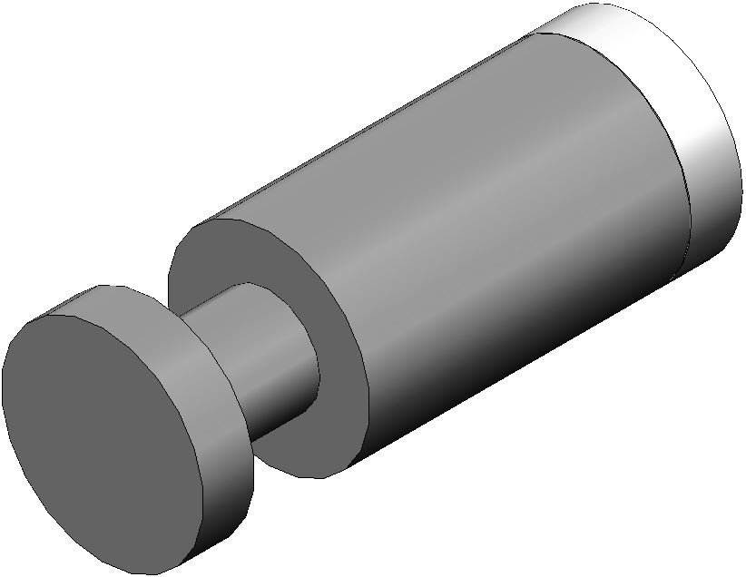  Fig 132: D0902432 Magnet/Standoff Assembly
Place the Mass or Optic  - Mount the Base Plate of the D0901460 HLTS Magnet Placement Fixture on an Optics Table using the 4 D980184 LOS Clamps.  - Place the Test Mass or Optic on the Base Plate.  The Mass/Optic Arrow must be facing downwards. | 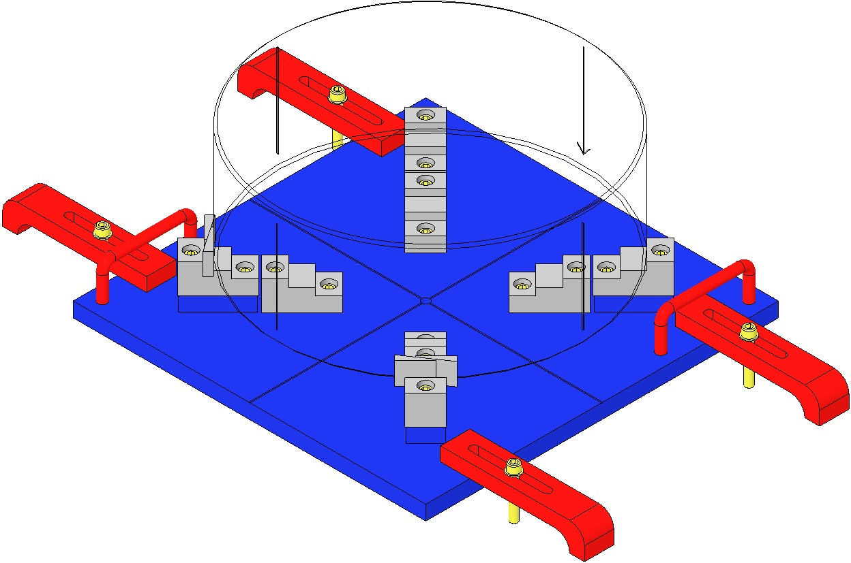  Arrow  Fig 133: Base Plate Mounted on Optics Table
- Place the Magnet Positioning Fixture (MPF) on top of the Mass / Optic.  For the Optic, ensure the PFA440HP-tipped Stops are installed on the Stop Screws | 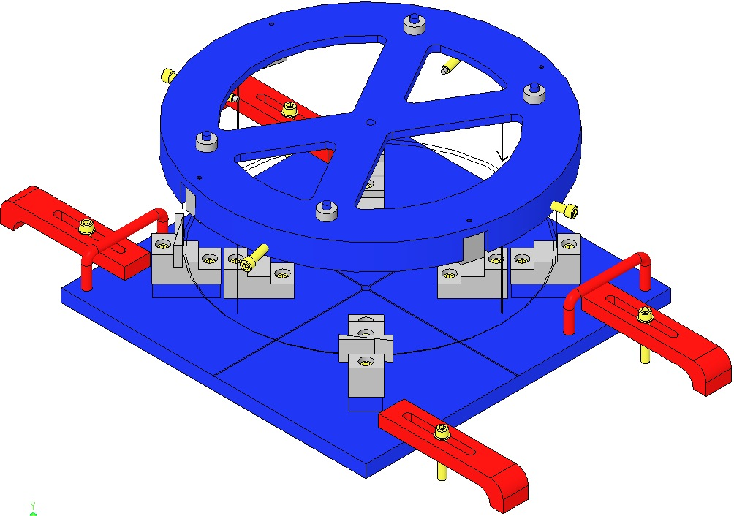  MPF  PFA Tip  Fig 134: MPF in place
Align the MPF and Mass / Optic scribe lines:  For clarity, the Base Plate is not shown.  The MPF Scribe Lines are not visible in the drawings; they fall within 4 flat areas on the MPF perimeter, about 15° clockwise from each Screw.  - Center the MPF on the Mass / Optic by obtaining equidistant readings between opposing pairs of MPF Scribe Lines and the Mass Optic perimeter, using a Depth Gage. The MPF Screw tips must barely contact and not “clamp” the Mass/Optic.  - For a Metal Mass, rotate the Mass while using a Machinist Square to align the Mass and Fixture scribe lines. Align at 2 Lines 90° apart.  For an Optic, sight across (through) the glass through 2 opposing scribe lines, then rotate the Optic while using a Machinist Square to align the MPF and Optic scribe lines. | 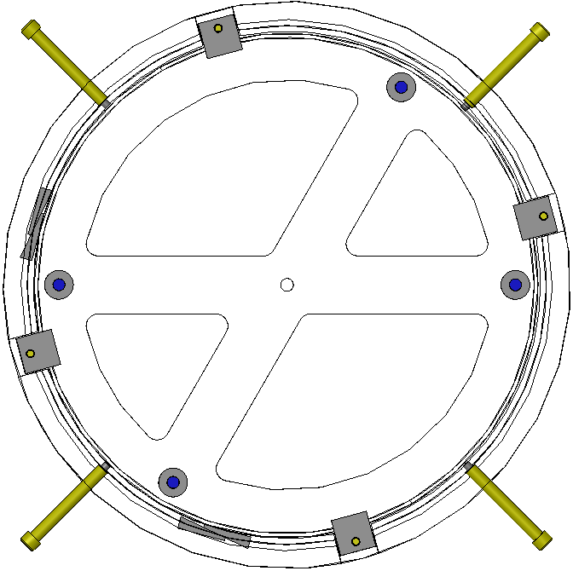  Equal measurements at opposing scribe lines  Fig 135: Centering the MPF on the Mass / Optic  Machinist’s  Square
Load Plungers  - Wipe the counterbore end of each plunger with Isopropanol and a Wipe.  - Using the Tweezers, load 4 Magnet/Standoff assemblies into the 4 Plungers, 2 North Magnets and 2 South Magnets. The Magnet end of each assembly rests within the Plunger counterbore.  The Magnet/Standoffs are held to the Plungers magnetically. | Counterbore  Assembly held to Plunger Magnetically  Fig 136: Plungers Empty and Loaded
- Lay the loaded Plungers on the Optics Table around the Fixture per the Magnetic Polarity layout shown.  Note that the “X” pattern is rectangular and not square; this pattern defines the Magnet layout. | 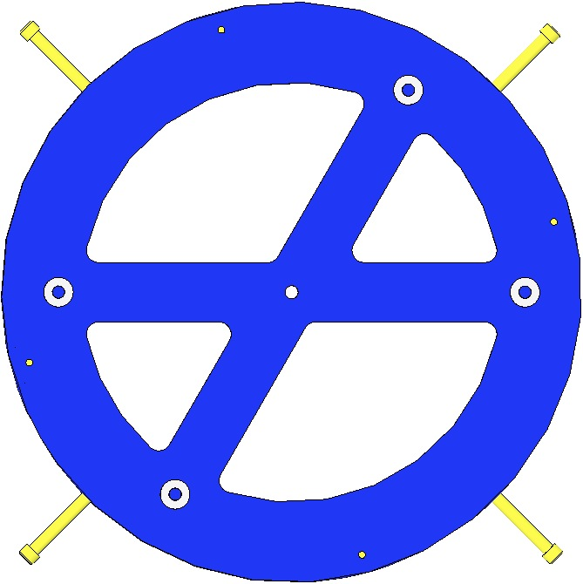  S  N  S  N  Fig 137: Magnet Polarity Layout
Bond Magnets to Mass/Optic  - Load the EP30-2 Cartridge with Mix Tube attached, into the Gun Applicator.  - Pull the trigger on the Gun Applicator 1 full stroke, to purge the Mix Tube of under-mixed adhesive.  - Dispense a “quarter-sized” pool of Adhesive onto a small piece of clean UHV aluminum foil.  - Hold a Plunger loaded with a Magnet/Standoff assembly vertically, with the Magnet/Standoff end facing up. Clean the Standoff with Isopropanol and a Wipe.  - Dip the end of a Sewing Needle in the pool of Epoxy and withdraw it, leaving a tiny drop on the Needle tip. Apply approximately ½ mm of Epoxy to the center of the Standoff end. | Plunger in Bushing  Fig 138: Loading Magnets into Fixture
- Load the Plunger, Magnet/Standoff down, into the appropriate Bushing in the MPF. Slide the Plunger down within the Bushing until the Standoff contacts the Mass/Optic. Press down on the Plunger lightly with one finger for about 2 seconds, then release.
- Repeat steps 11-13 to load all 4 Plungers into the Placement Fixture.
- Allow the Epoxy to cure within the Fixture at room temperature for 24 hours.
- Carefully remove the 4 Plungers from the MPF, and remove the MPF from the Mass/Optic.  - Center the Heat Lamp over the Fixture and adjust the height such that the Fixture surface is receiving 60°C, then allow the adhesive to cure for 4hr. | 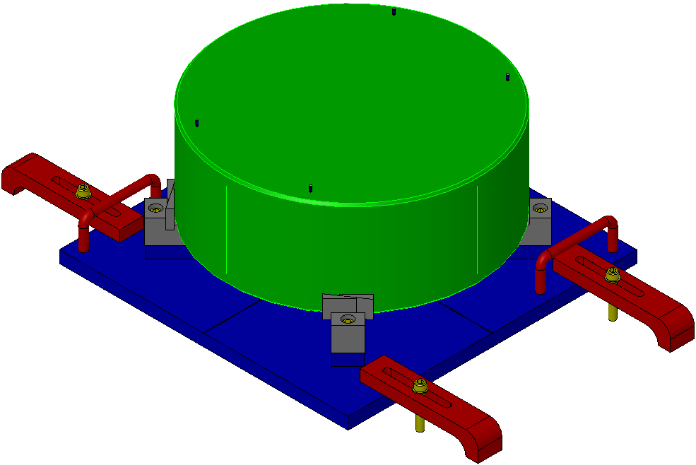  Fig 139: Heat Lamp Cure

Installing the BOSEMs

Documents
D070442 HLTS Overall Assembly

Materials
Qty | U | ID | Description
6 | Ea | D060218 | BOSEM Assembly
24 | Ea | NA | Socket Head Cap Screw 4-40 x 7/8” SSTL
24 | Ea | NA | Flat Washer #4 SSTL

Procedure
- Install the 6 BOSEMs in the arrangement shown, using:  - 24 Socket Head Cap Screws  4-40 x 7/8” SSTL  - 24 Flat Washers #4 SSTL  Torque to 5 in-lb  It may be necessary to install the end BOSEM opposite from the end shown, due to space requirements inside the HAM chamber. Use a non-magnetic hex key to avoid attracting the hex key to the Magnet and Flag Assembly.  Be careful not to bend the Magnet Flags.  Record the serial number and position of each BOSEM in ICS. | 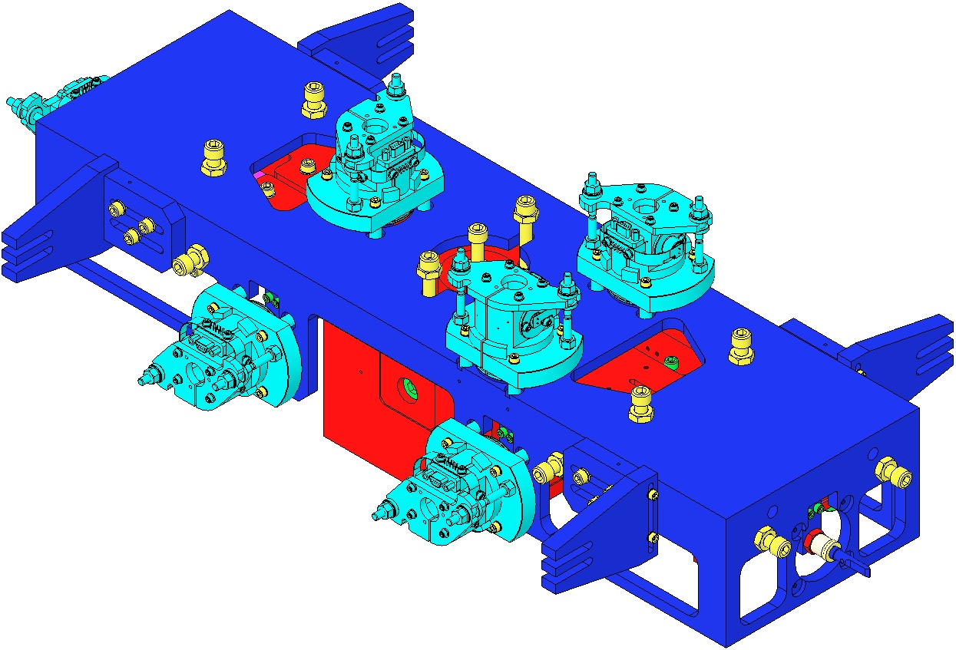  Fig 140: BOSEMs Installed
- After all 6 BOSEMs are attached, install the in-vacuum cabling and related cable connectors and clamps. Use silver-plated SHCS in threaded holes in the HLTS Structure.

Installing AOSEM Brackets

Procedure
- Adjust the push and pull screws on each AOSEM bracket so that the front face of each AOSEM is as far back as possible. Back off the earthquake stop on each AOSEM bracket.
- Attach the AOSEM brackets (as shown in Figure 37) to the HLTS Structure in this order: Bottom Mass Lower AOSEM Alignment Assembly (D0901551), Bottom Mass Upper AOSEM Alignment Assembly (D0901552), Intermediate Mass Lower AOSEM Alignment Assembly (D0901551), Intermediate Mass Upper AOSEM Alignment Assembly (D0902024). Record the serial number and position of each AOSEM on the HLTS Process Traveler.
Fig 141: AOSEM Bracket Arrangement

- Align each AOSEM vertically and laterally using the slots on the AOSEM brackets. Look through the barrel of the AOSEM and align the magnet/dumbbell assembly with the center axis of the AOSEM.
- Adjust the earthquake stop on each bracket to a distance of approximately 1 mm from the corresponding mass. Tighten the hex nuts on either side of the bracket to lock the earthquake stop in place.
- After all AOSEM brackets are installed, connect the in-vacuum cabling and related cable connectors and clamps.

Aligning OSEMs

Procedure
- Connect the in-vacuum cabling for the AOSEMs and BOSEMs to the Triples Test Stand. Confirm that each cable is connected correctly.
- Using the MEDM screens on the Triples Test Stand, read the open light voltage for each BOSEM. Adjust the BOSEM using the SHCS connecting it to the tablecloth for rough positioning. Use the PEEK hex nuts for fine adjustment. Position the BOSEM so that the Triples Test Stand indicates 50% of the open light value.
- Using the MEDM screens on the Triples Test Stand, read the open light voltage for each AOSEM, starting with those for the Intermediate Mass. Use the push and pull screws on each bracket to adjust the position of each AOSEM. Position each AOSEM so that the Triples Test Stand indicates 50% of the open light value.

