LIGO Laboratory / LIGO Scientific Collaboration

T080261-v2 LIGO 16 November 2011

L4-C Pod Assembly Procedure

J. Hanson, R. Mitchell, S. Foley, A. Stein, S. Barnum, K. Mason, F. Matichard

Distribution of this document:
Advanced LIGO Project

This is an internal working note
of the LIGO Laboratory.

California Institute of Technology  LIGO Project – MS 18-34  1200 E. California Blvd.  Pasadena, CA 91125  Phone (626) 395-2129  Fax (626) 304-9834  E-mail: info@ligo.caltech.edu | Massachusetts Institute of Technology  LIGO Project – NW22-295  185 Albany St  Cambridge, MA 02139  Phone (617) 253-4824  Fax (617) 253-7014  E-mail: info@ligo.mit.edu
LIGO Hanford Observatory  P.O. Box 1970  Mail Stop S9-02  Richland WA 99352  Phone 509-372-8106  Fax 509-372-8137 | LIGO Livingston Observatory  P.O. Box 940  Livingston, LA 70754  Phone 225-686-3100  Fax 225-686-7189

Clean room standards:

For a clean assembly, all LIGO standards should be followed, as presented in the latest version of the LIGO Contamination Control Plan (E0900047). Clean room garb including UHV gloves should be worn when working with clean parts.
All tools that come in contact with assembly should be cleaned to class B standards.
Assembly will be done under a portable clean room. Anytime a part of the assembly is not covered by the portable clean room, or not being actively worked on, it should be covered with appropriate clean covers (C3 polyester or equivalent).

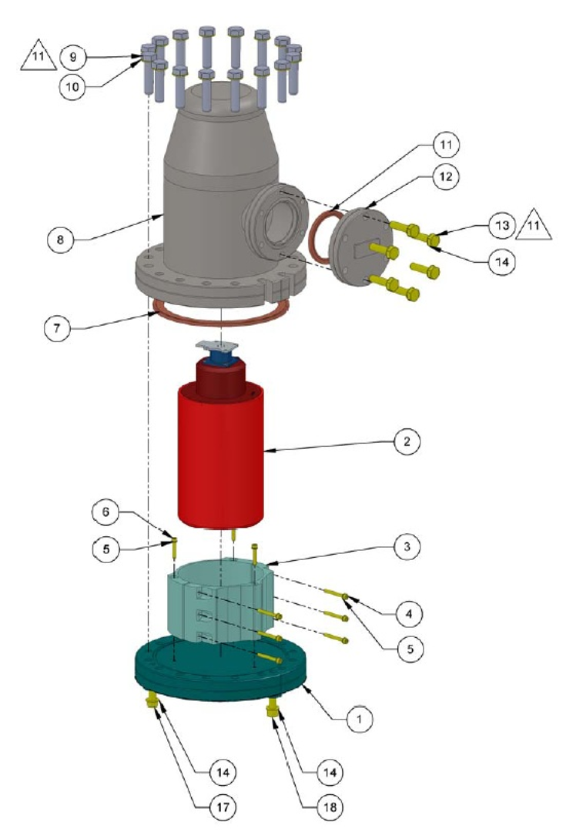

Figure 1: Exploded view of the whole Assembly

16 | N/A | 7/16” Spacer | Plastic | 4
15 | D1000058 | L4-C Pre-amp Cable | N/A | 1
14 | UCC WFV-25 | ¼ Vented Washer | 18-8 SSTL | 6
13 | D1102195 | ¼-28 x 1 ¼ 12pt Bolts silver plated (High Strength) | 18-8 SSTL | 6
12 | 100200 | 2.75” Electrical Feedthrough | AISI 304 | 1
11 | Nor –Cal G-275 | 2.75” CF Gasket | Copper | 1
10 | UCC WFV-31 | 5/16 Vented Washer | 18-8 SSTL | 16
9 | TWP-3120-NA | 5/16-24 x 1.25 12pt silver plated | 18-8 SSTL | 16
8 | D047823 | L4-C Chamber | AISI 304 | 1
7 | Nor-Cal G-600 | 6” CF Gasket | Copper | 1
6 | UCC C-206-410-na | 4-40 x .625 silver plated | 18-8 SSTL | 3
5 | NAS620C-4 | Washer | 18-8 SSTL | 6
4 | MCMASTER_92196A115 | 4-40 x .75 SHCS | 18-8 SSTL | 10
3 | D047824 | Clamp for L4-C in Pod | Aluminum | 1 set
2 | 006177-009 or 006177-010 | L4-C Seismometer | N/A | 1
1 | D047822 | Baseplate, CF Flange L4-C Pod | AISI 304 | 1
Item No. | Part Number | Description | Material | 1:Pod only/QTY.

Figure 2: Bill of Materials for L4C Pod Assembly

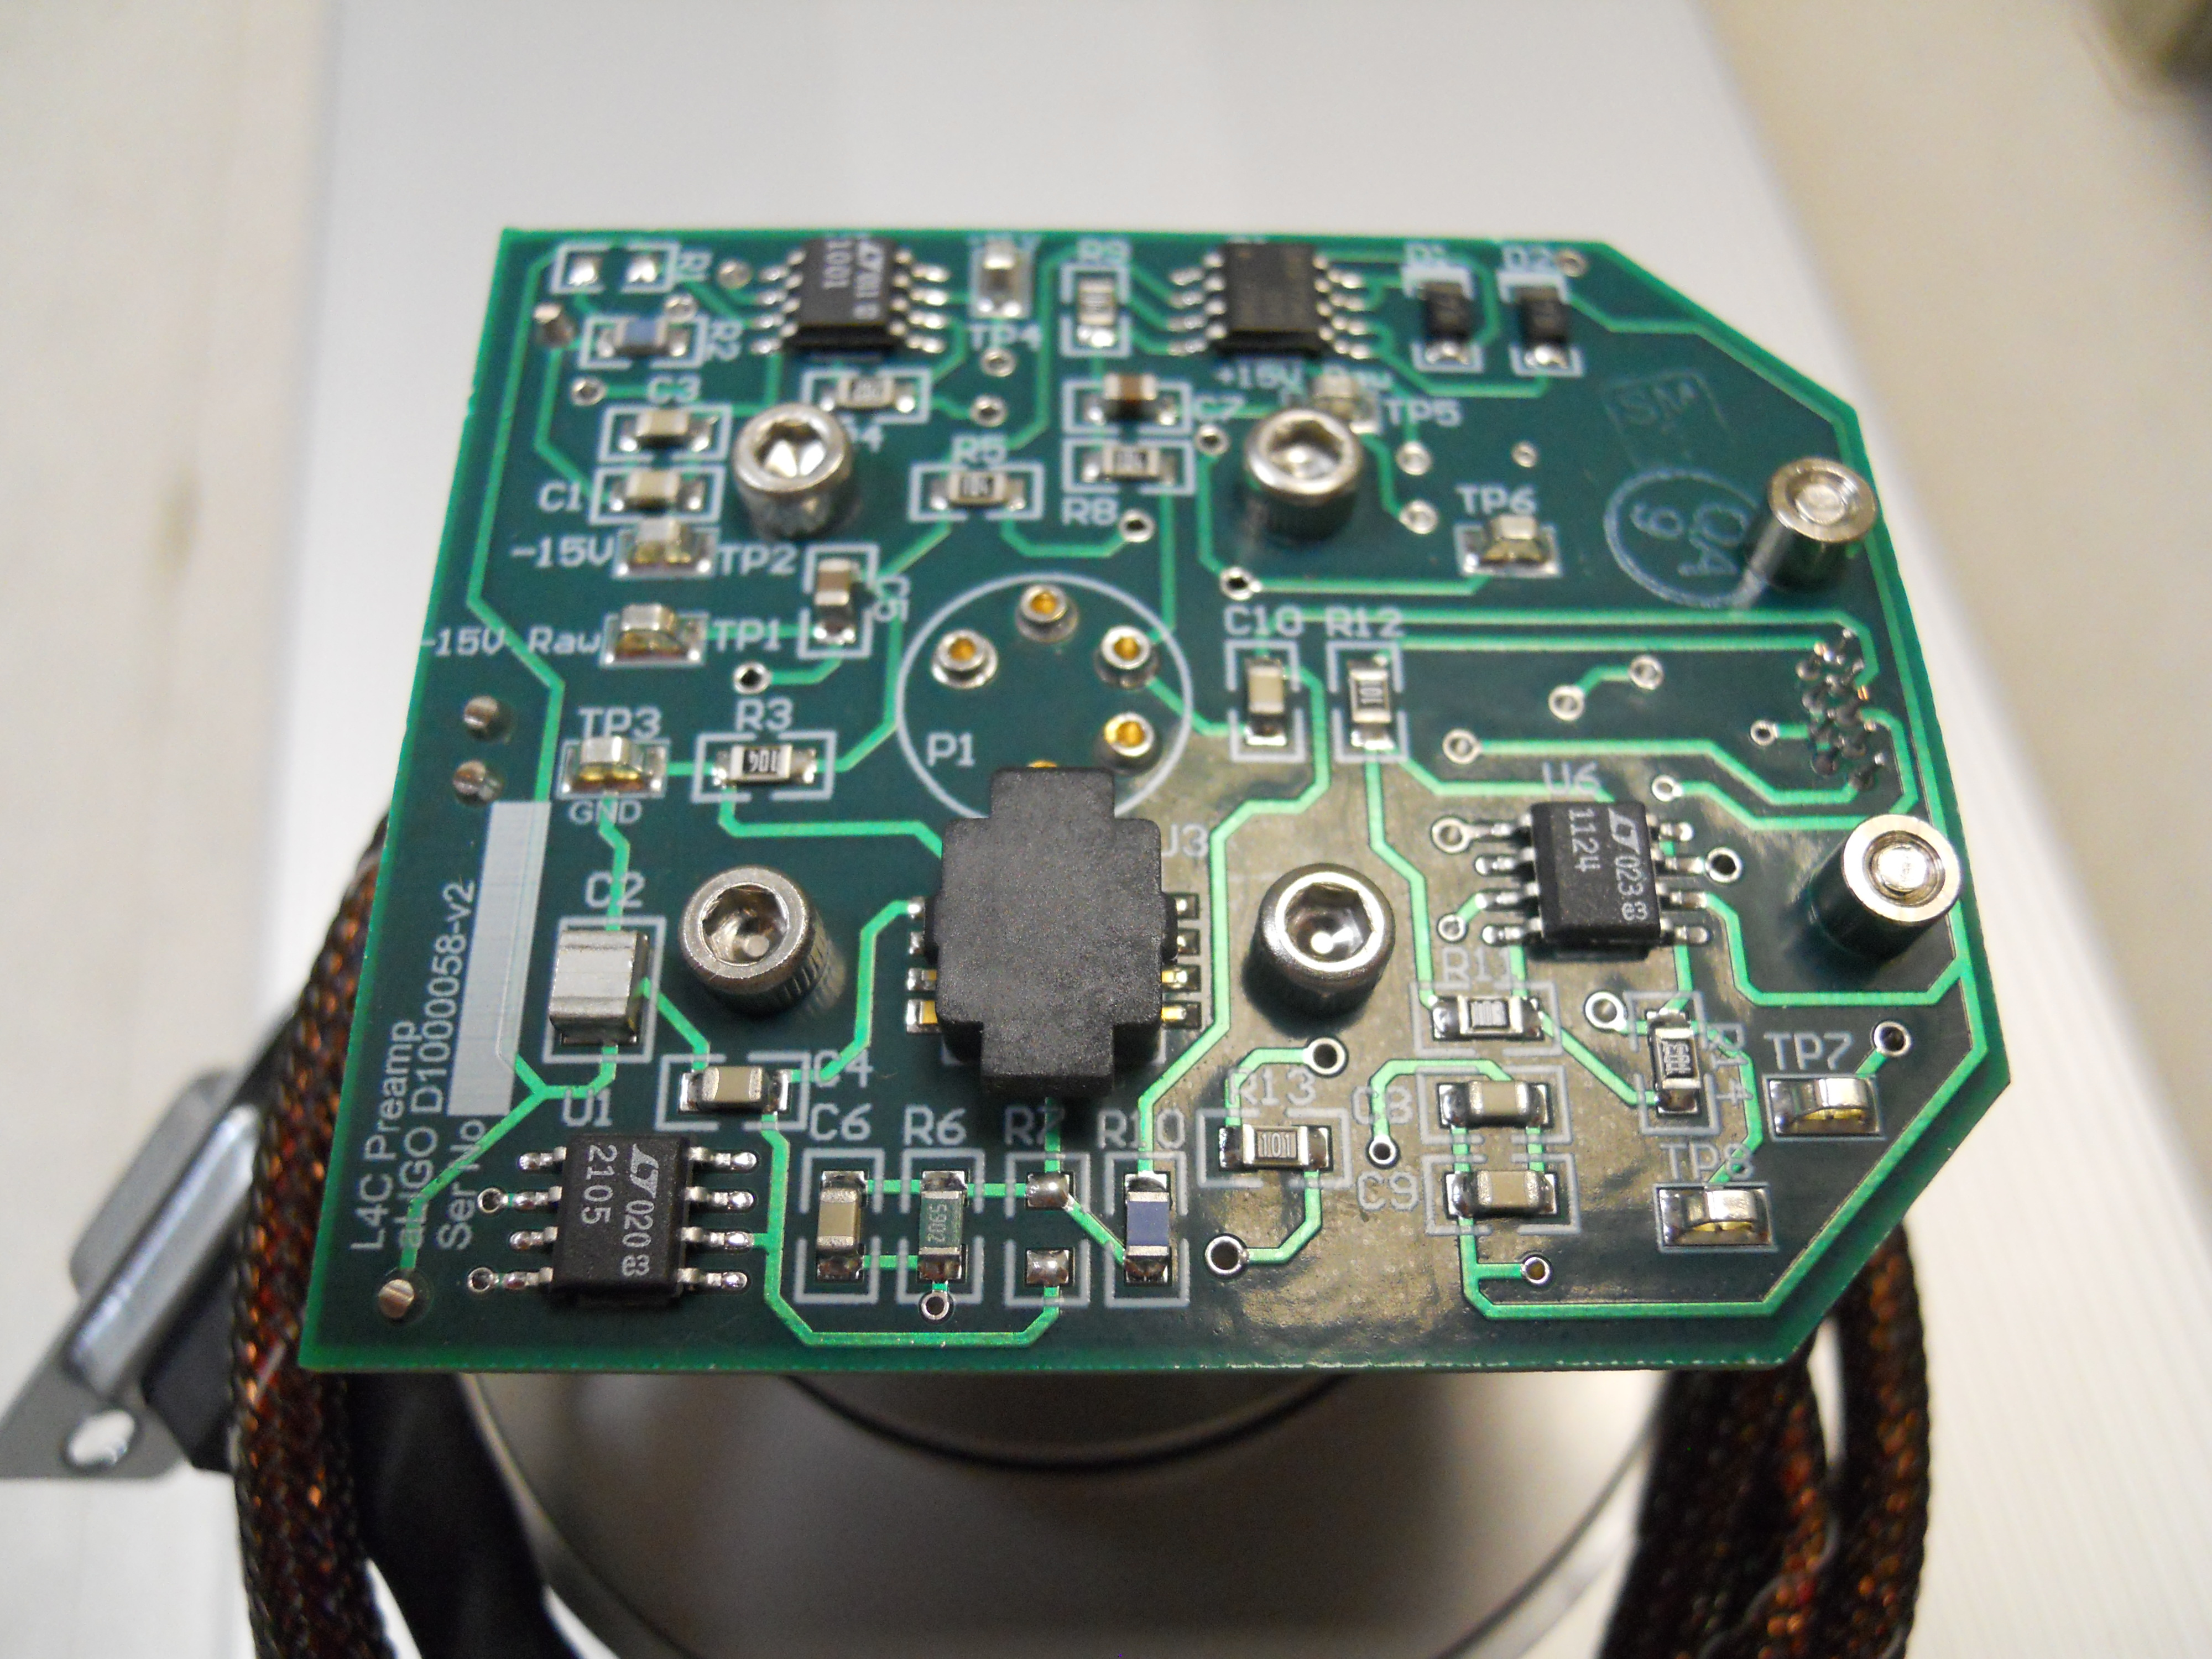
Figure 3: L4-C pre-amp installed

- Install L4-C Pre-amp cable (part – D1000058) onto the L4-C using (4) 7/16” plastic spacers and (4) 4-40 x .75 SHCS (P1 on the preamp board to E pin on the L4-C)

Hardware:

(4) 7/16” plastic spacers
(4) 4-40 x .75 SHCS
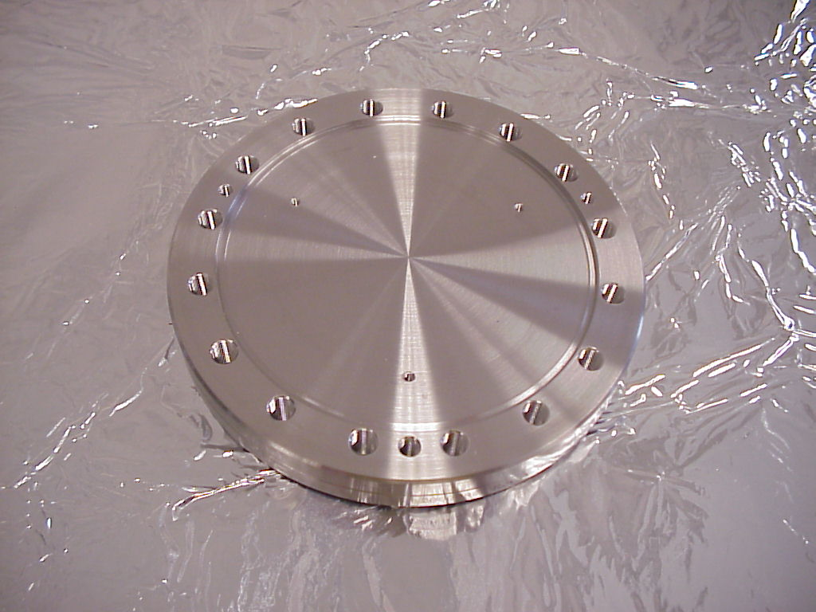
Figure 4: Base plate with knife-edge facing up and alignment mark facing forward

- Place (part D047822) Base Plate with knife-edge up. Inspect knife-edge for debris or damage

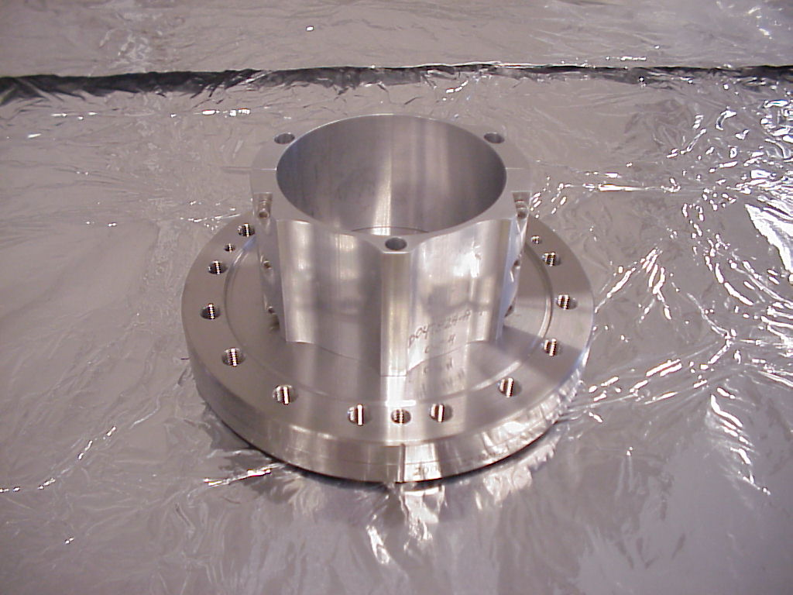
Figure 5: Base Plate with clamp installed

- Using the (6) 4-40 x .75 SHCS and (6) NAS620C-4L washers, loosely attach both halves of the clamp (part 20007824-1). Then loosely fasten the Clamp to the Base Plate using (3) Ag plated 4-40 x .625 SHCS. (Substitute AG plated 4-40 x .5 if using part D047822 type A)

Hardware:

(6) 4-40 x .75 SHCS
(6) NAS620C-4L washers
(3) Ag plated 4-40 x .625 SHCS

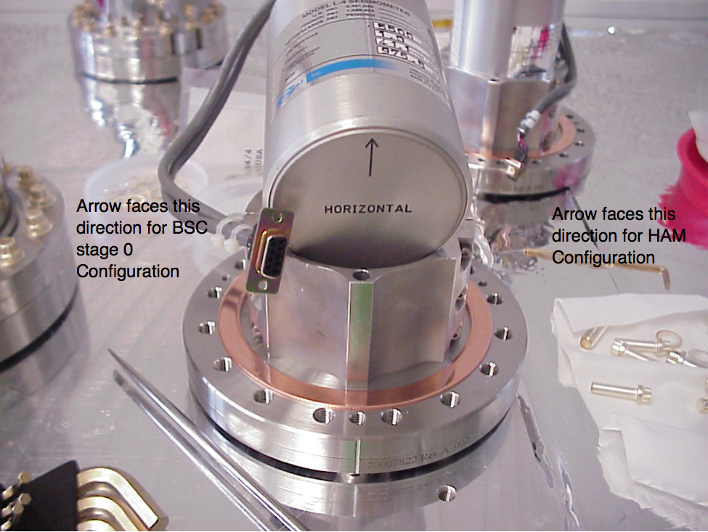
Figure 6: Orientation for horizontal Seismometer

- Slide the L4-C into the Clamp. The horizontal L4-C should be orientated as so the arrow on the bottom is pointing to the Align Mark on the Base Plate. There are also Two alternate configurations for horizontal as noted in the above photo. The vertical has no orientation.

- Now tighten the (6) 4-40 screws that mate the Clamp, and then tighten the (3) 4-40 screws that hold it to the Base Plate.

- Place a 6” gasket G-600 onto the Base Plate knife-edge (wipe with methanol and check for any defects before installing)

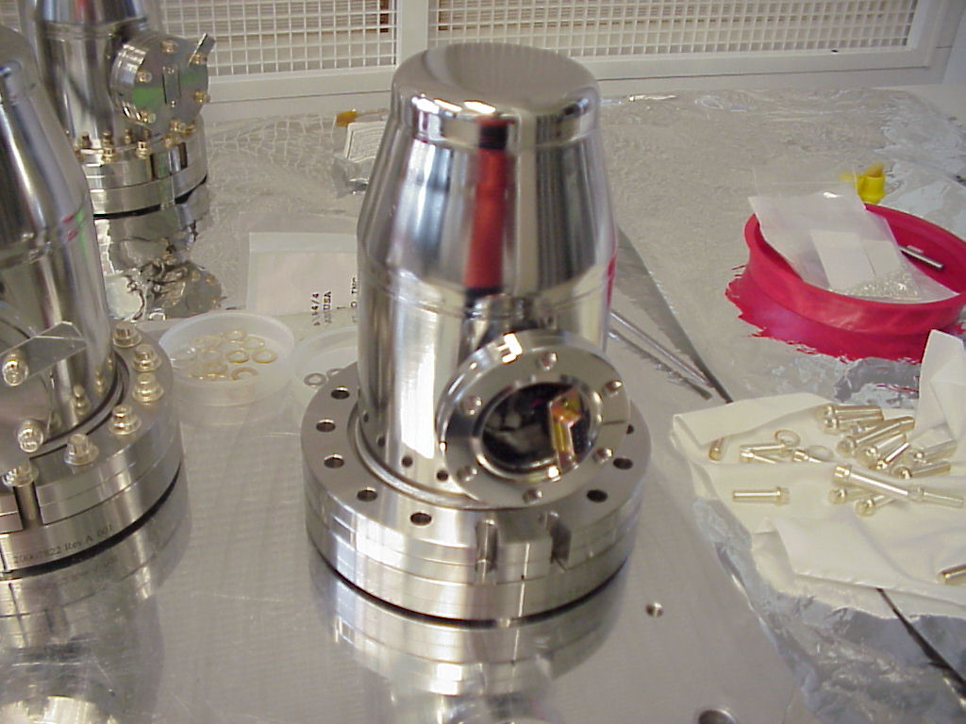
Figure 7: L4-C Pod Chamber Top Hat (D047823) over the L4-C Pod Base Plate (part D047822), with the vertical edge lines aligned on both part

- Carefully lower the Chamber Top Hat (part D047823) over the L4-C, onto the L4-C Pod base Flange (part D047822) while carefully feeding the cable through the side port. Line up the Align Marks for the Base Plate and the Chamber Keep in mind that the cable will not adjust (slide in or out) once the Chamber is seated, so only allow about 1” of the cable to protrude from the Side Port. Also do not to let the cable drop below the Clamp.

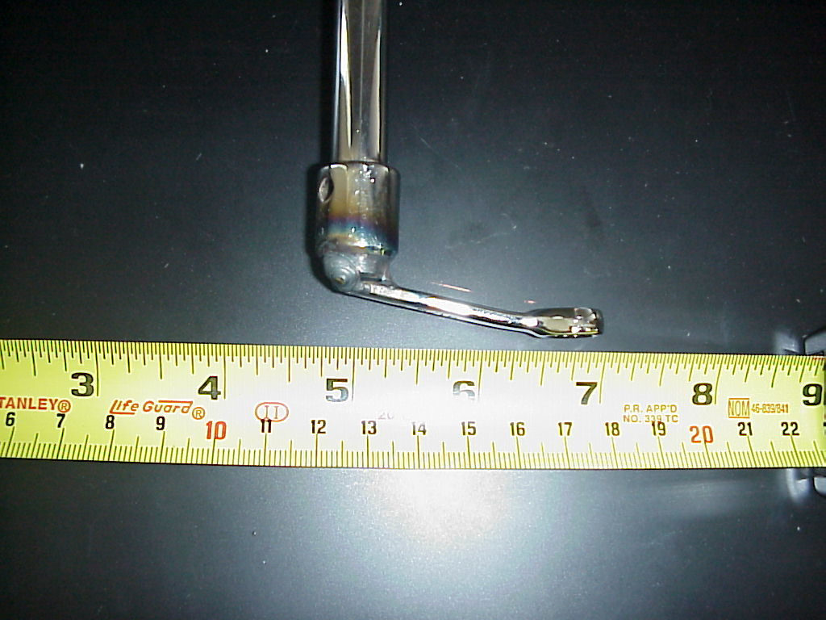
Figure 8: Special tool to torque bolts under side port

- Install the (16) TWP-3120-NA (5/16-24 x 1.25) 12pt bolts and WFV-31 vented washers, Then torque all the bolts incrementally up to final torque value of 325 in. lbs. using a circular clockwise pattern ensuring that the flanges have been brought metal to metal.

Hardware:

(16) TWP-3120-NA (5/16-24 x 1.25) 12pt bolts
(16) WFV-31 5/16 vented washers

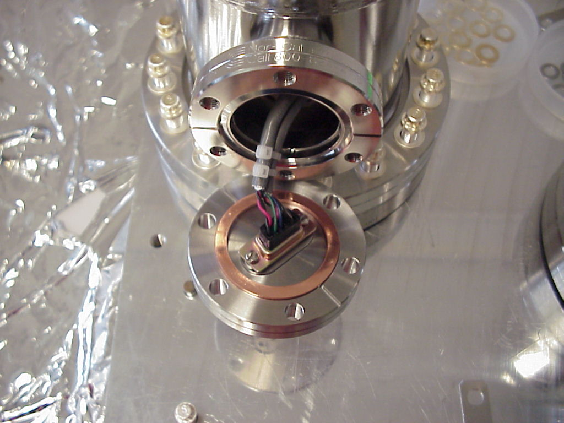
Figure 9: Cable installed onto Flange Feed Through with 2.75” CF Gasket. Ready for Neon Fill

- Next install a 2.75 gasket (wipe with methanol and check for any defects before installing), then hang on the 1” of cable protruding from the Side Port) Now fasten the cable to (part 100200) Flange Feed Through with (2) 4-40 x .25 SHCS

Hardware:
(2) 4-40 x .25 SHCS bolts

- Fill the Pod with Neon for 1 minute.

- Now carefully install the Feed Through (100200) onto the Side Port making sure the gasket is in position over the knife-edge.

- Install the (6) D1102195 ¼-28 x 1¼ 12pt bolts and WFV-25 vented washers and Then torque all the bolts incrementally up to final torque value of 325 in. lbs., using a circular clockwise pattern.

Hardware:

(6) D1102195 ¼-28 x 1¼ 12pt bolts
(6) WFV-25 ¼ vented washers

- Check that the flange faces are metal to metal.

- The L4C pod is now complete and needs to be Leak Tested

