APPROVALS | DATE | REV | DCN NO. | BY | CHECK | DCC | DATE
AUTHOR: Billingsley | 12/17/12 | V6 | E1201114
CHECKED: Torrie
APPROVED:Torrie
DCC RELEASE

Scope
aLIGO optic containers are used to ship and store specific aLIGO optics. There is one container and one shipping case per optic. This procedure covers disassembly, installation of an optic, and assembly. Optics may be stored indefinitely in these containers without experiencing degradation. Optics should always be re-cleaned per LIGO-E1100439 prior to use.

Applicable Documents
D0902146-v2 Assembly, ETM, COC Optic Container, Advanced LIGO
D0902120-v2 Assembly, FM, COC Optic Container, Advanced LIGO
D0902001-v6 Assembly, CP, COC Optic Container, Advanced LIGO
D0902138-v2 Assembly, R, COC Optic Container, Advanced LIGO
E1100439-v5 General Optics cleaning procedure

Environment
Optic Containers should only be opened in a clean environment, preferably a clean room. Use clean room protocol, tools should be wiped with methanol, use powder-free gloves for handling. Find the LIGO accepted clean room gloves here. Avaliable from vwrsp.com, catalog number 79999-304.

Optic containers, internal and external, should be stored indoors in a temperature controlled environment, roughly 25 +/- 5 C°.

Disassembly
All numbers ( ) reference Figure 1.
- Remove the optic container from the shipping case using the top handles only. MUST USE a two man lift or a crane if the optic is inside the container. Set the container down gently, preferably onto a rubber cushioned surface. Wipe the outside of the optic container using a lint free rag and methanol or isopropyl alcohol. Transport to a clean area.
- Loosen the hex nut in the center of the top plate and screw wedge plate clamp (12) up using ¼” hex on top.
- Unscrew the three socket head bolts on the top cover (3).
- Remove the top cover, turn the cover over to set it down, so that it rests on the handle.
- Use the side handles (26) to remove the outer sleeve.
- Use the handles (1), to lift the wedgeplate off of the top of the optic. Turn the wedgeplate over to set it down, so that it rests on the handles, not on the O-ring.
- Remove the locating sleeves ONLY if you can’t get a wrench in with them on. (18). Most of the Teflon sleeves have notches cut in them to allow for removal of the shafts and sleeves at the same time. If possible, leave the sleeves in place to give the optic more protection.
- Unscrew the locating shafts (17) and set aside.
- If the optic is a Test Mass, remove the blocks and screws (10, 11, 24).

Assembly
Ship the following optics only in the correct container type.

Optic Type | Container type | Container Drawing number
ETM, ITM | ETM | D0902146
FM, BS | FM | D0902120
CP | CP | D0902001
PR3, F-PR3, SR3 | R | D0902138

- Wipe the O-rings with a clean, lint-free cloth and spectroscopic grade isopropanol. See LIGO document T1000105 for the full o-ring cleaning procedure. Do not use acetone to clean the o-rings.
- Insert two of the three locating shafts (17).
- Cover the two locating shafts with locating sleeves (18). The libraries of locating sleeves have 1, 2, 3 or 4 rings on one end of the sleeve. NOTE: The end with the rings is oriented up. If there are no rings on the sleeves, the end with the larger diameter is oriented up.
- Locate the arrow on the barrel of the optic, this points to side one.
- Using the two locating sleeves as a guide, insert the optic, SIDE ONE DOWN, snugly up against the two sleeves.
- Insert the third locating shaft (17)
- Select a locating sleeve (18) from the sleeve library that fits snugly against the optic.
- If the container is being shipped empty, install the shipping sleeves (20) over the locating sleeves (18). NOTE: The empty container must be shipped with the three original(non-notched) locating sleeves. The shipping sleeves will not fit over the notched sleeves.
- If the optic is a Test Mass, install the blocks and screws (10, 11, 24) snugly enough so the blocks do not move when pressed.
- Wipe the o-ring of the wedgeplate with a clean, lint-free cloth and isopropanol.
- Install the wedgeplate.
- Install the outer sleeve. Check for shipping case orientation, sleeve handle is next to any locating shaft on all cases but BS/FM. For BS/FM sleeve handles are located parallel to any two locating shafts. See section 6 for a full description
- Loosen the clamp on the top cover (12)
- Install the top cover, fully tighten the three bolts which hold it in place.
- Tighten the clamp on the top cover, ¼ turn past first contact.
- Tighten the locking nut on the clamp.
- Check that the shipping case foam is firm and in good condition.
- Install in the shipping case by following procedure in Section 6. Include any tools that the container shipped with as well as the library of three extra locating sleeves (different sleeve widths allow for best fit for optic during shipping,) shipping sleeves and the three alignment knobs.

Alternative assembly
Alignment knobs may be used instead of using the two locating shafts and sleeves to guide the optic into the correct position. The alignment knobs must be removed and locating shafts and sleeves installed before installing the wedgeplate.

Fitting optics containers into orange shipping containers
In order to fit the optic containers into shipping containers correctly you must orient the top handles of the optic container so that the two foam rectangles on the top of the shipping cases fall in between them (See Fig.4 for TM, CP and R and Fig. 6 for FM/BS)
Note that the two foam rectangles on the top of the FM/BS shipping cases are at a 90º angle to the rest of the cases! These cases have 4 handles total, while the rest have only two.
For the Test Mass, CP and R shipping cases to fit in the shipping cases, align the outer sleeve of the optic container such that the top handles are in line with the sleeve handles (Fig. 5).
For the FM optics containers, orient their top handles perpendicular to the sleeve handles (Fig. 7).

7 Pictures and Diagrams
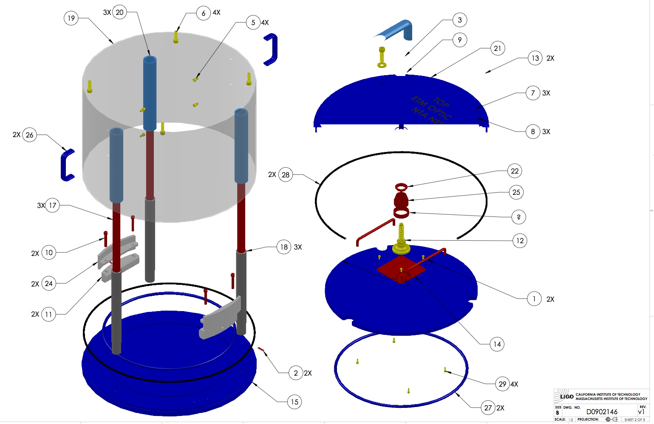
Figure 1: ITM Optic Container Assembly

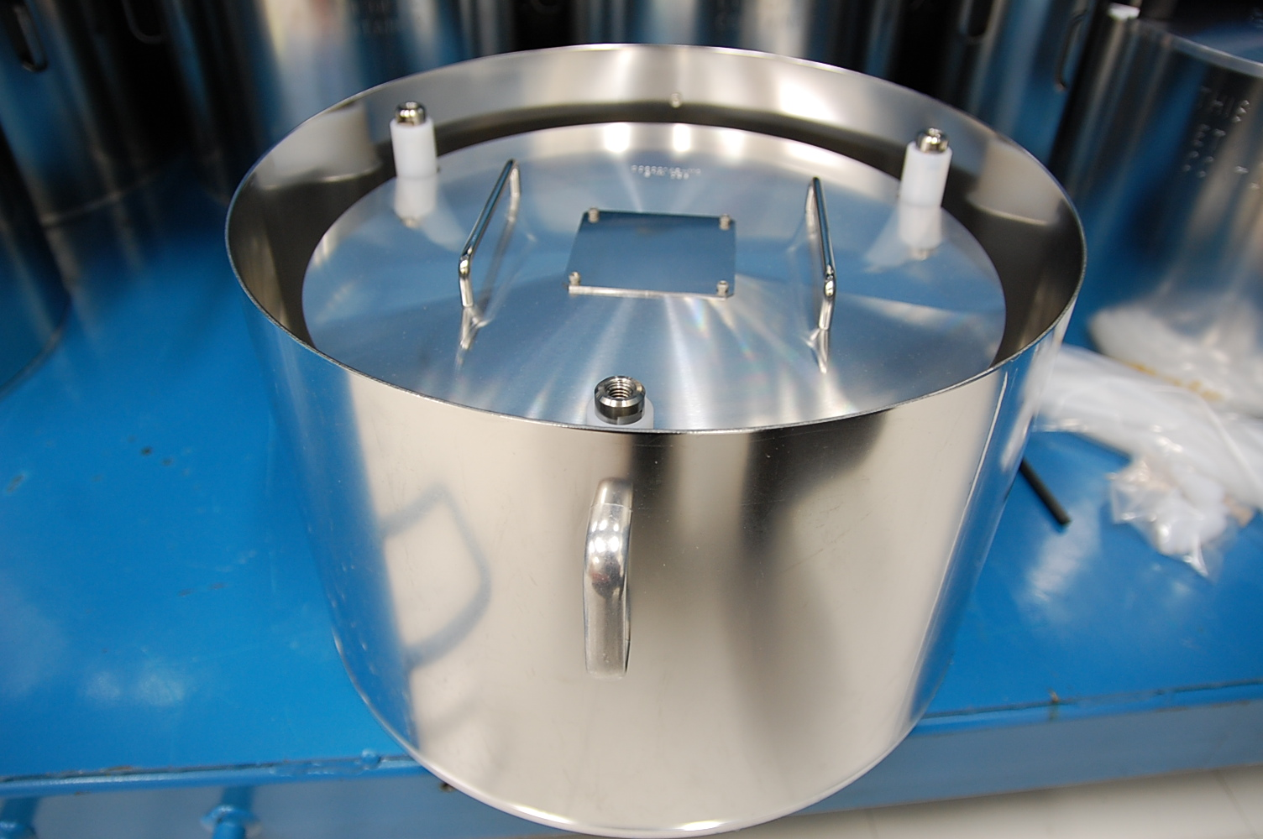
Figure 2: Sleeve handle is aligned with post for proper fit into TM, R, & CP shipping cases. 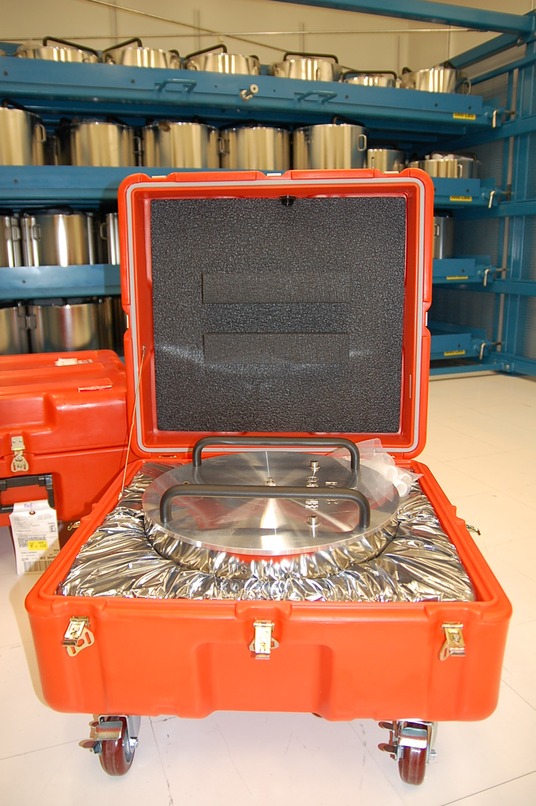
Figure 3: Proper orientation of shipping case foam and top handles on ITM, CP and R cases. Note the two foam rectangles that fit between the top handles of the optic container.

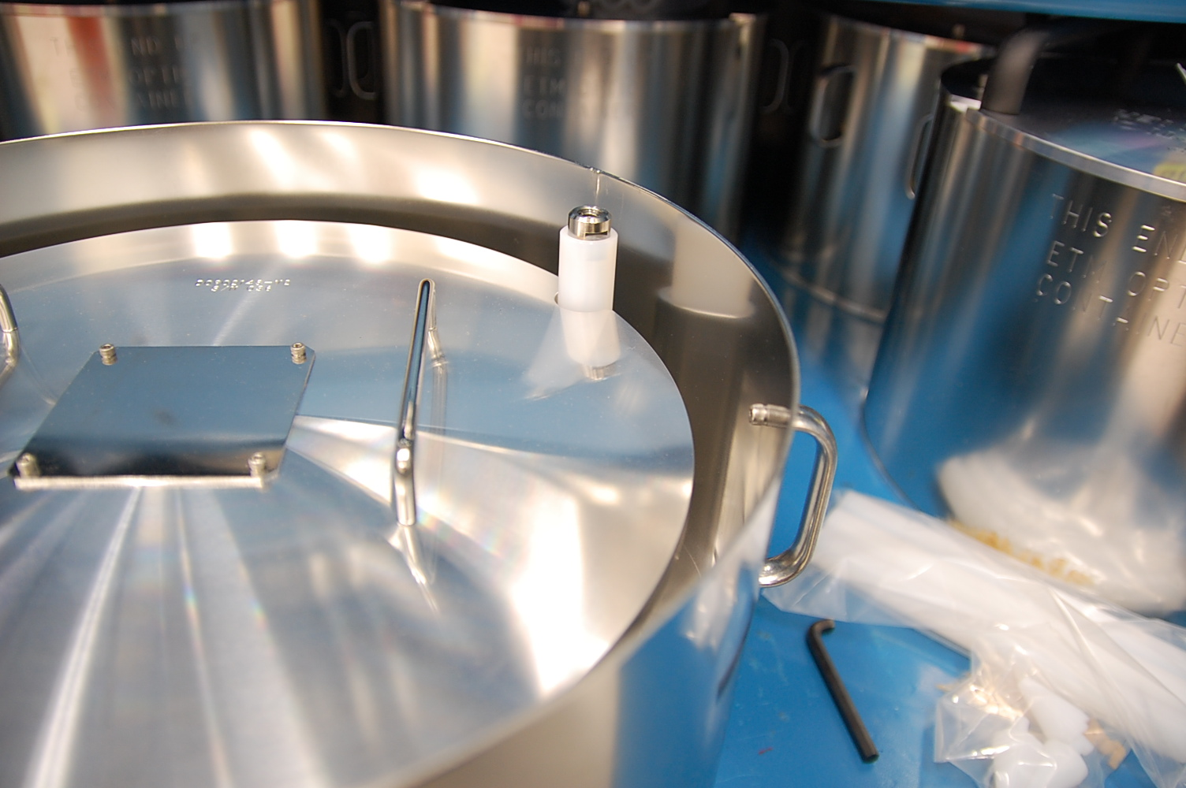
Figure 4: Orientation of FM/BS container handles to inner optics container posts.

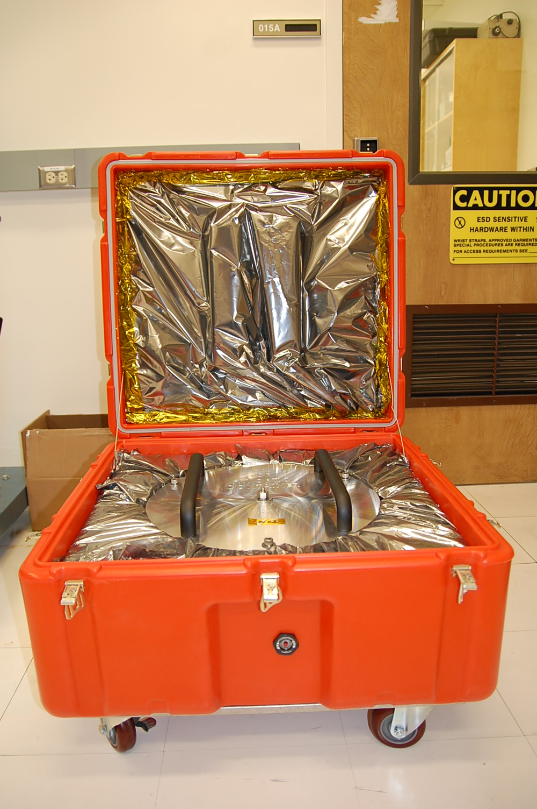
Figure 5: Proper orientation of the FM/BS container top handles and foam. The foam fits between the top handles.

Assembly & Shipping Optics Container Checklists

7.1 Disassembly
☐ Clean work area
☐ Wear Gloves
☐ 2 people (or crane if optic is inside) to lift from shipping case
☐ Wipe outside of container with lint free cloth and methanol
7.2 Assembly
☐ Wipe orings with lint free cloth and spectroscopic grade isopropanol
☐ Place optic snugly against Teflon sleeves.
☐ Choose third Teflon sleeve for snug fit.
☐ Shipping sleeves in place when shipping empty (20 in Fig. 1)
☐ Orient outer sleeve handles correctly to allow the shipping case to close
☐ Tighten 3 hex nuts.
☐ Tighten top clamp.
☐ Check for correct fit into the shipping case. Check foam condition.
☐ Include all the tools:
shipping sleeves
modified R container allen keys
extra Teflon sleeves(must add up to 6 total, 3 in the container and three extra in the shipping case.)
alignment knobs

BS/FM sleeve orientation all other optics

